Title page
Student name: Shzanur Rahman
Student ID number: 1815228
Programme: MBA- Masters of Business Administration
Module: International business
Module code: LCMB7014
Lecturer: Aderemi Ojebode
Assignment Title: International Business

Table of Contents
Title page 1
Table of Contents 2
Introduction 3
External factors for Internationalisation 4
PESTLE Analysis 4
Strategy for internationalisation 12
Geocentric Matters 12
Creation of campaigns 12
Resources 14
Improvisation in ecosystem 17
Context oriented factors 19
Factors for Growth of an International Business 19
Issues related to the complex international business environment 22
Conclusion 25
Reference list 26

Introduction
There is an implementation of “strategic agility” from the end of Harley Davidson for the purpose of enforcing expansion in the subsidiary venues in the foreign regions. According to Tien et al., (2019), the majorly relevant venue for this corporation has been Australia. The strategies which have been utilised by Harley Davidson have been considered to be shifted towards bringing an improvement to the process of marketing so that different demographics across Australia could get a glimpse into the heritage held by the organisation with regards to motorcycles (Pereira et al., 2022).

The organisation initially commenced its functioning in the US. However, throughout the years, multiple avenues of marketing have been utilised by Harley Davidson for the purpose of fostering the relevance of its motorcycles in nations such as Australia (Harley Davidson, 2023). In the coming portions there will be an analysis of the factors which are relevant externally that influence the procedures of internationalisation. Along with this, tactics will also be a new monitor for strengthening the matters of Harley Davidson’s internationalisation.

External factors for Internationalisation
Large companies from different countries are using technology more and more to compete with each other in the global marketplace. When these companies enter new markets, how well they can share their competitive technologies with their local branches is one of the things that determine their success (Kafetzopoulos et al., 2020). Since these branches are located in different environments, it's important to understand what factors affect the transfer of technology. Even though many scholars and business people are interested in this topic, there is not enough research done on the factors that influence the transfer of technology between these companies and their branches. As a result, identifying the various environmental factors that affect an organisation’s success on international grounds serves as a vital implementation of their strategic flow in order to achieve the right competition in their desired positioning.

PESTLE Analysis
Political
Political stability and strong institutions are crucial for supporting the growth and development of the declining Australian Automotive Industry. In 2021, the average score across 12 countries was 0.86 points. New Zealand had the highest score, which was 1.44 points, while Australia ranked 8th on the list with a 0.84 score (The Global Economy, 2022). Thus, strong political stability enables the industry to expand both domestically and internationally for Harley Davidson. Furthermore, stable political relations with other countries facilitate smooth trade and maintenance of offshore business connections. The government's stability also attracts investors, leading to infrastructure development and enhancing the industry's international reputation. Additionally, a stable government can attract resources for industry development, improving overall competitiveness and performance.
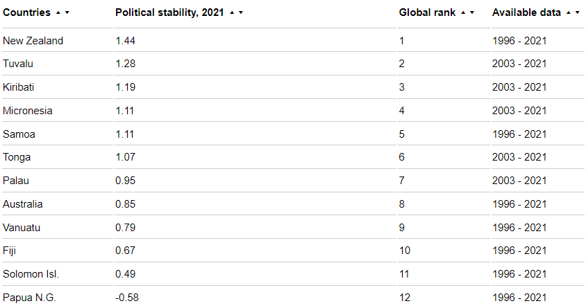
Figure 1: Country ranking on the basis of Political stability
(Source: The Global Economy, 2022)

In Australia, taxes are controlled and collected by the “Australian Taxation Office (ATO)” and sometimes by state “government revenue offices” (Australian Trade and Investment Commission, 2022). Favourable tax policies, Government subsidies and tax rates help the industry stay competitive by managing business costs. The main taxes that impact businesses in Australia are Company Tax, Goods and Services Tax, and the Capital Gains Tax (Australian Trade and Investment Commission, 2022). For instance, the Goods and Services Tax (GST) is a 10% tax imposed on the majority of products, goods and various services that are bought or used in Australia (Australian Government, 2021). This, in turn, prevents additional expenses from being passed on to consumers, resulting in favourable and competitive pricing for Harley-Davidson.

Companies such as the Australian Automotive Industry in Decline can benefit from trade blocks and trade treaties established by their home country. The “Australia-United States Free Trade Agreement (AUSFTA)” took effect on January 1, 2005. With the implementation of AUSFTA, over 97% of Australia's non-agricultural exports to the United States became exempt from duties, excluding textiles and clothing (Department of Foreign Affairs and Trade, 2021). Additionally, two-thirds of agricultural tariff lines were eliminated. As a result, 96.1% of all Australian exports are now exempt from tariffs (Department of Foreign Affairs and Trade, 2021). Thus, trade blocks help these businesses like Harley-Davidson by lowering the resources and overall costs during times of expansion and trading on Australian Grounds.

Economic
In December, Australia experienced a high increase in the monthly inflation director, reaching 8.4%. Furthermore, the country's consumer price index increased by 7% during the first quarter of 2023 (Lee, 2023). A rising inflation rate and consumer price index will determine a slow growth of the automotive industry as it falls under the high-expense categories of goods. If the inflation rate increases, it can result in reduced disposable income for individuals, potentially leading to a decrease in overall spending. This could negatively impact businesses and companies and also lower consumer confidence.
The Reserve Bank of Australia made a decision on Tuesday to stop increasing interest rates, marking only the second time this year. They have decided to keep the cash rate at 4.1%, which is the highest it has been in the past 11 years (Rachwani, 2023). Thus, an uncontrollable high-interest rate will affect the automotive industry and international businesses of Harley-Davidson in a negative manner as the consumers will find it difficult to apply for loans for their purchasing suitability’s.
However, In 2022, the total value of goods and services produced in Australia, known as the GDP, was approximately 1.7 trillion US dollars (O’Neill, 2023). As seen in Figure 2, the inclining GDP of Australia will allow international businesses to expand to a high-demanding consumer with average spending capabilities, impacting positively the growth of the businesses.
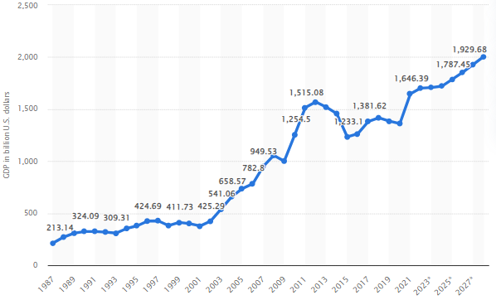
Figure 2: Increasing GDP of Australia
(Source: O’Neill, 2023)

Social
Australia is facing an increase in population which will tend to positively impact the automotive industry for the expansion of Harley-Davidson. The “Estimated Resident Population (ERP)” statistics indicate that Australia's population was 26 million people as of December 31, 2022. The population experienced a quarterly growth of 127,078 individuals, amounting to a 0.5% increase. Over the course of the year, the population grew by 496,800 people, representing a growth rate of 1.9% (Australian Bureau of Statistics, 2023). With the increasing population, the motorcycle industry of the automotive industry has also seen significant growth in terms of purchasing and registration of motorcycle vehicles in the nation. In 2022, there were slightly over 950 thousand motorcycles registered in Australia as shown in Figure 3 (Hughes, 2023). Throughout the year, the number of registered motorcycles kept growing consistently all over the country.
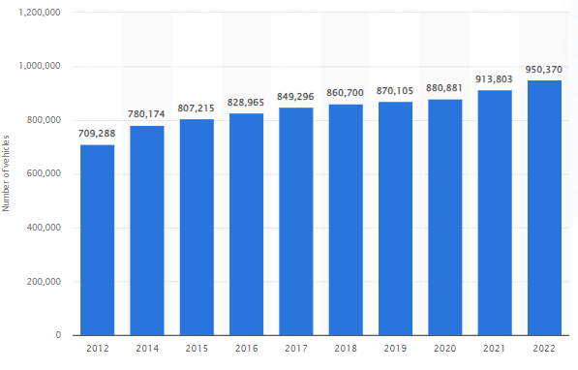
Figure 3: Motorcycle Registration in Australia
(Source: Hughes, 2023)

Similarly, the projected revenue for the Motorcycles market in 2023 is estimated to be 1,256 million U.S. Dollars. It is expected to experience an annual growth rate of 3.71% from 2023 to 2027. As a result, 1.452 million U.S. Dollars is the estimated reach of the total market value by 2027 (Statista, 2023). Thus, this will be a great opportunity for Harley-Davidson to establish its expansion with an expectation of steady growth in the Australian Market. This determines a strong motorcycle culture in the country which will enable a steady foothold for the demand for Harley-Davidson in the country.
However, in 2022, there were 1,194 deaths caused by road crashes. This represents a 5.8% increase compared to the previous year, 2021 (Bureau of Infrastructure and Transport Research Economics, 2023). This determines the strong need for safety protocols and regulations that are in demand for Australian Automotive consumers which needs to be estimated and implemented in the expansion strategy for Harley Davidson.

Technology
The technological development in Australia has been increasing due to its heavy investments in their research and Development infrastructure which has also positively impacted the automotive industry in terms of technological implementations. In the year 2019-20, businesses in Australia spent a total of $18,171 million on Research and Development (R&D). They also had 77,724 people working on R&D projects (Australian Bureau of Statistics, 2021). The Manufacturing industry also increased its R&D spending by $164 million, which was a 4% increase (Australian Bureau of Statistics, 2021).
Similarly, The augmented reality (AR) market for the Automotive industry was valued at $7 billion in 2020 and is predicted to grow at a compound annual growth rate (CAGR) of over 35% from 2020 to 2030 as shown in Figure 4 (Global Data, 2022).
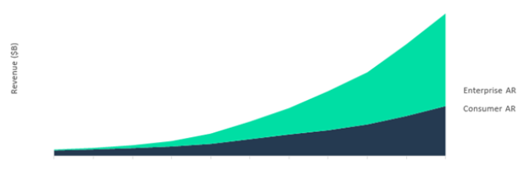
Figure 4: AR in Australian Automotive Industry
(Source: Global Data, 2022)

The global Internet of Things (IoT) market for the Automotive industry was valued at $622 billion in 2020 and is projected to grow at a CAGR of over 12% in the forecast period as shown in Figure 5 (Global Data, 2022).
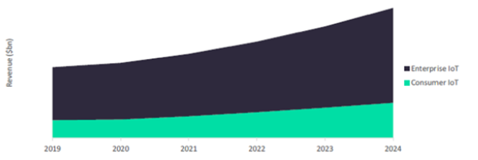
Figure 5: IoT in Australian Automotive Industry
(Source: Global Data, 2022)

Legal
As for the legal parameters, there are certain laws that are required to be abiding by for any international expansion in Australia.
- In Australia, there are rules and regulations in place to make sure that trading is equal and fair for both the parties involved in a trading. These rules are managed and enforced by the “Australian Competition and Consumer Commission (ACCC)” (Global Australia, 2022).
- “The Australian Consumer Law (ACL)” sets out rules and guidelines regarding things like unfair contract terms, guarantees for consumer rights, laws for product safety, agreements made without the consumer's request, lay-by agreements, penalties, and more (Global Australia, 2022).
- Environmental protection in Australia is a collaborative effort between the Australian Government, state and territory governments, and local governments. The Australian Government is responsible for legislation that regulates the assessment and approval of national environmental and cultural matters (Global Australia, 2022).
- Australia has established national privacy legislation, which is supervised by the “Office of the Australian Information Commissioner (OAIC)”. This legislation governs how businesses are allowed to collect, access, and store personal information and communication (Global Australia, 2022).

Environmental
The safety concerns regarding environmental regulations pose a major threat to international business. In a survey carried out in 2022, it was found that more than 38% of Australian consumers consistently thought about sustainability when choosing what to buy (Statista Research Department, 2023). Similarly, the primary greenhouse gas produced by vehicles is carbon dioxide (CO2), but they also release nitrous oxide and methane. Light vehicles are responsible for 11% of Australia's total greenhouse gas emissions (Green Vehicle Guide, 2023). Thus, this can affect the consumer purchasing decisions for Harley Davidson and thus are required to implement measures to develop a more sustainable approach towards their products while expanding to the Australian Market.

Strategy for internationalisation

Geocentric Matters

Creation of campaigns
The campaigns which are proliferated by Harley Davidson are directed towards capturing new forms of demographics in nations such as Australia. According to Chi et al., (2019), a common group of technology are utilised for the purpose of ensuring the efficacy of the concerned campaigns which would help the demographics of Australia to identify the relevance of such motorcycles. For this cause, multiple forms of communities are targeted for the purpose of providing them with the essential information regarding the usual popularity of the motorcycles produced by Harley Davidson (Pjatakova et al., 2019). There is generally a utilisation of the resources which are dispersed at a global scale which enables organisations in the likes of Harley Davidson to flourish in subsidiary venues such as Australia. Moreover, Sheth (2021) argued that different types of channels are utilised for the purpose of developing dependencies in mutual forms. This strategy would enable the noticeable base of the customers to identify the significance of the motorcycles developed by Harley Davidson. This is something that is a huge component for fostering internationalisation across geocentric scenarios.

When it comes to the routes with regards to the advertisement, Harley Davidson prefers to facilitate the alterations of its messages which would indicate some transformation from the traditional motto of the brand. Different types of merchandise are utilised for the purpose of establishing the general relevance of the motorcycle among the younger segments of customers (Zheng, 2021). The differences which can be found to be completely relevant between the nations in the likes of Australia and the US are usually accounted for by the experts of “international business” in Harley Davidson. Similarly, in order to develop multiple categories of campaigns, Harley Davidson strategically considers the income that is prevalent on the basis of a median in every household across Australia (Lin et al., 2019). The markets which are associated with Harley Davidson always strive to develop interconnectedness by encapsulating adaptation with the culture which is prevalent in countries such as Australia.
Shams et al., (2021) opined that in order to encapsulate the effective forms of campaigns, corporations in the likes of Harley Davidson pay heed to the elements which are considered to be governmental as well as cultural.

This is why the company namely Harley Davidson always takes note of the external elements such as the politics which are relevant in Australia as well as the technology which can be utilised for future matters of expansion. Moreover, according Nambisan et al., (2019) Harley Davidson acknowledges the fact that unlike the stores which have dominance in the areas of e-commerce, it needs to improvise strongly in the area of carrying out commerce in physical forms. Because of this reason, “internationalisation strategy” can only be brought forth through tactful elements of marketing (Rosińska-Bukowska, 2019). Marketing is one of those instruments which is helpful for encapsulating more profitability easily. This also enables organisations namely Harley Davidson to shift their usual predominance from the nations (US in this case) which usually act as their home.

Resources
There is a major requirement for improvising the usual ecosystem in organisations in the likes of Harley Davidson. Abdulwase et al., (2020) argued that the infrastructure should be renovated in a digitised form for the purpose of increasing the relevance of the concerned motorcycles produced by this corporation. This phenomenon needs to be extra cautiously incorporated in a very saturated form of markets such as Australia. Similarly, the innovations which may be probably incorporated by Harley Davidson may be considered to be absolutely alienating in the markets associated with Australia (Gul, 2020). For this reason, many of the rivals might hinder the concerned corporation's prospects of functioning in various areas across Australia. One of the underpinnings is that organisations especially Harley Davidson must pay attention to the laws which are relevant with regards to patent as well as copyrights all over Australia.

Once this is done, Shams et al., (2021) noted that the innovations in the segment of motorcycles should be acclimated to the lifestyles that are relevant among the inhabitants of Australia. Contrary to this, the relevance of cloning as well as the availability of various forms are substitutes resembling the motorcycles of Harley Davidson can act as a huge form of threat in saturated venues such as Australia (Zheng, 2021). Hence, the motorcycle should be developed with resources which are in accordance with the “economic circumstances” of every household spread across Australia. Moreover, Chi et al., (2019) asserted that new categories of connectivity can also be encapsulated by Harley Davidson which can facilitate the corporation to develop multiple partnerships across different borders between Australia and the US. When it comes to theories which are considered quintal essential for Harley Davidson, there ought to be an implementation of “absolute advantage”.
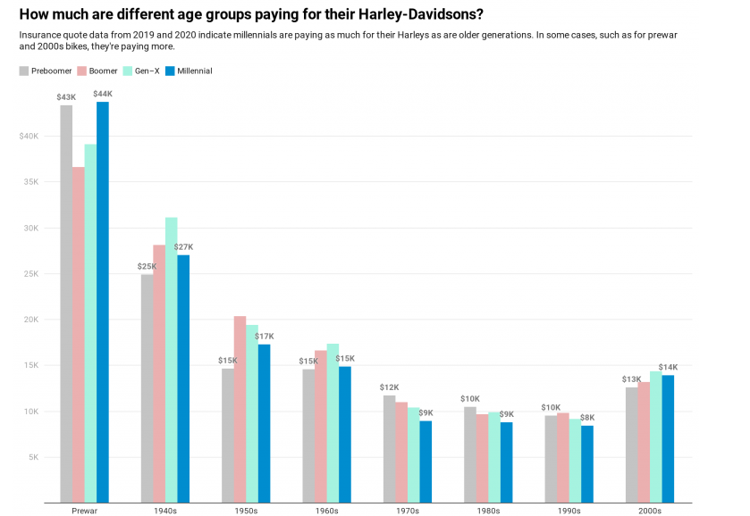
Figure 6: Demands for Harley Davidson Motorcycles
(Source: Hagerty Insider, 2023)

This form of theory would facilitate this company to increase the effectiveness in the processes of manufacturing which would in turn increase the relevance of motorcycle distribution across Australia. Aguilera and Grøgaard, (2019) mentioned that one of the causes of finding the aforementioned theory necessary is because there are two nations which have been found to be relevant in this paper. They are namely Australia and the US. This would aid in bringing an increase to the reduced revenue (as indicated by figure 6). According to Welch et al., (2020), the manufacturing aspects of Harley Davidson all over Australia are not as relevant as they are in the US. On the contrary, the US has been found to be highly relevant when it comes to the popularity of the same corporation.

Due to this cause, Harley Davidson can capture the elements of competitiveness by offering the motorcycles at better segments of pricing to the demographics spread across Australia (Buckley and Casson, 2019). Besides this, “comparative advantage” is another form of theory Which can be helpful for corporations namely Harley Davidson. This is because this form of theory relies upon productivity in relative form (Chi et al., 2019). Through this theory, Harley Davidson trades the resources which are prevalent in the USA with the ones available in Australia for the purpose of enforcing more quality in the motorcycles distributed across Australia.

The firms which function under the dominance of Harley Davidson can be renovated through digitisation. According to Zheng (2021), this circumstance will facilitate the authorities of Harley Davidson in the US to supervise the functions which are prevalent in several regions all over Australia. In order to proliferate the elements of internationalisation, Harley Davidson ought to look into the materials which are utilised by the generic competitors in the segments of motorcycles all over Australia (Paul and Criado, 2020). The majority of the designs which are encapsulated by Harley Davidson have been found to be in accordance with the classic components of the organisation.

In addition to this, the resources should be improvised by Harley Davidson for the purpose of encapsulating safety in its motorcycles all over Australia. As mentioned by Pereira et al., (2022), the materials which are utilised by Harley Davidson ought to be available in the global sphere so that the consumers across Australia are able to receive proper availability of the same easily at any reason. Apart from this, Zheng (2021) asserted that companies such as Harley Davidson must consider the concerns which are associated with the environment as well as factors of sustainability. Thus, the organisation ought to produce the concerned motorcycles in Australia by taking note of the climatic circumstances prevalent in the nation.

Improvisation in ecosystem
Harley Davidson must take into account the progress of the product as well as the conditions which are in relation to the economy of Australia as well as the US. As mentioned by Buckley and Casson (2019), there must be a prevalence of collaboration between the affirmations for the purpose of encapsulating the necessary forms of technology as well as coordinating the prevalent assets of the organisation. On the identical note, the technology which is essential for the purpose of developing the motorcycles must be encapsulated in the form of architecture that can be considered modular (Welch et al., 2020). The ecosystem which gets incorporated by Harley Davidson must be able to leverage upon the theory of “product life cycle”. According to Gul (2020), this implies the fact that Harley Davidson ought to incorporate flexible aspects procedures of manufacturing depending on the demands exerted by the Australian consumers with regards to motorcycles.

From this theory, there is also an implication that corporations such as Harley Davidson should take note of the trends which are absolutely relevant in various subsidiary economies such as Australia (Nambisan et al., 2019). Maturity should be brought about in the product such as motorcycles for the purpose of enforcing safety at a higher extent as well as understanding the repercussions which are generated towards the climate and the environment. Shaheer (2020) ascertained that the materials of governance should also be considered because it helps in regulating the usual markets and the architecture that are relevant to the development processes of motorcycles by Harley Davidson.

There is a requirement for extensive form of Investigation in the fear of renovating the existing forms of designs of the construct motorcycles at Harley Davidson. According to Rosińska-Bukowska (2019), one of the reasons for articulating the requirement for investigation is to identify the composition of the roadways which are found to be relevant across the US as well as Australia. Besides this, innovation in the pre-existing ecosystems of Harley Davidson should be done in a complementary manner between the US and the Australian venues (Tien et al., 2019). The materials as well as the ecosystems must take note of the factors which are geocentric.

Accordingly, there ought to be a unidirectional form of connectivity between them when it comes to the motorcycles produced by Harley Davidson (Welch et al., 2020). Moreover, Harley Davidson must incorporate the skills of those categories of workforce which have the capability to incorporate relevant expertise in the matters of “international business”. Apart from this, Paul and Criado (2020) opined that Harley Davidson must utilise the platforms which are deemed to be conceptualised in order to identify the relevant requirements of the sides of the concerned market of motorcycles. As stated by Dube et al., (2020) The diversity with regards to the preferences among the users of Motorcycles also needs to be evaluated by Harley Davidson all over Australia. In addition, the features should be introduced within the motorcycles which are commensurate with the preferences and the cultures exhibited by the households all over Australia.

Context oriented factors

Factors for Growth of an International Business
Brand Awareness
Brand awareness plays a vital role in determining the success of its sales and revenue collection as it helps organisations to have a strong brand image in front of the customers it is catering to. Harley-Davidson is a famous American company that is highly regarded worldwide. Based in Milwaukee, the company is known for its high-quality brand. Despite changes in the population and some difficulties in recent years, Harley-Davidson remains a top seller in the USA market. In 2022, they sold a total of 117,100 motorcycles in North America (Maia, 2023). Although this is a 12% decrease from the previous year, when they sold 134,413 units, the numbers were even worse in 2020. In that year, Harley-Davidson only sold 110,127 bikes in North America (Maia, 2023). As a result, Harley Davison has a strong presence in the motorcycle industry which will allow the business to develop a strong profile in the Australian market during its time of expansion.

On a global scale, Harley-Davidson delivered around 178,500 motorcycles, commonly referred to as 'hogs,' in 2022. However, the sales of Harley-Davidson motorcycles decreased by 7.7% between 2021 and 2022 (Carlier, 2023).
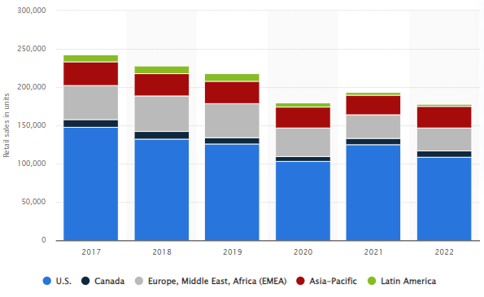
Figure 7: Harley Davidson Motorcycle revenue
(Source: Carlier, 2023)

However, due to their strong brand image and awareness, they have been able to boost their sales and profit generation by 37% due to the rise in demand for their company (Business Standard, 2023). Despite the loss faced during the pandemic era, its demand has helped the company to rise its profit generation which will play a major role in its expansion to the Australian Market.

Automotive Industry Demand in Australia
The largest part of the market is for On-road Motorcycles. It is estimated that in 2023, this segment will be worth around US$823.60 million (Statista, 2023). On-road motorcycles are the ones meant for riding on regular roads, like street bikes and touring motorcycles. They are very popular among people. This big market shows that many people want to buy on-road motorcycles, and it suggests that this segment will keep growing in the future in Australia. Due to the heavy demand for motorcycles in Australia, it is projected that the number of motorcycles sold in the market will reach 127,200 units by 2027 (Statista, 2023). This will develop a strong profile for Harley Davidson to establish a renowned and strong foothold in the region and enhance its expansion goals by various means.

Competition in the Motorcycle Industry in Australia
In 2020, the motorcycle industry in Australia experienced a significant milestone. Despite the marginal impact of the COVID-19 pandemic on the country's economy, there was a growing demand for motorcycles, driven by the search for safer and more individual means of transportation and a greater focus on environmental sustainability, including the emergence of electric motorcycles. By the end of the year, motorcycle and scooter sales reached 87,453 units, the highest in the past five years, with a 6.2% increase from the previous year (Team, M.C.D., 2022). This trend continued into 2021, with the industry performing better than expected. Total motorcycle sales for the year reached a 15-year high of 101,954 units, marking a 16.6% increase. Honda maintained its leadership position for the sixth consecutive year, experiencing a 32.4% increase in sales, while Yamaha, the previous market leader in 2015, saw a decrease in market share by only gaining 8.4%. Kawasaki secured the third position with a 5.6% sales increase (Statista, 2023). Thus, this demonstrates a strong competition for Harley Davidson in Australia and is needed to come up with strategies to lead the market with innovative measures.

Issues related to the complex international business environment
Sustainability Issue
The major concerns for organisations moving on international grounds in the current generation are the sustainability and environmental issues which are required to be addressed in order to plan a strategic move to the host country. The carbon emissions of a country's power system play a significant role in its ability to achieve substantial reductions in emissions. The extent to which Renewable Energy Sources (RES) are integrated into the overall energy mix depends on their penetration in the power sector, as RES applications in other energy subsectors are not as competitive (Dagoumas and Koltsaklis, 2019). RES offer environmental, social, and economic benefits, contributing to sustainable economic development. The transition to a low or zero-carbon economy depends on integrating RES into the GEP, driven by environmental concerns and market factors, such as the declining cost of renewable energy technologies. Similarly, motor vehicles have a substantial impact on urban air pollution and noise levels, which can negatively affect the quality of life in major cities.

In Australia, the primary approach to addressing vehicle emissions and noise has been through the implementation of stricter standards for new vehicles under the Australian Design Rules (ADRs). The ADRs, established under the Road Vehicle Standards Act 2018, specify the requirements that each vehicle model must meet before being introduced into the market (Department of Infrastructure, Transport, Regional Development, Communications and the Arts, 2022). These standards aim to regulate and control vehicle emissions and noise levels to mitigate their adverse effects on the environment and public health. This has resulted in the initiation of a Green vehicle guide for transport and vehicle-providing companies. Hence, for Harley Davidson, the major coherent will be regulating proper sustainability approaches to establish a better brand image for the company in the Australian Market.

Huge competition
By providing bikes at better price points to the various Australian demographics, Harley-Davidson may seize competitive advantages. Additionally, the concept of "comparative advantage" is another hypothesis that businesses like Harley Davidson might benefit from. This is so because this type of theory is based on relative productivity (Chi et al., 2019). According to this notion, Harley Davidson exchanges the resources that are plentiful in the USA for those that are accessible in Australia in order to mandate higher quality in the bikes sold across Australia. Digitization may be used to modernise the businesses that are controlled by Harley Davidson. Zheng (2021) claims that this situation will make it easier for Harley Davidson's US officials to keep an eye on the activities that are common in various parts of Australia.
For the purpose of conducting business in the foreign locations, Harley Davidson is one of the organisations that must pay attention to the regulatory as well as cultural components. One of the major subsidiary structures in Australia requires that businesses use specific assumptions that are crucial for capturing both productivity. In order for various Australian demographics to gain an understanding of the history that Harley Davidson has in relation to motorcycles, it has been suggested that the company's marketing strategies have been shifted in this direction (Pereira et al., 2022). The group first started operating in the US. However, Harley Davidson has used a variety of marketing strategies throughout the years to promote the relevance of its bikes in countries like Australia (Harley Davidson, 2023). The elements that matter outside and have an impact on the internationalisation processes will be examined in the next sections.

Harley Davidson should investigate the materials used by the generic rivals in the motorcycle sectors all across Australia in order to spread the aspects of internationalisation (Paul and Criado, 2020). The bulk of the designs that Harley Davidson incorporates have been discovered to be in line with the traditional elements of the company. Large corporations from many nations are increasingly employing technology to compete with one another in the global economy. One aspect of these businesses' success when they enter new markets is how successfully they can transfer their cutting-edge technology to their regional affiliates (Kafetzopoulos et al., 2020). Since these disciplines are situated in various settings, it's critical to comprehend the elements that influence the transmission of technology. The factors that affect the transfer of technology between major firms and their branches have not received enough attention from researchers, despite the fact that many academics and businesspeople are interested in this subject. Therefore, in order to attain the correct competition in their intended positioning, an organization's strategic flow must take into account the many external aspects that influence its performance on a global scale.

Conclusion
Harley Davidson is one of the corporations which needs to take note of the regulatory as well as cultural components for encapsulating business in the international areas. One of the notable forms of subsidiaries in Australia in which organisations must incorporate certain theories which are essential for encapsulating productivity as well as “competitive merits”. Besides this, Motorcycles which are developed from the end of Harley Davidson mass consider the elements of safety and they should be at power with the legislations incorporated by the “legal authorities of Australia”.

Reference list
Abdulwase, R., Ahmed, F., Nasr, F., Abdulwase, A., Alyousofi, A. and Yan, S., 2020. The role of business strategy to create a competitive advantage in the organization. Open Access J Sci, 4(4), pp.135-138.
Aguilera, R.V. and Grøgaard, B., 2019. The dubious role of institutions in international business: A road forward. Journal of International Business Studies, 50, pp.20-35.
Australian Bureau of Statistics, 2021. Research and Experimental Development, Businesses, Australia, 2019-20 financial year | Australian Bureau of Statistics. [online] www.abs.gov.au. Available at: https://www.abs.gov.au/statistics/industry/technology-and-innovation/research-and-experimental-development-businesses-australia/2019-20. [Accessed 5 July 2023]
Australian Bureau of Statistics, 2023. National, state and territory population, December 2022 | Australian Bureau of Statistics. [online] www.abs.gov.au. Available at: https://www.abs.gov.au/statistics/people/population/national-state-and-territory-population/dec-2022. [Accessed 5 July 2023]
Australian Government, 2021. Register for goods and services tax (GST) | business.gov.au. [online] business.gov.au. Available at: https://business.gov.au/registrations/register-for-taxes/register-for-goods-and-services-tax-gst#:~:text=Goods%20and%20services%20tax%20(GST)%20is%20a%20tax%20of%2010. [Accessed 5 July 2023]
Australian Trade and Investment Commission, 2022. Australian business taxes | Global Australia. [online] Globalaustralia.gov.au. Available at: https://www.globalaustralia.gov.au/news-and-resources/guide-to-investing/running-a-business/understanding-australian-taxes/australian-business-taxes. [Accessed 5 July 2023]
Buckley, P. and Casson, M., 2019. Decision-making in international business. Journal of International Business Studies, 50, pp.1424-1439.
Bureau of Infrastructure and Transport Research Economics, 2023. Road Trauma Australia—Annual Summaries. [online] Bureau of Infrastructure and Transport Research Economics. Available at: https://www.bitre.gov.au/publications/ongoing/road_deaths_australia_annual_summaries#:~:text=In%202022%2C%20there%20were%201%2C194. [Accessed 5 July 2023]
Business Standard, 2023. Harley sees 37% rise in profit boosted by higher demand for popular bikes. [online] www.business-standard.com. Available at: https://www.business-standard.com/companies/news/harley-sees-37-rise-in-profit-boosted-by-higher-demand-for-popular-bikes-123042700914_1.html [Accessed 5 Jul. 2023].
Carlier, M., 2023. Harley-Davidson - worldwide motorcycle sales by region 2018. [online] Statista. Available at: https://www.statista.com/statistics/252220/worldwide-motorcycle-retail-sales-of-harley-davidson/ [Accessed 5 July 2023].
Chi, T., Li, J., Trigeorgis, L.G. and Tsekrekos, A.E., 2019. Real options theory in international business. Journal of International Business Studies, 50, pp.525-553.
Dagoumas, A.S. and Koltsaklis, N.E., 2019. Review of models for integrating renewable energy in the generation expansion planning. Applied Energy, 242, pp.1573-1587.
Department of Foreign Affairs and Trade, 2021. Australia-United States FTA. [online] Australian Government Department of Foreign Affairs and Trade. Available at: https://www.dfat.gov.au/trade/agreements/in-force/ausfta/australia-united-states-fta. [Accessed 5 July 2023]
Department of Infrastructure, Transport, Regional Development, Communications and the Arts, 2022. Vehicle safety & the environment. [online] Department of Infrastructure, Transport, Regional Development, Communications and the Arts. Available at: https://www.infrastructure.gov.au/infrastructure-transport-vehicles/vehicles/vehicle-safety-environment. [Accessed 5 July 2023]
Dube, T., Eck, R.V. and Zuva, T., 2020. Review of technology adoption models and theories to measure readiness and acceptable use of technology in a business organization. Journal of Information Technology and Digital World, 2(4), pp.207-212.
Global Australia, 2022. Australian business and environment laws | Global Australia. [online] Globalaustralia.gov.au. Available at: https://www.globalaustralia.gov.au/news-and-resources/guide-to-investing/running-a-business/understanding-australian-business-regulation/australian-business-and-environment-laws. [Accessed 5 July 2023]
Global Data, 2022. Tech in Automotive – Report Bundle (5 Reports). [online] Market Research Reports & Consulting | GlobalData UK Ltd. Available at: https://www.globaldata.com/store/report/tech-in-automotive-bundle/ [Accessed 5 July 2023].
Green Vehicle Guide, 2023. Vehicle emissions | Green Vehicle Guide. [online] www.greenvehicleguide.gov.au. Available at: https://www.greenvehicleguide.gov.au/pages/UnderstandingEmissions/VehicleEmissions. [Accessed 5 July 2023]
Gul, M., 2020. Digital business strategies and competitive superiority. International Journal of Business Ecosystem & Strategy (2687-2293), 2(1), pp.17-31.
Hagerty Insider (2022) Millennials want your harleys, Hagerty Insider. Available at: https://insider.hagerty.com/trends/millennials-want-your-harleys/ (Accessed: 05 July 2023).
Harley Davidson (2023) Davidson in, Harley. Available at: https://www.harley-davidson.com/in/en/index.html (Accessed: 05 July 2023).
Hughes, C., 2023. Australia - motorcycle registration . [online] Statista. Available at: https://www.statista.com/statistics/606219/motorcycle-registrations-in-australia/. [Accessed 5 July 2023]
Kafetzopoulos, D., Psomas, E. and Skalkos, D., 2020. Innovation dimensions and business performance under environmental uncertainty. European Journal of Innovation Management, 23(5), pp.856-876.
Lee, J., 2023. Australia’s central bank leaves its key rate unchanged, says inflation ‘passed its peak’. [online] CNBC. Available at: https://www.cnbc.com/2023/07/04/reserve-bank-of-australia-july-decision.html#:~:text=The%20Reserve%20Bank%20of%20Australia [Accessed 5 July 2023].
Lin, R., Gui, Y., Xie, Z. and Liu, L., 2019. Green governance and international business strategies of emerging economies’ multinational enterprises: A multiple-case study of chinese firms in pollution-intensive industries. Sustainability, 11(4), p.1013.
Maia, B., 2023. How Harley Continues To Be The Best Motorcycle Manufacturer. [online] TopSpeed. Available at: https://www.topspeed.com/how-harley-davidson-continues-to-be-the-best-bike-maker-in-the-world/ [Accessed 5 July 2023].
Nambisan, S., Zahra, S.A. and Luo, Y., 2019. Global platforms and ecosystems: Implications for international business theories. Journal of International Business Studies, 50, pp.1464-1486.
O’Neill, A.. 2023. Australia - Gross domestic product (GDP) 2028. [online] Statista. Available at: https://www.statista.com/statistics/263573/gross-domestic-product-gdp-of-australia/#:~:text=In%202022%2C%20GDP%20in%20Australia. [Accessed 5 July 2023]
Paul, J. and Criado, A.R., 2020. The art of writing literature review: What do we know and what do we need to know?. International business review, 29(4), p.101717.
Pereira, C.S., Veloso, B., Durão, N. and Moreira, F., 2022. The influence of technological innovations on international business strategy before and during COVID-19 pandemic. Procedia computer science, 196, pp.44-51.
Pjatakova, D., Wassberg, E., Nortén, E. and Beckman, E., 2019. Harley-Davidson: Cruising from the Past to the Future. LBMG Corporate Brand Management and Reputation-Masters Case Series.
Rachwani, M., 2023. ‘It’s choking us’: how interest rates are forcing Australians to sell their homes. The Guardian. [online] 4 Jul. Available at: https://www.theguardian.com/australia-news/2023/jul/04/its-choking-us-how-interest-rates-are-forcing-australians-to-sell-their-homes#:~:text=On%20Tuesday%20the%20Reserve%20Bank [Accessed 5 Jul. 2023].
Rosińska-Bukowska, M., 2019. Human capital and intellectual capital in modern international business–based on studies of the strategies of transnational corporations. Comparative Economic Research. Central and Eastern Europe, 22(2), pp.141-158.
Shaheer, N.A., 2020. Reappraising international business in a digital arena: Barriers, strategies, and context for digital internationalization. AIB Insights, 20(4), pp.1-5.
Shams, R., Vrontis, D., Belyaeva, Z., Ferraris, A. and Czinkota, M.R., 2021. Strategic agility in international business: A conceptual framework for “agile” multinationals. Journal of International Management, 27(1), p.100737.
Sheth, J., 2021. New areas of research in marketing strategy, consumer behavior, and marketing analytics: the future is bright. Journal of Marketing Theory and Practice, 29(1), pp.3-12.
Statista Research Department, 2023. Australia: share of consumers who consider sustainability in purchasing decisions 2022. [online] Statista. Available at: https://www.statista.com/statistics/1359927/australia-share-of-consumers-who-consider-sustainability-in-purchasing-decisions/#:~:text=In%202022%2C%20a%20survey%20conducted. [Accessed 5 July 2023]
Statista, 2023. Motorcycles - Australia | Statista Market Forecast. [online] Statista. Available at: https://fr.statista.com/outlook/mmo/motorcycles/australia [Accessed 5 July 2023].
Team, M.C.D., 2022. Australian Motorcycles Market - Facts & Data 2022 | MotorCyclesData. [online] Motorcycles Data. Available at: https://www.motorcyclesdata.com/2022/01/28/australian-motorcycles/.
The Global Economy, 2022. Political stability in Australia. [online] TheGlobalEconomy.com. Available at: https://www.theglobaleconomy.com/rankings/wb_political_stability/Australia/. [Accessed 5 July 2023]
Tien, N.H., Phu, P.P. and Chi, D.T.P., 2019. The role of international marketing in international business strategy. International journal of research in marketing management and sales, 1(2), pp.134-138.
Welch, C., Piekkari, R., Plakoyiannaki, E. and Paavilainen-Mäntymäki, E., 2020. Theorising from case studies: Towards a pluralist future for international business research. Research methods in international business, pp.171-220.
Zheng, J., 2021. Harley Davidson’s CBBE Model Analysis. Learning & Education, 10(1), pp.119-120.

