CIPD Level 5
Associate Diploma in People Management

Emma Lawrence
CIPD No. 45737108

5CO02
EVIDENCE-BASED PRACTICE

Briefing Paper: Part 1

Evidence-based practice (AC1.1)
Evidence-based practice (EBP) is a concept amongst organisations and people practitioners who are involved in solving complex organisational problems and need to understand what works, to influence key outcomes (CIPD, 2023a). It is understood that EBP will encourage better decision-making, as the idea is that it’s achieved through critical appraisal of the best available evidence from multiple sources. The term ‘evidence’ means information, facts or data supporting (or contradicting) a claim, assumption or hypothesis. This evidence may come from scientific research, the local organisation, experienced professionals or relevant stakeholders (CIPD, 2024a).
The idea establishes the need to explore multiple sources, across four data types. This helps to generate sufficient evidence needed to make effective decisions, whilst removing all possible biases and opinion. Researched evidence from scientific literature can be effectively considered alongside professional expertise. This internal source can be derived from a range of colleagues and leaders who may provide context to an issue and consider the benefit or relevance of the research. Combining this with evidence, through internal organisation information and stakeholder feedback, can offer wide-ranging perspectives, whilst reviewing all limitations and strengths.
EBP is based on six principles which outline the main skills required to ‘increase the likelihood of a favourable outcome’ (Barends, Rousseau and Briner, 2014). These are reported as:
- Asking: Translate an issue into answerable questions.
- Acquiring: Search and retrieve the evidence.
- Appraising: Critically judge the trustworthiness and relevance of the evidence
- Aggregating: Contrast; evaluate gathered evidence.
- Applying: Incorporate evidence into a decision-making process
- Assessing: Evaluate and consider how well has the action worked out.

Adopting the above approach improves confidence in decision-making and steers way from an isolated style formed by opinions, biases or management fads and outdated wisdom. This can be applied to the early stages when identifying the problem and then making the decision to implement a solution. There will be limitations for use and, noting the four source types, along with the application of the six principles above, only highlights the robust practice to be followed. Ensuring each step is applied effectively can require appropriate and equitable resource; this will help to reduce any impact of bias.

According to Barends, Rousseau and Briner (2014, P. 18) the most important learning point is that EBP starts with a critical mindset. It means questioning assumptions, particularly where someone (including ourselves) asserts some belief as a fact. Always ask: ‘What is the evidence for that?’, ‘How trustworthy is it?’ and ‘Is this the best available evidence?’.
Knowing your organisation will be key, along with taking the time to understand the available data from a wider remit that positively impacts this. For example, when identifying a rise in absence, practitioners cannot rely on recorded absence data alone when considering a remedy to an issue identified. However, shifting the focus to managing health and wellbeing programmes increases the evidence base available to be able to consider strategies for preventing ill health absences (CIPD, 2024b).
In summary, EBP is a valuable and consistent approach to making informed decisions when solving problems. Utilising appropriate challenge against sources available should precede any decision, implementation, and review of interventions, to ensure expectations and needs have been met.

Analysis tools and methods (AC1.2)
To keep abreast of growth and development, organisations should review their effectiveness appropriately. Many tools and methods support this approach. One common diagnostic tool is the PESTLE analysis. This studies the key external factors (Political, Economic, Sociological, Technological, Legal and Environmental) that influence an organisation. It can be used in a range of different scenarios and can guide people professionals and senior managers in strategic decision-making (CIPD, 2024e)
As with any tool, there are both advantages and disadvantages to consider when carrying out a PESTLE analysis. This model encourages development of external and strategic thinking and facilitates an understanding of the wider business environment. Whilst it’s a simple framework to apply, users can be at risk of oversimplifying and using insufficient data. It can also enable an organisation to anticipate future business threats and take action to avoid or minimise their impact but needs to be completed on a regular basis to be effective (CIPD, 2024e).
In comparison, a SWOT analysis focus’ on internal factors at a specific moment in time, however, it does also review opportunities and threats which can expand this to a wider, external review. According to Taylor and Woodhams (2022a, p.46) a criticism of SWOT analyses is that they fail to address uncertainty or dependency.
However, regularly using a combination of tools, can be more helpful to develop an effective organisational strategy and support a range of business planning situations. These can range from product development in line with brand positioning, workforce planning to identifying skills gaps and new roles, or to support organisational change to understand workforce capabilities (CIPD,2024e).
When referring to methods for analysing data, employee engagement surveys can offer an insight into the factors influencing productivity and employee engagement. There are many stages of the employee cycle to consider including recruitment, retention, development or managing change processes. Capturing an understanding of employees’ needs from such surveys can provide credible information to help set any strategy direction. They offer a baseline enquiry to help recognise and diagnose patterns, issues, challenges and opportunities for development and improvement. A people analytics strategy should include the aim to connect people data with business data to inform business leaders and help them make decisions (CIPD, 2024c). Survey data can highlight a quantitative range of information compiling what factors influence employees and their performance. Whilst this approach can be considered a good source for identifying problems early, it’s also important to note that this is generally reflective using time that has passed and could be too focussed on past events. Being time sensitive could also influence the feedback provided. Practitioners, therefore, could consider this alongside other methods such as a more qualitative approach as this will enhance the numbers obtained and seek to provide a supporting explanation. Employee surveys give a representative view of experiences across the organisation. On the other hand, qualitative methods provide a richer understanding of employee experiences in their own words and can give deeper insight into why people are happy or unhappy (CIPD, 2024f).

Apply Critical Thinking (AC1.3)
Howlett (CIPD, 2019) defines critical thinking as the ability to think well and critically reflect on the ideas, opinions, and arguments of others. Unravelling what this means sees the concept of EBP continuing throughout, as Howlett continues to state that EBP is about asking good questions and that is a key aspect of critical thinking. Therefore, we continue to outline the need to base decisions on the best available evidence whilst removing all possible bias and opinion.
Critical thinking encourages healthy sceptism and enhanced communication with a view to overcoming issues. This context is reviewed by Armstrong (2016), who states that is not to mean disapproval or being negative. There are many positive uses, for example, testing a hypothesis, proving a proposition or evaluating a concept, theory or argument.
Having due regard for this method relies upon objectivity and rational thinking to be able to construct a well-reasoned argument whilst navigating through organisational concerns. Questioning and validating sources of evidence is essential. Armstrong also states to justify an argument, reasons have to be supported by evidence that should be based on valid research, rigorous observation and verifiable experience, not on hearsay. In this digitally developing world, the phenomenon of fake news highlights this as an example. When critically reviewing evidence it is important to establish what is fact over opinion, what could be unreasonable assumptions or are there some omissions not considered. Understanding the professional/expert’s credentials is useful to understand where any personal bias may lie.
Coburn (CIPD, 2019) explains how problems can rely on intuitive approaches or even welcome the digital transformation of Artifical Intelligence (AI). However, some issues are much more complex and still require the critical thinking to add value; emotional intelligence being a key factor within this. Coburn refers to a three step consideration and how HR is able to offer more proactive engagement with leaders. It’s shown that critical thinking is a collective approach offering a set of quality standards to follow, then a requirement to recognise the common errors. One example would include the biased nature of ‘jumping to conclusions’. Using the ability to manage ambiguity, hold difficult conversations and use persuasive language adds benefit to any organisation.
Whilst independent thinking is vital, the need to engage and persuade others is key to making a difference. Coburn continues to state how this reinforces the role of HR and the value of its function. In practice, this can be seen as many things within the evolving workplace and continues to reinforce the EBP concept and its advantages. Critically appraising evidence available provides credible ways to challenge for relevance, authenticity and validation. Whilst individual intelligence and contributions hold weight, the collaborative approach offers a balance to reaching sound solutions in organisations.

Decision-making processes (AC1.4)
To outline the importance of decision-making in organisations we revisit the six principles which indicate rational approach required to ‘increase the likelihood of a favourable outcome’ (Barends, Rousseau and Briner, 2014).
CMI (2015) define decision-making as skills to enable a manager to consider alternatives and use judgement to choose an appropriate and timely course of action. It is also reported that managers within organisations should apply their skills to select the most appropriate approach for the context they are operating in and the decision they need to make. Understanding the implications, including the effect on departmental and organisational objectives, will help to avoid costly mistakes and consequently make the decisions that add value to the business.
This can be found in different available models that allow for effective and ethical decision-making, which is an integral part of any organisation’s success.
De Bono (2018) introduced a technique for lateral thinking named ‘The Six Thinking Hats’ which describes colours for each step. The blue hat is deemed the controlling hat and will consider setting the agenda. It will feature thoughts on values of the organisation and ensure guidelines are followed. The green hat is the creative stage that will gather ideas and concepts required. An example could include changes to recruitment processes across an organisation to enhance talent attraction. The red hat is a function for considering feelings and intuition; likely to require a wider, collaborative information gathering approach to understand the impact on others. For example, considering the leader of the recruitment team whose primary functions are impacted by a different way of working day-to-day; the IT team who will consider software implications and changes for compatibility; the training team who need to engage and develop new programmes of learning for the organisation. The yellow hat will review benefits and values against what’s been gathered, whilst the black hat draws out any caution, with a sound record of logical reasons for concerns. Finally, the white hat relates to best available information; what is already available and what is required further.
Many individuals may wear multiple hats at different times, but the collaborative approach can be evident throughout and decreases the chances of making common errors during a process of change. It can be a lengthy process, so choosing the most suitable tool for the scenario should be considered. This supports Coburn (CIPD, 2019) who suggests the problems that we encounter in today’s world are better addressed in groups using collaborative and conversational intelligence more so than leaving it up to the expert to come up with the answer.
In comparison, another recognised tool is ‘The Force Field Analysis’ as formed by Kurt Lewin. According to Taylor and Woodhams (2022a, p.67), Lewin’s model insinuates the likelihood of there being winners and losers when there is change applied, hence, there will be pockets of support and resistance. Lewin’s belief is that leaders will take steps to strengthen the driving forces of change to eventually outweigh the views of the resistors. That said, this may identify whether it is wise to proceed; to have clarity on the anticipated change and the benefit of such implementation is key.

Ethical perspectives (AC1.5)
CIPD (2024g) state ethical practice as the application of ethical values to organisational behaviour. It applies in all aspects of organisational conduct, including corporate governance, employment practices, stakeholder relations, accounting practices, and issues of product and corporate responsibility. Each organisation should create a set of values shaping an ethical climate for its workforce.
Their research further underpins a wider consideration outlining eight different lenses when undertaking a decision-making process. Clark (2015) highlights the ethical tensions that can shift the balance dependent upon each situation. These eight ethical lenses and what they represent are:
- Fairness: everyone should be able to agree
- Merit: jobs should track talent and hard work
- Markets: jobs should follow from market exchanges
- Democracy: providing opportunity for a voice
- Wellbeing: should feel good at work
- Rights and duties: basic rights should not be violated
- Character: being the best ethical version of oneself
- Handing down: consideration for future generations.
Different frameworks that can be adopted to form judgements in the workplace. Taylor and Woodhams (2022a, p.154), state that deontology means duty and emphasises behaviour not consequences. It brings an approach focusing on adherence to rules that will guide appropriate behaviours, lead to good intentions and result in moral and ethical outcomes. This theory can be applied to policy writing where a range of organisational expectations must meet legal and statutory requirements when applied.
Utilitarianism is an alternative framework which considers the greatest benefits for the greatest number of stakeholders. This theory could be applied when reviewing reward schemes and maximising the benefits for the greater number of employees, as long as this fits in with supporting the whole organisation.
Using Monmouthshire County Council’s [hereafter MCC], (2022) 6-year corporate plan, it outlines MCC as a ‘values-led’ organisation where they encourage their people to be accountable, innovate and courageous. This is further underpinned by its core values noted as: Teamwork, openness, fairness, flexibility and kindness. People professionals lead the way in creating a shared ethical culture and CIPD (2024g) express that building trust by role-modelling ethical behaviour and applying principles and values consistently in decision-making.

Measure financial and non-financial performance (AC3.1)
Measuring performance will always be important to succeed, sustain and grow as an organisation. Gibson (2023) outlines that by assessing its operations, you can make informed decisions, find ways to improve, and establish accountability in the workplace.
Gross profit margin provides a quick, baseline financial measure of an organisation’s profitability and efficiency. Essentially, it deducts costs from revenue to reveal the surplus generated.
Gross Profit Margin = (Gross Profit / Revenue) x 100.
The success of income revenue will be represented in a higher gross profit margin. This value can be used to benchmark against previous accounting periods or against industry drivers. However, whilst a factual measure, there are limitations, and these relate to other costs not accounted for. Therefore, the gross profit margin, used in isolation, may not provide the overall picture and other methods may complement the data to understand context.
Measuring a private and public sectors will differ as the latter are controlled by the government and, generally, are not-for-profit organisations. Nevertheless, both qualitative and quantitative data prove worthwhile sources. As a public sector organisation, MCC (2024) have captured a review of performance in their most recent self-assessment report. Varying data sources have been utilised demonstrating a cycle of review for effectiveness, whilst incorporating ethical practices. Many non-financial measures exist and one utilised frequently is the use of stakeholders in the form of feedback, surveys and focus groups. Data can be compiled whilst meeting legal, political and environmental factors and its compliance provides a regard for changes, risk and opportunities when setting the overall strategic plan.

Impact of people practices (AC3.2)
Taylor and Woodhams (2022a, p.135), state the primary objective of the people management function is to add value to the organisation and its stakeholders. HR plays an integral role within an organisation’s strategy delivery; the function is not just concerned with the nuts and bolts of day-to-day people practices. Whilst not an exhaustive list, what HR can add to an organisation will be a bespoke application ranging from crisis prevention activities through review of policies and procedures, to continuous improvement activities where support, guidance and training maybe required. A cost-benefit analysis will weigh up the resources against meeting set objectives.
Induction processes are well-recognised for onboarding new employees. CIPD (2023b) report that an effective induction may affect employee turnover, absenteeism and employer brand. Its implementation and application will be critical in providing new employees with a welcoming overview of the organisation’s operations, culture and values. New employees should feel equipped with information they need to fulfil their role. A consistent and corporate approach can develop unity across the workforce at a very early stage. This encourages a platform for the same, positive messaging and could utilise group working at the outset. CIPD (2023b) continue to outline some pitfalls to avoid, and any induction developed should not overload new recruits with too much information, in a short space of time.
There are many ways to measure such people practices and the value added to an organisation whilst also being able to review the return on investment (ROI). One method to consider is employee performance appraisals. Evidence can be captured via timely appraisals, supervision meetings and assessments of any agreed KPIs. It could also be captured through employee engagement surveys, as referenced early in this paper. This feedback may provide insight into what they found useful, or any omissions they feel may have benefitted them.
Another method for measuring impact would be via people metrics, for example, absence and turnover data. Whilst a quantitative form of data, this can highlight any areas of concern and may be pinpointed to departmental level. Whilst turnover can sometimes be a natural process, high figures can indicate an area for change management processes.

Briefing Paper: Part 2

Data Analysis (AC2.1,2.2)
Figure 1. below displays tables and charts presenting the percentage values of each teams’ outcomes. Converting the raw data provided in ‘table 1’ helps to simplify information, ready to compare and present findings.
There is a mixed picture showing a rise in those achieving KPIs and above, and a decrease in those underperforming or not quite making the mark. An anomaly amongst this data is the Sales Teams record. Every member of the team has received the same judgement, across both quarter periods. This does raise more questions, indicating further sources are necessary. Questions could include: is there a need to review the KPIs and the criteria set for the team? Are they consistent with the organisation, or are they SMART targets?
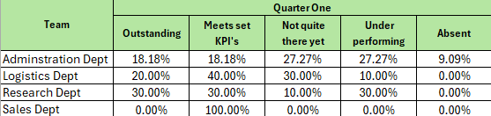
1.

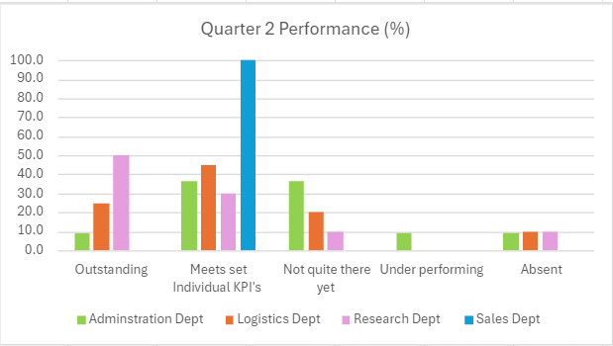
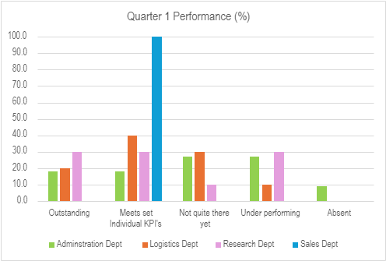
.

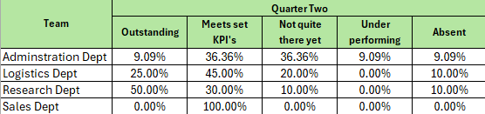

Figure 2 below, considers the bonus payments issued across the organisation. The total bonus’ paid across the two quarters equals £6,923.33. This is a small proportion in comparison to the total of salaries paid which equals £1,391,630. The total amount of bonus’ paid for this bi-annual period is just 0.5% of that value. The data also demonstrates a lack of consistency across the outcomes achieved. Of the 20 employees receiving a bonus payment, across both quarters, less than 50% of these were able to sustain the outstanding outcome across the whole period which questions the appropriateness of the judgement criteria.
Returning to the raw data within ‘table 1’ there are questionable areas within the Research and Development Team. Firstly, the Product Design Team Leader is receiving a higher salary than the Product Design Manager. Both employees were underperforming in quarter one, whilst in quarter two, the Manager is subsequently absent, and the Team Leader improved to meet their KPIs. Alongside that there is a Product Design colleague who was underperforming in quarter one yet reached outstanding in quarter two. This indicates some unrest or certainly disparity within this area of the organisation and would need further source evidence to critically appraise.
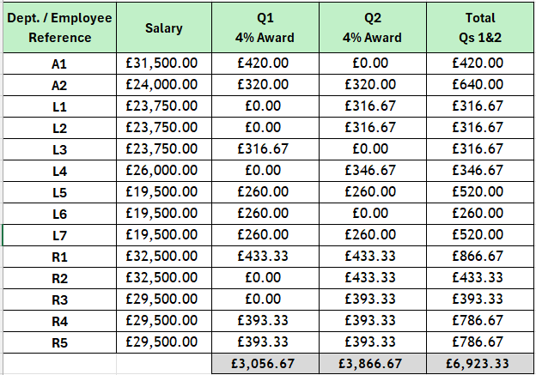
2.

Figure 3. below shows 26% of the workforce have received a bonus payment and the whole bi-annual period. This represents a low result for quality output.
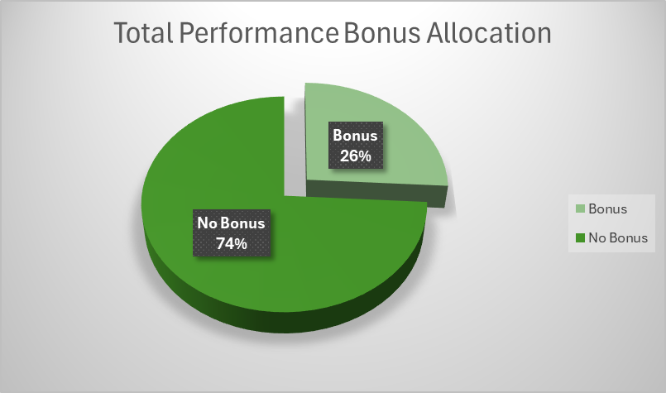
3.

Figure 4 pie chart displays the performance of each team proportionately showing the % value of employees receiving a bonus within their team.
With 50% achieving ‘outstanding’, the Logistics Team could be perceived as highest performing team, yet, with 0% of the Sales Team achieving ‘outstanding’ and not making the chart, they could be deemed as the lowest performing team. However, upon reviewing the raw data, the Sales Team all achieved their KPIs; not considered underperforming. This highlights the deep dive required as the data show all Sales employees are meeting the same outcome for two consecutive quarters, and no-one has reached ‘outstanding’ to receive the bonus. This presents a line of enquiry and questions effects on whole team, or individual, morale. ACAS (2024), state bonus schemes can help employers to keep employees engaged and motivated, recognise and reward employee performance, attract the best applicants for a role and retain experienced staff. However, this example demonstrates a risk of compromising these factors.

4.

This quantitative data holds relevant information for reviewing practice, however, it takes us back to the evidence-based principles and how this approach, in isolation, would not be considered sufficient. Supporting with further qualitative data would enhance the information this provides to allow for more insightful discussion and a deep dive into the challenges the performance management process presents - what else is available before drawing conclusions?
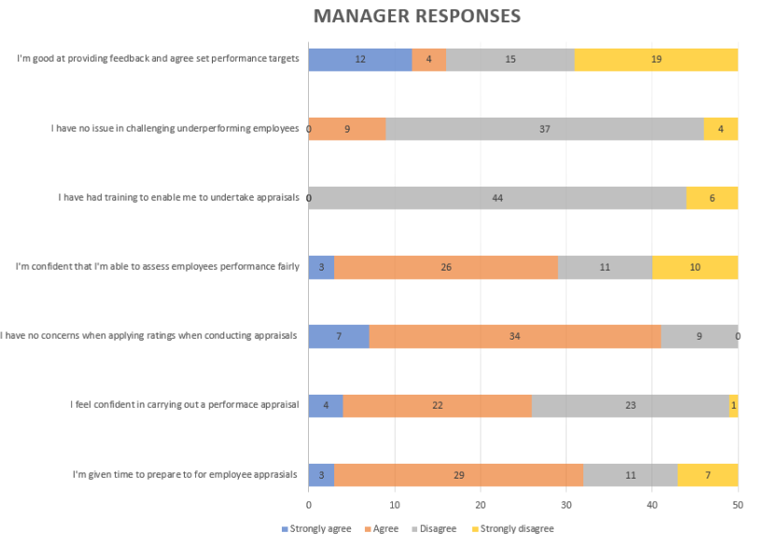
5.

Using the performance data provided in ‘table 2’, the managers’ responses are reviewed via this horizontal bar graph shown at figure 5 above. Main issue noted is that no managers have received performance appraisal training. This is a significant concern, especially where further data confirms that 41 of the 50 managers’ report having an issue addressing poor performance. That said, over half of managers state they are confident in assessing performance fairly but this feels contradictory to the earlier point. Time doesn’t seem to be an issue in terms of preparation; the lack of training appears to be having the biggest impact. This correlates with the data in ‘table 1’ that shows there were no managers in receipt of a bonus payment.
6.
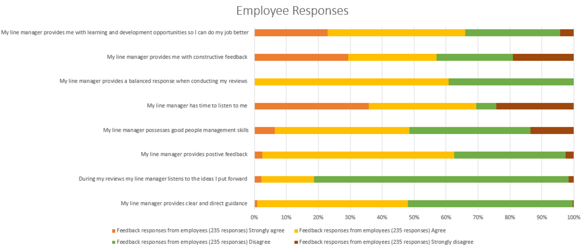

In figure 6, the responses of the employees are reviewed. Over 50% of employees feel they are not given clear and direct guidance, whilst over 80% of the employees feel their ideas are not valued. This provides an initial correlation between the two sets of data, suggesting managers are not equipped to lead appraisal processes. The responses linked to a balanced response and constructive feedback provide very mixed views and further supports the lack of guidance managers maybe providing at such reviews.
Recommendations (AC2.3)
Using observations above, both ‘table 1’ and ‘table 2’ present data that indicate areas to be addressed quite urgently. One recommendation is the organisation’s pay rates and reward framework. It appears pay decisions have been devolved to managers, even though there appears to be a skills shortage or training need. Taylor and Woodhams (2022b, p.70) outline that pay determination may appear to be a complex term, but it can be relatively simple. The survey reports how employees don’t feel they have their ideas listened to, so a process of consultation into any pay developments could help them feel valued and boost morale so that they feel adequately and fairly remunerated for their work. The application of the bonus scheme can be equally addressed in the same way. Employee participation is also referenced by Taylor and Woodhams (2022b, p.17) as something employees feel can contribute to good work and job quality and be beneficial for job satisfaction.
Risk to the organisation is cost and budget implications as well as the divisive consequences this may have on morale. That said, if no action is taken the risk could also see absence and retention rates severely impacted. Data in ‘table 1’ suggests the Sales Team are at risk of feeling undervalued, which may impact productivity. The purpose of the team is to generate new business and where there is lack of recognition for this work, the supply and demand chain is at risk with productivity rates likely to drop. The effectiveness of any bonus or incentive scheme depends on an awareness of the factors needed for success and an understanding that individuals may respond differently to the same stimulus (Cotton, 2024).
With the identification of no formal training taking place for managers, this would be the second, more urgent recommendation, as it signifies a high number of managers not being comfortable with appraising performance. Taylor and Woodhams (2022b, p.163) suggest that a badly done appraisal is worse than no appraisal at all, so therein lies the risk if the training need is not addressed. Addressing this could see the ability to offer in-house progression routes, where skills may be utilised internally and may increase desire for professional development. However, as there was no correlation to see between departments in ‘table 1’, this could prove more costly, as each department may need to be reviewed independently which may impact on resources and any additional cost associated with identified external training. When reviewing team performances, CIPD report that performance measures must be carefully chosen to be necessary and relevant. They should align with organisational strategy and suit the types of job in question (2024d).
Ultimately, when deciding upon people practices, benefits must outweigh the costs, and an EBP approach would need to be carefully implemented to engage with the best available data, apply critical thinking and decision-making principles.

Bibliography

ACAS (2024) Bonuses. Available at: https://www.acas.org.uk/bonuses (Accessed: 12 November 2024)
Armstrong, M. (2016) Armstrong's handbook of management and leadership for HR: developing effective people skills and better leadership and management. Fourth edition, London: Kogan Page
Barends, E., Rousseau, D.M. and Briner, R.B. (2014). Evidence-Based Management: The Basic Principles. Amsterdam: Center for Evidence-Based Management
CIPD (2015) Ethical decision-making: Eight perspectives on workplace dilemmas. Available at: https://www.cipd.org/globalassets/media/knowledge/knowledge-hub/reports/ethical-decision-making-2015-eight-perspectives-on-workplace-dilemmas_tcm18-9564.pdf (Accessed: 21 November 2024)
CIPD (2019) Podcast 154: Critical Thinking, [podcast] CIPD Podcasts Available at: https://soundcloud.com/cipd/podcast-154-critical-thinking?utm_source=clipboard&utm_medium=text&utm_campaign=social_sharing (Accessed: 15 November 2024)
CIPD (2023a) Evidence-based HR: Make better decisions and step up your influence. Available at: https://www.cipd.org/uk/knowledge/guides/evidence-based-profession/#what-is-evidence-based-practice (Accessed: 4 November 2024)
CIPD (2023b) Induction. Available at: https://www.cipd.org/uk/knowledge/factsheets/induction-factsheet/ (Accessed at: 22 November 2024)
CIPD, (2023c) Building an evidence-based profession. Available at: https://www.cipd.org/uk/views-and-insights/thought-leadership/insight/evidence-based-profession/ (Accessed: 5 November 2024)
CIPD (2024a) Evidence-based practice for effective decision-making. Available at: https://www.cipd.org/uk/knowledge/factsheets/evidence-based-practice-factsheet/#what-is-evidencebased-practice (Accessed: 16 November 2024)
CIPD (2024b) Absence Measurement and Management. Available at: https://www.cipd.org/uk/knowledge/factsheets/absence-factsheet/#Absence (Accessed: 22 November 2024)
CIPD (2024c) People Analytics. Available at: https://www.cipd.org/uk/knowledge/factsheets/analytics-factsheet/#three (Accessed: 20 November 2024)
CIPD (2024d) Performance management: an introduction. Available at: https://www.cipd.org/uk/knowledge/factsheets/performance-factsheet/#seven (Accessed: 20 November 2024)
CIPD (2024e) PESTLE analysis. Available at: https://www.cipd.org/uk/knowledge/factsheets/pestle-analysis-factsheet/#how-to-do-a-pestle-analysis (Accessed: 5 November 2024)
CIPD (2024f) Employee engagement and motivation. Available at: https://www.cipd.org/uk/knowledge/factsheets/engagement-factsheet/#assessing-and-measuring-employee-engagement (Accessed: 20 November 2024)
CIPD (2024g) Ethical practice and the role of people professionals. Available at: https://www.cipd.org/uk/knowledge/factsheets/ethics-role-hr-factsheet/#what-is-ethical-practice-in-organisations (Accessed: 21 November 2024)
CIPD (2024h) Ethics at work: An employer’s guide. Available at: https://www.cipd.org/en/knowledge/guides/ethics-work-guide/ (Accessed 21 November 2024)
Clark, S. (2015) Ethical Decision-making: Eight perspectives on workplace dilemmas Available at: https://www.cipd.org/globalassets/media/knowledge/knowledge-hub/reports/ethical-decision-making-2015-eight-perspectives-on-workplace-dilemmas_tcm18-9564.pdf (Accessed: 10 November 2024)
CMI (2015) Developing decision-making skills. Available at: CHK-277_Developing_decision_making_skills.pdf (Accessed: 20 November 2024)
Cotton, C. (2024) Bonuses and incentives. Available at: https://www.cipd.org/uk/knowledge/factsheets/bonuses-factsheet/#Payment (Accessed: 21 November 2024)
De Bono, E. (2018) The Six Thinking Hats ®. Available at: https://www.debono.com/_files/ugd/acf405_4bccd1c0abd749069868fed2e223d4be.pdf (Accessed: 10 November 2024)
Feltham, R. (2023) POW: The Psychology of Work: Episode 34: Stop, think and ask, 'what is the problem'? A conversation with Professor Rob Briner [Podcast]. 20 September. Available at:
https://www.spreaker.com/episode/episode-34-stop-think-and-ask-what-is-the-problem-a-conversation-with-professor-rob-briner--56871990 (Accessed: 10 November 2024)

Gibson, K. (2023) ‘How to measure your business performance’ Harvard Business School Online, 14 November 2023. Available at: https://online.hbs.edu/blog/post/business-performance-measurement (Accessed: 21 November 2024)

Monmouthshire County Council [MCC] (2022) Community and Corporate Plan 2022-28. Available at: https://www.monmouthshire.gov.uk/app/uploads/2023/07/MMCCommCorpPlan_Final_EN.pdf (Accessed: 18 November 2024)
Monmouthshire County Council [MCC] (2024) Self-assessment Report 2023/24. Available at: https://www.monmouthshire.gov.uk/app/uploads/2024/10/MCC-Self-Assessment_2023-24_Final_PDF.pdf (Accessed: 18 November 2024)
Taylor, S. and Woodhams, C (2022a) Studying Human Resource Management: A Guide to the Study, Context and Practice of HR, 3rd ed, London: CIPD
Taylor, S. and Woodhams, C (2022b) Human Resource Management: People and Organisations, 3rd ed, London: CIPD

