This portfolio will answer questions relating to the professional in the workplace, it will cover a range of topics from the role of the professional, group dynamics, experience from projects and the writer’s self-assessment and development plan.

The first part of the portfolio looks at the professional in the workplace. A professional is an individual who usually belongs to a professional body and adheres to a set of standards and has complete a level of learning (The Business Dictionary, 2020). This report will look at the role of the professional in the marketing industry governed by the CIM (The Chartered Institute of Marketing) and the standards and competencies a professional in the CIM must follow. This is shown on a graph (see appendix 1) in the graph there are 3 core competencies that all marketers must consider, 8 technical competencies that that are sector based and 10 behaviour competencies that are useful to consider despite the individuals role in the marketing sector.
The CIM have a list of 10 behaviours which they expect marketing professionals to consider in the industry to make the business successful. These are, creative – be able to imagine new ideas to promote the service or product, influencing – to be able to promote these ideas, this could be internally or externally to the public. To be collaborative – to be able to work well with others, to be responsible – to consider the impact the individual had on others both internally and externally and to the wider environment. To be financially literate – to be able to use calculations to assess the impact on the business, such as making profits. To be inspiring – to motivate others, to be innovative – to form and adapt ideas to solve problems. Challenging – to drive change for the positive, to be entrepreneurial – to think ahead to spot and maximise potential opportunities and lastly to be commercially aware which is to use experience and learning to positively impact the day to day work (The Chartered Institute of Markting, 2018). Practicing these behaviours are essential for the CIM to maintain a level of professionalism and to keep their members to carry on developing through the institute. As it is a recognised institute the members can use their logo as part of the members company.
The technical competencies are more specific to a sector within marketing, there is partnership marketing, risk and reputation, brand, integrated marketing comm, digital integration, product management, monitoring and measuring effectiveness, customer experience and partnership marketing. The MIC describes the technical competencies as more integral for growth within the field for career progression. (SUSSKIND & SUSSKIND, 2018) described the professional as having a unique set of skills that wouldn’t be common knowledge, this could be used as an example as there are many different types of marketing professionals the technical skills each have may vary from brand management to customer experience. The CIM recognises these 8 different types and with each one a member can benefit from career progression using it.
The main part or the core used by the CIM is insights, customer focus and strategy, these are the competencies that are used throughout the marketing industry regardless of sector or job role. The first is part of the core is insights. Insights uses research to develop answers to problems or potential problems. This is the heart of the CIM as marketing is the resolution or a problem that a consumer may have or may not know they have and selling a product or service said problem. The next core competency is customer focus, this section is all about the consumer and what the customer is saying about the company or product. This competency interacts with the consumer to create bonds and brand loyalty. It also makes sure that the consumer or potential consumers trust the product or service available. The last core competency is stagey which is gathering enough information to make the business goal through marketing achievable. Using knowledge to achieve growth for the business and in return profit. (Bhasin, 2019) explains why core competencies are so important within an organisation, the main reason is that it creates a natural competitiveness to the industry which means that with more competition the marketers involved have better ideas and stronger campaigns.
The second part of the portfolio will look at the elements of group dynamics and conflict resolution methods. Lewin’s group dynamics are explained by (The Mind Tools, 2019) there are 6 poor group dynamics explains by Lewin. The first is week leadership, this is when the team in question doesn’t have a strong leader to make decisions. The second in excessive deference to authority meaning that people want to agree with the leader, however, are holding back their own opinions thus not giving all they can. The third is blocking which means a team member disrupts the flow of the information, blocking has five subcategories. The first is the aggressor which means the team member is outspoken or disagrees with a lot said thus making them disruptive. The second is the negator which is to be critical of all ideas, the third is the withdrawer who doesn’t participate in discussions. The fourth is the recognition seeker who is boastful and through this dominates the session, lastly there is the joker which introduces humour at inappropriate times. The fourth of the main poor group dynamics is groupthink which means the group has such a desire to reach the right decision that they overlook other alternatives. The fifth dynamic is free riding which means they have limited responses to the group and let the rest of the team do all the work. The final one is evaluation apprehension which means the team members thinking creates a negative group dynamic and feel like they will be judges so they will hold their opinions.

(Belbin, 2020) explains that each person has a behaviour and joined with others could form to make a perfect team. The nine behaviours are plant, resource investigator, co – Ordinator, shaper, monitor evaluator, team worker, implementor, complete finisher and specialist. These nine roles (seen in appendix 2) are one way to help understand group dynamics. Through these roles the team members can understand their roles and it can lead to avoid conflict.
However, conflict can arise in any team, even if the ‘perfect’ team is achieved. There are many conflict resolution methods to use, however, this portfolio will focus on the Thomas – Kilmann method. (Manage train learn, 2019) describes the five conflict resolution options available in the Thomas – Kilmann method. The first is competing, this is being assertive and not letting the opposite belief win and that your belief is correct, the second is accommodating, this is the opposite to competing and will usually give in to the other side point of view. The third is avoiding which is you don’t want to deal with the problem straightaway and think there will be a better time to deal with the problem. The fourth is compromising, which is both sides get something they wanted but not everything. Lastly is collaborating, this is the belief that it is possible for both sides to have the outcome they want.

Development Plan

NAME: |  | MEMBERSHIP NUMBER:
COVERING THE PERIOD FROM: |  | TO:

Planned outcome

What do I want/need to learn? | What will I do to achieve this? | What resources or support will I need? | What will my success criteria be? | Target dates for review and completion
Experience working in a marketing team | Gain employment in a marketing company | CV needs updating | Gaining a role in a marketing team | August
Gain experience working with programs such as google analytics | Training to be completed | Training to be provided by a skilled member | Understanding of how to use the program | December

Belbin, 2020. The Nine Belbin Team Roles. [Online]
Available at: https://www.belbin.com/about/belbin-team-roles/
[Accessed 6 January 2020].
Bhasin, H., 2019. Core Competencies – Importance, Advantages and Limitation. [Online]
Available at: https://www.marketing91.com/core-competency/
[Accessed 2020 January 2020].
Manage train learn, 2019. Conflict Resolution: the Thomas-Kilmann Model. [Online]
Available at: http://www.managetrainlearn.com/page/conflict-resolution-model
[Accessed 6 January 2020].
SUSSKIND, D. & SUSSKIND, R., 2018. The Future of the Profession. 162(2), p. 125.
The Business Dictionary, 2020. Professional. [Online]
Available at: http://www.businessdictionary.com/definition/professional.html
[Accessed 6 January 2020].
The Chartered Institute of Markting, 2018. Professional Marketing Competencies. [Online]
Available at: https://www.cim.co.uk/membership/professional-marketing-competencies/
[Accessed 6 January 2020].
The Mind Tools, 2019. Improving Group Dynamics. [Online]
Available at: https://www.mindtools.com/pages/article/improving-group-dynamics.htm
[Accessed 06 January 2020].
Appendices
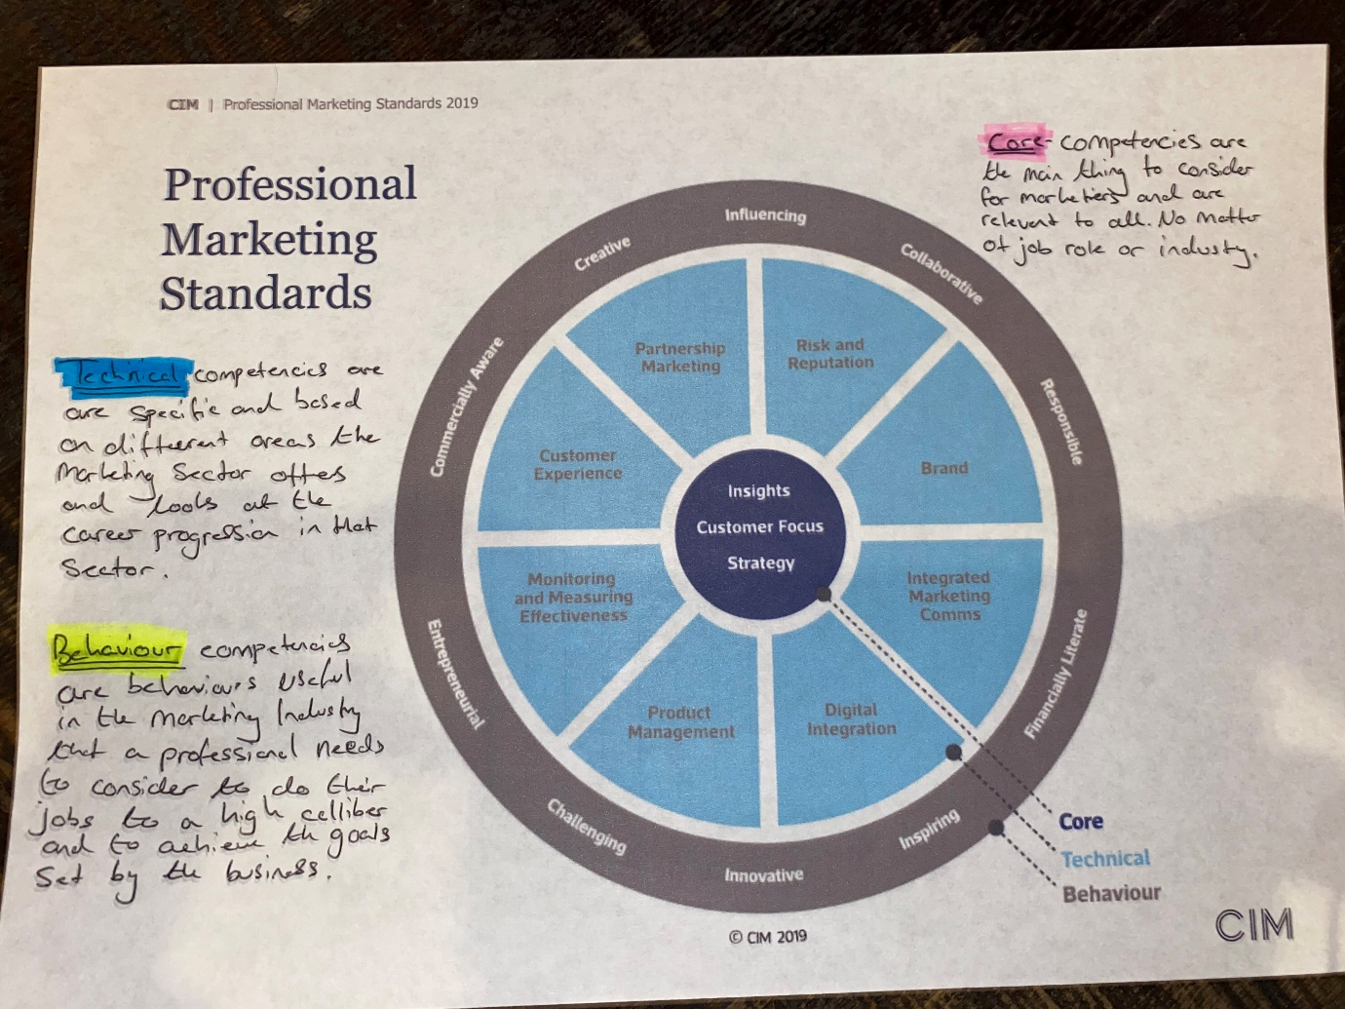
Appendix 1

Appendix 2 

