Student Name: Ffion Edwards
P Number: 2005075
Programme of Study: Photography in the Arts
Module: ADAD4018
Ways of Thinking Lecturer’s Name: Ryan Moule

Tasks in the order I received them:
Task 1: Observational Writing = 558 words
Task 2: Practice-based Writing = 329 words
Task 3: Manifesto Writing = 498 words

Task 1: Observational Writing:
Semiotics is the study of signs and symbols and their use of interpretation (Barthes, 1957). I believe semiotics are important to look into because it shows that everything has a meaning no matter how big or small, whether it be what a colour signifies or what the volume of an instrument in a scene of a film connotes. I think that semiotics help us identify different objects and helps us come to terms with our own views on different topics. There are lots of theories that look into semiotics, particularly Jean Beaudrillard’s Simulacra and Simulation theory. This theory looks at “how the relationships between reality, symbols and society, in particular the significations and symbolism in media and culture associated with building up an understanding of shared existence” (Wikipedia, 2020), some people would say this theory implies that Beaudrillard believed that society had become so used to looking at ‘recreations’ of things (like maps) that society no longer know what reality is. A good film that uses this theory is ‘The Truman Show’ (Peter Weir) which follows a man who has no idea that his everyday life is actually a TV show and all of his family and friends are actors and actresses (IMDB, 1998).

Within this text I have decided to look at J.Lo’s ‘I Luh Ya Papi’ music video. When watching the opening scene where it shows J. Lo sat on a sofa with two other women and a male director and they are discussing how to film the video and where it should be shot, and the director suggests places that kind of link to the song like a zoo or a carnival, however J. Lo and the two other women go on to say that when men do music videos they just put half naked women in the video and the men just sing in the video and sexualise the women and it gets thousands of views, whereas female artists have to think about how their videos are filmed and what is in it. The opening scene ends as one of the women stating “why do men always objectify the women in every single video? Why can’t we, for once, objectify the men?” which then fades out into the music video where J. Lo is sat on a bed with half naked men surrounding her. Within the room where this scene is filmed is lots of gold and a chandelier, and the colour gold typically connotes wealth and royalty, so in this scene where J. Lo is sat on a gold bed surrounded by men this signifies that J. Lo is the more successful one which goes against the typical ideology of men being more successful than women. The way the men are laying on the bed surrounding J. Lo suggests that she is the alpha as the men are surrounding her as if they are in a pack, which again goes against the typical ideology of men being the alpha. At one point in the video is a shot where J. Lo is singing in a dark studio where she is wearing all red, and the colour red, to me, connotes danger which I feel links to how she is put out as a very powerful woman throughout the video and the media.

References
En.wikipedia.org. 2020. Simulacra And Simulation. [online] Available at: <https://en.wikipedia.org/wiki/Simulacra_and_Simulation#:~:text=Simulacra%20and%20Simulation%20(French%3A%20Simulacres,media%20involved%20in%20constructing%20an> [Accessed 17 October 2020].
French Montana, 2014. I Luh Ya Papi. [video] Available at: <https://www.youtube.com/watch?v=c4oiEhf9M04> [Accessed 18 October 2020].
IMDb. 1998. The Truman Show (1998) - Imdb. [online] Available at: <https://www.imdb.com/title/tt0120382/> [Accessed 17 October 2020].
Oxfordlearnersdictionaries.com. 2020. Semiotics Noun - Definition, Pictures, Pronunciation And Usage Notes | Oxford Advanced Learner's Dictionary At Oxfordlearnersdictionaries.Com. [online] Available at: <https://www.oxfordlearnersdictionaries.com/definition/english/semiotics?q=semiotics> [Accessed 17 October 2020].

Task 2 Practice-based Writing:
An exhibition is typically used to show a collection of art to the public (Oxford, n.d). Womanhouse was an exhibition that was set up from January 30th to February 28th 1972 and was organised by Judy Chicago and Miriam Schapiro. Womanhouse was the first public exhibition that showed feminist art, it included a mixture of installations and performance. Chicago and Schapiro’s students from California Institute of Arts Feminist Art Programme all participated and worked together to make different art for the exhibition.
The first day of the exhibition only women were allowed to go and view it, after the first day anyone was allowed to go (Wikipedia, 2020). I personally think this works really well for getting their point across, however, in my opinion feminism is about gender equality, and I think them doing this is kind of going back on themselves and doesn’t really work in the sense of getting the equality they needed. According to Oxford Dictionary ‘feminism’ is “the belief and aim that women should have the same rights and opportunities as men” (Oxford, n.d), this definition supports what I believed feminism meant.
The pieces of work for the exhibition were made to show and exaggerate on the typical female conventions like how women are expected to do all the housework and their experiences with menstruation. The art was placed in different settings like; kitchen, dining room, bathroom all to create scenes to show the conventions. I think this is a very creative and unique way of installing art, and it reinforces their ideas of how women were typically shown. I think the art being installed in different settings like this is was really good in making the viewers think about the views and expectations of women, and I think this is a really interesting idea.
I personally think this exhibition is really interesting in the ways it shows different art and how they got their point across.

References
Elkin, L., 2018. Womanhouse. [online] Artreview.com. Available at: <https://artreview.com/ar-april-2018-feature-womanhouse/> [Accessed 20 November 2020].
En.wikipedia.org. 2020. Womanhouse. [online] Available at: <https://en.wikipedia.org/wiki/Womanhouse#Rooms/installations> [Accessed 20 November 2020].
Oxfordlearnersdictionaries.com. n.d. Exhibition Noun - Definition, Pictures, Pronunciation And Usage Notes | Oxford Advanced Learner's Dictionary At Oxfordlearnersdictionaries.Com. [online] Available at: <https://www.oxfordlearnersdictionaries.com/definition/english/exhibition?q=exhibition> [Accessed 8 December 2020].
Oxfordlearnersdictionaries.com. n.d. Feminism Noun - Definition, Pictures, Pronunciation And Usage Notes | Oxford Advanced Learner's Dictionary At Oxfordlearnersdictionaries.Com. [online] Available at: <https://www.oxfordlearnersdictionaries.com/definition/english/feminism?q=feminism> [Accessed 8 December 2020].
Task 3 Manifesto Writing:
My manifesto:
-Be creative and imaginative with my photographic ideas.
-Think outside of the box when it comes to taking and editing photographs.
-Be mindful that not everyone will like my photography.
-Include a mixture of digital and traditional photography to show more of a variety of work.
-Look at issues in society and create photographs linked to them.
-Take loads of photos at different angles to see which one works best.
-Taking time with creating images will mean the images would be more thought out.
-Believe with what you are showing in the photograph.
Be creative and imaginative with my photographic ideas.
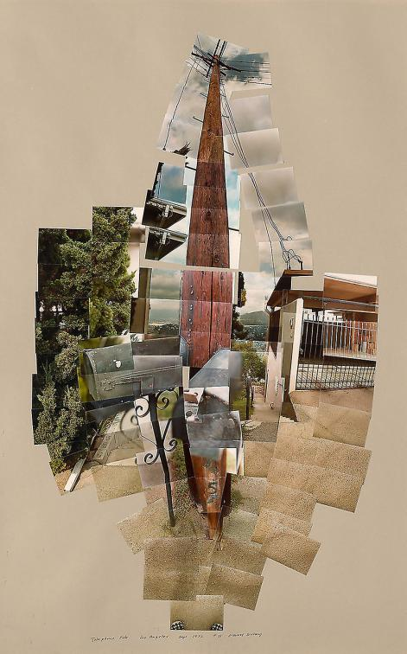

Fig 1. telephone pole, David Hockney.

Being imaginative with my ideas for my work I think is very important to making my photography more eye-catching and helps getting my photography recognised because people would recognise the amount of thought and work I put into it and be fascinated by what was done to the image. I feel like being imaginative with the constructing the photo makes the photo more interesting and I think it would make people more intrigued by the image because it is so unique. The photo I have included is David Hockney’s telephone pole photomontage from 1982 (Hockney, 2020), I really like this image and how it stands out from ‘traditional’ photography. I love how the multiple photos were put together in different ways to make the telephone pole.
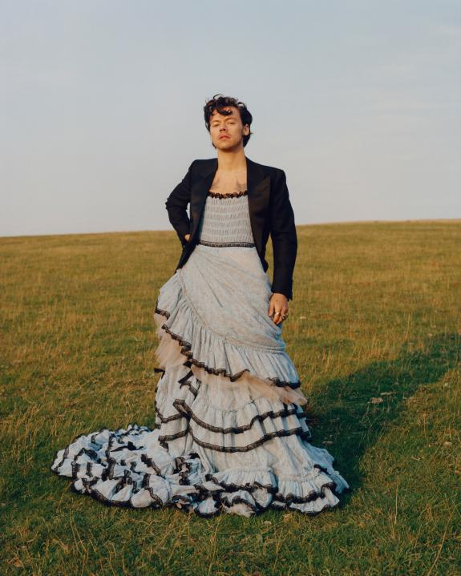
Look at issues in society and create photographs linked to them.

Fig 2. Harry Styles Vogue, Tyler Mitchell.

Personally I feel like creating images that relate to issues or topics within society will make the images relateable to the current times (when making the image) and eye opening. The photo I’ve included of Harry Styles for the December 2020 taken by Tyler Mitchell, this photo had a bit of backlash from people because he is in a dress, this lead to American Author Candace Owens saying “Bring back manly men”(Owens, 2020). I think that making images that go against stereotypes are very powerful and eye opening for a lot of people because it shows that stereotypes are just that and aren’t rules for people to follow.
Taking time with creating images will mean the images would be more thought out.
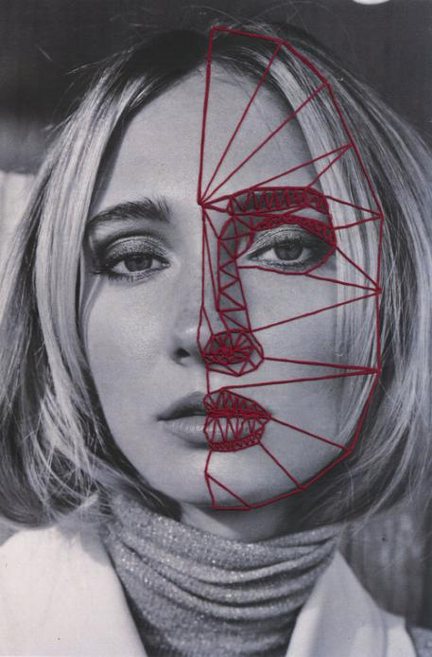

Fig 3. Hand Stitching, Jenna Mohn.

I think that taking the time to think about what you are going to photograph and what you are going to do with it is really important, because the topic you could be focussing on could have a really significant impact on things. The photo I’ve included was a part of Jenna Mohn’s hand stitching piece from 2017(Mohn, 2017). I find these pieces really interesting because It is not what is typically seen within photography and even though Mohn has not said of any reasoning behind doing the stitching, I like how she took her time to do something outside of the box.

References
2017. Instagram. [online] Available at: <https://www.instagram.com/p/BQDmuIzlXfX/> [Accessed 8 December 2020].
Hockney.com. n.d. Photographic Collages : Photos : Works | David Hockney. [online] Available at: <https://www.hockney.com/works/photos/photographic-collages> [Accessed 8 December 2020].
Twitter.com. 2020. Twitter. [online] Available at: <https://twitter.com/realcandaceo/status/1327691891303976961> [Accessed 8 December 2020].

List of Figures:
Figure 1. telephone pole, (1982) Accessed from https://www.hockney.com/works/photos/photographic-collages [Accessed on 8th December 2020]
Figure 2. Harry Styles Vogue, (2020) Accessed from https://www.vogue.com/article/harry-styles-cover-december-2020 [Accessed on 8th December 2020]
Figure 3. Hand stitching, (2017) Accessed from http://www.jennamohn.com/hand-stiching/4qluqa0i5bra5ar0aqnut2ysvxpywo [Accessed on 8th December 2020]

