e-portofolio report

Learning in digital era – Personal development plan (PDP)
BMPL4007

0
0
BMPL4011

Dumitru Vasile Gomoescu
Student number: 2223227

Table of contents

Gibbs Reflective Model...........................................................................................1

Conclusion using Gibbs Reflective Model. .............................................................2

Personal Development Plan: S.M.A.R.T Objectives...............................................3

S.M.A.R.T Goal.......................................................................................................4

References..............................................................................................................6

Gibbs Reflective Model

Personal development is a continuous process that involves intentional efforts to improve one's skills, knowledge, and abilities. It is a journey of self-discovery that requires constant reflection on one's experiences, thoughts, and behaviours. Reflection is an essential aspect of personal growth as it allows individuals to gain insight into their strengths and weaknesses, identify areas for improvement, and make necessary changes to achieve their goals.
Gibbs Reflective Model is a widely used framework for reflective practice in personal development. This model provides a structured approach to reflection that involves six stages: description, feelings, evaluation, analysis, conclusion, and action plan.
.

Importance Of Reflection In Personal Growth:

Reflection is a fundamental aspect of personal growth and development. It allows individuals to evaluate their experiences, thoughts, and emotions, which helps them identify their strengths and weaknesses. Reflecting on one's actions can help to promote self-awareness, which is essential in personal growth. The Gibbs Reflective Model is an effective tool for reflection as it provides a structured approach to evaluating experiences. This model comprises six stages that encourage individuals to examine their experiences from different perspectives.

The first stage of the Gibbs Reflective Model is the description of the experience. In this stage, individuals describe what happened during the experience. This involves providing details about the situation, including where it occurred and who was involved.

The second stage is the feelings stage which encourages individuals to reflect on their emotions during the experience. This stage promotes emotional intelligence as it allows individuals to understand how they feel about different situations.

The third stage of the Gibbs Reflective Model is evaluation where individuals analyse their experiences by considering both positive and negative aspects of it. This stage encourages critical thinking as it requires individuals to evaluate their actions objectively.

The fourth stage is analysis where individuals reflect on what they have learned from the experience.

The fifth stage is conclusion where individuals draw conclusions from their reflections by identifying what they could have done differently in similar situations in future or if they did something right then how can they do it again in future scenarios? This step helps them learn from past mistakes and make changes that will lead to personal growth.

Finally, action plan forms an integral part of this reflective model as it requires individuals to develop an action plan based on their reflections so that they can implement changes effectively into real-life scenarios for further development.

Conclusion:

In conclusion, the Gibbs Reflective Model is an effective tool for personal development. It provides a structured approach to reflection that allows individuals to identify their strengths and weaknesses and develop strategies for improvement. The model encourages individuals to reflect on their experiences, emotions, thoughts, and actions in order to gain a deeper understanding of themselves and their behaviour. Through this process of self-reflection, individuals can identify areas for growth and take steps towards personal development.

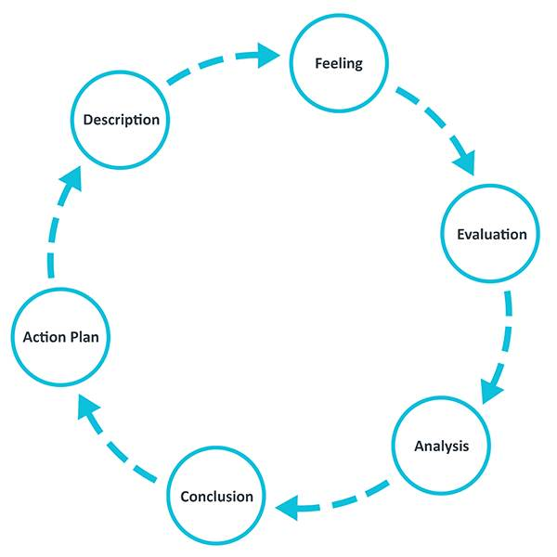
Gibbs Reflective Cycle

Over the last few months since I start as a student, I've been learning new and interesting information about policing . I meet new people that share same passion as me. As I am still at the beginning of this course, I am more curious and excited but worried at the same time. Cannot think if I ll have what it takes to keep up with all notions and new information as we are going through. As I always when I feel down, I push myself up and try to make the best of situation . When I sign-up for this course I hadn't much information of how will be and now after these months I can say that I feel more informed and aware of things that in the past didn't even knew existed or how they works .
My conclusion after all these months after all the reading and searching for materials for assignments is that there is nothing impossible is just a matter of priority.

Personal Development Plan: SMART Objectives

Personal development is an ongoing process that involves setting goals, acquiring new skills, and improving oneself. A personal development plan (PDP) is a tool that helps individuals to identify their strengths and weaknesses, set goals, and create a roadmap for achieving those goals. The PDP should include smart objectives that are specific, measurable, achievable, relevant, and time-bound.

Specific Objectives
The first step in creating a personal development plan is to identify specific objectives. Specific objectives are clear and concise statements that define what the individual wants to achieve. For example, instead of setting a general goal of "improving communication skills," the individual could set a specific objective such as "participating in at least one public speaking event per month." By setting specific objectives, the individual can focus their efforts on achieving those objectives rather than getting distracted by other tasks.

Measurable Objectives
The second step in creating a personal development plan is to ensure that the objectives are measurable. Measurable objectives allow individuals to track their progress towards achieving their goals. For example, if the objective is to participate in at least one public speaking event per month, the individual can track how many events they have participated in over time. This allows them to see whether they are making progress towards achieving their goal or whether they need to adjust their approach.

Achievable Objectives
The third step in creating a personal development plan is to ensure that the objectives are achievable. Achievable objectives are realistic and within reach of the individual's current abilities and resources. For example, if an individual has never participated in a public speaking event before, it may not be realistic for them to participate in one event per week. Instead, they may need to start with one event per month and gradually increase their participation over time.

Relevant Objectives
The fourth step in creating a personal development plan is to ensure that the objectives are relevant. Relevant objectives are aligned with the individual's overall goals and aspirations. For example, if an individual's overall goal is to become a successful entrepreneur, participating in public speaking events may be relevant as it can help them to develop their communication skills and build their network.

Time-Bound Objectives
The final step in creating a personal development plan is to ensure that the objectives are time-bound. Time-bound objectives have a specific deadline or timeframe for completion. This helps individuals to stay focused and motivated towards achieving their goals. For example, if the objective is to participate in at least one public speaking event per month, the individual could set a deadline of six months for themselves to achieve this objective.

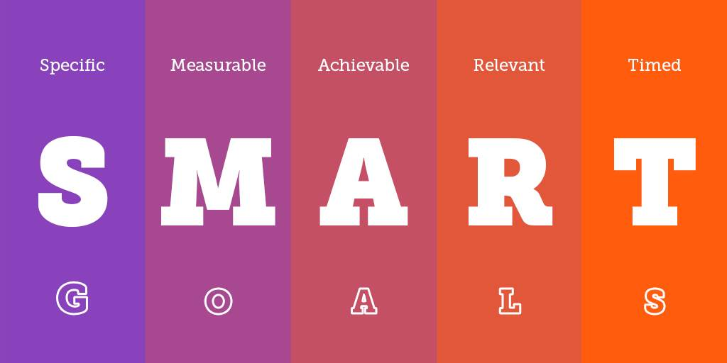

SMART GOALS

Goal : I want to improve my performance.

Specific : As I always been an athletic person which preferred sports and other outdoor activities. I didn't give much attention to computers and working with them. Improving my computer skills will help me finish my tasks faster and efficiently. Measurable: Within a few months I will have the ability to work with Word , PowerPoint and and other programs in a much easier way .
Achievable: Improving my computer skills is extremely important. It will help me to produce better quality assignments and other tasks. Also will help me at my current job. I am watching tutorials on Internet a few times a week about different programs. Relevant : Currently since all my classes are online. I have access and more time to get more familiar with different programs and experiment . Recently I was able to create a video only learning form YouTube tutorials.
Timed : I ve learn many things already on last few months and within few more months from now I will be able to master at least the programs that will help me with daily tasks and on long term learning new things from policing or how to operate on different programs on a computer will help me to advance professionally. Especially now when technology is everywhere .

Conclusion

In conclusion, personal development is an ongoing process that involves setting goals, acquiring new skills, and improving oneself. A personal development plan (PDP) is a tool that helps individuals to identify their strengths and weaknesses, set goals, and create a roadmap for achieving those goals. The PDP should include smart objectives that are specific, measurable, achievable, relevant, and time-bound.

References:

American Psychological Association (APA). (2020). Publication manual of the American Psychological Association (7th ed.).

Gibbs,G. (1988). Learning by Doing: A Guide to Teaching and Learning Methods.

Locke, E.A., & Latham G.P. (2002). Building a practically useful theory of goal setting and task motivation: A 35-year odyssey. American Psychologist, 57(9), 705-717.

Michigan Medicine Headlines. (2019). The importance of setting S.M.A.R.T Goals.

Osterman.K,F. (1990). Reflective Practice: A New Agenda for Education.
Schön. D,A .(1983). The Reflective Practitioner: How Professionals Think in Action.
Schunk D.H., & Zimmerman B.J. (1997). Social origins of self-regulatory competence: Implications for intervention and assessment.

The University of Edinburg . Gibbs’ Reflective Cycle.

