Business Plan for

“N-S-E-W"
Library Café

Produced By:

GROUP MEMBERS:
Student Name | Student No.
Alina-Adriana Badea | 2234830
Tatiana-Elena Bacalu | 2224927
Bianca-Stefania Postelnicu | 2223852
Syeda Begum | 2227588

Dated: 05-06-2024

Module Name: Entrepreneurship
Module Code: BMIH5001
Lecturer Name: Charlotte Joyner

CONTENTS

 |  |  |  | PAGE
1. | Executive Summary |  |  | 2
2. | The Business Idea |  |  | 3
3. | The Team |  |  | 6
4. | Market Research |  |  | 9
5. | Marketing Plan |  |  | 14
6. | Key Resources |  |  | 16
7. | Finances & Start-Up Support |  |  | 17
APPENDICES:
Appendix A |  |  |  | SWOT Analysis
Appendix B |  |  |  | PEST Analysis
Appendix C  Appendix D  Appendix E  Appendix F |  |  |  | Copy of Pitch Supporting Material  Financial breakdown and Startup  Promotion/Marketing Materials  Location Brochure

1. EXECUTIVE SUMMARY

N-S-E-W Library Café, located in the heart of Bath, merges the classic ambience of a library with the modern comfort of a café. Our mission is to create a cosy and inviting space where customers can enjoy a diverse collection of books, magazines, and locally sourced homemade bakery products, sandwiches, and beverages. This unique blend caters to book lovers, students, professionals, and anyone seeking a quiet place to relax, read, or work.

Our team comprises experienced professionals: Alina-Adriana Badea as the HR Manager, Tatiana-Elena Bacalu as the Marketing Manager, Bianca-Stefania Postelnicu as the Caffe Assistant, and Syeda Begum as the Finance Manager. Each member brings valuable skills and expertise to ensure the success of our venture.

Market research highlights Bath's rich cultural history, thriving tourism economy, and diverse population as ideal conditions for our business. Our marketing plan focuses on competitive pricing, diverse product offerings, and effective digital marketing strategies.

Key resources include a prime location at 124a High Street Weston, Bath, and partnerships with local suppliers for high-quality products. Our financial projections indicate a first-year profit of £18,620, supported by thorough financial planning and startup funding.

By promoting local partnerships and offering a unique blend of hospitality and literary culture, N-S-E-W Library Café aims to become a beloved community hub and a niche market leader in Bath.

2. THE BUSINESS IDEA

2.1 The Product/Service
Company Name: N-S-E-W Library Café
Location: Bath
Industry: Hospitality, Library Services, Retail

Business Description
N-S-E-W Library Café is a unique blend of a library and a café in the heart of Bath. We aim to create a cosy and inviting space where customers can enjoy a wide selection of new and old books and magazines and locally sourced homemade bakery products, sandwiches, and beverages. Our space is ideal for book enthusiasts, students, professionals, or anyone seeking a quiet, comfortable place to relax, read, or work.

Products/Services Offered:
- Books
A diverse collection of new and old books is sourced from local markets, car boot sales, and community donations.
- Magazines
Current issues of popular magazines catering to various interests.
- Bakery Items
Homemade cakes and pastries from local bakers are available through collaboration contracts.
- Sandwiches
Freshly made in-house or sourced from local suppliers.
- Beverages
Artisan coffee, tea, soft drinks, and freshly squeezed fruit juices.

Features and Benefits:
- Relaxing Atmosphere
Combines the peaceful environment of a library with the comfort of a café.
- Community Engagement
Promotes local businesses through partnerships with bakers and artisans.
- Convenience
Open 7 days a week from 9 am to 6 pm, providing a reliable spot for relaxation and work.
- Variety
Offers a wide range of reading materials and refreshments to cater to diverse customer preferences.
- Unique Experience
Provides a unique blend of hospitality and literary culture, creating a niche market in Bath.

Value Proposition
The N-S-E-W Library Café provides a unique atmosphere that blends the classic library ambience with a modern café experience. We aim to offer customers a unique space to read, work, and socialise by promoting local partnerships and offering a diverse selection of top-notch goods. Our strength lies in our blend of premium items, a supportive local network, and an unparalleled welcoming environment in Bath.

2.2 SWOT Analysis Summary

Strengths:
- A library and café blend creates a unique selling point.
- Situated in Bath, a city known for its rich literary history and tourism.
- Strong ties with local suppliers and the community enhance credibility and customer loyalty.
- A wide range of books, magazines, and food options attract a broad customer base.
Weaknesses:
- Establishing a library café involves significant investment in library resources and café equipment.
- The concept may appeal to a specific segment, limiting mass market appeal.
- Reliance on local bakers and suppliers could pose risks if partnerships falter.
Opportunities:
- Bath’s status as a tourist destination can attract visitors to the café.
- Literary events, book signings, and workshops can attract more customers.
- Introducing more locally sourced products and expanding the menu can increase revenue.
Threats:
- Economic instability could affect disposable income and reduce customer spending.
- Other cafés and bookshops in the area may pose competitive challenges.
- Disruptions in local supply chains could affect product availability and quality.

Risk Mitigation Strategies:
- Detailed financial planning and securing adequate funding to cover initial costs and operational expenses.
- Effective marketing strategies to raise awareness and attract a steady customer base.
- Secure formal agreements with local suppliers to ensure consistent product availability and quality.
- Continuously diversify product offerings to cater to evolving customer preferences and market trends.

3. THE TEAM

3.1 Key Personnel
Name and Company Position: Alina-Adriana Badea, Human Resources Manager
Skills and Experience: 8 years of customer service experience, followed by 4 years of experience in management. As skills developed from my work experience, I have good communication and management skills. I have good computer skills and effective time-management skills. I am fluent in English, Spanish and Romanian as well as having basic conversational knowledge in French language. From the 4 years management experience, I have learned how to conduct an interview and developed analytical skills that have helped me in successfully recruiting the required staff for my team.
Role and Responsibilities: Human Resources Manager. As a HR Manager I would be responsible to recruiting the staff required for our café as well as implementing efficient training and development strategies.

Name and Company Position: Tatiana-Elena Bacalu, Marketing Manager
Skills and Experience: Because of my passion for marketing, I am planning to complete a 12-months course of managerial marketing for a good organization and professional planning skills. I am also thinking that gaining a Fashion Design degree in high school it can contribute to boost the creativity in the help of promoting our business concept.
Role and Responsibilities: Marketing Manager. I will contribute to the growth of the business by implementing considerable marketing tactics and responding to the consumer demand.

Name and Company Position: Bianca-Stefania Postelnicu, Caffe Assistant
Skills and Experience: Dedicated customer-centric individual expert in dealing with clients, resolving problems, managing complaints, and answering their queries courteously in a fast-paced environment; strong work ethic and high level of integrity with ability to develop long-lasting relationships based on foundation of trust, collaboration and outstanding in recording transactions; excellent communication skills, with the ability to communicate effectively with employees, customers, and stakeholders at all levels. My languages proficiencies are
: Spanish (fluent) with a Spanish diploma Level B2 DELE, French (fluent) with a DELF B1 Diploma, Romanian (Fluent), Italian (Fluent).
Role and Responsibilities: Enthusiastic and customer-focused professional with 7+ years of experience in providing exceptional services to customers and delivering support to administrative operations.

Name and Company Position: Syeda Begum, Finance Manager & Barista
Skills and Experience: a seasoned finance professional with over 10 years of experience in financial management, budgeting, and strategic planning. Holds a degree in Finance and Accounting and is a certified Chartered Accountant (CA). Has a proven track record of optimizing financial operations, reducing costs, and implementing effective financial controls. Previous roles include positions in both corporate and small business environments, where successfully managed multi-million-pound budgets and financial reporting. Skilled in using advanced financial software and has extensive experience in financial forecasting, risk management, and compliance with financial regulations.
Role and Responsibilities: As the Finance Manager of the café library, Syeda Begum will be responsible for overseeing all financial activities and ensuring the financial health of the business. Her key responsibilities include Budgeting, financial reporting, cost management, forecasting, risk management, funding and investment, advisory role. This role is crucial in establishing a strong financial foundation for the café library, ensuring sustainable growth and profitability.

3.2 Skills Gaps & Key Partners

3.2.1 Additional Staff Requirements (Roles and Responsibilities):
During the first year we will look at recruiting two more additional staff as barista and waiter.
3.2.2 Training and Development:
• The HR of the company will provide customer service training to new employees to fill the lack of multitasking ability. Proper training is important to fill the skill gap and enhance the knowledge of services in the hospitality sector (Baum, 2019).
• The HR of the company will provide training to the financial professional to make him understand the current situation of the company and this process will help to fill the lack of financial knowledge within the organisation. The HR will provide initial financial training to make them aware of the situation (Burns, 2022).
• Providing training to the staff that will be responsible for managing the library and collecting different books from different sources.

3.2.3 Outsourced Support / Key Partners:
• Coffee bean suppliers who will provide high-quality and ethically sourced are important key partners for a café business (Proença et al., 2022)
• Local bakeries and food suppliers are important key partners for the café shop business because they help to manage the resources (Williams, 2021)
• Book suppliers who will help to manage the efficiency of the library

4. MARKET RESEARCH

4.1 Market Information, Trends and External Factors
We chose Bath, England, as the place to establish our library café because of its exceptional position, characterised by its abundant cultural history, thriving tourism economy, and diversified population.
Cultural and Historical Appeal
- The city of Bath has been declared a UNESCO World Heritage Site (Visit Bath, 2024). Bath is famous for its Roman-built baths and Georgian buildings, which draw in thousands of tourists annually (Office for National Statistics, 2024). The library café has the potential to benefit from this historical appeal by offering a comfortable and educational environment that showcases the local history and culture.
- Bath is closely linked to literature, particularly through its affiliation with Jane Austen, who resided in the city. The Jane Austen Centre and the yearly Jane Austen Festival attract avid readers, providing a potential consumer base for our business.
Demographics and Population
- Bath is home to a diverse population that includes pensioners, young professionals, and students from Bath Spa University and the University of Bath. Because of this diversity, a library café may serve a wide range of patrons with varying requirements and tastes.
- The population stands at 195,618 individuals in total. From an ethnic perspective, the majority of Bath's population is white, accounting for 92% of the total. The Asian ethnic group makes up 3.3% of the population. The current average age is 39.6 years as of 2022 (Varbes, 2024).
Business Environment and Support
- Bath offers a friendly business environment and a range of facilities, such as networking clubs, company incubators, and local government help, for entrepreneurs (Total Guide to Bath, 2024). The establishment and operation of a library café can benefit greatly from the support of this ecosystem.
- Bath is the venue for many literary and cultural events, including the Bath Festival of Children's Literature and the Bath Festival (Bath Festivals, 2024). These occasions can increase interest in a library café by presenting venues for special promotions, book signings, and themed activities.
Market Potential and Competition
- Bath has a lot of bookstores and cafés, but a combined library café fills a special gap, now only filled by Waterstones bookshop on Milsom Street (Bull, 2023). Our company may set itself apart from other cafés by offering a calm area for reading, studying, and indulging in premium coffee and food.
- Our library café can function as a gathering place for the community by holding informative workshops, book clubs, and reading groups. Interacting with the neighbourhood can increase the number of devoted patrons and improve the café's standing.
Impact of PEST Factors on the Library Café and Strategic Recommendations
The library café must follow commercial, health, and food safety laws to avoid penalties and closure, safeguarding its reputation. Regular internal audits and staff training maintain compliance.
Brexit-related import tariff changes may raise EU-sourced coffee prices, affecting business margins or forcing price modifications. To cut expenses and stay profitable, the café should use UK or non-EU suppliers and more local products.
To compete with Bath's many restaurants and cafés, the library café must offer distinctive services and events. Themed events, exclusive book readings, partnerships with local writers and artists, literary conversations, and book clubs can attract a niche audience interested in literature and culture.
Providing stable Wi-Fi and tech amenities will attract tourists, remote workers, and students, making the café a useful workspace. Its charging stations, fast Wi-Fi, and work and study spaces will boost its attractiveness. E-books and internet research databases enhance the library experience.

4.2 Customer Profiles
Profile 1: The Studious University Student | Profile 2: The Retired Book Lover | Profile 4: The Curious Tourist
Age: 21  Occupation: Student. Majoring in literature  Location: In Bath, UK  Interests: Reading, writing, coffee, scholarly talks, peaceful study spaces | Age: 67  Occupation: Retired Teacher  Location: In Bath, UK.  Interests: Reading, history, classical music, gardening, community events | Age: 34  Occupation: Travel Blogger  Location: Berlin, Germany (Visiting Bath)  Interests: Photographing, sightseeing, local culture, historical landmarks, and unique dining experiences
Habits: Three to four café visits per week.  Likes quiet corners with laptop power outlets.  Regularly orders a big coffee and pastry.  Visits for 2-3 hours, mostly studying or reading.  Attends café book clubs and scholarly gatherings. | Habits: Visits the café twice a week, generally in the morning.  Likes to sit by the garden-view window.  Orders Earl Grey tea and scones.  Likes historical fiction and community gatherings.  Frequently interacts with staff and consumers. | Habits: She visits the café twice in Bath.  Favours natural lighting for photography.  Taste regional flavours with specialty coffees and local treats.  Writes blog posts and enjoys the atmosphere for an hour per visit.  Asks workers about café history and local tips.  She tags the café in her social media posts.

4.3 Competitor Profiles

- Society Café
Society Café is a well-known independent coffee establishment (Tripadvisor, 2024). Its modern atmosphere and high-quality coffee are famous.
Differences:
- Society Café prioritises specialty coffee (Society Café, 2024).
- The café's sleek, modern appearance attracts younger, design-conscious customers.
- Art exhibitions and local artist support are their community focus.
Strengths:
- High coffee quality repute.
- Style and mood are trendy.
- Art and local events engage communities.
Weaknesses:
- Food menu is limited compared to competitors.
- May not be calm and tranquil enough for some consumers.

- The Boston Tea Party
The Boston Tea Party is a renowned café franchise. Its ethical approach emphasises sustainability and single-use plastic-free (Boston Tea Party, 2024).
Differences:
- Boston Tea Party's ethical and sustainable practices set it apart.
- They serve a variety of organic, healthful foods for different diets.
- Their cafés are casual and modern, appealing to a wide audience.
Strengths:
- High brand awareness and client loyalty (Tripadvisor, 2024).
- Sustainability matches consumer trends.
- Wide selection for health-conscious clientele.
Weaknesses:
- An independent café may have more personality than a chain.
- High prices may deter some clients.

- Waterstones
A well-known bookshop chain, Waterstones in Bath has a café. Book lovers frequent it for its broad selection and cosy seating for coffee and reading (Waterstones, 2024).
Differences:
- Waterstones is a bookstore with a café.
- The resources of a huge chain allow them to offer a wide range of books in all genres.
- Book buyers benefit from the café.
Strengths:
- High brand loyalty among bookworms.
- Lots of books, including new and best sellers.
- Bookshop and coffee shop in one.
Weaknesses:
- The café may be a side attraction.
- Independent businesses may have a more personal feel than chain stores.
- Cafés may not be as cosy or peaceful.

Unique Selling Proposition (USP): Our library café will combine a classic library and a modern café to provide a peaceful, inspiring location where guests can enjoy high-quality coffee, pastries, and a large collection of books.

Competitive edge:
- Niche: Bookworms, students, and remote workers seeking a peaceful, pleasant space.
- Community Engagement: Events, memberships, and workshops build community.
- Atmosphere: A cosy, inviting place that promotes relaxation and intellectual engagement, distinguishing us from other cafés that focus on coffee or cuisine.

5. MARKETING PLAN

5.1 Price
The company has planned to analyse the pricing strategy of its competitors and in this way can incorporate the competitive pricing strategy for giving high-quality products to their consumers at an affordable price. The menu list of the company suggests that the company is providing all the products to their consumers at a moderate price compared to the prices of other cafés in Bath, Uk (appendix E). For example, one of our competitors it will be “Café W” located inside Waterstone, a large chain of bookstores where their average costs are between £3.00 - £10(Bull, 2023) and our menu items will range from £2.00 - £5.00 and it will contain a wide selection of quality products.

5.2 Product
The main aim of the business is a library café; the café will sell fresh homemade bakery items, tea, coffee, sandwiches, books and magazines to the costumers. The company has planned to set a competitive pricing strategy for selling its products to its targeted consumers. The company will buy the books from the town market, community donations and car boots sales.
Branding ideas: The company has planned to create some relevant content and personalised products for targeting potential consumers towards their business. We think that a simple and modest design it can be a good idea to our packaging.
Logo: The logo of the company will also help to attract consumers to our business by expressing to them the key ideas and facts associated with their business. (appendix E)
5.3 Placement
The company will operate the business both in the online and offline methods. The consumers can get the products by visiting our library café physically, but they can also order and buy the products online from the official website “http://www.N-S-E-W.com.uk” or ordering with our food partners Just Eat and Uber Eats. But the service of reading and enjoying coffee at the same time will be gotten by the customers by visiting the store physically.

5.4 Promotion
Promotion is considered to be the most innovative and creative trend for the business to target customers towards the business by creating awareness among them (Blackwell, 2011). Most of the restaurants and cafés of the UK have used various digital technologies in their business to promote and advertise their products to customers (Huang and Rust, 2021). The consumer can give important feedback regarding business on their official website and the company must prioritise them to innovate their business (Chaffey and Smith, 2022).
We will use direct marketing by creating a website that will contain all the information about our business and we also will use social media as a tool to spread the word about the quality products which we are offering. In order to gain the market’s attention in a cost-effective method, we will use the most popular and commonly used social media platforms like: Facebook, Instagram, TikTok and Twitter. Using hashtags or publishing day by day short and interactive posts about our place and products will be a great approach to attract and increase our audience.
Because we are on the beginning of the business and our budget is not so large, we will avoid expensive advertising such television or radio, instead we will promote our store by cooperating with the local newspaper “Bath ECHO” (Bath Echo, 2015) and the monthly “The Bath Magazine” (The Bath Magazine, n.d.).
We will also be running a loyalty card scheme where customers can get 30% discount after their 3rd coffee purchase, 50% after their 5th coffee purchase and a free coffee after 9 coffee purchases (appendix E). For the books sale we will create membership programs where customers can accumulate points for every purchase and by offering discounted prices and special deals to our loyal customers.
Another example trough we can attract more people came to our place will be to offer small free samples of our fresh brewed coffee, tasty sandwiches or from our delicious range of pastries. We could stay apart from our competitors by exposing and recommend the free samples in front of our café, this action being a fantastic way to captivate more foot traffic and bringing the targeted consumers. A promotional banner situated outside the business with our logo, distributing eye-catching flyers in the street and big posters on our front windows will also grab people’s attention and increase our brand recognition.
Last but not least will be reaching our clients feedback trough a scanning feedback code helping us to improve our strength and to focus on our promotions.

6. KEY RESOURCES

6.1 Premises
The company will open its physical store at 124a High Street, Weston, Bath where customers can enjoy their time during the consumption of different beverage options such as coffee, soft drinks, cakes, sandwiches, pastries, and tea and they can use the library or buy books at that time. The collection of both new and old books and magazines within the shop is helping to enhance customer attraction for the company. The property will be available on the basis of a new full repairing lease with a commencing rent of £14,500 / year exclusive of VAT (propertylink.estatesgazette.com,n.d.) and the relatable business rates of £ 8300.(appendix-location brochure)

6.2 Equipment
Hiring the right employees following the first year, when we will look at operating the business between the 4 of us, and choosing a proper location along with choosing suppliers is important for our company. The business will need SOP software, modern industrial coffee machines, brewing accessories, barista tools provided by Pure Gusto(www.puregusto.co.uk, n.d.) and cleaning systems, all these will be required for a successful café shop. Selecting the right furniture and decor is another crucial choice for the business.

6.3 Key Suppliers
We will buy coffee bean assortments, tea range and all the other disposables from our partner supplier Pure Gusto(www.puregusto.co.uk, n.d.) who will provide high-quality and ethically sourced products. Local bakeries and food suppliers, homemade bakery shops which will advertise the company like Homemade by Ella(Homemade by Ella, n.d.) and book suppliers who will help to manage the effectiveness of the library are the key suppliers that operate and sell to customers on a day-to-day basis.

7. FINANCES AND START-UP SUPPORT
The projected financial summary indicates an overall profit of £19,820 for the first year of operations. This positive outcome is contingent upon achieving the estimated sales and securing the projected funding and loans.

EXPENDITURE | Year 1  £
Company Registration | 500
Rent and Rates | 22800
Staff Wages | 72000
Travel/Accommodation | 1200
Telephone (mobile) | 600
Broadband | 480
Utilities | 4800
Marketing and materials | 5000
Insurance | 2000
Capital Expenditure/Equipment | 15000
Training & Development | 1500
Accounting/Legal | 3000
Outside Services | 1500
Stock/Materials Purchases | 10000
Bank Charges | 600
Office Consumables | 1200
Loans Repayments | 6000
Total Expenditure | £ 148180
INCOME | Year 1  £
Sales A (Café Sales) | 90000
Sales B (Library Membership Fee) | 20000
Sales C (Event Hosting/Workshops) | 15000
Capital Introduced | 10000
Funding (Grants/Donations) | 8000
Loans/Borrowing | 25000
Total Income | £168000

YEAR ONE PROFIT/LOSS | £
Total Income | 168000
Total Expenditure | 148180
Profit/Loss | £19820

7.1 Financial Summary
The financial summary provided is grounded in realistic and well-researched estimates, ensuring a thorough understanding of the necessary costs and anticipated income for the café library's first year of operation. The detailed expenditure covers all essential aspects of establishing and maintaining the business, including rent, staff wages, utilities, marketing, and initial stock purchases. These costs have been meticulously calculated to provide a comprehensive overview of the financial requirements.
On the income side, the projections are based on attainable sales targets derived from industry research and anticipated customer engagement. The income streams include café sales, library membership fees, and revenue from event hosting, which together form a robust foundation for generating revenue.
Furthermore, the inclusion of start-up support from grants, loans, and personal investment highlights the strategic planning involved in securing necessary funds. These sources of support are crucial for covering initial expenditures and providing financial stability.
With the planned financial management and support from various start-up initiatives, the café library is well-positioned to meet its financial obligations and achieve profitability within the first year. This strong financial foundation will enable the business to grow and thrive, fulfilling its mission of serving as a community hub for coffee lovers and book enthusiasts alike. See appendix D.

The figures presented in the financial summary, see appendix D, are based on realistic and well-researched estimates. The expenditure covers all necessary costs for establishing and operating the café library, while the income projections are based on achievable sales targets and secured funding sources. The support from various start-up initiatives will provide a solid foundation for the business, ensuring it can meet its financial obligations and achieve profitability in the first year.

APPENDICES

Appendix A – SWOT Analysis

BUSINESS IDEA
Extended Value Proposition
N-S-E-W Library Café offers a distinctive environment that merges the traditional library setting with the modern café experience. Like the successful Book Club of California in San Francisco, which serves as a library and a community centre, our café provides a unique, enriching place to read, work, and socialise. This concept is supported by research highlighting how research cafés foster interdisciplinary dialogue and community engagement within university settings (Stephan, 2018). Promoting local collaborations—akin to the partnership strategies employed by Shakespeare and Company in Paris, which sources locally crafted goods—ensures a connection with the Bath community that enhances our service and product offerings (Bangani, 2023; Ochôa et al., 2021).
We offer a diverse range of high quality products, from freshly baked pastries similar to those at New York's Housing Works Bookstore Café, which partners with local bakers to provide unique culinary experiences (Deng et al., 2019), to a selection of artisan coffees and organic teas reminiscent of the offerings at London's Southbank Centre Book Market Café. These products satisfy the palate and enhance customer experience (Deng et al., 2019).
Our value lies in the combination of quality products, a supportive community network, and an inviting atmosphere that cannot be found elsewhere in Bath. Much like the model seen at The Last Bookstore in Los Angeles, which integrates artistic and cultural activities within its business structure, this unique combination positions N-S-E-W Library Café as a cultural hub within the local community (Hapel, 2020).

SWOT Analysis
Strengths:
Unique Concept: Combining a library and café creates a distinct selling point. Research supports this combination, showing that library cafés can serve as multifunctional hubs, improving social and educational experiences (Deng et al., 2019). The distinct atmosphere appeals to a wide range of customers looking for a place to unwind and work.
Location: N-S-E-W Library Café takes advantage of its prime location in Bath, known for its rich literary history and tourism. Bath's historical and cultural backdrop makes it an ideal destination for tourists and literary enthusiasts. The Research Awojobi et al., (2021) made on the strategic placement of library facilities emphasises the significance of location in increasing foot traffic and community engagement.
Community Focus: Strong connections to local suppliers and the community boost credibility and customer loyalty. Research shows that community engagement through local collaborations strengthens the social fabric and fosters customer loyalty, as evidenced by various community-centric library models (Bangani, 2023; Ochôa et al., 2021). These collaborations benefit local businesses and appeal to customers who value community integration.
Diverse Product Offering: A diverse selection of books, magazines, and food options draws a large customer base. A diverse product line meets many customer needs, increasing satisfaction and retention. Libraries that add cafés and other amenities report increased user engagement and satisfaction (Pandya & Boricha, 2019).
Weaknesses:
High Initial Costs: Opening a library café requires a significant investment in library resources and café equipment. The financial burden of establishing such an establishment is substantial, as evidenced by studies on the economic challenges confronting new business ventures in similar sectors (Wang & Wang, 2020). This includes the costs of library collections, café equipment, and interior design to create a welcoming environment.

Niche Market: Opening a library café requires a significant investment in library resources and café equipment. The financial burden of establishing such an establishment is substantial, as evidenced by studies on the economic challenges confronting new business ventures in similar sectors (Wang & Wang, 2020). This includes the costs of library collections, café equipment, and interior design to create a welcoming environment.
Dependency on Local Suppliers: Reliance on local bakers and suppliers could pose risks if partnerships falter. Supply chain stability is critical, and disruptions can significantly impact operations. Studies on business dependencies emphasise the risks associated with over-reliance on local suppliers, suggesting the need for diversified sourcing strategies (Pratama & Rachman, 2023).
Opportunities:
Tourism Growth: Bath's reputation as a tourist destination may attract customers to the café. The city's thriving tourism industry provides an excellent opportunity to attract a diverse and international clientele. According to research on how tourism affects local businesses, well-positioned ventures can capitalise on the influx of tourists, increasing visibility and profitability (Ariyani et al., 2022).
Event Hosting: Literary events, book signings, and workshops can all help to increase customer traffic. These events not only attract attendees but also provide opportunities for ongoing engagement. Libraries that host community events report higher foot traffic and stronger community ties (Ochôa et al., 2021).
Expanding Product Line: Introducing more locally sourced products and expanding the menu can help boost revenue. Diversifying offerings to include more local and unique products can help you reach a wider audience and increase sales. Studies on product diversification in cafés emphasise the importance of constantly evolving the product line to meet customer demands and market trends (Afsari & Rachmawati, 2019).

Threats:
Economic Downturns: Economic instability may reduce disposable income and customer spending. Economic fluctuations pose a significant risk to discretionary spending, which includes purchases at cafés and leisure activities. Small businesses frequently experience reduced patronage during economic downturns, according to research (Wang & Wang, 2020).
Competition: Other cafés and bookshops in the area may present a competitive challenge. Given the presence of established competitors, N-S-V-W Library Café must constantly innovate and differentiate itself. According to competitive analysis in the café industry, maintaining a unique value proposition and providing exceptional customer service is critical to remaining competitive (Pratama & Rachman, 2023).
Supply Chain Issues: Disruptions to local supply chains may impact product availability and quality. Ensuring consistent product quality and availability is critical, and supply chain issues can significantly impact business operations. Studies emphasise the importance of solid supply chain management strategies in mitigating such risks (Ariyani et al., 2022).

Risk Mitigation Strategies:
Financial Planning: Detailed financial planning and securing sufficient funding to cover initial and ongoing expenses. Effective financial management strategies, such as attracting investment and prudent budgeting, can help offset the high initial costs of establishing the library café (Wang & Wang, 2020).
Marketing and Promotion: Effective marketing strategies for increasing awareness and attracting loyal customers. Traditional and digital marketing channels can help increase visibility and attract a wide range of customers. According to Erwinsyah and Abni's 2020 research, targeted promotions and community engagement are critical for niche businesses' marketing strategies.
Supplier Agreements: Sign formal agreements with local suppliers to ensure consistent product availability and quality. Contracts formalise supplier relationships, providing supply chain reliability and consistency. Studies on supplier management highlight the value of formal agreements in ensuring business continuity (Ariyani et al., 2022).
Continuously diversify product offerings to meet changing customer preferences and market trends. Regularly updating the product line with new and innovative items can help the café remain relevant and appealing. Afsari & Rachmawati's (2019) research on business growth strategies indicates that diversification is critical for long-term success.

Appendix B – PEST Analysis

Political Factors
- Local Government Support: Bath boasts a dynamic local administration that actively promotes and nurtures small companies and tourists (Bath and North East Somerset Council, 2024). Efforts to encourage cultural and historical attractions can be advantageous for a library café.
- Regulations and Compliance: It is essential to comprehend the laws pertaining to business operations, health and safety, and food safety. Compliance is necessary to prevent closures and fines (Sutherland, 2023).
- Brexit Implications: Import taxes might alter after Brexit, especially if the café purchases speciality coffee or other goods from the EU (Signable, 2024). Costs and supply chains may be impacted by this.
Economic Factors
- Tourism Economy: Tourism contributes greatly to Bath's economy by bringing in a continual stream of potential clients. Business may be impacted by seasonal variations in visitor numbers, necessitating strategic planning for both peak and off-peak times. (Baumgardner, 2023).
- Local Economy and Disposable Income: Bath's population is rather well-off, and the city's economy is doing well (Bath and North East Somerset Council, 2023). As a result, citizens may have more money to spend on recreational pursuits like going to a library café.
- Competition and Market Saturation: Bath has a lot of restaurants and cafés, therefore there is a lot of rivalry. To draw clients, our library café must set itself apart with special services and events.
Social Factors
- Cultural Heritage and Literacy: Bath's rich cultural legacy and literary past draw readers who are eager to learn and are in tune with the idea of a library café.
- Demographics: Families, pensioners, professionals, and students are all mixed together in Bath. By providing a variety of offerings (learning rooms, events, family-friendly activities), we can expand your clientele by appealing to these distinct demographics.
Technological Factors
- Digital Marketing and Social Media: Social media and digital marketing techniques can increase exposure and draw in both locals and visitors (Novak, 2024). Online consumer interactions, promotions, and engaging content are essential.
- Point of Sale (POS) Systems: Inventory management, customer service, and operational efficiency are all improved by modern point-of-sale systems (Darragh, 2024). Using technology to offer online ordering and loyalty programmes helps draw in tech-savvy clients.
- Wi-Fi and Tech Amenities: It is possible to draw in tourists, remote workers, and students by offering dependable Wi-Fi and charging stations. Furthermore, providing digital materials such as e-books could improve the café's library feature.

Appendix C – Copy of Pitch Supporting Material
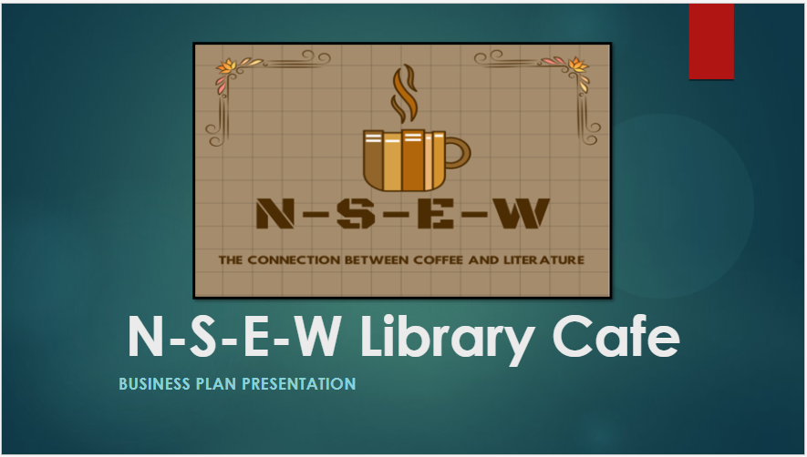

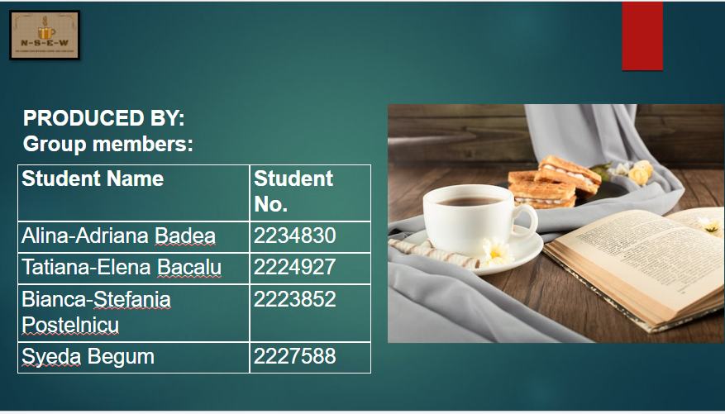

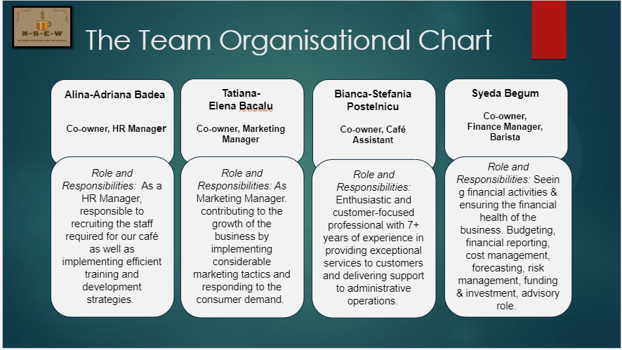

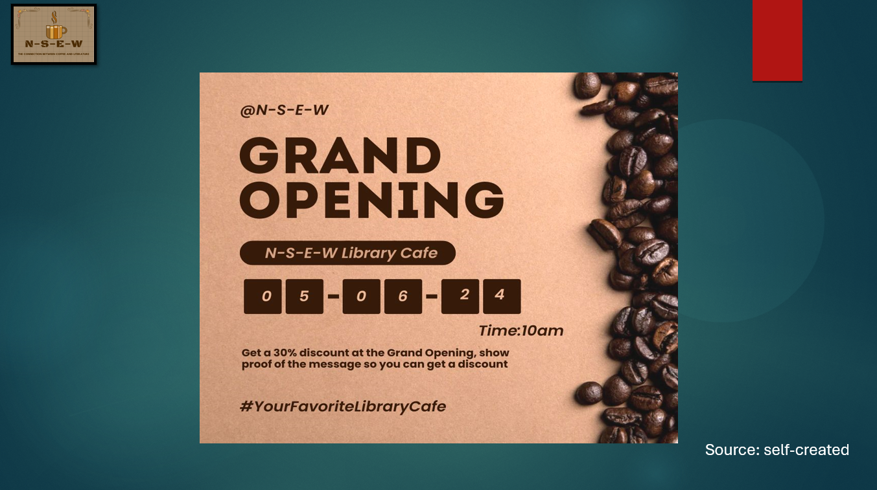

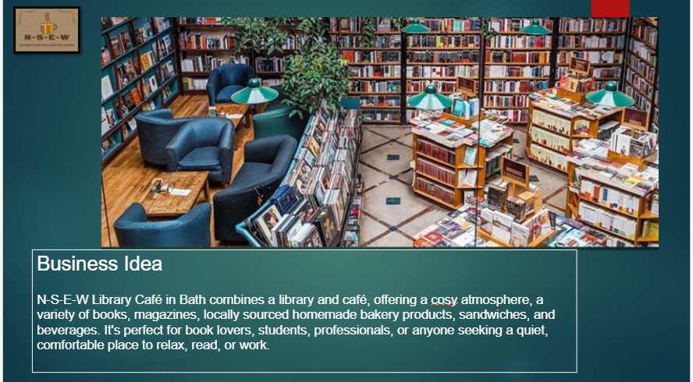

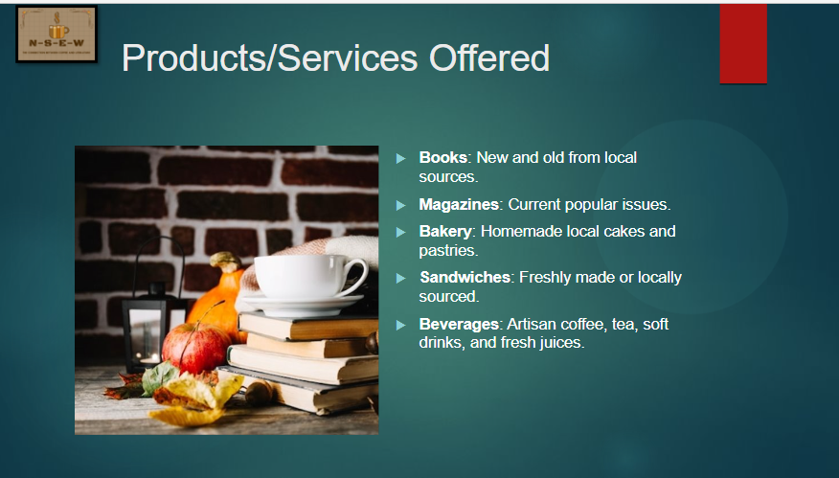

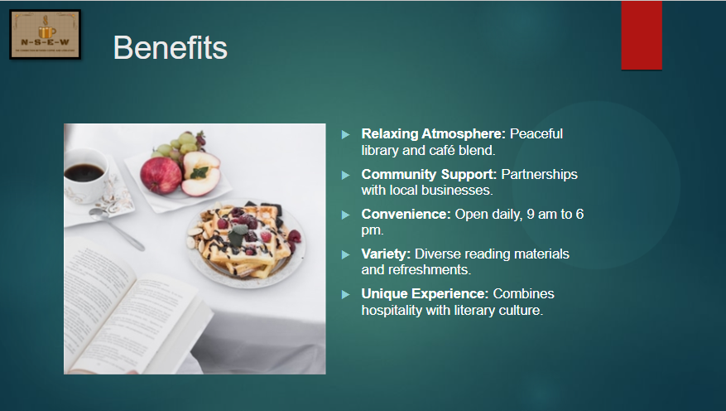

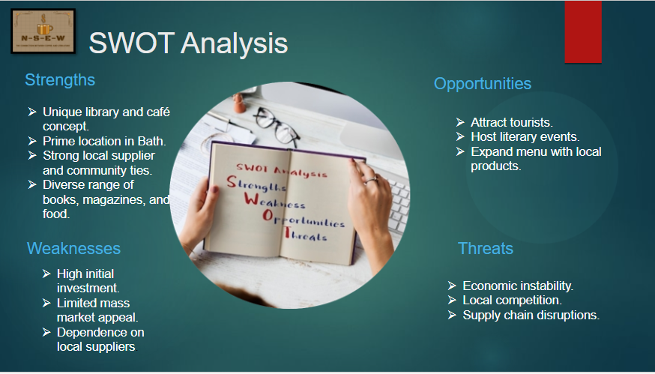

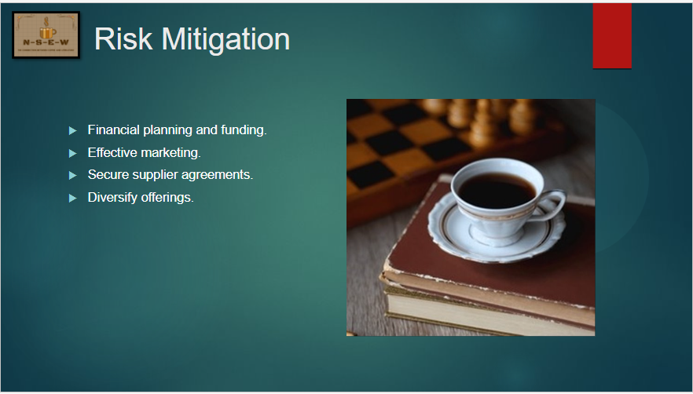

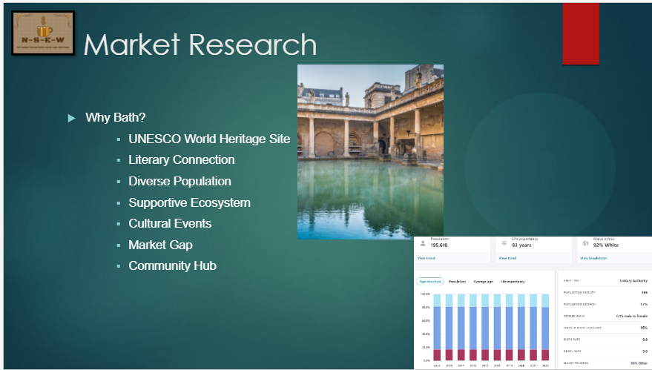
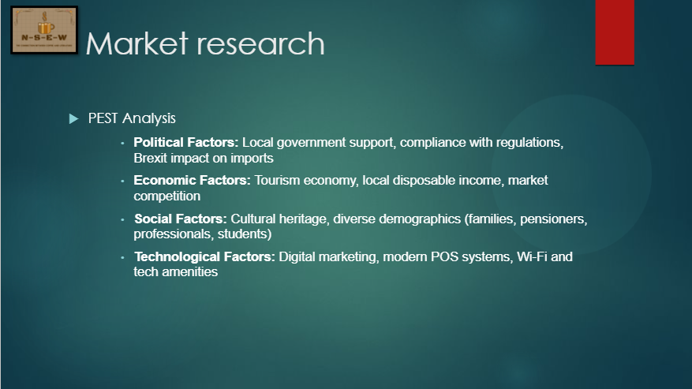

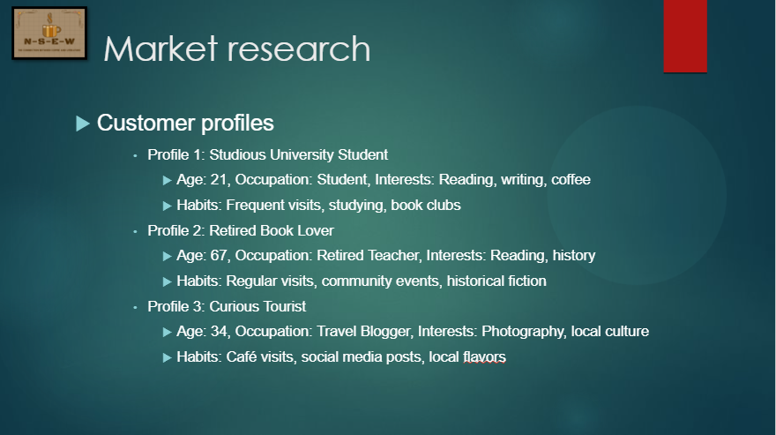
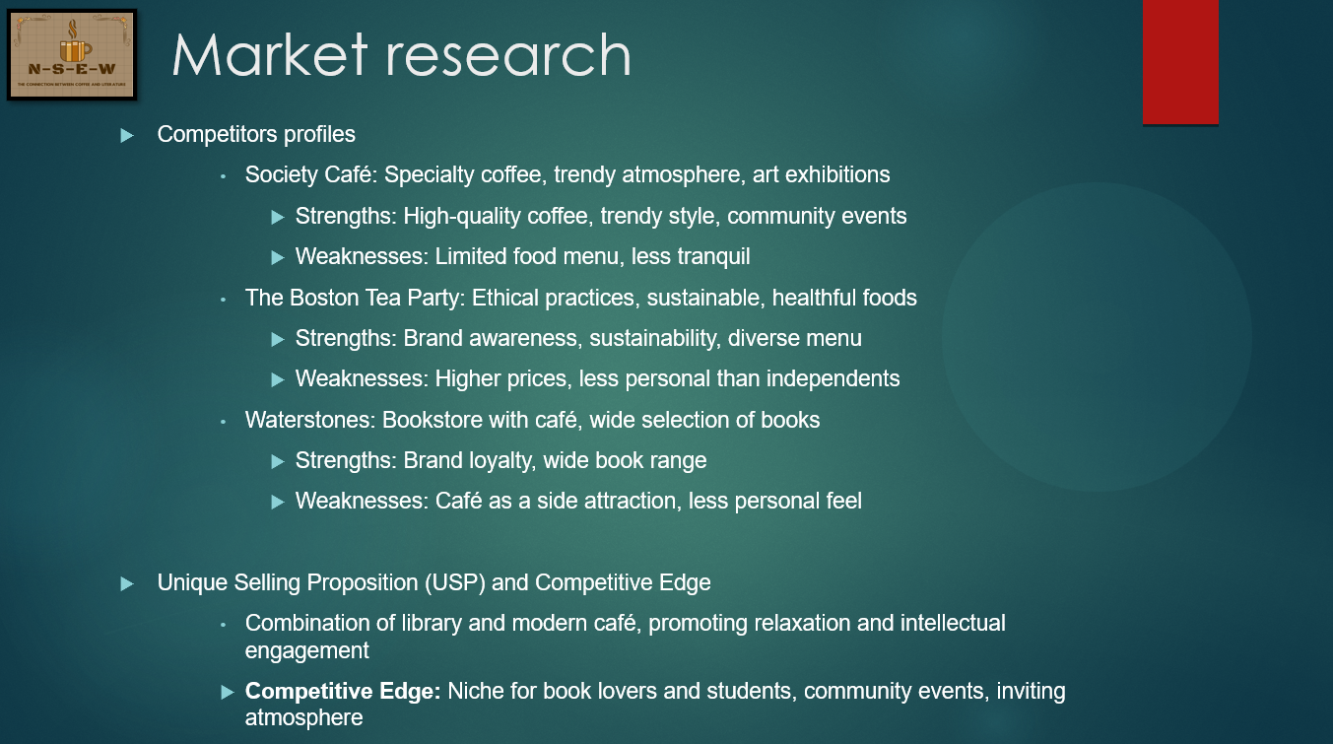

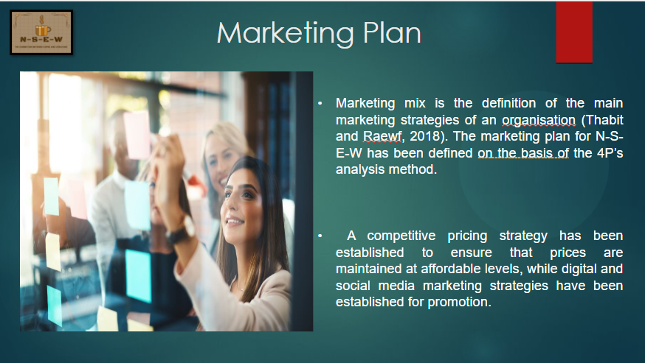

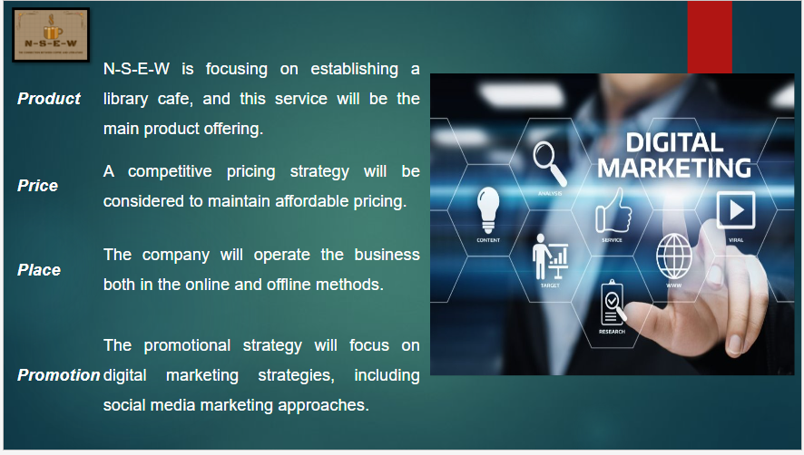

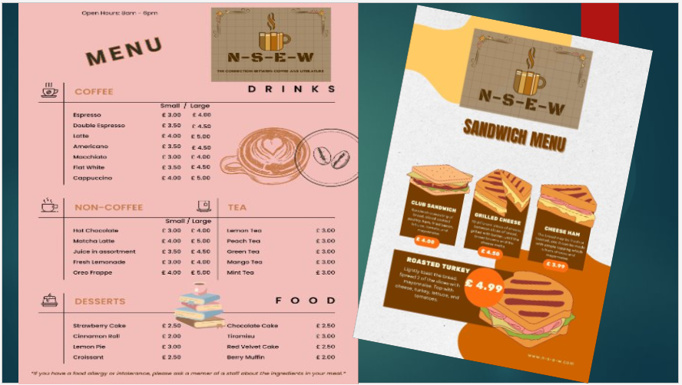
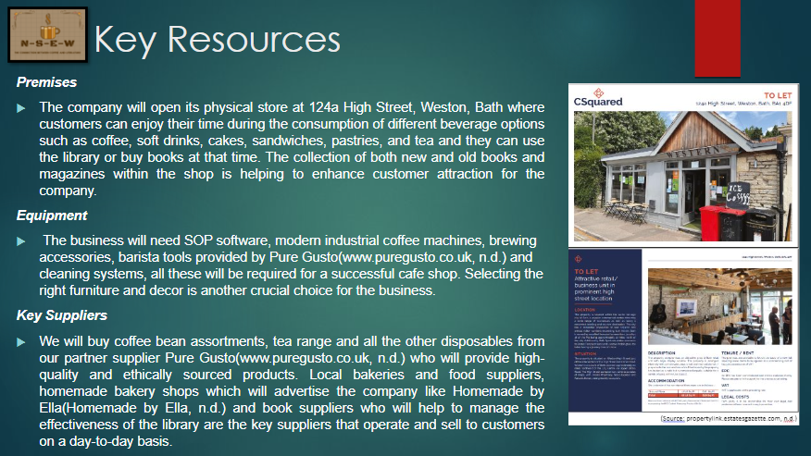

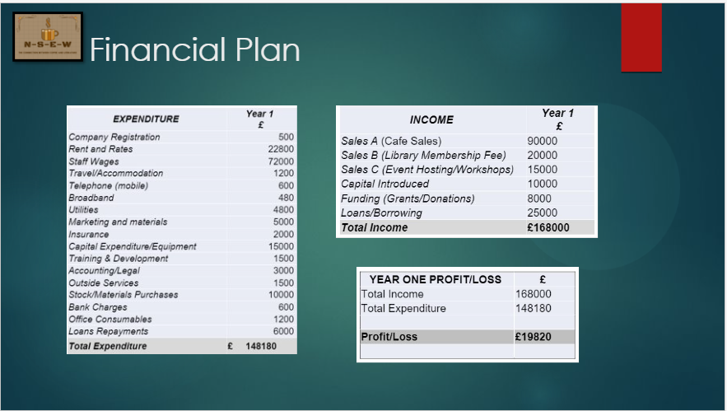
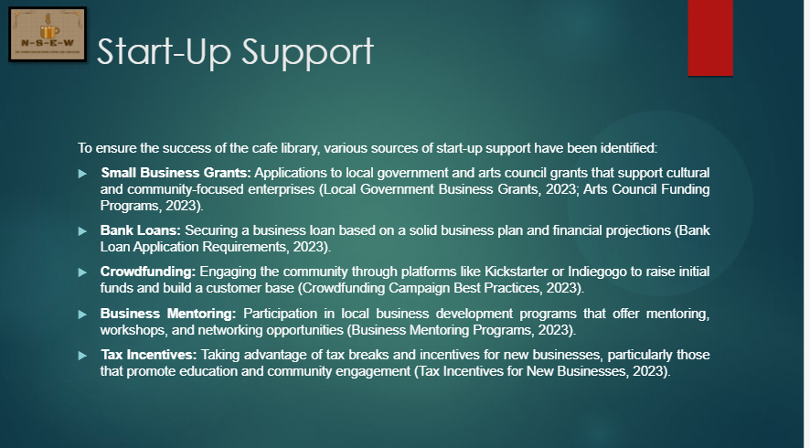

Appendix D – Financial breakdown and start-up

Expenditure Year 1 (£)

Company Registration (£500)
This covers the costs associated with legally registering the business, including registration fees, legal consultation, and necessary documentation (GOV.UK, n.d.; LegalZoom, n.d.).

Rent/Rates (£14,500 & £8300)
The property will be available on the basis of a new full repairing lease with a commencing rent of £14,500 / year exclusive of VAT and the relatable business rates of £ 8300. (appendix-location brochure)

Staff Wages (£72,000)
Based on hiring 4 full-time employees with an average annual salary of £18,000 each. This includes baristas, a library assistant, and a manager (Payscale, 2023; Glassdoor, 2023).

Travel/Accommodation (£1,200)
Budgeted for occasional travel for business purposes, such as attending conferences, workshops, or sourcing new suppliers (Business Travel Costs, 2023).

Telephone (mobile) (£600)
Monthly mobile phone bills for business use, estimated at £50 per month (Mobile Phone Plans for Businesses, 2023).

Broadband (£480)
Monthly broadband internet costs, estimated at £40 per month (Broadband Choices, 2023).

Utilities (£4,800)
Monthly costs for electricity, water, and gas, estimated at £400 per month (UK Power, 2023).

Marketing and materials (£5,000)
Includes initial launch marketing campaign, social media advertising, flyers, and promotional events (HubSpot, 2023).

Insurance (£2,000)
Comprehensive business insurance including public liability, employer’s liability, and contents insurance (Simply Business, 2023).

Capital Expenditure/Equipment (£15,000)
Purchase of furniture, coffee machines, kitchen equipment, library shelving, and initial stock of books and beverages (Café Equipment Pricing Guide, 2023).

Training & Development (£1,500)
Training for staff in customer service, barista skills, and library management (Barista Training Costs, 2023).

Accounting/Legal (£3,000)
Costs for accounting services and legal advice, including annual audits and legal compliance (Accounting Fees for Small Businesses, 2023).

Outside Services (£1,500)
Outsourced services such as cleaning, pest control, and occasional maintenance (Service Providers for Small Businesses, 2023).

Stock/Materials Purchases (£10,000)
Initial stock of books, coffee beans, teas, snacks, and other consumables (Café and Library Stock Suppliers, 2023).

Bank Charges (£600)
Monthly bank fees and transaction charges, estimated at £50 per month (Business Banking Fees, 2023).

Office Consumables (£1,200)
Office supplies including stationery, printer ink, and other miscellaneous items (Office Supplies Cost Estimates, 2023).

Loans Repayments (£6,000)
Repayments on loans taken to cover initial capital expenditure, assuming an annual repayment amount (Small Business Loan Repayment Schedules, 2023).

Sales / Income

Sales A (Café Sales) (£90,000)
Estimated from an average daily revenue of £250, based on selling coffee, snacks, and other refreshments. Assumes 360 operating days a year (National Coffee Association, 2023; IBISWorld, 2023).

Sales B (Library Membership Fees) (£20,000)
Based on signing up 200 members paying an annual fee of £100 each. Membership includes access to the library, events, and exclusive discounts (Library Membership Fees Comparison, 2023).

Sales C (Event Hosting/Workshops) (£15,000)
Income from hosting events, workshops, and book clubs, estimated at £1,250 per month (Event Hosting Revenue Estimates, 2023).

Capital Introduced (£10,000)
Owner’s personal investment into the business to cover initial start-up costs (Personal Investment in Start-ups, 2023).

Funding (Grants/Donations) (£8,000)
Anticipated grants and donations from local government, arts councils, and community organizations supportive of literacy and small businesses (Small Business Grants and Funding Opportunities, 2023).

Loans/Borrowing (£25,000)
Business loans obtained from banks or financial institutions to support start-up costs and initial operations (Business Loan Options and Criteria, 2023).

Start-up Support
To ensure the success of the café library, various sources of start-up support have been identified:
Small Business Grants: Applications to local government and arts council grants that support cultural and community-focused enterprises (Local Government Business Grants, 2023; Arts Council Funding Programs, 2023).
Bank Loans: Securing a business loan based on a solid business plan and financial projections (Bank Loan Application Requirements, 2023).
Crowdfunding: Engaging the community through platforms like Kickstarter or Indiegogo to raise initial funds and build a customer base (Crowdfunding Campaign Best Practices, 2023).
Business Mentoring: Participation in local business development programs that offer mentoring, workshops, and networking opportunities (Business Mentoring Programs, 2023).
Tax Incentives: Taking advantage of tax breaks and incentives for new businesses, particularly those that promote education and community engagement (Tax Incentives for New Businesses, 2023).

Appendix E – Promotion/Marketing Materials
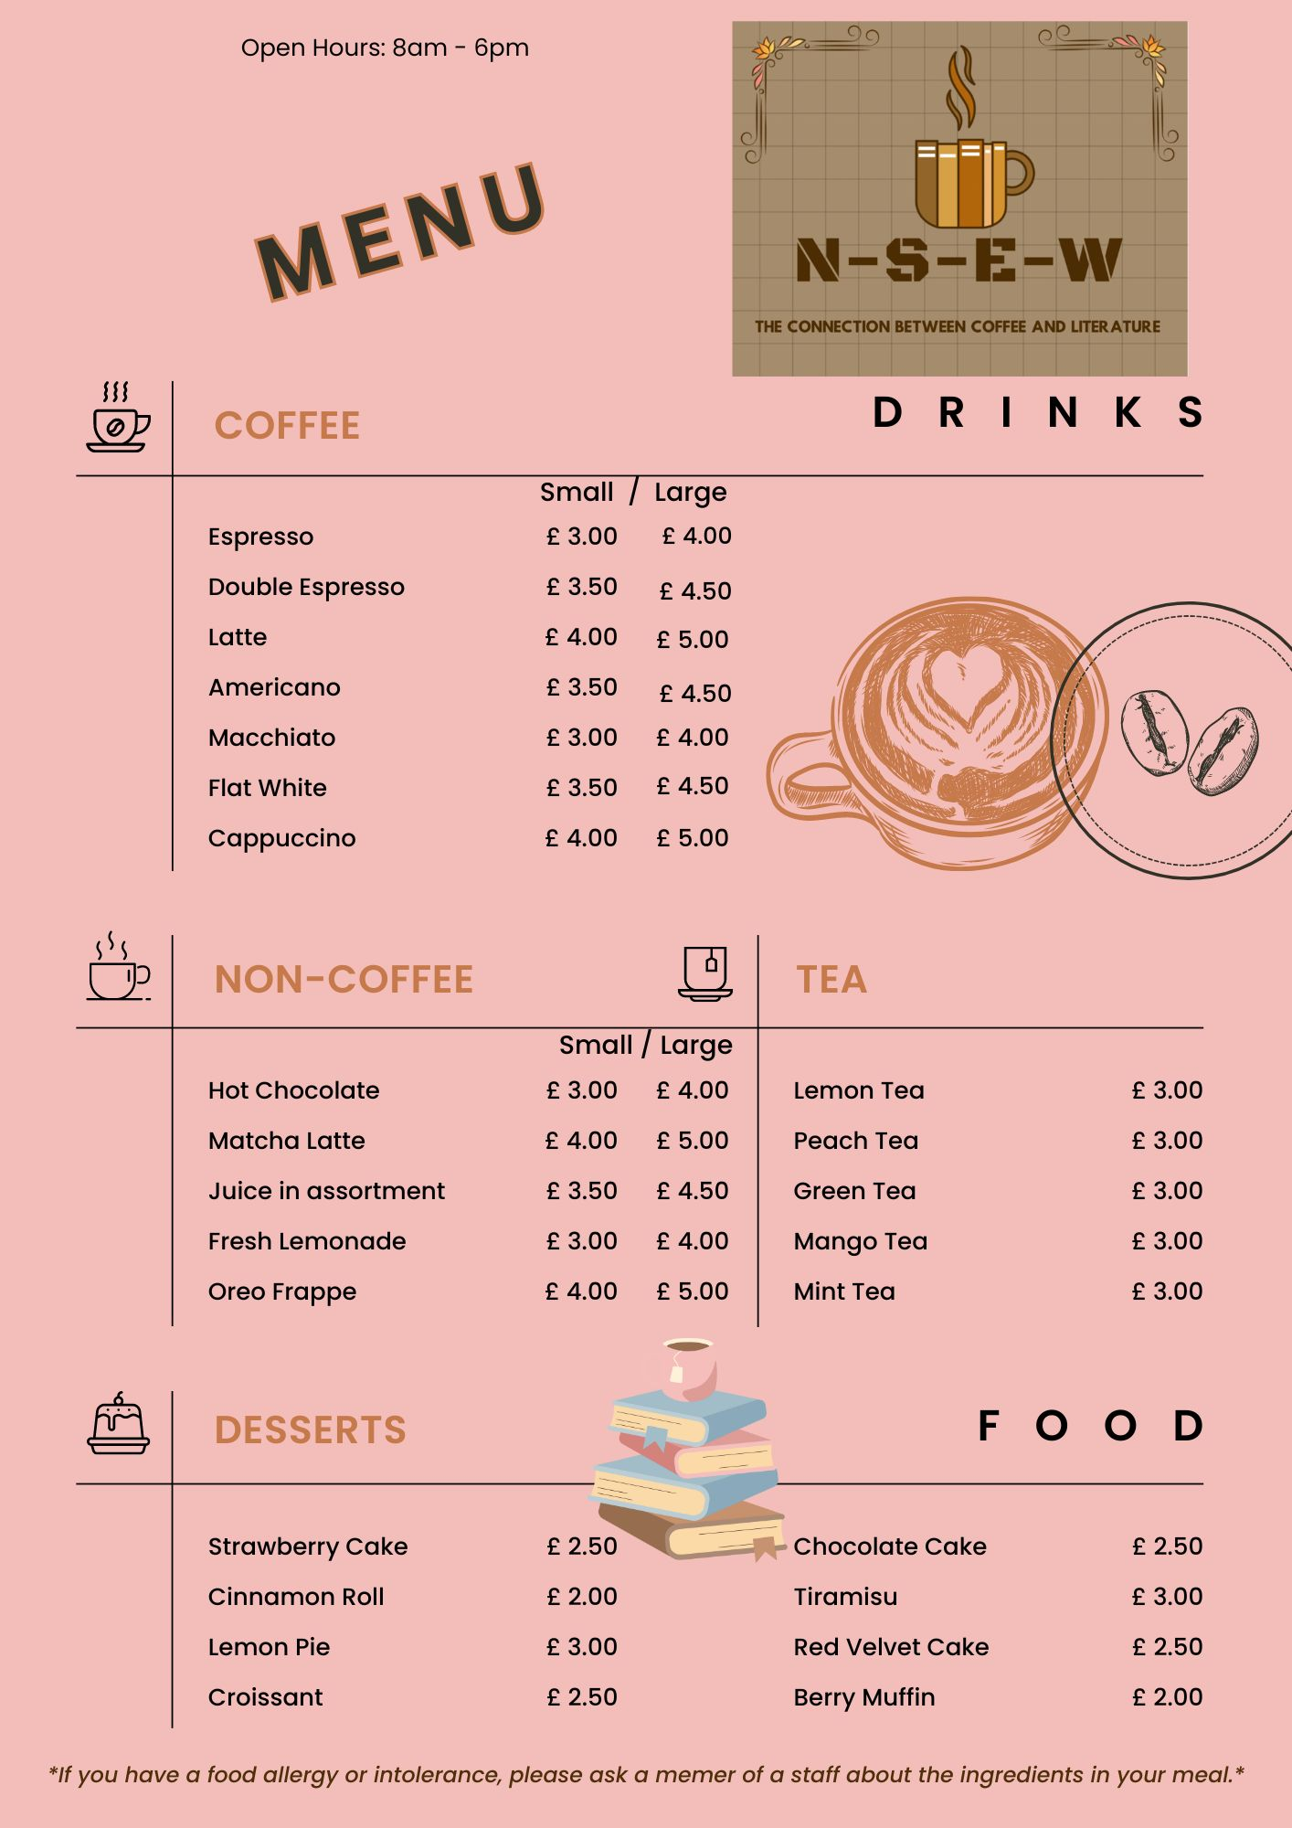Drinks and Desserts Menu (Source: self-created)
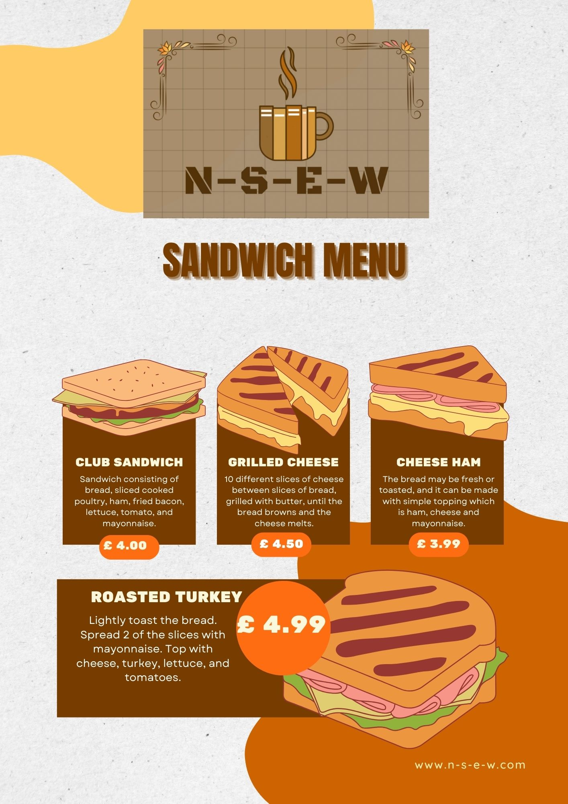
Sandwich Menu (Source: self-created)
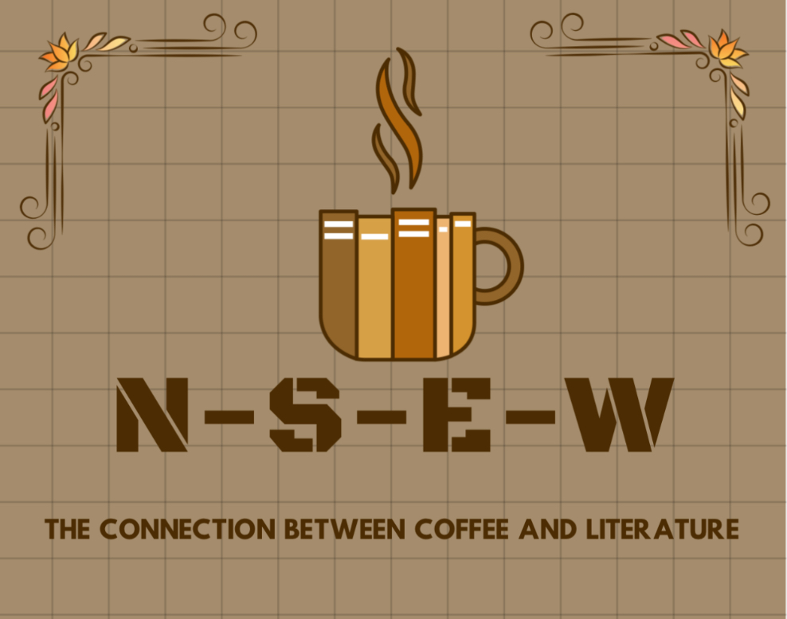
Logo of the company (Source: self-created)

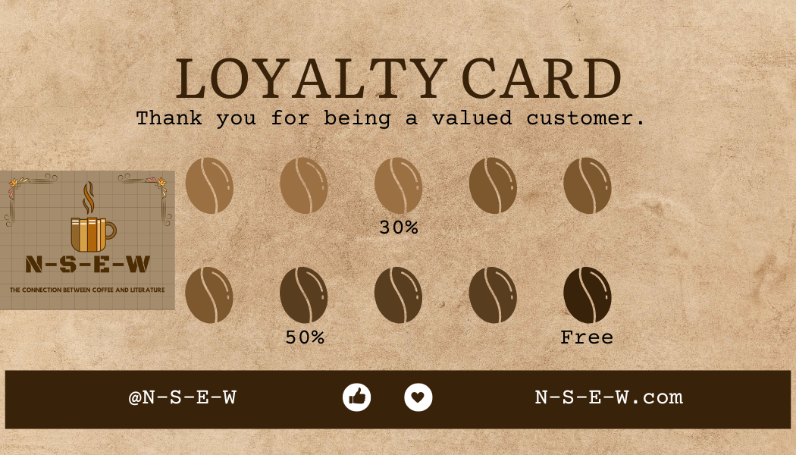Loyality Card (Source: self-created)




Appendix F – LOCATION BROCHURE
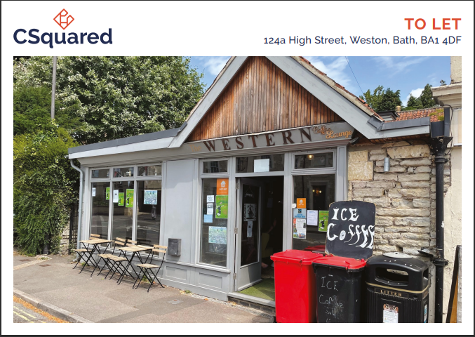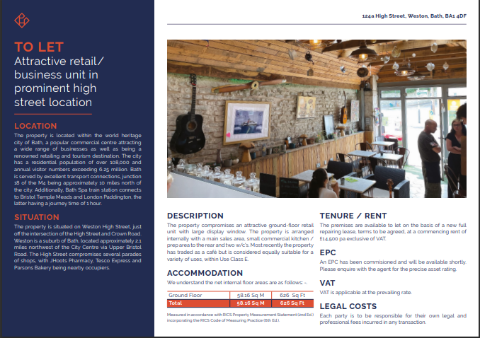 (Source: propertylink.estatesgazette.com, n.d.)
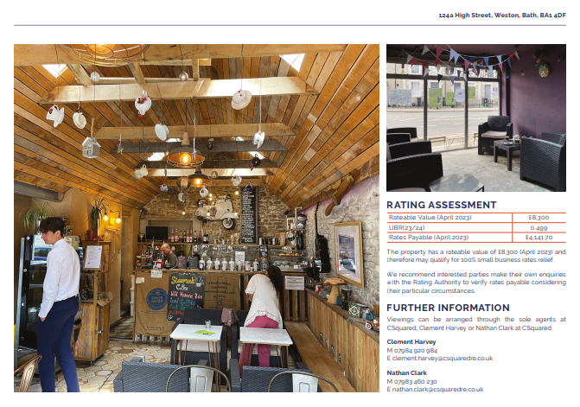
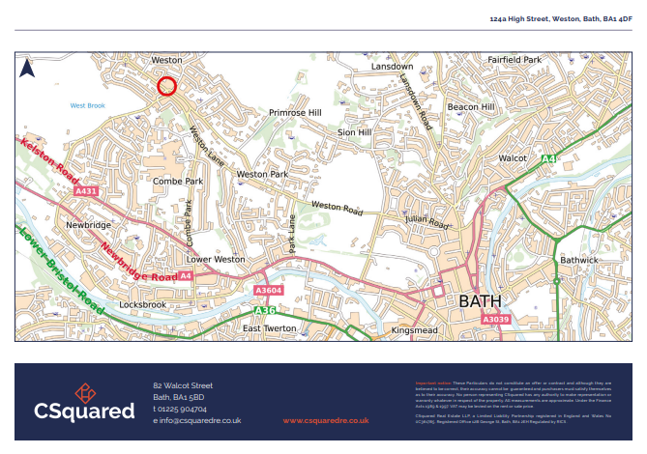
(Source: propertylink.estatesgazette.com, n.d.)

REFERENCE LIST:

Accounting Fees for Small Businesses. (2023). Available at: https://www.nerdwallet.com/small-business-loans?trk=nw_gn_6.0

Afsari, A., & Rachmawati, E. (2019). Tinjauan Tentang Penerapan Analisis Swot Dalam Meningkatkan Daya Saing Perusahaan (Studi Kasus Pada King Cafe). JEMPER (Jurnal Ekonomi Manajemen Perbankan). (Available at: https://www.neliti.com/publications/332958/tinjauan-tentang-penerapan-analisis-swot-dalam-meningkatkan-daya-saing-perusahaa )

Ariyani, A.H.M., Wulan, A.C., Sunyigono, A.K., & Subari, S. (2022). Analysis of the development strategy of SME Rubath Coffee Jombang East Java. Journal of Integrated Agribusiness. (Available at: https://www.researchgate.net/publication/235306603_Strategy_development_by_SMEs_for_competitiveness_A_review )

Arts Council Funding Programs. (2023). Available at: https://www.artscouncil.org.uk/our-open-funds

Awojobi, E.A., Okoro, C., & Babalola, Y. (2021). A SWOT analysis of physical infrastructure in government-owned university libraries in Ogun State, Nigeria. South African Journal of Libraries and Information Science, 86(2), 38-46. (Available at: https://www.researchgate.net/publication/348341446_A_SWOT_analysis_of_physical_infrastructure_in_government-owned_university_libraries_in_Ogun_State_Nigeria)

Bangani, S. (2023). Academic libraries’ support for quality education through community engagement. Information Development. (Available at: https://journals.sagepub.com/doi/10.1177/02666669231152862 )

Bank Loan Application Requirements. (2023). Available at: https://www.sba.gov/funding-programs/loans

Baum, T., (2019). Does the hospitality industry need or deserve talent? International Journal of Contemporary Hospitality Management, 31(10), pp.3823-3837.

Barista Training Costs. (2023). Available at https://www.baristatrainingacademy.com/

Bath and North East Somerset Council (2024) Support we offer to businesses. Available at: https://beta.bathnes.gov.uk/support-we-offer-businesses (accessed: 3rd June 2024).

Bath and North East Somerset Council (2024) Building the Bath & North East Somerset New Economy. Available at: https://democracy.bathnes.gov.uk/documents/s79404/Economic%20Strategy.pdf#:~:text=The%20City%20of%20Bath%20has%20a%20double%20UNESCO,percentage%20points%20growth%20%282012-2021%29%20National%3A%2075.5%25%20%28%2B5.0%20pp%29 (accessed: 1st June 2024).

Bath Echo. (2015). Home. [online] Available at: https://www.bathecho.co.uk/.

Bath Festivals (2024) Bring Bath Alive with Art. Available at: https://bathfestivals.org.uk/ (accessed: 21st May 2024).
Baumgardner, V. (2023) ‘What Is Seasonality In Tourism’, Tourist Secrets. Available at: https://www.touristsecrets.com/travel-tips/what-is-seasonality-in-tourism/#:~:text=Seasonality%20in%20tourism%20refers%20to%20the%20pattern%20of,other%20periods%20see%20a%20decline%20in%20tourist%20numbers. (accessed: 1st June 2024).

Blackwell, E. (2011), How to Prepare a Business Plan: Planning for Successful Start-up and Expansion, (5th Ed) Sunday Times Business Enterprise Series, Kogan Page

Boston Tea Party (2024) ‘Our commitment to sustainability and dreams of a better world’, Boston Tea Party. Available at: https://bostonteaparty.co.uk/who_we_are/charity.php (accessed: 3rd June 2024).

Broadband Choices. (2023) Business broadband comparison. Available at: https://www.broadbandchoices.co.uk/business

Bull, H. (2023) ‘15 Best Coffee Shops and Cafes in Bath’, Goats on the Road [blog]. 30th September. Available at: https://www.goatsontheroad.com/bath-cafes/ (accessed: 21st May 2024).

Bull, H. (2023). 15 Best Coffee Shops and Cafes in Bath. [online] Goats On The Road. Available at: https://www.goatsontheroad.com/bath-cafes [Accessed 1 Jun. 2024].

Burns, P. (2022) Entrepreneurship and Small Business, 5th Ed., Palgrave Macmillan: Basingstoke

Business Banking Fees. (2023). Available at: https://www.bankrate.com/banking/checking/best-business-checking-accounts/

Business Loan Options and Criteria. (2023). Available at: https://www.nerdwallet.com/small-business-loans

Business Mentoring Programs. (2023). Available at: https://www.score.org/find-mentor

Business Travel Costs. (2023). Available athttps://www.business.com/articles/employee-expense-reimbursements/

Café and Library Stock Suppliers. (2023). Available at: https://www.cafesolutions.com.au.

Café Equipment Pricing Guide. (2023). Available at: https://www.webstaurantstore.com/coffee-shop-supplies.html

Chaffey, D. and Smith, P.R., (2022). Digital marketing excellence: planning, optimizing and integrating online marketing. Routledge.

Commercial Real Estate Market Research. (2023). Available at: https://www.cbre.com/research.

Crowdfunding Campaign Best Practices. (2023). Available at: https://www.kickstarter.com/help/handbook/funding?ref=handbook_index

Darragh, R. (2024) ‘The best POS systems for small businesses in 2024’ , Startups. 19th January. Available at: https://startups.co.uk/payment-processing/small-businesses-pos-systems/ (accessed: 1st June 2024).

Deng, Q., Allard, B., Lo, P., Chiu, D.K.W., See-To, E., & Bao, A. (2019). The role of the library café as a learning space: A comparative analysis of three universities. Journal of Librarianship and Information Science, 51(4), 823-842. (Available at: https://journals.sagepub.com/doi/epub/10.1177/0961000617742469)

Erwinsyah, E., & Abni, D.R. (2020). Analisis Strategi Pemasaran Pada The Logoh Smoothies Cafe Di Tenggarong. Jurnal Ekonomi & Manajemen Indonesia. (Available at: https://www.researchgate.net/publication/361069540_Analisis_Strategi_Pemasaran_Pada_The_Logoh_Smoothies_Cafe_Di_Tenggarong)

Event Hosting Revenue Estimates. (2023). Available at: https://www.eventbrite.com/blog/event-budget-guide-ds00/

Glassdoor. (2023) Manager salary estimates. Available at: https://www.glassdoor.com/Salaries/manager-salary-SRCH_KO0,7.htm.

GOV.UK. (n.d.) Company and partnership registration fees. Available at: https://www.gov.uk/limited-company-formation/fees.

Hapel, R. (2020). Building A Contemporary Public Library Through Community Engagement: A Personal Journey. Public Library Quarterly, 39(4), 391-409. (Available at: https://www.tandfonline.com/doi/epdf/10.1080/01616846.2020.1772621?needAccess=true)

Homemade by Ella. (n.d.). Homemade by Ella. [online] Available at: https://homemadebyella.co.uk/ [Accessed 1 Jun. 2024].

Huang, M.H. and Rust, R.T., (2021). A strategic framework for artificial intelligence in marketing. Journal of the Academy of Marketing Science, 49, pp.30-50.

HubSpot. (2023) Marketing budget guidelines. Available at: https://blog.hubspot.com/marketing/budget-guidelines.

IBISWorld. (2023) Coffee shop industry report. Available at: https://www.ibisworld.com/united-states/market-research-reports/coffee-shop-industry/.

LegalZoom. (n.d.) Cost of setting up a business. Available at: https://www.legalzoom.com/articles/cost-of-setting-up-a-business.

Library Membership Fees Comparison. (2023). Available at: https://www.cilip.org.uk/page/Libraryfees.

Local Government Business Grants. (2023). Available at: https://www.gov.uk/business-finance-support.

Mobile Phone Plans for Businesses. (2023). Available at: https://www.uswitch.com/mobiles/business-mobile-phones/.

National Coffee Association. (2023) Café sales statistics. Available at: https://www.ncausa.org/Industry-Resources/Economic-Impact.

Novak, J. (2024) ‘What Is Digital Marketing? Types, Strategies & Best Practices’, Forbes. 16th February. Available at: https://www.forbes.com/advisor/business/what-is-digital-marketing/ (accessed: 1st June 2024).

Ochôa, P., Silva, P., & Silvestre, S. (2021). Alcântara World Café: Lisbon Public Libraries Network and NOVA University Partnership within Communities’ Processes of Participation. Library Trends, 69, 790-811. (Available at: Alcântara World Café: Lisbon Public Libraries Network and NOVA University Partnership within Communities’ Processes of Participation | IDEALS (illinois.edu) )

Office for National Statistics (2024) Travel Trends: 2023. Available at: https://www.ons.gov.uk/peoplepopulationandcommunity/leisureandtourism/articles/traveltrends/2023 (accessed: 21st May 2024).

Office Supplies Cost Estimates. (2023). Available at: https://www.staples.com.

Pandya, C., & Boricha, S. (2019). Service Quality and Customer Satisfaction of the GPERI Library Users: An Analytical Study. International Journal of Information Dissemination and Technology. (Available at: https://www.researchgate.net/publication/336057381_Service_Quality_and_Customer_Satisfaction_of_the_GPERI_Library_Users_An_Analytical_Study)

Payscale. (2023) Average barista salary. Available at: https://www.payscale.com/research/US/Job=Barista/Hourly_Rate.

Personal Investment in Start-ups. (2023). Available at: https://www.startups.com/library/expert-advice/personal-investment.

Penjualan Kafe DR. Koffie. Jurnal EMT KITA. https://pdfs.semanticscholar.org/eded/3168020881642366f03297ca8f9dd5ee193b.pdf?_gl=1*11y64gd*_ga*MTM5NDcxMzMzLjE3MDkyMTE3Mjc.*_ga_H7P4ZT52H5*MTcxNjk4NzYxMC43LjEuMTcxNjk4ODk5Ny4zMS4wLjA.

Pratama, A.J., & Rachman, M.E. (2023). Analisis Marketing Mix Terhadap Target

Proença, J.F., Torres, A.C., Marta, B., Silva, D.S., Fuly, G. and Pinto, H.L., (2022). Sustainability in the coffee supply chain and purchasing policies: A case study research. Sustainability, 14(1), p.459.

propertylink.estatesgazette.com. (n.d.). A Commercial Property For Sale Or Rent In Bath, BA1 4DF | Freehold | 626 Sq Ft. [online] Available at: https://propertylink.estatesgazette.com/property-details/6914559-124a-high-street-weston-bath-bath-and-north-east-somerset-ba1-4df [Accessed 1 Jun. 2024].

Service Providers for Small Businesses. (2023). Available at: https://www.businessnewsdaily.com/7747-best-business-services.html.

Signable (2024) New UK import rules 2024: A complete guide. Available at: https://www.signable.co.uk/uk-import-rules-2024/ (accessed: 1st June 2024)

Simply Business. (2023) Business insurance quotes. Available at: https://www.simplybusiness.co.uk/insurance/

Small Business Grants and Funding Opportunities. (2023). Available at: https://www.fundera.com/business-loans

Small Business Loan Repayment Schedules. (2023). Available at: https://www.americanexpress.com/en-us/business/trends-and-insights/articles/how-to-repay-small-business-loan

Society Café (2024) ‘EVENT!’ [Instagram]. 20th May. Available at: https://www.instagram.com/p/C7Mqk1vIruL/?img_index=1 (accessed: 3rd June 2024).

Stephan, K. (2018). Research cafés: how libraries can build communities through research and engagement. Insights: The UKSG Journal, 31. (Available at: https://www.researchgate.net/publication/327758258_Research_cafes_How_libraries_can_build_communities_through_research_and_engagement )

Sutherland, T. (2023) ‘Key Legal Considerations When Setting Up a Cafe in the UK’, Legal Vision. 4th July. Available at: https://legalvision.co.uk/business-structures/cafe-considerations/ (accessed: 3rd June 2024).

Tax Incentives for New Businesses. (2023). Available at: https://www.gov.uk/browse/business/business-tax

Thabit, T. and Raewf, M., 2018. The evaluation of marketing mix elements: A case study. International Journal of Social Sciences & Educational Studies, 4(4).

The Bath Magazine. (n.d.). Homepage. [online] Available at: https://thebathmagazine.co.uk/ [Accessed 1 Jun. 2024].

Total Guide to Bath (2024) Building Resilient Businesses in Bath: Strategies for a Changing World. Available at: https://www.totalguidetobath.com/business/building-resilient-businesses-in-bath/ (accessed: 21st May 2024).

Tripadvisor (2024) Society Café. Available at: https://www.tripadvisor.com.au/Restaurant_Review-g186370-d3463453-Reviews-Society_Cafe-Bath_Somerset_England.html (accessed: 3rd June 2024).

Tripadvisor (2024) Boston Tea Party. Available at: https://www.tripadvisor.co.uk/Restaurant_Review-g186370-d2323086-Reviews-Boston_Tea_Party_Bath_Kingsmead_Square-Bath_Somerset_England.html (accessed: 3rd June 2024).

UK Power. (2023) Average business utility costs. Available at: https://www.ukpower.co.uk/business-energy

Wang, J., & Wang, Z. (2020). Strengths, Weaknesses, Opportunities and Threats (SWOT) Analysis of China’s Prevention and Control Strategy for the COVID-19 Epidemic. International Journal of Environmental Research and Public Health, 17. (Available at: https://www.semanticscholar.org/reader/d0d221f4e4b296f308789d30592dbe114ef6fcd4)

Williams, S. (2021) FT Guide to Business Start Up: The most comprehensive guide for entrepreneurs, 32nd Ed., Financial Times Press: Harlow.

www.puregusto.co.uk. (n.d.). Next Day Coffee Supplies Direct From A1 Coffee Beans Supplier - Wholesale Coffee Company. [online] Available at: https://www.puregusto.co.uk/.

