Marketing plan written for Moxy Hotel

Student Name: Mihai Adrian Fariseu

Student ID number: 2215497

Marketing Essentials BMIH4005

Lecturer name: Ruth Taylor-Davies

Word Count 1653

Component A

Introduction
The following report will develop a marketing plan for MOXY hotel, it is a UK-based hotel that provides stylish service to the consumer. Moxy is one of the emerging hotel businesses and it is owned by the biggest hotel chain business called Marriott (Moxy-hotels, 2023). The report will provide information regarding the situation analysis, where the 5 c’s will be conducted. After this report will discuss the objectives and then also provide information regarding the strategy used for the marketing plan. Further, provide information regarding the tactics used in marketing and then develop an action plan and control system to measure the effectiveness of the marketing plan.

“Situation Analysis”
SWOT analysis

Strength  Stylish brand.  Specialised workers.  Innovation.  Rewards | Weakness  Brand recognition.  Lack of funds.
Opportunity  Attract customer that is stylish and fashionable.  People are engaged with technology. | Threat  Competitors  Price issues.
Table No.1: SWOT analysis
(Source: Created by the Learner )

Customer: Moxy is a stylish brand that provides stylish service, bar, playful and other services. Customers are generally between 20 to 40 and are fashionable. Online booking facility, so that people can book hotels.
Competitor: There is strong competition in the hotel industry, such as Premier Inn, six Senses, Hilton and others (Weinstein, 2022).
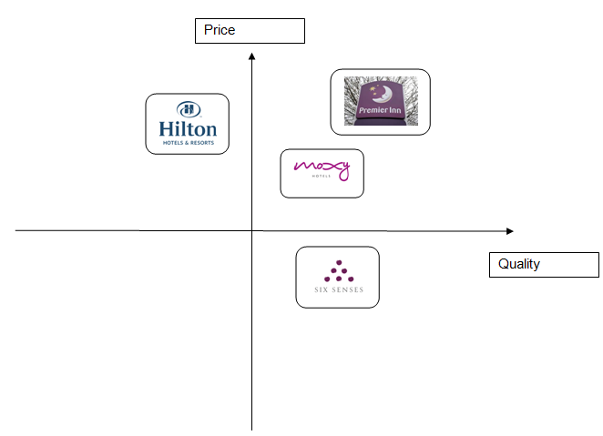
Figure No.1: Perceptual mapping
(Source: Created by the Learner)
Collaboration: The organisation collaborates with Marriott hotel, whic helps in getting funding support and recognition around the globe. Moxy has also partnered with “Bumble Spot” to provide better service to the customer (Xiong, L. and King, 2019).

Climate
Political factor | The UK has a free trade policy with more than 11 different countries, which encourages the organisation to go into international business (Stognief et al., 2022). therefore, the addition can also import raw materials from other countries.
Economic factor: | The inflation rate of the UK is about more than 10% that impact on the purchasing power of the individual (Henderson and Carruthers, 2022). It is estimated that it cost about £ 75 per night in Moxy, which has a positive impact on the organisation (Moxy-hotels, 2023).
Social factor: | People are highly updated because a large number of people are using technology on a regular basis. It is estimated more than 57% of people in the UK use social media, this has a positive impact because Moxy can use this channel for m, marketing (Richardson et al., 2020).
Technological factor: | It is estimated the current internet penetration rate is 97% (Keeler et al., 2019). People in the UK are booking hotels online via cell phone with the help of the internet. It also has a positive impact because the organisation provides online facilities to book hotels.
Legal factors | Moxy is following the “Equality Act 2010” to provide equal opportunity to employees (Bhopal, 2020). Therefore also follows the “National Minimum Wage Rate 2021”, which provides employees with more than 9 pounds (Dube, 2019).
Environmental factor | Moxy follows the “Environmental Act 2021”, they prefer online booking because it helps in reducing the consumption of paper in the organisation. Moxy also uses renewable resources, such as solar panels and so on (Macrory, 2023).
Table No.2: PESTLE analysis
(Source: Created by the Learner )

“Objective”
The main objective of the marketing plan is to our people about the stylish as well as sustainable practices that are done in the Moxy to provide better service to people. Show people about the exciting service provided by the organisation.

“Strategy”
The value proposition is very important in an organisation because it helps in understanding the needs of the customer and then taking necessary steps to fulfil their requirement of them. Mox is a brand that provides specialised service and a playful environment. The organisation also has good employees that help the organisation to fullfill consumer needs, it is estimated with more than 700 employees in the organisation. Consumers are also provided with rewards that attract that customer for regular visits (Moxy-hotels, 2023). The organisation is different from other organisations because the design is technology savvy which helps in increasing efficiency. The consumer of this hotel is generally young people, those between 20-40. The people of this age bracket in the UK are technology savvy and use technology on a regular basis, social media use is more than 57% (Richardson et al., 2020). Organisations provide online booking facilities to book their hotel. These are some of the strategies used by the Moxy organisation in marketing.

“Tactics”
Marketing Mix
Product: London city is the heart of the United Kingdom and a large number of people visit this location. It is estimated that more than 33 million people visit the UK every year from foreign locations (Silva and Hassani, 2022). There are different locations and destinations that attract people, such as Hyde Park, the British and various other locations.
Place: Consumers of the MOXY hotel will be able to look at the locations of their hotel through the company's website. The consumer also can use the Google Map facility and their apple watch that will direct them to the respective location of the hotel. Mpoxy will be updating its website with proper graphics and also there will be a physical store, so people can directly visit their hotels and book their desired rooms and services accordingly.
Price: It is also an important factor that helps in encouraging people to do business with the respective organisation. The Moxy will be using a competitive pricing strategy that will make the organisation different from others and attract consumers toward the organisation. Price impact on the purchasing power of customers, it is estimated that currently the inflation rate of the UK is growing rapidly and people facing problems in booking hotels that provide service at a reasonable price (Henderson and Carruthers, 2022). Price pointer is one of the important factor because it will attract consumers to do business with the organisation. Moxy will be providing exciting discounts and also provide more rewards to frequent visitors to maintain customer retention.
Promotion: Promotion is one of the important factors because of this help in increasing brand awareness and reaching border audience. Moxy will be using different promotional tools to reach the border audience. One of the effective promotional tools will be social media, according to sources, it is estimated that more than 57% of people in the UK use social media on a regular basis (Richardson et al., 2020). There will also be “open web advertising”, people hose are using websites or active on google will be aware of the organisation. These are some of the ther promotion techniques that will be implemented while promoting the organisation.

“Action Plan”
Marketing Scheduled
Marketing activities | Starting date | End date | Duration
“Choosing marketing calendar” | 1 April | 6 April | 6
“Generate campaign and content” | 7 April | 13 April | 6
“Prioritise the ideas” | 14 April | 17 April | 4
“Plan content for the week” | 18 April | 22 April | 5
“Actually create the content” | 23 April | 27 April | 5
Table No.3: Marketing Schedule
(Source: Created by the Learner)
Gantt Chart
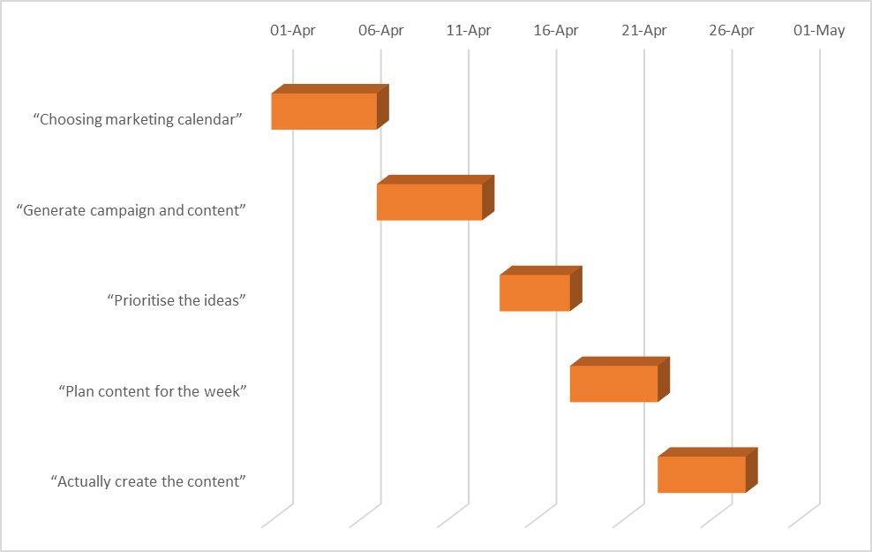
Figure No. 2: Gantt Chart
(Source: Created by the Learner)
At the initial stage of a marketing plan, there will be a process of choosing marketing calendar, here all the marketing project will be brought together. After this, there will be a process of generating content or a campaign, quality information will be gathered and prioritise the ideas and implement effectively. Planning the content is another stage in marketing because it will help in developing an effective plan in marketing. In the last stage, the formulated plan will be executed effectively so that the marketing plan will be productive.

“Control”
There are different ways to measure the success of a marketing plan. Customer engagement in the organisation is one of the effective methods of measuring the success of a marketing plan. Website traffic is another tool that will be used in measuring the success of the marketing, the number of visitors to the website (Lonsdale and Lucas, 2019). Profit is another important role that helps in measuring the success of a marketing plan, the revenue generated of the organistion if the revenue generated by the organisation shows profit then it will indicate that the marketing plan was successful.

Conclusion
The above report has provided good information regarding the Moxy hotel organisation and the different elements required in the marketing plan. The situation analysis has provided good information regarding the marketing plan and the resources available in the organisation. After this, it has also provided objective information and the strategy to fullfill or achieve the success of the marketing plan. After this, the report has also provided information with the help of the marketing mix. Further, it also provides the time and steps required in marketing plans and also develops gannet chart and provides a control strategy. Moxy can focus more on social media channels because it is cost-effective and reaches a larger consumer base with less expense. This will help the organisation to save money and execute on other requirements.

Component B Summary
Introduction
The report is about the marketing plan of Moxy, Moxy is one of the growing hotel organisations in the UK that provides stylish service.
Situation analysis
SWOT analysis

Strength  Stylish and playful | Weakness  Lack of funds
Opportunity  Consumers are technology savvy | Threat  Competitor
Table No.1: SWOT analysis
(Source: Created by the learner)
Customer: These people are between 20-40 and like enjoying more and prefer a playful environment.
Competitors:
.
Figure No.1: Perceptual mapping
(Source: Created by the learner)

Collaboration: Moxy has collaborated with “Bumble Spot”
Climate

Political factors | Free trade policy with 11 different countries.
Economical factors | Inflation rate is more than 12%.
Social factor | People are updated with the help of society.
Technological factor | The current internet penetration rate is 97%.
Legal factor | “Equality Act 2010” and “National Minimum Wage Rate 2021”
Environmental factors | “Environmental factor”
Table No.1: SWOT analysis
(Source: Created by the learner)
Objectives
To share information about the service.

Strategy
Provide a discount to the customer to visit again.

Tactics
Marketing mix
Product: London city is the heart of the United Kingdom and a large number of people visit this location. Place: Consumers of the MOXY hotel will be able to look at the locations of their hotel through the company's website. Price: It is also an important factor that helps in encouraging people to do business with the respective organisation. Promotion: This help in increasing brand awareness and reaching a border audience.
Action Plan
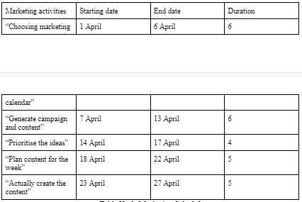
Table No.3: Marketing Schedule
(Source: Created by the Learner)

Control
There are different ways to measure the success of a marketing plan. Customer engagement in the organisation is one of the effective methods of measuring the success of a marketing plan.

Conclusion
The above report has provided good information regarding the Moxy hotel organisation and the different elements required in the marketing plan. The situation analysis has provided good information regarding the marketing plan and the resources available in the organisation.

References
Bhopal, K., 2020. Gender, ethnicity and career progression in UK higher education: a case study analysis. Research Papers in Education, 35(6), pp.706-721.
Dube, A., 2019. Impacts of minimum wages: review of the international evidence. Independent Report. UK Government Publication, pp.268-304.
Henderson, L. and Carruthers, J., 2022. Socio-economic factors, school type and the uptake of languages: Northern Ireland in the wider UK context. The Language Learning Journal, 50(6), pp.712-731.\
Keeler, B.L., Hamel, P., McPhearson, T., Hamann, M.H., Donahue, M.L., Meza Prado, K.A., Arkema, K.K., Bratman, G.N., Brauman, K.A., Finlay, J.C. and Guerry, A.D., 2019. Social-ecological and technological factors moderate the value of urban nature. Nature Sustainability, 2(1), pp.29-38.
Lonsdale, J. and Lucas, C., 2019. The Influence of Key Performance Indicators on relationship and performance of joint venture construction projects In The UK.
Macrory, R., 2023. Breaking the Mould—Britain’s New Office for Environmental Protection. Journal of Environmental Law.
Moxy-hotels (2023) Stylish Budget Hotels, Moxy Hotels. moxy-hotels. Available at: https://moxy-hotels.marriott.com/ (Accessed: March 7, 2023).
Richardson, J.T., Mittelmeier, J. and Rienties, B., 2020. The role of gender, social class and ethnicity in participation and academic attainment in UK higher education: an update. Oxford Review of Education, 46(3), pp.346-362.
Silva, E.S. and Hassani, H., 2022. ‘Modelling’UK tourism demand using fashion retail sales. Annals of Tourism Research, 95, p.103428.
Stognief, N., Walk, P. and Oei, P.Y., 2022. Political economy of climate and energy policies in the United Kingdom. The Political Economy of Coal, p.78.
Weinstein, A.T., 2022. Customer obsession–the springboard for a value creation strategy. Journal of Business Strategy, (ahead-of-print).
Xiong, L. and King, C., 2019. Aligning employees’ attitudes and behavior with hospitality brands: The role of employee brand internalization. Journal of Hospitality and Tourism Management, 40, pp.67-76.

Appendix


