Improving Supply chain Performance
Darren Thomas
Student ID 2117577
MSc Engineering Project Management, University of Wales Trinity of Saint David
ACEA 7011: Procurement and Supply Chain Management
Lecturer: Andrew Thorn
15th February 2022

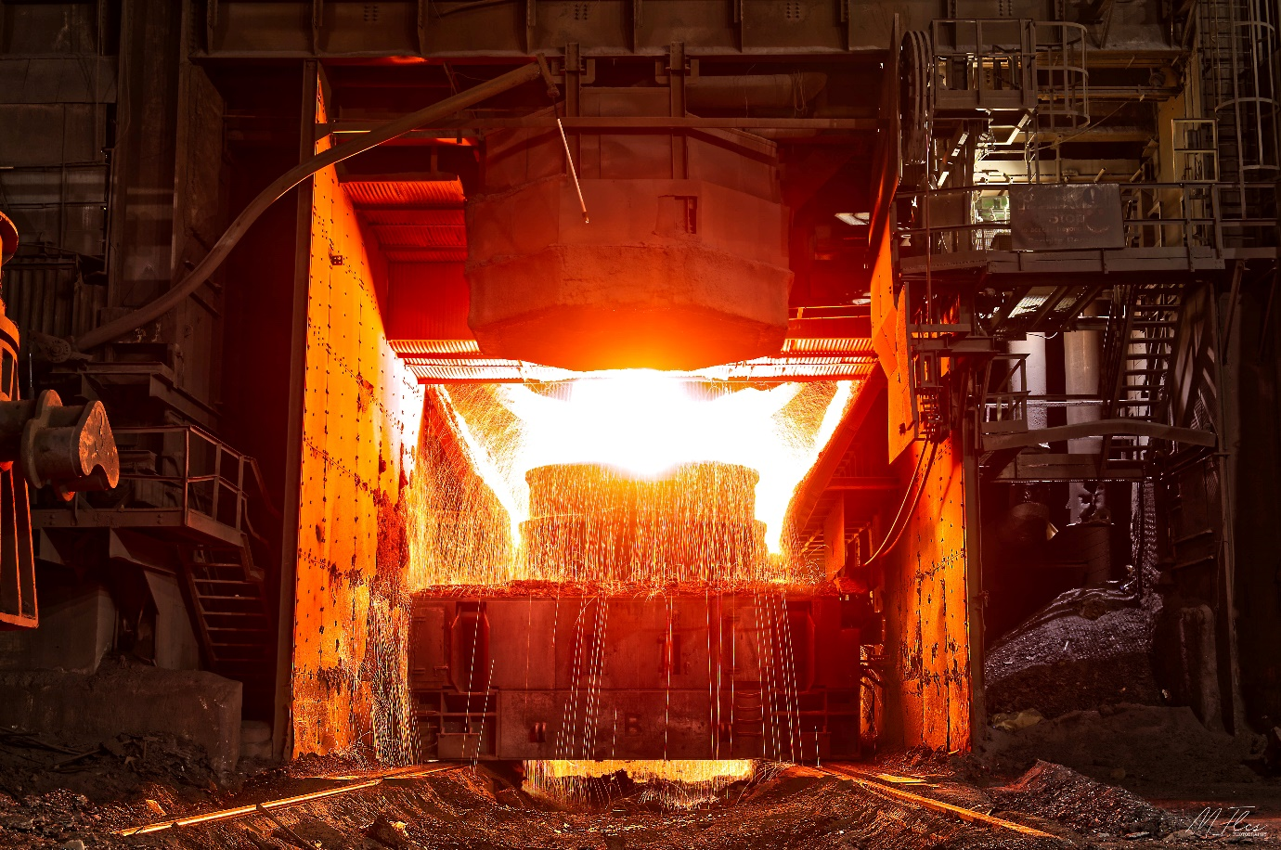

BOS Plant, Port Talbot Steel Works

Contents page

Table of Contents
Contents page 2
List Of Figures 3
Introduction 4
Critical evaluation of supply chain vulnerability 5
Risk Identification 7
The Risk assessment 10
Procedure for Risk Assessment 12
Steps to make the supply chain more resilient 14
Risk Management 14
Monitoring 17
The Supplier Appraisal Process 18
Creating an Effective Supplier Appraisal Process 18
Common Supplier Appraisal Mistakes 18
Supplier Evaluation 20
Quality, Cost, and Delivery 20
Financial Stability 21
Long Term Relationship 21
Total Quality Performance and Philosophy 21
E Commerce capability 21
Available Alternatives 22
Performance Score Card 22
Suppliers Assessment of Supply Chain Strategy. Lean/Agile. 23
Supplier Selection 24
Recommendations 25
Bibliography 26

List Of Figures
Figure 1. Supply Chain Risk 6
Figure 2. Mappin Supply Chain 7
Figure 3. Risk Identification 9
Figure 4. Details of Supply Chain 10
Figure 5. Risk Case Study 11
Figure 6. Pareto Chart 12
Figure 7. Risk Identification and Assessment 12
Figure 8. Basic Pareto 13
Figure 9. TIMWOODS 15
Figure 10. Matrix of Dependency 16
Figure 11. Plan Do Check Act. 17
Figure 12. Supply Chain Appraisal Flow Chart 19
Figure 13. Supplier Evaluation 20
Figure 14. QC&D 20
Figure 15. Balanced Score Card 22
Figure 16. Case Study Lean/Agile 23

Introduction

At the Primary Steel Making area within the BOS Plant in Port Talbot Steel Works many items integral to the process of steel making are manufactured by overseas companies. One of which is a German company which has manufacturing facilities in Dortmund near the North Rhine-Westphalia region, Germany.

One of the parts, an argon spool piece connector which assists in the argon bubbling process and ensures the molten steel is homogenously mixed is a particular concern. Lead times on the part are high due to the specialised materials, component complexity, specialist manufacture, and delivery times.

During the COVID 19 crisis this has been highlighted on several occasions, in the past 18 months spare stock has run out, one reason is inventory has been reduced for cost savings and now due to a shortage and a spike in failures this has nearly caused plant and production losses, which would not be cost effective for the company. Assessing the risk through the supply chain and its resilience will be key to understanding the issues to prevent further shortages.

Future contracts and agreements that bind the company to a supplier regarding guarantees of equipment requires the supplier appraisal process for the manufacture companies to be more robust in the future, this may allow the company more freedom or allow sourcing of components through different avenues authorised and certified by the supplier company.

Critical evaluation of supply chain vulnerability

The Procurement department and the area managers are continually pressured to reduce inventory and spares issues within the Steel works. Improvement in the supply chain will allow materials to be more cost effective and increase availability, with UK companies previously turning to lean and agile sourcing to reduce costs this has shown weaknesses in the supply chain, especially when unforeseen problems occur such as the Covid 19 Pandemic, earthquakes in Japan and Indonesia all putting manufacture and delivery of items on stop or delayed. Removing the slack that protects the supply chain and the company’s inventory has left the industry somewhat inflexible to these events. (Donald. Waters, 2011)

Issues also lie with the original UK based companies moving out of the UK to utilise for example China’s cheap labour, access to European government grants and manufacturing benefits for them. This follows an exaggerated trend in reduction of the UK’s share in the economy of manufacturing of components of the present day. On one hand the UK’s manufacturing industry has been reduced, (reduction equivalent of 10,000 factory jobs lost per month over ten years, (Davis, 2011))
On the other hand, the UK’s Manufacturing Desk work, office-based employment has increased, managing, organising, and selling now seems to be the UK’s foothold on the industry which is key to our issue with solving our supply chain issues with the argon spool piece connector as well as many other pieces of inventory.

The supply chain is made up of Manufacturers, suppliers and distributors working together as a team to source raw materials, manufacture them into useable items or products and to deliver the items to the relative destination for manufacturers and through to the final delivery of the finished product to the end user or customer for profit and or reward. To fulfil the orders and demands of the customers a reliable Supply Chain Management System must be in place as unplanned events occur frequently and can disrupt the flow of materials and products. (Jennifer Blackhurst, 2014) and mitigation must be put in place.

Supply Chain Risk Management (SCRM) can be defined as “The management of supply chain risks through coordination or collaboration among the supply chain partners so as to ensure profitability and continuity” (Jennifer Blackhurst, 2014)

Many Examples of Risk can be found via the internet and the library, Figure 1. below shows many good references that can be researched further and identify “The Supply Chain Risk as the disruption of flow between organisations.” (Ponis, 2010)

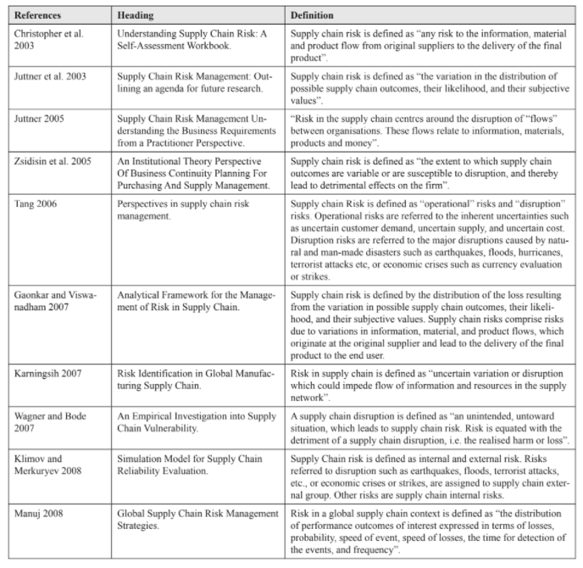

Figure 1. Supply Chain Risk
(Ponis, 2010)

The Risk management process can be carried out by addressing the four key elements.
- Risk identification.
- Risk assessment
- Risk management decision and implementation
- Risk monitoring

(Hallikas, 2004)

- Risk identification is where the risks within the companies supply chain can be identified. Where Mapping the supply chain for the component can be undertaken. Benefits of mapping the supply chain include improvement of relations, identify inefficiencies, helps visualise the process for good communication and development of core competencies.

- Risk assessment should cover the impact of risks facing the supply chain, This can be complicated, examples can be found in the work completed by Zsidisin et al (2004) (Zsidisin, 2004) and Halikas et al. (Hallikas, 2004) highlighting the top risks which will affect the vulnerability of the supply chain.

- Risk Management requires the prioritisation of the main supply chain issues that need to be assessed, Prioritising the top issues short term (Low hanging fruit) and long term, where mitigation can then be put in place and allocation of the resources in the form of a council or team to implement these fixes.

- And Lastly Monitoring over a period of time, Part of Plan Do Check Act,
(PDCA Toyota’s continuous improvement tools (Durward, 2008))

Risk Identification

Below in Figure 2. is a typical mapping of a supply chain in Industry.

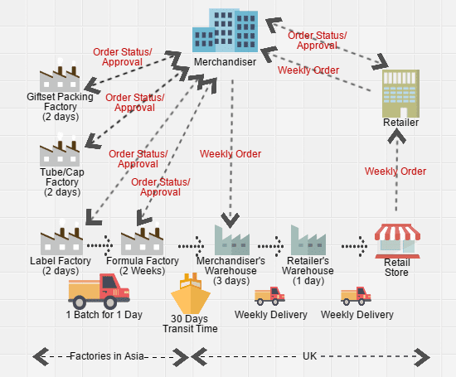

Figure 2. Mappin Supply Chain
(Vernall, 2021)

Risks can be identified as, procurement processes, materials, couriers and transportation, manufacture and workshop availability, skilled workers, quality control, shipping, weather, customs at French and UK ports.

The procurement process at Tata is robust, negotiating contracts to reduce costs and ensure quality is just part of the procurement process. Navigating through the process can be time consuming and can cause delays when issues arise, knowing who to contact is key to speeding up the process, the procurement procedure is in place to protect profitability of the company. (Patowarya, 2019) sourcing outside of the process may lead to a breach in contractual agreements and warranties.

The supplier company that manufactures the connector often see issues with material stock for production of several of the parts that make up the connector, sourcing the material can be a risk especially when there are unforeseen circumstances. Failure in ensuring stock levels are correct can and will delay manufacture and delivery times to all parties.

Couriers and transportation of the materials for manufacture, internal logistics at the manufacturing site and pickup and delivery of the final component can delay the overall lead time of the connectors.

Workshop availability, skilled labour to operate the machines, sickness and industrial action delays all have a part to play in the manufacture times of the components, including quality control, ensuring the components are all to drawing specification, assembled correctly and in good working order before shipment.

Shipping delays are common with issues from Customs, strikes and bad weather delaying shipments, all need to be considered not to delay the contractual agreement. Recently Brexit and Covid 19 lockdowns causing labour shortages and disruptions to logistics networks have all lead to a significant disruption to global supply chains. (Kamali, 2021).
The French workforce have also threatened the UK with disruption of the channel crossing concerning fishing licences, this has caused disruption of the supply chain on numerous occasions in previous years, November 2021 French fishermen blocked the port of Calais and the channel tunnel railway link causing delays and disruption to the UK supply Chain. (Henley, 2021)

Communication breakdown within the many layers of the supply chain has an effect on costs, materials, manufacture and delivery, trust through lack of communication is one of the main issues, with all parties doing their own thing, Engineers and craft personnel keeping personal satellite stock just in case causing obsolescence wastes, stores cutting back on inventory believing that parts are not critical, even stream lining the stores department by scrapping parts and materials that they believe are no longer required, manufacturers not seeing the importance of the lead times as some items are over stocked and others are low due to lack of foresight within the supply chain. Good communication and cooperation is required throughout the departments to reduce these issues. (Koester, 2015)

Risks Identified

Risk Profiles
Orders | O1 | Incorrect Information on Order
Orders | O2 | Order Held in Procurement
Orders | O3 | Uncertainties in Demand
Orders | O4 | Payments
Suppliers | S1 | Material Stock Shortage
Suppliers | S1 | Consumable shortage
Manufacture | M1 | Machine Availability
Manufacture | M2 | Skilled Labour Resource
Manufacture | M3 | Quality Control
Delivery | D1 | Transport Problems/Delays
Delivery | D2 | Damaged or Missing Consignments
Delivery | D3 | Delivery Paperwork and Procedures
Plan | P1 | Conflicting Supply Chain Objectives
Plan | P2 | Incorrect Forecasting
Plan | P3 | Communication between Tata and Customers
Plan | P4 | Lack of Visibility of Inventory Levels
Plan | P5 | Returns Policy and Rectification. PDCA

Figure 3. Risk Identification

The Risk assessment

After comparing the Risks Profiles Identified back in Figure 3. there are similarities through the findings. A key point is the lack of information flow between the companies, lack of data, inaccurate forecasting, and short-term planning, having the procurement department buy in to these findings is key to improvement.

Figure 4. Details of Supply Chain

The Internal Risks to the supply chain that can be addressed are the management or process of Placing the order including Material availability, Manufacture of components and Quality control as in Figure 4. above. Skilled labour, raw materials, health, and safety must all be in place, failure in any part would delay the manufacture and delivery of the finished component and or the quality of the items.
Rising material costs and cash flow issues due to unpaid bills by the customer can have a direct effect on the performance of the supplier company, as well as their managers hoarding excessive stock which can become obsolescent. (C. Donald J. Waters, 2011)

External Risks such as Import operations and customs delays, extreme weather, courier issues, payments all effecting lead times, issues need to be identified and mitigation put in place.
Some of the main causes of risks are inadequate cooperation and lack of visibility between parties within the supply chain. (Donald. Waters, 2011) Communication is essential.

The case study below in Figure 5. and Figure 6. identifies several tools used to identify Risk and how the wholesaler has prioritised the risks identified.

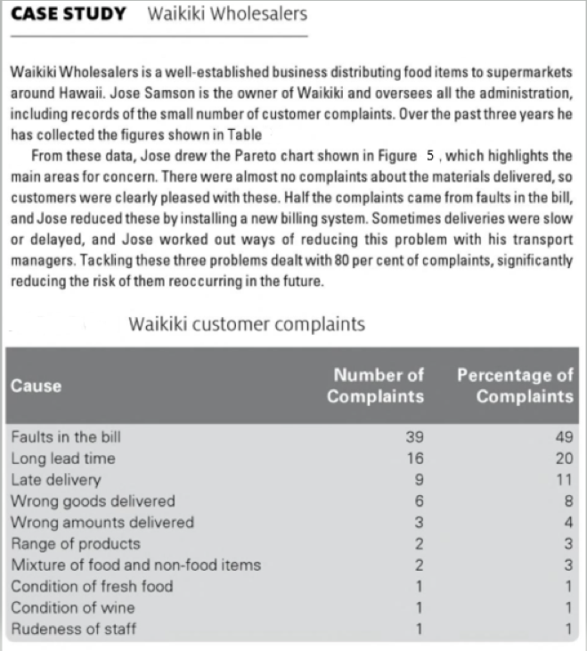

Figure 5. Risk Case Study
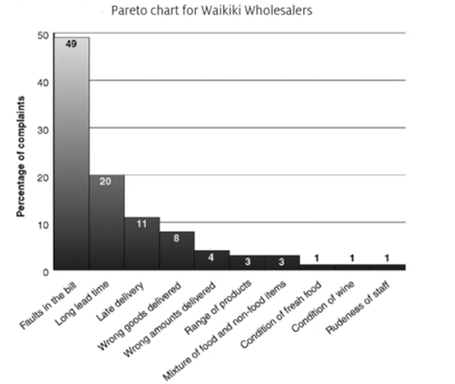

Figure 6. Pareto Chart

(C. Donald J. Waters, 2011)

Procedure for Risk Assessment

The general procedure for assessing the risks identified in a supply chain can be split into several operations (Figure 7) and the risks assessed in each, Inputs are the details of products, operations, business environment, suppliers and finance, the use of tools and procedures tools to highlight the outputs, a list of risks, their sources, symptoms, triggers, and consequences to record in a risk register. (Donald. Waters, 2011)

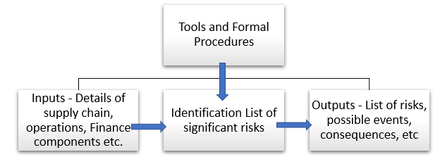

Figure 7. Risk Identification and Assessment

The risks can be identified from previous issues and delays as well as unforeseen external issues. 80% of the issues are generally seen from 20% of the causes. (Donald. Waters, 2011)

Figure 8. below shows a Basic Pareto with Priority Risks highlighted from past orders

Figure 8. Basic Pareto

From the Pareto Figure 8 we can clearly see where resource needs to be implemented and benefits will be seen, Delivery issues, order process and inventory are the largest issue with our findings, subject to the used.

Steps to make the supply chain more resilient

Risk Management

After the Pareto analysis has been completed (Figure 8) the Greatest risks can be focussed on and addressed to improve the resilience of our supply chain.

A Team or council can be set up to define a clear supply chain strategy with the companies core goals and objectives that address these risks.
.
Delivery delays are the main issue highlighted by the data used (Subjectable) which could also incorporate customs and weather, Mitigation should incorporate improved communication on expected completion times of every step of the supply chain and actions completed, this will reduce waiting times and speed up the process. KPI’s can be used to plot the waiting times at each stage to improve delivery expectations including when the items leave the supplier to when they are delivered to site,

Alternative routes can be used when delays are foreseen i.e. weather and channel crossing delays, due to the issues at Calais and Dover with blockades and fishing rights the UK have now looked at options on alternative port crossings from Holland and Belgium and to open trade routes on UK east ports to decrease our reliance on the French crossings. (Barns-Graham, 2021)
Travel restrictions due to Covid, have recently been implemented which has squeezed the supply chain and added further risks that mitigation needs to be in place for, the UK has previously invested in Lean and Agile manufacturing with Just in Time methodologies, going forward this will need to be addressed and risk assessed as the world changes.

Couriers and transportation procedures need to be in place to safeguard deliveries from any potential risk, contracts in place for delivery, loading and unloading practices scrutinised to ensure no damage to components occurs, or tampering potential ensuring security of the items. Understanding the needs of each department and section of the supply chain is essential to a robust supply chain, good communication and the correct information on the paperwork, to a set standard that all can interpret. (Great.Gov.UK, 2021)

The supplier company are required to source the material to manufacture the component. (Stock levels to be implemented). Manufacture of components by various engineering techniques, eg, machining, including Lathe, Miller, Drill, and welding of components together, all consumables to be ordered or on hand in workshops to reduce wasted time and resource. Lean manufacturing techniques and the use of the Toyota principles,5’s and TIMWOODS (Figure 9) can assist in identifying and reduce waste, improving the manufacturing times as well as Kanban systems for minimum and maximum stock levels. (Kelly, 2018)

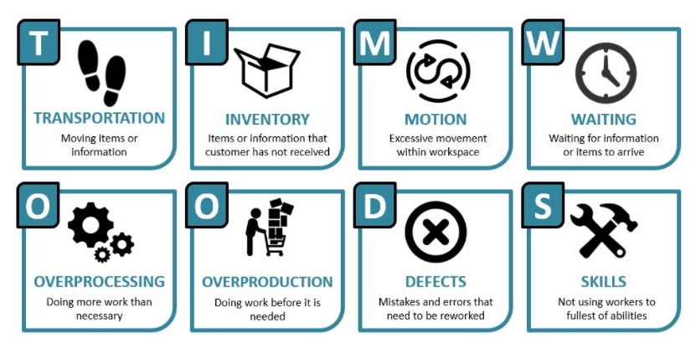

Figure 9. TIMWOODS

Workshop availability with procedures in place for priority tasks, skilled personnel to perform the machining and manufacturing tasks, Trained and competent personnel throughout the business, always ensuring safety.

Quality Control of components is essential ensuring conformance to specification reducing variance, ensuring reliability of the components. (Kulkarni, 2004) Min Max levels of order to ensure cost effectiveness of machine availability and set up as delays for materials would have the machinery left idol or set up for other jobs wasting valuable time and resource and reduction in returns.

Inventory levels within the supply chain are really an unknow, with the manufacturing shop floor personnel hoarding spares and material as a just in case scenario, to stores department misplacing them, to the onsite engineer and craft personnel keeping satellite stores and locker spares, shift engineers who have previously been caught out on a break downs, so they also keep a couple under the desk, its all down to trust in the supply chain, one way to improve is to use the data collated to set the min max levels correctly which is difficult and an ongoing process,
using maximum delays forecast and maximum usage of components minimum levels can be plotted to increase the required stock levels for improved availability on critical spares giving more flexibility in the system when issues arise, where standard delays and standard usage may be used on non-critical spares, which in turn reduces inventory and costs. Trust within the departments, supplier, procurement, and Engineering teams is essential to fully understand the levels of inventory used, stored, and required. Communication is essential to the smooth running of the supply chain which will help create transparency and trust between all parties, with benefits for all and contributes to a sustainable business. (Koester, 2015)

Risk Prevention is the preferred method, taking action before the event happens, good communication through the supply chain allowing the company to anticipate and avoid the problems not responding to risk after the failure has occurred. (Gregory L. Schlegel, 2014)

Single sourcing is advantageous if the supplier as well as the buying company (Tata) are dependent on each other, in this case the supplier has a large interest in the Steel works industry lowering the risk of failure to supply in good time, a good relationship is key to the success of both businesses , below is the Matrix of dependency which highlights the importance of the buyer and supplier collaboration benefits, Mutual dependency is a win win situation . Figure 10. (Bob Ritchie, 2008)

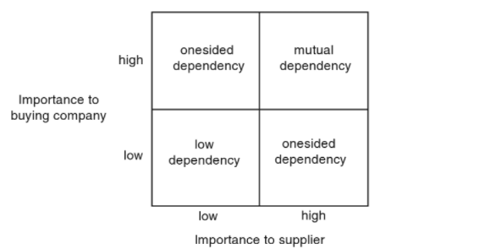

Figure 10. Matrix of Dependency

Single source suppliers can also be an issue where local manufactures may be able to produce the component in half the time but may have a cost implication and jeopardise contracts and unit performance due to legal obligations, design and tolerances of components. Multi source suppliers could be an alternative.

Monitoring

Monitoring the risks over time, taking good data, and measuring the information, old and new can assist with ongoing improvement to the supply chain. The Risk can change from week to week, season to season, year to year. Plan Do Check Act (Figure 11) is part of the Toyota principle for Lean management, tried and test throughout industry and is proven to be a good tool in problem solving. (Durward, 2008)

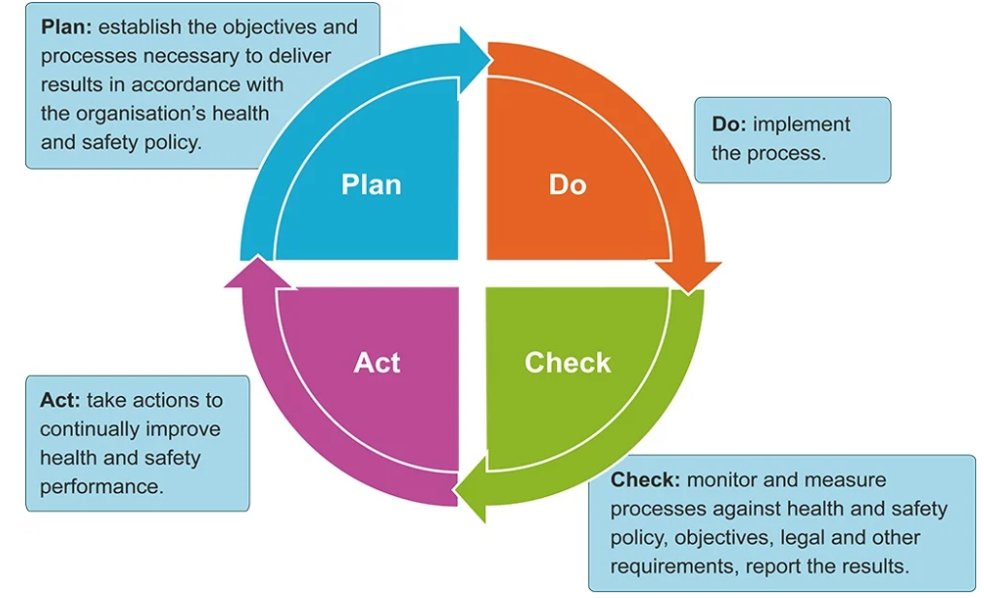

Figure 11. Plan Do Check Act.

(Dafydd Jenkins MSc, 2019)

The Supply Chain Manager within procurement is required to ensure all parts of the supply chain are in place. Including the supply chain strategy, materials and services are in place, focused on productivity and efficiency of manufacturing, delivery, and logistics and lastly the returns system for defective parts. (FERNANDO, 2021)

The Supplier Appraisal Process

The Supplier appraisal process can give a company many advantages if completed correctly. Many suppliers will not perform as they are required, and this can be identified and avoided through this process. Weaknesses in the supplier’s performance can be highlighted, discussed, and addressed. Customer service levels agreed and understanding each other’s needs can strengthen the buyer supplier relationship.

Creating an Effective Supplier Appraisal Process

Many companies aim to use a supplier appraisal, but most of the time the process is very subjective and ineffective. The appraisal system needs to be a systematic approach to deliver results.

An effective supplier appraisal process needs measurements and targets that are easily understood by both parties. Key Performance Indicators (KPI’s) should be aligned with the company’s priorities and non-negotiables. E.g. Value, Lead times, environmental impact and safety.

Discussions with both parties are required for decisions on the KPI’s and setting the graphical representation of the data also a reward system for improved performance, ensuring objectives set by the appraisal process yield benefits for the supplier and Tata. Some float in the KPI’s is required and not everything can be measured, but key objectives should be focussed on for improvement.

Common Supplier Appraisal Mistakes

Supplier appraisal doesn’t have to be complicated, but it needs to be completed to keep focus on the objectives otherwise the key benefits will be lost.

Focus needs to be on the agreed KPI measurements, communication with the supplier and regular feedback on performance is key to increase benefits, keeping KPI’s and system measurement simple and easy to understand can also assist in the customer relations between supplier and buyer. When carrying out a supplier appraisal, the supplier may believe there is a change coming and may be eliminated as a vendor so they will need to be reassured and the reasons are to promote continues improvement for both parties. (O'Byrne, 2019)

Supply Chain Appraisal Flow Chart
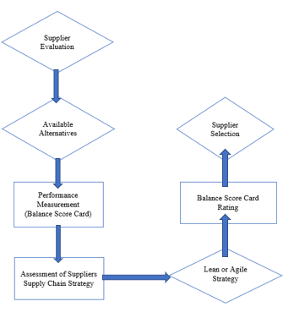

Figure 12. Supply Chain Appraisal Flow Chart

(Gordon, 2008)

Figure 12. shows a flow diagram of a route we can follow our supply chain appraisal. Firstly, Supplier evaluation needs to take place, followed by sourcing alternative available companies that can perform the same tasks, then to measure and score the companies a balanced score card can be produced to performance measure the companies against each other, assessment of the suppliers can then take place in regards to their supply chain strategy and our needs, leading back to our score card for an overall rating and supplier selection.

Supplier Evaluation

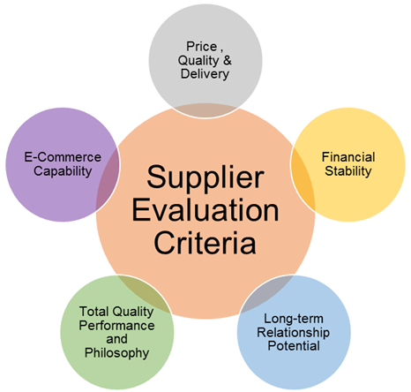

Figure 13. Supplier Evaluation

Quality, Cost, and Delivery

Quality, Cost, and Delivery (QC&D) highlighted in Figure 13. above and Figure 14. below is known to be one of the most important requirements within our supply chain, failure in quality in procurement, product quality, reliability, lead time is constraining, and supplier characteristics should all be taken into account. Adding value to their product by providing good quality service is essential, reducing waste through inventory, storage, and delivery controls. (Ng Shi Yun, 2018)

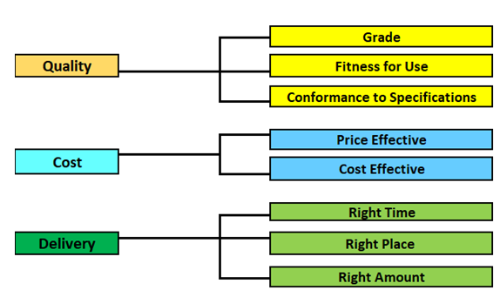

Figure 14. QC&D

Financial Stability

The supplier’s financial status should be evaluated as this can influence the customer service they provide, credit reports can inform us of their financial status and highlight their experience, stability, management, facilities and pricing policies all assisting in the supplier selection process.

Long Term Relationship

Gaining long term relationships with a company can encourage joint ventures for cost savings and new product development, communication on gaols of both companies for mutual benefits need to be discussed.

Total Quality Performance and Philosophy

The TQP gaol is to achieve zero defects and to change the way people do things to reach this goal, minimising the potential for defects is key, continuous improvement to achieve excellence. Assessing the suppliers on their performance and philosophy is highly essential to yield benefits for both parties.

E Commerce capability

In the current E Commerce world companies like Amazon and E bay lead the way. Buying and selling of goods and products by the touch of a button is key to reduction in costs, saving time and energy for both the supplier and the company, Access 24hours a day allowing quick turn around increasing higher profit margins and fast deliveries when required.

Available Alternatives

Evaluating the Risk of a single source supplier over multisource has its benefits including fewer contracts to maintain, increasing costs and time savings, better responsiveness, improved buying power and better-quality results. Due to the current issues around the pandemic, the supply chain has developed greater risks to delivery and manufacture of components, seeking alternatives or a plan B is essential for improving pricing, design, reducing risk, eliminating delivery issues and increasing production capacity where available or required. (Chester, 2021)

Performance Score Card

An example of a balanced Score card is below in Figure 15. The main perspectives to be considered are the financial, customer, business, learning and growth perspectives. Depending on the companies’ requirements this can be modified for criteria which best fits the needs and conditions of the company and a scoring Matrix used to assess the data.

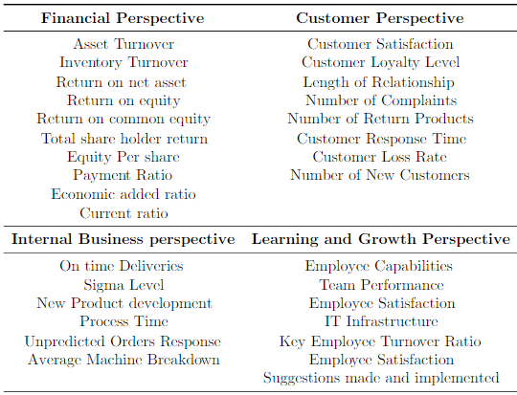

Figure 15. Balanced Score Card
(Galankashi, 2013)

Suppliers Assessment of Supply Chain Strategy. Lean/Agile.

The main supply chain strategies are Lean and Agile or a combination of both. Lean following the Toyota principles eg 5’s, level scheduling, Kanban, TQM, TPM. Discussion on which best suits the companies demands and requirements can be addressed.

The case study below Figure 16. Show a typical Lean Supply Chain Strategy

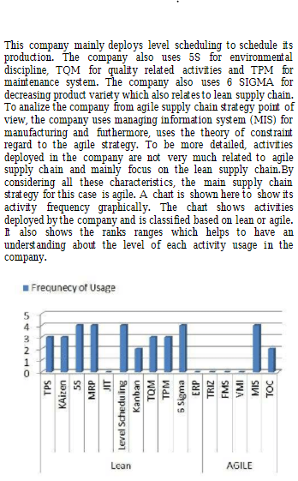

Figure 16. Case Study Lean/Agile

(Masoud Rahiminezhad Galankashia*, 2013)

Supplier Selection

With the use of all the data available a choice is to be made to satisfy the companies needs, Not only cost but reliability, customer focus, and flexibility, with our needs for the argon spool piece connector, (amongst other components).
Achieving goals requires SMART* strategy and careful planning.
However, the financial side of the management of the supply chain (Procurement department) will prioritise the cost accounting, which needs to be taken into consideration. (Patel, 2020)

*SMART. Specific, Measurable, Achievable, Relevant, Time Bound.
(Bruno S. Frey, 2002)

Recommendations

All departments within the company are tasked with reducing costs without increasing risk to steel production. The supply chain vulnerability and mitigation are key elements to the success of the process of cost reduction and profitability of the company.
The supply chain must go through re-development to manage and mitigate the changing risk and exploit new opportunities and improve the supply chain.
A supply chain Team or council to be set up to define a clear supply chain strategy with the company’s core goals and objectives at the forefront of the decision making.
Communication throughout the supply chain is essential to understand every department’s goals and objectives, reduction in inventory hoarding will reduce waste and help in cost reduction through reduction in obsolescence, over manufacture, holding costs and help to increase trust with a view of the inventory available through Kanban systems and Lean management tools, as well as transparency on lead times of spare parts through management systems such as SAP.
Correct forecasting and planning with expected life cycle of parts taken into consideration. Quality controls implemented to improve the life cycle and correct skilled labour to manufacture and install the components to ensure the lifecycle and beyond is reached.

Suppliers Distribution network, ensure data including charts, graphs and comparable documentation are similar throughout the supply chain for improved communication awareness and flow of inventory.
The use of today’s technologies is another key element that can be utilised to improve the supply chain, reviewing the existing processes, and utilizing apps, tools and techniques to improve the process helping streamline the supply chain.
Building healthier relationships with the suppliers on an ongoing basis can help achieve the goals of the company, improving communications, understanding goals objectives of all, measuring performance, paying bills on time all help towards reducing conflict.
Reviewing the policies and procedures in place regularly can ensure efficiency and compliance in turn help avoid bottle necks in the system and assist in the smooth running of the supply chain, mitigation of risks of theft and fraud can also be tackled.
In the current climate establishing Green Initiatives is crucial to the success of companies and the environment, reducing the companies carbon footprint wherever possible will increase the company’s sustainability and promote social responsibility.

Bibliography

Barns-Graham, W., 2021. News & Press: International Trade News. [Online]
Available at: https://www.export.org.uk/news/585576/UK-looks-to-diversify-trade-routes-in-and-out-of-Europe-following-French-threats-of-Calais-blockade.htm
[Accessed 18 January 2022].
Bob Ritchie, G. A. Z. ed., 2008. Supply Chain Risk. In: A Handbook of Assessment, Management, and Performance. Netherlands: Springer US, pp. 126-133.
Bruno S. Frey, M. O., 2002. Successful Management by Motivation: Balancing Intrinsic and Extrinsic Incentives.. In: M. O. P. B. S. F. Bruno S. Frey, ed. Germany: Springer, pp. 234,237..
C. Donald J. Waters, D. W., 2011. Vulnerability and Resilience in Logistics. In: Supply Chain Risk Management. s.l.:Kogan Page, pp. 99-114.
Chester, L., 2021. 5 Reasons to Explore Alternate Suppliers. [Online]
Available at: https://www.ascm.org/ascm-insights/5-reasons-to-explore-alternate-suppliers/
[Accessed 29 January 2022].
Dafydd Jenkins MSc, B. (. F. G. S., 2019. Astutis, PDCA Cycle. [Online]
Available at: https://www.astutis.com/astutis-hub/blog/plan-do-check-act-to-manage-safety
[Accessed 22 January 2022].
Davis, E., 2011. Made In Britain, How the nation earns its living.. s.l.:Little, Brown Group .
Donald. Waters, J. W. C. D., 2011. Supply Chain Risk Management:Vunerability and Resilience in Logistics. United Kingdom: Kogan Page.
Durward, K. S. l. A. S., 2008. Understanding A3 Thinking. A Critical Component of Toyota's PDCA Management System. s.l.:CRC Press.
FERNANDO, J., 2021. Investopedia. [Online]
Available at: https://www.investopedia.com/terms/s/scm.asp
[Accessed 22 January 2022].
Galankashi, M. R., 2013. Supplier Selection for Electrical Manufacturing Companies Based on Different Supply Chain Strategies. Open International Journal of Technology Innovations and Research.
Gordon, S. R., 2008. A Guide to Meaningful Metrics and Successful Results. In: Supplier Evaluation and Performance Excellence. United States: J. Ross Pub..
Great.Gov.UK, 2021. Documentation for international trade. [Online]
Available at: https://www.great.gov.uk/advice/prepare-for-export-procedures-and-logistics/documentation-international-trade/
[Accessed 18 January 2022].
Gregory L. Schlegel, R. J. T., 2014. An Emerging Discipline. In: Supply Chain Risk Management. United Kingdom: Taylor & Francis, pp. 1-19.
Hallikas, J. K. I. P. U. V. V. a. T. M., 2004. Risk Management process in supplier networks.. International Journal of Production Economics, Volume 90, pp. 47-58.
Henley, J., 2021. French fishers plan to block freight to UK in Brexit licences dispute. [Online]
Available at: https://www.theguardian.com/politics/2021/nov/23/french-fishers-plan-block-freight-uk-licences-dispute-brexit
[Accessed 23 January 2022].
Jennifer Blackhurst, T. W., 2014. Managing Supply Chain Risk and Vulnerability. London: Springer.
Kamali, P., 2021. What longer delivery times say about global supply chains. [Online]
Available at: https://www.weforum.org/agenda/2021/11/longer-delivery-times-supply-chain-disruptions
[Accessed 16 January 2022].
Kanbanize, 2021. Kanbanize. [Online]
Available at: https://kanbanize.com/lean-management/improvement/what-is-pdca-cycle
[Accessed 22 January 2022].
Kelly, R., 2018. How to Successfully Make the Transition from Theory to Effective Deployment. In: The Myths and Truths of Lean Transformations. United States: Taylor & Francis, pp. 1-54.
Koester, V., 2015. Communication Along the Supply Chain. [Online]
Available at: https://www.chemistryviews.org/details/ezine/8095361/Communication_Along_the_Supply_Chain.html
[Accessed 23 January 2022].
Kulkarni, S., 2004. Reliability and Quality Management. In: Supply Chain Management, Creating Linkages for Faster Business Turnaround. s.l.:Tata McGraw-Hill, pp. 221-224.
ManMohan S. Sodhi, C. S. T., 2012. Managing Supply Chain Risk. New York: Springer.
Masoud Rahiminezhad Galankashia*, F. Z. S. A. H. A. M. B., 2013. Assessment of Supply Chain Strategies and Analysis on the Performance of Companies Deployed Strategy Using Activity Based Approach. Jurnal Teknologi, pp. 39,43..
Ng Shi Yun, P., 2018. 5 Key Criteria for Supplier Evaluation in the Construction Sector. [Online]
Available at: https://publication.sipmm.edu.sg/5-key-criteria-supplier-evaluation-construction-sector/
[Accessed 29 January 2022].
O'Byrne, R., 2019. Supply Chain Leaders Academy. [Online]
Available at: https://www.supplychainleadersacademy.com.au/the-importance-of-an-effective-supplier-appraisal-process/
[Accessed 25 January 2022].
Patel, N., 2020. Global Trade, How to Select the Best Supply Chain for Your Business. [Online]
Available at: https://www.globaltrademag.com/how-to-select-the-best-supply-chain-for-your-business/
[Accessed 29 January 2022].
Patowarya, J., 2019. You Didn’t Know these 7 Steps of an Effective Procurement Process. [Online]
Available at: https://www.zycus.com/blog/procurement-technology/you-didnt-know-these-7-steps-of-an-effective-procurement-process.html
[Accessed 16 January 2022].
Ponis, S., 2010. Managing Risk in Virtual Enterprise Networks, Implemetenting Supply Chain Principles.. s.l.:Business Science Reference.
Vernall, M., 2021. What is supply chain mapping. [Online]
Available at: https://www.quora.com/What-is-supply-chain-mapping
[Accessed 16 January 2022].
Zsidisin, G. E. L. C. J. a. C. J., 2004. An Analysis of supply chain assesment techniques.. International Journal of Physical Distribution & Logistics Management, 34(5), pp. 397-413.

