Marketing Plan for six senses hotel

Student ID: 2239001
Student name: Koshis Bhattarai
Module name: Marketing Essentials
Module number: BMIH4005

Table of Contents
Introduction 3
Situation Analysis 3
Objectives 7
Strategy 7
Tactics 8
Action 9
Control 9
Conclusion 10
Reference List 14

Introduction
Six Senses is one of the most efficient 5-star luxury hotels originated in Bangkok which is being addressed in the assignment. This marketing plan identifies the proficiency of the company in its digital marketing genre and highlights new ways to improve it. The situational analysis of the company is being done which includes their 5C's, company, customer, competitor, collaborator, and climate. Their marketing mix is also analyzed followed by the proposal of an objective. The objective is targeted with some significant strategies that are evaluated by implementing the Ansoff matrix. Some tactics are prepared by using the RACE model and understanding the different marketing loopholes identified earlier.

Situation Analysis
Company
SWOT
Strength
The strength of the chosen organization mainly relies on providing quality services, attracting guests, and making good profitability.
Weakness
Technical implementation is quite low and staff experience is quite low also and these two can be the weaknesses for six senses.
Opportunities
The adaptation of the digital marketing utilization process can create opportunities for them (Bowie et al., 2017).
Threats
Increasing rate of competition and increasing rate of costs may create threats for them.
Customer
The segmentation process of the chosen organization is relying on the different age groups which are 16-34. The market segmentation process of the Six Senses is dependable on this type of demographic (Housden, 2008). On the other hand, the target market of the chosen organization is dependent on the number of guests.

Competitor
Perceptual positioning map
The Four Seasons are renowned as the biggest competitor of the Six Senses who are providing different types of quality services with technological facilities (Ryan, 2012). On the other hand, Six Senses are trying to implement technologies with quality services.
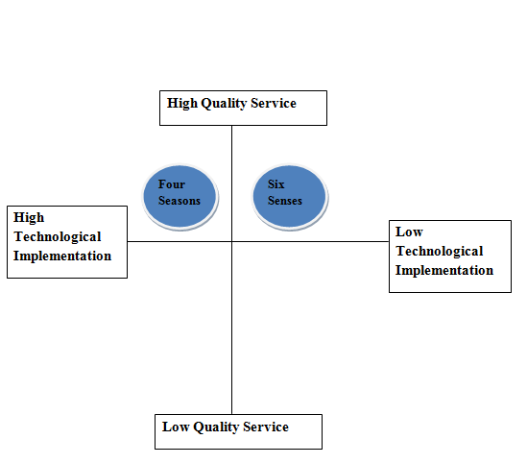
Figure 1: Perceptual positioning map
(Source: Self-made)
Bowman's strategy clock
Depending on this strategy clock, Six Senses can provide different types of quality services (Wei, 2022). They also try to implement technological advancements that enhance their capability to compete with others within the marketplace.

Collaborator
B2B Relationships
The B2B relationships are one of the most crucial things that help the chosen business organization to make some profit by providing quality services.
Partnerships
They made a partnership with the United States Coalition, which is responsible for providing essential sustainability that may attract guests (Smith and Zook, 2020).
Franchises
Depending on their franchises they can show their existence within the marketplace and it helps to create brand awareness also.

Climate
PESTLE Analysis
Political
Some tourism laws that are implemented by the government can affect the business of Six Senses.
Economic
Some of the economic changes such as inflations, and recessions may affect the entire business of Six Senses.
Social
The utilization of different social media platforms helps the Six senses to enhance their social existence.
Technological
Technological factors and their advancement play a significant role in them also (Chaffey and Ellis- Chadwick, 2019).
Legal
Different types of legal obligations such as tax deductions, and tourism laws may affect the entire business of Six Senses.
Environmental
The business of Six Senses is always trying to focus on the low rate of carbon footprint.

Marketing Mix
Product
The product of Six Senses is relying on providing excellent services to the guests.
Price
The price range of the hotel rooms is quite affordable for tourists.
Place
Consumers can book this hotel online and offline and it is one of the most attractive things (Kotler et al., 2020).
Promotion
In terms of brand promotion, Six Senses utilized different types of digital media tools.

Objectives
SMART
Aim: To develop better digital marketing proficiency to attract more organic reach (Lac, 2023).
Specific | Measurable | Achievable | Relevant | Time Bound
To enhance a market research team to identify better traditional or acquired preferences of new customers. | Every month, at least one new customer base will be harnessed and information will be presented. | It will require the support of an excellent R&D team which would help in adjoining the strings accordingly (Clow and Baack, 2013). | It is acceptable as Six Senses has an extravagant R&D team that is efficient in conducting the research. | 3 months

Strategy
Ansoff’s matrix
Six Senses will implement and use the strategy of market development of Ansoff Matrix as a new value proposition to attract customers to their products and services (Hultman et al., 2021). As a result, it will focus on selling existing products in various new markets by doing digital marketing.
- The strategy of market penetration will help to increase sales of products in existing markets.
- Following the strategy of market development will help to reach the maximum number of customers (Tan and Despotis, 2021).
- Thai companies also need to be careful in product development along with introducing new products in markets. In the context of brand reputation, this strategy will have broader support.
- Moreover, the company will be able to offer customers a diversity of products and services.
Changes in the Marketing mix
The hotel company Six Senses needs to make changes in the element promotion of the marketing mix to become efficient in this field by improving the quality of digital marketing.

Tactics
RACE
Factors | Strategy
Reach | The potential audience of Six Sense company is male and female both, where the percentage of females is 50.40% and 49.60% of males.
Act | Different types of support in various types of social media platforms like Face book, Twitter, WhatsApp, and so on to develop leads.
Convert | Achieve the approval to adopt different types of strategies like they receive approval of USGBC for the standard of LEED.
Engage | Make a deep relationship with customers by managing or maintaining their loyalty to customers.
Current communication process
A proper digital communication process will be handled through different types of social media platforms and email marketing. Besides this, the company also uses various running banner ads and also publishes different advertising articles. This type of advertising method of this company is not able to collaborate with huge amounts of customers (Tariq et al., 2022). Sometimes, they are unable to give proper information about this hotel to customers. So, in that case, for more growth of Six Sense Company, the management authority of this company has to focus on different types of high-quality type social media marketing platforms (Jobber and Ellis-Chadwick, 2020). Through this, they can communicate with large numbers of people in a single time and also can spread their proper marketing concept, their services, product details, and prices to all very easily.

Action
Gantt Chart
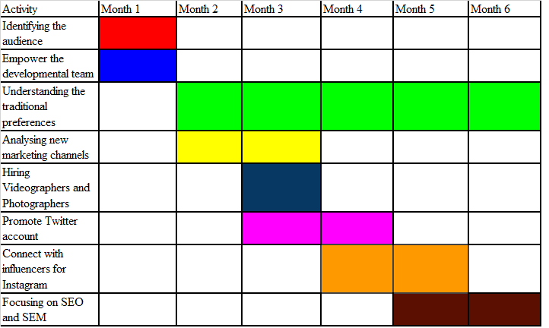
The above Gantt chart provides a clear assumption of the different activities that the company has to behold in the different months. The understanding of new customer preferences has been mentioned as a continuous process due to the gradual change in preferences (Tuomivaara, 2023). The developmental team should track the preferences regularly to gain new insights into the matter. These would be a matter of 6 months which would be helpful for the company in addressing the target customers and identifying their tastes.

Control
The success rate of the Six Senses hotel company will be measured by KPIs metrics. KPIs help businesses to meet ultimate targets and strategic objectives (Santos and Silva, 2019). So, it is very clear that this strategy is helpful for companies like Six Senses in improving and developing their functions and services.
- Trying to reach more new customers from different markets and regions within 1 year.
- Being more careful in the context of increasing brand value and positivity by 30% within 6 months (Ghauri, 2014).
- Being efficient in marketing to have an increment in the rate of revenue generation by 20% within 5 months.

Conclusion
From the above assignment, it can be concluded that the digital marketing proficiency of Six Senses is a major strategy for them to improve their reach. However, they are quite behind in terms of identifying the new traditions and this stagnate their impact on gaining a better customer base than the current period. The provision of the Gantt chart also showed an assimilative, yet compact overview of what show should be done by the company.

Reference List
Bowie, D., Buttle, F., Brookes, M., and Mariussen, A., (2017). Hospitality Marketing. 3 rd ed, Routledge, London
Chaffey, D. and Ellis- Chadwick, F., (2019). Digital Marketing. 7 th ed, Pearsons, London.
Clow, K. and Baack, D., (2013). Integrated Advertising, Promotion and Marketing Communications. 6 th ed, Pearson, London
Ghauri, P. N., (2014). International Marketing, 4 th Ed, McGraw Hill, London
Housden,M., (2008). Marketing Research &amp; Information, Butterworth Heinemann, Oxford.
Hultman, M., Papadopoulou, C., Oghazi, P. and Opoku, R., (2021). Branding the hotel industry: The effect of step-up versus step-down brand extensions. Journal of business research, 124, pp.560-570. Available at: https://eprints.leedsbeckett.ac.uk/id/eprint/7165/1/BrandingTheHotelIndustryTheEffectOfStepUpVersusStepDownBrandExtensions-AM.pdf
Jobber, D. and Ellis-Chadwick, F., (2020). Principles and practice of marketing. 9th ed. London:
Kotler, P., Armstrong, G., Harris, L. and He, H., (2020). Principles of marketing. 8 th European ed, London: Pearson Education Limited.
Lac, M., (2023). Is traditional TV advertising still relevant?: current state analysis and future developments. Available at: https://www.theseus.fi/bitstream/handle/10024/800934/Lac_Marie.pdf?sequence=2
Ryan, D., (2012). Understanding Digital marketing: Marketing Strategies for Engaging The Digital Generation. Kogan Page, London.
Santos, J.D. and Silva, O.L. eds., (2019). Digital marketing strategies for tourism, hospitality, and airline industries. IGI Global. DOI: 10.4018/978-1-5225-9783-4.ch001
Smith, P. R., and Zook, Z. E., (2020). Marketing Communications. 7 th ed, Kogan Page, London
Tan, Y. and Despotis, D., (2021). Investigation of efficiency in the UK hotel industry: A network data envelopment analysis approach. International Journal of Contemporary Hospitality Management. Available at: https://pure.hud.ac.uk/ws/files/34921450/CHECKED_IJCHM_revised_manuscript_02012021.pdf
Tariq, E., Alshurideh, M., Akour, I., Al-Hawary, S. and Kurdi, B., (2022). The role of digital marketing, CSR policy and green marketing in brand development. International Journal of Data and Network Science, 6(3), pp.995-1004. Available at: https://growingscience.com/ijds/Vol6/ijdns_2022_12.pdf
Tuomivaara, J., (2023). How Do Influencers Impact Young Women’s Consumer Purchase Decision-Making?. Available at: https://www.theseus.fi/bitstream/handle/10024/801599/Tuomivaara_Julia.pdf?sequence=2
Wei, D., (2022). Gemiverse: The blockchain-based professional certification and tourism platform with its own ecosystem in the metaverse. International Journal of Geoheritage and Parks, 10(2), 322-336. Available at: https://www.sciencedirect.com/science/article/pii/S2577444122000296

