

Programme: | MSc Public Health and Social Care in Practice
Module: | Population Health and Digital Health Promotion
Module code: | LCHS7009
Lecturer: | Diola Bijlhout`  Dr Ping Wu
Assignment Title: | Component 1  2 Blogs
Name: | Jahanvi Sodha
Student ID: | 2530085

Table of Contents
Blog 1- Critically discuss the impact of an existing digital technology currently used for a digital health promotion intervention 3
A public health challenge 3
Description of digital technology 4
Impact of digital technology in health promotion (advantages and limitations) 4
How this shortfall can be addressed? 6
References 7
Blog 2- Critically discuss the impact of a digital technology YOU DESIGNED for a digital health promotion intervention 9
Cancer is a leading public health concern. 9
Modified version of an existing one 10
How this modified digital technology can address cancer 10
Impact of the modified digital technology in health promotion 11
How can this shortfall be addressed? 12
References 13

Blog 1- Critically discuss the impact of an existing digital technology currently used for a digital health promotion intervention
Title: Cancer Prevention in the Digital Age: Are Mobile Health Platforms making a difference?

A public health challenge
Cancer is a significant public health challenge in the UK, which is a leading cause of life years lost and increasing concerns for early prevention (UK.GOV, 2026). 25% of deaths in the UK are caused by cancer as of 2021 (UK.GOV, 2026). Additionally, according to NHS Digital, new cancer cases reached 352,015 during 2023 to 2024, whereas 40% of cancers can be prevented through early preventive care, lifestyle modifications and participating in screening programmes (NHS Digital, UK, 2026).

Figure 1: An NHS doctor examines a mammogram of a cancer patient
(Source: Rawlinson, 2025)
Despite national awareness campaigns in the UK spreading the importance of continuous engagement in modifiable risk factors (Steele et al., 2025), such as:
- Physical inactivity
- Smoking
- Excessive alcohol consumption
- Unhealthy diets and
- Poor uptake of cancer screening (Parada et al., 2025; Espinosa-Salas et al., 2026).
These are the main causes of cancer and raise concerns about this public health problem.

Description of digital technology
The NHS-designed Cancer 360 platform uses AI to collect cancer patients' data into one central system, which helps doctors and nurses to identify the most affected patients and see them more quickly to ensure meaningful improvements in patient experiences (Rawlinson, 2025). The importance of the tool has been tested through a pilot test in United Hospital in Bath, where it has been found that it has the potential to provide a diagnosis for around 75% of patients within 28 days of referral (Rawlinson, 2025).
Through integrating the Health Belief Model (HBM), this app provides real-time health education and behavioural prompts, including:
- Personalised health information
- Screening reminders
- Symptoms awareness
- Lifestyle advice
- Smoking cessation directly through smartphones
These aims are to encourage individuals to adopt healthier lifestyles and participate in preventative healthcare (NHS.UK, 2025).

Impact of digital technology in health promotion (advantages and limitations)
This digital intervention helps in preventing cancers through the personalised interventions and ensure meaningful improvements in patient experiences.

Advantages

Figure 2: Cancer 360 speeds up cancer diagnosis
(Source: Innovation News Network, 2025)
- This app gives patients more controlled and better care, and it minimised 19% of hospital admissions rate (Innovation News Network, 2025).
- 84.7% of cancer patients in the UK received evidence-based diagnosis within 28 days through this app (NHS.UK, 2025).

Disadvantages

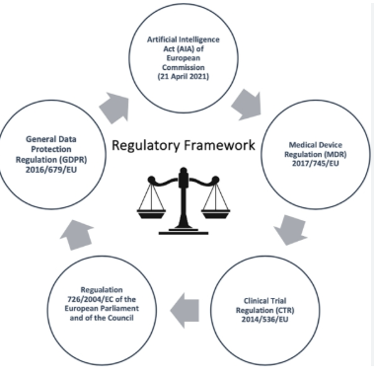
Figure 3: Ethical and regulatory challenges of AI technologies in healthcare.
(Source: Mennella et al., 2024)
- Despite these benefits, underserved populations (Deprived areas) may struggle to access and use the benefits of Cancer 360 due to a lack of internet connectivity (Kale et al., 2023; Mansour et al., 2024).
- If robust governance measures are not maintained during the Cancer 360 intervention, then it will cause data privacy concerns regarding issues, which can lead to patient trust erosion (Ahmed et al., 2025; Robles et al., 2026).

How this shortfall can be addressed?
These limitations can be addressed through providing digital literacy training among the underserved populations and designing accessible and user-friendly interfaces. Additionally, implementing data privacy governance and compliance with GDPR acts can help to prevent concerns about data privacy during this intervention.

References
Ahmed, M.M., Okesanya, O.J., Oweidat, M., Othman, Z.K., Musa, S.S. and Lucero-Prisno III, D.E., 2025. The ethics of data mining in healthcare: challenges, frameworks, and future directions. BioData mining, 18(1), p.47. Available at: https://doi.org/10.1186/s13040-025-00461-w Accessed 17th July 2026.
Espinosa-Salas, S., Keyes, D. and Gonzalez-Arias, M., 2026. Behavior modification for lifestyle improvement. StatPearls.
Innovation News Network. 2025. Millions of patients in the UK are set to receive a faster cancer diagnosis, helping cut treatment delays and boost survival rates as the government rolls out pioneering new technology across the NHS.. [Online]. Available at: https://www.innovationnewsnetwork.com/cancer-360-new-uk-tech-set-to-speed-up-cancer-diagnosis/57725/ Accessed 17th July 2026.
Kale, S., Hirani, S., Vardhan, S., Mishra, A., Ghode, D.B., Prasad, R. and Wanjari, M., 2023. Addressing cancer disparities through community engagement: lessons and best practices. Cureus, 15(8). Available at: https://doi.org/10.7759/cureus.43445 Accessed 17th July 2026.
Mansour, R., Abdel-Razeq, H., Al-Hussaini, M., Shamieh, O., Al-Ibraheem, A., Al-Omari, A. and Mansour, A.H. 2024. Systemic barriers to optimal cancer care in resource-limited countries: Jordanian healthcare as an example. Cancers, 16(6), p.1117. Available at: https://doi.org/10.3390/cancers16061117 Accessed 17th July 2026.
NHS Digital, UK. 2026. Cancer Services Profiles, 2025 annual update. [Online]. Available at: https://digital.nhs.uk/data-and-information/publications/statistical/cancer-services-profiles/2025-annual-update. Accessed 17th July 2026.
NHS.UK. 2025. Cancer 360 streamlines patient pathways across NHS trusts. [Online]. Available at: https://www.england.nhs.uk/long-read/cancer-360-streamlines-patient-pathways-across-nhs-trusts/ Accessed 17th July 2026.
Parada, M.L., Horn, J. and Cambron, C., 2025. Examining the continuity of modifiable cancer-risk behaviours from youth into adulthood through prospective longitudinal studies: A scoping review. Social Science & Medicine, p.118534. Available at: https://doi.org/10.1016/j.socscimed.2025.118534 Accessed 17th July 2026.
Rawlinson, K. 2025. NHS England aims for faster cancer treatment with new data tool. The Guardian. [Online]. Available at: https://www.theguardian.com/society/2025/may/04/nhs-england-cancer-360-tool-faster-diagnosis-treatment-data Accessed 17th July 2026.
Robles, P., Azevedo, L., Best, E. and Mallinson, D.J., 2026. Building Trust in Government AI: Balancing Innovation and Privacy in Healthcare Services. Public Organization Review, pp.1-20. Available at: https://doi.org/10.1007/s11115-026-01018-z Accessed 17th July 2026.
Steele, C., Harrington, J.M. and O'Reilly, S., 2025. Awareness of modifiable lifestyle risk factors and acceptability of secondary risk reduction services amongst Irish breast cancer survivors and oncology healthcare professionals. The Breast, 84, p.104561. Available at: https://doi.org/10.1016/j.breast.2025.104561 Accessed 17th July 2026.
UK.GOV., 2026. Cancer Healthcare Goals. [Online]. Available at: https://www.gov.uk/government/publications/life-sciences-healthcare-goals/cancer-healthcare-goals. Accessed 17th July 2026.

Blog 2- Critically discuss the impact of a digital technology YOU DESIGNED for a digital health promotion intervention
Title: Cancer Prevention in a New Digital Era

Cancer is a leading public health concern.
Cancer is still one of the significant public health concerns in the UK, where almost 222,874 men and 201,010 women are affected by Cancer (World Cancer Research Fund, 2025). Men have a slightly increased cancer prevalence rate of 11%, and women have an increased prevalence rate of 3.4% as of 2025 from 2024 (World Cancer Research Fund, 2025). As of 2026, more than 403,000 patients in the UK are diagnosed with Cancer due to not changing their dietary habits, smoking habits, physical activity and many more (Cancer Research UK, 2026).
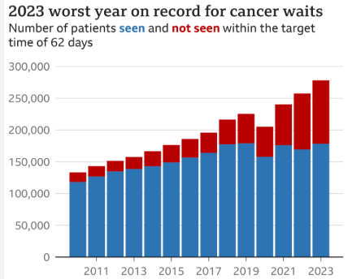
Figure 1: Cancer waiting times
(Source: Triggle, 2024)
Cancer prevention waiting times are increasing in England, which is a major concern for reducing morbidity and mortality rates (Triggle, 2024). Therefore, innovative digital interventions are required to improve public health engagement in cancer prevention and promote earlier diagnosis.

Modified version of an existing one
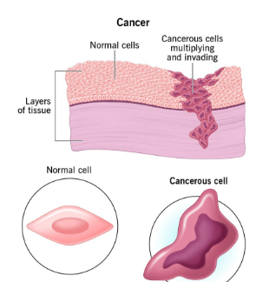
Figure 2: Causes of cancer
(Source: Cleveland Clinic, 2024)
A modified version of this existing Cancer 360 platform is Cancer360+, which will address digital exclusion through personalised, AI-driven and accessible preventive cancer care. The platform will integrate.
- Personalised cancer risk prediction
- Teleconsultation
- Medication reminders
- Behavioural coaching
Collectively, these initiatives will improve patient engagement and support cancer prevention (Doshi et al., 2024; Hwang et al., 2025). Through the lens of the Theory of Planned Behaviour (TPB) model, it can strengthen positive attitudes, reinforcing intentions to participate in cancer screening and enhancing perceived behaviour control (Kamyab et al., 2024; Najafi et al., 2025).

How this modified digital technology can address cancer
Cancer360+ has the potential to strengthen health promotion by delivering personalised preventive interventions directly to users through smartphones. AI-driven risk assessment helps individuals to recognise their personal cancer risk based on lifestyle, health records and family history, which allows them to get tailored recommendations from helathcare professionals digitally (Riaz et al., 2025), including:
- Screening participation
- Physical activity
- Smoking cessation
These personalised interventions are effective in strengthening early prevention of cancer and improving cancer preventive care while reducing huge pressure on the NHS for cancer prevention services (Kerr et al., 2021).

Impact of the modified digital technology in health promotion
This modified version can prevent cancer through personalised care options and can help to reduce repetitive hospital visits of an individual, which will be more briefly discuss in below:
Advantages
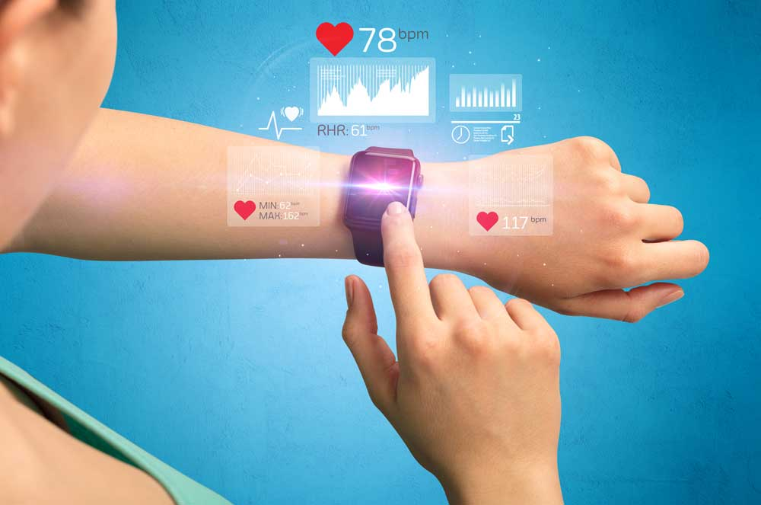
Figure 3: Wearable devices helps track health progress
(Source: Hospital Magazine, 2026)
- These wearable devices can help to reduce repetitive healthcare visits (Kang and Exworthy, 2022; Ke et al., 2025).
- Wearable technology can strengthen monitoring through long-term behaviour change (McCarron et al., 2025).
- It will reduce hospital bed occupancy rates by self-managing their own health.

Limitations
- Older adults and individuals with limited digital literacy may be at risk of not using this app because it's solely dependent on digital technologies.
- AI-generated recommendations sometimes lack clinical context.

How can this shortfall be addressed?
These challenges can be addressed through integrated simplified interfaces, offline functionality for older adults and multilingual accessibility features. Additionally, ensuring AI recommendations complement rather than replace clinical judgement will enhance patient safety and enable Cancer 360+ to become a more effective digital promotion intervention for cancer prevention in the UK.

References
Cancer Research UK. 2026. Cancer in the UK: what's needed as cases exceed 400000 a. [Online] Available at: https://news.cancerresearchuk.org/2026/04/23/cancer-in-the-uk-2026-cases-exceed-400000-for-the-first-time/ Accessed 17th July 2026.
Cleveland Clinic, 2024. Cancer. [Online] Available at: https://my.clevelandclinic.org/health/diseases/12194-cancer Accessed 17th July 2026.
Doshi, S.D., Bange, E.M., Daly, B., Kuperman, G., Panageas, K.S. and Morris, M.J., 2024. Telemedicine and cancer care: barriers and strategies to optimise delivery. The Cancer Journal, 30(1), pp.8-15. Available at: https://doi.org/10.1097/PPO.0000000000000691. Accessed 17th July 2026.
Hospital Magazine (2026) Wearable Devices. [Online] Available at: https://hospitalsmagazine.com/wearable-devices/ Accessed 17th July 2026.
Hwang, H.C., Kim, N.Y., Kim, D.S., Yu, E.S., Kim, S.M. and Kim, H.J., 2025. Efficacy of an app for self-efficacy of patients with cancer through tailored information delivery and coaching: protocol for a randomized controlled trial. BMC public health. Available at: https://doi.org/10.1186/s12889-025-25710-9. Accessed 17th July 2026.
Kamyab, A., Mohammadkhah, F., Asadi, S., Ghalehgolab, F. and Khani Jeihooni, A., 2024. The effect of an educational intervention on breast cancer screening of rural women: application of the theory of planned behavior. Cancer Control, 31, p.10732748241266788. Available at: https://doi.org/10.1177/10732748241266788. Accessed 17th July 2026.
Kang, H.S. and Exworthy, M., 2022. Wearing the future—wearables to empower users to take greater responsibility for their health and care: scoping review. JMIR mHealth and uHealth, 10(7), p.e35684. Available at: https://doi.org/10.2196/35684. Accessed 17th July 2026.
Ke, Y., Tay, V.Y., Leong, Y.H., Tan, C.J., Au-Yong, P.S., Sim, J.X., Nithiyananthan, M., Jin, L., Ng, R.R., Eng, M.H. and Abdullah, H.R., 2025. The role of wearable technology in home-based prehabilitation: a scoping review. British Journal of Anaesthesia, 134(1), pp.228-231. Available at: https://doi.org/10.17605/OSF.IO/JMZWT Accessed 17th July 2026.
Kerr, A., Key Chekar, C., Ross, E., Swallow, J. and Cunningham-Burley, S., 2021. Personalised cancer medicine: Future crafting in the genomic era (p. 288). Manchester University Press.
McCarron, A., Semple, S., Swanson, V., Gillespie, C., Braban, C. and Price, H.D., 2025. Piloting co-developed behaviour change interventions to reduce exposure to air pollution and improve self-reported asthma-related health. Journal of Exposure Science & Environmental Epidemiology, 35(2), pp.242-253. Available at: https://doi.org/10.1038/s41370-024-00661-2 Accessed 17th July 2026.
Mennella, C., Maniscalco, U., De Pietro, G. and Esposito, M. 2024. ‘Ethical and regulatory challenges of AI technologies in healthcare: A narrative review’. Heliyon, 10(4). Available at: https://doi.org/10.1016/j.heliyon.2024.e26297 Accessed 17th July 2026. Accessed 17th July 2026.
Najafi, S., Mohammadkhah, F., Salemi, S.A., Kamyab, A. and Jeihooni, A.K., 2025. The impact of educational intervention based on the theory of planned behavior on preventive behaviors for gastric cancer in obese and smoking individuals. BMC cancer, 25(1), p.129. Available at: https://doi.org/10.1186/s12885-025-13558-6. Accessed 17th July 2026.
Riaz, I.B., Khan, M.A. and Osterman, T.J., 2025. Artificial intelligence across the cancer care continuum. Cancer, 131(16), p.e70050. Available at: https://doi.org/10.1002/cncr.70050. Accessed 17th July 2026.
Triggle, N. 2024. Cancer waiting times in 2023 worst on record in England. BBC. [Online] Available at: https://www.bbc.com/news/health-68240096
World Cancer Research Fund, 2025. UK cancer statistics. [Online] Available at: https://www.wcrf.org/preventing-cancer/cancer-statistics/uk-cancer-statistics/ Accessed 17th July 2026.

