Workplace Culture and its impact on Organizational Efficiency

Assignment title:
Task 1- How do broader external environment factors along with Covid-19 & ethical dilemmas affect organisational culture and its performance

Task 2- Individual Reflective Essay

Module code: BMSW5105

Lecturer: Md Kalam

Student Name: Samata Khatoon

Student number: 1919228

Executive summary
A suitable workplace culture increases organisational efficiency and makes it easier to attain long term objectives and goals. Workplace culture has a significant influence in increasing an organisation’s productivity and profitability (Schein, 2016). Acknowledging the significant importance of the workplace culture, this report has discussed the external change factors using PESTLE analysis for a charity organisation named Age Concern UK. This report has analysed the organisation's workplace culture by implementing a cultural web tool to understand and evaluate its existing culture. To cope up with the changing environment, evaluating and making a change to the existing workplace culture should be a prioritised job for the management to ensure smooth organisational operations. This report also analysed two important ethical dilemmas and developed an appropriate course of action to manage these dilemmas. In the end, a self-reflective essay has been attempted to demonstrate my understandings and acquisition of skills while completing this report.

Contents
Executive Summary………………………………………………………………………….. ..2
Introduction ………………………………………………………………………………………4
Task 1……………………………………………………………………………………..5
PESTEL analysis of Age Concern UK………………………………………………………….5
Porter’s Five Forces analysis for the Age UK using cultural web tool………………………9
SWOT analysis for the Age Concern UK ……………………………………………………..11
Assessing workplace culture of Age Concern UK using cultural web tool………………….12
Critical evaluation of the relationship between Age Concern UK’s present culture and its efficiency in financial and non-financial performance …………………………………………16
Ethical dilemmas and their impact on Organisational performance in the context of Age Concern UK…………………………………………………………………………………………………….17
Task 2……………………………………………………………………………………….19
Individual Reflective Essay ………………………………………………………………………..19
Recommendations…………………………………………………………………………………..21
Conclusion……………………………………………………………………………………….. ….22
Reference …………………………………………………………………………………………….23
Appendix questionnaire and lecture notes………………………………………………………..25

Introduction

Workplace culture refers to the set of shared values, attitudes and beliefs that employees share while working in an organisational environment. Workplace culture is shaped and influenced by Individual upbringings, as well as social contexts (Fanggidae, 2018). Covid-19 has changed the traditional way of performing day to day office activities and it has brought so many new challenges before the management to face. In the current situation, creating and maintaining a positive workplace culture is significantly important for the management to increase organisational productivity and to hold the organisational growth in this changing environment (Caruso, 2016). Organisations that fail to ensure the development of an efficient workplace culture tend to have low staff morale and poor conduct which create a large hindrance to achieving a sustainable position in the competitive market. Acknowledging the huge importance of workplace culture, this report will try to identify and demonstrate broader external factors along with Covid-19 and ethical dilemmas’ effect on the organisational culture and productivity. This report will use PESTLE and SWOT analysis to identify and explain the change drivers and to demonstrate how an organisation can cope up with the changing environment efficiently. To demonstrate these aspects in an organisational context, this report has chosen the ‘Age Concern UK’. Age concern is a charitable organisation conducting its activities in the UK to support aged people by influencing government policy. The organisation also deals with other issues like influencing public opinion and discrimination and pensions. This report will assess the organisation's current workplace culture concerning its financial and non-financial performance. This report will also identify and demonstrate two ethical dilemmas that significantly influence the organisation’s performance and reputation.

Task 1
Creating an efficient workplace culture is very much important to adapt and compete with the changing environment. Workplace culture enables the employees to put their best effort into the organisation to ensure optimum production which leads to the attainment of a sustainable position in the market (Whiteley, Price and Palmer, 2018). Here at the beginning of the report, the impact of external forces on an organisation will be demonstrated by implementing PESTLE analysis using the context of Age Concern UK.

PESTLE analysis of Age Concern UK
An organisation’s business operation is mostly influenced by the broader external environmental factors under which the organisation is being run (Cole, Blaviesciunaite and Oliver, 2019). These factors significantly influence the workplace culture of an organisation like Age Concern UK.
Political Considerations: Like any other organisation, the political environment influences the business operation of the Age Concern UK in many significant ways. Some political factors affecting Age Concern UK's operations are outlined below along with their impact on stakeholders.
- Changes in social care policies following changes in power: Being a charity organisation, Age Concern UK is significantly influenced by political instability or change. Whenever a new government party comes in power, the organisation receives the heat like other business and social welfare organisations. Any political change forces management to focus on short-term needs and thus hampers the attainment of the organisation’s long term vision and sustainability. The government can reduce or withdraw federal funding for the charity organisations anytime which may lead to a sustainability crisis for the Age Concern UK.
- Health and safety regulations: Covid-19 has added a new dimension to the Age Concern UK's health and safety regulations. The organization had to maintain a super safety protocol as its clients are aged and severely vulnerable to the Covid-19 disease. To ensure the highest health security by maintaining guidelines provided by the government, Age Concern UK’s usual operations has been changed a lot along with the increase in the cost structure.
- Brexit: This factor has brought some huge changes in government policies which affect the organisation business operation. The organisation needs to deploy new strategic plans to carry on operations maintaining imposed restrictions and protocols.
Economic considerations: Every organisation is significantly affected by economic factors directly. The economic considerations for the Age Concern UK are demonstrated below:
- Income level: people’s income level directly influence their lifestyle and hence health conditions. Age concern UK’s most of the clients are economically challenged and were not a part of regular health checking programs. A person with a sound income level can check his or her health condition on regular basis and can prevent any unwanted disease or health issues from getting worsen. The income level of the community directly influences the number of patients and their conditions admitted in the Age Concern UK.
- Economic recession followed by Covid-19: In the case of economic recession, people tend to worry about their job security as more and more people lose their job (SUGARMAN, 2017). As they are economically in a vulnerable position, it is less likely for them to donate to charities. Thus economic bad conditions following Covid-19 impacted the Age Concern UK severely. Organisational strategic planning and workplace culture get affected significantly. Covid-19 has decreased people's income and increased expenses for ensuring health and safety measurement. In such a situation, people's disposable incomes have been reduced drastically which definitely will impact the donation of the charity organisations like Age Concern UK.
Social considerations: As an organisation like Age Concern UK conducts its operations in society, various social elements affect and shape the usual business operation (Gabriel, 2015). Age Concern UK’s social considerations are as follows:
- Family and social support: As the clients of the Age Concern UK's are mostly a physically vulnerable portion of the community, family and social support play a significant role here. If the family and social supports are adequate then the aged portion of the community can lead a healthy life. The number of patients with a deteriorating health condition will be decreased. The organization will need to increase its existing capacity no more.
- Social acceptance: this factor mostly determines whether an organization will be able to perform its activities in the long run. In the case of Age Concern UK, social acceptance has helped the organization to reach a large portion of the targeted population in a short period. As the Covid-19 affected the aged portion of the population most, the Age Concern UK is severely affected by this factor. In the UK, the home care fees and demand increased which has caused high turnover for such organisations.

Technological opportunities: Technology has replaced the old traditional organisational functions, procedures and paperwork’s (Manley, Sanders and Cardif, 2018). Now a day, an organisation’s long term sustainability mostly depends on how efficient its employees are technological. Some of the vital technological opportunities that are relevant to Age Concern UK are pointed out below:
- The invention in health science: Following the improvements in health science the number of aged people has been increased in the UK. The number of admitted people has also increased. The age concern UK's doctors are up-to-date with the changes. The organization's management ensures the availability of the latest technology and invention for ensuring better service.
- Smart communication tool and CRM system: If an organisation runs through using effective communication channels, it can perform its usual activities efficiently. The management of Age Concern UK ensures the use of smart communication tools in the organisation to make the required information freely available to the employees. The organisation is continually investing in the modern and latest hardware and software as part of a digital roadmap to develop a new CRM system. The technological changes brought huge opportunities to the management to perform organisational activities more efficiently and to provide quality service.
Legal considerations: Every organisation has to follow some legal guidelines to conduct its activities in a specific political area. The Age Concern UK also continues its operations maintaining some legal factors. This broad macro-environmental factor can bring significant change and can influence building workplace culture. Age Concern UK' some legal considerations are analysed below:
- It is a massive factor that whether the government is going to repeal European Union (EU) regulations replacing them with the newly made laws and regulations in the post Brexit period. This factor will have some implications in the Age Concern UK. The tax structure and other not for profit organization's guidelines and regulations may be changed which will directly influence the stakeholders.
- Some other important legal factors that influence Age Concern UK’s workplace culture are the procurement and competition laws, the working time directives and human rights acts. Because of the working time directives and human rights, the organization needs to design everything related to workplace culture matching with the legislative guidelines.
Environmental opportunities: In the twenty-first century the environmental issues are considered with utmost priority to ensure a healthy world for the future generation. Organisations are currently very conscious about maintaining an eco-friendly environment.
- Eco-friendly project design: The organisation is designing a new project named ‘South-East Project’ maintaining environmental factors and ensuring energy efficiency. The organisation is supporting older people to reduce their carbon footprint and utility costs. As the aged people are vulnerable to the toxic environment most, they are going to be the most benefits taker of this southeast project.
- Pressure from environmental activists: Due to the immense pressure from the environmental activists in recent times, the organisation designs their projects maintaining the green area and using biodegradable products. The whole community gets benefitted from this green area concept of the Age Concern UK.

Porter’s Five Forces analysis for the Age Concern UK

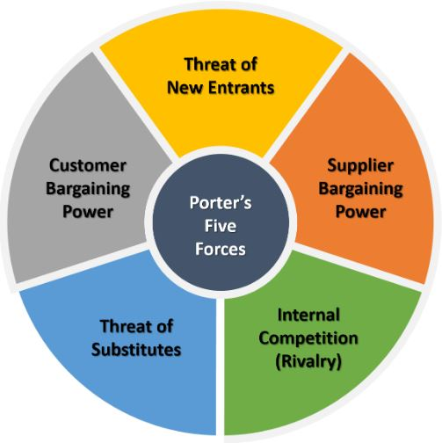
Professor Michael Porter – Established the Porter five forces.

Using Porter's Five Forces Model, the Age Concern UK's competitive strengths and vulnerabilities have been analysed below:
Competition: Although Age Concern UK is one of the market leaders, the market competition is very high and challenging there for the organization. The other charity organizations like Alzheimer's Society, The Stroke Association and Macmillan Cancer Support are performing well.
Potential new entrance: The risk of potential new entrance is very low in case of aged concern UK at this time as the pandemic has hit hard the whole economic system. The existing charity organizations are facing huge challenges following the huge decrease in the donation. The cost of maintaining such charity organizations has increased as these organizations are now implementing Covid-19 protocols and safety measurements. The clients are most vulnerable and that can lead to a drastic fall in organizational performance.
Power of suppliers: As the competition is high in this sector and the existing number of suppliers is not enough, the bargaining power of the supplier is high. The technology, medicine and other medical equipment’s provided by the suppliers are unique and vary in quality from one supplier to another. This is another reason for being higher supplier power.
Power of buyers: The number of suppliers is low and the competition is high which makes the bargaining power of the buyer low for this sector.
Power of customer: The customer used to have many options available before the pandemic period. But after the widespread impact of Covid-19, the situation has changed as the number of aged people got affected by the new Covid-19 disease. Currently, the need for such health care support has increased setting the customer's bargaining power low.

SWOT analysis for the Age Concern UK
In the previous PESTLE analysis, this report demonstrated and analysed some key change drivers generated from the external forces. These key change drivers influence an organisation’s strategic and operational planning. Management needs to create an efficient workplace culture to cope up with the challenges and to properly utilise the opportunities that these external forces are presenting (Mats Alvesson and Sveningsson, 2016). Here in this portion of the report, a SWOT analysis will be attempted for the Age Concern UK.
Strengths | Weaknesses
- Age Concern UK has dedicated and professional staff who are recruited from the local area.  - An experienced board of trustees  - Stable income from charity network and insurance  - Two hundred highly-skilled volunteers  - Very positive reputation and local acceptance. | - Lack of wide promotional activities beyond the local area. The organisation needs to advertise their services all over the UK evenly.  - Lack of fundraising activities and capabilities in the Covid-19period.  - Insufficient staff to cope up with the increased demand in this pandemic period.
Opportunities | Threats
- Implementing a digital approach to fundraising.  - Opportunity to develop a partnership with several service providers.  - Expandable social enterprise initiatives  - Gradual increase in the number of aged people who need service. | - Unexpected political, social and economic changes  - Failing to increase the organisational capacity to serve more people as the number of aged people is increasing in this Covid-19period where the number of donators is decreasing.

Assessing workplace culture of Age Concern UK using the cultural web tool
Workplace culture tends to become the focus of attention when an organisation is going through lots of changes generating from either internal and external environment or when an organisation's current culture does not seem to be appropriate to meet the changing demand (Schein, 2016). An inappropriate workplace culture tends to hinder organisational progress rather than helping to achieve a sustainable position in the competitive environment. Here in this part of this report, Age Concern UK’s workplace culture will be assessed using cultural web questions.
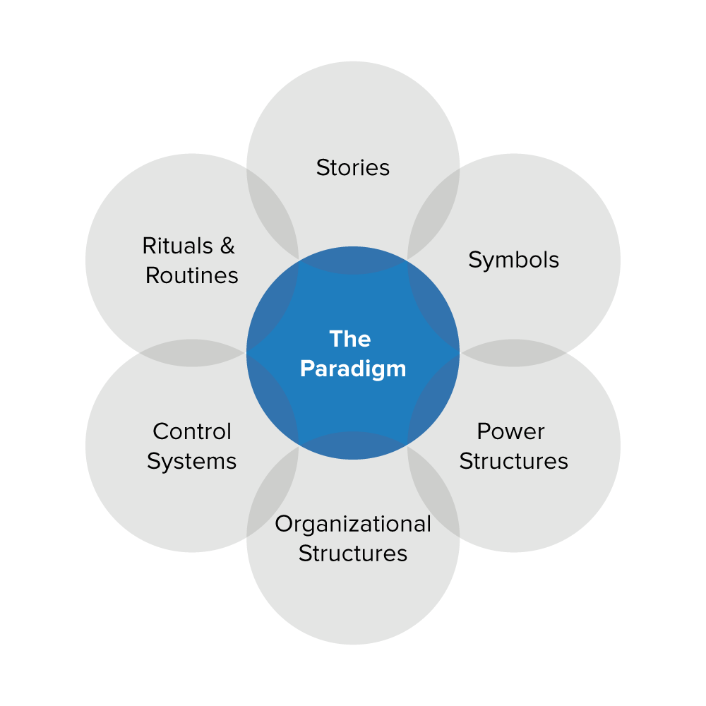
Cultural web: The Cultural Web refers to a tool developed by Gerry Johnson and Kevin Scholes in 1992, for mapping an organisation's workplace culture and a way of visualizing and demonstrating the various elements that influence organisational culture. It can be used to understand the effectiveness of present culture and to produce an appropriate culture for change management. The cultural web is a combination of 6 elements that are interrelated in nature. These elements help the management to identify what current culture is working and what is needed to be replaced (SUGARMAN, 2017). The elements are as follows:
Figure 1: Cultural web; source: (Caruso, 2016)
Stories: stories refer to organisations past events that are discussed by the organisations inside and outside people. Stories indicate an organisation’s perceived values by demonstrating its past accomplishments, pioneers and respectable persons.
To understand the current situation of this element, the following questions are needed to be asked?
- What stories do people currently tell about the Age Concern UK?
- What are the reputations that have been communicated with the stakeholders?
- Does the organisation perform any corporate social responsibility?
Assessment: The Age Concern UK has been able to provide superior service in the local area in emergencies like Covid-19. This organisation has a reputation to provide quick responses to clients and stakeholders queries. The Age Concern UK has the reputation to employ highly skilled employees. The organisation can increase its capacity to serve nationally and across the border. It already has a great responsive team to communicate with the stakeholders but the organisation should ensure the hotline service is available for twenty-four hours daily. Performing corporate social responsibilities is a must doing a job for organisations’ in the 21st century to gain social acceptance. Currently, the Age Concern UK's CSR activity is not wide and significant comparing to the other charity organisation of the UK. The organisation is needed to work on this element to ensure social acceptance of the organisation so that it can attract more donors and make the organisation’s financial condition healthy.
Rituals and routines: This element demonstrates an organisation's employees' and staffs' usual behaviours and actions. Assessing this element, management can get a clear signal about the acceptable behaviour in the workplace and what types of events can happen in the given situation.
In the case of Age Concern UK, the following questions can be asked to understand the effectiveness of current culture and if there is any need for correction.
- What do donors expect when they walk into the organisation?
- What do employees expect from the management and how do they like to be treated?
- Do the employees and staff have a uniform? Do they strictly abide by the organisational rules and regulations?
Assessment: Contributors and clients expect the organisation’s employees will treat with respect while they are in the visit to the organisation. Daily newspapers will be available and the visitors expect to be treated with the utmost respect. The employees expect that they will be provided transportation and accommodation service. The organisation already ensured that the employees all are uniformed and organisations rules and regulations are strictly abided by them. The Age Concern UK's management strictly maintains office time to ensure discipline in the organisation. But in modern times, providing flexible working hours can play a vital role to increase staff efficiency by providing motivation. In this Covid-19 period, working from home is a very widely used practice to ensure employees safety and maintain social distance and other movement restrictions imposed by the government.
Symbols: This element deals with the organisation’s visualizations including its logo, employee’s dress code, formal and informal communication. An organisation’s management can evaluate the symbols and assess whether there is a need for change (Mossop et al., 2015).
Assessment: organisation’s structural communication channel plays a vital role to ensure effective communication. An organisation's smooth operation depends on its efficiency in communication. The age concern the UK is needed to establish both formal and informal communication channels to ensure smooth and free flow of information throughout the organisation.
Power structures: this element deals with an organisation’s real power holders which may include senior executives or a group of executives or even a whole department. The majority of the organisational decision making is influenced by these peoples (Whiteley, Price and Palmer, 2018).
Organisational structures: this element deals with an organisational structure which is a very vital element of workplace culture. A well-defined organisational structure creates an energetic and smooth work environment (Manley, Sanders and Cardif, 2018). This element shows whose contributions are most valued in the organisation and also demonstrates the current structure’s limitations.
To assess the efficiency of the organisational structure of the Age Concern UK, the following questions are needed to be answered:
- Does the organisation maintain a hierarchical structure?
- Does the organisational structure maintain formal lines of authority?
- Do the employees feel comfortable working under such an organisational structure?
Assessment: the Age Concern UK uses a flat organisational structure that is easy and appropriate for meeting the local demand. But if the organisation gets larger in near future, management will need to replace it with a suitable one as the processes will get complicated. Employees are satisfied with the current organisational structure but to adapt to the changing demand arising from Covid-19 situation, the management is needed to rethink the structure to increase efficiency.
Control system: this element demonstrates the way following which an organisation is controlled. The control system includes an organisation’s financial systems, reward systems and quality systems (Mats Alvesson and Sveningsson, 2016). This element also includes how these systems are measured and distributed in the organisation.
To assess the Age Concern UK’s control system the following questions are needed to be asked:
- Does the management control the organisation loosely or tightly?
- Do the employees usually get rewarded according to their performance?
- Do management use reports to establish control over finance and operations?
Assessment: the management is very strict about the quality of the work to ensure supreme service. Employees get rewarded according to the quality of their work. The organisation is needed to increase the reward to motivate employees in this pandemic period. Employees are encouraged and given opportunities to work from home in this pandemic period. The management uses several periodical reports to establish control over the finance department.

Critical evaluation of the relationship between Age Concern UK’s present culture and its efficiency in financial and non-financial performance
Using the cultural web the age concern the UK can first assess its present culture and secondly, the management can look at how they want the culture to be matching with the changing environment. Then they can differentiate between the two and make a strategic plan to develop and implement an appropriate culture that will ensure high efficiency (Caruso, 2016). From the analysis conducted previously on the workplace culture of the Age Concern UK using the cultural web tool, the organisation’s current financial and non-financial performance is not in optimum condition as there is a lot to improve to adjust with the changed Covid-19 situation. The questionnaire (appendix 1) survey indicates that the Age Concern UK's workplace culture has a positive impact on its financial and non-financial performance. Although the organization has some lacking in developing a well-structured and efficient workplace culture; its existing culture is contributing a lot to the overall organizational performance. The Age Concern UK is currently using informal communication channels in the organisation. But this method can create so much trouble especially when it comes to ensuring professionalism. Informal communication can increase the risk of miscommunication and misinterpretation of information while flowing through the channel. From the question 5 & 6, it is found that the organization implements incentive packages and this practice increase employee motivation and hence productivity. Findings of the question 4, is that the organization is currently providing regular updates of the project's improvement arranging meetings that helps increase employee engagement and hence financial performance. The finding of survey question 1 is that the current management is communicated the financial performance of the organizational quarterly basis to ensure the progress is good. Implementation of these workplace cultures is helping the organization to attain higher financial and non-financial performance.

Ethical dilemmas and their impact on organisational performance in the context of Age Concern UK
Definition: Ethical dilemma, also known as an ethical paradox, refers to a situation regarding the decision-making process where there are two possible options and neither of them can be accepted from a moral point of view (Cellucci, 2015).
In practical life, we face different ethical problems which are mostly straightforward in nature and can be solved easily. But, In the case of ethical dilemmas in charity organisations, there can arise a different ethical paradoxical situation that will require a sharp judgemental call to solve efficiently. Here in this part of the report, two ethical dilemmas and their impact on Age Concern UK's performance will be demonstrated along with mentioning choice of actions.
- Compensation dilemma: Unlike the private business sector, designing compensation packages can be a huge ethical issue for the management of charity organizations. As the Age Concern UK is established and conducted to fulfil some specific social needs, such organisations are run by the raised fund that is collected from different donors. Especially, as the organization is currently struggling to meet the specific societal need for which the organisation was founded, providing high compensation to the CEO and president can arise an ethical dilemma (Mossop et al., 2015). The donors will feel that the organisation is deviated from its original motto or mission and expending the organisation’s valuable resources extravagantly. On the other hand, the president and CEO’s are generally highly experienced and can generate lucrative compensation packages if they were conducting a private business organisation or managing an organisation in the private sector.
The course of action and justification for the compensation dilemma: It would be a wise decision if the raised fund can be kept separated from the compensation packages for the president, CEO and top management. The management should never link the raised fund, collected for helping the accomplishment of organisational missions, to the compensation packages. The Age Concern UK should manage some other sources for making compensation. For example, if Age Concern UK runs a fundraising campaign for the implementation of a newly designed project to increase organisational capacity in this emergency Covid-19 period,, the organisation should never use the raised fund to increase the remuneration of the top management or the employees.
- Conflict of interest: In a charity organisation like Age Concern UK, a conflict of interest can arise in different aspects involving financials or the board members. The organisation can perform deals to provide benefits to the board members or to protect the interest of an individual. In this aspect, the Nature Conservancy case can be mentioned as the organisation bought land for 2.1 million and sold it to the former chairman of the organisation for 500000. Then in return, the former chairmen donated to the organisation worth 1.5 million to get a federal tax write-off (Bhandari, 2015). These sorts of the transaction can happen to benefit and get benefitted in a charity organisation but it can destroy an organisation’s reputation in the society. If such things continue to happen, the organisation can deviate from the path of its original mission.
The course of action and justification: The charity organisations like Age Concern UK should not involve in such activities to get some instant return. To ensure a sustainable position, a charity organisation must ensure its reputation and acceptance in society. The organisation should focus on long term sustainability and never involve in such activities that only protect some specific individuals' interests rather than the collective accomplishment of the organisation’s missions or motto (Bhandari, 2015).

Task 2

Individual Reflective Essay
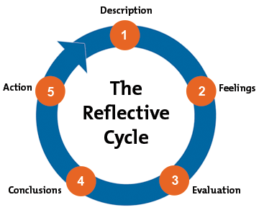
Using Gibb’s reflective cycle, here in this portion of the report, I am going to attempt a reflection on my learning outcome by completing this course. In 1988, Graham Gibbs constructed this model to give structure to reflective learning. Following are the six steps of Gibbs reflective cycle that will be helpful to reflect my learning outcome from completion of this report
Figure 2: Gibb's Reflective Cycle; Source: (Bhattarai, 2016)
Description: For the preparation of the assignment on workplace culture and its impact on organisational efficiency I had chosen an organization named Age Concern UK which is a charity organization providing health and social care support to aged people. I was instructed to critically assess the broad environmental aspects and workplace culture of the organization using appropriate models and techniques.
Feelings: At first I was much tensed about the implication of academic writing guidelines, i.e. referencing, going through journals and articles, using the appropriate academic word, maintaining the overall format of the academic report. I knew I would have to have a clear understanding of the PESTLE, Porter's Five Forces model analysis and other theoretical models to efficiently analyse the organization.
Evaluation: From the completion of this report, I have come to learn some significantly important skills and understandings regarding workplace culture and its importance in increasing organisational efficiency. The first objective of this report is to understand the workplace culture and the importance of developing an efficient workplace culture to cope up with changing environment. In this pandemic period, every business and charity, private and public organisation have taken a heat-conducting the usual business operations. I have come to understand the influence of broad external forces that mostly shape an organisation's culture and strategy. The external forces create various change drivers that influence the management to develop a suitable workplace culture to cope up with these changes. By producing this report, I have come to learn the importance of suitable workplace culture to achieve a sustainable position in the market. This report also helped me to understand the impact of Covid-19 on the usual organisational operations and how it impacted the workplace culture of Age Concern UK. Another important learning outcome of this report is to learn assessing an organisation’s workplace culture by implementing cultural web questions. This learning outcome has made my conception more clear about the importance of workplace culture in increasing organisational efficiency.
Analysis: The preparation of this report has made my justification more clear about the ethical dilemmas that a charity organisation’s management can face. I have illustrated some practical ethical dilemmas and courses of action to find a solution that enriched my ability in making judgemental calls. Completion of this project has enabled be a better plan and design of an academic report to efficiently complete it in time. I went through several articles and journals to have clear understandings of workplace cultures and organisational efficiency. This report has made me able to efficiently read different articles and journals related to my topic. Properly citing different authors’ work is also an important part of such academic writing which enabled me to learn about maintaining ethical considerations while producing this report. This report also helped me to better understand the structure and formalities of academic reports.
Conclusion: The preparation of this report has made my understanding more clear about the impact of Covid-19 on the charity organisation’s performance. What opportunities and threats this pandemic has brought for the UK’s charity organisations, are understood by the PESTLE analysis. I have also learnt to analyse an organisation's current culture's efficiency by using the cultural web tool.
Action plan: In future whenever I will have the opportunity to prepare such academic projects, I will be concentrating more on the following things to produce a better report:
- Going through the theoretical models and frameworks from different journals and articles to get a clear understanding of their efficient implications in my academic writing.
- Going through relevant publishing as much as I can to develop a strong understanding of the topic.
- Preparing a better academic report maintaining formats, referencing and all other aspects.
- Increasing the extent of primary research to accurately identify the workplace's culture's impact on organizational productivity.
Recommendations
New approaches are needed as we have learnt how older people were left behind during the pandemic. As we know the devastating effects the coronavirus pandemic has had on older people's lives and its consequences for Age UK services. Most of the face to face service was interpreted by the pandemic. The pandemic has shown how vital services was impossible to run, following the Government’s social distancing rules, Age UKs were forced to adapt or close.
Some of the recommendations as follow
- Online approach
- Provide support for older people to remain active, as volunteers or share their skills
- Provide a service that allows older people to be more independent
- Provide training on using digital devices
- Older people to have a role in the local economic development, such as open their businesses
- Strategic planning for an ageing population and how to include everyone to make a contribution

Conclusion
Workplace culture has a significant influence in increasing an organisation’s productivity. To cope up with the changing environment, evaluating and making the change to the existing workplace culture should be a prioritised job for the management to ensure smooth organisational operations (Cole, Blaviesciunaite and Oliver, 2019). A suitable workplace culture increases organisational efficiency and makes it easier to attain long term objectives and goals. To assess the current workplace culture, using a cultural web tool can be key. Using this tool, Age Concern UK can assess its current workplace culture and make adjustments to cope up with the Covid-19 situation. Identifying and managing ethical dilemmas with the proper cause of action is also important to gain reputation and social acceptance.
The pandemic has changed the landscape of the services provided by the local Age UK. However, the Age UK network immediately respond to older people’s needs during the crisis, quickly adapting their services and introducing new ways to support older people. The reality is that the pandemic has affected the finances, which forced service closures, staff redundancies and close few local Age UK doors. However, working with local partners and Local Authorities Age UK has managed to provide most of the vital services for older people.

Reference
Bhandari, S.B. (2015). Ethical Dilemma of Nonprofits in the Agency Theory Framework. Journal of Leadership. [online] Available at: https://www.researchgate.net/publication/286450324_Ethical_Dilemma_of_Nonprofits_in_the_Agency_Theory_Framework [Accessed 17 Jul. 2021].
Bhattarai, A. (2016). Reflecting on Personal Learning. Journal of NELTA, 10(1).
Caruso, S.J. (2016). A Foundation For Understanding Knowledge Sharing: Organisational Culture, Informal Workplace Learning, Performance Support, And Knowledge Management. Contemporary Issues in Education Research (CIER), [online] 10(1), p.45. Available at: https://www.semanticscholar.org/paper/A-Foundation-For-Understanding-Knowledge-Sharing%3A-Caruso/2d792ed4f178ff566e095ab41e8d6b951feb5b67 [Accessed 18 Jul. 2021].
Cellucci, T. (2015). Raising the Ethical Floor: Ethical Dilemmas Today. PsycCRITIQUES, [online] 60(46). Available at: https://www.researchgate.net/publication/284204198_Raising_the_ethical_floor_Ethical_dilemmas_today [Accessed 17 Jul. 2021].
Cole, R.J., Blaviesciunaite, A. and Oliver, A. (2019). The changing nature of workplace culture. International Journal of Palliative Nursing, [online] 25(5), pp.211–211. Available at: https://www.emerald.com/insight/content/doi/10.1108/F-02-2013-0018/full/html [Accessed 14 Jul. 2021].
Fanggidae, R.E. (2018). Organisational Culture and Spirituality Workplace: Empirical Study of Influence of Organisational Culture and Spirituality Workplace. E3S Web of Conferences, [online] 73, p.11017. Available at: https://www.e3s-conferences.org/articles/e3sconf/abs/2018/48/e3sconf_icenis18_11017/e3sconf_icenis18_11017.html [Accessed 18 Jul. 2021].
Gabriel, K.K. (2015). Organisational Development, Organisational Culture and Organisational Change. SSRN Electronic Journal. [online] Available at: https://www.researchgate.net/profile/Gabriel-Kamau-Kungu/publication/314462503_Organisational_Development_Organisational_Culture_and_Organisational_Change/links/5fa9456192851cc286a07e72/Organisational-Development-Organisational-Culture-and-Organisational-Change.pdf [Accessed 16 Jul. 2021].
https://www.ageuk.org.uk/. (n.d.). https://www.ageuk.org.uk/. [online] Available at: https://www.ageuk.org.uk/about-us/what-we-do/our-year/ [Accessed 26 Jul. 2021].
Manley, K., Sanders, K. and Cardif, S. (2018). Effective workplace culture: the attributes, enabling factors and consequences of a new concept. Don’t Forget The Bubbles. [online] Available at: https://www.researchgate.net/profile/Kate-Sanders-2/publication/263453602_Effective_workplace_culture_the_attributes_enabling_factors_and_consequences_of_a_new_concept/links/569765db08aec79ee32aa029/Effective-workplace-culture-the-attributes-enabling-factors-and-consequences-of-a-new-concept.pdf [Accessed 20 Jul. 2021].
Mats Alvesson and Sveningsson, S. (2016). Changing organisational culture: cultural change work in progress. 2nd ed. [online] London: Routledge, Taylor & Francis Group. Available at: http://untag-smd.ac.id/files/Perpustakaan_Digital_2/ORGANISATIONAL%20CULTURE%20Changing%20Organisational.pdf [Accessed 17 Jul. 2021].
Mossop, L., Dennick, R., Hammond, R. and Robbe, I. (2015). Analysing the hidden curriculum: use of a cultural web. Blackwell Publishing Ltd, [online] pp.12–14. Available at: https://onlinelibrary.wiley.com/doi/pdfdirect/10.1111/medu.12072 [Accessed 28 Jul. 2021].
Schein, E.H. (2016). Organisational culture and leadership. 5th ed. Hoboken, New Jersey Wiley.
SUGARMAN, B. (2017). A Hybrid Theory of Organisational Transformation. Research in Organisational Change and Development, [online] 16, pp.43–80. Available at: https://www.researchgate.net/publication/235260687_A_Hybrid_Theory_of_Organisational_Transformation [Accessed 21 Jul. 2021].
Whiteley, A., Price, C. and Palmer, R. (2018). Corporate culture change: adaptive culture structuration and negotiated practice. Journal of Workplace Learning, [online] 25(7), pp.476 498. Available https://www.researchgate.net/publication/262896516_Corporate_culture_change_Adaptive_culture_structuration_and_negotiated_practice [Accessed 15 Jul. 2021].
Lecture notes by lecturer Md Kalam

Appendix
Questionnaire
- The following questions have been asked and analysed to understand the impact of organizational culture on financial and non-financial performance.
- In Age Concern UK, are the quarterly Accounts and financial reports presented to the Higher Management Committee for reviewing and correcting existing procedures?
- Does the organization's management arrange regular staff meetings to deliver project's updates?
- Does the management ensure higher employee engagement by providing stimulus packages?
- Does the organization have any reward package for high performing employees?
- Do reward packages influence employee’s productivity?
- Does the organization use any smart communication tool?


