

MBA DISSERTATION
LCMB7035

Name of University & Programme of Study: University of Wales Trinity Saint David & Master of Business Administration (MBA)

Research Title: Impact of Digital Branding on Burberry’s Competitive Positioning in the UK Luxury Fashion Market

Name: Meet Dineshbhai Malani
Student ID: 2504764
Supervisor: Mazen Joureih
Declaration
I Meet Malani declare that this dissertation has been composed by myself, that the work contained herein is entirely my own except where explicitly stated otherwise in the text, and that this work has not been submitted for any other degree or qualification, in whole or in part, except as specified.

Signature:. meet malani

Acknowledgment
I sincerely thank my supervisor for valuable guidance, my family and friends for constant encouragement, and the University of Wales Trinity Saint David for providing resources and support throughout this dissertation.
Abstract
This research analysed the role of digital branding on the competitive positioning of Burberry in the UK luxury fashion market. The study evaluates the impact of digital branding strategies on brand image, customer interaction and the effectiveness of the company to sustain a competitive leverage in the ever more digital market. The case organisation chosen was Burberry as it has made a great reputation to adopt digital innovation and still maintain its luxury brand. The research was founded on the interpretivist research philosophy and inductive research approach and used the qualitative Systematic Literature Review (SLR) to collect and analyse secondary sources, i.e., peer-reviewed journal articles, industry reports and other trustworthy online sources. The PRISMA framework was used to inform the selection of the literature, and a thematic analysis was used to extract major themes. The findings suggest that digital branding that includes social media marketing, digital storytelling, influencer relationships, omnichannel experiences, and personalised customer experience are significantly boosted by digital branding and, consequently, brand image and customer loyalty of Burberry, which further facilitates a competitive positioning of the company. However, the research comes up with the challenges associated with ensuring brand exclusivity, brand authenticity, and reacting to fast evolving consumer expectations and changes in technology. The study finds that innovation and luxury heritage are important in maintaining the long-term competitive advantage. The research aids the existing literature by giving insights unique to Burberry as it offers practical suggestions to the luxury fashion managers in the UK, who would like to enhance digital branding strategies in the changing UK luxury fashion industry.
Table of Contents
CHAPTER 1: INTRODUCTION 9
1.1 Background & Problem Statement 9
1.2 Research Aim 11
1.3 Research Objectives 11
1.4 Research Questions 11
1.5 Significance of Study 11
1.6 Brief Research Methodology 12
1.7 Structure of the dissertation 13
CHAPTER 2: LITERATURE REVIEW 15
2.1 Introduction 15
2.2 Evolution of digital branding in luxury fashion 15
2.3 Importance of digital branding in the luxury fashion industry 18
2.4 Impact of digital branding on customer engagement and brand image 20
2.5 Challenges in maintaining luxury brand exclusivity 23
2.6 Strategies to manage competitive positioning in the luxury fashion market 24
2.7 Theoretical Background 26
2.8 Conceptual framework 29
2.9 Literature Gap 30
2.10 Chapter summary 30
CHAPTER 3: RESEARCH METHODOLOGY 31
3.1 Introduction 31
3.2 Research Design using Saunder’s Onion Model 31
3.3 Data Collection Method 35
3.4 Data Analysis 39
3.5 Ethical Consideration 39
3.6 Chapter Summary 40
CHAPTER 4: FINDINGS, ANALYSIS AND DISCUSSION 41
4.1 Introduction 41
4.2 Presentation of Findings 41
4.3 Analysis of Results 51
4.4 Discussion of Results 63
4.5 Chapter Summary 68
CHAPTER 5: CONCLUSIONS AND RECOMMENDATIONS 69
5.1 Summary of main findings 69
5.2 Conclusion based on the research questions 70
5.3 Recommendations 71
5.4 Limitation of Research 73
5.5 Recommendation for Future Work 73
Reference List 74
Appendices 89
Appendix 1: Thematic Mapping 89
Appendix 2: Quality Appraisal Process by CASP Tool 90

List of Figures
Figure 1: UK luxury fashion market revenue 9
Figure 2: Dissertation structure 13
Figure 3: Consumers following luxury brands on social media 16
Figure 4: Leading fashion luxury brands 19
Figure 5: Brand Equity Theory 27
Figure 6: Dynamic Capabilities Theory 28
Figure 7: Conceptual Framework 29
Figure 8: Research Onion 32
Figure 9: PRISMA Flowchart 38

CHAPTER 1: INTRODUCTION

1.1 Background & Problem Statement
Over the last several years, the luxury fashion industry has undergone constant change owing to the fast digitalisation and changes in consumer behaviour. Traditionally, luxury brands have been in a position to produce brand value by exclusivity, heritage and physical experiences within the retail stores. The extensive adoption of digital technologies, social networks, online commerce and mobile applications has fundamentally changed how luxury brands engage with consumers and the ability to maintain their competitive advantage (Sanz-Lopez et al., 2024). The digital branding has become a strategic business operation enabling the luxury fashion firms to improve customer relationship, brand presence and give customers personalised experience across different areas of digital interactions. In 2024, the luxury fashion market in the UK imported approximately US 7.39 billion of revenue and continues to grow because it evidences the increased importance of digital interactions in influencing consumer buying decisions (Statista, 2026). Such a digital revolution has compelled luxury fashion companies to include new branding strategies without compromising exclusivity and prestige which have defined luxury business.
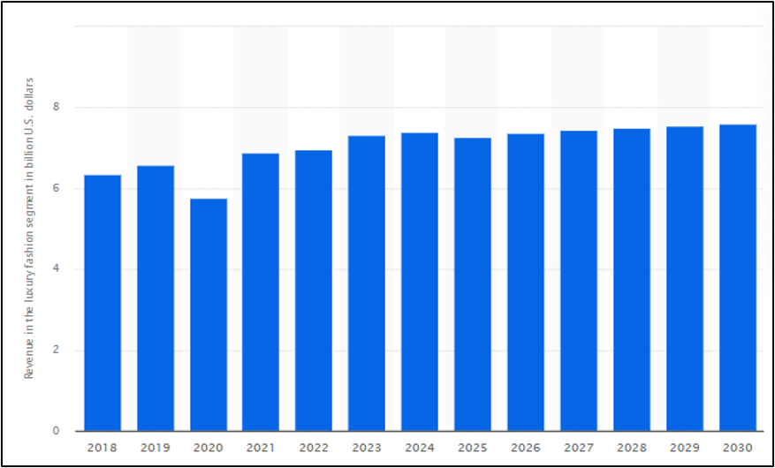
Figure 1: UK luxury fashion market revenue
(Source: Statista, 2026)
Burberry is among such brands which have turned out to be one of the first brands in the category of leading luxury fashion brands to adopt digital branding strategies. The firm has been hugely invested in digital innovation by means of social media marketing, influencer partnerships, live-streamed fashion shows, digital storytelling, and omnichannel customer experiences (Liu and Liu, 2025). These have helped Burberry to update its traditional British luxury heritage and capture younger digitally linked consumers and enhance brand awareness across the globe. The continual contact with the customers that digital branding activities, emotional contact, and brand loyalty offer (Casciani et al., 2022). These are the key drivers of long time competitiveness in the already competitive UK luxury fashion market. Digital branding has offered a change in this that was viewed as a marketing communication tool to a strategic capability that allows the company to engage the customer, brand differentiation and positioning.
The trend of employing digital branding in the luxury fashion industry is on the rise; there are considerable gaps in the existing academic literature. Previous studies have largely been on the topics of digital marketing, social media marketing, influencer marketing or consumer purchasing behaviour in an overall luxury fashion perspective. Although these studies have identified the importance of digital channels in enhancing the level of customer engagement and brand equity, not many studies have specifically investigated how digital branding of Burberry has contributed to the UK luxury fashion market (Russo et al., 2025). Furthermore, the rapid pace of the digital technologies development and the changing demands of consumers. The current competition in the luxury brands across the globe entails the continuous evaluation of digital branding strategy in order to understand its contribution to sustainable competitive advantage.
This study will address these gaps by emphasising on the relation between digital branding strategies, brand image, customer engagement and competitive positioning of Burberry in the UK luxury fashion market. Burberry is the case organisation that the research employs because it has proven its superiority in digital innovation and dominance in the UK luxury fashion market. The systematic review of the recent academic literature was used to conduct the research. Industry data to offer a holistic insight into the role of digital branding in achieving competitive success and the areas that need further strategic elaboration. The results will be used in the field of academic literature on digital branding in the luxury fashion sector and offer some practical advice to luxury fashion managers aiming at enhancing brand competitiveness in a more digital business world.

1.2 Research Aim
The aim of this research is to evaluate the impact of digital branding on Burberry’s competitive positioning in the UK luxury fashion market.

1.3 Research Objectives
- To identify the digital branding strategies used by Burberry in the UK luxury fashion market.
- To examine the impact of digital branding on Burberry’s brand image and customer engagement.
- To evaluate how digital branding contributes to Burberry’s competitive positioning against other luxury fashion brands in the UK.

1.4 Research Questions
RQ1. What digital branding strategies does Burberry use in the UK luxury fashion market?
RQ2. How does digital branding influence Burberry's brand image and customer engagement in the UK luxury fashion market?
RQ3. How does digital branding contribute to Burberry's competitive positioning compared with other luxury fashion brands in the UK?

1.5 Significance of Study
The research will be important because it will improve awareness of the impact of digital branding on the competitiveness of Burberry in the UK luxury fashion sector. Academically speaking, this research addresses a serious gap since it investigates the case of Burberry, rather than the luxury fashion brands, in general. The existing literature is dedicated to digital marketing, social media, influencer activities of influencers, or consumer behaviour. Nonetheless, the existing evidence of the benefits of integrated digital branding in competitive positioning through brand image, customer engagement, and strategic differentiation is scarce. The dissertation will prove useful in the knowledge of digital branding in the contemporary luxury industry through the synthesis of recent academic sources and industry findings. In terms of management, the results will offer valuable information to marketing professionals, brand managers, and decision-makers aiming to reinforce digital approaches. Organisations can be informed on resource allocation by digital branding activities that create interest among customers, make brand recognition easy, and make it possible to differentiate the market, which can help organisations deal with the evolving consumer demands.
The research has practical implications to the researchers themselves as the research has given them a broad platform that can be utilized in future to research on digital branding, luxury brand management and competitive strategy. As it shows, secondary qualitative evidence can be organised in a system of analysis, where complex business phenomena can be explored. Moreover, the study is helpful to teachers and learners as it gives an evidence-based argument that exhibits the connection between competitive advantage and branding innovation. The findings can encourage policymakers and industry players to invest more in digital capacities that can facilitate business resilience and global competitiveness. The study presents a comprehensive perspective of digital branding behavior of Burberry and its impact on its market and performance and gives recommendations. They can be used in strategic decision-making, competitive advantage, customer relations and future research management on the digital transformation of the UK luxury fashion industry and in academic research on the topic.

1.6 Brief Research Methodology
The research philosophy used in this study is the interpretivist research philosophy since it aims at comprehending the effects of digital branding on the competitive positioning of Burberry. It will be based on the interpretation of existing academic and industry evidence and not testing the causal relationship. The inductive research approach is used to detect any recurring patterns and themes in the literature and allow the formation of contextual knowledge about digital branding strategies (Saunders et al., 2023). The study is based on a qualitative case study approach, and Burberry is chosen as the target organisation due to its established leadership in digital innovation in the UK luxury fashion market.
The qualitative design applied is a mono-method design that involves a Systematic Literature Review (SLR), which was used to gather secondary data by way of peer-reviewed journal articles, company reports, and other reliable publications in the industry. Structured database searches are done using predefined keywords, Boolean operators and inclusion and exclusion criteria to identify relevant literature, complemented by the PRISMA framework. Thematic analysis is used to analyse the collected data and identify and interpret crucial themes associated with digital branding, brand image, customer engagement, and competitive positioning (Braun and Clarke, 2023). The cross-sectional time horizon is used to study the existing digital branding practices. Ethical principles are upheld during the research process by using credible secondary sources, proper referencing, and adhering to the university ethics and academic integrity requirements of research.

1.7 Structure of the dissertation
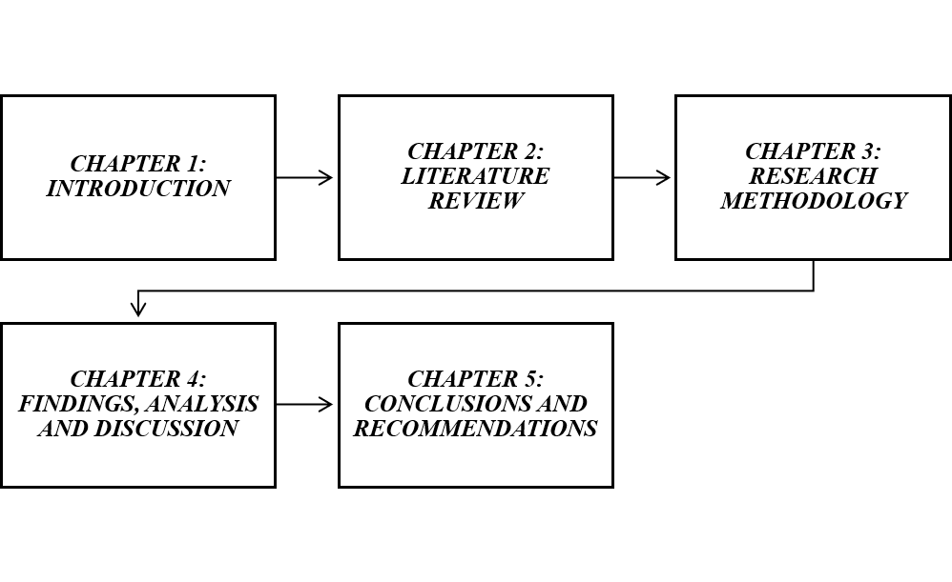
Figure 2: Dissertation structure
(Source: Self-developed)
Chapter 1: Introduction- Chapter 1 introduces the research, where the background, problem statement, research aim, objectives, research questions, significance of the research, research methodology, and the overall structure of the dissertation are presented.
Chapter 2: Literature Review- The chapter critically examines the available academic literature on digital branding, customer engagement, brand image, and competitive positioning in the luxury fashion industry. It addresses the theoretical basis, conceptual framework and determines the research gap.
Chapter 3: Research Methodology- The chapter provides the research philosophy, approach, strategy, method of data collection and the methods of data analysis and ethical considerations that were used to meet the research objectives.
Chapter 4: Findings, Analysis and Discussion- The chapter provides and discusses the results of the systematic literature review. Discussion of the results is carried out in terms of the research objectives, theoretical framework, and past literature.
Chapter 5: Conclusion and Recommendations- This chapter will summarise the main findings, answer the research questions, give practical and theoretical recommendations, address the limitations of the research, and provide direction for future research.

CHAPTER 2: LITERATURE REVIEW

2.1 Introduction
The chapter is a critical review of the available literature on the role of digital branding in competitive positioning of Burberry in the UK luxury fashion industry. It analyses the contemporary level of digital branding in the luxury fashion sector and the importance of digital branding in the creation of a more robust brand image, enhanced customer relationships, and competitive advantage. Moreover, it outlines the pertinent theoretical background, constructs a conceptual framework, outlines the literature gap that exists, and lays the groundwork for the research methodology that is discussed in the next chapter.

2.2 Evolution of digital branding in luxury fashion
Digital branding has dramatically transformed the luxury fashion industry through its ability to change the way brands engage with customers, establish markets, and create long-term relationships with customers. According to Dave and Gupta (2025), luxury fashion brands previously relied on the physical stores, exclusive fashion shows, print advertisements and celebrity endorsements to market the luxury brand without sacrificing an image of prestige and exclusivity. Klarna (2020) stated that 80% of Gen Z, 70 percent of Millennials, more than half of Gen X, and 41% of Baby Boomers subscribed to luxury brands on social media. Nonetheless, Alzeiby et al. (2026) stated that due to the rapid evolution of digital technologies and changed consumer demands the branding practices shifted towards interactive digital media and digital branding became an important component of competitive strategy.
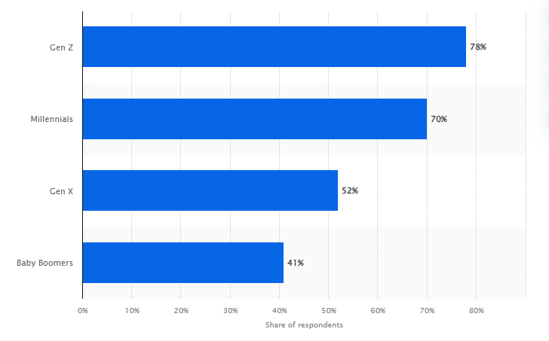
Figure 3: Consumers following luxury brands on social media
(Source: Klarna, 2020)
The first phase of digital branding in luxury fashion was mainly related to creating an online presence via corporate websites and online stores. These internet platforms were sources of information, but not interactive marketing, and brands could show product collections and communicate their heritage. This was progressing to make life easier for consumers, but most of the luxury brands were reluctant to go digital. According to Shukla and Rosendo‐Rios (2025), higher access would diminish exclusivity that would make the difference between luxury products and their mass market counterparts. Consequently, the digital adoption in the luxury industry was slow compared to other retailing sectors.
Even though it is claimed by numerous scholars that digital branding makes luxury brands stronger as it improves their presence on a global level and improves the interaction with customers (Cosmai, 2024; Pantano et al., 2022), some other researchers suggest the opposite. Shukla and Rosendo-Rios (2025) argue that over-access to digital can water down exclusiveness, which has been a main characteristic of luxury brands. Increased presence in social media can give an impression of overexposure, which diminishes the luxury products' rarity and prestige. On the other hand, Casciani et al. (2022) claim that exclusivity may not be weakened by digitalisation under the condition that the brands meticulously regulate the content, selective product releases and the presence of high-quality online experiences. Thus, the literature indicates that digital branding has the potential to enhance market penetration and at the same time threaten the luxury exclusivity, which is why striking a balance between the two is critical to maintaining competitive standing.
The popularity of social media sites was an important milestone in the history of digital branding. Cosmai (2024) stated that social networks like Instagram, Facebook, TikTok, and YouTube helped luxury brands to engage with consumers directly through visual storytelling, live content, and interactive campaigns. Contrary to conventional advertisements, social media offered a possibility of constant interaction where the consumers were able to comment, share and take part in online communities of the brand. This change made branding a two-way communication into a continual dialogue between brands and customers. In that case, Tolonen Torralbo (2022) mentioned that this strategy enhanced the relationship with customers and increased brand awareness. It can transition the traditional idea of exclusivity, as luxury brands have become more available to broader audiences.
The technological innovation has increased the pace of digitalisation of branding in the luxury fashion industry. As opined by Minh and Hue (2025), AI, augmented reality, virtual fashion shows, personalised recommendations, and mobile apps are increasingly becoming part of brands to facilitate better customer experiences. These technologies make things more convenient for consumers and offer an immersive and customised experience that consumers could not have had in the traditional retailing methods. Similarly, Mia (2024) stated that another aspect of digital innovation is that luxury brands have been able to bring digital and physical experiences together, as clients can pass through the physical stores and the digital aspect. This omnichannel has emerged as a significant characteristic of the new luxury branding as more consumers demand a uniformed experience across all channels, they can interact with.
Consumer demographics and purchasing behaviour have had an impact on the development of digital branding. Millennials and Generation Z have become key customer segments in the luxury fashion market and are important to younger generations. These consumers are active on digital technologies and tend to consider the brands based on their internet presence and then make the purchase decision. As a result, Pantano et al. (2022) stated that luxurious brands have diversified their digital branding techniques to incorporate influencer partnerships, digital narratives, interactive initiatives, and personalised customer experiences. Brands are striving to establish emotional ties and long-term relations with their customers using interesting digital content, which conveys their values and identity.
As much as there are advantages associated with digital branding, it has also come with a number of challenges to the luxury fashion brands due to its development. Expanding online will weak the perception of exclusivity and luxury in case the brands turn into too common. Additionally, Casciani et al. (2022) mentioned that it is necessary to invest in technology, content creation, and customer engagement plans regularly to have a consistent brand identity on different digital platforms. The pace, at which technology is changing, suggests that brands have to continuously develop their online skills without losing their roots and genuineness.

2.3 Importance of digital branding in the luxury fashion industry
Digital branding has become a vital part of the luxury fashion industry as it helps the brands to reinforce their presence on the market, establish effective relationships with customers, and be competitive in the long term. Iannilli and Linfante (2022) stated that leveraging digital branding, as opposed to traditional branding, which largely depended on physical stores, fashion magazines, runway shows, and celebrity endorsements, incorporates online platforms, social media, websites, and mobile apps to establish constant communication with consumers. With the growing digitalisation of purchasing behaviour, luxury fashion brands have realised that digital presence is no longer a luxury to be successful in business. In 2023, Dior led global luxury fashion with a Media Impact Value (MIV) of US$4.3 billion, followed by Chanel at US$3.5 billion (Launchmetrics, 2023).
Digital branding has provided one of the most important contributions, which has the capability of enhancing the brand visibility without compromising the brand identity. Through digital, luxury brands can communicate their values, heritage and products to potential customers in various markets without geographical restrictions since they can reach people all over the world. Terentieva et al. (2025) further stated that a coherent digital presence contributes to brand recognition by making sure that consumers experience a similar visual representation, message, and customer experience on different online platforms. This uniformity builds consumer confidence and helps create a memorable brand image in a more competitive marketplace.
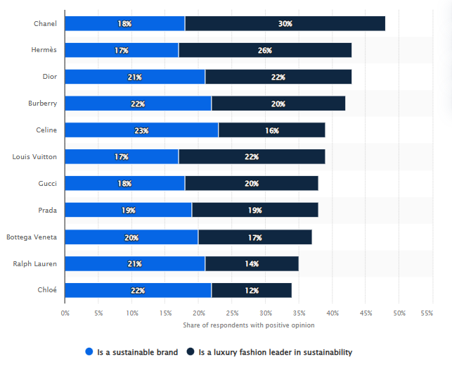
Figure 4: Leading fashion luxury brands
(Source: Launchmetrics, 2023)
Digital platforms promote direct communication between consumers and brands, unlike conventional advertising, in which the communication process is mostly one-way. According to Li and Ahmed (2024), the customers can interact with the brands through comments on social media, taking part in online campaigns, viewing events live streamed, and sharing their experiences online. These interactions open possibilities for how brands can establish better emotional relationships with consumers and develop insights into customer preferences and expectations. Greater involvement leads to a higher customer relationship, brand loyalty and consumer satisfaction.
The other significant benefit of digital branding is that it has an impact on purchasing behaviour. Contemporary consumers visit the Internet to conduct research on luxury brands and make a buying choice. On the other hand, Lin and Ku (2023) stated that, information on brand websites, online advertising, customer feedback, and social media content persuades consumers that they are quality, authentic, and valuable. An excellent online presence makes consumers trust a brand and lessens indecision in decision-making. This has made digital branding a significant consideration to influence customers at the first point of awareness through to the final point of purchase and aiding in customer retention in the long-term.
Digital branding helps luxury brands to provide personalised customer experiences. Brands can offer personalised product suggestions, online-only offerings and individualised communication through digital technologies depending on the unique consumer preferences. Khan et al. (2022) further stated that, the personalisation establishes a feeling of exclusivity as it makes the customers feel considered and appreciated during their buying process. This will enhance customer satisfaction and promote repeat purchases and customer loyalty. Simultaneously, Oham and Ejike (2024) stated that personalised experiences enable luxury brands to stand out from the crowd of competitors by offering services that are not solely related to the quality of products.
Another feature that can be value-added to the luxury fashion industry in terms of innovation is that of digital branding. According to the opinion of Malangke (2025), the new technologies, which include AI, augmented reality, online fashion shows, and immersive online experiences are gaining popularity across the brands, as they enhance customer interactions. These innovations can make it easier and more progressive and innovative. Moreover, Kothari et al. (2025) opined that fashion luxury companies that are efficient in embracing technology in their brand are better placed to embrace the evolving consumer needs and remain competitive in the dynamic markets.

2.4 Impact of digital branding on customer engagement and brand image
Digital branding has transformed the luxury fashion brands to interact with consumers by creating more powerful customer interactions and creating a favourable brand image. The increasing use of social media, digital storytelling, personalised online experiences and interactive marketing have helped luxury brands to build long term relationships with their customers outside of the traditional retail environment (Jain et al. 2026). With consumers growing increasingly digitally connected, luxury brands are increasingly turning to digital branding as a means of creating perceptions and loyalty in the fashion industry.
Effective digital branding has a lot of important consequences, customer engagement being one of them. Digital branding, as opposed to the conventional type of marketing that revolves around advertisements of products using the one-way communication system, promotes active interaction between the brand and the consumers. Similarly, Karlsson and Ryberg (2024) stated that customers can engage in conversations, exchange experiences, give feedback, and create a personal interaction with brand content through social media, websites, mobile apps and online communities. The ongoing interactions produce more emotional ties between consumers and brands, build stronger trust, and promote long-term relationships. Consequently, Panjaitan (2022) further stated that customer engagement is now regarded as a significant measure of brand success in the digital field.
The benefits of personalised digital branding also bring about significant questions on the privacy of the consumer and ethical use of data. Gachet and Chammassian (2024) also claim that personalised experiences can increase customer satisfaction levels because the communication and recommendations presented to the client are made based on his or her preferences. Nonetheless, the growing focus on the use of customer data could raise the issue of privacy, surveillance and transparency. Unless consumers feel that they have adequate control over the manner and use of their personal data, they might feel hesitant to give out personal information. It follows that although personalisation helps to increase customer interactions and loyalty, luxury brands need to provide a balance to personalised experiences and responsible data governance and compliance with privacy policies to maintain consumer trust.
Luxury brands have possibilities to convey more personalised experiences with the help of digital branding. With the help of customer data and digital technologies, brands will be able to offer suggestions and recommendations, provide individualised content and create unique online experiences, based on individual preferences. As stated by Shammout et al. (2025), personalisation enhances customer satisfaction since consumers feel they are recognised and appreciated in the process of their purchasing process. This improves emotional attachment to the brand and re-buys. Besides, Tarabieh (2022) added that luxury brands have the opportunity to be different by using personalised communication and offer a personalised experience that is not limited to the products themselves.
Similarly, Gachet and Chammassian (2024) stated that, social media is one of the most effective methods of enhancing customer engagement. Luxury brands can use Instagram, TikTok, YouTube, and Facebook to present the new collections, provide the content behind-the-scenes, host live events, and interact with customers. These platforms allow consumers to interact with the brands by commenting, liking, sharing, and creating user-generated content. However, Tuti and Sulistia (2022) argued that the constant attention demanded by digital branding necessitates continuous content and quick response to customer demands; thus, digital branding is a long-term strategic undertaking and not a marketing action that can take place in the past.
Digital branding is a crucial aspect of brand image development, along with customer engagement. Brand image is the general attitude of the consumers towards the quality, reputation, values and identity of a brand. As stated by Nuseir et al. (2023), the positive brand image in the luxury fashion industry has some impact on consumer confidence, intentions to purchase and long-run loyalty. Digital branding has a role in this as it provides the brand with consistent messages, high-quality visual content, and a message about the heritage and craftsmanship of the brand on various digital platforms. Rane et al. (2023) further stated that premium positioning is enhanced by a robust digital presence and assists consumers in relating the brand to exclusivity, innovation, and quality.
Digital storytelling has turned out to be a valuable means of strengthening brand image. According to Antczak (2024), luxury brands focus on the promotion of their products but are increasingly turning to storytelling to share a history of the brand, its craftsmanship, its sustainability efforts, and its brand values. These stories generate emotional links that build consumer perceptions and strengthen brand authenticity. Customers will tend to establish positive attitudes towards the brands that are able to convey meaningful stories that do not simply use promotional advertising. Therefore, Gupta et al. (2024) stated that storytelling has emerged as an effective element of online branding campaigns in the luxury fashion sector.
Although it has its advantages, customer engagement and brand image are some of the challenges associated with digital branding. Greater exposure over the internet can expose the brands to consumer criticism, negative reviews, and fast-spreading information that can impact consumer perceptions. Gachet and CHAMMASSIAN (2024) stated that one negative experience is likely to have an immediate impact on the brand image since information can be shared across the globe in a relatively short time using digital media. Moreover, Rane et al. (2023) further stated that, overdependence on digital may decrease the feeling of exclusivity, which is one of the distinguishing features of luxury fashion brands. There is a need to balance between being accessible and ensuring the maintenance of a strong brand image.

2.5 Challenges in maintaining luxury brand exclusivity
The issue of brand exclusivity has emerged as one of the biggest challenges of luxury fashion brands in the digital age. According to Khattak and Khattak (2024), luxury brands created their value by means of scarcity, high pricing, and high-level craftsmanship, and managing customer experiences. Nevertheless, Rane et al. (2023) added that, with the blistering growth of digital branding, brands are more accessible and visible, which has posed a challenging tradeoff between reaching broader audiences and maintaining the exclusivity that is a hallmark of luxury. According to Bilancia et al. (2025), consumers are engaging more with brands via online channels; luxury corporations have to keep evolving their branding processes but without jeopardizing their luxurious position.
Amplified digital accessibility is one of the key challenges. Luxury brands are now more visible and accessible to consumers across the globe through social media platforms, e-commerce sites, and mobile applications. Dave and Gupta (2025) stated that, although this expanded reach offers a possibility to find new customers, it can also decrease the perception of exclusivity of luxury items. Consequently, the authors of the study by Rane et al. (2023) believed that luxury companies have to pay close attention to their online activities to preserve status and enjoy the advantages of digital communication.
The prevalence of fake products in the marketplace using online platforms is another major challenge. Moreover, Alzeiby et al. (2026) mentioned that the consumers may experience an increasing inability to differentiate between authentic products and counterfeits, which may hurt the brand image and decrease customer trust. Luxury brands should therefore invest in product authentication and more advanced measures of digital protection to ensure their brand name is not lost.
Another challenge is to have a constant brand image in various digital channels. Laradi et al. (2023) state that luxury brands use websites, social media, mobile apps, and online campaigns as channels to communicate, and all these channels have to be updated regularly and include customized content. Unstable communication, absence of customer experiences, or online negative reviews can easily disseminate through digital platforms and influence the perception of consumers. According to Ewur et al. (2025), unlike in the traditional marketing where companies strictly controlled their communication, in the case of digital branding, the company and the user-generated content must be managed, and therefore managing the reputation becomes more complicated.
Luxury brands have a dilemma on how to balance between innovation and heritage. The new generation of consumers requires brands to embrace new technologies, personalised services and interactive digital experiences. Dave and Gupta (2025) added that luxury brands should uphold their history, craftsmanship, and authenticity, which is the basis of their competitive advantage. Overdependence on digital trends can undermine traditional luxury values, and under usage of digital can undermine competitiveness.
A balance should be maintained between digital accessibility, innovation, authenticity, and heritage to maintain the exclusivity of the luxury brands. Moreover, Alzeiby et al. (2026) mentioned that the effective management of these issues helps luxury fashion brands to maintain their high-end reputation and be a relevant and competitive brand within the growing digital environment.

2.6 Strategies to manage competitive positioning in the luxury fashion market
The management of competitive positioning has become a significant issue in recent times in luxury fashion brands as digital technologies continue to bring about a transformation in consumer expectations and competitive forces in the market. Ewur et al. (2025) believed that luxury brands have to be unique and integrate innovation, customer experiences and good brand identity without sacrificing their tradition and exclusiveness. A good competitive positioning assists organisations to create sustainable value, win the loyalty of customers as well as create a competitive edge in a very competitive global market.
Digital innovation is one of the best practices in enhancing competitive position. The usage of artificial intelligence, virtual reality, and augmented reality, as well as interactive digital platforms, is becoming a common trend in luxury fashion brands to enhance customer experiences. Bilancia et al. (2025) stated that the technologies enable the brands to provide personalised recommendations, virtual product demonstrations and online shopping experiences that result in customer satisfaction. Digital innovation helps brands to react faster to the evolving consumer preferences as well as to solidify their brand image as progressive and progressive organisations.
The other significant approach is building an integrated omnichannel experience. The contemporary consumer can engage with the luxury brand via various touch points such as retail outlets, online platforms, applications, and social networks. As opined by Gupta et al. (2024), enhancing brand identity and customer satisfaction is made possible by offering a cohesive experience in all these channels. The consumers anticipate getting the same amount of service, product information and brand experience irrespective of the platform they are operating on. Thus, Karlsson and Ryberg (2024) stated that the combination of online and offline has become a key to keeping competitive positioning and creating long-term relationships with customers.
Personalisation is an effective strategy that has been adopted to increase competitiveness. Consumers of luxuries are more demanding when it comes to customised services and personalised experiences that are based on their personal taste. As stated by Rane et al. (2023), digital technologies enable brands to offer personalised product recommendations, unique content, and personalised communication that enhance customer engagement and loyalty. Luxury brands can distinguish themselves in terms of pricing and customer experience by offering customers unique and memorable experiences, which help in retaining customers. However, Terentieva et al. (2025) stated that personalisation should be managed in a manner that is responsible to ensure that the consumers trust it and that the privacy of the customers is not jeopardised.
It is crucial to maintain the brand tradition and be innovative to maintain competitive positioning. Further, Casciani et al. (2022) stated that history, craft and authenticity are some of the key attributes of luxury fashion brands that add value to them. As much as it needs to be digitised to be able to compete, it is important that the technological changes fail to implement their tradition, but they should rather enhance the traditional values that the brands hold. Similarly, Bilancia et al. (2025) stated that, these a balance helps luxury brands to attract younger digital consumers without sacrificing exclusivity, which attracts current clients.
Strategic alliances help in enhanced competitive positioning. Gupta et al. (2024) stated that collaborations with well-chosen influencers, designers, artists and luxury events serve to increase the reach of brands as well as strengthen the credibility and brand prestige. These partnerships generate new interest among the consumers and provide brand awareness without undermining the image of luxury if they are consistent with its identity and values.

2.7 Theoretical Background
Combining Brand Equity Theory and Dynamic Capabilities Theory, the conceptual framework used in this research is based on the theoretical foundations of these theories. Brand Equity Theory is the theory that describes the benefits of digital branding activities to customer engagement and brand image that are the mediating variables in the framework. These enhanced perceptions of the customers eventually lead to Burberry competitive positioning. The Dynamic Capabilities Theory is able to supplement this view by expounding how Burberry keeps on changing its digital branding abilities as a response to the technological advancements and the evolving expectations of the consumers. Thus, the conceptual framework combines two theories in that it demonstrates how digital branding affects the competitive positioning based on the customer engagement and brand image along with highlighting the adaptability of the organisation to the competitive advantage as a critical mechanism in maintaining the competitive advantage.
Brand Equity Theory
Brand Equity Theory is used to understand the impact of brand value on consumer perceptions, buying behaviour and competitive advantage of an organisation. According to Oliveira et al. (2023), an effective brand has more value since consumers are aware of it, have confidence in its quality and with time, they build emotional attachments. The presence of brand equity is usually measured by the following dimensions: brand awareness, perceived quality, brand associations and brand loyalty. It can help to achieve more meaningful customer relationships and better business results.
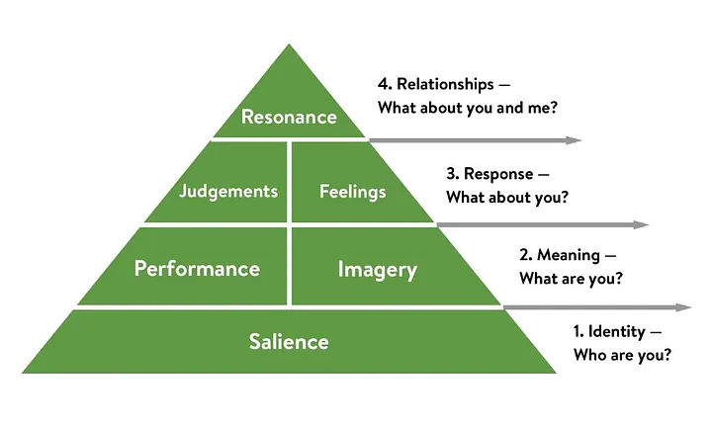
Figure 5: Brand Equity Theory
(Source: Hawker, 2019)
The theory of Brand Equity is relevant in the luxury fashion sector in the context of how digital branding can help to boost brand value. Online branding practices such as social media marketing, online storytelling, personalised engagement, and online customer interaction contribute to building a stronger consumer awareness and developing positive perceptions of a brand (Ewur et al., 2025). The more consumers engage with digital content, the higher the chances of establishing a sense of trust, loyalty and emotional attachment to luxurious brands. These results help in retaining the customer and enhance the competitive position of a firm.
Although relevant, there are limitations in Brand Equity Theory. It mainly concentrates on branding and customer perceptions and pays less attention to the role played by the fast-changing digital technology and market dynamics. Moreover, Laradi et al. (2023) stated that high brand recognition does not necessarily ensure competitiveness in the case where luxury brands lack exclusivity and authenticity. However, the theory is applicable in this study as it describes the process in which digital branding builds the brand image, customer relationship, and competitive positioning in the luxury fashion market.
Dynamic Capabilities Theory
The Dynamic Capabilities Theory is used to describe how organisations attain and maintain a competitive advantage through a continuous process of changing their resources, capabilities and strategies in response to the changing business environments. The theory underlines that companies should not have to own valuable resources as they should earn to recognise market opportunities, undertake strategic changes and transform organisational capability aligned with changing technological developments and consumer needs (Anh et al., 2026). This flexibility helps organisations to be competitive in dynamic industries that are marked by high innovation speed and uncertainty in the market.
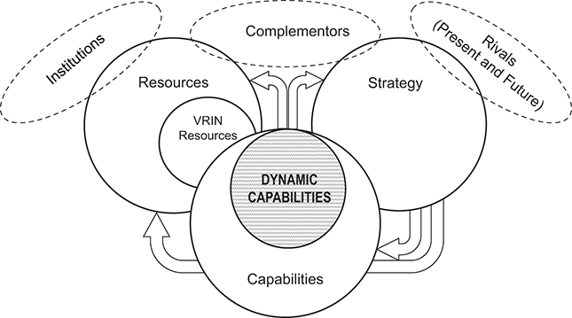
Figure 6: Dynamic Capabilities Theory
(Source: Teece, 2025)
Dynamic Capabilities Theory can be applied to the luxury fashion industry to gain a useful insight into the way brands react to the digital transformation. The growing use of social media, e-commerce, artificial intelligence, and personalised online experiences has necessitated that luxury brands keep on revising their branding and maintaining their heritage and exclusivity (Laradi et al., 2023). With the adoption of digital innovation and reaction to evolving consumer expectations, luxury brands can enhance customer engagement, brand image, and stay competitive in the market.
Despite the fact that the theory is effective in explaining organisational adaptability, there are some limitations to it. It fails to lead explicitly on how dynamic capabilities are to be measured or created, and thus, it is not easy to apply in a real-life scenario. Moreover, keeping up with changes in the market failed to necessarily lead to competitive advantage since external economic factors and consumer tastes can affect business performance (Casciani et al., 2022). However, the Dynamic Capabilities Theory applies in this study as it focuses on the potential of digital branding capabilities to enable luxury fashion brands to maintain competitive standing in a fast-paced digital world.

2.8 Conceptual framework
The theoretical framework shows the association between digital branding and the competitive positioning of Burberry in the luxury fashion market in the UK. In this research, digital branding is taken as the independent variable, whereas the mediating variables, which affect the relationship between digital branding and competitive positioning, which is the dependent variable, are customer engagement and brand image. Effective digital branding, such as online marketing, online storytelling, and a customised online experience, will increase customer interaction and brand recognition. The framework presents a logical basis on which to analyse how digital branding helps Burberry to position itself in the market and analyse the findings of the research.
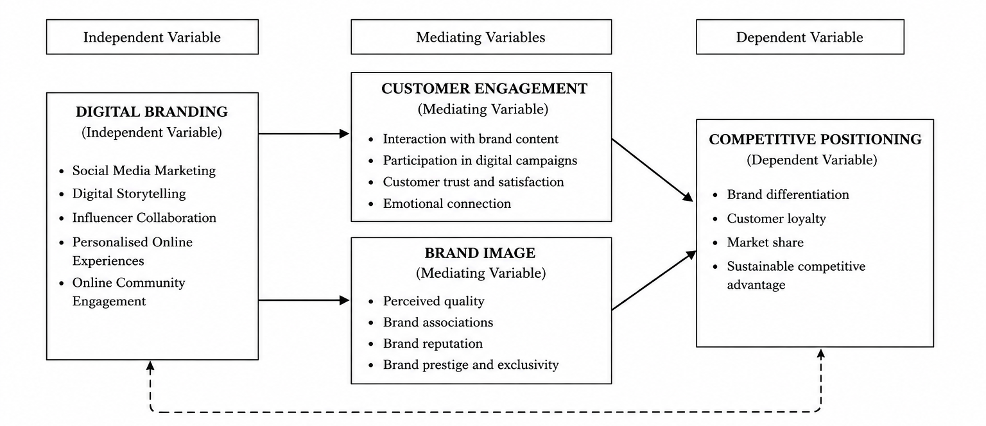
Figure 7: Conceptual Framework
(Source: Self-developed)

2.9 Literature Gap
The literature on digital marketing, social media interaction and brand equity in the luxury fashion industry is widely researched. However, limited studies have been conducted with a particular focus on the effects of digital branding on the competition of Burberry in the UK luxury fashion industry. The majority of the past research like Laradi et al. (2023) and Casciani et al. (2022) is based on consumer behaviour or the overall digital marketing practices instead of examining the impact of digital branding on customer engagement, brand image and competitive advantage, as it aligns with a single luxury brand situation. Moreover, a lack of adequate incorporation of Brand Equity Theory and Dynamic Capabilities Theory in explaining this relationship exists. Thus, this paper fills in these gaps by offering a specific discussion of the digital branding techniques used by Burberry and how they help the company attain competitiveness.

2.10 Chapter summary
The chapter has critically examined the available literature on digital branding and its application in the luxury fashion industry. It analysed the development and significance of digital branding, its effect on customer interactions and brand reputation, the issue of retaining exclusivity of a luxury brand, and the mechanisms applied to ensure a solid competitive stance. The applicability of the Brand Equity Theory and Dynamic Capabilities Theory within the context of explaining the relationship between digital branding and competitive advantage was discussed in the chapter.

CHAPTER 3: RESEARCH METHODOLOGY

3.1 Introduction
In this chapter, the method of the study was presented, which explains the methodological framework used to explore the effects of digital branding on the UK luxury fashion market competitive positioning of Burberry. It describes and supports the research philosophy, approach, methodology of choice, strategy, time frame, and data collection and analysis methods used in the study, guided by the Research Onion. The chapter has also focused on ethical issues, quality of research and methodological limitations, showing how the chosen methods meet the aim and objectives of the study and how they can ensure transparency, rigour, coherence and academic credibility in the implementation process.

3.2 Research Design using Saunder’s Onion Model
Research Onion
The research is informed by the Research Onion of Saunders et al. (2023), which offers a systematic approach to designing research, as it allows selecting the right methodological decisions. It has six interrelated layers that provide methodological coherence, transparency, and research rigour. The below image depicts the choices made in the research that guided to complete the research process in an appropriate manner.
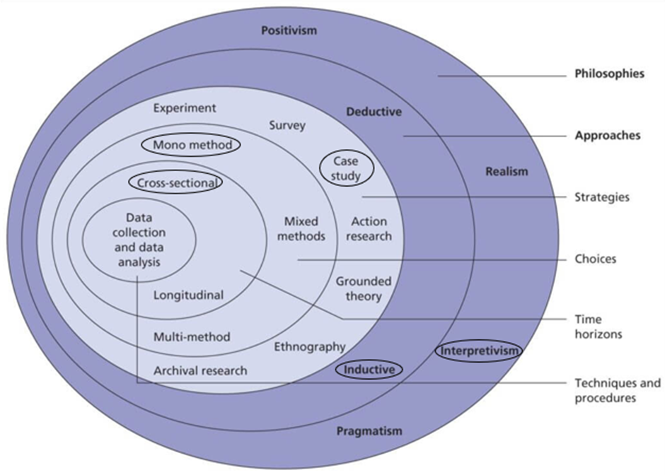
Figure 8: Research Onion
(Source: Saunders et al., 2023)
3.2.1 Research Philosophy
Research philosophy is defined as a collection of beliefs and assumptions, according to which the creation, interpretation, and application of knowledge in a study are conducted (Muzari et al., 2022). Popular philosophical stances are positivism, interpretivism, realism, and pragmatism, which vary in their perspectives on reality and knowledge. In general, positivism presupposes that reality is objective and measurable with the help of numerical values, which is why this paradigm is appropriate to test a hypothesis and analyse the results statistically. Conversely, interpretivism maintains that reality is socially constructed and focuses on how to comprehend meanings, experiences and contextual phenomena. Unlike pragmatism, which does not consider objective reality and supports the choice of methods according to their practicality in solving the research problem, realism integrates objective reality with the subjective interpretation of the research problem (Ikram and Kenayathulla, 2022).
The interpretivist philosophy is especially suitable as this research does not consider the secondary literature to be objective facts but as socially constructed meanings of digital branding practices. The varied views on the effects of digital branding on customer engagement, brand image and competitive positioning are found in academic research, industry reports and publishers of companies. The researcher concludes these perspectives, outlines similarities and differences among the researchers, and finds out repetitive meanings with the techniques of thematic analysis. Instead of statistically measuring the variables, the study aims at understanding the ways in which other scholars have elucidated the digital branding strategies used by Burberry in their context. This process of interpretation correlates with the use of qualitative secondary data and allows getting a deeper insight into the phenomenon.
The philosophy of this study is interpretivist, as it aims to explain the value of digital branding strategies of Burberry in mobilising its competitive stance in the UK luxury fashion market by interpreting qualitative secondary data. As the study does not involve causal relationships testing but focuses on branding strategies, customer relations, and competitive advantage, interpretivism was a more highly contextual approach. Positivism is not suitable since the research is not a quantitative measure or hypothesis test, whereas realism and pragmatism are also inapplicable since the research focuses on subjective organisational phenomena, rather than objective validation or methodological flexibility (Ali, 2024).
3.2.2 Research Approach
The research approach describes the logical connection between theory and data, and how the research starts either with the current theories or generates new theoretical understanding based on evidence gathered. The most common approaches as per Saunders’ Onion are deductive and inductive ones. The deductive approach begins with prior existing theories, develops hypotheses and verifies them through empirical data, and this is suitable in quantitative research, which aims at establishing causal relationships. An inductive approach, on the other hand, commences with the data gathering and analysis, and through this process, patterns, themes, and interpretations can be realised before more conceptual insights are formed (Okoli, 2023).
The research is an inductive one as it seeks to understand the competitive positioning effects of the digital branding strategies at Burberry through the interpretation of qualitative evidence in the academic literature and the industry sources. Instead of testing a set of hypotheses, the study establishes recurring themes regarding digital branding, customer engagement, and competitive advantage regarding the phenomenon. The deductive method cannot be used since the research does not aim to statistically prove theoretical relationships. Hence, inductive reasoning is more appropriate to the interpretivist philosophy and qualitative nature of this study.
3.2.3 Research Strategy
A research strategy is a general guideline on how the research will be undertaken in order to achieve the research aim and objectives (Anas and Ishaq, 2022). Some of the common research strategies are case study, survey, experiment, ethnography, grounded theory and archival research, as each is appropriate to a specific purpose of the research. Quantitative research is traditionally linked to survey and experiment strategies, which allow testing the hypothesis and performing statistical analysis on a big sample. Conversely, a case study enables an in-depth exploration of a particular organisation, event or phenomenon in its natural setting, so it is ideally suited to a qualitative research project designed to gain a rich contextual insight (Taherdoost, 2022).
This research used a case study strategy, with Burberry as a major luxury fashion brand in the UK. The plan allowed for evaluating the digital branding efforts of the company in detail and their impact on customer interaction, brand perception, and positioning using various secondary data sources. Survey and experimental methods cannot be used since the study does not quantify primary data or causally investigate relationships. Similarly, neither ethnography nor grounded theory suits the study because it does not imply field observation and the creation of a new theory, and the case study is the most suitable strategic decision.
3.2.4 Research Choice
Research choice can be defined as the methodological choice of which data and methods to use in tackling the research objectives (Mulisa, 2022). These three main research options include mono-method, mixed methods and multi-method. A mono-method uses either qualitative or quantitative methods; it offers methodological consistency and depth within a single paradigm of research. Mixed methods incorporate both qualitative and quantitative methodologies to obtain complementary information, and multi-method research incorporates a combination of multiple methods in either a qualitative or a quantitative approach (Umar et al., 2023).
The research applied a mono-method qualitative research option due to its aim to create a comprehensive knowledge of the digital branding techniques employed by Burberry and their impact on the competitive positioning using qualitative secondary data. The qualitative method makes it possible to interpret the textual data of academic literature, corporate reports and publications on the industry and create a rich context. Mixed-methods and multi-method approaches are not suitable, since the study neither gathers primary quantitative data nor seeks to combine the paradigms of various methodological approaches. Thus, a mono-method qualitative design is the most consistent and appropriate one to meet the objectives of the research.
3.2.5 Time Horizon
Time horizon is used to describe the time frame within which the research is carried out, and data are gathered to answer the research questions (Nair, 2024). The two major time horizons are the cross-sectional and longitudinal time horizons. A cross-sectional study looks at a phenomenon at one time based on data collected within a specific time, and as such, it is appropriate when conducting research on existing organisational practices or market dynamics. Conversely, a longitudinal study requires repeated observations and a lot of time and resources to collect data over an extended period to observe changes, trends or developments.
The study followed a cross-sectional time horizon since it examined the existing digital branding practices by Burberry and their effectiveness in competitive positioning in the modern UK luxury fashion market based on secondary sources available in the recent past. The research design that should be used is not a longitudinal design since the research is not aimed at analysing the change over time, but at giving a detailed description of the current phenomenon in a given period.

3.3 Data Collection Method
3.3.1 Data Collection
Data collection can be defined as a structured process of data collection that is necessary to answer the research questions and utilise the data to achieve the research objectives (Ajayi, 2023). The data needed in research may be collected using either primary or secondary sources of research, depending on the type of research. Primary data entails gathering first-hand data by using primary methods like surveys, interviews, focus groups and observations. These are suitable where the researchers want to get first-hand information about attitudes, behaviours or experiences. On the other hand, secondary data collection is a common practice of qualitative research due to its ability to allow researchers to synthesise existing knowledge, pinpoint the patterns across multiple sources, and perform extensive analyses in a cost-effective and time-saving way (Cheong et al., 2023).
In this research, secondary data was used as the method of data collection in order to understand how digital branding has influenced Burberry in the competitive positioning of the UK luxury fashion market. The application of Systematic Literature Review (SLR) offers a systematic and transparent method of locating, reviewing and synthesising pertinent literature using various high-quality sources.
3.3.2 Search Strategy
A search strategy is a methodical procedure that is employed to discover and retrieve pertinent literature that can answer the research questions with consideration of transparency, uniformity, and reproducibility (Marzi et al., 2025). Various search strategies consist of narrative searching, scoping reviews and systematic literature searches. The systematic search strategy uses set protocols, pre-identified keywords, and eligibility criteria to guarantee a thorough search of the relevant evidence. This method is mostly applicable to qualitative secondary research that involves strict synthesis of evidence.
The current research has a systematic search strategy, which is aligned with the methodology of the SLR. In the research, Google Scholar, Wiley Online Library, and ScienceDirect were searched by using keywords such as digital branding, Burberry, luxury fashion, competitive positioning, brand image, and customer engagement in combination. The use of Boolean operators, including AND, NOT and OR, was used to select the search results and enhance the accuracy of the search results. Thus, the systematic search strategy offered a transparent, comprehensive and reliable process of identifying literature that directly supports the research objectives.
3.3.3 Study Selection Process
Research selection is defined as the methodical assessment of the literature retrieved to evaluate its relevance and quality to be included in the review (Azarian et al., 2023). The methods of study selection can be different, starting with informal manual selection, and including the use of structured eligibility screening. Informal selection is considerably dependent on the judgement of the researcher and can lead to a high probability of selection bias and inconsistent judgements. Comparatively, a structured selection procedure uses preset inclusion and exclusion criteria to make sure that the studies are evaluated uniformly based on their relevance, methodological quality, and congruence with the research aims. This increases the credibility, transparency, and reliability of findings of secondary research (Irvine, 2024).
Inclusion and Exclusion Criteria
Criteria | Inclusion Criteria | Exclusion Criteria
Article Type | Peer-reviewed journal articles | Non-peer-reviewed articles and blogs
Language | English-language publications | Non-English publications
Time | Published between 2022 and 2026 | Publications before 2022
Relevance | Studies related to digital branding, Burberry, luxury fashion, customer engagement, and competitive positioning | Studies unrelated to the research topic
Article accessibility | Full-text articles with accessible content | Duplicate records and inaccessible full-text publications
After the database search, duplications were deleted, and the titles, abstracts and keywords were filtered based on relevancy. The predetermined inclusion and exclusion criteria were then used to carry out a complete-text evaluation on eligible studies. Peer-reviewed journal articles, reputable industry reports, company publications and English-language publications published between 2022 and 2026 that discuss digital branding, Burberry, luxury fashion, customer engagement, or competitive positioning are the inclusion criteria. Duplicate studies, conference abstracts, blogs, opinion articles, non-English publications and literature not pertinent to the research topic were eliminated, on the other hand. The below PRISMA flow diagram illustrates the ways 161 records were identified initially from different databases, then systematically screened and assessed, which led to the final selection of 10 studies for the research work.
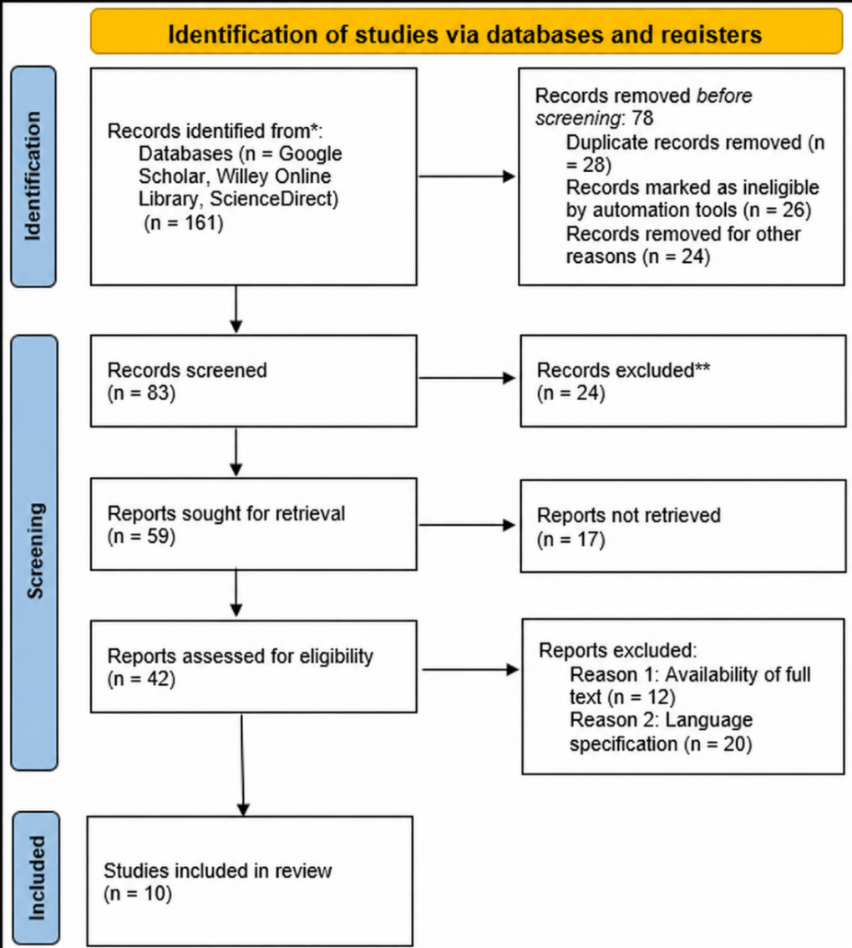
Figure 9: PRISMA Flowchart
(Source: Self-developed)

3.4 Data Analysis
The process of systematically organising, examining and interpreting data collected to come up with meaningful findings that respond to the research objectives is known as data analysis (Naeem et al., 2023). Thematic analysis, content analysis, narrative analysis and discourse analysis are some of the common analytical methods used to conduct qualitative research, and each has its differences in terms of focus and application. The content analysis is mostly applied in order to measure or classify the text data, whereas the narrative analysis studies the stories and experiences of people. The study of language and social interactions in particular situations is the object of discourse analysis. Conversely, thematic analysis is a technique of determining common patterns and themes in qualitative data and therefore is one of the most adaptive and popular techniques used to analyse secondary textual evidence (Braun and Clarke, 2024).
The thematic analysis followed in this study is based on the framework proposed by Braun and Clarke (2006) since it offers a rigorous but flexible method for the analysis of qualitative secondary data. The process consists of six steps: familiarisation with the data, generating initial codes, searching themes, reviewing themes, defining and naming themes, and finally producing the final report. These phases allow the researcher to find patterns systematically in how Burberry, through its digital branding strategies, customer engagement, brand image, and competitive positioning, has operated. The reason why content, narrative and discourse analyses are not embraced is that the study does not aim at quantifying the content of the text, analysing personal stories and analysing language use. Thus, the most suitable data analysis technique is thematic analysis, which produced detailed and valuable insights in line with research goals that delivers the most accurate outcomes.

3.5 Ethical Consideration
Ethical implications are associated with the need to make sure that the research is conducted responsibly, transparent, and with academic integrity. Even though the ethical concerns of primary research that involves human subjects are prevalently related to the research of this kind, they are also relevant to secondary research to maintain the responsible use of published data (Taquette and Borges da Matta Souza, 2022). The research is solely based on secondary data sources (peer-reviewed journal articles, company reports, and other trusted sources on the industry); thus, no human subjects, personal information, or confidential information are utilised, which is why no informed consent or risks of ethical concerns in the recruitment of the participants are required. The study followed the ethical requirements of the university by giving due credit to all the sources by citing the sources appropriately and not plagiarising, creating or misrepresenting the results. Moreover, the credibility and public accessibility of the sources used should be minimised to reduce bias and increase research integrity (Drolet et al., 2023). Interpretation of data was done without the manipulation of evidence to favour certain predetermined conclusions to make sure that the findings of the research are credible, transparent and scholarly throughout the research process.

3.6 Chapter Summary
The chapter presented the research methodology that was applied in the study of how digital branding can influence the competitive positioning of Burberry in the UK luxury fashion industry. Research Onion enabled the study to warrant the choice of an interpretivist philosophy, inductive methodology, mono-method qualitative research design, case study design, cross-sectional time frame, secondary data collection via Systematic Literature Review, and thematic analysis. Ethical issues were also taken care of, making sure that the research is carried out with transparency, rigour, credibility and academic integrity.

CHAPTER 4: FINDINGS, ANALYSIS AND DISCUSSION

4.1 Introduction
This chapter introduces and explains the results of the systematic literature review, which was carried out to explore the effects of digital branding on the competitive positioning of Burberry in the UK luxury fashion market. Braun and Clarke's (2006) six-stage thematic analysis framework was used to analyse the findings, which made it possible to identify common patterns and themes throughout the chosen studies. The chapter begins by giving the results of the thematic analysis and then explains the results in the context of the research objectives and the theoretical frameworks of Brand Equity Theory and Dynamic Capabilities Theory, which underpin these results.

4.2 Presentation of Findings
Sl no. | Author name and Year of publication | Validity of the research | Research method applied | Geographic region | Key findings | Relevance
1. | Fetais et al., 2023 | The research has a great level of validity as it has been published in a peer-reviewed journal and has a sound empirical model with the proper statistics analysis. The validated measurement scales and large sample size contribute to the trustworthiness and credibility of the results. | Quantitative empirical research using survey data analysed through structural equation modelling (SEM). | Qatar (Middle East) | The study results indicated that social media marketing practices can greatly enhance customer engagement, trust, satisfaction and brand loyalty among the luxury fashion consumers. The interactive type of digital communication helps to enhance the relationships with customers in the long term and affects the consumer attitude towards luxury brands in a positive way. | The article is closely related as it describes how digital branding strategies causing engagement and loyalty, which aligns with the investigation of Burberry into the competitive positioning through the use of digital branding, which is the basis of the study.
2. | Gupta et al., 2024 | Springer releases the chapter in an edited academic book, which is why it is a reliable scholarly source. Though it is not empirical but conceptual, it offers well-substantiated theoretical debates on the basis of existing literature on luxury marketing. | Conceptual and literature-based analysis. | Global | This paper posits that luxury brand management has changed with the advent of new technologies like artificial intelligence, digital relationship marketing, and omnichannel strategies. A sustainable competitive advantage relies on the incorporation of technological innovation and a good relationship with customers. | It offers theoretical justification for the effectiveness of using digital branding to reinforce the competitive positioning and justifies the Dynamic Capabilities Theory that is embraced in this dissertation.
3. | Islam, 2025 | The research shows reasonable validity by employing systematic quantitative research on the determinants of customer loyalty. Even though the study was carried out in the context of luxury markets in general, and Burberry in particular, the results can be generalised to luxury fashion. | Quantitative survey research. | Bangladesh | The strongest customer loyalty drivers were found to be customer satisfaction, high quality of service and purchase motivation. The study concludes that ongoing positive customer experiences are important in long-term brand relationships. | The article helps to sustain the discourse of customer engagement and loyalty as the significant consequences of successful digital branding in luxury fashion brands.
4. | Kaur et al., 2024 | The article is in a well-known peer-reviewed journal and offers an exhaustive discussion, as backed up by the recent literature on luxury fashion branding and sustainability. | Qualitative literature review. | Global | The results show that luxury brands are increasingly combining sustainability and digital marketing strategies as means to reinforce brand image, boost consumer confidence and increase their long-term competitiveness. Digital storytelling also helps create a closer emotional appeal to consumers. | The research has added to the comprehension of the role of digital branding in expanding beyond promotion in enhancing brand image, customer trust and competitive differentiation in luxury fashion markets.
5. | Kim et al., 2026 | The study has high validity as it was published in a reputable academic journal and used confirmed theoretical frameworks. The analytical strategy offers credible evidence on the consumer reaction to digital sustainability strategies. | Quantitative empirical research using signalling theory. | South Korea | The research established that digital sustainability programs have a positive impact on consumer trust, brand reputation and purchase intentions. Perceptions of authenticity and competitive advantage in luxury fashion are greatly enhanced through strategic digital communication. | The results prove arguments related to digital branding, brand image and competitive positioning and show the need for strategic communication to sustain the value of luxury brands.
6. | Nyrhinen et al., 2024 | The study is very valid as it is published in one of the most reputable international journals, and the statistical analysis used is rigorous, including a large sample of young online consumers. | Quantitative survey research with statistical modelling. | Finland | The presence of online marketing stimuli, customised suggestions and interactions with the digital platform play a vital role in influencing impulse buying behaviour in younger consumers. The role of digital environments in purchasing decisions is growing. | The article presents evidence on the effects of digital branding on online consumer behaviour, contributing to the arguments about customer interaction and online communication in luxury fashion markets.
7. | Park et al., 2024 | The research validity is good since it uses the Brand Equity Theory and tests the hypotheses' relationships with the help of the proper statistical methods. | Quantitative empirical research. | South Korea | Brand image has a positive influence on brand equity, which in turn influences behavioural intentions as well as consumer loyalty. Favourable brand images are a good way of enhancing overall brand value and competitiveness. | This paper has a direct impact on applying the Brand Equity Theory to the dissertation and how digital branding helps to build a better brand image and competitive positioning.
8. | Sankala, 2024 | The study was published in a reputable marketing journal, which presents credible evidence on the topic of influencer marketing and consumer behaviour. Quantitative design enhances internal validity, but results can be different in different industries. | Quantitative survey research. | India | Consumer purchase behaviour, trust and brand loyalty are some of the areas where social media influencer marketing has a great impact. Veritable influencers produce more emotional appeal and enhance the consumer attitude towards luxury brands. | The study is topical as influencer partnerships are a significant approach to digital branding that boosts customer interactions, brand recognition and competitive edge in the luxury fashion industry.
9. | Krsmanović, 2026 | The article offers more recent evidence that is limited to luxury branding in digital times. It is mainly conceptual but synthesises up-to-date literature and provides valuable theoretical insights into the exclusivity of luxuries. | Conceptual research supported by a literature review. | Europe | Digital marketing has not only increased access to luxury brands, but it has also posed a challenge to exclusivity. Effective luxury brands strike a balance between a more extensive digital presence and highly regulated high-end brand experiences. | The article is very relevant since it directly analyses the key issue of this dissertation, as the correlation between digital branding, luxury exclusivity and competitive positioning.
10. | Liu et al., 2025 | The article has good methodological validity as it has been published in a good journal and has been empirically analysed through the use of established measurement models. | Quantitative empirical research employing structural equation modelling (SEM). | South Korea | Green value has a positive impact on brand trust, online customer experience and buying desire. The study proves that customer trust is a mediator between digital engagement and purchasing behaviour. | The results contribute to the discussion on customer engagement, brand trust and digital branding and present evidence that effective digital communication enhances customer relations and the competitive positioning among luxury fashion brands.

4.3 Analysis of Results
4.3.1 Theme 1

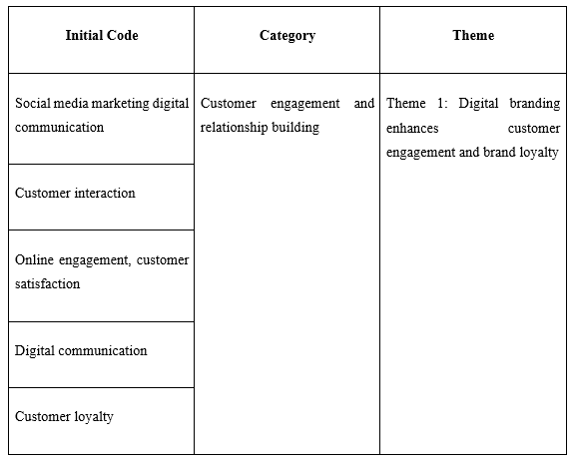
The initial theme was based on the repetitive original codes of social media marketing, digital communication, customer interaction, online engagement, customer satisfaction and customer loyalty. These ideas were evident throughout the analysed literature as one of the main results of successful digital branding practices. It is considered that online channels are extremely important in enhancing the relationships between luxury brands and consumers (Golob et al., 2022). This theme is connected to RQ1, which is to determine the most common digital branding approaches reported in the literature on luxury fashion reviewed, the most common were social media marketing, digital communication and influencer engagement. It helps answer RQ2, by showing that these strategies are helpful in enhancing customer engagement, trust and brand loyalty. Hence, the results can be viewed as the indicators of the broader luxury fashion industry that offers a conceptual framework in the context. As per company annual report 2025, this transition can be observed in the Burberry Forward strategy, as the company puts customers at the core of its business model and invests in the omnichannel retailing, online experiences and commercially relevant online product presentation (Burberry, 2025).
Fetais et al. (2023) emphasised that interactive social media activities are of great benefit in customer engagement, satisfaction, trust and loyalty among luxury fashion consumers. In the same vein, Sankala (2024) revealed that influencer marketing can boost digital communication, as it facilitates real interactions, which can positively affect consumer perception and buying behaviour. These recurring results came up with the original codes of social media marketing, digital communication, and customer interaction.
Additional common concepts were found to be online engagement and customer satisfaction. Islam (2025) noted that customer satisfaction and positive experiences with the brand enhance the duration of customer loyalty, whereas Liu et al. (2025) have discovered that online customer engagement increases the purchase desire indirectly via brand trust. These recurring results solidified the type of customer interaction and relationship development. Moreover, it indicated that digital branding is helpful in enhancing promotional efforts and can help generate meaningful customer relationships (Rowi et al., 2024).
These associated categories were merged into the overall theme of digital branding, improving customer engagement and brand loyalty. Synthesis of evidence shows that through digital branding, luxury brands can communicate with their consumers, promote ongoing interaction, and emotional engagement. As a result, customer satisfaction, trust and loyalty are more likely to improve as a result of improved engagement, which are critical towards maintaining a competitive stance in the luxury fashion industry (Nkegbe and Abor, 2023).
4.3.2 Theme 2
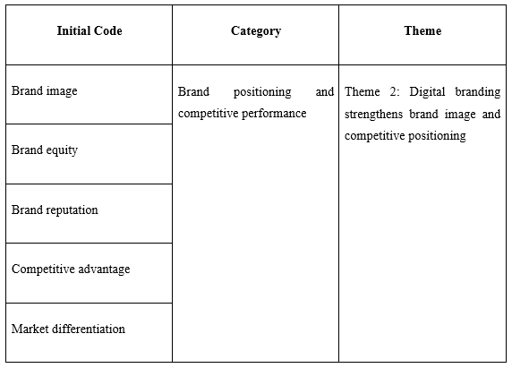
The second theme aligned with the repeated first codes of brand image, brand equity, brand reputation, competitive advantage and market differentiation, which were combined into the larger category of brand positioning and competitive performance. Prasetya et al. (2025) stated that digital branding proved to be a strategic tool for improving the perception of luxury brands among consumers as well as reinforcing their competitive strength in the market. This theme is directly related to RQ2, as it proves that digital branding increases brand image, brand equity and customer perceptions among luxury brands of fashion. It is relevant to RQ3 as a stronger brand image and market differentiation were constantly related to a better competitive positioning. Comparing with the argument of Krsmanović (2026), this evidence is mostly applicable to luxury brands based on the findings can be used to offer an analytical framework of how Burberry can enhance its competitive advantage by digital branding. As per the Burberry annual report 2025, the brand is enhancing functionality on its website enhancing omnichannel distribution and developing a customer-friendly online shopping experience (Burberry, 2025).
Park et al. (2024) discovered that brand equity is greatly boosted by a good brand image, resulting in an increase in consumer loyalty and behavioural intentions. In the same manner, Kim et al. (2026) found that strategic digital communication has a positive impact on brand reputation since it makes consumers perceive a higher degree of authenticity and organisational credibility. This evidence produced the first sets of brand image, brand equity and brand reputation codes, whereby digital branding plays a crucial role in creating positive consumer perceptions.
Additional research revealed competitive advantage and market differentiation as common concepts. Gupta et al. (2024) opined that the combination of new digital technologies, relationship marketing and omnichannel strategies can help luxury brands gain a competitive edge over their rivals and maintain a sustainable competitive advantage in the long term. Similarly, Kaur et al. (2024) revealed that digital branding, together with sustainability-oriented communication, enhances the organisational reputation and shapes the distinctive positioning on the market. These consistent findings were aligned with the theme of brand positioning and competitive performance, which was the strategic importance of digital branding that goes beyond promotional efforts.
In the last phase of thematic analysis, the category identified was narrowed down into the general theme of digital branding, which enhances brand image and competitive positioning. The evidence synthesis implies that successful digital branding helps luxury brands to create better brand equity, enhance corporate reputation and create a clear market distinction. These play a part in ensuring a long-term competitive advantage through customer perceptions and strengthening the luxury brand's premium positioning (Sugita and Handayani, 2024).
4.3.3 Theme 3
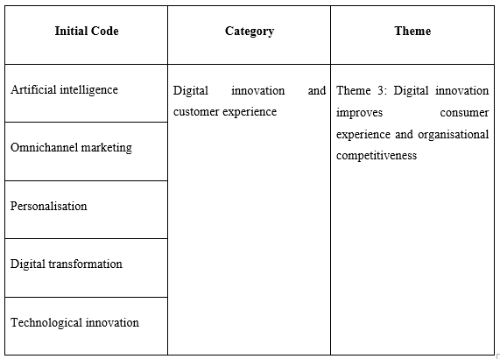
The third theme was based on the repeated first codes of artificial intelligence, omnichannel marketing, personalisation, digital transformation, and technological innovation, which were sub-categorised under digital innovation and customer experience. Budiarti (2024) shows a consistent pattern that technological innovation has changed the way luxury brands engage with buyers to enhance their competitiveness. This theme helps to justify RQ1 as AI, omnichannel marketing and personalisation are key digital branding strategies that have been reported in the literature reviewed. It is related to RQ3 as these technological capabilities enhance the organisational competitiveness and customer experience. According to Burberry annual report 2025, the emphasis on developing customer relationships based on immersive storytelling, customer-centred retailing and digital experiences is among the priorities as part of its Burberry Forward programme (Burberry, 2025).
AI and technological innovation were two salient concepts identified in the coding process in the chosen literature. Gupta et al. (2024) posited that AI has transformed the way luxury brands are operated through the ability to analyse consumer preferences, customise marketing strategies and build long-term relationships with customers. Equally, Kim et al. (2026) discovered that digital technologies and new communication strategies enhance brand authenticity, consumer trust and organisational competitiveness. AI, digital transformation, and technological innovation, which signify the rising significance of digital abilities in the branding of luxury brands (Widjaja, 2025).
Additional reading created a focus on the omnichannel marketing and personalisation as emerging themes in a number of research studies. Gupta et al. (2024) highlighted that employing online and offline customer experiences through omnichannel approaches helps luxury brands provide a smooth customer experience across various platforms. Similarly, Nyrhinen et al. (2024) showed that customised online suggestions and interactive online experiences have a considerable impact on consumer buying behaviour, especially younger consumers. Digital innovation and customer experience, which demonstrate the technology-driven strategies, add customer convenience, engagement and satisfaction (Agu et al., 2024).
The category identified was narrowed down to the overall theme of how digital innovation enhances consumer experience and organisational competitiveness. The evidence synthesis implies that the ongoing investment in digital technologies can help luxury brands provide their customers with personalised experiences, enhance operational efficiency and react efficiently to shifting customers' expectations (Theocharis and Tsekouropoulos, 2025). Therefore, digital innovation increases customer value and organisational competitiveness, which means that luxury fashion brands like Burberry can continue to stay competitive in a technologically focused market.
4.3.4 Theme 4
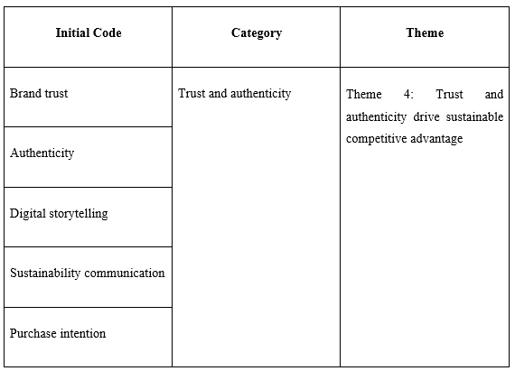
The fourth theme was the result of the resemblance of the initial codes of brand trust, authenticity, digital storytelling, sustainability communication, and purchase intention that were clustered into the broad concept of trust and authenticity. Helmi et al. (2022) show that consumer trust and impressions of authenticity are the key products of a successful digital branding. Moreover, it has a strong impact on purchasing behaviour and the sustainability of organisational competitiveness in the luxury fashion sector in the long term. This theme mainly provides responses to RQ2, demonstrating that trust, authenticity and digital storytelling enhance customer associations and enhance purchase intentions. It leads to RQ3 as authentic digital communication increases the organisational reputation and competitive advantage in the long term. Burberry annual report 2025 stated that, its international promotions of its iconic trench coat and the British identity show how Burberry merges heritage and digital storytelling to cement its brand value and relevance (Burberry, 2025).
Brand trust was one of the most common concepts that were identified in the process of coding the reviewed literature. Liu et al. (2025) showed that brand trust mediates between digital customer engagement and purchase intention, meaning that consumers tend to buy the products of the brand that they believe to be trustworthy. Similarly, Fetais et al. (2023) established that consumer trust, satisfaction and loyalty are greatly enhanced via digital interactions through social media. These repeat results gave rise to the first code of brand trust, which emphasised its significance in creating lasting customer relationships.
Additional examination showed that authenticity, digital storytelling, and sustainability communication were constantly mentioned among the factors that affected consumer perceptions. According to Kaur et al. (2024), digital storytelling helps luxury brands to share information about their heritage, values, and sustainability efforts, which enhances emotional bonds with customers. Similarly, Kim et al. (2026) found that open sustainability communication leads to an improved perception of authenticity and strengthens organisational reputation. Karp et al. (2024) showed that consumers increasingly consider authentic and responsible online communication as a value when considering luxury brands.
The evidence synthesis implies that the best way to use digital branding is to build authentic consumer experiences, build brand trust, and convey organisational values across digital platforms. These aspects have a positive impact on purchase intention, besides strengthening customer loyalty and organisational reputation (Torres and López, 2024). As a result, building trust and authenticity via successful digital branding can make luxury brands, like Burberry, stay competitive over time in an ever more digital and competitive luxury fashion marketplace.
4.3.5 Theme 5
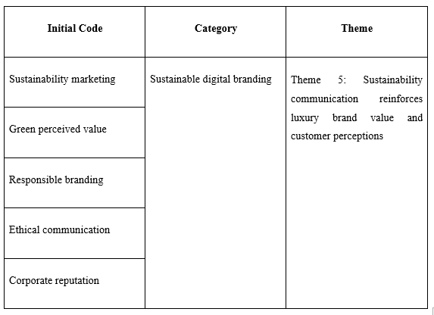
The fifth theme was based on the repetition of the original codes of sustainability marketing, green perceived value, responsible branding, ethical communication, and corporate reputation, which were united into the bigger theme of sustainable digital branding. Dabić et al. (2023) suggest that sustainability has been integrated into the digital branding approaches, which allow luxury companies to advance their image and gain a better perception of customers. This theme will be added to RQ2 as it will show that sustainability communication has a positive impact on consumer trust, brand value and customer perceptions. It answers RQ3, because the sustainability-based digital branding enhances the competitive differentiation within the luxury fashion market. According to Burberry annual report 2025, the company pledges to responsible sourcing, climate action and sustainable value creation, which means that sustainable communication has become a part of the brand strategy (Burberry, 2025).
Kaur et al. (2024) emphasised that the concept of sustainability in luxury fashion brands is becoming a part of the digital branding strategy that helps to convey the notion of environmental responsibility and build consumer trust. Likewise, Liu et al. (2025) discovered that the concept of green perceived value has a positive impact on brand trust, digital customer engagement and purchase intention. Sustainability marketing and green perceived value. This proves that consumers are more willing to assess luxury brands according to the quality of their products and their environmental responsibility (Prayitno, 2023).
The additional examination found the responsible branding, ethical communication, and corporate reputation to be significant and interdependent notions. Kim et al. (2026) posited that open communication about sustainable actions improves perceptions of genuineness and boosts the organisational image. Similarly, Kaur et al. (2024) have pointed out that responsible branding backed by ethical digital communication helps luxury brands to create more emotional connections with their consumers and strengthen their luxury image in the market. Sustainable digital branding, with sustainability as a strategic value in luxury fashion branding, is increasingly gaining popularity.
These categories were incorporated into the overall theme of sustainability communication that strengthens the value of luxury brands and perceptions of customers. The evidence synthesis indicates that digital branding with a focus on sustainability enhances corporate reputation, increases customer trust, perceived brand value and purchase intentions. Luxury brands can be distinguished in a competitive market with the help of effective communication of environmental and ethical initiatives to meet the evolving consumer expectations (Ohinok and Hunka, 2023). This means that sustainability communication has emerged as an important strategic asset towards the long-term brand value and competitive positioning in the luxury fashion industry.
4.3.6 Theme 6
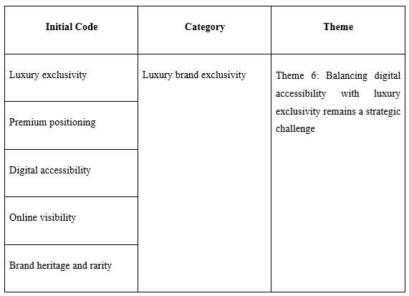
The sixth was based on the presence of the initial codes of luxury exclusivity, premium positioning, digital accessibility, online visibility and brand heritage and rarity that were further classified under the umbrella theme of luxury brand exclusivity. Kreiterling (2023) stated that digital branding offers great opportunities to reach a larger number of consumers and increase brand awareness. It is challenging in preserving exclusivity and prestige that luxury brands are characterised by. This theme answers the RQ3 directly as it states that the luxury brands need to find a balance between the digital accessibility and exclusivity. This balance is constantly cited in the reviewed works as a key determinant of competitive positioning in the long term. According to Burberry annual report 2025, the organisation focus on customer-centred distribution is the enhancement of online capabilities, better product presentation and better relationships on physical stores, e-commerce and wholesale channels, which is the practical use of omnichannel retailing (Burberry, 2025).
The luxury exclusivity and premium positioning were the concepts found in the chosen literature identified during the coding process. Krsmanovic (2026) opined that luxury branding has been revolutionised by digital marketing because of its accessibility to the brand via online marketing and social media. However, increased online presence can undermine the sense of scarcity and exclusivity, which are the core attributes of luxury brands. Similarly, Gupta et al. (2024) indicated the benefits of digital technologies in enhancing customer engagement and operational efficiency; luxury brands should handle their digital presence with caution to avoid losing their premium position in the market. Luxury exclusivity and premium positioning that conveyed the need to retain a unique brand identity even in the face of growing digitalisation (Hanhimäki, 2025).
The additional analysis discovered the recurring concepts of digital accessibility, online visibility, and brand heritage and rarity. Ahmed and Ahmed (2025) emphasised that online platforms allow luxury brands to connect with broader global communities and improve customer experiences. However, access through the internet can diminish the sense of scarcity, which is a traditional contributor to luxury brand value. Kaur et al. (2024) highlighted the idea that it is critical to maintain brand heritage and embrace digital transformation to stay authentic and competitive in the long term.
These groups were incorporated into the general theme of balancing digital accessibility with luxury exclusivity, which is a strategic issue. Evidence synthesis indicates that to become a successful luxury brand, digital branding efforts need to be strategic. This balance helps organisations like Burberry to experience the advantages of digital innovation that forms the cornerstone of sustainable competitive advantage in the luxury fashion sector (Alsheref et al., 2024).

4.4 Discussion of Results
4.4.1 Discussion based on Objective 1
According to Vogue Business (2025) the analysed literature reliably shows that luxury fashion brands are increasingly implementing digital branding such as social media marketing, AI-powered personalisation, omnichannel retailing, influencer marketing and sustainability communication. The thematic analysis revealed that social media marketing, digital communication, omnichannel marketing, AI, collaboration with influencers, digital storytelling and sustainability communication are one of the most influential strategies (Jain et al., 2026).
Based on the results Gupta et al. (2024), who reasoned that AI, omnichannel retailing and relationship marketing brought changes in the management of luxury brands, as it allows the brand to provide its customers with a seamless customer experience across various digital touchpoints. Similarly, Fetais et al. (2023) have discovered that social media marketing is effective in increasing customer engagement, trust and brand loyalty by engaging them daily in digital communication. This aligns with the identified themes, in which social media marketing and digital communication have proven to be the leading approaches in reinforcing relationships with consumers. However, these strategies are not to be viewed as equally efficient in the case of Burberry as the evidence is mostly representative of the broader luxury fashion industry. The extent to which digital innovation is merged with their heritage, exclusivity and positioning in the UK market will determine their relevance to Burberry.
As per the results the postulates of Dynamic Capabilities Theory, which demonstrates that organisations gain long-term competitive advantage by sustaining constant adjustment of their capabilities in response to market needs. The use of novel digital technologies, individualised marketing and online and offline experiences shows that Burberry has the potential to re-organise organisational resources to meet changing consumer demands. Moreover, Yan et al. (2022) emphasised that sustainability communication and digital storytelling have turned into significant strategic assets. It helps luxury brands to convey authenticity, reinforce corporate reputation, and outshine competitors.
However, effective digital branding goes beyond technology implementation can be beneficial for the organisations. Lanfranchi et al. (2026) highlighted that the issue of more digital access can disrupt the exclusivity that has traditionally been linked to luxury brands. Hence, Burberry has to strike the right balance between digital innovation and the maintenance of the high-end brand and heritage. In general, the evidence will address RQ1 as it will show that digital branding strategies focused on customer-centred interactions, tech innovation and genuine digital communication are the key processes that help luxury fashion brands to enhance their market presence. It implies that the majority of the conclusions are made based on the evidence on the luxury fashion in general.
4.4.2 Discussion based on Objective 2
Focusing on the results it can be stated that digital branding positively affects the brand image and customer interaction of Burberry to a considerable extent in the UK luxury fashion market. Social media marketing, digital communication, digital storytelling, influencer collaborations and personalised customer experiences contribute to strengthening consumer relationships and boosting perceptions of brand quality and authenticity (Zhang, 2024). These results indicate that digital branding helps Burberry to build closer emotional ties with consumers and consolidate its high-end brand image.
On the other hand, Fetais et al. (2023), who analysed that the marketing activities of social media can greatly enhance customer engagement, customer satisfaction, trust and brand loyalty by maintaining constant digital communication. Similarly, Sankala (2024) discovered that influencer marketing improves customer engagement, boosting brand credibility and motivating consumers to have a stronger emotional attachment. These results align with Theme 1, in which digital branding was observed to enhance customer interaction and relationship maintenance in the long-term. Moreover, Jung et al. (2024) revealed that digital customer engagement has a positive relationship with purchase intention, as the growing brand trust implies that engagement and trust interact and enhance consumer behaviour.
Based on the findings it can be understood that digital branding has a positive effect on the brand image of Burberry. Park et al. (2024) concluded that brand equity is enhanced by a favourable brand image, resulting in increased customer loyalty and positive behavioural intentions. Similarly, Kim et al. (2026) opined that strategic digital communication improves the organisational reputation and strengthens the perceptions of realness in the luxury fashion markets. Luo et al. (2025) emphasised that digital storytelling and sustainability communication enhance emotional connections and consumer perceptions of luxury brands. The results align with Theme 2 and Theme 5, which found brand image, corporate reputation and sustainability communication to be significant to competitive positioning.
The Brand Equity Theory, according to customer perceptions, brand awareness, and positive brand associations, which are strong and lead to higher brand value and competitive advantage. Online branding by Burberry boosts brand equity by increasing the level of customer engagement, trust and brand reputation, which strengthens its luxury status in the UK fashion industry (Salinas and Abril, 2026). The results indicate digital branding has been a vital source of customer engagement and brand image, which helps Burberry to maintain good relations with customers in the luxury fashion industry.
All these findings can address RQ2, as they will show that digital branding enhances customer engagement, brand trust, emotional attachment and brand equity. Instead of depending on the individual research, the evidence synthesis shows that these mutually reinforcing factors enhance customer relationships and competitive positioning. Even though this literature is mostly on luxury fashion brands as these findings present a sound theoretical justification to the effectiveness of digital branding of Burberry. However, these beneficial impacts are not expected to be applicable to Burberry to such degree since much of the evidence reviewed is devoted to luxury fashion brands in general and Burberry in particular. Consumer behaviour differences, market context and brand heritage could impact on the effectiveness of digital branding.
4.4.3 Discussion based on Objective 3
Digital branding has a great role to play in enhancing the competitive positioning of the Burberry brand in the UK luxury fashion market by augmenting brand differentiation, customer engagement and organisational reputation. The thematic analysis revealed that digital branding helps luxury brands to integrate technological innovation, personalised customer experiences and authentic brand communication to form sustainable competitive advantages. Lee (2025) indicates that the digital branding strategy of Burberry is not confined to promotional efforts, as it serves as a strategic strength that can facilitate market dominance in the long-term perspective.
Gupta et al. (2024) claimed that luxury brands could distinguish themselves in competitive markets with the help of digital technologies, such as AI, omnichannel marketing and relationship management. Equally, Park et al. (2024) established that a solid brand image has a positive effect on brand equity, which positively affects customer loyalty and competitive performance. The results align with the findings of Theme 2, which revealed that digital branding reinforced brand image and market differentiation, thus enhancing competitive positioning. Moreover, Lee et al. (2024) revealed that strategic digital communication enhances brand reputation and consumer attitudes towards authenticity, allowing luxury brands to gain a competitive edge through effective communication and innovation.
Sustainability communication is a contributor towards competitive positioning. Kaur et al. (2024) discussed that incorporating sustainability in digital branding improves corporate reputation and consumer trust. Salinas and Abril (2026) discovered that green perceived value and digital customer engagement have a positive effect on purchase intention due to high brand trust. These results indicate that customers are becoming more concerned about luxury brands in terms of product quality, ethical and sustainable business operations. Thus, the issue of sustainability communication has assumed a significant role in differentiation in terms of the luxury fashion industry (Yu et al., 2023). This implies that digital branding may not necessarily generate sustainable competitive advantage. In the case of Burberry, it has had to minimize the need to compromise exclusivity, heritage and authenticity in favour of technological innovation and accessibility to customers.
Krsmanović (2026) suggested that the growing digital access could lessen the exclusivity that is traditionally linked to luxury brands. This conclusion means that Burberry has to strike a balance between digital innovation and maintaining its heritage, rarity and premium positioning. The results are consistent with the theory of Dynamic Capabilities Theory, which suggests that organisations can maintain competitive advantage by constantly adjusting their resources and capabilities to the evolving market conditions. The dynamic capabilities Burberry has displayed in its technical innovation, customer interaction, sustainability communication and brand heritage (Kelleci, 2022). It illustrates the capabilities required to sustain a high level of competitiveness in comparison to other luxury fashion brands in the UK.
In general, overall findings has provided answers to RQ3 by proving that digital branding enhances competitive positioning by providing better brand differentiation, technological innovation, sustainability communication and customer loyalty. However, Vogue Business (2025) report stated that, stated that the need to preserve the exclusivity of luxury and at the same time increase digital access as an ongoing strategic dilemma. This observation is applicable to Burberry since maintaining a heritage and digital transformation is crucial to the maintenance of a competitive advantage in the long term.
4.4.4 Research Question Synthesis
The thematic analysis shows that the most identified strategies of digital branding are social media marketing, AI-driven personalisation, omnichannel retailing, influencer collaborations, digital storytelling and sustainability communication. All these results respond to RQ1 as they determine the key strategic directions embraced in the luxury fashion industry. Even though there is a lack of empirical evidence to be employed regarding Burberry, the literature reviewed offers a solid theoretical foundation of learning about the digital branding strategy of Burberry.
The synthesis shows that digital branding can improve the customer engagement with increased trust, emotional attachment, customer satisfaction and brand loyalty. Favourable customer perceptions are enhanced by enhanced brand image and brand equity. These results provide answers to RQ2, as they demonstrate that digital branding enhances consumer relations and leads to high-quality brand positioning.
The results show that digital branding is related to competitive positioning in terms of enhancing market differentiation, organisational reputation, customer loyalty and innovation capability. However, exclusivity and expansion of digital accessibility is a strategic dilemma that has been pointed out in the literature. Thus, the competitive advantage is based on the implementation of digital technologies based on the maintenance of the heritage and authenticity of the luxury brands.

4.5 Chapter Summary
This chapter provided the results of the systematic literature review and processed the results with the six-stage thematic analysis framework by Braun and Clarke (2006). The conclusions revealed that digital branding boosts customer involvement, brand image, enhances digital innovation, fosters trust and authenticity, and supports sustainability communication. It serves as a contributor to the competitive positioning of Burberry and poses challenges concerning the need to preserve luxury exclusivity. One of the main limitations that were detected in conducting the systematic literature review is the lack of Burberry-specific empirical research. Most of the evidence reviewed analyses the digital branding in the broader luxury fashion industry. Thus, the discussion makes inferences of these wider results to elucidate the competitive positioning of Burberry but not to state that there were direct empirical results of how Burberry carried out its digital branding practices. These findings were associated with the research objectives and underlying theories and formed the basis of the conclusion and recommendations that are made in the next chapter.

CHAPTER 5: CONCLUSIONS AND RECOMMENDATIONS

5.1 Summary of main findings
The research explored the effects of digital branding on the competitiveness of Burberry in the UK luxury fashion industry based on a systematic literature review. The results were summarised based on the six-stage thematic analysis methodology created by Braun and Clarke (2006), leading to six general themes that were able to respond to the research questions. In general, the results indicate that digital branding is a strategic asset that helps luxury brands to build better customer relationships, enhance brand value, and maintain a competitive advantage in an ever-increasing digital market.
The initial objective was to find out the digital branding approaches applied by Burberry to the UK luxury fashion market. The results indicated that the key strategies are social media marketing, digital communication, omnichannel marketing, AI, influencer collaborations, digital storytelling and sustainability communication to connect with consumers and enhance brand performance. The tactics will help Burberry offer customised customer experience whilst ensuring a uniform communication between the various online platforms.
The second objective has investigated how digital branding affects the brand image and customer involvement of Burberry. The results showed that the digital branding process is an effective way to increase customer engagement, customer satisfaction, customer trust and customer loyalty by enhancing interactive experiences of the digital environment. Moreover, digital branding enhances brand image through enhanced brand equity, corporate reputation and consumer perceptions of genuineness. Another aspect that was found to be significant in enhancing emotional attachment between the brand and the consumers was sustainability communication and digital storytelling.
The third objective was to measure the role of digital branding in terms of Burberry's competitive advantages over other luxury fashion brands in the UK. The results showed that branding on the Internet helps Burberry to stand out in terms of technological innovation, personalised customer experiences and genuine brand communication. In that case, the discussion has included the fact that there is a strong strategic dilemma on how to balance digital access and luxury exclusivity. Overexposure to the internet has the potential to minimise perceptions of exclusivity, and Burberry must maintain its legacy and luxury branding by innovating online.

5.2 Conclusion based on the research questions
This paper concludes that digital branding is a key element in enhancing the competitiveness of Burberry in the UK luxury fashion market. The systematised literature review proved that digital branding is not confined to the promotion activity but has transformed into a strategic ability. It facilitates customer interaction, brand image development and sustainable competitive advantage. The results show that Burberry can effectively combine digital technologies and its luxury brand image to address the evolving consumer demands and retain its position in the market.
In the context of the first research question, which addressed the digital branding practices at Burberry. The study concludes that the brand engages in a mix of social media marketing, omnichannel marketing, AI, digital storytelling, influencer collaborations and sustainability communication as part of its strategy to enhance customer relationships and brand visibility. The strategies will help Burberry to provide personalised and continuous digital experiences at various customer touchpoints and facilitate long-term brand building.
The second research question was investigative in nature of how digital branding affects the brand image and customer engagement of Burberry. The results conclude that good digital branding has a positive impact on customer satisfaction and trust, customer loyalty and purchase intention, and it improves brand image and corporate reputation. Moreover, the genuine digital communication and sustainability practices enhance the emotional connection that consumers have to the brand and solidify the Burberry premium position in the luxury fashion market.
The third research question was how digital branding has helped Burberry to be competitive with other luxury fashion brands in the UK. The paper concludes that Burberry can distinguish itself using innovative methods, customer-oriented experiences and a good brand equity due to digital branding. However, the results indicate that greater access to digital will pose a challenge in maintaining exclusivity and rarity that has been a prerogative of luxury brands. Thus, a healthy balance between digital innovation and the heritage of luxury is critical to keeping up a competitive advantage.
On the whole, the results are consistent with the Brand Equity Theory, as they show that digital branding helps to increase brand value in terms of better customer perceptions and loyalty. They advocate Dynamic Capabilities Theory, which explains how Burberry has been able to constantly adjust its digital capabilities to evolving technological and consumer landscapes. As a result, successful online branding is one of the strategic assets that can help Burberry to remain competitive in the UK luxury fashion market in the long-term.

5.3 Recommendations
Improve artificial intelligence-based personalisation.
In order to provide a more personalised customer experience on digital platforms, Burberry ought to keep investing in AI and data analytics. Recommendation systems that are powered by AI, personalised marketing campaigns and predictive understanding of customers will enhance customer engagement and satisfaction. However, these efforts must be aligned with data privacy requirements and be transparent about how customer data is gathered and used to ensure that consumer confidence is not lost.
Enhance omnichannel customer experiences.
The results show that a smooth correlation between the online and offline channels is a key factor in customer engagement and competitive advantage. Burberry should enhance its omnichannel by aligning its online business with its mobile applications, social media, physical outlets and stores into a single customer experience. Additional services like click-and-collect, virtual consultations, digital appointments and customised in-store experiences can enhance the experience of convenience and strengthen the presence of a cohesive brand experience.
Develop digital communications that are sustainable.
Sustainability communication was found to be a significant aspect of brand image and customer perceptions. Burberry must consequently raise the profile of its environmental and social responsibility programs by telling stories online, participating in interactive campaigns and publishing sustainability reports. Sustainable sourcing, ethical manufacturing and circular fashion initiatives need to be emphasised on digital platforms to induce consumer confidence, strengthen corporate image and branding and separate the brand in the ever-evolving luxury fashion market.
Maintain the exclusivity of luxury and increase digital access.
Even though online branding increases customer interaction and penetration in the market, too much online presence can undermine the sense of exclusivity. To sustain its high-end status, Burberry needs to create unique online experiences that will support the luxury image of the brand. Exclusive online product releases, invitations-only online events, special membership programmes and bespoke luxury services may enhance the level of digital activity without losing the rarity, heritage and prestige linked to the Burberry brand.
Enhance real-world digital storytelling and collaboration with influencers.
The results indicate that truthful communications and influencer partnerships have a positive impact on customer trust and brand loyalty. Burberry must, consequently, focus on the collaboration with the selectively chosen influencers whose ideals are compatible with the heritage, craftsmanship and sustainability promises of the brand. Moreover, the organisation ought to increase its application of digital storytelling by demonstrating its history, design experience, craftsmanship and innovation with interesting multimedia information. True narration can help build emotional bonds with the consumer, brand credibility and solidify Burberry as a unique brand in the extremely competitive UK luxury fashion market.

5.4 Limitation of Research
The study has relied entirely on a literature review, which is systematically and based on secondary data, as compared to primary data collected by the researcher on Burberry customers or industry experts. Therefore, the results are subject to the quality and extent of the research chosen. The review process has not incorporated all the relevant research, as ten peer-reviewed articles were included in it, and the inclusion criteria were limited to the period of their publication. The research failed to consider the luxury fashion market in other parts of the world besides the UK. Moreover, this restricted the applicability of the results to other luxury brands or other geographical and industry markets. Since the analysis was based on secondary evidence and thematic analysis, it was able to find patterns throughout the literature but could not directly gauge the reactions of Burberry customers or create causal relationships. The small piece of evidence that was specifically Burberry also limited the extrapolation of the results of the broader luxury fashion sector to the context of UK Burberry.

5.5 Recommendation for Future Work
The study can be further advanced in the future by including primary research, including interviews or surveys with Burberry clients, marketing experts and experts in luxury fashion, to give first-hand information on how effective digital branding strategies are. A comparative analysis with other major luxury fashion brands, like Gucci, Louis Vuitton and Prada, would give a wider insight into the digital branding practices of the competitors in the UK luxury market. The impact of the emergent technologies, such as AI, virtual reality and the metaverse, on consumer engagement and brand competitiveness may be explored by future researchers. Longitudinal research can be conducted on the dynamics of digital branding during the change in consumer preferences and technological progress. These limitations in the methodology used in the study should be overcome in future research by including primary data by carrying out surveys to customers and conducting interviews to Burberry consumers and industry players. The longitudinal research would eliminate the cross-sectional limitation of the current study by analysing the dynamics between consumer preferences and technological advances and the effectiveness of digital branding. Further comparison with other luxury brands would help test the existence of the themes found in the context of thematic analysis as unique to Burberry or industry trends.

Reference List
Agu, E.E., Iyelolu, T.V., Idemudia, C. and Ijomah, T.I., (2024). Exploring the relationship between sustainable business practices and increased brand loyalty. International Journal of Management & Entrepreneurship Research, 6(8), pp.2463-2475. https://www.researchgate.net/profile/Tochukwu-Ijomah-2/publication/383847817_Exploring_the_relationship_between_sustainable_business_practices_and_increased_brand_loyalty/links/66dc447d2390e50b2c7212e7/Exploring-the-relationship-between-sustainable-business-practices-and-increased-brand-loyalty.pdf
Ahmed, A. and Ahmed, U., (2025). Ethical marketing practices: Building trust and authenticity. Strategic marketing tactics: Developing your competitive edge in today's market, pp.292-313. https://www.gbppublications.com/_files/ugd/5e526c_d512b35bd3f04b9eac3a95ed47ef78ea.pdf#page=305
Ajayi, V.O., (2023). A review on primary sources of data and secondary sources of data. Available at SSRN 5378785. https://papers.ssrn.com/sol3/papers.cfm?abstract_id=5378785
Ali, I.M., (2024). A guide for positivist research paradigm: From philosophy to methodology. Idealogy Journal, 9(2). http://www.idealogyjournal.com/ojs/index.php/idealogy/article/view/596
Alsheref, F.K., Khairy, H.A., Alsetoohy, O., Elsawy, O., Fayyad, S., Salama, M., Al-Romeedy, B.S. and Soliman, S.A.E.M., (2024). Catalyzing green identity and sustainable advantage in tourism and hotel businesses. Sustainability, 16(12), p.5267. https://www.mdpi.com/2071-1050/16/12/5267
Alzeiby, E.A., Sahore, N., Galgotia, D. and Szabó-Szentgróti, E., (2026). Consumption patterns in urban sophisticate branding. A qualitative perspective on its psychological foundations. Acta Psychologica, 262, p.106049. https://www.sciencedirect.com/science/article/pii/S0001691825013630
Anas, N.A.S.I.R.U. and Ishaq, K.A.M.I.L.U., (2022). Qualitative research method in social and behavioural science research. International journal of management, social sciences, peace and conflict studies, 5(1), pp.89-93. https://www.researchgate.net/profile/Nasiru-Anas/publication/361174520_Qualitative_Research_Paper/links/62a0d31955273755ebdd5ef0/Qualitative-Research-Paper.pdf
Anh, N.T.P., Khoi, B.H., Thu, N.Q. and Ghi, T.N., (2026). The role of the level of artificial intelligence adoption on business model innovation, sustainable competitive advantage, and firm performance: Integrating the TOE framework and Dynamic Capabilities theory. Green Technologies and Sustainability, p.100384. https://www.sciencedirect.com/science/article/pii/S2949736126000503
Antczak, B., (2024). The influence of digital marketing and social media marketing on consumer buying behavior. Journal of modern science, 56(2), pp.310-335. https://www.ceeol.com/search/article-detail?id=1280334
Azarian, M., Yu, H., Shiferaw, A.T. and Stevik, T.K., (2023). Do we perform systematic literature review right? A scientific mapping and methodological assessment. Logistics, 7(4), p.89. https://www.mdpi.com/2305-6290/7/4/89
Bilancia, A., Costa, F. and Staudacher, A.P., (2025). Achieving sustainability and circular economy in the luxury fashion industry through lean practices: A systematic literature review. Computers & Industrial Engineering, 206, p.111107. https://www.sciencedirect.com/science/article/pii/S0360835225002530
Braun, V. and Clarke, V., (2023). Toward good practice in thematic analysis: Avoiding common problems and be (com) ing a knowing researcher. International journal of transgender health, 24(1), pp.1-6. https://www.tandfonline.com/doi/abs/10.1080/26895269.2022.2129597
Braun, V. and Clarke, V., (2024). A critical review of the reporting of reflexive thematic analysis in Health Promotion International. Health Promotion International, 39(3), p.daae049. https://academic.oup.com/heapro/article-pdf/doi/10.1093/heapro/daae049/57953479/daae049.pdf
Budiarti, A., (2024). Strategic Brand Positioning in the Digital Marketplace: Insights from Emerging Businesses. Kontigensi: Jurnal Ilmiah Manajemen, 12(2), pp.1023-1036. https://jurnal.dim-unpas.web.id/index.php/JIMK/article/view/768
Burberry Plc. (2025). Annual report 25/26. [online] Burberry Plc Corporate. Available at: https://www.burberryplc.com/investors/annual-report-25-26 [Accessed 7 Aug. 2026].
Casciani, D., Chkanikova, O. and Pal, R., (2022). Exploring the nature of digital transformation in the fashion industry: opportunities for supply chains, business models, and sustainability-oriented innovations. Sustainability: Science, Practice and Policy, 18(1), pp.773-795. https://www.tandfonline.com/doi/abs/10.1080/15487733.2022.2125640%4010.1080/tfocoll.2024.0.issue-sustainable-redesign-of-the-global-fashion-system
Cheong, H.I., Lyons, A., Houghton, R. and Majumdar, A., (2023). Secondary qualitative research methodology using online data within the context of social sciences. International Journal of Qualitative Methods, 22, p.16094069231180160. https://journals.sagepub.com/doi/abs/10.1177/16094069231180160
Cosmai, C., (2024). Communicating luxury values in the digital age: an analysis on Instagram and TikTok. https://unitesi.unive.it/handle/20.500.14247/27075
Dabić, M., Stojčić, N., Afawubo, K., Chouki, M. and Huck, N., (2023). Market orientation, restructuring and collaboration: The impact of digital design on organizational competitiveness. Creativity and Innovation Management, 32(3), pp.425-441. https://onlinelibrary.wiley.com/doi/abs/10.1111/caim.12567
Dave, M. and Gupta, P., (2025). Elegance in Promotion: A Comparative Study of Advertising Techniques for Luxury Watches, Jewellery and Fashion. https://www.researchgate.net/profile/Meet-Dave-3/publication/391154181_Elegance_in_Promotion_A_Comparative_Study_of_Advertising_Techniques_for_Luxury_Watches_Jewellery_and_Fashion/links/687029aaae516743559bb948/Elegance-in-Promotion-A-Comparative-Study-of-Advertising-Techniques-for-Luxury-Watches-Jewellery-and-Fashion.pdf
Drolet, M.J., Rose-Derouin, E., Leblanc, J.C., Ruest, M. and Williams-Jones, B., (2023). Ethical issues in research: Perceptions of researchers, research ethics board members and research ethics experts. Journal of Academic Ethics, 21(2), pp.269-292. https://indianapublications.com/articles/IJHSS_3(1)_14-20_61f38990115064.95135470.pdf
Essiz, O. and Senyuz, A., (2024). Predicting the value‐based determinants of sustainable luxury consumption: A multi‐analytical approach and pathway to sustainable development in the luxury industry. Business Strategy and the Environment, 33(3), pp.1721-1758. https://onlinelibrary.wiley.com/doi/abs/10.1002/bse.3569
Ewur, G.D., Govender, J.P. and Amoah, J., (2025). Antecedents of Brand Equity on Consumer Purchasing Behaviour in Emerging Markets. Does Consumer Scepticism Moderate the Relationship?. African Journal of Applied Research, 11(7), pp.133-162. https://www.ajaronline.com/index.php/AJAR/article/view/1430
Fetais, A.H., Algharabat, R.S., Aljafari, A. and Rana, N.P., (2023). Do social media marketing activities improve brand loyalty? An empirical study on luxury fashion brands. Information Systems Frontiers, 25(2), pp.795-817. https://link.springer.com/article/10.1007/s10796-022-10264-7
Gachet, V. and CHAMMASSIAN, R., (2024). The personalization of the customer experience in luxury clothing industry in the Digital Era. https://sonar.ch/documents/330906/files/BT-GACHET_Victoria_2024.pdf?download
Golob, U., Burghausen, M., Kernstock, J. and Davies, M.A., (2022). Brand management and sustainability: exploring potential for the transformative power of brands. Journal of Brand Management, 29(6), pp.513-519. https://link.springer.com/article/10.1057/s41262-022-00293-7
Gupta, V., Hushain, J. and Mathur, A., (2024). The future of luxury brand management: A study on the impact of new technology and relationship marketing. In AI in Business: Opportunities and Limitations: Volume 1 (pp. 57-68). Cham: Springer Nature Switzerland. https://link.springer.com/chapter/10.1007/978-3-031-48479-7_6
Hanhimäki, O., (2025). Authenticity in sustainable branding and its effect on consumers trust and loyalty. https://osuva.uwasa.fi/items/da45b22c-9137-4e52-9eb0-647d71a16cdd
Hawker, K. (2019). Keller’s Brand Equity Model — What It Is & How to Use It. [online] Medium. Available at: https://medium.com/@keatonhawker/kellers-brand-equity-model-what-it-is-how-to-use-it-84e42d562299 [Accessed 10 July 2026].
Helmi, S., Ariana, S. and Supardin, L., (2022). The role of brand image as a mediation of the effect of advertising and sales promotion on customer purchase decision. Journal of Economics and Sustainable Development, 13(8), pp.90-99. https://www.researchgate.net/profile/Lalu-Supardin-2/publication/362467944_The_Role_of_Brand_Image_as_a_Mediation_of_The_Effect_of_Advertising_and_Sales_Promotion_on_Customer_Purchase_Decision/links/62eb5c5f88b83e7320a93471/The-Role-of-Brand-Image-as-a-Mediation-of-The-Effect-of-Advertising-and-Sales-Promotion-on-Customer-Purchase-Decision.pdf
Iannilli, V.M. and Linfante, V., (2022). Exploring disrupting scenarios in the fashion retail and communication paradigms. Luxury Studies: The In Pursuit of Luxury Journal, 1(1), pp.45-65. https://intellectdiscover.com/content/journals/10.1386/ipol_00005_1
Ikram, M., and Kenayathulla, H. B. (2022). Out of touch: comparing and contrasting positivism and interpretivism in social science. Asian Journal of Research in Education and Social Sciences, 4(2), pp. 39-49. https://www.researchgate.net/profile/Maryam-Ikram/publication/366810045_Out_of_Touch_Comparing_and_Contrasting_Positivism_and_Interpretivism_in_Social_Science/links/63b30f54097c7832ca84ccd3/Out-of-Touch-Comparing-and-Contrasting-Positivism-and-Interpretivism-in-Social-Science.pdf
Irvine, A., (2024). First steps in qualitative secondary analysis: experiences of engaging with the primary research team. International Journal of Social Research Methodology, 27(6), pp.721-733. https://www.tandfonline.com/doi/abs/10.1080/13645579.2023.2267836
Islam, M.R., (2025). Drivers of customer loyalty in the luxury market: An analysis of satisfaction, service experience, and purchase motivation. International Journal of Engineering Technology Research & Management. https://www.researchgate.net/profile/Md-Raihanul-Islam-3/publication/398663877_Drivers_of_Customer_Loyalty_in_the_Luxury_Market_An_Analysis_of_Satisfaction_Service_Experience_and_Purchase_Motivation/links/693e492d9aa6b4649dc07535/Drivers-of-Customer-Loyalty-in-the-Luxury-Market-An-Analysis-of-Satisfaction-Service-Experience-and-Purchase-Motivation.pdf
Jain, V., Verma, C., Agarwal, M.K. and Rajkumar, A., (2026). Influence of content authenticity on long-term consumer loyalty in digital markets. International Journal of Research & Technology, 14(S1), pp.608-628. https://ijrt.org/j/article/view/1070
Jung, H.J., Tian, X. and Oh, K.W., (2024). Sustainable threads: analyzing the impact of corporate social performance, CSR message authenticity and information transparency on purchase intentions. Fashion and Textiles, 11(1), p.12. https://link.springer.com/article/10.1186/s40691-024-00379-7
Karlsson, J. and Ryberg, A., (2024). The Power of Customization: Exploring the impact of customized design and fit on user experience and perceptions of garments. https://www.diva-portal.org/smash/record.jsf?pid=diva2:1912483
Karp, V., Burko, I., Murenets, I., Polynyak, V. and Krysovatyy, I., (2024). Enhancing competitive advantage through digital innovation and organisational culture in the logistics sector. Salud, Ciencia y Tecnología-Serie de Conferencias, 3, p.1165. https://dialnet.unirioja.es/servlet/articulo?codigo=9872660
Kaur, H., Choudhary, S., Manoj, A. and Tyagi, M., (2024). Creating a sustainable future: insights into brand marketing in the luxury fashion industry. Cogent Business & Management, 11(1), p.2328391. https://www.tandfonline.com/doi/abs/10.1080/23311975.2024.2328391
Kelleci, A., (2022). Key determinants of luxury marketing accordant with sustainability-oriented value perspectives. Sustainability, 14(10), p.5916. https://www.mdpi.com/2071-1050/14/10/5916
Khan, S.A., Al Shamsi, I.R., Ghilan Al Madhagy, T.H. and Anjam, M., (2022). When luxury goes digital: does digital marketing moderate multi-level luxury values and consumer luxury brand-related behavior?. Cogent Business & Management, 9(1), p.2135221. https://www.tandfonline.com/doi/abs/10.1080/23311975.2022.2135221
Khattak, K. and Khattak, J., (2024). Market positioning and competitive advantage: A case study of luxury fashion brands. Competitive Research Journal Archive, 2(02), pp.38-49. https://www.thecrja.com/index.php/Journal/article/view/4
Kim, Y., Kim, Y., Lee, M. J., and Roh, T. (2026). Strategic sustainability in the digital era: signaling theory and consumer responses in luxury fashion. Industrial Management & Data Systems, 1-33. https://www.researchgate.net/profile/Taewoo-Roh/publication/403883833_Strategic_sustainability_in_the_digital_era_Signaling_theory_and_consumer_responses_in_luxury_fashion/links/69e0dcaed2ec9a706ec00a65/Strategic-sustainability-in-the-digital-era-Signaling-theory-and-consumer-responses-in-luxury-fashion.pdf
Klarna, (2020). Consumers following luxury brands on social media worldwide 2021, by generation. [online] Statista. Available at: https://www.statista.com/statistics/1359716/consumers-following-luxury-brands-on-social-media-worldwide-by-generation/?srsltid=afmbooq_mw0t0qjip9mxbidzsp_zvohmcb7rug-v9vo0sp-aw9jmpxsz [Accessed 10 July 2026].
Kothari, H., Choudhary, A., Jain, A., Singh, S., Prasad, K.D.V. and Vani, U.K., (2025). Impact of social media advertising on consumer behavior: role of credibility, perceived authenticity, and sustainability. Frontiers in Communication, 10, p.1595796. https://www.frontiersin.org/journals/communication/articles/10.3389/fcomm.2025.1595796/full
Kreiterling, C., (2023). Digital innovation and entrepreneurship: A review of challenges in competitive markets. Journal of Innovation and Entrepreneurship, 12(1), p.49. https://link.springer.com/article/10.1186/s13731-023-00320-0
Lanfranchi, G., Cioli, A., Amanti, A. and Marinelli, L., (2026). Reconfiguring competitive advantage: a resource dynamic framework for generative AI adoption in digital content marketing. European Journal of Innovation Management, 29(3), pp.770-798. https://www.emerald.com/ejim/article/29/3/770/1299548
Laradi, S., Berber, N., Rehman, H.M., Hossain, M.B., Hiew, L.C. and Illés, C.B., (2023). Unlocking the power of social media marketing: Investigating the role of posting, interaction, and monitoring capabilities in building brand equity. Cogent business & management, 10(3), p.2273601. https://www.tandfonline.com/doi/abs/10.1080/23311975.2023.2273601
Launchmetrics, (2023). Leading fashion luxury brands worldwide 2023, by MIV. [online] Statista. Available at: https://www.statista.com/statistics/1480407/luxury-fashion-brands-miv/?srsltid=afmboorqklkm6wqzotr4gwc8og7pryljx-t2-5cs1yahp0_3rnbwdipc [Accessed 10 July 2026].
Lee, G.K.S., (2025). Building brands for a sustainable future: Integrating strategy, consumer response and ethical communication. Asian Journal of Economics, Business and Accounting, 25(5), pp.10-9734. https://papers.ssrn.com/sol3/papers.cfm?abstract_id=5261202
Lee, Z., Gordon-Wilson, S., Davies, I. and Pring, C., (2024). Communicating about sustainability in fashion: a construal level theory approach. European Journal of Marketing, 58(1), pp.313-341. https://www.emerald.com/ejm/article-abstract/58/1/313/1223086
Li, X.A. and Ahmed, U., (2024). Creating Cohesive Brand Experiences Through Integrated Campaigns. Strategies for brand communications and management: Bridging Academia and Practice, pp.183-213. https://www.gbppublications.com/_files/ugd/5e526c_c3bf3b6cf4554b91a722de8e7c512c9a.pdf#page=196
Lin, F.L. and Ku, T.H., (2023). Effect of digital brand experience on luxury fashion brand authenticity, attachment and loyalty. South African Journal of Business Management, 54(1), pp.1-8. https://www.scielo.org.za/scielo.php?pid=S2078-59762023000100022&script=sci_arttext
Liu, S. and Liu, C., (2025). Mapping the digital transformation in the fashion industry: the past, present and future. Journal of Fashion Marketing and Management: An International Journal, 29(7), pp.1292-1319. https://www.emerald.com/jfmm/article/29/7/1292/1268460
Liu, X., Kim, T.H. and Lee, M.J., (2025). The impact of green perceived value through green new products on purchase intention: Brand attitudes, brand trust, and digital customer engagement. Sustainability, 17(9), p.4106. https://www.mdpi.com/2071-1050/17/9/4106
Luo, S., Henninger, C.E., Normand, A.L. and Blazquez, M., (2025). Gen Y consumer perceptions of web-based sustainability communications–the case of luxury fashion. Journal of Strategic Marketing, 33(4), pp.467-483. https://www.tandfonline.com/doi/abs/10.1080/0965254X.2022.2160483
Malangke, A., (2025). The Role of Social Media Live Marketing in Brand Awareness and Sales Growth. Available at SSRN 5126932. https://papers.ssrn.com/sol3/papers.cfm?abstract_id=5126932
Marzi, G., Balzano, M., Caputo, A. and Pellegrini, M.M., (2025). Guidelines for bibliometric‐systematic literature reviews: 10 steps to combine analysis, synthesis and theory development. International Journal of Management Reviews, 27(1), pp.81-103. https://onlinelibrary.wiley.com/doi/abs/10.1111/ijmr.12381
Mia, M.Y., (2024). Luxury Fashion Branding: Consumer Engagement and Market Dynamics. Available at SSRN 6111647. https://papers.ssrn.com/sol3/papers.cfm?abstract_id=6111647
Minh, H.V. and Hue, N.T.T., (2025, October). Branding Strategies in the Luxury Goods Market: Managing Brand Identity, Customer Perception, and Competitive Positioning in a Saturated Market. In Proceedings of the International Conference on Contemporary Studies in Social Sciences (ICSSSS 2025) (p. 97). Springer Nature.
Mulisa, F. (2022). When does a researcher choose a quantitative, qualitative, or mixed research approach?. Interchange, 53(1), pp. 113-131. https://link.springer.com/article/10.1007/s10780-021-09447-z
Muzari, T., Shava, G.N. and Shonhiwa, S., (2022). Qualitative research paradigm, a key research design for educational researchers, processes and procedures: A theoretical overview. Indiana Journal of Humanities and Social Sciences, 3(1), pp.14-20. https://indianapublications.com/articles/IJHSS_3(1)_14-20_61f38990115064.95135470.pdf
Naeem, M., Ozuem, W., Howell, K. and Ranfagni, S., (2023). A step-by-step process of thematic analysis to develop a conceptual model in qualitative research. International journal of qualitative methods, 22, p.16094069231205789. https://journals.sagepub.com/doi/abs/10.1177/16094069231205789
Nair, A. (2024). Cross Sectional Study vs Longitudinal Study. [online] Enago Academy. Available at: https://www.enago.com/academy/cross-sectional-and-longitudinal-study/ [Accessed 10 Jul. 2026].
Nkegbe, F. and Abor, Y., (2023). The role of social media in enhancing customer engagement and brand loyalty. Journal of Policy Options, 6(3), pp.26-34. http://resdojournals.com/index.php/jpo/article/view/305
Nuseir, M.T., El Refae, G.A., Aljumah, A., Alshurideh, M., Urabi, S. and Kurdi, B.A., (2023). Digital marketing strategies and the impact on customer experience: A systematic review. The effect of information technology on business and marketing intelligence systems, pp.21-44. https://link.springer.com/chapter/10.1007/978-3-031-12382-5_2
Nyrhinen, J., Sirola, A., Koskelainen, T., Munnukka, J. and Wilska, T.A., (2024). Online antecedents for young consumers’ impulse buying behavior. Computers in Human Behavior, 153, p.108129. https://www.sciencedirect.com/science/article/pii/S0747563223004806
Oham, C. and Ejike, O.G., (2024). Customer interaction and engagement: A theoretical exploration of live promotional tactics in the arts. Journal name not provided. https://www.researchgate.net/profile/Chinweizu-Oham/publication/385137078_Customer_interaction_and_engagement_A_theoretical_exploration_of_live_promotional_tactics_in_the_arts/links/6718000368ac304149ab910d/Customer-interaction-and-engagement-A-theoretical-exploration-of-live-promotional-tactics-in-the-arts.pdf
Ohinok, S. and Hunka, V., (2023). The impact of digitalisation on the efficiency and competitiveness of an organisation in the modern business environment. Економіка розвитку систем, 5(2), pp.54-58. https://esd-journal.sumy.ua/index.php/journal/article/view/34
Okoli, C., (2023). Inductive, abductive and deductive theorising. International Journal of Management Concepts and Philosophy, 16(3), pp.302-316. https://www.inderscienceonline.com/doi/abs/10.1504/IJMCP.2023.131769
Oliveira, M.O.R.D., Heldt, R., Silveira, C.S. and Luce, F.B., (2023). Brand equity chain and brand equity measurement approaches. Marketing Intelligence & Planning, 41(4), pp.442-456. https://www.emerald.com/mip/article-abstract/41/4/442/295910
Panjaitan, R., (2022). Mediating role of customer engagement: Brand image enhancement from social-media marketing. Jurnal Maksipreneur: Manajemen, Koperasi, dan Entrepreneurship, 12(1), pp.11-21. https://ejournal.up45.ac.id/index.php/maksipreneur/article/view/971
Pantano, E., Pedeliento, G. and Christodoulides, G., (2022). A strategic framework for technological innovations in support of the customer experience: A focus on luxury retailers. Journal of Retailing and Consumer Services, 66, p.102959. https://www.sciencedirect.com/science/article/pii/S0969698922000522
Park, J., Park, M. and Yoo, J., (2024). The Effect of Upcycling Fashion Brand Image on Brand Equity and Behavioral Intention-Focusing on Brand Equity Theory and the Moderating Role of Green Peer Influence. The Korean Fashion and Textile Research Journal, 26(4), pp.366-379. https://www.kftrj.org/xml/41992/41992.pdf
Prasetya, F.A., Soetjipto, B.E. and Wardhana, L.W., (2025). Brand Positioning Analysis in Enhancing Customer Loyalty: A Systematic Literature Review. Economics and Business Journal (ECBIS), 3(4), pp.357-370. http://ecbis.net/index.php/go/article/view/209
Prayitno, A., (2023). Innovation Strategy in Business: Increasing Efficiency and Competitiveness in the Digital Age. Jurnal Ekonomi, Akuntasi dan manajemen Indonesia (JEAMI), 2(01), pp.140-150. https://jurnal.seaninstitute.or.id/index.php/Juemi/article/view/657
Rane, N., Choudhary, S. and Rane, J., (2023). Metaverse for enhancing customer loyalty: Effective strategies to improve customer relationship, service, engagement, satisfaction, and experience. Service, Engagement, Satisfaction, and Experience (November 1, 2023). https://papers.ssrn.com/sol3/papers.cfm?abstract_id=4624197
Rowi, A.S., Wahyudi, M.A., Oswari, T. and Purwoko, B., (2024). The role of digital marketing strategies in enhancing customer engagement and brand loyalty: a study of e-commerce platforms. International Journal of Business, Law, and Education, 5(2), pp.2778-2788. http://ijble.com/index.php/journal/article/view/936
Russo, I., Mola, L. and Giangreco, A., (2025). Digitalisation for survival: managing resources in digitalising operations and processes in the fashion industry. Production Planning & Control, 36(1), pp.1-19. https://www.tandfonline.com/doi/abs/10.1080/09537287.2023.2251001
Salinas, G. and Abril, C., (2026). Exploring the relationship between sustainability perceptions and brand value: how and why does perceived sustainability affect brand value?. Spanish Journal of Marketing-ESIC, 30(3), pp.303-328. https://www.emerald.com/sjme/article/doi/10.1108/SJME-08-2024-0240/1256234
Sankala, S., (2024). The impact of social media influencer marketing on consumer behavior and brand loyalty. Academy of Marketing Studies Journal, 28(2). https://www.researchgate.net/profile/Suneel-Sankala-2/publication/388147145_The_impact_of_social_media_influencer_marketing_on_consumer_behavior_and_brand_loyalty/links/678bdc5082501639f5f74aaa/The-impact-of-social-media-influencer-marketing-on-consumer-behavior-and-brand-loyalty.pdf
Sanz-Lopez, F., Gallego-Losada, R., Montero-Navarro, A. and García-Abajo, E., (2024). Is the digitalisation the future of the luxury industry?. Heliyon, 10(21). https://www.cell.com/heliyon/fulltext/S2405-8440(24)16060-4
Saunders, M. N., Lewis, P., and Thornhill, A. (2023). Research Methods for Business Students.-.https://research.birmingham.ac.uk/en/publications/research-methods-for-business-students-3
Shammout, E., Meqdadi, O., Shammout, A.B. and Alshaketheep, K.M.K.I., (2025). Sustainable Marketing’s Impact on Purchase Intentions: The Roles of Brand Image, Trust, and Customer Engagement. Journal of Logistics, Informatics and Service Science, 12(6), pp.31-44. https://www.researchgate.net/profile/Khaled-Alshaketheep/publication/397439133_Sustainable_Marketing's_Impact_on_Purchase_Intentions_The_Roles_of_Brand_Image_Trust_and_Customer_Engagement/links/69fa18dd1f20da6f66546d5e/Sustainable-Marketings-Impact-on-Purchase-Intentions-The-Roles-of-Brand-Image-Trust-and-Customer-Engagement.pdf
Shukla, P. and Rosendo‐Rios, V., (2025). When luxury loses its luster: How democratization affects traditional luxury consumers. Psychology & Marketing, 42(8), pp.2107-2120. https://onlinelibrary.wiley.com/doi/abs/10.1002/mar.22219
Statista. (2026). Revenue in the luxury fashion segment United Kingdom| Statista. [online] Available at: https://www.statista.com/forecasts/1435999/revenue-luxury-fashion-luxury-goods-market-united-kingdom/?srsltid=AfmBOoq2BWjppHNR4eu63z75PHVrW6jnYqyIlqWG77f9MLP9mzcsAfK8 [Accessed 27 May 2026].
Sugita, F.R. and Handayani, D.W., (2024). The influence of digital marketing and brand awareness on forming the branding image of technology companies. Int. J. Sci. Res. Manag, 12(01), pp.5757-5762. https://iigdpublishers.com/storage/tMhrzrBUmtTIfZgJPrO6eyi5DYiQo1-metaVGhlIEluZmx1ZW5jZSBvZiBEaWdpdGFsIE1hcmtldGluZyBhbmQgQnJhbmQgQXdhcmVuZXNzIG9uIEZvcm1pbmcgdGhlIEJyYW5kaW5nIEltYWdlIG9mIFRlY2hub2xvZ3kgQ29tcGFuaWVzNS5wZGY=-.pdf
Taherdoost, H. (2022). What are different research approaches? Comprehensive review of qualitative, quantitative, and mixed method research, their applications, types, and limitations. Journal of Management Science & Engineering Research, 5(1), pp. 53-63. https://hal.science/hal-03741840/document
Taquette, S.R. and Borges da Matta Souza, L.M., (2022). Ethical dilemmas in qualitative research: A critical literature review. International Journal of Qualitative Methods, 21, p.16094069221078731. https://journals.sagepub.com/doi/abs/10.1177/16094069221078731
Tarabieh, S.M.A., (2022). The impact of social-media marketing activities on consumers’ loyalty intentions: The mediating roles of brand awareness, consumer brand engagement and brand image. Jordan Journal of Business Administration, 18(4). https://www.researchgate.net/profile/Saeed-Tarabieh/publication/364303500_The_Impact_of_Social-media_Marketing_Activities_on_Consumers'_Loyalty_Intentions_The_Mediating_Roles_of_Brand_Awareness_Consumer_Brand_Engagement_and_Brand_Image/links/638cafe07d9b40514e15044a/The-Impact-of-Social-media-Marketing-Activities-on-Consumers-Loyalty-Intentions-The-Mediating-Roles-of-Brand-Awareness-Consumer-Brand-Engagement-and-Brand-Image.pdf
Teece, D.J. (2025). Dynamic Capabilities. [online] Cambridge University Press. https://www.cambridge.org/core/elements/dynamic-capabilities/90101DC1EA1A6AFF9228C3FA4CD31930. [Accessed 10 July 2026].
Terentieva, N., Karpenko, V., Yarova, N., Shkvyria, N. and Pasko, M., (2025). Technological innovation in digital brand management: Leveraging artificial intelligence and immersive experiences. J. Res. Innov. Technol, 4(2), pp.201-223. https://library.acadlore.com/JORIT/2025/4/2/JORIT_04.02_06.pdf
Theocharis, D. and Tsekouropoulos, G., (2025). Sustainable consumption and branding for Gen Z: How brand dimensions influence consumer behavior and adoption of newly launched technological products. Sustainability, 17(9), p.4124. https://www.mdpi.com/2071-1050/17/9/4124
Tolonen Torralbo, M., (2022). Storytelling through videos on social media to build a small business brand. https://lutpub.lut.fi/handle/10024/165043
Torres, J. and López, M., (2024). Impact of Innovation on the Business Model on Organizational Quality and Competitiveness. National Journal of Quality, Innovation, and Business Excellence, 1(1), pp.1-6. https://theeducationjournals.com/index.php/NJQIBE/article/download/133/118
Tuti, M. and Sulistia, V., (2022). The customer engagement effect on customer satisfaction and brand trust and its impact on brand loyalty. Jurnal Manajemen Bisnis, 13(1), pp.1-15. https://journal.umy.ac.id/index.php/mb/article/view/12518
Umar, U., Purwanto, M.B. and Al Firdaus, M.M., (2023). Research and development: As the primary alternative to educational research design frameworks. JELL (Journal of English Language and Literature) STIBA-IEC Jakarta, 8(01), pp.73-82. http://journal.stibaiec-jakarta.ac.id/ojs/index.php/jell/article/view/172
Vogue Business. (2023). Vogue Business Index: Burberry regains its top spot in omnichannel service, per Vogue Business Index. [online] Vogue. Available at: https://www.vogue.com/article/burberry-regains-its-top-spot-in-omnichannel-service-vogue-business-index [Accessed 7 Aug. 2026].
Vogue Business. (2025). How to drive footfall in a retail fallout. [online] Vogue. Available at: https://www.vogue.com/article/how-to-drive-footfall-in-a-retail-fallout [Accessed 7 Aug. 2026].
Widjaja, A.F., (2025). Factors influencing purchase intention in e-commerce: An analysis of brand image, product quality, and price. JUMDER: Jurnal Bisnis Digital dan Ekonomi Kreatif, 1(3), pp.32-47. https://journal.dinamikapublika.id/index.php/JUMDER/article/view/27
Yan, X., Espinosa-Cristia, J.F., Kumari, K. and Cioca, L.I., (2022). Relationship between corporate social responsibility, organizational trust, and corporate reputation for sustainable performance. Sustainability, 14(14), p.8737. https://www.mdpi.com/2071-1050/14/14/8737
Yu, J., Liang, M. and Jin, C.H., (2023). The effects of luxury brand influencer characteristics on self-brand connection: focused on consumer perception. Sustainability, 15(8), p.6937. https://www.mdpi.com/2071-1050/15/8/6937
Zhang, Z., (2024). Exploring the green edge: the role of market orientation and knowledge management in achieving competitive advantage through creativity. Humanities and Social Sciences Communications, 11(1), pp.1-16. https://www.nature.com/articles/s41599-024-03174-3

Appendices

Appendix 1: Thematic Mapping
Research Focus | Category | Initial Codes | Final Theme
Digital branding strategies | Customer engagement and relationship building | Social media marketing, Digital communication, Customer interaction, Online engagement, Customer satisfaction, Customer loyalty | Theme 1: Digital branding enhances customer engagement and brand loyalty
Brand value and market performance | Brand positioning and competitive performance | Brand image, Brand equity, Brand reputation, Competitive advantage, Market differentiation | Theme 2: Digital branding strengthens brand image and competitive positioning
Technology adoption | Digital innovation and customer experience | Artificial intelligence, Omnichannel marketing, Personalisation, Digital transformation, Technological innovation | Theme 3: Digital innovation improves consumer experience and organisational competitiveness
Consumer perceptions | Trust and authenticity | Brand trust, Authenticity, Digital storytelling, Sustainability communication, Purchase intention | Theme 4: Trust and authenticity drive sustainable competitive advantage
Sustainability practices | Sustainable digital branding | Sustainability marketing, Green perceived value, responsible branding, Ethical communication, corporate reputation | Theme 5: Sustainability communication reinforces luxury brand value and customer perceptions
Luxury brand management | Luxury brand exclusivity | Luxury exclusivity, Premium positioning, Digital accessibility, Online visibility, Brand heritage and rarity | Theme 6: Balancing digital accessibility with luxury exclusivity remains a strategic challenge

Appendix 2: Quality Appraisal Process by CASP Tool
Article name | Did the review address a clearly focused question? | Did the authors look for the right type of papers? | Do you think all the important, relevant studies were included? | Did the review’s authors do enough to assess the quality of the included studies? | If the results of the review have been combined, was it reasonable to do so? | What are the overall results of the review? | How precise are the results? | Can the results be applied to the local population? | Were all important outcomes considered? | Are the benefits worth the harms and costs?
Fetais et al., 2023 | No | Yes | Yes | Yes | Yes | Yes | Yes | Yes | Yes | No
Gupta et al., 2024 | Yes | No | Yes | Yes | Yes | Yes | Yes | Yes | No | Yes
Islam, 2025 | No | Yes | Yes | Yes | Yes | No | Yes | Yes | Yes | Yes
Kaur et al., 2024 | Yes | No | Yes | Yes | Yes | No | Yes | Yes | Yes | No
Kim et al., 2026 | No | No | Yes | Yes | Yes | Yes | Yes | Yes | Yes | No
Nyrhinen et al., 2024 | Yes | Yes | Yes | Yes | Yes | Yes | No | No | Yes | Yes
Park et al., 2024 | Yes | No | Yes | Yes | Yes | Yes | Yes | No | Yes | Yes
Sankala, 2024 | No | Yes | Yes | Yes | Yes | Yes | No | Yes | No | Yes
Krsmanović, 2026 | No | Yes | Yes | Yes | Yes | Yes | Yes | Yes | Yes | No
Liu et al., 2025 | No | Yes | Yes | Yes | Yes | Yes | Yes | Yes | Yes | No

