Cameron Churchill

Web and Mobile Technologies

Contents
Introduction 2
Development of the website 3
Owners – Owners.php 4
Coaches – coaches.php 5
The players – lfcplayers.php 6
Anfield – (stadium.php) 9
Implemented page features 10
Conclusion 11
Bibliography 14

Introduction
The aim and objective of this assignment was to create and develop an application suitable for use in a desktop environment or on a mobile phone. The content must be obtained and displayed by an AJAX call to REST services such as JSON. The subject of the website was left to my discretion, therefore I decided to design the website around Liverpool Football Club as it is a subject that I know in depth about and also something that I am very passionate about. I was also required to use JavaScript to import external data, such as JSON API as there had to be 2 separate AJAX calls to display information to the website via a database. I also carried out the development of the website by using a mobile phone simulator, where I was able to see how the website would look on a mobile device as well as a desktop device.

Development of the website

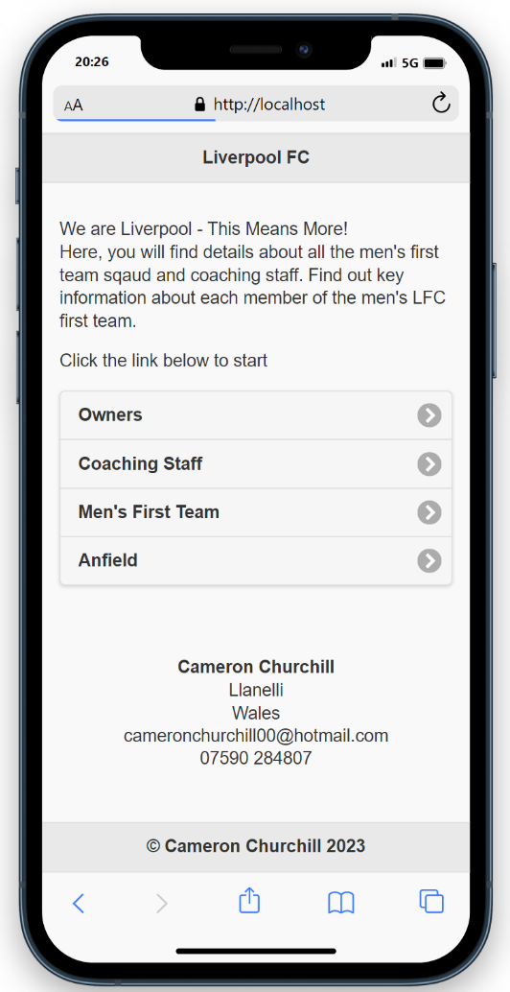
The image below shows the construction of the homepage (index.php) of the website. The image shows an introduction to the website, followed by the pages of the website which are jQuery mobile features to enhance the usability of the website on a mobile device, as well as giving the end user a different way to navigate around the website compared to how they would normally navigate around a normal website. The homepage concludes with contact details of the creator, followed by a copyrighted footer of the creator of the website.

Owners – Owners.php

[1] The image below shows information displayed on the webpage about the owners of Liverpool Football Club. I have also included a ‘learn more’ hyperlink, which gives the target audience the opportunity to click between pages and read more into the ownership of the football club. Also, on the next page of the webpage, I have included the option for the users to click back to the homepage of the website.
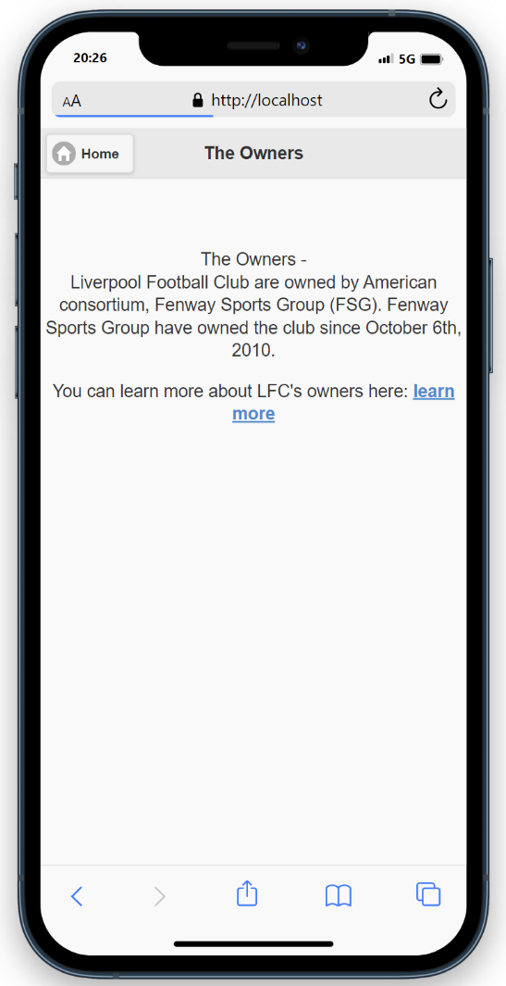

Coaches – coaches.php

[2] The image below shows an image of the first AJAX/JSON API call from a database. However, as there was no public Liverpool FC API, I had decided to challenge myself to call this AJAX/JSON from a database and display information on the webpage. As I had challenged myself, this meant that I had to create two separate databases to call from, whereas the database would have been already created had there been an existing public API.
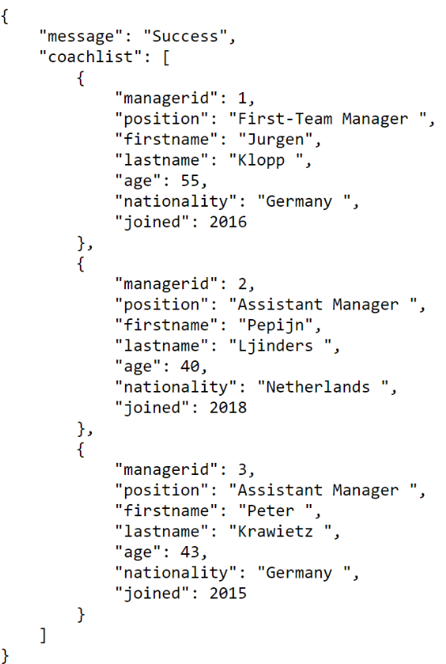
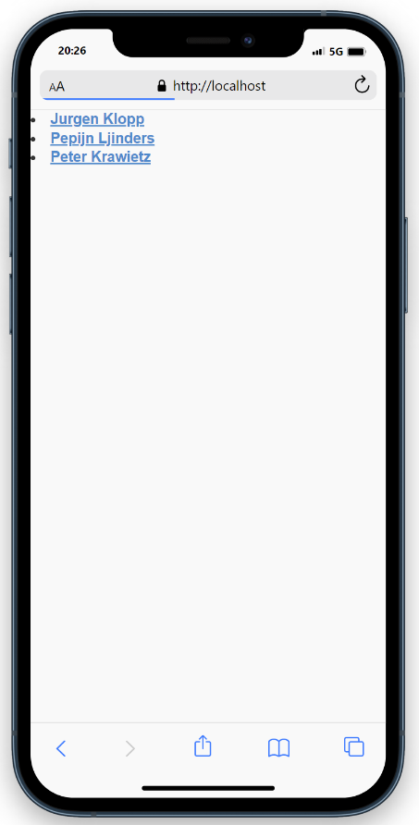
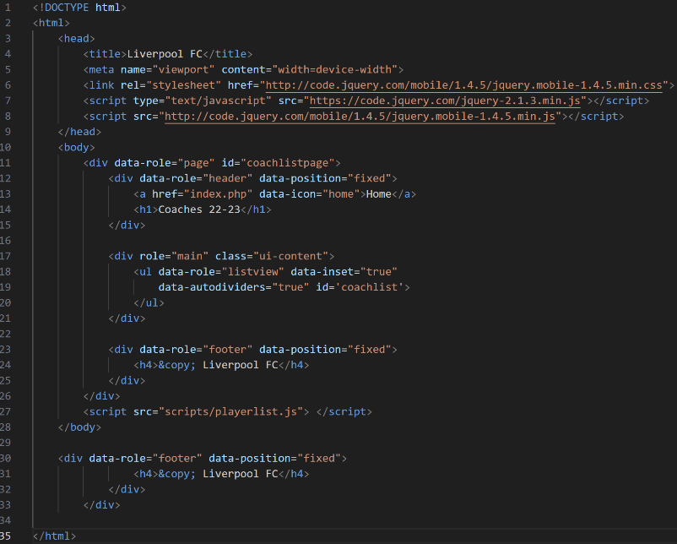

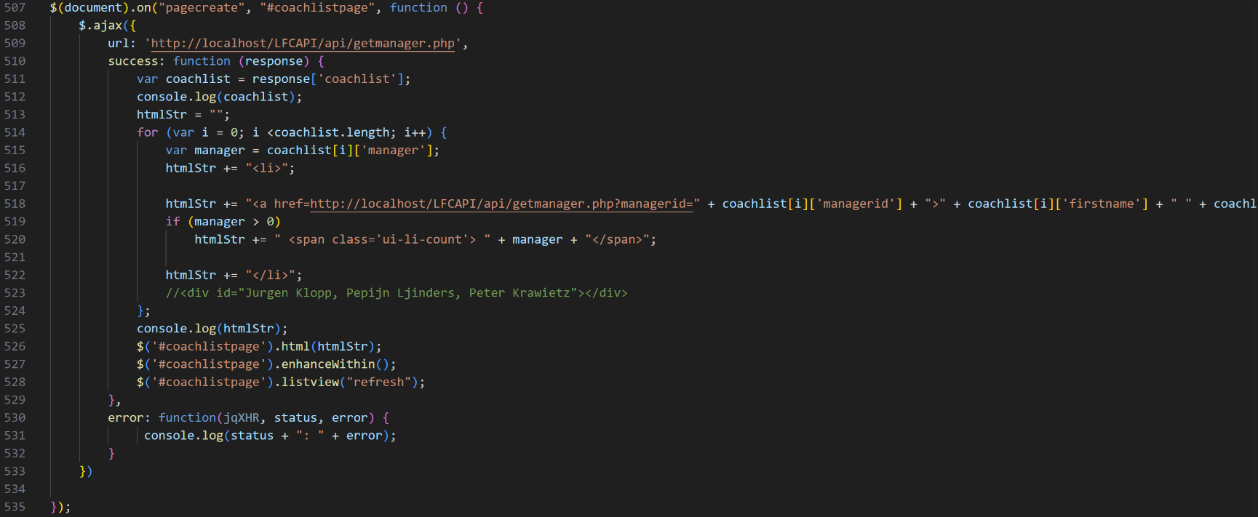
The code listings above show how the API was called and how the output appeared onto the webpage, as well as showing that the variables of the JavaScript code must match up to the set variables on the pages that the webpage is based on.

The players – lfcplayers.php
[2] The screenshot below shows the page display of players in each position. The numbers which are next to the positions shows how many players play in that position for Liverpool Football Club. However, my next task was to render data from the database to display each goalkeeper in the goalkeeper page, each defender, midfielder, and attacker. There is also a search bar which I have implemented, to make it easier for a user to search for a position instead of clicking on a position.
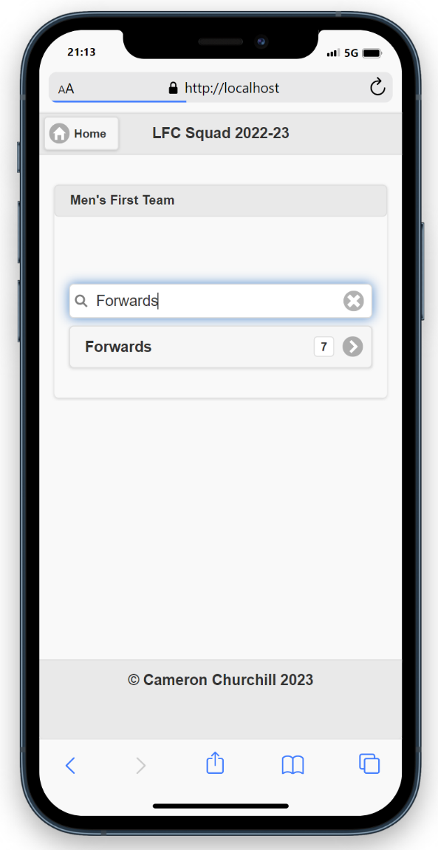
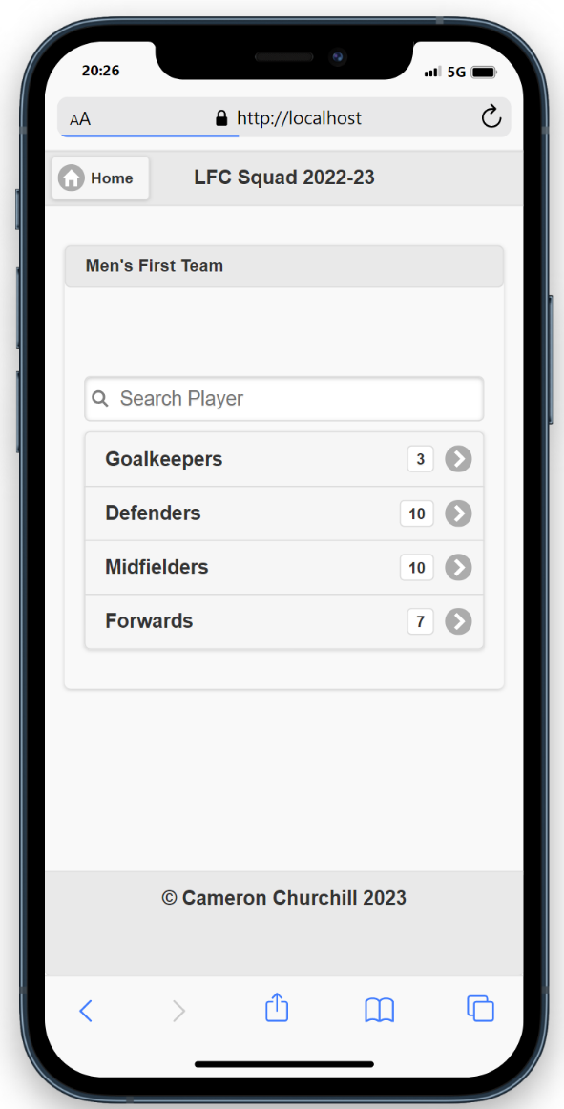

In order to call the API from the second database which I created, I followed the first principle as calling the first AJAX/JSON API, as I had to ensure that the variables matched up with the variables that were set in the webpages, I then followed this up by doing the same principle for each position which provided me with a successful AJAX/JSON call.
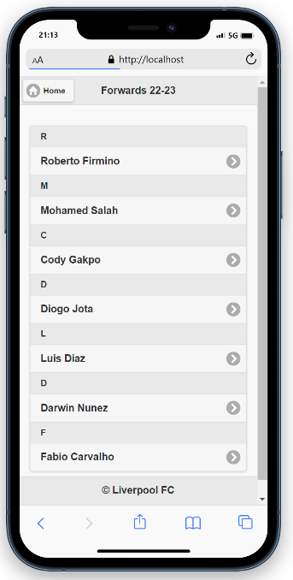
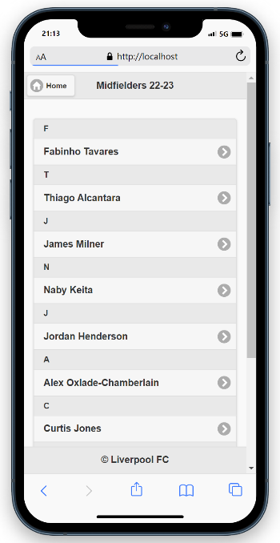
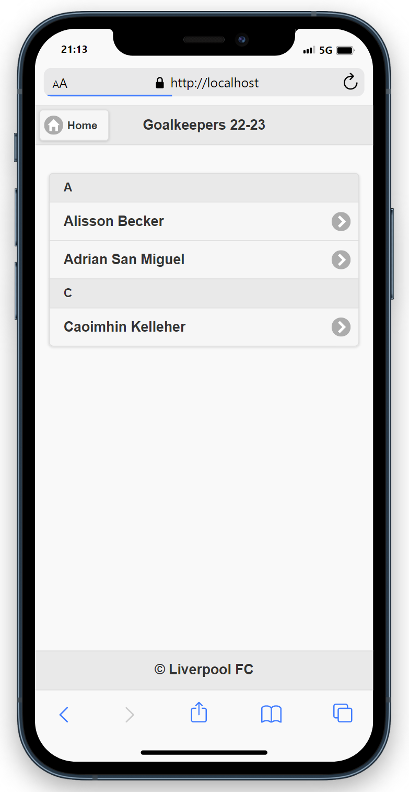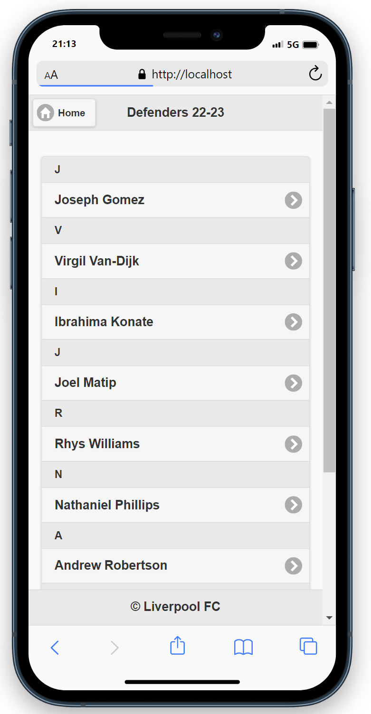

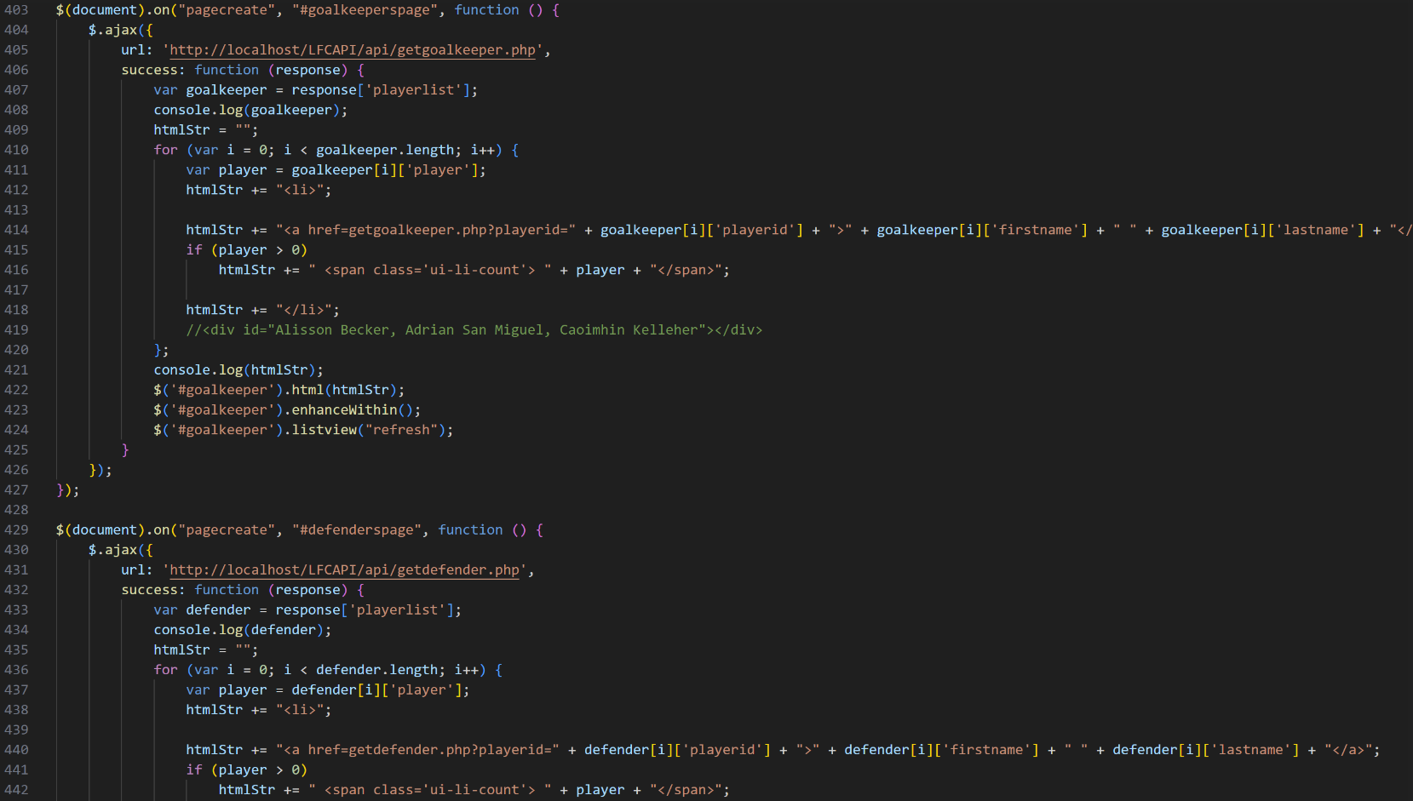

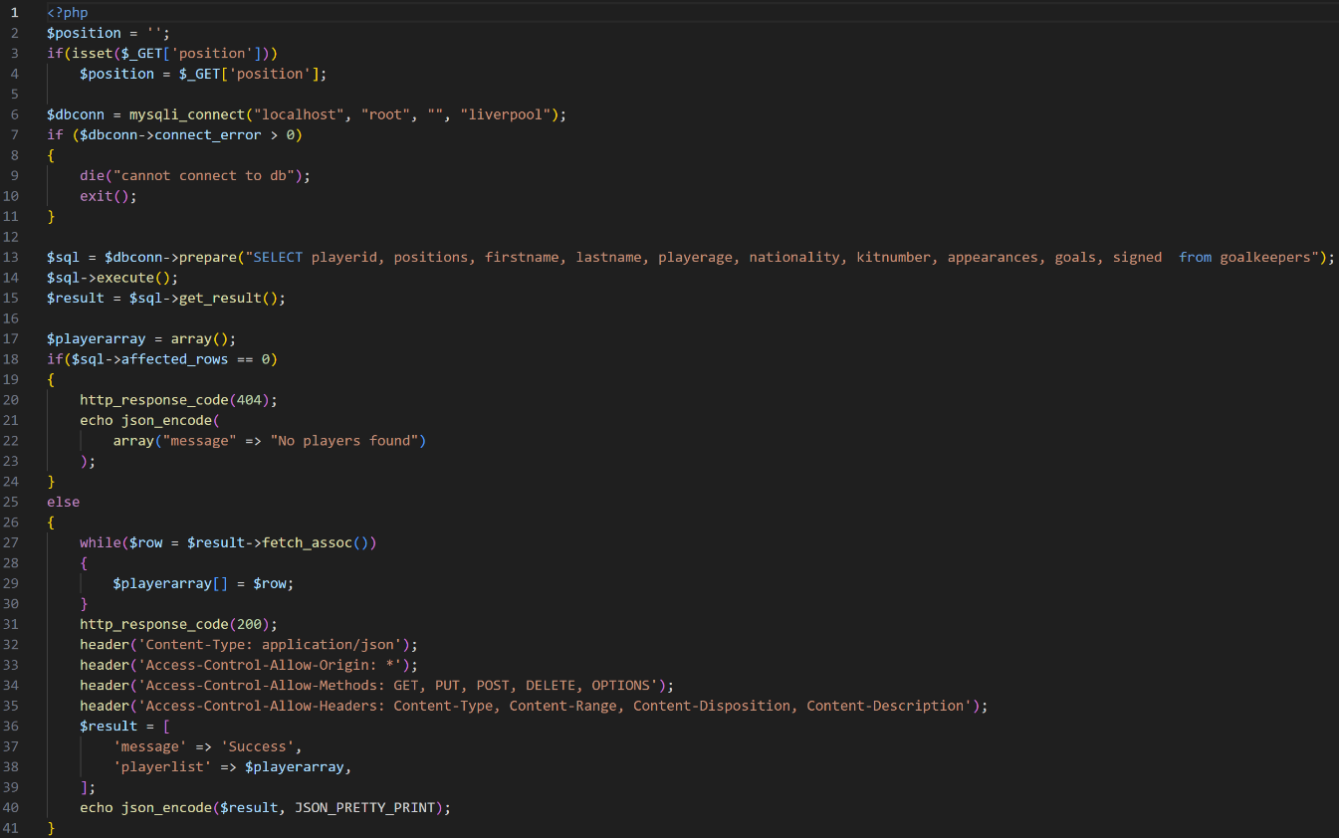
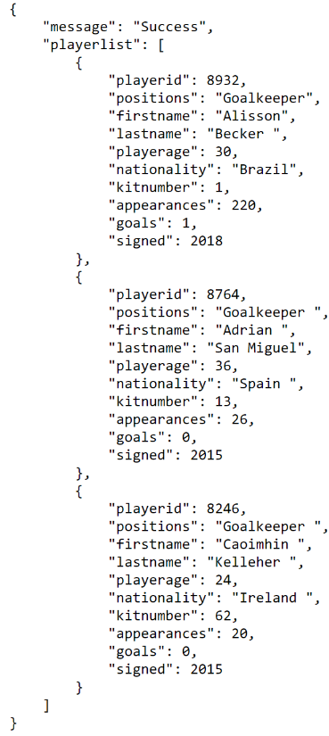

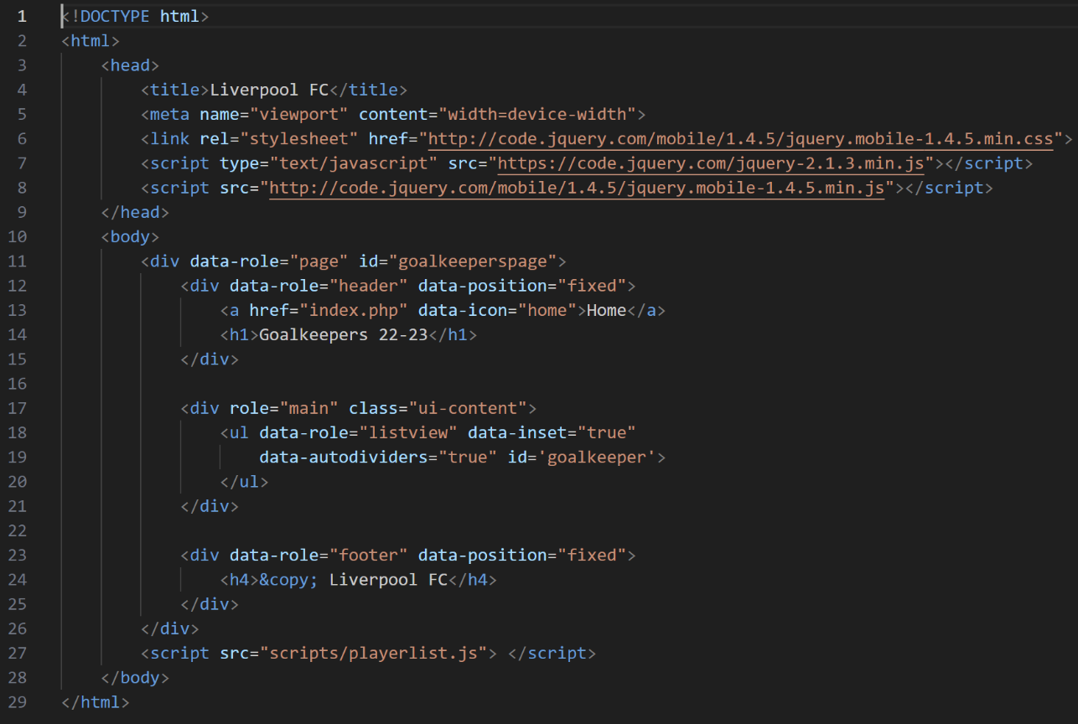

Anfield – (stadium.php)
For the Anfield webpage, I had decided to write some content about the iconic stadium as I have got a wide knowledge about the stadium, therefore I thought that it gives the end user something else to look at on the website and will also provide them with in depth detail about the stadium. The audience may be aware that the stadium is an iconic venue across the world, but they may not be aware of just why it is so iconic, which is why I used my own general knowledge of the stadium to describe in detail why Anfield is such a special place and a must visit, no matter which sport you are interested in and whether you’re going to see a football game or attend a stadium tour, you will find out why the stadium is such an iconic venue.
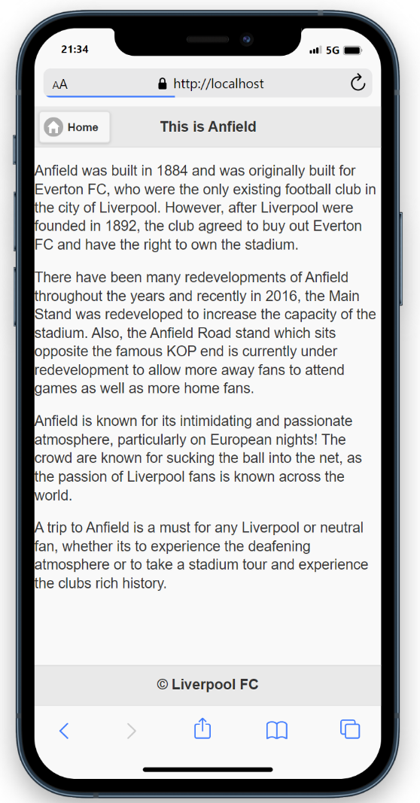

Implemented page features

In order to make the creation of the website more interesting and more dynamic, I used page transitions on each page designed, which are a jQuery Mobile feature to improve the navigation system of the website. Below, I have attached screenshots to show how the transitions were implemented on each page, as each transition is different on each page to give the website a more unique and more dynamic feel. Another reason why I have used page transitions is for the website to become more interesting, as if the website navigated like a normal website, it would be too vague and boring. Also, it is also a mobile based website, therefore it was appropriate to use page transitions as it fits the purpose of my design.
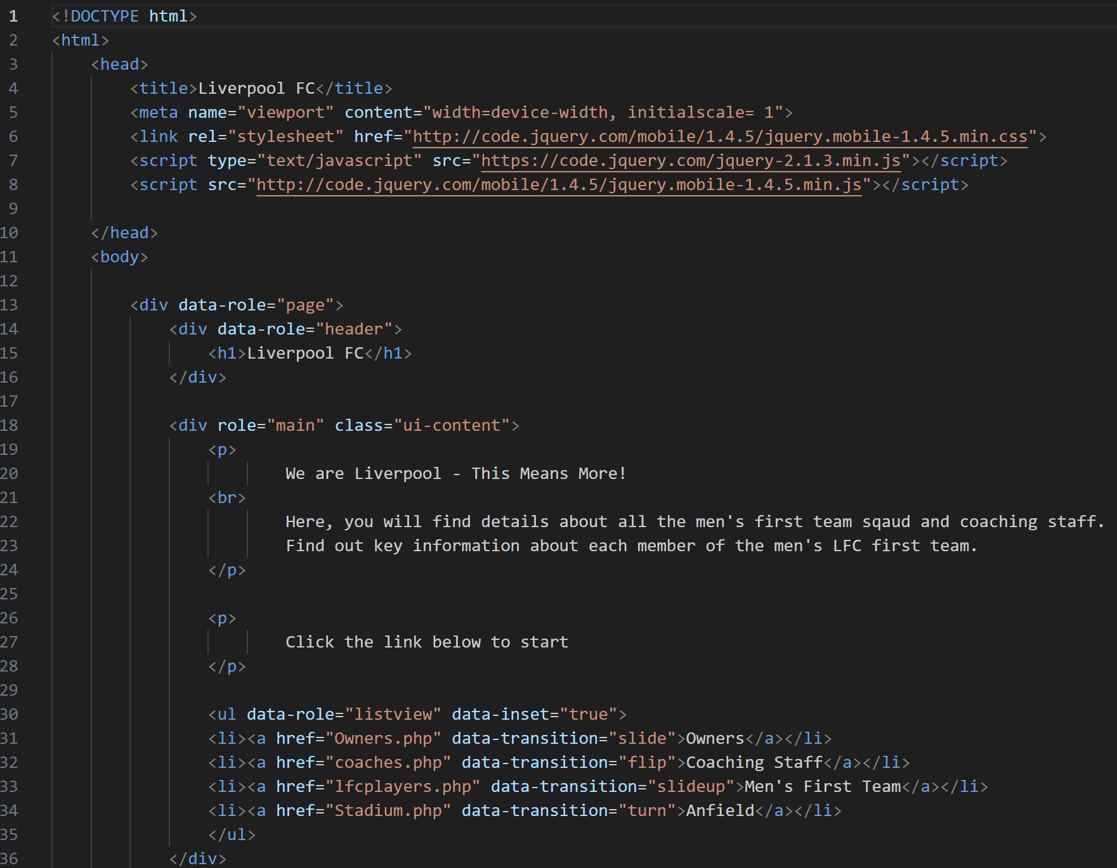

Conclusion

Overall, I believe that my website fits the need of the end user, as the layout of the website is clear, it is easy to navigate to and from each webpage and most importantly, both API calls successfully display on the web page. As previously stated, I challenged myself to create two APIs as there was no public API available, which meant that I had to create two separate databases to be able to call both API’s by using JavaScript, jQuery Mobile, AJAX and JSON. Furthermore, the text on the webpage is readable and understandable, as the font type and the font size are adequate for the end user and the structure of the text is also key to the readability of the webpage. However, if I was to design the website again, I would ensure that there is an existing public API available, as this would have helped the development of my website as I feel that the layout and structure of the coach’s webpage could be better, although the AJAX/JSON call was successful. Finally, I have attached screenshots below to showcase the compatibility of my website, as it is available to view on multiple devices, which makes it more mobile/desktop friendly for the end user. As mentioned at the beginning, the aim of the website was to ensure that the website is compatible and usable on not just mobile devices, but also on desktops, even though the purpose of the website was for it to be jQuery friendly.
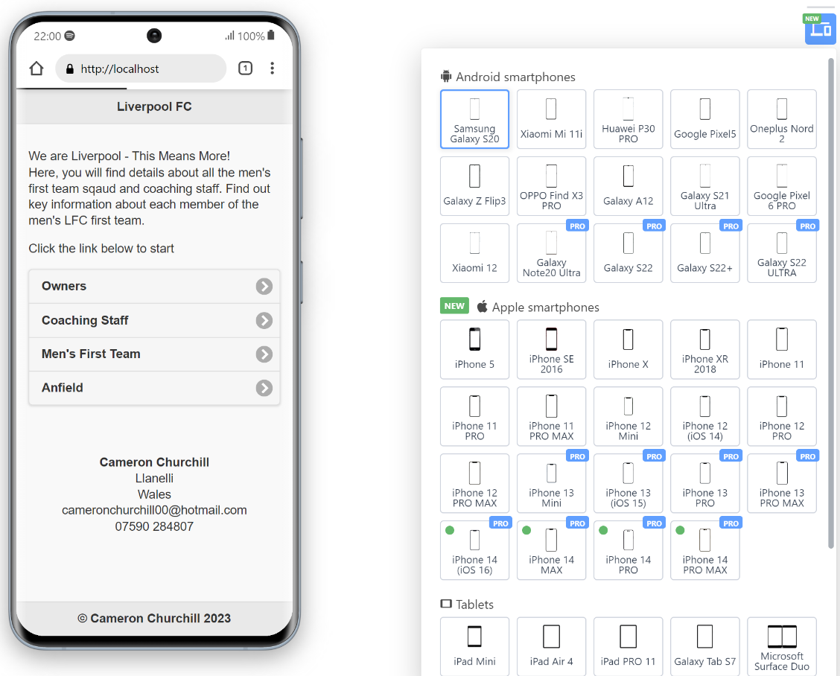

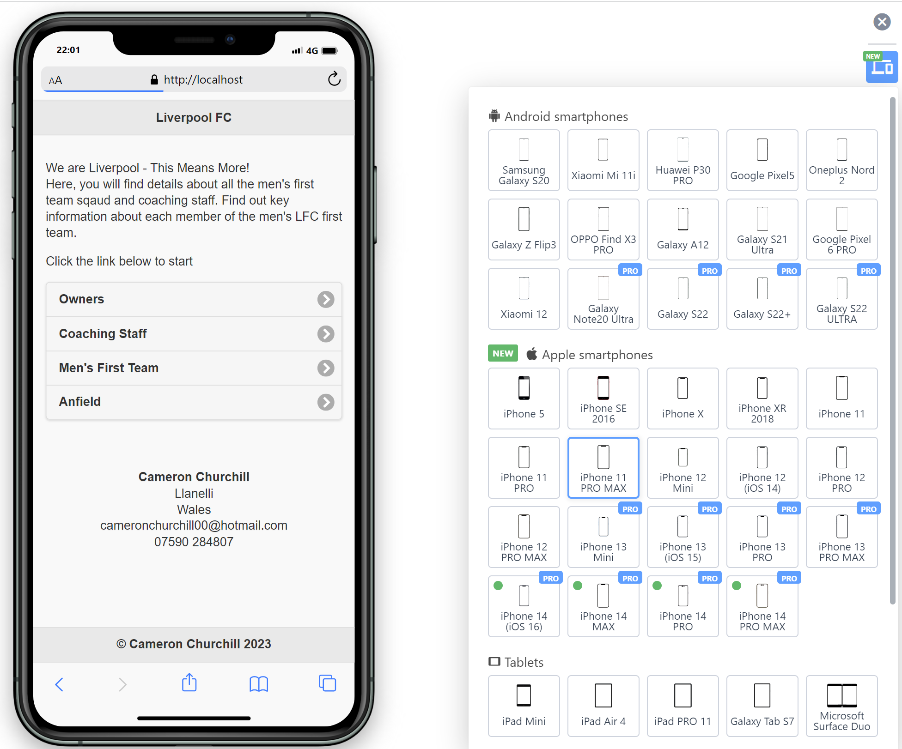

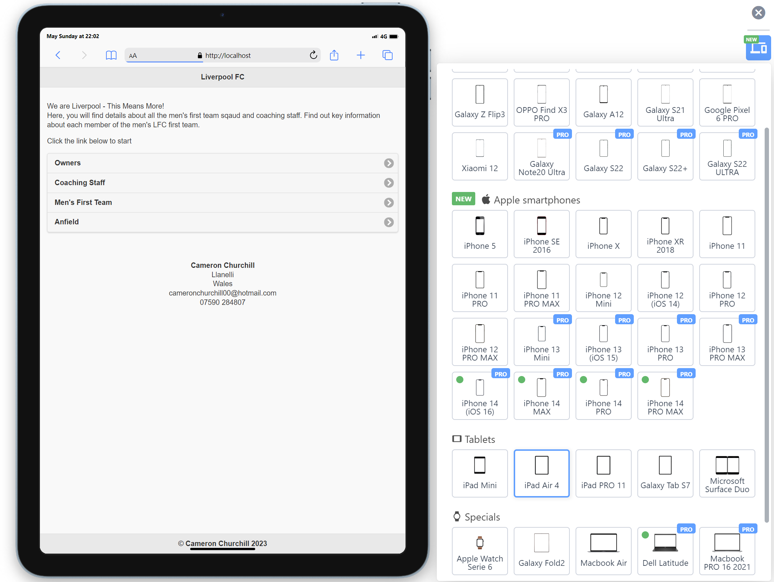

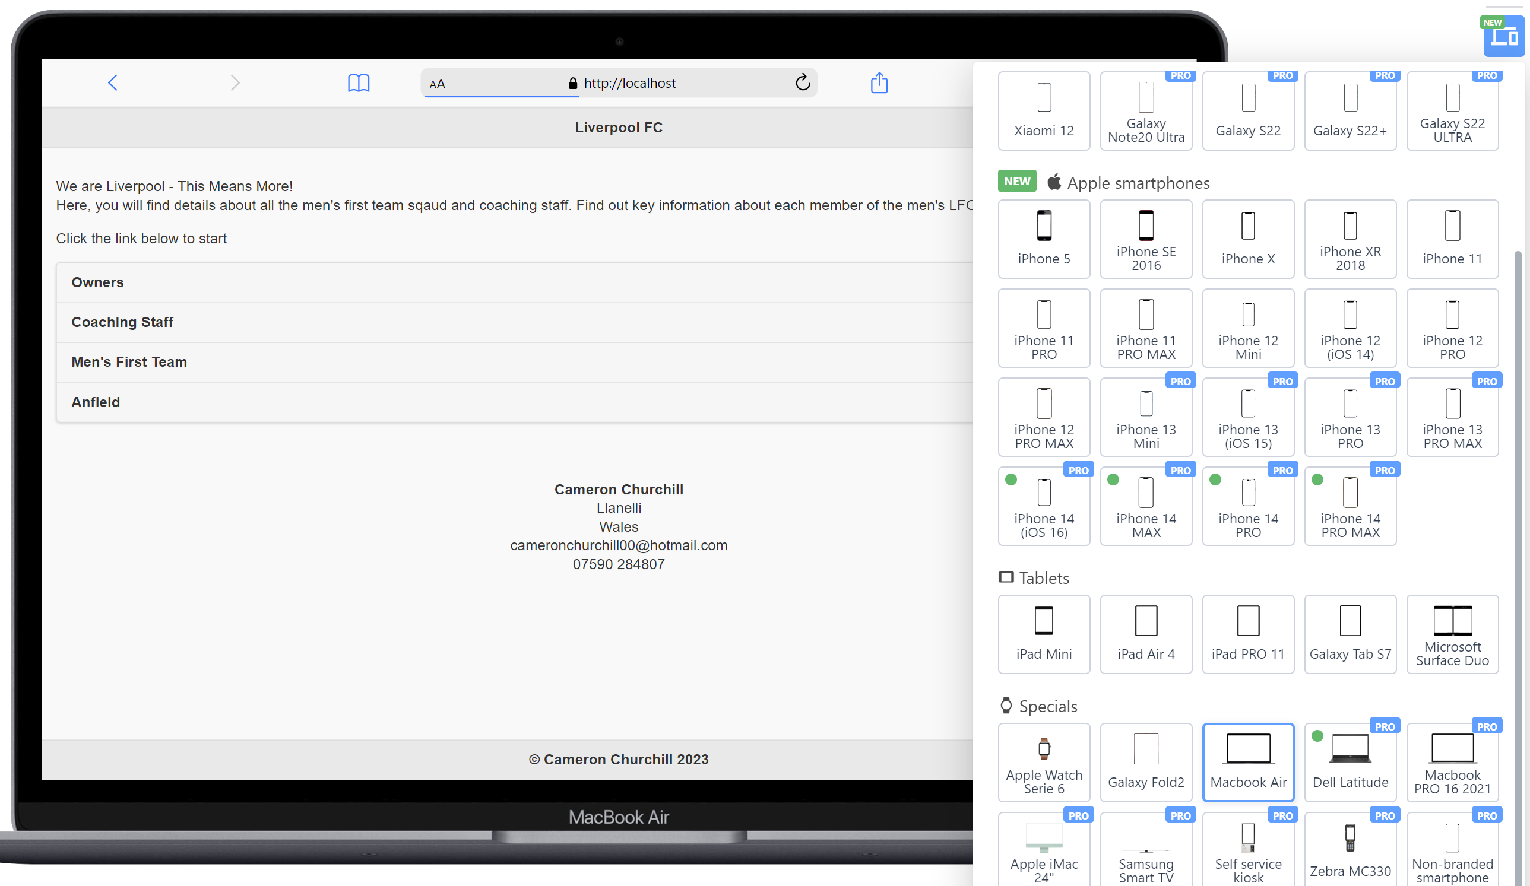

Bibliography

[1] | “BBC Sport - Football - Liverpool takeover completed by US company NESV,” BBC , 15 October 2010. [Online]. Available: http://news.bbc.co.uk/sport1/hi/football/teams/l/liverpool/9094283.stm. [Accessed 14 May 2023].
[2] | “Liverpool FC - Team,” Liverpool FC, 2023. [Online]. Available: https://www.liverpoolfc.com/team/first-team. [Accessed 14 May 2023].

