Richard Morgan |BA Computer Games Design | P149700
Word Count: 5014
Abstract
This document runs through the application of colour theory and shape theory and how character designers still have control over the lore of a game depending even if customization has been made available to the player. Covering base knowledge on colour wheel and the construction of colour relationships with colour theory; whether or not people with a colour vision deficiency should be given more accessible characters and features to aid them when playing games. Similarly, to the application of colour theory, knowing how the basic shapes can be utilised to reflect the personality and feelings a character may have, how understand shapes it benefits a designer to be aware of the effects a strong character design.
What elements of visual appeal are used in designing a strong character for a game or animation?

Contents
Introduction 2
Colour Theory 3
Colour Blindness 4
Shape Theory 6
Character customization 9
Conclusion 11
Bibliography 12

List of Illustrations

Figure 1: Nediger, M. (2018). Base colour Wheels. [image] Available at: https://venngage.com/blog/how-to-pick-colors/ [Accessed 12 Dec. 2018].
Figure 2: Nediger, M. (2018). Colour wheel Relationships. [image] Available at: https://venngage.com/blog/how-to-pick-colors/ [Accessed 12 Dec. 2018].
Figure 3: Hardin, B. (2016). Doom filter of deuteranopia. [image] Available at: https://www.gamersexperience.com/colorblind-accessibility-in-video-games-is-the-industry-heading-in-the-right-direction/ [Accessed 11 Dec. 2018].
Figure 4: Roberge, M. (2016). Wreck It Ralph. [image] Available at: https://vignette.wikia.nocookie.net/wreckitralph/images/d/dc/Ralph.png/revision/latest?cb=20161113154352 [Accessed 11 Dec. 2018].
Figure 5: Frederick, T. (2018). Glitch. [image] Available at: http://wreckitralph.wikia.com/wiki/Vanellope_von_Schweetz?file=Vanellopewirdisney.png [Accessed 12 Dec. 2018].
Figure 6: Pixar (2018). Carl from Up. [image] Available at: https://www.pixar.com/feature-films/up/ [Accessed 11 Dec. 2018].

Summary of topic.
The information being covered is that which supports the use of Colour and shape theory being applied while designing a character for a game or animation. In addition to this looking loosely on the topic of colour vision deficiency and how designers possibly cater for those who have colour-blindness. Lastly assessing how character customisation fits a game without ruining the lore of the game.

Introduction

The purpose of this paper is to inform novice creators and designers the importance of visual appeal, and how showing how taking certain things into consideration when designing a character can really boost the creative impact of that character. This paper will cover the importance of colour theory, but to also consider those who’s have a colour vision deficiency. Being unable to see colour the same way as someone with Trichromacy puts them at a disadvantage, how to use colour to put them on an even playing field.

When designing a character, it's essential to understand a few key points before beginning the early stages of visual development. It’s important to know the demographic of the game or animation in which the character is being created for. Without knowing the audience, it would be challenging to create a character that the viewers would find more appealing.
For example, Mario is a well-known Nintendo character, and aimed toward a young demographic. His body is made up from soft rounded shapes and his colour pallet is bright and based off the primary colours, blue, red and yellow; these colours are easily recognisable to younger children. Mario’s design is simplistic, and his silhouette is easily identified making Mario’s character design most likely one of the strongest in the games industry.
It's important to understand that when creating a character, it's crucial to understand the visual style of the game as well. If a character’s design isn't cohesive with the whole image of the game, it would ruin the overall aesthetic.
In addition to focusing on the game or animation’s demographics, it’s just as significant to the character designer to understand the role they have within their universe. Whether a character is the protagonist or antagonist, or more of a background or support based character, each role will have a different impact to the characters final design.

“The first theories about colour were propounded by the Greek philosopher Aristotle, who maintained (in De colouribus) that the two principal "colours" were white and black - light and its absence.” (Visual-arts-cork.com, n.d.)

One of the earliest stages of creating concepts is when the sketch down ideas, designers often work in pencil sketching on paper, or if drawing digitally, some create their work in a monochromatic format. Working like this allows the artist to see the values of the light and darks of an image without needing to assign a colour pallet to it right away. By understanding the shades and highlights in a concept you can accentuate certain areas of the design when you add colour.

“A color that can evoke one reaction in one person may evoke the opposite reaction in another, due to culture, prior association, or even just personal preference.” (Chapman, 2018)
Colour Theory is used by designers and artist to aid them in creating the most visually appealing concepts and artworks by influencing their use of colour. By applying certain colours to designs it will impact how the viewer perceives the image. Humans and animals’ associate colours with events in their lives, Traffic lights indicate whether it is safe to cross the road, a red light indicates danger, so it's instinctive to stop. Just as ladybirds can be painted red with black spots, it’s to pose as a warning to their predators.
There is a range of terminology used when working with colour theory, so it’s best to renew knowledge on the basics of the colour wheel as it's essential to know the core points.

Colour Theory

The primary colours are red, yellow and blue. These colours cannot be created by being mixed together, they’re essentially the core colours of the colour wheel. Secondary colours are formed from two primaries being mixed together.eg a combination of red and yellow, creates orange, just like primary colours there are only 3 secondary colours.
Tertiary colours are when a primary colour and secondary colour are blended together. Unlike primary and secondary colours there are 6 tertiary colours, an example of a tertiary colour would be, yellow-green, this being the combination of Yellow and green. The primary colour takes precedence in the colour naming.
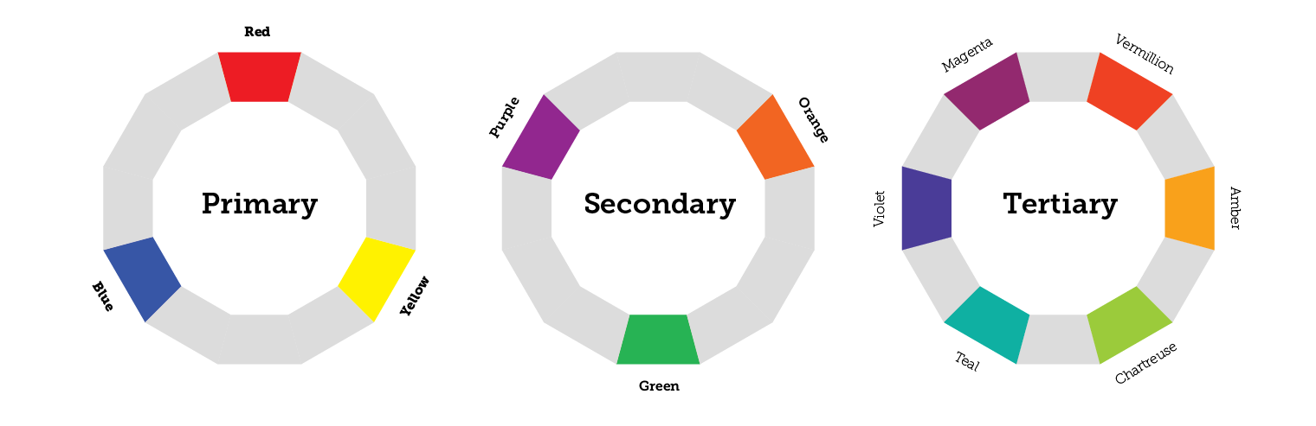
Fig 1: Base Colour Wheels

Complimentary colours are opposite each other on the colour wheel, whereas analogous colours are a combination of three colours directly beside each other on the wheel. A well thought out colour scheme can greatly affect the way that a character might be perceived and/or the impact that character may have on the audience, the character Spyro is a good example of complementary colours as he is purple and yellow.
The basic stages of colour grouping would be the split of cool and warm colours. Warm colours would be made up from Yellow, orange, and red, whereas cool colours would consist of the opposite side of the colour wheel, being green, blue and violet. Being split into these two-colour groups the colours would draw out certain feelings and emotions depending on which colour group they’re from.
Warm colours pull the focus towards heightened emotion, energy, fire, summer, power, heat, where the cool colours in contrast are set on being calming, rejuvenating and cold, often remind us of winter or snow and ice, however blue can also make the viewer have a sense of loneliness and/or indicate depression.
Red is the most emotionally intense colour, indicating danger, passion, war, warmth etc and can be either negative or positive. The warm colours are viewed as being ‘active colours’ that ‘pop’ and stand out more, whereas cool colours are calm and seen more as a ‘passive’ and recede into the background.
There are 6 main ways to group together colours when creating a colour scheme:
- Analogous – this colour scheme is the selection of 3 colours located directly next to each other, e.g. Blue green, green and yellow green.
- Complimentary – These colours are opposite each other on the colour wheel and when used together they become a high contrast colour combination. E.g. green and red.
- Split-complimentary – A colour scheme that is formed with the use of both complimentary and analogous colour schemes, instead of choosing the opposite colour on the wheel both colours adjacent to the complimentary colour are used instead. E.g. Blue used with red-orange and yellow-orange.
- Triadic – When selecting three colours on the colour wheel that are evenly spaced apart from one and other. E.g. linking the primary colours blue, red and yellow together.
- Quadrilateral – Similarly to triadic but instead of 3 evenly spaced colours it is 4. E.g. Red, blue-purple, yellow- green and yellow orange.
- Tetradic – When using two complimentary colour schemes together. E.g. Purple and yellow, Blue and orange.
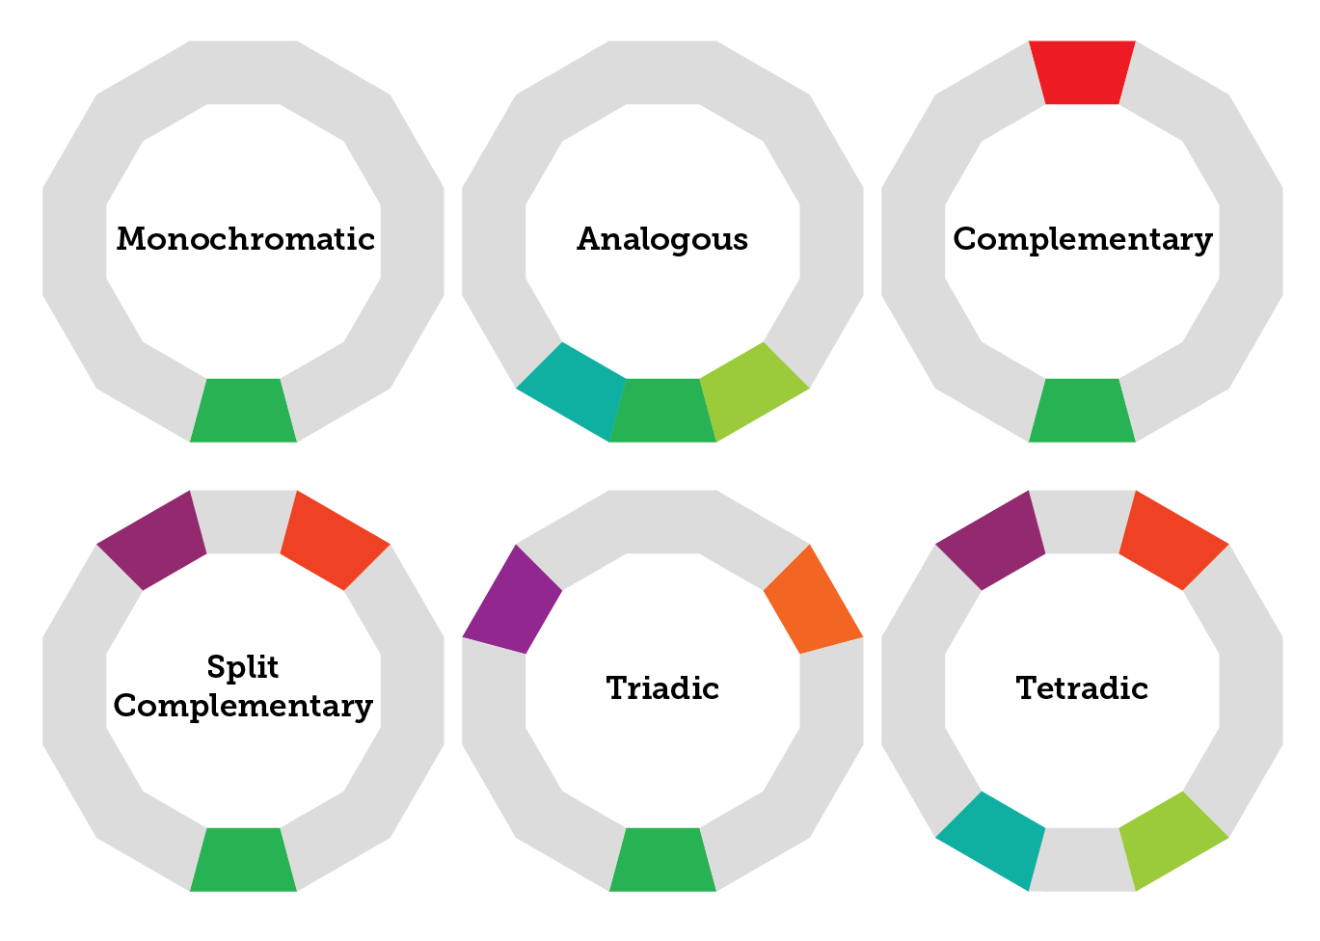
.

Fig 2: Colour Wheel Relationships

Knowing different schemes of colour allows the designer to achieve greater concepts and ideas, broadening what their thought process is and in addition to achieving self-development. The artist or designer will be more aware of what would be more appropriate for their target demographic as well, meaning their work will be greater appreciated by their selected audience.

However, how does colour theory apply when some of the target audience are colour-blind? Some game companies have begun to combat this by using filters or changing textures of their assets, environments and characters in their games. However, some methods are better than others, how can designers improve their creations, so they’re better suited for those with colour vision deficiency.
“… In other words, it's surprisingly common! And yet, it's something that the board games world is only just starting to take into consideration. “(Hewitt, 2017)

Colour Blindness

Humans see colour because of an area at the back of the eye called the retina. It isn’t the retina itself that allows people to see colour but a smaller section on the retina called the fovea, this part of the eye is made up of millions of cone cells and rod cells, and these are what allow us to perceive light and colour. The rod cells allow humans to see in low light conditions, were as the cones allow people to identify different colours. There is only one type of rod cell, but there are 3 types of cone cells, and they register these 3 colours, red, green and blue.
When viewing colours, the cones will transmit its own unique signal to the brain. When we see yellow light, it is a combination of the cones that register red and green light.
People see less colour at night because there is only a single type of rod cell, because of this only one kind of signal can be sent to the brain, and this is registering light or lack of light.
When colours are processed through the fovea they’re registered as different wave lengths. Blue has the shortest wave lengths, green medium sized wave lengths and red having the longest. Each cone is stimulated when light is being seen. Cones care bad at deciding colours individually, so they use signals from the other cones to pinpoint the colour that’s being seen, this is called Trichromacy.
Colour vision deficiency is carried through on the ‘X’ chromosome and is a recessive gene. All ‘X’ chromosomes need to be affected for someone to have a colour vision deficiency.
1 in 12 men are have it, whereas 1 in 200 women do. This is because women have two ‘X’ Chromosomes instead of an ‘X’ Chromosome and a ‘Y’ chromosome like men, making it less likely for a woman to become colour vision deficient. Women are more likely to be considered carriers of the gene as colour vision deficiency is hereditary.

- Trichromacy – This is regular colour vision, as all colour light cones are accurately placed along the colour spectrum.
- Deuteranomaly – The most common form of colour vision deficiency, this would be when someone experiences reduced sensitivity to green light.
- Protanomaly – with protanomaly it’s a reduction of the red light that people see.
- Tritanomaly – This is when someone has a reduced intake of blue light, this is a rarer form of colour deficiency.

All except trichromacy are forms of colour vision deficiency, these are the most commonly diagnosed conditions. Everyone will experience colour deficiency uniquely, with some cases being highly exaggerated and others being closer to the most common colour vision, trichromacy. As well as these forms, it’s also possible to have Achromatopsia, also known as monochromatic vision where someone can only see in black to white, with a complete absence of colour.

“… Check the enable UI Colorblind Mode option. To activate a colorblind filter, select the appropriate option from the dropdown menu. You can select a filter for Protanopia, deuteranopia or tritanopia.” (Blizzard Support, 2017)

As previously mentioned, many games are beginning to create settings for players who have colour vision deficiency. League of legends, world of warcraft, Rocket league, Doom and Splatoon these are some examples of games that have created options in their games for colour blind people, although there are options made available, some haven’t been executed to a high enough quality for some games. People who played Overwatch commented on the fact that their colour-blind mode wasn’t accurate,
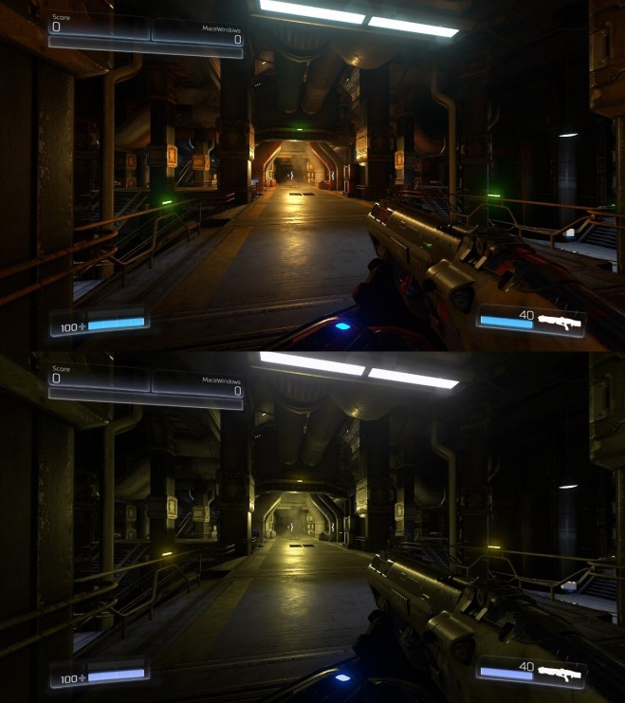
The image to the left are two screen shot of the game doom combined together, the top image is a caption of the game in its normal vision mode for those with trichromacy, but the bottom half of the picture is a filter for how people with deuteranopia see the game in its normal mode, so there isn’t any actually support for those with that specific type of colour blindness . The beneficial thing of this image is it shows people with trichromacy how people with deuteranopia perceives colour.

Fig 3: Doom filter of deuteranopia

Ways to combat it:
- Colour blind texture packs – For games or videos completely rehaul the set of textures for those who have colour vision deficiency. It is impossible to try and recreate it as those with trichromacy will see it but, it will make things easier and more enjoyable for the colour deficient player.
- If for a physical product, like a board or card game, recreate it with colour blind alternative, or specifically release games for those with colour vision deficiency. It would be appreciated.
- In digital games create an option in the settings that allows the player access to choose from a diverse colour wheel or slider. This grants player, no matter how severe their colour deficiency is, the option to choose something that will stand out to them significantly better. This aids in team-based games where it’s difficult to see who friend is and who is foe.
- Avoid using filters that alter the players whole view this obscures the game and hasn’t seemed to work successfully yet in games.
- Working with and getting feedback from people who have colour-blind deficiency will be the most beneficial thing someone can do when coming to design work, whether its for a character or a whole game system.

If designing with a player with achromatopsia in mind, then colour cues aren’t going to be beneficial to that particular player. Shape theory can assist in visual cues which can assist players in their games. In the Mario kart games there is an ability to send a shell shooting out to hit a player in front. A player with achromatopsia, wouldn’t be able to tell the difference, and players with Deuteranomaly and between the first and second kind of shell however, because the third shell is shaped different, this can aid those players to rejecter which kind of ability they have.

“Shapes play a big role in character design. They can tell a story about the character visually.” (Tillman, 2011)

Shape Theory

Shapes can represent the personality and attitude of a design. is important in design for many reasons, designers will use it to impact visual cues, or to be eye-catching and diverse in comparison to a more generic shaped object or designs, it can be used to help decipher the differences in puzzles.

Shape meaning
- Square – Sharp features, often seen as strict or stern characters, these characters are not usually flexible, they can be quite moody, they can become angry. (carl from up)
- Triangle – pointed featured characters, can be seen as edgy, they may misbehave and seen as the trouble makers in a animation or game.
- Circle – Rounded features, friendly, flexible, kind, easy going,

When creating a character, a designer can use a combination of shapes to create a character to reflect a personality or story.
Using the shapes listed above can help the viewer or player understand what kind of person the character is.
As mention previously Mario is a recognisable character due to his colour pallet and shape, even compared to the characters in that particular universe proceeds to be unique. Mario’s brother Luigi has a similar shape to Mario but because there is a height difference between the character, they’re still recognisable side by side. If comparing a character from a stylised world to one who is meant to reflect a realistic style it becomes easy to recognise who is who, however when making the comparison between two characters from a realistic style game, it becomes harder to tell them apart.

Most highly recognised characters from games and animations are those who have a unique style and strong colour pallet, with the overall visual appeal of the character being high to the viewer or player. Examples of well recognised games characters being Mario, Sonic, Crash-bandicoot, and Yooka from animations, Micky Mouse, bugs bunny and road runner. All these characters have unique silhouettes within their worlds.

A good comparison for characters outside of the same game would be Fox Mc cloud, Tails, Lucky the fox. Tails and Lucky both have very simplistic character design however their silhouettes are still unique and recognisable even side by side; Fox Mc cloud has a more details character design and is still is distinctive character. Blow are the silhouettes of each character side by side. All are distinguishable.

As the characters above are all unique in their designs and can be told apart because of the style of the game, it makes things harder to make realistically styled characters indistinguishable. When asking a minority of gamers who the character below was, they couldn’t decide if it was Joel from The Last of Us or Nathan Drake from Unchartered. The two have a dishevel silhouette

But these characters are good strong character for their story and have a good character design, because people who play the games can in moments relate to their reactions and characteristics within their games.

When designing characters its important to take into consideration the style of the animation or game, as well as the personality and role of the character. This will all reflect heavily on the overall design when being created. Certain shapes have particular connotations, like how rounded shapes are seen as soft. This can be used to emphasises a character or trick the player into thinking certain things about a specific character.

“Artists typically use shape, size, pose and proportion as the first design layer to express role, physicality and personality traits of a character. “ (Islam et al., 2010)

In the game Heavy Rain, there is a character called Scott Shelby, he is the antagonist of the game, however early on in the game, he is portrayed as kind and sympathetic. His role at the start is to trick the player into believing that he is a good character and doing good by the story within the game. This is also reflected in his shape, Scott is a rounded character, making him appear,

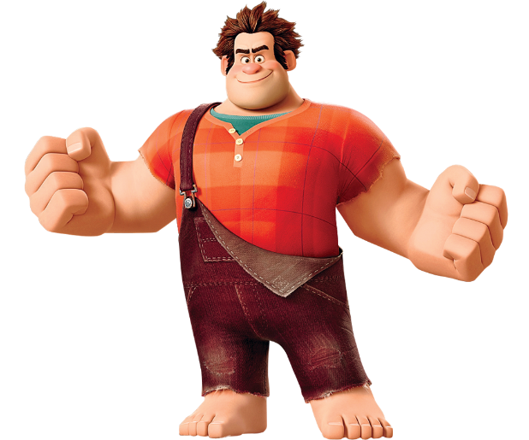
Shape: Built twice the size of Felix, ralphs huge fists and large body were designed perfectly for the job he was meant to do, to wreck the block of apartments. The way ralph is built is highly influenced by his role for his game. Yet the characters together fit well within the whole of the animation. His fists are very square indicating ________ Yet his face is made up of softer shape, viewers will subconsciously react in a different way to his face. Colour: Ralph’s colour pallet is predominantly warm tones, from his dungarees being burgundy and his shirt being a red-orange. His design shows an accent colour of green-blue underneath his most visible top. This being complimentary to his outer shirt. Ralphs overall look compliments his counterpart Glitch.
Fig.4: Wreck It Ralph.
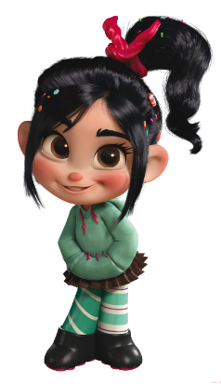
Shape: Glitch was seen as scruffy in comparison to the other racers wearing a hoodie with her mismatched patterned tights, having messy hair and sprinkles however as her role for the animation she suits the design, it has purpose to reflect how out of place she is, she's proud of her design as when she transforms into her original design (Vanellope Von Sweets) she states that that isn't her true self. Glitch’s colour is made from soft minty greens and is complimentary to ralphs warm colour pallet. The brown in glitch’s clothes is there to be a neutral colour. Black probably wouldn’t have fitted with the character, but the deep brown still brings it to a deeper level.
Fig.5: Glitch

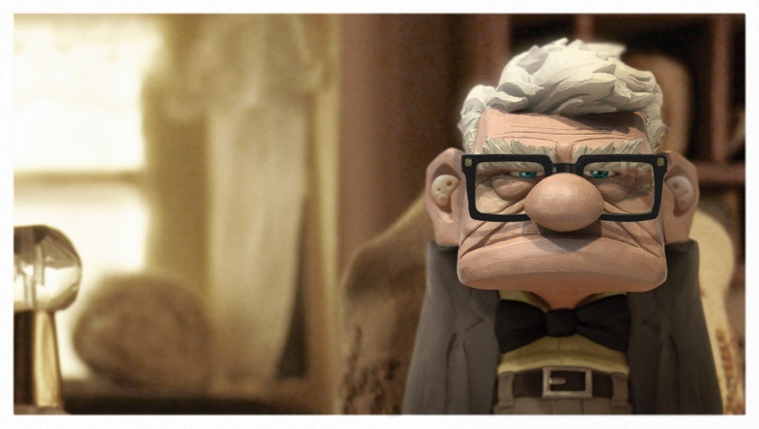
A design that plays more obviously to the viewer on the use of shape though would be carl from the Pixar movie up. His personality go hand in had with how shape theory works, Pixar have really played on the element of square meaning to be stubborn. Carl is a particularly moody character with a strong and unique character design By adding accessories like his glasses and the buckle on his belt are indicating to the type of character he is. His short stocky frame is one represents a rectangle as his arms come down by his side still creating a long solid shape. Even though Carl is a stern character at moments, he does have softer features on his face, like his nose and ears. So, this counterbalances the design for those softer sweeter moments. Carl has a dark colour palette mostly made up and neutral colours, which are colour usually associated with being bland or boring.
Fig.6: Carl from Up.
“Most scholars and scientists seem to agree that total photo- and audiorealism is not necessary for a virtual reality environment to produce in the viewer a sense of immersion,” (McMahan, 2003)

Shape theory can still be applied to games that use realism to base their general game style. Many players feel more immersed when playing a game, but sometimes the working to a realistic format can be restrictive to the designer. With Stylised games, the cartoon like styles allow the creators to have more freedom when it comes to the design pallets of the game. Games like overwatch, have animated shorts where examples of how versatile styled games can be.
Games like Detroit: Becoming human are designed in a more realistic manner, but this helps the delivery pf a sentimental story. But even with the restriction of working in realism there is still a large selection of characters made for the game. A side character called Luthor has a role of a gentle giant within the game. but one of the first interaction with him is violence. The character is used as a body guard, protecting a black-market merchant. Part of Luthor’s race (synthetic beings) is being made to serve humans. All the Synthetic character are giving the appearance of humans to make the people of that world more comfortable around them. The game still followed the rule of visual appeal form within the game world and projected it to the players. The characters are cohesive with the realistic style that the designers originally wanted. Because of the use of realism, the player becomes attached to the characters within the world because they’re viewed as similar.

Character customization
When creating concepts for a game character the designer will take into consideration a number of factors, i.e. The characters purpose, the characters personality, their motive, etc. these elements will all aid in the final design. Other practices like the use of colour theory and shape theory and the application of running through many concepts to a achieve refined and final idea, will impact the final design. This will influence the player and help them understand how the character is meant to be perceived from their role within the game.

For example, the lead protagonist in the Witcher Series is a character called Geralt. When designing the protagonist, the designers must abide by the lore within the game to make the story more immersive and believe able. Geralt is a mutated character who has magical abilities, is over 100 years old, he does not age like other characters similarly to the rest of the Witcher’s. His hair is very light grey to white and his eyes look like yellow cat eyes.

Geralt was made a playable character in the game series Soul Calibur 6. Although Geralt isn’t originally for the series, they create a story specifically for him. This smooth transition into the game allowed the flow of this character to fit into the overall feeling of the game.
Due to the game being based in a realistic styled fantasy world Geralt’s shape isn’t exaggerated in any way. Because of his Profession he has an athletically toned body but isn’t overly muscular. His colour pallet is dark and in the 3rd game can vary depending on the players choice of armour. But his original colour pallet consists of deep browns, usually with no accent of colour.

“…implying that customization may affect player motivation towards a game since a player’s loyalty to a game indicates enjoyment and motivation to play that game.”

Soul Calibur 6 has a large character customizer, with a number of options for clothing and props, colour slides and options to contort and adjust accessories.

However how does this apply when character customisation is applied within a game? When a player is given freedom to do as they please with a character’s image does it affect in a negative way the aesthetic and feel that the designers originally intended for the game? How does affect the visual appeal of the game as a whole.

There many games with character customisation as an option, some have large variety of choices where as others have smaller collections of items available to use. Destiny, a first-person shooter, is a game that has a smaller and more restrictive character creator. This potentially due to them wanted to keep their game to a target visual appeal. Alternatively, there are games like sims 2 which allow players to customise their character with more freedom, this could be due to the versatility of the game as a whole.

“Gamer loyalty is important for game developers as it provides stable revenue for them and represents a business advantage (Reichheld & Schefter, 2000).”

Allowing players to create their own characters gives the player an additional reason to come back and play the game. Some players will create characters that will fit with the lore of the game, this keeping the player heavily immersed in the game and maintaining the visual aesthetic that some designers intend. However, some players enjoy the creative freedom they’re given with the characters, completely obstructing the lore of the game. Though this is fine and well, they’ve been granted that creative freedom from the designers and developers of the game. But when a player who commits to the lore of the game is put in a team with a player who has exploited the creative freedom to the maximum, it can ruin the immersion for the player who is committed to the lore.
An example of this would be in the game Soul Calibur 6 where players online have created characters in the customization option that, don’t fit with the lore of the game. some characters that have been created have been based off animation or other game characters like, the Pokémon magicarp or Marge from the Simpsons.

Whether it’s for self-improvement or for the employer, a designer will want to create their best works; this means progressing through a line of development. Setting targets for projects and constructing a design process will assist in well-developed concepts. Though a designer may be more biased towards an original design, it could be beneficial to create alternative ideas, as this shows the designer has versatility with their creative pallet.

Conclusion
The purpose of this paper was to aid designer and artists with their process and knowledge when designing a character. Working on concepts without the use of visual appeal and simply just running with the first idea the designer gets can result in the creation of a weaker character that may not suit the demographic the game is aimed toward.
Applying the theory of colour and shape to designs will allow the designer to achieve a greater understanding of the character developing process; gaining this knowledge will assist in creating stronger concepts for games, animations and possibly live action movies e.g. Marvel Studios, Fantastic Beasts, Star Trek.
If a certain combination of colours is more eye-catching, it doesn’t always mean it’s the better option, the visual appeal of a design needs to be cohesive to make the character pop in positive ways, not negative. having the right colours on a design will aid hugely in the completed design.
This applies to shape theory as well. If a character’s silhouette is too mis-matched and complex, the character is likely to be harder to recognise so the designer should idea consider simplifying the concepts.
Its important to know the characters role as this impacts heavily on shape and use of colour so plan out before starting a string of concepts that might not really fit that character’s role. Making it so that the audience can understand and digest a character’s appearance quicker.
Designers will want to think outside of the box when coming to creating new concepts, so instead take a different perspective on a design. People with colour vision deficiency see things differently to those who have trichromacy. Take into consideration the alternative colours that can be used when designing that might pop out to those whose vision is different.
Development of concepts with unique thought maybe seen as innovative thinking. Utilising knowledge on those who see differently could help you develop as a designer and be beneficial toward you employer and world place. In addition, it means that as a designer considering thinking of those with colour vision deficiency you can give hundreds of players and viewers a game or design more accessible and suited to their needs.
If in doubt when designing a game and creating modes for those with colour deficiency, confers with a group of people who are colour blind. This way improvements to the game can be made without much room for error.

When character customization is placed into a game it is still the designers of the game who allow as much freedom as they intend. The creators of the games and custom items will decide collectively just how much detail they will allow with the customisation. In cases such as soul Calibur used above its easy to see that the designers wanted to give the players as much freedom as they want. However, in cases like mass effect they’ve only granted the player to a select few times. If they wanted to allow the character the ability to create crazy characters they could have.

In cases like guild wars where even with a large range of options this customization section of the game keeps the characters that are being created still in line with the lore of the game, and this is continued throughout the rest of the game with the dyes and armour sets they provide for the players. Versatility like this in games keeps players returning and replaying the games. Games with more replay value have more worth to developers and designers as they can see what the players like about the games etc.

Whether a character has been designed specifically for the protagonist role in a game or if the designers of a game have implemented a way for players to customise character, it can still be built with the application of colour and shape theory. How viewers will perceive the game is an individual option just like viewing art, it will impact each uniquely. If a characters, visual appeal fits cohesively with the game

Bibliography
Chapman, C. (2018). Color Theory for Designers, Part 1: The Meaning of Color. [online] Smashing Magazine. Available at: https://www.smashingmagazine.com/2010/01/color-theory-for-designers-part-1-the-meaning-of-color/ [Accessed 4 Dec. 2018].
McNee, L. (2015). The Psychology of Color For Artists. [online] Lori McNee Art & Fine Art Tips. Available at: https://www.finearttips.com/2015/07/the-psychology-of-color-for-artists/ [Accessed 12 Dec. 2018].
Visual-arts-cork.com. (n.d.). Colour Theory in Fine Art Painting. [online] Available at: http://www.visual-arts-cork.com/artist-paints/colour-theory-painting.htm [Accessed 11 Dec. 2018].
Colour Blind Awareness. (2018). Inherited Colour Vision Deficiency - Colour Blind Awareness. [online] Available at: http://www.colourblindawareness.org/colour-blindness/inherited-colour-vision-deficiency/ [Accessed 12 Dec. 2018].
Hewitt, J. (2017). Thoughts on Game Design: Colour Blindness. [online] Needy Cat Games. Available at: https://www.needycatgames.com/blog/2017/8/29/thoughts-on-game-design-colour-blindness [Accessed 10 Dec. 2018].
Brown, M. (2018). Making Games Better for Gamers with Colourblindness & Low Vision | Designing for Disability. [video] Available at: https://www.youtube.com/watch?v=xrqdU4cZaLw [Accessed 12 Dec. 2018].
Blizzard Support. (2017). Using Color Blind Mode. [online] Available at: https://eu.battle.net/support/en/article/31224 [Accessed 10 Dec. 2018].
Tillman, B. (2011). Creative character design. New York: Routledge, p.6.
Nieminen, M. (2017). PSYCHOLOGY IN CHARACTER DESIGN Creation of a Character Design Tool. Bachelor’s thesis Degree programme in Design. South-Eastern Finland University of Applied Sciences.
Islam, M., Nahiduzzaman, K., Ashraf, G. and Why, Y. (2010). Learning Character Design from Experts and Laymen. [ebook] ReaseachGate, p.2. Available at: https://www.researchgate.net/publication/224202426_Learning_Character_Design_from_Experts_and_Laymen [Accessed 12 Dec. 2018].
McMahan, A. (2003). Immersion, Engagement, and Presence A Method for Analyzing 3-D VideoGames. [ebook] p.1. Available at: https://alisonmcmahan.com/sites/default/files/pdfs/papers/ch3-McMahanrev.pdf?fbclid=IwAR2LrCP3DOF9xVFHkeXZRG0yqHcI9RcKZNoR7g0NSJhIwROr7l3xr5YYpl0 [Accessed 12 Dec. 2018].
Reichheld, F. F., & Schefter, P. (2000). E-Loyalty. Harvard Business Review, 78.

