Title Page
Hotel Handbook for Intercultural Competence

Name: Viktoria Benko

Student ID number: 2130343

Module title: Foreign Languages and Cultural Awareness (BMIH5003)

Lecturer: Rodrigo F. Aguilera

Executive Summary

Although the hotel industry is recovering from the effect of the pandemic, researchers are trill trying to find out if there are other issues related to reduced number of guests for example guest services they are offering, the lack of revenue and the influence of culture on the hotel industry (ProQuest Central, 2020). Since tourists have limited periodic time to adjust to different cultural ways so the need to deliver superior customer value, understanding different cultures from both demand and supply sides of tourism and hospitality and the impact of these international industries has led to many researchers focusing on employee satisfaction and customer behaviour and other cultural aspects including intercultural competence and sensitivity and risk avoidance. (Koc, 2020)

Figure 1: Picture showing a multicultural workforce.
Source: Internet
If a hotel has a multicultural workforce, managers must develop organisational systems that flexible enough to take into account the value of rewards within a range of cultures where they operate. (Mullins, 2016) It is very important for people to understand the impact of culture at workplaces and hospitality in general is very important as Regional, National or Group cultures exert stronger influence in organisations than these factors depend on individual. (Nahavandi, 2021)
Contents
Title Page 1
Executive Summary 2
Introduction Country A (Hotel location) 4
Country B (guest’s home country & culture) 5
Country Analysis 6
Hofstede's cultural dimensions 7
Hotel Handbook (do’s & don’ts) 8
Conclusion 9
Recommendation 9
References: 9

Introduction Country A (Hotel location)
Figure 2 : Faena Hotel, Buenos Aires, Argentina, South America.
Source: Internet
Faena Hôtel Buenos Aires
Location: Martha Sa Lotti 445,Buenos Aires C1107CMB Argentina
Faena Hotel Buenos Aires located near all the city’s considerable tourist attractions. Argentine culture is a combine of European tradition and Latin American and native traditions. Argentines are very proud of their nation and its mixed heritage as well as their ability to rise above adversity. Tango is a popular dance from that begin in Argentina in the late 19th century. It is a combination of African, European, and indigenous music and dance method. Argentine cuisine is known for its meat plate mostly beef. Asado a variety of barbecue is a national dish. Many Argentine traditions, example music, dance and clothing have been influences by the gaucho way of life, which is an major cultural symbol in Argentina. Football is the most favoured sports in Argentina, and many Argentines are intense about the game. The national team has won multiple World Cup championships. It is good for Argentinians as it is believed sporting activities help people forget a bit about their worries, stay healthy, build relationships and forget about racism. (Morgan, 2018) . Buenos Aires the capital is known for its spirited cultural location. It has many theatres, museums, art galleries, and music place. They have seen this as a way of expressing their opinions, hopes, fears and ideas. (Rocha, 2017) Mate a traditional Argentine drink made from steeped yerba mate leaves, is an main part of Argentine culture. Argentina has a rich and various culture. Argentinian cultural helped by the globalisation on major forms of entertainment and interest in forms of cultural tourism has led to them being one of tourists’ favourite destination. (Alexandra R. Gonçalves, 2022).

Country B (guest’s home country & culture)
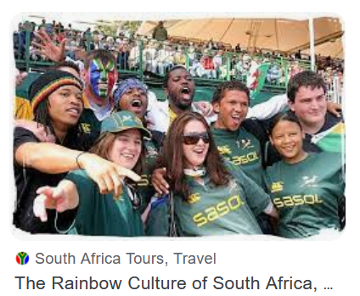
Figure 3: Showing the Rainbow culture of South Africa
Source: Internet
South Africa is a country in Africa with affluent and diverse cultural heritage that has grown over centuries, influenced by African and European oral history. South Africa has 11 formal languages, including English, Afrikaans, isiZulu, isiXhosa and Sesotho. Most people are fluent various languages. South Africa has a spirited music scene that involve genres such as jazz, gospel, hip hop, kwaito and traditional African music. The country also familiar for unique dance styles, such as gumboots and pantsula. Traditional South African food includes dishes such as bobotie( a savoury meat pie) braai(barbecue) and biltong(dried meat. This diverse culture has helped people be more responsible, resilience, governable, adaptable, take off barriers between communities and most important building a better future together as one, local development and inclusive growth. (Jarkko Saarinen, 2022)

Country Analysis
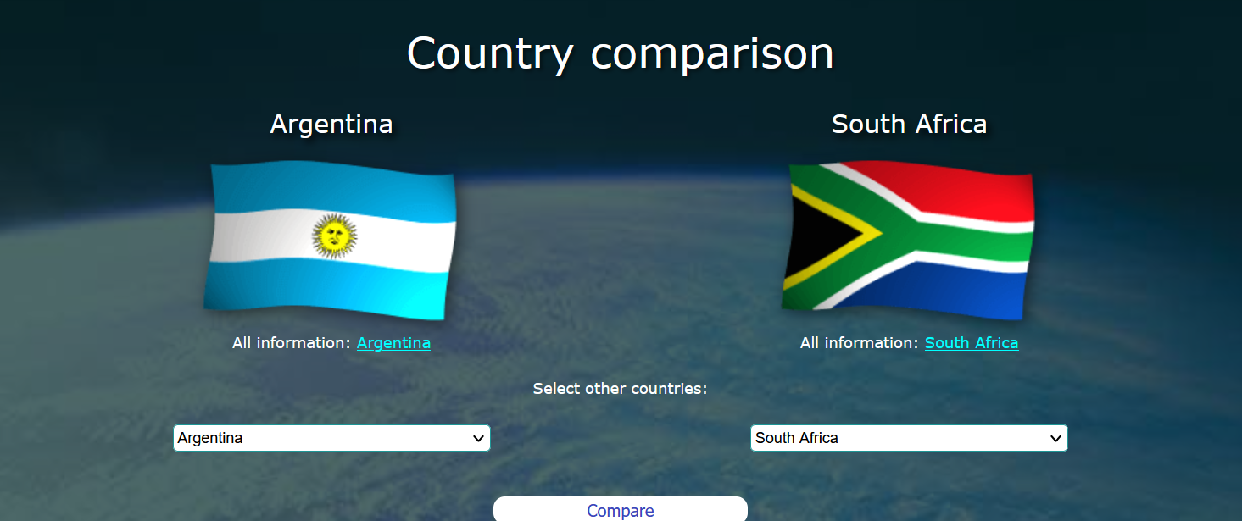

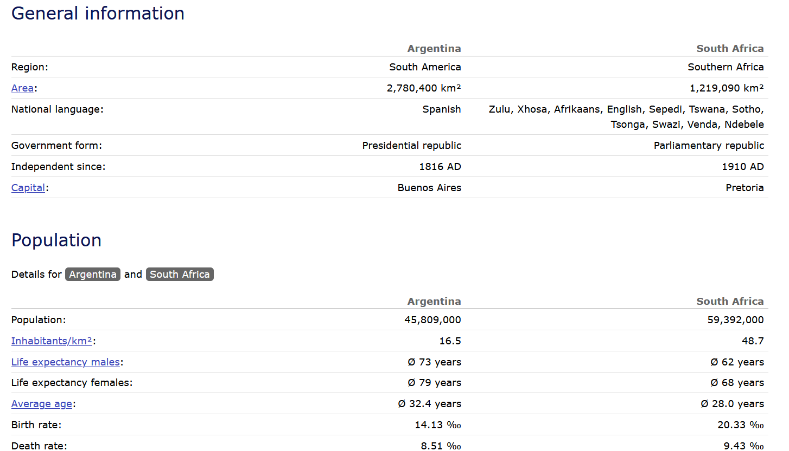
Figure 4: A table showing statical comparison between Argentina and South Africa
Source: https://www.worlddata.info/country-comparison.php?country1=ARG&country2=ZAF#google_vignette

Hofstede's cultural dimensions
Hofstede’s Cultural Dimensions Theory was created in 1980 by Dutch management researcher Geert Hofstede. The aim of the study was to determine the dimensions in which cultures vary.
Since this is framework that help us understand cultural differences across societies. When comparing the hotel industries in Argentina and South Africa using Hofstede's dimensions, we can identify some key differences.
Power distance - Argentina has a higher power distance, which means that there is a greater acceptance of hierarchical structures and authority figures. In the hotel industry, this might manifest in a greater emphasis on formal titles and clear hierarchies. South Africa has a lower power distance, which means that there is more of an expectation for communication and decision-making to be decentralized. Individualism vs. Collectivism - Argentina is more collectivist, meaning that there is a greater emphasis on group harmony and loyalty. In the hotel industry, this might translate to a more team-oriented approach to problem-solving. South Africa, on the other hand, is more individualistic, which might result in a greater focus on personal achievement and recognition.
Masculinity vs. Femininity -This dimension refers to the degree to which a culture values traditional masculine traits (such as competitiveness and assertiveness) over traditional feminine traits (such as compassion and collaboration). In hotels, this might manifest in the way that employees interact with guests and with each other. In masculine cultures, employees might be more likely to compete with each other for recognition and promotions, while in feminine cultures, there might be more of an emphasis on collaboration and building relationships. Both Argentina and South Africa rank relatively high on masculinity, meaning that there is a strong emphasis on assertiveness and competitiveness. In the hotel industry, this might be reflected in a focus on achieving targets and driving revenue.
Uncertainty avoidance - Argentina has a higher uncertainty avoidance, meaning that there is a greater aversion to risk and ambiguity. In the hotel industry, this might result in more standardized procedures and a slower pace of change. South Africa has a lower uncertainty avoidance, which might lead to more innovation and experimentation in the hotel industry.

Hotel Handbook (do’s & don’ts)
Do list:
- Respect the staff and other visitors.
- Look through and understand the hotel policies and procedures.
- Be generic and polite to the hotel staff.
- Be mindful of sound level and the hotel quiet time.
- Use proper security measures while visit in the hotel.
- Greet the visitors with a handshake and a smile, use official titles such Mr. or Mrs. unless told otherwise.

Don’ts list

- Don’t smoke in the non-smoking zone of the hotel.
- Don’t vandalism or destroy the hotel property.
- Don’t interrupt other people with loud noises .
- Don’t steal or lose hotel belongings.
- Don’t bring pets without authorization from the hotel staff.
- Don’t disturb the hotel policies and rules.
- Use swear word or make derogatory comments about race ,ethnicity or religion.
- Disregard or disrespect cultural practices like traditional clothes or celebrations.
- Take photo of people or places without asking for their permission.
- Assume that they all speak English kind speak loudly or slowly to try be in touch.
- Eat or offer cuisine with your left hand, as it is considered rude.

Conclusion
The world of business for all corporations in the 21st century is worldwide independent, multiplex and rapidly changing. That means sophisticated worldwide leadership skills are be in need of more than ever today. Individual and management success is no longer dependent simple on business acumen. Our power to understand ,communicate and manage over borders, nations, and culture has never been as principal as it is now. So businesses need to stay competitive.

Recommendation
Overall hotels need to be aware of the impact that culture have on the guest experience. By understanding cultural differences and adapting their services and offering accordingly, hotels can provide an unforgettable experience that caters to the diverse needs of their guests.

References:

Abramson, N. R., 2018. Managing cultural differences : global leadership for the 21st century. Tenth edition. ed. Abingdon : Routledge.
Alexandra R. Gonçalves, C. R. d. A. J. C. M. M. L. G. S. Q., 2022. Handbook of Research on Cultural Tourism and Sustainability. Pennsilvannia*: IGI Global.
Hamwee, R., 2015. ‎Culture Smart! The Essential Guide to Customs & Culture. London: Kuperard.
Jarkko Saarinen, B. L. N. N. M., 2022. Southern African Perspectives on Sustainable Tourism Management. New York City: Springer International Publishers.
Koc, E., 2020. Cross Cultural Aspects of Tourism And Hospitality. Abingdon : Taylor and Francis.
Morgan, W. J., 2018. Illinois: Human kinetics.
Mullins, 2016. Managing people from diffrent cultures. s.l.:s.n.
Nahavandi, A., 2021. The Cultural Mindset: Managing People Accross Cultures. Los Angeles: Sage Publications.
ProQuest Central, 2020. The vertical pandemic: Niches needing help. Accounting Today, Vol.34 (6), pp. p.8-10.
Rocha, C., 2017. Argentinian Cinema and National Identity (1966-1976). Liverpool: Liverpool University Press.
Timothy, D. J., 2023. Cultural Heritage and Tourism in Africa./. s.l.:Taylor and Francis.
https://www.hofstede-insights.com/country-comparison-tool

