Menu Engineering

Student name: Sarda Anu Stefania Kumar
Student ID number: 2230813
Module title: Food & Beverage Operations
Module code: BMIH4002
Lecturer name: Jaliya De Silva
Word count: 398

The objective of this assignment is to introduce a new menu to the Hotel Trinity located in Doncaster; this hotel accepts offers for menus as they want to help other businesses to extend also and to offer their customers a variety of choices when it comes to foods and beverages. (Trinity Hotel, 2019)
The menu designed is an “À la carte” one, which stands for the concept of ordering individual dishes from a menu instead of the set menu offered at the table.
An À la carte menu has a list with prices for each dish. Although the prices can be a little bit higher, these menus have also more flexibility. (Ward, S., 2023)
This restaurant concept is the most indicated one for a hotel restaurant as the customers have multiple choices. The dishes proposed in this menu are suitable for a variety of consumers as it has all types of food – from meat and sea food to vegetarians and vegan dishes or gluten and/or lactose free ones.
As the four starts hotels are usually located in touristic areas, such as near major cities or beaches, the target audience is mainly composed of tourists and business travellers (Jones, J., 2022) and the restaurant can prepare dishes with high-quality regional agri-food products from the local area. (Lopes, C., 2022)
The À la carte menu has a list with prices for each dish. Although the prices can be a little bit higher, these menus have also more flexibility.
The reasons for choosing this type of menu are the flexibility for customers to choose exactly what they want to eat and choose dishes that will fit their preferences and/or dietary restrictions and the control over how much an individual wants to spend. (Menubly, 2023)
Value-based, competition-based, cost-plus, and dynamic pricing are all models that are used frequently as pricing strategies; the one chosen for this menu is based on an analysis concerning the other four starts hotels restaurant prices mainly, hotels that are located in the proximity of the Trinity Hotel in Doncaster so the chosen prices for this menu are at a competitive level being slightly lower than at the other restaurants but are also decided based on cost-plus as well as the dynamic pricing. (Paddle, 2023)
In conclusion with an a la carte menu you get exactly what they want without being constrained by a predetermined menu when ordering.


À la carte menu
BREAKFAST Price (£)
- Pancakes (gluten free) 4.9
- Eggs (fried or scrambled) 3.9
- Toast 4
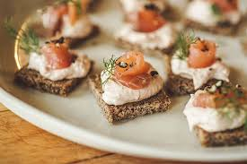
- Sausages/ Bacon 3.5
STARTERS
- Spring rolls 4.9
- Salmon mouse* 7.5
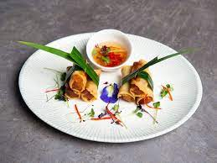
- Buffalo caprese* 5.9
- Fish & chips* 5.5
*All starters are served with bread*
SOUP & SALAD
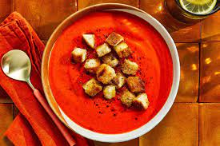
- Tomato soup 7.5
- Cold asparagus soup 9
- Caesar salad 13
- Caprese salad 9.5
- Greek Salad 10.5
- Tuna salad 10.9
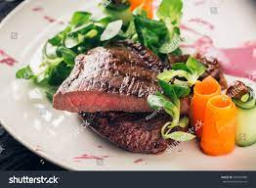
MAIN COURSE
- Rib-eye steak* 19
- Sirloin steak* 20
- Roast pork and herb stuffing* 18
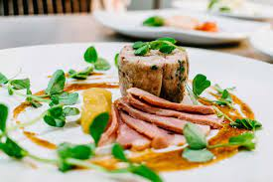
- Pasta Bolognese 15
- Pasta Aglio e Olio 13
- King prawn primavera* 18
- Pan fried Salmon* 20
*Main courses are served with mushrooms, tomatoes & onion rings, or vegetables & potatoes*

DESSERTS
- Carrot cake 6.9
- Cheesecake with strawberries 8.9
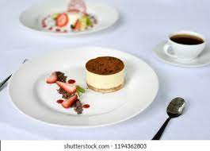
- Red velvet cake 9.5
- Tiramisu/ Vegan tiramisu 8.5
- Cookie dough 6.7
- Ice cream (2 scoups) 8
BEVERAGES
Hot beverages
- Espresso 3.2

- Americano 4,5
- Cappuccino 5
- Decaffeinate 3
- Irish coffee 5.9
- Tea (green/ black/ forest fruits) 4
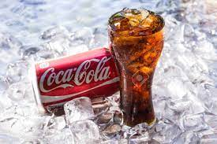
Soft drinks
- Coke/Diet coke 5
- Fanta/ Sprite 5
- Tonic water 4
- Water 3
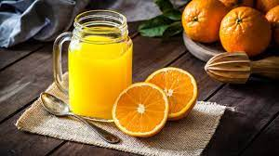
- Sparkling water 3,5
- Iced tea 4
- Red bull 6
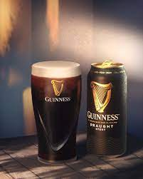
- Orange juice 4.5
Beers
- Heineken 5.9
- Guinness 6.5
- Carling 5,5
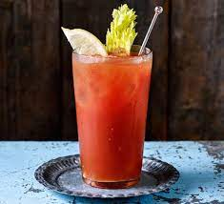
Cocktails
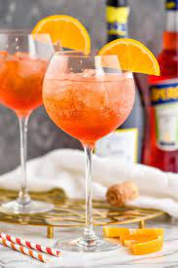
- Mojito 9
- Aperol spritz 10
- Cosmopolitan 8,5
- Bloody Mary 9
- Pina colada 8,5
Non-alcoholic cocktails
- Virgin mojito 7
- Pear and rose punch 8
- Virgin pina colada 8
Wines
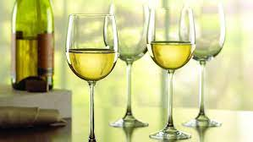
- Chardonnay * 7,5
- Merlot* 8.3
- Pinot noir* 8.5
- Cabernet Sauvignon* 8.9
- Sauvignon blanc* 9

- White Zinfandel* 8.3
- Mulderbosch Cabernet Sauvignon Rose 9.5
*Price per glass*
Whiskey & MORE
- Chivas 8
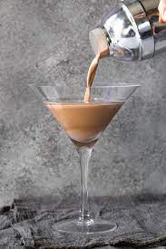
- Jack Daniels 6.5
- Absolut 7.2
- Ciroc 9
- Hennessy 8.3
- Courvoisier 9
**Allergens might be found in the dishes of this menu, please check list**
ALLERGENS list (dishes may contain)
- celery
- cereals containing gluten (such as wheat, barley, and oats),
- crustaceans (such as prawns, crabs, and lobsters),
- eggs
- fish
- lupin
- milk
- molluscs (such as mussels and oysters),
- mustard
- peanuts
- sesame
- soybeans

REFERENCES
- A La Carte Menu - Meaning and Examples – available online at Menubly, accessed on 1st of June 2023
- A La Carte Serving in Regional Restaurants – Celso Lopes , João Leitão, Juan Rengifo-Gallego- available online at sustainability-14-06615-v2.pdf - Sustainability | Free Full-Text | Place-Branded Foods with Responsible and Sustainable Management: A La Carte Serving in Regional Restaurants (mdpi.com) accessed on 2nd of June 2023
- à la carte, adj., and adv. – available online at Oxford English Dictionary (oed.com), accessed on 1st of June 2023
- A La Carte: A La Carte Meaning, Matthew Krimmel, available online at A La Carte: A La Carte Meaning, Table Cover and Sample Menu (binwise.com), accessed on 1st of June 2023
- Doncaster prices 2023, Terri Simpson, available online at Prices in Doncaster June 2023 prices in restaurants, prices of food and drinks, transportation, fuel, apartments, hotels, supermarkets, clothing, currency (hikersbay.com), accessed on 2nd of June 2023
- Management & Operation - Janine Jones available online at Hotel Star Ratings Guide: 1-5 Star Hotels Explained (webstaurantstore.com), accessed on 1st of June 2023
- The pricing strategy guide – available online at Pricing strategy guide: 7 types, examples, & how to choose (paddle.com), accessed on 1st of June 2023
- Trinity Groups – available online at Trinity Groups (trinityhotelgroups.com), accessed on 1st of June 2023
- Types of Menu: 5 Types of Menus to Use In Your Restaurant SARAH WARD – available online at Types of Menu: 5 Types of Menus to Use In Your Restaurant (binwise.com), accessed on 1st of June 2023
- VISIT DONCASTER – City of Doncaster Council - available online at Restaurants in Doncaster (visitdoncaster.com),accessed on 2nd of June 2023

