Dummy Report for Strategic Management Assignment 1 2018 – Include the title of the Report Here



OCTOBER 2018

MODULE NAME: stategic management & sustainbility(m3x9111)
Name: xu zi li
Student Number: 1903330

Table of Contact
1.0 Executive summary 2
2.0 Introduction 4
2.1 Report remit 4
2.2 Background of the organization 4
2.3 Definitions of major concepts 5
2.3.1 Cost leadership 5
2.3.2 Differentiation 6
2.3.3 Focus 6
3.0 Main body 8
3.1 Implementation of the strategy 8
3.2 Advantages & disadvantages of the strategy 9
4.0 Conclusion 11
4.1 Recommendations 11
5.0 References 12
Appendix 14
List of figures: 16

1.0 Executive summary
This report will analyze Lidl & Co. KG information. And give examples of the conditions and actions required to implement the strategy. It will critically assess the strengths and weaknesses of competitive strategy and make some appropriate recommendations. This report is intended to inform readers of market competition strategies and the actions taken to address them. Let readers understand the advantages and disadvantages of competitive strategy. Through my suggestions, readers can have a comprehensive understanding of the competition strategy.
Lidl Stiftung & Co.KG is located in Neckarsulm, Germany. This is a global chain discount supermarket in Germany. The number has reached 10,000. It has now spread to 29 countries. Lidl offers a limited range of food and non-food items every week. The company also provides online shopping services. Lidl is a fast-growing retailer in Germany. Porter believes that these three strategies are essential to every company. Failure to clarify these strategies may result in the company being in an unfavorable strategic position. The cost leadership strategy refers to companies that reduce operating costs through effective means. This allows companies to gain a competitive advantage strategy at a lower total price. When companies implement cost leadership strategies, differentiated strategies refer to companies that focus on multiple choices of users. The company gives the product one or more qualities and meets the specific needs of the customer. Focusing strategy means that companies focus their operations on a particular target market. The company's business is specific and can do its best in one particular segment of the market. Thus, beyond the competition. All three strategies have achieved a tremendous competitive advantage.
Through the analysis of 7p, we can learn the marketing strategy of life. They are taking advantage of cost leadership strategies and implementing the strategy with incredible efficiency. The company implements a cost leadership strategy. Various measures must be taken to reduce the total operating costs and make the price lower than the competition. Companies rely on low-cost to achieve high profits, which allows companies to take a favorable position in the competition.
About 90% of LIDL's products are owned by their brands. This is the biggest reason for the company's low prices. Therefore, the quality of the product is guaranteed, and the cost is saved, and the middleman is eliminated. The cost of hiring employees is an expense that significantly increases the efficiency of employees, which can reduce the number of employees. The company's pricing is always lower than the market value. It can be profitable through small profits but quick turnover.
This strategy provides organizations with higher profits and increased team market share. This strategy can improve business sustainability and reduce market competition. However, this could be in critical areas of the business. This has led to financial cuts. This approach leads to a lack of product innovation. It ignores the importance of consumer feedback. It requires a lower quality of raw materials to reduce costs in order to create higher profits. Advertising or marketing budgets may need to be changed. It can reduce some new customers. This strategy requires successful mass sales.
All in all, companies need to understand the competitive strategy of their competitors fully. Have a correct analysis and research on their competitive strategy.
Companies need to ensure that essential departments receive financial support. Product diversification and innovation are crucial. Companies should ensure that the quality of each product is in line with standards. When managers choose products, they must consider all the factors of the product. Determine the product's profitability is high.

2.0 Introduction

2.1 Report remit
This report will analyze the Lidl &Co. KG’s information. In a highly competitive market, the company has adopted some competitive strategies to ensure its strategic position. It will give examples and explain the conditions and actions required to implement the strategy. For a competitive strategy, the report will critically evaluate the strengths and weaknesses and make some appropriate suggestions.
The purpose of this report is to give readers an understanding of the competitive strategies in the market and the measures taken for the strategy. Let the reader understand the advantages and limitations of the competitive strategy. Through my suggestions, readers can have a comprehensive understanding of the competitive strategy.

2.2 Background of the organization
Lidl Stiftung & Co.KG is located in Neckarsulm, Germany. This is a German global (Lidl.NI, 2019) discount chain supermarket. Lidl is also known as the supermarket of the poor. It is a private company and currently belongs to Dieter Schwarz Holdings. (Lidl.NI, 2019).
In 1930, its prototype was a food wholesaler. In 1977, the company began to focus on discount markets, supermarkets, and cash and goods wholesale markets. The first store opened in the UK in 1994 and has proliferated in the 21st century. It is now spread across 29 countries (Lidl.NI, 2019). Nowadays, the number of Lidl's chain stores has reached 10,000(Lidl.NI, 2019). There are already 450 stores in Germany and the United States, with more than 5,000 (Lidl.NI, 2019) employees.
Lidl offers a limited range of foods and non-food items provided weekly, including household items, sports equipment, electronics, and themed foods. There are bakeries in stores across Europe and a baking area. The company also offers online shopping services (Lidl.NI, 2019).
Lidl is a fast-growing retailer in Germany. Lidl and Aldi drove Wal-Mart out of Germany together, so the company is high reputation.
On 17th April 2019, Lidl promotes sports in Northern Ireland. The company invested £160,000 in local youth sports. The club received new training accessories and equipment. (Appendix 1)
On 22nd January 2019, Lidl is committed to treating fish in a 100% responsible manner. Lidl advocates protecting the ocean. (Appendix 2)

2.3 Definitions of major concepts
In 1980, American scholar Porter (2005) proposed five competitive forces for corporate profitability in his book. Based on a detailed analysis of the competitiveness, Porter further proposed a general strategy that can be applied to enterprise practice.
According to Porter's analysis, the general strategy has three essential points to gain a competitive advantage，, for instance, cost leadership, differentiation, and focus, respectively. Porter calls general strategy.
There are four primary sources of competitive advantage in Porter's Generic Strategies. Such as cost leadership, differentiation, focus cost leadership, and focus differentiation.

Figure 1: Porter’s Genic Strategies

Figure 1: Porter’s Genic Strategies

Porter believes that these three strategies are essential to every company. Failure to clarify these strategies may result in the company being in an unfavorable strategic position. If leaders want to ensure that the company is invincible, then choosing the right competitive strategy is very important. Leaders need to have a good understanding of the content and impact factors of the competitive strategy. (YiFei,2014).

2.3.1 Cost leadership
The cost leadership strategy, also known as the low-cost strategy, refers to companies that reduce operating costs through effective means (Katarina, 2019). This allows companies to gain a competitive advantage strategy at a lower total cost.

Companies can achieve significant competitive advantages when implementing cost leadership strategies. First, when the product is sold at the same price, the cost of the company is lower than other companies in the same industry. So, companies can get higher profits if the company maintains the industry's average profitability. Products sold at lower prices can increase the competitiveness of their products. Second, relative to the higher cost, companies can force suppliers to maintain the original estimate through a cost leadership strategy. The cost leadership strategy allows companies to achieve more gross profit. Third, cost leaders can constitute barriers to entry. New competitors are subject to many limitations, such as technology, management, and experience. New competitors cannot get low-cost participation in the competition. Cost leaders sell products at lower prices when they encounter new competitors, which can devastate new competitors (JiSheng,2014).

2.3.2 Differentiation
The differentiation strategy is also called the characteristic advantage strategy, which means that the enterprise pays attention to the multiple choices of customers. The company gives the product one or more qualities and meets the specific needs of the customer. Differentiation strategies are divided into four types, namely product differentiation strategy, service differentiation strategy, personnel differentiation strategy, and image differentiation strategy (Kokemuller, 2019).
Enterprises can gain a sizeable competitive advantage when implementing differentiation strategies. First, companies can gain more loyal customers through differentiation strategies. Second, in the face of the threat of alternatives, the differentiation strategy can effectively increase the competitiveness of enterprises (Whiting, 2018). Third, the differentiation strategy makes the purchaser lack comparable products and weakens the buyer's sensitivity to price.

2.3.3 Focus
The focus strategy, also known as the centralized strategy, refers to the focus of the company's operations on a specific target market. The business is single-minded and can do its best in a particular market segment (Zaware, 2016). Thus, beyond the competition.
Companies can gain a significant competitive advantage when implementing focused strategies. First of all, because the company's focus is concentrated, resulting in a narrow market, companies can better understand the market and customers. They are thereby providing better products and services. Second, the focus strategy has adapted to the characteristics of limited enterprise resources. Companies can focus on providing the best service to a particular target market. Third, management is simply because of the centralized management objectives (Gaille, 2018). Finally, this strategy can reduce business operating costs. This will help to concentrate on the use of resources and achieve specialization.

3.0 Main body
The company implements a cost leadership strategy. First, companies must have advanced equipment and production facilities. And companies can improve equipment utilization. Secondly, enterprises should use management experience to strengthen the control of costs and management costs. Companies need to go all out to reduce costs. Finally, minimize expenses for research and development, marketing, advertising, and services. In short, various measures must be taken to reduce total operating costs. Making costs lower than competitors and relying on low-cost to obtain high profits, so that enterprises occupy a favorable position in the competition (Dolgui, 2014).

According to Porter's thinking, the cost leadership strategy is reflected in lower prices. But it is not blindly lowering the price. Instead, let companies turn costs into controllable cost leadership. In other words, companies need to find a source of sustainability before they can achieve a low-cost strategy. This will prevent competitors from imitating (Moschetti, 2016). This cheap advantage will last long.

3.1 Implementation of the strategy
First, about 90% of Lidl's products belong to its own brands. It means Lidl can control manufacturing costs and cut supply costs. So, it can charge less compared to big brands but still get more profits. This is the biggest reason for the company's low price. Each product undergoes extensive testing, such as checking the quality, taste, and feel. They work with local and regional farms. Every Lidl product goes through quality testing and a carefully selected process. Therefore, it is possible to guarantee the quality of the product, save costs, and eliminate middlemen (Bhasin, 2019). The public well receives Lidl's private label products. The annual taste test award hosted by The Grocer compares large-brand products with Lidl and other supermarkets' own-brand products. Many products of the Lidl brand have also won awards. For example, the mini Auckland cucumber is widely praised. Shoppers call them crunchy bento and lunch box ideas. Lidl's sourdough and croissants received the highest ratings. There is a clear winner in the dining aisle. However, customers can still find some well-known brands on the shelves, and Lidl has witnessed an increase in sales of these branded goods. For example, in January's first Big 99p event (Bentley, 2018), the event saw significant brands such as Walkers, Cadbury, Uncle Bens, Heinz, and Hewlett-Packard sold at that price.
Second, the cost of hiring employees is an expense. If the company can significantly increase employee efficiency, Lidl can reduce the number of employees. When customers shop in Lidl, they often see that Lidl employees are busier than employees in other supermarkets. Lidl employees tend to be more responsible. The company reduced the number of employees to save costs. Therefore, Lidl has only a limited number of employees in each store, but each employee must be held accountable. As a result, significant cost savings can be achieved. Thereby further reducing the price of the product.
Third, the company's pricing is always below market value. It can quickly profit from the meager profit, reduce the profit per product, and sell more products. It attracts more customers at a reasonable price. For example, according to a recent survey of 20 products, Lidl was found to be 9% cheaper than Wal-Mart in the United States. For example, we found that the price of W5 dishwasher tablets was only £ 2.95 per pack of 60 tablets, and in a recent weekend discount, they have dropped to £ 1.99. In comparison, 60 tablets of Tesco's own brand are priced at £ 7, and 60 tablets of Finish are priced at £ 7 (Bentley, 2018). No one wants to pay a higher price for the same product, which could explain why Lidl retained the title of the UK's fastest-growing retailer.

3.2 Advantages & disadvantages of the strategy
The cost leadership strategy has several advantages.
First, the strategy provides the organization with higher profits. The strategy focuses on operating at a low cost within the market and industry. By reducing development and production costs, if Lidl can offer competitive prices and earn higher profits than other companies, the company is likely to earn higher profit margins.
Second, this strategy can increase the team's market share. Not only can they achieve higher margins, but they can also increase market share over time. If the company's goods or services cost the least and the price is acceptable, it will buy the commercial goods first. (Ruddick, 2015).
Third, the strategy can improve business sustainability. When the company's costs are low, the financial threat of organizing bankruptcy is even less. This sustainability will be a considerable advantage when economic conditions deteriorate. When there is a price war or trade war, the company with the lowest operating cost has the highest chance of survival (Kapolna,2018).
Fourth, this strategy reduces competition in the market. Companies that can implement this strategy have also succeeded in bringing their future advantages. Because they can offer more affordable prices to consumers. As a result, competition in new markets is limited. Competitors may struggle to get the same price. Over time, this can control the market. (Lidl, 2019)

The cost leadership strategy has some drawbacks.
First, it could lead to financial cutbacks in critical areas, hurting the business.
Some cost owners may want to reduce costs in critical areas of the company, such as its customer service department.
Second, this approach leads to a lack of product innovation. For many leaders, R&D seems like an extra expense. Savings here result in fewer new products or services coming to market (Lidl, 2015).
Third, it reduces the importance of consumer feedback. If Lidl focuses only on maintaining services or products and reducing their costs, some customers will spend more money on competing products because they can better meet their needs.
Fourth, lower quality raw materials may be needed to create higher margins. Advertising or marketing budgets may need to be changed. This can reduce the number of new customers acquired.
Fifth, this strategy requires successful large-scale sales. Cost leadership leads to mass sales, which is the most successful approach (Natalie Regoli, 2019). This is how organizations maintain overall profitability.
The strengths and weaknesses of the cost leadership style show us that this process can be used to create unique competitive advantages. It also slows down the organization's ability to adapt to a changing environment. In order to function effectively, cost leadership must be carefully managed to generate profit. There are significant risks (Lusch, 2017).

4.0 Conclusion
Lidl’s success in a fiercely competitive market is closely related to Lidl's competitive strategy. Due to the use of the right strategy, Lidl quickly gained market share. However, if Lidl wants to continue to maintain or enhance its own advantages, it also needs to gradually change Lidl’s competitive strategy following changes in social needs. Only in this way can Lidl stabilize their market position. All in all, if companies want to be invincible in the fierce market competition, they need a competitive strategy for competitors. Have a correct analysis and research on their competitive strategy. Only in this way can we grasp the development direction of the enterprise and continue to grow in the development to obtain a broader profit and growth space for the enterprise.

4.1 Recommendations
First, when companies are implementing cost leadership strategies, they need to ensure that essential departments receive financial support. For the customer service department, this department seriously affects customer loyalty (Dyson, 2014). If you ignore this link, the company may lose a lot of customers.
Then, product diversification and innovation are essential. The company should pay attention to the upgrading of products while saving as much as possible.
Second, it does not reduce the quality of the product while saving costs. It cannot blindly lessen the quality of raw materials to lower prices. Companies should ensure that the quality of each product is in line with standards.
Finally, because the cost leadership strategy must be successful in the case of massive sales, so, when managers choose products, they must consider all the factors of the product. It is determined that the profitability of the product is high before it can be bought and sold.

5.0 References
Bhasin, H. (2019). Marketing Strategy of LIDL – LIDL Marketing Strategy. Available at: https://www.marketing91.com/marketing-strategy-of-lidl/ (Accessed 16 November 2019).

Bentley, D. (2018). 17 things you should know about shopping at Lidl. Available at: https://www.cambridge-news.co.uk/news/uk-world-news/lidl-aldi-shopping-tricks-discounts-14267830 (Accessed: November 16, 2019).

Brown, G. (2015). Giant Lidl distribution hub to create 500 West Midlands jobs. Available at: http://www.birminghampost.co.uk/business/business-news/giant-lidl-distribution-hub-create-888311 (Accessed 16 November 2019).

Dolgui, A. & Proth, J. M. (2014). ‘Pricing strategies and models’. Annual Reviews in Control, 34(1), pp. 101-110.

Dyson, R. G. (2014). ‘Strategic development and SWOT analysis at the University of Warwick’. European Journal of Operational Research, Volume 152, pp. 631-640.

Gaille,B. (2018) 15 Focus Strategy Advantages and Disadvantages. Available at: https://brandongaille.com/15-focus-strategy-advantages-and-disadvantages/ (Accessed: 16 November 16, 2019).

JiSheng, Y. (2014) ‘The content and necessary condition analysis of enterprise general competition strategy’, Fazhiyujingji,293(11), pp.79-80.

Kokemuller, K. (2019) Differentiated Business Strategies. Available at: https://smallbusiness.chron.com/differentiated-business-strategies-20638.html (Accessed: 16 November 16, 2019).

Katarina, K. (2019) Cost Leadership – Definition, Examples, & Strategies. Available at: https://www.feedough.com/cost-leadership-definition-examples-strategies/ (Accessed: 16 November 16, 2019).

Lidl (2019) Available at: https://corporate.lidl-ni.o.uk/about-lidl/history (Accessed: November 16, 2019).

Lidl, (2015). Customer orientated expansion. Available at: http://property.lidl.co.uk/cps/rde/xchg/lidl_uk/hs.xsl/5187.htm (Accessed: November 16, 2019).

Lusch, R. F., Vargo, S. L. & O’Brien, M. (2017). ‘Competing through service: Insights from service-dominant logic’. Journal of Retailing, 83(1), pp. 5-18.

Michael, E. (2005) Competition Strategy: a handbook of theory and practice. Basingstoke: Huaxia Press.

Morschett, D., Swoboda, B. & Schramm-Klein, H. (2016). ‘Porter outlines four generic strategies; differentiation, cost leadership, differentiation focus and cost focus’. Journal of Retailing and Consumer Services, 13(4), pp. 275-287.

Munbodh, E. (2019). Best and worst Lidl own-brand foods revealed - rated by the shoppers themselves. Available at: https://www.mirror.co.uk/money/lidl-shoppers-reveal-44-favourite-14128032 (Accessed: November 16, 2019).

Regoli, N (2019) Available at: https://futureofworking.com/14-advantages-and-disadvantages-of-cost-leadership-styles/ (Accessed: November 16, 2019).

Ruddick, G. (2015). Supermarkets could increase prices to pay for living wage. Available at: http://www.telegraph.co.uk/finance/newsbysector/retailandconsumer/11736662/Supermarkets-could-increase-prices-to-pay-for-living-wage.html (Accessed 16 November 2019).

Siro, I. Kapolna, E. Kapolna, B. & Lugasi, A. (2018). ‘Functional food. Product development’. marketing and consumer acceptance—A review. Appetite, 51(3), pp. 456-467.

Whiting, B. (2018) Differentiation Strategy: Definition & Examples. Available at: https://study.com/academy/lesson/differentiation-strategy-definition-examples.html (Accessed: 16 November 16, 2019).

YiFei, C. (2014) ‘The brand positioning analysis of JiangSu satellite TV based on porter's three general strategies’, China Academic Journal Electronic Publishing House. All rights reserved. [Online]. Available at: http://www.cnki.net (Accessed: 16 November 16, 2019).

Zaware, N. (2016) Focus strategy. Available at: https://www.slideshare.net/drnitinzaware/focus-strategy (Accessed: 16 November 16, 2019)

Appendix
Appendix 1：Lidl northern Ireland launches new sport for good programme
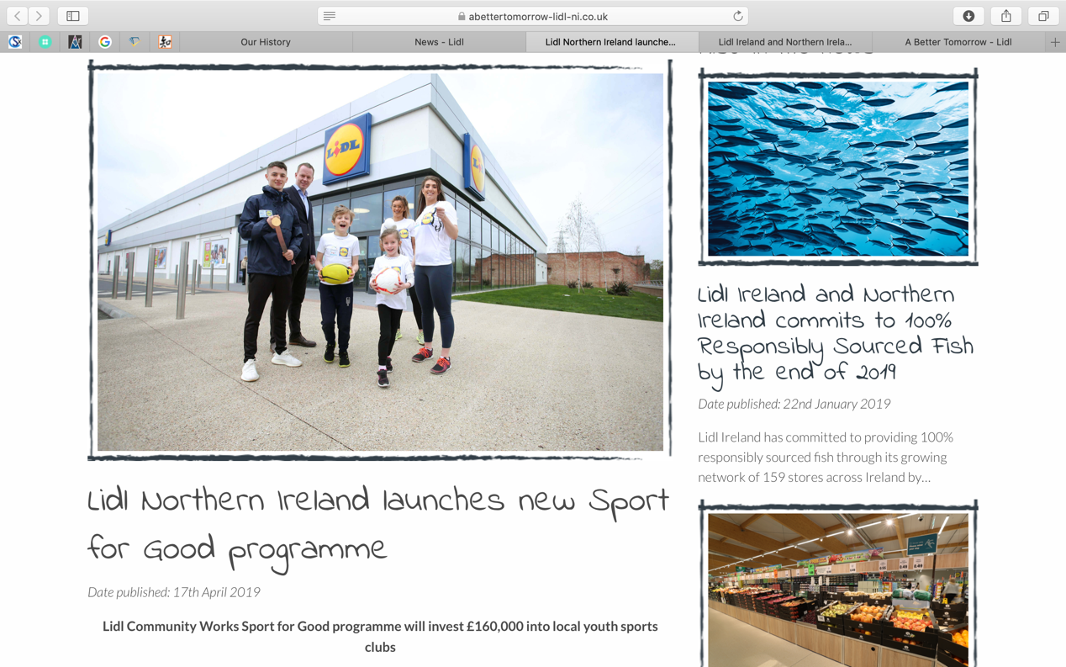
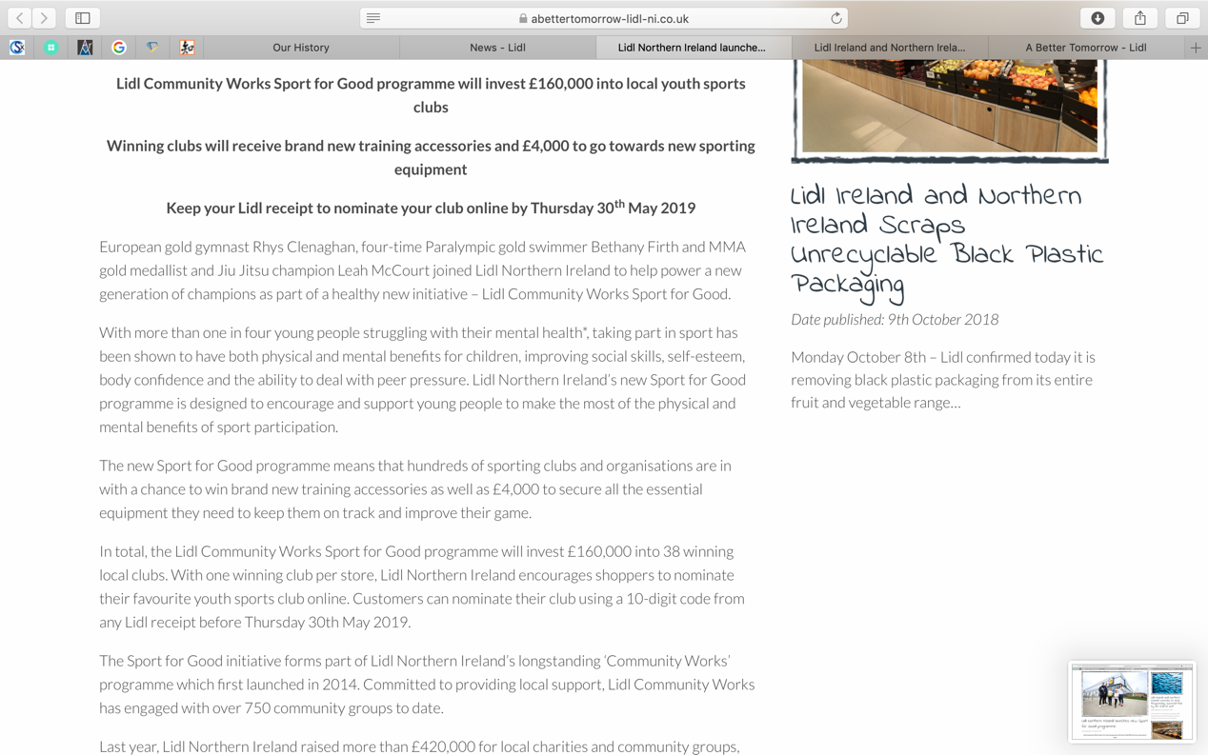

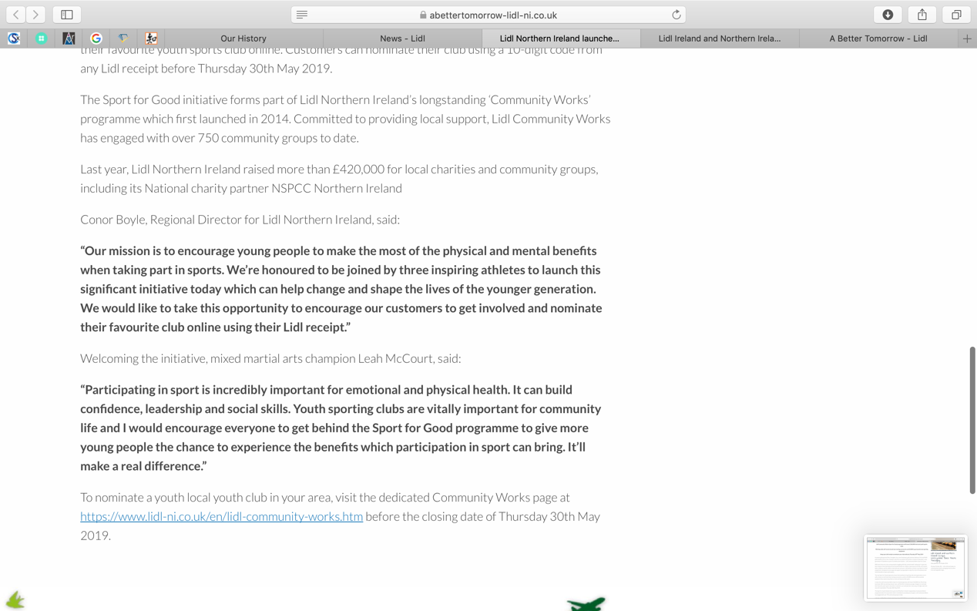
（reference：https://www.abettertomorrow-lidl-ni.co.uk/news/lidl-northern-ireland-launches-new-sport-for-good-programme/ ）

Appendix 2：Lidl Ireland and northern Ireland commits to 100% responsibly sourced fish by the end of 2019
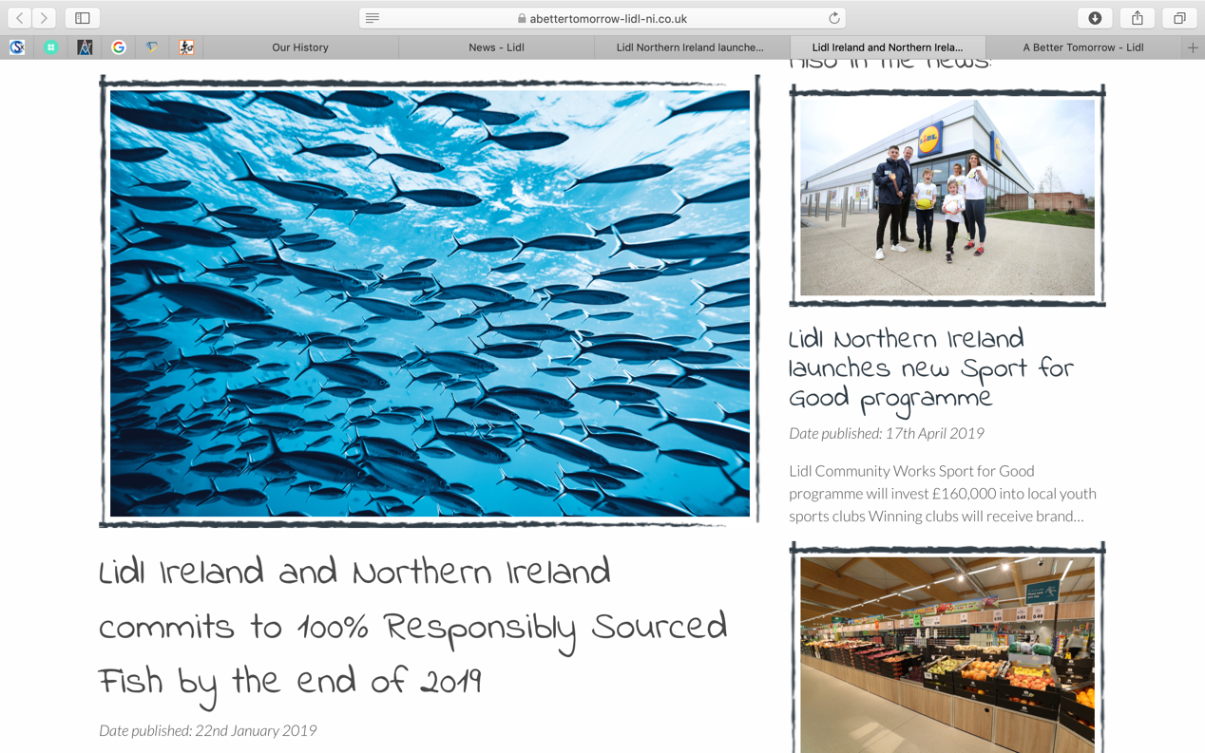
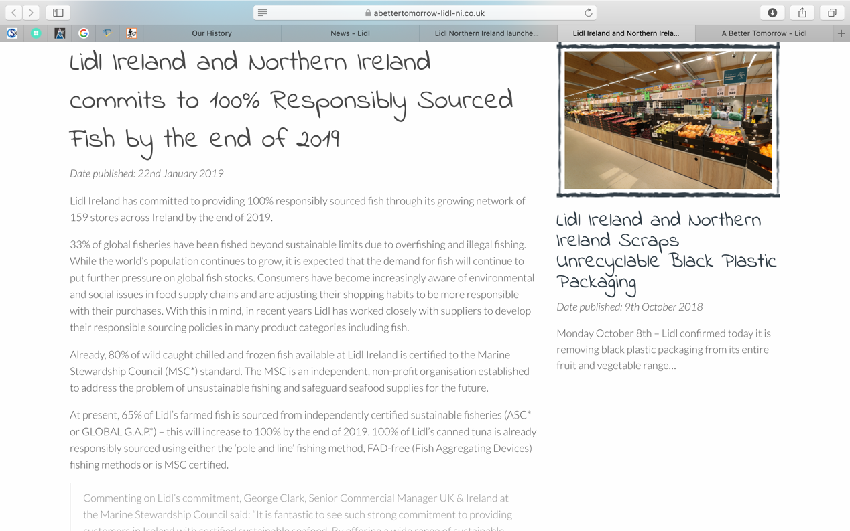

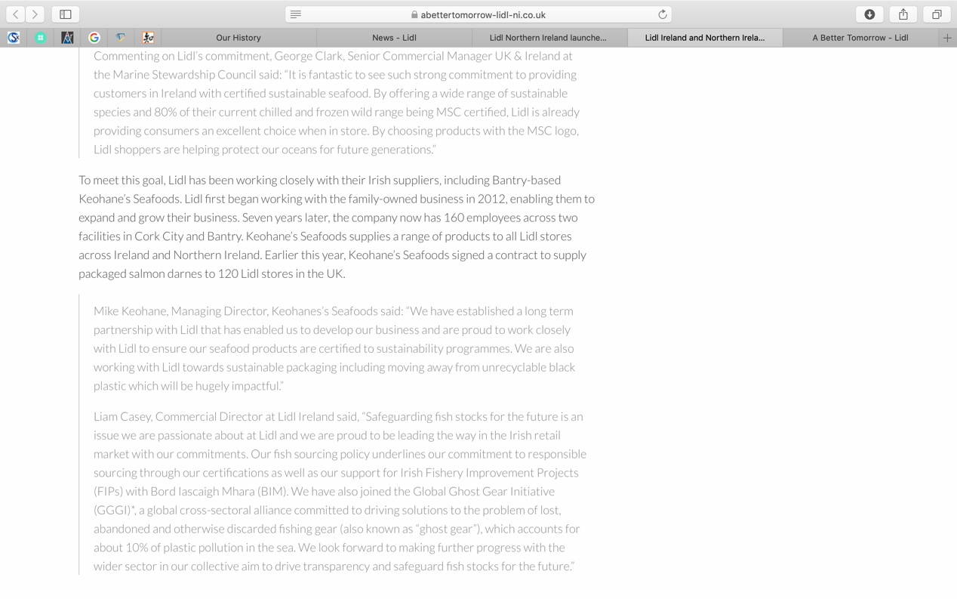
（reference：https://www.abettertomorrow-lidl-ni.co.uk/news/lidl-ireland-commits-to-100-responsibly-sourced-fish/ ）

List of figures:
Figure 1: Porter’s Genic Strategies

