PROBLEM SOLVING AND DECISION MAKING (BMSW4004)

NAME : DANIELA BABAN
STUDENT ID NR :2131547
DATE :24.10.2022

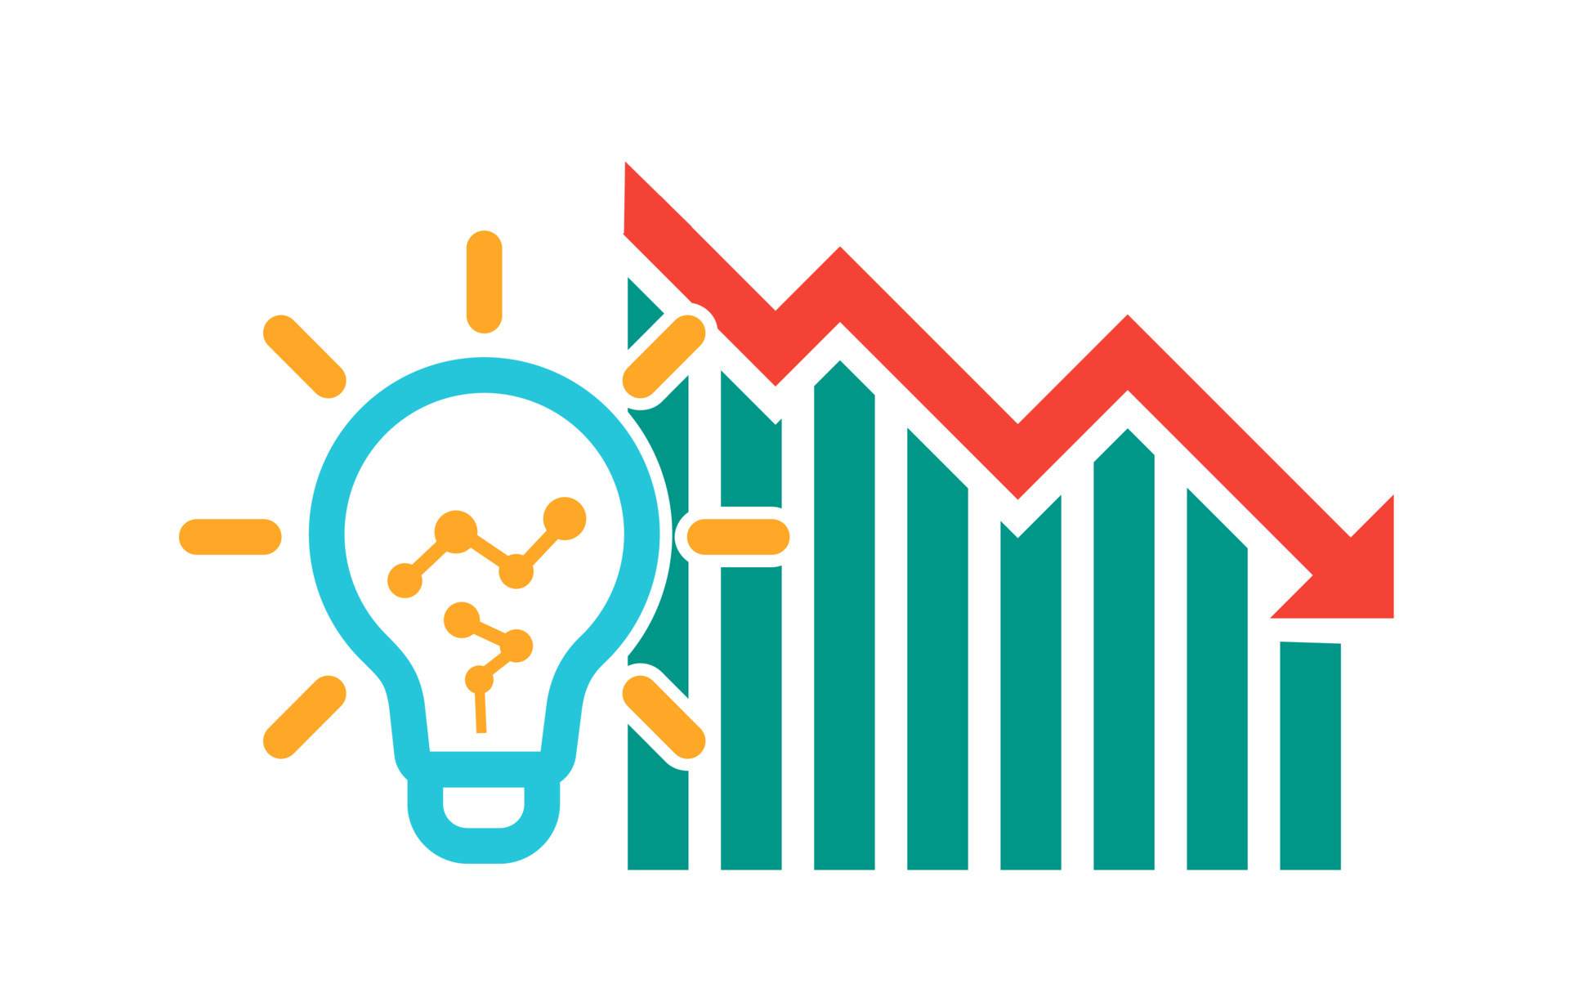
- Electricity and gas raising crisis .

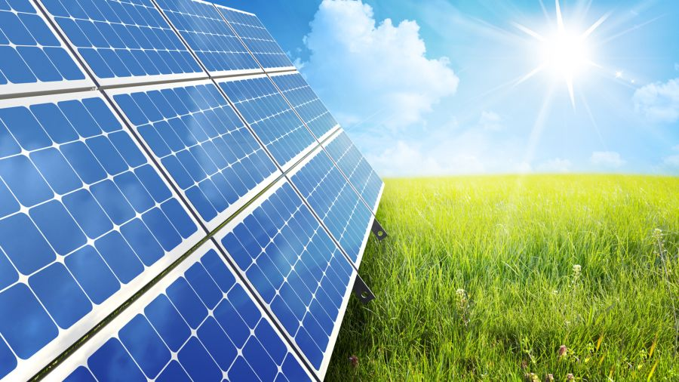

NATURE :

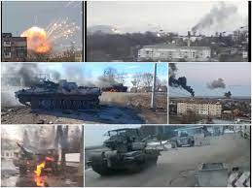

The uk energy sistem has been plunged into chaos by a storm of market forces
witch threatens to rip through the economy home energy suppliers
to heavy industry rising costs .
Who is causing it ?
Covid and the war between ukraine and russia are the reasons why
the costs of energy and gas are rising, since pandemic showed up the
Gaz supplies have been cut off , countries across the world have been experiencing a long winter in 2020 and 2021 because the gas supplies had a big deley .China’s imports of gas via super-chilled tankers was expected to travel to Europe from Qatar.
Rusia ‘s state -backed gas company and refused to increase the export to europe and uk ,because of the high-recordet prices going up across the continent .The electricity system had a system witch a bug impact on how and were the electricity is generated and delivered ,in general the enviromental effects can include : gases and air poluated .

SCOPE
The 2022 global energy crisis began in the aftermath of the COVID-19 in 2021 were half of the globe was facing shortages and increased prices in oil ,gas ,and electricity markets .
Most of the houses in uk are affected , the organisations , the food productions and the transportations because they all need electricity and gas to work .The average household in England ,Scotland and Wales will spend more than 3,000£ a year on energy ,from october 2022 the annual bill wii arrive at 4,000£ that means energy bills will be more then double , the households will not manage and will not be able to afford the bills for electricity because half of them are low incomes few are depending on benefits or they being poor .

IMPACT: Rising energy costs:
The impact on households ,pensioners and those on low income , organisations , food factory ,and transport,the energy bills in uk are to rise considerably over the next year ,energy prices are likely to hit lower income households disproportionately ,as they spend a higher proportion of their income on utility bills and more likely to be in fuel poverty .
The energy crisis had a big impact on energy company failures ,since august 2021 ,26 energy suppliers have gone out of business,disruptions to the global energy market are putting Governments worldwide under enormous pressure .Rising energy prices are accelerating the cost -of-living crisis and sustaining the vicious cycle of constrained household budgets : increasing food and energy poverty , increasing social unrest .
A crisis can develop due to industrial actions like strikes and government embargoes .The cause may be over -consumption , aging infrastructure ,choke point disruptions or bottlenecks at oil refineries and port refineries and port facilities that restrict fuel supply .
Disruptions to the global energy market are putting Governments worldwide under enormous pressure .Rising energy are accelerating the cost of living and the household budget acros all the UK .

