DS1: My Digital Life



Here's my facebook page screen capture. I do use facebook to stay in touch with friends and family and update about me. Also it's useful for joining some interest based groups and following news.



This screenshot is of WhatsApp. I use WhatsApp on a daily basis, I text my friends and family and also call my friends and family, make video calls and text my class mates.

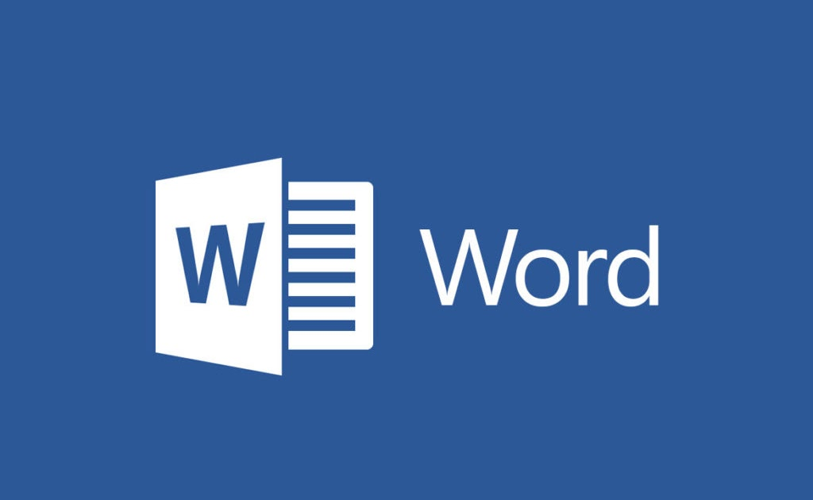
In the screenshot displayed above, is a screen shot of Microsoft Word. I use Word for my school work and assignments, it allows me to create reports and keep my work organised, also enabling me to make high standard work and improve my writing.


Here is a screenshot of my Gmail account. I use it for my emails to lecturers, university information and I rely on my university emails. It allows me to keep organized and to ensure I don't miss any important messages.


This is a screenshot of Youtube. I use Youtube for my studies as well, I tend to watch educational videos, to listen music, tutorials, lectures etc. As well as for entertainment, and for learning a new skill.


This is a screenshot of ChatGPT. I use ChatGPT as a tool for academic learning to help me understand difficult subjects, generate assignment ideas, develop writing, and for academic purposes in general.

My Short Reflection

The use of digital technology is a part of my daily life and this is the case for many people. I communicate with my friends and family via Facebook and Whatsapp, work with Microsoft Word and I communicate with my lecturers through the means of electronic mail and use these two digital tools everyday, I use Youtube to educate myself and I sometimes ask for answers or learn from the content on it and I also use Chatgpt when I cannot access certain information and learn through it, and I feel that I can make efficient use of the simpler aspects of digital technology and online services, although I am hoping to improve my knowledge and abilities when it comes to advanced digital tools and advanced online search skills. I think that the development of digital skills is extremely important in my studies and my future career.future career.

Student name: Diana Nicoleta Chiriac

CCL Number: 2542848

