
Assignment 2:
Operating Systems
CertHE Computing Skills for Workplace

Computer Architecture and Operating Systems. ACCA4022_LON
Kwame Assa Agyei (Lecturer)
University of Wales Trinity Saint David
(London Campus)
Student Name: Mustafa Ay
Student Number: 2513629
Group: 01
Date: April 2026

Table of Contents
Introduction 1
1. Key functions of Operating Systems 1
1.1 Process and Processor Management 1
1.2 Memory Management 1
1.3 File System Management 1
1.4 Security and Protection 2
1.5 User Interface 2
2. Use of Windows OS CLI commands. 2
3. Use of Linux OS CLI commands. 7
4. Use of Windows OS scripts. 11
5. Use of Linux OS scripts. 12
Conclusion 13
References 13
Appendices 14

Introduction

Key functions of Operating Systems
Operating systems play an essential role in the overall functionality of a computer by acting as the intermediary between all hardware components and application software used at the same time or during different times by various programs. Process management allows the user to control with ease the programs running in the background along with the completion of those programs on a computer while it is running. Memory management allows the user to monitor how much memory is being used and to manage the amount used without conflict between multiple applications at the same time. File Management allows the user an easy way to find out where things are, as well as provide him with the ability to create, modify, and delete files and folders whenever needed. Security Management prevents access from unauthorized entities by using both passwords and permissions. Finally, an operating system has provided a means for users to interact with their device via GUI-based and command-line-based means (i.e. by mouse and keyboard).

Process and Processor Management

Process management allows the operating system to control running programs in the computer. It manages how tasks are started, executed and completed. The processor is shared between different programs so that multiple applications can run at the same time efficiently.

Memory Management
Memory management helps the operating system control how RAM is used by different programs. It ensures that each program gets enough memory to run properly and prevents conflicts between applications running at the same time.

File System Management

File system management allows the operating system to organise files and folders on storage devices. It helps users create, delete, rename and access files easily and keeps data stored in an organised way.

Security and Protection

Security and protection help prevent unauthorised access to the computer system. The operating system uses passwords and permissions to protect user data and ensure that only authorised users can access important information.

1.5 User Interface

The user interface allows users to interact with the computer system. It can be graphical such as using a mouse and icons, or command-line based where users type commands in the terminal.

2. Use of Windows OS CLI commands.
Figure 1: ipconfig
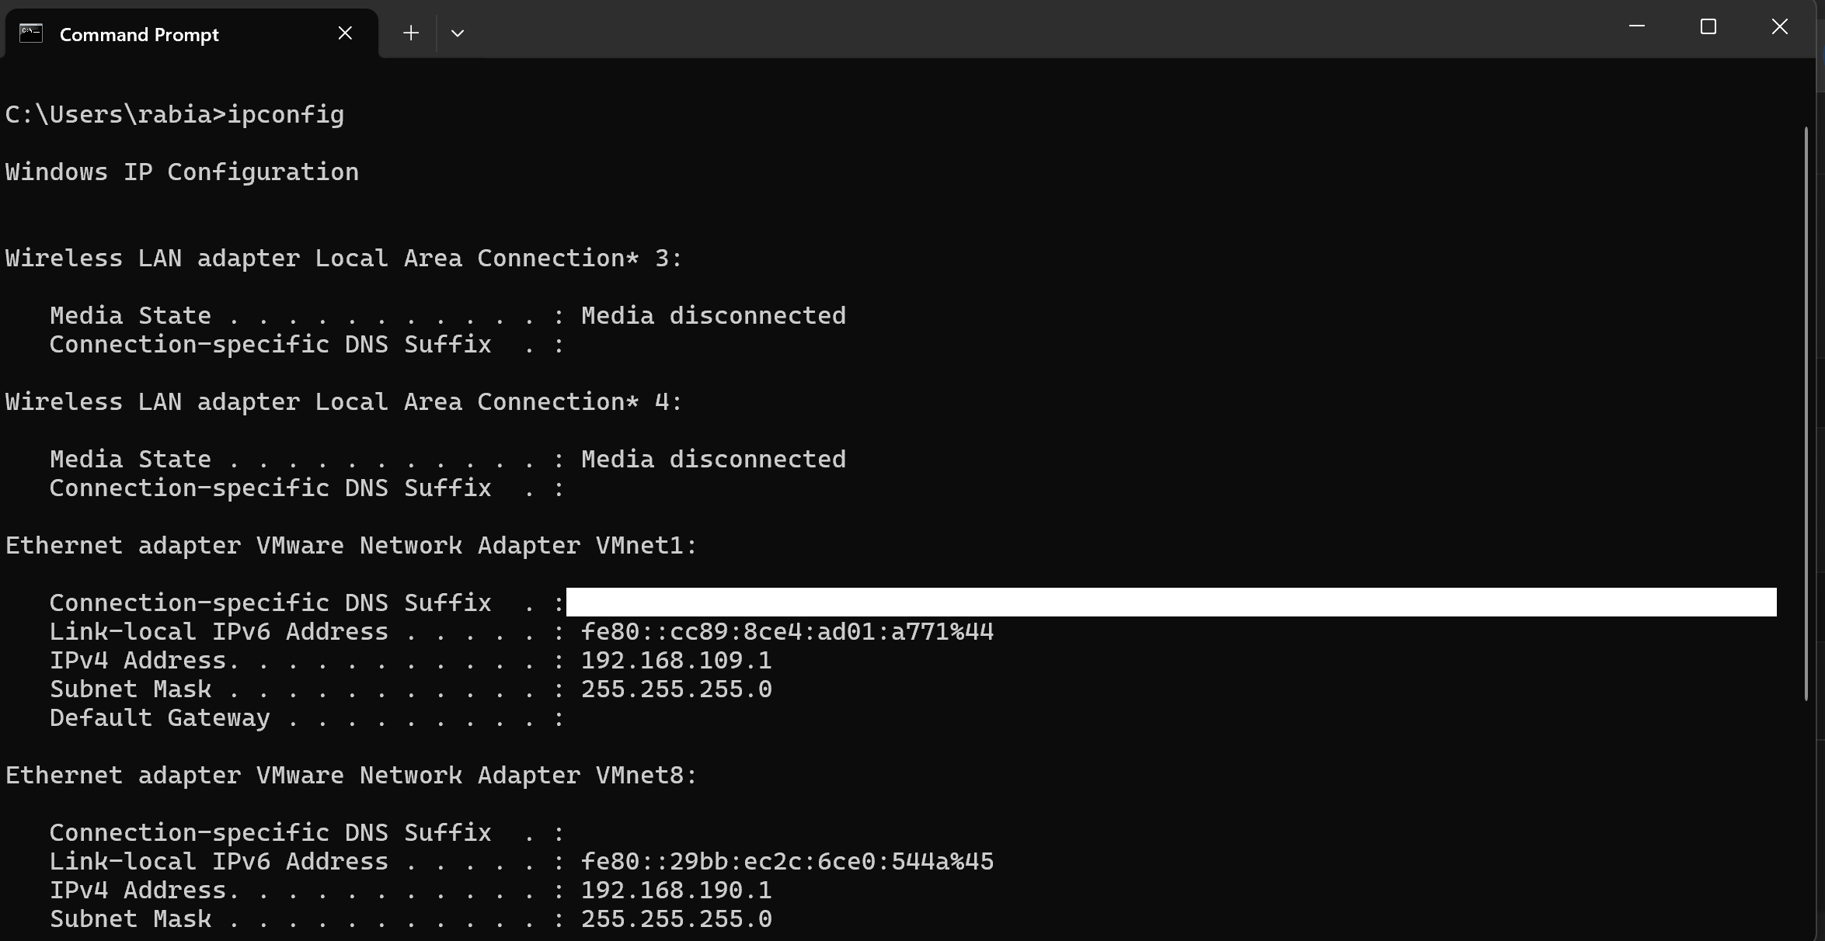
The ipconfig command is used to display the network configuration details of the computer. It shows important information such as IP address, subnet mask and default gateway. This command is useful for troubleshooting network connectivity issues.

Figure 2: dir
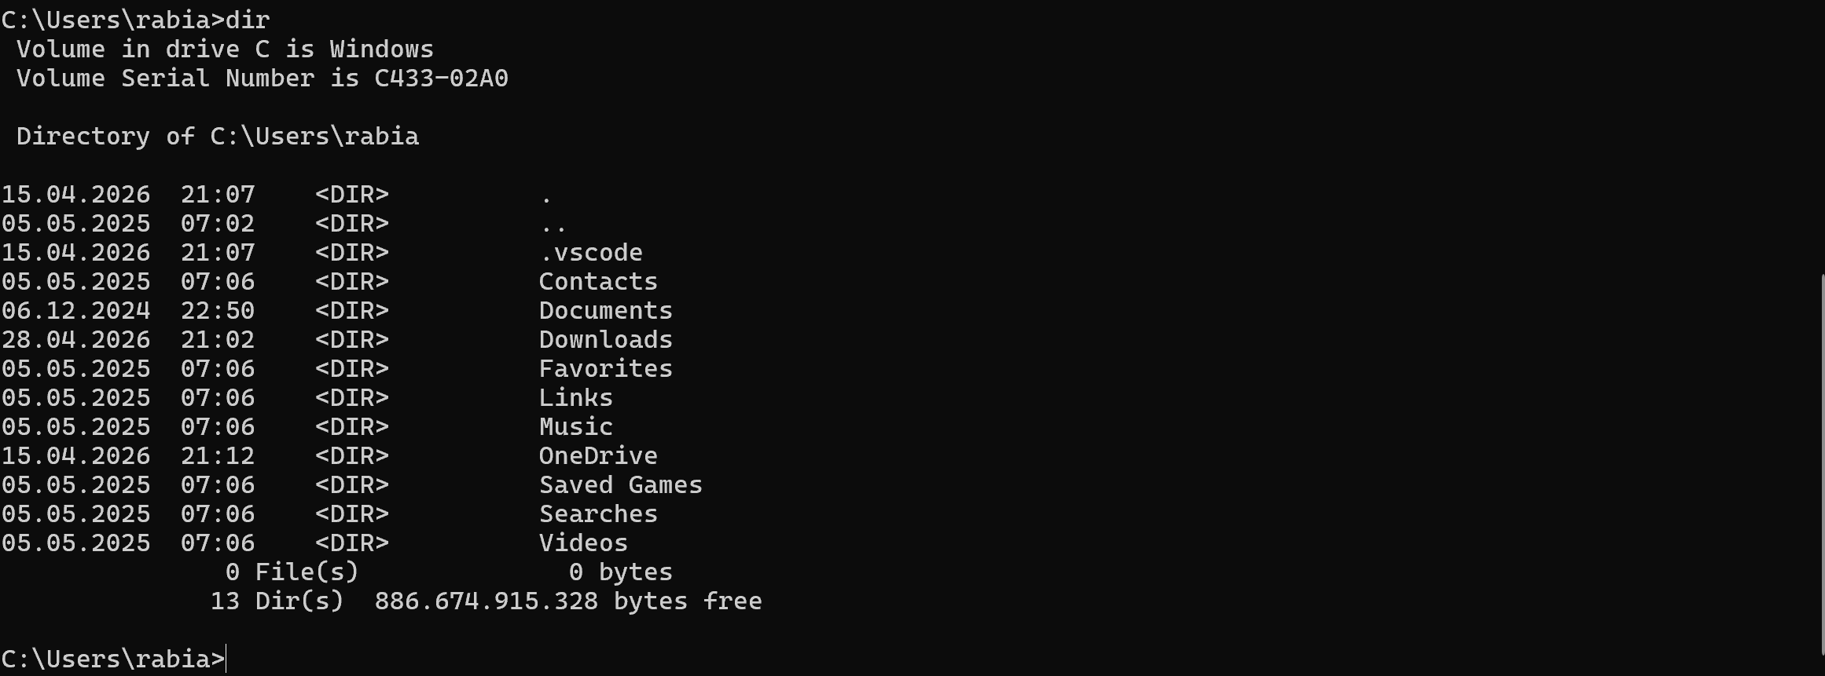
The dir command is used to display the list of files and folders in the current directory. It helps users to view available files and manage directories using the command line interface.

Figure 3 : systeminfo
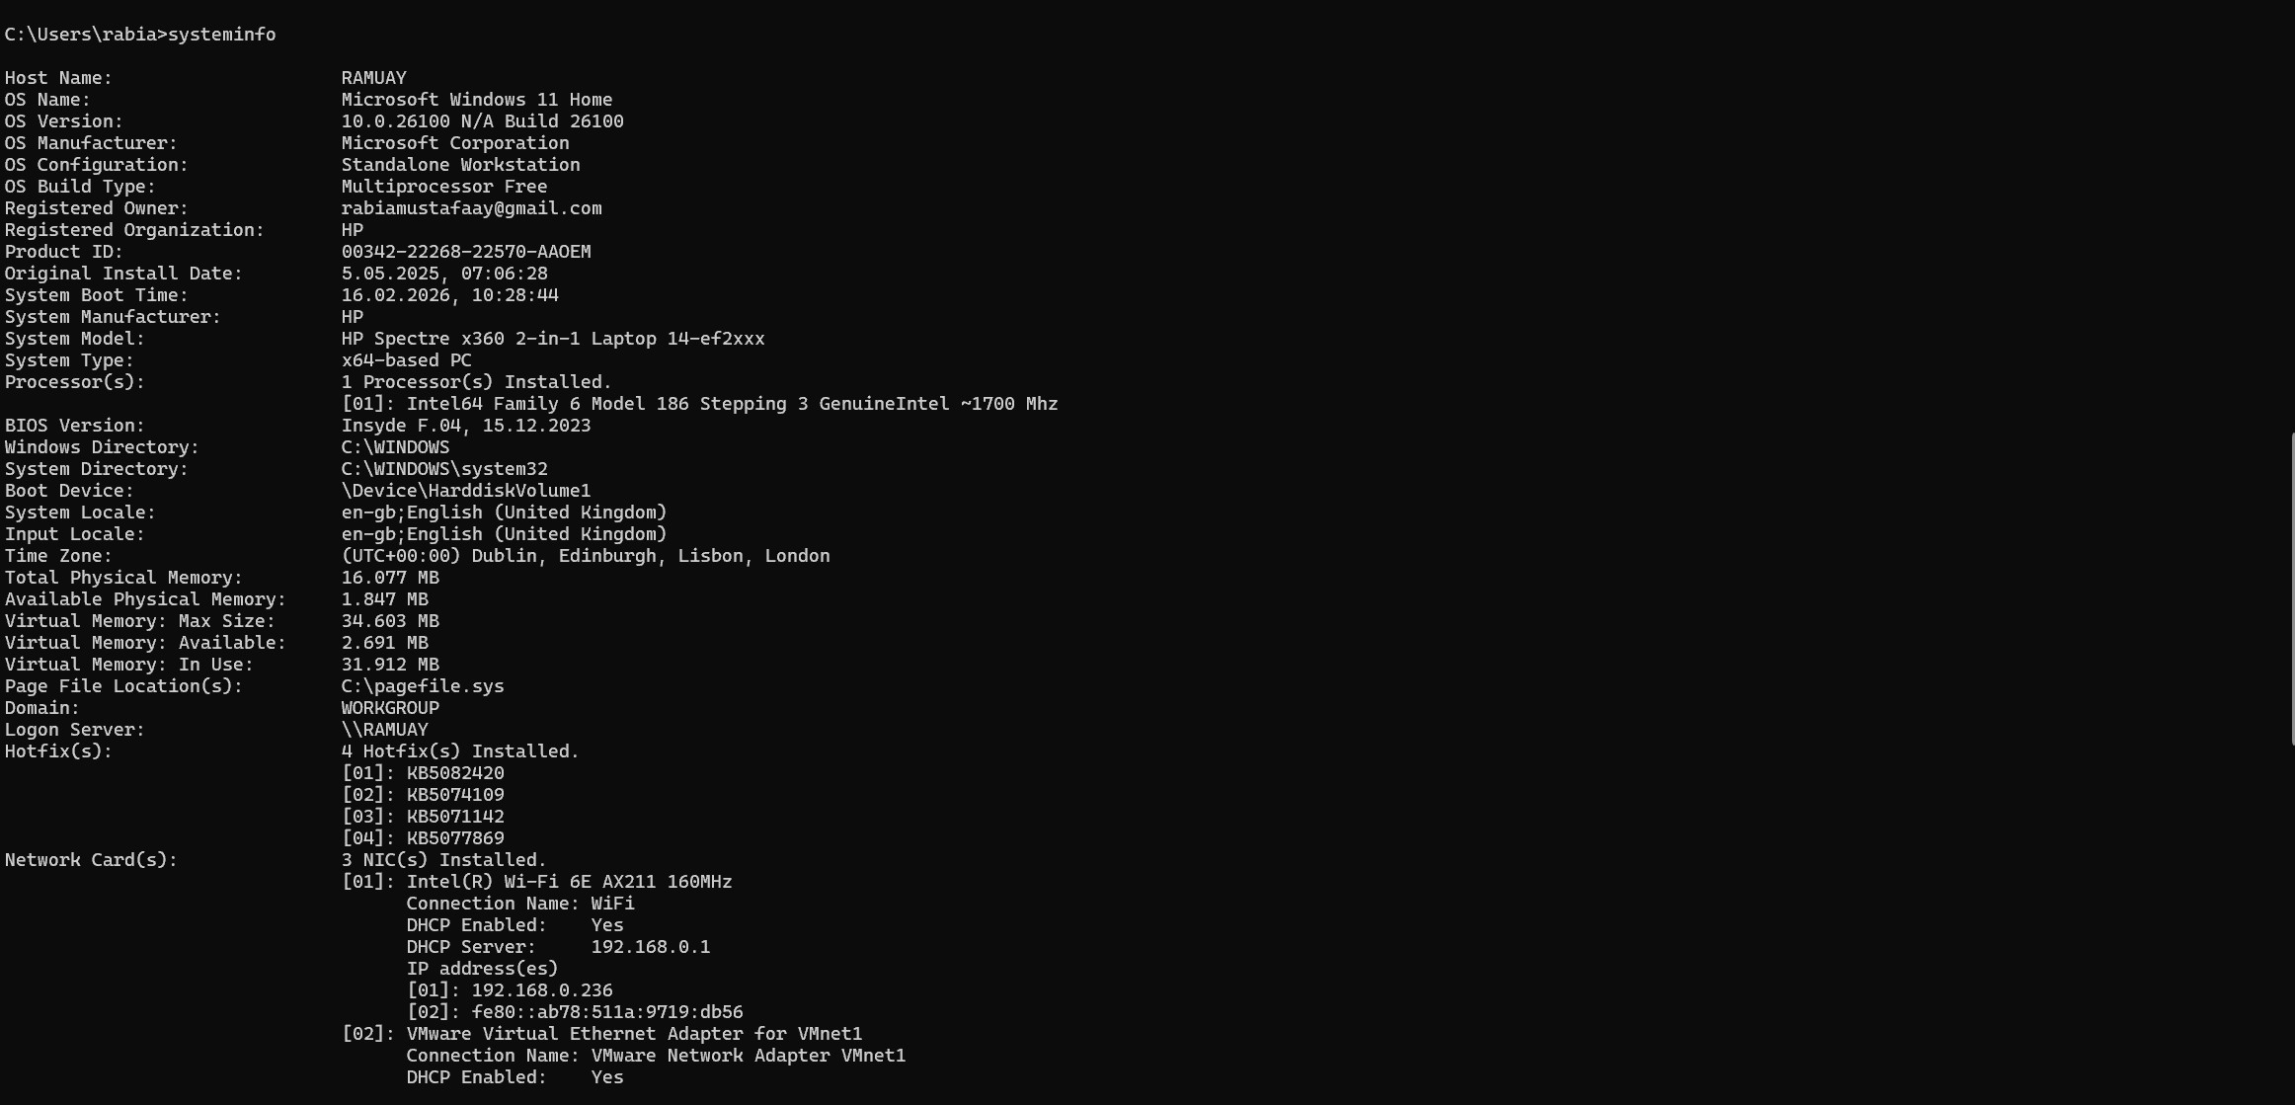
The systeminfo command displays detailed information about the computer system such as operating system version, system type, processor information and memory details. This command is useful for system monitoring and troubleshooting.

Figure 4 : whoami
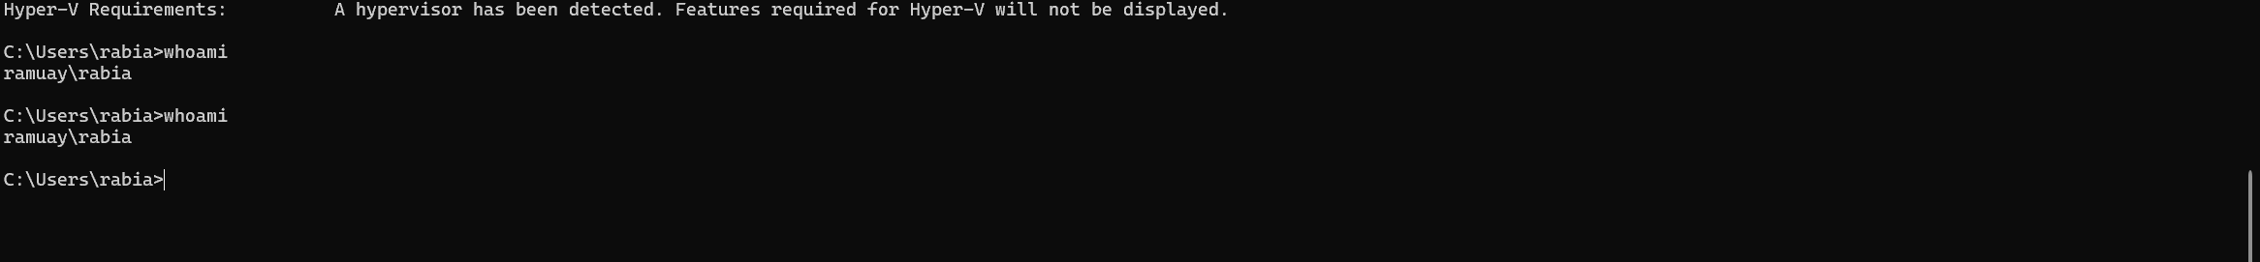
The whoami command shows the name of the currently logged-in user. This command is useful for identifying the active user account in the system environment.

Figure 5 : hostname
The hostname command displays the name of the computer on the network. It helps identify the system when working in network environments.

Figure 6 : tasklist
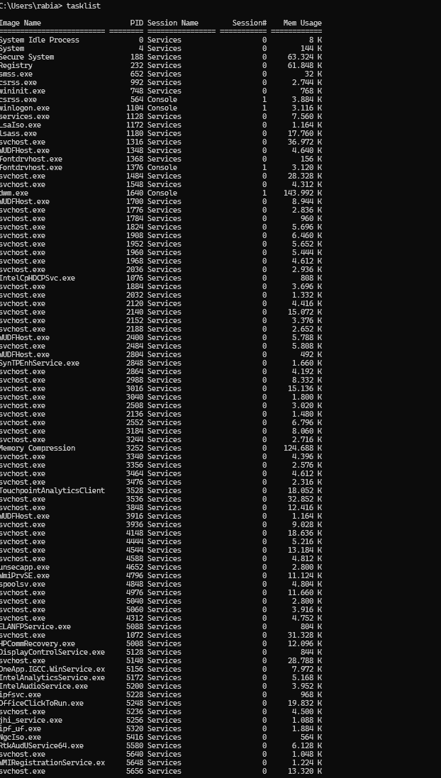
The tasklist command displays all currently running processes on the system. It is useful for monitoring active programs and troubleshooting system performance issues.

Figure 7 : ping
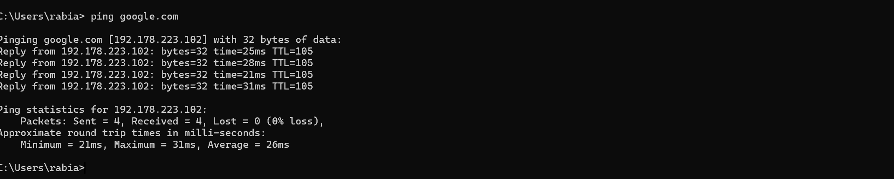
The ping command is used to test the connectivity between the computer and another network device. In this example, it checks whether the system can communicate with google.com successfully.
Figure 8 : mkdir
The mkdir command is used to create a new directory in the current location. In this example, the system shows that the folder already exists, which confirms that the directory was successfully created earlier.
Figure 9 : cd
The cd command is used to change the current directory. In this example, the command moves the user into the testfolder directory.
Figure 10 : cd move back
The cd .. command is used to move back to the previous directory level. It helps users navigate efficiently through folder structures in the command line interface.

3. Use of Linux OS CLI commands.

Figure 11: Output of pwd command showing current directory location
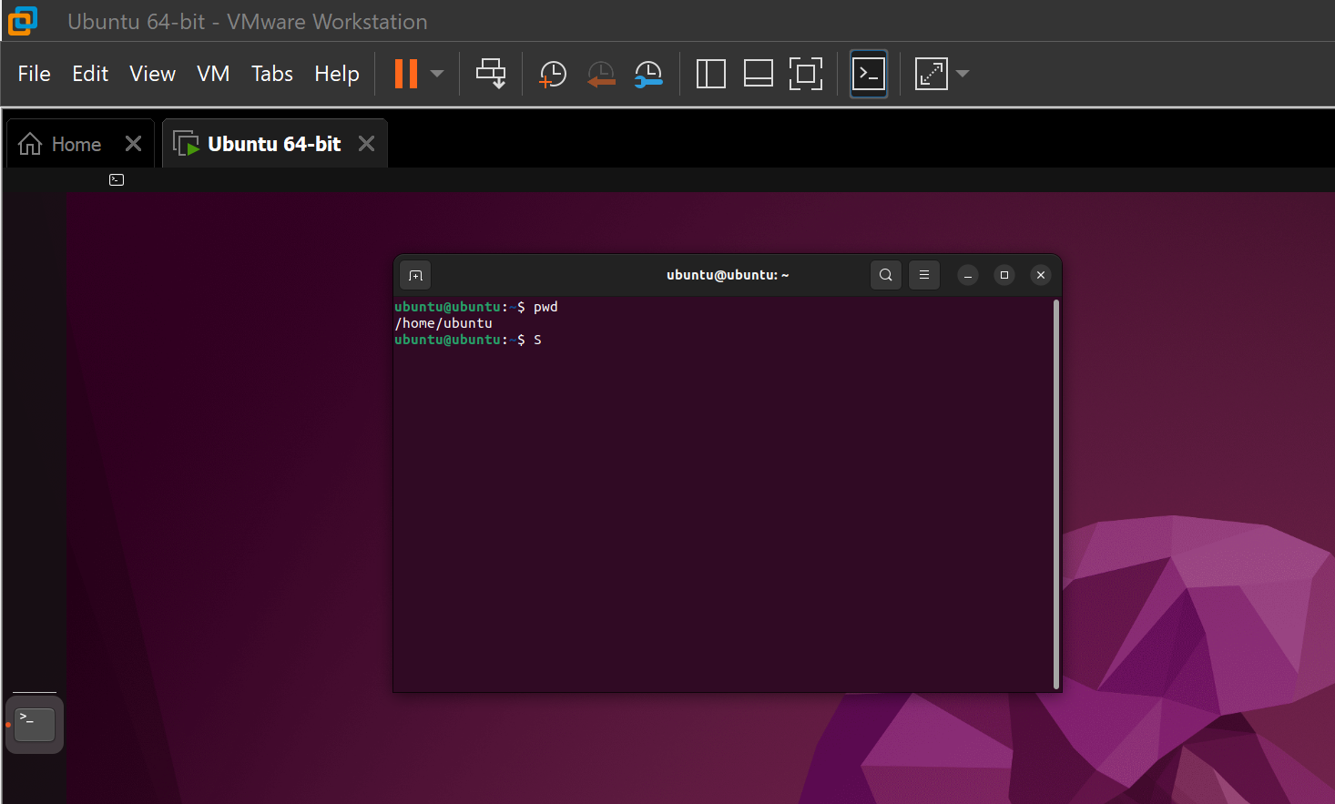
This command shows the current folder location in Linux. It helps the user know where they are working.

Figure 12: Output of ls command showing directory contents
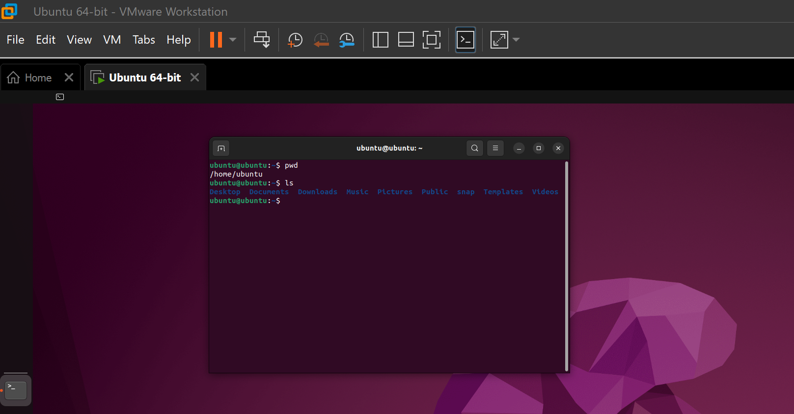
The ls command shows files and folders in the current location. It helps the user see what is inside the directory.

Figure 13: Output of whoami command showing current user
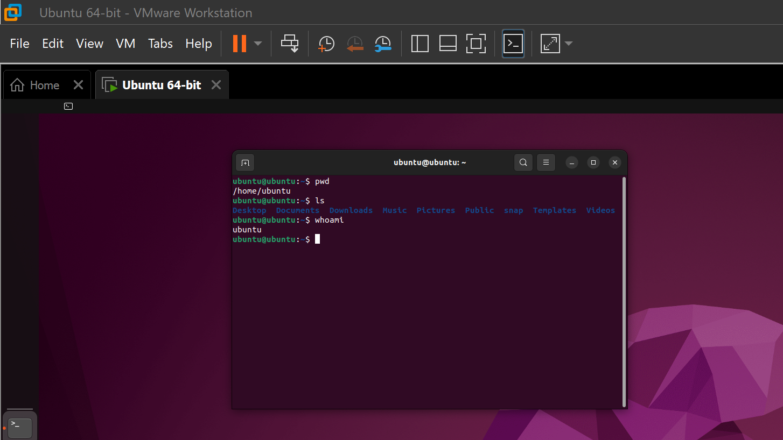
The whoami command shows the current user name in the Linux system. It helps the user check which account is active.

Figure 14: Output of hostname command showing system name
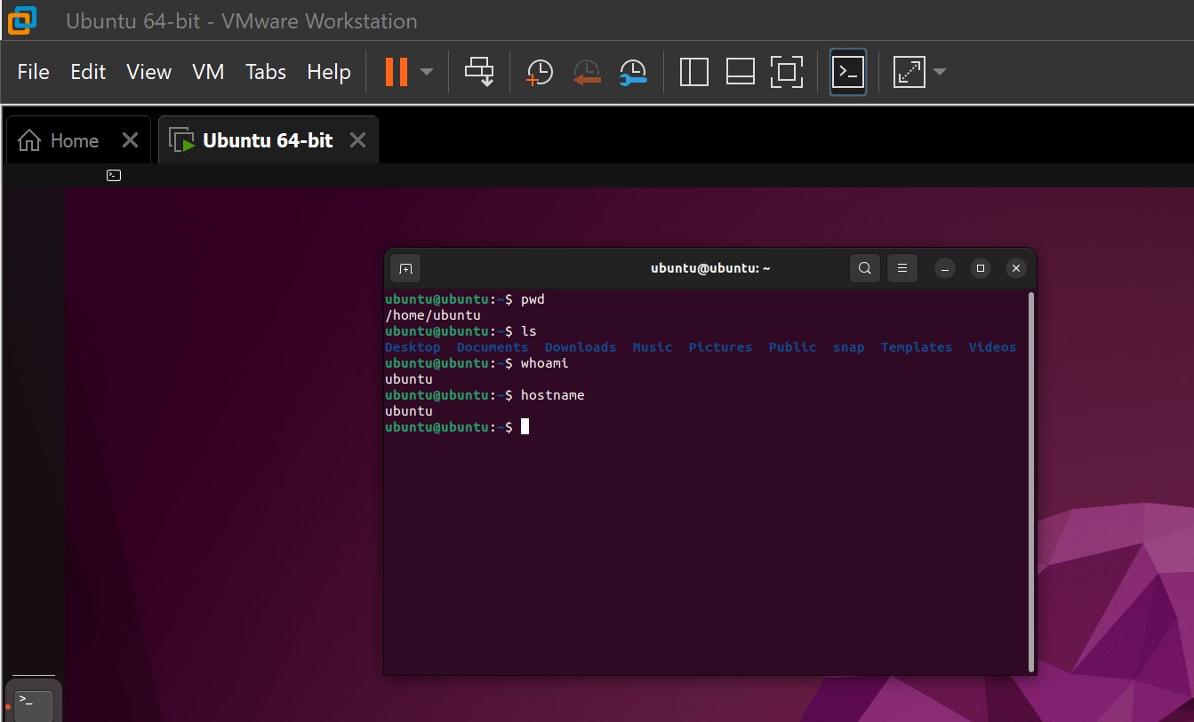
The hostname command shows the computer name in the Linux system. It helps identify the device on the network.

Figure 15: Output of cd command moving to parent directory
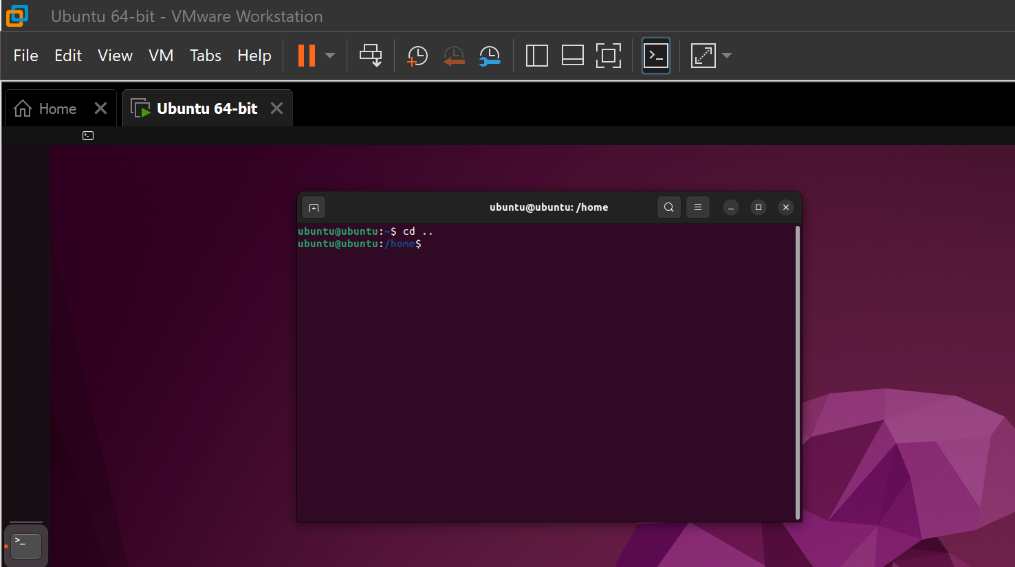
The cd .. command moves one directory back in Linux. It helps the user navigate between folders
Figure 16: Output of mkdir command creating testlinux directory
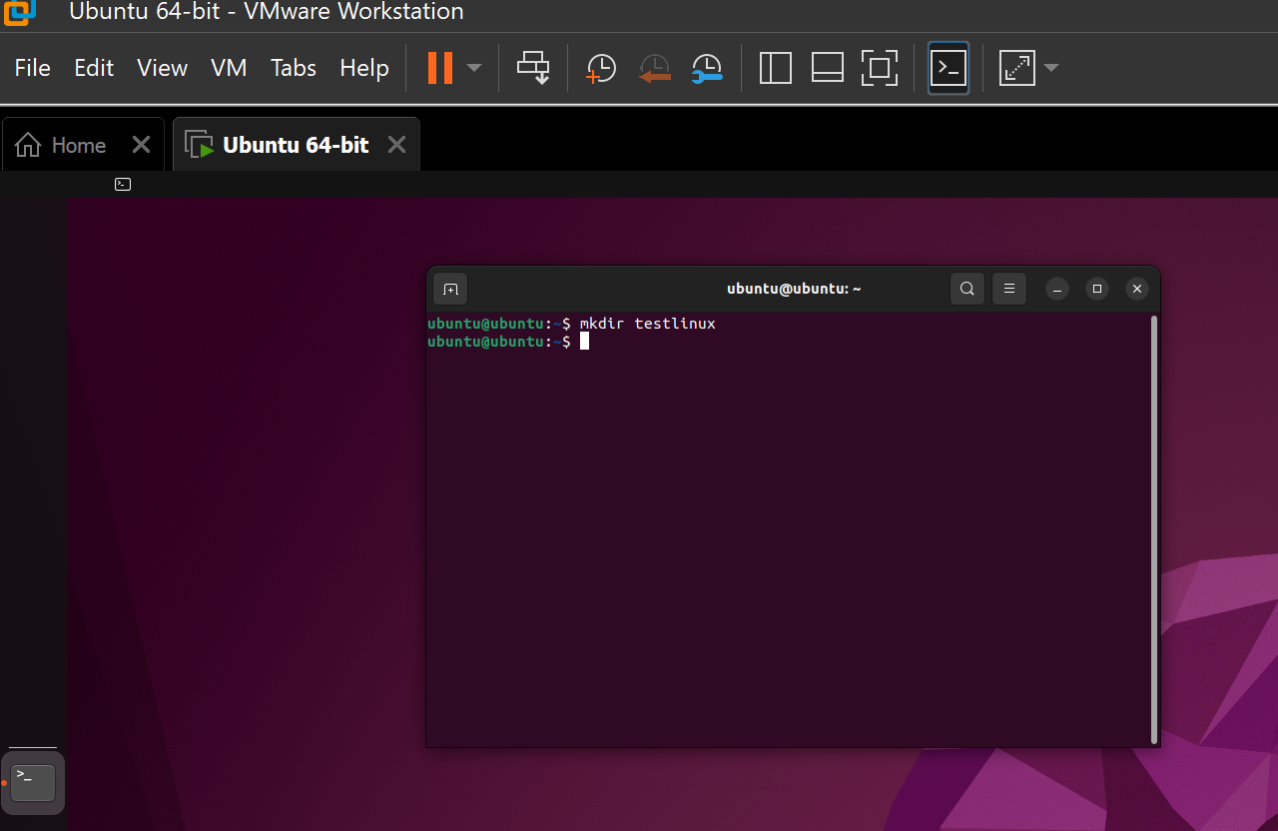
The mkdir command creates a new folder called testlinux in Linux.

Figure 17: Output of cd command entering testlinux directory
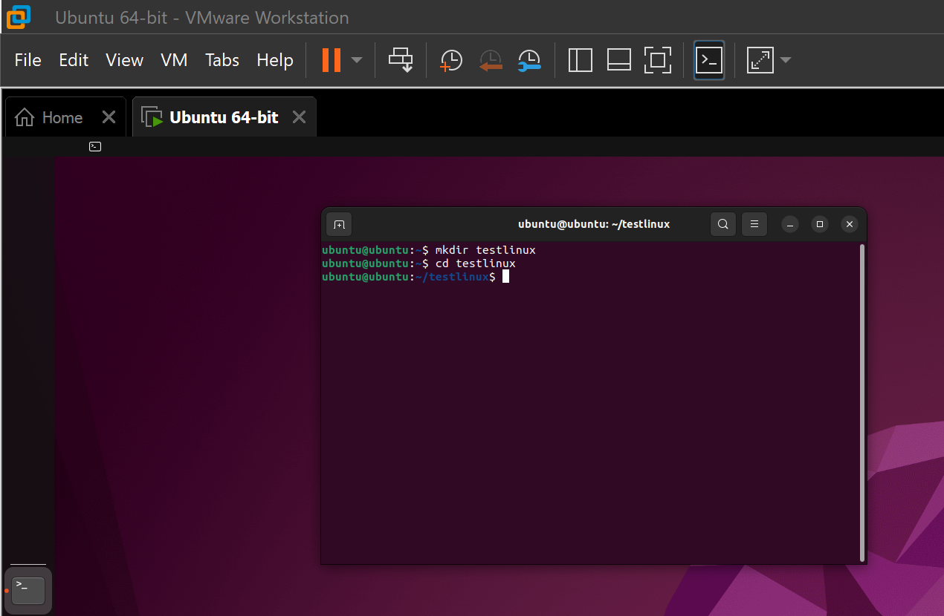
The cd command opens the testlinux folder and changes the working directory

Figure 18: Output of touch command creating testfile.txt
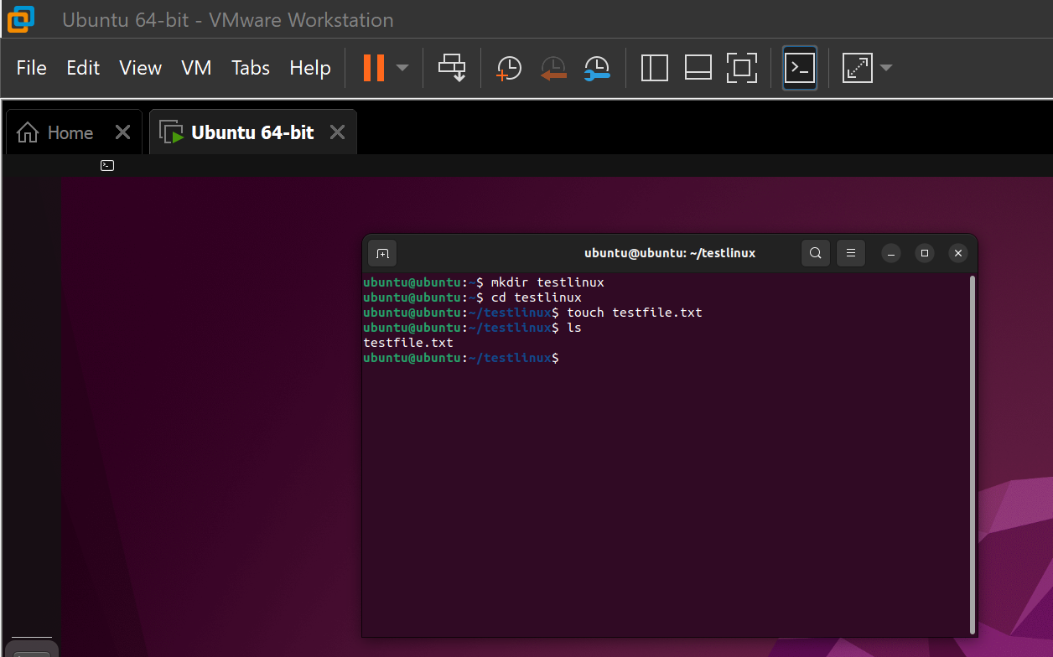
The touch command creates a new file called testfile.txt in Linux.

4. Use of Windows OS scripts.
Figure 19: Output of Windows batch script execution
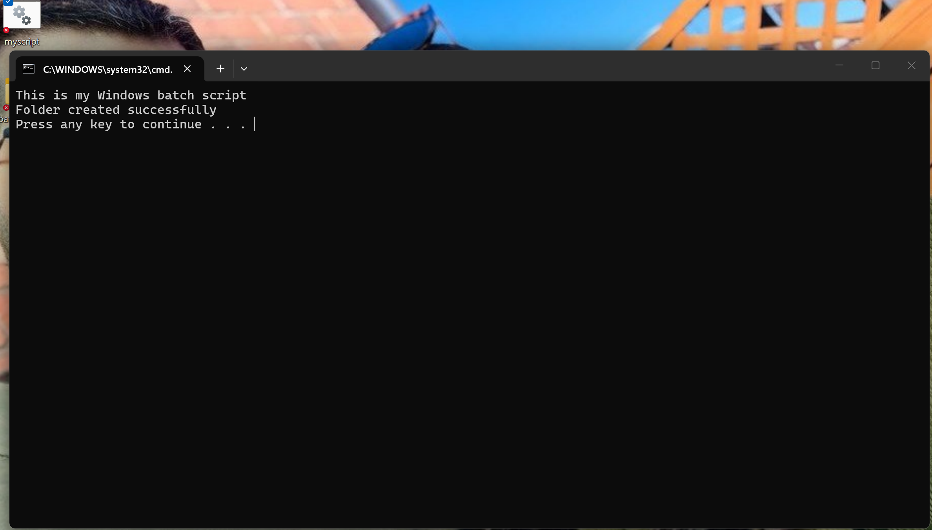
This batch script creates a folder called batchfolder and shows a message. It is an example of simple automation in Windows.

Figure 20: Windows batch script code example
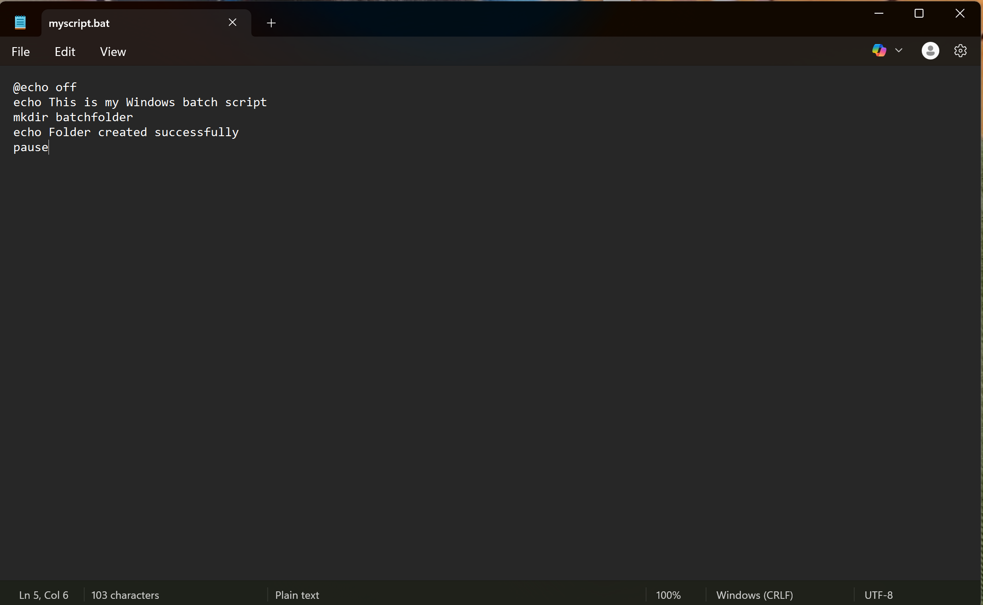
This script shows a simple Windows batch file used to create a folder and display messages.

5. Use of Linux OS scripts.
Figure 21: Output of Linux bash script execution
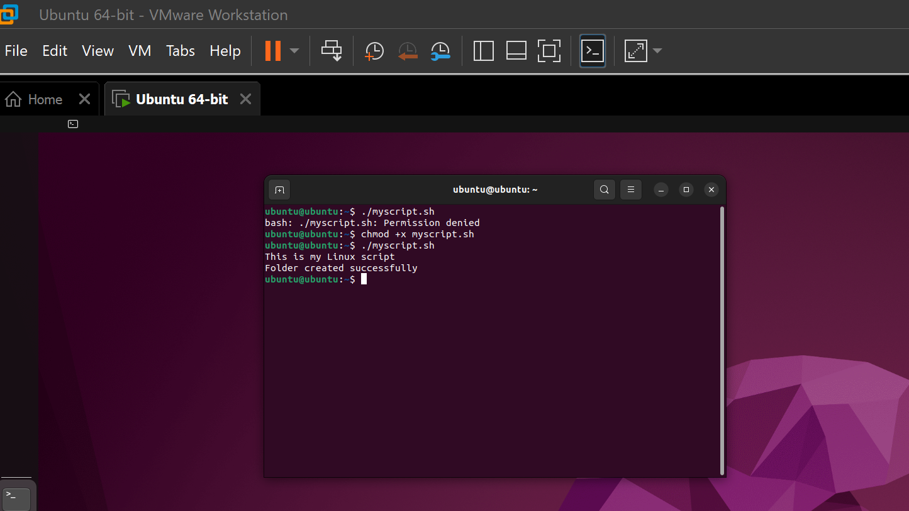
This Linux script creates a folder called linuxfolder and displays a message using bash scripting

Figure 22: Linux bash script code example
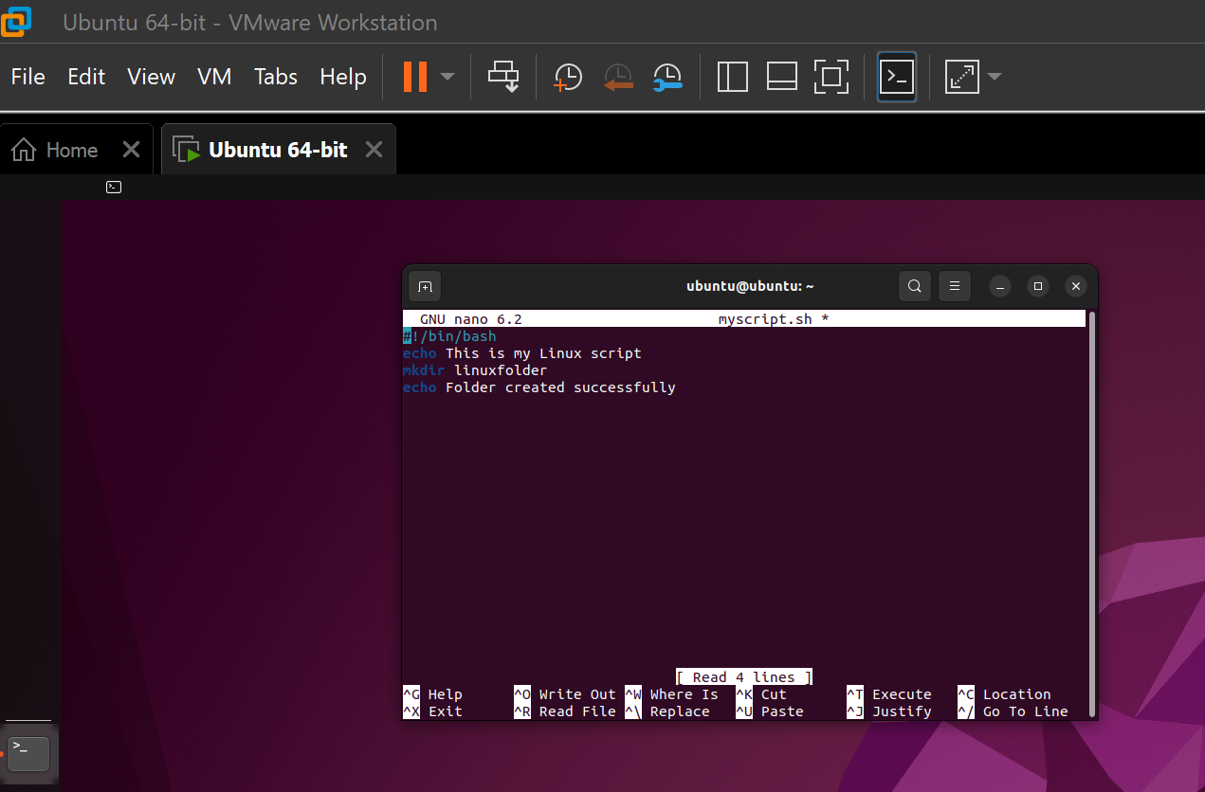
This script shows a simple example of Linux bash scripting used to create a folder and display a message.

Conclusion
For this assignment, I’ve been using both Linux terminal commands as well as Windows command prompt commands as practical examples to help me better grasp the way operating systems function. I’ve learned how to create directories, check the operating system’s details, and manage files through the use of the command line interface tools. Command line environments are important for system administration and troubleshooting tasks in modern operating systems [1]
I also created simple scripts in Windows and Linux which helped me understand how automation works in operating systems. These scripts showed how tasks can be completed faster using commands.
This assignment helped me improve my basic technical skills and confidence in using command line environments. It also helped me understand the importance of scripting in real-world computing tasks. [2]

References
[1] Microsoft, “Windows Command Line documentation,” Microsoft Learn. Available: https://learn.microsoft.com/

[2] Ubuntu Documentation Team, “Linux command line basics,” Ubuntu Documentation. Available: https://help.ubuntu.com/

Appendices
Appendix A – Evidence of Linux terminal practice
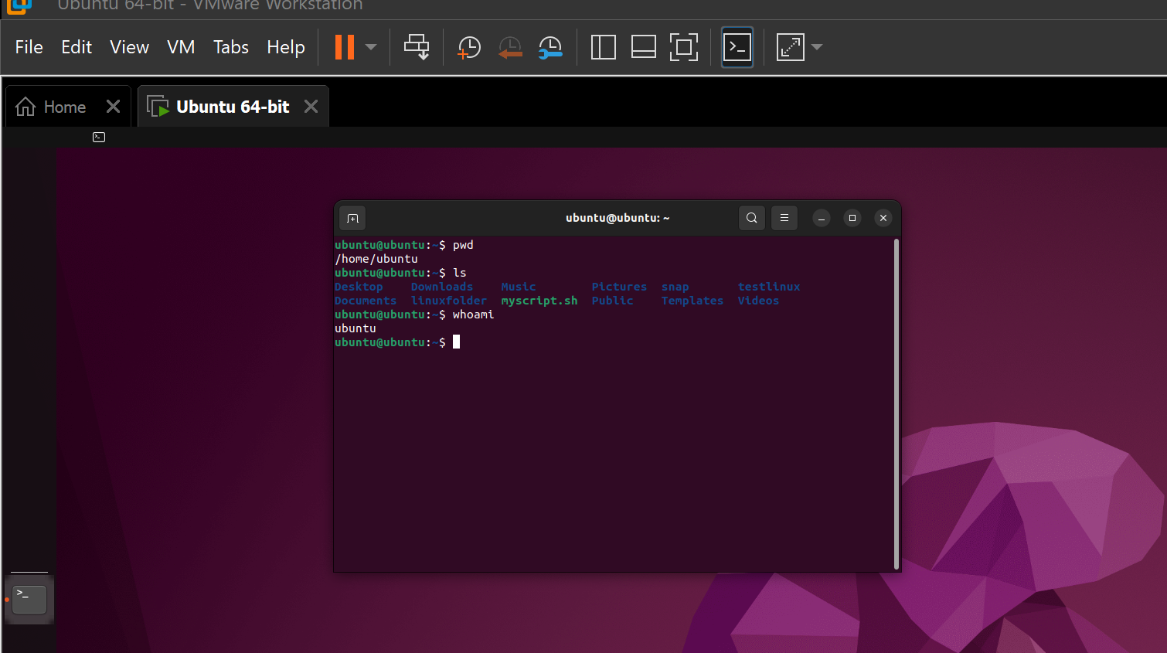

This screenshot shows my practice work using Linux terminal commands during the assignment activities.

Appendix B – Evidence of Microsoft Learn command line study
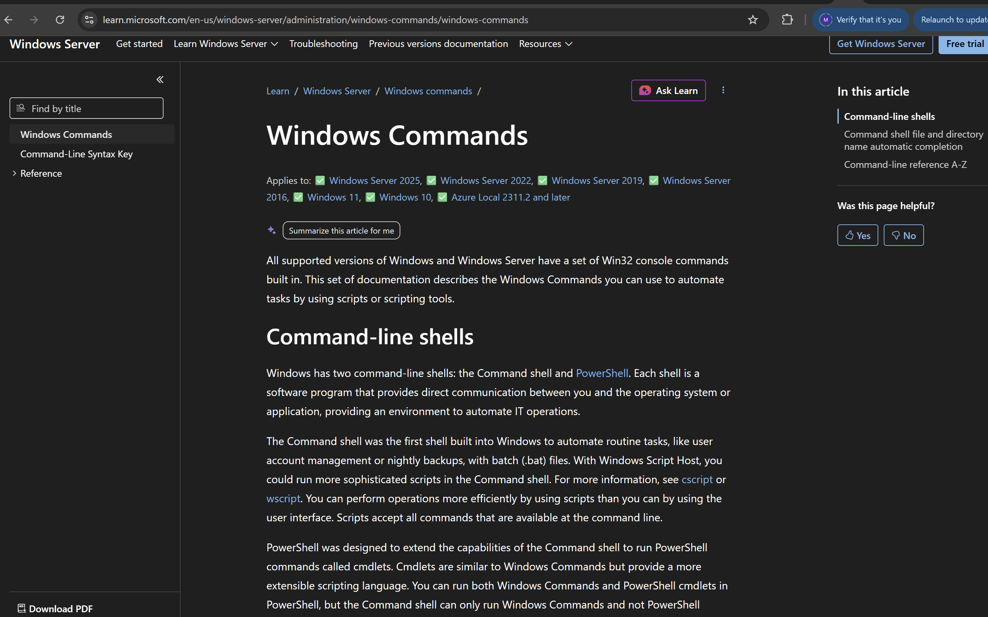
This screenshot shows my independent learning using Microsoft Learn resources to understand Windows command line tools.

