
LCMB7034 International Business Concepts

International Competitiveness of China’s Electric Vehicle Industry and Tesla’s Strategic Position: An Application of Porter’s Diamond and International Business Frameworks

Programme: Master of Business Administration
Lecturer: Dr Robert Ejike Undeogu
Student name: Syed Ajharul Amin
Student ID: 2436655
Word Count: 5064
Submission Deadline: Friday 20/03/2026 by 2pm

Table of Contents
1.0 Introduction 3
2.0 Industry and Country Overview 4
2.1 China’s macroeconomic and policy context for EVs 4
2.2 Size, scope and economic importance of the Chinese EV industry 4
2.3 Major domestic and multinational firms and relative positioning 6
3.0 Porter’s Diamond Analysis of the Competitiveness of China’s EV Segment 9
3.1 Factor Conditions 9
3.2 Demand Conditions 10
3.3 Related and Supporting Industries 10
3.4 Firm Strategy, Structure and Rivalry 12
3.5 Role of Government and Chance 12
4.0 Evaluation of Tesla as a Foreign MNC in China’s EV Segment 14
4.1 Tesla’s Entry Mode and Strategic Role of China 14
4.2 Political and Legal Factors: Opportunities and Constraints 15
4.3 Economic and Competitive Factors 16
4.4 Cultural and Social Factors 18
5.0 Conclusion to the Industry Report 19
6.0 Reflective Account on the Research and Writing Process (Gibbs’ Reflective Cycle) 20
6.1 Description 20
6.2 Feelings 20
6.3 Evaluation 20
6.4 Analysis 21
6.5 Conclusion 22
6.6 Action Plan 22
7.0 Reference List 23

1.0 Introduction
This report evaluates the international competitiveness of the Chinese electric vehicle (EV) sector and the strategic stance of Tesla in it by using Porter's Diamond and the chosen international business frameworks. To be more precise, the report differentiates between the bigger new energy vehicle (NEV) policy context in China and the competitive environment within the EV market. China has become the leading market and manufacturing ecosystem in the global shift to electric mobility, and has been equipped with industrial policy, economies of scale, battery competence and robust domestic demand (Lorente Salaberria and Xia, 2023; IEA, 2025). Nevertheless, this benefit is not to be simply described but critically evaluated to determine its sustainability. The report therefore looks at not just the magnitude and significance of the Chinese EV market, but also at the degree to which competitiveness is sustainable or relies on policy assistance, demand control and export growth. It subsequently analyses Tesla as a foreign multinational company in this environment, with respect to how its strategic decisions, performance and future outlook in China are influenced by political, legal, economic and cultural factors.

2.0 Industry and Country Overview

2.1 China’s macroeconomic and policy context for EVs
China is the second-largest economy and biggest manufacturing hub in the world, and its long-term aspirations are to ascend the value chain of more advanced manufacturing sectors, such as automotive (Hill, 2023). The Chinese government has listed the emerging industry among new energy vehicles (NEV), including battery electric vehicles, plug-in hybrid and fuel-cell vehicles, as important since the late 2000s. Subsidies, tax exemptions, support of research and development and investment in infrastructure have provided by national industrial plans such as Made in China 2025, and other NEV development plans have accelerated adoption and ability building in the country (ICCT, 2020; Chen et al., 2024).
There has been a series of development of policy. Policies in the early years were more of direct purchase subsidies and pilot demonstration cities, and more recent were more of charging infrastructure support, tighter fuel economy and emission standards and incentives tied to technological performance, driving range and battery energy density (ICCT, 2020; Hu et al., 2022). Industrial policy, by extension, is a powerful contextual force in the development of the firm's strategies and the general business competition environment in line with the institution-based perspective of international business that emphasises the importance of formal rules and incentives in determining the strategic decision-making (Collinson et al., 2020).

2.2 Size, scope and economic importance of the Chinese EV industry
China now ranks as the largest market in the world in terms of electric-cars but analytical accuracy needs a distinct separation between electric vehicles (EVs) and new energy vehicles (NEVs) (ICCT, 2020). Within the Chinese policy framework, the NEVs typically consist of battery electric vehicles (BEVs), plug-in hybrid electric vehicles (PHEVs), and fuel-cell vehicles, but other international data sets use only electric cars or only passenger BEV/PHEV segment. This report refers to EV market to passenger electric-car competition and NEV industry to the larger Chinese production and policy system unless otherwise. Based on that, China has contributed approximately half of all electric-car sales worldwide over the last few years, which proves that it is the most significant national market in the industry.
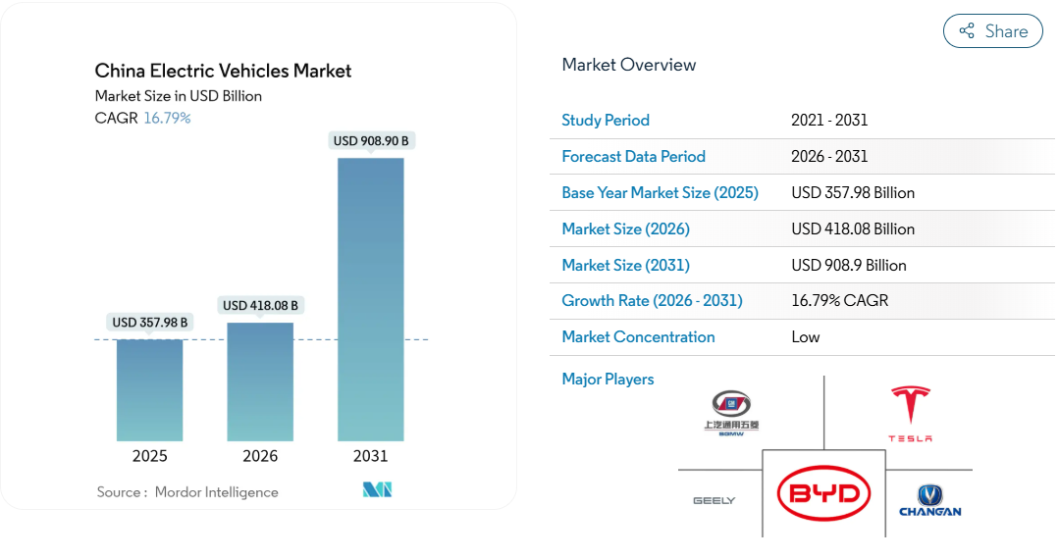
Figure 1. China Electric Vehicles Market Size (Mordor Intelligence, 2026)
The market growth curve is also important, but the forecast values should be considered with caution. In terms of commercial market-intelligence estimates, there is a further growth in the Chinese EV market as to 2031, but this would be reliant on the extent of the category, price suppositions, and even whether they gauge the business of the sole passenger EV or the broader NEV segment (Mordor Intelligence, 2026). Consequently, this utilises Figure 1 as an indicative representation of scale and direction, and not as an absolute representation of future market value (Mordor Intelligence, 2026).
In addition to vehicle sales, the economic significance of the EV industry in China is that it consists of a broader ecosystem of battery production, vehicle charging systems, software and connectivity solutions, component assembly, and logistics (Hu et al., 2022; Oxford Institute for Energy Studies, 2024). This expanded industrial richness is what makes the industry strategically significant.
Table 1: Selected indicators of China’s EV segment and global position
Indicator (latest available) | China (approximate) | Global context and notes
Share of global EV car sales | Around 50–55 per cent of global EV sales | China consistently largest single EV market (IEA, 2025)
EV share of new car sales in the domestic market | Above 30 per cent and rising | Among the highest penetration rates globally (Aranca, 2025)
EV exports from China (units) | Several million vehicles annually | Rapid growth, especially in Europe (Electricity Lawyer, 2025)
Number of NEV manufacturers and brands | Hundreds of registered NEV makers | Consolidation currently underway (Arthur D. Little, 2024)
Contribution to industrial output and employment | Major contributor to manufacturing value added | Key pillar of industrial policy (Chen et al., 2024)

The table 1 is a summary of the chosen indicators which demonstrate that the power of competition of China lies not only in its internal demand, but also in its level of industry, export capacities and integration of ecosystem.

2.3 Major domestic and multinational firms and relative positioning
The competition within the Chinese EV market is no longer the simplest scenario of the opposition between the local companies and the international ones. Instead, relative positioning is based on the combination of segment coverage, cost position, battery integration, software capability, pricing flexibility, and scale by the firms. Domestic leaders like BYD are also in a particularly advantaged position as they compete on both the mass and mid-range tiers and enjoy both the high rates of vertical integration of batteries and components, which contributes to low costs and quicker pricing reactions (Arthur D. Little, 2024; Aranca, 2025). In comparison, companies like NIO, XPeng and Li Auto are competing rather with premium differentiation, smart-cabin attributes and digital integration of the ecosystem rather than with pure cost leadership (Arthur D. Little, 2024; Chen, 2024).
Table 2: Relative positioning of selected EV firms in China
Firm | Segment coverage | Cost position | Vertical integration | Software/ecosystem strength | Pricing behaviour / recent trajectory
BYD | Mass to upper-mid market | Strong | Very high, especially batteries | Moderate to strong | Aggressive pricing; gaining share (Aranca, 2025; Arthur D. Little, 2024)
NIO / XPeng / Li Auto | Premium / tech-oriented | Weaker than BYD | Lower to moderate | Strong local digital features | Compete through differentiation and innovation (Arthur D. Little, 2024; Chen, 2024)
Tesla | Mid- to premium BEV | Competitive but under pressure | Moderate | Strong global software brand, but less locally embedded | Strong volumes, but relative share pressure and price cuts (Daxue Consulting, 2024; Henry, 2026)
Volkswagen / BMW | Broad portfolio, transitioning to EVs | Mixed | Lower in EV-specific integration | Mixed | Strong legacy brands, but slower EV repositioning (Henry, 2026)

Tesla is one of the best-positioned MNCs among the foreign firms due to its Shanghai Gigafactory, which provides it with the scale that enables production efficiency and the exportation of the product, but its comparative market position has been strained as its regional rivals have enhanced the quality of their features and increased their price competition (Daxue Consulting, 2024; Henry, 2026). Established foreign car makers like Volkswagen and BMW still have brand equity, but most have been lagging behind in gaining the same agility EV-specific agility of committed Chinese competitors (Henry, 2026). Local procurement support, infrastructure coordination, production incentives and faster scaling via built-in supplier networks (that can somehow be converted into sharper pricing, faster model rollout and better local market access) are also policy instruments that domestic companies tend to benefit more sharply in terms of competitive results (Chen et al., 2024; Hu et al., 2022).

3.0 Porter’s Diamond Analysis of the Competitiveness of China’s EV Segment
Porter’s Diamond serves as an effective model not only to determine the origin of national competitive advantage but also to determine whether this advantage is structurally embedded or still dependent on the support of the policy and the fleeting nature of the market circumstances (Vlados, 2019). The model when applied to the EV segment of China proposes that the intensity of rivalry, combined with strong production capacity, high and sophisticated demand at home, expansive and well-developed supporting industries, and high intensity of rivalry, are the sources of competitiveness.

3.1 Factor Conditions
Factor conditions in the EV industry of China are not only becoming more sophisticated, as opposed to being primitive. These comprise the presence of a high number of engineers and technicians attached to producing automotive, batteries, electronics, and software, and manufacturing clusters in the provinces including Shanghai and Guangdong that drop the coordination expenses and enhance speed to scale (Chen et al., 2024; Oxford Institute for Energy Studies, 2024). The strength of China in the lithium-ion battery production is particularly critical since batteries are the most strategically important element in EV cost and performance. Battery manufacturing and processing of essential materials have been led at the domestic level, which has helped to reduce costs, ensure supply security, and achieve learning effects throughout the industry (Hu et al., 2022).
These factor conditions are strategically important because they make the EV advantage of China more difficult to replicate compared to a low cost of labour advantage (Electricity Lawyer, 2025). Cumulative benefit can be generated by battery capacity, supplier concentration and accrued manufacturing experience which favours life cycle (Chen et al., 2024). Meanwhile, there are still certain weaknesses especially when the supply chains of raw materials are open to geopolitical stress or worldwide pricing fluctuations. Still, the factor conditions in China can be regarded as one of the most persistent factors in EV competitiveness since it involves the ability to form capabilities over time as opposed to cost arbitrage (Hu et al., 2022).

3.2 Demand Conditions
The Chinese market has an abnormally strong demand conditions as the local market is massive in size and quality intensive. The largest electric-car market in the world is China, and the policy, including purchase subsidies, licence-plate quotas of internal combustion vehicles in large cities, and sponsorship of charging infrastructure stimulated the car adoption pace (ICCT, 2020; IEA, 2025). Nevertheless, the nature of demand is equal to its quantity. The Chinese are becoming more demanding in their requirements in terms of the advanced state of infotainment, over-the-air updates, integration of apps, and digitally connected mobility experiences, compelling companies to compete on the functionality of software and ecosystems, not just on price and range (Arthur D. Little, 2024).
Such conditions of demand have served to make the Chinese market a test market in terms of products rapid iteration and feature competition (Henry, 2026). This facilitates innovativeness and enhances global competitiveness. However, the state does not have a complete autonomy over the demand conditions. Policy support helped shape the domestic market, and the gradual disappearance of direct subsidies provokes the question of whether the EV demand will be equally high without the support of the administration and local policy benefits (Chen et al., 2024).

3.3 Related and Supporting Industries
The related and supporting industries in China are exceptionally strong to strengthen the strength of the EV. China is home to global battery giants, including CATL and BYD, but also important suppliers of electric motors, inverters, semiconductors, power electronics and other fundamental electric vehicle parts (Hu et al., 2022). Moreover, the telecommunications and digital services sector promote connected-vehicle systems and the vast ports and logistics network in China makes it easy to export in large volumes to other markets worldwide (Oxford Institute for Energy Studies, 2024).
Much more than that supporting industries do exist is that they are in such a state of being that they are tightly coupled with vehicle manufacturers in an industrial ecology (Electricity Lawyer, 2025). This lowers transaction costs, decreases the time taken in innovation, and also facilitates a quicker dissemination of new designs and production practises among the firms. According to Porter, this is among the most obvious sources of long-term national benefit since competitiveness is not sustained by individual firms, but through networks and clusters of firms (Vlados, 2019).
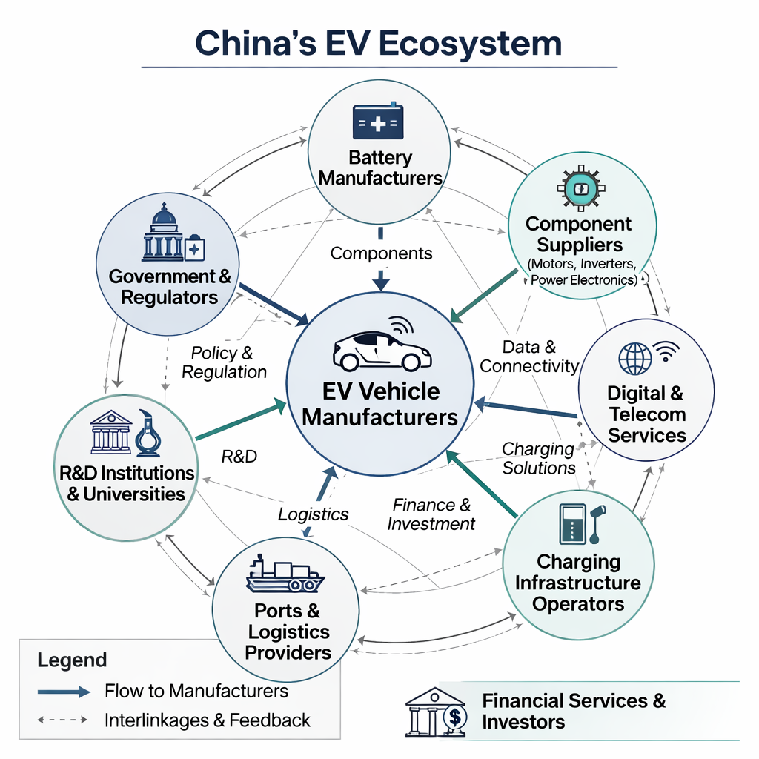
Figure 2: Conceptual cluster map of China’s EV ecosystem (Self-Designed based on Chen et al., 2024; Vlados, 2019; Hu et al., 2022)
Figure 2 illustrates vehicle manufacturers located in the centre linked with battery and components suppliers, digital services providers, charging infrastructure operators and export logistics. Feedback loops indicate the way knowledge and innovation spread across the cluster in accordance with Porter's view that innovation and competitive advantage were frequently generated by them in geographically displaced and networked structures (Vlados, 2019; Hu et al., 2022).

3.4 Firm Strategy, Structure and Rivalry
The competition within the Chinese EV market is tough and has turned into one of the key sources of rivalry (Tsiligiris, 2018). The abundance of NEV entrants, as well as local government backing of regional champions, resulted in a very competitive domestic market with companies competing fiercely on price, features, speed of models on the market and by digital innovation (Arthur D. Little, 2024; Henry, 2026). It has compelled companies to innovate fast, and to cut costs quickly, but it has also compelled international companies to go as fast as possible to localise and specific strategic reactions (Chen, 2024).
Regarding the Porter’s framework, high domestic competition is capable of enhancing efficiency and innovation provided that it is coupled with challenging customers and suppliers who can respond to the challenge (Collinson et al., 2020; Vlados, 2019). The same trend can be clearly observed in EV segment in China. But there is also an insightful weakness that is shown through rivalry. In case market leadership relies more on ferocious price reductions, compression of margins, and accepting low-profitability, then certain competitive power will be an expression of scale with or without long-term pay-off (Arthur D. Little, 2024).

3.5 Role of Government and Chance
The emergence of the EV industry in China has been spurred by the government instead of being accidental. Subsidies, tax-free treatment, procurement facilitation, industrial planning, infrastructure deployment, and regulatory encouragement were combined in the strategy of Central and local authorities to hasten adoption and establish local production capacity (ICCT, 2020; Chen et al., 2024). All these measures reinforced the various sections of the Diamond at once by boosting demand, stimulating investment and making clusters possible.
This also implies that a portion of the EV advantage of China is conditional. The progressive removal of the direct subsidies is a serious challenge of how competitiveness can be maintained by the firms with the help of productivity, the quality of products, and the power of the ecosystem only. When the leadership in the market is maintained even without the direct state support, the advantage of China may be evaluated as more resilient. When the profitability suffers in a steep decline, then not only part of the benefit can be more policy-conditional than the size of the scale now demonstrates (Hu et al., 2022; Chen et al., 2024).
Regarding the chance variable outlined by Porter, the most pertinent ones are not generic historical shocks but EV-specific disruptions in the form of the Covid-19 pandemic, semiconductor shortages, and battery-material supply chain volatility, and increased trade barriers to the export of Chinese EVs (Henry, 2026; Bonanomi, 2026). These happenings are important as they would put the Chinese EV model to the test, to determine its external pressure.

4.0 Evaluation of Tesla as a Foreign MNC in China’s EV Segment

4.1 Tesla’s Entry Mode and Strategic Role of China
The case of Tesla Gigafactory Shanghai has been a pivotal move in both Tesla and the Chinese automotive FDI regime. Compared to most former foreign producers, who had to enter into joint ventures, Tesla was allowed to establish a fully foreign-owned enterprise, which was not only indicative of regulatory liberalisation but of China seeking to attract high-profile investment in high-tech manufacturing (Daxue Consulting, 2024; Cooke, 2020). In the context of the OLI (ownership- location- internalisation) paradigm, Tesla has used the ownership benefits in brand, technology and software, location benefits in the large Chinese market and efficient supply chain and internalisation benefits in terms of retaining proprietary technology and quality in a wholly owned structure (Dunning, 2003; Collinson et al., 2020).
Gigafactory Shanghai has become the largest manufacturing plant within the company in the world and a major export point as it provides vehicles to its markets in Asia and Europe. According to the reports, record China sales of approximately 83,000 vehicles in December 2025 explain partly why the market matters, yet competition has decreased Tesla's share of the overall Chinese EV market (Kindig, 2023; Reuters, 2025). Therefore, China is also a key growth engine, a cheaper production foundation and a testing ground for Tesla technologies. Table 4 provides an overview of the reasons why Tesla has internationalised into China through the Dunning model.
Table 3: Tesla’s internationalisation into China through the OLI lens
OLI element | Tesla’s advantages and motives in China
Ownership | Strong global brand, proprietary battery and software technology, first-mover EV reputation (Hill, 2023; Daxue Consulting, 2024)
Location | Large and growing EV market, dense supplier network, competitive labour costs, supportive industrial policy (Chen et al., 2024; Arthur D. Little, 2024)
Internalisation | Desire to protect intellectual property, maintain quality and integrate manufacturing, RandD and software within a unified global system (Dunning, 2003; Cooke, 2020)

4.2 Political and Legal Factors: Opportunities and Constraints
The political and legal situation in China does not solely influence the Tesla strategy but through decisions on the ownership, localisation, compliance and operational control. The favourable environment of the pro-NEV policy in China facilitated the growth of Tesla politically by promoting the demand of EVs via tax exemptions, the implementation of charging infrastructure, and the general policy of industrial upgrading (ICCT, 2020; IEA, 2025). The strategy of Tesla in reaction was to invest in local massive production with Gigafactory Shanghai, where it could control production, technological assimilation, and quality control instead of leveraging a traditional joint venture (Cooke, 2020; Daxue Consulting, 2024). The quantifiable result was that Shanghai became not only a primary production hub of the Chinese market but also an export centre, which tightened the cost leadership of Tesla and made it reliant less on production hubs in the US (Cooke, 2020; Reuters, 2025).
Nonetheless, the legal environment puts a limit on which Tesla is directly hindered in its business model. The governmental control of data security, autonomous vehicles, mapping, and data flows across the border is especially significant due to the fact that the competitive edge of Tesla is partially attributed to the integration of software and data-driven features of a vehicle (Chen et al., 2024; Hill, 2023). To ensure compliance arrangements such as localised data governance and better alignment with Chinese regulatory expectations have been required to enable Tesla to avoid being derailed in its connected-vehicle operations. The strategic implication of this is that the software-based ownership benefits of Tesla cannot be transferred into China as is. Compliance increases the complexity of operations and can restrict the standardisation of global systems at Tesla.
Table 4. Political and legal conditions: Tesla-specific mechanisms and outcomes in China
Condition | Tesla’s strategic response | Measurable outcome / implication
Pro-NEV industrial policy and local government support (ICCT, 2020; Chen et al., 2024) | Built and scaled Gigafactory Shanghai as a wholly owned plant | Faster production scale-up and stronger local cost position (Cooke, 2020; Daxue Consulting, 2024)
Support for high-tech FDI and favourable local financing conditions | Retained ownership and operational control rather than entering a JV | Greater protection of process integration and brand control
Tightening data, cybersecurity, and connected-vehicle regulation (Chen et al., 2024) | Adjusted compliance and local data-handling practices | Higher compliance costs and reduced standardisation across markets
Geopolitical and regulatory uncertainty | Used China both as domestic base and export hub | Greater scale efficiency, but higher exposure to regulatory and political risk

4.3 Economic and Competitive Factors
Tesla benefits of scale, access to suppliers, and export efficiency are the three primary advantages of economic China. To start with, the Chinese EV market is large that it can accommodate mass production that will enhance the utilisation of plants and reduce the unit cost. Second, being close to battery manufacturing companies, parts suppliers, and manufacturing logistics systems, Tesla will reduce lead times and enable quicker response to regional demand (Hu et al., 2022; Aranca, 2025). Third, Shanghai has been used by Tesla not only to reach Chinese buyers but also to provide other markets, which is why the plant has become a strategic part of Tesla in the global manufacturing footPrint (Cooke, 2020; Henry, 2026).
However, such economic benefits have proved to be more difficult to transform into long-lasting competitive edge. Aggressive model-refresh, powerful digital interface, and pricing agility have helped domestic companies, in particular BYD and other smart-EV competitors, consolidate their positions (Arthur D. Little, 2024; Chen, 2024). Tesla has reacted with multiple price cuts and increased localisation, but the quantitatively measurable result has been ambivalent: absolute sales in China have been stable, relative market share has been put under pressure (Kindig, 2023; Reuters, 2025). The strategic upshot of such a downturn is that Tesla becomes more vulnerable to the forces of commoditisation, feature-equity, and ecosystem disfavour in a market where local competitors can easily replicate the core EV functionality and surpass Tesla in local online integration and flexibility in pricing.
Table 5. Tesla’s economic and competitive position in China: indicators and interpretation
Indicator | Evidence | Strategic interpretation
Absolute sales volume | Record monthly China sales of around 83,000 units in December 2025 (Reuters, 2025) | Tesla remains commercially significant in China
Market share trajectory | Relative share under pressure amid stronger domestic rivalry (Kindig, 2023; Arthur D. Little, 2024) | Suggests intensifying competition rather than simple volume failure
Pricing behaviour | Multiple price cuts in response to rivalry (Kindig, 2023; Chen, 2024) | Indicates margin pressure and reduced pricing power
Role of Shanghai plant | Major domestic and export hub (Cooke, 2020; Henry, 2026) | Improves scale efficiency but increases dependence on China-based production

4.4 Cultural and Social Factors
Market fit is the most significant way Tesla is influenced by cultural and social factors as opposed to the abstract national difference. The Chinese EV consumers are highly sensitive to digital functionality, smart-cabin features, quick innovation process, and price to performance ratio, which implies that competition is influenced by the ecosystem relevance and user experience as well as engineering quality (Arthur D. Little, 2024; He and Hao, 2023). The strategy Tesla has chosen to respond to is a partial localisation by domestic product production, integration of local suppliers and their adaptation to the Chinese demands in the digital markets. Nonetheless, local companies frequently have a competitive edge in terms of the integration of platforms and responsiveness to consumers due to a stronger integration into the local digital ecosystems (Chen, 2024).
The factual result is that Tesla still is a great global brand in China, yet brand strength is no longer adequate to ensure the market leadership. With the domestic competitors closing the technology divide and enhancing the relevance of the software, Tesla must face the challenge of selective localisation: altering the product, service, and stakeholder engagement enough to compete effectively, without sacrificing the globalisation that defines its business model internationally (Gryphon and Pustay, 2020; Hill, 2023).

5.0 Conclusion to the Industry Report
The competitiveness of EVs in China is not so much a policy result, but a slowly gaining industrial competitive edge founded on high-end battery capacity, massive domestic markets, concentrated supplier networks, and stiff competition spurring innovation. The weakness of its binding, however, is whether these strong sides will continue to be profit-sustaining as subsidy help diminishes, overcapacity intensifies, and export growth encounters more political opposition.
In the case of Tesla, China is strategically invaluable since it is a place where the scale of the market, manufacturing efficiency, access to supplies, and export-platform value can all be seen in one place. However, the limiting factor to long-term benefit is no longer the entry or scale of production but the capacity of Tesla to protect differentiation in a market where national competitors are gaining greater similarity on fundamental EV technology and win on the price agility, localisation and the fit of digital ecosystems.
In the next three to five years, the interplay between local competition intensification and foreign constraint, in particular stricter data control, increased export barriers, and further technological progress of Chinese EV companies is likely to change the attractiveness of China to Tesla.

6.0 Reflective Account on the Research and Writing Process

6.1 Description
This report writing and research began with the identification of the EV segment in China and Tesla as the country- industry- MNC combination. This has been decided on the presence of a large and recent literature and the apparent topicality of the sector in the current international business discussions (Lorente Salaberria and Xia, 2023; Wild and Wild, 2023). I have then gathered scholarly material, policy reports and consultancy, as well as industry analyses, including those of the International Energy Agency, Aranca, Arthur D. Little and the Oxford Institute of Energy Studies, and theoretical literature on international business models like the Porters diamond, OLI, PESTEL, and Hofstede (Dunning, 2003; Hofstede, 2011). After reading and annotating these sources, I broke down the report using the format of the assignment and wrote sections in sequence and reworked the text to make it coherent and critical and meet word count requirements.

6.2 Feelings
I was inspired and somewhat discouraged at the start. The popularity of the Chinese EV industry and the place of Tesla in it made the selection of more relevant sources a complex task at the outset and the existing amount of data overwhelmed judgement. I also had to worry about reaching a level of critical analysis that level 7 demands and not just talking about trends and events. The more I went, the more confident I became because I was able to identify more of those key frameworks and how they could be applied to organise the analysis in a good manner. The reduction of a mass of data into a structured argument through Porters Diamond and other related models was thought-provoking and sufficient to make the knowledge of international business seem more tangible and applicable.

6.3 Evaluation
The reflections on the successes include the fact that the selection of a sector with rich and quality literature facilitated access to the reinforcement of arguments with recent and credible information, which strengthened the connection with sources of research-based information and met the assessment standards regarding literature use. The combination of various frameworks, including Diamond, OLI and PESTEL, served to shift away more towards a description to a systematic and creative analysis, which is the focus of master’s level cognitive skill (Collinson et al., 2020; Buye, 2021).
There were troubles, however, as well. The synthesis of the conflicting interpretations, i.e. optimistic perspectives of the coming predominance of China, and more questioning arguments concerning the overcapacity and trade tensions, required a difficult judgement and sometimes remained with some uncertainty remaining (Bonanomi, 2026). Another reason was time, which made it difficult to discuss the financial aspects of firms or model alternative strategic scenarios of Tesla.

6.4 Analysis
The examination of these experiences through the Gibbs framework and international business approach allows determining that the learnt experience that is the most valuable in terms of the significance of structured frameworks in coping with complexity. The Diamond of Porters, OLI, and PESTEL plus the cultural model by Hofstede provided prisms to philtre through the heaps of data, as well as to narrow down on specific causal relationships, such as the impact of government policy on the conditions of factors or the impact of the cultural distance on managerial practises (Dunning, 2003; Hofstede, 2011).
A second lesson learnt is that triangulation is important in international business research. Different aspects of the same phenomenon are sometimes more emphasised in policy documents, consultancy reports and academic articles. Such reports include, such as technological success and affordability of China, whereas others mention the threats of political and trade (Henry, 2026). The comparison of these sources was used to create a more balanced and critical perspective that aligns with the level 7 expectation of being able to assess the existing research and draw subtle conclusions (Griffin and Pustay, 2020; Hill, 2023).
Time management and repetitive drafting was also revealed to be important in the process. My initial work was too descriptive and contained too much side information. Revision taught me to focus both on the arguments that were directly connected with the assignment brief and to explicitly connect each part to the learning outcomes like the ability to prove the knowledge of international business environment and the ways of engaging the foreign market.

6.5 Conclusion
In conclusion, the researching and writing of this report have helped me to enhance my knowledge regarding the Chinese EV industry and gaining insight into how international business frameworks can be applied in real-life situations. I felt more confident in my critical approach to a diverse range of sources and organising the complicated analysis and reflection over my own practise as a researcher. Simultaneously, I also realised that my abilities in data analysis, synthesis of opposing points of view and short academic writing could be enhanced.

6.6 Action Plan
My action plan will be more organised and quantifiable in the future. First, I will initiate the literature search at a sooner date and create a claim evidence matrix in which all significant statistics, predictions, and comparative utterances are connected to a source, definition, date, and page number reference. This will enhance the accuracy of the evidence and minimise the chances of unsubstantiated assertions. Second, I will set clear criteria of source credibility, with priority given to peer-reviewed journal articles, authoritative institutions, and quality industry reports, and weaker sources of commentary will only be used to provide supplementary information. Third, during the drafting process, I will restrict myself to fewer frameworks and will test frame whether they will be of any analytical value, which will enable me to reduce the aspect of framework stacking and will enable me to utilise them in a more thorough way. Fourth, I will have a revision phase where I will exclusively tighten synthesis by transforming the descriptive passages into analysis being driven by judgement. Lastly, I will persist in applying the reflective cycle of Gibbs to the assessment of my academic process and transform experience into certain work improvement in the future (Adeani et al., 2020).

7.0 Reference List
Adeani, I. S., Febriani, R. B. and Syafryadin, S. (2020) Using GIBBS’ reflective cycle in making reflections of literary analysis. Indonesian EFL Journal, 6(2), 139–148.
Aranca (2025) Special report: Charging Forward: China’s rise to dominance in the global EV market. May. Available at: https://www.aranca.com/assets/docs/Charging-Forward-Chinas-Rise-to-Dominance-in-the-Global-EV-Market.pdf (Accessed: 28 February 2026).
Arthur D. Little (2024) Chinese electric vehicles 2024. Available at: https://www.adlittle.com/sites/default/files/reports/ADL_Chinese_electric_vehicles_2024_0.pdf (Accessed: 27 February 2026).
Bonanomi, A. (2026) Automotive, China vs. Rest of the World. Electric Motor Engineering, 27 February. Available at: https://www.electricmotorengineering.com/automotive-china-vs-rest-of-the-world/ (Accessed: 28 February 2026).
Buye, R. (2021) Critical examination of the PESTEL analysis model. Project: Action Research for Development, pp. 1–12.
Chen, R. (2024) Chinese EVs impact on the global auto industry. Third Bridge, 1 November. Available at: https://www.thirdbridge.com/en-us/about-us/media/perspectives/how-chinese-evs-are-shaking-up-the-global-auto-industry (Accessed: 28 February 2026).
Chen, Y., Dai, X., Fu, P., Luo, G. and Shi, P. (2024) A review of China’s automotive industry policy: recent developments and future trends. Journal of Traffic and Transportation Engineering (English Edition), 11(5), 867–895.
Collinson, S., Narula, R. and Rugman, A. M. (2020) International business. 8th ed. Essex: Pearson Education Limited.
Cooke, P. (2020) Gigafactory logistics in space and time: Tesla’s fourth gigafactory and its rivals. Sustainability, 12(5), 2044.
Daxue Consulting (2024) Tesla in China. Available at: https://daxueconsulting.com/tesla-in-china/ (Accessed: 28 February 2026).
Dunning, J. H. (2003) The eclectic (OLI) paradigm of international production. In International business and the eclectic paradigm: Developing the OLI framework, p. 21.
Electricity Lawyer (2025) Analyzing China’s dominance in the 2024 global electric vehicle market. Available at: https://electricitylawyer.com/wp-content/uploads/2025/05/ANALYZING-CHINAS-DOMINANCE-IN-THE-2024-GLOBAL-ELECTRIC-VEHICLE-MARKET.pdf (Accessed: 25 February 2026).
Griffin, R. W. and Pustay, M. W. (2020) International business: A managerial perspective. Global edition, 9th ed. Pearson.
He, W. and Hao, X. (2023) Competition and welfare effects of introducing new products into the new energy vehicle market: empirical evidence from Tesla’s entry into the Chinese market. Transportation Research Part A: Policy and Practice, 174, 103730.
Henry, I. (2026) China’s auto industry: EV surge, exports and global manufacturing. Automotive Manufacturing Solutions, 26 January. Available at: https://www.automotivemanufacturingsolutions.com/strategy/chinas-auto-industry-ev-surge-exports-and-global-manufacturing/2592741 (Accessed: 24 February 2026).
Hill, C. W. L. (2023) International business: Competing in the global marketplace. 14th ed. New York: McGraw-Hill.
Hofstede, G. (2011) Dimensionalizing cultures: The Hofstede model in context. Online Readings in Psychology and Culture, 2(1), 8.
Hu, S., Liu, Z., Tan, Y., Cheng, X., Chen, Z. and Long, Z. (2022) The status quo and future trends of new energy vehicle power batteries in China—analysis from policy perspective. Energy Reports, 8, 63–80.
International Energy Agency (2025) Trends in the electric car industry. In Global EV Outlook 2025. Available at: https://www.iea.org/reports/global-ev-outlook-2025/trends-in-the-electric-car-industry-3 (Accessed: 26 February 2026).
Kindig, B. (2023) Tesla’s China market share continues to slide. Forbes, 7 December. Available at: https://www.forbes.com/sites/bethkindig/2023/12/07/teslas-china-market-share-continues-to-slide/ (Accessed: 25 February 2026).
Lorente Salaberria, J., and Xia, L. (2023) Economic Watch: The rise of China’s EV sector and its implications for the world. BBVA Research, April. Available at: https://www.bbvaresearch.com/wp-content/uploads/2023/04/The_rise_of_China_s_EV_sector_and_its_implications_for_the_world_WB.pdf (Accessed: 27 February 2026).
Mordor Intelligence (2026) China electric vehicles (EV) market outlook. Available at: https://www.mordorintelligence.com/industry-reports/china-electric-vehicles-ev-market-outlook (Accessed: 28 February 2026).
Oxford Institute for Energy Studies (2024) China EVs presentation. February. Available at: https://www.oxfordenergy.org/wpcms/wp-content/uploads/2024/02/Presentation-China-EVs-Feb-2024.pdf (Accessed: 28 February 2026).
Reuters (2025) Tesla’s China sales rise to record high 83,000 in December. Reuters, 3 January. Available at: https://www.reuters.com/business/autos-transportation/teslas-china-sales-rise-record-high-83000-december-2025-01-03/ (Accessed: 28 February 2026).
Tsiligiris, V. (2018) An adapted Porter Diamond Model for the evaluation of transnational education host countries. International Journal of Educational Management, 32(2), 210–226.
Vlados, C. (2019) Porter’s diamond approaches and the competitiveness web. International Journal of Business Administration, 10(5), 33–52.
Wild, J. J. and Wild, K. L. (2023) International business: The challenges of globalization. 10th ed. Essex: Pearson Education Limited.

