

Register System using Facial Recognition and Machine Learning

by
Robert McIntyre

Supervisor: Gordon Dickers
Second Marker: Andrew baker

Project submitted as part of the requirements for the award of BSc(Hons) Software Engineering

April 2019

Declaration Form of Consent
DECLARATION

I, ............................................Robert McIntyre………………………………… declare that I am the sole author of this Project; that all references cited have been consulted; that I have conducted all work of which this is a record, and that the finished work lies within the prescribed word limits.

This work has not previously been accepted as part of any other degree submission.

Signed: ......Robert McIntyre.......................................

Date: ........8th May 2019.......................................

FORM OF CONSENT

I ............................................Robert McIntyre………………………………… hereby consent that my Project, submitted in candidature for the B.Sc. Software Engineering degree, if successful, may be made available for inter-library loan or photocopying (subject to the law of copyright), and that the title and abstract may be made available to outside organisations.

Signed: ........Robert McIntyre.....................................

Date: ............8th May 2019...................................

Abstract
This project covers the history of Neural networks and Deep Learning algorithms from its beginning in the 1940’s to the current trends of today. It also contains the development of a system to register students using facial recognition.

Contents
Declaration Form of Consent i
Abstract ii
Table of Figures vi
Tables of Tables vii
Introduction 1
Aim 1
Objectives 1
Structure of Report 1
Research and Review of Literature 2
Introduction 2
Supervised and Unsupervised learning 2
History of Neural Networks / Deep Learning 3
Activation functions 6
Convolutional Networks 7
Shift invariant 7
Multi Cascaded Convolutional Networks 7
Recurrent Neural Network 8
Deep Learning Trends 8
How does face recognition work? 9
Support Vector Machines 9
Face recognition Techniques 10
Histogram equalisation 10
Linear transformations 10
Current problems with face recognition 11
Research and Development Methodology 12
Waterfall Method 12
Feature Driven Development 12
Dynamic systems development method 13
Method chosen 13
Philosophy 13
Method used 14
Libraries that will be used 14
Software Needed 14
Design 16
functional and non-functional requirements 16
Gantt Chart 17
Hardware interfaces 17
Functional requirements 18
UML diagram 19
Entity relationship diagram 19
Implementation 21
Iteration One 21
Iteration Two 22
Iteration Three 23
Testing 25
Screenshots of project 25
Iteration one 28
Iteration two 28
Iteration Three 28
Evaluation 29
References 30
Image References 33
Appendices 34
Ethic Form 34
Outline any anticipated risks that may adversely affect any of the participants, the researchers and/or the University, and the steps that will be taken to address them. 44
Full risk assessment completed and appended? 44

Table of Figures
Figure 1 - Backpropagation 5
Figure 2 - Method of Back Propagation 5
Figure 3 - Convolutional Neural Network for Image 6
Figure 4- Support vector graph 10
Figure 5 - Gantt Chart 18
Figure 6 - UML Sequence Diagram 20
Figure 7 - Entity relationship Diagram for Database 20
Figure 8- UML Diagram 21
Figure 9- Static image comparison 22
Figure 10 - User Interface 23
Figure 11 - Code for opening camera and capturing image 23
Figure 12 - Third Interation of user interface 24
Figure 13- Checking of the face recognition 24
Figure 14 - Code for viewing two images in window 24
Figure 15 - Taking a photo to import 27
Figure 16- Successful comparison of images 27

Tables of Tables
Table 1 - Truth Table for the XOR (Exclusive Or) 3

Introduction
This project is looking at producing a register system that uses facial recognition with machine learning. Current literature and research are looked at to determine ways of optimising lighting and methods for face recognition. This system is to replace the current system of pen and paper. Last year in 2018 the author created a register system using RFID student ID cards. The system should differentiate between the skin and the lecturer in a particular room.

Aim
The aim of this report is to create a student attendance system that uses facial recognition and machine learning to recognise a face reliably and assess the accuracy of the method.

Objectives
- To investigate the different machine learning libraries and training sets on how to recognise human faces.
- To determine methods to use and assess the accuracy of the system
- To analyse and evaluate the accuracy of each model of facial recognition system and determine the best model to use for student attendance.
- To design a register system to monitor the student’s attendance to work with the facial recognition.

Structure of Report

Research and Review of Literature

Introduction
Machine learning is being used more now because of large amount of data that is being produced by multinational such as Microsoft, Facebook and Google. This data needs to be analysed and formatted into models using computational analysis and algorithms. [1]
In the latest resurgence of neural networks which is now called deep learning there are several differences from the original neural networks. Deep learning networks are neural networks with many layers with weights that are initialised at the start of the program instead of being random. There are more nodes to enable more complex models. The layers are also connected in different ways. The nodes do not have to be fully connected to each other but are connected in small areas. The network has more connections and can optimise more parameters. This is possible because computing power has increased many times in recent years. This has allowed much more complex algorithms for feature extraction and making this automatic. [2] Deep learning uses a combination of strategies for training to obtain better values for the weights. [3]

Supervised and Unsupervised learning
The three main types of machine learning systems are: supervised, unsupervised and reinforced learning. Supervised learning is where you feed data manually into the system. An example of supervised learning is to filter out unwanted mail from your inbox. The system needs to figure out what the keywords in the subject line. Supervised learning is used in neural networks and linear regression. Unsupervised learning is where the system creates a set of data without labels. There are many algorithms the use unsupervised learning including clustering, visualisation and dimensionality reduction. Reinforced learning is when the system learns by itself, if the system does something correct you give the system a reward. If the system guesses incorrectly you penalise the system. A recent example of this is the Google Alpha Go. The system learns the game Go from scratch and then plays against professionals.[4]

History of Neural Networks / Deep Learning
The idea of machine learning started in the 1940’s with Walter Pitts and Warren McCulloch researching how the neurons in the brain worked.[5] This is used as a basis for the development of machine learning. This worked on a binary system that used logic gates AND, OR and NOT.
The next improvement in the understanding of neural networks came in 1959 with Frank Rosenblatt’s paper titled “The Perceptron: A probabilistic model for information storage and organization in the brain.”[6]. This had the idea of allowing the computer to learn from a set of training data or examples. This is where the computer executes a set of instructions and compares the results with the expected outcome. If this does not match the computer alters the condition and recomputes the result. This is continued until the expected outcome is found. An example of this is linear regression. Neural Networks have many inputs and a series of outputs which are called layers. During this time there were only so many layers a neural network could have because of the limitation of the computing power, but this did enable the application of neural networks for pattern analysis, noise cancellation and adaptive control. [7]
Between 1960 and 1980 there was a lack of progress improving the research of neural networks partly due to the computational power of computers but also from the work done by Minsky et al. [8] They found that although the perceptron theory had some success on very simple problems, when the problems were more complex the task wasn’t solved. One problem with the perceptron model is that if it comes across something that it hasn’t encountered before like an XOR it does not know what to do with it.
The Exclusive Or which is also known as the XOR. This is a type of truth table that strictly need to have a 1 and a 0 to produce an output of 1. The result is only true when either expressions are available. This can be shown in the table below[9] The exclusive Or problem can be solved using back propagation. So, a hidden layer is needed to be used. The layers are fully connected.
Input A | Input B | Output
0 | 0 | 0
1 | 0 | 1
0 | 1 | 1
1 | 1 | 0
Table 1 - Truth Table for the XOR (Exclusive Or)
Looking at this truth table, the exclusive or problem is non linearly separable as you need either 1 and a 0 or a 0 and a 1 to get the input of 1. This does not classify the data into two categories. In this case there needs to be more than one hidden layer.
Although back propagation had been used in the 1960’s it was reinvented 1982 by David Parker and redeveloped in 1986 by Rumelhart and McClelland which reinvigorated the concept of neural network research. [7][10] Back propagation is a method of processing and learning. In back propagation this tends to consist of three or more layers. The first layer is the input layer, the final layer is the output layer and the layers in between are the hidden layers where the processing happens. All of the nodes in the layers are partially interconnected from the 1st layer to the 2nd and the 2nd to the 3rd. Data is inputted into the input layer. It then works its way through the hidden layers where it is processed and then the output layer where the decision is made if the data needs to be corrected. The correction is back propagated back to the input layer.[7] Activation functions are the weight value given to each output node. This will change as the computer learns from gathering more data until there are no more corrections to be made. Measuring the error changes using activation functions is no longer the best method for neural network learning instead calculus is used now to find the correct weights. The values of the activation function either ranges from the 0 to 1
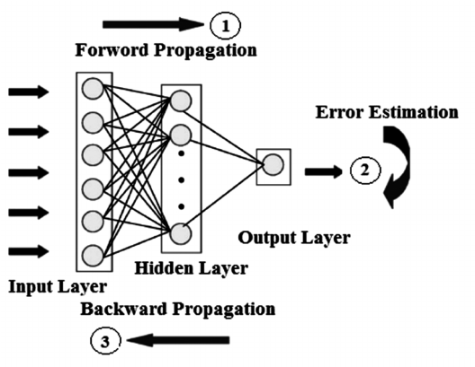
Figure 1 - Backpropagation
Figure 2 - Method of Back Propagation
The hidden layers are used for processing the data. Using deep learning techniques on raw data is difficult therefore feature extraction is used in the hidden layers to process the data before the techniques are applied.
The next development in neural networks was the “multilayer feedforward networks”[2] where they were able to solve the exclusive or problem in earlier discovered neural network theories. A feedforward multi-layer network is usually trained by the back-propagation algorithms. [2] At this time however the computers did not have enough computational and graphics power or memory needed for the required mathematics. For computers at this time it was a challenge to understand handwriting because of the large amount of data for the computer to analyse.[11]
After much work on back propagation it was seen that the Convolutional Neural Network (CNN) that were important did not work as well as expected. The reason was that back propagation relies on the error from the output being passed back through the layers and changing the weighting on each layer. This relies on large amount of maths producing either very large or small numbers resulting in the vanishing or exploding gradient problem.[12]
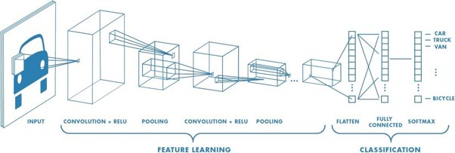
Figure 3 - Convolutional Neural Network for Image
Diagram of how the convolutional neural network works These outputs will uniquely identify the individuals. A series of numbers is produced and to compare the records in the database. These outputs will uniquely identify the individual.

Activation functions
An activation function of a node defines the output for a given set of inputs. This is important as it decides whether that node should be activated or not. Activation functions are transformations, many of these are non-linear. There are different activation functions for different required outputs. Products of the activation function are transferred to the next layer as the input.
There many different types of activation functions, each of them has their own use. The linear activation function leaves the signal unchanged. This is used in the input layer. The sigmoid function reduces the extreme values in the data. Tanh is similar to sigmoid but there is a range from 1 to -1 rather than 0 to 1 therefore it can cope with negative number more easily. A variation of tanh is a hard tanh where the data is capped from -1 to 1 creating a decision boundary. The SoftMax activation function is a distribution function used in the classification of outputs. This is used for a single output and can be applied to continuous data.[2]
Rectified Linear units’ function (ReLU) is currently the most up to date activation function in use. In ReLU there is a threshold input value in which the output is zero until the threshold is reached. After this there is a linear relationship as defined. The use of ReLU function reduces the amount of vanishing exploding gradients compared to other activation functions. This is because the value is either 0 or a constant.[2]
The rectified linear unit activation function will be used in facial recognition system part of this project as the image is pushed through a convolutional neural network. [2]

Convolutional Networks
Convolutional Neural Networks (CNN) are way of analysing visual data. These consist of two types layers: convolutional layer and pooling layer. A convolution is a mathematical operation which defines how the two data sets are merged to produce an output.[2] This enables the nodes to look at a small section of the data. The results of the nodes are aggregated and the nodes next layer process these results. This means that the nodes of successive layers see larger portions of the data. The means that the feature does not have to be relearnt again and again. Pooling is a down sampling operation used to reduce the size of the dataset and to help control overfitting. Pooling layers are placed in between the convolutional layers. There are many ways of pooling the most common are max and average pooling. Max pooling uses a fixed filter to resize the data. [4] Each layer in the neural network is responsible at looking at a different feature in the image.

Shift invariant
Convolutional neural networks use a technique called shift invariant. This is where the image can be shifted left or right to generalise the results so that the image can be processed. The patterns identified in the image are treated as vectors and using support vector machine classifiers features can be extracted. Some research has been done to use these patterns as matrices and compute them using the Fourier transform which improves the recognition rate. [13]

Multi Cascaded Convolutional Networks
Multi Cascaded Convolutional Networks are used to improve face recognition in images by using multiple steps. Some cascade face detectors use Hear like features to process images rapidly and use Adaboost learning algorithms to train the system. Adaboost is a boosting algorithms that attempts to produce a strong classifier from weaker ones The background part of the image is quickly removed to allow more processing on facial features. [14] In real applications however, there is a large amount of variation in the face and therefore other models have to be used such as the “deformable part model”. By using both face detection and face alignment through a multi stage process the performance of the algorithms are improved. Firstly, it focuses on the area of interest then this identifies which of these areas have faces in them and finally determine the facial features and their positions [15].

Recurrent Neural Network
Recurrent Neural Network (RNN) is another type neural network architecture. This has a third dimension which is time, whereas convolutional neural network only has two dimensions. Constructing the input dataset takes longer as this is more complex. Training an RNN takes a large amount of computational power and needs good initialisation of weights. RNN also uses a modified version of back propagation algorithm called Back Propagation Through Time (BPTT)[2] Recurrent neural network works similarly to a feedforward network. When the recurrent neural network is used tanh is mainly used instead of the other activation functions as the tanh can include negative values closer to the negative values. With the RNN there is only one node which is sending and receiving the outputs.

Deep Learning Trends
Deep learning is more popular currently because there are advances in the internet allowing the use of cheap processing power in the cloud.[16] There are a number of large corporations that are investing in deep learning and generating a large amount of data. Microsoft, IBM and Google, Facebook. Microsoft have a deep learning group and one example of where they use this is in computer vision API. The technology is used in Microsoft Word and PowerPoint for automatic image descriptions. [17] Google are using deep learning in their active question and answering system. This enables it to get using the most appropriate answer using a pretrained model. This is model split into three different sections; the question answering environment, the reformulation model and the answer selection model. Each has a training model. [18] Facebook uses machine learning in many different applications. These include reading images and videos to the blind and an automatic caption that are in the videos in the feed. [19] IBM have used their skills to develop deep learning tools so their customers can you use deep learning for their projects. [20]
One of the reasons for the large increase in research in face recognition is the use of CNN for learning a model and the public access to large amounts of training data sets with ”2.6M images, over 2.6k people”. [21]

How does face recognition work?
Neural networks are used in the process of face recognition. There are several different methods used in the face recognition process. These are face detection, normalisation, feature extraction, database feature comparisons and giving a face an ID. [22][23]
Face detection is needed to check to see if there is a face in captured image or video. It needs to also work out where the face is on the image.[24]
Once the face has been detected the input is then normalised. There are a couple of stages in the normalisation process. This process involves getting the input face in the same proportions as the images in the database. This includes stretching the image to increase the probability of the face to match. There are algorithms for normalising images these consist of converting the image to greyscale. This will remove unwanted features from the image.
Then there is feature extraction where this will pick out features using certain algorithms. The final step is to compare these features with the images inside a database. [22][23]

Support Vector Machines
Support vector machines are used to find a hyperplane in dimensional space using linear algebra. There are usually two sets of data that split by a hyperplane. This is a way of classifying the data sets onto two different planes as shown a diagram here. Showing that the data dataset is linearly separable [4] [25][26]
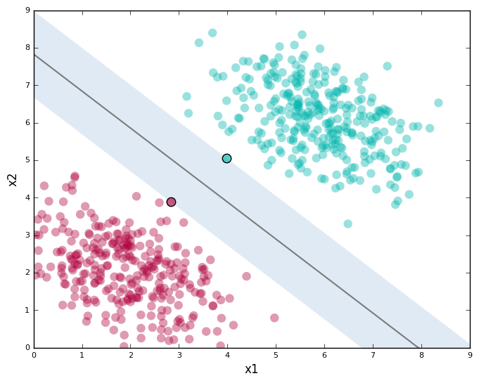
Figure 4- Support vector graph

Face recognition Techniques
There are several techniques for facial recognition such as histogram equalisation, columnwise linear transformations and correction by piecewise linear transformation.

Histogram equalisation
Histogram equalisation is used to enhance the contrast of the image. Two functions, probability mass function (PMF) and Cumulative distributive function (CDF) are used to calculate histogram equalisations. This is used to make the image clearer but in some instances it makes the image worse and the contrast would then need to be decreased. After calculating the PMF of the pixels and using the CDF values calculated to adjust the greyscale the two are put together to produce a new image. The resulting histogram is stretch compared to the original but has the same overall shape. [28]

Linear transformations
Linear transformations are used because some images have disproportionate light intensities in them. These methods are used to reduce or eliminate the effects. One transformation is columnwise which is applied to each column of the image. This does not require heavy image processing as each column is treated independently. With columnwise transformation the fact the face is mostly symmetrical left to right is used to adjust the image. Piecewise is another type of transformation which is used to correct for lighting intensities. This is where all the pixel values in the column are multiplied by a scaler factor . [29] Piecewise is a segmented function where the pixels are spit into sections that are each calculated by a different factor.

Current problems with face recognition
Face recognition systems have improved in the last five years as there are many new methods and techniques that researchers have discovered. There are many hurdles to overcome with the use of face recognition in different conditions. These issues include lighting, orientation and facial changes of the subject in the original photo. There are several solutions that may overcome the lighting issues including “column wise linear transformations” and “piecewise linear transformation”. [29] There can be some issues with the positioning of the camera when capturing an image of the subject. If the camera is too far away the image may be too low a resolution for the system to compare. Therefore, cameras need to be place at face level for an average height person. However, there has been some research using Facenet which instead of using CNN use “a method to directly learn an embedding into an Euclidean space for face verification”[30]. Other things to consider are objects that that may obstruct or alter crucial features such as sunglasses, facial hair and aging.

Research and Development Methodology
In this project the approach taken is of a positivist view in which data will be gathered from what that camera sees and recognises people’s faces. The system will be looked at to measure how quickly the system can see and recognise the faces. Also, different conditions for a face to be recognised need to be tested. There will be many ethical and legal issues that will have to be taken into consideration to see if there are any risks that we need to be aware of. In this project an exploratory route is taken in which data is collected to recognise the problem. In this case the problem will be recognising the human faces including the facial features. The project will be experimental in looking at different ways that a computer system can pick up faces and improve the system to meet the project needs. Once the project is done there will be a written report which describes how the system works and whether all the aims and objectives have been met.
There are many software development life cycles. These include Agile, scrum, waterfall methods and feature driven development. For this project feature driven, waterfall methods and agile methods were looked at to determine which was most suitable.

Waterfall Method
Waterfall method is where the user defines all their requirements at the start of the project. There are typically five sections in the waterfall method which consist of Requirements, Design, Implementation, Verification and Maintenance, separating it into clear steps. The system requirements are set at the start of the project. If there are any changes the user would like to make, then the development cycle has to be restarted. The Waterfall method is good for small projects and the method has a specific set of deliverables but the requirements need to be precise and cannot be changed easily once the project has been started. the waterfall method allows for easy testing and analysis at the end of the project.

Feature Driven Development
In the feature driven development there are sections to develop the project which consist of short iterative processes that consists of five basic sections. There are also five main sections of the feature driven development model which are as follows: Develop an overall model, build a features list, Plan by feature, design by feature, build a feature. The first section of this model is to have a detailed construction of how the project works with the client and the lead development team. With the information in the first Steps you can deduce the information that is needed to create the whole project. These features will then need to be divided into their own sections. Each feature should take roughly 2 weeks. The next stage of the process is where the all the features of them planned. The next steps for the process are to design the feature using all the different types of design UML diagrams. While all this process is happening in the code is developed and tested by the main programmer of the project when the main programmer is happy with the code for the feature this can be joined onto the main project using source control. Some examples of this use GitHub. This is typical used with a large team of developers with each person doing a different feature and then they can all be connected together.

Dynamic systems development method
Dynamic systems development method the form of rapid prototyping methodology. This is a different type of agile method used in creating software. With this method there are certain rules for creating the system requirements which is shorted to the abbreviation MoSCoW. The abbreviation MoSCoW shows what the system must, should, could and would like have. With the system there are features that has a higher priority. With the system there are features that have a higher priority. Must is a requirement for the project. Should is needed if possible but the project can succeed without it. Could are nice to have and don’t affect other features and Would are features that may be a requirement in the future but are not needed now.

Method chosen
The best methodology to use for the face recognition system would be the waterfall method as the requirements are set at the start of the project and it’s good for testing and analysis at the end.

Philosophy
In the major project a positive approach is taken. Data is gathered to test facial recognition in the register system. Comparisons of faces are taken to get the closest possible outcome to the right person.

Method used
Face recognition is usually done in the several steps where the first step is usually the face detection process of it’s taking a certain region of the face. The features that are extracted need to be normalised to find the critical areas of the persons face. The most important section of the face recognition system is to define the position of the person face within an image or video. Once this method finds where the person face is located in the video or image this should be able to pick up the all the different features that off sound and be able to pick out between the right people in the image. It will compare all the pictures that are within the database for the required lecture and compare the input image with the images that are stored in a database to see if it can identify the person. Once a person is found they will be registered into a SQL database and be marked on the register.

Libraries that will be used
There are many libraries that are written to find a person’s face. Most notably there’s one that is called face_recognition which is a python library written by Adam Geitsey [31]which uses a histogram of oriented gradients which is known as a feature descriptor. This feature descriptor can simplify an image by extracting useful information.[32] This project uses the library for SQL called SQLlight3, the database will be stored locally on the PC which will store dummy student and lecturer's information.

Software Needed
Tensorflow and Pytorch are both open source libraries for machine learning applications such as neural networks. Tensorflow was developed by google and Pytorch was developed and used by facebook. Recurrent neural networks are best suited to Pytorch as this allows for a dynamic graph whereas, Tensorflow uses a static graph so you must define the variable length at the start of the code. Pytorch is easier to learn and start implementing as it is written in python whereas with Tensorflow you will have to learn about sessions and place holders. Tensorflow has a large amount of resources as the community is large. For this project Pytorch will be used.
PyTorch uses a GPU which is needed for the machine learning of the project. Pytorch is also used with CUDA. CUDA is parallel computing platform used for specialised operations in contrast to the CPU which is good at handling general computations. When using a neural network, a GPU is faster to do the computations on rather than the CPU as these computations can be carried out in parallel. Parallel computing is where there is one computation which is broken down into smaller computations that can be run at same time. This is dependent on how many cores are on a piece of hardware Typically on a CPU there are 4-8 cores however on a GPU there are many more cores. On a GPU there may be up to 2000 cores. There are many different types of graphical user interface libraries for python such as qtpi which uses sockets and bindings. For the development of the project QTPY is used for the user interface which is integrated within python. The operating system that is needed to run the software requires an installation of the latest Linux distribution of Ubuntu 18.10.

Design
The project is to create a register system using facial recognition and machine learning. From the initial statement the following functional and non-functional requirements were developed.

functional and non-functional requirements
- The system must be able to correctly identify what a face looks like.
- The system must be able to compare the person’s face within the system
- The system will be able to run in a Linux environment
- When scanning a person's face, the environment shouldn't be brightly lit or really dark.
- The camera needs to be in the correct position and the right camera focus.
- There should be a set amount of time to see if the system cannot recognise a face.
From these functional and non-functional requirements, it was decided to run project using commercially available machine learning libraries and training sets. These are more available in a Linux environment as this is where they were first developed. Part of the project will be Investigating how to recognise faces. The main methods for face recognition are: Face detection, feature extraction, face comparison using a database that stores images of faces. in the design of the project various machine learning libraries will be looked at including TensorFlow and pytorch and face_recognition to decide which to use. Tensorflow and pytorch are commercially avaliable machine learning libraries used for deep learning. Face_recognition is another library that enables faces to be compared .I aim to look at all to see which is the most appropriate for the project. Pytorch may be simpler to use than tensorflow so was looked at that first. After a quick look at each learning library face_recognition was the one chosen as it was simple to use and it included all the features needed to create the project.
The project will be using a SQL database for the Register side of the system. SQL is used to create and manage the database. It will be used to log everyone in the monitoring system. Ideally the system would be where the person’s face is recognised and they are registered when they pass into the lecture room. First the system will start by recognising a face as a still image and then will progress to using a video file and then to a live feed. Once recognised the data will be entered into a database to provide information on attendance.

Gantt Chart
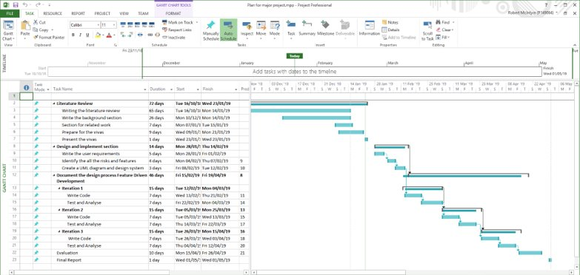
Figure 5 - Gantt Chart
this is the Gantt chart to show the intended progress which has three iterations to the development. The iterations are to create a program to compare a still image to an image stored in the database, compare a video file to an image that is stored and compare a live feed to an image stored. Also, to create an SQL Database to store all the register information about the users. An ethics form needs to be completed because there is identifiable information that may be stored and so permission need to be obtained to comply with GDPR legislation.

Hardware interfaces
The system requires a camera or a webcam for an image of each participant to be registered in the program.The PC requires one USB port and the necessary drivers needed to run the program.

Functional requirements
The first step is to take a picture of the user or use a video feed to capture the footage. After the images are taken, the images need to be pre-processed taking out any unnecessary parts of the image. The image is cropped to a certain size of pixels with the face being in the middle of the image.

The sequence diagram and entity relationships describe how the project is intended to work. It shows a simple representation of how the system should Operate.

UML diagram
This is the UML diagram showing the sequence of events of how the student is going to interact with the system. Also showing the steps involved within the system.

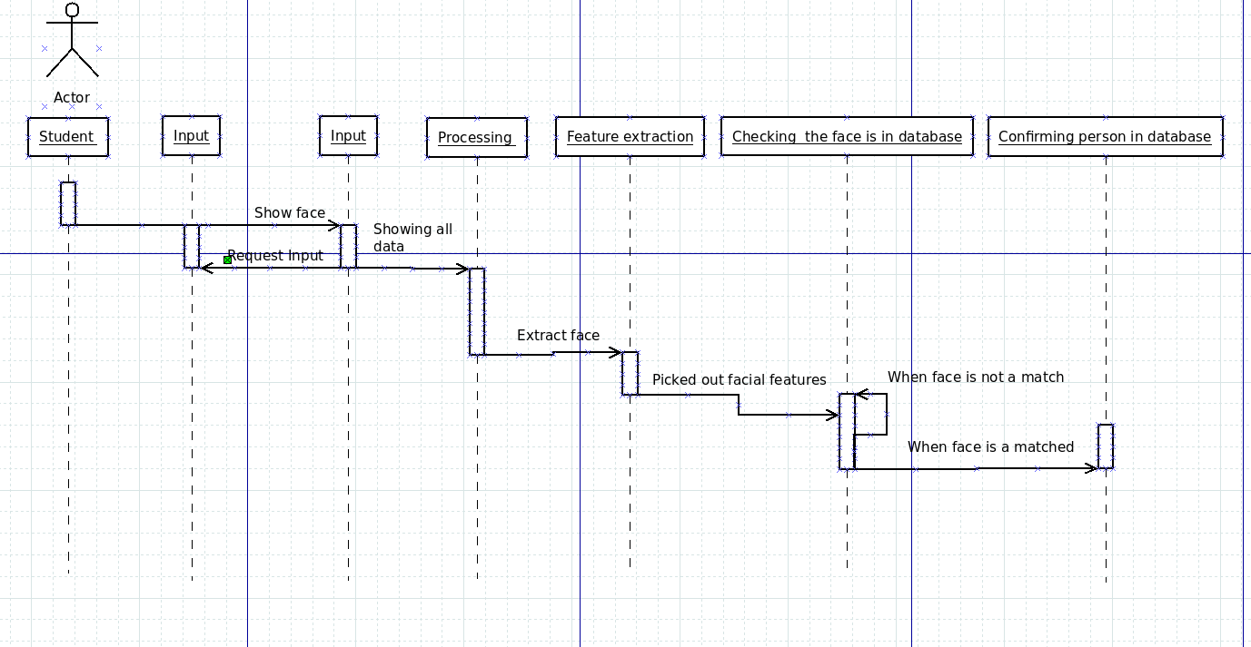
Figure 6 - UML Sequence Diagram

Entity relationship diagram

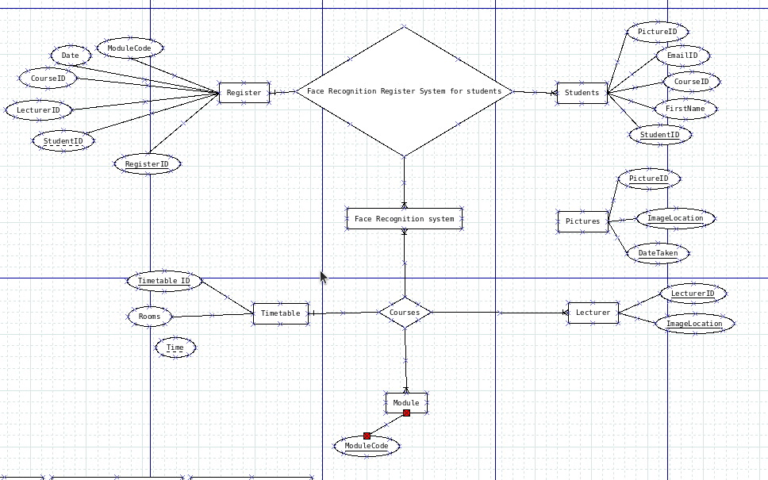
Figure 7 - Entity relationship Diagram for Database
Here is the entity relationship diagram for the database to be used in the system.
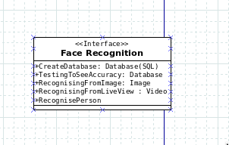
Figure 8- UML Diagram
This is describing the face recognition part of the system.

Implementation
In the implementation section of the project feature driven development will be used where features are added to programme over time using iteration steps. For designing the interface QTDesigner was used. Using QTDesigner allows the facility to drag and drop entities into a window and also setting up the layout. The code for the features are written behind these entities.

Iteration One
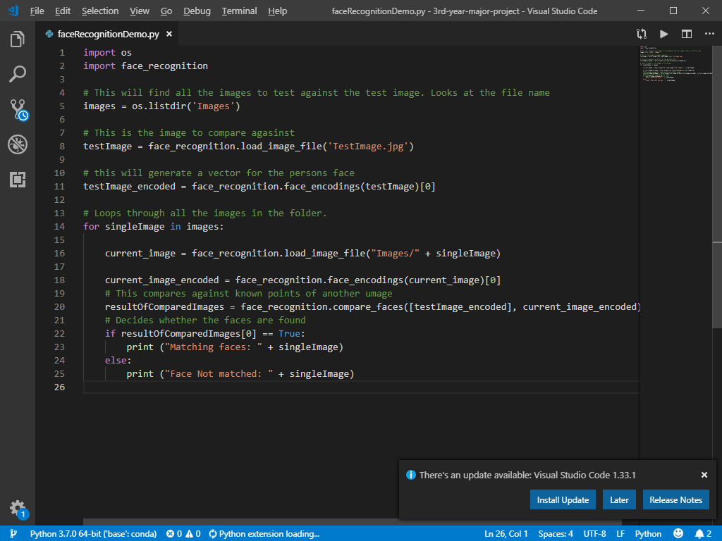
Figure 9- Static image comparison
This is a simple first iteration code where the system has a list of celebrity images and one non celebrity image. A test image is loaded and compared with the images in a folder and a match is found.

Iteration Two
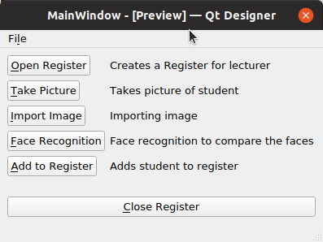
Figure 10 - User Interface
The main window was produced to allow each feature to be tested separately. First a file is created to store the register for each lecture. The next step was to allow the user to take a picture.
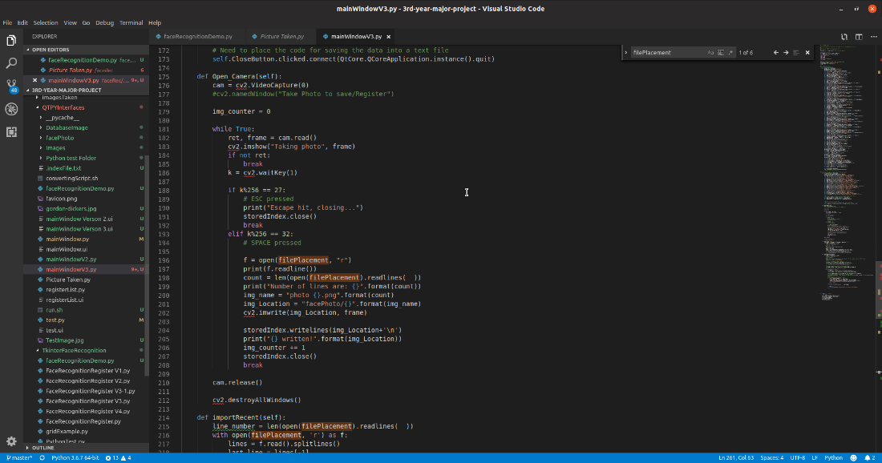
Figure 11 - Code for opening camera and capturing image
The user needs to press the space bar to take the image on the camera. The Image is then stored in a folder for later comparision.

Iteration Three
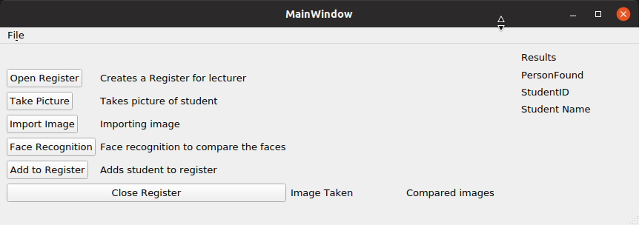
Figure 12 - Third Interation of user interface
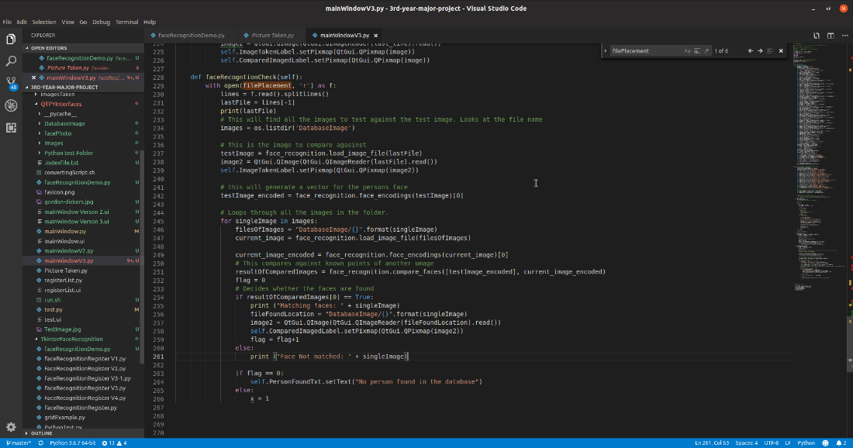
Figure 13- Checking of the face recognition
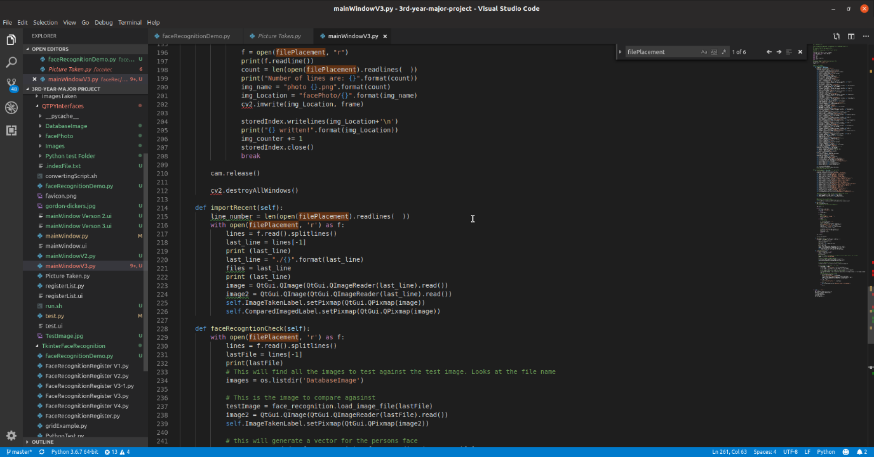
Figure 14 - Code for viewing two images in window
This step is comparing the face of the image taken with the stored images. If a match is found both images are displayed on the screen and the name will be added to the register.

Testing

Test No | Operation | Expected Outcome | Actual outcome | Pass/fail
 | Open Register | A File is created ready for the students attendance | The file is created not necessarily in the right format | Partial Pass
 | Taking an Image | An Image is taken from the camera and displayed on the window | The user is able to take a picture | Pass
 | Importing the image | Image is saved into a folder | The image is saved onto a folder | Pass
 | Pre-processing image | The image is cropped to the right size for the image to be compared | The image is in the right size for the comparison | Pass
 | Comparing the stored faces | The face is either successfully or un successfully matched | Faces matched and displayed on screen | Pass
 | Name of image is added to the register | Name should be added to the folder | No name is added yet | Fail
Table 2 - Testing evaluation table

Screenshots of project

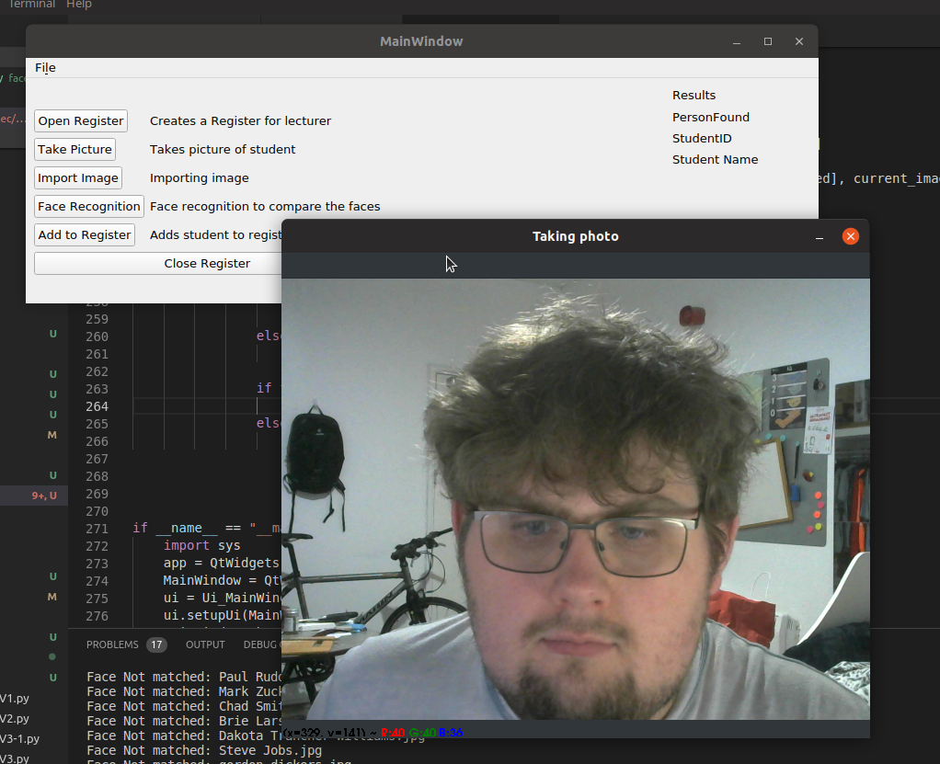
Figure 15 - Taking a photo to import
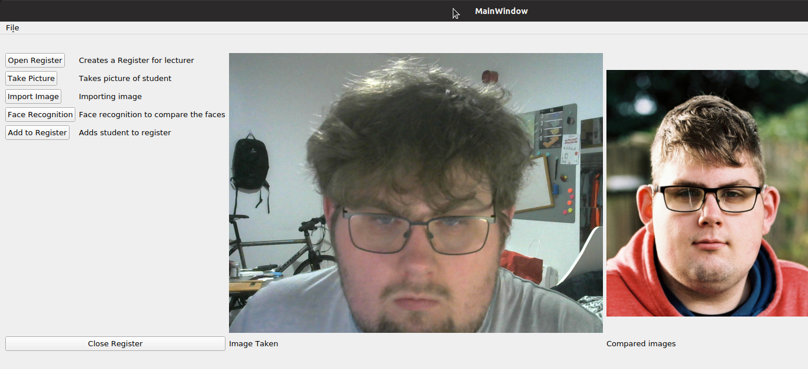
Figure 16- Successful comparison of images

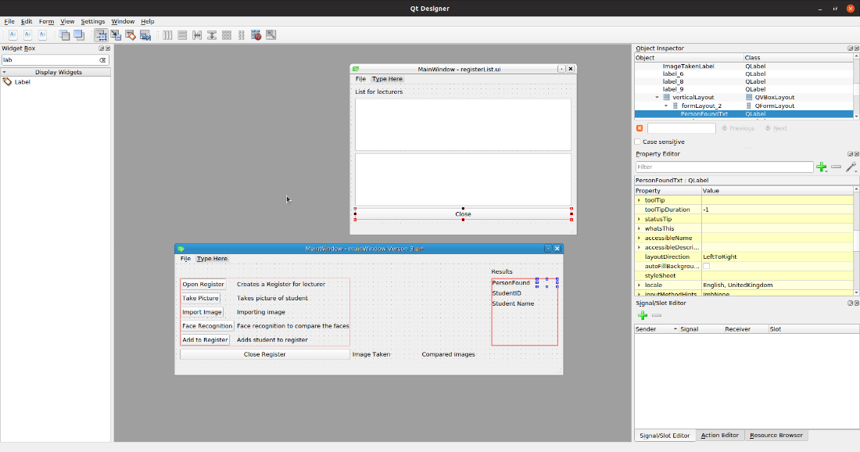
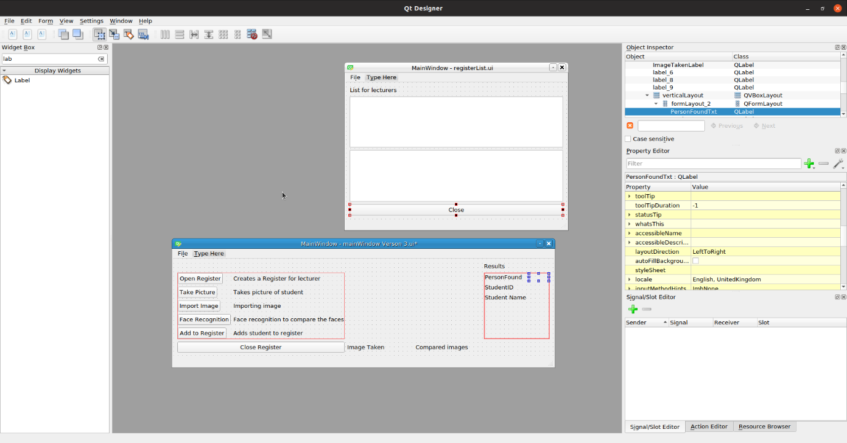

Iteration one

Iteration two
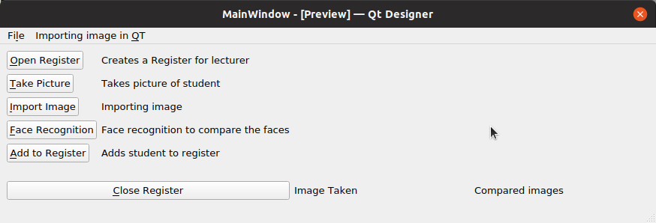

Iteration Three
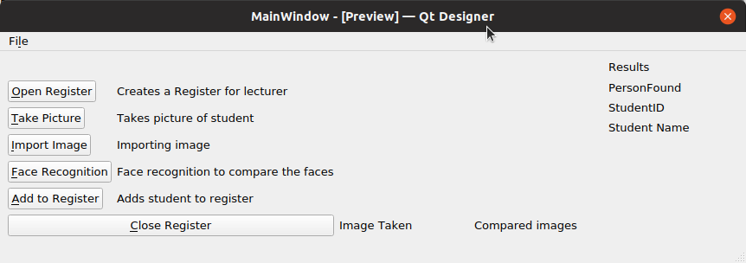

Evaluation
A system has been created that can analyse static and live images and compare them to a folder of stored images. More work needs to be done to improve the database to enable it to be used as a register system. The work has been proved that the system can be used as a register system. Some machine learning algorithms could be used to improve facial recognition in different types of lighting conditions.

References
[1] T. W. Edgar and D. O. Manz, Research methods for cyber security. .
[2] J. Patterson and A. Gibson, Deep Learning, First Edit. O’Reilly Media, 2017.
[3] G. E. Hinton, S. Osindero, and Y.-W. Teh, “A Fast Learning Algorithm for Deep Belief Nets,” Neural Comput., vol. 18, no. 7, pp. 1527–1554, Jul. 2006.
[4] A. Géron, Hands-on machine learning with Scikit-Learn and TensorFlow : concepts, tools, and techniques to build intelligent systems. .
[5] F. B. Fitch, “McCulloch Warren S. and Pitts Walter. A logical calculus of the ideas immanent in nervous activity. Bulletin of mathematical biophysics, vol. 5 (1943), pp. 115–133.,” J. Symb. Log., vol. 9, no. 02, pp. 49–50, Jun. 1944.
[6] F. Rosenblatt, “The perceptron: A probabilistic model for information storage and organization in the brain.,” Psychol. Rev., vol. 65, no. 6, pp. 386–408, 1958.
[7] J. E. Dayhoff, Neural network architectures : an introduction. Van Nostrand Reinhold, 1990.
[8] M. Minsky, S. Papert, and L. Bottou, Perceptrons : an introduction to computational geometry. .
[9] D. Kaur and A. Holland, “Comparative Analysis of ANN trained with Back Propagation and Genetic Algorithm for Implementation of Exclusive-OR Problem,” ICIS ’09 Proc. 2nd Int. Conf. Interact. Sci. Inf. Technol. Cult. Hum., pp. 7–10, 2009.
[10] D. E. Rumelhart, J. L. McClelland, and S. D. P. R. G. University of California, Parallel distributed processing : explorations in the microstructure of cognition. MIT Press, 1986.
[11] Y. LeCun et al., “Backpropagation Applied to Handwritten Zip Code Recognition,” Neural Comput., vol. 1, no. 4, pp. 541–551, Dec. 1989.
[12] J. Schmidhuber, “Deep learning in neural networks: An overview,” Neural Networks, vol. 61, pp. 85–117, Jan. 2015.
[13] J. Ruiz-Pinales, J. J. Acosta-reyes, A. Salazar-Garibay, and R. Jaime-Rivas, “Shift Invariant Support Vector Machines Face Recognition System.” 2008.
[14] P. Viola and M. J. Jones, “Robust Real-Time Face Detection,” Int. J. Comput. Vis., vol. 57, no. 2, pp. 137–154, May 2004.
[15] K. Zhang, Z. Zhang, Z. Li, and Y. Qiao, “Joint Face Detection and Alignment Using Multitask Cascaded Convolutional Networks,” IEEE Signal Process. Lett., vol. 23, no. 10, pp. 1499–1503, Oct. 2016.
[16] A. Saiyeda and M. A. Mir, “Cloud computing for deep learning analytics:A survey of current trends and challenges,” 2017.
[17] “Deep Learning Group.” [Online]. Available: https://www.microsoft.com/en-us/research/group/deep-learning-group/. [Accessed: 05-May-2019].
[18] “What’s New in Deep Learning Research: How Google Uses Reinforcement Learning to Ask All the Right….” [Online]. Available: https://towardsdatascience.com/whats-new-in-deep-learning-research-how-google-uses-reinforcement-learning-to-ask-all-the-right-69c172f113c4. [Accessed: 05-May-2019].
[19] “Applying machine learning science to Facebook products.” [Online]. Available: https://research.fb.com/category/machine-learning/. [Accessed: 05-May-2019].
[20] “Deep Learning as a Service, IBM makes advanced AI more accessible for users everywhere - Watson.” [Online]. Available: https://www.ibm.com/blogs/watson/2018/03/deep-learning-service-ibm-makes-advanced-ai-accessible-users-everywhere/. [Accessed: 05-May-2019].
[21] O. M. Parkhi, A. Vedaldi, and A. Zisserman, “Lin, Face Recognition,” no. Section 3, 2015.
[22] T. Dawa and N. Vijayalakshmi, “A Comparative Review on Different Methods of Face Recognition,” Orient. J. Comput. Sci. Technol., vol. 10, no. 1, pp. 227–231, Mar. 2017.
[23] W. Wójcik, K. Gromaszek, and M. Junisbekov, “Face Recognition: Issues, Methods and Alternative Applications,” in Face Recognition - Semisupervised Classification, Subspace Projection and Evaluation Methods, InTech, 2016.
[24] V. Bhandiwad and B. Tekwani, “Face recognition and detection using neural networks,” in 2017 International Conference on Trends in Electronics and Informatics (ICEI), 2017, pp. 879–882.
[25] D. Nedal and P. Morgan, Introduction to Machine Learning with Python. 2014.
[26] C. Chio, D. Freeman, C. C. Chio, and D. Freeman, Machine Learning and Security Clarence. 2017.
[27] Shaoyan Zhang and Hong Qiao, “Face recognition with support vector machine,” in IEEE International Conference on Robotics, Intelligent Systems and Signal Processing, 2003. Proceedings. 2003, vol. 2, pp. 726–730.
[28] “Histogram Equalization.” [Online]. Available: https://www.tutorialspoint.com/dip/histogram_equalization.htm. [Accessed: 05-May-2019].
[29] M. Lee and C. H. Park, “An efficient image normalization method for face recognition under varying illuminations,” in Proceeding of the 1st ACM international conference on Multimedia information retrieval - MIR ’08, 2008, p. 128.
[30] F. Schroff, D. Kalenichenko, and J. Philbin, “FaceNet: A Unified Embedding for Face Recognition and Clustering,” Mar. 2015.
[31] “Machine Learning is Fun! – Adam Geitgey – Medium.” [Online]. Available: https://medium.com/@ageitgey/machine-learning-is-fun-80ea3ec3c471. [Accessed: 23-Jan-2019].
[32] “Histogram of Oriented Gradients | Learn OpenCV.” [Online]. Available: https://www.learnopencv.com/histogram-of-oriented-gradients/. [Accessed: 28-Apr-2019].

Histogram of Oriented Gradients | Learn OpenCV. (n.d.). Retrieved April 28, 2019, from https://www.learnopencv.com/histogram-of-oriented-gradients/
[22] Machine Learning is Fun! Part 4: Modern Face Recognition with Deep Learning. (n.d.). Retrieved April 28, 2019, from https://medium.com/@ageitgey/machine-learning-is-fun-part-4-modern-face-recognition-with-deep-learning-c3cffc121d78

Image References
Figure 1 -
https://www.researchgate.net/profile/Morteza_Esfandyari/publication/241741756/figure/fig2/AS:298577172680729@1448197753779/Back-propagation-multilayer-ANN-with-one-hidden-layer.png

Appendices

Ethic Form
APPLICATION FOR ETHICAL APPROVAL

In order for research to result in benefit and minimise risk of harm, it must be conducted ethically. A researcher may not be covered by the University’s insurance if ethical approval has not been obtained prior to commencement.

The University follows the OECD Frascati manual definition of research activity: “creative work undertaken on a systematic basis in order to increase the stock of knowledge, including knowledge of man, culture and society, and the use of this stock of knowledge to devise new applications”. As such this covers activities undertaken by members of staff, postgraduate research students, and both taught postgraduate and undergraduate students working on dissertations/projects.

The individual undertaking the research activity is known as the “principal researcher”.

Ethical approval is not required for routine audits, performance reviews, quality assurance studies, testing within normal educational requirements, and literary or artistic criticism.

Please read the notes for guidance before completing ALL sections of the form.

This form must be completed and approved prior to undertaking any research activity. Please see Checklist for details of process for different categories of application.

SECTION A: About You (Principal Researcher)

Full Name: |  |  | Robert McIntyre
Tick all boxes which apply:
Member of staff: | ☐ | Student: |  | ☒ | Honorary research fellow: | ☐

Faculty/School/Centre: | School of Applied Computing / FACE
Campus: | Swansea Mount Pleasant
E-mail address: | Rmcintyre.149064@student.uwtsd.ac.uk
Contact Telephone Number: | 07546224184
For students:
Student Number: | P149064 | Undergraduate | ☒
Programme of Study: | Software Engineering | Taught Postgraduate | ☐
Director of Studies/Supervisor: | Gordon Dickers | Research | ☐

SECTION B: Approval for Research Activity

Has the research activity received approval in principle?  (please check the Guidance Notes as to the appropriate approval process for different levels of research by different categories of individual) |  | YES | ☒ | NO | ☐
 |  |  |  | Date
If Yes, please indicate source of approval (and date where known): | Research Degrees Committee |  | ☐
 | Faculty Research Committee |  | ☐
 | Other (write in)  SOAC Research Methods Module |  | ☒ | May 2018
Approval in principle must be obtained from the relevant source prior to seeking ethical approval.

SECTION C: External Ethical Guidance Materials

Please list the core ethical guidance documents that have been referred to during the completion of this form (including any discipline-specific codes of research ethics, and also any specific ethical guidance relating to the proposed methodology). Please tick to confirm that your research proposal adheres to these codes and guidelines.
UWTSD Research Ethics and Integrity Code of Practice | ☒
British Computer Society Code of Ethics | ☒
 | ☐

SECTION D: External Collaborative Research Activity

Does the research activity involve collaborators outside of the University? |  | YES | ☐ | NO | ☒
If Yes, please provide the name of the external organisation and name and contact details for the main contact person:
Institution
Contact person name
Contact person e-mail address

Where research activity is carried out in collaboration with an external organisation
Does this organisation have its own ethics approval system? | YES | ☐ | NO | ☒
If Yes, please attach a copy of any final approval (or interim approval) from the organisation

SECTION E: Details of Research Activity

Indicative title: | Register System using Facial Recognition and Machine Learning
Proposed start date: | October 2018 | Proposed end date: | April 2019
Purpose of research activity (including aims and objectives)
Outline the purpose, aims and objectives of the research activity, including key research questions. Show briefly how existing research has informed the proposed activity and explain what the research activity will add and how it addresses an area of importance. (Maximum 300 words)
This project is looking at producing a register system that uses facial recognition with machine learning. Current literature and research are looked at to determine ways of optimising lighting and methods for face recognition.
Aim
The aim of this report is creating an attendance system that uses facial recognition and machine learning to recognise a face reliably and access the accuracy of the method.

Objectives
I. To investigate the different machine learning libraries and training sets on how to recognise human faces.
II. To determine methods to use and assess the accuracy of the system
III. To analyse and evaluate the accuracy of each model of facial recognition system and determine the best model to use for student attendance.
IV. To design a register system to monitor the student’s attendance to work with the facial recognition.

(this box should expand as you type)
Proposed methods
Provide a brief summary of all the methods that may be used in the research activity, making it clear what specific techniques may be used. If methods other than those listed in this section are deemed appropriate later, additional ethical approval for those methods will be needed. (Maximum 600 words)
In the major project a positive approach is taken. Data is gathered to test facial recognition in the register system. Comparisons of faces are taken to get the closest possible outcome to the right person.

(this box should expand as you type)

Location of research activity
Identify all locations where research activity will take place.
UWTSD Swansea

(this box should expand as you type)
Research activity outside of the UK
If research activity will take place overseas, you are responsible for ensuring that local ethical considerations are complied with and that the relevant permissions are sought. Specify any local guidelines (e.g. from local professional associations/learned societies/universities) that exist and whether these involve any ethical stipulations beyond those usual in the UK (provide details of any licenses or permissions required). Also specify whether there are any specific ethical issues raised by the local context in which the research activity is taking place, for example, particular cultural sensitivities or vulnerabilities of participants.
(this box should expand as you type)

SECTION F: Scope of Research Activity

Will the research activity include: | YES | NO
Use of a questionnaire or similar research instrument? | ☐ | ☒
Use of interviews? | ☐ | ☒
Use of diaries? | ☐ | ☒
Participant observation with their knowledge? | ☒ | ☐
Participant observation without their knowledge? | ☐ | ☒
Use of video or audio recording? | ☐ | ☒
Access to personal or confidential information without the participants’ specific consent? | ☐ | ☒
Administration of any questions, test stimuli, presentation that may be experienced as physically, mentally or emotionally harmful / offensive? | ☐ | ☒
Performance of any acts which may cause embarrassment or affect self-esteem? | ☐ | ☒
Investigation of participants involved in illegal activities? | ☐ | ☒
Use of procedures that involve deception? | ☐ | ☒
Administration of any substance, agent or placebo? | ☐ | ☒
Working with live vertebrate animals? | ☐ | ☒
Other primary data collection methods, please explain in this box  Smart home? Recording when people walk into room and leave?  Data logs of errors | ☒ | ☐

If NO to every question, then the research activity is (ethically) low risk and may be exempt from some of the following sections (please refer to Guidance Notes).

If YES to any question, then no research activity should be undertaken until full ethical approval has been obtained.
SECTION G: Intended Participants

Who are the intended participants: | YES | NO
Students or staff at the University? | ☒ | ☐
Adults (over the age of 18 and competent to give consent)? | ☒ | ☐
Vulnerable adults? | ☐ | ☒
Children under 18? | ☐ | ☒
Prisoners? | ☐ | ☒
Young offenders? | ☐ | ☒
Those who could be considered to have a particularly dependent relationship with the investigator or a gatekeeper? | ☐ | ☒
People engaged in illegal activities? | ☐ | ☒
Others (please identify): | ☐ | ☒

Participant numbers and source
Provide an estimate of the expected number of participants. How will you identify participants and how will they be recruited?
Images used for testing the system are publicly available or myself. Possibly may use one or two others with their permission.

this box should expand as you type)

Information for participants: | YES | NO | N/A
Will you describe the main research procedures to participants in advance, so that they are informed about what to expect? | ☒ | ☐ | ☐
Will you tell participants that their participation is voluntary? | ☒ | ☐ | ☐
Will you obtain written consent for participation? | ☒ | ☐ | ☐
Will you explain to participants that refusal to participate in the research will not affect their treatment or education (if relevant)? | ☒ | ☐ | ☐
If the research is observational, will you ask participants for their consent to being observed? | ☒ | ☐ | ☐
Will you tell participants that they may withdraw from the research at any time and for any reason? | ☒ | ☐ | ☐
With questionnaires, will you give participants the option of omitting questions they do not want to answer? | ☒ | ☐ | ☐
Will you tell participants that their data will be treated with full confidentiality and that, if published, it will not be identifiable as theirs? | ☒ | ☐ | ☐
Will you debrief participants at the end of their participation, in a way appropriate to the type of research undertaken? | ☒ | ☐ | ☐
If NO to any of above questions, please give an explanation
(this box should expand as you type)

Information for participants: | YES | NO | N/A
Will participants be paid? | ☐ | ☒ | ☐
Is specialist electrical or other equipment to be used with participants? | ☐ | ☒ | ☐
Are there any financial or other interests to the investigator or University arising from this study? | ☐ | ☒ | ☐
Will the research activity involve deliberately misleading participants in any way, or the partial or full concealment of the specific study aims? | ☐ | ☒ | ☒
If YES to any question, please provide full details
(this box should expand as you type)

SECTION H: Anticipated Risks

Outline any anticipated risks that may adversely affect any of the participants, the researchers and/or the University, and the steps that will be taken to address them.

If you have completed a full risk assessment (for example as required by a laboratory, or external research collaborator) you may append that to this form.

Full risk assessment completed and appended?

Yes ☐
No ☒

Risks to participants
For example: emotional distress, financial disclosure, physical harm, transfer of personal data, sensitive organisational information
No risks to participants

(this box should expand as you type)
If research activity may include sensitive, embarrassing or upsetting topics (e.g. sexual activity, drug use) or issues likely to disclose information requiring further action (e.g. criminal activity), give details of the procedures to deal with these issues, including any support/advice (e.g. helpline numbers) to be offered to participants. Note that where applicable, consent procedures should make it clear that if something potentially or actually illegal is discovered in the course of a project, it may need to be disclosed to the proper authorities
N/A

(this box should expand as you type)
Risks to investigator
For example: personal safety, physical harm, emotional distress, risk of accusation of harm/impropriety, conflict of interest
None

(this box should expand as you type)
University/institutional risks
For example: adverse publicity, financial loss, data protection
None

(this box should expand as you type)
Adverse outcomes
List measures put in place to limit any adverse effects or outcomes of research activity where appropriate. Include any emergency protocols.
None

(this box should expand as you type)

Disclosure and Barring Service
If the research activity involves children or vulnerable adults, a Disclosure and Barring Service (DBS) certificate must be obtained before any contact with such participants. | YES | NO | N/A
Has a DBS certificate been obtained? | ☐ | ☐ | ☒

SECTION I: Feedback, Consent and Confidentiality

Feedback
What feedback will be provided to participants, how will this be done and when?
Email address will be available for participants to contact you to get feedback from the study or more information on the project.

(this box should expand as you type)
Informed consent
Describe the arrangements to inform potential participants, before providing consent, of what is involved in participating. Describe the arrangements for participants to provide full consent before data collection begins. If gaining consent in this way is inappropriate, explain how consent will be obtained and recorded.
User will be given information at the start of the questioner their continuation use of questions is given as their consent
Will be told their continued use of questions will be deemed as consent.
Continuing onto the questions will be deemed as consent.

(this box should expand as you type)
Confidentiality / Anonymity
Set out how anonymity of participants and confidentiality will be ensured in any outputs. If anonymity is not being offered, explain why this is the case.
No confidential or personal information will be collected

(this box should expand as you type)

SECTION J: Data Protection and Storage

In completing this section refer to the University’s Research Data Management Policy and the extensive resources on the University’s Research Data Management web pages (http://uwtsd.ac.uk/library/research-data-management/).
 | YES | NO
Does the research activity involve personal data (as defined by the Data Protection Act)?  “personal data” means data which relate to a living individual who can be identified—  (a) from those data, or  (b) from those data and other information which is in the possession of, or is likely to come into the possession of, the data controller, and includes any expression of opinion about the individual and any indication of the intentions of the data controller or any other person in respect of the individual. | ☒ | ☐
If YES, provide a description of the data and explain why this data needs to be collected:
Images needs to be compared to add to the register

(this box should expand as you type)
Does it involve sensitive personal data (as defined by the Data Protection Act)?  “Sensitive personal data” means personal data consisting of information as to –  (a) the racial or ethnic origin of the data subject,  (b) his political opinions,  (c ) his religious beliefs or other beliefs of a similar nature,  (d) whether he is a member of a trade union (within the meaning of the Trade Union and Labour Relations (Consolidation) Act 1992),  (e) his physical or mental health or condition,  (f) his sexual life,  (g) the commission or alleged commission by him of any offence, or  (h) any proceedings for any offence committed or alleged to have been committed by him, the disposal of such proceedings or the sentence of any court in such proceedings. | ☐ | ☒
If YES, provide a description of the data and explain why this data needs to be collected:
(this box should expand as you type)

Will the research activity involve storing personal data on one of the following: | YES | NO
Manual files (i.e. in paper form)? | ☐ | ☒
University computers? | ☐ | ☒
Private company computers? | ☐ | ☒
Home or other personal computers? | ☐ | ☒
Laptop computers/ CDs/ Portable disk-drives/ memory sticks? | ☒ | ☐
“Cloud” storage or websites? | ☐ | ☒
Other – specify: | ☐ | ☒
For all stored data, explain the measures in place to ensure data confidentiality, including details of password protection, encryption and anonymisation:
Once completed all data will be deleted permanently

(this box should expand as you type)

Will the research activity involve any of the following activities: | YES | NO
Electronic transfer of data in any form? | ☒ | ☐
Sharing of data with others at the University? | ☒ | ☐
Sharing of data with other organisations? | ☐ | ☒
Export of data outside the European Union or importing of data from outside the UK? | ☐ | ☒
Use of personal addresses, postcodes, faxes, emails or telephone numbers? | ☐ | ☒
Publication of data that might allow identification of individuals? | ☐ | ☒
Use of data management system? | ☐ | ☒
Data archiving? | ☐ | ☒
If YES to any question, please provide full details, explaining how this will be conducted in accordance with the Data Protection Act (and/or any international equivalent):
Data will be shared with supervisor and external examiner

(this box should expand as you type)

List all who will have access to the data generated by the research activity:
Robert McIntyre
Supervisor (Gordon Dickers)
Secondary Marker (Andrew Baker)
External Examiner

(this box should expand as you type)
List who will have control of, and act as custodian(s) for, data generated by the research activity:
Robert McIntyre

(this box should expand as you type)
Give details of data storage arrangements, including where data will be stored, how long for, and in what form. Will data be archived – if so how and if not why not.
Encrypted file on one drive
Stored on Robert McIntyre’s machine until end of the project then it will be deleted.

(this box should expand as you type)

SECTION K: Declaration

The information which I have provided is correct and complete to the best of my knowledge. I have attempted to identify any risks and issues related to the research activity and acknowledge my obligations and the rights of the participants.

In submitting this application I hereby confirm that I undertake to ensure that the above named research activity will meet the University’s Research Ethics and Integrity Code of Practice
Signature of applicant: | Robert McIntyre | Date: 12th March 2019

For students:
Module Leader: | Dr Nik Whitehead
Signature:
Date:

For staff:
Head of School/Assistant Dean:
Signature:
Date:

Checklist: Please complete the checklist below to ensure that you have completed the form according to the guidelines and attached any required documentation:
☒ | I have read the guidance notes supplied before completing the form.
☒ | I have completed ALL RELEVANT sections of the form in full.
☒ | I confirm that the research activity has received approval in principle
☒ | I have attached a copy of final/interim approval from external organisation (where appropriate)
☒ | I have attached a full risk assessment (and have NOT completed Section H of this form) (where appropriate)
☒ | I understand that it is my responsibility to ensure that the above named research activity will meet the University’s Research Ethics and Integrity Code of Practice.
☒ | I understand that before commencing data collection all documents aimed at respondents (including information sheets, consent forms, questionnaires, interview schedules etc.) must be confirmed by the DoS/Supervisor, module tutor or Head of School.

RESEARCH STUDENTS AND STAFF ONLY
All communications relating to this application during its processing must be in writing and emailed to pgresearch@uwtsd.ac.uk , with the title ‘Ethical Approval’ followed by your name.
You will be informed of the outcome of your claim by email; therefore it is important that you check your University and personal email accounts regularly.

STUDENTS ON UNDERGRADUATE OR TAUGHT MASTERS PROGRAMMES should submit this form (and receive the outcome) via systems explained to you by the supervisor/module leader.

