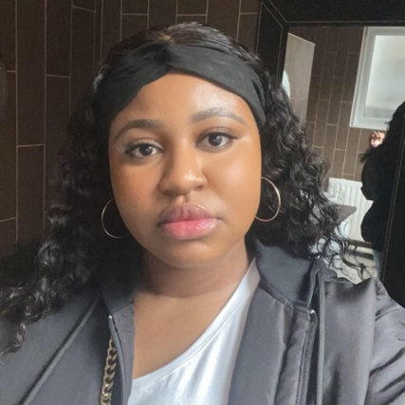
Digital profile

My name is Kerene Kipulu, I am 22 years old from Cardiff, and I am currently enrolled at Trinity Saint David's University to pursue a degree in international travel & tourism management. I am studying this course because I want to work in the Travel & Tourism sector.

Skills & Expertise

Interpersonal skills

Effective Communication

Teamwork

Problem solving

Productivity & organisation

Adaptability

Hobbies & Passions

Hobbies:

I have many hobbies but the one that is my favourite and the one I am good in would be cooking and baking, which I mostly do for my friends and family. I have been cooking since the age of 16, so for 6 years now and baking for 2.

Another hobby of mine is video editing and anything technology-related. I discovered the joy in doing this and decided to turn video editing into a hobby by posting edits on my TikTok, which now has over 5,000 followers and a total of 827,000 likes in a year. this became enjoyable, and I realised that it generates a lot of engagement from my followers and viewers. I have three videos with a total of 1,800,000 million views, and in just two weeks, one of my videos received nearly one million views. I was able to achieve this by learning about the algorithm.

Passion:

My passion has always been to further my studies in Travel and Tourism. I became interested in this because I chose it for my GCSE in year 11 and continued all the way through level 2-3 at college. I am passionate to develop a more professional and academic approach to Travel & Tourism, as I'll be working in the industry.

STRENGTHS & weaknesses

My strengths are communication skills, I believe to be particularly good at this in a group setting, when there is work set, I also believe to have good leadership skills as I have had the opportunity to be a leader of groups a lot of times in college.

Despite having leadership skills, I still have a weakness at public speaking, which I need to work on. I also have a weakness in procrastination, I tend to let this get to the last minute in order to do this, which is another thing I am really working hard on especially as a University student.

What type of personality do i have?

I tend to get introverted and quite when I am in an environment that I am unfamiliar with or when i meet new people. When I get comfortable though I perceive myself as very friendly and. I am a very open minded person in terms of learning new things. Most people that know me would describe me as funny, very talkative and motivated.

What am i like within a team?

In a team I am very involved in helping my team and learning ways to improve if need be, I am a team player, and very friendly, I always want everyone in my team to feel comfortable enough to participate and give their opinion. I am competitive, so I ensure that when I’m in a team that we achieve the things we need to. I like to motivate and enjoy my participation.

