The Effectiveness of the Current Structure of NHS Wales

Content Page
Introduction 3
Statistics 4
Evaluation of current structure 7
Conclusion 9
Recommendations 10
Reference List 11

Introduction:
In this report the effectiveness of the current structure of NHS wales will be explained, statistics will be included as well as information about where the funding comes from. Any issues or concerns that may be affecting the NHS Wales in the future will be included as well as some recommendation on how these issues can be resolved. NHS Wales (2019) states that it is a public funded National Health Service (NHS), which offers healthcare to over 3 million individuals that live in Wales. Community Pharmacy Wales (2019) mention that the NHS has a key principle which is that good healthcare should be available to everyone, despite how wealthy an individual is. NHS Wales (2019) state that there are 7 Local Health Boards which are:
- Aneurin Bevan University Health Board
- Betsi Cadwaladr University Health Board
- Cardiff & Vale University Health Board
- Cwm Taf Morgannwg University Health Board
- Hywel Dda University Health Board
- Powys Teaching Health Board
- Swansea Bay University Health Board
GPOne (2019) mentions that each health board is divided into locality offices and a directory of local GP services can be found on each health board web site, therefore, all the health boards plan, secure and deliver healthcare services in the area.
According to the NHS Wales (2019) currently there are three NHS Trusts in Wales, which are:
- Welsh Ambulance Services NHS Trust;
- Velindre NHS Trust
- Public Health Wales
These services focus on providing and delivering specialist services in cancer care and a variety of national support services to the people living in Wales. NHS Wales (2019) the Public Health organisation in Wales became operated on 1st October 2009, now it functions the National Public Health Service, Wales Centre for Health, Welsh Cancer Intelligence & Surveillance Unit, Congenital Anomaly Resister & Information Service for Wales and Screening Services Wales. The main role of the Public Health Trust is to promote health and prevent unhealthy lifestyles.
Statistics:
According to Nuffield Trust (2019) the NHS is the world’s fifth largest employer with 1.7 million of employees. NHS Wales (2019) mentions that the healthcare services in Wales can offer over 200 career opportunities which includes paramedics, pharmacist, gynaecologists, radiographers, clinical engineers and midwives. Multiple Sclerosis Trust (2018) suggests that the NICE is the organisation that the NHS Wales follows treatments and prescription drugs, but also it is guided by the All Wales Medicines Strategy Group, therefore which can sometimes give the NHS a different recommendation. According to the NHS Wales (2019) the welsh government is advised by the department for Health and Social Services on strategies for healthcare and social care and policies in Wales, this also includes contributing to relevant legislation and providing funding for the NHS and other bodies that relate. NHS Wales (2019) mentions that the Chief Executive of NHS Wales is Dr Andrew Goodall, which is also the Director General for Health and Social Services. Dr Andrew Goodall is accountable to the Cabinet minister for Health and Social Services and is responsible to provide policy advice and exercising strategic leadership and management of the NHS. The Chief Executive will chair a National Delivery Group to support this role, forming part of the Department for Health and Social Services. The NHS Wales (2019) add on that the Office of the Chief Medical Officer leads policy and programmes for the security and development of each individual’s health and for the drop in inequalities in health, professional and medical advice to Ministers, the Health & Social Care Development and other parts of the Welsh Government are also provided. NHS Wales (2019) reference that Community Health Council in Wales are statutory lay bodies that represent the interests of the public in the health service in their district, people get their independent voice in their local NHS and the services it provides.
78,000 staff are employed in the NHS in Wales, which makes it the biggest employer in Wales, moreover, staff working in the NHS are drawn from many profession and occupational groups that work in a variety of settings across Wales (NHS Wales, 2019).
Funding:
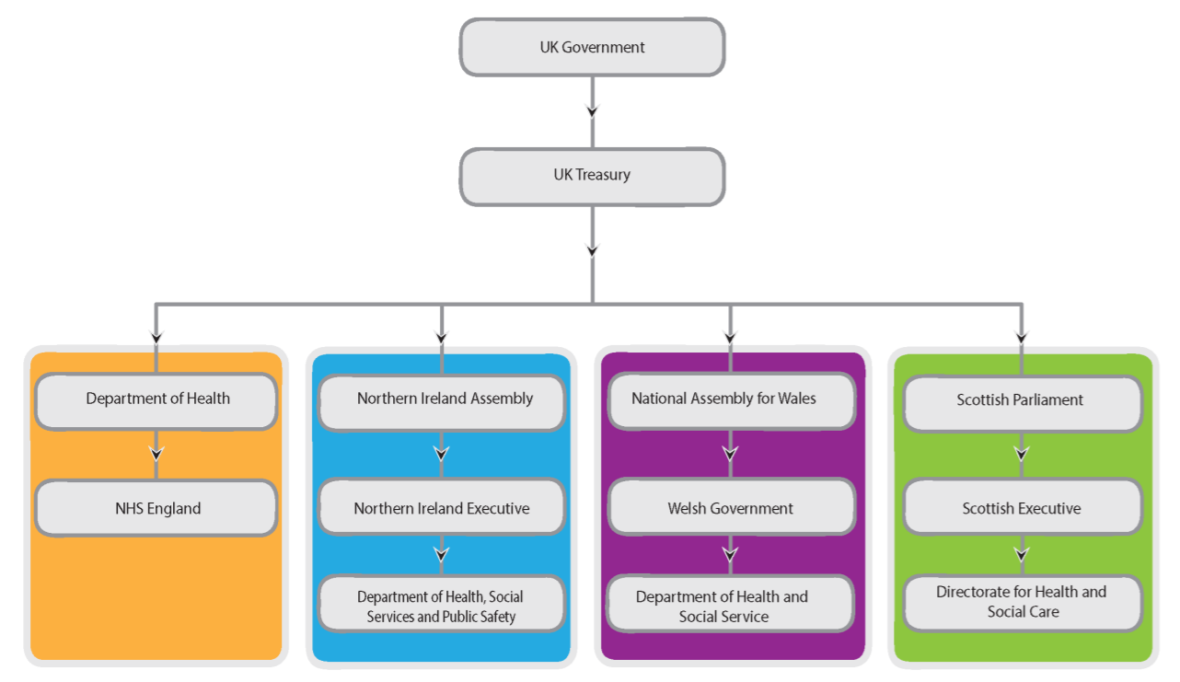
In the graph above it is shown how the funding is processed, first the UK Government sends the funding to the Treasury and then the National Assembly for Wales receives the fund which allow the funding to be received by the Department of Health and Social Services in order to make all the payments needed in the services across Wales.
According to the NHS Wales (2019) the payments for this service are covered by general taxation with a small proportion raised through national insurance contributions, moreover, the Welsh Assembly Government has the responsibility of payment the total amount of money for all areas for health and health services. The NHS Wales (2019) also include the fact that the majority of the funding’s are received from the Welsh Government, in order for it to cover the essential daily running cost of the healthcare services in Wales.
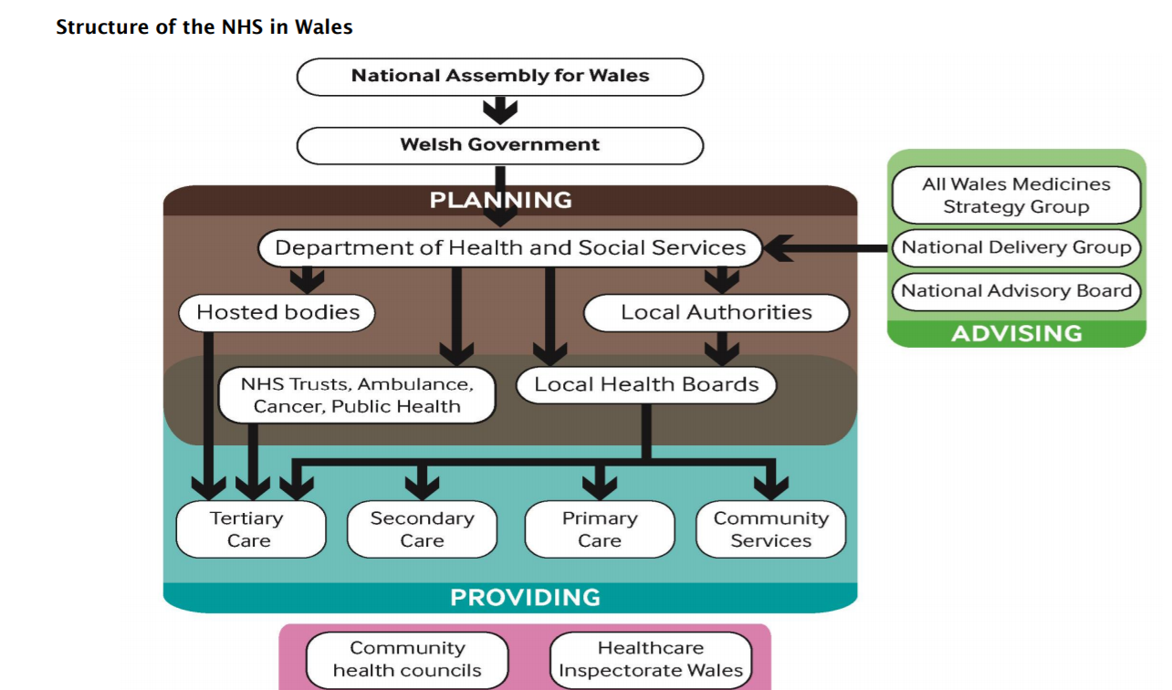
In the graph above is a plan that shows where the funding goes to. The Department of Health and Social Services is given a set of expectations, then the Local Authorities, Local Health Boards and NHS Trust then respond to the expectations through the planning documents. The NHS Trust and the Local Health Boards will concentrate on offering care to people across Wales after the Welsh Government and the NHS bodies discuss how resources will be used to address healthcare needs in a three-year period. The Local Health Board will then communicate with the Local Authorities in order to decide how Tertiary Care, Secondary Care, Primary Care and Community Services are going to be delivered.
Evaluation of current structure:
According to the King Funds (2019) the NHS is currently facing major financial pressures as it is struggling to maintain the standards of care. The national and local NHS urgently need to focus on developing the quality and delivery of better-value care as this also includes improving the safety, effectiveness and experiences of care. Kings Fund (2019) mentions that the NHS is facing a challenge to improve the quality of care while trying to cope with the biggest funding’s in its history. King Funds (2019) also adds on that the quality of this service is deteriorating rather than developing as waiting times are increased and the services in communities are struggling to cope and meet the demands for care in the face of low budget and the shortage of staff.
Professional Judgement
Nursing Times (2019) mention that the professional judgment involves expert and multi-disciplinary groups agree what a department or ward team size will be and mix by consensus.
Pros:
This method is the simplest and quickest as information about patient dependency data is not required. Another advantage for the professional judgment calculation would be that it is less expensive and time-consuming than the fieldwork-determined multipliers (Nursing Times, 2019).
Cons:
Although there are advantages to professional judgment, however, this method may run into difficulties if finance managers and clinicians do not agree with each other. Another major disadvantage about the professional judgment method would be that if nurses decide all alone how many nursing staff needed it may be very subjective (Nursing Times, 2019).
Staff to bed ratio
The staff to bed method includes staff to occupy bed ratio from “best-practice” wards that pass a service-quality test. The staff to bed ration method is used in all services in the UK, however it needs to be used with caution (Nursing Times, 2019).
Pros:
The main advantage of this method is that it provides excellent benchmarks and are simple to use (Nursing Times, 2019).
Cons:
A disadvantage of the staff to bed ratio method is that it is evidence-based meaning that it will be costly to maintain and establish. With this method all patients will generate the same workload as well as making it inappropriate for admission and assessment wards because of the amount of times a bed empties and fills each shift without recognition (Nursing Times, 2019).
The workload-quality method
Workload quality method is the most popular in the NHS UK. It uses throughputs, direct patient care, occupancy, patient dependency and ward overhead data from best-practice wards (Nursing Times, 2019).
Pros:
The workload-quality method is the most sensitive to nursing workload than any other method, as it important to place patients in the correct ‘care level’. This method is flexible and has excellent free available software in order to calculate the workforce (Nursing Times, 2019).
Cons:
This method is very costly to set up and maintain as it uses seven data sets which are very important such as ensuring that staffing estimations are workload-based. This sophisticated method would mean that busy ward staff need to collect data, which does not help with patient care directly, therefore the staffing formula is not suitable for small wards with low dependency patient as recommended establishments may be insufficient to place at least one RN on each shift. There may be concerns about importing the data as borrowed data may not be from quality assured wards (Nursing Times, 2019).
Overall in by the information above it shows that there is still room for improvement in NHS organisation. The information above shows all the advantages and disadvantages of each methods that are used by the NHS workforce, therefore, the most successful would be the Workload-quality method as it is the most popular in the UK. In this section, it shows that most methods are expensive meaning that the NHS is trying its best to provide the public with free good-quality healthcare services.
Conclusion:
This report has looked at the seven Health Boards and 3 NHS Trust work in the NHS Wales organisation. The main roles of the NHS Trust had also mention as well as the date that it was operated. The structure of the NHS organisation was also included in this report as it shows information about how the funding’s are provided to the services and where it comes from. Graphs were included in this report to help show how the funding gets to the Local Health Boards, the graph showed the funding process from the UK treasury all the way to the Department of Health and Social Services. It then went on to discuss about the advantages and disadvantages of the NHS service, here financial issues were mentioned as the biggest problem currently in the NHS is the finance. However, there were still some advantages to do with the methods of the workforce of the NHS and how the services ensure that the patients get the treatments needed.
Recommendation:
In order for the needs required for the UK population the NHS Wales would need to make some changes, the main improvements that are needed in the NHS service is improving the quality of healthcare, improving financial efficiency and improving the broader health and wellbeing of the population. According to King Fund (2019) there are many ways that the NHS can deliver better outcomes without having to spend a large amount of money, for example reducing unwarranted variations in care and addressing overuse, misuse and underuse of treatments. In order to offer the changes that are required to sustain and develop care, the NHS is needed to move from pockets of innovation and isolated examples of good practice to system-wide improvement.

Reference List:
Community Pharmacy Wales (2019) About NHS Wales. Available at: http://www.cpwales.org.uk/The-Health-Landscape/About-NHS-Wales.aspx (Accessed at 14th April 2019)
GPOne (2019) NHS Wales Structure. Available at: http://www.gpone.wales.nhs.uk/nhs-wales-structure (Accessed at 17th April 2019)
King Fund (2019) Making case quality improvement. Available at: https://www.kingsfund.org.uk/publications/making-case-quality-improvement (Accessed at 24th April 2019)
Multiple Sclerosis Trust (2019) NHS Wales. Available at: https://www.mstrust.org.uk/a-z/nhs-uk#nhs-wales (Accessed at 19th April 2019)
NHS Wales (2019) About Us. Available at: http://www.wales.nhs.uk/nhswalesaboutus (Accessed at 16th April 2019)
NHS Wales (2019) Budget Charges. Available at: https://www.wales.nhs.uk/nhswalesaboutus/budgetcharges (Accessed at 19th April 2019)
NHS Wales (2019) Careers. Available at: http://www.wales.nhs.uk/nhswalesaboutus/workingfornhswales/careers (Accessed at 15th April 2019)
NHS Wales (2019) Local Health Boards. Available at: http://www.wales.nhs.uk/ourservices/directory/localhealthboards (Accessed at 14th April 2019)
NHS Wales (2019) Structure. Available at: http://www.wales.nhs.uk/nhswalesaboutus/structure (Accessed at 16th April 2019)
Nuffield Trust (2019) The NHS is the world’s fifth largest employer. Available at: https://www.nuffieldtrust.org.uk/chart/the-nhs-is-the-world-s-fifth-largest-employer (Accessed at 20th April 2019)
Nursing Times (2019) Evaluating the strength and weaknesses of NHS workforce planning. Available at: https://www.nursingtimes.net/news/workforce/evaluating-the-strengths-and-weaknesses-of-nhs-workforce-planning-methods/5020289.article?search=https%3a%2f%2fwww.nursingtimes.ne t%2fsearcharticles%3fqsearch%3d1%26keywords%3dSTRENGTH+AND+WEAKNESS+OF+NHS+WORKFORCE (Accessed at 23rd April 2019)

