Major Project Stage One

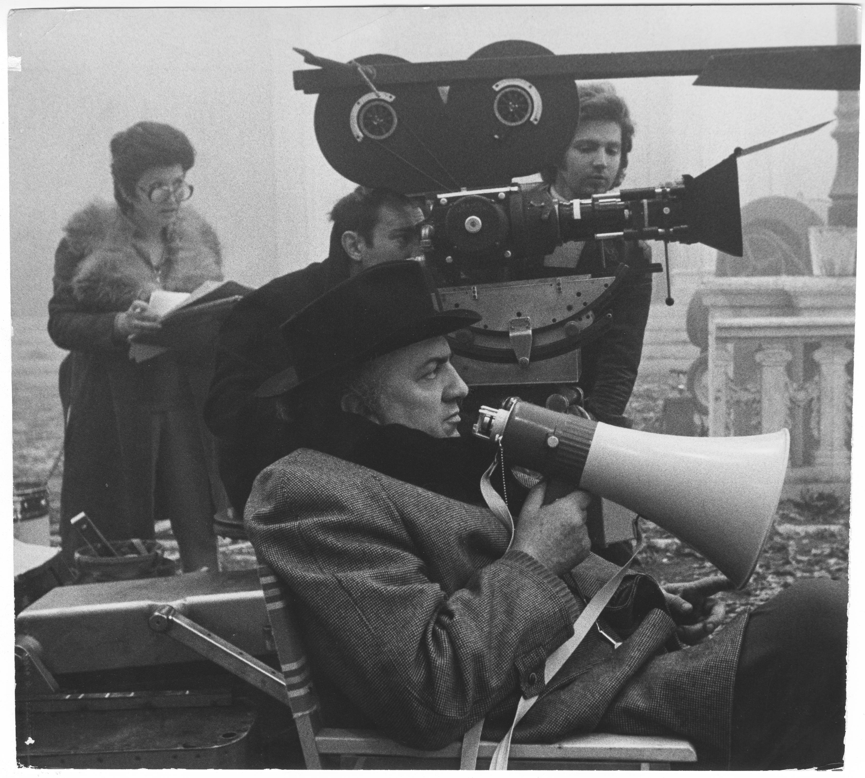Federico Fellini directs on the set of Amarcord (1973).

2018-19

M6X01898

Major Project Stage One
(M6X01898)

Level 6 module – 20 credits

Teaching is by lecture and hands-on tutorial workshop.

Lecture and Workshop: Tuesday 2pm – 5pm

Lecture and Workshop: Wednesday 9-1pm

Lecture and Workshop: Friday 12.30 – 4.30pm

Module Tutor
Timi O’Neill (timi.oneill@uwtsd.ac.uk)
Chris Buxton (chris.buxton@uwtsd.ac.uk)
Alison Franks (Alison.franks@uwtsd.ac.uk )
John Hill (john.hill@uwtsd.ac.uk )

Module Support
Kylie Boon (kylie.boon@uwtsd.ac.uk)
Adam Shailer (adam.shailer@uwtsd.ac.uk)
Room AD201

For times when the tutors are available for consultation please refer to Moodle and make an appointment. If you need to consult the course team urgently, please email the staff member concerned.

CONTENT
- Project definition

- Research opportunities, methods, and techniques

- Project synopsis

- Project treatment

- Project planning

- Target audience identification and user expectation

- Further development in project design or definition such as test recordings, proof of concept demos, scripts, real or virtual models, storyboards, etc

- Audio-visual communication techniques

- Specific to the student’s research needs, with advice and support from specialist academic staff

Module Aims and Learning Outcomes For Assessment
AIMS
Stage 1 of the Major Project offers the student an opportunity to thoroughly research a problem area and to communicate that information with intended solutions to an audience in a manner that reflects practices and standards found in industry.

LEARNING OUTCOMES
Upon the successful completion of this module, the student should be able to demonstrate the ability to:

- Identify and critically evaluate an intellectually challenging idea that would be appropriate for their Major Project.

- Communicate effectively the research areas, design solutions, technical requirements, and overall specification relevant to their Major Project idea, using contemporary methods and techniques.

Transferable Skills:
Note-taking, oral expression, research skills, communication, evaluative and analytical skills, interview, and media production.

Module evaluation:
At the end of this module, you will be asked to complete a module evaluation form.
Please refer to the anticipated learning outcomes when making your evaluation.

Timetable:
The module is taught over a ten week period, starting in week one of Semester one. Each class will last for three hours, with two classes per week.

LEARNING AND TEACHING STRATEGY

Introductory lectures will delineate the indicative content above, encouraging the depth of research and development necessary for a project of this size, duration and level. The material specific to the student’s individual research needs will be addressed through a scheduled programme of one-to-one tutorials.

BIBLIOGRAPHY

Essential
Honthaner, E. (2010) The Complete Film Production Handbook. Oxford: Focal.
Stradling, L. (2010) Production management for TV and film: the professional's guide. London: Methuen Drama

Recommended
Block, B. (2007) The Visual Story: Creating the visual structure of film, TV & digital media (2nd ed.). Oxford: Focal Press.
Brown, B. (2011) Cinematography: Theory & Practice (2nd ed.). London: Focal Press.
Cross, M. (2013) Audio Post-Production for film & television. Milwaukee: Hal Leonard Books.
Curran Bernard, S. (2010) Documentary Storytelling: Creative Nonfiction on Screen. Abingdon: Focal Press.
Dancyger, K. (2013) The Technique of Film & Video Editing (5th ed.). Oxford: Focal.
Dancyger, K. and Rush, J. (2013) Alternative Scriptwriting (5th ed.). Oxford: Focal.
Lancaster, K. (2012) DSLR Cinema: Crafting the look with large sensor video 2nd ed.). Oxford: Focal.
Mackendrick, A. (2006) On Film-Making. London: Faber.
Munroe, R. (2009) How Not To Make A Short Film: Secrets of a Sundance programmer. New York: Hyperion.
Rabiger, M. (2007) Directing: Film Techniques & Aesthetics (4th ed.). Oxford: Focal Press.
Rabiger, M. (2009) Directing the Documentary (5th ed.). Abingdon: Focal Press.
Vogler, C. (2007) The Writer’s Journey: Mythic Structure for Writers (3rd ed.). Studio City, CA: Michael Weise.
Zinnes, A. (2012) The Documentary Film Maker’s Handbook: The Ultimate Guide to Documentary Filmmaking. London: Bloomsbury Continuum.

Background
Bordwell, D. and Thompson, K. (2016) Film Art: An Introduction (11th ed.). New
York: McGraw-Hill.
Barsam, R. and Monahan, D. (2016) Looking At Movies: An Introduction To Film (5th ed.). New York: W W Norton.

Journals
Screen
Broadcast
Sight and Sound
Filmmaker
Journal Of Screenwriting

Web Sites
www.bbc.co.uk/filmnetwork/filmmaking
www.bfi.org.uk
www.creativescreenwriting.com
http://dochouse.org
http://filmmakermagazine.com
http://www.raindance.org

Students will be directed to appropriate online resources over the course of the module.

The bibliography is subject to change depending on available software and associated texts.

MODULE OUTLINE

You will be expected to conduct non-assessed tasks as part of your development on this module.

session | Lesson Theme | Activity/Notes
1 | Introduction to Module. Goal Setting. Initial Research. Assessment Negotiation | Students research and prepare brief presentations on potential Major Project
2 | Research & Development of Major Project Idea. Consultation process. Rough Pitch Draft | Students continue research and development process in consultation with academic staff and present a rough draft of their pitches
3 | The acting process (i) | Students discuss the relationship between acting and directing
4 | Visualisation | Students research, prepare and present key images to assist in visualisation of Major Project
5 | Fundraising and Feasibility | Students analyse the requirements for Major Projects, assess appropriate fundraising options and present plans for practical realisation of Major Project
6 | The acting process (ii) | Students discuss the relationship between acting and directing
7 | Stage One Finalisation | Students continue development of Major Project and prepare for Viva presentation
8 | Scheduling/Crewing Up/Production Calendar/Budgeting | Students plan production aspects of Major Project, discuss and agree schedule
9 | The acting process (ii) | Students discuss the relationship between acting and directing
10 | Presentation mocks | Students present rough drafts of the presentations
11 | Presentation mocks | Students present rough drafts of the presentations
12 | DEADLINE

This schedule is subject to change and students are advised to check Moodle for the latest module information.

ASSESSMENT

Assessment Component 1 – Viva Presentation (50%)
Each student presents his/her Major Project in a manner that simulates a ‘pitch’ in industry, where the student formally presents all the research and preparatory work together with a detailed indication of intent for the following stages.

Assessment Component 2 – Pre-Production Portfolio & Reflection (50%)
Students must create a portfolio of relevant documents prepared for the Pre-Production of their Major Project, together with reflection on the Pre-Production process. (Approx. 3000 words, 2000 words Pre-Production Portfolio, 1000 words Reflection).

Assessment Summary
Activity type | Percentage
Written Exam
Coursework | 100%
Practical
TOTAL | 100%

You will be marked against how you addressed the intended learning outcomes of the module, as shown on the Module Feedback Form at the end of this booklet, as well as on your creative, technical craft, and production skill
Coursework Submission Instructions

You must conform to the following guidelines for submitting your work:

Film and accompanying media-

- High quality MPEG 4 file(s),

- The file(s) should be in a folder with the following label structure- StudentNumber_ModuleCode_AssignmentNumber
(An example would be 130000_ CAMF6007_1),

- Films should be labelled clearly with the title of the production,

- Submission should be made via Moodle by the deadline. Check that the exported file will fit the upload limit set by Moodle.

- A copy of the film should also be submitted to the staff office by the deadline.

Written Work
- The file(s) should be in a folder with the following label structure- StudentName_StudentNumber_ModuleCode_AssignmentNumber
(An example would be JohnSmith_130000_ M6X01898_1)

- Written work must be a Microsoft Word (or PDF's for scripts and storyboards) compatible document formatted with double line spacing and include references for all third party content you have used (books, images, websites, films etc) and must conform to the School Reference Guidelines (booklet available separately). There must be a word count at the end of the document.

- Folders of mixed file formats can be submitted as an archived Zip file.

- Pre-production material must be submitted as a hard copy comb bound with a cover and contents page.
- Files should be submitted via Moodle and in hard copy to the staff office by the deadline.

DEADLINE AND FEEDBACK

Deadline (both components): 23/11/18
Feedback (both components): 18/01/19

Feedback is an essential part of University life. It helps learners to maximise their potential at different stages of training, raise their awareness of strengths and areas for improvement and identify actions to be taken to improve performance.

Feedback can be seen as informal (for example in day-to-day encounters between
Academic staff and students, between peers or between colleagues) or formal (for example as part of written or tutorial assessment). However, there is no sharp dividing line between assessment and teaching in the area of giving feedback on learning. Feedback is
part of the overall dialogue or interaction between teacher and learner, not a one-way
communication process.

During your studies you will therefore receive feedback in many ways, including the following:

Dialogue between teachers and students in formal classes.

Direct questions and responses from teachers inside and outside formal classes.

Email correspondence between teachers and students.

Interactions between students and teachers using the module message board on
Moodle.

Informal comments and responses to pitches and presentations in classes.

Comments and annotations added to written submissions, such as essays and
reflective journals.

Formal written feedback in response to assignments recorded on the summative
assessment module feedback forms.

You will have an opportunity to discuss your feedback with your tutor. Feedback will be
returned on assessed work within twenty clear working days of submission.

The following assessment forms are the basic templates for the forms that will be used in assessing your work on the module. The forms relevant to each specific assignment will be circulated directly to you as appropriate.

Notes:

