Reflection Of Learning In This Module

Contents
Introduction 3
Academic Concepts 3
A Theory Of Learning Kolb 3
Fig 1: Kalb four stages of learning 4
Technical Skills 4
Time Management 5
Creativity skills 5
Decision tree and Statistics 6
Academic writing 7
Knowledge 8
Techniques 8
Exercise 8
Conclusion 10
References 11

Introduction
The reflective report is a report that helps to determine our involvement, knowledge, and understanding in preparing such a report. The following reflective report has been generated by me to reflect my work, personal records, and to include my experiences and thoughts that I have gained during the course. This report is a reflection of what I've learned academically after completing the term and module. It has been a great experience to complete a term with a variety of things. I've achieved different skills through this module. I had many confusions and miss-conceptions on different topics previously. But completing this module has covered all of those. After completing this module I relearned things I was not clear about or things I forgot. During the course, I've gone through different challenges and overcome those by the skills I previously had. But this led me to learn a few more new things. This module helped me to understand we're never done with learning a topic. If we want to know more, we can. This report is produced in accordance with the course outline.

Academic Concepts
There are many ways to learn things. The more ways we practice, the more we realize which one is the easiest for us to learn. Thus we become more efficient learners in different contexts. To develop my learning process, this module made me try different techniques to remember topics. Through this module, I have gained different skills but I have learned more about professional life and career plans.

A Theory Of Learning Kolb
The theory of Kolb is based on a large amount of research on how people learn different things. The result of Kolb's research says that people usually learn in a cyclic pattern. Kolb suggested that, when we grow up, we tend to build preferences according to our mindset and we grow tendencies in our brain on how to learn in a certain method. But in such cases, we don't try to understand the thing we're learning. Most of the people have a preferred learning method of their own which influences their choice most of the time. Formal and informal ways are also should take into consideration while learning something new. But this should not be the way of learning something. In some cases, we should try new ways of learning instead of our preferred ways.

In this theory, Kolb mentioned four stages and stated that people are not effective with these stages always or hardly effective. From my personal experience, I understood that it is very hard and challenging to learn new things and manage time effectively. In spite of that the experience of learning that particular new thing was a delightful and efficient one. I've undertaken different challenges during the module to learn new academics and develop employability skills and made abstract conceptualization. I've experimented with learning new things going out of my preferred methods and overcome my weaknesses in learning.

Fig 1: Kalb four stages of learning

Technical Skills
I've learned how to use different software in this module. While completing my report, I'm using Microsoft Office Word and Google Docs. I knew how to use this software previously, but this time I got to learn a few more things. Besides, I getting feedbacks from my works and collecting data for the report from different online sites. This is helping me to enhance my data collecting skill. While collecting data I'm learning new things, knowing new things. All these technical skills and learnings will help me in my upcoming professional life. (Moon, 2000).

Time Management
I consider myself a lazy person. And it is really hard for a lazy person to manage time properly. I have noticed one thing from my previous reports that I can never meet the deadlines for my laziness. While writing this report of the module, I'm learning how to manage time. If one does 500 words each day of this part 2 of the report, it would take only 4 days to complete, but for my laziness, I'm doing this at the end of the eleventh hour. I'm just two days before the submission deadline and I have done only 1/4th of the report. So now I remember, while the slides were projected by the teacher of this module, they've talked about planning about work and manage the time accordingly. I've failed to do that planning. This is big learning from my class. From now on, I'll do a plan just after getting the work on hand so that I don't have to suffer much and worry about the deadlines. Even I would suggest every other student out there to follow the same strategy of doing the work on time and having a plan on that particular task before starting.

Creativity skills
In the second week of the module, the personal SWOT analysis was projected in the class. I had a little idea about personal SWOT analysis. Previously I used to consider SWOT analysis for goods only. But after that class, I understood it is really important for students like us to do the SWOT analysis of our own. By the SWOT analysis, I got to know my strong zones, weak zones, threats I might face the opportunities I have. Combining all these things I understood sometimes we need to be creative about ourselves and not only about the products. This creativity skills I’ve learned from the module will help me in my professional life. After that lesson, the slides of brainstorming were projected and I got to know the new definition of brainstorming. Previously what I used to know about brainstorming was not enough to develop my creativity. I got to know about two types of brainstorming, Group Brainstorming, and Individual brainstorming. From the discussion of brainstorming, I understood that a brainstorming done lonely creates many more ideas than a brainstorming done as a group. Individual brainstorming creates different situations and images of those situations, later on, it helps one to solve in the near future. (Perry, 1986).

Decision tree and Statistics
We human beings think about different solutions when we face a problem. From a lot of solutions, we create images of those and select the easiest we think that would be to do the task avoiding all the negative decisions we had thought of. We create an imaginary tree of different solutions to a particular problem and select one as a decision. That's a decision tree. The tree is used in decision analysis and to represent the decisions as well as making decisions visually and explicitly. In the third week of the course, the teacher presented a database analysis and design topic. Database analysis is one of those topics I am interested on. As I was familiar with the topic previously, I found it more interesting when the teacher started talking about it vastly. My previous knowledge about database analysis and design helped me to understand the topics our teacher explained in a better way. For example, a financial institution decides whether an individual should be offered a loan or not with the help of decision tree and statistics.

Academic writing
My writing skills were not really good before this module. When we were given a 2000 words report, I was tensed about how to write this. But in a class, our teacher discussed academic writing in detail. I learned a few important things from the discussion. Previously I used to think, academic writing is all about grammar and vocabulary. But that discussion broke my misconception about academic writing. I realized my writing skills are not so good because I don't practice much. I have sound knowledge about topics but yet I fail to deliver good writing because I lack practice or exercise. When this report was assigned I was pretty nervous whether I know 2000 vocabularies or not or if I will be able to complete this task perfectly. But after remembering that class I realized all I have to do is follow some technique. The hack of good academic writing is to know about the topic firstly. Then it comes to technique. One should know the technique of writing something good. Then one should practice or exercise that topic again and again until he thinks he can write more than he’s assigned. After completing all these, the final task comes, practical strategies. I think if one follows these steps, he can easily write good academic writing. (Cottrell, 2003).

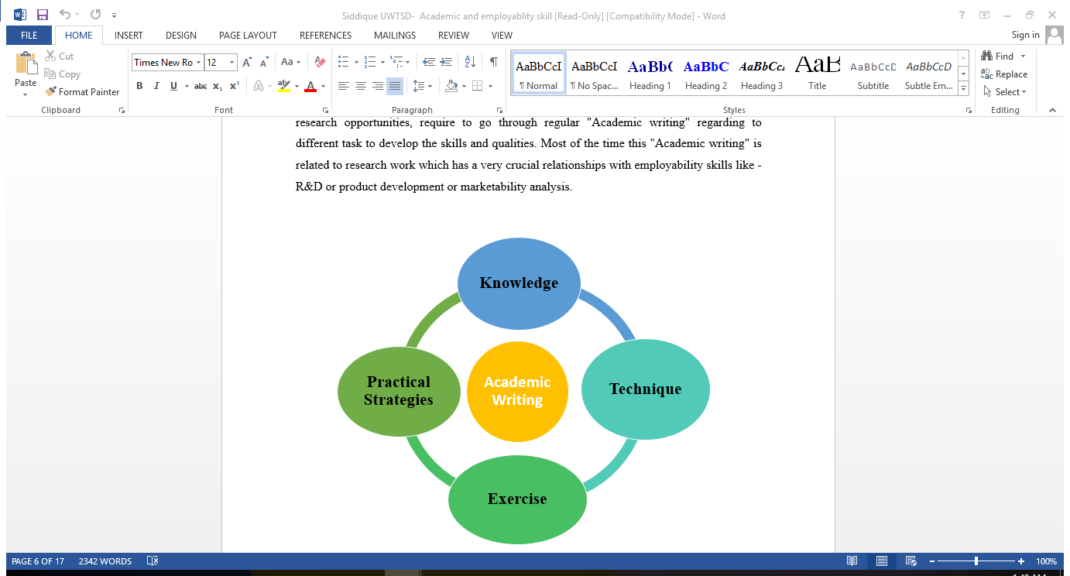
Figure 2 Academic Writing (Boud,2001)

Knowledge
I had a sound knowledge about what the employers look for in a recrute while recruiting. But I was avoiding the interpersonal aspects. But those aspects were appeared to be the most vital ones. Those aspects are the key to attain the top ladder for an organization. I had a great communication skill, good knowledge about my academics and had some good technological knowledge. But yet I was lacking some of the important aspects like public speaking, interview facing and problem-solving. Everybody in this globe wants to be successful. But only a few come successful because it's not easy to become. To become a successful man professionally, it's not enough to just some common knowledge. Besides one needs to have a great personality with some attractive skills like immediate problem solving, public speaking, etc. I've learned all these things from the module and now looking forward to obtaining these skills soon. So that I can have a better career. I got sound knowledge about how one should step forward to reach the goal. (Coffield,2004)

Techniques
Even after working a lot on my techniques, I was still facing a few problems. So I've decided to change my approach to solving problems. I need to focus on some issues like self-motivation, interest, and time management. As I have failed even after trying a lot of time, it broke my self confident somehow. So I need to motivate myself by aiming my future. Besides, developing critical thinking ability is also necessary. In this module, I learned to undertake the research practices that were dic=scussed in workshops and lectures theoretically during the course. (Coffield, 2004).

Exercise
University students are expected to think and analyze critically. This thing applies to me as I'm a university student. I have attended all the lectures of the module which helped me a lot to critically analyze my research. I got both theoretical and practical understanding by applying theories and knowledge of the books into a practical context. The theory also explained how to implement different models according to my context and prepared a whole report. The theory also taught me the methods to research practically collecting data. The understanding from the lectures also helped me in searching for various data sources.
After successfully writing this report, I learned to use examples and facts. Since my researching skills have improved considerably, it has enabled me to find sources for my future research process. It also improved my conclusive argument, clear presentation of the paper, collection of data, analysis skills which helped to write the report in an appropriate format. Compared to my skills before writing reflection, I made a huge progress (Felder, 1988).

Conclusion
Here, we are close to the end after several months of courses. The course has taught us a lot of new things and I enjoyed attending the classes. Writing this reflective essay helped me put things into retrospect. Technical skills have improved due to the course and I would like to continue practicing for surviving in the workplace. I regained some energy to overcome and fight back challenges by prioritizing important things and wisely managing my time. Time has come to act. I had fun finishing this reflective journal but still, I cannot believe that I could finally do it. I never thought that I would be able to finish it on time. I am just a few words far away to the milestone of 2000 words. During the process, it enabled me to learn many things about myself by revealing my writing skills. Finally, putting everything in reflective paper helped me to draw a perfect picture of myself that assisted me in modifying my strengths and evaluating weaknesses (Cottrell, 2003).

References
Boud, D. & Soloman, N. (Eds) (2001) Work-based Learning – A new higher education. Buckingham, SHRE/Open University Press.
Coffield, F., Moseley, D., Hall, E., Ecclestone, K. (2004), Learning Styles and Pedagogy in Post-16 Learning: a systematic and critical review, London, The Learning and Skills Research Centre (LSRC), UK
Cottrell, S. (2003), Skills for Success: The Personal Development Handbook. Basingstoke: Palgrave Macmillan.
Fanthome, C. (2004) Work Placements: A survival guide for students. Palgrave
Felder, R. M., & Silverman, L. K. (1988). Learning and Teaching Styles in Engineering Education. Eng. Education, 78(7), 674--681.
Gibbs, G. (1988), Learning by Doing: A Guide to Teaching and Learning Methods. Further Education Unit, UK
Honey, P. and Mumford, A. (1992). The manual of learning styles: Revised version. Maidenhead: Peter Honey
Kolb, D. (1984), ‘Experiential Learning: Experience as the source of Learning and Development.’ PHI, New Jersey.
Moon, J. (2000), Reflection in learning and professional development: theory and practice. London: Routledge Falmer.
Perry (1968) Patterns of development in thought and values of students in a liberal arts college.
Schon, D. (1991), Educating the Reflective Practitioner: Towards a new design for teaching and learning. San Francisco. Jossey-Bass.

