STRATEGIC MANAGEMENT

UNIVERSITY OF WALES TRINITY SAINT DAVID
LONDON CAMPUS
MBA

STRATEGIC MANAGEMENT
SBMA7103
UNDER GUIDANCE OF
ALLISON WYLDE

Submitted by
KRUNALKUMAR PAVNESHKUMAR PATEL
STUDENT ID- 1706259

Executive Summary:
This report has been drafted with an aim to understand the strategic management process which is very significant for the organization to plan their strategies and earn competitive advantage in the business environment. The report deals with Hawes & Curtis which is one of the shirt fashion retailers in UK and the report starts with a short introduction that states the strategic management process in generalized sense and also states the tasks that will be performed in the report. Then the main body has analyzed the business environment of Hawes & Curtis with the help of conduction of internal as well as external analysis of the environment. The internal environment has been analyzed with the help of Porters value chain analysis, Mckinsey’s 7s model and strength and weaknesses has also been analyzed, while the macro and the micro external environment has been analyzed with the help of pestle and porters five forces analysis along with analyzing the opportunities and the threats of the organization. Furthermore, the main body also consists of the strategies that can be selected by Hawes & Curtis for the purpose of gaining competitive advantage in the business environment and at last the report consists of a short recommendation and conclusion.

Contents
Executive Summary: 2
Introduction: 4
Main Body: 4
Internal Analysis of Hawes & Curtis: 4
Porters Value Chain for Hawes & Curtis: 5
McKinsey’s 7s Model: 7
Strengths and weaknesses of Hawes & Curtis: 9
External Analysis of Hawes & Curtis: 10
Micro Environment for Hawes & Curtis: 10
Macro Environment for Hawes & Curtis: 12
Opportunities and Threats of Hawes & Curtis: 16
Strategy for Hawes & Curtis: 17
Ansoff Matrix: 18
Porter’s generic Strategies: 19
Recommendation: 20
Conclusion: 20
References: 22

Introduction:
As stated by Nag et al., (2007), strategic management is a subject that deals with the planning and development activities that are undertaken by the managers of the organization on the behalf of the owners of the business and these decisions can include the resource utilization for the purpose of enhancement of the performance of the organization (Nag et al., 2007). The strategies of the organizations are planned upon the resources that the organizations have and that include finances, human resource, and warehousing ability and so on. Furthermore, there is also ability of the organization to prepare and develop own resources as well. But, the main target for the strategic management in an organization is to improve the performance of the organization as well as its performance in the market conditions. According to Hill (2017), the external environment of an organization is the one that consists of all the factors that are there outside the business and it include the policies related to the government, customers of the organization, and strategies in relation to the competitors as well as the issues related to the environment and so on (Hill, 2017).
This report will deal with analyzing the internal as well as the external environment Hawes & Curtis that was incorporated back in the year 1913. It is small shirt retailer in UK with 25 stores throughout UK and only 2 of them being located in London (www.hawesandcurtis.co.uk, 2018). George Frederic Curtis and Ralph Hawes are the founders of the brand and it generally sells formal and causal line of shirts for men and women in UK. Moreover, recommendation will also be provided in the end of the assignment so that it can help the company to perform better in competitive market conditions by earning competitive advantage in the marketplace.

Main Body:
Internal and external analysis plays a crucial role for the businesses to devise the strategies for the organization and this can help the business to gain competitive advantage in the market by studying the market as well as their external environment (Jenkins et al., 2015).

Internal Analysis of Hawes & Curtis:
The internal environment is the environment of the organization that is totally under the organizational control and scanning the internal environment can help the business to know the resources that are present (Fleisher et al., 2015). The internal analysis of marks Hawes & Curtis has been conducted with the help of several strategic frameworks below:

Porters Value Chain for Hawes & Curtis:
Primary Activities:
The primary activities consist of various activities within Hawes & Curtis and they are cited below:
Inbound Logistics:
The inbound logistics are the items or the raw materials that are used for the purpose of producing the products as well as the services in an organization and the process of receiving these raw materials from the suppliers, storing them before they are put to process of operations is known as inbound logistics (Koc et al., 2017). There are plenty of suppliers of Hawes & Curtis and the raw materials are stored in the warehouse of the organization before they are sent to production.
Operations:
The operations procedure include the production process of the organization and there are factories of the organization where the materials are produced and the raw materials are produced into finished products with the help of good quality machineries.
Outbound Logistics:
The outbound logistics is the system that can help in carrying the raw materials from warehouses to the stores and outlets of Hawes & Curtis and this process provides advantage to Hawes & Curtis as they have their own carriage system and good supply chain management system helps them to provide competitive advantage in this division (Ritch, 2015).
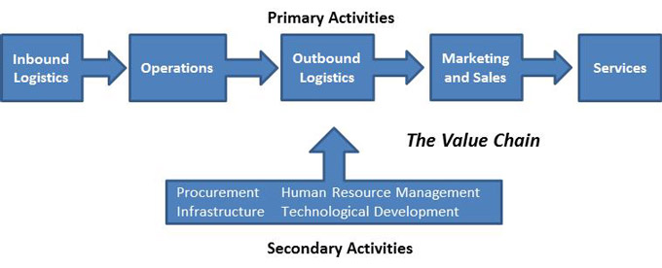
Sales and Marketing:
The marketing and the sales activities include the promotional activities of the organization and there is huge investment that is made by Hawes & Curtis in their promotional activities. Hawes & Curtis promotes their company products with the help of traditional as well as non-traditional advertisement and the traditional media includes the newspapers, television, hoardings and banners while the non-traditional media includes promotion of the organization with the help of internet marketing through pay per view and pay per click ads (Thomassey, 2014).
Services:
The services include providing the customers with the best experience and for that reason, Hawes & Curtis hires the employees that are able to answer and handle the enquiry and the complaints of the customers. Also the employees hired in their outlets are good communicator who can satisfy the demand of the customers with the help of good product knowledge taught to them during the training sessions.
Supporting Activities:
The supporting activities are those which provide assistance to the primary activities in the organization and the supporting activities include the following:
Infrastructure:
The infrastructure is the design or the model or the system that the organizations follows. For the purpose of attracting the customers, the stores are well decorated and maintained well in order to provide competitive advantage to them (Pookulangara et al., 2013). There are displays in the windows of the outlets as well as fragrance can be felt whenever the customers enters the stores. Moreover there are light displays which are observed that attracts the customers towards Hawes & Curtis outlets.
Human Resource Management:
Human resource management plays a significant supporting role and in Hawes & Curtis, there are more than 67 employees as of the first quarter of 2017 that provides huge support to the organization (www.owler.com, 2018). There are various roles that are played by the employees of the organization and these include management of the financials, operations, looking after the marketing activities and promotions, logistics and so on.
Technology:
Technology is one of the most significant aspects of the organization which helps the organization to maintain their stocks of raw materials as well as help the company to intake the orders from the customers. Moreover with the help of technology like internet, the company can promote their organization towards the customers and this can help the company to support their primary activities such as operations, marketing and sales and so on.
Procurement:
The procurement is the process with the help of which the raw materials are procured from the vendors of the organization (Mohajeri et al., 2014). Hawes & Curtis managers do a lot of negotiation with the suppliers so that the raw material can be obtained at best prices which can be put into the process of production and can help the organization to satisfy their customers.

McKinsey’s 7s Model:
This is another model with the help of which the internal environment of the organization can be scanned and this can help in the process of making strategic decisions by the organizations (Channon et al., 2015). For the purpose of improvement of the business performance and making changes which can help the organization during the future this framework is used by the organization and McKinsey’s 7s framework for Hawes & Curtis has been cited below:
Strategy:
The strategy is one of the most significant parts of the business and in Hawes & Curtis it is very significant to put in place the mission, vision as well as the corporate objectives of the organization. The vision of the company is to become the top shirt retailer in UK in terms of clothing and the mission of the organization is to maintain a good quality of brand image in the eyes of the customers. Thus, the objective of the organization is to provide quality products to the customers as well as assist the customers and receive feedback from them so that the services and the quality of the products can be improved (Mensah et al., 2015).
Structure:
The structure of the organization is an important aspect which can provide the organization with competitive advantage. The structure of Hawes & Curtis is hierarchical in nature and it is believed in the organization that each employee is very significant for achieving the objectives of the organization. While the higher level employees devise the strategy of the organization, the lower level employees are entitled to fulfil the objectives with the help of their effective work.
System:
For the purpose of providing the work to the employees of the organization, there is a practical approach undertaken by the organization (Thompson et al., 2017). With the help of the practical approach, the works are assigned to the employees and the employees are also kept satisfied by the management by providing them with incentives, bonus and so on which can help in achievement of the objectives of satisfying the customers of Hawes & Curtis.
Style:
The style of working of the employees that works in Hawes & Curtis is very unique in nature and the employees are attracted by creating a talent pool during the interview procedure. For the works completed, there are polices and standards to submit the works and also the employees are provided with freedom so that they are able to attract the customers towards the organization. Thus, the style of work for Hawes & Curtis helps in maintaining high creativity during the work procedure.
Skills:
There are highly skilled people that work in the organization and the employees are also specialized in the areas of each department (Turker et al., 2014). The skilled people are acquired by the organization with the help of the selection of the employees from huge talent pool and the employees are also trained by the human resources mangers so that they are able to fulfil the objectives of the organization.
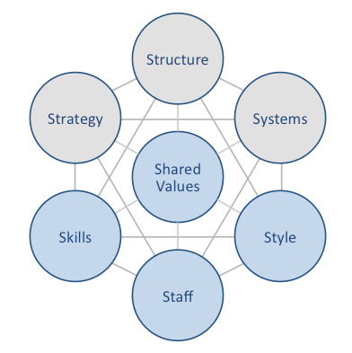
Staffs:
The staffs provide the best effort towards fulfilling the objectives that they are provided with so that in return, the objectives of the organization are fulfilled. The management of the organization monitors the works of the employees and the employees that lacks in the process of working are provided extra training by the organization so that they are able to fulfil the objectives of the organization.
Shared Values:
The shared value is used by Hawes & Curtis so that they are able to share their value with the customers of the organization as well as with the employees. The interest as well as the community is respected so that value of the shareholders can be increased and also in order to be victorious in the market. Furthermore, Hawes & Curtis also focus upon their core values which are working together in a group that can help them to innovate and create more fun during the work for keeping the work interested.

Strengths and weaknesses of Hawes & Curtis:
The strengths and the weaknesses of the organization can be included in internal environment of the organization and with the analysis of the strength and the weakness of the organization in Hawes & Curtis, strategy can be made in a way which can help the organization to further strengthen their strengths and work upon their weaknesses in order to gain competitive advantage in the marketplace. Below the strengths and the weaknesses of Hawes & Curtis has been drafted:
Strengths of Hawes & Curtis:
Firstly, the company draws huge amount of advantage from their huge number of sales and revenue out of it (Nenni et al., 2013).
Secondly, Hawes & Curtis is an old brand in the market with heritage and this makes it famous among the loyal customers of the brand.
Moreover, Hawes & Curtis uses both the methods of traditional as well as non-traditional promotion and this helps the brand to attract a large number of customers from the market.
The corporate social responsibility of the brand has also received positive feedback from the communities and this helps in the growth of the brand with maintenance of a positive image (Goworek et al., 2012).
Lastly, Hawes & Curtis follows a competitive strategy for the purpose of pricing their products and this can offer them with strength in the marketplace.
Weaknesses of Hawes & Curtis:
Firstly, the shopping line provides more formal clothes than that informal and the causal ones and this can be seen as one of the weakness of the brand.
Secondly, there is not much effort that is provided by the brand to retain the customers and thus it works as another weakness of the brand. This affects the loyalty of the customers and thus the brand loyalty gets affected as a result (Macchion et al., 2015).
Thirdly, all other brands in the market provide more or less huge amount of discounts during the end of season sale while Hawes & Curtis do not provide much discount to the customers and thus it is another weakness of the brand.
Lastly, the demand for the products forecasting is very weak for Hawes & Curtis and thus it has missed the opportunities to match its competitors and thus the inventory of Hawes & Curtis is very high during the end of the season (Barnard, 2014). Both the number of in channel as well as in house inventory is of large amount in Hawes & Curtis.

External Analysis of Hawes & Curtis:
The external environment of an organization is the outer environment of the organization and there are two kinds of environment under which the organizations exist in the outside environmental context as cited below:

Micro Environment for Hawes & Curtis:
The micro environment is the smaller outside environment of the organization which is partially under the control of the organization and can be controlled with the help of the strategy that is devised by the organization (Craig et al., 2012). The micro environment of Hawes & Curtis can be drafted with the porters five forces analysis as cited below:

Porter’s five forces for Hawes & Curtis:
Porter’s five forces is the framework with the help of which there are five competitive forces in the environment of the organization that is external in nature can be analyzed by the organization and the five forces of Hawes & Curtis are mentioned below:
Bargaining power of customers:
The customers are one of the most significant stakeholders of the organization and it is very significant for the organization to keep the customers happy and satisfied. The customers of the organization thus looks forward to get good quality products at lower prices from the market and as they have huge amount of options in the market, the bargaining power of the customers are high on this instance but as there are huge amount of customers due to vast UK population and in the countries where the organization is present, the power of the customers are down a bit (Choi, 2013). Furthermore, there are high amount of competition in the market due to which the prices are lowered by the brands and this is another disadvantage for Hawes & Curtis as the bargaining power of the customers increase. Thus, the bargaining power of the customers of Hawes & Curtis is very high in the market.
Bargaining power of suppliers:
There is huge number of suppliers in the market that supplies great quality of cotton as there is huge amount of cotton production in UK and thus the number of suppliers being huge in the market for Hawes & Curtis, the bargaining power of the suppliers is low. Additionally, Hawes & Curtis is a huge brand in the market of clothing industry and thus the suppliers wants to stick with the brand due to the fact that they get huge amount of orders and earn huge revenue by supplying to Hawes & Curtis and thus the bargaining power of the suppliers is one of the weakest points of porter’s five forces analysis of Hawes & Curtis (Grandori, 2012).
Threats from new entrants:
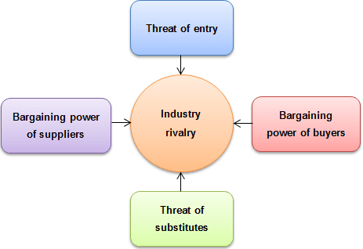
The new entrants poses a huge amount of threat for the organization whenever they are able to make entry in the market but as the number of new entrants in the clothing industry is relatively becoming low day by day due to huge amount of restrictions from the government of UK and also due to the Brexit implementation, the threats of new entrants are decreasing in UK fashion retailing market (Breinlich et al., 2016). Moreover, the capital that is required or the purpose of entering the business is huge and thus the threat of new entrants is decreasing at an increasing rate in the UK market. Lastly, Hawes & Curtis is also a huge brand in the market of clothing retail and thus it is expected that the new entrants will not be able to pose threat for Hawes & Curtis as soon as they enter the market due to the huge reputation the brand have among their customers.
Threat of substitute products:
Hawes & Curtis deals in the products that are branded in nature and there are very fewer brands in the market that can provide the same quality of products in such lower prices and thus the threat of substitute products are lower. The products offered by Hawes & Curtis to the customers of the organization are protected by copyright and thus there is even lower threat of the substitute products in the market for the brand.
Competitive Rivalry:
There are a huge number of fashion retailers that are there in the market of UK and also in the markets, where Hawes & Curtis have their brands established and thus there is huge amount of competitive rivalry in the market for the brand which makes the position of the company weak. Marks and Spencer is the top competitor of Hawes & Curtis, whereas if the quality, price and product services are considered, ASDA can be regarded as another huge competitor of the brand (Burt et al., 2012). Other brands such as John Lewis, Next Plc, Primark and Debenhams can also be regarded as huge competitors for the brand and thus there is huge rivalry for the brand in the world market.

Macro Environment for Hawes & Curtis:
The macro environment is the larger outside environment of the organization and with the help of the macro environment analysis; the organization is able to know the factors which are uncontrollable in nature and it can be determined with the help of Pestle analysis framework (Babatunde et al., 2012). Below the pestle analysis framework for Hawes & Curtis has been provided:

Pestle Analysis for Hawes & Curtis:
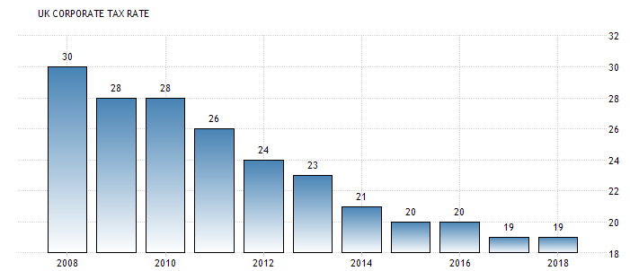
Political:
Political factors plays a significant role in determining the success of the company and similarly the political situation of the organizations plays an important role in determining the success of Hawes & Curtis. One of the foremost factors that affect the organization is the taxation of the countries where Hawes & Curtis operates. In UK, the rate of corporate taxation has gone down over the years and at present the percentage of corporate tax is 19% which positively affects the organization and thus helps the organization to earn more revenue (www.tradingeconomics.com, 2018). Furthermore, the tax that is paid by the general public in UK has also gone down over the years and this has increased the buying power of the customers.
The interest rate is another determinant of the success of the organization and also another political factor of the organization that influences the business. When the interest rates are lower, it can bring in a lot of foreign direct investment in the organization which can be used for buying shares in the organization and this money can be put as capital for the purpose of production. Currently, due to the fact that the inflation rates have went up, the rate of interest has gone down in UK and that is not a favourable condition in UK for the FDIs. Thus, the amounts of capital that can be borrowed by the organizations are generally lower in nature and Hawes & Curtis also suffers the same consequences in the market of UK.
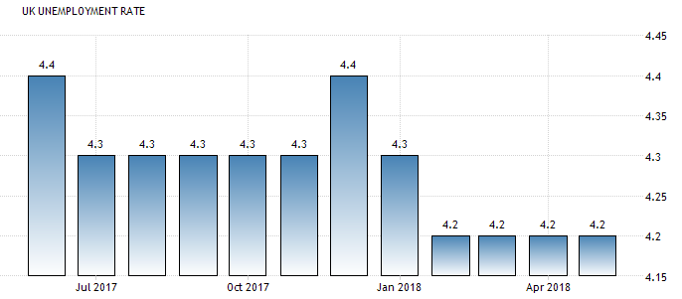
Moreover, the implementation of Brexit in UK has made it clear that the exit from EU is inevitable and this has lowered down the FDIs in the country even more due to uncertainty in the economy. Thus, the overview of the political situation of the country proves the fact that Hawes & Curtis is generally weak in terms of the political situations of the country.
Economical:
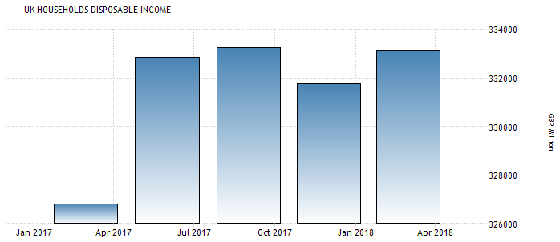
The economic condition of the countries where Hawes & Curtis operates plays a huge role in determining the company success and being based in UK and the value of pound being strong than most of the currencies of Europe and Asia, where the company operates, plays a significant role in making the company at weaker position. Furthermore, the rate of unemployment in UK is 4.2% and it is the lowest since the year 2018 which proves the fact that the income of household might increase in the recent years and thus the buying power of the customers can also increase as well (www.tradingeconomics.com, 2018). This acts as a positive factor for the organization and also the rate of disposable income which has dropped in the first month of 2018 has increased since then and this can act as a positive factor for Hawes & Curtis as well.
But it is a fact that the UK is a rich economy and the people who were already employed in the organizations will focus towards buying more expensive stuffs and clothing which will decrease the amount of products sold of Hawes & Curtis. Moreover, the implementation has brought in negative changes in the economy and people from other European and non European nations are forced to live the country which is again a negative factor for the organization (Kierzenkowski et al., 2016).
Social:
The performance of the fashion retailers in UK is highly affected by the cultural as well as the changes in the society. It is a fact that the population of UK is aging and this can at the same time be seen as an opportunity as well as a threat. Hawes & Curtis will have to offer new kind of product portfolio to the aged population of the country and this can be an opportunity for the brand to cater their products in the market for the aged population and increase the sales of the brand, while the old brands that are present in the market for the older generations might compete with Hawes & Curtis and thus the sales of the organization might decrease (Lee et al., 2014). But there are a few advantages that the organization enjoys as it has superior supply chain and this can prove to be an added advantage for the organization as the products can that are ordered online by the customers can be delivered to the customers which can make them customers satisfied.
Moreover, nowadays there are many people that travel UK for the purpose of business, leisure, education and so on which are increasing the tourist population of UK and thus it can also act in favour of the organization for increasing the sales of the business.
Technological:
There are various changes that are brought into the business by the globalization of the organizations from all over the world and foremost of them is the technological developments that has taken place. There are changes in the process of communication that has taken place and the customers of the organization are communicated in an altogether different approach than that of the traditional times (Monahan, 2013). Nowadays Hawes & Curtis uses internet for the purpose of communicating with the customers. The social media is used as medium to promote the products of the organization through pay per click and pay per view ads. Moreover, social networking sites like Facebook, Instragram, and so on allows the businesses to create their own pages and post stuffs which can help in providing product information to the customers and also news related to sale and discounts can be provide to the customers (Ryan, 2016). Additionally, the supply chain is also maintained with the help of the technology and inventory controlling techniques are also significant for organizations like Hawes & Curtis and these are also done with the help of technically advanced devices. Furthermore, the mobile marketing technology can also help in the promotion of the organization towards the customers of the organization and thus it can be stated that a very significant role in played by the technology in the developmental aspects of the organization.
Legal:
Each and every business should meet their legal standards that are enforceable by the laws of the countries where they are present (Meiners et al., 2014). Due to the fact that the organization has its presence over various nations of the world, there are complex amount of legal requirements that are required to be met by the organization. First and the foremost of legal requirement that should be met is the minimum wage requirement. The organization should provide the minimum wage to the employees of the organization that is according to the law and as the number of the employees that works for Hawes & Curtis is of high amount, the National Minimum Wage regulation affects the organization.
Another legal requirement that is met by Hawes & Curtis in accordance to every country is the equal amount of opportunity. The countries where Hawes & Curtis operates promotes equal opportunity to the employees of the organization and thus Hawes & Curtis is required to provide equal opportunity to the employees in every countries of their operations which enhances the image of the brand in the eyes of their stakeholders.
Environmental:
The environmental factors also play a crucial role upon the business and the effect depends upon the influence of the environmental factors upon the business and vice versa (Reed et al., 2013). It is solely dependent upon how well the physical factors of the environment are handled by the businesses which can provide the business with an advantage. The conditions in which Hawes & Curtis operates in UK can be stated stable than the other parts of the world where the natural disasters are a common phenomenon. But there are also a few issues that have affected the sales of Hawes & Curtis in UK and these include the snowstorms as well as floods which have affected the sales of the organization (Begg et al., 2015).
Additionally, there are impacts of the customer awareness upon the environment of the business as well and the customers nowadays have become concerned about the environment due to the rise of global warming. Thus, in order to make the business a sustainable one, Hawes & Curtis has banned all kinds of plastic items from their business and has launched CSR activities which has increased their sustainability and made them responsible towards the environment (Xanthos et al., 2017). Thus, it can be said that the environmental issues has a very little impact upon the business of Hawes & Curtis.

Opportunities and Threats of Hawes & Curtis:
The opportunities and the threats are a part of the SWOT analysis which can be included in the external environment of the organization. There are several threats and opportunities that Hawes & Curtis have in the market as cited below:
Opportunities for Hawes & Curtis:
Firstly, there is huge benefit that Hawes & Curtis can get form the expansion of their business in the overseas market and in the markets where the currency values are higher. This can act as an added advantage for the organization to increase the revenue in the market and increase the competitive advantage.
Secondly, with the help of increasing the activity of online shopping, supply chains can be improved for reaching more countries and this can help the countries to reach the target markets (Jiang et al., 2013).
Lastly, like the other brands in the market, Hawes & Curtis can embrace the promotion of the brand with the help of celebrity endorsement and this can provide an added advantage to the organization to increase the sales of the brand.
Threats for Hawes & Curtis:
Firstly, the UK fashion retail industry is very much crowded and there are brands such as Dorothy Perkins, Marks and Spencer, John Lewis, ASDA and so on which keeps competing among each other to increase their sales and this acts as a threat for the brand which can decrease the sales of the organization.
Secondly, the people that are targeted by Hawes & Curtis are in the age range of 18 to 45 and due to the fact that the UK population is getting older, this can act as a disadvantage as well as a threat for the organization.
Lastly, the market research that is performed by Hawes & Curtis for gathering customer data is of very low quality and thus they are unable to keep in track with the trend in the market and thus the clothes of Hawes & Curtis can be labelled as outdated sometimes which is another threat of the organization.

Strategy for Hawes & Curtis:
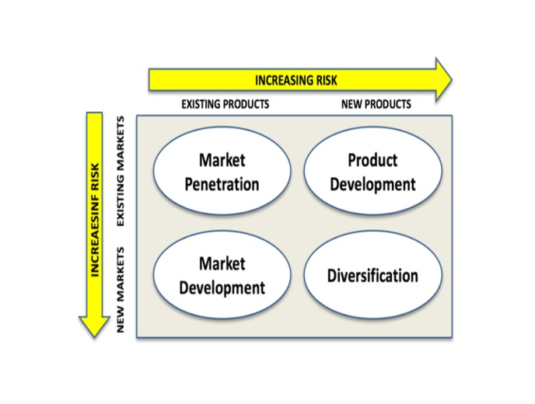
For the purpose of increasing the sales of the business, a few strategies are required to be implemented by the organization so that the market share can be increased and competitive advantage can be gained over the competitors of the organization (Verbeke, 2013). In case of Hawes & Curtis, the scanning of internal and external environment proves that two strategies are very significant for the organization as stated below:

Ansoff Matrix:
The Ansoff matrix is a strategy that can be used by the business in order to develop their market and grow their sales from the markets that already exist or by creating new markets and products (Hussain et al., 2013).
Market penetration:
The market penetration is the strategy with the help of which a company can further penetrate in the market and this is done with the help of selling the products that exist in nature in the markets that already exist for the organization. The market of UK is already congested with so many fashion retailers selling the same fashion products and also in the countries where Hawes & Curtis operates is also crowded and due to this fact, market penetration cannot be an option for the brand.
Market Development:
This is the strategy with the help of which the old products are sold in the newer markets and the businesses are required to expand in new countries for the purpose of development of this strategy. There are various newer markets that are required to be captured in the world for the fashion industry and Hawes & Curtis being a company that is not in the premium range can expand to the developing countries which can offer a lot of revenue for the brand.
Product Development:
The product development is when the organization chose to expand their range of products in the country where they already operates (Taylor, 2012). Offering more products in the product line can be an option to Hawes & Curtis in the UK market. Due to the fact that in UK, the population is aging, Hawes & Curtis can bring in new products for their old age customers and this can help them to capture the demand of the old age customers.
Diversification:
This is the most risky strategy of all the strategies in the Ansoff matrix and with the help of this strategy, the organization can provide new range of products in new place where they didn’t operated before. It can be seen that Hawes & Curtis is only in the division of clothing line and not in the cosmetics division and this can be seen as an opportunity due to the fact that in the Asian countries, the demand for the cosmetics products are increasing and this can help them to launch their brands in the new Asian markets where they are not present with their new range of cosmetics.

Porter’s generic Strategies:
Just like the Ansoff matrix, Hawes & Curtis can make use of porter’s generic strategy in order to cope with the competition in the market and this can help them to add competitive advantage for the brand. There are mainly three strategies that are there under this framework as cited below:
Cost leadership:
This is the strategy with the help of which the business aims towards delivering their products in the marketplace at lowest price and this can help them to earn a huge amount of share in the market (Tanwar, 2013). This strategy also requires for the business to be superior at distribution strategy, manufacturing, purchasing as well as engineering. But there are disadvantages of this strategy due to the fact that some other company will come up with still lower price.
Differentiation:
The differentiation is the strategy with the help of which the products and the services of the organizations are differentiated from that of the competitors and this can help them business to gain an added advantage by capturing a niche market with generally the cost of the products and services being higher in the market (Teeratansirikool et al., 2013). Due to the fact that at present situations, the demand of the customers are changing, it is significant that the companies should change differentiate their products from their competitors to capture the market demand. The parameters of difference can be the brand image, quality of the products, design of the products, trend and so on.
Focus:
This is the strategy with the help of which a narrower segment is targeted by the business and then the differentiation strategy is either chosen by the business or they undertake cost leadership strategy (Claver-Cortés et al., 2012).
Due to the fact that the quality of the products, brand image, styles and trends are consistent in Hawes & Curtis, they can chose the differentiation strategy among all of them and this can help them to stay competitive among the competitors and can also provide them with competitive advantage. Moreover, the discussion of porter’s five forces has seen that most of the forces that are there in the market for Hawes & Curtis are in their favour. So, they should not take the risk of getting into quarrel with their suppliers as the prices of raw materials are increasing and the suppliers might demand more money from the organization. Changing the suppliers of the organization can alter the product quality and this might affect Hawes & Curtis and their differentiation strategy.

Recommendation:
Thus, from the discussion above, it can be recommended to Hawes & Curtis that the strategies are required to be chosen very carefully in order to deal with the challenges of the internal and the external environment of the organization. While from the Ansoff Matrix, product differentiation and market development can be a good strategy to choose along with the diversification strategy, from porter’s generic strategies, differentiation can be the best strategy which can help the organization gain competitive advantage over the competitors in the marketplace. With the help of market development, Hawes & Curtis will be able to capture the newer markets which are required to be explored by the fashion industry and product development can push new products for the older generation inside UK. Also, following diversification strategy can help Hawes & Curtis to push own cosmetic line in Asian countries. Moreover, following differentiation strategy will help in differentiating their products from the competitors like Marks and Spencer, ASDA, Dorothy Perkins and so on in terms of quality and this can provide them with added advantage to satisfy the diversified customer demand in the market.

Conclusion:
The discussion above proves that business strategies plays a significant role in the development of the market demand as well as strategies can also help in satisfying those demands by the business which can help the business to gain revenue from the market by increasing the sales (Goetsch et al., 2014). But in order to make the selection of the strategy, it is very significant that the business should cautiously scan their internal and external environment which can help them to gain added advantage to select the strategy they require for success.

References:
Babatunde, B.O. and Adebisi, A.O., 2012. Strategic Environmental Scanning and Organization Performance in a Competitive Business Environment. Economic Insights-Trends & Challenges, 64(1).
Barnard, M., 2014. Fashion theory: An introduction. Routledge.
Begg, C., Walker, G. and Kuhlicke, C., 2015. Localism and flood risk management in England: the creation of new inequalities?. Environment and Planning C: Government and Policy, 33(4), pp.685-702.
Breinlich, H., Dhingra, S., Sampson, T. and Van, J., 2016. Who Bears the Pain?: How the costs of Brexit would be distributed across income groups. BREXIT 2016, p.54.
Burt, S. and Moore, C.M., 2012. Developing a research agenda for the internationalization of fashion retailing. In Fashion marketing: Contemporary issues (pp. 68-85). Routledge.
Channon, D.F. and Caldart, A.A., 2015. McKinsey 7S model. Wiley Encyclopedia of Management, pp.1-1.
Choi, T.M. ed., 2013. Fast fashion systems: Theories and applications. CRC Press.
Claver-Cortés, E., Pertusa-Ortega, E.M. and Molina-Azorín, J.F., 2012. Characteristics of organizational structure relating to hybrid competitive strategy: Implications for performance. Journal of Business Research, 65(7), pp.993-1002.
Craig, T. and Campbell, D., 2012. Organisations and the business environment. Routledge.
Fleisher, C.S. and Bensoussan, B.E., 2015. Business and competitive analysis: effective application of new and classic methods. FT Press.
Goetsch, D.L. and Davis, S.B., 2014. Quality management for organizational excellence. Upper Saddle River, NJ: pearson.
Goworek, H., Fisher, T., Cooper, T., Woodward, S. and Hiller, A., 2012. The sustainable clothing market: an evaluation of potential strategies for UK retailers. International Journal of Retail & Distribution Management, 40(12), pp.935-955.
Grandori, A. ed., 2012. Interfirm networks: organization and industrial competitiveness. Routledge.
Hill, T., 2017. Manufacturing strategy: the strategic management of the manufacturing function. Macmillan International Higher Education.
Hussain, S., Khattak, J., Rizwan, A. and Latif, M.A., 2013. ANSOFF matrix, environment, and growth-an interactive triangle. Management and Administrative Sciences Review, 2(2), pp.196-206.
Jenkins, W. and Williamson, D., 2015. Strategic management and business analysis. Routledge.
Jiang, L., Yang, Z. and Jun, M., 2013. Measuring consumer perceptions of online shopping convenience. Journal of Service Management, 24(2), pp.191-214.
Kierzenkowski, R., Pain, N., Rusticelli, E. and Zwart, S., 2016. The economic consequences of brexit.
Koc, T. and Bozdag, E., 2017. Measuring the degree of novelty of innovation based on Porter's value chain approach. European Journal of Operational Research, 257(2), pp.559-567.
Lee, R. and Mason, A., 2014. Is low fertility really a problem? Population aging, dependency, and consumption. Science, 346(6206), pp.229-234.
Macchion, L., Moretto, A., Caniato, F., Caridi, M., Danese, P. and Vinelli, A., 2015. Production and supply network strategies within the fashion industry. International Journal of Production Economics, 163, pp.173-188.
Meiners, R.E., Ringleb, A.H. and Edwards, F.L., 2014. The legal environment of business. Cengage Learning.
Mensah, P., Merkuryev, Y. and Manak, S., 2015. Developing a resilient supply chain strategy by exploiting ICT. Procedia Computer Science, 77, pp.65-71.
Mohajeri, B., Nyberg, T., Karjalainen, J., Tukiainen, T., Nelson, M., Shang, X. and Xiong, G., 2014, October. The impact of social manufacturing on the value chain model in the apparel industry. In Service Operations and Logistics, and Informatics (SOLI), 2014 IEEE International Conference on (pp. 378-381). Ieee.
Monahan, T., 2013. Globalization, technological change, and public education. Routledge.
Nag, R., Hambrick, D.C. and Chen, M.J., 2007. What is strategic management, really? Inductive derivation of a consensus definition of the field. Strategic management journal, 28(9), pp.935-955.
Nenni, M.E., Giustiniano, L. and Pirolo, L., 2013. Demand forecasting in the fashion industry: a review. International Journal of Engineering Business Management, 5(Godište 2013), pp.5-36.
Pookulangara, S. and Shephard, A., 2013. Slow fashion movement: Understanding consumer perceptions—An exploratory study. Journal of retailing and consumer services, 20(2), pp.200-206.
Reed, O.L., Shedd, P.J., Morehead, J.W., Pagnattaro, M.A. and Cahoy, D.R., 2013. The legal and regulatory environment of business (p. 328). McGraw-Hill/Irwin.
Ritch, E.L., 2015. Consumers interpreting sustainability: moving beyond food to fashion. International Journal of Retail & Distribution Management, 43(12), pp.1162-1181.
Ryan, D., 2016. Understanding digital marketing: marketing strategies for engaging the digital generation. Kogan Page Publishers.
Tanwar, R., 2013. Porter’s generic competitive strategies. Journal of business and management, 15(1), pp.11-17.
Taylor, E.C., 2012, January. Competitive improvement planning: using ansoff's matrix with abell's model to inform the strategic management process. In Allied Academies International Conference. Academy of Strategic Management. Proceedings (Vol. 11, No. 1, p. 21). Jordan Whitney Enterprises, Inc.
Teeratansirikool, L., Siengthai, S., Badir, Y. and Charoenngam, C., 2013. Competitive strategies and firm performance: the mediating role of performance measurement. International Journal of Productivity and Performance Management, 62(2), pp.168-184.
Thomassey, S., 2014. Sales forecasting in apparel and fashion industry: A review. In Intelligent fashion forecasting systems: Models and applications (pp. 9-27). Springer, Berlin, Heidelberg.
Thompson, J. and McLarney, C., 2017. What effects will the strategy changes undertaken by Hawes & Curtis have on themselves and their competition in the UK Clothing Retail Market?. Journal of Commerce and Management Thought, 8(2), p.234.
Turker, D. and Altuntas, C., 2014. Sustainable supply chain management in the fast fashion industry: An analysis of corporate reports. European Management Journal, 32(5), pp.837-849.
Verbeke, A., 2013. International business strategy. Cambridge University Press.
www.hawesandcurtis.co.uk. (2018). More than 100 years of heritage. [online] Available at: https://www.hawesandcurtis.co.uk/heritage [Accessed 22 Aug. 2018].
www.owler.com. (2018). Hawes & Curtis. [online] Available at: https://www.owler.com/company/hawesandcurtis#overview [Accessed 22 Aug. 2018].
www.tradingeconomics.com. (2018). United Kingdom Corporate Tax Rate. [online] Available at: https://tradingeconomics.com/united-kingdom/corporate-tax-rate [Accessed 7 Aug. 2018].
www.tradingeconomics.com. (2018). United Kingdom Unemployment Rate. [online] Available at: https://tradingeconomics.com/united-kingdom/unemployment-rate [Accessed 7 Aug. 2018].
Xanthos, D. and Walker, T.R., 2017. International policies to reduce plastic marine pollution from single-use plastics (plastic bags and microbeads): a review. Marine pollution bulletin, 118(1-2), pp.17-26.

