
KGF cONSTRUCTION
Introduction to Web and Database Concepts HTML & CSS Web Development

Sameeran Raveenthiran
Student Number: 2114454

Table of Contents
Introduction 2
Requirements 2
Implementation 4
Validation 9
Evaluation 12
References 13
Appendices 14

- Introduction
KGF construction is a company that provides manufacturing and service providers. In this report, I will be providing information about the company and website, The main content of this report is how I created the website, by showing screenshots of the codes and website, and validation of codes, and evaluating my website.
- Requirements
This website is primarily used to maintain relevant production records. This website offers features that allow members to create construction projects, partners, suppliers, items and more. They can also modify the record created. This website is quick and easy to find and minimizes labor and time.
This project will make your website interactive. This website is for the construction company. The users of this website are the company and the management of the company. The targeted users are the customers that want to take services from the company, and anyone that is willing to have a construction work carried out for them. The main purpose of this website is that the customers can visit the website and then they can do the research on the company. They can know that how much the company is capable for the construction and know about the machinery that used by the company, also know about the multiple tools that company uses for the construction processes.
In the technologies, we used HTML and CSS only for the development of the website. HTML (Hypertext Markup Language) is for the scripting language and to make the web page documents and the CSS (Cascading Style Sheet) is for the style sheets on the website.[1]
HTML also known as Hypertext markup language is the default language for documents to be designed and shown in a web browser. This can be aided by technologies including CSS and scripting languages like JavaScript.[1]
CSS is created to allow the presentation and content, colors, fonts, and layout to be separated. This separation increases the accessibility of the content and offer more control and flexibility in the specification of presentation characteristics. It also enables many web pages to share the formatting by stating the relevant CSS in a separate .css file, which aids the website by decreasing the repetition and complexity of structural content and allow the .css file to be cached which increases the page load speed within the pages that shares the files and its formatting.

- Implementation
3. 1 Home Page
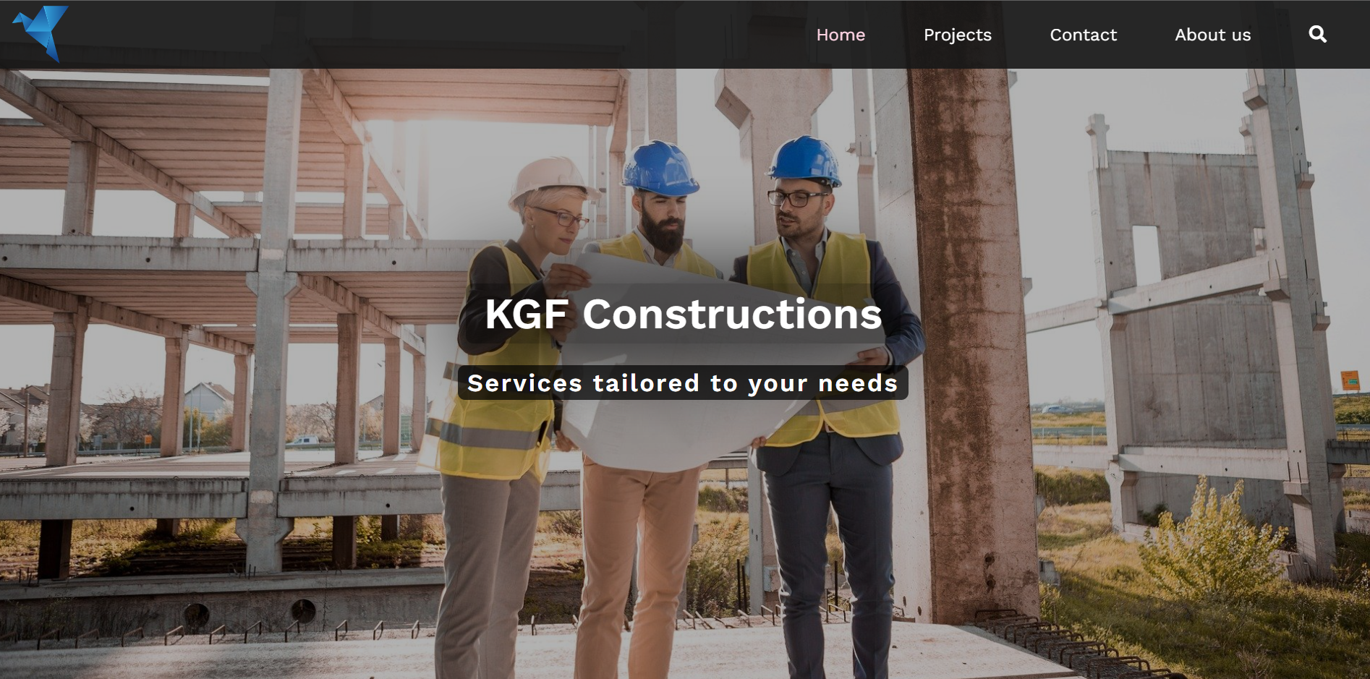
This is the home page of the website that appears on the start. This has a screen that has an image of the construction engineers that is good for the home page and on the upside for the Navigation bar there is a logo on the top left corner and then a home page button and the Projects button and the Posts button and the Contact button and also the About Us page and at last there is a search icon for the searching purposes. Customers can click on any button to go on that specific page to see the details of that page.
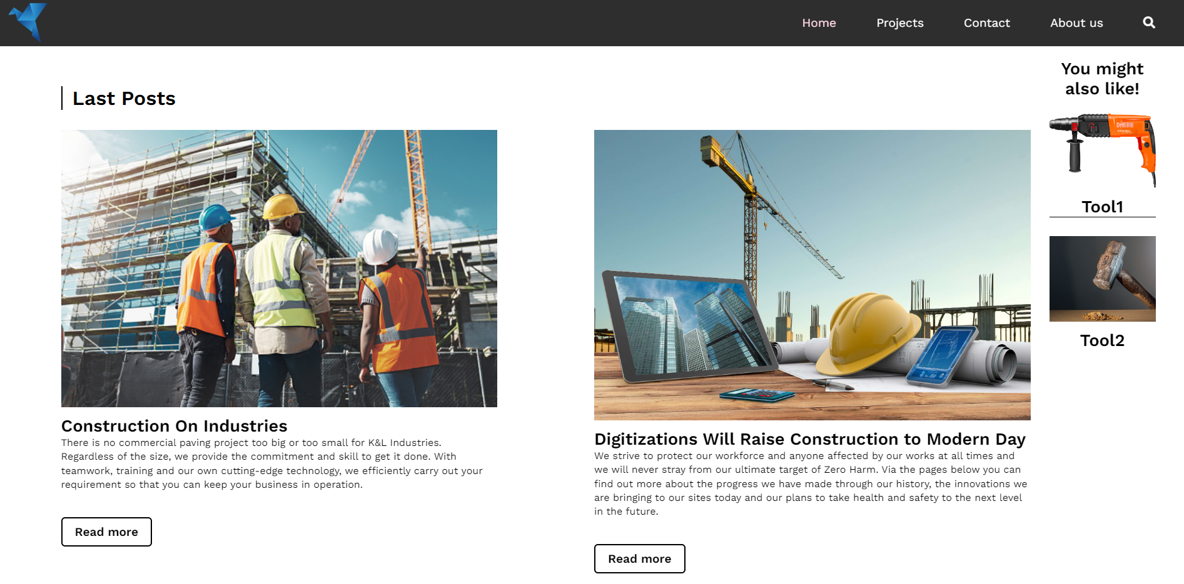
Here customers can see the projects developed by the company that how the company makes these projects. Customers can see all the provided information by the company about the project on this website. Customer can know about the information about the project. This is also the details of the project. As we can see that there are multiple projects here and user can know about the details of the multiple projects. At last, there is also some links that can take customer to their willing page. This helps the customer and this is for the easiness of the customer. For example, if a customer wants to go back to the “Home” page then he does not need to scroll up the page to go back to that page. The customer can just click on these links to go to their desired page and there are also some details about the website developer.
3. 2 Contact Page

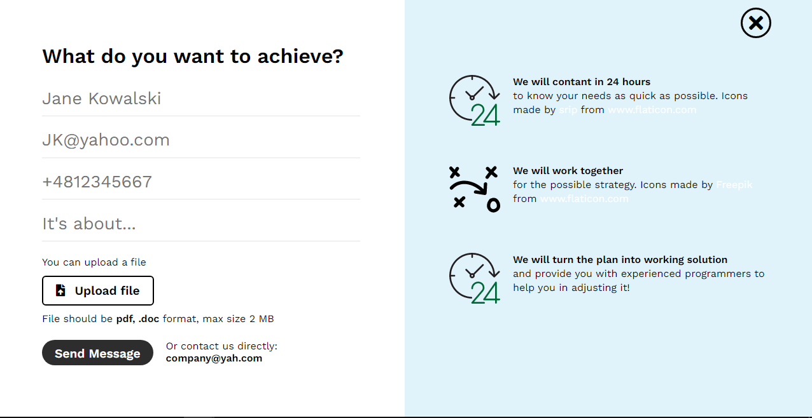
This is the Contact page. It appears after user clicking on the Contact button. Here are all the details about the company and the customer can contact to the company by seeing all the information from here.

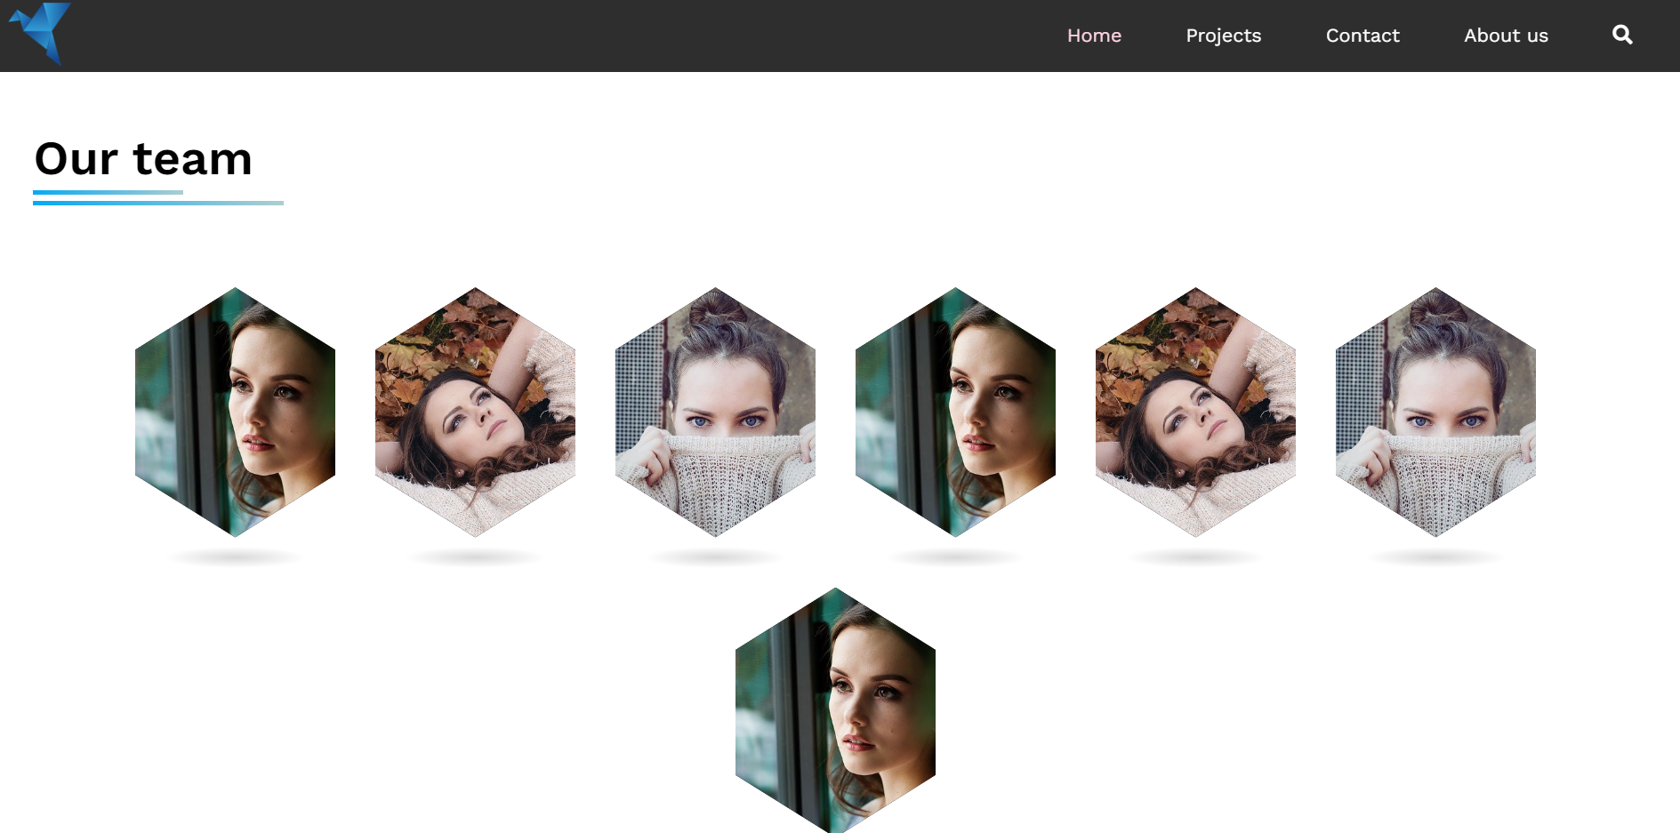
3. 3 About Us Page:
This page will appear after clicking the About Us button. This will tell the customer about the team and about the employees of the company and how much they are capable for doing the projects. After clicking on any image, the customer can see all the details about that member and he can find all the details about him/her.
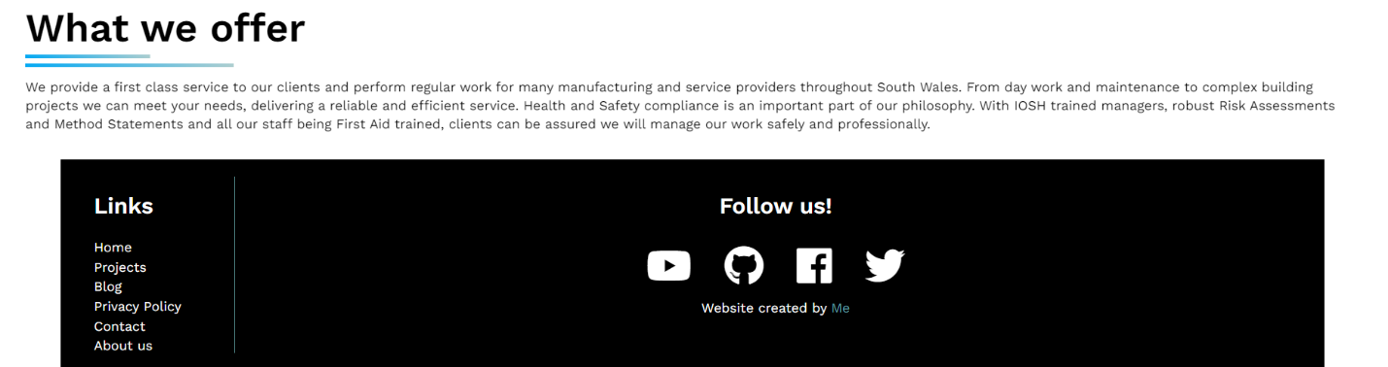
This page is to tell the customer what the company will offer to the customer. Then they can easily know about the offers of the company to the clients.

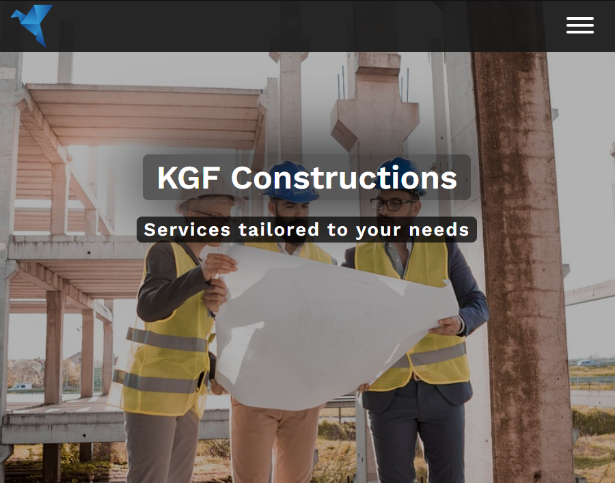
Our website is also responsive. As we can see whenever we change the size of the window then the size of the screen of the website will also change and the menu bar will change into the button.
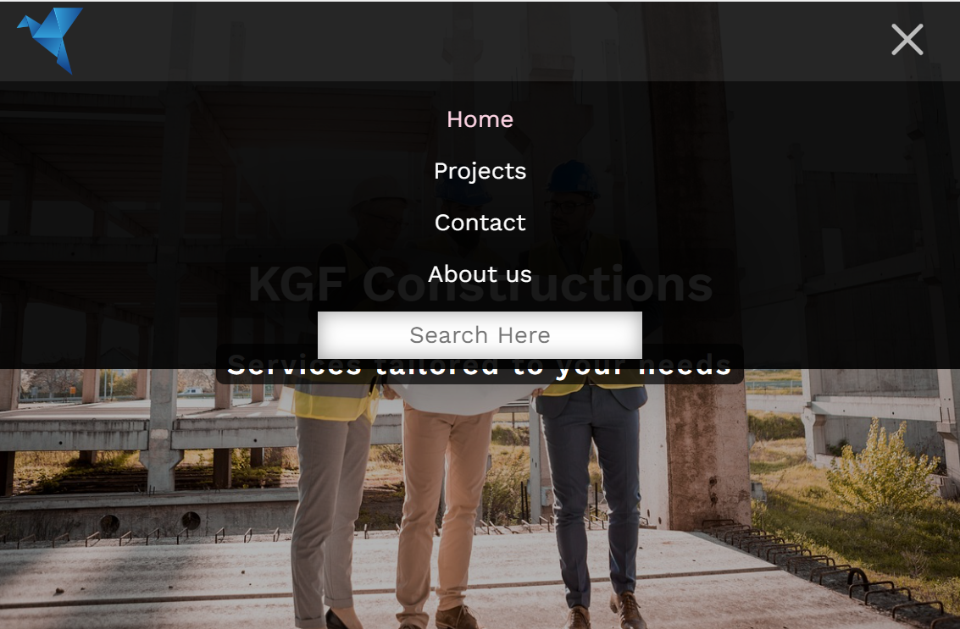
This will appear after clicking the 3 lines menu button.

- Validation
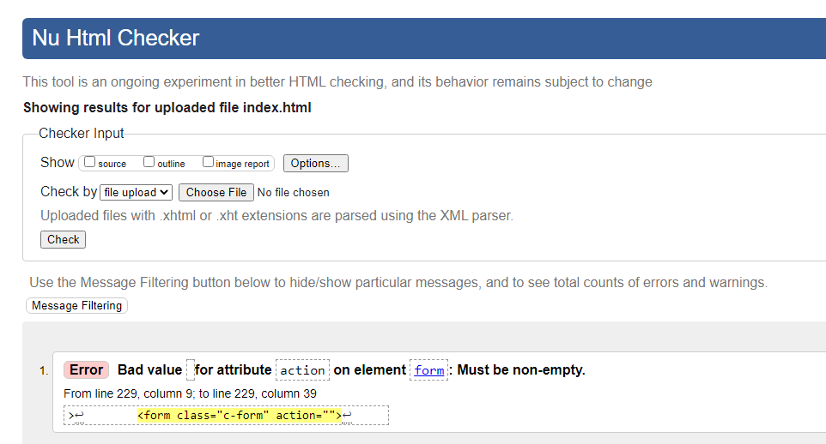
During validation these errors occurs in the index.html file. This is an error because the action attribute is empty.
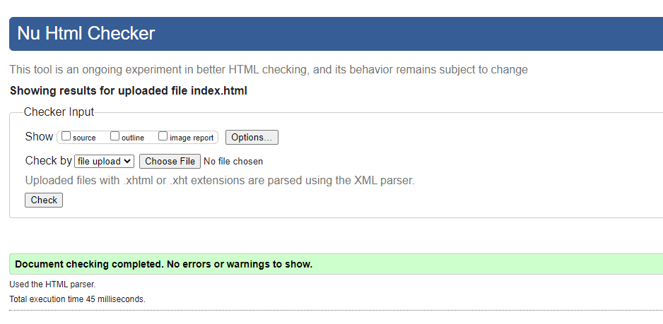
I fixed this error by filling the action attribute of every form element. (action=” #”) and now there isn’t any error.

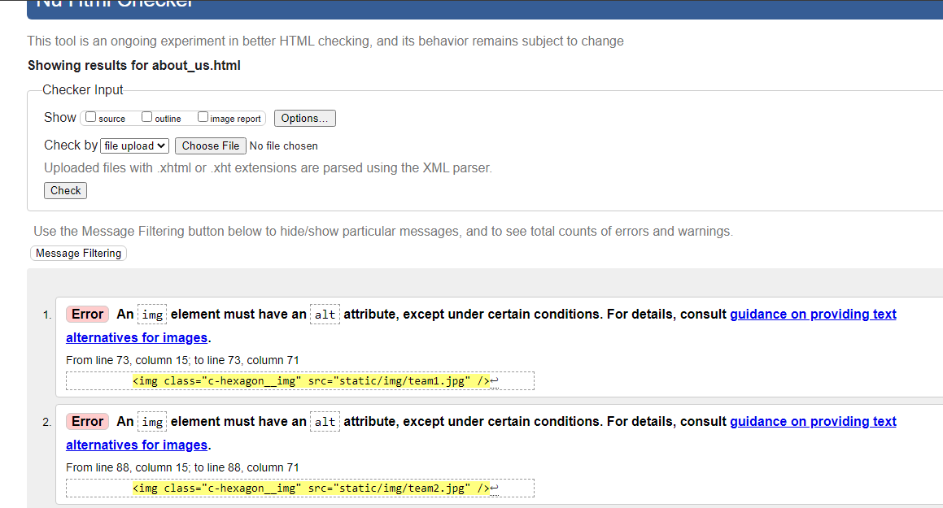
These are some errors in the about_us.html file. These are just for the img attribute that must be alt attribute.
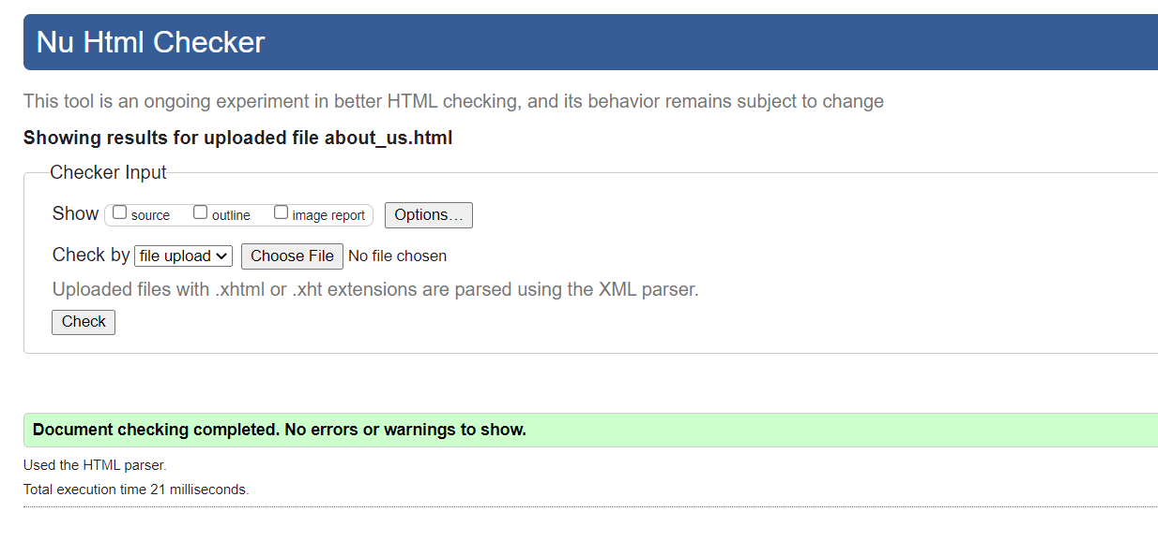
I fixed this error by filling the alt attribute of every img element. (alt=”image”) and now there isn’t any error.

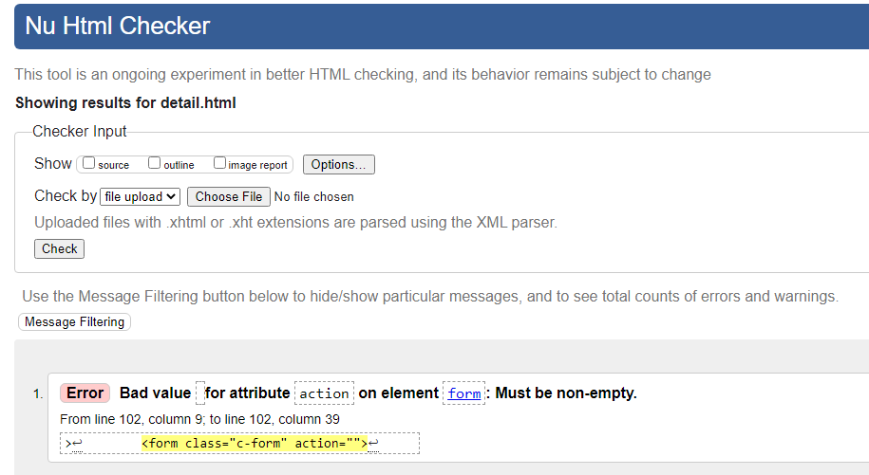
This is the error in the detail.html file. This error is due to the action is empty.
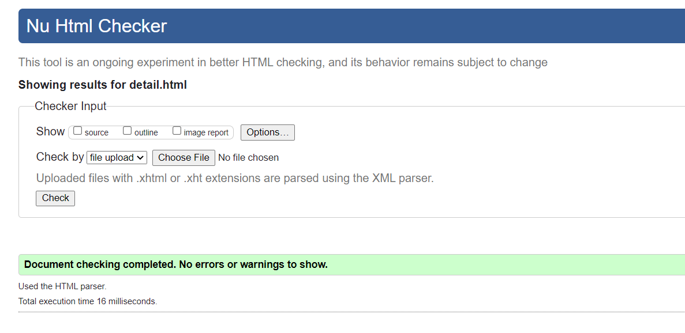
I fixed this error by filling the action attribute of every form element. (action=” #”) and now there isn’t any error.

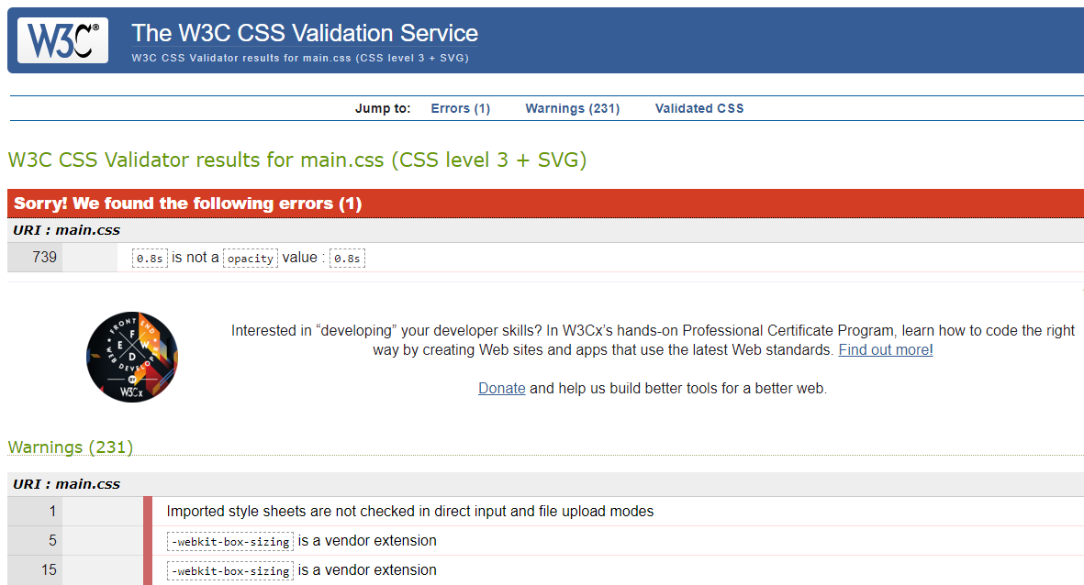
These are the errors appeared in the CSS file. These are just warnings about importation and extension errors.

- Evaluation:
5.1 Section A:
In the case of websites and software applications, usability has been defined as the ease at which an average person can use the software or website to achieve specific goals. Usability is comprised of learnability, memorability, efficiency, satisfaction, and errors. Web accessibility means that websites, tools, and technologies are designed and developed so that people with disabilities can use them. More specifically, people can: perceive, understand, navigate, and interact with the Web. contribute to the Web. Our website is good in these two terms.
Search engine optimization is the process of improving the quality and quantity of website traffic to a website or a web page from search engines. SEO targets unpaid traffic rather than direct traffic or paid traffic. This will be happened in our website after deployment.

- Usability:
There are various points that you must know when building a website. Your website must look appealing enough that people would want to look at it. And it must contain information that is relevant to the topic that you would want to share with the audience. Usability is basically how easily an average person can use the website to achieve their specific goal. Basically, this determines how user friendly the website can be such as the user interface is the space where the users interact with the website. [2, 3]
Research Study:
There was a research study that conducted from the years 2005 to 2014, and this study presents the research trends in usability issues of websites. A total of 199 studies were included in this research, and the results of this study concluded with the most addressed usability issue is navigation. Furthermore, majority of the studies utilized user-based usability evaluation method (UEMs) and the most used UEMs are either usability testing or Questionnaire. As mentioned before users shouldn’t find it difficult to use a website, especially when it comes to navigation. Having a lack of navigation in a website makes it difficult for the user to achieve their specific goal when using the website. [4]
- Accessibility:
The main purpose of creating a website is to attract visitors, however this can tend to be hard when developers don’t prioritize accessible web design. What this means is the website must be usable by everyone, including people with disability or impairments. There are variety of resources and tools that can be used to make the website more accessible. [5]
Research Study:
In the UK there was an increase in the use of technology, and this led to web accessibility to become a huge issue, as the focus of web accessibility are disabled people. With the use of three automated web accessibility tools. There was a research study conducted to explore the accessibility of the homepages of 66 research intensive universities with respect to the WCAG 2.0 checkpoints. The result of this study indicates that the common checkpoint violations include the provision of text options for contrast errors, non-text content, and the increase of compatibility with future tools and technologies. Overall, the study shows that web accessibility has increased in the UK, especially when compared with other websites in other countries. This suggests that as the technology has shown drastic increase, web developers made sure that tools and techniques were used to make website more accessible for disabled people. [6]
- Search engine optimisation:
The purpose of SEO is to improve the website by increasing the visibility when visitors are looking for a specific products or piece of information. They can use the search tool that helps them get what they want. The better visibility the website has, the higher chance of the website to gather more attention. [7]

Research Study:
This research study was conducted to show how search engine optimization has an influence on business performance. The research strategy for this is to analyze that is derived form google analytics focusing on the number of sessions, visits, average engagement time, and keywords. The data they have extracted from before and after the use of SEO shows that the website exposure has increased largely after the use of SEO. [8]
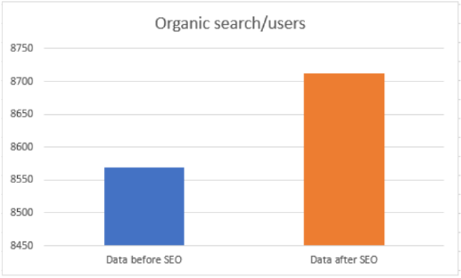

With the use of SEO small and medium sized businesses had found it easier to attract specific clients. As the diagram shows using the SEO the website of the business is rated higher which makes it more accessible to internet consumers. [8]
5.2 Section B:
- Usefulness:
The website shows details of the projects that has been conducted under the company’s name. On the website it includes relevant text and images about the projects to show the visitors an understanding of what the website is about. The design of the website is simple and not hard to use, because the visitors can click on different pages. For example, the visitors can click on the projects page and this page will tell information about each individual projects that the company has done. I believe this website is simple to use and easy to navigate due to that. The main purpose of the website is to deliver information about the company and what the company does, in case of any visitors are interested in having future projects with the company. The improvements I will make for my website is by adding more information about the company, adding more projects, and add more pictures to make it look more appealing. [9]

- Accessibility:
The website is operable for example if a user cannot use a mouse, they can have an alternative option of using the keyboard to navigate around the website, because the website has information given on each page without the need of clicking on a specific button to access a piece of information. [9]
In addition, the website is easy to understand because it uses clear concise language and offers functionality which can be easily understood. Visitors can click on different pages at the top of the website if they want to view more information, and each label are clear and can be easily seen for people with poor eyesight. I have chosen high contrast color such as white background and black text, this makes the website more visible and doesn’t allow any strain on any user’s eyes. [9]
The website has an option where they can search for a specific information with the help of the search tool. This makes the website much easier to navigate and easier to meet their needs. Furthermore, the website also has an option where the user can contact the company in case of any doubt. User can pick their own mix of technologies, in other words the website is compatible with other browsers, so the user can use the website without the need of downloading a specific browser to use the website. [9]

- References:
6. 1 Requirements:
- https://www.investopedia.com/terms/h/html.asp

6. 2 Evaluation:
Usability:
- https://usabilitygeek.com/an-introduction-to-website-usability-testing/
- https://21designs.com.au/learn/designer-tips/what-is-usability-in-web-design/
- https://www.researchgate.net/publication/304370784_Research_Trends_in_Web_Site_Usability_A_Systematic_Review
Accessibility:
- https://www.dreamhost.com/blog/make-your-website-accessible/
- https://journals.sagepub.com/doi/full/10.1177/21582440211056614
Search Engine Optimization:
- https://searchengineland.com/guide/what-is-seo
- https://www.researchgate.net/publication/361160235_Influence_of_search_engine_optimization_SEO_on_business_performance_Case_study_of_private_university_in_Sarajevo
Accessibility:
- https://www.willowtreeapps.com/craft/the-four-principles-of-accessibility#:~:text=The%20industry%20standard%20guidelines%20for,an%20introduction%20to%20these%20principles.

- Appendices:
7. 1 Home page:
<!DOCTYPE html>
<html lang="en">
<head>
<meta charset="UTF-8" />
<meta name="viewport" content="width=device-width, initial-scale=1.0" />
<title>KGF Constructions</title>
<link
rel="stylesheet"
href="https://use.fontawesome.com/releases/v5.1.0/css/all.css"
integrity="sha384-lKuwvrZot6UHsBSfcMvOkWwlCMgc0TaWr+30HWe3a4ltaBwTZhyTEggF5tJv8tbt"
crossorigin="anonymous"
/>
<link href="https://unpkg.com/aos@2.3.1/dist/aos.css" rel="stylesheet" />
<script src="https://unpkg.com/aos@2.3.1/dist/aos.js"></script>
<link rel="stylesheet" href="static/styles/main.css" />
<script src="static/scripts/script.js" defer></script>
</head>
<body>
<div class="c-loader">
<div class="c-loader__ring"></div>
</div>
<div class="c-backdrop"></div>

<nav class="o-nav">
<div class="o-nav__logo">
<a class="o-nav__logo-link" href="index.html">
<img class="o-nav__logo-img" src="static/img/logo.png" alt="logo" />
</a>
</div>
<button class="c-hamburger hamburger--stand js-hamburger" type="button">
<span class="c-hamburger__box">
<span class="c-hamburger__inner"></span>
</span>
</button>
<ul class="c-menu js-menu">
<li class="c-menu__item">
<a class="c-menu__link c-menu__link--active" href="index.html"
>Home</a
>
</li>
<li class="c-menu__item">
<a class="c-menu__link" href="posts.html">Projects</a>
</li>
<li class="c-menu__item">
<a class="c-menu__link js-ctc-btn" href="#">Contact</a>
</li>
<li class="c-menu__item">
<a class="c-menu__link" href="about_us.html">About us</a>
</li>
<li class="c-menu__item">
<div class="c-menu__search js-search-icon">
<i class="fas fa-search c-menu__search-icon"></i>
</div>
<div class="c-menu__search-box js-search-box">
<input
class="c-menu__search-input"
type="text"
placeholder="Search Here"
/>
</div>
</li>
</ul>
</nav>
<div class="o-banner">
<h1 class="c-heading-big c-heading-big--shadow u-white">KGF Constructions</h1>
<h3 class="c-heading-small c-heading-small--shadow u-white u-center">
Services tailored to your needs
</h3>
</div>
<main>
<section class="o-context">
<a href="posts.html" class="o-context__heading"
><h2 class="c-heading-medium o-context__heading-medium">
Last Posts
</h2></a
>
<div class="c-card" data-aos="fade-up">
<div class="c-card__image">
<a href="detail.html" class="c-card__image-link">
<img
class="c-card__image-img"
src="static/img/blog1.jpg"
alt=""
/>
</a>
</div>
<div class="c-card__description">
<a href="detail.html">
<h3 class="c-heading-small c-card__heading-small u-black">
Sustainibility
</h3>
</a>
<p class="paragraph c-card__paragraph">
our aim is to set out our global goals, to provide an overarching framework and empower our colleagues to take action to deliver a better future in their geographies. Across the UK, US and Hong Kong, each of our businesses are now developing bespoke Sustainability Action Plans to ensure we address specific local challenges and priorities and leave a positive legacy in the communities we serve.
</p>
<a href="detail.html" class="a-btn c-card__a-btn">Read more</a>
</div>
</div>
<div class="c-card" data-aos="fade-up">
<div class="c-card__image">
<a href="detail.html" class="c-card__image-link">
<img
class="c-card__image-img"
src="static/img/blog2.jpg"
alt=""
/>
</a>
</div>
<div class="c-card__description">
<a href="detail.html">
<h3 class="c-heading-small c-card__heading-small u-black">
Health and Safety
</h3>
</a>
<p class="paragraph c-card__paragraph">
We strive to protect our workforce and anyone affected by our works at all times and we will never stray from our ultimate target of Zero Harm.

Via the pages below you can find out more about the progress we have made through our history, the innovations we are bringing to our sites today and our plans to take health and safety to the next level in the future.
</p>
<a href="detail.html" class="a-btn c-card__a-btn">Read more</a>
</div>
</div>
<a href="posts.html" class="o-context__heading"
><h2 class="c-heading-medium o-context__heading-medium">
Last Projects
</h2></a
>
<div class="c-card" data-aos="fade-up">
<div class="c-card__image">
<a href="detail.html" class="c-card__image-link">
<img
class="c-card__image-img"
src="static/img/project1.jpg"
alt=""
/>
</a>
</div>
<div class="c-card__description">
<a href="detail.html">
<h3 class="c-heading-small c-card__heading-small u-black">
The Southern Gateway - California
</h3>
</a>
<p class="paragraph c-card__paragraph">
This $666 million project for California Department of Transportation (TxDOT) will rebuild and widen Interstate 35E south of downtown Dallas and widen U.S. 67 between I-35E and I-20 and the I-35E/U.S. 67 split.
</p>
<a href="detail.html" class="a-btn c-card__a-btn">Read more</a>
</div>
</div>
<div class="c-card" data-aos="fade-up">
<div class="c-card__image">
<a href="detail.html" class="c-card__image-link">
<img
class="c-card__image-img"
src="static/img/project2.jpg"
alt=""
/>
</a>
</div>
<div class="c-card__description">
<a href="detail.html">
<h3 class="c-heading-small c-card__heading-small u-black">
Whitechapel Station, Elizabeth line, London
</h3>
</a>
<p class="paragraph c-card__paragraph">
The new Whitechapel station is a key interchange hub on the Elizabeth line, serving thousands of passengers per day.
</p>
<a href="detail.html" class="a-btn c-card__a-btn">Read more</a>
</div>
</div>
</section>
<aside class="o-aside">
<div class="o-aside__wrapper">
<h3 class="c-heading-small o-aside__heading-small u-center">
You might also like!
</h3>
<div class="c-card o-aside__card">
<div class="c-card__image">
<a href="detail.html" class="c-card__image-link">
<img
class="c-card__image-img"
src="static/img/tool1.png"
alt=""
/>
</a>
</div>
<h3 class="c-heading-small u-center">Tool1</h3>
</div>
<div class="c-card o-aside__card">
<div class="c-card__image">
<a href="detail.html" class="c-card__image-link">
<img
class="c-card__image-img"
src="static/img/tool2.jpg"
alt=""
/>
</a>
</div>
<h3 class="c-heading-small u-center">Tool2</h3>
</div>
</div>
</aside>
</main>

<div class="o-contact js-ctc-modal">
<div class="o-contact__close js-close-modal">
<i class="fas fa-times o-contact__close-icon"></i>
</div>
<div class="o-contact__left">
<h2 class="c-heading-medium">What do you want to achieve?</h2>
<form class="c-form" action="#">
<div class="c-form__field">
<input
class="c-form__input"
type="text"
name="name"
id="name"
placeholder="Jane Kowalski"
/><label class="c-form__label" for="name">Your name</label>
</div>
<div class="c-form__field">
<input
class="c-form__input"
type="email"
name="email"
id="email"
placeholder="JK@yahoo.com"
/>
<label class="c-form__label" for="email">Your email address</label>
</div>
<div class="c-form__field">
<input
class="c-form__input"
type="tel"
name="phone"
id="phone"
placeholder="+4812345667"
/>
<label class="c-form__label" for="phone"
>Phone number (optional)</label
>
</div>
<div class="c-form__field">
<input
class="c-form__input"
type="text"
name="about"
id="about"
placeholder="It's about..."
/>
<label class="c-form__label" for="about"
>Tell us about your project</label
>
</div>
<div class="c-form__upload">
<p class="paragraph">You can upload a file</p>
<div class="c-form__upload-box">
<button class="a-btn c-form__btn">
<i class="fas fa-file-upload c-form__icon"></i>Upload file
</button>
<p class="paragraph c-form__paragraph">
File should be <span class="u-bold">pdf, .doc</span> format, max
size 2 MB
</p>
</div>
</div>
<div class="c-form__submit">
<input
type="submit"
class="a-btn c-form__sub-btn"
value="Send Message"
/>
<p class="c-form__email">
Or contact us directly:
<span class="u-bold">company@yah.com</span>
</p>
</div>
</form>
</div>
<div class="o-contact__right">
<div class="c-aces">
<div class="c-aces__image">
<img
class="c-aces__image-img"
src="static/img/24-hours.svg"
alt=""
/>
</div>
<div class="c-aces__context">
<p class="paragraph u-bold">We will contant in 24 hours</p>
<p class="paragraph">
to know your needs as quick as possible. Icons made by
<a href="https://www.flaticon.com/authors/srip" title="srip"
>srip</a>
from
<a href="https://www.flaticon.com/" title="Flaticon"
>www.flaticon.com</a
>
</p>
</div>
</div>
<div class="c-aces">
<div class="c-aces__image">
<img
class="c-aces__image-img"
src="static/img/strategy.svg"
alt=""
/>
</div>
<div class="c-aces__context">
<p class="paragraph u-bold">We will work together</p>
<p class="paragraph">
for the possible strategy. Icons made by
<a href="https://www.flaticon.com/authors/freepik" title="Freepik"
>Freepik</a
>
from
<a href="https://www.flaticon.com/" title="Flaticon"
>www.flaticon.com</a
>
</p>
</div>
</div>
<div class="c-aces">
<div class="c-aces__image">
<img
class="c-aces__image-img"
src="static/img/24-hours.svg"
alt=""
/>
</div>
<div class="c-aces__context">
<p class="paragraph u-bold">
We will turn the plan into working solution
</p>
<p class="paragraph">
and provide you with experienced programmers to help you in
adjusting it!
</p>
</div>
</div>
</div>
</div>

<footer class="o-footer">
<div class="o-footer__left">
<h3 class="c-heading-small o-footer__heading-small u-white">Links</h3>
<ul class="c-footer-list">
<li class="c-footer-list__item">
<a class="c-footer-list__link" href="#">Home</a>
</li>
<li class="c-footer-list__item">
<a class="c-footer-list__link" href="#">Projects</a>
</li>
<li class="c-footer-list__item">
<a class="c-footer-list__link" href="#">Blog</a>
</li>
<li class="c-footer-list__item">
<a class="c-footer-list__link" href="#">Privacy Policy</a>
</li>
<li class="c-footer-list__item">
<a class="c-footer-list__link" href="#">Contact</a>
</li>
<li class="c-footer-list__item">
<a class="c-footer-list__link" href="#">About us</a>
</li>
</ul>
</div>
<div class="o-footer__right footer__heading-small">
<h3 class="c-heading-small o-footer__heading-small u-white">
Follow us!
</h3>
<ul class="c-social__list">
<li class="c-social__item">
<a class="c-social__link" href="#">
<i class="fab fa-youtube"></i>
</a>
</li>
<li class="c-social__item">
<a class="c-social__link" href="#">
<i class="fab fa-github"></i>
</a>
</li>
<li class="c-social__item">
<a class="c-social__link" href="#">
<i class="fab fa-facebook"></i>
</a>
</li>
<li class="c-social__item">
<a class="c-social__link" href="#">
<i class="fab fa-twitter"></i>
</a>
</li>
</ul>
<p class="paragraph u-white">
Website created by <span class="o-footer__sign">Me</span>
</p>
</div>
</footer>
<script>
AOS.init();
</script>
</body>
</html>

7. 2 Project page:
<!DOCTYPE html>
<html lang="en">

<head>
<meta charset="UTF-8" />
<meta name="viewport" content="width=device-width, initial-scale=1.0" />
<title>KGF Constructions</title>
<link
rel="stylesheet"
href="https://use.fontawesome.com/releases/v5.1.0/css/all.css"
integrity="sha384-lKuwvrZot6UHsBSfcMvOkWwlCMgc0TaWr+30HWe3a4ltaBwTZhyTEggF5tJv8tbt"
crossorigin="anonymous"
/>
<link href="https://unpkg.com/aos@2.3.1/dist/aos.css" rel="stylesheet" />
<script src="https://unpkg.com/aos@2.3.1/dist/aos.js"></script>
<link rel="stylesheet" href="static/styles/main.css" />
<script src="static/scripts/script.js" defer></script>
</head>
<body>
<div class="c-loader">
<div class="c-loader__ring"></div>
</div>
<div class="c-backdrop"></div>

<nav class="o-nav">
<div class="o-nav__logo">
<a class="o-nav__logo-link" href="index.html">
<img class="o-nav__logo-img" src="static/img/logo.png" alt="logo" />
</a>
</div>
<button class="c-hamburger hamburger--stand js-hamburger" type="button">
<span class="c-hamburger__box">
<span class="c-hamburger__inner"></span>
</span>
</button>
<ul class="c-menu js-menu">
<li class="c-menu__item">
<a class="c-menu__link c-menu__link--active" href="index.html"
>Home</a
>
</li>
<li class="c-menu__item">
<a class="c-menu__link" href="posts.html">Projects</a>
</li>
<li class="c-menu__item">
<a class="c-menu__link js-ctc-btn" href="#">Contact</a>
</li>
<li class="c-menu__item">
<a class="c-menu__link" href="about_us.html">About us</a>
</li>
<li class="c-menu__item">
<div class="c-menu__search js-search-icon">
<i class="fas fa-search c-menu__search-icon"></i>
</div>
<div class="c-menu__search-box js-search-box">
<input
class="c-menu__search-input"
type="text"
placeholder="Search Here"
/>
</div>
</li>
</ul>
</nav>
<main>
<section class="o-context posts">
<a href="posts.html" class="o-context__heading"
><h2 class="c-heading-medium o-context__heading-medium">
Last Posts
</h2></a
>
<div class="c-card" data-aos="fade-up">
<div class="c-card__image">
<a href="detail.html" class="c-card__image-link">
<img
class="c-card__image-img"
src="static/img/1.jpg"
alt=""
/>
</a>
</div>
<div class="c-card__description">
<a href="detail.html">
<h3 class="c-heading-small c-card__heading-small u-black">
Construction On Industries
</h3>
</a>
<p class="paragraph c-card__paragraph">
There is no commercial paving project too big or too small for K&L Industries. Regardless of the size, we provide the commitment and skill to get it done. With teamwork, training and our own cutting-edge technology, we efficiently carry out your requirement so that you can keep your business in operation.
</p>
<a href="detail.html" class="a-btn c-card__a-btn">Read more</a>
</div>
</div>
<div class="c-card" data-aos="fade-up">
<div class="c-card__image">
<a href="detail.html" class="c-card__image-link">
<img
class="c-card__image-img"
src="static/img/2.jpg"
alt=""
/>
</a>
</div>
<div class="c-card__description">
<a href="detail.html">
<h3 class="c-heading-small c-card__heading-small u-black">
Digitizations Will Raise Construction to Modern Day
</h3>
</a>
<p class="paragraph c-card__paragraph">
We strive to protect our workforce and anyone affected by our works at all times and we will never stray from our ultimate target of Zero Harm. Via the pages below you can find out more about the progress we have made through our history, the innovations we are bringing to our sites today and our plans to take health and safety to the next level in the future.
</p>
<a href="detail.html" class="a-btn c-card__a-btn">Read more</a>
</div>
</div>
<div class="c-card" data-aos="fade-up">
<div class="c-card__image">
<a href="detail.html" class="c-card__image-link">
<img
class="c-card__image-img"
src="static/img/3.jpg"
alt=""
/>
</a>
</div>
<div class="c-card__description">
<a href="detail.html">
<h3 class="c-heading-small c-card__heading-small u-black">
Building Plans-Residen Construction
</h3>
</a>
<p class="paragraph c-card__paragraph">
Family owned and operated with over 30 years of home building experience. Call us today! Let us help make your vision a reality. Don't have plans, we can help. Award Winning Contractor. Family Owned Business. Luxury Homes. Expert Craftsmanship.
</p>
<a href="detail.html" class="a-btn c-card__a-btn">Read more</a>
</div>
</div>
<div class="c-card" data-aos="fade-up">
<div class="c-card__image">
<a href="detail.html" class="c-card__image-link">
<img
class="c-card__image-img"
src="static/img/4.jpg"
alt=""
/>
</a>
</div>
<div class="c-card__description">
<a href="detail.html">
<h3 class="c-heading-small c-card__heading-small u-black">
Construction on Building
</h3>
</a>
<p class="paragraph c-card__paragraph">
There's nothing better than stepping into your new home for the first time. We at Precise Builders are dedicated to designing a space that matches you and your family's needs, down to the last detail. Precise Builders believes your new home should be a masterpiece that will complement your lifestyle for years to come.
</p>
<a href="detail.html" class="a-btn c-card__a-btn">Read more</a>
</div>
</div>
<div class="c-card" data-aos="fade-up">
<div class="c-card__image">
<a href="detail.html" class="c-card__image-link">
<img
class="c-card__image-img"
src="static/img/5.jpg"
alt=""
/>
</a>
</div>
<div class="c-card__description">
<a href="detail.html">
<h3 class="c-heading-small c-card__heading-small u-black">
Construction On Bridge
</h3>
</a>
<p class="paragraph c-card__paragraph">
The construction industry is well known for falling behind in the implementation of information technologies. Many digital technologies are, however, applicable throughout the entire value chain, and the use of industrialized construction is rapidly increasing with a view to improving planning, design, construction, assembly, operation and maintenance. Different technologies have changed the engineering and construction processes drastically, and the rate at which change is taking place is generally agreed to be accelerating. This article presents four international case studies that exemplify the utilization of information modeling in bridge design projects. Information modeling is more than just a new technology – it is a new way of working which has the power to totally transform the design and construction industry.
</p>
<a href="detail.html" class="a-btn c-card__a-btn">Read more</a>
</div>
</div>
<div class="c-card" data-aos="fade-up">
<div class="c-card__image">
<a href="detail.html" class="c-card__image-link">
<img
class="c-card__image-img"
src="static/img/6.jpg"
alt=""
/>
</a>
</div>
<div class="c-card__description">
<a href="detail.html">
<h3 class="c-heading-small c-card__heading-small u-black">
Construction on Road
</h3>
</a>
<p class="paragraph c-card__paragraph">
A road is a wide way route on land in between two places. It is a specially prepared surface which allows travel by foot or some form of conveyance, including (but not limited to) a motor vehicle, cart, bicycle, or horse. Roads are an integral part of infrastructural development when it comes to development and progression of communities as well as nations. A road provides access to employment, social needs, health and education services etc. hence, road networking can easily be categorized as one of the top priorities for infrastructural development.The premix is prepared in a hot mix plant of a required capacity with the desired quality control. The bitumen may be heated up to 150 – 177 deg C and the aggregate temperature should not differ by over 14 deg C from the binder temperature. The hot mixed material is collected from the mixture by the transporters, carried to the location and is then spread by a mechanical paver at a temperature of 121 to 163 degrees Celsius. The camber and the thickness of the layer are accurately verified.
Control of the temperatures during the mixing and the compaction are of great significance in the strength of the resulting pavement structure.
</p>
<a href="detail.html" class="a-btn c-card__a-btn">Read more</a>
</div>
</div>
<div class="c-card" data-aos="fade-up">
<div class="c-card__image">
<a href="detail.html" class="c-card__image-link">
<img
class="c-card__image-img"
src="static/img/blog2.jpg"
alt=""
/>
</a>
</div>
<div class="c-card__description">
<a href="detail.html">
<h3 class="c-heading-small c-card__heading-small u-black">
Post title - two
</h3>
</a>
<p class="paragraph c-card__paragraph">
Lorem ipsum dolor sit amet consectetur adipisicing elit. Deserunt
vero dolores sint perspiciatis inventore? Facilis praesentium
commodi dignissimos iure possimus molestiae ex magni sapiente
itaque exercitationem, fuga quis. Doloribus, provident! Lorem
ipsum dolor sit amet consectetur adipisicing elit. Mollitia natus
autem eos quisquam distinctio temporibus culpa sunt nihil, non
earum exercitationem minus voluptatem harum, placeat fugiat nobis
illo expedita repellat?
</p>
<a href="detail.html" class="a-btn c-card__a-btn">Read more</a>
</div>
</div>
</section>
<aside class="o-aside">
<div class="o-aside__wrapper">
<h3 class="c-heading-small o-aside__heading-small u-center">
You might also like!
</h3>
<div class="c-card o-aside__card">
<div class="c-card__image">
<a href="detail.html" class="c-card__image-link">
<img
class="c-card__image-img"
src="static/img/tool1.png"
alt=""
/>
</a>
</div>
<h3 class="c-heading-small u-center">Tool1</h3>
</div>
<div class="c-card o-aside__card">
<div class="c-card__image">
<a href="detail.html" class="c-card__image-link">
<img
class="c-card__image-img"
src="static/img/tool2.jpg"
alt=""
/>
</a>
</div>
<h3 class="c-heading-small u-center">Tool2</h3>
</div>
</div>
</aside>
</main>

<div class="o-contact js-ctc-modal">
<div class="o-contact__close js-close-modal">
<i class="fas fa-times o-contact__close-icon"></i>
</div>
<div class="o-contact__left">
<h2 class="c-heading-medium">What do you want to achieve?</h2>
<form class="c-form" action="#">
<div class="c-form__field">
<input
class="c-form__input"
type="text"
name="name"
id="name"
placeholder="Jane Kowalski"
/><label class="c-form__label" for="name">Your name</label>
</div>
<div class="c-form__field">
<input
class="c-form__input"
type="email"
name="email"
id="email"
placeholder="JK@yahoo.com"
/>
<label class="c-form__label" for="email">Your email address</label>
</div>
<div class="c-form__field">
<input
class="c-form__input"
type="tel"
name="phone"
id="phone"
placeholder="+4812345667"
/>
<label class="c-form__label" for="phone"
>Phone number (optional)</label
>
</div>
<div class="c-form__field">
<input
class="c-form__input"
type="text"
name="about"
id="about"
placeholder="It's about..."
/>
<label class="c-form__label" for="about"
>Tell us about your project</label
>
</div>
<div class="c-form__upload">
<p class="paragraph">You can upload a file</p>
<div class="c-form__upload-box">
<button class="a-btn c-form__btn">
<i class="fas fa-file-upload c-form__icon"></i>Upload file
</button>
<p class="paragraph c-form__paragraph">
File should be <span class="u-bold">pdf, .doc</span> format, max
size 2 MB
</p>
</div>
</div>
<div class="c-form__submit">
<input
type="submit"
class="a-btn c-form__sub-btn"
value="Send Message"
/>
<p class="c-form__email">
Or contact us directly:
<span class="u-bold">company@yah.com</span>
</p>
</div>
</form>
</div>
<div class="o-contact__right">
<div class="c-aces">
<div class="c-aces__image">
<img
class="c-aces__image-img"
src="static/img/24-hours.svg"
alt=""
/>
</div>
<div class="c-aces__context">
<p class="paragraph u-bold">We will contant in 24 hours</p>
<p class="paragraph">
to know your needs as quick as possible. Icons made by
<a href="https://www.flaticon.com/authors/srip" title="srip"
>srip</a
>
from
<a href="https://www.flaticon.com/" title="Flaticon"
>www.flaticon.com</a
>
</p>
</div>
</div>
<div class="c-aces">
<div class="c-aces__image">
<img
class="c-aces__image-img"
src="static/img/strategy.svg"
alt=""
/>
</div>
<div class="c-aces__context">
<p class="paragraph u-bold">We will work together</p>
<p class="paragraph">
for the possible strategy. Icons made by
<a href="https://www.flaticon.com/authors/freepik" title="Freepik"
>Freepik</a
>
from
<a href="https://www.flaticon.com/" title="Flaticon"
>www.flaticon.com</a
>
</p>
</div>
</div>
<div class="c-aces">
<div class="c-aces__image">
<img
class="c-aces__image-img"
src="static/img/24-hours.svg"
alt=""
/>
</div>
<div class="c-aces__context">
<p class="paragraph u-bold">
We will turn the plan into working solution
</p>
<p class="paragraph">
and provide you with experienced programmers to help you in
adjusting it!
</p>
</div>
</div>
</div>
</div>

<footer class="o-footer">
<div class="o-footer__left">
<h3 class="c-heading-small o-footer__heading-small u-white">Links</h3>
<ul class="c-footer-list">
<li class="c-footer-list__item">
<a class="c-footer-list__link" href="#">Home</a>
</li>
<li class="c-footer-list__item">
<a class="c-footer-list__link" href="#">Projects</a>
</li>
<li class="c-footer-list__item">
<a class="c-footer-list__link" href="#">Blog</a>
</li>
<li class="c-footer-list__item">
<a class="c-footer-list__link" href="#">Privacy Policy</a>
</li>
<li class="c-footer-list__item">
<a class="c-footer-list__link" href="#">Contact</a>
</li>
<li class="c-footer-list__item">
<a class="c-footer-list__link" href="#">About us</a>
</li>
</ul>
</div>
<div class="o-footer__right footer__heading-small">
<h3 class="c-heading-small o-footer__heading-small u-white">
Follow us!
</h3>
<ul class="c-social__list">
<li class="c-social__item">
<a class="c-social__link" href="#">
<i class="fab fa-youtube"></i>
</a>
</li>
<li class="c-social__item">
<a class="c-social__link" href="#">
<i class="fab fa-github"></i>
</a>
</li>
<li class="c-social__item">
<a class="c-social__link" href="#">
<i class="fab fa-facebook"></i>
</a>
</li>
<li class="c-social__item">
<a class="c-social__link" href="#">
<i class="fab fa-twitter"></i>
</a>
</li>
</ul>
<p class="paragraph u-white">
Website created by <span class="o-footer__sign">Me</span>
</p>
</div>
</footer>
<script>
AOS.init();
</script>
</body>
</html>

7. 3 About us page:
<!DOCTYPE html>
<html lang="en">
<head>
<meta charset="UTF-8" />
<meta name="viewport" content="width=device-width, initial-scale=1.0" />
<title>KGF Construction</title>
<link
rel="stylesheet"
href="https://use.fontawesome.com/releases/v5.1.0/css/all.css"
integrity="sha384-lKuwvrZot6UHsBSfcMvOkWwlCMgc0TaWr+30HWe3a4ltaBwTZhyTEggF5tJv8tbt"
crossorigin="anonymous"
/>
<link href="https://unpkg.com/aos@2.3.1/dist/aos.css" rel="stylesheet" />
<script src="https://unpkg.com/aos@2.3.1/dist/aos.js"></script>
<link rel="stylesheet" href="static/styles/main.css" />
<script src="static/scripts/script.js" defer></script>
</head>
<body>
<div class="c-loader">
<div class="c-loader__ring"></div>
</div>
<div class="c-backdrop"></div>

<nav class="o-nav">
<div class="o-nav__logo">
<a class="o-nav__logo-link" href="index.html">
<img class="o-nav__logo-img" src="static/img/logo.png" alt="logo" />
</a>
</div>
<button class="c-hamburger hamburger--stand js-hamburger" type="button">
<span class="c-hamburger__box">
<span class="c-hamburger__inner"></span>
</span>
</button>
<ul class="c-menu js-menu">
<li class="c-menu__item">
<a class="c-menu__link c-menu__link--active" href="index.html"
>Home</a
>
</li>
<li class="c-menu__item">
<a class="c-menu__link" href="posts.html">Projects</a>
</li>
<li class="c-menu__item">
<a class="c-menu__link js-ctc-btn" href="#">Contact</a>
</li>
<li class="c-menu__item">
<a class="c-menu__link" href="about_us.html">About us</a>
</li>
<li class="c-menu__item">
<div class="c-menu__search js-search-icon">
<i class="fas fa-search c-menu__search-icon"></i>
</div>
<div class="c-menu__search-box js-search-box">
<input
class="c-menu__search-input"
type="text"
placeholder="Search Here"
/>
</div>
</li>
</ul>
</nav>
<main>
<section class="o-team">
<h1 class="c-heading-big o-team__heading-big">Our team</h1>
<div class="c-hexagon" data-aos="fade-up">
<div class="c-hexagon__box">
<div class="c-hexagon__shape">
<img class="c-hexagon__img" src="static/img/team1.jpg" alt="image issue" />
<div class="c-hexagon__content">
<div>
<h3 class="c-heading-small">Angel Kowalski</h3>
<p class="paragraph">
Elegant and considerate craftsmanship a proud legacy of
traditional values and these are the reasons for KGF Constructions
</p>
</div>
</div>
</div>
</div>
<div class="c-hexagon__box">
<div class="c-hexagon__shape">
<img class="c-hexagon__img" src="static/img/team2.jpg" alt="image issue" />
<div class="c-hexagon__content">
<div>
<h3 class="c-heading-small">Catherine Porter</h3>
<p class="paragraph">
We're not a business thats stuck in the past> We're a family
firm with over a century of combined construction experience.
</p>
</div>
</div>
</div>
</div>
<div class="c-hexagon__box">
<div class="c-hexagon__shape">
<img class="c-hexagon__img" src="static/img/team3.jpg" alt="image issue" />
<div class="c-hexagon__content">
<div>
<h3 class="c-heading-small">Emma Grace</h3>
<p class="paragraph">
We have a directly employed workforce to ensure standards are met
and that clients have a consistent point of contact.
</p>
</div>
</div>
</div>
</div>
<div class="c-hexagon__box">
<div class="c-hexagon__shape">
<img class="c-hexagon__img" src="static/img/team1.jpg" alt="image issue" />
<div class="c-hexagon__content">
<div>
<h3 class="c-heading-small">Isabella Layla</h3>
<p class="paragraph">
The wide range of services offered under the KGF Construction
means we're able to meet our clients every needs. All with high
standard of quality and care.
</p>
</div>
</div>
</div>
</div>
<div class="c-hexagon__box">
<div class="c-hexagon__shape">
<img class="c-hexagon__img" src="static/img/team2.jpg" alt="image issue" />
<div class="c-hexagon__content">
<div>
<h3 class="c-heading-small">Sophia Ivy</h3>
<p class="paragraph">
Our main priority is to focus on meeting specific needs
of our core customers while sharing our established
corporate values.
</p>
</div>
</div>
</div>
</div>
<div class="c-hexagon__box">
<div class="c-hexagon__shape">
<img class="c-hexagon__img" src="static/img/team3.jpg" alt="image issue" />
<div class="c-hexagon__content">
<div>
<h3 class="c-heading-small">Ava Lin</h3>
<p class="paragraph">
The projects we work on benefit from a truly professional
finish that minimises fuss and makes life simpler for our
clients.
</p>
</div>
</div>
</div>
</div>
<div class="c-hexagon__box">
<div class="c-hexagon__shape">
<img class="c-hexagon__img" src="static/img/team1.jpg" alt="image issue" />
<div class="c-hexagon__content">
<div>
<h3 class="c-heading-small">Charlotte Dee</h3>
<p class="paragraph">
We identify ourselves as a truly client led organisation
with a hands on approach local authorities and private
customers.
</p>
</div>
</div>
</div>
</div>
</div>
<h1 class="c-heading-big o-team__heading-big">What we offer</h1>
<div data-aos="fade-up">
<p class="paragraph">
We provide a first class service to our clients and perform regular work
for many manufacturing and service providers throughout South Wales.
From day work and maintenance to complex building projects we can meet your needs,
delivering a reliable and efficient service. Health and Safety compliance is an important
part of our philosophy. With IOSH trained managers, robust Risk Assessments and Method Statements
and all our staff being First Aid trained, clients can be assured we will manage our work safely
and professionally.
</p>
</div>
</section>
</main>
<div class="o-contact js-ctc-modal">
<div class="o-contact__close js-close-modal">
<i class="fas fa-times o-contact__close-icon"></i>
</div>
<div class="o-contact__left">
<h2 class="c-heading-medium">What do you want to achieve?</h2>
<form class="c-form" action="#">
<div class="c-form__field">
<input
class="c-form__input"
type="text"
name="name"
id="name"
placeholder="Jane Kowalski"
/><label class="c-form__label" for="name">Your name</label>
</div>
<div class="c-form__field">
<input
class="c-form__input"
type="email"
name="email"
id="email"
placeholder="JK@yahoo.com"
/>
<label class="c-form__label" for="email">Your email address</label>
</div>
<div class="c-form__field">
<input
class="c-form__input"
type="tel"
name="phone"
id="phone"
placeholder="+4812345667"
/>
<label class="c-form__label" for="phone"
>Phone number (optional)</label
>
</div>
<div class="c-form__field">
<input
class="c-form__input"
type="text"
name="about"
id="about"
placeholder="It's about..."
/>
<label class="c-form__label" for="about"
>Tell us about your project</label
>
</div>
<div class="c-form__upload">
<p class="paragraph">You can upload a file</p>
<div class="c-form__upload-box">
<button class="a-btn c-form__btn">
<i class="fas fa-file-upload c-form__icon"></i>Upload file
</button>
<p class="paragraph c-form__paragraph">
File should be <span class="u-bold">pdf, .doc</span> format, max
size 2 MB
</p>
</div>
</div>
<div class="c-form__submit">
<input
type="submit"
class="a-btn c-form__sub-btn"
value="Send Message"
/>
<p class="c-form__email">
Or contact us directly:
<span class="u-bold">company@yah.com</span>
</p>
</div>
</form>
</div>
<div class="o-contact__right">
<div class="c-aces">
<div class="c-aces__image">
<img
class="c-aces__image-img"
src="static/img/24-hours.svg"
alt="image issue"
/>
</div>
<div class="c-aces__context">
<p class="paragraph u-bold">We will contant in 24 hours</p>
<p class="paragraph">
to know your needs as quick as possible. Icons made by
<a href="https://www.flaticon.com/authors/srip" title="srip"
>srip</a
>
from
<a href="https://www.flaticon.com/" title="Flaticon"
>www.flaticon.com</a
>
</p>
</div>
</div>
<div class="c-aces">
<div class="c-aces__image">
<img
class="c-aces__image-img"
src="static/img/strategy.svg"
alt="image issue"
/>
</div>
<div class="c-aces__context">
<p class="paragraph u-bold">We will work together</p>
<p class="paragraph">
for the possible strategy. Icons made by
<a href="https://www.flaticon.com/authors/freepik" title="Freepik"
>Freepik</a
>
from
<a href="https://www.flaticon.com/" title="Flaticon"
>www.flaticon.com</a
>
</p>
</div>
</div>
<div class="c-aces">
<div class="c-aces__image">
<img
class="c-aces__image-img"
src="static/img/24-hours.svg"
alt="image issue"
/>
</div>
<div class="c-aces__context">
<p class="paragraph u-bold">
We will turn the plan into working solution
</p>
<p class="paragraph">
and provide you with experienced programmers to help you in
adjusting it!
</p>
</div>
</div>
</div>
</div>

<footer class="o-footer">
<div class="o-footer__left">
<h3 class="c-heading-small o-footer__heading-small u-white">Links</h3>
<ul class="c-footer-list">
<li class="c-footer-list__item">
<a class="c-footer-list__link" href="#">Home</a>
</li>
<li class="c-footer-list__item">
<a class="c-footer-list__link" href="#">Projects</a>
</li>
<li class="c-footer-list__item">
<a class="c-footer-list__link" href="#">Blog</a>
</li>
<li class="c-footer-list__item">
<a class="c-footer-list__link" href="#">Privacy Policy</a>
</li>
<li class="c-footer-list__item">
<a class="c-footer-list__link" href="#">Contact</a>
</li>
<li class="c-footer-list__item">
<a class="c-footer-list__link" href="#">About us</a>
</li>
</ul>
</div>
<div class="o-footer__right footer__heading-small">
<h3 class="c-heading-small o-footer__heading-small u-white">
Follow us!
</h3>
<ul class="c-social__list">
<li class="c-social__item">
<a class="c-social__link" href="#">
<i class="fab fa-youtube"></i>
</a>
</li>
<li class="c-social__item">
<a class="c-social__link" href="#">
<i class="fab fa-github"></i>
</a>
</li>
<li class="c-social__item">
<a class="c-social__link" href="#">
<i class="fab fa-facebook"></i>
</a>
</li>
<li class="c-social__item">
<a class="c-social__link" href="#">
<i class="fab fa-twitter"></i>
</a>
</li>
</ul>
<p class="paragraph u-white">
Website created by <span class="o-footer__sign">Me</span>
</p>
</div>
</footer>
<script>
AOS.init();
</script>
</body>
</html>

7. 4 CSS:
@import url("https://fonts.googleapis.com/css2?family=Work+Sans:wght@400;600&display=swap");
* {
margin: 0;
padding: 0;
-webkit-box-sizing: inherit;
box-sizing: inherit;
font-family: inherit;
}

html {
font-size: 16px;
}

body {
-webkit-box-sizing: border-box;
box-sizing: border-box;
}

a {
text-decoration: none;
color: #fff;
}

ul {
list-style: none;
}

input:focus,
textarea:focus {
outline: none;
}

body {
font-family: "Work Sans", sans-serif;
font-weight: 400;
}

.c-heading-big {
font-size: 3rem;
font-weight: 600;
}

@media screen and (max-width: 768px) {
.c-heading-big {
font-size: 2.5rem;
}
}

.c-heading-big--shadow {
background-color: rgba(0, 0, 0, 0.5);
padding: 5px 20px;
border-radius: 8px;
margin-bottom: 1.5rem;
-webkit-box-shadow: 0 0 100px 4px black;
box-shadow: 0 0 100px 4px black;
}

.c-heading-medium {
font-size: 2rem;
font-weight: 600;
}

@media screen and (max-width: 768px) {
.c-heading-medium {
font-size: 1.7rem;
}
}

.c-heading-small {
font-size: 1.7rem;
}

@media screen and (max-width: 768px) {
.c-heading-small {
font-size: 1.4rem;
}
}

.c-heading-small--shadow {
background-color: rgba(0, 0, 0, 0.7);
padding: 3px 10px;
border-radius: 8px;
letter-spacing: 2px;
}

.paragraph {
line-height: 1.4;
}

.u-noscroll {
margin: 0;
height: 100%;
overflow: hidden;
}

.u-white {
color: white;
}

.u-black {
color: black;
}

.u-center {
text-align: center;
}

.u-bold {
font-weight: 600;
}

.u-nohover {
pointer-events: none;
}

.c-hamburger {
display: none;
}

@media screen and (max-width: 1025px) {
.c-hamburger {
font-size: 2em;
padding: 15px 15px;
display: inline-block;
cursor: pointer;
-webkit-transition-property: opacity, -webkit-filter;
transition-property: opacity, -webkit-filter;
transition-property: opacity, filter;
transition-property: opacity, filter, -webkit-filter;
-webkit-transition-duration: 0.15s;
transition-duration: 0.15s;
-webkit-transition-timing-function: linear;
transition-timing-function: linear;
font: inherit;
color: inherit;
text-transform: none;
background-color: transparent;
border: 0;
margin: 0;
overflow: visible;
outline-style: none;
}
}

/*!
* Hamburgers
* @description Tasty CSS-animated hamburgers
* @author Jonathan Suh @jonsuh
* @site https://jonsuh.com/hamburgers
* @link https://github.com/jonsuh/hamburgers
*/
.c-hamburger:hover {
opacity: 0.7;
}

.c-hamburger.is-active:hover {
opacity: 0.7;
}

.c-hamburger.is-active .c-hamburger__inner,
.c-hamburger.is-active .c-hamburger__inner::before,
.c-hamburger.is-active .c-hamburger__inner::after {
background-color: #fff;
}

.c-hamburger__box {
width: 40px;
height: 24px;
display: inline-block;
position: relative;
}

.c-hamburger__inner {
display: block;
top: 50%;
margin-top: -2px;
}

.c-hamburger__inner,
.c-hamburger__inner::before,
.c-hamburger__inner::after {
width: 40px;
height: 4px;
background-color: #fff;
border-radius: 4px;
position: absolute;
-webkit-transition-property: -webkit-transform;
transition-property: -webkit-transform;
transition-property: transform;
transition-property: transform, -webkit-transform;
-webkit-transition-duration: 0.15s;
transition-duration: 0.15s;
-webkit-transition-timing-function: ease;
transition-timing-function: ease;
}

.c-hamburger__inner::before,
.c-hamburger__inner::after {
content: '';
display: block;
}

.c-hamburger__inner::before {
top: -10px;
}

.c-hamburger__inner::after {
bottom: -10px;
}

/*
* Stand
*/
.hamburger--stand .c-hamburger__inner {
-webkit-transition: background-color 0s 0.075s linear, -webkit-transform 0.075s 0.15s cubic-bezier(0.55, 0.055, 0.675, 0.19);
transition: background-color 0s 0.075s linear, -webkit-transform 0.075s 0.15s cubic-bezier(0.55, 0.055, 0.675, 0.19);
transition: transform 0.075s 0.15s cubic-bezier(0.55, 0.055, 0.675, 0.19), background-color 0s 0.075s linear;
transition: transform 0.075s 0.15s cubic-bezier(0.55, 0.055, 0.675, 0.19), background-color 0s 0.075s linear, -webkit-transform 0.075s 0.15s cubic-bezier(0.55, 0.055, 0.675, 0.19);
}

.hamburger--stand .c-hamburger__inner::before {
-webkit-transition: top 0.075s 0.075s ease-in, -webkit-transform 0.075s 0s cubic-bezier(0.55, 0.055, 0.675, 0.19);
transition: top 0.075s 0.075s ease-in, -webkit-transform 0.075s 0s cubic-bezier(0.55, 0.055, 0.675, 0.19);
transition: top 0.075s 0.075s ease-in, transform 0.075s 0s cubic-bezier(0.55, 0.055, 0.675, 0.19);
transition: top 0.075s 0.075s ease-in, transform 0.075s 0s cubic-bezier(0.55, 0.055, 0.675, 0.19), -webkit-transform 0.075s 0s cubic-bezier(0.55, 0.055, 0.675, 0.19);
}

.hamburger--stand .c-hamburger__inner::after {
-webkit-transition: bottom 0.075s 0.075s ease-in, -webkit-transform 0.075s 0s cubic-bezier(0.55, 0.055, 0.675, 0.19);
transition: bottom 0.075s 0.075s ease-in, -webkit-transform 0.075s 0s cubic-bezier(0.55, 0.055, 0.675, 0.19);
transition: bottom 0.075s 0.075s ease-in, transform 0.075s 0s cubic-bezier(0.55, 0.055, 0.675, 0.19);
transition: bottom 0.075s 0.075s ease-in, transform 0.075s 0s cubic-bezier(0.55, 0.055, 0.675, 0.19), -webkit-transform 0.075s 0s cubic-bezier(0.55, 0.055, 0.675, 0.19);
}

.hamburger--stand.is-active .c-hamburger__inner {
-webkit-transform: rotate(90deg);
transform: rotate(90deg);
background-color: transparent !important;
-webkit-transition: background-color 0s 0.15s linear, -webkit-transform 0.075s 0s cubic-bezier(0.215, 0.61, 0.355, 1);
transition: background-color 0s 0.15s linear, -webkit-transform 0.075s 0s cubic-bezier(0.215, 0.61, 0.355, 1);
transition: transform 0.075s 0s cubic-bezier(0.215, 0.61, 0.355, 1), background-color 0s 0.15s linear;
transition: transform 0.075s 0s cubic-bezier(0.215, 0.61, 0.355, 1), background-color 0s 0.15s linear, -webkit-transform 0.075s 0s cubic-bezier(0.215, 0.61, 0.355, 1);
}

.hamburger--stand.is-active .c-hamburger__inner::before {
top: 0;
-webkit-transform: rotate(-45deg);
transform: rotate(-45deg);
-webkit-transition: top 0.075s 0.1s ease-out, -webkit-transform 0.075s 0.15s cubic-bezier(0.215, 0.61, 0.355, 1);
transition: top 0.075s 0.1s ease-out, -webkit-transform 0.075s 0.15s cubic-bezier(0.215, 0.61, 0.355, 1);
transition: top 0.075s 0.1s ease-out, transform 0.075s 0.15s cubic-bezier(0.215, 0.61, 0.355, 1);
transition: top 0.075s 0.1s ease-out, transform 0.075s 0.15s cubic-bezier(0.215, 0.61, 0.355, 1), -webkit-transform 0.075s 0.15s cubic-bezier(0.215, 0.61, 0.355, 1);
}

.hamburger--stand.is-active .c-hamburger__inner::after {
bottom: 0;
-webkit-transform: rotate(45deg);
transform: rotate(45deg);
-webkit-transition: bottom 0.075s 0.1s ease-out, -webkit-transform 0.075s 0.15s cubic-bezier(0.215, 0.61, 0.355, 1);
transition: bottom 0.075s 0.1s ease-out, -webkit-transform 0.075s 0.15s cubic-bezier(0.215, 0.61, 0.355, 1);
transition: bottom 0.075s 0.1s ease-out, transform 0.075s 0.15s cubic-bezier(0.215, 0.61, 0.355, 1);
transition: bottom 0.075s 0.1s ease-out, transform 0.075s 0.15s cubic-bezier(0.215, 0.61, 0.355, 1), -webkit-transform 0.075s 0.15s cubic-bezier(0.215, 0.61, 0.355, 1);
}

.c-menu {
display: -webkit-box;
display: -ms-flexbox;
display: flex;
font-size: 1.2rem;
-webkit-box-align: center;
-ms-flex-align: center;
align-items: center;
color: #fff;
}

@media screen and (max-width: 1025px) {
.c-menu {
position: fixed;
top: 75px;
left: 0;
-webkit-box-orient: vertical;
-webkit-box-direction: normal;
-ms-flex-direction: column;
flex-direction: column;
width: 100%;
background-color: rgba(0, 0, 0, 0.9);
padding-bottom: 10px;
font-size: 1.4em;
-webkit-transition: 0.3s ease-out;
transition: 0.3s ease-out;
z-index: -1;
-webkit-transform: translateY(calc(-100% - 75px));
transform: translateY(calc(-100% - 75px));
}
.c-menu.is-active {
-webkit-transform: translateY(0%);
transform: translateY(0%);
}
}

.c-menu__link {
padding: 0 2rem;
-webkit-transition: 0.3s;
transition: 0.3s;
position: relative;
overflow: hidden;
}

@media screen and (max-width: 1025px) {
.c-menu__link {
padding-top: 1em;
display: block;
}
}

.c-menu__link::before {
content: '';
display: block;
position: absolute;
width: 0%;
height: 0.125rem;
background-color: #fff;
bottom: -0.5rem;
left: 2rem;
-webkit-transition: 0.3s;
transition: 0.3s;
}

.c-menu__link:hover::before {
width: calc(100% - 2rem);
}

.c-menu__link--active {
color: #ffd5e5;
}

.c-menu__search-icon {
padding: 0 2rem;
-webkit-transition: 0.3s;
transition: 0.3s;
cursor: pointer;
}

.c-menu__search-icon:hover {
color: #ffd5e5;
}

@media screen and (max-width: 1025px) {
.c-menu__search-icon {
display: none;
}
}

.c-menu__search-box {
position: fixed;
top: 75px;
-webkit-transition: 0.3s;
transition: 0.3s;
right: 0;
-webkit-transform: translate(100%, -50%);
transform: translate(100%, -50%);
}

@media screen and (max-width: 1025px) {
.c-menu__search-box {
position: initial;
width: 100%;
padding-top: 1em;
-webkit-transform: translate(0);
transform: translate(0);
}
}

.c-menu__search-box.active {
-webkit-transform: translate(0, -50%);
transform: translate(0, -50%);
}

.c-menu__search-input {
font-size: 1em;
height: 2em;
padding: 0 1em;
border: none;
-webkit-box-shadow: inset 0px 0px 18px 0px rgba(0, 0, 0, 0.4);
box-shadow: inset 0px 0px 18px 0px rgba(0, 0, 0, 0.4);
}

@media screen and (max-width: 1025px) {
.c-menu__search-input::-webkit-input-placeholder {
text-align: center;
}
.c-menu__search-input:-ms-input-placeholder {
text-align: center;
}
.c-menu__search-input::-ms-input-placeholder {
text-align: center;
}
.c-menu__search-input::placeholder {
text-align: center;
}
}

.c-backdrop {
position: fixed;
width: 100%;
height: 100vh;
top: 0;
left: 0;
background: rgba(0, 0, 0, 0.75);
z-index: 10;
pointer-events: none;
display: none;
}

.c-backdrop.visible {
display: block;
pointer-events: all;
}

.c-loader {
position: fixed;
height: 100vh;
width: 100%;
display: -webkit-box;
display: -ms-flexbox;
display: flex;
-webkit-box-align: center;
-ms-flex-align: center;
align-items: center;
-webkit-box-pack: center;
-ms-flex-pack: center;
justify-content: center;
background: #fff;
-webkit-transition: all 0.5s;
transition: all 0.5s;
z-index: 10000;
}

.c-loader__ring {
height: 70px;
width: 70px;
border: 5px solid #ddd;
border-radius: 50%;
position: relative;
display: -webkit-box;
display: -ms-flexbox;
display: flex;
-webkit-box-align: center;
-ms-flex-align: center;
align-items: center;
-webkit-box-pack: center;
-ms-flex-pack: center;
justify-content: center;
}

.c-loader__ring:after {
position: absolute;
content: '';
height: 100%;
width: 100%;
border-radius: 50%;
border: 5px solid cadetblue;
border-top-color: transparent;
-webkit-animation: rotate 1.5s linear infinite;
animation: rotate 1.5s linear infinite;
}

@-webkit-keyframes rotate {
100% {
-webkit-transform: rotate(360deg);
transform: rotate(360deg);
}
}

@keyframes rotate {
100% {
-webkit-transform: rotate(360deg);
transform: rotate(360deg);
}
}

.c-card {
-ms-flex-preferred-size: 45%;
flex-basis: 45%;
margin-bottom: 30px;
}

.c-card__image {
width: 100%;
margin-bottom: 10px;
-webkit-transition: 0.3s;
transition: 0.3s;
}

.c-card__image:hover {
-webkit-box-shadow: 0 10px 10px -4px #777;
box-shadow: 0 10px 10px -4px #777;
}

.c-card__image-img {
width: 100%;
}

.c-card__heading-small {
-webkit-transition: 0.3s;
transition: 0.3s;
}

.c-card__heading-small:hover {
color: cadetblue;
}

.c-card__a-btn {
margin-top: 40px;
color: black;
}

.a-btn {
font-size: 1.2rem;
font-weight: 600;
padding: 10px 20px;
border: 2px solid black;
border-radius: 6px;
-webkit-transition: 0.3s;
transition: 0.3s;
display: inline-block;
}

.a-btn:hover {
border-color: cadetblue;
background-color: cadetblue;
color: #fff;
}

.c-footer-list__link {
display: block;
padding-top: 5px;
}

.c-footer-list__link:hover {
color: #ffd5e5;
}

.c-social__list {
display: -webkit-box;
display: -ms-flexbox;
display: flex;
}

.c-social__item {
font-size: 3em;
padding: 10px 20px;
}

.c-social__item:hover .fa-youtube {
color: red;
}

.c-social__item:hover .fa-facebook {
color: #3b5998;
}

.c-social__item:hover .fa-github {
color: #bbb;
}

.c-social__item:hover .fa-twitter {
color: #1da1f2;
}

@media screen and (max-width: 768px) {
.c-social__item {
padding: 10px 10px;
}
}

.c-form {
display: -webkit-box;
display: -ms-flexbox;
display: flex;
-webkit-box-orient: vertical;
-webkit-box-direction: normal;
-ms-flex-direction: column;
flex-direction: column;
-webkit-box-flex: 1;
-ms-flex-positive: 1;
flex-grow: 1;
-ms-flex-pack: distribute;
justify-content: space-around;
padding-top: 1.3rem;
}

.c-form__input {
border: none;
border-bottom: 1px solid #e4e4e4;
font-size: 1.7rem;
padding-bottom: 0.7rem;
width: 100%;
}

@media screen and (max-width: 768px) {
.c-form__input {
font-size: 1.2rem;
}
}

@media screen and (max-width: 640px) {
.c-form__input {
font-size: 1rem;
}
}

.c-form__field {
position: relative;
}

.c-form__label {
left: 10px;
position: absolute;
top: -10px;
opacity: 0;
-webkit-transition: 0.2s;
transition: 0.2s;
}

.c-form__input:not(:placeholder-shown) ~ .c-form__label {
background: #fff;
-webkit-transform: translate(0, -50%);
transform: translate(0, -50%);
opacity: 1;
}

.c-form__btn {
background-color: #fff;
margin: 10px 20px 10px 0px;
display: inline-block;
}

.c-form__paragraph {
display: inline-block;
}

.c-form__icon {
margin-right: 15px;
}

.c-form__submit {
display: -webkit-box;
display: -ms-flexbox;
display: flex;
}

@media screen and (max-width: 768px) {
.c-form__submit {
-webkit-box-orient: vertical;
-webkit-box-direction: normal;
-ms-flex-direction: column;
flex-direction: column;
}
}

.c-form__sub-btn {
border-radius: 40px;
height: 40px;
border: none;
background-color: rgba(23, 23, 23, 0.9);
color: #fff;
-webkit-transition: 0.3s;
transition: 0.3s;
margin-right: 20px;
-webkit-box-flex: 2;
-ms-flex-positive: 2;
flex-grow: 2;
}

.c-form__sub-btn:hover {
background-color: #000;
}

.c-form__paragraph {
-webkit-box-flex: 1;
-ms-flex-positive: 1;
flex-grow: 1;
}

.c-aces {
height: 5rem;
display: -webkit-box;
display: -ms-flexbox;
display: flex;
margin-bottom: 3.75rem;
}

.c-aces__image {
height: 100%;
}

.c-aces__image-img {
margin-right: 20px;
height: 100%;
}

.c-hexagon {
position: relative;
display: -webkit-box;
display: -ms-flexbox;
display: flex;
-webkit-box-pack: center;
-ms-flex-pack: center;
justify-content: center;
-webkit-box-align: center;
-ms-flex-align: center;
align-items: center;
-ms-flex-wrap: wrap;
flex-wrap: wrap;
margin: 20px 0;
}

.c-hexagon__box {
position: relative;
width: 200px;
height: 250px;
margin: 50px 20px 0px;
}

.c-hexagon__box::before {
content: '';
position: absolute;
bottom: -35px;
width: 100%;
height: 30px;
background: radial-gradient(rgba(0, 0, 0, 0.15), transparent, transparent);
border-radius: 50%;
-webkit-transition: 0.5s;
transition: 0.5s;
}

.c-hexagon__box:hover::before {
opacity: 0.8;
-webkit-transform: scale(0.8);
transform: scale(0.8);
}

.c-hexagon__box:hover .c-hexagon__shape {
-webkit-transform: translateY(-30px);
transform: translateY(-30px);
}

.c-hexagon__box:hover .c-hexagon__content {
opacity: 1;
}

.c-hexagon__shape {
position: absolute;
top: 0;
left: 0;
width: 100%;
height: 100%;
background-color: #000;
-webkit-clip-path: polygon(0 25%, 50% 0, 100% 25%, 100% 75%, 50% 100%, 0 75%);
clip-path: polygon(0 25%, 50% 0, 100% 25%, 100% 75%, 50% 100%, 0 75%);
-webkit-transition: 0.5s;
transition: 0.5s;
color: white;
}

.c-hexagon__img {
position: absolute;
top: 0;
left: 0;
width: 100%;
height: 100%;
-o-object-fit: cover;
object-fit: cover;
-webkit-transition: 0.5s;
transition: 0.5s;
}

.c-hexagon__content {
position: absolute;
top: 0;
left: 0;
width: 100%;
height: 100%;
display: -webkit-box;
display: -ms-flexbox;
display: flex;
-webkit-box-pack: center;
-ms-flex-pack: center;
justify-content: center;
-webkit-box-align: center;
-ms-flex-align: center;
align-items: center;
padding: 10px;
text-align: center;
font-size: 12px;
background: linear-gradient(135deg, #03a9f4, rgba(95, 158, 160, 0.5));
opacity: 0;
-webkit-transition: 0.4s;
transition: 0.4s;
}

.o-nav {
position: fixed;
display: -webkit-box;
display: -ms-flexbox;
display: flex;
width: 100%;
top: 0;
height: 75px;
left: 0;
background: rgba(23, 23, 23, 0.9);
-ms-flex-item-align: stretch;
align-self: stretch;
-webkit-box-pack: justify;
-ms-flex-pack: justify;
justify-content: space-between;
padding: 0rem 1rem;
z-index: 5;
}

.o-nav__logo {
height: 100%;
padding: .3rem 0;
}

.o-nav__logo-link {
height: 100%;
}

.o-nav__logo-img {
height: 100%;
}

.o-banner {
-ms-flex-preferred-size: 100vh;
flex-basis: 100vh;
-ms-flex-item-align: stretch;
align-self: stretch;
background: rgba(0, 0, 0, 0.3) url("../img/main-big.jpg") no-repeat fixed center;
background-size: cover;
background-blend-mode: overlay;
display: -webkit-box;
display: -ms-flexbox;
display: flex;
-webkit-box-orient: vertical;
-webkit-box-direction: normal;
-ms-flex-direction: column;
flex-direction: column;
-webkit-box-align: center;
-ms-flex-align: center;
align-items: center;
-webkit-box-pack: center;
-ms-flex-pack: center;
justify-content: center;
}

@media screen and (max-width: 1025px) {
.o-banner {
background-image: url("../img/main-small.jpg");
}
}

.o-context {
-webkit-box-flex: 1;
-ms-flex-positive: 1;
flex-grow: 1;
margin-left: 3%;
display: -webkit-box;
display: -ms-flexbox;
display: flex;
-ms-flex-wrap: wrap;
flex-wrap: wrap;
-webkit-box-pack: justify;
-ms-flex-pack: justify;
justify-content: space-between;
}

@media screen and (max-width: 768px) {
.o-context {
-webkit-box-orient: vertical;
-webkit-box-direction: normal;
-ms-flex-direction: column;
flex-direction: column;
}
}

.o-context__heading {
-ms-flex-preferred-size: 100%;
flex-basis: 100%;
}

.o-context__heading-medium {
color: black;
margin: 2rem 0;
padding: 0px 1rem;
border-left: 2px solid black;
-webkit-transition: 0.7s;
transition: 0.7s;
}

.o-context__heading-medium:hover {
padding-left: 0.2rem;
color: cadetblue;
border-color: cadetblue;
}

.o-aside {
min-width: 200px;
display: -webkit-box;
display: -ms-flexbox;
display: flex;
-webkit-box-orient: vertical;
-webkit-box-direction: normal;
-ms-flex-direction: column;
flex-direction: column;
-webkit-box-align: center;
-ms-flex-align: center;
align-items: center;
position: relative;
}

@media screen and (max-width: 768px) {
.o-aside {
width: 100%;
}
}

.o-aside__wrapper {
position: -webkit-sticky;
position: sticky;
top: 75px;
width: 100%;
padding: 20px 0px 20px 30px;
}

@media screen and (max-width: 768px) {
.o-aside__wrapper {
border-top: 5px solid black;
width: 70%;
padding: 20px 0;
}
}

.o-aside__heading-small {
margin-bottom: 1.5rem;
}

.o-aside__card {
-ms-flex-preferred-size: 100%;
flex-basis: 100%;
}

.o-aside__card:nth-of-type(2n-1) {
border-bottom: 1px solid black;
}

.o-footer {
width: 90%;
background-color: black;
padding: 20px 10px;
display: -webkit-box;
display: -ms-flexbox;
display: flex;
margin-top: 2rem;
}

@media screen and (max-width: 768px) {
.o-footer {
-webkit-box-orient: vertical;
-webkit-box-direction: normal;
-ms-flex-direction: column;
flex-direction: column;
width: 100%;
}
}

.o-footer__left {
-ms-flex-preferred-size: 200px;
flex-basis: 200px;
border-right: 1px solid cadetblue;
display: -webkit-box;
display: -ms-flexbox;
display: flex;
-webkit-box-orient: vertical;
-webkit-box-direction: normal;
-ms-flex-direction: column;
flex-direction: column;
-webkit-box-pack: center;
-ms-flex-pack: center;
justify-content: center;
padding-left: 2%;
}

@media screen and (max-width: 768px) {
.o-footer__left {
border-bottom: 1px solid cadetblue;
border-right: none;
text-align: center;
}
}

.o-footer__right {
-webkit-box-flex: 1;
-ms-flex-positive: 1;
flex-grow: 1;
display: -webkit-box;
display: -ms-flexbox;
display: flex;
-webkit-box-orient: vertical;
-webkit-box-direction: normal;
-ms-flex-direction: column;
flex-direction: column;
-webkit-box-align: center;
-ms-flex-align: center;
align-items: center;
}

.o-footer__heading-small {
margin: 20px 0px;
}

.o-footer__sign {
color: cadetblue;
}

.o-contact {
height: 100vh;
width: 100%;
position: absolute;
top: 0;
left: 0;
background-color: #fff;
opacity: 0;
display: -webkit-box;
display: -ms-flexbox;
display: flex;
z-index: -1;
-webkit-transition: 0.3s;
transition: 0.3s;
}

@media screen and (max-width: 1025px) {
.o-contact {
-webkit-box-orient: vertical;
-webkit-box-direction: normal;
-ms-flex-direction: column;
flex-direction: column;
}
}

.o-contact.is-open {
opacity: 1;
z-index: 10000;
}

.o-contact__close {
position: absolute;
top: 2%;
right: 5%;
font-size: 2em;
border: 3px solid black;
border-radius: 50%;
height: 1.5em;
width: 1.5em;
cursor: pointer;
}

.o-contact__close-icon {
position: absolute;
top: 50%;
left: 50%;
-webkit-transform: translate(-50%, -50%);
transform: translate(-50%, -50%);
-webkit-transition: 0.2s;
transition: 0.2s;
}

.o-contact__close:hover .o-contact__close-icon {
-webkit-transform: translate(-50%, -50%) rotate(75deg);
transform: translate(-50%, -50%) rotate(75deg);
}

.o-contact__left, .o-contact__right {
-ms-flex-preferred-size: 50%;
flex-basis: 50%;
display: -webkit-box;
display: -ms-flexbox;
display: flex;
-webkit-box-orient: vertical;
-webkit-box-direction: normal;
-ms-flex-direction: column;
flex-direction: column;
padding: 70px 70px;
}

@media screen and (max-width: 1025px) {
.o-contact__left, .o-contact__right {
height: 70vh;
}
}

@media screen and (max-width: 768px) {
.o-contact__left, .o-contact__right {
padding: 50px 20px 20px 20px;
height: 100vh;
}
}

.o-contact__right {
background-color: #e0f3fa;
display: -webkit-box;
display: -ms-flexbox;
display: flex;
-webkit-box-orient: vertical;
-webkit-box-direction: normal;
-ms-flex-direction: column;
flex-direction: column;
width: 100%;
-webkit-box-pack: center;
-ms-flex-pack: center;
justify-content: center;
}

@media screen and (max-width: 1025px) {
.o-contact__left {
padding-top: 30px;
}
}

.o-team {
display: -webkit-box;
display: -ms-flexbox;
display: flex;
-webkit-box-orient: vertical;
-webkit-box-direction: normal;
-ms-flex-direction: column;
flex-direction: column;
margin-top: 100px;
-webkit-box-align: center;
-ms-flex-align: center;
align-items: center;
}

.o-team__heading-big {
position: relative;
-ms-flex-item-align: stretch;
-ms-grid-row-align: stretch;
align-self: stretch;
margin: 2rem 0;
}

.o-team__heading-big::before {
content: '';
position: absolute;
margin-top: 5px;
top: 100%;
left: 0;
width: 0px;
height: 4px;
background: linear-gradient(135deg, #03a9f4, rgba(95, 158, 160, 0.5));
-webkit-animation: highlighted_min 0.8s ease-in forwards;
animation: highlighted_min 0.8s ease-in forwards;
}

.o-team__heading-big::after {
content: '';
position: absolute;
margin-top: 10px;
top: 110%;
left: 0;
width: 0px;
height: 4px;
background: linear-gradient(135deg, #03a9f4, rgba(95, 158, 160, 0.5));
-webkit-animation: highlighted_max 0.8s 0.3s ease-in forwards;
animation: highlighted_max 0.8s 0.3s ease-in forwards;
}

@-webkit-keyframes highlighted_min {
100% {
width: 150px;
}
}

@keyframes highlighted_min {
100% {
width: 150px;
}
}

@-webkit-keyframes highlighted_max {
100% {
width: 250px;
}
}

@keyframes highlighted_max {
100% {
width: 250px;
}
}

body {
display: -webkit-box;
display: -ms-flexbox;
display: flex;
-webkit-box-orient: vertical;
-webkit-box-direction: normal;
-ms-flex-direction: column;
flex-direction: column;
-webkit-box-align: center;
-ms-flex-align: center;
align-items: center;
}

main {
display: -webkit-box;
display: -ms-flexbox;
display: flex;
width: 95%;
-webkit-box-flex: 1;
-ms-flex-positive: 1;
flex-grow: 1;
}

@media screen and (max-width: 768px) {
main {
width: 99%;
-webkit-box-orient: vertical;
-webkit-box-direction: normal;
-ms-flex-direction: column;
flex-direction: column;
}
}

.posts {
margin-top: calc(2rem + 75px);
}

.detail {
width: 80%;
margin: calc(75px - 1px) auto 0;
}
/*# sourceMappingURL=main.css.map */

7. 5 JavaScript:
'use strict';
// LOADER
document.body.setAttribute('class', 'u-noscroll');
const loader = document.querySelector('.c-loader');
window.onload = function () {
setTimeout(() => {
loader.style.opacity = '0';
document.body.className = document.body.className.replace('u-noscroll', '');
setTimeout(() => {
loader.style.display = 'none';
}, 200);
}, 300);
};

//SEARCHBOX $ MENU
const searchIcon = document.querySelector('.js-search-icon');
const searchBox = document.querySelector('.js-search-box');
const menuIcon = document.querySelector('.c-hamburger');
const backdrop = document.querySelector('.c-backdrop');
const mobileNav = document.querySelector('.js-menu');

searchIcon.addEventListener('click', () => {
searchBox.classList.toggle('active');
});

window.addEventListener('scroll', () => {
searchBox.classList.remove('active');
mobileNav.classList.remove('is-active');
menuIcon.classList.remove('is-active');
});

menuIcon.addEventListener('click', () => {
mobileNav.classList.toggle('is-active');
menuIcon.classList.toggle('is-active');
});

// CONTACT POP_UP
const contactModal = document.querySelector('.js-ctc-modal');
const ctcBtn = document.querySelector('.js-ctc-btn');
const closeBtn = contactModal.querySelector('.js-close-modal');
const mediaQuery = window.matchMedia('(min-width: 1024px)');

const toggleContactModal = () => {
contactModal.classList.toggle('is-open');
backdrop.classList.toggle('visible');
}

ctcBtn.addEventListener('click', () => {
toggleContactModal();
if (mediaQuery.matches) {
document.body.setAttribute('class', 'u-noscroll');
}
});

[closeBtn,backdrop].forEach(cls => cls.addEventListener('click', () => {
document.body.className = document.body.className.replace('u-noscroll', '');
const inputs = contactModal.querySelectorAll('input');
inputs.forEach((input) => (input.value = ''));
toggleContactModal();
}));

