Please add your targets from the previous assignment (Only relevant if you have completed an assignment).

Targedau / Targets | Sut rydych wedi gweithio ar hwn /  How you have worked on this | Ceir enghraifft ar /  An example can be found on
Targed/Target 1  My first target is to ensure I do not move on too quickly when talking about one point. | I have worked on this by going into more detail about 1 point I am talking about. | Talking about cross-curricular and creativity.
Targed/Target 2  Continue to develop my use of conjunctions to help the flow of my writing. | I have used a broad range of words and found that when I am writing I can link parts of my essay together with ease. | Throughout my essay I have used words such as, in criticism, additionally, however.
Targed/Target 3  Ensure I use good punctuation throughout | I have worked on this through reading through my essay multiple times to ensure I have not missed anything out. | I believe I have used correct punctuation throughout.

Critically reflect on your progress in planning, preparing and teaching lessons that incorporate specific pedagogical principles.

(This evidence should be taken from you Professional Learning Passport – PLP).

Identify one of these pedagogical principles as an area for development and justify the next steps in your development.
Professional Experience Template 1 | Assessment for Learning (AfL)
Pedagogy Standard | Assessment
What did you do and why? | ​​​​​​​Throughout my Professional Teaching Experiences (PTE) I have experimented and used a range of Assessment for Learning (AfL) strategies in the classroom. Initially, I engaged with AfL in my first PTE when my class mentor introduced me to strategies such as Edward de Bono's thinking hats, WAGOLL (What A Good One Looks Like) and WILF (What I'm Looking For). In my second PTE I used further methods of AfL such as success criteria and questioning directed by lollipop sticks. However, in my third PTE I have used a broad range of techniques from all four elements of AfL, including feedback and self and peer assessing.  The first AfL strategy I have used is questioning. Throughout this strategy I have adapted the key questions in my lessons to suit the age and ability of the children. Using lollipop sticks with the children's names on has been an effective strategy to differentiate questioning whilst also challenging the children to think outside the box. The questioning was often paired with using mini-whiteboards in Mathematics and Numeracy where the children would show the answer after a countdown of 3. After setting the children off on their main task I circled round the classroom to each table giving children verbal feedback. I would always go to the child who has struggled with questioning first to ensure they understand the task fully so they are able to engage.  At the end of the lesson I either asked children to self assess their work or and peer assess by swapping their books with their partners. Self and peer assessment will always be informed by success criteria which I implemented in every lesson in PTE3. After completing a small-scale action research assignment on AfL I realised the importance of providing success criteria for each session. This links in with the professional learning standard wider reading and research findings because the completion of the assignment increased my confidence in understanding theories around assessment which can impact day-to-day practice.  This experience also links in with differentiation because the formative strategies have allowed me to differentiate better as the techniques have allowed me to see where the children are in terms of their progression. The strategies also allow me to understand whether I need to challenge them more in a certain area or whether I need to provide more support.
What have you learned? | During this experience, I have learned that using AfL strategies can make children more involved in their learning which helps the children progress. Understanding AfL is integral to my future as a teacher, as AfL helps create a sense of self-efficacy in the learner. My experience in implementing AfL into my practice has met the intended outcomes as I have seen learners reflecting on their own and the work of others and setting targets which are achievable. During bridging I have shared AfL strategies with the students in my network to share with them how I have used quality questioning with the children in my PTE. I noticed that using lollipop sticks and wording questions differently to allow different abilities to access the learning objective has improved pupil engagement in my classes as they are actively thinking of an answer. As well as using the AfL strategies consistently I have also evaluated them to find implications, for example, using the lollipop sticks may come across as "picking on people" to some pupils which may put them off answering the question. Evaluating the AfL methods I have used has helped me articulate and understand the range of purposes and practices for assessment which shows I have met this standard.
What next? | I intend to carry on my use of AfL in the future to create a classroom with a high number of AfL opportunities. However, I would like to try out some new strategies that I did not have the opportunity to try in my PTE, for example, KWL grids. To find new strategies I will have discussions with fellow students and research using online materials. I would also like to read further into Black and Wiliam's research on AfL to support further learning and development.  Furthermore, in the future I would like to further develop my use of questioning during guided reading using Barrett's Taxonomy to influence further thinking and information recall with the children.

Professional Experience Template 2 | The use of J2E
Pedagogy Standard | Blended Learning Experiences
What did you do and why? | In this experience I engaged in implementing virtual learning environments for the children in my class. When planning lessons, I always considered whether using the school laptops would be appropriate and whether I could link the lesson in with the Digital Competency Framework (DCF). At least one group of children would use J2E in every literacy lesson. J2E is a “virtual blank piece of paper” on which you can put text, images, videos, sound, or animation. You can also upload and share files and work with a class teacher. Usually, the children who would use the laptops would be the group who had completed the reading eggs intervention in the mornings. Throughout my PTE3, children have used this software to write stories, design posters, create bar charts and complete coding activities. The children used j2e5 to write their stories and design posters and j2data to create bar charts for their science experiments. I have focused on 'blended learning experiences' for this experience as I have encouraged the use of imaginative approaches using the laptops to benefit all children's learning. I have also linked in the standard 'cross-curricular themes' because I have engaged with the innovative techniques to implement all three cross-curricular frameworks in my lessons.
What have you learned? | I have learned that implementing the use of technology in classrooms can be made easy with software such as J2E. The children have been excited in my lessons when they are able to use this site, and some can be even more engaged in lessons compared to when they complete work in their workbooks. In addition, I have also used iPads in PTE1 with a Foundation Learning class to conduct research on their local area as part of their enhanced provision. In PTE2, KS2 children used laptops to conduct research on ways to help the environment. Furthermore, although children used the laptops for mainly Language, Literacy and Communication sessions, through using the Data and Computational thinking strand of the DCF I was able to plan my lessons and implement the use of J2E into Mathematics and Numeracy and Science and Technology. The main implication I came across for the learners was the time it takes for them to log on to their accounts, therefore, time must be given at the start of sessions for children to log on, so they get the most out of their time on the laptops.
What next? | In the future, I would like to use computer technology such as J2E in more AoLE's, for example, Humanities, Expressive Arts and Health and Well-being. After completing a series of dance lessons, I think I could have used technology to record the dance and rewatch it with the children to analyse how they could improve their rhythm and technique which could in turn encourage peer and self-reflection. To improve my future development, I would also like to use different technologies in the classroom, for example iPads. It would also be beneficial for me to research any other software the children can use. Through my own initiative I taught a coordinates lesson with a game called Dino Dig, therefore, I will use online materials to aid me in finding beneficial resources for the classroom.

Professional Experience Template 3 | Outdoor Learning
Pedagogy Standard | Real life authentic contexts
What did you do and why? | This professional experience consisted of me completing some lessons outdoors with the children in my classes throughout placement. During PTE1 I engaged in a number of outdoor numeracy activities, for example, I hid a number of pictures and the children had to go on a hunt to find them whilst completing a tally chart of how many images they found.  In PTE2, I was involved in a forest school which was led by another member of staff. However, through collaboration I was able to work with her to enhance the children's learning in the outdoor area. I completed activities with groups, for example, identifying different funghi in the forest and identifying leaves and trees. In addition, the children had opportunities to learn through play and express themselves through art by painting with mud.  In PTE3, I decided to introduce the children to evaporation through taking them outside and making a puddle with a jug of water. We had a class discussion on how long the puddle would take to dry up and why? After the children saw a puddle in real-life they realised how puddles usually dry up when it is sunny. Therefore, heat is needed for evaporation. This was the start of a series of lessons where I referred to real-life contexts throughout, for example, condensation happens when water vapour changes to liquid after touching a cold surface like when the mirror steams up after a shower.  I decided to link outdoor learning with real-life authentic contexts because I have allowed the children to indulge in nature which has encouraged a natural learning experience, for example, the children participated in problem solving and often had moments where they realised how a process works. I have also linked this experience to 'blended learning experiences' because using outdoor learning shows that I have used a different approach to benefit the learners.
What have you learned? | This experience is important to my development as it has allowed me to see learning in action in a different environment other than the classroom. It has also allowed me to see how children can make more sense of concepts if it is related to something they have experienced in real-life. I have also decided to link this standard with 'working with in-school colleagues' as I organised lessons with the forest schoolteacher for most of the sessions and collaborated with her to broaden my own knowledge on forest school as it was something I had never experienced before. She communicated with me regularly to determine what skill set needed to be focused on as I had more contact time with the class than her. The main thing I learned when providing real-life contexts for children is that any environment can be changed to suit relevant topics and enhance the pupil’s engagement. I have shared this practice with others through discussion and I have always tried hard to provide real-life contexts in the schools I visit.
What next? | The children were not afraid to try out new things in these environments and were taking risks, for example, they could do things that they would not usually do like climbing a tree. Working with the forest schoolteacher gave me an aspiration to develop my expertise in this area as I could see that the children had really enjoyed the experience. As a result of this experience, I am motivated to use real-life experiences with children so they can transfer numeracy and literacy skills confidently. I saw children in PTE3 learn from first-hand and hands on activities and this is something I would like to continue into my lessons as a teacher.

Professional Experience Template 4 | Using cross-curricular frameworks consistently
Pedagogy Standard | Cross-curricular themes
What did you do and why? | Throughout my Professional Teaching Experience (PTE) I have ensured that I have used cross-curricular themes in my planning to ensure the children in my class are progressing in their numeracy, literacy and digital competence. It has been my responsibility to implement these frameworks into my planning. I have linked this standard in with 'Exploiting subject disciplines in areas of learning' because I have paid close attention to the Areas of Learning and Experience (AoLEs) when linking cross-curricular frameworks, particularly Science and Technology lessons where it is possible to integrate the literacy framework through writing predictions and explanations and the numeracy framework through collecting and representing data in tables and bar charts. I have also linked this standard in with 'Blended learning experiences' because I always considered whether using the school laptops would be appropriate for the lesson and whether I could link a specific lesson in with the Digital Competency Framework (DCF). I have consistently used technology in my lessons where children have been using skills from the LNF framework and incorporating those skills into the DCF, for example, creating their bar-chart on J2Data to progress within the 'Data and Information Literacy' strand and writing their predictions on J25 to progress within the 'Creating Digital Content' strand.
What have you learned? | In this experience I have learned how to implement the cross-curricular frameworks across the AoLEs and link them in with different themes to ensure sufficient curriculum content is covered in lessons. In the 'meaningful links across the curriculum' box in my lesson plans I have used the Literacy and Numeracy Framework (LNF) and the Digital Competency Framework (DCF) regularly. In my previous teaching practices, I did not look at the frameworks and the strands within them in as much detail as I have done in PTE3. However, during this experience I have seen development in my own practice as I have been actively engaging with these frameworks and focusing on the 'Progression Steps' in the relevant strands to see which are prominent to the children in my class.
What next? | I will continue to use cross-curricular themes in my planning to ensure that the children I teach reach high levels of competence in these key skills. I also intend to give pupils frequent opportunities to develop these skills across all AoLEs. In the future, I plan to encourage children to use their skills in real-life authentic situations, particularly in number and problem solving. This is something that I have done in PTE1 but I would like to extend further to benefit my own practice. In addition, I noticed that some children were not confident using computers, for example, a lot of children in my class were learning to log on correctly as they struggled in reading their usernames and passwords, therefore, in the future I intend to encourage children by getting every child to practice logging onto HWB every morning instead of just one group.

The pedagogical principle I have chosen to critically reflect on in this assignment is reinforcing cross-curricular responsibilities such as the literacy and numeracy framework and the digital competence framework (DCF). The Professional Standards of Teaching (Welsh Government, 2019) state that to meet this standard “the teacher must know, understand and engage with the principles of curriculum design and innovation, with development of cross-curricular themes relevant to areas of learning and justifies decisions”.
The school I will be referring to in this assignment is a small, busy, and successful school, at the centre of a village community. The school state that they pride themselves on the opportunities they offer, the results they achieve and the atmosphere. At present, there are 98 full-time and 22 part-time pupils on roll aged 3-11. These children are split into 4 mixed-year classes (******** Primary School, 2023). The class I completed my Professional Teaching Experience (PTE) in was a year 3 and 4 mixed-age class. Every morning there was a rotation of activities, for example, table 1 and 5 would have reading eggs, table 2 would do guided reading with the class teacher, table 3 would do comprehensive reading and table 4 would do spelling. This rotated each day of the week but on a Friday every table would do spelling. In addition, the first lesson of each day would be Language Literacy and Communication (LLC), the second would be Maths and the third would be related to the class topic to cover a range of material each day.
Through implementing the cross-curricular frameworks into my lesson planning and preparation of resources, I have seen the children make progress. Therefore, I would like to develop this area further so that the children in my future class are benefitting from the deep learning cross-curricular themes can make if the pedagogical principle is incorporated effectively in teaching.

The Curriculum and Assessment (Wales) Act 2021 Section 24 states that the curriculum must make provision for teaching and learning that develops the mandatory cross-curricular skills and encompasses each Areas of Learning and Experience (AoLEs). Donaldson (2015) makes it pertinent that these cross-curricular skills are the foundations for learning and are essential to being able to participate successfully and confidently in the future. In addition, it is recommended that the expectations for these cross-curricular responsibilities should be embedded in the AoLEs. Donaldson (2015) also recognises this through his 12 pedagogical principles which identifies using cross-curricular frameworks and wider skills in each AoLE can release creativity in learning environments to give children beneficial experiences. On the other hand, Power, Newton and Taylor (2020) acknowledge the curriculum development and educational reform in Wales and declare that the experiential, cross-curricular approach may create educational inequalities due to the costs of resources. They also criticise Donaldson’s ‘Successful Futures’ as they believe the reorganisation is a ‘radical departure’. The journal states that for all learners to benefit from the new curriculum and cross-curricular responsibilities there will need to be investment in disadvantaged schools to ensure the pupils in those schools receive an experience equivalent to advantaged pupils.

On the contrary, the need for said investment could be eradicated through effective teaching strategies. Pring (1976) cited in Skinner (2010, p.92) looked closely at curriculum integration and found that when teachers relate different subject disciplines to a particular issue such as global warming, learners are engaged as the theme leads to an end product. This occurs especially, when learners follow their own interest as this can encourage children to naturally move through various aspects of a topic, for example, links to literacy, numeracy and the DCF. However, these pieces of research may be considered outdated and Pring mainly focuses on secondary education in his books.

Pring’s (1976) theory does correlate with recent research centred around listening to learners’ interests which indicates the importance of student voice in planning lessons and that pupil voice has an impact on strong relationships, student empowerment and motivation (Conner, 2022). In criticism, Brown et al (2020) challenges pupil voice as some teachers may receive ‘unanticipated responses’ that might not be appropriate or able to link in with a cross-curricular approach to learning. Skinner (2010) also notes that using this method may misguidedly aim to incorporate different subject areas and often have no line of enquiry to structure learning which may cause weak integration and unsatisfactory didactic teaching.

When planning for cross-curricular integration in my practice, I considered pupil voice through creating an EPIC planning mind map (See Appendix 1) around a topic with ideas from children. To avoid any misconceptions, I guided the children using the AoLE’s so they were able to express their ideas on every aspect of the curriculum. One of their ideas that I decided to focus on in my PTE was explaining the water cycle as the children were keen to understand where rain came from and why it was a liquid. Hayes (2010) emphasises how a fusion of ideas and concepts across subject areas attempts to make education more relevant and meaningful for children.

The Programme for International Student Assessment (PISA) (2012) reiterates the importance of using literacy and numeracy in cross-curricular contexts, to promote a range of skills with links to the curriculum in lesson plans centred around topics such as greenhouse gases and mobile phone use. In addition, the source recommends using PISA as it supports an expansive pedagogy for teachers and can help access deeper levels of learning through questioning. Furthermore, Petersson (2019) analysed the link between motivation and using a cross-curricular approach and found that cross-curricular teaching had a positive impact on motivation towards English due to active participation and encouragement from the teacher which made it an exciting and fun approach. This implies that using creative cross-curricular approaches can be used as an extrinsic motivator. This researcher used creative approaches in his work which shows cross-curricular approaches should be creative to enhance motivation. Barnes (2011, p266) says “the motivation to learn must come first”. However, it is also noted that the practitioner must be willing to change. Although, Greenwood (2013) interviewed teachers and found the overall attitudes of teachers was positive as they felt pupils were more enthusiastic when lessons were planned in a cross-curricular way and content facilitated transferable skills.

Throughout my placement I taught a series of science lessons for afternoon topic book work, in which I implemented the cross-curricular frameworks (See Appendix 2). The lessons were based around states of matter where we learnt about solids, liquids, and gases, and focused on how these can change states, which helped the children understand ‘the water cycle’. The children used their literacy skills throughout the series of lessons, for example, they completed a practical sorting task where they were introduced to unfamiliar words. The children had to place the objects into categories to show if they understand which item is a solid or liquid. This task aimed to show their understanding of solids, liquids and gases. Medwell et al. (2012) identify that an important pedagogical link to teaching is getting the children to be able to use morphology and etymology when spelling new words and taking place in meaningful talk with peers to assist understanding.
Peacock et al. (2012) state that misconceptions can occur through these sessions due to children frequently confusing words such as ‘dissolving’, ‘melting’ and ‘turning into water’, using them to mean the same thing. Krnel et al. (1998) supports this as they summarise that children could identify melting in water and understand the change from a solid to a liquid, but they weren’t able to generalise this into other substances. However, this source may be considered outdated and does not focus on the new curriculum. Therefore, the experiences of the children in these lessons were valuable. On the other hand, a later article by Krnel et al. (2003) states that when children classify states of matter, they are gradually developing a more elaborated schema which enables them to distinguish between each of the properties and differences between an object and matter.

Another way I have implemented cross-curricular literacy skills is writing an explanation on the water cycle. To gain children’s understanding I used many creative strategies such as singing a song about the water cycle with the children so they can remember the steps to the process and creating a ‘mini water cycle’ demonstration in the corner of the classroom where children can go over and observe (See Appendix 3). During this session, I planned to link the literacy skills to ‘Progression Step 2’ of the ‘Planning and organising for different purposes, audiences and context’ strand which stated that the child “can organise their writing into a logical sequence, for example, write using an introduction to the topic and a conclusion, present information as a process, use ordering words” (Welsh Government, 2022). Morrison and Milner (2014) support implementing literacy skills into science lessons as they mention how similar thinking and communication skills are used through students comparing and contrasting ideas and generating questions. In addition, Rowley and Cooper (2009) state that using creative strategies in a cross-curricular project offers an ‘added extra’ of enhanced learning in other curriculum areas.

During our series of science lessons, the numeracy framework was also implemented. The children participated in their own investigations on rates of evaporation, they used mathematic tools such as tables, bar-line graphs and temperature readings. Therefore, I linked the lesson to the Progression Steps 2 and 3 on the ‘collecting, representing and interpreting data’ strand as the children were able to collect data from their experiments, represent it in their bar-line graphs and draw conclusions from observing the shape of the graph (Welsh Government, 2022).
To be able to incorporate numeracy correctly into lessons it is important that teachers are confident in delivering the material. Before lessons, I would always research and revise any work that I was unsure of in order to develop my own subject knowledge. Mooney et al. (2009) considered teachers confidence when teaching data handling and found that some teachers knowledge in this area is a substantial issue, which can have an effect on pupil confidence and achievement. Additionally, to address pupil’s confidence in mathematics Wilson (2015) states that creativity in mathematics can be enhanced through visual, verbal and kinaesthetic approaches. In the future, I would like to improve my creativity in teaching mathematics and adopt different teaching strategies as I develop.

When planning my lessons, I also incorporated skills from the digital competency framework. One of my main aims in my final PTE was to use technology creatively within the classroom so I decided that one group of children could use the computers in each lesson. This was rotated throughout the week, so children were able to access computers every day. The main software systems that were used were on HWB, for example, children used J2E5 in literacy lessons to type their work. During our science investigation write-up children were confident in using J2Data to upload their results and represent data in a bar chart using this software. This practice links to the four purposes as the children in my classroom became confident individuals and “ambitious, capable learners who use digital technologies creatively (Welsh Government, 2015). Mooney et al. (2012) highlights the importance of embedding ICT into children’s learning and suggest that constructing bar graphs in software is useful for children to use in cross-curricular work. However, Barnes (2015) notices how using ICT in the classroom needs to support the progressive development of subject skills, knowledge and understanding. In addition, Cutting and Kelly (2015) recognise that opportunities are often missed to use technology to help process data from investigations. However, in my practice I gave children this opportunity which allowed them to see direct evidence from their investigations and helped them understand underlying concepts which in turn created class discussion.

Donaldson (2015) concludes that the three cross-curriculum responsibilities need to be embedded into the Progression Steps in each of the AoLEs along with wider skills such as critical thinking and problem solving. However, teachers should seek opportunities to reinforce wherever they can in their teaching approaches. This is supported by Estyn (2017) who states teachers need to take advantage of opportunities that occur naturally in the curriculum to reinforce literacy and numeracy.

Throughout my practice I have been flexible in using effective teaching strategies, enhancing creativity, and motivating children to help them progress. Many children in my PTE class struggled with their literacy and numeracy skills. Therefore, I have seen the importance in linking my lessons across the curriculum to other AoLEs and the cross-curricular skills frameworks, so children are able to practice their wider skills regularly. When planning for my science lesson I made sure I used the What Matters Statement that had a clear link with the lesson so the children knew what they were learning about, this was “Matter and the way it behaves defines our universe and shapes our lives” (Welsh Government, 2020). The children in my class were working at Progression Step 2 in this lesson which was “I can explore relationships between living things, their habitats and their life cycles” (Welsh Government, 2020). However, some children were able to work at Progression Step 3 where the Description of Learning was “I can recognise that our planet provides natural materials and can explain why they may have been processed to make them useful” (Welsh Government, 2020).
Throughout the progression steps, there is a lot of repetition, Welsh Government (2021) mention how this is intentional to ‘emphasise the need for learners to benefit from consolidation and generalise their learning across a range of contexts’. In order to do this, I also linked this lesson with the humanities AoLE as the topic fits in with the lesson plan with strong links.
Throughout my practice I measured progression through formative assessment. Alonzo (2023) supports the use of formative assessment in learning progression but addresses the importance of keeping an eye on students who struggle so practitioners can provide appropriate support in order to address equity concerns. To demonstrate this I used Assessment for Learning (AfL) through self and peer assessment (See Appendix 4), exit slips and whiteboard drills, this allowed me to see where specific learners were in terms of the progression steps relating to cross-curricular responsibilities and within AoLEs and allowed me to provide them with challenge or support to motivate them to learn.

In the future, I would like to develop my cross-curricular links further so that they are stronger. Donaldson (2015) states that “artificial connections would render the exercise meaningless, but if powerful connections within and between AoLEs can be found they are likely to improve and reinforce learning in the constituent disciplines”, for example, instead of asking the children to use a practical sorting activity I could have introduced them to a Carroll diagram to promote numeracy links further. Going forward I will make sure that my teaching is creative, motivational and provides children with experiences that hook them into cross-curricular learning. Skinner (2010) reinforces the use of these strategies as they mention how effective teaching should give children motivation to learn at all years, therefore, giving valuable transferable skills. Additionally, Kerry (2015) notices the social and cultural learning experiences of a child as children are not only active learners in the classroom but have interests that derive from many sources. Therefore, whilst building on children’s interests to provoke further challenge and extension I will also consider the wider community around the child, for example, their active participation in cultural communities.
Using cross-curricular responsibilities has transformed my practice because it made me realise that the most effective teaching comes from lessons that have been planned with deep connections. This reflection was based off Kerry (2015) who believes in a holistic approach that covers material in depth rather than covering a syllabus superficially.
As I continue into my career, I am aiming to be a reflective practitioner. Pollard (2019) states that being a reflective teacher builds you up to be a resilient and committed practitioner which is essential to the effectiveness in teaching. I will also ensure I maintain high standards of teaching and base my practice off the Professional Teaching Standards and continue to understand and engage with the principles of curriculum design and innovation to develop cross-curricular themes in my classroom, whilst linking them to relevant areas of learning.

References
Alonzo, A.C. (2023) “Learning progressions: Affordances, critiques, and pathways toward equity,” International Encyclopedia of Education(Fourth Edition), pp. 544–559. Available at: https://doi.org/10.1016/b978-0-12-818630-5.14064-3. (Accessed: April 5, 2023).
Barnes, J (2011) Cross-curricular learning 3-14. 2nd Edition. SAGE Publications Ltd. London.
Barnes, J (2015) Cross-curricular learning 3-14. 3rd Edition. SAGE Publications Ltd. London.
Brown, M. et al. (2020) “Parent and student voice in Evaluation and Planning In Schools,” Improving Schools, 23(1), pp. 85–102. Available at: https://doi.org/10.1177/1365480219895167. (Accessed on: April 2, 2023).
Conner, J.O. (2021) “Educators’ experiences with student voice: How teachers understand, solicit, and use student voice in their classrooms,” Teachers and Teaching, 28(1), pp. 12–25. Available at: https://doi.org/10.1080/13540602.2021.2016689. (Accessed on: April 2, 2023).
Donaldson, G. (2015) Successful Futures: Independent Review of Curriculum and Assessment Arrangements in Wales. Available at: https://www.gov.wales/sites/default/files/publications/2018-03/successful-futures.pdf (Accessed: April 6, 2023).
Estyn (2017) Active and experiential learning - effective foundation phase practice in delivering literacy and numeracy in Year 1 and Year 2, Estyn. Available at: https://www.estyn.gov.wales/thematic-report/active-and-experiential-learning-effective-foundation-phase-practice-delivering (Accessed: April 6, 2023).
Greenwood, R (2013) “Subject-based and cross-curricular approaches within the revised primary curriculum in Northern Ireland: teachers' concerns and preferred approaches”, Education 3-13: International Journal of Primary, Elementary and Early Years Education, 41(4), pp. 443-458, DOI: 10.1080/03004279.2013.819618. (Accessed on: April 2, 2023).
Hayes, D. (2010) “The seductive charms of a cross-curricular approach,” Education 3-13, 38(4), pp. 381–387. Available at: https://doi.org/10.1080/03004270903519238.
Kerry, T. (2015) Cross-curricular teaching in the primary school: Planning and facilitating imaginative lessons. London: Routledge.
Petersson, C (2019) Motivational Practices – Creative Teaching and Learning through cross-curricular activities. Using cross-curricular activities in order to promote students' motivation to the subject of English. Halmstad Uiniversity, School of Education, Humanities and Social Science. Available at: http://www.diva-portal.org/smash/record.jsf?pid=diva2%3A1334500&dswid=-7761 (Accessed: April 2, 2023).
Skinner, D (2010) ‘Effective Teaching ad Learning in Practice’. Continuum International Publishing Group. London.
The Curriculum and Assessment (Wales) Act 2021 Section 24 Available at: https://www.legislation.gov.uk/asc/2021/4/section/24 (Accessed: March 27, 2023).
Krnel et al. (2003) “The development of the concept of matter?: A cross-age study of how children classify materials,” Science Education, 87(5), pp. 621–639. Available at: https://doi.org/10.1002/sce.10080 (Accessed: April 4, 2023).

Krnel, D et al. (1998) D. Krnel, R. Watson & S. A. Glažar (1998) Survey of research related to the development of the concept of ‘matter’, International Journal of Science Education, 20(3), pp. 257-289, DOI: 10.1080/0950069980200302 (Accessed: April 4, 2023).

Mendell et al. (2012) Achieving QTS Meeting the Teachers Standards Framework. Primary English. Knowledge and Understanding. 6th Edition. Learning Matters. SAGE Publications London.

Mooney et al. (2009) Achieving QTS Meeting the Professional Standards Framework. Primary Mathematics. Knowledge and Understanding. 4th Edition. Learning Matters Ltd.

Morrison and Milner (2014) Literacy in Support of Science: A Closer Look at Cross-Curricular Instructional Practice. Michigan Reading Journal. 46(2). Article 7. Available at: https://scholarworks.gvsu.edu/cgi/viewcontent.cgi?article=1302&context=mrj (Accessed on: April 4, 2023).

Peacock, G et al. (2012) Achieving QTS Meeting the Teachers Standards Framework. Primary Science Knowledge and Understanding. 6th Edition. Learning Matters. SAGE Publications London.

********Primary School (2022) Available at: https://www.pengelliprimaryschool.com/ (Accessed: 6 February 2023).

Pollard, A (2019) Reflective teaching in schools. 5th Edition. Bloomsbury. London.
PISA (2012) A guide to using PISA as a learning context Available at: https://hwb.gov.wales/storage/402d0edc-ad8d-4277-8bf6-83f9d177b822/guide-to-using-pisa-as-a-learning-context.pdf (Accessed: 3 April 2023).

Power, S., Newton, N. and Taylor, C. (2020), ‘Successful futures’ for all in Wales? The challenges of curriculum reform for addressing educational inequalities. The Curriculum Journal, 31(1) 317-333. Available at: https://doi.org/10.1002/curj.39 (Accessed: March 27, 2023).

Rowley, C. and Cooper, H. (2009) Cross-curricular approaches to teaching and learning. Los Angeles: SAGE.

Welsh Government (2019) Professional Standards for teaching and leadership. OGL. Available at: https://hwb.gov.wales/api/storage/19bc948b-8a3f-41e0-944a-7bf2cadf7d18/professional-standards-for-teaching-and-leadership-interactive-pdf-for-pc.pdf (Accessed on: February 10 2023).
Welsh Government (2020) Science and Technology: Statements of what matters, Hwb. Available at: https://hwb.gov.wales/curriculum-for-wales/science-and-technology/statements-of-what-matters (Accessed: April 6, 2023).

Welsh Government (2021) Consultation Document. Cross-curricular skills frameworks. Revised ABC Steps. Education Wales. OGL. Available at: https://www.gov.wales/sites/default/files/consultations/2021-05/consultation-document-cross-curricular-skills-frameworks-revised-abc-steps_0.pdf (Accessed: March 27, 2023).

Welsh Government (2022) Literacy and Numeracy Frameworks, Hwb. Available at: https://hwb.gov.wales/api/storage/4d852cbe-03d6-4c36-8175-c281461c8690/literacy-framework.pdf (Accessed: March 24, 2023).

Wilson, A (2015) Creativity in Primary Education. 3rd Edition. London. Learning Matters.

Appendix
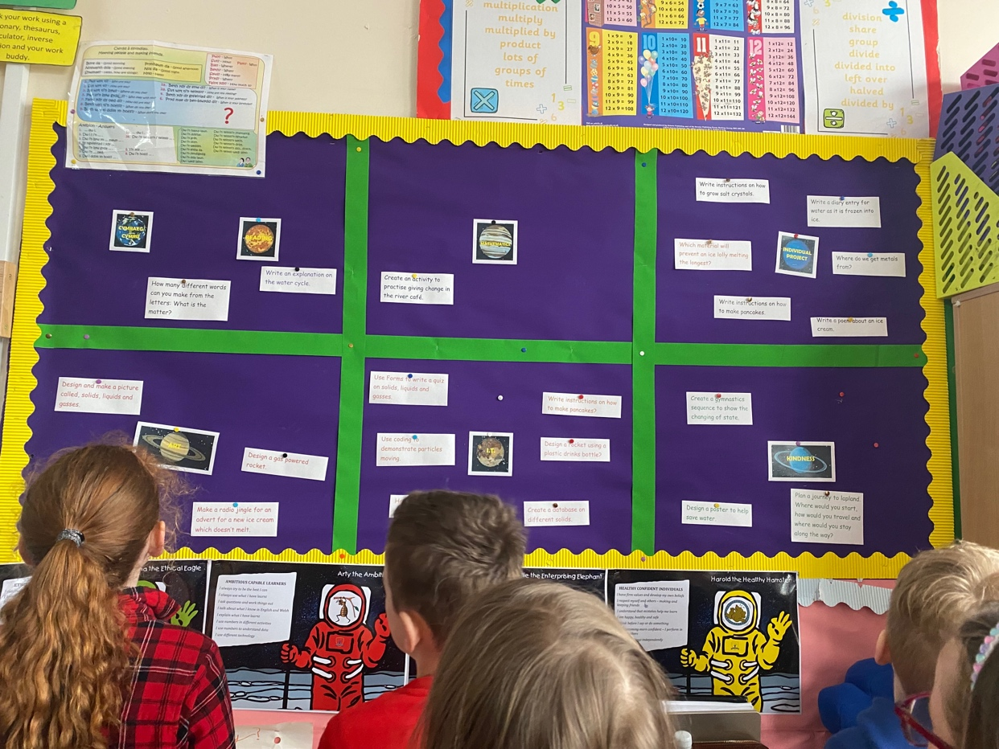
Appendix (1)

Appendix (2)
Student-teacher: | Miss Bagshaw | Class / Group: | Year 3/4
AoLE or Subject: | Science and Technology – The Water Cycle | Date: | 08-09-10/03/23
Meaningful links to Curriculum (What Matters Statements, Descriptions of learning, previous curriculum...) | - WMS3 - The world around us is full of living things which depend on each other for survival.  - DoL - PS2 - I can explore relationships between living things, their habitats and their life cycles.  - WMS4 - Matter and the way it behaves defines our universe and shapes our lives.  - DoL - PS3 - I can recognise that our planet provides natural materials and can explain why they may have been processed to make them useful.
Four Purpose driver:  (Remember to go ‘beyond the headlines’. Only main links should be identified here) | - Ethical, informed citizens who: understand and consider the impact of their actions when making choices and acting  - Ambitious, capable learners who: can explain the ideas and concepts they are learning about
Meaningful links across the curriculum  Links to other AoLEs or the Cross-curricular skills frameworks) | Humanities  - WMS5 - Informed, self-aware citizens engage with the challenges and opportunities that face humanity, and are able to take considered and ethical action.  - DoL – PS2 - I can take care of resources and not waste them, and I am conscious of the importance of creating a sustainable future.  - WMS3 - Our natural world is diverse and dynamic, influenced by processes and human actions.  - DoL – PS3 - I can give simple descriptions of the processes that lead to change in the natural world.  DCF  - Producing – Creating digital content – PS2 - I can create, edit and organise multimedia components (text, images, sound, animation and video) in selected software as appropriate, such as: • text and images, e.g. change font type, size and style; highlight text to use cut, copy and paste; use bullet points; inserting images, crop and rotate • presentation, e.g. add hyperlink using highlight; copy and paste; add, delete and reorganise slides  - Producing – Evaluating and improving digital content - PS2 - I can give an opinion about my own work and suggest improvements based on the success criteria.  Literacy Framework  - Writing – Planning and organising for different purposes, audiences and context - PS2 - I can organise my writing into a logical sequence, e.g. write using an introduction to the topic and a conclusion, present information as a process, use ordering words.
Personal Targets (make reference to targets identified in Planning Guide or QTS Professional Standards and weekly mentor meetings. You may also draw from targets linked to the Welsh Language Competency Framework)
- Leadership - Supporting Formal Leadership Roles - The teacher demonstrates an understanding of the nature of responsibilities within and across teams and of the contributions individuals make towards the school's ethos and the successful fulfilment of the school's vision.
Learning Objectives (4:15 on video)
What do you want the pupils to have learnt by the end of the lesson? Is this a lesson about building tools or learning to use them better? ‘You are learning X to develop an understanding of Y so that you can apply to Z in the future’.
- To be able to understand and explain the process of the water cycle
Success Criteria (6:42 on video)
Help pupils develop a deep understanding of what they are supposed to learn, help them understand what success will look like, how the lesson’s tasks relate to the objective.
See PPT. for different success criterions for each session...
- I have used scientific vocabulary.
- I understand the different processes that happen in the water cycle.
- I have labelled my diagram correctly and checked it with a friend.
- I can explain the water cycle orally with a friend.
Planning for misconceptions:
Every lesson holds the promise of both learning and mistakes. Use this section to anticipate pupil errors and your responses to them and seek guidance if required.
Ensure that the children have use of spare laptops in case their laptops slow down/run out of battery. Also provide high level of differentiation for learners who need support/extensions.

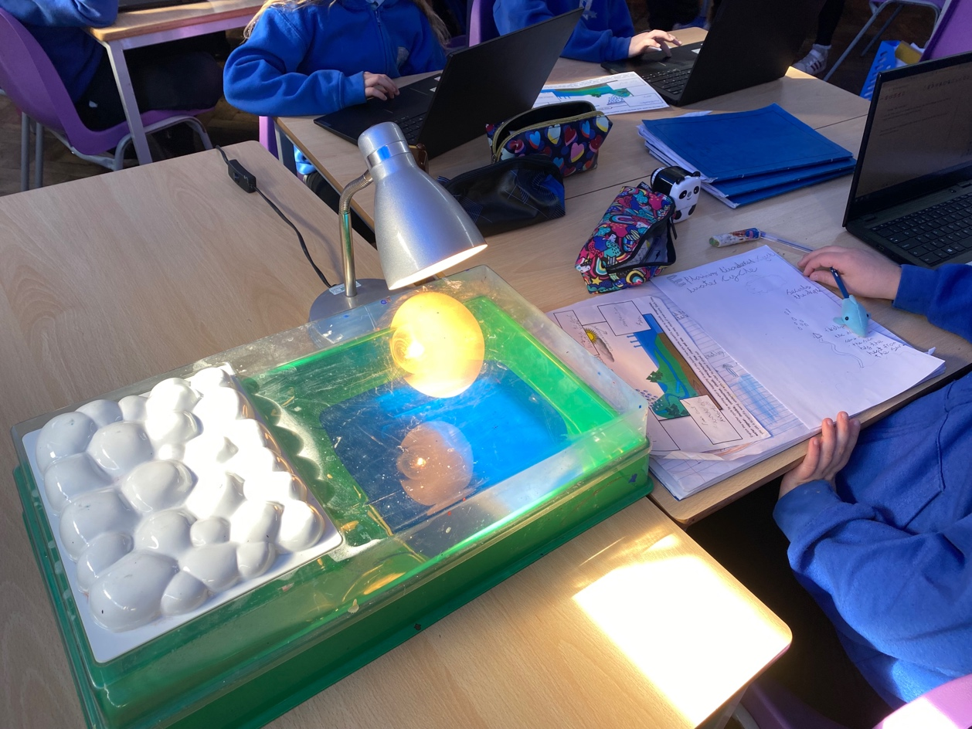
Appendix (3)

Appendix (4)

