
Group Project
Analysis and reflection of an error in project planning and its after effects.

May , 2023
University of Wales Trinity Saint David

Jordan Briskham
1504704

Contents page:

Abstract 2

Introduction 5

Literature Review 7

Methodology 12

Reflections 17

Conclusion 30

Appendices 34

References 36

Abstract

Introduction

A reflective analysis of a commissioned practical approach project, preparing mechanical engineering students at Neath Port Talbot College for the 2022 World Skills competition, a reflection and critical analysis of the approach and suggested improvements for 2023 competitions.

Literary review
The methodology of project management can heavily influence its success. Research identified literature to determine relevant change and project management methodologies pertinent to the aims of the project.
Methodology
Quantitative and qualitative data was collected to demonstrate empirical data and express observations collected.
Quantitative data was collected using a Gantt chart, which displays the key events of the project, which are the planning phase, qualifying stage, preparation for the final and competition week.
A questionnaire was also used to understand the retrospective evaluation of the project completed by the team members of the competition.

Reflection
Data collected suggests that applying a Gantt chart earlier in the project would allow a more visual indication of the team's progress and potentially identity issues such as time
pressures at an earlier date. Thus meaning a compromise with employers may have been reached and an utilisation of a more achievable timeframe established.

Questionnaire results
Results indicated that participants one and two had a positive experience of the process, whereas participant three had a more negative opinion than their peers. Participant three’s opinions mirror the finding of the researcher that a modified approach would be beneficial to adopt.

Conclusion
Constraints of the report included a limited range of data due to the small number of participants in the team.
Critical areas highlighted for improvements in future projects are identifying power influence over the project, employing adequate tools for project management, and using conflict management techniques.

Introduction

A project was commissioned to plan a practical approach to prepare mechanical engineering students at Neath Port Talbot College for the 2022 World Skills competition, Manufacturing Team Challenge. This report displays a reflective analysis of an error in the project planning and how this error subsequently affected other downstream processes. This analysis aims to critically analyse circumstances pertaining to this scenario and draw conclusions to help improve the process for implementation on the 2023 competition cycle.

The NPTC group was established in 2013 following a merger between Coleg Powys and Neath Port Talbot College. NPTC group prides itself on that status brought about by operating the largest conglomerate of colleges in Wales, with its campuses covering a significant portion of Wales's land mass. In addition, the group bears a national presence with subsidiary companies throughout the UK and internationally through various subsidiary institutions in China and India.
NPTC group is dedicated in its approach to teaching and training. This is achieved shown by the range of both academic and vocational subjects which are available to study. In addition, students have to opportunity to attain a range of accredited qualifications from levels 1 to 7. The NPTC group educates 20000 students and employs over 900 staff members across nine campuses throughout Neath Port Talbot and Powys​ (NPTC, 2023)​.

World Skills is an independent charity which is present in 80 countries globally which
Hosting technical skill competitions worldwide has fostered strong links with educators, employers and governments. Their objective as an organisation is to drive international skill progression of young adults enrolled in technical education programs or within work-based learning settings by providing training and competition based- assessment opportunities. Successful students can challenge themselves and gain world-class skills to improve their desirability to potential or current employers. (World skills, 2023)

The Manufacturing Team Challenge consists of 3 moderated rounds of competition- regional qualifiers, national qualifiers and national finals. Employers and education providers can field multiple teams, but it is stipulated that competitors must be under the age of 22 and are studying an academic course between levels 2 and 6. Each team comprises three individuals who ideally should possess differing engineering skill sets. This is due to the varied elements of the challenge, which test learners' proficiency against various criteria and skills matrices. (World Skills, 2023)

​

Literary review
It has been posed that applying worthy project management methodology can hold a heavy bearing on whether a project is a success (Munns and Bjeirmi, 1996). Literature was considered, and research was executed to discover relevant areas of project and change management methodologies applicable to the project aims. Project management is critical as it sets out a plan of approach that can be used to execute strategic goals (Murray-Webster and Dalcher, 2019). Without setting these objectives, evidence suggests that a project risks failure (McManus and Wood-Harper, 2008). Mowday and Sutton (1993) believe that the effective application of management skills builds a positive foundational environment for organisational harmony, a position shared by Dutta and Chaudry (2021)and Harris and Harris (1996)

It has been suggested that managing project stakeholders effectively can not be overstated (Assudani and Kloppenborg, 2010). A stakeholder is categorised as any individual or group affected by an organisation's practices (Kaku, Zhu and Fangninou, 2022). Research suggests that stakeholders can be categorised as internal- who are intrinsically connected with the application of a project, or external- who hold an interest in the project but are not involved in its execution (Slabá, 2014). It has been suggested that the purpose of a project is predominantly to deliver benefits to its stakeholders (Rajablu, Marthandan and Fadzilah, 2023). Jergeas et al. (2000) posit that a shareholders stake is strongly interwoven with project success.
Furthermore it could be argued that managers have a duty to recompense these stakeholders by possessing the necessary skills to execute strategic business objectives competently. This point is further explored through the scope of corporate social responsibility. CSR is intimately connected with various business-centric methodologies, which can be viewed from several differing standpoints (Tokoro, 2007) (Slabá, 2014). It proposes approaches to promote ethical choices within organisations to ensure that the objectives pursued are in the best interests of their associated stakeholders and not purely from a financial standpoint (Bright and Cortes, 2019).

The question here lies with how the correct techniques should be applied to identify stakeholders within a project and how to categorise them. Approaches for this were explored and evaluated, with findings suggesting using a Mendelow matrix (Mendelow, 1991). This model allows an individual to categorise stakeholders according to their power and interest. Research suggests this is a worthy approach as it allows the manager to plan an approach to best allocate their time and resources between these interest groups (Maylor and Turner, 2022) (Rahma et al., 2021). Although widely employed, arguments have been posed over some aspects of this model (Cuofano, 2023), namely the subjective nature of the selection and categorisation of the stakeholders. This analysis may be prone to biases based on the intrinsic value of the individuals employing the tool, thus oversimplifying the stakeholder's actual standing.

Further reading was afforded to the topic motivation. It has been extensively theorised that individuals are motivated by intrinsic and extrinsic needs. Maslow's (1943) theories circulating motivation pose that people's needs can be classified against a five-step model. Maslow posed that physiological, safety, love, esteem and self-actualisation needs can accurately categorise an individual's motivations (Cassidy and Kreitner, 2012). Here he theorised that most individuals are unaware of these needs. However, these individuals will progress through the model incrementally with the emergence of higher needs as the lower needs are fully fulfilled. Although widely cited, some critics challenge Maslow's principles due to the strict ordering of principles (Wahba and Bridwell, 1976). Further Limitations were discovered through research, highlighting that Maslow's model should be viewed with scepticism since it was not developed for use in professional settings.​ (Mullins, 2016)
​
Motivation was further explored through goal-setting theory and by evaluating Locke's (1968)approach. It was posed that the goals or intentions of individuals play an integral part in determining their behaviours. Furthermore, Locke's research suggests that a combination of goal difficulty- defined as the extent to which it is deemed challenging or demanding- and the extent of a person's commitment will regulate the level of performance delivered. Finally, it was argued here that individuals with a defined and structured management framework would perform better than those with no or vague goals.
Further research identified the benefits of adopting stretch goals (Sitkin et al., 2011). These are defined as goals which are ambitious and are targeted at areas where performance requires modification. It could be argued that these principles have more practical bearing for the manager than Maslow's model. Locke proposed that his theory should be viewed more as a motivational technique than a formal theory concerning motivation (Locke, 1975). Goal theory presses the importance of planning, setting challenging yet achievable goals and providing individuals with timely and high-quality feedback on their performance. Research suggests that although this technique shows merit, it is essential that the goals are agreed and accepted on the individual level. Some individuals may reject the application of these modified goals (Lunenberg, 2011). However, it has been suggested that this may be minimised by including the individual in the goal-setting process rather than simply enforcing it (Bandura, 1977) (Cassidy and Kreitner, 2012).

The research was finalised with the exploration of conflict management strategies. This was explored through applicable modalities such as forcing, superordinate goals and negotiation. (Mullins, 2016)
It has been argued that forcing is the least desirable option to employ as it relies on intervention from a superior to overpower the positions of the aggrieved parties. However, research suggests that the application of this technique does not resolve the underlying issues, and they may re-emerge with more fervour. (Cassidy and Kreitner, 2012)
The application of superordinate goals was further explored. This technique involves the application of challenging or valuable goals which unite the disagreeing parties (Höchli, Brügger and Messner, 2018). Although sometimes compelling, it has been suggested that this technique is often a short-term solution to the problems faced. (Cassidy and Kreitner, 2012)
To underline these principles is the application of problem-solving through negotiation tactics. Evidence suggests that this is one of the more effective approaches to managing conflicts that may arise (Ross, 1993). This is often achieved by assessing the sources of the conflict at its basal form. These principles complement Lockes(1975) theory as they suggest the application of agreed goals between the parties to whether this is through compromise or the solution to their perceived disagreements.

Through the research provided, it is posed that the application of these theories will be applied in retrospect to analyse the project in question. This aims to draw conclusions for future improvements to the process and improve the experience for all relevant stakeholders.

Methodology
This report aimed to retrospectively analyse the project in question, assessing a failure in the planning process and how it could be mitigated in future applications using appropriate change and project management methodology. This project was commissioned in response to the need to select, manage and prepare suitable students for the World skills manufacturing team challenge. It was carried out between March and November 2022 and involved one teaching staff member tasked with managing the project and three students selected as competitors. The need for project management was vital in this process as the learners would need support and guidance throughout the process to gain the necessary skills to compete at the national finals. In this case, the project manager's duties were to mentor the individuals involved, source training, provide financial assistance and manage the Health and safety elements involved. Qualitative and quantitative techniques were employed to gather the necessary data for the analysis due to the need to express empirical data gained and observations of experiences and events. Research suggests this is a favourable approach for project success, as supported by (Shenhar and Dvir, 1996) and (Sandelowski, 2000).

The quantitative approach taken in this case was employing a Gantt chart. It was used to display each step of the project from its inception to its final implementation. The project was separated into four distinct phases; firstly, a planning phase where the chosen team entered the competition - secondly followed, a qualifying stage- where the teams had to create a prototype for the competition. The third phase covered the preparation for the national final, and the last phase was used for the week of the competition. Each phase was broken down into stages displayed in the Gantt chart. These showed key events involved with the project and were derived from the competition specification and time frame provided. The reason for planning each phase separately was due to the uncertainty of qualification. The benefits of adopting a Gantt chart, in this case, are that the complexities of the project can be broken down into manageable sections so duties can be divided and delegated effectively and the timeframe managed efficiently (Geraldi and Lechter, 2012).
Although Gantt charts are widely used within organisational management research, there are some shortcomings, namely, how each critical activity interrelates. These relationships are not always clearly visually represented, as each activity has unique start and finish durations. Completing this task may relate to a later activity further down the chart rather than its nearest successor. Furthermore, a Gantt chart only shows one course of events or a particular scenario. This does not work well with projects with multiple scenario outcomes, as this would mean that numerous Gantt charts must be employed (Ballesteros-Pérez, Larsen and González-Cruz, 2017).
The questionnaire was designed to gain retrospective feedback on this project from the three students involved post-competition. It was administered virtually using Microsoft Forms, which consisted of ten questions. The format followed a criterion of eight questions using the Likert scale and two using long-form answers. In this case, the scale-covered 7 points. Research suggests that using this approach versus a 5-point model is more favourable as it gives the user more options to express their opinion on each question more accurately (Finstad, 2010). The benefit of using the Likert scale in this format is that it supplies the end user with quantifiable data that is relatively simple to interpret. In addition, the data can be used to populate a graphical profile to measure the opinions or perceptions of the participants, which can provide greater insight into their thoughts and emotions about the subject (Heiberger and Robbins, 2014). Although the Likert scale is widely accepted, some limiting factors exist, particularly in providing descriptive feedback for future improvements. This has been addressed by using open-ended questioning, allowing the participants to express feelings or ideas that they may not be able to communicate through the restrictive scope of the scale (Albudaiwi, 2017). This gives rise to the opportunity of gaining insights that can be taken forward for further reflection.
It could be argued that one of the main limiting factors, in this case, circulates predominantly in the size of the group being assessed, as this will inevitably restrict the range of data to a degree (Faber and Fonseca, 2014). There is also the question of bias due to the group size and the fact that the author of the questionnaire is known personally by the participants. Therefore, responses from the survey may inadvertently identify the individuals involved, which may influence their answers (Choi and Pak, 2005).

In parallel with the quantitative data gained, this report applied qualitative approaches. Ethnographical principles provide the researcher with the required data to critically assess the project in question (Caulfield, 2023) (Kramer and Adams, 2017). The researcher was uniquely positioned to be involved in the entire process, from inception to implementation. Due to this fact, data is available from feedback gained through team meetings, practical workshops and other observational opportunities with the individuals involved. The justification for adopting this approach is to broaden the range of data available to the author in this case. It can reinforce the information gained through the other stated data sources. The main benefit of applying this methodology is the wealth of immersive insight gained through these experiences, which can apply context to the experimental group. This can supply the researcher with valuable nuances that would not be available through quantifiable means (Jones and Smith, 2017). Further evidence suggests that these principles are better applied within a small-scale setting which lends itself to the validity of its use in this case (Caulfield, 2023).

Although valuable information can be gained from ethnography, there are some limiting factors identified with applying this technique. These circulate particularly with the risk of observer bias which can occur through the subjective interpretations of the researcher's opinions (Collins and Odoyo, 2020) (Khan, 2018). This can be controlled by using multiple observers, known as triangulation, although it was not feasible in this case. Ethnographic studies typically also occur over an extended period. Again, this may not be practical in some situations, but as the researcher, in this case, has prior knowledge of the process, it has mitigated this issue.

Reflection
Through applying the methodological principles stated, opportunities were identified to reflect upon for implementing the Manufacturing Team Challenge to future students at Neath College. In addition, by using these principles, it was possible to break down the project into its key events and phases and organise them into a logical order.

Director of Studies at the college's Engineering department and the project manager involved in this case. The DOS requested the PM to select a team to develop for the opening stages of the project. The PM used the competition specification to assess against the criteria and identify a suitable framework of both practical and interpersonal skills that would be necessary. It was found that the competitors would need practical knowledge of machining, fabrication and electronics, further to this experience of using technological packages such as Computer-Aided Design and programming software. This information was used to select three suitable candidates from the engineering department. Each individual was an apprentice who attended the college one day weekly and was chosen based on the merits of their practical disciplines.

As all of the candidates were employed, it was necessary to hold a meeting with their employers to gain permission for them to compete. Within this meeting, a case was made showing the benefits they would gain from releasing their apprentices- focussing on the enhanced training they would receive and the exposure of their company name if the competitors were successful. This is an example of how stakeholders were holistically engaged within the project. Further evaluation was carried out to identify the stakeholders involved in this project and was populated using a power: interest stakeholder map (Mendelow, 1991). These were categorised as internal- internally involved in the project and external- entities who maintain a vested interest in the process but are not directly associated. It could be argued that maintaining stakeholders' requirements is a critical part of the planning process (Assudani and Kloppenborg, 2010).
As shown in Figure one, the stakeholders, in this case, were organised according to how much power and influence they maintained within the project and the impact that they could make if their support were withdrawn. At the bottom end of the scale are competitor colleges; these should be monitored to assess for innovation and to look for areas of good practice but should be among the lowest priorities for a project manager. The column labelled 'keep informed' refers to the need to sustain these stakeholders' interests but not rely on their support; in this case, an appropriate choice would be students interested in competing in the competition in the future. In this case, the PM must leverage their interest but not overmanage and lose sight of more important elements. The top row of the scale shows the column 'keep satisfied'. The interested parties in this case- Namely the competitor's employers and representatives from the World Skills organisation hold high power. If their support is withdrawn, the project will fail, but low influence as they hold little bearing over the internal processes of the team's project. These stakeholders must be sufficiently managed, involved and informed to ensure they are satisfied throughout the process. At the highest end of the scale, labelled 'manage closely', we have the highest priority stakeholders. Without a proactive approach to managing the team in question, it could be argued that the project is likely to fail. It is vital that the PM actively manages these parties throughout the process. In this case, the NPTC group was the sole provider of financial support, and it could be argued that they are the party with the most interest in gaining a return on their investment- in this case, funding opportunities, exposure and accolade for the college if the students achieved an award.
Figure One- Power Interest Matrix Source: (Mendelow,1991)
High
Manage closely:
Team members
NPTC Group management

Monitor only:
Other Competitor colleges
Keep satisfied:
Employers
Competition representatives
Power
Keep informed:
Interested students

Low
High
Low
Interest

On confirmation from the student's employers, 3 hours were added to the student's timetables weekly to allow for the design and development of their product. At first, this was deemed sufficient, but as the project progressed, it became apparent that the team was not meeting their deadlines. This caused a reactive response from the PM to facilitate an increase in their agreed working hours. Through discussion with their respective employers, extra time was requested but was subsequently denied. Their justification, in this case, was that the preparatory stages of the competition were agreed to be completed during their assigned study day and not at a detriment to their employment duties. This subsequently resulted in the team members attending the college outside their working hours. It could be argued that this error damaged the credibility of the PM with both the employers and the team members. In this case, it was a severe oversight which could have jeopardised the project's success due to the stakeholders withdrawing their support. (Shepherd and Haynie, 2011)

To further examine this oversight, a Gantt chart was created and populated retrospectively to show areas of non-conformance. Analysing the chart's data suggested some areas that could be modified for future implementation. For example, as shown in Appendix One, between July 7th 2022 and September 8th 2022, there were no meetings between the team because the academic year had ended and the students had returned to their respective employers. Although practical work may not have been able to continue during this period, the PM could have utilised this time for the learners to maintain contact remotely to continue with the written and design elements of the competition. If the team members had continued with their weekly meetings and tasks, they would have added 9 extra weeks to their allocated time, thus substantially reducing the pressures they applied in the latter phases of the project. Although this approach demonstrates how time could have been reclaimed, it is not without its caveats, as between the stated period, the PM, in this case, was absent due to annual leave. This suggests why the project was paused until the academic year was recommenced. A possible approach to alleviate this issue in future could be for the PM to organise virtual team conferences during this period to allow them to oversee and track progress. Evidence suggests this method can give positive outcomes if managed effectively (Garro-Abarta, Palos-Sanchez and Aguayo, 2021). On reflection, the evidence suggests that employing a Gantt chart would have allowed the PM to visually track the team's progress more efficiently and possibly identify the time constraints at an earlier date. This could have been applied to the planning of the process, and a negotiated settlement was reached with the employers in question so that a more feasible timeframe was agreed.

Motivation and Conflict Management

Due to the increased workload applied during this time, observations of the group showed that this negatively affected their motivation. It could be argued that individuals are motivated by intrinsic and extrinsic forces, which affect their motivation to work (Reiss, 2012). Intrinsic motivation derives from within an individual, for example, participating in something due to the enjoyment of a challenge, an activity, or the challenge of a new task. Extrinsic factors are external to the individual and are typically reward-based; for example, in this case, they could refer to the praise they would gain from their peers in the event of winning the competition​ (Shkoler and Kimura, 2020) (Cassidy and Kreitner, 2012). In typical management scenarios, such extrinsic motivators as salary enhancements could be employed to raise motivation, although, in this setting, it was neither appropriate nor possible. This posed a challenge for the PM, where they would have to appeal to the group's values to engage them effectively. Locke (1968) suggests that a goal-setting model could have been applied in this case. It is posed that individuals lacking motivation are typically not clear on their goals (Mullins, 2016). These goals should be agreed upon within the organisation and consist of stretch goals. These specific performance aims are ambitious and challenging but set at an achievable level. (Lunenberg, 2011)

Further observations of the team working collaboratively made it apparent that they were experiencing communication problems. Although they had elected a team leader, it was found that he was often passive in meetings. Evidence suggests that the ambiguous natures of these types of leaders can cause conflict within the working environment (Sharrat, 2016), a position further shared by Harold and Holtz(2015). There was a scenario noted where there was a disagreement over an element of the design during the project's final phase. Two members wanted to use a previously agreed approach, while one wanted to adopt another more complicated method. These differences in opinion were not solved for three consecutive weeks until the PM was forced to intervene to resolve and impose the more straightforward design due to time constraints. Retrospective thought of the situation suggests that the PM should have been more observant of the signs leading up to the conflict and intervened earlier. There were evident personality clashes in the group which had not been identified until after the team had been finalised. The looming deadline of the competition also had an apparent effect on the occurrence of this event which added a degree of pressure to an already strained relationship. Research into this issue identified alternative approaches that could have been explored, such as setting superordinate goals (Cassidy and Kreitner, 2012) (Mullins, 2016). This technique is typically applied by uniting the conflicting parties under a common goal but has been shown only to mask the issue rather than solve it. Another more suitable approach would have been to negotiate a settlement using appropriate problem-solving strategies, to get to the source of the disagreement (Ross, 1993). This method appeared the most conducive option but was heavily reliant on the project's time constraints, which in this case were not favourable.

Questionnaire results

On request, the three competitors completed a questionnaire post-competition. This aimed to provide feedback for improvements that could be implemented before the next competition cycle in 2023. Figure three and four refer to these results and a key that shows the questions posed in reference to the chart. The data of the three individuals assessed suggests that participants one and two had largely positive experiences through this process. They consistently answered highly on the Likert scale, which proposes positive opinions.

Further feedback gained from the participants through the long-form answers shown in Figure five proposed similar results. The comments from participant one consisted of predominantly technical feedback; his answer to question nine was incomplete and, therefore, difficult to conclude. Participant twos comment about the process were stated. They stated, "I felt very involved as all ideas shared about the project were listened to and taken into mind; during the competition, we all had different tasks to complete, which meant we were all involved with the final project." This again suggests a positive outlook on the project. Finally, the comments provided against question ten were consistent between all participants, where they all cited technical concerns pertaining to their build.

The data proposes that this was the only area where participant three agreed with their peers. He further cited concerns towards the time constraints around the time of the end of the project, which further supports the recommendations of implementing better time management tools in future. The data further suggest that Participant Three's answers supported the previous findings and suggest that a modified management approach should have been employed in this case. Although the participants completed the test anonymously, it could be argued that there is evidence to suggest that it is the individual's feedback in the conflict associated with this project. By the PM employing more effective conflict management techniques at an earlier date, he may have had the opportunity to negotiate a more suitable solution to improve the aggrieved parties' outlook.

Figure two- Likert participant scoring graph

Figure three – Likert-based question profile

Question profile | Likert Scale Key
1. How satisfied are you with the support you received from your mentor in the run up to the world skills competition 2022? | 1= Very dissatisfied  2= dissatisfied  3= Somewhat dissatisfied  4= Neither satisfied nor dissatisfied  5= Somewhat Satisfied  6= satisfied  7= Very satisfied
2. How satisfied are you with the management of the process leading up to the competition?
3. How satisfied were you with the experience of competing in the World Skills competition 2022?
4. How satisfied are you with the design and innovation elements of your final product?
5. How satisfied are you with the investment of time against your result in this competition?
6. How satisfied were you with the communication and collaboration between you and your team in the world skills competition 2022?
7. How likely would you be to recommend the competition to other students? | 1= Very unlikely  2= Unlikely  3= Somewhat unlikely  4=Neither likely nor unlikely  5= Somewhat likely  6= Likely  7= Very likely
8. How satisfied were you with the quality of training that you received through the process? | 1= Very dissatisfied  2= dissatisfied  3= Somewhat dissatisfied  4=Neither satisfied nor dissatisfied  5= Somewhat Satisfied  6= satisfied  7= Very satisfied

Figure 4- Open questioning profile
Long form question profile | Participant 1 | Participant 2 | Participant 3
9. Did you feel involved and informed during the different project stages? Please provide any suggestions for improvement. | I would personally suggest more preparation in regards to getting ready for the main project, such as practicing basics like wiring diagrams, assembly etc. | I felt very involved as all ideas shared about the project were listened to and taken into mind, during the competition we all had different tasks to complete which meant we were all involved with the final project. | I was involved with all stages of the competition but I felt that my ideas were outvoted regularly. In future I think there should be extra training on different types of CAD packages.
10. Were there any unforeseen challenges or obstacles encountered during the project? If yes, how well were they addressed? | We encountered an issue with our third motor, resulting in a not operational motor. We addressed this as a team and put in place a plan to overcome it. | One problem we found was that our glue wasn't strong enough to mounds the wheels to the car so we ended up welding the shaft onto a bolt and securing them that way. Another problem we encountered was that our motor was burning out, luckily we had a spare motor which we used but know next time to use a strong motor and can recommend this to the next competitors. | We had problems with the design on the build week. We struggled to fit the wheels on to the robot but managed in the end. We were running out of time towards the end of the project also and only just managed to print the body of the robot in time.

Conclusion

In conclusion, this report has examined the identified issues within the planning process of this project and also found critical areas for improvements that provide valuable insights that can be applied to improve the process in future.

Firstly a power: interest framework was populated to identify the stakeholders in this scenario. This analysis would have allowed the PM to identify the parties within this case with the most power and influence over the process (Assudani and Kloppenborg, 2010). This would help them identify how best to distribute their time and how closely each party should be monitored or managed (Slabá, 2014) (Maylor and Turner, 2022). It was posed that evidence suggests that not conforming to the agreements with stakeholders who hold high power and influence within the project can jeopardise project success.

It was shown that the PM, in this case, should have adopted more effective project management scheduling tools, such as using a Gantt chart. This would have provided them with a visual aid to identify the time constraints at an earlier date where they could have possibly been mitigated (Mullins, 2016). By applying this process retrospectively, it was identified that crucial opportunities were missed in maximising project productivity. For example, nine weeks of sessions were shown that could have been utilised to distribute the workloads of the team members involved more effectively.

Further to this point, it was demonstrated here how adopting substandard planning choices negatively affected the stakeholders in this case, namely the team members' motivation. Observations showed that the extra workload and time constraints applied to the team members at this time affected their productivity. In this case, the PM was in a challenging position to motivate the students involved, as the more common extrinsic motivators such as salary enhancement, were inappropriate in this circumstance (Shkoler and Kimura, 2020). It was suggested that setting intrinsic stretch goals that are ambitious yet achievable for the team members in question could have helped to alleviate this issue. (Locke, 1975)

Conflict management techniques were identified as an area for improvement, as highlighted in the scenario noted. It was suggested that by adopting a more proactive approach to observing the team members, the PM could have intervened earlier and employed a more tactful approach to resolving the issues. Proposals for modifying these behaviours were offered, such as using superordinate goals (Cassidy and Kreitner, 2012) and negotiating using problem-solving techniques to gain access to the root of the problem. (Ross, 1993) It was found through feedback that this was an issue that had not been fully resolved in the team, even post-competition.

The findings underscore the significance of employing appropriate planning modalities for projects. In addition, a critical analysis of the project in question has identified opportunities to improve the process for future competitors.
Furthermore, it is essential to note the limitations within this report, such as the small range of data provided through the questionnaire and the possibility of observer bias by adopting an ethnographical approach. These limitations allow future reflection within this process, which can serve as a foundation for further exploration.

Appendices
Appendix one - World skills gantt chart
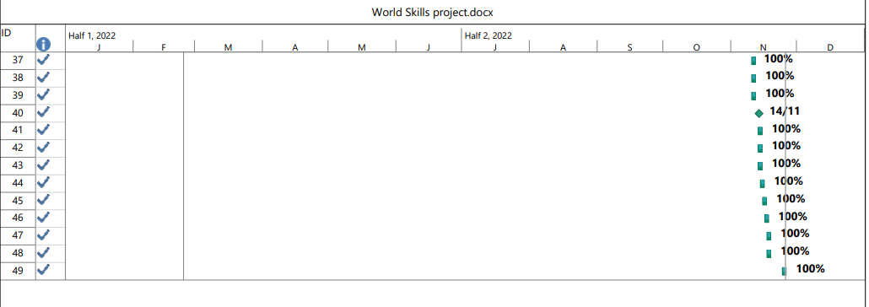
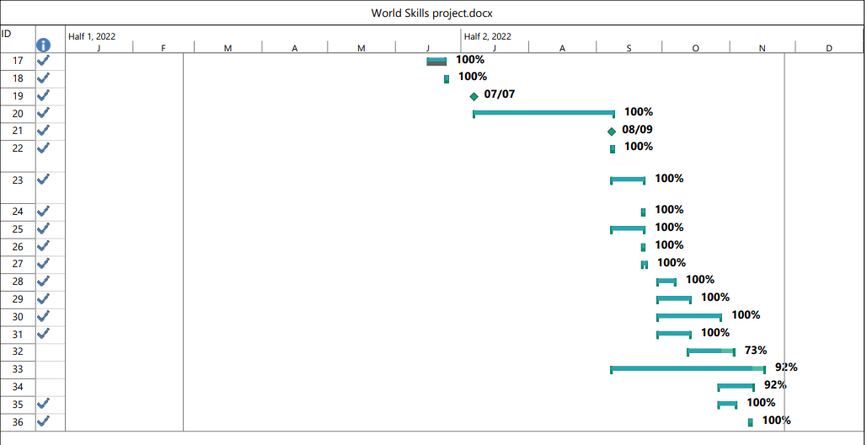
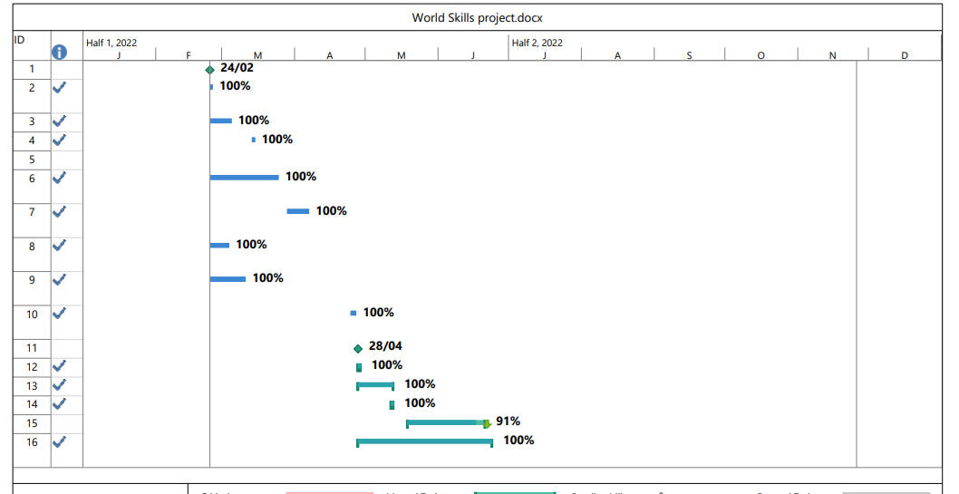
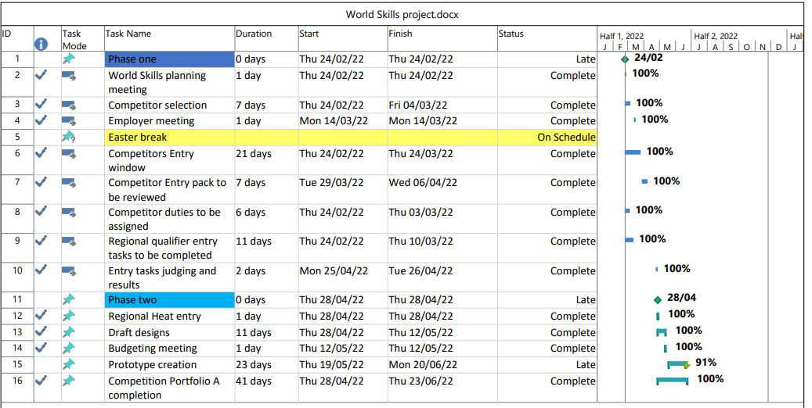
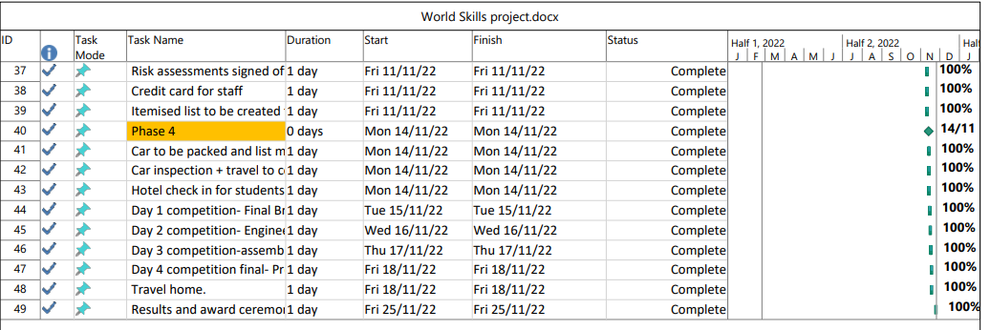
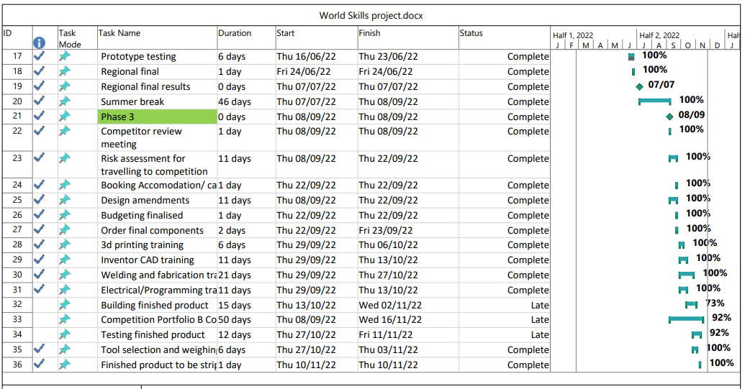

Reference list

Albudaiwi, D. (2017) The SAGE Encyclopedia of Communication Research Methods, 4th edition, Thousand Oaks CA: SAGE Publications Inc.
Assudani, R. and Kloppenborg, T.J. (2010) 'Managing Stakeholders for Project Management Success: An Emergent Model of Stakeholders', Journal of general management, vol. 35, no. 3, pp. 67-80.
Ballesteros-Pérez, P., Larsen, G.D. and González-Cruz, M.C. (2017) 'DO PROJECTS REALLY END LATE? ON THE SHORTCOMINGS OF THE CLASSICAL SCHEDULING TECHNIQUES', Journal of Technology and Science Education, vol. 8, no. 1, November, pp. 17-33.
Bandura, A. (1977) 'Self-efficacy: Toward a unifying theory of behavioral change.', Psychological Review, vol. 84, no. 2, 191-215, pp. 191-215.
Bright, D.S. and Cortes, A.H. (2019) Principles of Management, 1st edition, Houston, TX: Openstax.
Byars-Winston, A. and Lund-Dahlberg, M. (ed.) (2019) The science of effective mentorship in STEMM, Washington, DC: The National Academies Press.
Cassidy, C.M. and Kreitner, R. (2012) Principles of management, 12th edition, Cengage learning.
Caulfield, J. (2023) What is Ethnography, April 06th, [Online], Available: https://www.scribbr.co.uk/research-methods/ethnography-explained/ [May 09th 2023].
Choi, B.C.K. and Pak, A.W.P. (2005) 'A Catalog of Biases in Questionnaires', Public Health Research, Practice and policy, vol. 2, no. 1, pp. 1-13.
Collins, A.N. and Odoyo, O. (2020) 'Ethnography, Its Strengths, Weaknesses and Its Application in Information Technology and Communication as a Research Design', Computer Science and Information Technology, vol. 8, no. 2, June, pp. 50-56.
Cuofano, G. (2023) Four Week MBA, April 08th, [Online], Available: https://fourweekmba.com/mendelow-stakeholder-matrix/#:~:text=Their%20relationships%20with%20an%20organization,nuance%20in%20understanding%20stakeholder%20dynamics. [May 10th 2023].
Dutta, A. and Chaudry, S. (2021) 'Managing people effectively: Challenges and best practices', Journal of management Research and Analysis, vol. 8, no. 1, may, pp. 10-14.
Faber, J. and Fonseca, L.M. (2014) 'How sample size influences research outcomes', Dental press journal of orthodontics, vol. 19, pp. 27-29.
Finstad, K. (2010) 'Response Interpolation and Scale', Journal of Usability Studies, vol. 5, no. 3, May, pp. 104-110.
Garro-Abarta, V., Palos-Sanchez, P. and Aguayo, M. (2021) 'Virtual Teams in Times of Pandemic: Factors That Influence Performance', Organisational Psychology, vol. 12, February, pp. 1-14.
Geraldi, J. and Lechter, T. (2012) 'antt charts revisited: A critical analysis of its roots and implications to the management of projects today.', International Journal of Managing Projects in Business., vol. 5, no. 10, September, pp. 1-28.
Harold, C.M. and Holtz, B.C. (2015) 'The effects of passive leadership on workplace incivility', Journal of Organisational Behaviour, vol. 36, no. 1, pp. 16-38.
Harris, P.R. and Harris, K.G. (1996) 'Managing effectively through teams', Team performance management, vol. 2, no. 3, pp. 23-36.
Heiberger, R. and Robbins, N. (2014) 'Design of Diverging Stacked Bar Charts for Likert', Journal of Statistical Software, vol. 7, no. 5, pp. 1-32.
Höchli, B., Brügger, A. and Messner, C. (2018) 'How Focusing on Superordinate Goals Motivates Broad, Long-Term Goal Pursuit: A Theoretical Perspective.', Frontiers in psychology, vol. 9, pp. 1-14.
Hussain, S.T., Lei, S., Akram, T., Haider, J., Hussain, S.H. and Ali, M. (2018) 'Kurt Lewin's change model: A critical review of the role of leadership and employee involvement in organisational change,', Journal of Innovation & Knowledge, vol. 3, no. 3, Dec, pp. 123-127.
Jergeas, G.F., E, W., Skulmolski, G.J. and Thomas, J.L. (2000) 'Stakeholder management on construction projects', AACE International Transactions, 12.1-12.6.
Jones, J. and Smith, J. (2017) 'Ethnography: Challenges And opportunities', evidence based Nursing, vol. 20, pp. 98-100.
Kaku, P.M., Zhu, H. and Fangninou, F.F. (2022) 'Evaluation of the EIA process in Zanzibar: the participation', Environment, Development and Sustainability, march, pp. 1-21.
Khan, M.H. (2018) 'Ethnography: An Analysis of its Advantages and Disadvantages', SSRN, pp. 1-7.
Kramer, M. and Adams, T. (2017) The SAGE Encyclopedia of Communication Research Methods., 4th edition, Thousand Oaks, CA: SAGE Publications.
Locke, E.A. (1968) 'Towards a Theory of Task Motivation and Incentives', Organisational Behaviour and Human Performance, vol. 3, pp. 157-189.
Locke, E.A. (1975) 'Personal Attitudes and Motivation', Annual Review of Psychology, vol. 26, pp. 457-480.
Lunenberg, F.C. (2011) 'Goal Setting Theory of Motivation', International Journal of Management, vol. 15, no. 1, pp. 1-6.
Maslow, A. (1943) 'Maslows Hierarchy of needs', in A theory of human motivation, 50th edition.
Maylor, H. and Turner, N. (2022) Project Management, 11th edition, Harlow: Pearson.
McManus, J. and Wood-Harper, T. (2008) Research gate, [Online], Available: https://www.researchgate.net/publication/329539985_A_study_in_project_failure [May 05th 2023].
Mendelow, A. (1991) 'Stakeholder mapping. ', Proceedings of the 2nd International Conference on In- formation Systems, Cambridge, MA.
Morrison-Smith, S. and Ruiz, J. (2020) 'Challenges and barriers in virtual teams: A literature review', SN applied Sciences, vol. 2, May, pp. 1-33.
Mowday, R. and Sutton, R. (1993) 'organisational behaviour: linking individuals and groups to organisational concepts', Annual reviews of psychology , vol. 44, pp. 195-229.
Mullins, L. (2016) Management and Organisational Behaviour, 11th edition, Harlow: Pearson.
Munns, A.K. and Bjeirmi, B.F. (1996) 'The role of project management in achieving project success', International Journal of Project Management, vol. 14, no. 2, pp. 81-87.
Murray-Webster, R. and Dalcher, D. (2019) APM Body of knowledge, 7th edition, Princes Risborough.
Rahma, A.T., Elbarazi, I., Ali, B.R., Patrinos, G.P., Ahmed, L.A. and Al-Maskari, F. (2021) 'Stakeholders' Interest and Attitudes toward Genomic Medicine and Pharmacogenomics Implementation in the United Arab Emirates: A Qualitative Study', Public Health Genomics (2021) 24 (3-4): 99–109, vol. 24, no. 4, pp. 99-109.
Rajablu, M., Marthandan, G. and Fadzilah, W. (2023) 'Managing for Stakeholders: The Role of Stakeholder-Based Management in Project Success', Asian Social Science, vol. 11, no. 3, 2015, pp. 111-125.
Reiss, S. (2012) 'Intrinsic and Extrinsic Motivation. ', Teaching of Psychology, vol. 39, no. 2, pp. 152-156.
Ross, L. (1993) Reactive devaluation in negotiation and conflict resolution., 1st edition, Stanford: Standford University.
Ryan, R.M. and Deci, EL (2000) 'Intrinsic and Extrinsic Motivations: Classic Definitions and', Contemporary Educational Psychology, vol. 25, pp. 54-67.
Sandelowski, M. (2000) 'Combining Qualitative and Quantitative Sampling,Data Collection, and Analysis Techniques in Mixed-Method Studies', Research in nursing, vol. 23, January, pp. 246-255.
Sharrat, A. (2016) Smith Business Insight, October 11th, [Online], Available: https://smith.queensu.ca/insight/content/how-passive-leaders-undermine-employee-well-being.php#:~:text=Passive%20leaders%20have%20a%20negative,due%20to%20psychological%20work%20fatigue. [May 11th 2023].
Shenhar, A.j. and Dvir, D. (1996) 'Toward a typological theory of project management,', Research Policy, vol. 25, no. 4, june, pp. 607-632.
Shepherd, D.A. and Haynie, M.J. (2011) 'Venture failure, Stigma and Impression Management: A self- verifification, self determination view', Strategic Entrepreneurship Journal, vol. 5, no. 2, June, pp. 178-197.
Shkoler, O. and Kimura, T. (2020) 'How Does Work Motivation Impact employees investment at work and their job engagement? A moderaed-moderation perspective through an international lens', Frontiers in Psychology, vol. 11, pp. 1-3.
Sitkin, S.B., See, K.E., Miller, C.C., Lawless, M.W. and Carton, A.M. (2011) 'The paradox of Stretch Goals: Organisations in the pursuit of the seemingly impossible', Academy of Management Review, vol. 36, no. 3, pp. 544-566.
Slabá, M. (2014) 'STAKEHOLDER POWER-INTEREST MATRIX AND', The 8th International Days of Statistics and Economics, 11-13 September, pp. 1366-1374.
Tokoro, N. (2007) 'Stakeholders and Corporate Social Responsibility', Asian Business and Managment, vol. 6, pp. 143-162.
Wahba, M.A. and Bridwell, L.G. (1976) 'Maslow reconsidered: A review of research on the need hierarchy theory.', Organizational Behavior & Human Performance, vol. 15, no. 2, pp. 212-240.
World skills (2023) https://www.worldskillsuk.org/?gclid=CjwKCAjwscGjBhAXEiwAswQqNJivuYBbk1C-Yrv5afkhNYh76L__G0EWqBz9SRWMAn9qoNXr0wEUuRoC_c0QAvD_BwE, [Online], Available: https://www.worldskillsuk.org/?gclid=CjwKCAjwscGjBhAXEiwAswQqNJivuYBbk1C-Yrv5afkhNYh76L__G0EWqBz9SRWMAn9qoNXr0wEUuRoC_c0QAvD_BwE [May 01st 2023].
World Skills (2023) World Skills manufacturing team challenge, [Online], Available: https://www.worldskillsuk.org/competitions/manufacturing-team-challenge/ [May 01st 2023].

