Happy Paws Dog Grooming
Monthly Booking Summary
Data Table and Bar Chart

Prepared by:
Xiomara Elizabeth Villalobos Serrano

Role:
Junior Assistant

Prepared for:
Ms. Carter

Date:
12 October 2026

Why I chose my tool
I chose Excel because it is easy to use. I can organize the booking data in a table, use formulas to calculate the totals, and create a bar chart to show the most and least popular services.
I also read a short guide on the UWTSD Digital Skills website about using tables in Excel. It said tables help make numbers clear, so this supported my choice. (DigiCentre,n.d).

What information I used
I used the booking information provided by Ms Carter for the business Happy Paws Dog Grooming; he gave me the data 1-4 weeks. I used the number of bookings for each service:

- Week 1: Full Groom 14, Wash and dry 8, Nail trin 6, Puppy groom 4
- Week 2: full groom 12, wash and dry 10, nails 5, puppies 3
- Week 3: full groom 16, wash + dry 9, nails 8, puppies 5
- Week 4: full groom 15, washes 11, nails 7, puppies 4.

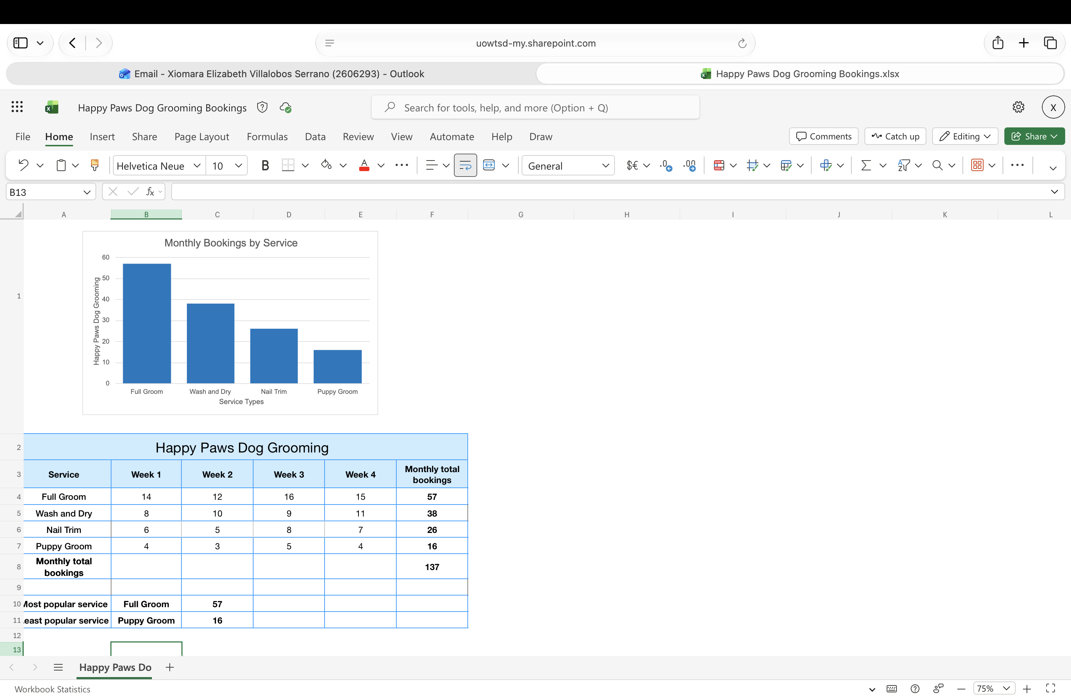

How I created my artefact
- First, I typed the data into an Excel table, I entered the headings Week 1-4, Full Groom, Wash and Dry, Nail Trim and Puppy Groom, I entered the booking information provided by Ms Carter for Weeks 1 to 4.

- Then I selected all the booking data, including the headings, I selected Insert and then Table. I made sure that my table has headers was selected and created the table.

- Then I used a simple formula to calculate total of each service per week to get the total per month. for example:
- =SUM (B4:E4)

- Then I used a simple formula to select the most and least popular service, for example:
- =MAX (F4:F7)
- =MIN (F4:F7)

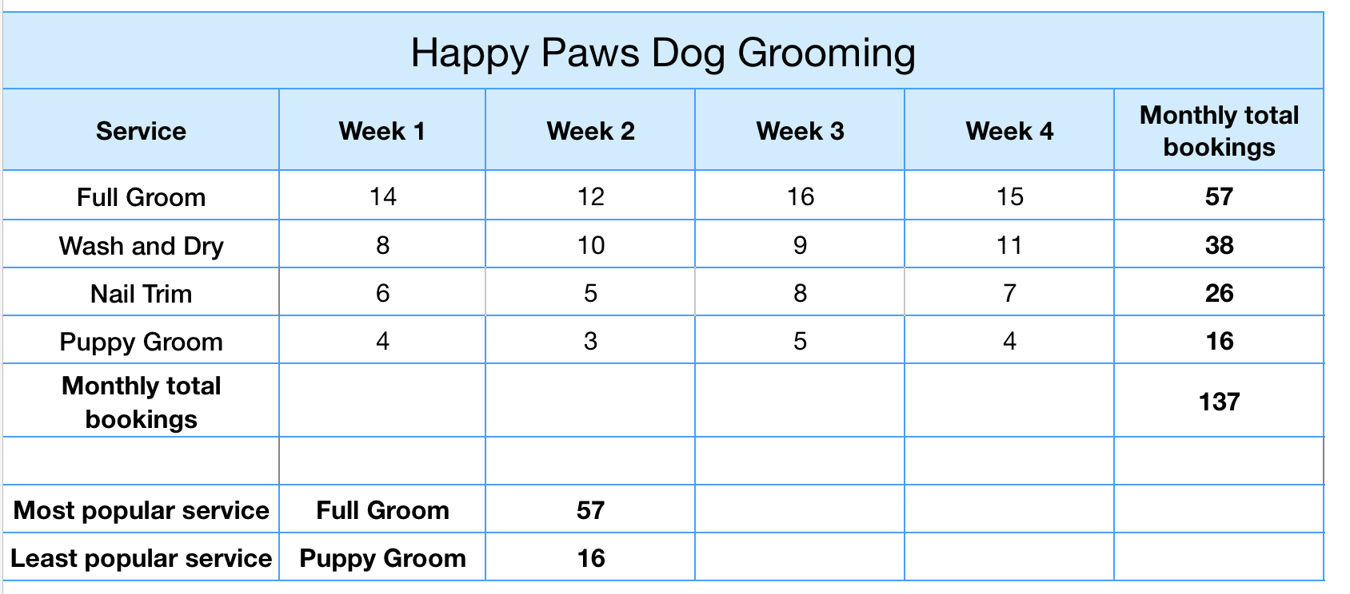

Creating the chart
- After creating the table, I selected the booking information that I wanted to show in the chart.
- I clicked the Insert tab.
- I selected my chart; I choose a column chart.
- The chart showed the different services and the total of services per month.
- I added a clear title, such as Happy Paws Monthly Bookings, I leave the original blue colour.
- Finally, I checked the chart to make sure the information was clear and easy to understand.
- Finally, I checked the numbers again to make sure they were correct.

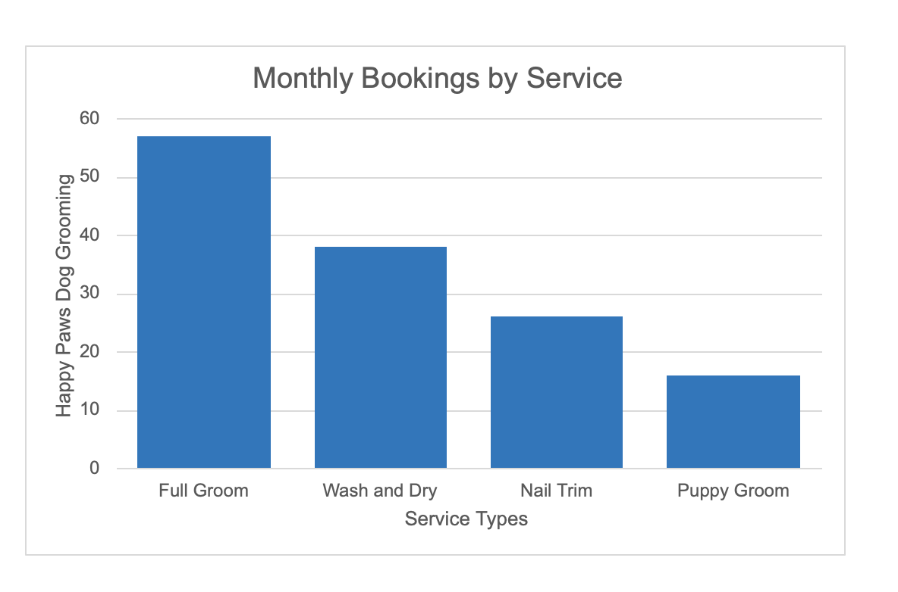

What changes I made

- At first, my table was hard to read, so I added colour and bold headings, and I change the type and size of the words and numbers.
- I changed the chart type because the pie chart was confusing, this one explains exactly what Ms Carter requested.
- I added the most and least popular service to make the information clearer.

Feedback I used
My tutor said that I need to add in- text citation, and at the bottom of the document should I add the references, I don’t need to add any link.
A classmate said its clear and easy to understand.
I changed both based on the feedback.

Final explanation
This artefact helps to Ms Carter to know how many services there are made in the month for her business Happy Paws Dog Grooming. The table and bar chart make it easy to compare the services and understand which services were most popular with customers.

References

- DigiCentre, University of Wales Trinity Saint David (n.d.) Bitesize Excel – Working with tables.
Available at: https://uowtsd.sharepoint.com/teams/DigiCenterresources_GRP/_layouts/15/stream.aspx?id=%2Fteams%2FDigiCenterresources%5FGRP%2FPublic%20resources%2FVideos%2FVideos%20English%2FExcel%20Working%20with%20Tables%20%2D%20Spring%202025%2Emp4&ga=1&referrer=StreamWebApp%2EWeb&referrerScenario=AddressBarCopied%2Eview%2E5364e70c%2Df47e%2D4776%2Db8b0%2D36c0b35f8e8d ( Accessed: 19 October 2026)

- DigiCentre, University of Wales Trinity Saint David (n.d.) Bitesize Excel – Understanding pivot tables. Available at: https://uowtsd.sharepoint.com/teams/DigiCenterresources_GRP/_layouts/15/stream.aspx?id=%2Fteams%2FDigiCenterresources%5FGRP%2FPublic%20resources%2FVideos%2FVideos%20English%2FBitesize%20Excel%20%E2%80%93%20Understanding%20Pivot%20Tables%20%2D%20Spring%202025%2Emp4&ga=1&referrer=StreamWebApp%2EWeb&referrerScenario=AddressBarCopied%2Eview%2E2acd65d2%2Dff8e%2D4a76%2Da971%2Da2f2ed7f4ee7. (Accessed: 19 October 2026)

