  Component One:  What are the key skills required when working in the housekeeping team? 750 words (+/- 10%)  Contribution to Overall Module Assessment: 25% | Student No: | 2211429
 | Module Title: | Operating Hotel Facilities
 | Module Code: | BMIH4006
 | Lecturer: | Lisa Knight
Housekeeping is a fundamental department in the hospitality industry, which plays a significant role in ensuring guests have a comfortable and enjoyable experience during their stay. Working in the housekeeping team requires a range of skills and qualities, including attention to detail, time management, communication, teamwork, and physical stamina. This essay will discuss the required skills for housekeeping and the importance of these skills in the hospitality industry.

One of the essential skills for housekeeping is attention to detail. According to Beech (2018), housekeeping staff must have a sharp eye for detail to ensure that every aspect of the guest's room is taken care of, from the cleanliness of the bed linens to the placement of the amenities. Attention to detail is critical in ensuring that the room meets the hotel's high standards and provides a comfortable and pleasant experience for guests.

Time management is another crucial skill for housekeeping. According to the American Hotel & Lodging Educational Institute (2019), effective time management skills are essential for ensuring that all rooms are cleaned thoroughly and on time, while also allowing for unexpected tasks or emergencies that may arise. Housekeeping staff must be able to manage their time effectively to complete all the cleaning tasks within the given time.

Communication is a critical skill for housekeepers. As pointed out by Henderson (2019), clear communication is essential for ensuring that guests' needs are met, and housekeeping tasks are completed efficiently. Housekeeping staff must be able to communicate effectively with guests, other staff members, and supervisors.

Teamwork is another essential skill required for housekeeping. According to the International Journal of Hospitality Management (2017), effective teamwork is essential for ensuring that all tasks are completed efficiently and on time, and for maintaining a positive and supportive work environment. Housekeeping staff must be able to work collaboratively with other team members and support them when needed.

Physical stamina is an important skill for housekeepers. As noted by the International Journal of Hospitality Management (2017), housekeeping staff must be able to lift and move heavy objects, such as mattresses and furniture. They must also be able to stand for extended periods of time and work in a variety of positions, such as bending or crouching to clean low areas or reaching high to clean tall surfaces.

In conclusion, working in the housekeeping team of the hospitality industry requires a range of skills and qualities, including attention to detail, time management, communication, teamwork, and physical stamina. These skills are critical in ensuring that guests have a comfortable and enjoyable experience during their stay. Therefore, housekeeping staff must develop and hone these skills to succeed in the hospitality industry.

In addition to technical skills, housekeepers must also possess important soft skills, such as communication and time management. Clear communication with guests and other hotel staff is necessary to ensure that guests' needs are met and that the housekeeping team is working efficiently. Time management skills are crucial in order to complete tasks within a tight schedule and ensure that all rooms are cleaned thoroughly and to a high standard.

Moreover, housekeeping is a physically demanding job that requires stamina, strength, and attention to detail. Housekeepers must be able to perform physically demanding tasks such as lifting heavy objects, bending, and standing for long periods of time. They must also have an eye for detail to ensure that every aspect of the room is clean and tidy.

Finally, it is important for housekeepers to have a positive attitude and a customer-service mindset. Housekeepers are often the first and last point of contact for guests, and their demeanor can strongly influence a guest's overall experience. A friendly and accommodating attitude can go a long way in making guests feel welcome and valued.

In conclusion, the role of a housekeeper is essential to the success of any hotel or hospitality business. The skills and competencies required for this position are diverse and demanding, ranging from technical knowledge to physical stamina to soft skills such as communication and customer service. A highly trained and skilled housekeeping team can ensure that guests have a positive experience and keep them coming back time and time again.

Word Count | 692

Component Two:
Contribution to Overall Module Assessment: 25%
In this scenario – You have just been promoted to team leader for a floor within the hotel. A guest complains that on their arrival, their room had not been properly cleaned. Create an action plan and answer the following questions.

Problem | Why did it happen? | What are you going to do? | How will you prevent this from happening in the future? | What measures would you introduce to improve team effectiveness?
A guest complains that there are no toiletries in their room. | The housekeeping staff forgot to restock the toiletries. | Apologize to the guest and have the staff restock the toiletries immediately. | Implement a restocking checklist for housekeeping staff. | Regular training sessions for staff.
A guest complains about the temperature control in their room. | The temperature control system malfunctioned. | Send maintenance to the room to fix the temperature control system. | Regularly check and maintain temperature control systems. | Incentive programs for high-performing staff.
A guest complains that their room has not been serviced for the day | he housekeeping staff missed the room during their rounds. | Send housekeeping staff to service the room immediately. | Implement a room service tracking system. | Regular performance evaluations.
A guest complains about the noise level in their room. | The room is located near a noisy area of the hotel. | Offer to move the guest to a quieter room. | Offer earplugs to guests staying in noisy areas of the hotel. | Team-building exercises.
A guest complains about the lack of towels in their room. | The laundry department did not deliver enough towels to the housekeeping staff. | Ask the laundry department to deliver more towels immediately. | Increase communication between the laundry and housekeeping departments. | Feedback system for staff to share suggestions for improvement.

Component Three:
Contribution to Overall Module Assessment: 50%
Your task is to create and prepare a presentation following the detailed scenario provided below.

As the floor housekeeping manager and given the recent guest complaints you need to put together a basic training presentation for your colleagues within the housekeeping team to get the best out of them, ensure that brand standard is being achieved and that Health and Safety procedures are also being followed.



Training Notes: This presentation aims to educate our team on the importance of maintaining the highest standards of cleanliness and safety in our hotel. By the end of this training, you should be able to identify best practices in the industry, understand our brand standards, and be able to apply Health and Safety practices in our daily work.


Training Notes: Our brand standards are the guidelines we need to follow to ensure that we provide our guests with a consistent and exceptional experience. We need to maintain high standards of cleanliness and presentation to meet our guests' expectations.
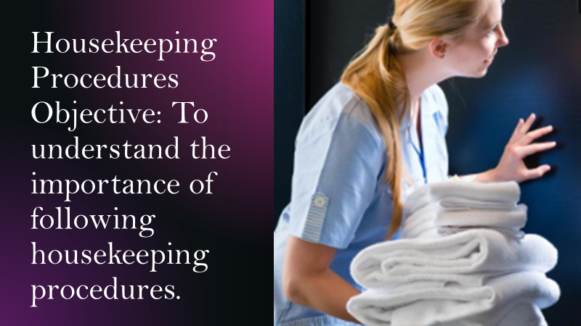

Training Notes: Following housekeeping procedures is crucial to maintaining consistency and quality in our work. We need to follow our procedures to ensure that our guests' rooms are cleaned to the highest standard.
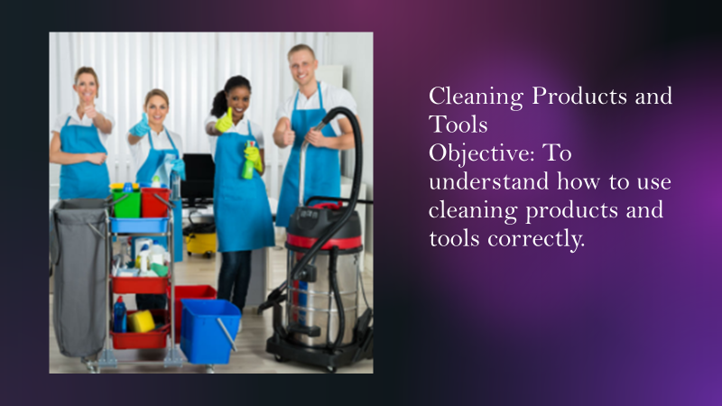

Training Notes: It is essential to use the right cleaning products and tools to achieve the desired cleaning results. We need to use the right products and tools to avoid damage to surfaces and to ensure the safety of our guests.



Training Notes: Making a bed to the required standard is essential in providing a comfortable and clean environment for our guests. We need to follow the correct procedure to ensure that our guests have a good night's sleep.
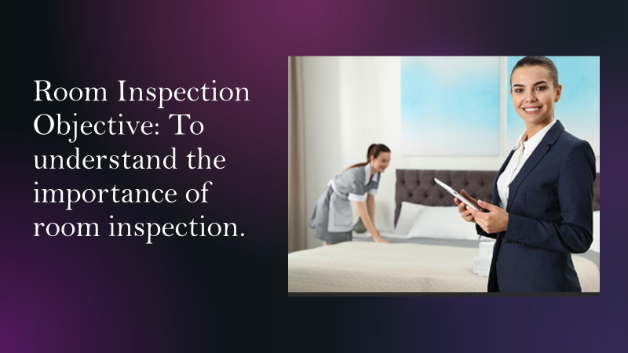

Training Notes: Room inspection is essential in ensuring that our rooms are clean and safe for our guests. We need to conduct regular inspections to check that our team is following the correct procedures and meeting our brand standards.
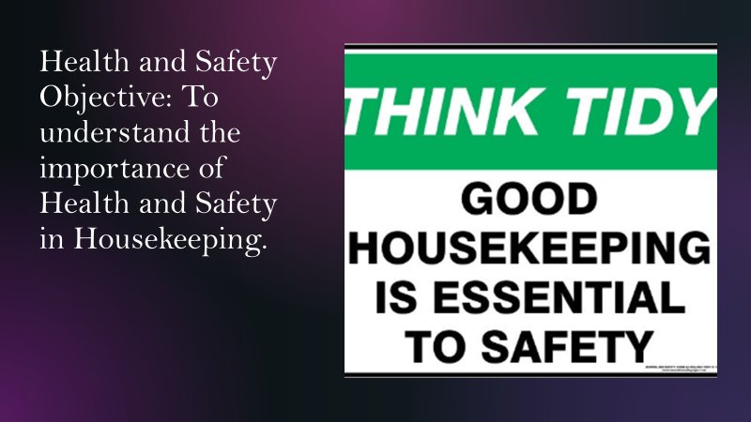

Training Notes: Health and Safety is essential in ensuring that our team and guests are safe. We need to follow the correct procedures to avoid accidents and injuries.
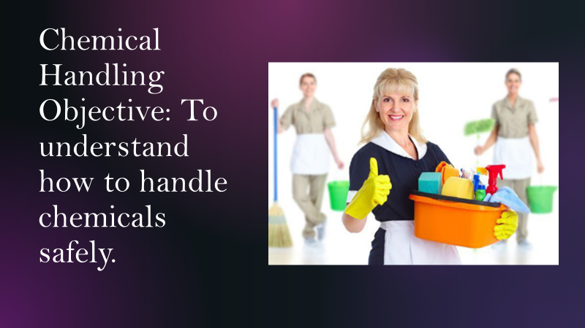

Training Notes: Chemicals are hazardous and can be harmful if not handled correctly. We need to follow the correct procedures to ensure that we use chemicals safely and avoid accidents.
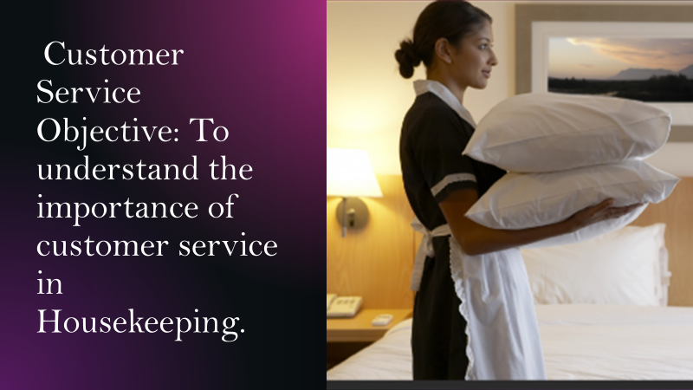
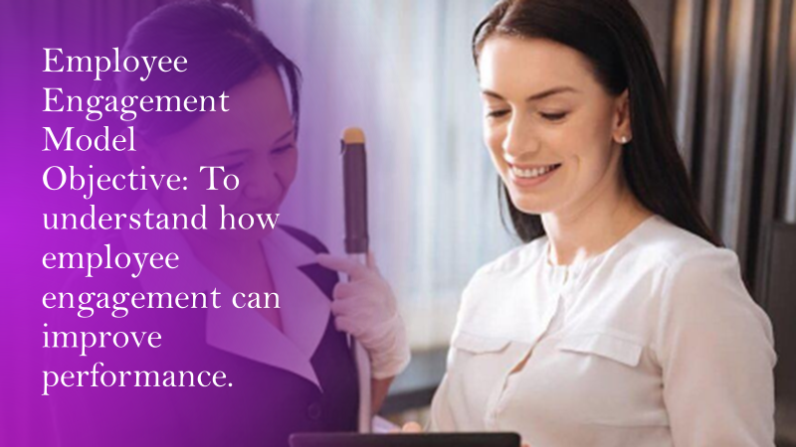
Training Notes: Customer service is essential in providing a memorable experience for our guests. We need to be friendly, helpful, and attentive to our guests' needs.
Employee engagement is essential in improving performance and job satisfaction. Gallup's Q12 model is a useful framework for understanding employee engagement.

References
Part 1
American Hotel & Lodging Educational Institute. (2019). Skills needed to work in housekeeping.
Available at:
https://www.ahlei.org/blog/2019/07/25/skills-needed-to-work-in-housekeeping/
(Accessed 03.06.2023)

Beech, J. (2018). The importance of attention to detail in housekeeping.
Available at:
https://www.hospitalitynet.org/opinion/4087926.html
(Accessed 30.05.2023)

Henderson, M. (2019). 5 skills every housekeeper needs.
Available at: https://www.hcareers.com/article/career-advice/5-skills-every-housekeeper-needs
(Accessed 29.05.2023)

International Journal of Hospitality Management. (2017). Skills and competencies required for the housekeeping department in the hospitality industry.
Available at:
https://www.sciencedirect.com/science/article/pii/S0278431916301072
(Accessed 26.05.2023)

World Tourism Organization. (2019). Global report on the current state of the tourism sector.
Available at:
https://www.unwto.org/global-report-on-the-current-state-of-the-tourism-sector
(Accessed 28.05.2023)

Part 2
1. "Hotel Housekeeping: Operations and Management" by J. Raghubalan and Smritee Raghubalan
2. "Hotel Front Office Management" by James A. Bardi
3. "Managing Quality Service in Hospitality: How Organizations Achieve Excellence in the Guest Experience" by Robert C. Ford and Michael C. Sturman
4. "The Cornell School of Hotel Administration Handbook of Applied Hospitality Strategy" edited by Cathy A. Enz and J. Bruce Tracey
5. "Hotel Operations Management" by David K. Hayes and Jack D. Ninemeier.

Part 3

1. "Housekeeping Management" by Matt A. Casado and Connie S. Martin (2008) - Casado, M. A. and Martin, C. S. (2008) Housekeeping Management. Hoboken, N.J.: John Wiley & Sons.

2. "The 5S Pocket Guide" by Enna (2010) - Enna. (2010) The 5S Pocket Guide. Westbrook, ME: Enna.

3. "Kaizen: The Key to Japan's Competitive Success" by Masaaki Imai (1986) - Imai, M. (1986) Kaizen: The Key to Japan's Competitive Success. New York, N.Y.: Random House.

4. "Standard Operating Procedure" by Tariq Ahmad (2016) - Ahmad, T. (2016) Standard Operating Procedure. Boca Raton, FL: CRC Press.

5. "Lean Six Sigma for Service" by Michael L. George (2003) - George, M. L. (2003) Lean Six Sigma for Service. New York, N.Y.: McGraw-Hill.

6. "Hotel Operations Management" by David K. Hayes and Jack D. Ninemeier - Hayes, D. K. and Ninemeier, J. D. (2017) Hotel Operations Management. New York, N.Y.: Pearson.

7. "Chemical Safety Training: A Guide to the Globally Harmonized System of Classification and Labeling of Chemicals (GHS)" by Craig B. Simonsen (2015) - Simonsen, C. B. (2015) Chemical Safety Training: A Guide to the Globally Harmonized System of Classification and Labeling of Chemicals (GHS). Boca Raton, FL: CRC Press.

8. "Exceptional Service, Exceptional Profit: The Secrets of Building a Five-Star Customer Service Organization" by Leonardo Inghilleri and Micah Solomon (2010) - Inghilleri, L. and Solomon, M. (2010) Exceptional Service, Exceptional Profit: The Secrets of Building a Five-Star Customer Service Organization. New York, N.Y.: AMACOM.

9. "The Power of People: Learn How Successful Organizations Use Workforce Analytics To Improve Business Performance" by Nigel Guenole, Jonathan Ferrar, and Sheri Feinzig (2017) - Guenole, N., Ferrar, J. and Feinzig, S. (2017) The Power of People: Learn How Successful Organizations Use Workforce Analytics To Improve Business Performance. Pearson Education.

10. "First, Break All the Rules: What the World's Greatest Managers Do Differently" by Marcus Buckingham and Curt Coffman (1999) - Buckingham, M. and Coffman, C. (1999) First, Break All the Rules: What the World's Greatest Managers Do Differently. New York, N.Y.: Simon & Schuster.

