AS1 Reading Task Mind Map


Assessment 1 – Reading Task Template
PART 1: Upload your photo of your A3 in-class notes here:
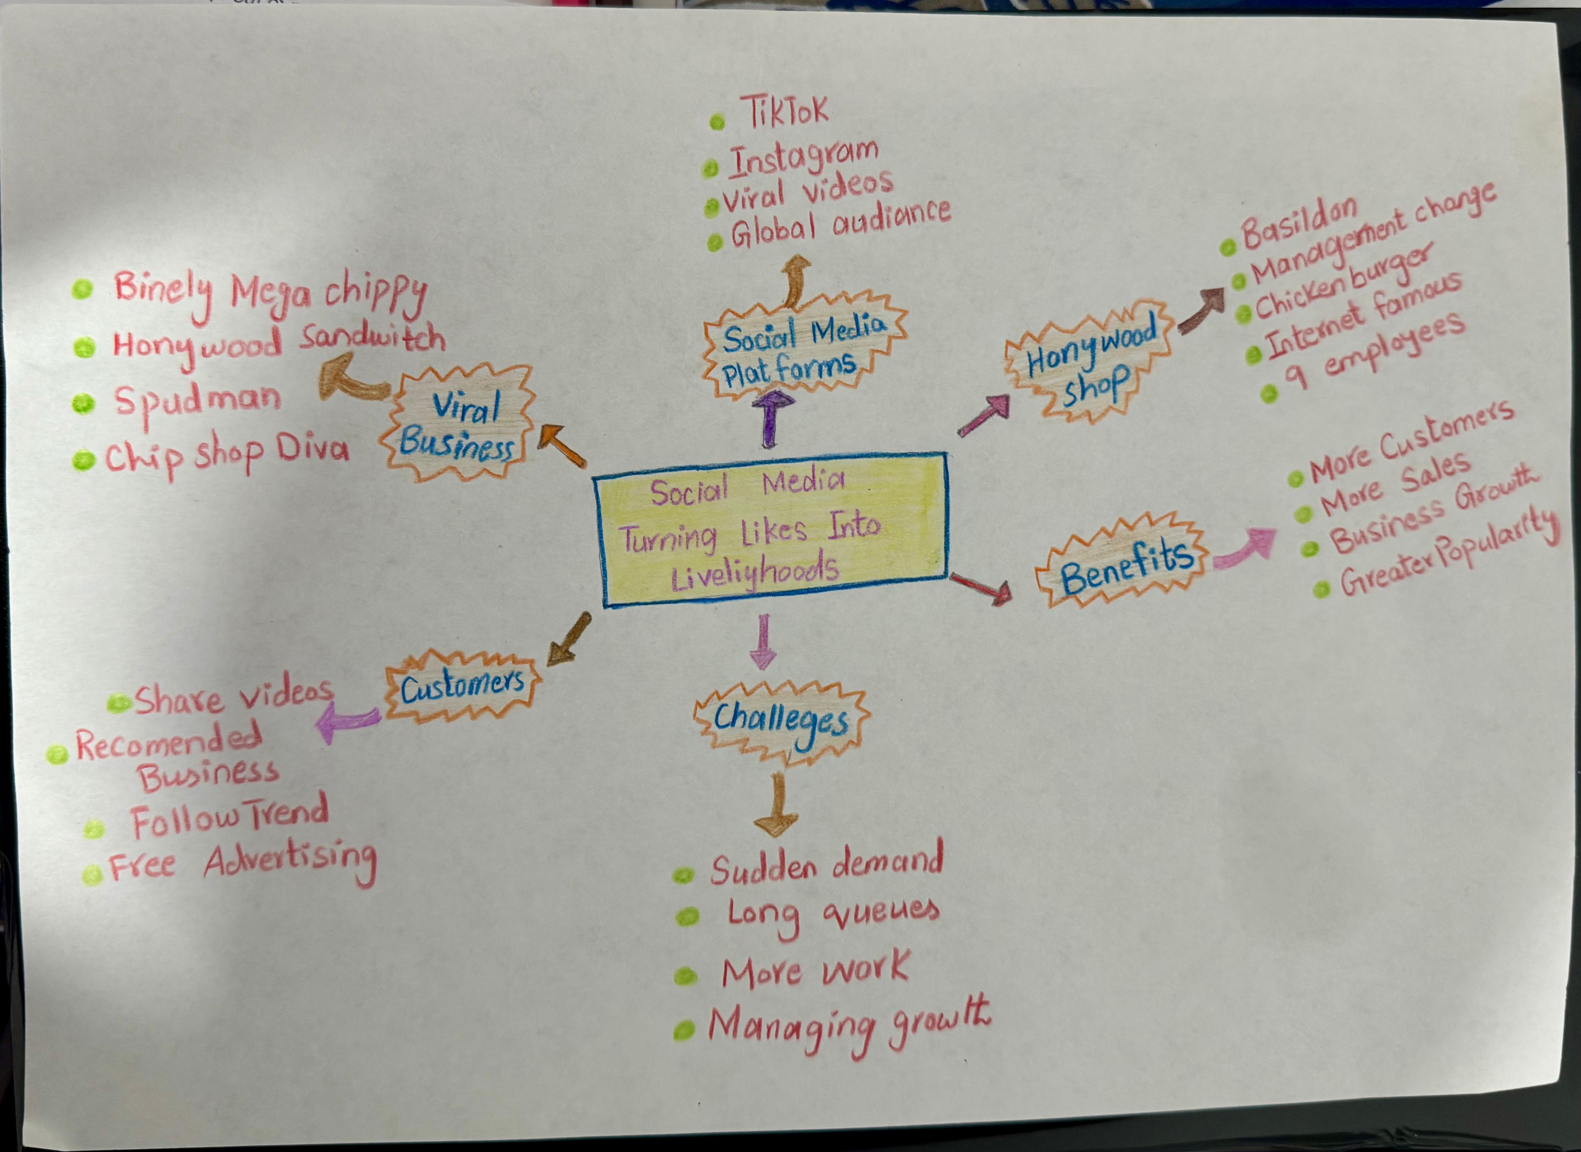

PART 2:
- Answer every question below in 1-3 full sentences.
- Use your own words. Do not use generative AI to answer these questions.
- Include a specific detail from the text when asked.
REMINDER
- The main idea is the overall message of the whole text.
- A key point helps to explain the main idea.
- A specific detail or example from the text shows that the key point is true.

- What is the main idea of the whole text?

Social media platforms like TikTok allow small local businesses to go viral, driving massive growth and transforming their online popularity into major real-world growth.

- What is one key point that supports the main idea, and which specific example from the text shows this?

Going viral drastically boosts trade increase customer interest and sales, as seen when a business Binley mega chip’s increased tenfold due to viral social media videos

- What is a different key point that supports the main idea, and which specific example from the text shows this?

Social media attention attracts customers from long like some teenagers
Traveling from as far Cyprus to visit Krystals boutique after see their TikTok viral video and some customer travel 3 hour just for the chicken burger at Honeywood sandwich

- Which part of the text do you think is most important, and why?

in the opening section that how social media platforms like TikTok enable over 1.5 million Uk small businesses to gain global visibility its establishes that how modern digital trend transform local commerce into thriving regional destinations

Reflection:

- What did you find difficult in this task (including in-class components), and why was it difficult?
It was tricky to extract the overall message without getting overwhelmed by all the individual business examples and handwritten mind map details.

- What helped you with this difficulty, and how did it help you?
The reminder checklist on the screen was a huge help. It made it so easy to separate the big picture from the smaller details, so I could pair each main point with a solid example from the text

