Screen Shots
Task 1 : Brauns
Structure of Brauns
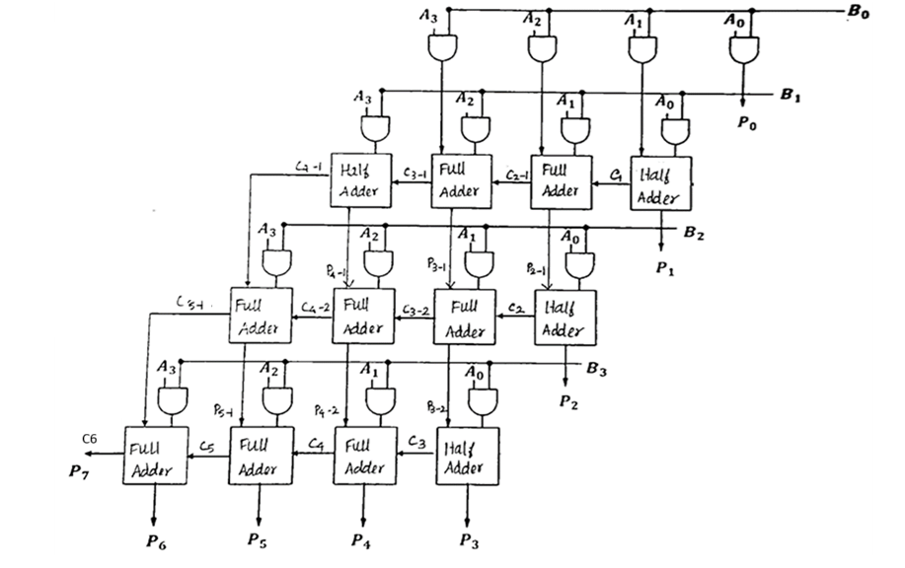
Simulation Waves (Sample 1)
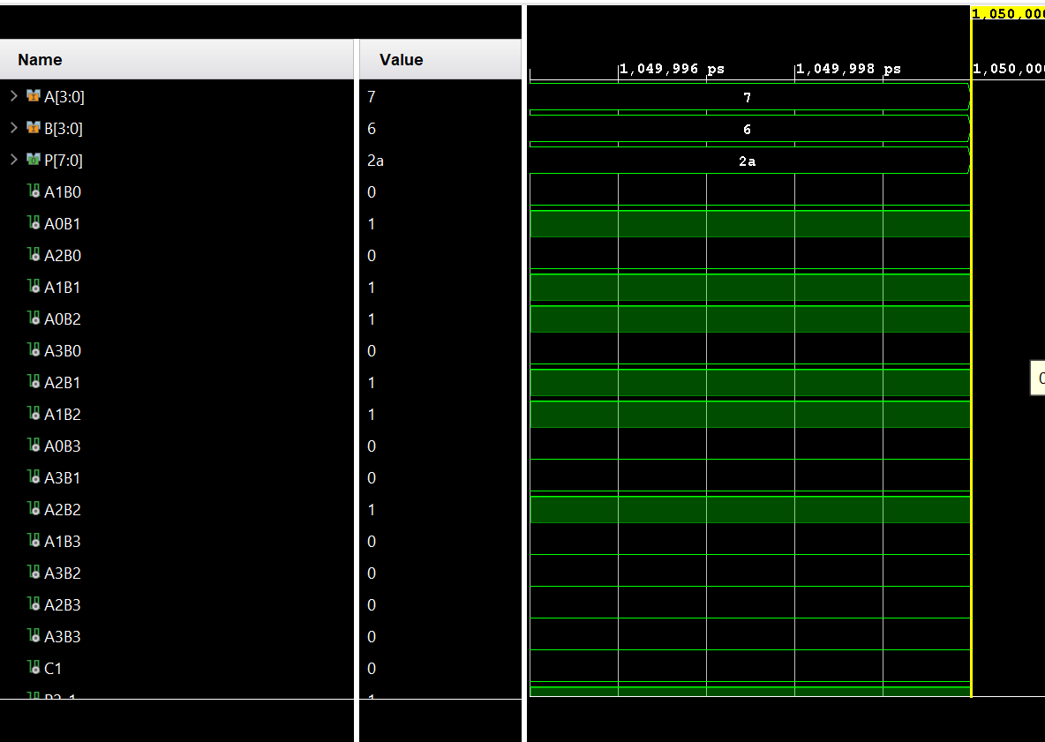

Sample 2
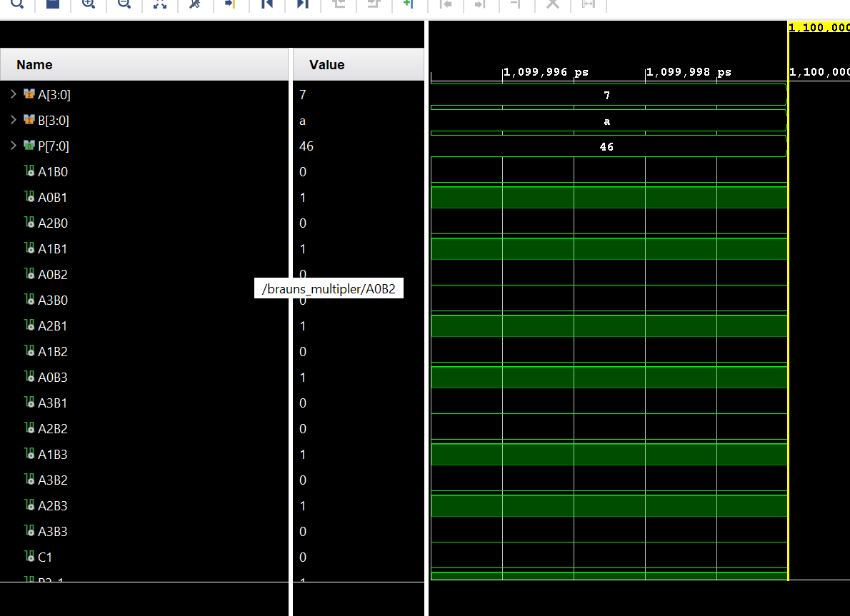

Sample 3
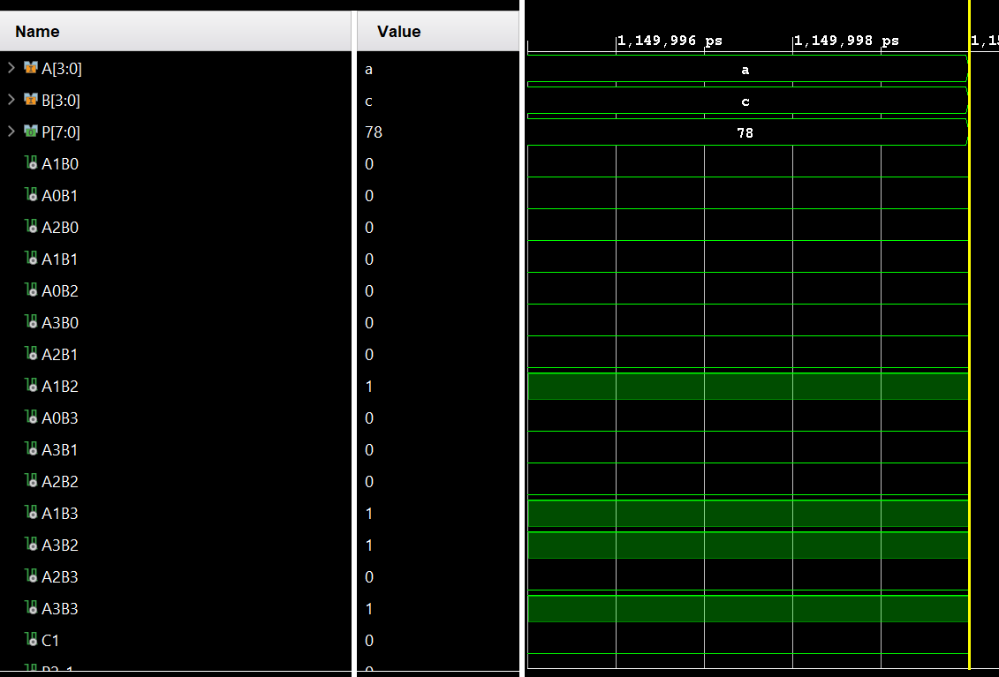
Sample 4
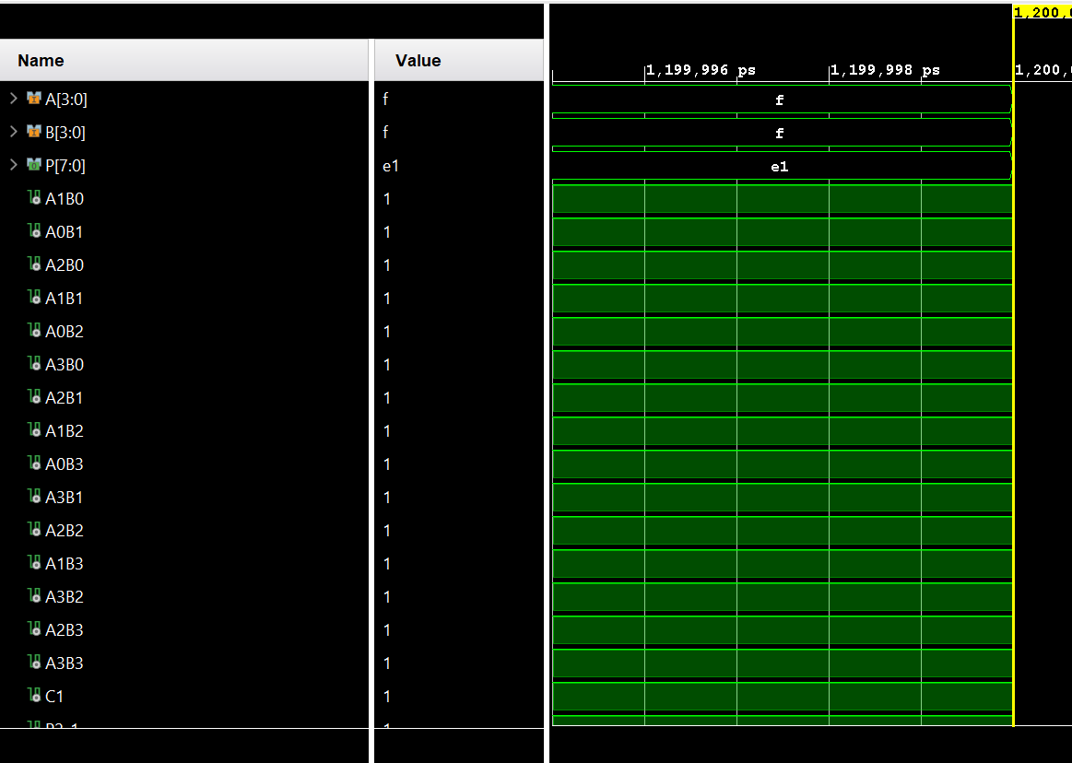

RTL Design
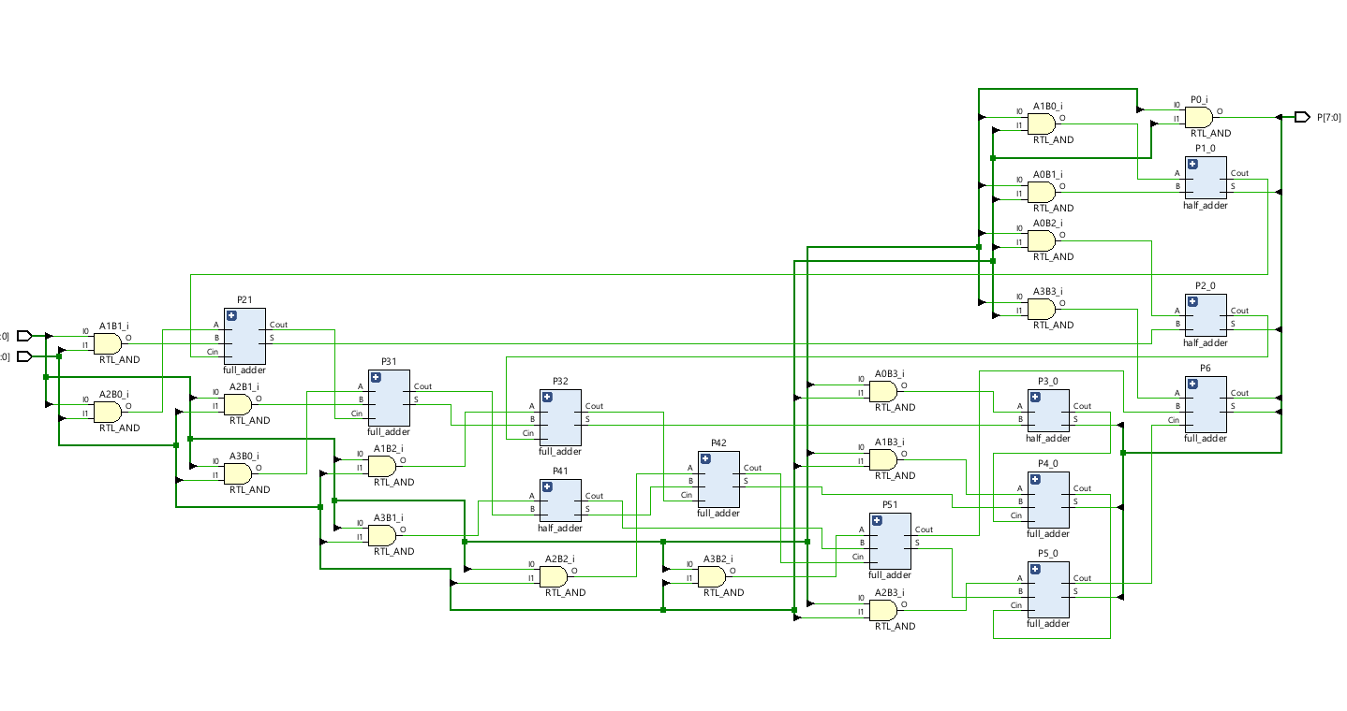

Implementation Schematics
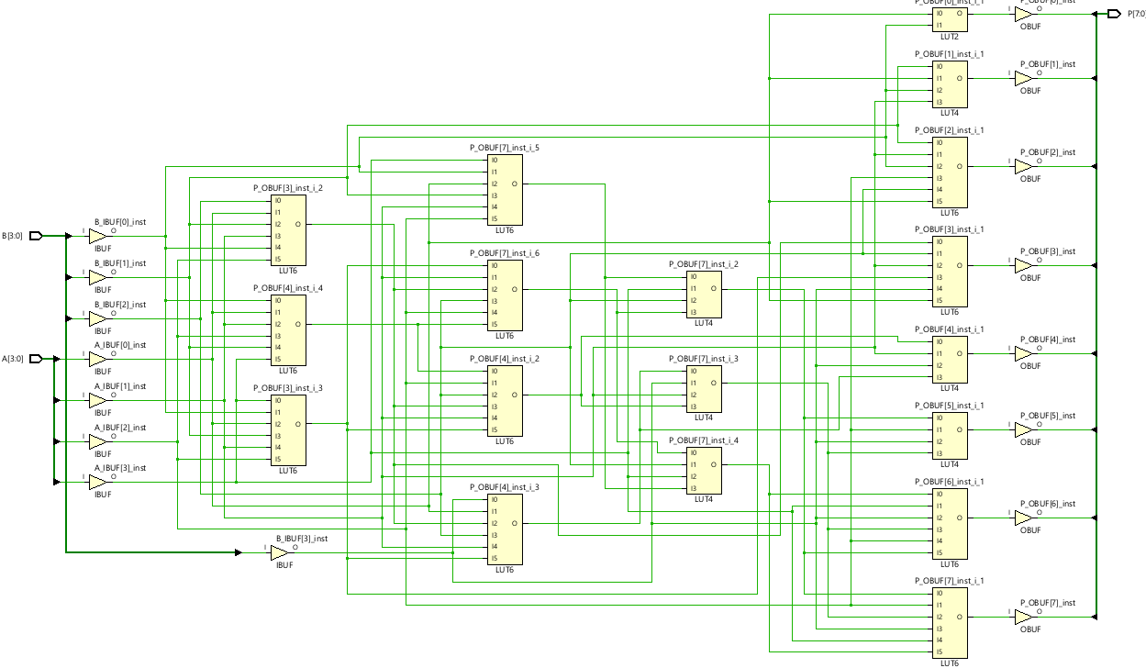

Device

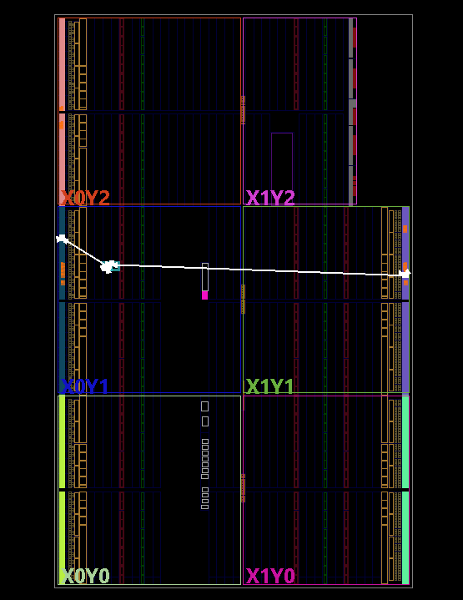

I/O Planning

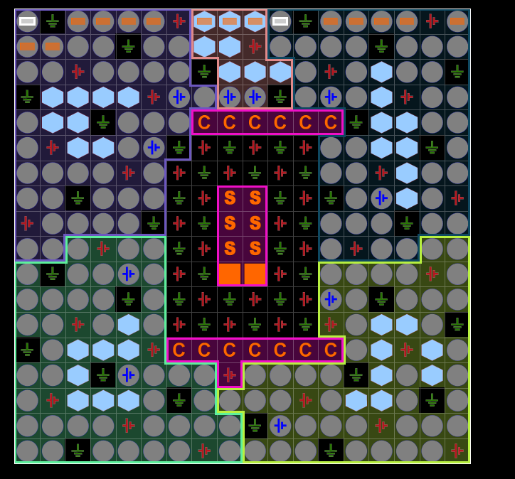

Task2: Wallace (Please Screen shot the following )
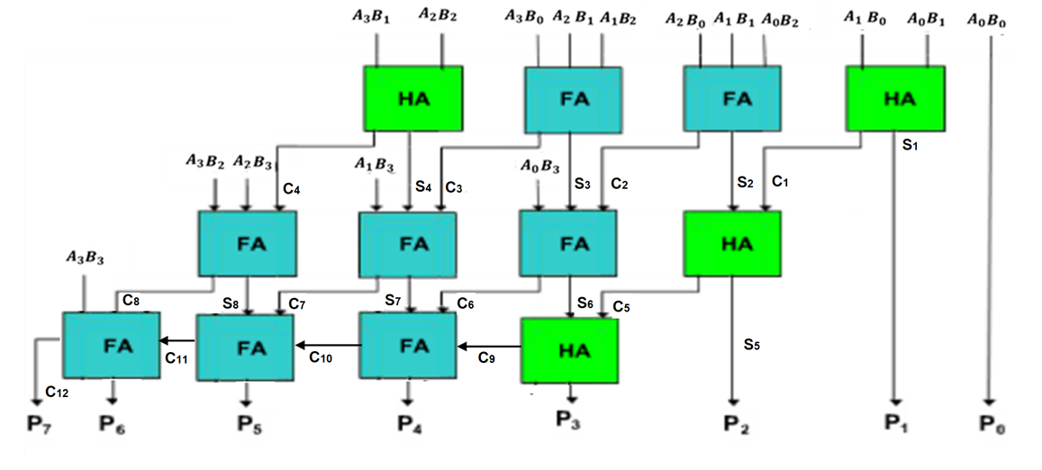
Screen shots of
Simulation : Sample 1, 2, 3, 4
RTL Design
Implementation Schematics
I/O Planning

Task 3
Longest Delay diagram for Brauns
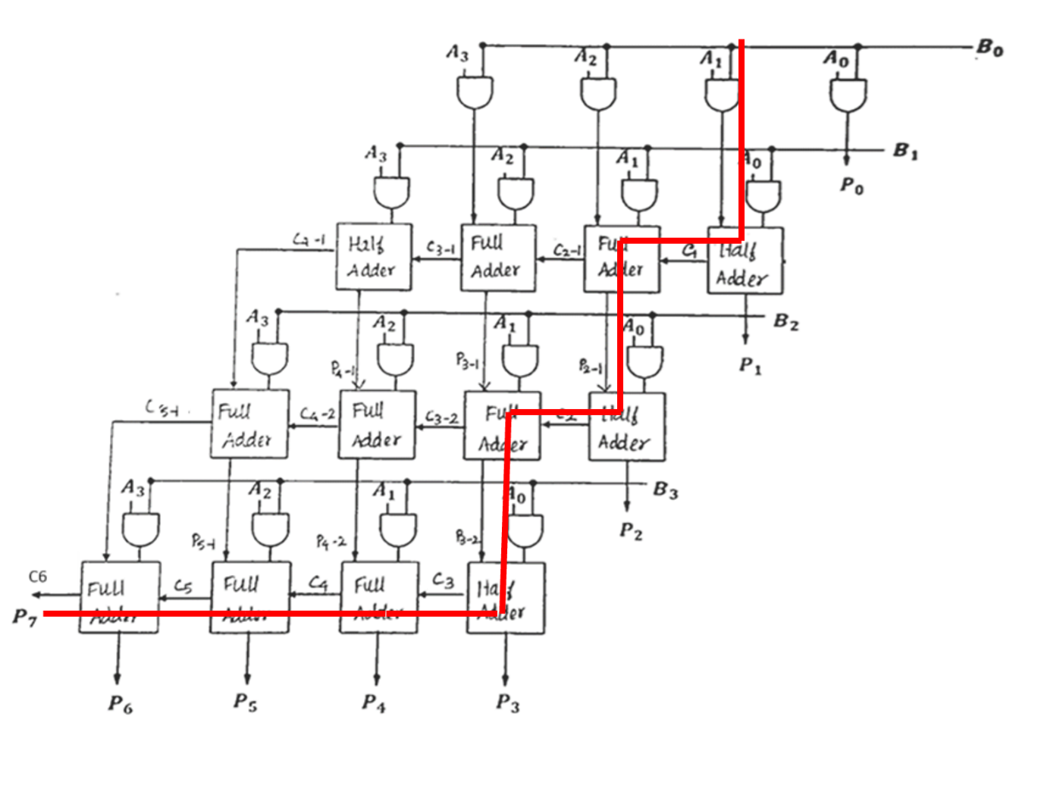
Longest Delay diagram for Brauns

Timing Constraints
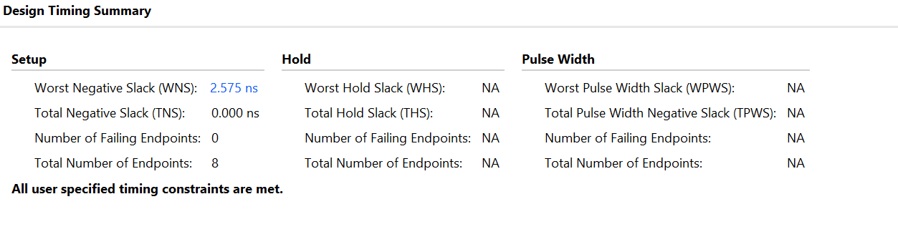

Report Utilization

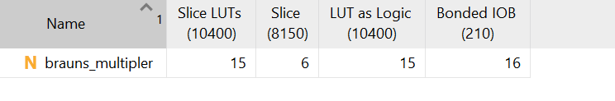
Project Summary
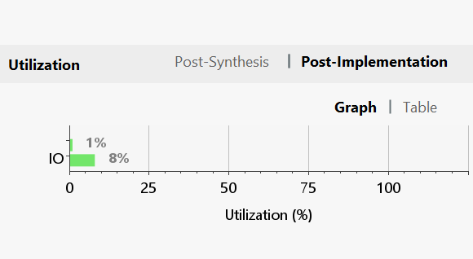
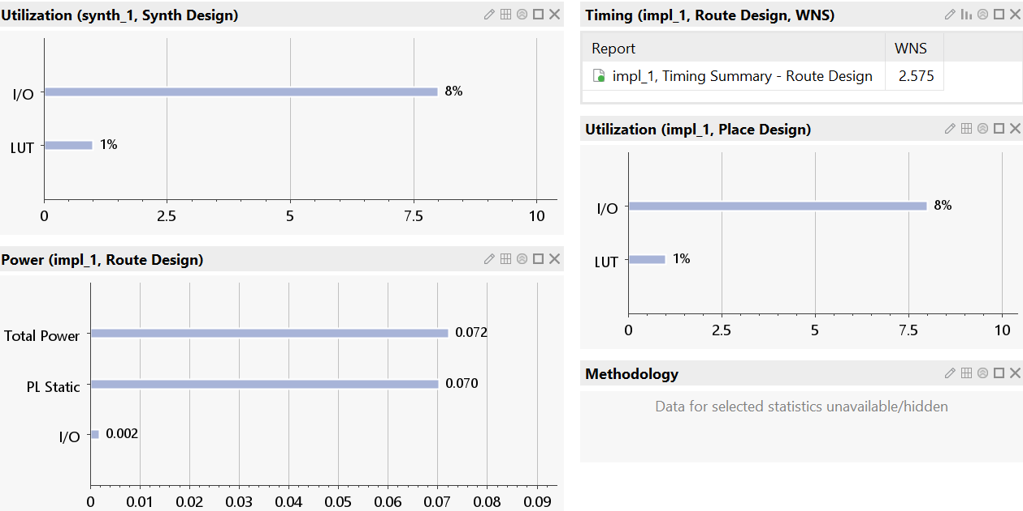
Power Report


