FESTIVALS AND EVENTS
ANTI-SOCIAL BEHAVIOUR

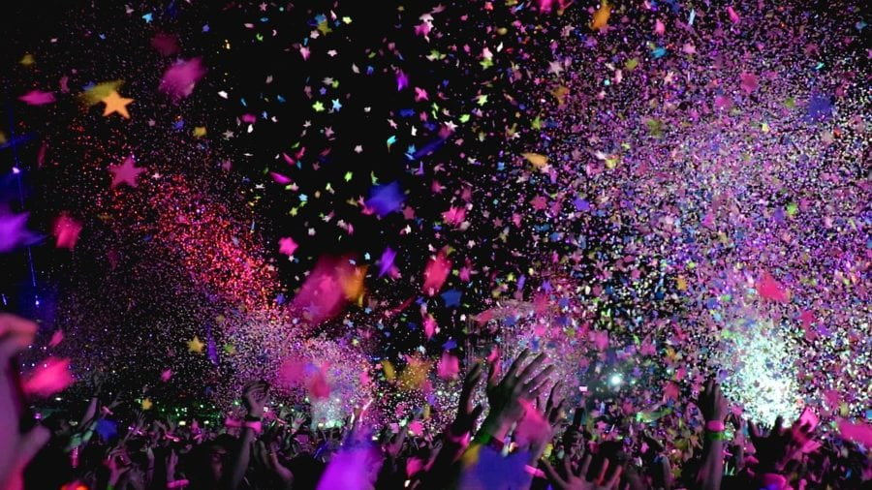(Walker, 2021)

Work done by: Amy Davies, Jasmine Evans, Shannon Davies and Sandra Galisteo

Content page

Group roles and meetings.............................pages 2,3,4

Benefits of events and festival........................................pages 5,6,7

Bibliography..................................page 8

Group Member Roles:
Proposer- Amy Davies (Topic: Social impacts of festival/events)
Seconder- Jasmine Evans (Topic: Environmental impacts of Festivals/event)
Chair- Sandra Galisteo (Topic: Economic impacts of festivals/ events)
Summer Up- Shannon Davies (Topic: Health and wellbeing of festivals/ events)

Team Meeting Minutes:
14/01/21
Start time: 11:30am
Finish time: 12:00pm
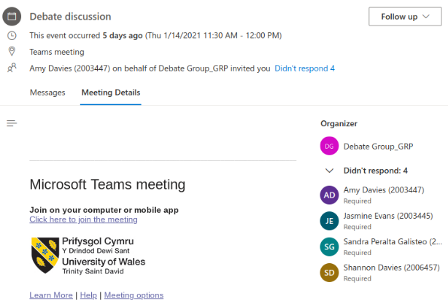
Attendees:
Amy Davies
Jasmine Evans
Shannon Davies
Sandra Galisteo

18/01/21
Start time: 16:40pm
Finish Time: 17:00pm
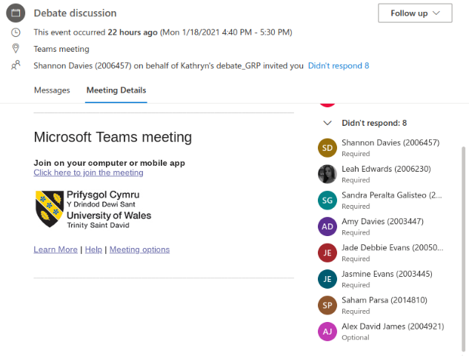
Attendees:
Jasmine Evans
Amy Davies
Shannon Davies
Sandra Peralta
Jade Debbie Evans (For Group)
Saham Parsa (For Group)
Did not Attend:
Alex James (For group)
Leah Edwards (For group)

19/01/21
Start time: 16:40pm
Finish time: 17:00pm
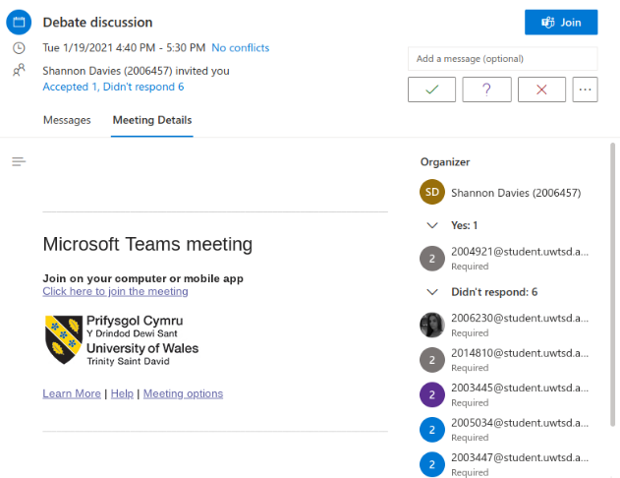
Attendees:
Jasmine Evans
Amy Davies
Shannon Davies
Sandra Peralta
Leah Edwards (For group)
Jade Debbie Evans (For group)
Saham Parsa (For group)
Alex James (For group)

Benefits of events and festivals

Economic impacts of festivals and events:
Events and festivals bring tourists from different countries or even domestic visitors which means that they will need to stay in a hotel, hostel, camping. After conducting a poll on social media on Instagram of people's preferences of where to stay during festivals/events. The majority have chosen camping over hotels and hostels. (Instagram, 2021)
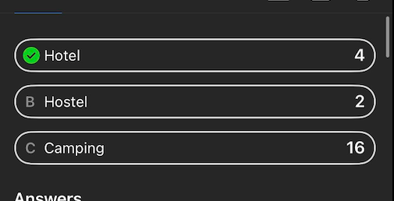
(Instagram, 2021)
Also, consume food either in a restaurant or in a shop and provides money to the local economy. Also, gives people the opportunity to visit places that they would not normally visit and possibly entice them to go again (Walker, 2021).
The main points:
- Increase of sales in local businesses
- Creation of employment
- Increase in annual visitors
- Increase countries money
(Janeczko, Mules and Ritchie, 2002)
Important statistics in the events industry in the UK:
- The events industry contributes £70 billion to the UK economy each year
- 85 million people attend events each year
- There are over 10,000 events venues in the UK
- 1,000,000 people work in the live events industry
(Antoniuk, 2020)

Social impacts of festivals and events:
There are a number of positive social impacts that festivals and events can have such as :
- The developing communication and social networks within a community (Fernandes, 2013)
- The improvement of social cohesion within the society (Arcodia & Whitford, 2007)
- The development of existing resources within a community (Arcodia & Whitford, 2007)
One example of positive social impacts on an event is The Gathering which was held in Ireland in 2013. Some of the positive impacts experienced due to the event were:
- Families reunited
- Great community spirit
- New relations with communities and people outside of Ireland
- Skills have improved within the community
- Gave a sense of place and pride to people
Another big festival that has had positive impacts in the community is Glastonbury. Over the years they have helped improve local resources to better the community and strengthen relations with the people that live there. Glastonbury festival has: renovated a child's play area in Pilton playing fields, repaired a chapel roof, repaired the local churches heating system etc.

Health and wellbeing of events
Festivals and events can have health and wellbeing benefits.
- Lowers the risk of developing depression (Vennard, 2019)
- Lowers the amount of the stress hormone (Vennard, 2019)
- Improves yourself esteem (Charlton, 2018)
- Improves your mood (Charlton, 2018)
- A researcher found out that going to live music events made people happier than going alone (Brand, 2018)
- 25% increase in feeling of self-worth (Brand, 2018)
Wellbeing events
“Wellbeing events are aimed for people to make positive choices around their own health and wellbeing while engaging in physical activities, relaxation sessions and informative workshops” (Health Fair Events | Wellbeing People, 2021)
Wellbeing festival
- Green man festival
Green man festival takes place in a field within Wales with dedicated stations for yoga classed and hot tubs. (Norton, 2017)

Environmental impact on festivals and events:
Festival and Event companies are trying their best to become more environmentally friendly. When festivals were first brought to the UK, they were not considered the best for our environment, although over the past couple of years, the companies who host the events are working together to make the events better and safer for the environment. Although, when it comes to big festivals, it is usually the attendees that are negatively affecting the local environment.
Main positive environmental impacts that festivals are hoping to put in place:
- Make sure that food waste gets correctly disposed of (The Industry Observer, 2018)
- Making utensils used for food and beverages biodegradable (The Industry Observer, 2018)
- In 2019, more than 60 major festivals including Reading, Leeds and Download pledged to go plastic free by 2021. (The Guardian, 2019)
- The UK’s biggest festival, Glastonbury, in 2019 banned the sale of single use plastic drinks bottles (The Guardian, 2019)
- Festivals and events encourage individuals to reduce their carbon footprint by using local public transport or to car share with others (The Guardian, 2019)
- Festivals are in close contact with a company called GreenMan which provides people in need with the tents that have been left on the festival sites (The Guardian, 2019)
(The Industry Observer, 2018)
How the customers at the festival or event can help to reduce the strain on the environment:
- Take reusable bottles for drinks (Shower in a Can, 2019)
- Use biodegradable Products (Shower in a Can, 2019)
- Use environmentally friendly hygiene products (Shower in a Can, 2019)

BIBLIOGRAPHY

Antoniuk, N., 2020. How Many People Are At Risk Of Losing Their Jobs In The Events Industry?. [online] Quadrant2Design. Available at: <https://www.quadrant2design.com/events-industry-working-statistics> [Accessed 18 January 2021].
Brand, D., 2018. Going To Concerts May Help You Live Longer, Research Finds. [online] Global Citizen. Available at: <https://www.globalcitizen.org/en/content/live-music-mental-health-live-longer-study/?fbclid=IwAR3zA7kqzkt1qicAXDMadS5HUT6fqBdBQJj1eFjPieuqdGL5iYfbl3U5fu0> [Accessed 19 January 2021].
Charlton, D., 2018. Health Benefits Of Music Festivals. [online] Bupa.co.uk. Available at: <https://www.bupa.co.uk/newsroom/ourviews/health-benefits-music-festival?fbclid=IwAR1EuiK2oktJ3tx6CIH6w218Ava-OEGAWXuNFohSKhmFcy7zP0Mggx5tJXg> [Accessed 19 January 2021].
Cooper, B., 2019. Top 5 tips to reduce your plastic waste this festival season, Available at: <https://www.shower-in-a-can.co.uk/blogs/blog/top-5-tips-to-reduce-your-plastic-waste-this-festival-season> (Assessed:18 January 2021)
Cuckoo Events, 2017, The importance of the social impacts of events, Available at: The Importance Of The Social Impacts Of Events | Cuckoo (Accessed: 17th January 2021).
Glastonbury Festivals, 2021, Local benefits, Available at: Local benefits | Glastonbury Festival (glastonburyfestivals.co.uk) (Accessed: 17th January 2021).
Instagram. 2021. Instagram. [online] Available at: <https://www.instagram.com> [Accessed 19 January 2021].
Iqbal, M., 2019. Tents, toilets, transport: eco-friendly festivals tackle the unholy trinity, Available at: < https://www.theguardian.com/music/2019/jun/23/green-music-festivals-eco-environment> (Assessed: 18 January 2021)
Janeczko, B., Mules, T. and Ritchie, B., 2002. [online] Sustain.pata.org. Available at: <https://sustain.pata.org/wp-content/uploads/2015/02/Mules_EcoImpactsFestivals_v6.pdf> [Accessed 18 January 2021].
Norton, S., 2017. The Best Wellness Festivals In The UK. [online] inews.co.uk. Available at: <https://inews.co.uk/inews-lifestyle/wellbeing/best-wellness-festivals-uk-79514> [Accessed 19 January 2021].
Reid, P., 2018. 8 ways Festivals are Becoming more environmentally friendly, Available at: <https://theindustryobserver.thebrag.com/8-ways-festivals-environmentally-friendly/> (Assessed: 17 January 2021)
Vennard, M., 2019. Could Music Festivals Be Good For Your Health?. [online] BBC News. Available at: <https://www.bbc.co.uk/news/health-49194336?fbclid=IwAR0jkYn_1fqhZcIDH-5mHIGmlreOJRF27lQPCLWG0Sgail8w7uFLldUHGAY> [Accessed 19 January 2021].
Walker, G., 2021. How The Events And Festivals Benefits The Local Economy. [online] BUSINESSFIRST. Available at: <https://www.businessfirstonline.co.uk/other-articles/how-the-events-and-festivals-benefits-the-local-economy/> [Accessed 16 January 2021].
Wellbeing People. 2021. Health Fair Events | Wellbeing People. [online] Available at: <https://www.wellbeingpeople.com/products/health-fairs-and-events/health-fair-events/> [Accessed 19 January 2021].

