University of Wales Trinity Saint David
Wales Institute of Science &Art

Electronic ignition and fuel injection systems
Electronic control systems (ACHA4010)

Owain Wilcox (2003601)
March 2022
Contents

1 Introduction 1
1.1 Aims and Objectives 1
2 Health and Safety 2
3 Methodology 3
3.1 LE3 Testing Procedure 3
3.2 Motronic Testing Procedure 3
4 Workshop Results and Data 4
4.1 LE3 Static and Running Data 4
4.2 Motronic Static and Running Data 9
5 Oscilloscope Waveforms 14
5.1 Crank Position Sensor 14
5.2 LE3 Speed Reference Communication Between ECUs 17
5.3 Primary Coil Windings 18
5.4 Secondary Coil Windings 20
5.5 LE3 Spark Advancement Unit Signal 22
5.6 LE3 and Motronic Supply and Earth 23
5.7 Injection at Idle 24
5.8 Injection under Acceleration 25
5.9 Injection under Deceleration 26
5.10 Motronic Simultaneous Injection 27
5.11 Motronic Rotary Idle Valve 28
5.12 Airflow and Throttle Potentiometer 29
5.13 Motronic Lambda Sensor 30
6 Modifications 31
7 Conclusion 33
8 References 34

Table 1: LE3 Pin Voltages with Ignition Off and On 6
Table 2: LE3 Engine Statistics and Resistance Readings for Multiple Sensors and Actuators 7
Table 3: LE3 Engine Running Data 8
Table 4: Motronic Pin Voltages with Ignition Off and On 10
Table 5: Motronic Engine Statistics and Resistance Readings for Multiple Sensors and Actuators 11
Table 6: Motronic Engine Running Data 12

Figure 1: LE3 Wiring Diagram 4
Figure 2: LE3 Spark Advance Unit Wiring Diagram 5
Figure 3: LE3 NTC2 Resistance vs Engine Temperature 8
Figure 4: Motronic Wiring Diagram 9
Figure 5: Motronic NTC2 Resistance vs Engine Temperature 13
Figure 6: LE3 & Motronic Crank Angle Sensor Waveforms 14
Figure 7: Inductive CPS Waveform by Pico Technology 15
Figure 8: Camshaft Position Sensor and Distributor Inductive sensor by Pico Technology 16
Figure 9: LE3 Speed Reference between Spark and Fuel ECUs 17
Figure 10: LE3 and Motronic Ignition Primary Coil Waveforms 18
Figure 11: LE3 and Motronic Ignition Secondary Coil Waveforms 20
Figure 12: LE3 Spark Advance Signal vs Primary Ignition Waveform 22
Figure 13: LE3 and Motronic Supply and Earth 23
Figure 14: LE3 and Motronic Injection at Idle Waveform 24
Figure 15: LE3 and Motronic Injection under Acceleration Waveform 25
Figure 16: LE3 and Motronic Injection under Deceleration Waveform 26
Figure 17: Motronic Simultaneous Injection Waveforms 27
Figure 18:Motronic Rotary Idle Valve Waveform 28
Figure 19: Motronic Airflow and Throttle Potentiometer Waveform 29
Figure 20: Motronic Lambda Sensor Waveform 30

Introduction

This report will overview the testing procedure for ignition and injection systems aboard 2 engines. They are both Vauxhall engines however one is equipped with the LE3 engine management system, the other a Motronic engine management system. The LE3 incorporates an amplifier and a mechanical distributer to provide a spark. This system uses two separate ECUs for fuelling and spark control. The Motronic system, however, is a Distributorless Ignition System (DIS) which utilises a wasted spark unit controlled by a singular ECU. This assignment revolves around comparing data between these two engines, recognising potential problems with the management systems, and suggesting potential upgrades to improve the efficiency of the engines.

Aims and Objectives

The aim throughout this assignment is to outline the testing procedure for the engines whilst acknowledging and adhering to the correct PPE guidelines. Several comparisons between resistances, voltages, and waveforms will be made, highlighting, and defining specific key points within the injection/ignition cycles. The aim is to observe the operation of actuators and sensors, record and analyse the data and understand how the engine operates during various phases of its warmup procedure. Following this, the objective is to suggest appropriate improvements to components on the engine based on the waveforms and data acquired during testing. As the LE3 engine is the older of the two, it is fair to hypothesise that this engine will be the inferior of the two yet will provide the most room for improvement when introduced to more modern technology.

Health and Safety

Before testing began on the live engines, certain health and safety aspects had to be adhered to. Safety boots and lab coats had to be worn at all times within the workshop, as specified by UWTSD’s workshop policy. Regarding the live engines, all fans and belts were covered with thick steel mesh, however, it was still imperative to tuck away any loose clothing such as hoodie toggles to avoid entrapment within the engines reciprocating parts. Consideration towards others was also crucial. To expand, it was important to verbally check with team members before starting the engine to ensure that fingers, and themselves in general, were clear of moving parts. May it be noted that before starting the engine, an exhaust fume extractor had to be placed on the engines exhaust to prevent harmful fumes from being inhaled during the test procedure.

Methodology

This section defines the testing procedure followed during the workshop session. One group worked on the LE3 whilst one worked on the Motronic system. The LE3 system required back probing the fuel and spark ECUs to acquire the data whereas the Motronic system had been simplified to a custom box with each ECU pin number labelled. The first stage for both groups was to check all pins within the ECU under two conditions: the first was ignition off, the other ignition on. The LE3 had 30 pins in total across the 2 ECU’s, of which only 23 were functional, whereas the Motronic had 33 functional pins. Alongside this, each group measured and recorded the resistances of all 4 injectors, the throttle position sensor resistances, and the air flow meter resistances, all to be cross referenced against manufacturer tolerance specs. Once completed, both groups combined to observe the LE3 testing procedure.

LE3 Testing Procedure

Firstly, a temperature probe was inserted in place of the dipstick to accurately measure the engine temperature in degrees Celsius. From here, the engine was cranked over until it started; may it be noted that an oscilloscope was used to measure the cold crank duration of the engine during this process, and the engine was left to run until 20 degrees. When the temperature reading hit 20 degrees, an oscilloscope was used to measure pin 3 signifying the injector on time. As soon as this reading was captured, the engine was stopped and a further 2 pins were tested. These were the resistance of the NTC2 sensor and the voltage reading of Pin 8. Once completed, the engine was started again and allowed to heat up to the next heat interval where the steps above were repeated. This continued every 10 degrees up to nominal running temperature at 60 degrees.

Motronic Testing Procedure

The Motronic testing procedure mirrors that of the LE3, however, additional pins were tested once the engine was stopped. These were pin 4, connected to the rotary idle valve, pin 5, which was connected to the charcoal cannister and pin 28, which referenced the lambda sensor. Pin 44 displaying the NTC1 data was also tested however it was only tested at 20 degrees and 80 degrees.

Workshop Results and Data

This section reviews the data collected from the workshop session. It will provide the test data for both engines under static and running conditions.

LE3 Static and Running Data
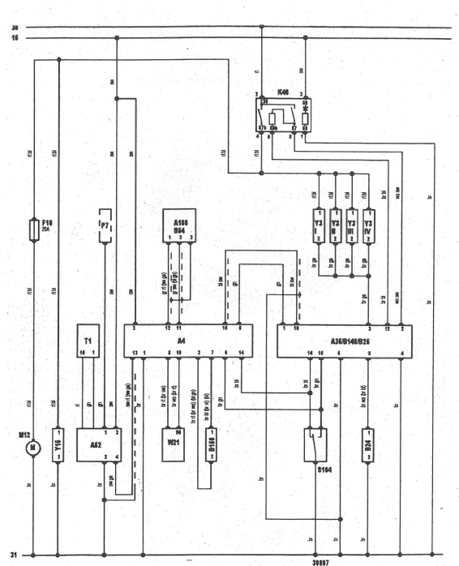

.

Figure 1: LE3 Wiring Diagram
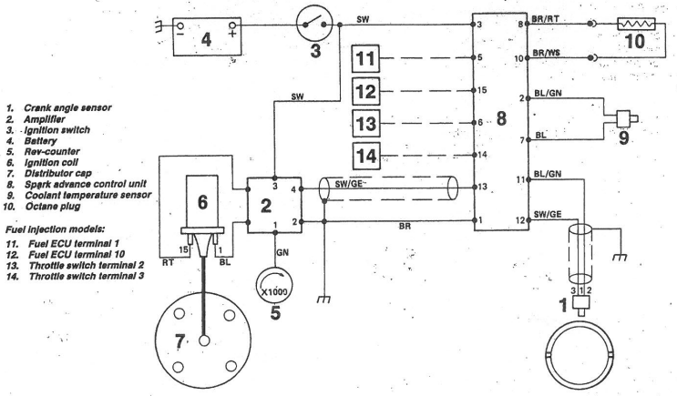
Figure 1 shows the wiring diagram for the LE3 system, highlighting its separate ECUs for the fuelling and spark ignition control. This system uses a throttle switch, as seen in Figure 1 as component S184, connected to the fuel ECU via pins 14 and 16. Figure 2 provides a more visual interpretation of the spark advancement unit, highlighting the distributor and amplifier as annotations 7 and 2 respectfully.
Figure 2: LE3 Spark Advance Unit Wiring Diagram

Table 1: LE3 Pin Voltages with Ignition Off and On
Table 1 indicates that when the ignition is off, all control systems and auxiliaries have a reading of 0V as no power is running through the system. With the ignition on, the switches in the ignition close and provide 12V of power to pins 2 and 12 on the fuelling ECU, powering the unit. The 2 ECUs are connected via an insulated wire between pins 10 on the fuelling unit, and pin 15 on the spark advance unit. However, additional connections between the two ECU’s exist such as the Spark unit linking to the throttle position sensor (TPS) via pins 6 and 15, and pins 14 to 14 to provide a load reference. This is an outdated system as the TPS is either open or closed and does not provide voltages throughout the entire pedal travel. The amplifier receives power directly from the ignition into pin 1 with a reading of 11.92V. This in turn powers the tachometer via pin 3, which again provides a voltage reading of 11.92V.

Table 2: LE3 Engine Statistics and Resistance Readings for Multiple Sensors and Actuators

Table 2 provides the battery voltage with the ignition off at the time of testing as well as the engine temperature of 19.3°C. Cross referencing against Table 1 shows that the battery drains by 0.43V when the ignition is switched on as power is being fed to the ECU’s and auxiliaries, primed for starting.

Regarding the TPS, it operates via a basic on/off switch which reduces the engines efficiency
as there are no load referenced other than 0% throttle and 100% throttle. This means the ECU must rely on other sensors such as the air flow and engine timing to assume the correct amount of fuel.
The resistance readings acquired during testing are correct (overlooking the manufacturers specs) since the switch is in the throttle closed position and pins 2 and 18 monitor that line and provide a resistance reading. Pins 3 and 18, however, read the throttle open line and as the throttle is closed it provides the multimeter with an open line reading or infinite resistance. Having said this, the TPS and Auxiliary Air valve are both outside of manufacturer specs parameters suggesting that the parts are worn and may need to be replaced.

The resistances of the injectors are all within manufacturer specs and are all a similar value and therefore can be assumed to be functioning correctly. At this point, all static tests and data had been completed and an oscilloscope was used to measure the cold cranking injector on time of 75.3ms as shown in Table 2.
Table 3: LE3 Engine Running Data
Table 3 displays the LE3 engine running data. As previously stated, the engine was heated to the desired temperature and the waveform was captured on an oscilloscope via pin 3 before the engine was stopped and the resistance of the NTC2 sensor and pin 8 voltage was gathered. The data shows that as the engine temperature increased, the injector on time steadily decreased along with both the NTC2 sensor voltage and resistance. This is due to the increase in temperature within the cylinder as it is far easier to ignite fuel in a hot environment than a cold one. Subsequently this means that less fuel is required to provide an adequate burn at higher temperatures than at low ones.
Figure 3: LE3 NTC2 Resistance vs Engine Temperature

Figure 3 displays the NTC2 sensor resistance vs Engine Temperature. This graph implies that the biggest resistance drop, of nearly 1000Ω, happens between 20 and 30°C of the engine warm up phase with diminishing returns after that. If the engine was able to warm up to an operating temperature of around 80-90°C, then it would be fair to hypothesise that the resistance of NTC2 would further decrease to around 250Ω.

Motronic Static and Running Data

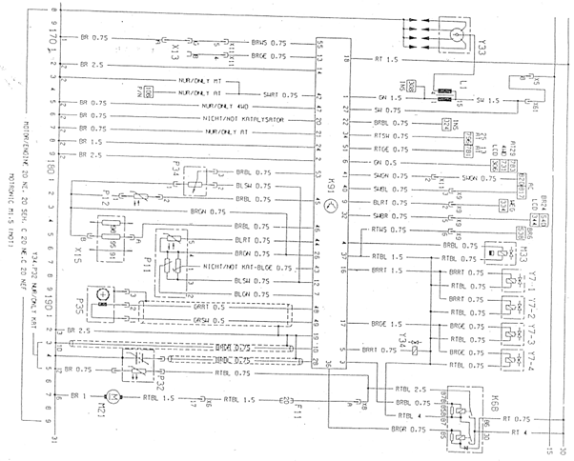

Figure 4 displays the Motronic system wiring diagram. This system runs from a singular ECU that controls both the fuel and spark ignition simultaneously. This system incorporates more auxiliary components than the LE3 system such as a charcoal cannister and an early narrowband 0-1V lambda sensor. Pins 12 and 53 link the throttle potentiometer to the ECU. This provides a benefit over the LE3 system as the engine can reference the throttle position and adjust injection times and duration accordingly to achieve a stoichiometric ratio of 14.7:1. Component Y33 labelled in the top left of Figure 4 also highlights that this is a wasted spark system rather than a distributor system like the LE3. Table 4 below displays the static data acquired from the testing of the Motronic system.
Figure 4: Motronic Wiring Diagram

Table 4: Motronic Pin Voltages with Ignition Off and On

Table 4 shows the acquired voltages with the ignition on and off. It also has a description of the component that each ECU Pin is connected to. Looking at the Ignition Off column, 2 pins read near battery voltage suggesting that the Motronic system has “Keep alive memory” as pins 18 and 36 maintain a continuous live even with ignition off. Pin 18 is the permanent live feed from the battery and pin 36 routes through the control circuit relay for the ECU and auxiliary components.

Table 5: Motronic Engine Statistics and Resistance Readings for Multiple Sensors and Actuators
Looking at the battery voltage in Table 5, it shows that there is a voltage drop of 0.41V between the ignition off and the ignition on, like the LE3 system, as the ECUs are powered up. A difference to note between the systems is that the cold cranking injection time is a third of that of the LE3. The idle speed control valve is within manufacturer spec as well as all 4 injectors.
May it be noted that this engine did suffer from pre-detonation and hesitance under snap throttle. The data in Table 5 shows that the throttle open resistance value was 560Ω above manufacturer specifications, that combined with the missing pin and high resistance readings between pins 3 and 4 on the Air Flow Sensor could contribute to the issue that the engine was experiencing as both its load and air references may have been incorrect under Wide Open Throttle (WOT) conditions.

Table 6: Motronic Engine Running Data

Table 6 displays the running data for the Motronic engine. This engine was able to run to 80°C instead of 60°C so more data was gathered. To begin, a breakdown of what each pin signifies:
- Pin 45 – NTC2 (V)
- Pin 16 – Injector on time (m/s)
- Pin 4 – Rotary idle control valve (%)
- Pin 5 – Tank ventilation/Charcoal canister (On/Off)
- Pin 28 – Lambda sensor (On/Off)
- Pin 44 – NTC1 (V)
Like the LE3, as the engine temperature increases, the voltage of the NTC2 on pin 45 decreases, as does the injector on time. However, at 70 and 80°C the injector on time increases from previous values. This is not an anomaly, rather a result of the fans being turned on to cool the engine. The fans act as a parasitic drain on the engine meaning it must work harder to maintain the same output to when the fans were off. The ECU reacts to this by injecting more fuel to compensate for the loss in energy. A similar trend can be seen in the idle control valve, it increases by 2% when the fans are activated to help maintain a steady idle and prevent the engine from stalling out when addition components in the vehicle are switched on at idle, such as lights, heaters, and fans.

Even though the engine has a lambda sensor, it will not operate until it is sufficiently heated up. Until this point, the engine is operating in a closed loop; taking data from its preprogramed data tables, until it receives a signal from the lambda sensor. In this case, the lambda sensor switched on between 20-35°C. This is the point that it started to fluctuate between 0-1V, yet it does not mean that it was fully functional at this temperature.

The charcoal canister is an eco-control method to prevent harmful gasses escaping the fuel tank and entering the atmosphere. Referring to table 6, it shows that the ECU did not start switching the canister until the engine reached a temperature between 40-52°C. This is for emission purposes. The engine needs to be hot enough to burn the excess pollutants, therefore activating the canister before 40°C would be counterintuitive and would increase the overall emissions of the engine.
Figure 5: Motronic NTC2 Resistance vs Engine Temperature

Figure 5 displays the NTC2 resistance vs engine temperature. The sensor is working correctly in its function and follows the same trend as the LE3 NTC2 sensor, however the resistances are far below manufacturer specifications for this engine. Due to all being below manufacturer specs this is unlikely to be human error or faulty equipment and the part should be replaced as a precaution.

Oscilloscope Waveforms

This section analyses the waveforms acquired from both engines. Comparisons between the oscilloscope readings will be made to deduce how the ECU’s control timings and durations of actuators when reacting to load and speed.

Crank Position Sensor
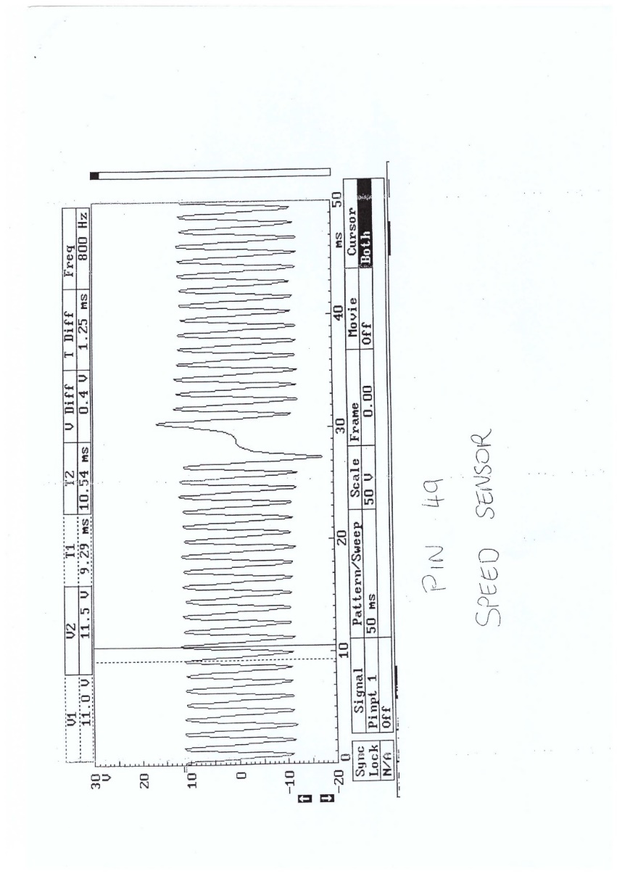
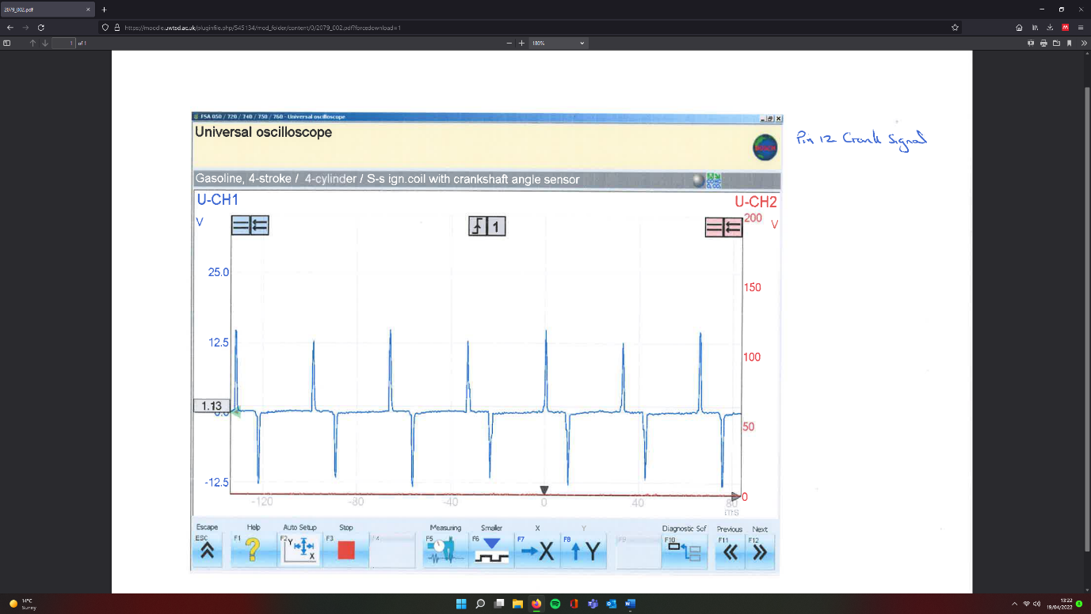
Figure 6: LE3 & Motronic Crank Angle Sensor Waveforms
The Crank position sensor (CPS) is arguably the most important sensor on the engine as it monitors the rotational speed of the engine. The ECU reads this data and subsequently alters the injection and ignition times and/or duration accordingly to maintain the correct air to fuel ratio and prevent pre-detonation or misfiring. Both sensors above in Figure 6 are analog sensors.
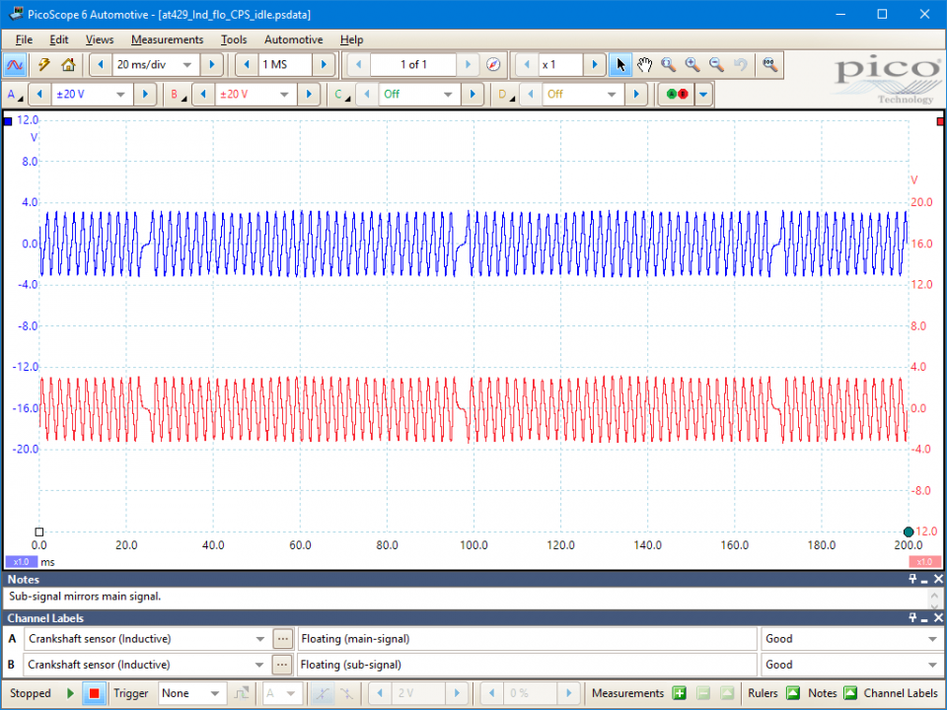
Figure 7: Inductive CPS Waveform by Pico Technology
Figure 7 is an Inductive CPS waveform provided by Pico Technologies. It is identical to the Motronic system with the exemption that the Motronic system operates between greater voltages of around +/-18V at the maximum peak and +/-10V average peak. This determines that the Motronic sensor is an Inductive CPS. These sensors are self-powering and operate via a magnetic field within the sensor being broken by a pulse ring, in this case, the teeth of the flywheel. The maximum peak is produced from a greater gap between two of the flywheel teeth. This maximum peak acts as a TDC reference for the ECU.

Regarding the LE3 CPS in Figure 6, it differs from the typical sine waveform commonly seen in analog systems. It shares more attributes with a camshaft position sensor than a crank sensor, as shown in Figure 8 provided by Pico Technology.
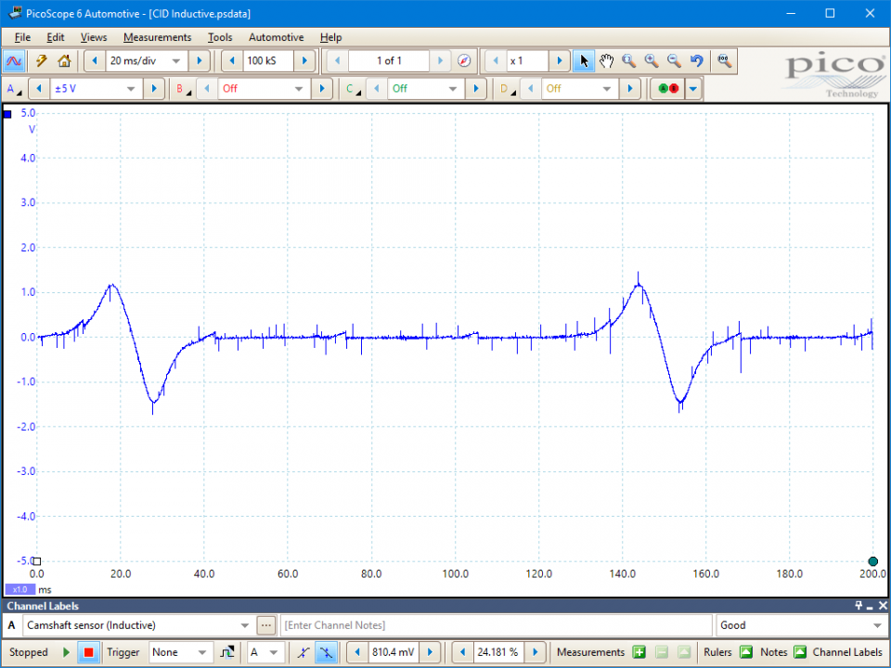
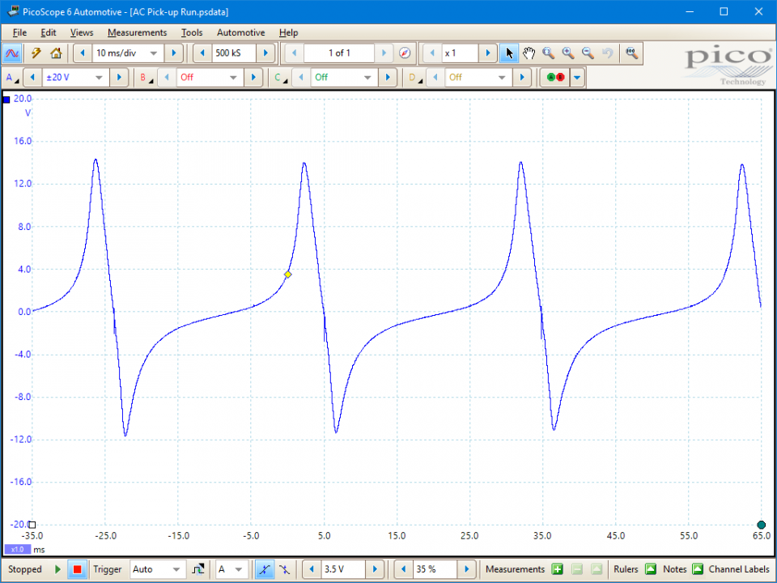
Figure 8 shows a Camshaft position sensor (Left) and a Distributor inductive pickup (Right). The LE3 waveform shares traits with both waveforms in the sense that it has a stable baseline of 0V with sharp peaks and troughs. The LE3’s peak is around 13V, it then immediately drops to 0V for 8-10ms before dropping to a trough around 12.5V.
Figure 8: Camshaft Position Sensor and Distributor Inductive sensor by Pico Technology

Due to this, it would fair to presume that the Spark ECU takes its position readings from either the Camshaft or distributer, rather than the Crankshaft. As the LE3 Waveform in Figure 6 is unique with the 8-10ms 0V reading, the sensor may be utilising a metal disk with specific cut-outs passing the magnetic induction sensor. However, if this is the case, it seems inefficient in comparison to using a standard distributor AC voltage system or taking the readings from the crankshaft.

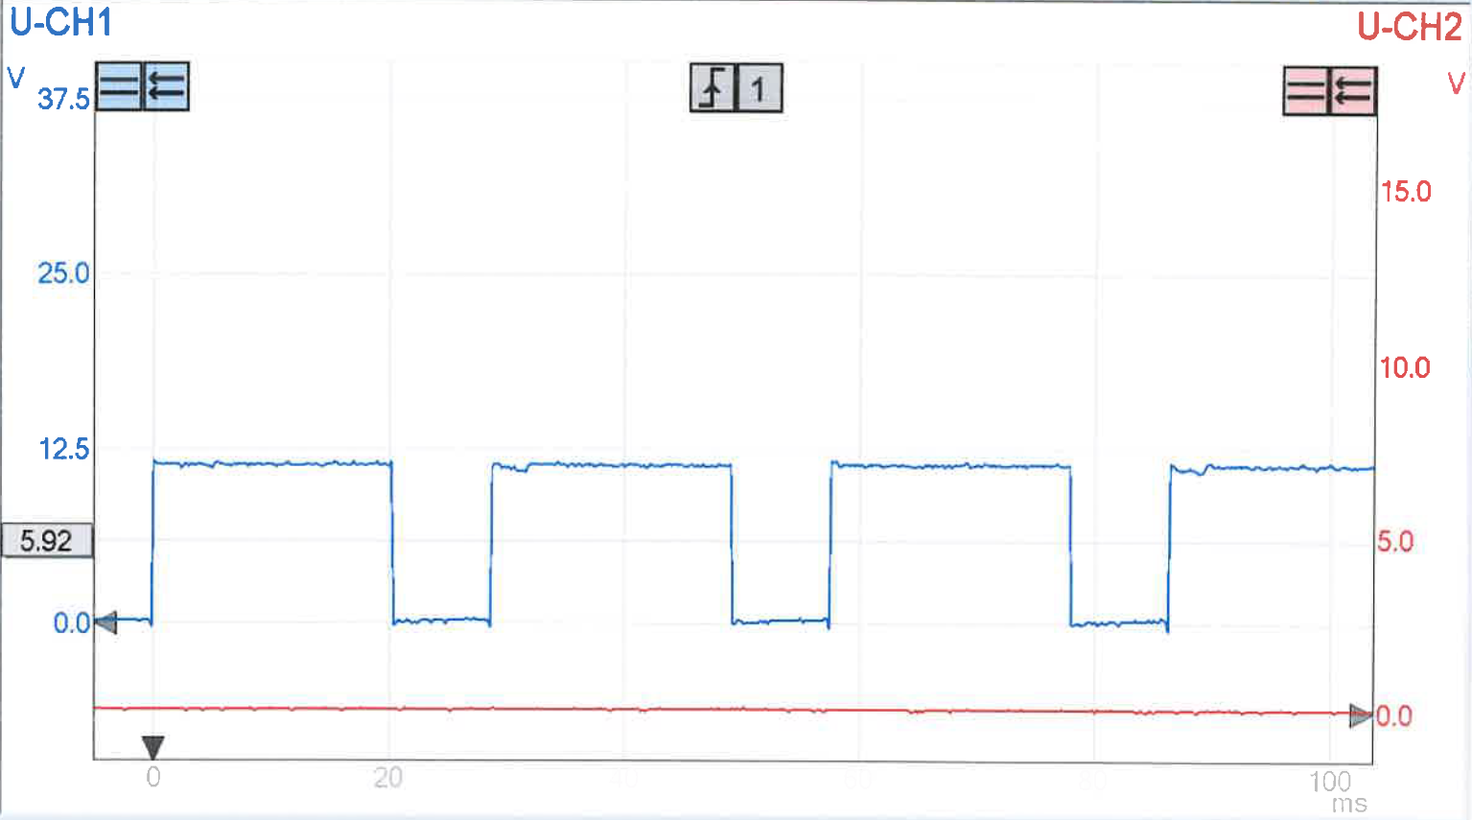
LE3 Speed Reference Communication Between ECUs
Figure 9: LE3 Speed Reference between Spark and Fuel ECUs
Figure 9 depicts the speed reference data shared between the spark and fuel ECUs respectfully on the LE3 system. This waveform is a digital remodelling of the analog signal received from the crank sensor, shown in Figure 6. It switches between 0V and 12V with a 20ms duration at 12V and a 4ms duration ad 0V. This reference is converted within the spark ECU and shared via pin 5 to pin 1 on the fuel ECU. The fuel ECU will use this data to correctly time the injection start, on time and frequencies throughout the engine operating parameters.

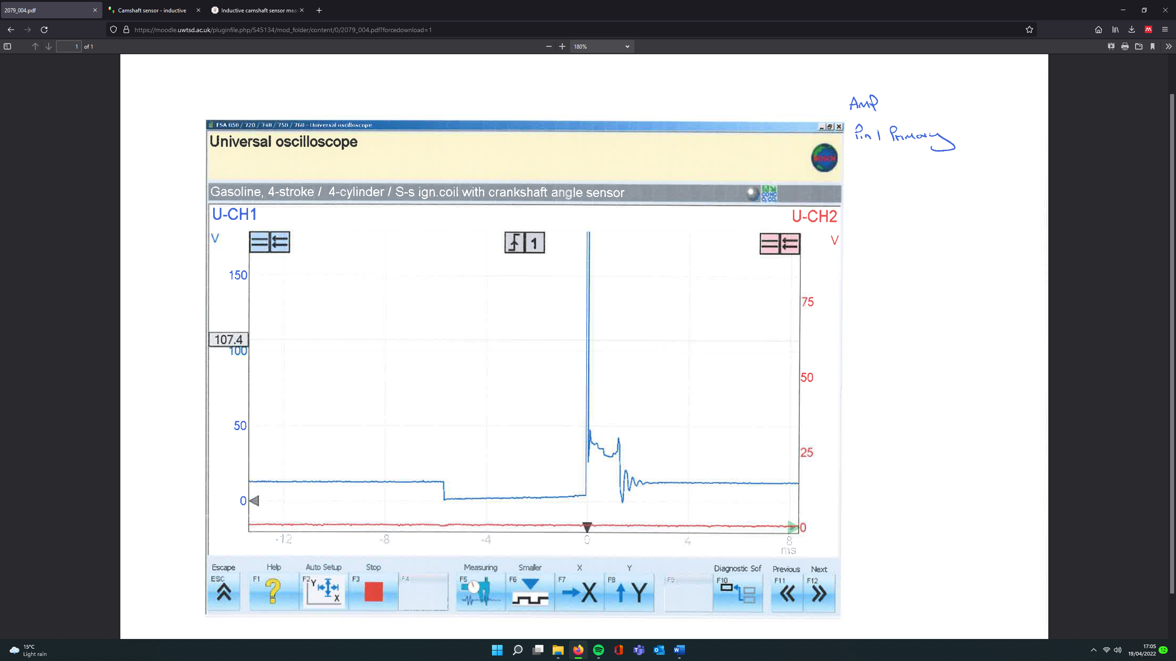
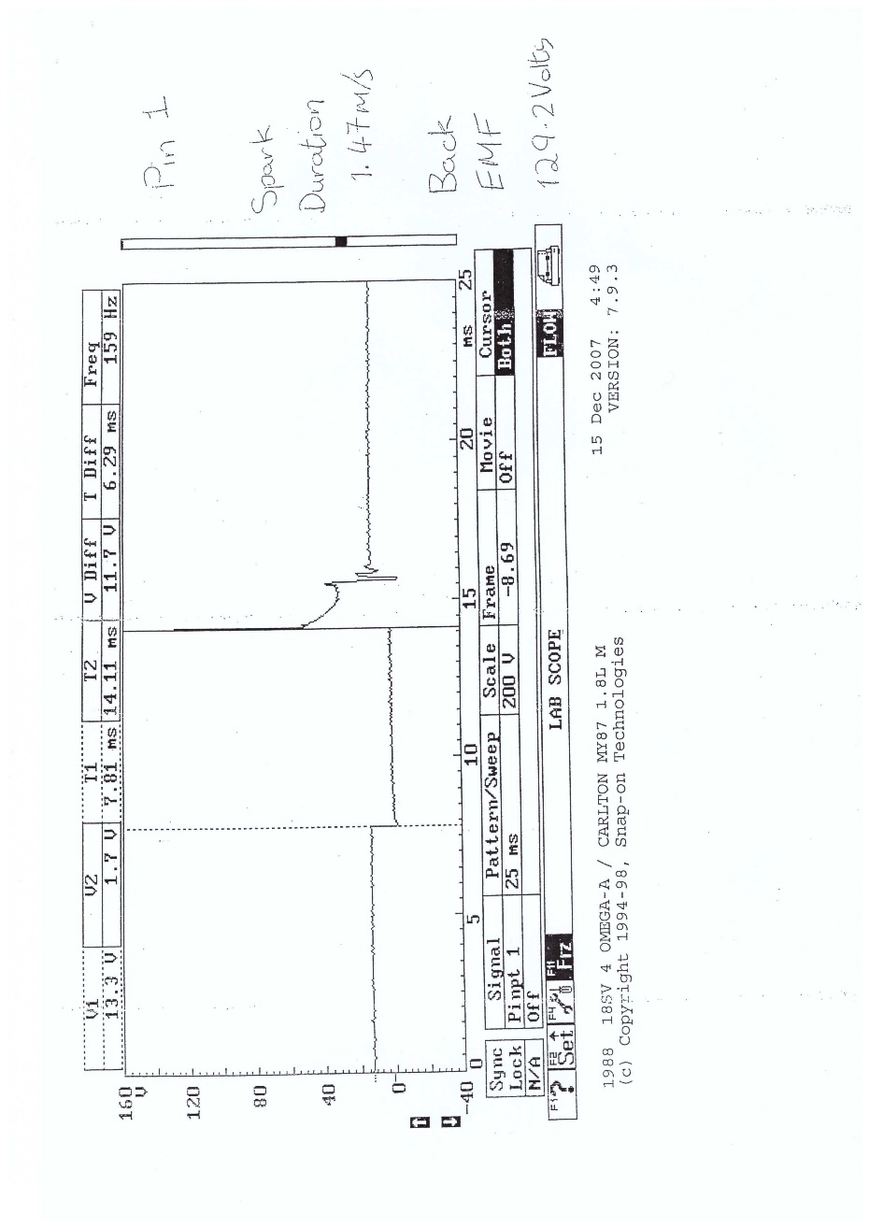
Primary Coil Windings
Figure 10: LE3 and Motronic Ignition Primary Coil Waveforms
4
3
2
1
Figure 10 shows the waveform for the primary coils of the LE3 and Motronic systems. As shown, they both have a constant live of 12V. On the LE3 this is backed by Figure 1 which shows battery voltage entering the Amplifier from ignition live 15, to pin 3 on the amplifier. When looking at Table 1, pin 3 reads a voltage of 11.92 during the time of testing. This voltage is then fed into the ignition coil and is the voltage seen in Figure 10. For the Motronic system, Figure 4 shows a feed from ignition live 15 to the negative side of the coil pack. Looking at table 4, this reads as 12.04V entering the coil.
The number annotations on Figure 10 are explained below at what each point of the graph represents:
- Voltage dips to 0V for a duration of around 6ms for both the LE3 and Motronic systems. This is known as the dwell period and occurs when the ECU grounds the circuit, saturating the primary coil with current.
- When it switches the earth again, the current falls rapidly yet the voltage spikes drastically in the primary coil to 160V+ for the LE3 and 129.2V for the Motronic system.
- This is the spark duration showing the length of time the spark took to bridge the gap between the electrode and the ground, the value was 1.47ms for the Motronic system. This event happened at 50V for both the LE3 and Motronic.
- After the high voltage has dissipated, the voltage briefly drops to 0V before returning to and settling at 12V, ready for the next event. Steps 2-4 take less than 3ms for both systems (Autoditex.com, 2020).

To expand on annotation 2, the high voltage will rush from the primary coil into the secondary coil and out through high-tension (HT) leads. This is a point in the ignition cycle where the LE3 and Motronic systems differ. On the LE3, the voltage will arrive at the central terminal of the distributer, which in turn connects to a rotating arm within the assembly. There are 4 more terminals within the distributer (in this engine), one for each cylinder. When the rotating arm passes over the corresponding cylinder terminal, the circuit is momentarily completed and the electricity travels down that terminal, through the HT lead, and to the spark plug.

The Motronic works differently. It is a Distributorless Ignition System (DIS) meaning the distributor is replaced with a more advanced unit. To begin, the amplifier is removed from the system and the ECU controls the correct amount of voltage needed to produce a good spark. Secondly, after the electricity has left the primary circuit, it enters a wasted spark coil pack. This acts as the secondary coil, amplifying voltage into the thousands with one coil operating for 2 cylinders simultaneously. Cylinders 1&3 and 2&4 are connected so that the spark will fire on a compression and exhaust stroke. However, the voltage is not split equally. Due to the lower pressure in the exhaust cylinder, the wasted spark requires very little energy to bridge the spark plug gap, leaving more energy for the main spark (UWTSD, 2022).

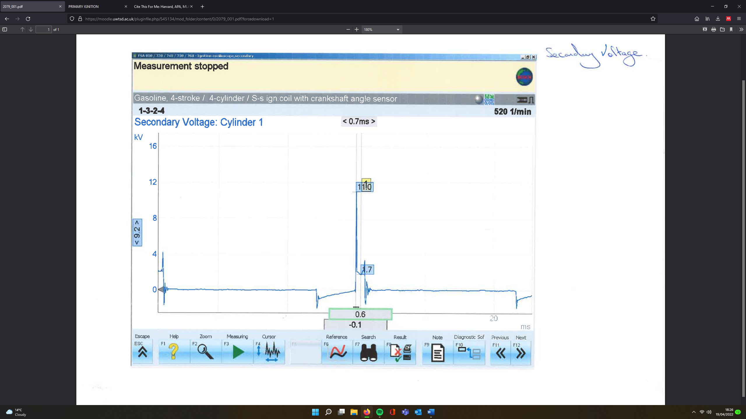
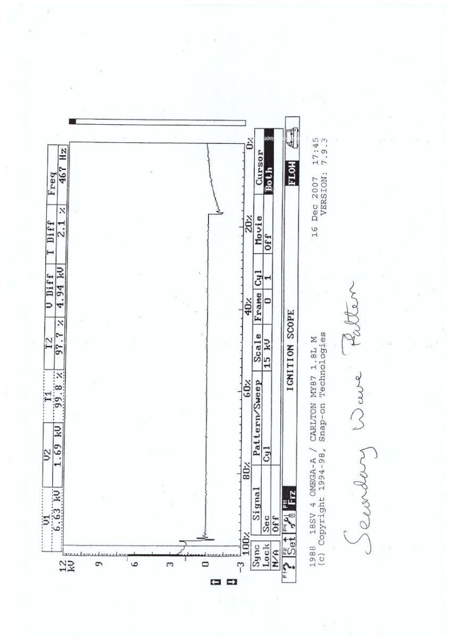
Secondary Coil Windings
1
4
3
Figure 11: LE3 and Motronic Ignition Secondary Coil Waveforms
2
The secondary coil works much the same way as the primary coil bar a few exceptions. Figure 11 shows that both the LE3 and Motronic have a 0V baseline compared to the primary coils 12V baseline. Number 1, as illustrated on Figure 11, shows that the voltage drops below 0V as the circuit is grounded by the ECU. There are slight coil oscillations within the secondary coil at this point as current is beginning to flow into the primary coil. Number 1 is known as the dwell time and should correspond directly to the dwell time of the primary coil as it is the time taken for the primary coil to saturate with current. Unlike the primary coil, however, voltage rises gradually from negative values back to 0V before the firing event. This is because the primary coil has created a magnetic field that resists current flow. Therefore, if the current remains the same yet the resistance increases, Ohms law states that the voltage must also increase, hence rising voltage on the dwell period.
Number 2 on Figure 11 displays the firing events for the LE3 and Motronic systems. This works the same way as the primary coil, however, because the secondary coil houses considerably more windings than the primary, the voltage is greatly multiplied. A primary coil houses between 150-300 turns of wire whereas the secondary coil houses 15000-30000 (Denso, 2021). The LE3 system has a peak voltage of 11KV and the Motronic peaks at 6.63KV. This is almost half that of the LE3 system. The LE3 incorporating a distributor in its system means the electricity needs to jump an additional gap between the rotor arm and the cylinder terminal. This in turn requires a higher voltage and would explain why the voltage output from the secondary coil is greater than that of the Motronic system.

Additionally, the ECU on the Motronic controls the amount of voltage to the ignition coils, only providing the system with the voltage required to jump the spark plug gap. Although, this value seems a little low. A possibility to consider is that the system has a lower resistive pathway than the LE3. During the workshop testing, it was stated that the HT Leads were replaced with a cheaper, non-manufacturer variant. This could lower the resistance throughout the system, therefore lower the secondary coil voltage output.

Number 3 on Figure 11 displays the spark duration. The Motronic has a greater spark duration than the LE3 system. This is due to it being a wasted spark system where the spark will fire twice, once through the true pathway and once through the wasted pathway. Number 4 shows the coil oscillations like that of the primary coil, dropping below 0V before returning and settling at 0V.

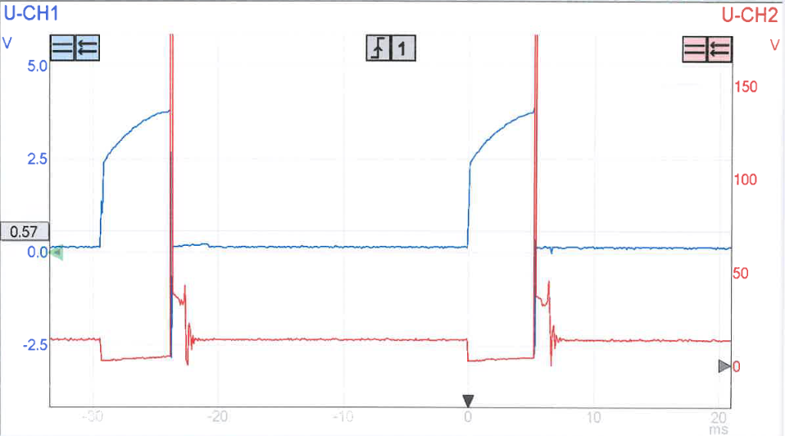
LE3 Spark Advancement Unit Signal
Figure 12: LE3 Spark Advance Signal vs Primary Ignition Waveform

Figure 12 displays the LE3’s spark advancement signal on channel one against the primary coil waveform on channel 2. The spark advance signal was measured at pin 4 on the amplifier and has a baseline of 0.13V as indicated in Table 1. It increases in voltage at the same time as the primary coil is switched and its dwell period begins as the spark advancement unit supplies the amplifier with voltage. It quickly rises to 2.5V before tapering off at a peak of around 3.5V. As soon as the ECU switches the ground, the voltage drops back to its original 0V.

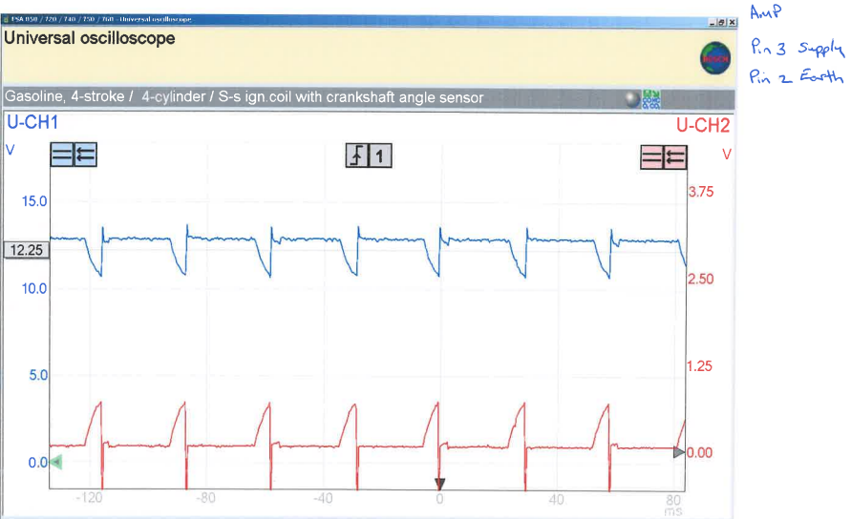
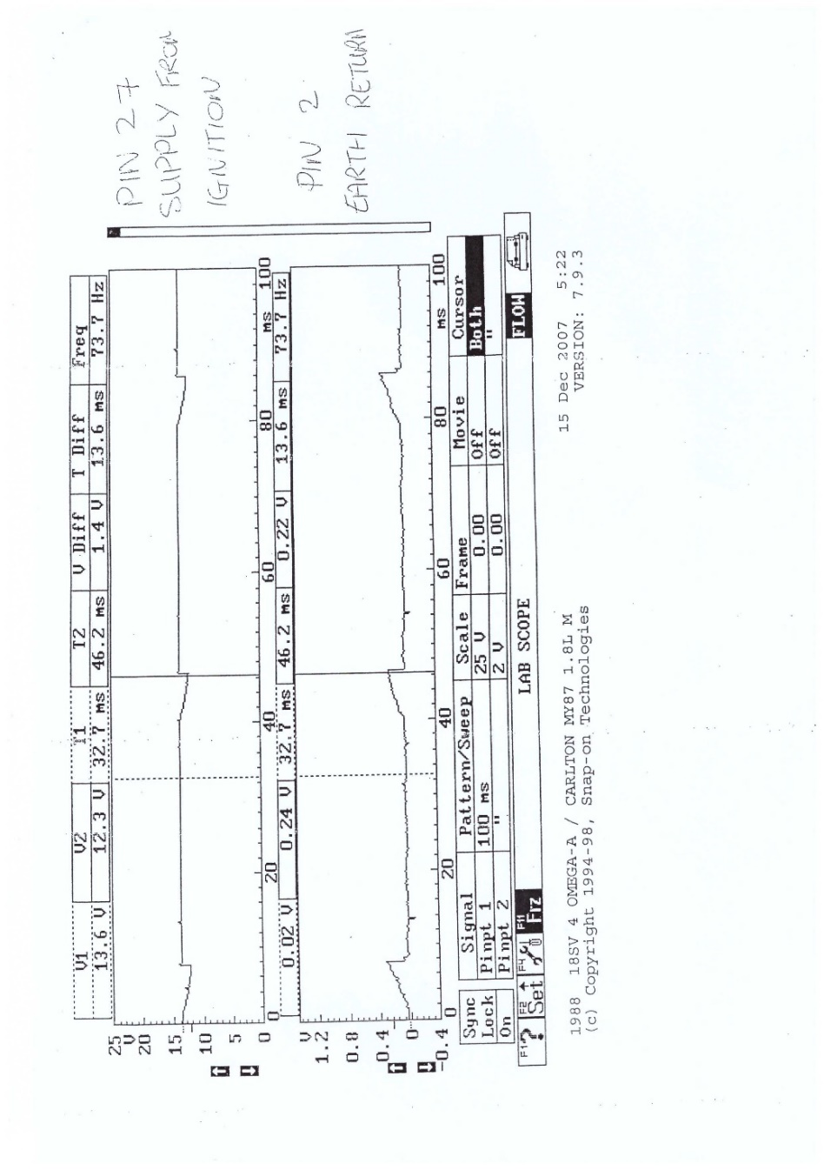
LE3 and Motronic Supply and Earth
Figure 13: LE3 and Motronic Supply and Earth
Figure 13 shows the supply in red, and the earth return in blue on the LE3 measured from pins 3 and 2 respectively. The supply voltage has a reading of 12.25V and that dips to 11V when power is sent to the amplifier during the ignition phase. When the power supply stops, a back EMF is created reading 13V before settling at the original 12.25V. The earth supply shows a voltage of 0.02V as seen in table 1 which spikes to 0.5V when the system is grounded to complete the circuit. When this earth is switched, a back EMF is created, dropping the voltage to below 0V before returning to its original voltage. This cycle repeats every 30ms. The Motronic system mirrors the LE3 however the original supply voltage reads 14V which drops to 12V when power is sent to the ignition coils. The earth spikes from 0V to 0.3V when the circuit is completed. This has a longer cycle than the LE3 lasting approximately 38ms.

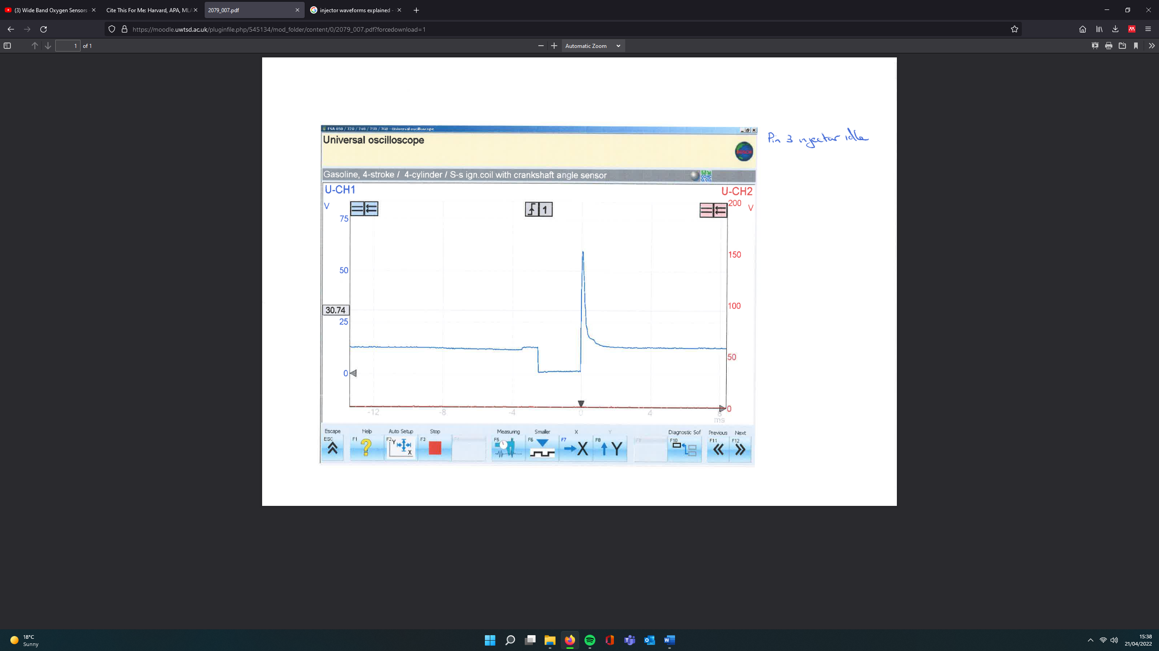
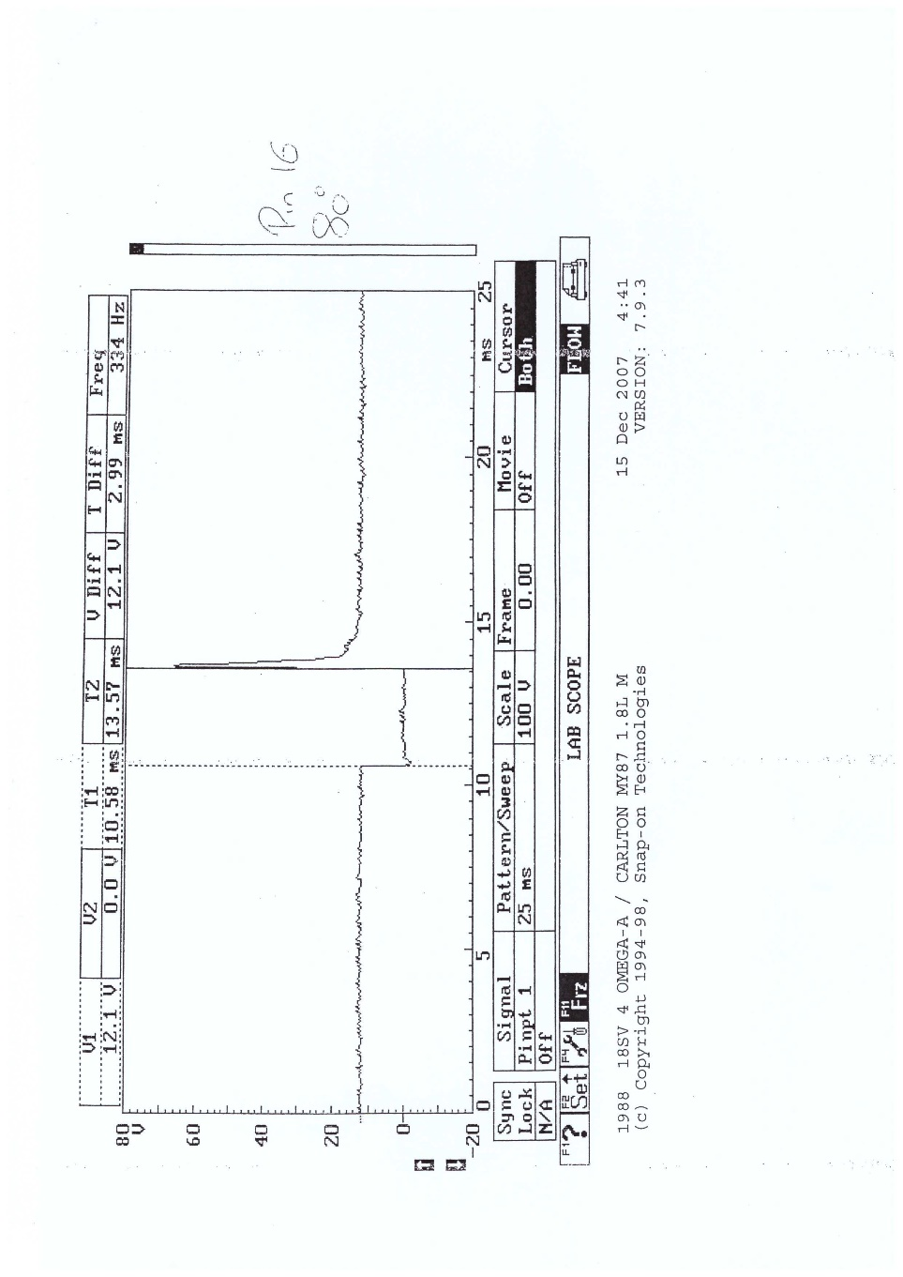
Injection at Idle
Figure 14: LE3 and Motronic Injection at Idle Waveform
Figure 14 highlights the injection waveform for the LE3 and Motronic systems. Both systems have a base voltage of 12V. Like the ignition system, the ECU grounds the circuit, and the voltage drops to 0V while current builds. Both the LE3 and Motronic system have an injector on time of around 3ms at idle, stated as 2.99ms on the Motronic waveform. When the ECU switches again, the current drops drastically and the voltage spikes up to 60V on the LE3 and 66V on the Motronic. The little bump indicated on both graphs is the vibration of the injector pintle hitting the seat in the injector upon closing (Markel, 2017).

Injection under Acceleration
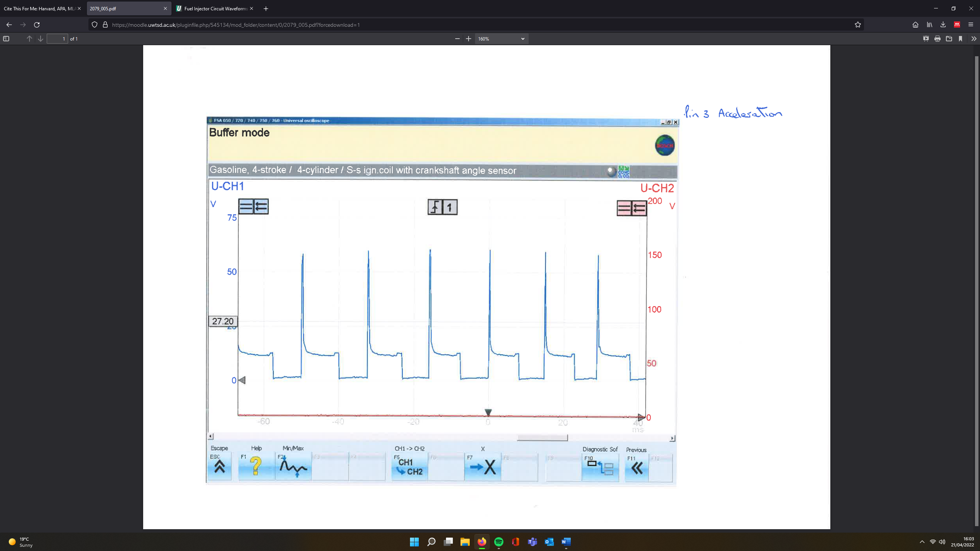
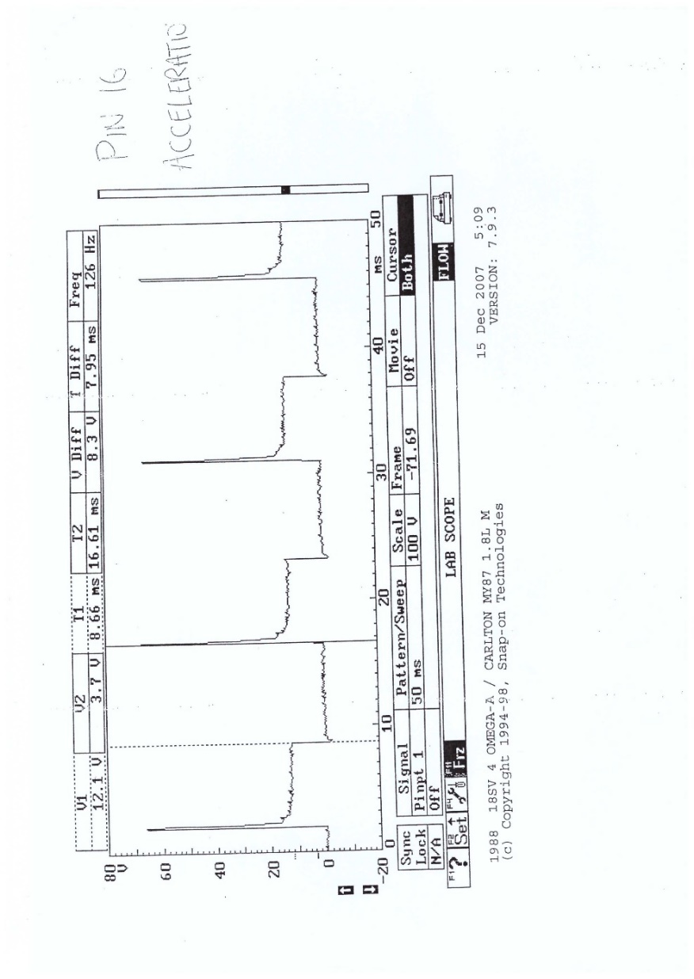
Figure 15: LE3 and Motronic Injection under Acceleration Waveform
Figure 15 portrays the injection patterns for both engines under acceleration conditions. The voltages values remain the same as those shown in Figure 14, however the injection duration and frequency of injection events have altered. The injection duration increases for both engines to around 8ms for the LE3 and 7.95ms for the Motronic. As for the frequency, at least 2 injection events occur for both engines in Figure 15 within the same 25ms period as the single injection event in Figure 14.

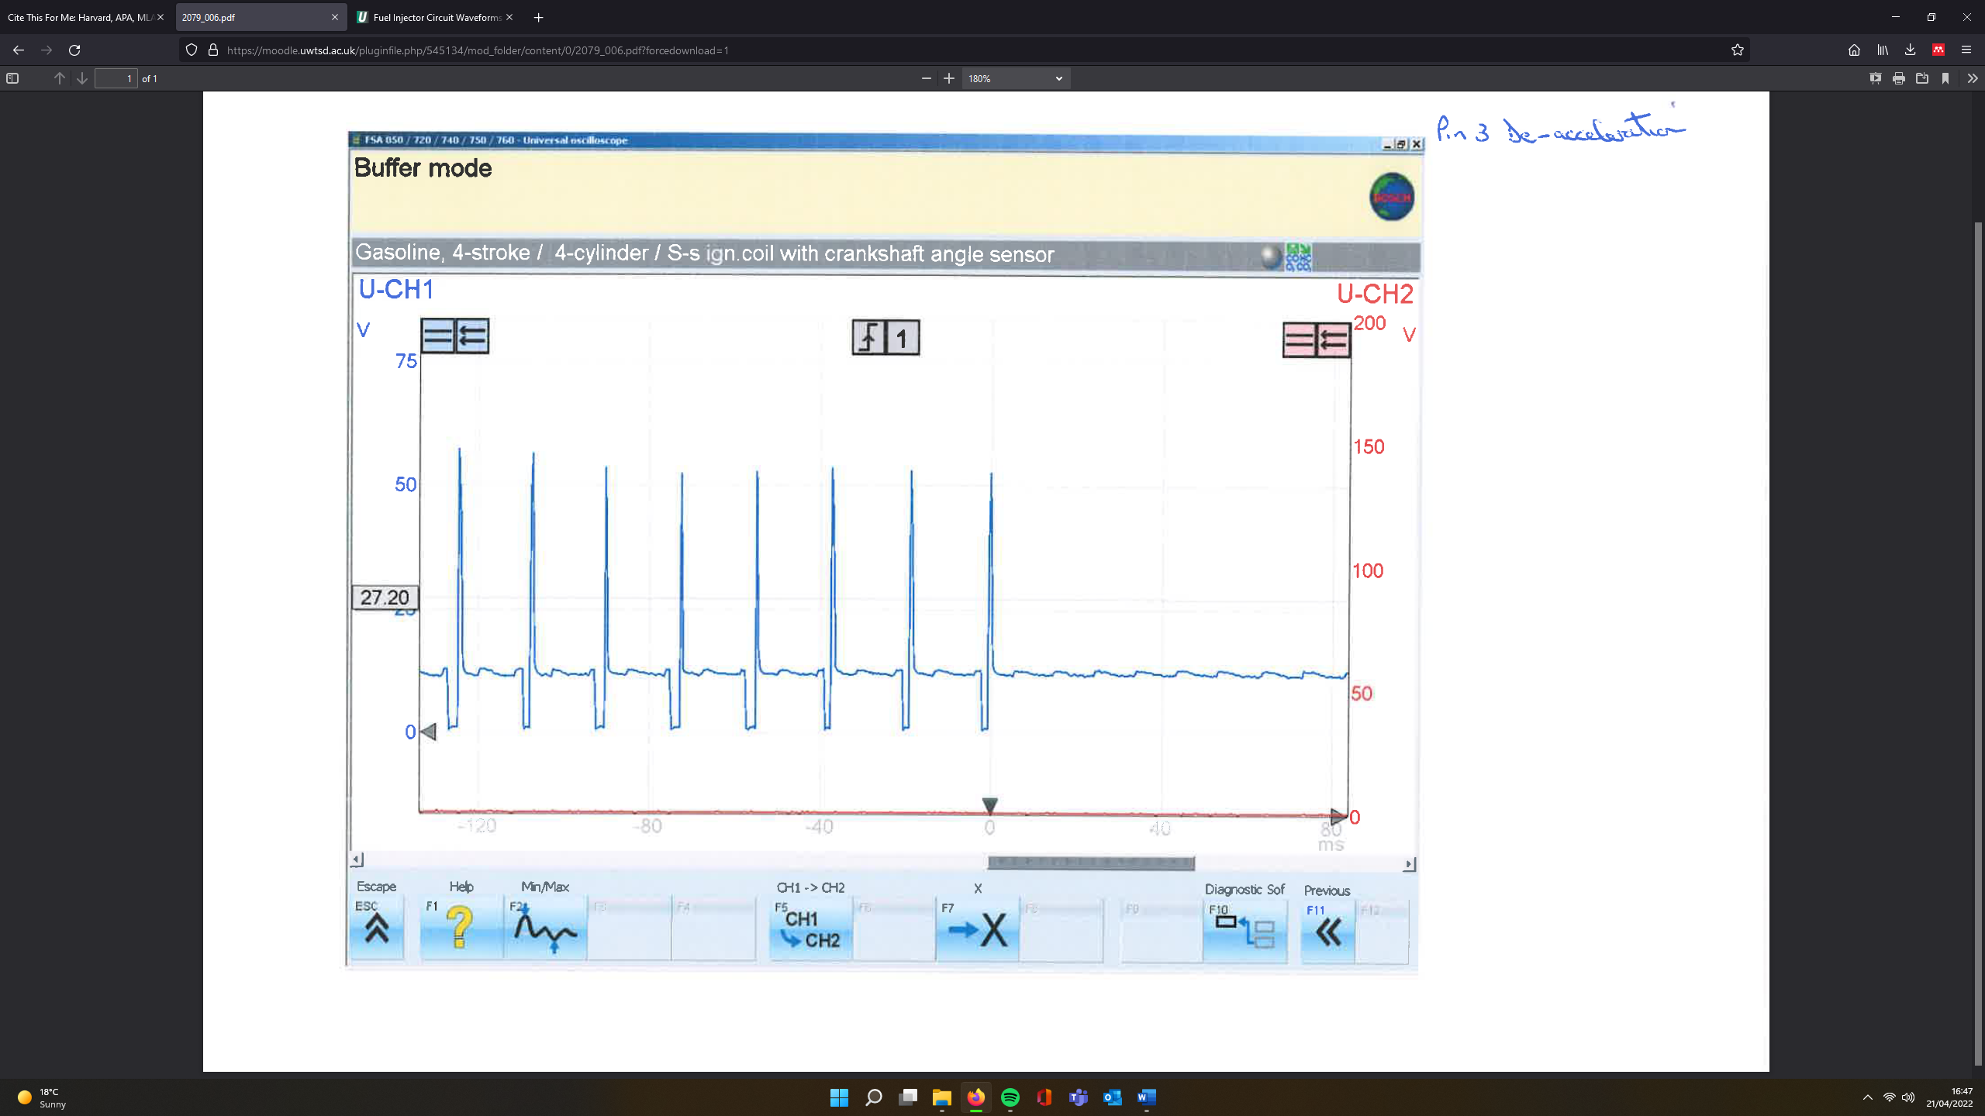
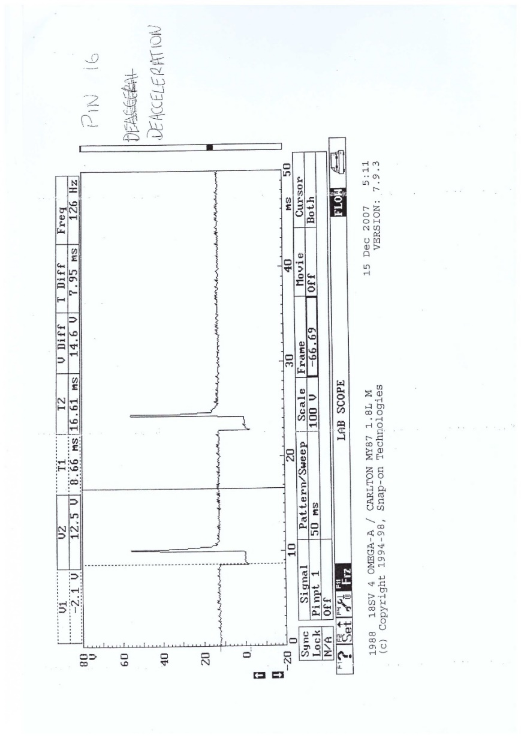
Injection under Deceleration
Figure 16: LE3 and Motronic Injection under Deceleration Waveform
When decelerating, the injection on time reduces on both engines as seen in Figure 16. The LE3 graph is difficult to read however the Motronic engine suggests that the injection duration on deceleration is around 1.3ms. The peak voltages also drop, as observed on the LE3 waveform. The main factor however lies with the tail end of the graphs. When decelerating and in over run conditions, the ECU recognises that no loads are required from the engine and shuts off the injectors until a load input is received or the engine revs low enough to idle range. This is to preserve fuel and improve the efficiency of the engine.

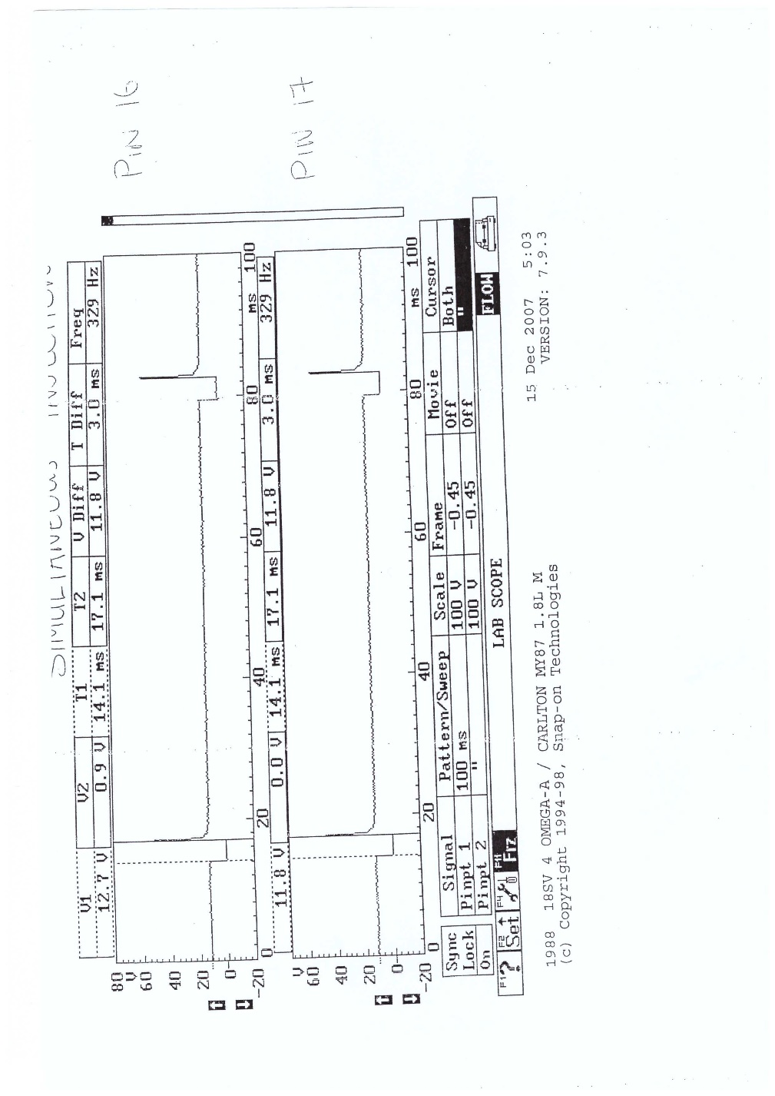
Motronic Simultaneous Injection
Figure 17: Motronic Simultaneous Injection Waveforms
Figure 17 shows the Motronic injector waveforms recorded from pins 16 and 17. The system is fed from battery voltage, indicated on the graph and Table 4 as 12.04 volts. It shows both injector banks firing simultaneously for a duration of 3ms due to the wasted spark system.

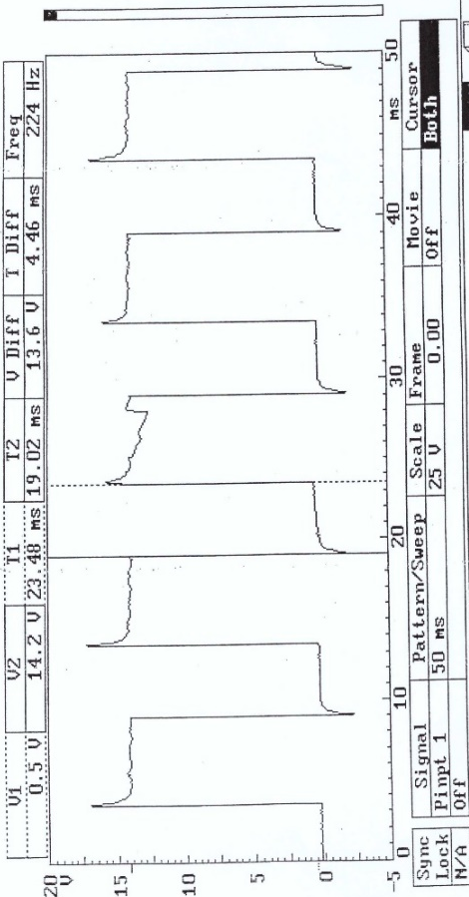
Motronic Rotary Idle Valve
Figure 18:Motronic Rotary Idle Valve Waveform

The rotary idle valves function of to maintain manufacturer base idle when the engine is subject to loads. For example, the engine has just been started, and auxiliaries such as headlights, heaters and window demisters have all been turned on. These are heavy electrical loads so the alternator would have to compensate. The alternator serves as a parasitic load on the engine so in this instance would reduce the RPMs to the point of stalling. However, before that can happen, the ECU would send a signal to the rotary idle valve commanding it to increase the base idle to compensate for these loads. This action can be seen in Table 6 where the rotary idle valve begins to reduce in percent value until 70°C. At this point, the fans were turned on to cool then engine and the value can be observed as increasing from 43% at 60°C to 45% at 70°C to compensate.

The waveform seen in Figure 18 is the communication between the ECU and the rotary idle valve as observed at pin 4. It switches between battery positive 14.7V and battery negative at 0.5V. The pulse width modulation (PWM) is 50% as it reads 0V for 5ms and 14.7V for 5ms (Picoauto.com, n.d)

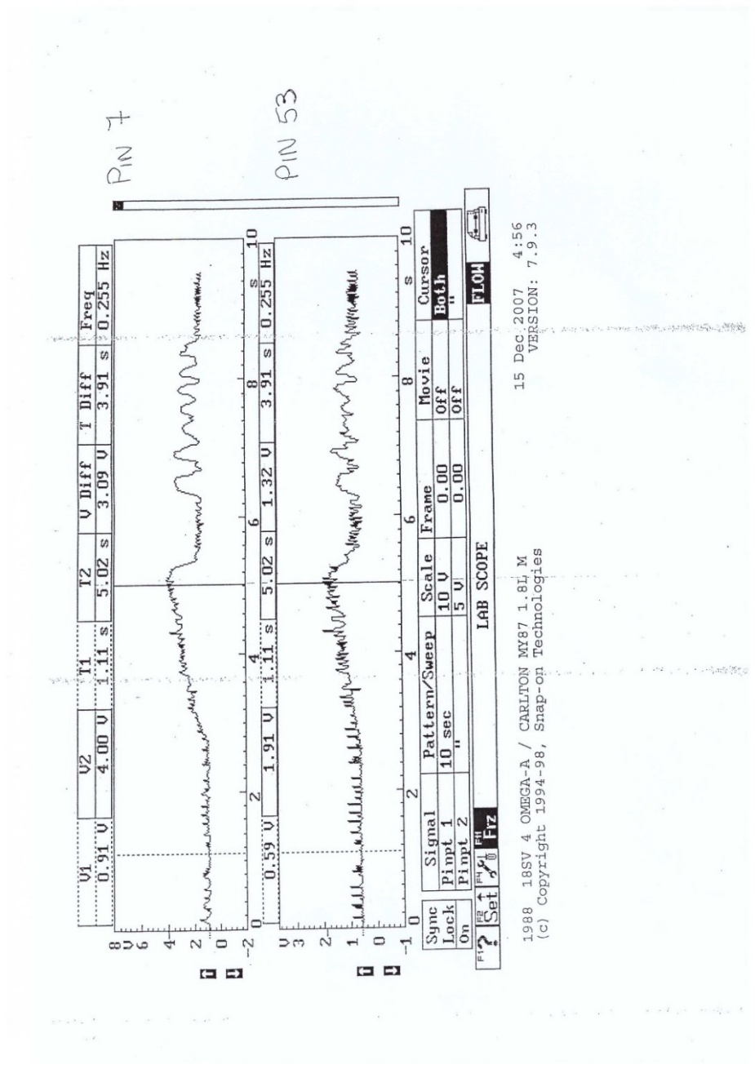
Airflow and Throttle Potentiometer
Figure 19: Motronic Airflow and Throttle Potentiometer Waveform

Figure 19 displays the throttle actuations (bottom waveform) against the change in air flow entering the engine (top waveform). The throttle potentiometer waveform has more interference than the air flow waveform however it can be seen that the airflow mirrors the input from the throttle potentiometer.

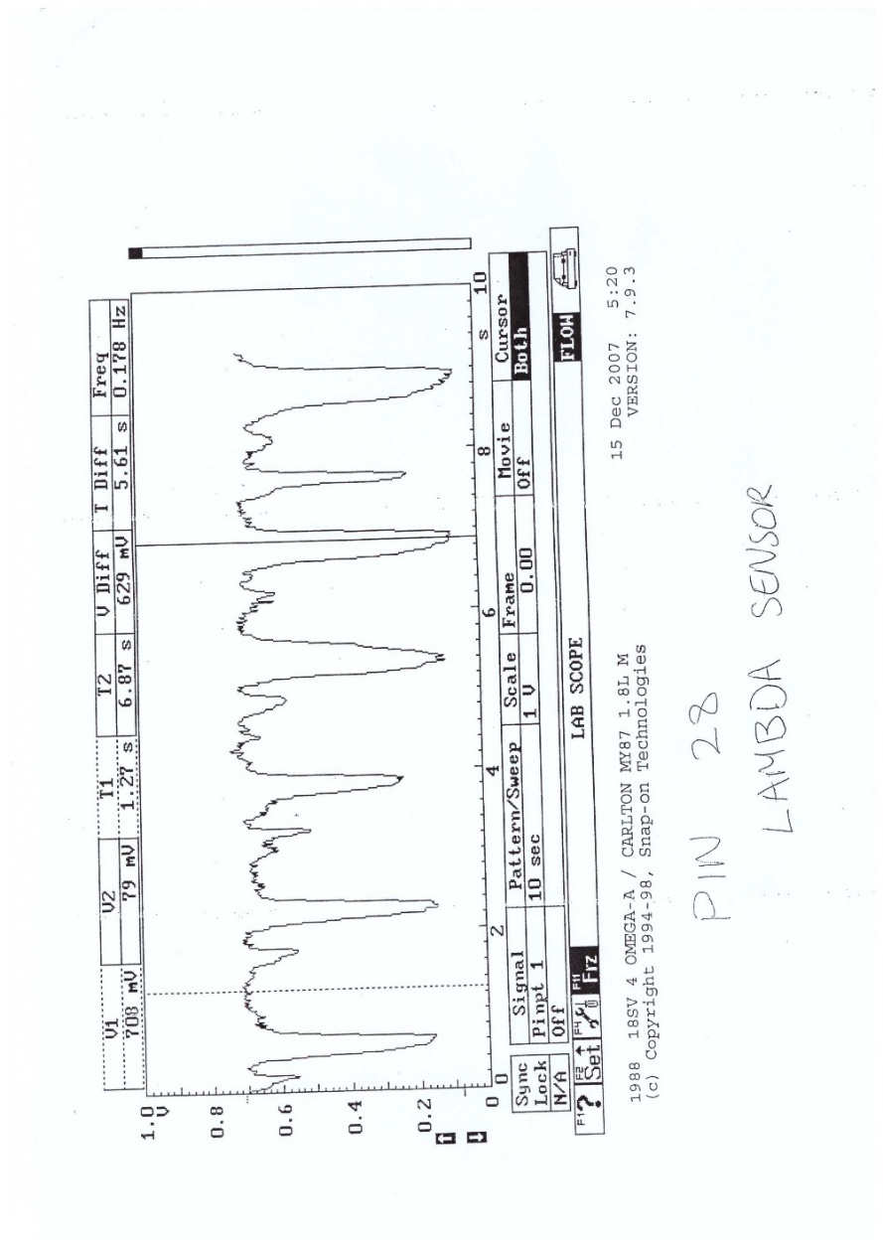
Motronic Lambda Sensor
Figure 20: Motronic Lambda Sensor Waveform
Figure 20 was measured at pin 28 and shows the narrow band Lambda sensor switching between 0-1V. When referencing against table 6, it is shown that this system doesn’t begin switching until around 30°C engine temperature. This only indicated the start of the lambda switching however it won’t begin fully switching until the sensor has reached a temperature of 350° at whatever corresponding engine temperature that may be.

This sensor monitors the exhaust gasses leaving the engine and relays information back to the ECU telling it to lean the fuel mix or enrichen it. The ECU interprets the higher voltage signal of 0.7V in Figure 20 as the engine running too rich, therefore, it leans the fuel mix slightly to maintain an economic burn. The dips in Figure 20, that range from 0.08V to 0.25V, is the lambda sensor signalling that the fuel mix has been leaned too much, the ECU reads this and will subsequently enrich the fuel.

Modifications

This section involves analysing the data above, assessing where one of the systems can be improved, and suggesting potential modifications to improve the efficiency of the engine. The LE3 system is easier to upgrade as there are more outdated components than the Motronic system, however, both systems can be improved so the focus will be mainly on the Motronic engine.
An engine relies on the accuracy and speed of its sensors to efficiently control actuators to maintain the correct engine parameters. Naturally, improving the sensor quality will improve the engine efficiency as the ECU can react quicker and more accurately to changes in engine speed, load, and temperature if it is given more information. As a result, the following is a list of recommended upgrades to be applied to the Motronic Engine:

- Crankshaft and Camshaft hall effect sensors
- Sequential ignition with coil on plug
- MAF sensor
- Wide band lambda sensor

Upgrading the Crankshaft sensor from an inductive to a hall effect sensor will decrease the relay time to the ECU as it wouldn’t have to convert an analog signal into a digital signal. Adding hall effect camshaft sensors would also improve the system as the ECU would have the precise location of the crankshaft and camshafts within their cycles. This would allow for more efficient fuelling and spark timings. Regarding the ignition side, sequential ignition with a multi coil on plug unit would allow for greater control of the spark as each individual cylinder can be monitored. There are also fewer pathways for the voltage to be lost as this system removes the high-tension side of the system until directly above the spark plugs. This removes the need for the external ignition coil and HT leads.

Incorporating a hot wire Mass Air Flow (MAF) sensor would aid the ECU in measuring the quantity and density of air entering the engine. MAF sensors work by applying a voltage to a platinum wire, causing it to heat up to a specific temperature. When air passes over the wire, the temperature reduces, the more air, the greater the temperature drop. The wire’s electrical resistance is directly proportional to temperature meaning that as the temperature drops, so does the resistance. As there is a constant supply voltage yet less resistance, more current is allowed to flow through the wire, heating it back up to its original temperature. These current fluctuations are converted into a voltage signal and sent to the ECU as a highly accurate air mass reading (Engineering Explained, 2012). If this engine was equipped with forced induction, then a MAF sensor wouldn’t suffice as it is located between the air box and the throttle body. This would lead to unmetered air entering the engine from the turbo/supercharger whereas a map sensor is located in the intake manifold and would be able to measure the additional air (DensoProducts.com, n.d).

The current lambda sensor on the Motronic is a narrow band 0-1V sensor. These types of sensors don’t accurately measure the Air-Fuel Ratio (AFR), rather lean the fuel mix when it senses the engine has dropped below the stoichiometric ratio of 14.7:1 and enriches it when it surpasses 14.7:1. This can be upgraded to a wide band lambda which operates between 0-5V and can accurately measure fuel ratios as rich as 6:1 up to a lean 20:1. This far surpasses the needs of the Motronic engine however it is highly accurate in its AFR readings and would improve the efficiency of the engine over a narrow band sensor.

These upgrades may require additional components to be upgraded on the vehicle. For example, the stock ECU may not be capable of running some of the modifications and would therefore have to be remapped or replaced entirely to be able to efficiently run the engine. An additional controller would be necessary to run the wide band lambda sensor as these sensors often operate with 6 wires. The controller is used to allow the wide band lambda to be used to its full potential as it aids in heating up the sensor itself as well as interpreting the signals to send to the ECU. Regarding the sequential ignition, the wasted spark unit would have to be discarded and coil on plug coils fitted above each spark plug with the necessary low-tension wiring implemented into the ECU.

Conclusion

This report has analysed the testing methods, static data, and live data of the Vauxhall LE3 and Motronic control systems. The aims set out at the beginning of the report have been met as explanations of how the different ECUs operate and interpret sensor data have been assessed and compared against one another. Live waveforms were obtained from the engines and cross examined, looking for differences in voltages, frequencies, and durations of components such as injectors and ignition coils. It was observed that the LE3 system uses older technology than the Motronic system which impacted its ability to monitor specific engine functions. Components such as the TPS registering either 0% or 100% load meant that the engine had to depend on other sensor data and cross reference against a look up data table, set by the manufacturer, to function correctly. This highlights that as technology progresses and more accurate sensors are implemented onto modern engines, the monitoring of vehicle economy and performance is enhanced and subsequently makes the engine more efficient.

References

Autoditex.com. 2020. Primary Ignition. [online] Available at: <https://autoditex.com/page/primary-ignition-32-1.html> [Accessed 4 April 2022].

DENSO.com. 2021. Back to basics: How an ignition coil works. [online] Available at: <https://www.denso-am.eu/news/deneur21_04_ignition-coil-basic-principles> [Accessed 14 April 2022].

DensoProducts.com. n.d. MAP vs. MAF - What’s the difference? [online] Available at: <https://www.densoproducts.com/map-vs-maf-whats-the-difference-2> [Accessed 21 April 2022].

Engineering Explained, 2012. Mass Air Flow Sensor - Hot Wire - Explained. [online] Youtube.com. Available at: <https://www.youtube.com/watch?v=Z3QuuEPef4k> [Accessed 21 April 2022].

Markel, A., 2017. Fuel Injector Circuit Waveforms. [online] UnderhoodService. Available at: <https://www.underhoodservice.com/fuel-injector-circuit-waveforms/> [Accessed 21 April 2022].

Picoauto.com. n.d. Idle speed control valve - rotary solenoid. [online] Available at: <https://www.picoauto.com/library/automotive-guided-tests/rotary/> [Accessed 22 April 2022].

