

Content

Content 2
List of Figures and Tables 3
A. Explanation of Code and Logic 4
B. Justification of Programming Choices 6
C. Testing and Validation 7
D. Efficiency and Scalability Reflection 9
E. Reflection on Learning and Use of Generative AI 10

List of Figures and Tables
——— ◆ ———
Figures
Figure 1 Flowchart of the R program logic 5
Figure 2 Controlled boundary test and floating-point precision investigation in R 8
Figure 3 Controlled boundary results in R 8

Tables
Table 1 Key Design Decisions in the R Solution 7
Table 2 Testing and Validation of the R Solution 9

A. Explanation of Code and Logic
I developed the R solution in stages, with the output of each stage supporting the next. The program begins by defining the main constants: 28 days, five warehouse zones, six product categories, a base value of 100 units and a processing rate of 0.85 minutes per unit. I also used set.seed(2237641) so that the same simulated data could be reproduced when rerunning and testing the program.
The warehouse_data dataframe is created using three nested for loops representing days, zones and product categories. This ensures that every possible combination is processed, producing 840 records (28 × 5 × 6). Within the innermost loop, a random integer between −12 and +12 is added to the UnitsProcessed to introduce variation. ProcessingTime is then calculated by multiplying UnitsProcessed by 0.85. This dataframe provides the foundation for all subsequent analysis.
For the zone analysis, an outer loop processes each zone while an inner loop examines every record. When the zone matches, UnitsProcessed is added to a running total, and the result is stored in zone_totals. A similar approach is used for category_average_time, where both processing time and the number of matching records are accumulated before calculating the mean.
Anomaly detection requires additional processing. For each day–zone combination, the program first calculates the average units processed across the six categories. Individual records are then compared with this average and classified as anomalies when they fall more than 15% above or below it. The complete results are stored in processing_anomalies, while TRUE cases are extracted into true_anomalies for easier inspection.
Finally, the program identifies the most productive day for each zone. Daily totals are calculated and compared with the highest value found so far. When a higher total is encountered, both the day and value are updated and eventually stored in peak_zone_days. Overall, the program follows a sequential structure in which the initial simulated dataset is progressively processed into increasingly focused summaries and checks.
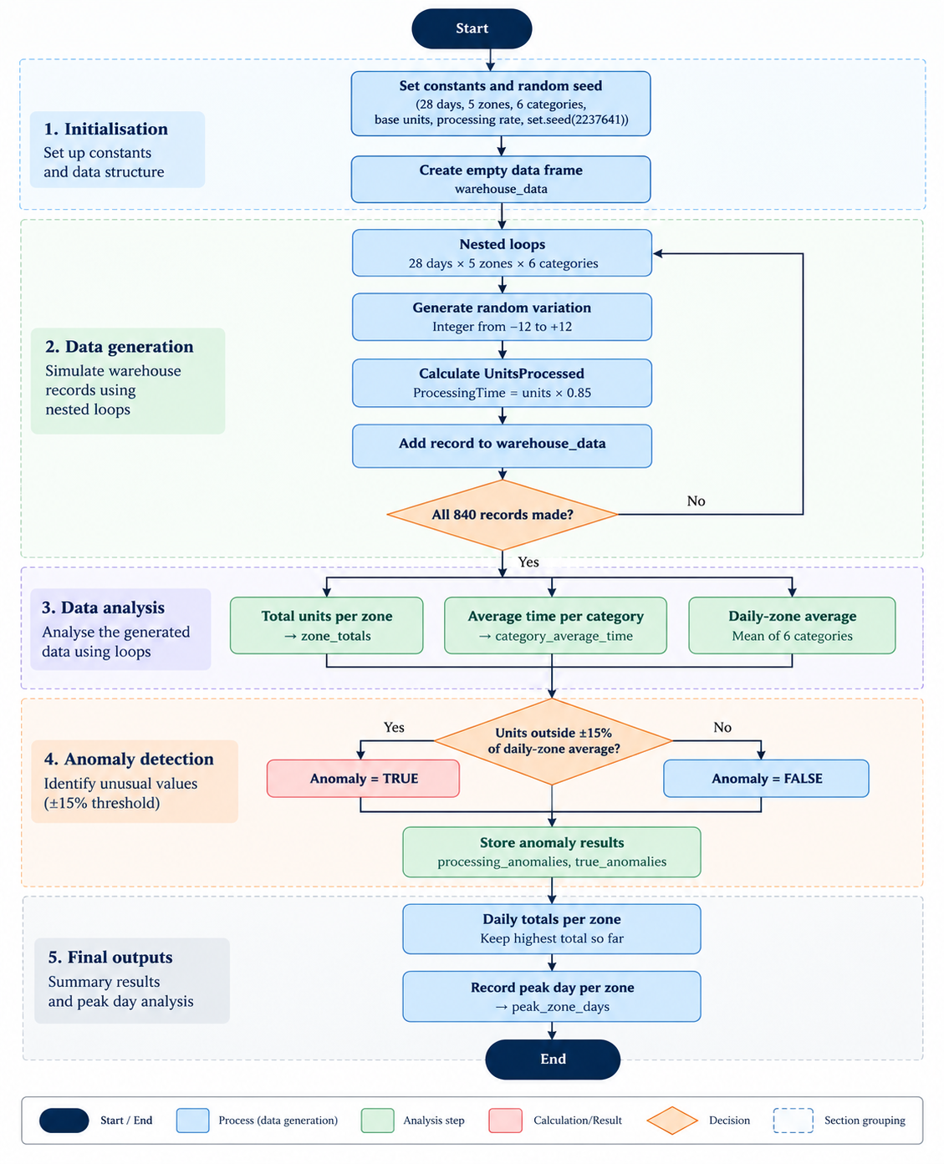
Figure 1: Flowchart of the R program, showing how the simulated warehouse dataset is generated and then analysed to produce zone totals, category averages, processing anomalies and peak days.

B. Justification of Programming Choices
I selected a dataframe as the main data structure because the warehouse data contains several related variables with different data types. Storing each observation as a row and Day, Zone, Category, UnitsProcessed and ProcessingTime as columns provided a clear structure that could be accessed consistently within the loops. I also stored the outputs of each analysis in separate dataframes, such as zone_totals, category_average_time, processing_anomalies and peak_zone_days. This made individual results easier to inspect and validate, although it requires additional objects to be maintained.
Nested for loops were appropriate because the simulation has a natural hierarchical structure of days, zones and product categories. They ensured that all 840 combinations were processed systematically and made the calculation steps explicit. The same loop-based approach was used for totals, averages, anomaly detection and peak-day identification. Although this improves transparency and makes the processing logic easier to follow, repeatedly scanning warehouse_data is less efficient as the dataset grows.
Alternative approaches in R could include vectorised operations or aggregation tools, which would generally produce shorter code and could improve performance on larger datasets. However, high-level aggregation functions were restricted by the assessment brief. I therefore prioritised a loop-based design that satisfied the requirements while also demonstrating how values are accumulated, compared and stored at each stage.
The simulation also relies on several assumptions. Processing time is fixed at 0.85 minutes per unit, while random variation is limited to integers between −12 and +12, as specified by the scenario. These assumptions provide a controlled and reproducible simulation but simplify real warehouse operations, where processing performance could vary according to product type, equipment, staffing and workload.
Overall, the chosen design prioritised transparency and correctness over computational efficiency. This was appropriate for the assessment because the loop-based approach makes each stage of the data manipulation visible and easier to verify. However, the repeated scanning of the dataframe creates a trade-off between readability and performance, which would become more important as the dataset increases in size.
Table 1. Key Design Decisions in the R Solution
Design decision | Justification
Dataframe structure | Provides a clear row-and-column structure for storing and accessing warehouse records.
Nested for loops | Systematically processes every required day, zone and category combination.
Separate result dataframes | Keeps each analysis output separate, making results easier to inspect and validate.
set.seed(2237641) | Makes the simulated dataset reproducible for testing and verification.
±15% anomaly threshold | Applies the specified rule consistently when identifying unusual processing values.
0.85 processing rate | Applies the processing-time assumption specified in the scenario consistently.

C. Testing and Validation
I tested the program at different stages to confirm both the structure of the dataset and the accuracy of the calculations. The expected dataset size was 840 records (28 × 5 × 6), and the generated output contained 840 rows and five columns. I also confirmed that each category contained 140 records (28 × 5), showing that all required day, zone and category combinations had been generated. I also restarted R and ran the complete script in a clean session to confirm that it executed independently without relying on previously created objects.
I then manually verified the anomaly logic using an actual result from the program. For Day 1, Zone 2, Category 6, UnitsProcessed was 156 and the displayed DailyZoneAverage was 131.67. Using the displayed average, the upper threshold is approximately 151.42 (131.67 × 1.15). Since 156 > 151.42, the expected result is TRUE, which matched the program output. This provided direct evidence that the upper anomaly condition was operating correctly.
I also conducted a small, controlled boundary test using an average of 100 units and values of 85, 84.99, 100, 115 and 115.01. The expected classifications matched the program for four of the five values. However, the upper boundary value of 115 was unexpectedly classified as TRUE. Further investigation showed that, due to floating-point representation, R stored the result of 100 × 1.15 as approximately 114.99999999999999 rather than exactly 115. Consequently, the strict > comparison evaluated 115 as being above the calculated threshold. This identified a floating-point precision issue that would not have been apparent from the main dataset alone.
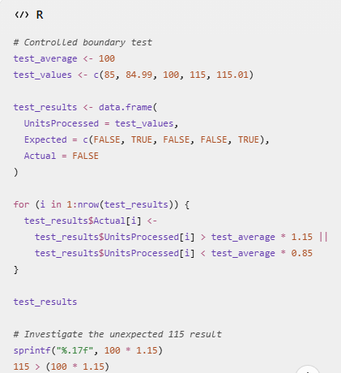

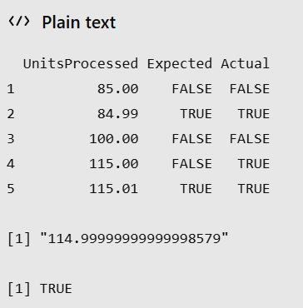

Figure 3 Controlled boundary results
Figure 2 Controlled boundary test and floating-point precision investigation in R.

Overall, the testing combined structural checks, manual calculation, clean-session execution and controlled boundary testing. The boundary test demonstrated that numerical comparisons can produce unexpected results because of floating-point representation. In a more robust implementation, this could be addressed by using an appropriate numerical tolerance when making boundary comparisons. This increased confidence in the main results while also identifying a limitation for future development.

Table 2. Testing and Validation of the R Solution
Test | Evidence/result | Demonstrates
Dataset dimensions | 840 rows, 5 columns | Required combinations generated
Category records | 140 records per category | Categories generated consistently
Zone totals | Separate totals for Zones 1–5 | Zone accumulation worked correctly
Manual anomaly check | 131.67 × 1.15 ≈ 151.42; 156 > 151.42 → TRUE | Anomaly rule produced expected result
Controlled boundary test | 4/5 matched; 115 returned TRUE due to floating-point precision | Identified numerical edge case
Peak-day identification | One peak day per zone | Maximum-value logic worked
Clean execution | Full script ran after R restart | Code was self-contained

D. Efficiency and Scalability Reflection
The current loop-based solution performs adequately for the simulated dataset of 840 records. However, some tasks repeatedly scan warehouse_data, particularly anomaly detection and peak-day identification. As the number of days, zones and categories increases, these repeated scans would increase processing time and computational demand. Therefore, although the approach is suitable for the current dataset, it would become less efficient for hundreds of thousands or millions of warehouse records.
For a larger real-world dataset, vectorised operations or specialised data-manipulation tools could reduce repeated row-by-row processing and improve performance. These approaches were not used because high-level aggregation functions were restricted by the assessment brief. Another improvement would be to reduce unnecessary repeated scans by storing intermediate results that could be reused in later calculations. Clear variable names and separate analysis stages would still be retained because they improve readability and maintainability. This demonstrates that the current design is appropriate for the assessment requirements, while a more scalable implementation would require a different balance between transparency, efficiency and maintainability.

E. Reflection on Learning and Use of Generative AI
Completing this assignment developed both my confidence and my understanding of programming in R. One of my main challenges was working with nested loops. When incomplete expressions occurred, I initially found it difficult to identify where the problem was. As I progressed, I became more systematic by checking brackets, loop boundaries and smaller sections of code before rerunning the complete script. I also initially confused R Markdown syntax with commands that could be entered directly into the R Console. Resolving this helped me understand more clearly how RStudio separates code execution from documentation.
A key lesson from the assignment was that producing an output does not necessarily mean that the code is correct. Checking dimensions, manually verifying calculations and rerunning the script in a clean session showed me the importance of validating results rather than simply accepting them. I also became more confident using dataframes, loops and conditional statements to manipulate data and break a larger programming problem into manageable stages.
I used generative AI as a supporting learning tool to explain unfamiliar concepts, help me understand errors and consider ways of structuring parts of the code. I did not treat its suggestions as automatically correct; I ran the code myself, examined the outputs and worked through the logic to ensure that I understood the solution. This helped me recognise both the usefulness and limitations of AI-assisted learning.
If I completed a similar project again, I would design the testing strategy earlier and create small, predetermined test cases before analysing the full dataset. The controlled boundary test particularly showed me that code can appear logically correct while still producing unexpected results because of numerical representation. In future work, I would therefore place greater emphasis on edge-case testing and validation throughout development rather than treating testing mainly as a final stage. Overall, the assignment has improved my confidence in debugging, validating and critically evaluating R code, while also showing me the importance of understanding why a result occurs rather than simply accepting the output.

