

Student: Marinela Braganca
Student ID:2328116

Module name: Changemakers: Building your Personal Brand for Sustainable Employment

Module code: BMHP5015
Lecturer name: Brian Mashumba

Table of Contents
Unit 1
Introduction……………………………………………………………………………..3
Why self-awareness is important……………………………………………………...4
What does a boundaryless career mean……………………………………………5

Unit 2
2.2. Networking meaning…………………………………………………………………6
2.3. Why do you think that increasing the network in health and social care is important... 6

3. Unit 4: The Pursuit of Happiness
3.2 Job opportunities in health and social care, and social/video reflection…………….8
3.4SerendipityMindset…………………………………………………………………………9
4. The pursuit of happiness……………………………………………………………………9
4.1Online reflection quiz on limiting beliefs…………………………………………………9
4.2Impact of technological changes on health and social care………………………….10/11

Introduction
The Changemakers: Building Your Brand for Sustainable Employment module has provided me with essential knowledge and practical tools to develop my personal and professional
growth. Throughout the unit, I explored key topics such as personal branding, motivation, purpose, autonomy, boundaryless careers, the gig economy, emotional intelligence, soft and hard skills, and the importance of curiosity for continuous learning. These ideas helped me understand how the modern workplace is changing and why adaptability, resilience, and self-awareness are crucial for future career success.
Through activities, reflections, and the Johari Window model, I gained a clearer understanding of how I see myself and how others perceive me, which helped me recognise strengths, challenges, and areas for growth. I also realised that building a strong personal brand requires authenticity, confidence, and the ability to communicate my values and skills effectively. Overall, this module has strengthened my understanding of career development and equipped me with meaningful strategies to prepare for future job opportunities. In this unit, we covered topics such as ambition, what drives you, boundaryless careers and boundaryless skills. In Unit 1, I learned about ambition, motivation, purpose and self-determination. I also explored my emotions and how they influence my decisions. Through the Johari Window, I discovered that in my open area, I see myself as caring and compassionate. In my hidden area, I struggle to speak when upset. In the blind area, others see me as strong and intelligent. In the unknown region, I realised I must believe more in myself. This unit improved my confidence and my clarity about the future

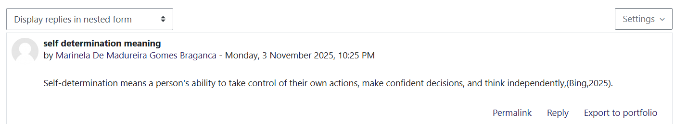

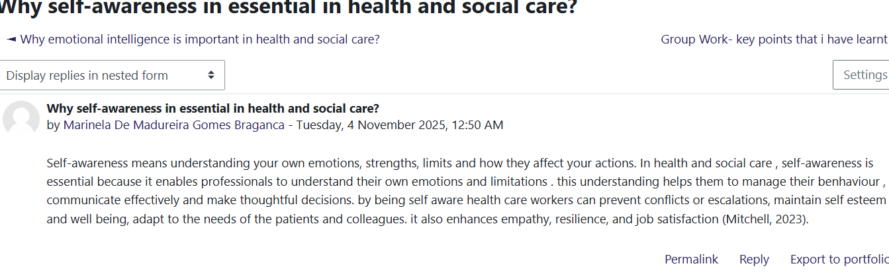I learned that in health and social care, self-awareness is crucial because it helps individuals understand their strengths, weaknesses, values, and emotions, which are essential for personal and professional development, as shown in Figure 2. Through self-awareness activities, I can understand my strengths, emotions, weaknesses, and limitations, and how they impact my work. According to Carden et al. (2022), in health and social understanding, one's own strengths, limitations, and emotions help professionals manage their behaviour, communicate effectively with others, and make sound decisions. I learn that Self-awareness further allows professionals to manage stress and provide care services with empathy. Self-awareness in the health and social care sector ensures proper care management, self-esteem, and makes professionals accountable for their actions (Younas et al. 2020). From the self-awareness activity, I learned that self-awareness helps with adaptation to patients and system requirements, and it improves resilience and job satisfaction. In the future, I will maintain a reflective journal to assess my performance and identify areas for improvement.

I learn that Emotional intelligence is essential for building trust and developing patient-centric care approaches (Sharp et al., 2020). I know that it is important for healthcare professionals to manage their own emotions. EI helps professionals behave appropriately and remain calm under pressure.
From this activity, I learnt that EI helps increase communication and teamwork between staff and patients. In health and social care, EI helps identify patients with high emotional distress who are unable to communicate, enabling early intervention and better emotional support (McNulty and Politis, 2023). Thus, emotional intelligence helps build better relationships in health and social care settings and improves the quality of care.

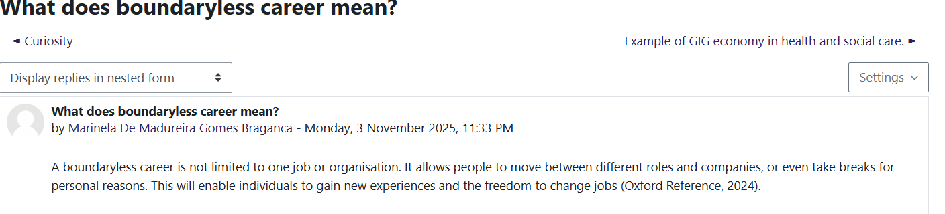
I learn that a boundaryless career is a career path that is not bound to a single organisation or profession. According to Figure 5, in a boundaryless career, an individual can switch roles, move to different companies, or take a break from work for personal reasons. In the current health and social care environment, professionals can move through various roles and organisations; this flexibility supports continuous learning and adaptability, as well as high problem-solving skills. A boundaryless career enables individuals to gain new experiences and provides them with the freedom to change jobs to achieve high job satisfaction (Mazzetti et al. 2024). This activity helps me understand that my career in health and social care may not follow a linear path, and that I may need to switch roles or organisations in the future for better job opportunities. My continuous learning, network building, and transferable skills can help me switch between roles and maintain high performance (Prommegger et al. 2021). This influences me to focus more on professional development through various courses and training programmes.

Unit 2: It’s a small world
In Unit 2, I learned about “it’s a small world,” “variety is the spice of life,” the network society, and making connections, which helped shape my understanding of networking and communication.
2.1 Networking meaning: In this online activity, I was asked to define networking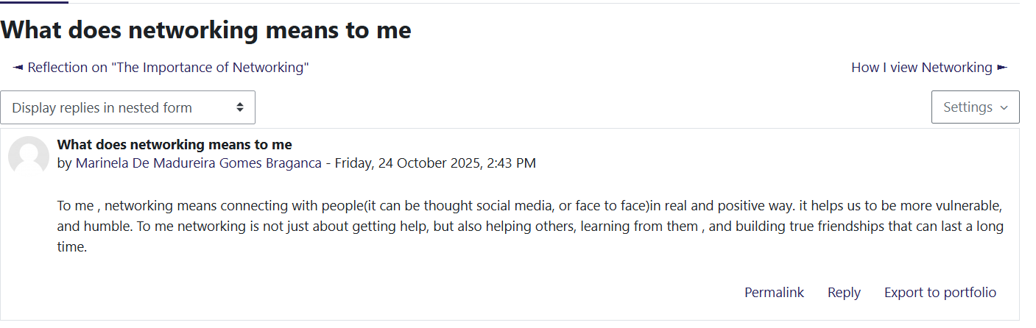
It’s a small world, and this unit helped see how connected we really are. In Unit 2, I learned that networking is “the action or process of interacting with others to exchange information and develop professional or social contacts”. (Hardy and Buckley, 2014).
It’s a small world, and Unit 2 helped me understand how important networking is in health and social care, because a network is crucial, as it influences patient care and makes patients more compassionate.
2.2 Why do you think that increasing networking in health and social care his important
Network in health and social care. In this online activity, I explain that networking helps professionals share ideas, experiences, and information to improve care quality. I also wrote that networking makes communications more personal and effective.
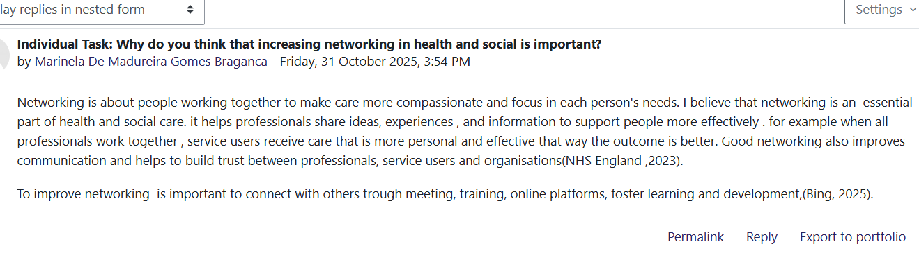From the activity I did on Moodle about the importance of increasing networking in health and social care, I found that a stronger network is significant, as a modern care system operates collaboratively. Increasing networking helps healthcare settings, as shown in the screenshot. Increasing networking within health and social care organisations helps build trust and effective communication among healthcare professionals, patients, and other staff (NHS, 2023). I also learn that to improve networking, it is essential to connect with others through meetings, trainings, and online platforms.
Before this unit, my online presence and my ability to connect with people were too weak. I realised that I only connected with family and a few friends, and I stayed in my comfort zone. I realised that if I want to grow, I need to communicate with people from different backgrounds, because avoiding interactions has stalled my personal and professional development.
During this unit, my understanding of global issues also grew. I saw that many people around the world struggle with inequality and limited access. In a network society, global inequalities arise because power, digital access, and economic conditions are unequal (World Health Organisation, 2025). Hofstede’s Cultural Dimensions is a theory that helps us understand how cultural values influence behaviour in organisations and society (Nickerson, 2025). Linking this theory helped me understand that self-awareness is essential because it enables me to understand not only others' cultures but also my own behaviours and values, as well as communication differences across cultures. For example, in health and social care, it can promote better decision-making and relationships with others (Care Learning, 2024). I also learned that communication has changed: before it was face-to-face, but now the web and social media make global networking easier and faster. Overall, this unit makes me realise that I need to adapt and step out of my comfort zone if I want to grow.

Unit 3: Opportunity knocks.

In Unit 3, I learned about creating your own luck, identifying career opportunities, and selling your skills to employers in health and social care.
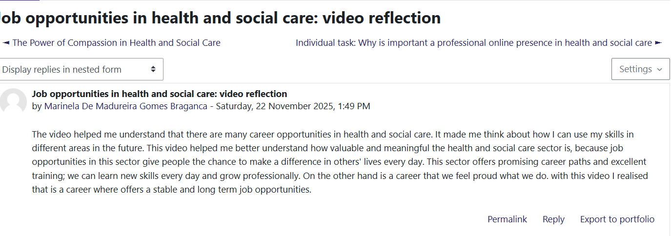
During this unit, I gained more knowledge on how to prepare for my career in health and social care. I identified my skills and strengths, the work values and work-life that are important to me when applying for a job and also learned how to create a clear CV and cover letter. I realised that a CV alone is not always enough because many opportunities depend on networking and recommendations. Opportunity knocks, and during this unit, I understood that when I do not act, I may miss significant chances to grow. For example, in the past, I refused to work in a solicitor's office because I felt insecure and stayed in my comfort zone.
Using Gibbs’ Reflective Cycle helped me reflect on this situation in a structured way. I described what happened, explored my emotions, evaluated the impact of my decision, analysed why I reacted this way, and planned how to respond differently by building confidence and taking opportunities when they appear. (McLeod, 2024)
I learned that updating my CV, using LinkedIn, and making connections can open new career doors in health and social care (NHS, 2025).
Serendipity mindset: In this activity, I was asked to research and explain what the serendipity mindset means. I explain that serendipity is about achieving good results from unexpected situations when people make positive, proactive choices. It is not just about luck but about noticing opportunities and linking ideas to create something useful.
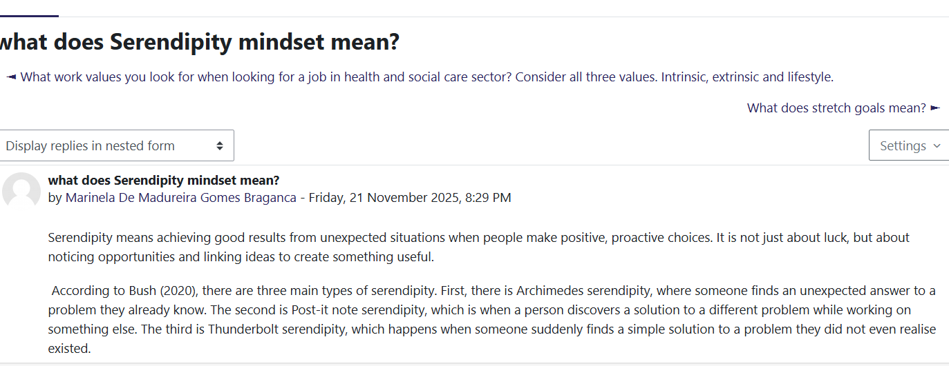
I also learned about the serendipity mindset, which is the ability to turn unplanned moments into positive opportunities or good luck (Shows, 2025).
I developed an understanding of how changing perspectives in health and social care is essential. I also discovered that websites and blogs help communication and professional identity. A blog is a regularly updated online page used to share knowledge and insight (Nardi et al., 2004). Finally, I learned that success is not only about luck, but also about effort, mindset, and how we communicate and treat others. During my online activity, I explored and understood the importance of blogging in health and social care. According to Powell (2023), changing perspectives helps health and social care professionals be adaptive and engage in continuous learning.

Unit 4: The pursuit of happiness
During this unit, I learned how to develop my skills, mindset, and confidence for my future career in health and social care. One topic that impacted me was limiting beliefs, which are thoughts that can unconsciously restrict actions and potential (Meadows, 2015). Through the lectures and online activities, I realised that sometimes I do not grow because I stay in my comfort zone or doubt my abilities, as shown in this online activity quiz.
Online reflection Quiz on limiting beliefs: this figure reflects an online activity quiz. After completing this quiz, help me recognise and reflect on my mindset and how long these limiting beliefs will continue to grow.
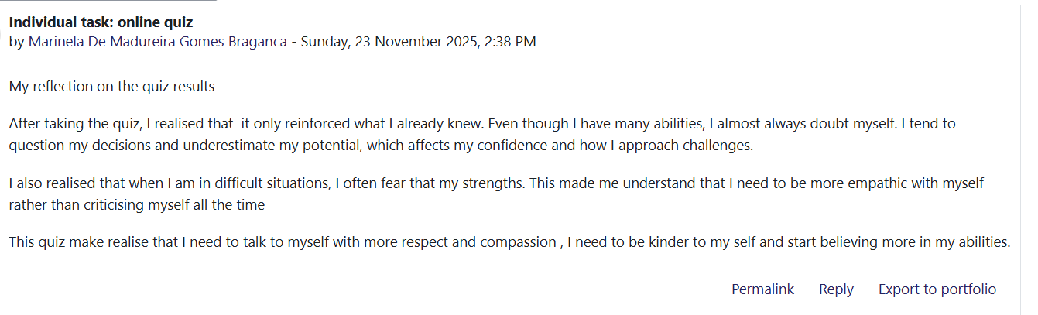 This learning helped me recognise when I am limiting myself and gave me strategies to challenge these beliefs. I also learned that limiting beliefs can negatively affect practice in health and social care by preventing professionals from learning new skills or speaking up (CareLearning, 2024).
I also learned about grit, which means perseverance and passion for long-term goals (Duckworth et al., 2007; Duckworth, 2016). This reminded me that success is not only about luck but also about consistent effort. Another meaningful learning was resilience. According to the Cambridge Dictionary (2019), resilience is the quality of returning quickly to a good condition after a problem. I now understand that we cannot be resilient without experiencing failures, because both are important for growth.

Impact of technological changes on health and social care
This screenshot shows an activity on the effects of technological change in health and social care. I had to explain how technology is improving services, such as digital records, but I also need to analyse the positive and negative aspects of it.
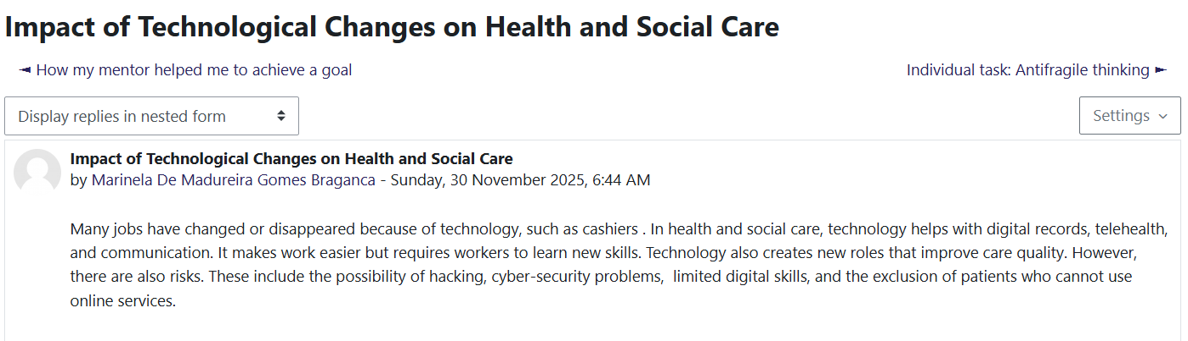

I learned that changing careers is part of building my personal brand because it shows growth, adaptability and willingness to learn new skills (Tensese, 2024). As shown in this figure, I also know that many jobs in health and social care are changing or have changed due to technological developments. According to Health (2025), technology is changing health and social care by improving the support delivered. For example, motion sensors and artificial intelligence reduce unnecessary hospital visits, thereby reducing pressure on staff. I learned about mentors and mentees, and I understand that it is essential for developing new skills. For example, in health and social care, a mentor is important because they help staff grow professionally and personally. A mentor guides a less experienced worker, builds confidence, and supports new skill development. (Care Learning,2024).I link this learning to Bandura's Social Learning Theory, which says that people learn by observing others and modelling behaviour (Pratt et al., 2010). During online activities, I could learn through observation, for example, by watching others explain their own thoughts.

Conclusion
In conclusion, this module has helped me develop a deeper understanding of myself, my goals, and the skills required to build a sustainable career. I now recognise the importance of motivation, autonomy, emotional intelligence, adaptability and continuous learning in shaping my personal brand. Exploring concepts such as boundaryless careers and the gig economy broadened my awareness of today’s job market and the need to remain flexible and confident. Through reflection, especially using the Johari Window, I gained clarity about my strengths and areas for improvement. Overall, I feel more prepared, self-aware and motivated to shape my future career with purpose.

References
usch, C., 2024. Towards a theory of serendipity: A systematic review and conceptualisation. Journal of Management Studies, 61(3), pp.1110–1151.
Cambridge Dictionary, 2023. Resilience. Available at: https://dictionary.cambridge.org/dictionary/english/resilience.
Care Learning, 2024. What is mentoring in health and social care? Available at: https://carelearning.org.uk/blog/mentoring.
Canteart, G.R., Pype, P., Valcke, M. and Lauwerier, E., 2022. Interprofessional identity in health and social care: analysis and synthesis of assumptions and conceptions in literature. International Journal of Environmental Research and Public Health, 19(22), p.14799.
Carden, J., Jones, R.J. and Passmore, J., 2022. Defining self-awareness in the context of adult development: A systematic literature review. Journal of Management Education, 46(1), pp.140–177.
Elmer, T., Mepham, K. and Stadtfeld, C., 2020. Students under lockdown: Comparisons of students’ social networks and mental health before and during COVID-19. PLOS One, 15(7), p.e0236337.
Goldman, J. and Wong, B.M., 2020. Nothing soft about ‘soft skills’: Core competencies in quality improvement and patient safety education and practice. BMJ Quality & Safety, 29(8), pp.619–622.
Guan, Y., Arthur, M.B., Khapova, S.N., Hall, R.J. and Lord, R.G., 2019. Career boundarylessness and career success: A review, integration and guide to future research. Journal of Vocational Behavior, 110, pp.390–402.
Jurevicius, O., 2023. The Johari Window Model: All You Need to Know. Strategic Management Insight. Available at: https://strategicmanagementinsight.com/tools/johari-window/
McNulty, J.P. and Politis, Y., 2023. Empathy, emotional intelligence, and interprofessional skills in healthcare education. Journal of Medical Imaging and Radiation Sciences, 54(2).
NHS UK, 2023. Developing your NHS staff network. Available at: https://www.england.nhs.uk/long-read/developing-your-nhs-staff-network/
NHS UK, 2025. Integrated care. Available at: https://www.hee.nhs.uk/our-work/integrated-care
Nickerson, C., 2025. Hofstede’s cultural dimensions theory & examples. Simply Psychology. Available at: https://www.simplypsychology.org/hofstede
Powell, J., 2023. New Perspectives on Health and Social Care. Springer Nature.
Pratt, T.C., Cullen, F.T., Sellers, C.S., Winfree Jr, L.T., Madensen, T.D., Daigle, L.E., Fearn, N.E. and Gau, J.M., 2010. The empirical status of social learning theory: A meta-analysis. Justice Quarterly, 27(6), pp.765–802.
Rachmad, Y.E., Al, R., Mountain, K. and Nashr, K., 2023. Personal Branding Theory. ResearchGate. Available at: https://researchgate.net/profile
Shows, R., 2025. Research shows a serendipity mindset could aid entrepreneurial success. USC Marshall Business School. Available at: https://www.marshall.usc.edu/posts/serendipity

World Health Organisation, 2022. Mental health. Available at: https://www.who.int/news-room/fact-sheets/detail/mental-health.
World Health Organisation, 2025. Social determinants of health. Available at: https://www.who.int/health-topics/social-determinants.
Zhao, Y., Niu, G., Hou, H., Zeng, G., Xu, L., Peng, K. and Yu, F., 2018. From Growth Mindset to Grit in Chinese Schools. Frontiers in Psychology, 9. doi: https://doi.org/10.3389/fpsyg.2018.02007

