
Portfolio 4 components
Module title: Foreign Languages & Cultural Awareness
Module code: BMIH5003
Lecturers: Giulia Chifari, Antoinette Milne
Name: Amirul Islam
Student ID: 2234363

Table of Contents
Component 1 - Professional Reflection 3
Component 2 - Training Plan 4
Component 3 - Student Self-Reflection 7
Component 4 - Training Presentation: Hyatt Hotels 9
References: 14

Component 1 - Professional Reflection
During breakfast at a crowded hotel restaurant, I encountered a cultural misunderstanding, which highlighted the significance of having strong communication skills and being culturally sensitive in the hospitality industry. A supporter moved toward me and mentioned a top off of an apparently unadorned refreshment. The sequence of events that would follow began at this point. The client spoke Mandarin almost exclusively. However, due to the language barrier, I interpreted their actions as a kind of rejection, which caused the guest to feel confused and a little irritated. In the hotel industry, misunderstandings are frequently caused by disparities in cultural, linguistic, and communicative practices. These factors may cause discomfort or dissatisfaction among visitors. (Nakata & Sivakumar, 2020) Misunderstandings of fundamental assertions, expressions, and actions could be the cause of this. Due of my deficient capability in Mandarin and the visitor's low order of English, a miscommunication happened. Another factor that contributed to the encounter's increased complexity was the clear cultural norms regarding indirectness and the use of nonverbal cues. After careful consideration, it is evident that I must improve my communication skills and cultural sensitivity in order to effectively manage various guest interactions. To overcome communication barriers and ensure good comprehension among workers and tourists, it is essential to improve one's linguistic proficiency (Lee & Liu, 2019). I am able to provide exceptional focus on the needs and preferences of your guests because I am adept at actively listening to them, regardless of any language barriers they may have. Because of my broad information on a few societies, I'm ready to show appreciation and deference for different method for correspondence, customs, and social conventions. Thusly, this cultivates a friendly feel for guests and diminishes the likelihood of distortion. Subsequent to distinguishing regions for, not set in stone to effectively look for chances that would assist me with improving my expert development. According to Wang & Noe (2019), taking part in language classes or workshops could help me become more proficient in Mandarin and other languages that hotel guests frequently use. To guarantee a thorough handle of different correspondence circumstances, my essential goal will be to utilize undivided attention abilities, including summarizing and looking for explanation when fundamental. Moreover, I seek to upgrade my social mindfulness through dynamic commitment to submersion occasions and obtaining preparing in social ability. I would be able to confidently navigate the complexities of numerous languages and cultures thanks to this. Scholarly information unequivocally upholds the utilization of social correspondence hypotheses as accommodating devices for recognizing and settling social false impressions in the neighbourliness business. This support has been significant. By providing useful insights into the impact of cultural differences on communication styles and behaviours, Hofstede's cultural dimensions theory has significantly influenced the development of successful intercultural communication strategies. According to Taras & Steel's (2019) face negotiation theory, during intercultural communication, people from different cultural backgrounds employ distinct conflict resolution and face-saving strategies. Eventually, the social confusion that happened during the morning meal administration featured the pivotal meaning of having magnificent relational abilities and social responsiveness in the cordiality area. I will focus on improving language proficiency, active listening, and cultural sensitivity to achieve my goal of increasing visitor satisfaction and strengthening cross-cultural ties.

Component 2 - Training Plan
This training session aims to give hotel employees the skills and knowledge they need to overcome challenges in cultural communication. In today's diverse world, language proficiency, cultural sensitivity, and effective communication skills are essential for providing visitors with exceptional experiences and fostering positive cross-cultural interactions.
Identification of Key Areas for Improvement
Language Skills
Enhancing one's ability to communicate and comprehend clearly in important languages that hotel guests use, like Mandarin, Spanish, or French. This includes being able to say common phrases and using language that is appropriate for hospitality settings (Jackson, 2019).
Cultural Awareness
Creating attention to social contrasts in correspondence styles, customs, and manners to delicately explore different visitor collaborations. This envelops grasping social aspects, perceiving non-verbal signs, and adjusting correspondence methodologies as needs be (Liu and Zhang, 2020).
Communication Techniques
Improving one's capacity for active listening, paraphrasing, and nonverbal communication in order to guarantee accurate comprehension and efficient communication across a variety of cultural contexts. This includes improving sympathy, posing explaining inquiries, and utilizing fitting tone and non-verbal communication ((Rijamampianina, 2021zzzzzzzzzzzzzzzzzzzzzzzzzzzzzzzzzzzzzzzzzzzzzzz

Outline of Training Modules
Language Workshops
Objective: Improve language proficiency in key languages relevant to the hotel's guest demographics.
- Basic language lessons focusing on essential phrases and vocabulary related to hospitality (Liu & Zhang, 2020).
- Role-playing exercises simulating common guest interactions to practice language skills in context.
- Language immersion activities, such as watching films or listening to music in the target language, to enhance language acquisition.
Cultural Sensitivity Training
Objective: Cultivate awareness and understanding of cultural differences to foster inclusive and respectful guest interactions.
- Introduction to cultural dimensions theory (e.g., Hofstede's cultural dimensions) to understand how cultural values influence communication behaviors.
- Case studies and real-life scenarios highlighting cultural misunderstandings and their impact on guest satisfaction (Salas-Vallina & Fernández-Martínez, 2019).
- Cross-cultural communication strategies, including adapting communication styles and understanding cultural nuances.
Role-Playing Exercises
Objective: Provide practical opportunities for staff to apply language skills, cultural awareness, and communication techniques in simulated guest interactions.
- Role-playing scenarios representing diverse cultural contexts, such as greeting guests from different cultural backgrounds or handling guest requests.
- Feedback sessions facilitated by trainers or peers to identify strengths and areas for improvement in intercultural communication skills (Le & Gardner, 2020).
- Reflection exercises to encourage self-awareness and continuous learning from role-playing experiences.

Incorporation of Interactive and Practical Elements
Interactive Language Workshops
- Engage participants through interactive activities, games, and group discussions to reinforce language learning and make the training sessions dynamic and engaging.
- Incorporate technology such as language learning apps or online resources for interactive practice outside of workshops (Williams & Levett-Jones, 2019).
Real-Life Scenarios
- Integrate real-life examples and case studies from the hotel industry to contextualize training content and illustrate the relevance of intercultural communication skills in guest interactions.
- Conduct on-site visits to observe guest interactions firsthand and apply learned concepts in practical situations (Rijamampianina, 2021).
Role-Playing Exercises
- Provide opportunities for hands-on practice in a safe and supportive environment, allowing participants to apply newly acquired skills and receive constructive feedback from trainers and peers.
- Utilize role-playing scenarios with varying levels of complexity to simulate diverse guest interactions and cultural contexts (Rijamampianina, 2021).
- Encourage active participation and reflection to enhance learning outcomes.

Component 3 - Student Self-Reflection
Stage of Reflection | Description
Description | Initially, my understanding of cultural awareness was limited to basic knowledge of different cultures' customs and traditions. I recognized the importance of politeness and sensitivity but lacked deeper insight.
Feelings | I felt confident in my ability to interact with individuals from diverse backgrounds, but I underestimated the complexities of cultural communication (Deresky, 2017).
Evaluation | Through experiences such as the scenario in the hotel restaurant, I realized the depth of cultural nuances that impact guest interactions. This challenged my assumptions and prompted a re-evaluation of my approach.
Analysis | As I engaged in cultural sensitivity training and reflected on real-life scenarios, I began to grasp the significance of cultural dimensions in communication styles (Hampden-Turner & Trompenaars, 2020). I learned that effective communication goes beyond language proficiency to include understanding non-verbal cues, social norms, and values.
Conclusion | My journey led to key learnings about the importance of cultural awareness in the hospitality industry. It is not merely about avoiding misunderstandings but about fostering genuine connections with guests and creating inclusive environments.
Action Plan | Moving forward, I am committed to continuous learning and improvement. I will actively seek opportunities to deepen my cultural knowledge, engage in cross-cultural interactions, and apply cultural competence in all aspects of my work (Nedelko & Brzozowski, 2020).

SMART Goals | Specific | Measurable | Achievable | Relevant | Time-bound
Language Proficiency | Enhance proficiency in Mandarin to effectively communicate with Chinese-speaking guests. | Achieve a conversational level of fluency in Mandarin within six months. | Dedicate 30 minutes daily to language practice through online courses and language apps. | Relevant to improving guest satisfaction and fostering positive interactions in a Mandarin-speaking market. | Complete Mandarin proficiency assessment in six months to measure progress.
Cultural Sensitivity | Develop a deeper understanding of cultural nuances to better serve guests from diverse backgrounds. | Attend cultural sensitivity training workshops and complete assigned readings on cultural dimensions theory. | Attend at least one cultural sensitivity training workshop per quarter and dedicate 1 hour weekly to self-study on cultural dimensions. | Relevant to providing inclusive and respectful guest experiences in a multicultural environment. | Complete all assigned readings and workshops within the next six months.
Communication Skills | Improve active listening and non-verbal communication skills to enhance understanding and rapport with guests. | Increase active listening and non-verbal communication effectiveness by 20% within three months. | Practice active listening techniques during daily guest interactions and seek feedback from colleagues. Enroll in a communication skills workshop to learn effective non-verbal communication strategies. | Relevant to delivering personalized and attentive service to guests and building rapport. | Conduct a self-assessment of communication skills progress every month for three months.
Cross-Cultural Interaction | Engage in cross-cultural interactions to broaden perspectives and adapt communication styles accordingly. | Initiate conversations with guests from different cultural backgrounds during daily interactions. | Set a goal to engage in at least two meaningful cross-cultural conversations per week. Actively seek opportunities to interact with guests from diverse backgrounds during hotel events or activities. | Relevant to fostering cultural understanding and building connections with guests from diverse backgrounds. | Reflect on cross-cultural interactions and lessons learned every week.

Component 4 - Training Presentation: Hyatt Hotels

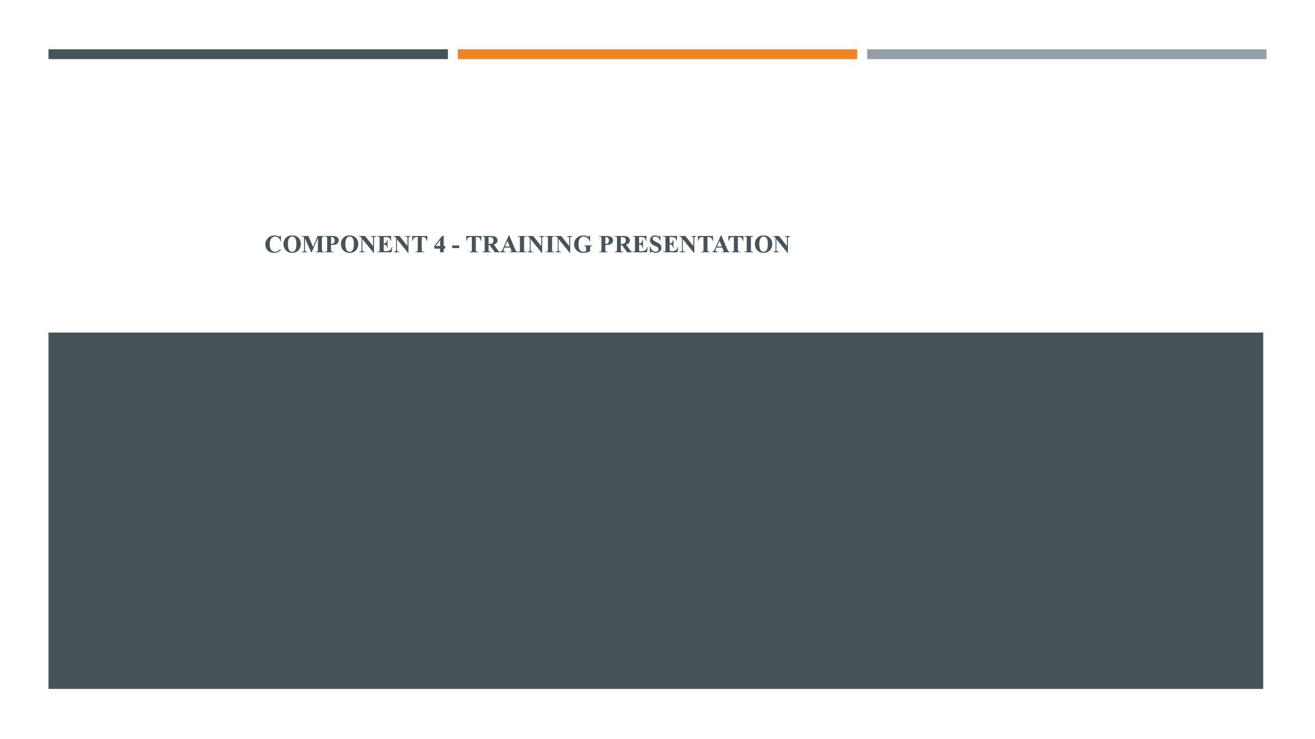
Slide 1: Importance of Language Skills in Hospitality.
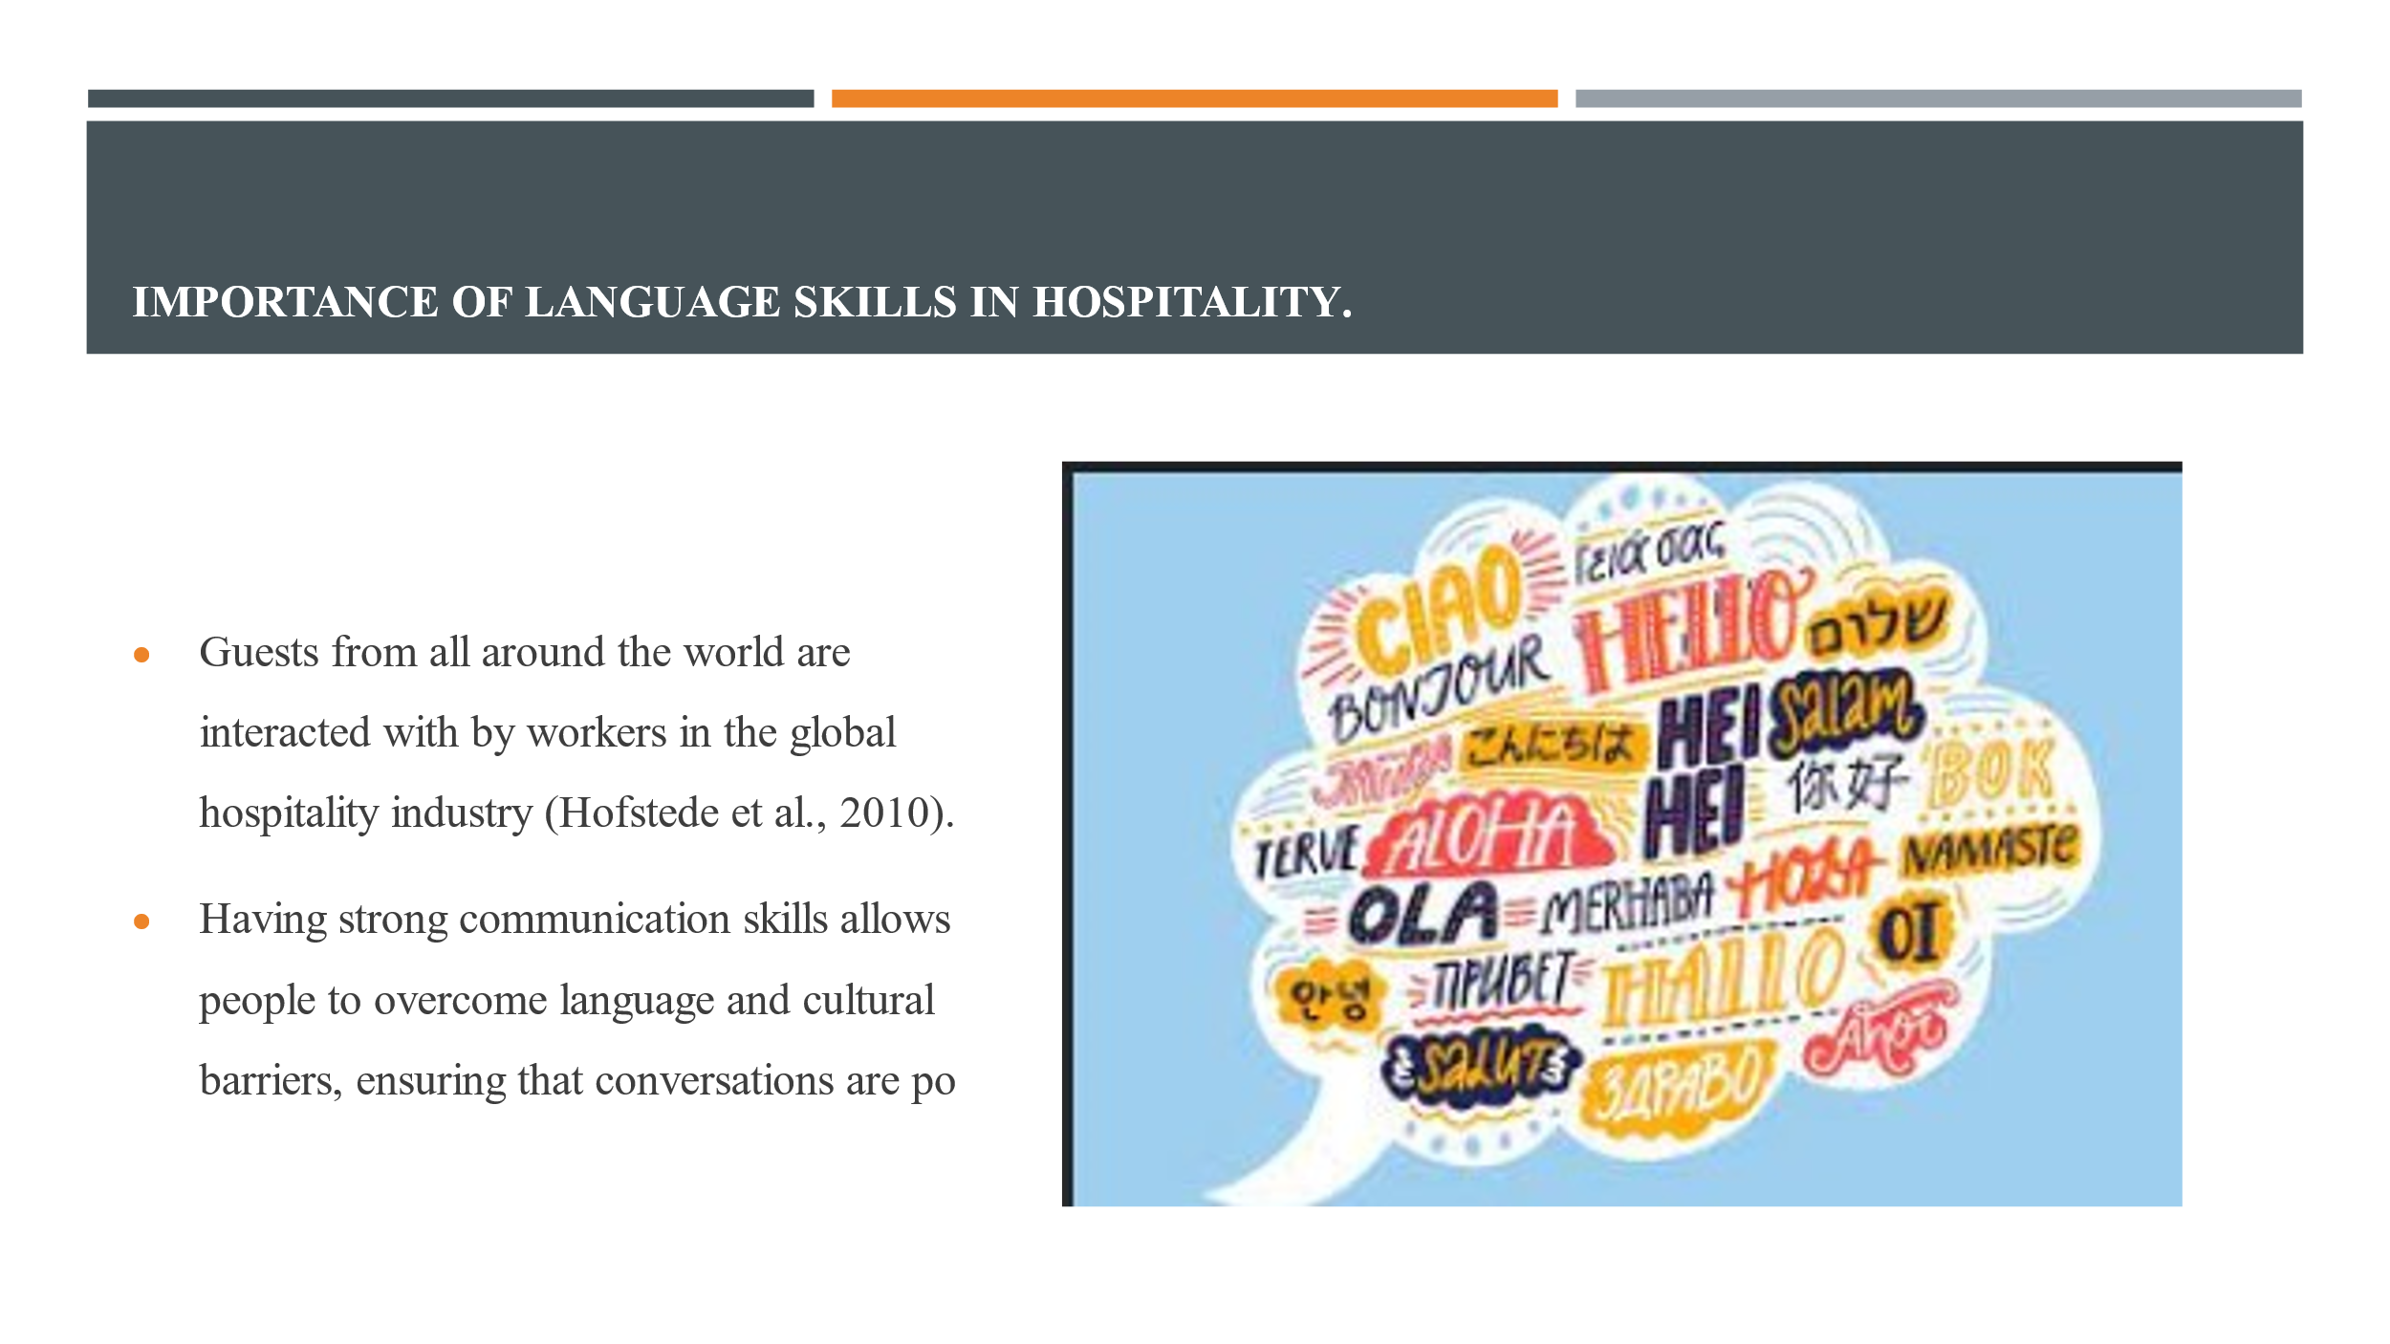
Slide 2: Importance of Multilingualism in Hospitality
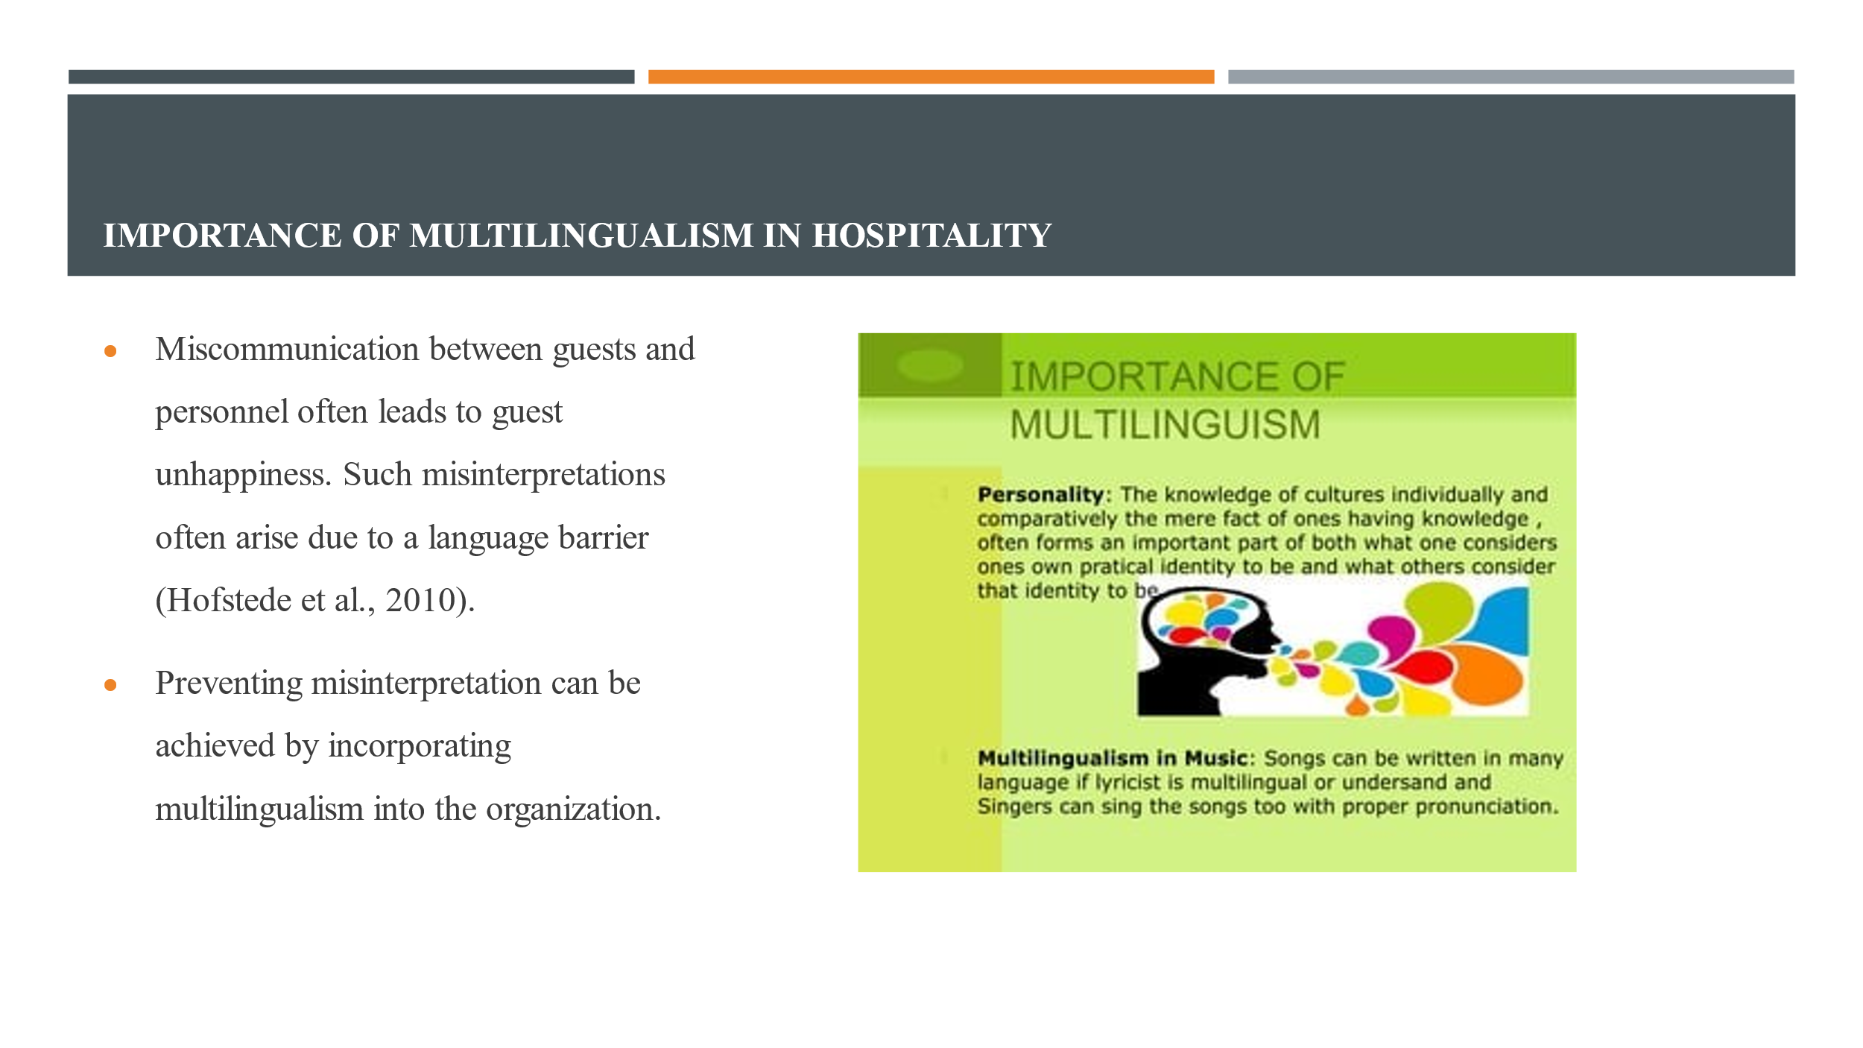
People who can speak multiple languages can process information at a faster and more efficient rate. Payment for speaking a second language is often received. One should keep in mind that speaking a language in high demand could potentially lead to an increase in salary.

Slide 3: Spanish
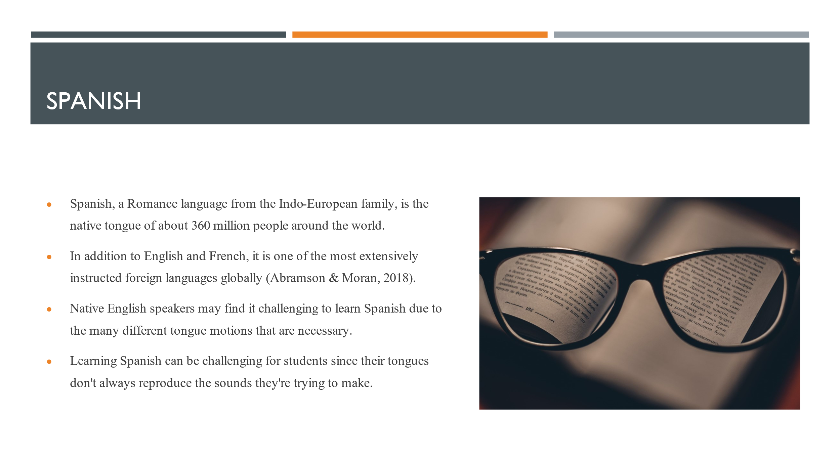
Due to its numerous striking resemblances with several other languages, Spanish is often considered one of the most accessible languages to learn, regardless of one's native tongue. Despite persistent issues with Spanish, the way these problems appear may vary for individuals who are native speakers of other languages. Acquiring proficiency in Spanish is a worthwhile endeavor that will yield benefits for anyone employed in the hotel sector.

Slide 4: Politeness in Business Context
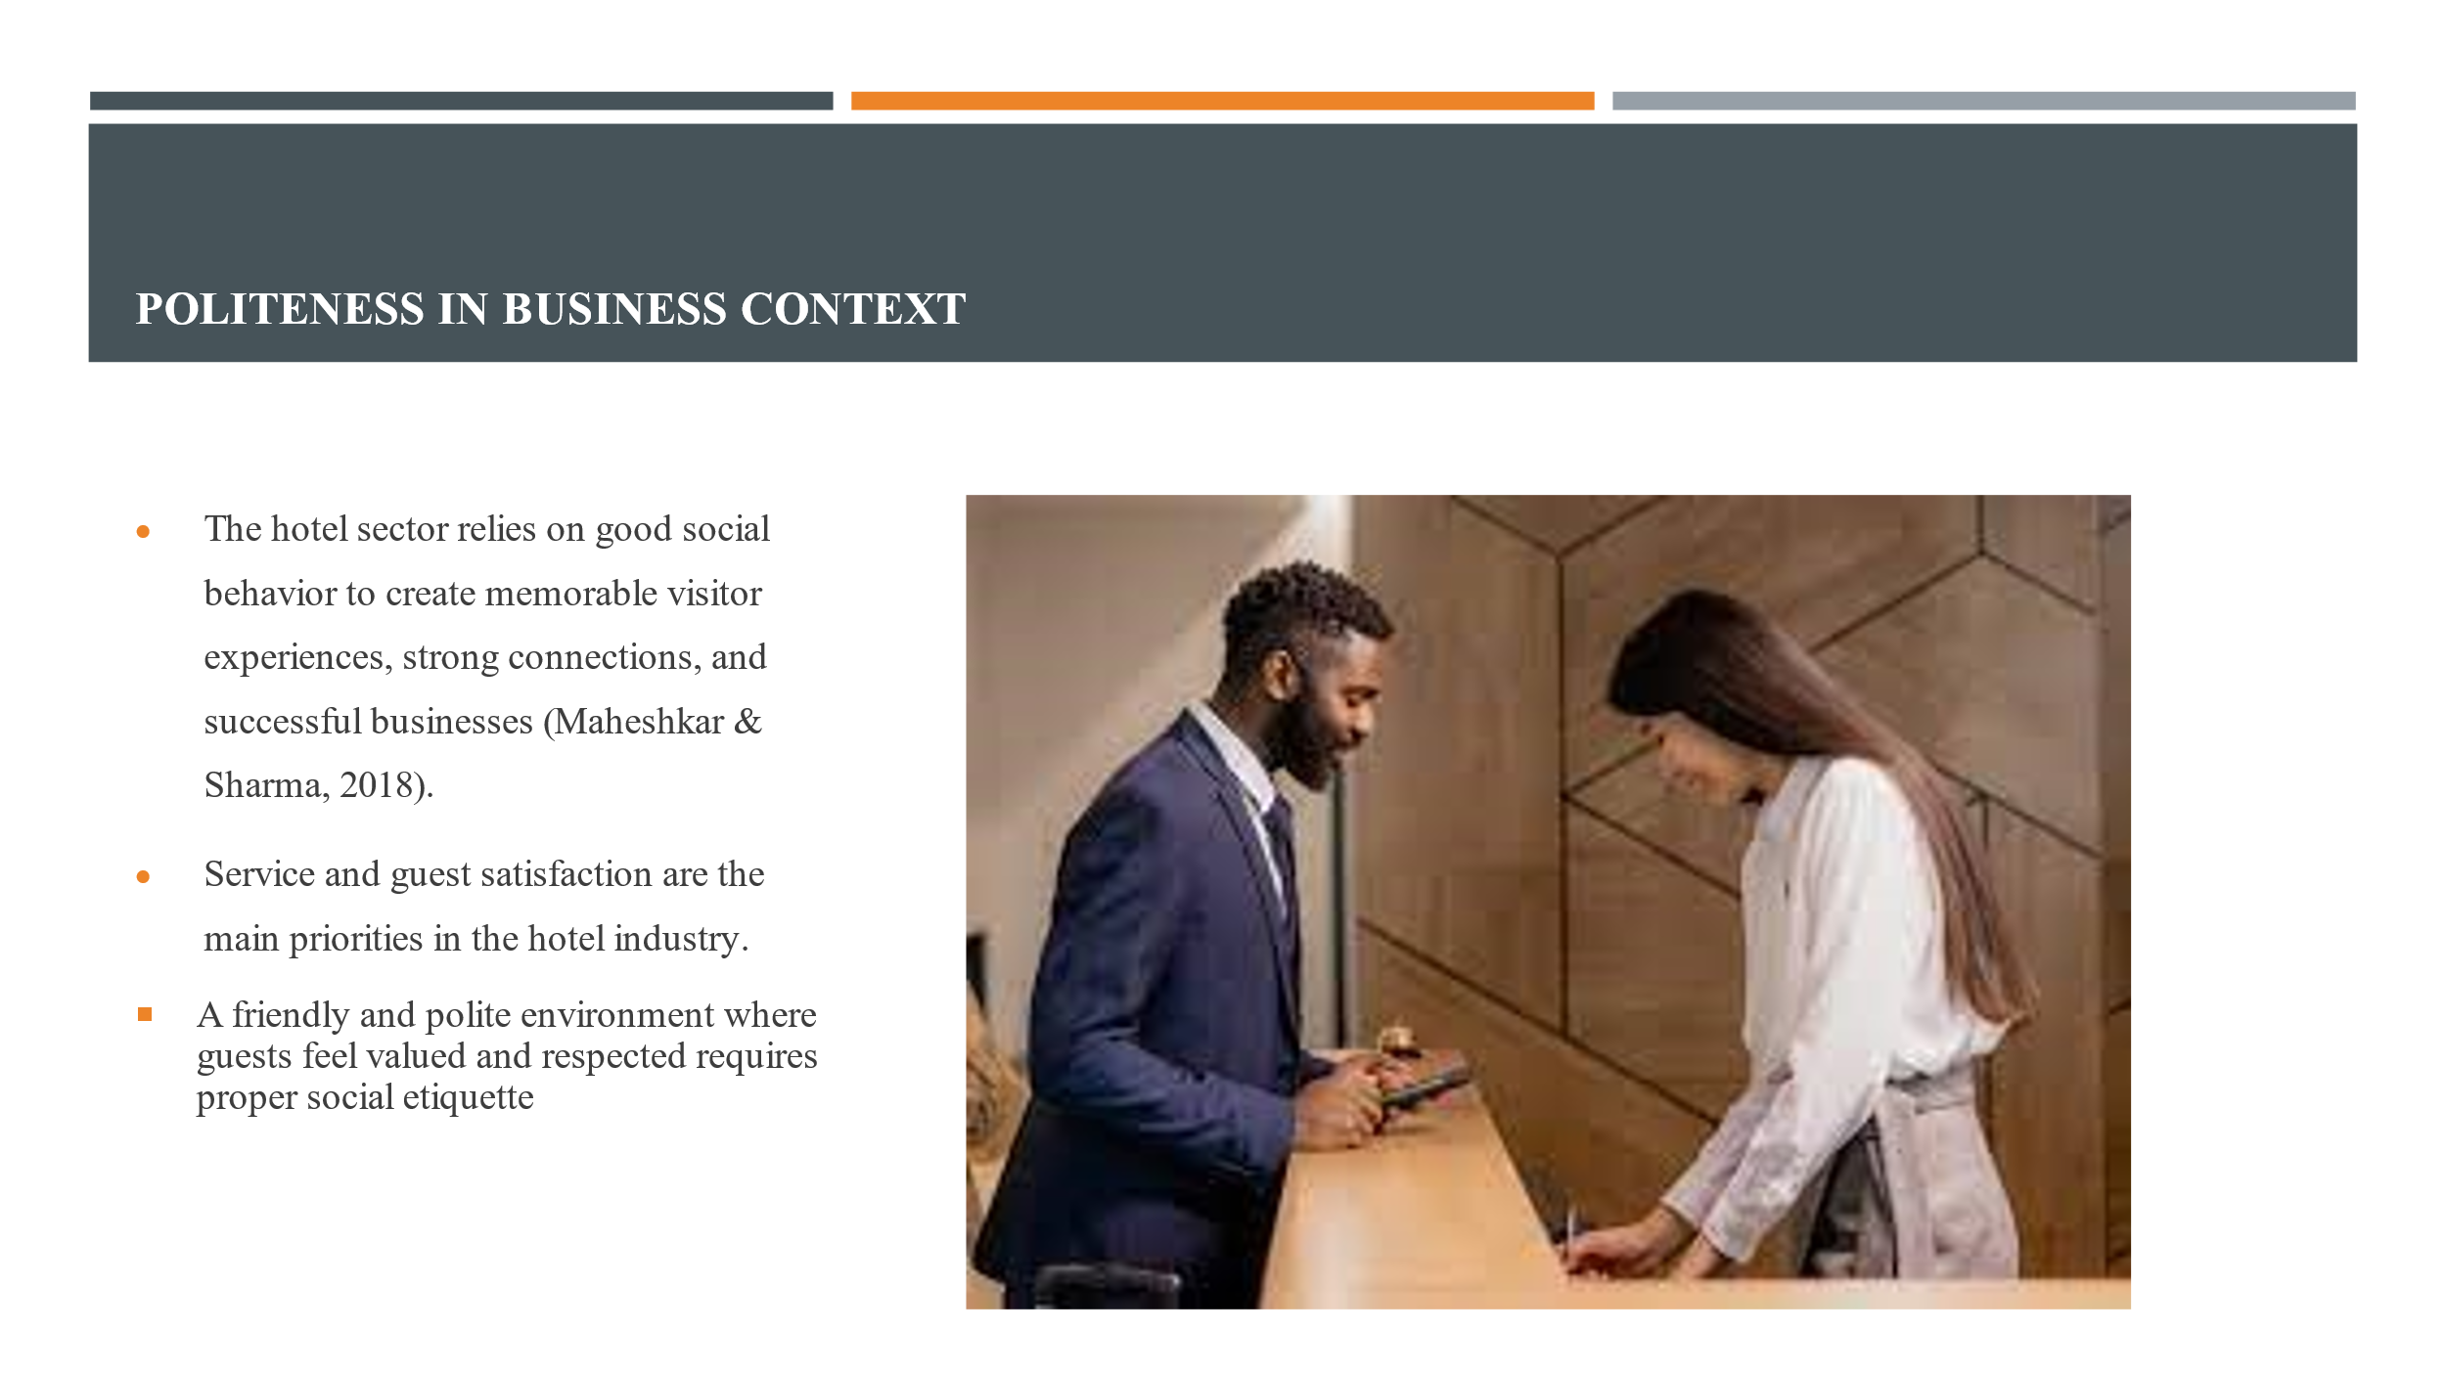
In today's era of online reviews and social media, employees' actions can affect a hospitality company's reputation. Good manners can help you prevent PR problems. Respectful and compassionate employees develop long-term connections with customers, which boosts loyalty and repeat business. Respecting social conventions and cultural differences helps guests feel at home. Cultural ignorance can cause miscommunication and discomfort. Hotel staff training emphasizes social graces.

Slide 5: Benefits of Language Skills
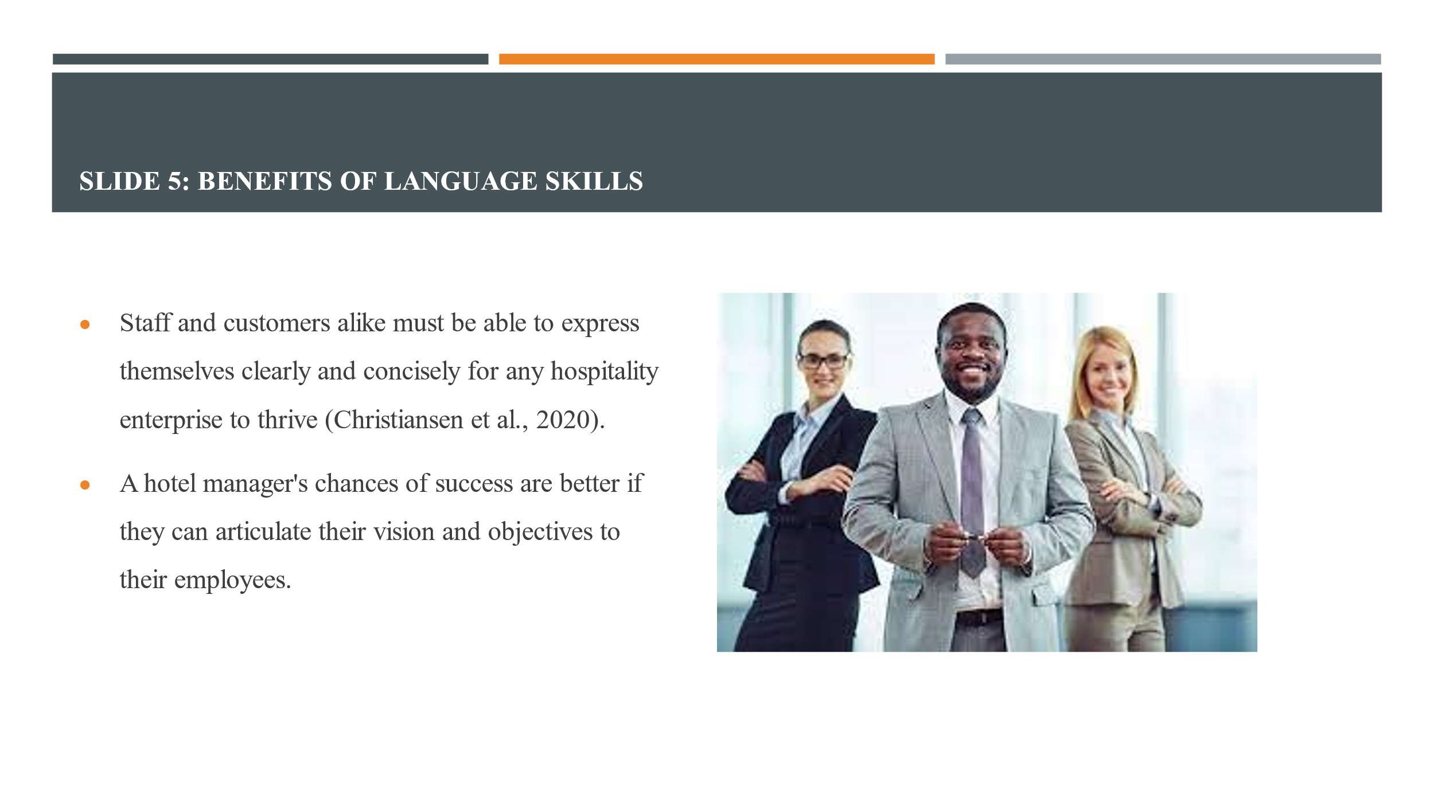
The efficacy of every hospitality enterprise relies on the concise and accurate communication skills of its staff and guests. The probability of success for hotel management is greater if they possess the ability to effectively communicate their aims and vision to their personnel. Businesses in the tourism sector frequently handle intangible commodities and services that involve individuals. Conversely, a deficiency in foreign language skills can diminish the worth of these attractions by impeding communication between staff and customers, resulting in reduced efficiency.
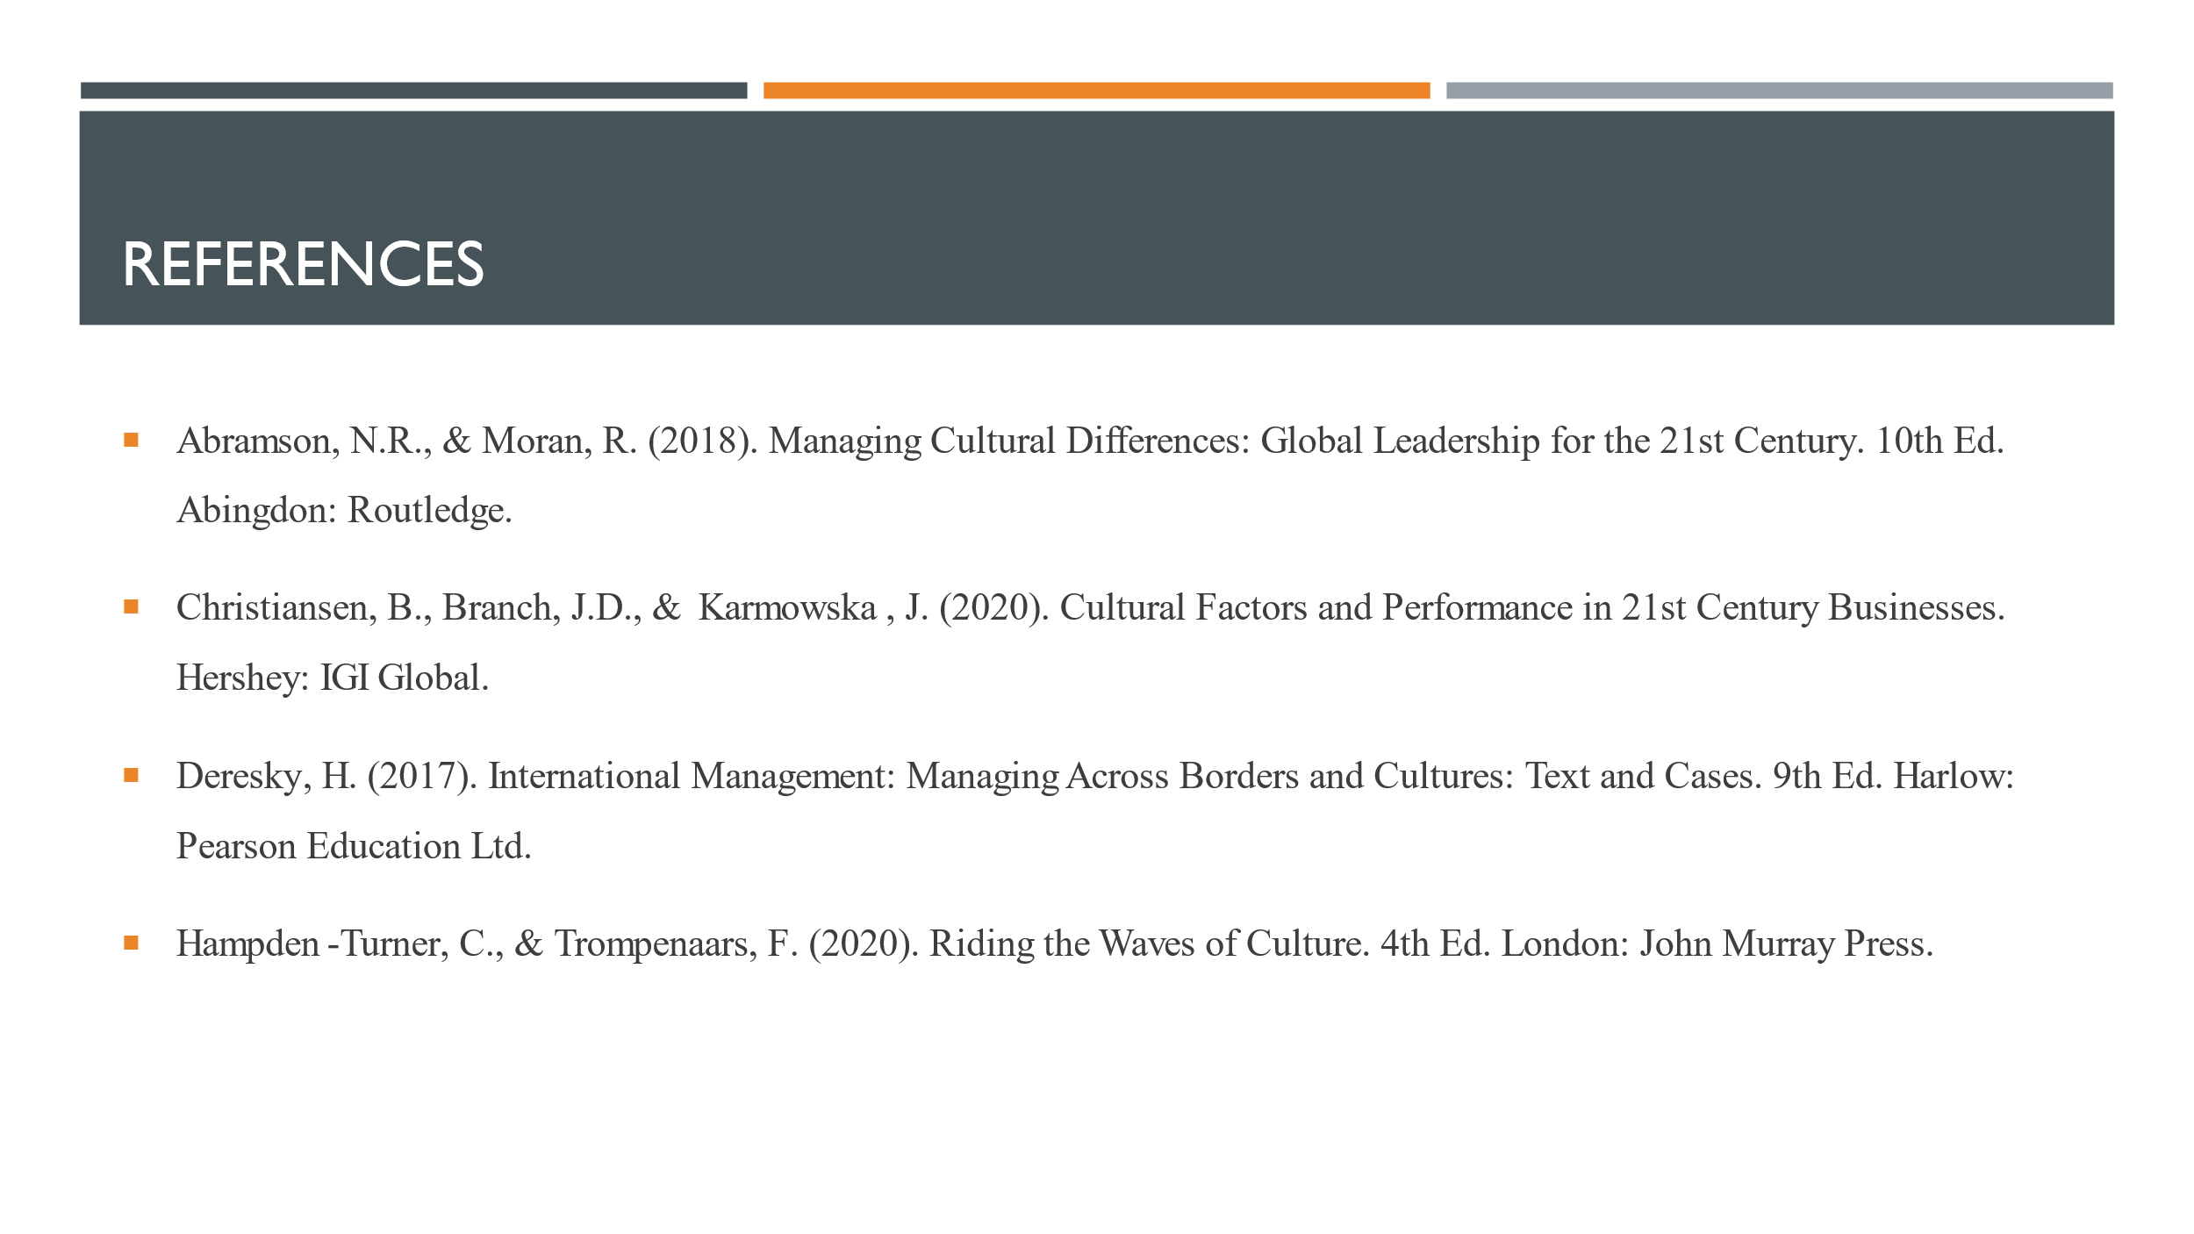

References:
Abramson, N.R., & Moran, R. (2018). Managing Cultural Differences: Global Leadership for the 21st Century. 10th Ed. Abingdon: Routledge.
Christiansen, B., Branch, J.D., & Karmowska, J. (2020). Cultural Factors and Performance in 21st Century Businesses. Hershey: IGI Global.
Deresky, H. (2017). International Management: Managing Across Borders and Cultures: Text and Cases. 9th Ed. Harlow: Pearson Education Ltd.
Hampden-Turner, C., & Trompenaars, F. (2020). Riding the Waves of Culture. 4th Ed. London: John Murray Press.
Hofstede, G., Hofstede, G.J., & Minkov, M. (2010). Cultures and Organizations: Software of the Mind. 3rd Ed. New York: McGraw-Hill.
Jackson, T. (2019). Cultural Intelligence: Surviving and Thriving in the Global Village. New York: Routledge.
Le, T., & Gardner, W. L. (2020). Culturally Intelligent Leadership: A Review and Future Research Agenda. Journal of International Business Studies, 51(5), 761-784.
Lee, A. J. Y., & Liu, Y. (2019). The Effect of Cultural Intelligence on Expatriate Adjustment and Job Performance: The Moderating Role of Host National Relations. Journal of Global Mobility, 7(1), 21-38.
Liu, Y., & Zhang, H. (2020). The Impact of Cultural Intelligence on Cross-Cultural Adjustment and Job Performance: A Moderated Mediation Model. International Journal of Intercultural Relations, 78, 132-142.
Maheshkar, C., & Sharma, V. (2018). Handbook of Research on Cross-Cultural Business Education. Hershey: IGI Global.
Nakata, C., & Sivakumar, K. (2020). The Impact of Cultural Intelligence on Marketing Effectiveness: Evidence from Multinational Companies. Journal of International Marketing, 28(2), 75-94.
Nedelko, Z., & Brzozowski, M. (Eds.). (2020). 'Recent advances in the roles of cultural and personal values in organizational behavior' in Ordóñez de Pablo, P. Advances in Human Resources Management and Organizational Development Book Series. Hershey: IGI Global.
Rijamampianina, R. (2021). The Role of Cultural Intelligence in Hotel Management: A Case Study Approach. Journal of Hospitality & Tourism Research, 45(1), 125-142.
Salas-Vallina, A., & Fernández-Martínez, E. (2019). The Influence of Cultural Intelligence on Expatriate Job Performance: The Mediating Role of Cross-Cultural Adjustment. International Journal of Intercultural Relations, 73, 41-50.
Taras, V., & Steel, P. (2019). How to Operationalize Hofstede's Cultural Dimensions: A Consolidated Review of Current Practices. Journal of International Business Studies, 50(9), 1544-1571.
Wang, S., & Noe, R. A. (2019). Knowledge Sharing: A Review and Directions for Future Research. Human Resource Management Review, 29(4), 370-383.
Williams, D. M., & Levett-Jones, T. (2019). Cultural Competence: A Concept Analysis. Nursing & Health Sciences, 21(4), 482-487.

