
Skills for the Workplace
Module Assignment Submission
Student Name: | Martine Kennedy
Student Number: | 2010990
Module No: | BMSK4008
Module Title: | Academic and Research Skills

Statement of Confirmation of Authenticity
By the act of making this submission, the student declares that this is the work of the student named above. The work has not, in whole or in part, been knowingly presented elsewhere for assessment, or where assessment has been built on a previous assessment, this has been identified. Where materials have been used from other sources it has been properly acknowledged. If this statement is untrue, the student acknowledges that an assessment offence has been committed.
Attention is drawn to the plagiarism and unfair practice policies of both the University and of ILM.
Permission for ILM to use this script
ILM uses learners’ submissions – on an anonymous basis – for assessment standardisation. By submitting, both the centre and the learner agree that ILM may use this script on condition that identifying information is removed. However, if you are unwilling to allow ILM use this script, please refuse by ticking the box:
Table of Contents
Managing Remotely: Is it the Way Forward? 3
Part 1 Error! Bookmark not defined.
1.1 Introduction 3
1.2 Research 7
1.3 Findings 7
1.4 Conclusion 7
Part 2 Error! Bookmark not defined.
Personal Reflection on Managing Remotely Error! Bookmark not defined.
2.1 Description 8
2.2 Feelings 9
2.3 Evaluation 9
2.4 Analysis 9
2.5 Conclusion 10
References 11
Appendix 1 Error! Bookmark not defined.
Appendix 2 26

Managing Remotely: Is it the Way Forward?

Introduction

For this assignment, the student was tasked to research aspects of managing remotely. Many businesses have introduced remote working over the years’ however we have seen a significant rise since the coronavirus pandemic. Once society is back to normal this may be the modern way to conduct business.

Demonstrate your awareness of the academic and research skills required for your learning journey by producing a referenced, structured report.
According to the National Career Service (2020) “Around 8 million people in the UK are now working from home. Businesses have furloughed a large number of their employees in sectors like:
- accommodation and food services
- tourism and leisure
- construction
- creative arts
- non-food retail
There is a growing demand for people to work in sectors like IT, logistics and food sales.
Employers are also looking for workers with good digital skills. You are more likely to bounce back from any setbacks in the labour market if you have transferable skills.”
The author identifies that the UK do not currently have specific laws around homeworking. Owen (2020) advises, “Spain has drafted legislation to ensure remote workers have equal working conditions and career development opportunities, while last week Germany proposed a Mobile Work Act, giving employees a legal right to work from home wherever possible.
The Republic of Ireland is also updating its guidance for people working remotely, and France has had laws regulating home working hours since 2017.
The UK has yet to follow suit, however, in bringing forward bespoke legislation to protect home workers. But some would argue the current situation makes this more urgent and more likely.”
The student feels the implementation of such laws should be introduced, as in their opinion remote working will become the modern way of operating businesses. It is therefore important to have such measure in place to protect both the employer and employee.
A study by Aspen Publishers (2019) suggests, “Here are eight things the best managers do to successfully lead remote teams:
1. They keep in touch. Great managers connect with their people by email, Skype, or phone conversations. This isn't an occasional event either; it's a regular and predictable conversation that they look forward to.
2. They focus on more than tasks. The best managers know they need to show that they worry about everyone's successes and challenges. It's not only about the project or job at hand.
3. They talk about personal stuff and professional stuff. Being remote doesn't mean treating people like distant relatives. Good managers master the art of chatting and take time to discuss and share information about what's going on.
4. They even talk about themselves a little. They know that managing well is personal, and they don't forget this just because their team member isn't in the room with them that day.
5. They listen more carefully. The greatest managers listen more when they are talking with people who aren't in the room with them. They are more attentive, more alert for signs and clues, and more conscious of the need to understand what is really going on.
6. They get really clear about what they need done. They know the goals their employee needs to achieve and what standards need to be met. They know it's harder to course correct along the way when everyone is remote and that less time together requires more clarity up front.
7. They ask more questions too. Great managers ask questions about context, about things that get in the way, about local relationships, and about resources. They make fewer assumptions that they know how things are or what would be best, so they inquire more and assume less.
8. They do more coaching. They do so not because remote employees need more coaching than other team members, but because there is a ton of value in exploring alternatives and options, and that's what coaching is. As a result, a large part of the conversation is the manager and the remote worker together coming up with great solutions given the environment the employee is working in-talking about priorities, and resources, and opportunities, and possible pitfalls, and choices.”
Quiros E (2012) confirms his theory as “Let me share some of my favourite must-do items for any remote leader.
1. Energize your team with a vision. To win as a team and as an organization, it's critical to involve your remote group in the creation and deployment of a common vision. Ask yourself what your most important breakthrough will be and set this as the direction that propels your people and your action plan. If it isn't possible to do this face to face, take time to have a brainstorming forum, group chats, and calls with video where you come to a clear, meaningful statement of the accomplishment your team will be known for.
2. Engage them with a robust action plan. This is probably one of the most critical aspects of remote leadership. Each team member needs to feel engaged and have a clear understanding about what will be requested from them or their teams, how it will be measured, and when you will expect it. To do this well is to set a solid foundation and clear the way for what will come. Draft an action plan with a clear link to your vision and engage each team member individually with the objectives assigned to them. Align on the way updates will be presented and on key milestones. Give examples of the way you like updates to be presented and the data you expect to see in them.
3. Be in touch with your team. You need to be disciplined about having periodic touchpoints in order to stay connected. Watch out for overly independent employees who think they don't need direction and allow the distance to grow. It's important to align priorities, review action-plan progress, and talk about career development. It also doesn't hurt to build a personal relationship that fosters trust and open communication. Though there are various constraints, mostly financial, make sure to schedule face-to-face time as much as possible, and, again, make use of the vast array of available videoconferencing technologies. It isn't a requirement, but a leader with a personal touch is very effective and builds trust
4. Celebrate success. As action plan goals and objectives are accomplished, make sure to take time to recognize your team. Involve your immediate supervisor in periodic updates and get the right exposure for your team or individuals. Pay special attention to communicating effectively and celebrating breakthrough results and contributions. Above and beyond shouldn't be invisible. Make sure your immediate supervisor is aware of what you're doing, is involved, and knows your team. He or she needs to be able to represent them well during performance appraisals or promotion recommendations.
5. Build a team identity. Schedule regular team meetings where you discuss and review relevant topics with team members. Encourage them to create sub teams to work on organisational development items that benefit the group and, if possible, the entire organisation, such as training, Web information-sharing portals, process improvements, network, etc.
6. It isn't for everybody. The advantages of having a remote team are possible only if the individuals have strong ethical values and principles. Micromanaging is much harder and rather unproductive in these situations. Monitoring when an employee logs in or out, if he or she is connected from a certain place or another, or simply monitoring daily productivity just isn't effective in many businesses. Having the right people and behaviour is crucial, so take time to provide honest and effective feedback. You need to point out behaviours that aren't acceptable and be especially careful when people are falling behind. This might require a strong intervention.
Contrary to common beliefs, people working remotely often end up putting in more hours than those who are in the office. Make sure you stay aware of this situation and avoid overloading the person who is out of sight. A good work/life balance is as important here as anywhere else. Stay on top of career interests and morale to ensure you maximize productivity and minimize costs.”
Both theories are of similar contents, which the student acknowledges the focus strongly indicating to the importance of effective communication to successfully manage remotely.
From a personal perspective the author works within the food industry. Therefore, it is not feasible for her to work from home. However, to date this course has been completed online. This has presented its challenges, as it is a new experience for the student. They feel that solely online learning, breaks down the communication somewhat. This could be due to the lack of confidence in this area or not adapting to remote working.
In previous office-based roles however, the option of working from home was presented to various colleagues where the student views the above methods to be productive for the business as a whole.
The author notes that there are many elements of being an effective manager. Hersey and Blanchard’s Situational Leadership (Crown as King) is something the student found beneficial. The basis of the theory being, as a manager you need to have a balance of “direction and support” when liaising with your staff. You should be aware of individuals traits and how they best deal with situations and then adapt your management approach to one of four techniques for the best outcome.
Whilst reviewing the learning styles of the student, it is noted that depending on the situation and/or mindset, she will adapt to various learning styles. The VARK results showed that the author learning style is one with “Read/Write strategies.” This is something that the student would agree with as they most definitely absorb a lot more information by reading clear, precise information. Bullet points are often used for note taking etc, as well as relaying vital information.
The author scored highest with a Pragmatist style of learning with the Honey & Mumford process, followed closely as a Theorist and Reflector style. Although she was initially surprised that she scored exceptionally low as an Activist learner compared to the other categories, upon reflection they would agree that over recent years, she does plan and have reservations when taking risks. This would apply to both a personal and work environment.
The Dantec evaluation showed her style as an “AC - Abstract conceptualization.” This would indicate that the student has a converging style of learning.
It is recognised by the student that although they have previous management experience, they lack qualifications. Their GAP analysis – see appendix A, outlines areas of development, with a strong focus on obtaining a BA Honours degree. They feel to reach their full potential, areas such as being a confident public speaker, improving their computer skills, along with effective time management would be highly beneficial. Her Action Plan analysis see appendix B, supports the areas as outlined above with clear SMART objectives.
Although the author does feel she has strong communication and Interpersonal skills within the workplace, it is noted that through study she does not always have the same confidence. Having not studied for so many years this is a big adjustment. Finding a healthy balance between, work, study and family life is proving challenging, as there are simply not enough hours in the day. An area that is apparent to the student is that her organisational skills need improving. Her PDP – see appendix C highlights that she needs to work on effective time management and planning, including prioritising task. Networking is also an area to be improved as she has not done this for some time.

Provide evidence of data handling and analysis, an ability to interpret basic statistics and construct an academic argument.
Recent statistics by ONS (2020) state, “In April 2020, nearly half (46.6%) of people in employment did some of their work from home, with the vast majority (86.0%) of these homeworkers stating that this was because of the coronavirus (COVID-19) pandemic.”
The student decided to use data from three categories which are as follows:
- Age – see appendix D
- Occupation – see appendix E
- Region – see appendix F

The data compiled by age category indicates, 54.3% (25-34 years), closely followed by 51.3% for those aged between 35-49. People aged between 16-24 were at the lowest percentage at 30.2%. The author was not surprised by these findings as the data is purely based on the workplace, opposed to studying which they would then expect a higher figure amongst younger persons.

69% of professional occupations were amongst the highest category of homeworking since the pandemic. Whilst only 5.4% of manual workers have switched to remote working. The student acknowledges that working from home is not feasible for all employment.

Whilst analysing the data by region, the author identifies that there is no surprise that London shows 57.2% of people working from home. Whilst the West Midlands is the lowest percentage at 35.3%

Lilly. Chris (2021) findings “Our research found that 60% of the UK’s adult population are currently working from home during the Coronavirus lockdown. 26% of Brits plan to continue to work from home permanently or occasionally after lockdown. On average, each of these workers will save £44.78 a week by cutting out things like commuting and buying lunch out. This results in 23.9 million Brits working from home are saving around £1.1 billion each week between them. Before the lockdown only 1.54 million people worked from home for their main job, just 6% of how many do now during lockdown. 10 years ago, this figure was a mere 884,000. Two different surveys both found that around two-thirds of employees say they’re more productive when working from home. However, one in five remote workers have also said they struggle with loneliness.” They go onto summarise data which indicates are lonely during lockdown – see appendix G

The author has compiled a questionnaire and requested that 20 individuals complete. 10 aged between 10-15 years and 10 aged18-40 – see appendix H
She then went onto collate the data received and compile various charts – see appendix I - M
The data suggests that 59% of adults where not working/studying from home before the pandemic, whilst 100% of children understandably were attending school. 7 out of 10 for both age categories do not wish to return to office base/study fulltime when the pandemic is over.

In relation to productivity working/studying from home again 8 aged 10-15 and 7 out of the adults say they are more productive at home. The student feels working with percentages and or laid out in the graphs as in appendix best shows such data, however with this area calculated the mean, mode and range as an example. She decided the median was not relevant at all for this data.

(Age 10 – 15)
Mean = 3.3
Mode = 1
Range = 7

(Age 18-40)
Mean = 3.3
Mode = None
Range = 5

41% state their reasons for wanting to work/study from home are that they are more productive. This was data based on combined ages.

Reflect on your research by using a recognised reflect model.
For this part of the assignment, I decided to use Gibb’s reflection model – see appendix O
I was tasked to research how to manage remotely, which included my experience as a remote worker. Due to the pandemic, there is a huge amount of data available, and I was confident is this area. The initial lecture, outlining the expectations I was quite overwhelmed as there were various terminologies, I was unfamiliar with, for example mean, mode, median, range. I therefore researched certain aspects after the session.
Once we completed the second session, I felt more confident in my approach. However, due to work, family commitments I was unable to focus as much as I would have liked. I acknowledge the fact that my organisational skills need improving. Development in this area would be hugely beneficial. I put additional pressure on myself to complete the assignment, as I did not have the time I would expect to be totally focused.
As outlined above, this is an area I plan to work on and have attached a PDP specifically for this area. By breaking things down, perhaps daily and effectively planning I hope to fully utilise my time moving forward. I completed various learning logs throughout the process, however, have attached two – see appendix P and Q.

CRAAP
The student conducted CRAAP analysis on all contents researched, however decided to “The Problem with Managing Remotely and Eight Ways to Make it Easier” – see appendix N

References

Office for National Statistics (2020)
Available at:
http://www.Coronavirus and homeworking in the UK - Office for National Statistics (ons.gov.uk) [Accessed:20 Feb 2021]

Office for National Statistics (2020)
Available at:
http://www.Coronavirus and homeworking in the UK - Office for National Statistics (ons.gov.uk) [Accessed:20 Feb 2021]

Office for National Statistics (2020)
Available at:
http://www.Coronavirus and homeworking in the UK - Office for National Statistics (ons.gov.uk) [Accessed:20 Feb 2021]

Office for National Statistics (2020)
Available at:
http://www.Coronavirus and homeworking in the UK - Office for National Statistics (ons.gov.uk) [Accessed:20 Feb 2021]

Owen.J.(2020) ‘Is a new bill of rights for remote workers in the offing?’ People Management
Is a new bill of rights for remote workers in the offing? (peoplemanagement.co.uk)

VARK (2020) “Read/Write Strategies”
Available at: https://www.vark-learn.com/strategies/read/write-strategies [Accessed: 23/3/ 2021]

National Careers Service (2020)
Available at:
https://www.Understanding the working world during COVID-19 | Career’s advice | National Careers Service [Accessed 24/2/21]

McGrath, J. and Bates, B (2017) The Little Book of Big Management theories. 2nd edn. Edinburgh Gate, Harlow

Gibbs, G. (1988) Learning by doing; A guide to teaching and learning methods. London: FEU
The Problem with Managing Remotely and Eight Ways to Make it Easier. 2019. The Receivables Report, 34(6), pp. 5-7.

QUIROS, E., C.M.A., 2012. Remote Leadership Can Bring Out Your Best. Strategic Finance, 93(12), pp. 16-16,18.

Lilly. C. (2021)
Available at:
https://www.Working from home (WFH) statistics 2021 | Finder UK [Accessed: 17/3/21]

Bibliography
Tech republic. (2021). Remote working is here to stay. Available at:
https://www.Remote working is here to stay: These eight strategies can make it more successful for everyone - TechRepublic [Accessed 16/2/21]

Ofcom. (2020). Remote working. Available at:
https://www.Search - Ofcom [Accessed 20/3/21]

IONOS (2020) start up guide
www.Ionos.co.uk/startupguide/productivity/right-to-work-from-home/ [Accessed 19/2/21]

https://www.Managing a virtual workplace: EBSCOhost (uwtsd.ac.uk)
The Academy of Management executive (1993), 2000-08-01, Vol.14 (3), p.81-90 [Accessed 19/2/21]

Acas (2021). Managing work from home. Available at:
https://www.Managing working from home: Working from home during the coronavirus pandemic - Acas [Accessed 17/2/21]

Appendix A
Martine’s Gap Analysis
Objective | Current Position | Deficiency | Actions
What do I want to learn? | What can I already do? | What am I lacking? | How do I fix this?
Successfully complete my first years Higher of Education, Skills for the workplace course | Previous management experience within the workplace | Lack of qualifications | Complete and obtain qualification by 31/9/21
On completion of my first year's course, I will commit to a further two-year study to obtain my BA hours degree | Previous management experience within the workplace | Lack of qualifications | Complete and obtain BA Honours degree by 30th November 2023
Focus on becoming an effective, confident public speaker | Hold presentations with confidence around certain people | Confidence with public speaking | Continue to practise presentations for family members and record/review progress by 30/4/21
Increase my knowledge of Microsoft | Basic PC skills | I have become rusty with my computer knowledge, as I do not use a PC on a regular basis. | Continue to use the computer at home frequently and complete a computer training course by 30/6/21
Improve on effective time management for  healthy balance of work, family, study, and personal time | Asking and accepting the support from family and friends. | I take on too many tasks/duties | Accept support from family members to assist me with childcare for my daughter to study/work – review monthly 30/4/21
Commit to seeking alternative employment, with a higher salary and a more interesting role | My CV is up to date, along with the skills to successfully search and apply for job vacancies. | Lack of qualifications | Ensure CV is up to date.  Research job vacancies  Complete and pass Level 4, to gain qualification by 31/12/21

Appendix B
Martine’s Action Plan
Objectives | Tasks | Success criteria | Timeframe | Resources
List your goals | What do you need to do to achieve these goals? | How will you identify your success?  (number Rating 1 poor – 10 excellent) | When do they need to be done by? | Who or what do you need to help you?
Successfully complete my first years Higher of Education, Skills for the workplace course | Complete all assignments and pass to ensure I gain overall marks required | 10 | 31/9/21 | UWTSD Carmarthen University
On completion of my first year's course, I will commit to a further two-year study to obtain my BA hours degree | Complete all assignments and pass to ensure I gain overall marks required | 10 | 30/11/23 | UWTSD Carmathen University
Increase my knowledge of Microsoft | Find a suitable computer course. Continue to practise at home. | 8 | 30/6/21 | External computer training company/college.
Focus on becoming an effective, confident public speaker  Increase my knowledge of Microsoft | Continue to practise presentations for family members and record/review progress | 6 | 30/4/21 | Family/friends
Improve on effective time management for  healthy balance of work, family, study, and personal time | Accept support from family members to assist me with childcare for my daughter to study/work | 7 | 30/4/21 | Family/friends
Commit to seeking alternative employment, with a higher salary and a more interesting role | Ensure CV is up to date, network. Complete and pass year one of the Skills for the workplace course | 9 | 31/12/21 | Recruitment companies/Internet

Appendix C
Martine’s PDP
What do I want to learn? | What do I have to do? | What support and resources will I need? | How will I measure success? | Target Date for Review
Networking | Update personal social media accounts. Keep in touch with previous work colleagues and attend events where applicable | Internet/phone | Monthly review of tasked completed | 30/4/21
Effective Time Management | Compile and fully utilise to do list for work/study and family life. Set clear deadlines working by priority | Internet, family and friends for support with certain areas of home life | Weekly review of tasks and duties and adjust where appropriate to get a healthy balance. | 4/4/21
Prioritising task | Compile and fully utilise to do list for work/study and family life. Set clear deadlines working by priority | Internet, family and friends for support with certain areas of home life | Weekly review of tasks and duties and adjust where appropriate to get a healthy balance. | 4/4/21
Effective Planning | Compile and fully utilise to do list for work/study and family life. Set clear deadlines working by priority | Internet, family and friends for support with certain areas of home life | Weekly review of tasks and duties and adjust where appropriate to get a healthy balance. | 4/4/21

Appendix D

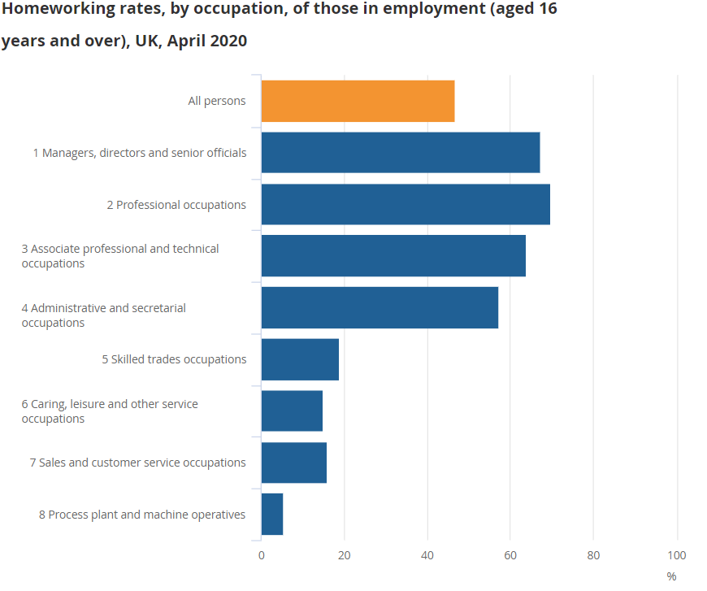

Appendix E

Appendix F
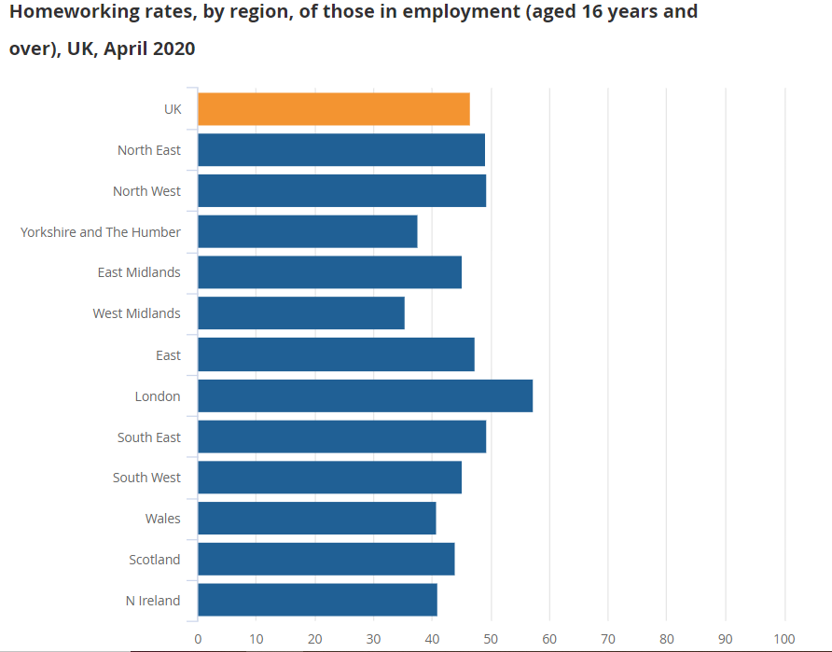

Appendix G
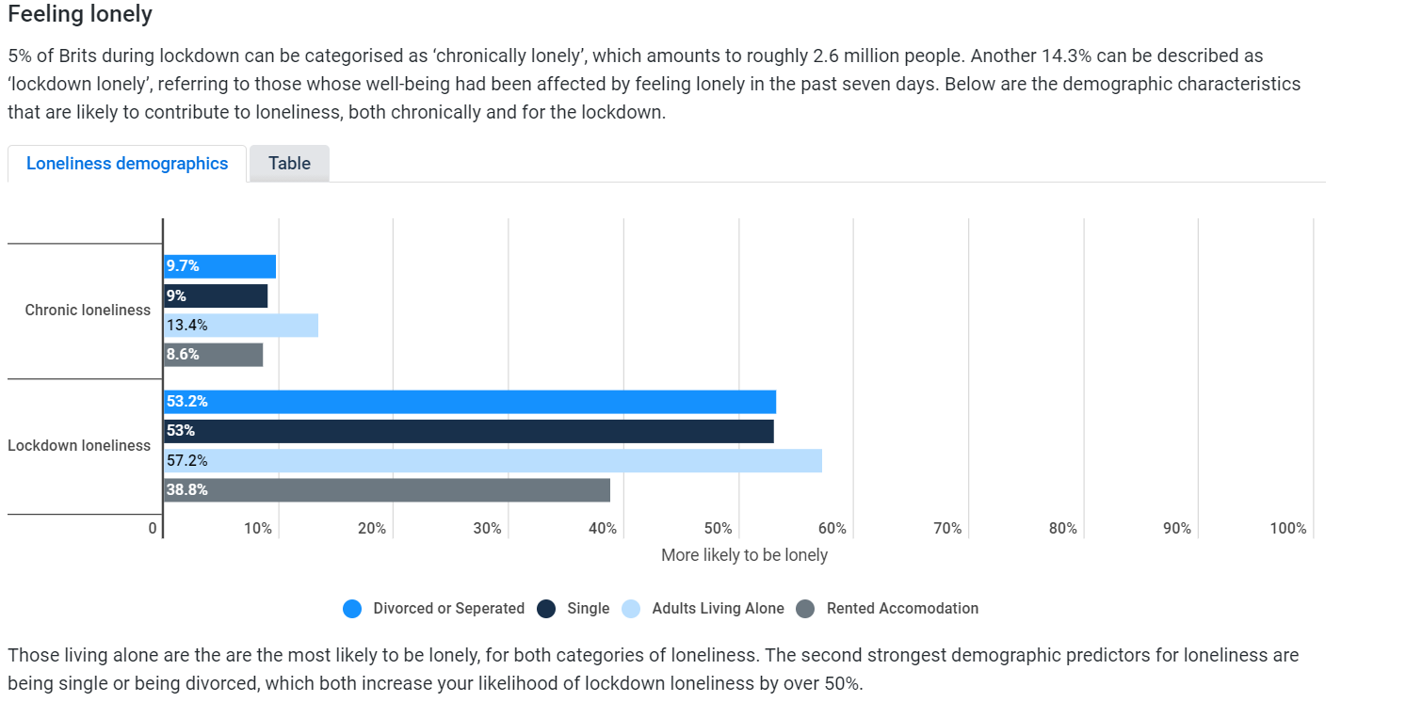

Appendix H
Questionnaire:
Age bracket (tick where appropriate)
- 10-15
- 18-25
- 25-40
Gender
- Female
- Male
- Prefer not to say

Did you work/study from home before Coronavirus
- Yes – fulltime
- No
- Flexible working hours (office and office based)

Do you want to return to the office once the pandemic is over?
- Yes
- No
- Sometimes
Pls specify reason:------------------------------------------------------------------------------------------------------------------------------------------------------------------------------------------------------------------------------------------------------------------------------------------------------------------------------------------------------------------------------------------------------

Do you feel you are more productive working/studying from home?
- Yes
- No
- Sometimes
Pls specify reason:------------------------------------------------------------------------------------------------------------------------------------------------------------------------------------------------------------------------------------------------------------------------------------------------------------------------------------------------------------------------------------------------------

Appendix I
Age 10-15 years

Appendix J
Age 18-40

Appendix K

Appendix L

Appendix M
Age 10 – 40 years

Appendix N

CRAAP analysis
Currency
The information was published June 2019 and obtained from the university library which is a reliable source. The author, David Deacon has been previously recognised by the Best Practice Institute as a “Best Organisational Practitioner”. As well as being the author of The Self-Determined Manager, he also coaches management through various businesses and has been in this field for many years. The information was easily obtainable.
Relevance
The information was relevant for my research, which I found informative. The author is non-biased and aimed to develop organisations.
Accuracy
Given the authors experience in this field, the information provided is accurate. There is an unbiased tone to the text and presented well.
Purpose
Whilst another theorist may take a slightly different approach, the author speaks from experience. The point of view appears objective and impartial with no political, cultural or religious agenda.

Appendix O
Gibb’s reflection model

Gibbs (1988)
Appendix P

Martine’s learning logs:
Learning Logs
SfWP Outreach Programme Session Learning Log
Module Code: BMSK4008 Date: 16/2/21
Session Number and date: (1) 16/2/21
Student Name: Martine Kennedy
What happened?
What was the session about?
The online lecture was an overview of the Academic and Research module, detailing the criteria for each question, along with the expectations of what to be included in the assignment.
How do I think/feel about this?
I found this session quite daunting, as whilst I am familiar with working/studying remotely, certain topics covered, such as, learning logs, DIKW, mean, median and mode were areas I was not confident.
How well or how badly did it go?
The session went well and although I left feeling overwhelmed, I was confident the tutor (Bob Wilson) would elaborate/explain in detail on future lectures.
My conclusion/reflections/lessons learning
What did I learn?
What I learned most from this session was the criteria for the assignment. As well as the purpose of Learning logs, GAP analysis and Action plans. We recapped on SMART objectives, which I found beneficial.
What have I achieved?
After the session, I researched areas such as DIKW, mean, median and mode which I then felt more at ease about the assignment.
What have I learned about myself?
Since starting the course, I have found that I question myself on my ability. However, once I take a step back and apply myself it is never as bad as I originally thought.
How does what I am learning lead me to becoming better at a skill?
I am finding the course focuses on areas that will apply to the workplace, which is beneficial for my personal progression.
What is my SMART objective?
Continue to complete assignments on time and aim to achieve at least 75% for each module moving forward – review 31/9/21.

Appendix Q

Learning Logs
SfWP Outreach Programme Session Learning Log
Module Code: BMSK4008 Date: 19/2/21
Session Number and date: Research for assignment
Student Name: Martine Kennedy
What happened?
What was the session about?
I was researching data on managing remotely.

How do I think/feel about this?
I found this quite challenging, as there is so much data. I often second guess what I am going to use in my assignments, which can be time-consuming, and I then lose focus as not confident in what I am doing.

How well or how badly did it go?
The process was fair on this occasion, once I decided how I was going to proceed, I was more confident.

My conclusion/reflections/lessons learning
What did I learn?
Various data, on the impact remote working, which we have seen a significant rise since the COVID 19 pandemic.

What have I achieved?
Completing more of the assignment and the understanding of managing remotely in more detail.

What have I learned about myself?
I need to be more confident with researching, as I am finding the process time-consuming.

How does what I am learning lead me to becoming better at a skill?
I am finding the course focuses on areas that will apply to the workplace, which is beneficial for my personal progression.

What is my SMART objective?
Once the assignment has been marked, review feedback and take the necessary actions to improve – 30/4/21

