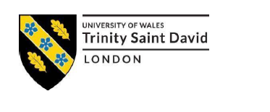

Name: Elizabeth Ademiluyi

ID Number: 1710949

Module Title: MARKETING MANAGEMENT

Module Code: SBMA7138

Assignment Title: Marketing Assignment 1

Assignment Task: Report

Module Leader: Richard Small

Module Lecturer: Tushara Balendran

Word Count: 3500 Words (Plus or Minus 10%)

Table of Contents
Introduction 2
Company Background 3
Zara’s Strategic Marketing Objectives 4
SWOT Analysis of Zara Organisation 4
Strengths: 4
Weaknesses 5
Opportunities 5
Threats 5
SWOT Critical Analysis 5
Definition of Marketing 5
Product: 6
Promotion: 6
People: 6
Process: 6
Physical evidence: 6
Integrated Marketing Communications Diagram 7
Several ways that Zara can use to generate innovative marketing strategies for raising awareness of the Zara brand. 9
Promotion 9
Customer Focus 9
Relationship Marketing 9
Superior Customer Service 10
Customer satisfaction 10
Measure and Monitor Customer Satisfaction 10
Five Gaps Model of Service Quality 11
Advertisement 13
Marketing Communication 14
Customers End to End Journey 15
Zara’s Customer Touchpoints 16
Brand 18
“Brand identity 18
“Brand image 18
“Brand equity 18
Keller's Brand Equity Model of Constructing Powerful Brand 19
The diagram below is an example of how Zara’s brand moves from brand awareness to financial value. 20
The four stages model of integrated marketing communications (IMC) 21
Stage 1: Tactical coordination of marketing communications 22
Stage 2: Redefining the scope of marketing communications 22
Stage 3: Application of information technology 23
Stage 4: Financial and strategic integration 23
Digital Marketing 24
Zara’s future brand and business challenges 25
Critical Analyses 25
Conclusion 26
Recommendations 26
References 27

Introduction
Organisations experience several challenges by operating in a crowded and competitive marketplace. Such challenges include: changing business environment, globalisation, frequent rise of digitalisation, managing reputation, increasing brand awareness, competition, rising expectations of customers and information management. Zara cleverly survive and prosper because they have effective and efficient marketing systems and processes in place together with a differentiated value proposition and marketing strategies which has helped them to achieve sustained competitive advantage.
This report will critically appraise the different ways, manner and methods by which Zara organisation can generate innovative marketing strategies for raising awareness of their brand as well as managing and accessing the customer journey across a variety of communication channels to ensure current and future stakeholders’ expectations are satisfied.

Company Background
Zara organisation, global fashion powerhouse, fast fashion pioneer, customer first Fashion Company (obsessed with customers) was started in 1975 in Spain by Amancio Ortega and Rosalía Merain downtown Galicia in the northern part of Spain. Zara manufacture and retails clothes, shoes and accessories for all ages and sexes. Zara’ parent company and owner is Inditex, the Spanish fashion group and owner of the world’s biggest fashion group. They currently have numerous online portals as well as 2,251 stores worldwide. Zara is famous for developing new products and getting it to stores within two weeks unlike other retailers six months timing and it is now one of the world’s most successful fashion retail brands (www.Zara.com, 2012; Roll, 2018). Zara employed 171,000 worldwide with an annual growth of 1.7%, and their brand value on May 2017 was: $11.3 Billion (Forbes, 2018). The advancement of the retail landscape and the tenacious rise of online shopping have encouraged retailers to invest significantly in their online offerings and delivery abilities, which has proved beneficial (IBIS World, 2017).
One of Zara’s Stores in City Centre.
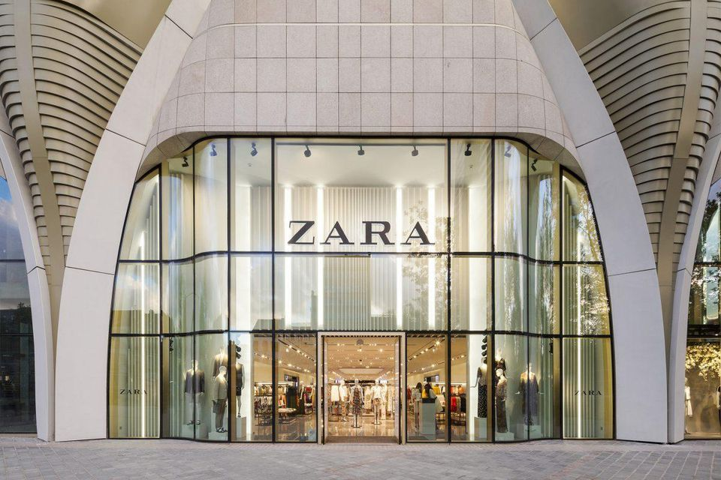
(www.Zara.com, 2018).

Zara’s Strategic Marketing Objectives

- Increase company equity
- Maximise customer satisfaction
- Increase purchase frequency.
- Unceasing growth.
- Intensify brand awareness.
- Reduce waste and recycle more to support sustainability.
(www.Zara.com, 2018).

SWOT Analysis of Zara Organisation

Strengths:
- Very strong brand name.
- Cost leadership.
- Strong supply chain management.
- Differentiation strategy.
- Active use of stores for advertisement.

Weaknesses
- Centralized distribution system.
- Inadequate investment on advertisement.

Opportunities
- More advertisement to penetrate global market.
- More distribution centres.
- Diverse Cultural Area.

Threats
- Strong global competitors
- Economic uncertainty limit consumer expenditure and revenue
(www.Zara.com, 2018).

SWOT Critical Analysis
SWOT Analysis is an important tool for strategic planning based on static environmental factors. Although, changes such as, price increase, government legislations or economic factors affects its validity. Zara need to improve on its weaknesses and threats and also focus on its strengths and opportunities to gain and maintain a strong competitive advantage.

Definition of Marketing
According to Dr. Philip Kotler marketing is “the science and art of exploring, creating, and delivering value to satisfy the needs of a target market at a profit”. Kotler added that Marketing recognises unsatisfied requirements. It outlines and measures the scope of the market and the revenue potential (Cohen, 2018).
The UK Chartered Institute of Marketing (CIM) defined marketing as follows, “Marketing is the management process responsible for identifying, anticipating and satisfying customer requirements profitably” (www.cim.com, 2018). The CIM thus recognised that marketing includes the organisation of seven elements called the 7p’s of marketing or a marketing mix which are: Product, Price, Place, Promotion, People, Process and Physical evidence, all seven are vital segments of marketing (www.cim.com, 2018).
Product: Zara identify, select and develop products that give customers what they want with the right quality and value to meet their expectations.
Price: Zara looks and determines its prices from customer perspective, and they look after their customers by providing affordable, good value for money prices for their products.
Place: Zara’s product displays, distribution and delivery systems are second to none. Their products are usually available on time both online and in store.

Promotion: Zara Develops and implement a promotional strategy that communicates with employees, customers and other interested parties the value and attributes of products in ways that will gain attention, be attractive, send a reliable message and give the customers reasons to prefer their products to other products
People: The reputation of Zara’s brand rest in the hands of its employees who provide the services because they make a reflective influence on customer satisfaction, therefore, Zara’s employees are well trained, motivated and well mannered.
Process: Zara’s process of delivering their products or services, and the behaviour of their employees, who delivers it, are good and satisfactory to customers.
Physical evidence: Zara reduce customer’s uncertainty by clearly displaying the products they are buying in their shops and online, with a well-designed homepage and website which confirms customer’s assumptions or reassures customers of Zara’s good products.
The seven ingredients of marketing mix are major to Zara’s success and none can be reflected separately.

Integrated Marketing Communications Diagram

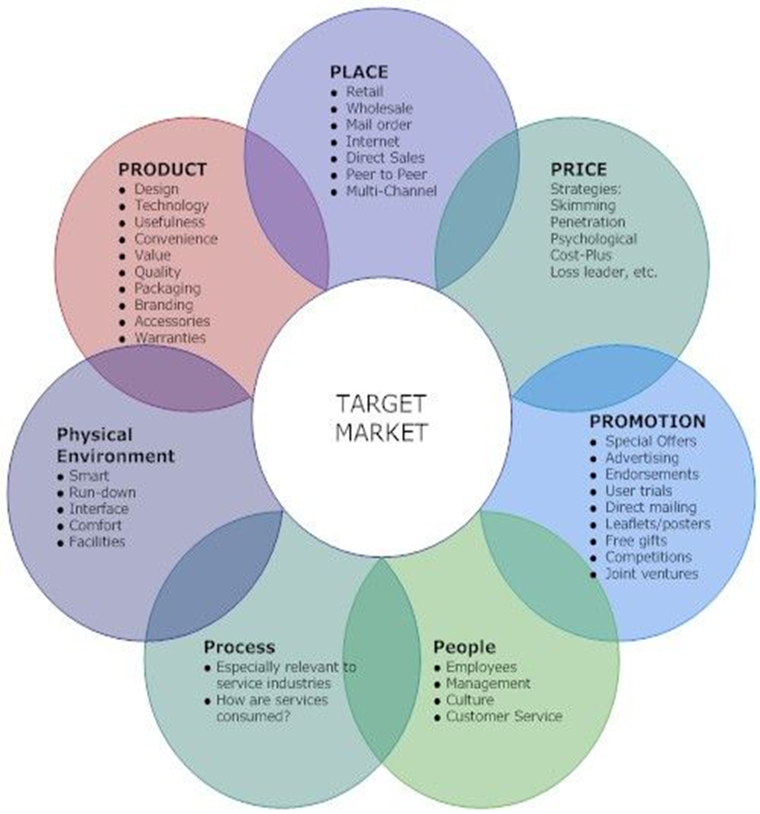
(Pinterest, 2018).

Several ways that Zara can use to generate innovative marketing strategies for raising awareness of the Zara brand.

Promotion
This report largely emphasise on the promotion segment of marketing. “Promotion is the way a company communicates what it does and what it can offer customers” (www.cim.com, 2018). It comprises; advertising, branding, public relations (PR), corporate identity, sales management, social media outreach, exhibitions and special offers (www.cim.co.uk, 2018).
Zara promotes in various ways that communicates the benefits of their products to their customers and pave ways for a dialogue with customers in their shops and online. The design of Zara’s website is regularly updated to give customers a good first impression. Zara advertise on social media to attract all their target customers on social media. Not only that, Zara’s shop windows and walls displays wonderful photographic adverts that is very catchy for customers to identify the reasons for choosing and buying Zara’s products. But Zara need to use more paid advertisement to create more awareness for a brand.

Customer Focus
Customers are Zara’s major designer, therefore they relentlessly concentrate on their customers and this has helped customers to co-create Zara. Zara regularly improve, extend existing products, and develop new ones in order to satisfy their customers. They provide what the customers want, when they want it, how they want it and where they want it. This strategy of Zara is good and needs to be more developed to raise the awareness of the Zara brand (Roll, 2018).

Relationship Marketing
To improve the awareness of Zara’s brand, they will need to use the techniques of relationship marketing, which is on building bonds and ties with its customers by way of providing customer loyalty cards, having customers data to inform them of sales and offers, improve feedbacks and customer loyalty. The more Zara knows its customers, they will be able to innovate and compete better. This strategy will help to retain customers who will invite more customers and raise Zara’s brand awareness (Hooley et al. 2011).

Superior Customer Service
Providing superior customer service will raise the awareness of Zara’s brand. These means going the extra mile for customers, providing friendly help to customers, taking responsibility for your mistakes and repair your reputation, knowing customer’s wants and respond speedily to satisfy customers, being positive and willing to assist customers (Hooley et al. 2011). There is great value in Zara’s ensuring the delivery of excellent customer service.

Customer satisfaction
“Customer satisfaction is the degree of how products and services provided by a company surpass or meet customer’s expectation” (Keller, 2010). Zara is customer centred and customer focused but there is always room for improvement. Maximising customer’s good experiences will bring in more customers, retain current customers, bring in more profit and help Zara to maintain, retain and sustain their competitive advantage.

Measure and Monitor Customer Satisfaction
Regular customer satisfaction survey will help Zara to monitor its customers and how satisfied they are. For example, Zara need to recognise issues important to customers, quantity their expectations, performance and service delivery and examine differences through gap analysis (Hooley et al. 2011). This will help Zara to know where there are needs for improvements and maintain customer satisfaction. The report will use the five gaps model of service quality below to explain how customers can be best satisfied.

Five Gaps Model of Service Quality
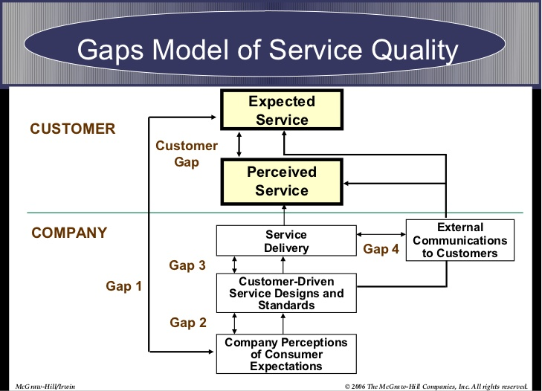
(Management & Business, 2018).

Customers always compare the service they received with what they expect, and when it does not match their expectation, a gap arises.

  - Gap between the customers’ expectations and the organisations perception arises when the organisation does not appropriately perceive what the customers want. Customer surveys, feedbacks and research can help to determine customer’s wants or needs.
  - Gap between management perception and service quality specification arise when organisation understands customers want but not translated effectively (not standardised). Policies and procedures should be clearly communicated to service staff or providers.
  - Gap between service quality requirement and service delivery arise when the service provider is not trained or motivated to provide the required service. Training and motivation should be provided to service providers.
  - Gap between service delivery and external communication arise when organisations advertisement or promotional promise is higher, juicer and better than the service delivered. Realistic promotions should be used.
  - Gap between expected service and experienced service arise when the consumer misunderstand the service quality, that is, the expectation is higher than the experience. Deal with the problem immediately or get feedback and improve on the quality of service.

(Management & Business, 2018).

Advertisement
“Advertising is the channel of communication that was paid for to promote a company’s products and services in order to increase brand awareness, sales and revenue from such products and services” (Bullmore, 2016). Advertising is every paid method of presentation and promotional ideas, goods or services by an identified sponsor that are non-personal (Kotler et al. 2012). Advertising powers a business by contributing heavily to the improvement of its sales and revenue. It changes the business landscape with vital information about the business been made available to customers (Patterson, 2014). Advertisement support as network for customer’s awareness, brand image, informs and impact customers and support business to concentrate on customer’s request (Management Study Guide, 2017).
Zara depends greatly on verbal communications and social media, and their insight of possible customers is reduced to family and friends, which is not perfect without advertisement. However, brand communication is vital in enticing new customers to Zara’s brand in order to sustain growth.
Zara spend 0.3 per cent of its sales revenue on advertising compared to 3.5 per cent by its challengers in the industry. Zara’s prominent locations, store location and store window displays and 0.3% of sales revenue spending on advertisement is not enough to advertise Zara’s good business. Although, Zara is powerfully driven by their brand experience, adequate efficient paid advertisement will bring about more awareness, customers, sales, revenue and sustained competitive advantage.

Marketing Communication
Well Organised marketing communications conveyed promotional messages through media channels such as: print, social media, radio, television, direct mail and personal selling to the market. It is about the 4P’s (Now 7P’s by CIM) of marketing. It is the means or channels adopted by companies to convey messages about their products and their brands to the market (www.businessdictionary.com, 2018).
Communication is the greatest noticeable component of an offering’s marketing mix; therefore, companies spend millions of dollars every year to advice buyers about the quality of their products and its benefits (Kotler & Chernev, 2012). Marketing communications can be more cost effective and efficient if they are well integrated and properly managed (www.cim.co.uk, 2018). The communication method comprise six vital decisions which includes: setting the goal, developing a message, selecting the media, developing the creative solution, implementing the communication campaign and evaluating the campaign results (Kotler & Chernev, 2012).
Marketers encounter difficulties with the various resources and options of communications available to support their brands, such as: advertisement, Television, Print, Bill Boards, social media interactions, Radio, Internet, Public relations, digital marketing, personal sales, direct marketing, sales promotions like; arts, sports, sponsorships, celebrity endorsement and so on. Many of these options should be combined to enhanced marketing communication in order to achieve stakeholder objectives (Keller, 2010).
Zara need to manage, align and implement marketing communications in a strategic way so that it will be well structured, with planned clear messages, well-co-ordinated and well directed to raise their brand awareness and achieve stakeholders’ expectations, company objectives and satisfy its customers (www.cim.co.uk, 2018).

Customers End to End Journey
Organisations will be able to understand and meaningfully improve performance by observing the customers experience through the customer’s eyes from customer’s end to end journey. This journey may last for days or weeks, it includes many happenings before, during, and after the experience of a product or service, via multiple channels and touchpoints. Organizations that fail to appreciate the customer’s journey and manage their end-to-end experiences that shape the customer’s opinion about the business can prompt a torrent of negative consequences such as: lost sales and lower employee morale, while providing customers with the best experience will improve sales, enhance customer and employee satisfaction and reduce end to end service cost. Organisations often find that it is expensive to keep and retain customer’s (Neher et al, 2016). Zara need to strategically monitor its customer’s end to end journey to raise brand awareness and ensure the fulfilment of stakeholders’ expectations.

Zara’s Customer Touchpoints
The most important touchpoint of Zara is their store

(www.zara.com, 2018).

Zara’s customer touchpoints is their brand's opinions of customer connection, from the start to the end. It is communication between industries, brands, products and Customers. For example, when a customer sees Zara’s new design party dress online, she searches for the availability of the product, tries the cloth at the store, she likes it and buy the new cloth, she is satisfied with the purchase and then she gives feedback. Monitoring customer experience systematically is an important step to improve customer’s experience and organisations bottom line.
Zara stores are designed to generate customer’s comfortable feelings, positive emotions, and buying impulse. So that all interactions and communications are positive, easy and feedback is easily collected from the customer (www.zara.com, 2018).

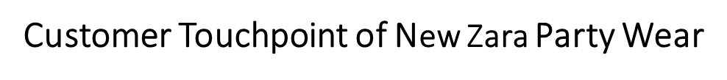

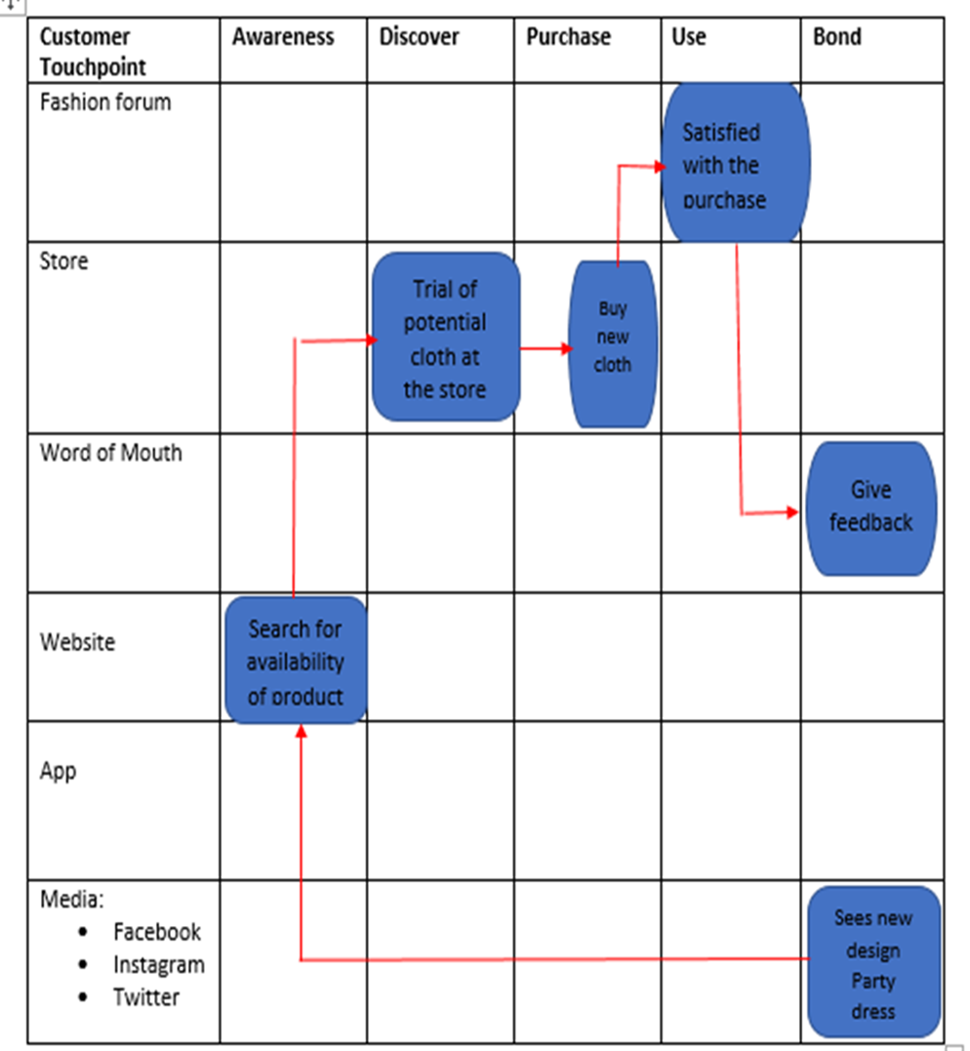
(www.zara.com, 2018).

Brand
“A brand is a name, term, sign, symbol or design or a combination of them, intended to identify the goods or services of one seller or group of sellers and to differentiate them from those of competitors”(Kotler et al. 2012).
“Brand identity is the way a company aims to identify or position itself or its product or service; the visual or verbal expressions of a brand which leads to the psychological or emotional associations that the brand aspires to maintain in the minds of the consumer” (Kotler et al. 2012).
“Brand image is the way the public actually perceives this aim” (Kotler et al. 2012).
“Brand equity is the added value endowed on products and services which may be reflected in the way consumers, think, feel and act with reverence to the brand” (Kotler et al. 2012).
Zara’s brand is a very strong brand with strong loyal customer base and good brand name, identity, image, equity and more. But Zara should not rest, they need to continue to innovate, research, develop so that they will remain relevant in the manufacturing industry and gain sustained competitive advantage.

Keller's Brand Equity Model of Constructing Powerful Brand
Customer based brand equity (CBBE) pyramid model

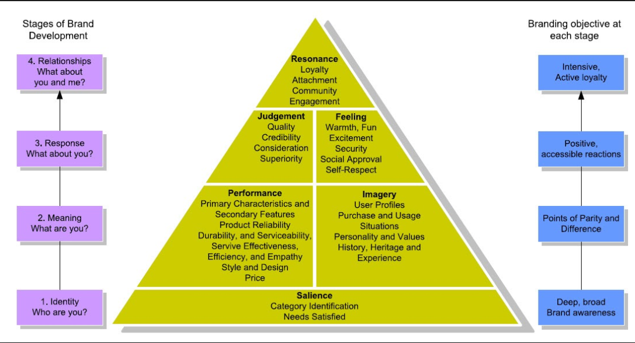
(Keller, 2007).

Keller (1993) suggests that brand equity represents the condition where the customer has a variance effect of brand knowledge from been acquainted with the brand and remembers favourable, strong and distinctive brand association (Keller, 1993).
In the above Customer based brand equity (CBBE) pyramid, Kotler and Keller argue that the bases of brand equity are shaped by the brand knowledge the customer has. This knowledge empowers the consumer to distinguish brands and it also guides their minds and reactions to marketing activities (Kotler and Keller, 2006). Zara’s marketers can create more customer base brand equity by engaging in more advertisements, encouraging and motivating their customers to be more aware and familiarise themselves with their brand, and also embrace favourable, strong and unique brand associations in memory (Keller, 2012). Keller maintains that globally active companies should shape their worldwide customer based equity model on his “Ten commandments of Global Branding” (Keller, 2012).

The diagram below is an example of how Zara’s brand moves from brand awareness to financial value.

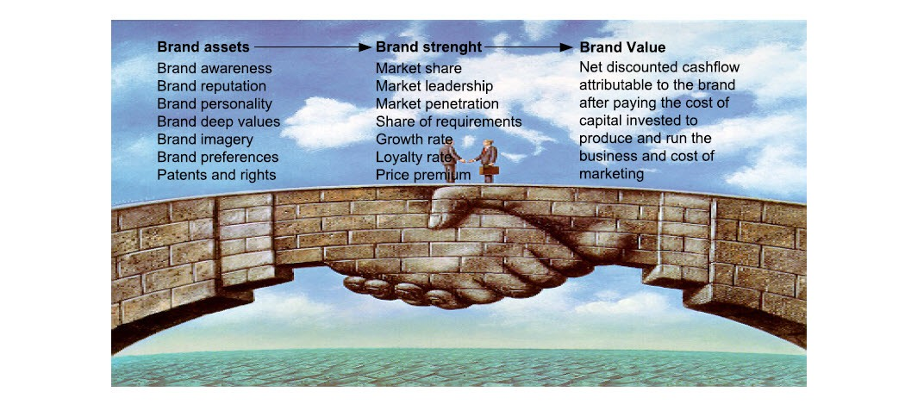
(Kapferer, 2007:14).
Kapferer differentiates three levels of brand equity which are: brand assets, brand strength and brand value. He added that these three fluctuates in time due to competition and environmental changes (Kapferer, 2007). Zara can use effective and efficient marketing strategies to improve and develop their brand assets, strength and value to gain more awareness, customers, sales, profit and competitive advantage.

The four stages model of integrated marketing communications (IMC)

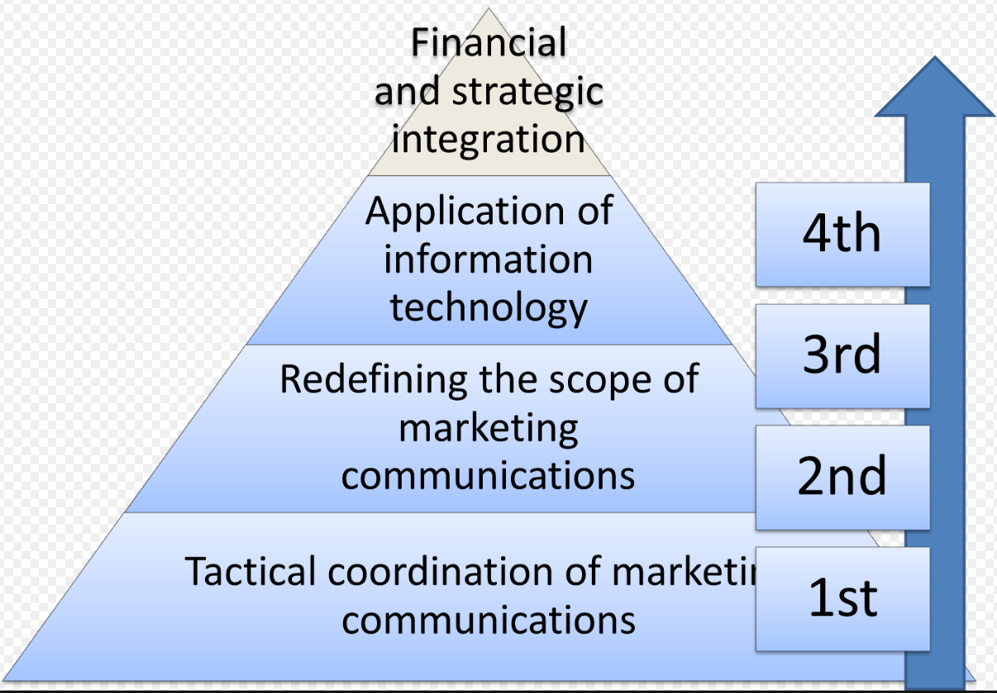

(www.marketingstudyguide.com, 2018).

Model debated in marketing textbooks to clarify the idea of IMC involves four stages of IMC (Schultz and Kitchen, 2000).
For organisations to ensure effective communication to customers and prospects globally and certify that their brand messages travel worldwide, IMC is designed to help organisations to position and leverage marketing communication globally and practice it to their ongoing strategic advantage. Global communication demonstrate successful strategizing, selection of suitable communication procedures, and the execution of global communication strategy that embraces all channels of communication, internally and externally. According to Schultz and Kitchen (2000), only the marketers and agencies that have the capacity to brand products and services globally will succeed, therefore necessitates organisations to offer global, integrated marketing services and communications for their customers. O. Butch Drake, president-CEO, American Association of Advertising Agencies (cited in Schultz and Kitchen, 2000) supports the fact that Communicating Globally comes to a guaranteed formula for future success. The combination of intelligent global market knowledge, developing trends and technologies, and common sense Schultz and Kitchen (2000) brighten the way for successful brand building in the 21st century with four stages model of IMC which are:
- Tactical coordination of marketing communications
- Redefining the scope of marketing communications
- Application of information technology
- Financial and strategic integration

The shape of the model specifies that most companies begins from the lowest (the widest part of the model) and only few organisations are at the top (where it is very narrow); organisations therefore should aspire to progress up.

Stage 1: Tactical coordination of marketing communications
The first stage towards IMC approach in a company is coordination across specialist areas, the agreement of; use of a standard logo, company slogan, corporate colours, and a general message. They all have goals to achieve, such as advertising that seeks to increase brand awareness (Schultz and Kitchen, 2000).

Stage 2: Redefining the scope of marketing communications
In this stage concerning IMC, the business deliberates on bigger of touch points than its basic communication tools. In stage one, the business concentrates on the main communication tools. Secondly, the organisation focuses on how and where possible or present customers can come to be attracted or engaged with the brand. The business access the brand through the eyes of a consumer and may consider; sponsorships, email contact, media attention, interaction with staff, competitive comparisons, information and comparison websites, retail sales people, staff uniforms, after sales service contacts, signage on buildings, word-of-mouth, and so on -as all possibly part of customer’s journey towards or away from the brand (Schultz and Kitchen, 2000).

Stage 3: Application of information technology
Stage three incorporates the communications approaches attained in stages one and two, through the information and organisational practices. Better use of data and information is created and shared through their delivery networks, including retailers and suppliers. For example, banking customer databases permit Banks to trail every customer’s movement and understand their customer’s behaviour via marketing communications (Schultz and Kitchen, 2000).

Stage 4: Financial and strategic integration
Finally, stage four echoes that marketing purpose in large companies becomes strategically and financially incorporated. Starting point for marketing communications is determined by top-level strategic plan, followed by the marketing strategy and plan, successfully implemented via marketing mix elements, with marketing communications.
At the fourth stage, all the improvements from stages 1-3 are applied, but the business becomes financially and marketing metric focused in relations to its marketing communications. At this stage, they look at the return on investment (ROI), such as increased brand awareness by 5% and work out the impact that has over time, experimental rates, brand loyalty and bottom line.
This stage can be very challenging with multinational companies having several target markets to track; this necessitates the necessity to reflect a range of strategic initiatives. Therefore only a slim proportion of organisations accurately function at the fourth stage of the model (Schultz and Kitchen, 2000).
Implementing the four stages model of IMC will help Zara to increase brand awareness and achieve stakeholder’s expectations.

Digital Marketing
“Digital marketing refers to advertising delivered through digital channels such as search engines, websites, social media, emails and mobile apps” (Marketo, 2018). It is a form of promotion where organisations communicate directly to customers through a variety of media. It can also be described as the advertisement of products and services via digital technologies, mostly on Internet, mobile phones, text messages, display advertising, email, websites, online adverts, fliers, database marketing, promotional letters, brochures, catalogue distribution and any other digital channels.
Digital marketing involves extensive variety of marketing activities and businesses experience digital transformation in various ways, it is changing marketing and customer experience throughout industries. An example of digital marketing is Content Marketing. Great content drives digital marketing activities; it is a main pillar of current search engine optimization (SEO), it assist organisations to be seen on social media, it provides organisations valuable things to offer customers such as, emails and paid search advertisements. A clever content that is relevant, educates, inspires, and allow your audience to see your valuable information’s and remain with the organisation (Marketo, 2018).
Several people depend on on social network to research, ascertain and teach themselves about a brand before they engage with the establishment. Postings on Facebook and Twitter accounts are not enough; businesses should include social essentials into aspects of marketing and build peer-to-peer sharing prospects. When your audience participate with your content, they are likely to share it. This eventually leads them to become customers, and furthermore, they will encourage their friends to become customers (Marketo, 2018).
Digital marketing helps organisations to focus on emerging generation, connect virtual reality to augmented reality or the pre-dimension view of the actual thing and allows mass customisation. Organisations can use direct marketing strategies through database and relationship marketing, they can create awareness through various channels, they can send personalise messages and hide their main strategy from the competition.

Zara’s future brand and business challenges
Brands develop around 15-20% of their website traffic through mobile devices and this continues speedily. The flood of investments scheduled in mobile commerce spaces and Zara’s competitors currently gaining advantage on the mobile front, Zara need to quickly make mobile shopping an easy and delightful experience. They need to implement, absorb and influence social media and digital platforms in their advertising and communication strategies profounder going forward (Roll, 2018).
As Zara target customer sections, they should begin to use additional social and digital platforms for communication and for sharing their products and services. Therefore, Zara need to improve on its strategic ways to build digital intelligence platform and have a robust presence on digital platforms to be more competitive and accomplish stakeholder’s expectations.

Critical Analyses
- Although Zara is a market leader in the manufacturing industry, incorporating good advertisements will take them to the blue ocean where competition is irrelevant.
- For Zara to stay in date, be relevant and fulfil stakeholder’s expectations, they need to create innovative marketing strategies to raise the awareness of Zara’s brand as well as manage and evaluate their customer’s journey across a variety of communication channels.
- Zara need to increase its distribution channels for added brand awareness and publicity.
- Zara’s Business Strategies are very effective in its business endeavours; however, they need to be more aggressive in communicating their products qualities and benefits to the masses in order to maintain and sustain their competitive advantage.

Conclusion

One of Zara’s global success secrets is the culture and respect that the customer is the best authentic trendsetter. It is therefore important that this philosophy continually reflect in all Zara’s current and future business strategies.
For Zara to continue successful competition and maintain its competitive advantage, it is essential that they shift away from price and focus on quality. It is thus vital for Zara to invest in building strong brand positioning and aggressively communicate it through the various advertising channels available.
By incorporating the above explained innovative marketing strategies, Zara will raise its brand awareness, achieve unexpected increase in profits and market share, there will be great demand for Zara’s products, maximise customer satisfaction and fulfil stakeholders’ expectations.

Recommendations

- Increase the advertisements of Zara’s products.
- More Global Investments.
- Increase digital marketing.
- Intensify growth to increase revenue.
- Maximize customer satisfaction.
- Invasion of Asian Market.

References

Business Dictionary, (2018) Marketing communications (Online) Available at:
http://www.businessdictionary.com/definition/marketing-communications.html (Accessed 12/05/ 2018).

Bullmore Jeremy (2016) What is advertising? (Online) Available at: http://www.adassoc.org.uk/publications/what-is-advertising/ (Accessed: 12/05/2018).

Cohen Heidi, (2018)72 Marketing Definition (Online) Available at: (Accessed 12th May 2018) https://heidicohen.com/marketing-definition/ (Accessed: 14/05/2018).

Forbes, (2018) Zara on Forbes Lists #51 World's Most Valuable (Online) Available at:
https://www.forbes.com/companies/zara/ (Accessed 14/05/ 2018).

Hooley, G.J., Nicoulaud, B. & Piercy N.F. (2011) Marketing Strategy and Competitive Positioning, 5Th ed. FT/Prentice Hall International

IBIS World, (2017) Clothing Retailing - UK Market Research Report (Online) Available at: https://www.ibisworld.co.uk/industry-trends/market-research-reports/wholesale-retail-trade/except-of-motor-vehicles-motorcycles/clothing-retailing.html (Accessed 13/05/ 2018).

Keller, K.L. (1993), “Conceptualizing, measuring, and managing customer‐based brand equity”, Journal of Marketing, Vol. 57, pp. 1‐22.

Keller Kevin, (2012) Strategic Brand Management: Global Edition Pearson Education Limited.

Keller Kevin Lane, (2010) Mastering the Marketing Communications Mix: Micro and Macro Perspectives on Integrated Marketing Communication Programs Journal of Marketing Management Volume 17, 2001 - Issue 7-8

Kotler et al. (2012) Marketing Management 14th Edition. Pearson Education Limited.

Kotler P & Chernev, A. (2012) Strategic Marketing Management, 8th ed. Cerebellum Press

Management & Business, (2018) The Gap Model (Online) Available at: https://buscreative.blogspot.co.uk/2015/12/the-gap-model.html (Accessed 14/05/ 2018).

Management Study Guide, (2017) Classification of Advertising (Online) Available at: http://www.managementstudyguide.com/classification-of-advertising.htm (Accessed: 13/05/2018).
Marketo, (2018) What Is Digital Marketing? (Online) Available at: https://uk.marketo.com/digital-marketing/ (Accessed 12/05/ 2018).

Neher et al. (2016) From touchpoints to journeys: Seeing the world as customers do (Online) Available at: https://www.mckinsey.com/business-functions/marketing-and-sales/our-insights/from-touchpoints-to-journeys-seeing-the-world-as-customers-do (Accessed 12/05/ 2018).

Patterson Gavin, (2014) Advertising Pays; How advertising fuels the UK economy (Online) Available at: http://www.adassoc.org.uk/wp-content/uploads/2014/09/Advertising_Pays_Report.pdf (Accessed: 10/05/2018).

Philip Kotler, Kevin Lane Keller, (2006) Marketing Management. Pearson Prentice Hall

Pinterest, (2018) Explore Marketing Strategies, Marketing Ideas and more! (Online) Available at: https://www.pinterest.co.uk/pin/66991113177999930/ (Accessed: 10/05/2018).
Roll Martin, (2018) The Secret of Zara’s Success: A Culture of Customer Co-creation (Online) Available at: https://martinroll.com/resources/articles/strategy/the-secret-of-zaras-success-a-culture-of-customer-co-creation/ (Accessed: 10/05/2018).

Schultz Don E. and Kitchen Philip J. (2000) Communicating Globally. Palgrave.

The Chartered Institute of Marketing, (2018) What is marketing? (Online) Available at: https://www.cim.co.uk/media/4772/7ps.pdf (Accessed: 13/05/2018).

The Chartered Institute of Marketing, (2018) Managing Marketing Communications. (Online) Available at: http://www.cim.co.uk/training-courses/managing-marketing-communications-0020.html (Accessed: 13/05/2018).

The Marketing Study Guide, (2018) Understanding the four stages of integrated marketing communications (Online) Available at: http://www.marketingstudyguide.com/understanding-four-stages-integrated-marketing-communications/ (Accessed: 10/05/2018).

Zara.com. (2018). ZARA Official Website. (Online) Available at: https://www.zara.com/ (Accessed 12/05/ 2018).

