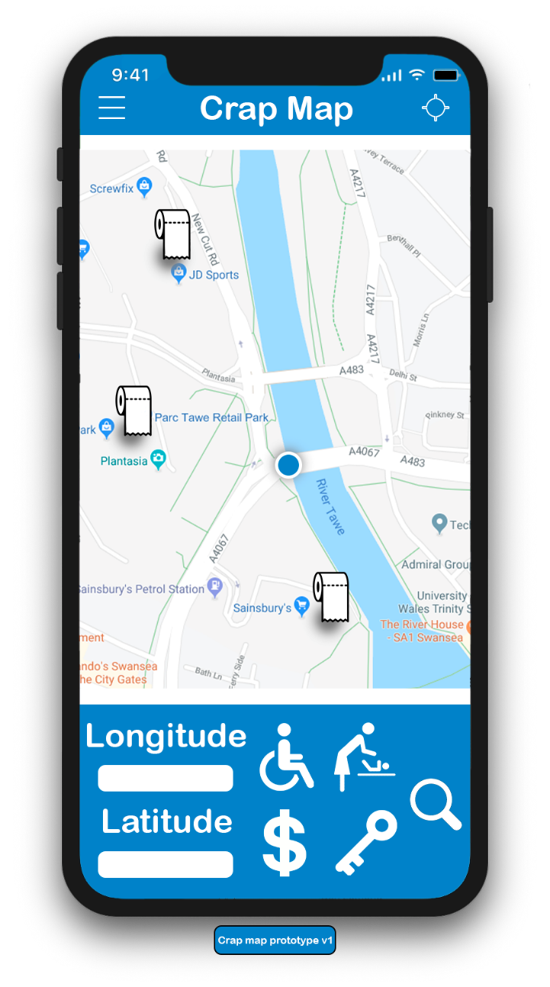
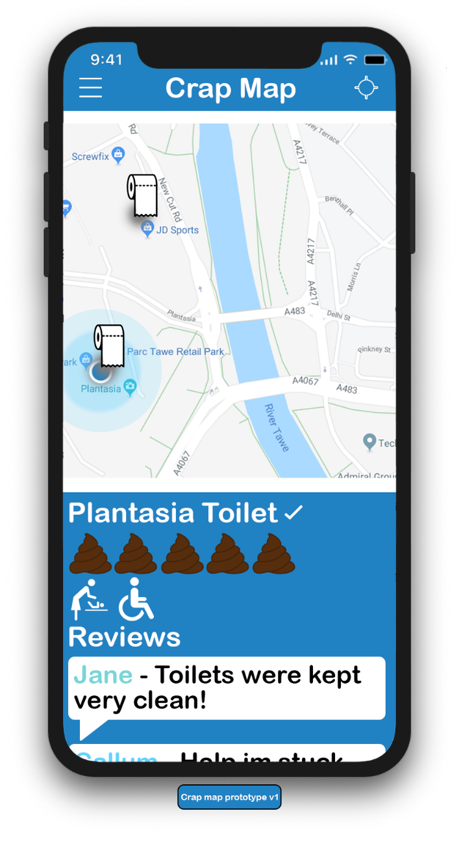
Illustration

Above is an illustration of the proposed product, it shows both the main menu (right) and the screen shown when clicked on a toilet (left). One of the main considerations was accessibility so everything had to be minimalistic looking and easy to read. Icons had to be self-explanatory as well. A blue colour scheme was also chosen because of its clinical feel and its relations to toilets.
In this current illustration you can see a multitude of features, one being the ability to view where you are on the map in real time, our rating system which is scored on a 1-5 basis, commented reviews of the toilet, search by toilet feature & a longitude and latitude search.

Trading name
[1]For our trading name, we wanted to pick something that stands out but also gives the target market an idea of what the product is, because of this, the name we choose was Toilet Map, the name is simple but very effective, it tells you instantly what the product is.

Legal Classification
Choosing our legal classification for the company was a simple process of deciding where our company stands finicality, as we wanted shares and shareholders to allow investment in our company and wanted our company to be one that had no formal restrictions and needed to be financially separate from the people running it. This meant that a limited company was the way to proceed. [2]

Brief start-up description
Our innovation project idea is a mobile phone application that allows the user to locate a toilet in there near area, with a range of toilet searching abilities for disabled, baby changing and private toilets. Our application allows a streamlined way of viewing toilets, with helpful information such as toilet reviews & ratings.
Our purpose is to provide toilet access for everyone but mainly those with disabilities more specifically, stress urinary incontinence & bowel incontinence. It is very important for these people that they have access to a toilet when necessary. [3] [4]

Documenting team members roles & responsibilities
While creating the product initiation document it was decided that sections would be split on people strengths and capabilities, this was decided as a group to maximise productivity.
Kyle
Kyle’s role in the product initiation document consisted mainly of documenting information about the inner workings of the company rather than the actual product itself, this meant the legal classification of the company, descriptions of the company & how finances would be managed.
Bradly
Bradly’s role in the PID was mainly based around the design of the product, he was responsible for deciding on our minimal viable product as well as creating brand advertising. This makes Bradly’s role important, as it decides to amount of work that needs to be completed before we launch the product. He also plays a key role in figuring out any skill gap within our tech start up, this is to ensure that everything runs smoothly.
Callum
Callum’s responsibilities were mainly based around the actual product and consisted of our brand advertising strategy, as well as our branding he also had the role of supplying finical information, this includes figuring out our cash-flow forecast and a break-even analysis. Callum’s role plays a vital part in the PID, His branding strategy alone is very important as that allows us to find potential customers. His cash-flow forecast, and a break-even analysis will play a critical role in deciding which direction we can take.
Sean
Sean main responsibility was the development of the application, he had to document the development process of the app as well as describing the implementation process. His other roles were gaining primary research for the market while also deciding who our target market is. Sean’s roles and responsibilities crucial in making sure the application gets to its MVP.

Mission Statement
When choosing our mission statement, we wanted it to be simple for our target market to understand, but it had to be honest and realistic while communicating expectations and ethics. With this in mind, our mission statement is:
We want the ability to give everyone the right of being able to use the toilet when they want, without barriers and to feel pride and respect of everyone at crap map [5]

Objectives & Values
Help with Objectives & Values
Transparency: Being able to be transparent with customer on both our successes and failures allows trust between users and company.
Customer First: Putting the customer first is our number one priority, as they drive our company and are the reason, we do what we do. [6]
Support Each Other: For us to be able to be committed to caring and encouraging, is one of our main priorities to enable support for both tram members and customers.
Doing what’s right: For us we want to be able to be guided by a strong moral compass and to do what is politically correct while holding high ethical standards. [6]

Market for our product
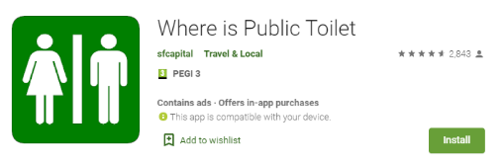
Currently it is a safe to conclude that there is a massive market for our product, one thing that sets us apart from most products is the fact that everyone uses toilets, for this reason anyone is a potential user of our product.
500,000 +
Prove by getting getting app
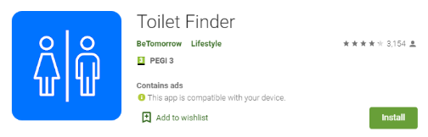
500,000 +

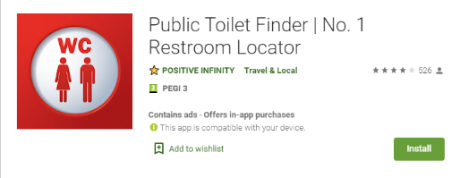
100,000 +

[7] [8] [9]
Above is downloads from the 3 most popular toilet applications on the google play store. From these finding it can be easily concluded there are at least 1.1 million people who would be interested in downloading a toilet app. Though the market is probably much bigger than that considering that the apple app store doesn’t even give statistics on app downloads & the google play store only shows downloads in increments.

A questionnaire was also created and filled in by 25 people to help us better understand if there was really a market for this. One of the most useful question for this was: “Would you find an app with a map of all local public toilets useful?”
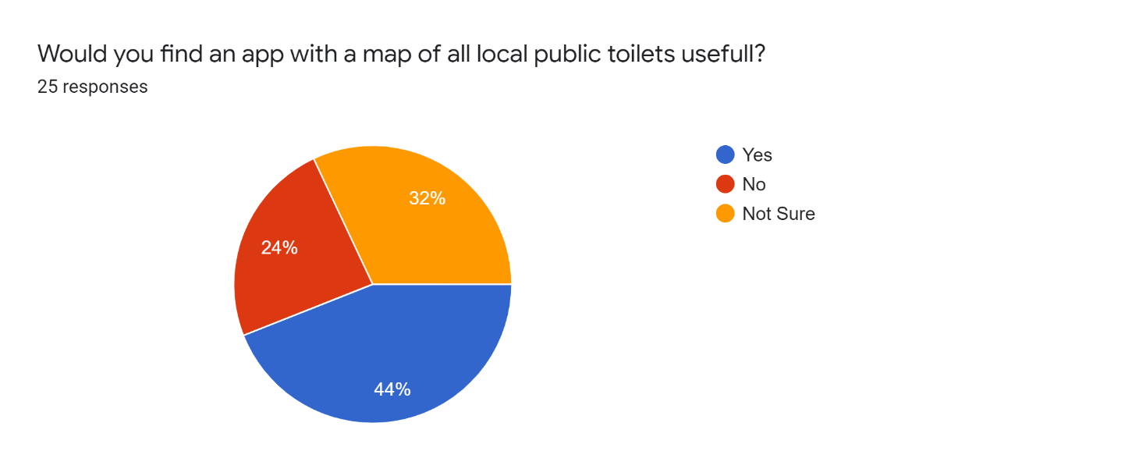
As stated, you can clearly see that most people would be interested in downloading an app to find toilets. This same point is also backed up by another question we asked which was how difficult it was to find a public toilet where an over whelming majority don’t find it very easy to find a toiler.
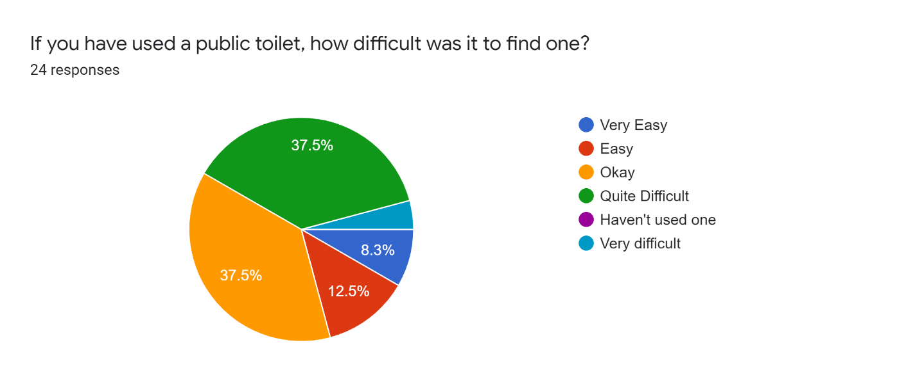
Based on all these factors it can easily be concluded that there is a market for our product. [10]

How Finances will be managed
Managing the finances will be mostly independent by us, we will try manage the finances early on in our company while it is still fairly manageable in a aim to reduce cost which will benefit the company massively early on and would allow for the funding to be used for more research. Other techniques will be approached in order to help manage funding within the company such as charting the cashflow, this will allow us to visually see the inflow of cash and outflow.
The chart will also be able to be viewed over different time scales to help further manage the funds while also allowing use to see the rate in which cash is coming into the company. One final way we plan on managing our funds is to review expenses on a regular basis. This includes looking at profit loss reports, balance sheet reports and statement of cash flow report, these will help to spot any issues that could potentially be coming our way and elevate them quickly before they become serious. [11]

Reflection
During this document I have developed a variety of my skills, one of the main skills I have improved on is my graphics design, during the project it was required that an illustration and prototype were made, this mean that I had to make it which taught me how to make a professional looking piece of graphics.
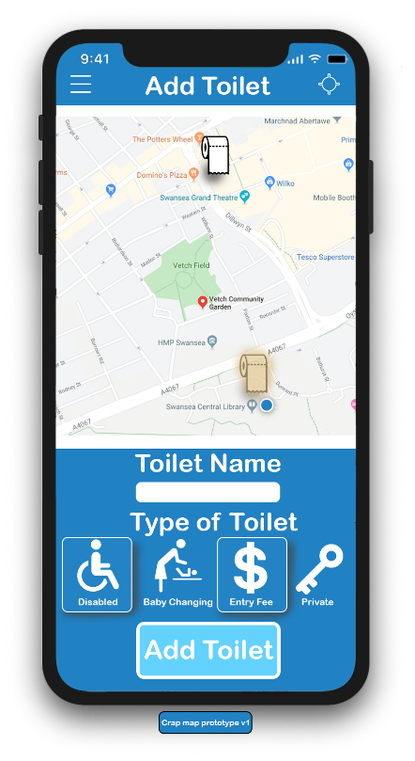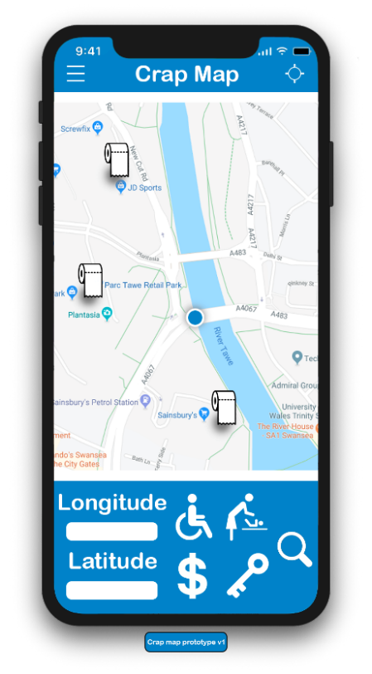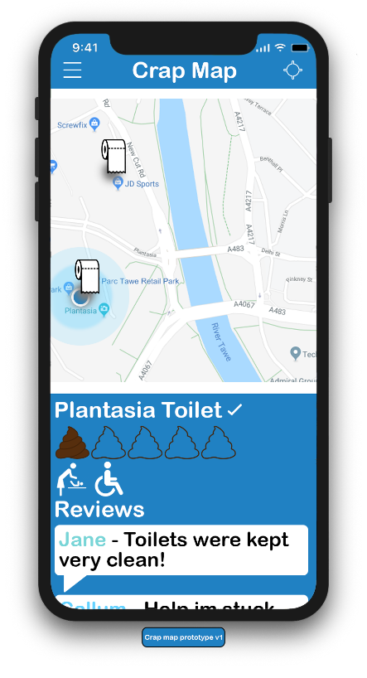
The research I had to do also helped me to gain a better understanding of how businesses work and how you would successfully start a new business. Another key point that I improved on was how to market a product. When first starting the development process we though that just putting social media posts would be enough but there was so much more to it, such as picking certain times of day to post advertisements to improve the reach of it.

Networking
Due to corona virus I was not able to attend any industry networking event.

Team Working and Collaboration
During our time working together we all kept in close contact with each other, one of the main ways we were doing this was on an application called discord which allowed us to all be in a group text chat. About every week or so we would all meet on the discord as discuss our current progress and what needed to be done.
We also worked together by deciding what roles everyone is doing, rather than just handing it out in a random order, it was mainly based on everyone’s strengths, so that the work could be done in the most efficient way possible.
The final way we worked together was through a shared drive on google docs that allowed everyone to see an up to date version of everyone’s parts that they had to do with in the document, this allowed everyone to visually see what was missing so it was easier to spot problems and rectify them.

References

[1] | G. Townley, “Choosing a company name, trading name or trade mark,” Companies House, [Online]. Available: https://companieshouse.blog.gov.uk/2019/02/12/choosing-a-company-name-trading-name-or-trade-mark/. [Accessed 5 Febuary 2020].
[2] | UK Government, “Limited companies,” [Online]. Available: https://www.gov.uk/limited-company-formation . [Accessed 10 Febuary 2020].
[3] | NHS, “Urinary incontinence,” [Online]. Available: https://www.nhs.uk/conditions/urinary-incontinence/. [Accessed 10 Febuary 2020].
[4] | NHS, “Bowel incontinence,” [Online]. Available: https://www.nhs.uk/conditions/bowel-incontinence/. [Accessed 12 Febuary 2020].
[5] | M. Maeda, ncyclopedia of Small Business, Third Edition book, March : 26, 2011.
[6] | Whittington & Associates, “Vision, Mission, Values, Goals, and Objectives,” [Online]. Available: https://www.whittingtonassociates.com/2016/12/vision-mission-values-goals-objectives/. [Accessed 26 Febuary 20 2020].
[7] | Google Store, “Where is Public Toilet,” [Online]. Available: https://play.google.com/store/apps/details?id=sfcapital.publictoiletinsouthaustralia&hl=en_GB. [Accessed 3 March 2020].
[8] | Google Store, “Toilet Finder,” [Online]. Available: https://play.google.com/store/apps/details?id=com.bto.toilet&hl=en_GB. [Accessed 6 March 2020].
[9] | Google Store, “Public Toilet Finder,” [Online]. Available: https://play.google.com/store/apps/details?id=sfcapital.publictoiletinsouthaustralia&hl=en_GB. [Accessed 6 March 2020].
[10] | K. &. Sean, “Toilet Questionnaire,” [Online]. Available: https://docs.google.com/forms/d/1NqwXWoNBjJM0lmNINf4M55-I51vtefv_87gH4fC-sFw/edit?ts=5de6754c#responses. [Accessed 10 April 2020].
[11] | Xero, “How to manage your finances and cashflow,” [Online]. Available: https://www.xero.com/uk/resources/small-business-guides/business-management/manage-cashflow/. [Accessed 2 April 2020].

