Nursing Portfolio

Tania Davies
1804209
Rumee Aktar
Content

Page 2 introduction

Pages 3 – 12 Evidence

Pages 13 – 17 Action Plans

Page 18 Journal Entries

Pages 19 – 20 Work Experience

Pages 21 – 22 Write up from my Placement Supervisor

Page 23 Hours Completed

Pages 24 – 25 References

Introduction
I would like to welcome everyone who will access this portfolio. My name is Rumee Aktar and I am nineteen years old. I am currently in my first year studying Nursing Studies and Health and I attend the University of Wales Trinity Saint David (UWTSD) (University of Wales Trinity Sint David, 2019). Previously, I was in Gower College Swansea studying Health and Social Care Level 3. I studied this course because I had done the level 1 / 2 in secondary so I desired to further my knowledge on that course. Not only that but I wanted to be a nurse, so I knew that my Level 3 course would progress me into the next steps.

Currently, I am working in Ethnic Minorities and Youth Support Team (EYST). I work in the Belonging Project and My role in the project is a belonging sessional worker, the project involves children and young people involving in entertaining activities and working alongside many organisations and schools (EYST, 2019).

Evidence

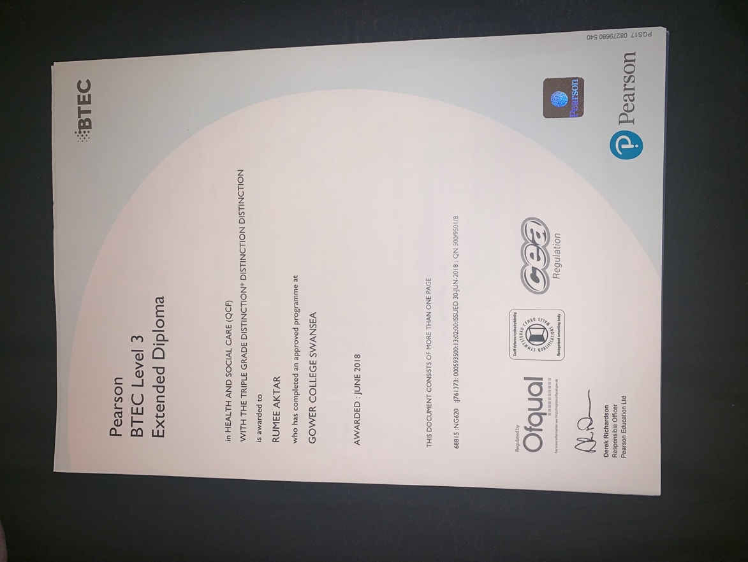

Above is my qualification from Gower College Swansea obtaining Triple Distinction* Distinction Distinction in Health and Social Care.
Below are four images showing that I was involved in the project called the Chips, Curry and Cappuccino (CCC). The project was about discovering and appreciating the multi-cultural food heritage and how people who have migrated started their business and their journey. Research and interviews were taken place of the histories from the Bangladeshi, Italian, Middle Eastern and Chinese communities.

The CCC project further made school teaching packs, the aim was for teachers to teach the children about how there is different cultural food heritage in Swansea and the different type of tastes, flavours and food that there is.

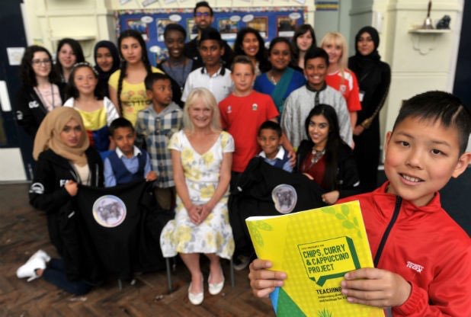

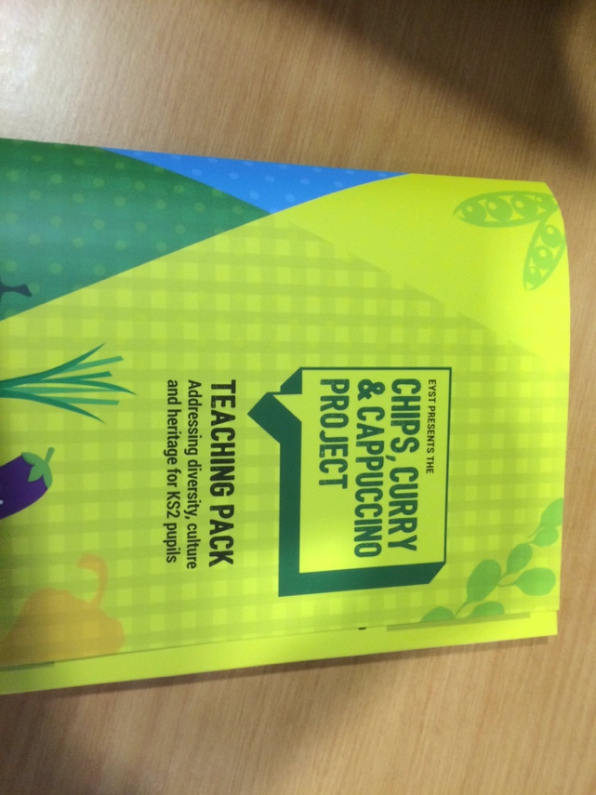
Above is the image that shows that we went to a primary school to give the teaching pack a test drive to see if it would be effective.

This was the final product of the teaching pack, it came with a CD that fit KS2 pupils.
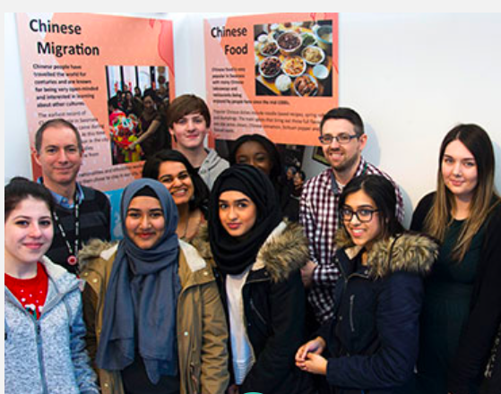

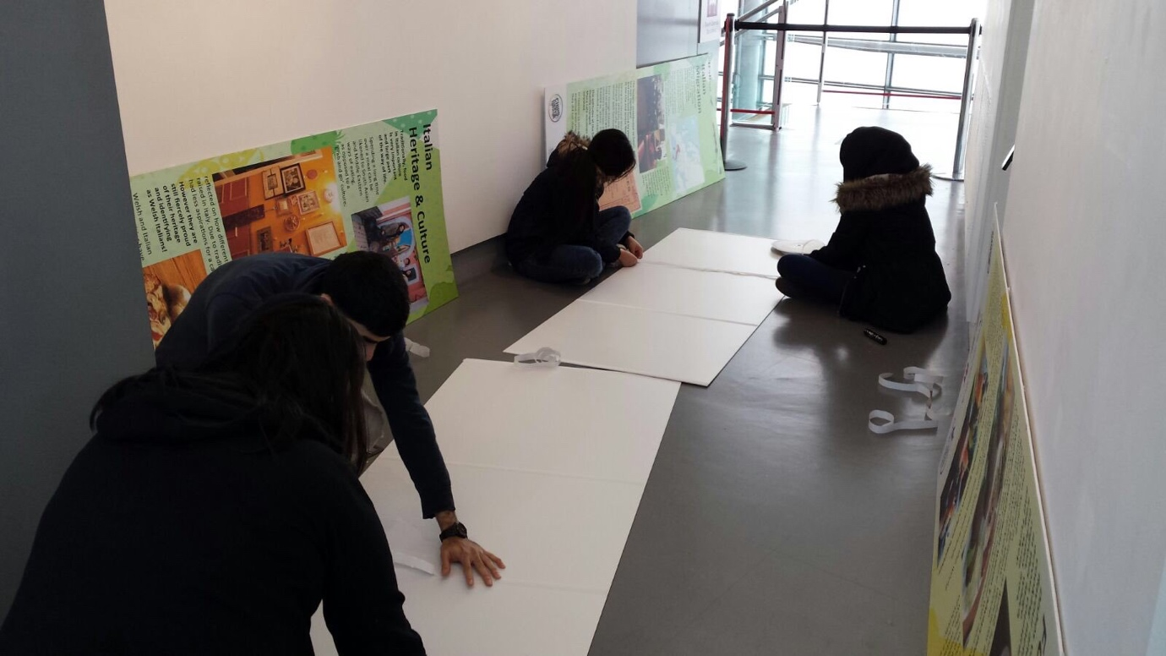
The CCC project completed with a mobile exhibition held in the National Waterfront Museum, individuals who participated in the project including me set up the exhibition alongside staff who worked in the national waterfront museum helped us.

We had to put panels together and up, display objects that were collected from those who were interviewed and individuals who were in the CCC project too and have a television fitted to present our video.

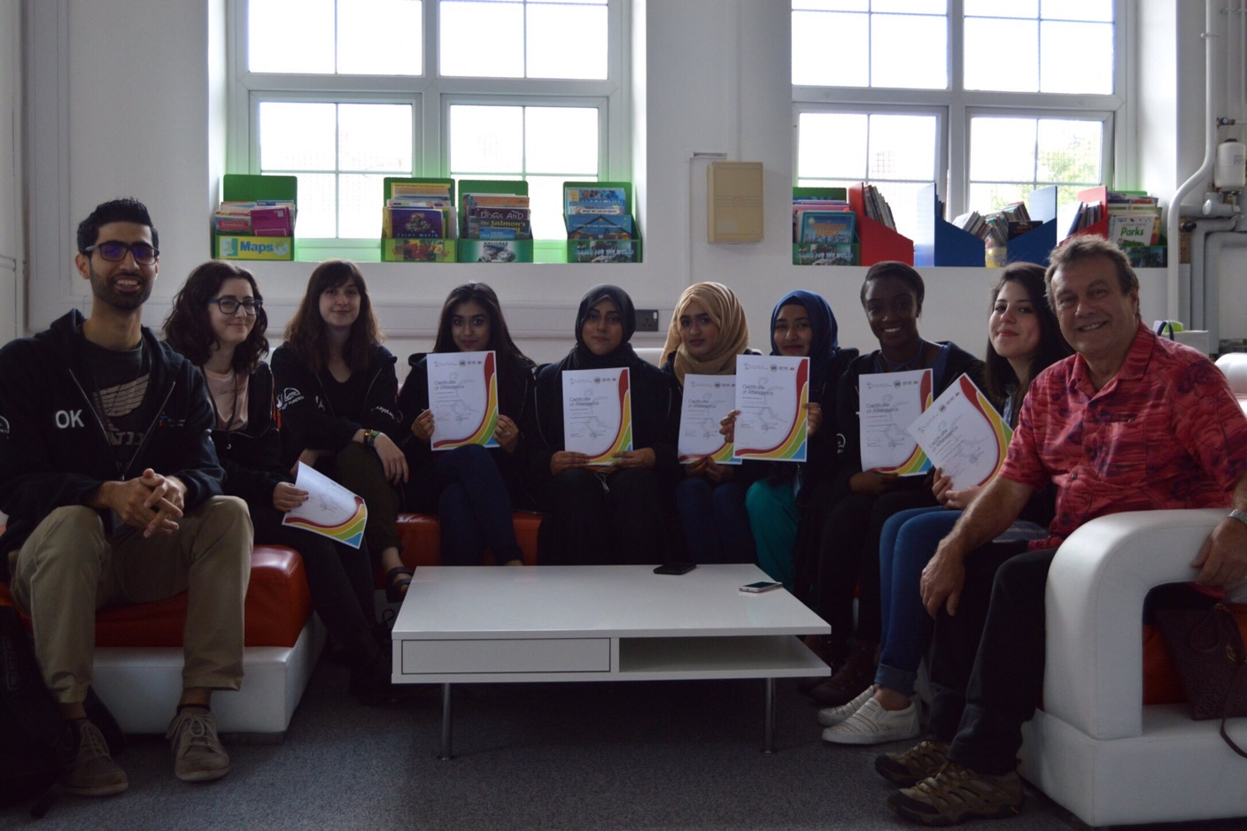

Above is an image taken in the National Waterfront Museum where we were given our Certificate of Attendance for producing the CCC project.

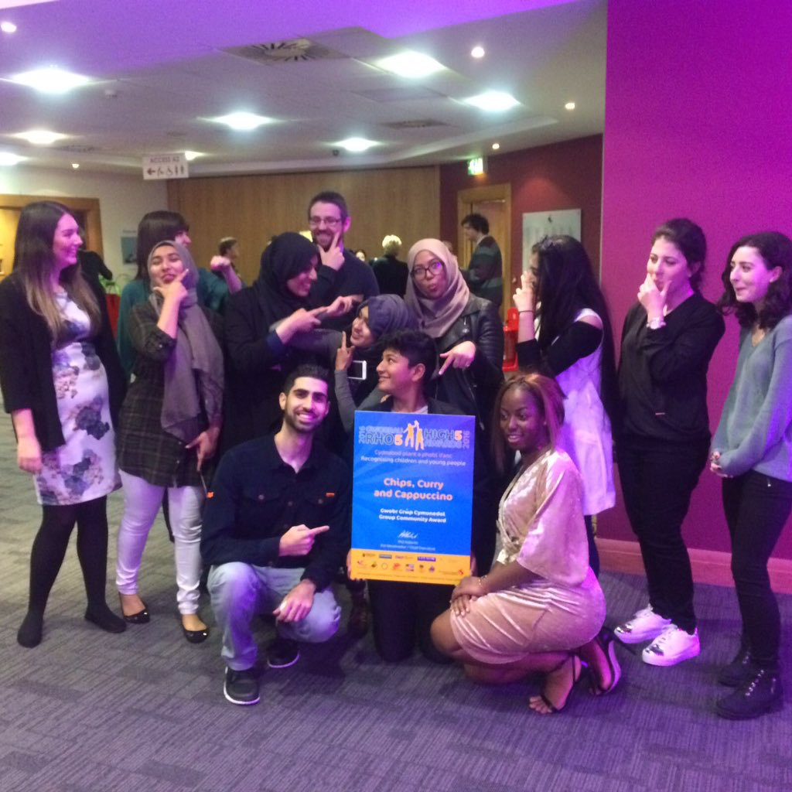

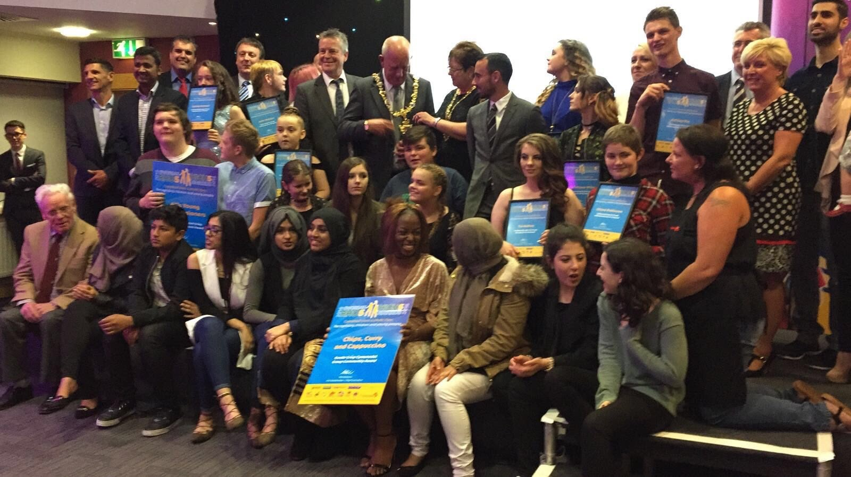

The CCC project was then an award-winning project that got recognised by the High Five Awards, we also won a Canon camera as a gift from High Five Awards. We were presented the Awards by Leon Britton ex Swansea football player and The Mayor.

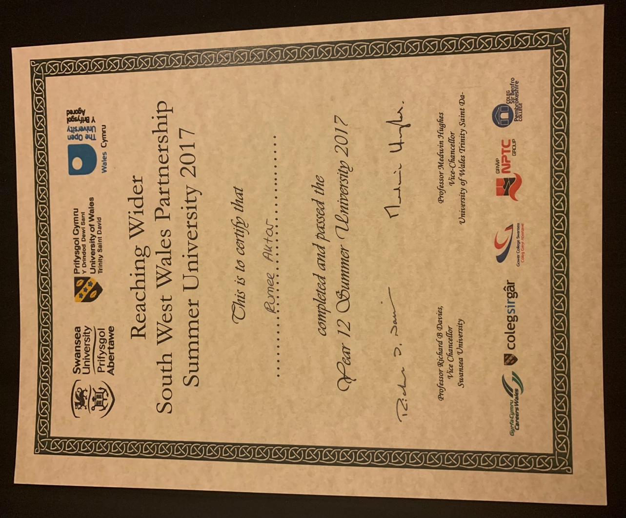

Above is a certificate and image that shows that I completed and graduated in Summer University. Summer University was a three-week intense programme that involved choosing a module producing Essays and presentation using in university format and using the APA referencing.

Rumee Aktar (13/02/2000)

82 Aberdyberthi Street,

Swansea,

SA1 2NH

Tel: 07778575887

01792447943

Email: Rumeeaktar15@hotmail.com
Multilingual: English, Bengali, Urdu, Welsh

Personal Profile
I am an enthusiastic person that has a lot of skills to offer to you or your company. I am a motivated and eager person and can't wait to start. I am an easy person to communicate to and I give my best to anyone I work for and with. I am currently studying at the University of Wales Trinity Saint David's doing a HE course in Nursing Studies and Health. I love to give up my personal time and help other people such as volunteering work. I have gained lots of teamwork experience which has helped me work with a variety of people. I am self-motivated & organised and this is shown through the experience that I have gained. I am a fast learner and I can adapt to the company really quickly.

Education and Qualifications
2018 – Present: The University of Wales Trinity Saint David, HE in Nursing Studies and Health
Key Modules: Introduction to Health Research, Communication and Counselling, Introduction to the Physiology of the Body, Managing Organisations, Professional Academic Development, Workplace Practice.

2016 – 2018: Gower College Swansea, BTEC Level 3 Extended Diploma in Health and Social Care
- Grades achieved; D*DD

2011 – 2016: Pentrehafod Comprehensive School
- Fourteen GCSE’s including English and Maths, all A*-C grades;

GCSEs achieved:
English Language: C
English Literature: C
Mathematics: C
Applied Business Studies: BC
Religious Studies: C
Bengali: C
Science: Merit
Health and Social Care Lvl 1/2: Merit
ICT: Merit
Welsh Baccalaureate: Pass
Working with Others: Pass
Information and Communication: Pass
Application of Number: Pass
Communication: Pass

IT Skills

I am very experienced in using computer programs such as Microsoft Word, Microsoft PowerPoint, Microsoft Excel and many search engines. I have gained and developed these skills thoroughly through my studies and daily usage.
Relevant Experiences

Current – 2019 Ethnic Minorities & Youth Support Team (EYST) Swansea

Currently, I am working in Ethnic Minorities and Youth Support Team (EYST). I work in the Belonging Project and My role in the project is a belonging sessional Worker, the project involves children and young people involving in entertaining activities and working alongside many organisations and schools (EYST, 2019).

2016 – 2018: Hafod & Saint Helens Primary School

Going on placements has built and strengthened my confidence and my sensitivity to have empathy towards difficult situations. With the skills I have developed throughout my academic years, I was able to empathise with the child, making sure my attention was focused only on the child, and that I was listening carefully. The child could thus, disclose how they felt and to be confident.

10th July 2017 – 28th July 2017: Summer University Swansea

I undertook and graduated from a three-week intensive programme by Reaching Wider. I excelled in the module of Health and Social Care. Joining in this module extended my knowledge of nursing. In the module, I learned about diversity and equality, basic life support, wound management and infection control in healthcare.
I was also tested if the content that I had learned was right by giving an essay and presentation. I have passed and had gained many communication skills and a lot of confidence from attending the course.

2015 – on and off volunteer: EYST Swansea

I give up my time to volunteer at EYST (Ethnic Youth Support Team) which is a local Swansea charity that helps different ethnic people. I have a passion for helping people and giving up my time to make someone happy. Volunteering has helped me learn how to use my own initiative, how to prioritise situations as well as being able to make an appropriate, good judgment to respond to vital issues.

2014 – 2015: Project – The Chips Curry and Cappuccino

I was previously involved with a project within the youth club called Chips Curry and Cappuccino, which was an award-winning project. This enabled me to gain beneficial key skills such as communication, teamwork and respect. The young adults were able to communicate with me because of my enthusiastic personality.

References Upon Request

Action Plans SMART

Long Term Goal | Deadline for accomplishment
To Become a qualified Adult nurse | 2022/23

SMART Short Term Goal

Goal 1:
Specific | Measurable | Achievable | Realistic | Timescale
The action I want to take upon myself is to wake up early around 7:00 pm and be productive with my day. This important to me because I sleep late, and it is affecting my performance in university. | I will know I have reached this goal by seeing a difference in what chores, assignments I have completed within the time I have woken up early. | I know this task will be achievable because I will have to set myself a new routine, it may get difficult to wake up on time at the start but after a few days I feel like my body and myself will be in a systematic routine that I will need to have the urge to get out of bed. The resources that I will accomplish this task is an alarm clock, I can use my I phone to put on multiple alarms on to set myself in a good routine. There may be potential barriers that may prevent the routine from staying consistent, this is work and if I take a nap throughout the day or if I am up in the night and not getting enough seven to eight hours of sleep. My parents wake up early so they could help me to wake me up if I am oversleeping. | This goal is relevant to my long term goal because I know I will have to wake up early and attend university lecturers on time and I know half of my time will be on placement so I will need to be energised for those days, so it is important for me to start being in a routine. This goal is easy but I feel like I need to stick to it then it would not be a problem, I know I can achieve this goal realistically if I really want to change my ways and do it for when I become a nurse as I will have to have the energy to be productive and awake throughout my shifts. | I will start this action on the 4th of May and end on 3rd July. I will keep tabs and notes logged in my phone showing days I overslept and slept late. I will avoid sleeping late by switching my phone off.

Goal 2:
Specific | Measurable | Achievable | Realistic | Timescale
The task I would like to obtain is eating healthy. This is important to me as I have gastric and acid reflux so it affects my day throughout. I am going to do this by sticking a rule. | This will consist of me trying to eat healthily and avoid eating junk food. The rule will be to eat, one type of meat, one/two types of veg and one type of fat. I will know I have reached my goal as I will feel different, I will feel much lighter and energised and I would have lost some weight. | I know I will be able to achieve this goal because I will produce a timetable with a diary entry. Factors that may affect me from achieving this goal will be eating out with my family and friends or feeling lazy and frying or ordering a takeaway. I will overcome this from happening by making meal preps and storing them away. | This goal is not relevant to my long term goal but will have some impact on my performance as being a nurse because I will be a lot more energised and be very concentrated in what I am doing and not lazy. I think I can achieve this goal. However, I may face barriers such as my family ordering in food and handing it to me or if I am feeling extremely tired and I do not want to make something, so I will order in. But, I will overcome this by limiting my temptation and giving myself a cheat day, so I do not crave fatty food and sugary drinks all the time. | Set yourself an achievable time frame with set deadlines and points to check your progress. When will you start? What is the target deadline for reaching this goal?  I have set myself an achievable time frame which is 4th May till August. I will keep checking in my progress by weighing myself as it will fluctuate.

Goal 3:
Specific | Measurable | Achievable | Realistic | Timescale
The task I want to do is finish my assignments off. This is important to me as it will impact on if I go on to do the Nursing Degree Course as I need a Pass.  I am going to do this by producing a timetable sheet and slotting down my availability. | I know I will have reached this goal because I would have submitted before the deadline date and got on to the adult nursing course. | I know I will be able to achieve this goal if I sit down and give myself a few hours without any distractions. I may need some help to achieve some assignment as I may struggle with them, so I will have to contact with friends from the course and contact my lecturer from the module. | This goal is relevant and fits my long term goal because if I do not pass this course I will not get into my chosen university and into adult nursing. This goal will be quite difficult but with some help and guidance, I think I can pass these assignments and pass the course. | My deadline date is on the 3rd of May so I have three weeks starting on the 8th of April 2019. I will keep track of my assignment and time by seeing how much work I have done within each week.

Journal Entries

I was in EYST for seven weeks for my placement and I completed 36 hours and 14 minutes.

Week one and two I had an introduction day where I was gone through policies and procedure of how the organisation runs. I was introduced to all the staff members and reassured if I needed anything to ask. I was put in the front office from 10 am till 1 pm. Then 2 pm till 5pm/6pm I was with children and young people aged 10-18. In the mornings I was in front desk where I had to greet and help clients to what they needed so I could link them with a staff or book an appointment with the two staff members who deal with asylum seekers and refugee support for them. I had to answer calls and transfer them to staff members if they were requested. In the afternoon I was greeted by the belonging project worker, he gave me a quick run through in what I had to do. I had to go and interact with children and young people and do activities with them.

Week three and four was different, I was on the front desk till 11 am and then I had two shadows to volunteers that provide employment support to clients among many other things such as housing support. Some of the clients were Bengali speakers so they would not understand clearly what was being discussed and the decision they are making, so I had to be their interpreter to translate information correctly, so they knew what arrangements they were agreeing on. In the afternoon in the drop in county lines came in to talk to children and young people about drug abuse and gangs, then had a discussion if they knew what they would do if they knew someone was doing drugs (South Wales Police, 2019).
Week five Swansea Mind came into the mixed drop in to teach young people how to improve they are mental and teach them some techniques because exam season is approaching (Swansea Mind, 2019). Week six the young people had a mental health talk and how they can find solutions to improve their mental health (Time to Change, 2019). Week seven a lady came into talk to the young girls about body image and how it impacts individuals, we had to discuss things we liked and disliked about ourselves and how media has an effect on teenagers (Oakes, 2019).
Work Experience

The model of reflection that I will be using to reflect back on my placement experience is Kolb’s Learning Theory 1984 cited in Bergsteiner et al (2010).

The first step of Kolb’s learning theory is to experience something or to do something (Muscat and Mollicone, 2013).

During my placement, in the morning times I would be at the office in the front desk helping clients with their needs as I was their first place to contact the rest of the team, I had to have a conversation with them even though there were difficulties with the language barrier, but I was able to communicate using my hand gestures and body language I had to book and make appointments and answer the telephone (King, 2015). In the afternoon, I was in the drop-in centre where I had to work with children ages 10-18. I had to walk around and interact with them casually, there would be some workshops on, so I had to settle them down and then at the end of the session provide evaluation forms and make each of them fill them out.

The second step of Kolb’s Learning theory is to reflect back on what you have done (Smith and Evans, 2006).
When I was in the office at the front desk I felt quite nervous and overwhelmed my anxiety was kicking in as I thought I would not be able to help clients. Further, I felt extremely nervous to answer the telephone and then transfer as I was not to use to it. When I was in the drop-in centre in the afternoons, I felt quite uncomfortable as they were older teenagers, so I thought I would not be able to connect with them. However, my communications skills helped me interact with them and my bubbly personality helped make them open up to me and speak to me in confidence.

The third step of Kolb’s learning theory is learning from the experience, and making new concepts (Allan, 2016).
Things that I would do differently is to have an open mind to it without thinking I cannot do something, I will use my skills that I have developed previously in my placements, so I can get more use out of my placements without struggling. I will overcome my nervousness by reassuring and talking to staff members on how to minimise my anxiety.

The last step of Kolb’s learning theory is putting the ideas in the experience (Bell and Morse, 2003).
I will not think negative about myself when doing something and thinking I cannot do something, I will do this by having a positive mindset and going in with a positive attitude. I will use my sets of skills that I have developed previously by initiating myself and reminding myself that I am capable of talking to individuals who cannot communicate by with me verbally, so I could show them non-verbally using hand motions (Collins et al, 2011) and I will overcome my nervousness by talking beforehand with my supervisor which will have an impact on my performance.
Overall, I feel like this experience has given me an insight on how nursing will feel like as I will be facing people whose first language is not English and having to handle a variety patient.

Write up from my Placement Supervisor
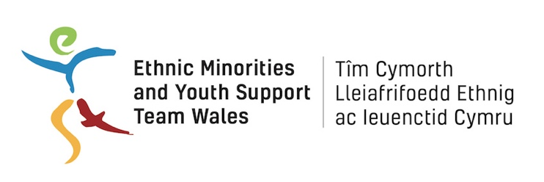
Unit C,
11 St. Helen’s Road,
Swansea
SA1 4AB

Date: 01/05/2019

Dear whom it may concern,

I am writing to provide a reference for Rumee Aktar. Rumee has completed her placement with Ethnic Minorities & Youth Support Team (EYST Wales) over the past few months. Rumee started her placement on the 27th February 2019 and has completed just over 36 hours at EYST. During Rumee’s placement, her role involved working with young people and adults, primarily from an ethnic minority background.

During her placement, Rumee worked with young people, aged 10-18 years old, as part of our youth drop-in service. Primarily, she worked on the ‘Belonging' project which supports young people, aged 10-18, from an ethnic minority background. She facilitated activities and workshops from a range of partnership organisations, including: MIND – relaxation techniques, South Wales Police – County Lines awareness, and Terrence Higgins Trust – Body Image workshop with young females. Rumee also engaged young people in activities and encouraged them to socialise with each other in the drop in space.

During the day time hours, Rumee worked on the front desk to ensure a smooth running front of house. During her role on the front desk, she would often support asylum seekers and refugees accessing support and advice through our Asylum Seeker and Refugee Support project. Rumee would be the first contact for a client on the front desk, where often she would be faced with a language barrier, to find out what support we could provide to match the clients need. She made appointments and phone calls for clients based on their need. She also interpreted, Rumee is a Bengali speaker, some of our client’s issues when accessing employment support with our volunteers. Rumee supported those experiencing a language barrier very well and she always treated those facing this barrier with patience, dignity and respect.

Rumee also completed induction training on the 27th February 2019 to ensure that she was prepared for her role before starting and also to familiarise herself with confidentiality, boundaries and safeguarding whilst involved in her placement at EYST. Rumee complied with all of EYST’s policies and procedures during her placement.

It has been a pleasure to host Rumee’s placement at EYST and as a result of her natural talents she has been recruited by EYST in a youth worker role. We are really looking forward to seeing her develop in a paid role at EYST – she will be a great asset to the time as she has already displayed fantastic qualities when working with vulnerable people.

If you require further information please do not hesitate to get in touch via email jami@eyst.org.uk or telephone 01792 466980.

Yours sincerely,

Jami Abramson
Volunteer Co-ordinator

Hours Completed
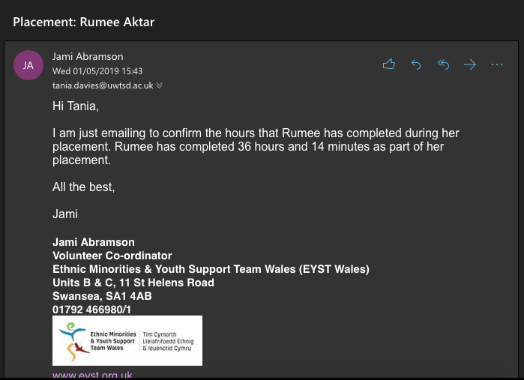

It is evident in the screenshot above that I have completed 36 hours and 14 minutes. I was not able to complete the full 60 hours as I was off ill for three days because of my health problems. I could not make up the time as my placement was for 10 weeks block only and I then I got offered a job and it would affect my role while working with clients then children and young people.

References:
Allan, B. (2016) Emerging Strategies for Supporting Student Learning. London: Facet Publishing.

Bell, S. and Morse, S. (2003) Measuring Sustainability. London: Earthscan. Available at: https://www-dawsonera-com.salford.idm.oclc.org/readonline/9786000002428 (Accessed 3rd May 2019)

Bergsteiner, H., AveryAvery, C. G. and Naumann, R. (2010) Kolb's experiential learning model: critique from a modelling perspective. Studies in Continuing Education. 32 (1) pp. 29 – 46. Available at: https://www-tandfonline-com.salford.idm.oclc.org/doi/full/10.1080/01580370903534355?scroll=top&needAccess=true (Accessed 3rd May 2019)

Collins, G. L., Schrimmer, A., Diamond, J. and Burke, J. (2011) Evaluating verbal and non-verbal communication skills, in an ethnogeriatric OSCE. Patients Education and Counseling. 83 (2) pp. 158 – 162. Available at: https://www-sciencedirect-com.salford.idm.oclc.org/science/article/pii/S0738399110003046 (Accessed 3rd May 2019)

Ethnic Minorities and Youth Support Team. (2019) The Belonging Project. Available at: http://eyst.org.uk/project.php?s=the-belonging-project (Accessed 28th April 2019)

King, R. (2015) Communication Skills. Nursing Standard. 29 (50) pp. 61 – 62. Available at: https://journals-rcni-com.salford.idm.oclc.org/doi/full/10.7748/ns.29.50.61.s44 (Accessed 3rd May 2019)

Muscat, M. and Mollicone, P. (2013) Using Kolb’s Learning Cycle to Enhance the Teaching and Learning of Mechanics of Materials. Manchester University Press. 40 (1) pp. 66 – 78. Available at: https://journals-sagepub-com.salford.idm.oclc.org/doi/pdf/10.7227/IJMEE.40.1.10 (Accessed 3rd May 2019)

Oakes, K. (2019) The Complicated Truth about Social Media and Body Image. Available at: http://www.bbc.com/future/story/20190311-how-social-media-affects-body-image (Accessed 3rd May 2019)

South Wales Police. (2019) County Lines Criminality. Available at: https://www.south-wales.police.uk/en/advice/county-lines-criminality-drug-dealing-exploitation-vulnerable-people/ (Accessed 3rd May 2019)

Swansea Mind (2019) Welcome to Swansea Mind. Available at: http://www.swanseamind.org.uk (Accessed 3rd May 2019)

Time to Change. (2019) Opening up to Mental Health. Available at: https://www.time-to-change.org.uk/talk-about-mental-health/telling-someone-about-your-mental-health-problem (Accessed 3rd May 2019)

University of Wales Trinity of Wales. (2019) Certificate of Higher Education in Nursing Studies and Health. Available at: https://www.uwtsd.ac.uk/cert-he-nursing-studies-health/ (Accessed 28th April 2019)

