

MENTAL DISORDERS AND PSYCHOPATHOLOGY
BMH 6006
ASSESSMENT 1
Topic – Disturbance of activity and attention – ADHD- (F90.0-ICD-10).
SUPPORTING PAPPER

Lecturer name : Bianca Filippo
Student name: Yuliana Abadzhieva
Student ID:1818406
Submission date:21/08/2023-2:00pm.
Introduction
The ICD-10/F90.0 diagnosis of Attention Deficit Hyperactivity Disorder (ADHD) will be covered in this supplementary article. All ages are affected by the neurodevelopmental condition known as ADHD, which is frequently accompanied by impulsivity, hyperactivity, and inattention. According to estimations in children and adolescents, it has a 5% to 7% global frequency and is one of the most common mental conditions among youngsters. (Polanczyk et al., 2014).
The reasons for ADHD are complex and include both inherited and environmental factors, according to the study. Studies have shown numerous possible genes associated with ADHD susceptibility, highlighting the significance of neurotransmitter systems like dopaminergic and noradrenergic pathways in the disorder's pathophysiology.
(Thapar et al., 2013).

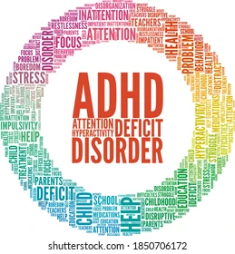

Definition of the disorder

ADHD (Attention-Deficit/Hyperactivity Disorder) is a neurodevelopmental disorder described by a recurrent pattern of inattention and hyperactivity-impulsivity that impairs day-to-day functioning and development. People with ADHD usually struggle to maintain focus, control impulsive behaviours, and control hyperactivity in academic, professional, and social environments. (American Psychiatric Association, 2013).
One of the most common juvenile psychiatric disorders, ADHD, is considered to affect 5% to 7% of children and adolescents globally. Difficulties focusing, missing details, and being easily distracted are all signs of ADHD inattention. Among the symptoms of hyperactivity and impulsivity are fidgeting, trouble sitting still, interrupting others, and making rash decisions (Polanczyk et al., 2014).
Even though the exact cause of ADHD is not fully understood, research suggests a complicated interaction between hereditary and environmental factors. Heritability estimates from twin and family studies, which have a substantial genetic component, range from 70% to 80% (Faraone et al., 2005). Neuroimaging studies have discovered structural and functional alterations in the brains of patients with ADHD in regions related to attention, impulse control, and executive functioning. (Cortese et al., 2012).

Classification within the ICD-10
ADHD is classified as a neurodevelopmental disorder in the ICD-10 (International Classification of Diseases, 10th Revision). The ICD-10 gives a systematic framework for diagnosing and classifying medical issues, including mental health conditions like ADHD. (World Health Organisation, 1992).
The code "F90" in the ICD-10 designates ADHD specifically, and it is broken down into three subtypes:
- F90.0 - Hyperkinetic syndrome (disturbance of activity and attention): This subtype primarily includes signs of impulsivity and hyperactivity-inattention.
- F90.1 - Hyperactive Conduct Disorder: This subtype comprises conduct disorder behaviours and hyperactivity-impulsivity symptoms.
- Other hyperkinetic disorders, or F90.8, are cases that exhibit vital signs of hyperactivity and attention issues but do not entirely fit the criteria for the prior categories.
The classification system of the ICD-10 makes it simpler for medical professionals and academics to detect and study ADHD using approved criteria systematically. The World Health Organisation (1992) provided classification standards for ADHD inside the ICD-10. The ADHD diagnosis code "F90" is divided into various subcategories, such as "F90.0 - Disturbance of activity and attention (hyperkinetic syndrome)," "F90.1 - Hyperactive conduct disorder," and "F90.8 - Other hyperkinetic disorders." This classification aids in the identification and better understanding of ADHD by medical professionals and academics. (World Health Organisation, 1992).

Data related to ADHD.

- When examining data on ADHD, age is a crucial factor. Children are frequently diagnosed with the illness, and the prevalence rates change with age.
- Research indicates that ADHD, one of children's most common neurodevelopmental illnesses, affects 5–10% of kids worldwide.
- According to the Centres for Disease Control and Prevention (CDC), 6.1 million kids (9.4% of kids between the ages of 2 and 17) in the UK had been diagnosed with ADHD as of 2016.
- Additionally, efforts to gather data focus on discovering more about how ADHD is identified. This procedure includes assessing healthcare providers' methods and guidelines to arrive at the diagnosis (Russell et al. 2013).

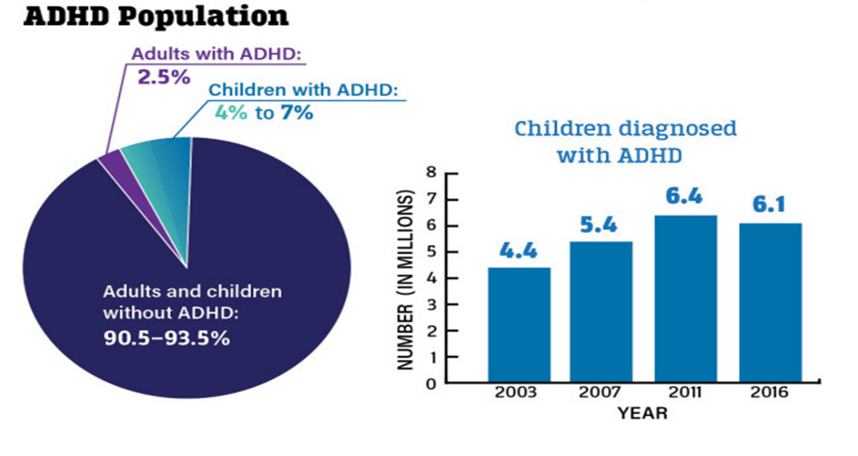
Symptoms of ADHD
According to the American Psychiatric Association, the signs of ADHD (Attention-Deficit/Hyperactivity Disorder) can be loosely divided into two categories: inattention and hyperactivity-impulsivity. (2013).
Inattentiveness signs:
Focus Issues: People with ADHD usually struggle to focus on tasks, especially those requiring extended mental effort.
Making Careless Errors: They may frequently make errors due to their urge to focus on details or finish tasks fast.
Problems with task organisation: People with ADHD may struggle to plan and organise their activities, tasks, and assignments.
Avoiding Mentally Demanding Jobs: People frequently avoid or put off jobs that call for sustained mental effort since it can be challenging to pay attention. Forgetting everyday tasks, appointments, and duties regularly is frequent.
Misplacing or losing daily needs like keys or school supplies is typical.
Symptoms of hyperactivity and impulsivity:
Excessive Fidgeting or Restlessness: Hyperactivity shows up as persistent restlessness or difficulty sitting motionless.
Inability to Remain Seated: In situations like meetings or classes, where sitting still is needed, people with ADHD may find it challenging to maintain their position.
Children may run or climb in inappropriate places, such as indoors or in busy situations.
Having Trouble Playing Quietly: People with ADHD frequently struggle to play quietly during leisure activities.
Interrupting or Intruding on Others: Impulsivity might interfere with other people's games, talks, or activities.

Difficulty Waiting for Turns: People with ADHD may find waiting their turn in talks, games, or other situations difficult.

Diagnosis with ADHD
Whether a person is diagnosed with ADHD as an adult or youngster, it can completely change their life. The diagnosing procedure frequently entails a thorough examination by a medical expert. The evaluation involves carefully reviewing each patient's symptoms, medical background, and family history. Numerous people utilise medications to manage their symptoms and preferences. Medication is not the only method for managing ADHD. Undoubtedly, CBT is a type of behavioural therapy. (Anon, 2023).

Historical treatments and overview
Similar ADHD symptoms were previously documented in the 18th century.
Researchers hypothesised that neurological dysfunction was the primary cause in the middle of the 20th century. Several drugs were created and improved during the ensuing decades to address the symptoms of ADHD. Methylphenidate, also called Ritalin, emerged as an ADHD stimulant drug in the 1990s. Treatments for ADHD include behavioural therapy, psychoeducation, medication, and medication. (Mahone and Denckla,2017).

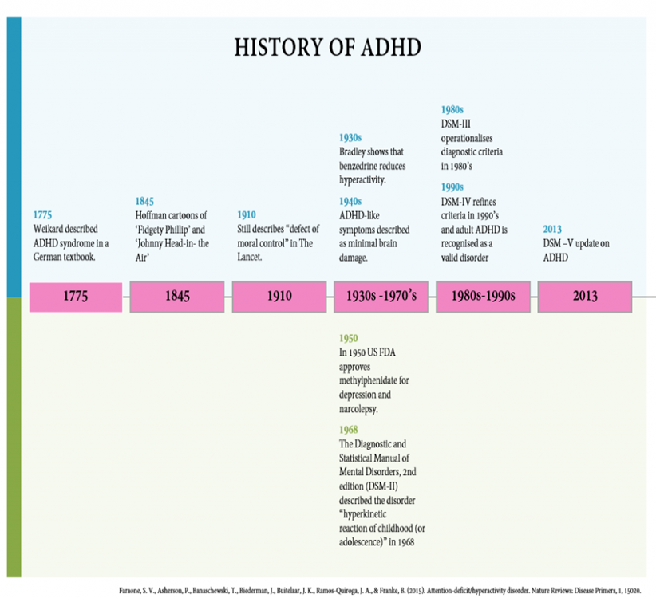

Current treatments of ADHD in UK.
Behaviour Modification:
The goal of behavioural therapies is to change the behaviours connected to ADHD. These may consist of:
A form of counselling called behavioural therapy assists persons with ADHD to learn to manage their symptoms, get more orderly, and rein in their impulse (Sonuga-Barke et al., 2020).
Parent Training: According to Daley et al. (2018), parents are given instructions on how to manage their child's behaviour, establish routines, and employ techniques for positive reinforcement.
Psychoeducation: The process of informing individuals about ADHD and how to manage it is known as psychoeducation. This can make it simpler for those who are ill and their families to understand the condition and how to cope with its challenges.
Medication:
Stimulant medications: Methylphenidate and amphetamines are two common stimulant medications used to treat ADHD symptoms. Increasing the concentration of neurotransmitters in the brain enhances concentration and restraint. (McCarthy et al., 2021).

Non-Stimulant Drugs: Non-stimulant medications like atomoxetine may be administered to those who do not respond well to stimulants or who have medical issues that make them contraindicated. (Gillies et al., 2018).
Combination of Treatment: In some cases, a combination of behavioural therapy and medications is indicated to give complete symptom treatment (Molina et al., 2020).

Analyse of the positive and negative treatments available for ADHD disorder.
Positive Effects of ADHD Treatments:
Effectiveness of Medication: Stimulant medications, such as methylphenidate and amphetamines, are effective in reducing the signs and symptoms of ADHD, especially in improving attention and impulse control. (McCarthy et al., 2021).
Behavioural Interventions: According to Daley et al. (2018), parent education and behavioural treatment can provide individuals and their families valuable strategies for controlling symptoms and improving functioning. People may receive the tools from these therapies to enhance their coping mechanisms and quality of life.
Negative Aspects of Treatments for ADHD:
Stimulant medications may have adverse effects such as decreased appetite, difficulty sleeping, and an elevated heart rate. (McCarthy et al., 2021).
Long-Term Success: Although medication can reduce symptoms dramatically over the short term, there are doubts about its long-term effectiveness, mainly when used as the sole therapy method. (Molina et al., 2020).

Policy and Legislations (Mental Capacity Act 2005).
A statute that helps to safeguard people who might have trouble making their own decisions is the Mental Capacity Act of 2005. Since persons with ADHD occasionally have difficulty making decisions, it is related to ADHD disorder. The proper application of this regulation ensures that these people receive just treatment and have their rights upheld. When people must make important decisions, it is advantageous to have direction and aid. (UKGovernment,2005).

Principles of care when working with people with ADHD.
Understanding and Recognising: Understanding the nature of ADHD is necessary for providing adequate care. Think of concentration, impulse control, and hyperactivity problems as symptoms of ADHD, a neurodevelopmental illness (American Psychiatric Association, 2013). Recognise that neurobiological variances rather than deliberate destructive behaviours are to blame for these challenges.
Behavioural interventions: Include research-backed behavioural strategies that support the development of practical coping mechanisms for people living with ADHD. Coaching and behavioural therapy can improve adaptive behaviour, impulse control, and attention. (Sonuga-Barke et al., 2020).

Conclusion
In summary, there has been a significant breakthrough in understanding and treating ADHD. The history of ADHD therapies ranges from ancient ideas of moral inadequacy to modern evidence-based therapy, illustrating the ongoing endeavour to comprehend this complex disorder better and treat it. As research into the origins of ADHD advances, it is imperative to approach therapy from a complete, multidimensional viewpoint that considers biological and psychological aspects. (Hasan, 2018).

Recommendation
Prioritise patient-centred care by actively involving people with ADHD in goal setting and decision-making. When developing interventions, please consider their preferences and values.
Long-Term Outlook: Recognise that ADHD is a chronic disorder and assist people in creating coping mechanisms they can use well into adulthood. Encourage the development of independence and self-control abilities. (NHS, 2019).

Organisations/websites
- https://www.bing.com/ck/a?!&&p=8372d2ee9d972b5eJmltdHM9MTY5MTk3MTIwMCZpZ3VpZD0zYjVjYThjNi1jYjdmLTY1ZjQtMjdiMS1iOTFkY2E0NzY0MjMmaW5zaWQ9NTIwNA&ptn=3&hsh=3&fclid=3b5ca8c6-cb7f-65f4-27b1-b91dca476423&psq=Organistions+for+supporting+ADHD&u=a1aHR0cHM6Ly93d3cubWluZC5vcmcudWsvaW5mb3JtYXRpb24tc3VwcG9ydC90aXBzLWZvci1ldmVyeWRheS1saXZpbmcvYWRoZC1hbmQtbWVudGFsLWhlYWx0aC8&ntb=1.
- https://www.bing.com/ck/a?!&&p=878460868fa6989dJmltdHM9MTY5MTk3MTIwMCZpZ3VpZD0zYjVjYThjNi1jYjdmLTY1ZjQtMjdiMS1iOTFkY2E0NzY0MjMmaW5zaWQ9NTIzMQ&ptn=3&hsh=3&fclid=3b5ca8c6-cb7f-65f4-27b1-b91dca476423&psq=Organistions+for+supporting+ADHD&u=a1aHR0cHM6Ly93d3cuYWRoZGZvdW5kYXRpb24ub3JnLnVrLw&ntb=1.

Reference list
American Psychiatric Association. (2013). Diagnostic and statistical manual of mental disorders (5th ed.). Arlington, VA: American Psychiatric Publishing.
Anon, (2023). Diagnosis Pathways | ADHD UK. [online] Available at: https://adhduk.co.uk/diagnosis-pathways/ [Accessed 11 Jul. 2023].
Cortese, S., Kelly, C., Chabernaud, C., Proal, E., Di Martino, A., Milham, M. P., & Castellanos, F. X. (2012). Toward systems neuroscience of ADHD: A meta-analysis of 55 fMRI studies. American Journal of Psychiatry, 169(10), 1038-1055.
Daley, D., van der Oord, S., Ferrin, M., Danckaerts, M., Doepfner, M., Cortese, S., ... & Sonuga-Barke, E. J. S. (2018). Behavioral interventions in attention-deficit/hyperactivity disorder: A meta-analysis of randomized controlled trials across multiple outcome domains. Journal of the American Academy of Child & Adolescent Psychiatry, 57(3), 165-177.
Gillies, D., Sinn, J. K. H., Lad, S. S., Leach, M. J., & Ross, M. J. (2018). Polyunsaturated fatty acids (PUFA) for attention deficit hyperactivity disorder (ADHD) in children and adolescents. Cochrane Database of Systematic Reviews, 10, CD007986.
Hasan, S. (2018). ADHD (for Parents). [online] Kidshealth.org. Available at: https://kidshealth.org/en/parents/adhd.html [Accessed 14 Jul. 2023].
Mahone, E.M. and Denckla, M.B. (2017). Attention-Deficit/Hyperactivity Disorder: A Historical Neuropsychological Perspective. Journal of the International Neuropsychological Society, [online] 23(9-10), pp.916–929. doi:https://doi.org/10.1017/s1355617717000807.
Molina, B. S., Hinshaw, S. P., Swanson, J. M., Arnold, L. E., Vitiello, B., Jensen, P. S., ... & Hechtman, L. (2020). The MTA at 8 years: Prospective follow-up of children treated for combined-type ADHD in a multisite study. Journal of the American Academy of Child & Adolescent Psychiatry, 59(2), 192-201.
McCarthy, S., Wilton, L., Murray, M. L., Hodgkins, P., Asherson, P., Wong, I. C. (2021). The epidemiology of pharmacologically treated attention deficit hyperactivity disorder (ADHD) in children, adolescents, and adults in UK primary care. BMC Pediatrics, 21, 10.
NHS (2019b). Treatment - attention deficit hyperactivity disorder (ADHD). [online] NHS. Available at: https://www.nhs.uk/conditions/attention-deficit-hyperactivity-disorder-adhd/treatment/ [Accessed 14 Jul. 2023].

Polanczyk, G., de Lima, M. S., Horta, B. L., Biederman, J., & Rohde, L. A. (2014). The worldwide prevalence of ADHD: A systematic review and meta regression analysis. American Journal of Psychiatry, 164(6), 942-948.
Russell, G., Rodgers, L.R., Ukoumunne, O.C. and Ford, T., 2014. Prevalence of parent-reported ASD and ADHD in the UK: findings from the Millennium Cohort Study. Journal of autism and developmental disorders, 44, pp.31-40.
Sonuga-Barke, E. J. S., Brandeis, D., Cortese, S., Daley, D., Ferrin, M., Holtmann, M., ... & Dittmann, R. W. (2021). Nonpharmacological interventions for ADHD: Systematic review and meta-analyses of randomized controlled trials of dietary and psychological treatments. American Journal of Psychiatry, 178(4), 281-295.
Thapar, A., Cooper, M., Eyre, O., & Langley, K. (2013). What have we learnt about the causes of ADHD? Journal of Child Psychology and Psychiatry, 54(1), 3-16.
UK Government (2005). Mental Capacity Act 2005. [online] Legislation.gov.uk. Available at: https://www.legislation.gov.uk/ukpga/2005/9/contents [Accessed 11 Jul. 2023].

