Mankind
As he walked down the cracked street, fallen into disrepair from years of being sun scorched, he pondered the meaning of these last seven years. Rows of houses on either side were derelict, their jagged windows like mouths, waiting to consume this last soul. The man walked barefoot, carrying himself towards nothing. He reflected on his survival- asking himself the same questions over and over. When you’re the last man alive, there’s not much else to do except survive and reminisce.
A gaunt animal loped into the road. Its skin clung to its bones and its mouth foamed. What once may have passed for a family pet snarled at the man, hungry. The man backed away but let out a yell of pain as his foot sunk on to an overlooked rusty nail. The dog darted close and sunk its cracked yellow teeth into the flesh of his arm. He plunged his scavenged blade into its neck, the dog’s jaw locking in its death throes. Collapsing onto the twisted pavement, his vision clouded as darkness claimed him.
He awoke, his fever burning with a fierce heat he had not felt since he was young. He decided to comb the nearest house for medical supplies. Coming to the master bedroom, before he even opened the faded door, he was hit by a powerful smell of decay. The mummified body of a man lay across the yellowing linen. In one hand there was clutched an old service revolver. He found that it was loaded, and swiftly embraced his fate- he would not recover from the rabid wound he had received. A quick death is more than a man could hope for in this dying world. Pointing the barrel to his temple, the man gave a dry chuckle punctuated by a painful cough and uttered a single word before pulling the trigger.
“Extinction.”
Bedouin’s Idol
Yet again I have completed my pilgrimage- but for what purpose I know not. This Temple to which we trek for weeks through the harsh desert offers very little relief from the dominating sun. Yet we all still come here twice a year to offer some of our number as sacrifices. I have never seen another person’s face; which makes the killings easier, but I must wonder do the others feel the same way I do? Do they question why? No one has ever even seen this being to which we give our brethren’s lives.
Shifting the small wooden statuette between my armoured fingers, I ponder its bizarre visage. Despite our people’s heavy mantled environmental suits, and our traditional greens, beiges and faded reds that we swaddle ourselves in, I am certain that this creature to which I am supposed to pray bears no likeness to anything on this planet. I am tired of these constant journeys, I long for a reward for my devotion, or at least a reprieve. That is if this idol’s muse even exists. But if it doesn’t, what have my people been labouring and dying for all these years? I can’t even begin to entertain my culture being in vain. But, the thought of freedom is an alluring one. Adjusting the hose on my mask, to relieve some of the pressure from this boiling planet, I notice another of our number wander past, but they make no notice of me, as they never do. I wonder if they have the same treasonous thoughts as I- but I will never know. Think of what we could achieve, a society, a life! Like the days gone by- I’ve seen them, my dreams grant me such visions.
Six months later, I am ready to set off again, but my gaze turns to the ocean of sand in the opposite direction to the Temple. What lies beyond?

Wasteland
Raw wind bruises my skin,
Blank white stretches for miles.
Pulling this winter coat tighter,
I set off in no particular direction.
This frozen desert has claimed many;
Will I be its next victim?

A blizzard rages around me
But it’s nothing to the storm inside
Filling me with strength to carry on.
I am one with this glacial landscape
While its glorious snow engulfs
And swallows me whole.

Wandering ever onwards
I will my frostbitten limbs to carry on.
Though they ache and protest
I must reach my goal.
I generate heat inside my heart
And wander ever onwards

In the distance one icy temple.
My salvation from this biting hyperborean
Who chases me through Siberia,
But I’m faster, outpacing his frigid gait.
I stand outside this gelid palace;
Is this my tomb?

Rolling Bones

Pooling our resources-
I have the tobacco; he has the papers.
We find a pack of filters beneath the seat.
We are tired, barely conscious- rock blares from the radio
As midnight approaches, we roll our precious cigarettes.

The stories we tell each other while we roll, the songs we experience
Bring us together, as friends, as brothers;
The act of sharing our music, our tales and our tobacco
Is something intimate, something that is rarely experienced.

Now we have finished our creations,
Ready to enjoy the smoky fruits of our labour
A serene calm is at once shattered when,
Fags dangling from our lips,
Shock and pain washes over us;
We can’t find a lighter.

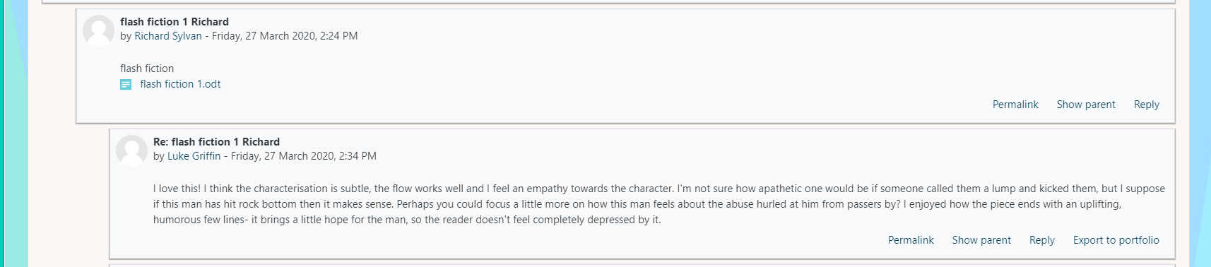
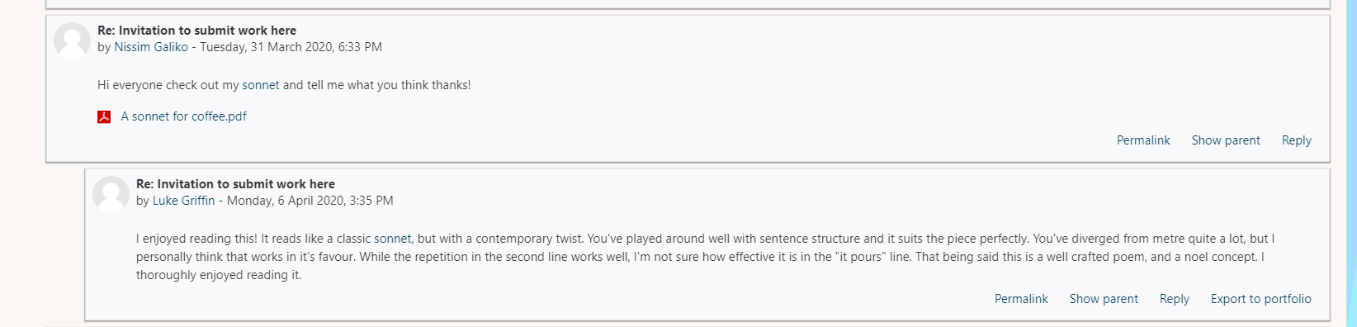
Evidence of comments on others work:

Comments on my own work:

When writing Bedouin’s Idol I originally wrote a more self-reflective monologue, however this didn’t show the isolation the character felt well enough, so I took on board some advice and decided to show an interaction between the Bedouin and another of their number. Through this I think I displayed some further aspects of their character that I previously could not. I liked this piece for one reason- its semi-allegorical nature allowed me to explore the duality of religion and its place in culture, however I wish I could have expanded it slightly in order to explore some further aspects of the society I have created, perhaps linking it to our own.

For Rolling Bones I drew on a few real-life experiences to craft a poem from the heart. To do this I envisioned the event the poem portrays and tried to recreate it as vividly as possible. I’m sure many people like me have experienced similarly the unfortunate ironic twist at the end, and I purposefully wrote this in order to allow my target audience to relate to my poem. I think the use of rhyme could improve this poem, but I’m not sure whether that would make it feel less real if I had, and I think I could have made better use of structure if I tried.

