

UNIVERSITY OF WALES TRINITY SAINT DAVID
Master of Business Administration (MBA)
MODULE: STRATEGIC MANAGEMENT (LCMB7003)

ASSESSMENT COMPONENT: INDIVIDUAL REPORT
Strategic Evaluation of Tesla's Electric Vehicle Business in the United States: Enhancing Competitive Advantage

Prepared for the Board of Directors
Role: Strategic Management Consultant

Student Name: Prahar Sunilbhai shah
Student ID: 2528026
Word Count: Approximately 5,000 words
Submission Date: 17 July 2026
Lecturers: Amare Desta (London) / Ejike Udeogu (Birmingham)

Table of Contents
Table of Contents 1
Section 1: Strategic Analysis and Recommendations 1
1. Organisational Context and Overview 1
2. External and Internal Analysis 1
2.1 External Environment: PESTEL Analysis 1
2.2 Internal Environment: VRIO Analysis 1
2.3 SWOT Analysis 1
3. Comprehensive and Holistic View of the Organisation 1
3.1 Corporate Social Responsibility (CSR) Strategy and Alignment 1
3.2 Balanced Scorecard Analysis 1
4. Strategic Choices and Implementation 1
4.1 Strategic Choices at the Business Level 1
4.2 Recommended Strategy and Validation 1
4.3 Implementation: Delivering Optimum Performance and Competitive Advantage 1
4.4 Potential Challenges and Mitigation Solutions 1
Section 2: Reflective Account 1
Description 1
Feelings 1
Evaluation 1
Analysis 1
Conclusion 1
Action Plan 1
References 1

Section 1: Strategic Analysis and Recommendations

1. Organisational Context and Overview
Tesla, Inc., founded in 2003, and located in Austin, Texas, is an established company that has become the leader in electric vehicle production all over the world, especially in the United States market. This paper is dedicated to Tesla's EV business operations in the United States. It is justified due to the fact that the US is the biggest and the most significant country for Tesla's sales with approximately 35-40% of global deliveries in the recent years, presence of Gigafactories in the country such as Texas and Nevada and dynamic policy environment of the US influenced by the Inflation Reduction Act and its legislative amendments (Tesla, 2026; Cox Automotive, 2026). Moreover, the US offers rich and transparent information about business operations due to SEC reports and serves as the example of intensive rivalry between traditional car makers trying to move towards electric vehicles and newcomers into this niche.
The mission statement of the company is defined as the acceleration of the world's transition to sustainable energy. Its vision includes the creation of "the most compelling car company of the 21st century" with the help of electric vehicles, automation and energy production systems (Tesla, 2026). The business model of the company includes vertical integration in terms of battery production, vehicle manufacturing, direct-to-consumer sales (without involvement of dealerships), own charging system and over-the-air software updates to improve products and get additional revenue streams due to FSD subscriptions.
The American automotive industry experienced tremendous changes, especially the electric vehicle subsector. The total number of new cars sold in the country reaches 16 million units, and the market share of EVs was 7-8% in 2025 (IEA, 2025; Cox Automotive, 2026). However, the leader of the American EV market is the company Tesla, though it lost a substantial part of its market share from 70% in some periods to 45-59% in 2025 due to the increasing competition from such brands as Chevrolet, Cadillac (General Motors), Ford, Hyundai-Kia, Rivian, Lucid, and BMW-Mercedes-Benz (Cox Automotive, 2026). The US production of Tesla, especially at Gigafactory Texas, plays an important role in compliance with domestic content rules for incentives and overcoming tariffs for imported Chinese EVs.
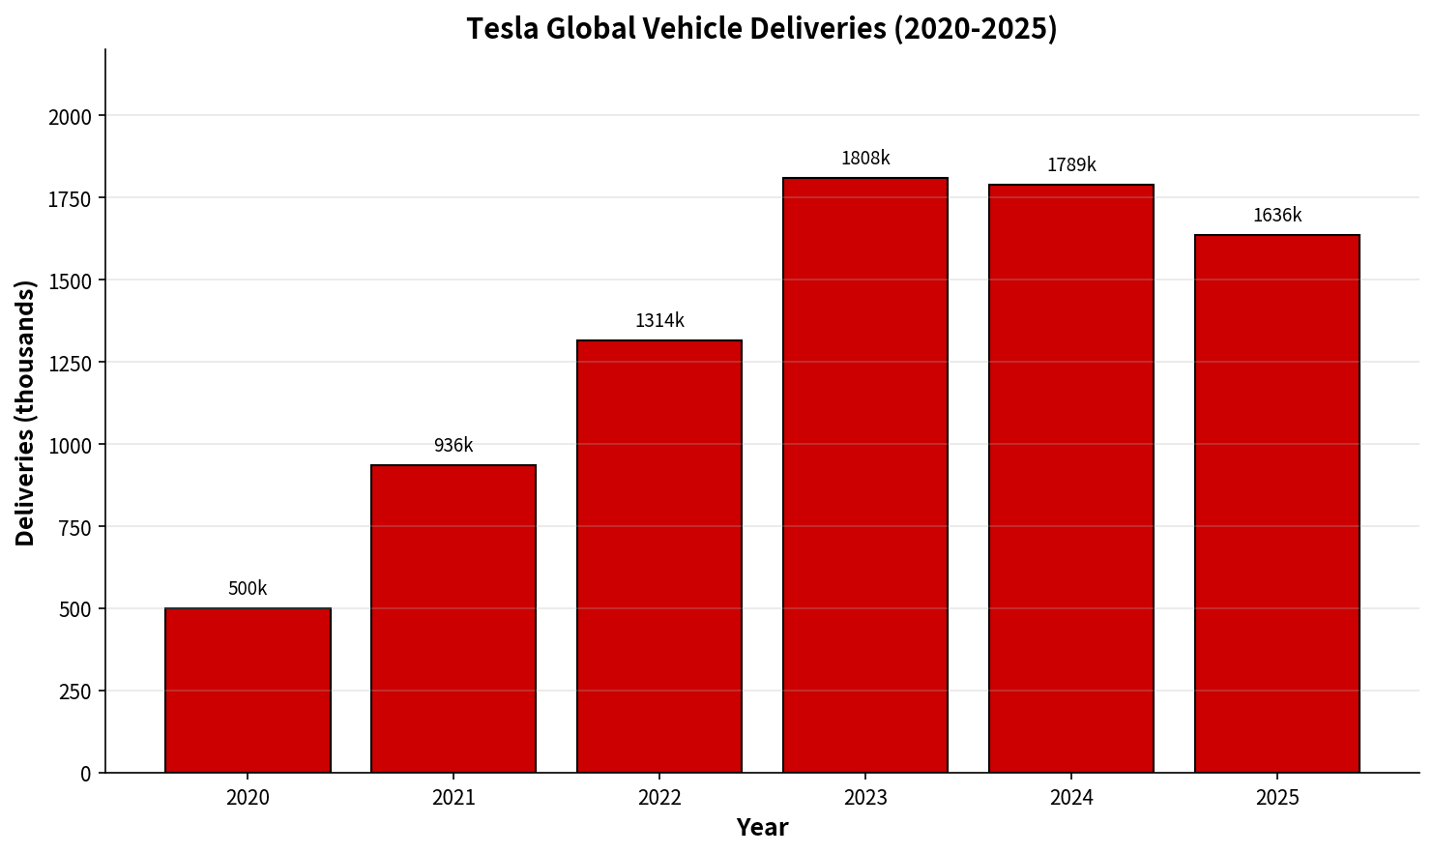
Figure 1: Tesla Global Vehicle Deliveries (2020–2025). Source: Adapted from Tesla Quarterly Updates and IR reports (Tesla, 2026).
For the fiscal year 2025, Tesla sold around 1.636 million cars worldwide, of which the number of cars sold in the US market was around 580,000 cars, which indicated a year-over-year reduction in sales owing to reduced demand in the EV market in the aftermath of IRA credit changes (Tesla, 2026; industry analyses). Even though there have been volumes issues, but the position of Tesla in the US market is strong due to its brand image, technological superiority, and manufacturing economy.

2. External and Internal Analysis

2.1 External Environment: PESTEL Analysis
A critical PESTEL examination reveals a complex opportunity-threat landscape for Tesla's US EV operations. The most salient factors are synthesised below, prioritising those with highest strategic impact (Clean Energy CU, 2026).
Factor | Critical Analysis of Opportunities and Threats for Tesla US EV Business
Political | The end of the $7,500 federal tax credit in 2025 for EVs is a huge threat that adds to the weakening of demand in Q4 2025 and the market share drop to ~5.8% of total US sales (Cox Automotive, 2026). Nevertheless, the later introduction of the One Big Beautiful Bill Act, including the vehicle loan interest deduction in case of a purchase of US-assembled EVs, partially offsets the former, giving an advantage to Tesla in terms of its domestic manufacturing capacity (Tesla satisfies the requirement due to Gigafactory Texas). Tariffs of up to 100%+ applied to Chinese EVs ensure Tesla from low-cost competition. Political polarisation caused by Elon Musk is a brand image threat and possible volatility in regulation.
Economic | High interest rates and inflation increase EV prices, worsening the situation with demand elasticity after incentives and contributing to Tesla's volume drop in 2025 (Tesla, 2026). Volatility of battery raw materials' prices and costs of the supply chain is still a threat, although Tesla is resilient thanks to vertical integration and long-term contracts. Fluctuations in the currency rate and general economic slowdown risk may impact sales. Opportunities lie in the fact that software/high-margin recurring revenues can compensate for hardware's margin pressure.
Social | Environmental consciousness and preference of Gen Z and millennials towards sustainable vehicles is an opportunity, while the problem of 'range anxiety', the lack of charging infrastructure in rural/suburban US, and negative public opinion about the EV mandate in some states constitute the threats. The active involvement of Musk in politics has polarised the consumers' perception, thus alienating part of the Tesla buyers (industry commentary, 2025-2026). The direct sales model and owners' clubs give the company additional points for differentiation, while variable quality perception and complaints of the customer service represent a weakness area.
Technological | Tesla's dominance in the field of AI, FSD software, OTA updates and Dojo supercomputer gives Tesla the ability for sustained differentiation and revenue growth through the robotaxis and FSD subscriptions. 2024-2025 unveils of the Cybercab/Robotaxi represent an opportunity for potential future pivot into MaaS. At the same time, the difficulty in reaching the goal of unsupervised autonomy, as well as improvements in ADAS of competitors (like GM Super Cruise or Ford BlueCruise) are a threat. Battery technology advancements (4680 cell format) represent an opportunity.
Environmental | The mission alignment of Tesla with the goals of the US in reducing greenhouse gas emissions (like net-zero pathways) and measurable impact – millions of tons of CO2 equivalent annually reduced (Tesla Impact Report, 2025) – make it legitimate and advantageous for marketing purposes. Opportunities in circular economy (recycling program scaling to 14,000+ tons recently) and battery storage synergies (Megapack) supplement the business of EVs. At the same time, possible scrutiny on the mining activities in the supply chain (of lithium, nickel, and cobalt) and the discussions on lifecycle emissions become threats. ESG transparency will help Tesla to keep its good reputation.
Legal | NHTSA investigations and lawsuits related to Autopilot/FSD safety allegations represent legal and reputational threats to Tesla, delaying the robotaxi commercialisation and increasing compliance costs (NHTSA reports, 2025). Labour relations (non-union status of Tesla) and ongoing labour disputes are the operational risks. On the other hand, favourable USMCA trade regulations and domestic content incentives under the new law contribute to Tesla's production in the US.
Table 1: PESTEL Analysis – Key Opportunities and Threats for Tesla's US EV Business (Critical factors prioritised). Sources: Compiled from Tesla (2026), Cox Automotive (2026), IEA (2025), Liu (2026), and regulatory disclosures.

2.2 Internal Environment: VRIO Analysis
Applying the VRIO framework (Barney, 1991; updated in contemporary strategic literature) to Tesla's key resources and capabilities reveals sources of sustained competitive advantage, alongside areas requiring attention.
Resource / Capability | Valuable? | Rare? | Costly to Imitate? | Organised to Exploit? | Competitive Implication
Vertical Integration & Gigafactories (US-based: Texas, Nevada) | Yes – Enables cost control, quality, supply security, and domestic content compliance for incentives. | Partially – Scale and integration depth rare among US EV peers; legacy OEMs lag. | Yes – Massive capital investment, tacit knowledge, and time required; path dependent. | Yes – Tesla exploits via rapid iteration, in-house battery/tech development. | Sustained Competitive Advantage
Software/AI Ecosystem (FSD, OTA, Dojo, App integration) | Yes – Drives differentiation, high-margin recurring revenue, and future robotaxi potential. | Yes – Data moat from fleet learning and real-world miles is rare and accumulating. | Partially – Competitors investing heavily (Waymo, Cruise, legacy ADAS); data advantage erodes slowly. | Yes – Strong exploitation via continuous deployment and subscription model. | Temporary to Sustained Advantage (requires regulatory progress)
Brand Equity & Direct Sales Model | Yes – Premium positioning, loyal following, and control over customer experience. | Partially – Strong EV brand, but legacy luxury brands (BMW, Mercedes) have broader heritage. | Partially – Brand can be built over time; direct model replicable but culturally difficult for dealers-heavy OEMs. | Yes – Tesla leverages via community, marketing efficiency, and ecosystem lock-in. | Competitive Parity to Advantage
Supercharger Network (now partially open) | Yes – Critical infrastructure for long-distance EV adoption and customer experience. | No longer rare – Opening to other EVs and competitors building out (e.g., Electrify America, Ionity). | Partially – Physical infrastructure costly but increasingly shared/standardised. | Yes – Tesla continues to expand and optimise for own fleet advantage. | Parity (diminishing advantage)
Table 2: VRIO Analysis of Tesla's Key Resources and Capabilities in the US Context. Framework adapted from Barney (1991) and contemporary applications in EV strategy literature.
There are a few sources of Tesla’s competitive advantage that exist, with the foremost of them being vertical integration in its American manufacturing and software/AI. Not only do Gigafactories offer the company competitive edge through low costs and high-quality production, but they also place the company in an optimal position to leverage domestic content incentives and tariffs protection. On the other hand, the competitive edge of Superchargers is becoming less apparent due to its opening and the investments made by competitors, making it crucial for the company to innovate within software-defined competitive advantage.

2.3 SWOT Analysis
Synthesising the external and internal analyses yields the following SWOT profile for Tesla's US EV business:
STRENGTHS (Internal) | WEAKNESSES (Internal)
• Advantages through vertical integration and US Gigafactories (VRIO: sustained)  • AI/software moat from FSD data, OTA  • Brand equity and direct-to-customer approach with lock-in within ecosystem  • Ability to iterate quickly due to large scale in manufacturing  • Measurable effect on sustainability in line with mission (carbon footprint reduction) | • Decreasing sales figures recently (2025) and margins due to competition and policy changes  • Narrower range of products compared to its competitors (limited number of models)  • Quality inconsistencies and consumer perception of services  • Heavy reliance on Musk himself  • Dwindling edge of superchargers due to competitive entry  • Risks in implementing the ambitious autonomy plan
OPPORTUNITIES (External) | THREATS (External)
- Domestic production of vehicles through government policy and tariffs on China  - Leadership in AI/autonomy to drive robotaxis and mobility as a service  - Broaden lower-cost EV offering to regain share and increase total addressable market  - Battery recycling opportunities  - Growing focus on sustainability from younger demographics | • Expiry of federal tax credits for EVs (September 2025)  • Increasing rivalry from traditional OEMs (GM, Ford) as well as new competitors with wider ranges  • Regulatory challenges and legal liabilities associated with unmonitored FSD/robotaxi  • Weaknesses within the supply chain and volatile costs of raw materials  • Brand polarization due to political activism by leadership  • Macroeconomic factors affecting premium cars
Table 3: SWOT Analysis for Tesla's US EV Business. Synthesised from PESTEL, VRIO, Tesla IR data, and market analyses (2025-2026).
The SWOT analysis shows that Tesla has strengths in terms of technology and integration which it can utilize to combat threats arising from policy changes and rivalry in the market. The strategy to be employed is to capitalize on opportunities available in areas of autonomy and affordable models.

3. Comprehensive and Holistic View of the Organisation

3.1 Corporate Social Responsibility (CSR) Strategy and Alignment
CSR activities at Tesla are integral to its mission "to accelerate the world's transition to sustainable energy" and include product impact, supply chain activities, and transparency through annual Impact Reports (Tesla, 2025 Impact Report). In the 2025 Impact Report, Tesla demonstrates cumulative CO2e avoidance amounting to more than tens of millions of metric tonnes, with US Tesla vehicles averting 52 metric tonnes of CO2e per vehicle throughout their lifetime on average, as well as scaling battery recycling efforts (more than 14,000 metric tonnes reported recently) and responsible sourcing commitments (Tesla, 2026). In other words, CSR activities are in perfect alignment with business goals: sustainability is not just another buzzword but a core value which underlies product development, marketing and stakeholder value creation.
The problem, however, is that the mentioned alignment is incomplete. While Tesla is doing very well at lowering the environmental footprint through the use of products, there is still much work to be done concerning supply chain transparency: mining operations' (lithium, nickel, cobalt) and labor standards are questioned (even though there is substantial improvement in terms of transparency, independent verification is still needed to maintain credibility in these respects), workplace culture and diversity statistics are criticized in some external reports and, consequently, can potentially damage the 'social' side of the company's ESG performance and affect hiring and retention in a highly competitive tech/automotive sector; Autopilot safety messages and related disclosures have been questioned by both regulators and media as being possibly misleading about the current technological readiness and safety issues (RAC, 2026).

3.2 Balanced Scorecard Analysis
The Balanced Scorecard (Kaplan & Norton, 1992, 1996) is a comprehensive model for measuring performance with an alignment between strategy and operations through four different perspectives. Below is the adapted scorecard for the US EV business of Tesla which translates the mission and strategic imperatives of Tesla into specific objectives, KPIs, targets, and actions. It is important to mention that Tesla has no published internal scorecard as it does not publish its Balanced Scorecard.
Financial Perspective
Objective | Key Performance Indicators (KPIs) | Targets (2026-2027) | Initiatives
Restore and grow US automotive revenue and profitability | US EV revenue; Automotive gross margin (excl. regulatory credits); Free cash flow from operations | US deliveries +8-12% YoY; Gross margin 17-19%; Positive FCF growth | Optimize product portfolio and pricing; increase software subscriptions; decrease costs through 4680 and efficiencies in manufacturing
Diversify revenue streams beyond vehicle sales | FSD/Autopilot subscription & one-time revenue; Energy storage deployment revenue (US) | FSD attach rate >30%; Energy storage US revenue +25% YoY | Promote FSD v12+ features; capitalize on Megapacks sales to US data centers/ utilities
Customer Perspective
Objective | Key Performance Indicators (KPIs) | Targets (2026-2027) | Initiatives
Defend and grow US EV market leadership | US EV market share; Brand consideration/NPS among EV intenders; Repeat purchase rate | US EV share stabilise >50%; NPS >70; Repeat >40% | Model Y/3 marketing for next generation; develop entry level model; improve Supercharger experience
Deliver superior ownership experience & charging ecosystem | Customer satisfaction (CSAT) scores; Charging reliability/uptime; Service wait times | CSAT >85%; Supercharger uptime >99%; Mobile service resolution <24hrs average | Increase service centers and mobile fleets; improve quality of Over-the-Air updates; proactively reach out to customers
Internal Business Processes Perspective
Objective | Key Performance Indicators (KPIs) | Targets (2026-2027) | Initiatives
Achieve operational excellence in US manufacturing & quality | Production cost per vehicle; First-time quality rate; Warranty claims per 1000 vehicles | Cost reduction 5-8% YoY; Quality rate >95%; Warranty claims -15% | Ramping up Dojo for 4680 cell production process; Quality Assurance using artificial intelligence; Supplier programs
Accelerate safe autonomy & software-defined vehicle capabilities | FSD miles driven autonomously (unsupervised validation); Regulatory submission milestones; OTA deployment velocity | Significant unsupervised FSD validation miles; NHTSA engagement milestones met; Bi-weekly OTA cadence maintained | Scaling up Dojo; Gathering real-world data; Documentation of safety case & regulatory pilot (e.g., Texas/California)
Learning and Growth Perspective
Objective | Key Performance Indicators (KPIs) | Targets (2026-2027) | Initiatives
Build organisational capability in AI, software & sustainable manufacturing | R&D spend as % of revenue; AI/software engineering headcount growth; Employee engagement scores | R&D >10% revenue; AI talent +15% YoY; Engagement >80% | University alliances and internal AI institute; cultural programs on work-life balance and purpose alignment; skills development for advanced manufacturing
Foster innovation culture while strengthening governance & ESG integration | ESG disclosure scores/ratings improvement; Innovation pipeline metrics (patents, new features deployed); Safety incident rates | Top-quartile ESG ratings; Patent filings +10%; Recordable safety incidents reduction | Supply chain due diligence and third-party audits; cross-functional innovation sprints; safety-first leadership program
Table 4: Balanced Scorecard for Tesla's US EV Business (Consultant-adapted framework based on Kaplan & Norton, 1992, 1996; grounded in Tesla's public strategy and 2025-2026 disclosures).
Such a BSC helps in translating the strategy into action by starting with the organization’s mission, then through customer value, operational excellence, and finally the core competencies of the business. Policy and competitive changes can thus be dealt with through the regular review of the scorecard.

4. Strategic Choices and Implementation

4.1 Strategic Choices at the Business Level
In terms of business strategy, Tesla has always practiced the differentiation strategy (Porter, 1985) with an emphasis on high performance, advanced technology (software/AI), high-end brand, and an ecosystem versus low-cost competition. This is seen through the firm’s positioning relative to competitors for mainstream cars and luxury ICE/EVs and through vertical integration and direct access to customers (Statista, 2026). Cost leadership strategy does not fit the brand positioning of Tesla nor its intense R&D activities, while 'best-cost' hybrid strategy may lead to 'stuck in the middle' (Porter, 1985) situation with no advantages, which can be seen from margin pressures during the price war periods.
Alternatives to this strategy include focused differentiation (narrower segment of premium/advanced) or broad market penetration through lower cost vehicles. Considering increasing competition and the necessity to expand the pie of electric vehicles in the USA and maintaining market share, a hybrid strategy should be pursued, but only if differentiation strategy will remain the core one.

4.2 Recommended Strategy and Validation
The suggested strategy involves adopting an advanced differentiation strategy based on software-defined vehicles, autonomy, and ecosystem, in addition to product development for wider market reach (like next-generation platform at a reduced price) and market penetration techniques in the US (Sustainability Magazine, 2026). This will utilize the VRIO-sustainable strengths of Tesla in vertical integration and AI/software.
Validation via frameworks:
Force | Analysis with Authentic Data | Implication for Tesla
Competitive Rivalry | High. The market share of Tesla vehicles in the USA had fluctuations (45-59% in 2025); General Motors had more than 150,000 electric cars sold, which was 48% higher compared to the previous year (Cox Automotive, 2026). | High price/margin pressures; continued differentiating on FSD/software and ecosystem is necessary.
Threat of New Entrants | Moderate. Capital-intensive industry for production and battery-making, but software and AI reduce some of these barriers. Chinese imports pay 100%+ taxes, protecting American manufacturers (Liu, 2026). | The Gigafactory scale and home market contents create barriers for Tesla.
Buyer Power | Increasing. Cancellation of $7,500 government tax incentive on electric cars (September 2025) increased price consciousness amidst more model options (Cox Automotive, 2026; Clean Energy CU, 2026). | Focus on TOC marketing, leasing, and ecosystem lock-in.
Supplier Power | Moderate. Vertical integration by Tesla (US-based Gigafactories, 4680 batteries) minimizes dependency on other companies, but lithium-nickel price fluctuations remain (Tesla, 2026). | Backward integration and long-term contracts to keep costs low.
Threat of Substitutes | Low-Moderate. Hybrid engines/petrol internal combustion engine dominate in the short term, yet stricter emission standards and | Autonomy and software defined mobility to define substitutes.
Porter’s Five Forces: Industry rivalry is high and intensifying due to legacy OEM EV launches and new entrants; buyer power is increasing due to more choices available; threat of substitutes (hybrids, efficiency gains from the ICE) still exists but decreasing long-term; supplier power is moderate (Tesla backward-integrates into some aspects); threat of new entrants is moderate (high barrier to entry of capital/technology but software disruptors exist) (Science Nature Page (2026). Differentiation/data moat offered by Tesla provides relative protection, which supports the strategy (Porter, 2008; updated EV industry analysis).
Strategy | Analysis with Authentic Data | Implication for Tesla
Market Penetration | Current offerings (Model 3/Y, Cybertruck) in current US markets. Sales in 2025 US market ≈580,000 units (decline YoY); Q4 share saw recovery to 59% owing to increased selection options (Cox Automotive, 2026). Emphasis on leasing, FSD subscriptions, Supercharger experience, and strategic marketing. | Defend/grow share and recurring revenue; highest feasibility given current capabilities and US manufacturing base.
Market Development | Expansion of current products into newer segments in the US (for instance, fleet buyers, rural customers, lower income through refreshed or used cars). Limited presence currently among non-early adopters. | Moderate opportunity; leverage domestic policy incentives and financing innovations to expand addressable market.
Product Development | New products in current US market: affordable EV platform, refreshed models, Cybertruck/Semi at scale, and FSD/robotaxi services. Narrow product portfolio compared to GM/Ford/Hyundai (Tesla, 2026; IEA, 2025). | Priority recommendation – addresses share erosion and affordability challenges while exploiting software/AI strengths.
Diversification | New products/markets: robotaxi or mobility-as-a-service, Optimus or energy storage (Megapack) | Selective pursuit only; supports long-term vision but secondary to core US EV focus given execution and regulatory risks.
Ansoff Matrix: Main vectors include Product Development (affordable EV platform, refreshing of current models, FSD/robotaxi services offering) and Market Penetration (targeting US market, marketing/financing innovations, charging experience for promotion among intenders). Market Development (e.g., targeting other US markets/regions) is a secondary vector; Diversification (energy storage, Optimus) is a supportive but not a main vector for this US-based EV company.
Criterion | Analysis with Authentic Data | Conclusion
Suitability | Perfect fit with the external environment (high US tariffs over 100% against Chinese electric cars and domestic assembly incentive policies following IRA) and strong internal capabilities (vertical integration, FSD data moat, software recurring revenue) (Liu, 2026; Cox Automotive, 2026; Tesla, 2026). | High – Strategy directly addresses share erosion and leverages VRIO-sustained advantages.
Acceptability | Moderately high. Value creation through margin-rich software/FSD subscriptions and volume recovery, and value creation to stakeholders with mission-consistent investors/employees. Risks (FSD regulatory delays, execution risk on new platforms, brand risk) can be mitigated by incremental deployment (Tesla, 2026; industry analysis 2025–2026). | Medium-High – Strong returns potential with targeted risk mitigation.
Feasibility | High. Exploits existing US capabilities directly (scale at Gigafactory Texas/Nevada, Dojo AI training, FSD validation from real-world fleet, OTA network). Pathways for next-generation platform development are evident (Tesla, 2026). | High – Resource and capability alignment is strong.
SAFe Evaluation (Johnson et al., 2020): Suitability is high since the strategy is compatible with external opportunities (policy protections, self-driving technologies trend) and internal capabilities (integration, software) (Tridens Technology, 2026). Acceptability is medium-high as it offers creation of shareholder value via high-margin software/subscriptions and recovery of volumes; risks (regulatory, execution risks) are manageable in phases with support from mission-aligned stakeholders (investors, employees). Feasibility is high as it builds upon existing company capabilities (Gigafactories, Dojo system, fleet data).

4.3 Implementation: Delivering Optimum Performance and Competitive Advantage
The strategy offers optimum performance through enhancing the moat of Tesla. Vertical integration provides cost-quality competitive advantage and makes it eligible for policies. The software and artificial intelligence differentiator add switching costs and new revenue stream (with FSD subscriptions scaling up substantially) (U.S. News, 2026). Real-life examples include how Tesla's over-the-air update model has allowed feature monetization and constant improvements impossible for old school players, and its American production puts it ahead of imports amid high tariffs (Tesla earnings discussion).

4.4 Potential Challenges and Mitigation Solutions
Key challenges and proposed solutions:
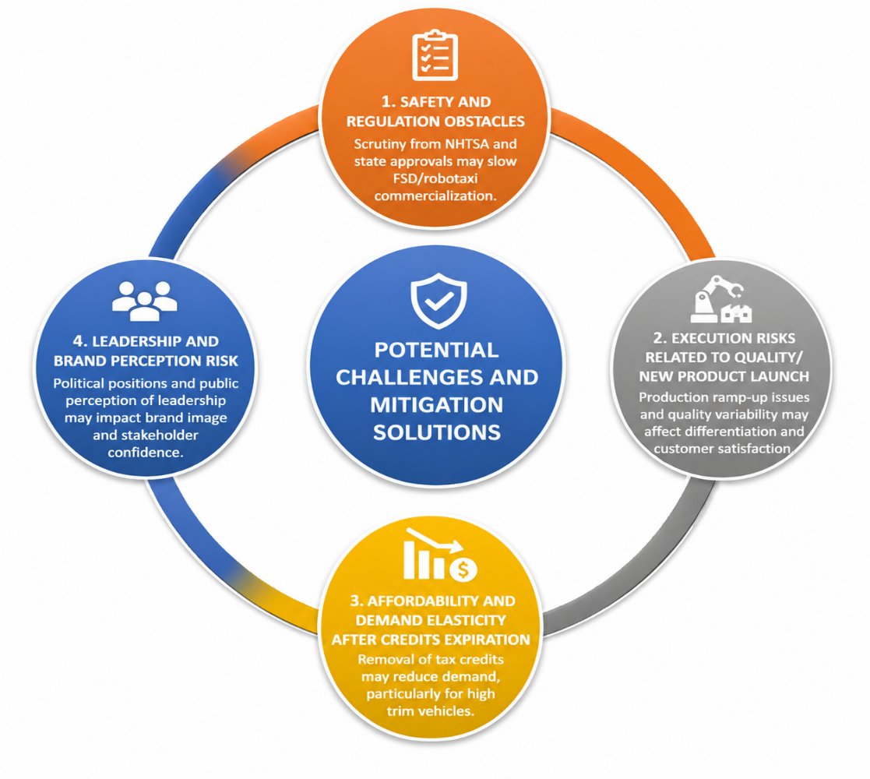
Figure 2: Potential Challenges and Mitigation Solutions
(Source: Self-Developed)
1. Safety and regulation obstacles for unsupervised FSD/robotaxi: Scrutiny from NHTSA and state approvals could hinder commercialization process. Mitigation measures include publication of safety cases based on data transparency; geographical phased pilots (Texas - home-state advantage); proactive interaction with regulators; cooperation with insurance/actuaries on liability issues (Yang, 2025). Use of existing FSD miles for validation purposes is recommended.
2. Execution risks related to quality/new product launch: Variability in fit & finish, historical problems in production ramp-up might jeopardize differentiation. Mitigation actions involve rapid improvement of AI/Computer vision quality gate system at factories; supplier development programs; phased launch of new platforms with heavy validation process; organizational focus on "First time quality" metrics.
3. Risks of affordability and demand elasticity after credits expiration: Removal of tax credit for buyers will put additional pressure on volume, especially on high trims (Virta, 2025). Mitigation actions include development of next generation affordable platform; further development of leasing/financing programs; focus on TCO in marketing communications; use of domestic incentives/loans interest deduction.
4. Risk of leadership and brand perception: Political position of Musk introduces potential risk factors. Mitigation of this risk includes professional brand communication with diversified executive involvement; focus on product or innovation story; good corporate governance signals without alienation of institutional stakeholder base.
Effective implementation of these recommendations is possible only with disciplined capital allocation and coordination across software, manufacturing, regulatory and marketing teams. Monitoring and adjustment should be done using proposed Balanced Scorecard. In order to keep leadership through leveraging core competencies and compensating for execution/market access issues, Tesla can become dominant company in the US EV industry.

Section 2: Reflective Account
This reflective account employs Gibbs' Reflective Cycle (Gibbs, 1988) to critically examine the process of researching, analysing, and preparing the strategic evaluation of Tesla's US EV business.
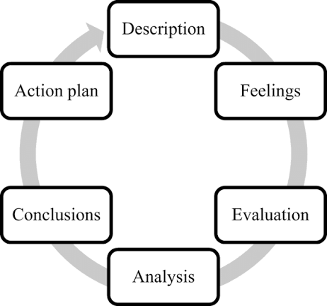
Figure 3: Gibbs’ Reflective Cycle
(Source: Self-Developed)

Description
As part of the assignment, one had to assume a role of strategic management consultant and create a board report analysing strategic position of Tesla in US EV industry and suggesting steps to improve its competitive advantage. It was decided to conduct an analysis of US EV activities of Tesla because of its market dominance, availability of information (being traded in US and reporting to the SEC), significance of manufacturing/policy in US, and contemporary relevance to electrification, autonomy, and industrial policies. Sources included systematic gathering of company sources (Tesla Impact Report 2025, Quarterly Updates, Investor relations presentations), secondary market data (Cox Automotive, IEA Global EV Outlook 2025), analysis of policies, and academic/practitioner literature about strategic management frameworks (Porter, VRIO, Balanced Scorecard, Ansoff, SAFe) (Ansoff, 1957). Frameworks were evaluated critically; for example, synthesis of PESTLE and VRIO in SWOT analysis, then strategic formulation and implementation. Reflection part is based on Gibbs' cycle.

Feelings
At first, I was intimidated by the task at hand—the synthesis of dynamic and real-time data based on the constantly changing 2025-2026 policy and competition environment (credit expiration under IRA, sales variance, milestones related to autonomy) along with the connection between theoretical approaches and practical applications. There were concerns associated with the credibility and relevancy of data in the context of evolving US EV policies. However, as the research continued, especially after comparing Tesla's IR data with the independent findings of Cox and IEA, and successfully connecting VRIO strengths to the observed results (for example, Gigafactory for policy eligibility), I became more confident. It was challenging and thought-provoking enough to strengthen my interest in strategic management in rapidly changing industries.

Evaluation
Positive aspects of the work: The research process was robust and multifaceted enough to allow a critical rather than purely descriptive review based on empirical evidence. Quantitative data (charts of deliveries, market shares) used in combination with qualitative analysis was highly beneficial for the validity of arguments made. Multiple models were applied (PESTLE, VRIO, SWOT, BSC, Porter's 5 Forces, Ansoff, SAFe), which indicates the broad use of the module and gives holistic understanding. The consulting tone was appropriately kept considering that the document was to be delivered to the Board, being objective, evidence-based and actionable. Negative aspects of the work: Lack of time did not allow conducting more thorough primary research (e.g. no interviews or proprietary databases used); the BSC model looks quite logical but still speculative due to lack of validation.

Analysis
The difficulties were caused by the intrinsic conflict between academic rigor (critical thinking, multi-angle approach, Harvard referencing) and the practical character of strategic consulting for an actual company. Since Tesla was highly visible, there was plenty of contradictory secondary data available, thus requiring triangulation of sources and up-to-date information (2025-2026 data). Using approaches like BSC without access to confidential KPIs helped me understand one of the frequent challenges in a real world - when consultants have to create proxies using publicly available data on the strategy and financial performance of an organization and the industry metrics. The success factors in this task include proper scoping (only US EV), synthesis in stages, and objective critical attitude towards Tesla's strengths and weaknesses.

Conclusion
This assignment has improved my ability to analyze strategies in realistic conditions. It taught me that successful analysis requires not just a knowledge of the framework but the ability to put together incomplete and fast-changing data into a logical recommendation, with limitations stated clearly. This was particularly apparent in the case of Tesla since external disturbances can put even the best resource endowment to the test, thus emphasizing the importance of having dynamic capabilities and being able to monitor the execution of a strategy (using techniques such as BSC). I have also realized the moral aspect of consulting—a need to assess risks and not only opportunities.

Action Plan
To ensure better preparedness for future strategic initiatives, I would:
- Ensure adequate consideration of time allocation to scenario planning on major uncertainties (such as policy and technological developments);
- Look for any chance to collect primary information or verify my understanding by experts (for instance, through participating in business networks, consulting practitioners);
- Create templates that will facilitate quick framework implementation and sources' referencing in cases of strict deadlines;
- Provide the explicit listing of all assumptions and limitations in the appendices;
- Read recent strategic management literature (like dynamic capabilities and platform strategies). All of this will help me grow in terms of strategic practice.
To summarize, writing this report was a useful practical experience in strategic thinking, reminding me that the competitive advantage in fast-changing industries such as US EVs should be continuously achieved by aligning the company's strengths with the changing environment, implementing the plans in practice and self-examining.

References
Ansoff, H.I. (1957) ‘Strategies for diversification’, Harvard Business Review, 35(5), pp. 113–124. https://www.researchgate.net/profile/Faris-Alshubiri/post/is_there_any_research_article_suggesting_further_study_on_market_penetration_and_market_development/attachment/59d6202279197b807797e9c0/AS:288872320782343@1445883937051/download/2.pdf
Barney, J. (1991) 'Firm resources and sustained competitive advantage', Journal of Management, 17(1), pp. 99-120. http://diglib.globalcollege.edu.et:8080/xmlui/bitstream/handle/123456789/704/00483.pdf?sequence=1&isAllowed=y
Clean Energy CU (2026) 'Does the 2026 Tax Deduction for American-Made Vehicles ...', Clean Energy CU Blog. Available at: https://www.cleanenergycu.org (Accessed: 15 July 2026).
Cox Automotive (2026) Electric Vehicle Sales and Market Share (US – 2026 Updates). Available at: https://caredge.com/guides/electric-vehicle-market-share-and-sales (Accessed: 15 July 2026).
Deloitte (2025) Global Automotive Consumer Study: Electric Vehicle Trends. London: Deloitte.
Edmunds (2026) 'What Is the Percentage of Electric Cars in the U.S.?', Edmunds.com. Available at: https://www.edmunds.com/electric-car/articles (Accessed: 15 July 2026).
EdrawMind (2026) 'Tesla's Mission & Vision Statement Analysis', EdrawMind. Available at: https://edrawmind.wondershare.com (Accessed: 15 July 2026).
Gibbs, G. (1988) Learning by Doing: A Guide to Teaching and Learning Methods. London: Further Education Unit.
IEA (2025) Global EV Outlook 2025: Catching up with climate ambitions. Paris: International Energy Agency. Available at: https://www.iea.org/reports/global-ev-outlook-2025 (Accessed: 15 July 2026).
Johnson, G., Whittington, R., Scholes, K., Angwin, D. and Regnér, P. (2020) Exploring Strategy: Text and Cases. 12th edn. Harlow: Pearson.
Kaplan, R.S. and Norton, D.P. (1992) 'The balanced scorecard – measures that drive performance', Harvard Business Review, 70(1), pp. 71-79.
Liu, C. (2025) 'The rise and recent decline of Tesla's share of the U.S. electric vehicle market', World Electric Vehicle Journal, 16(2), p. 90. https://10.3390/wevj16020090
Liu, M. (2026) ‘Tariffs on electric vehicles deepen woes of U.S. automakers’, npj Climate Action. Available at: https://www.nature.com/articles/s44168-025-00330-6 (Accessed: 15 July 2026).
McKinsey & Company (2025) The Road to Electric: Automotive's Electrification Journey. New York: McKinsey.
Porter, M.E. (1985) Competitive Advantage: Creating and Sustaining Superior Performance. New York: Free Press.
Porter, M.E. (2008) ‘The five competitive forces that shape strategy’, Harvard Business Review, 86(1), pp. 78–93.
Porter, M.E. (2008) 'The five competitive forces that shape strategy', Harvard Business Review, 86(1), pp. 78-93.
RAC (2026) 'Tesla statistics, data and sales numbers', RAC Drive. Available at: https://www.rac.co.uk (Accessed: 15 July 2026).
Science Nature Page (2026) 'Tesla's 2025 financial report shows 46% profit drop', Facebook/ScienceNaturePage (summarising Gitlin analysis). Available at: https://www.facebook.com (Accessed: 15 July 2026).
Statista (2026) 'Tesla - statistics & facts', Statista. Available at: https://www.statista.com/topics/2086/tesla (Accessed: 15 July 2026).
Sustainability Magazine (2026) 'Tesla's Sustainability Impact Report 2025: Reaching Net Zero', Sustainability Magazine. Available at: https://sustainabilitymag.com (Accessed: 15 July 2026).
Tesla (2026) About Tesla. Available at: https://www.tesla.com/about (Accessed: 15 July 2026).
Tesla (2026) Impact Report 2025. Available at: https://www.tesla.com/impact (Accessed: 15 July 2026).
Tesla (2026) Q4 2025 Production, Deliveries & Deployments and Impact Report 2025. Available at: https://ir.tesla.com and https://www.tesla.com/impact (Accessed: 15 July 2026).
Tesla (2026) Q4 2025 Production, Deliveries & Deployments. Available at: https://ir.tesla.com (Accessed: 15 July 2026).
Tesla (2026) Q4 2025 Production, Deliveries & Deployments. Available at: https://ir.tesla.com (Accessed: 15 July 2026).
Tesla (2026) Q4 2025 Update Deck. Available at: https://assets-ir.tesla.com (Accessed: 15 July 2026).
Tridens Technology (2026) 'Tesla Sales, Revenue & Production Statistics (Jul 2026)', Tridens Technology Blog. Available at: https://tridenstechnology.com (Accessed: 15 July 2026).
U.S. News (2026) 'Best Tesla Alternatives in 2026', U.S. News & World Report. Available at: https://cars.usnews.com (Accessed: 15 July 2026).
Virta (2025) The Global Electric Vehicle Market In 2025. Available at: https://www.virta.global (Accessed: 15 July 2026).
Yang, H. (2025) 'Analysis of Tesla's Sustainable Development Strategy from the Perspective of ESG', SHS Web of Conferences, 2025. Available at: https://www.shs-conferences.org (Accessed: 15 July 2026).

