Module code: ACCA4023

Course name: Introduction to Web and database concepts

Student Number: 1902008

Student Name: Abigail Louise Crimlis

Date: 26/04/2021

TABLE OF CONTENT

- Implementation pg1 – pg4
- Validation pg5 – pg7
- Evaluation pg8 – pg9
- Website evaluation pg10
- References pg11
- Appendix

INTRODUCTION
A fully formed website can be one of the most important assets to a business / organisation if developed correctly. Utilizing UX design, accessibility and SEO techniques can transform a website to be the lead source of income for many. In this report I will discuss the basics of Usability, accessibility and SEO and then apply these techniques into a website created using HTML and CSS web standards.

Requirements
Plant.co is a gardening tips website, its aimed at anybody who is interested in growing their own plants, flowers, or herbs. The community Hub on the site will allow users to upload pictures of their plants for assistance with diagnostics from other users.

Implementation
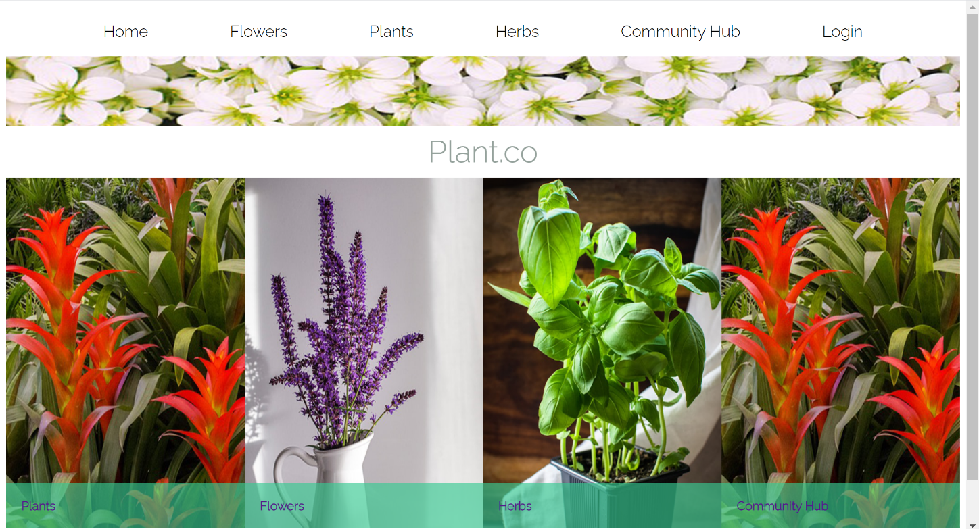
- Landing page

1
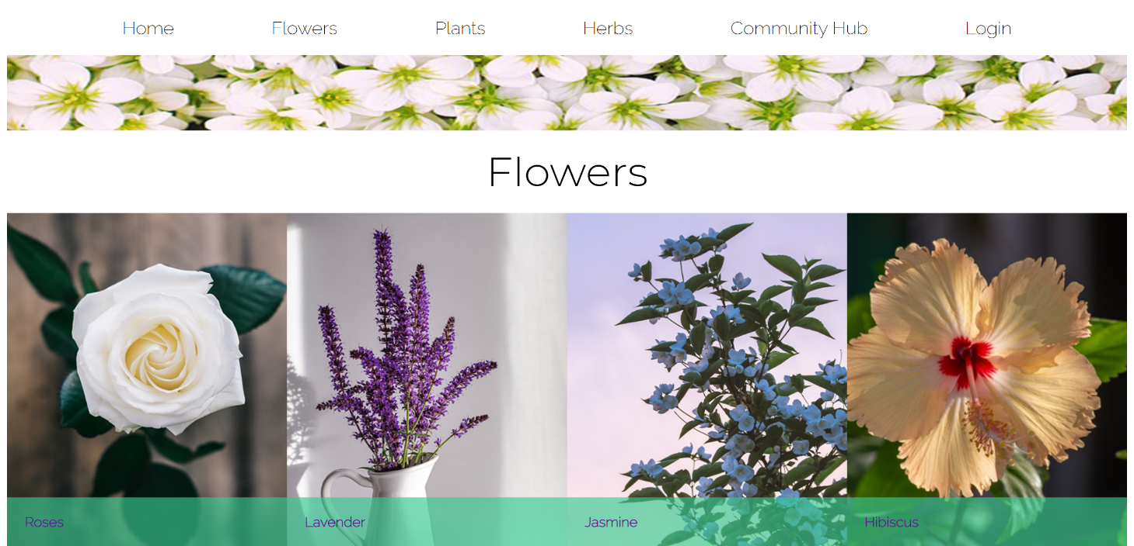
- Flowers main page
- Plants main page
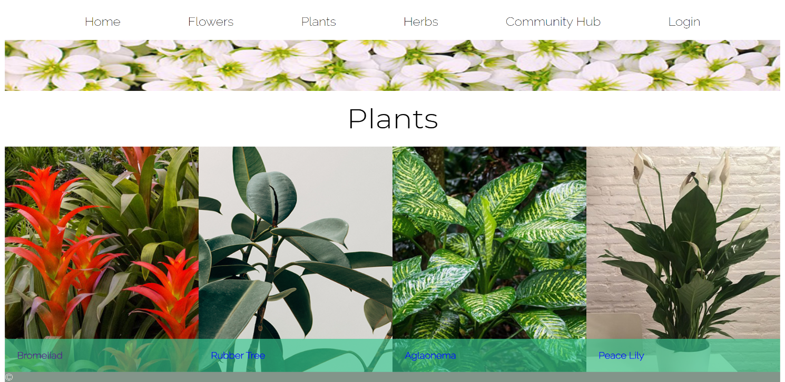
Used to see the variety of each plant on the site. Users can also navigate to each plant by hovering over the plants link at the top, a dropdown menu appears with the plant names.
- Herbs main page

2
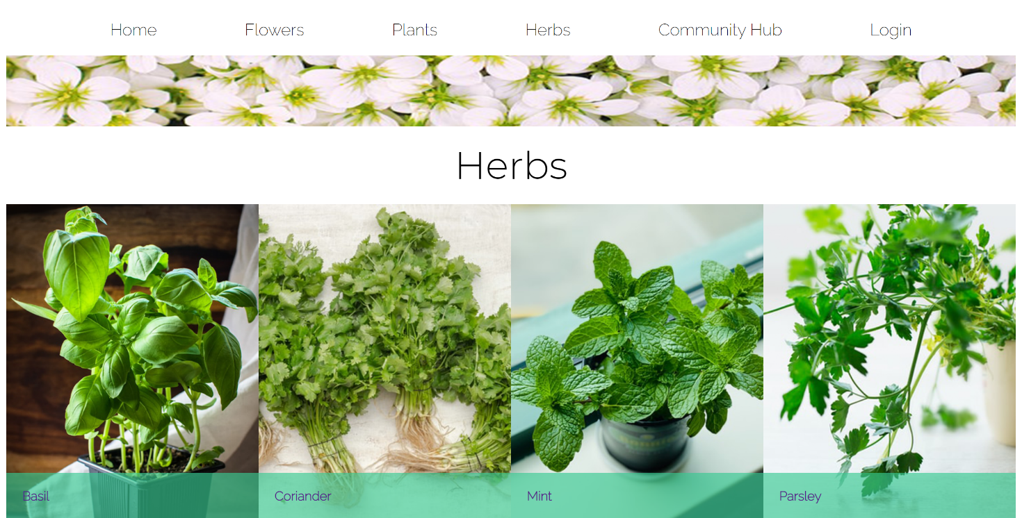

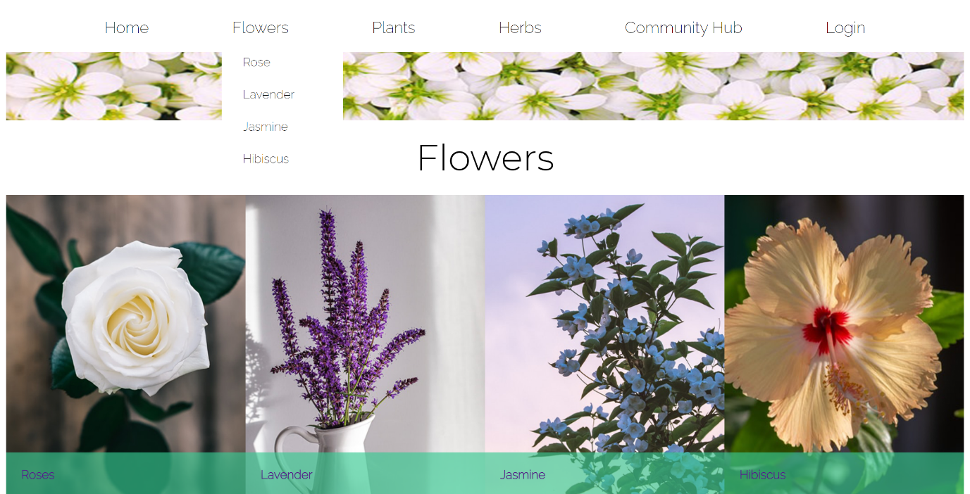
- Navigation

- Login page

3
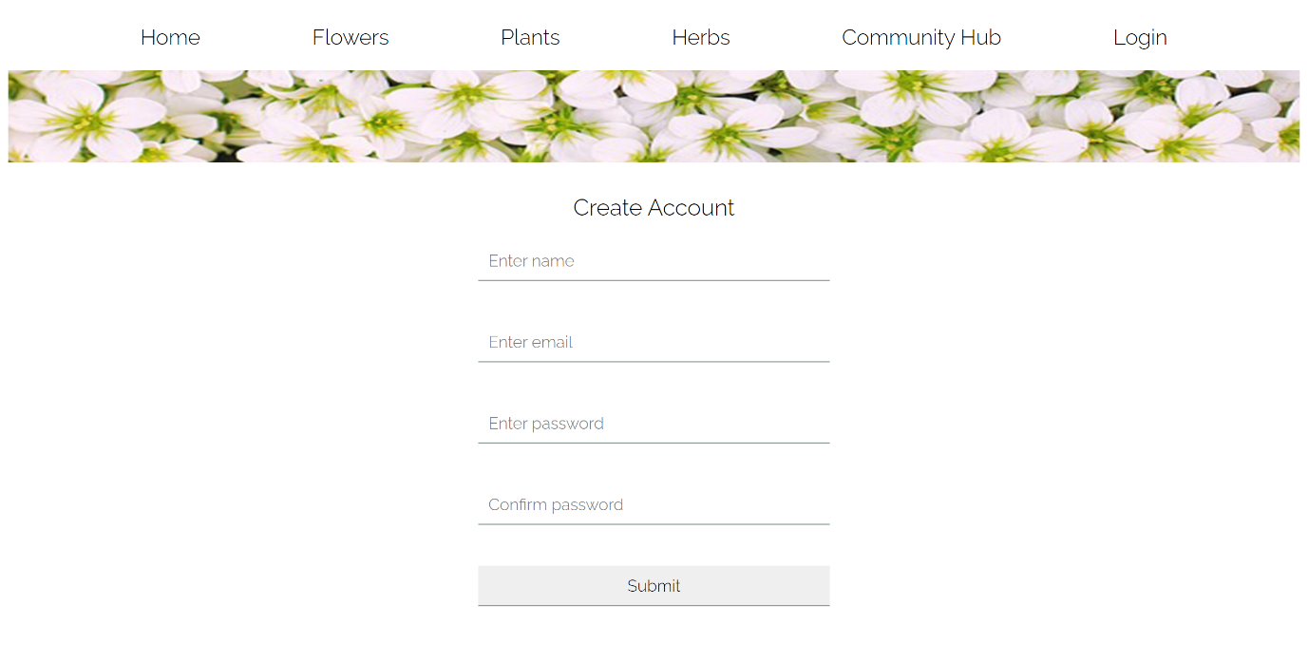
- Individual element page (jasmine.html etc)
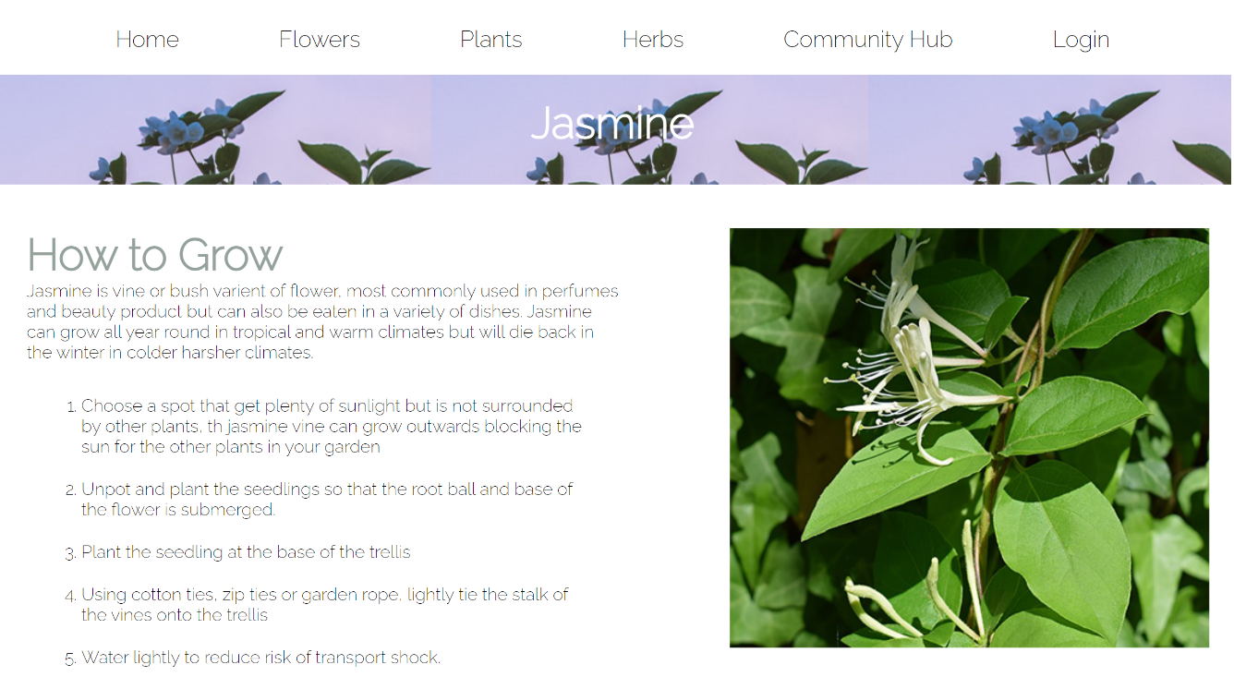

- Community hub
I did not have time to complete the coding for the community hub page, so I have included the design layout in XD to showcase how it will look when completed.

4
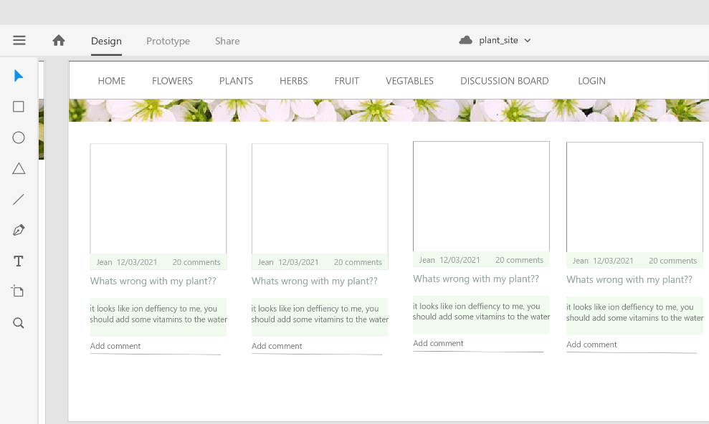
Validation
To validate my website, I used https://validator.w3.org/nu/#file and uploaded each file that has a different structure.

HTML
Index.html
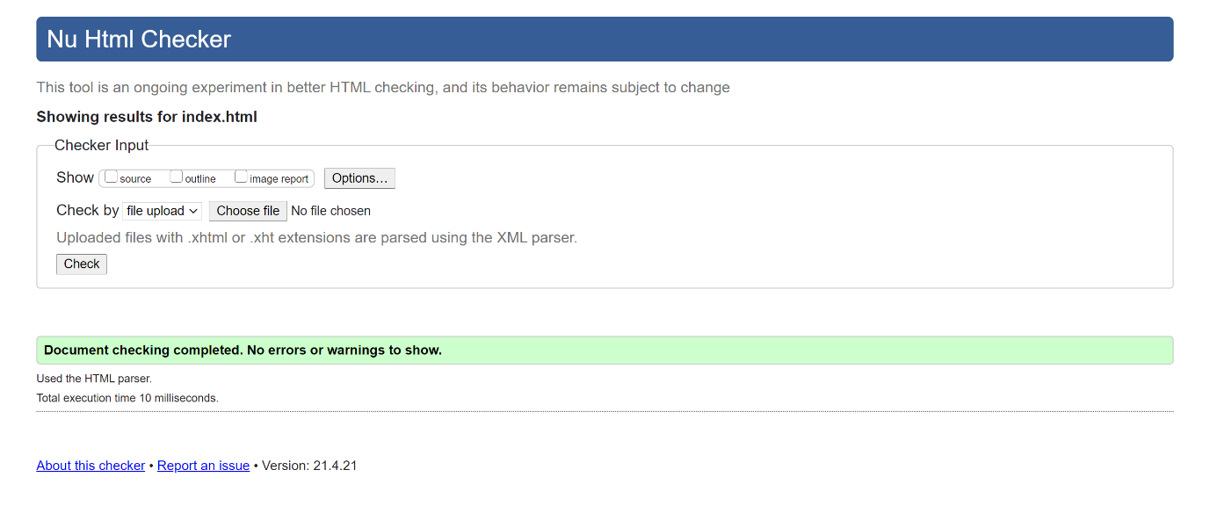

Flower.html (same as plant.html and herb.html)

5
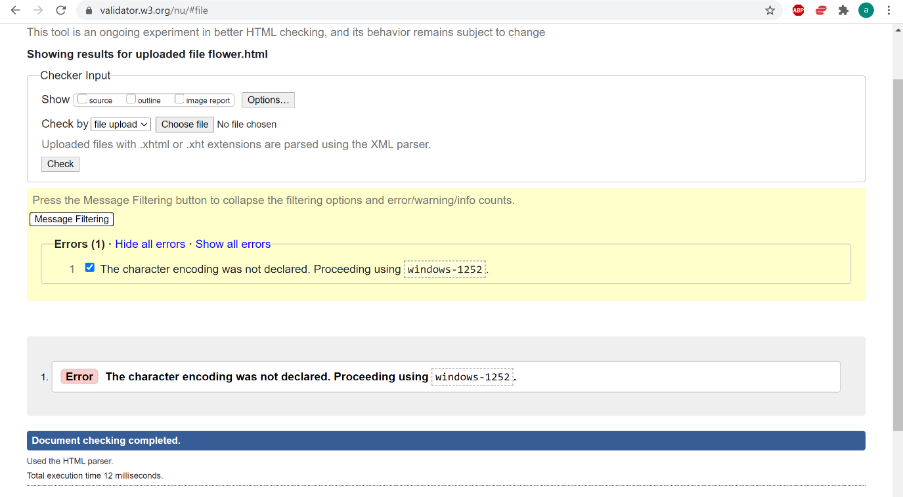
This error was due to not declaring the media encoding type within the HTML file. To rectify this issues I added <meta charset="UTF-8"> to all of my html files. The utf-8 encoding type allows for all different types of symbols and characters, without this added to the file the browser will not know which standard to use.
Individual element page (lavender.html , basil.html etc)
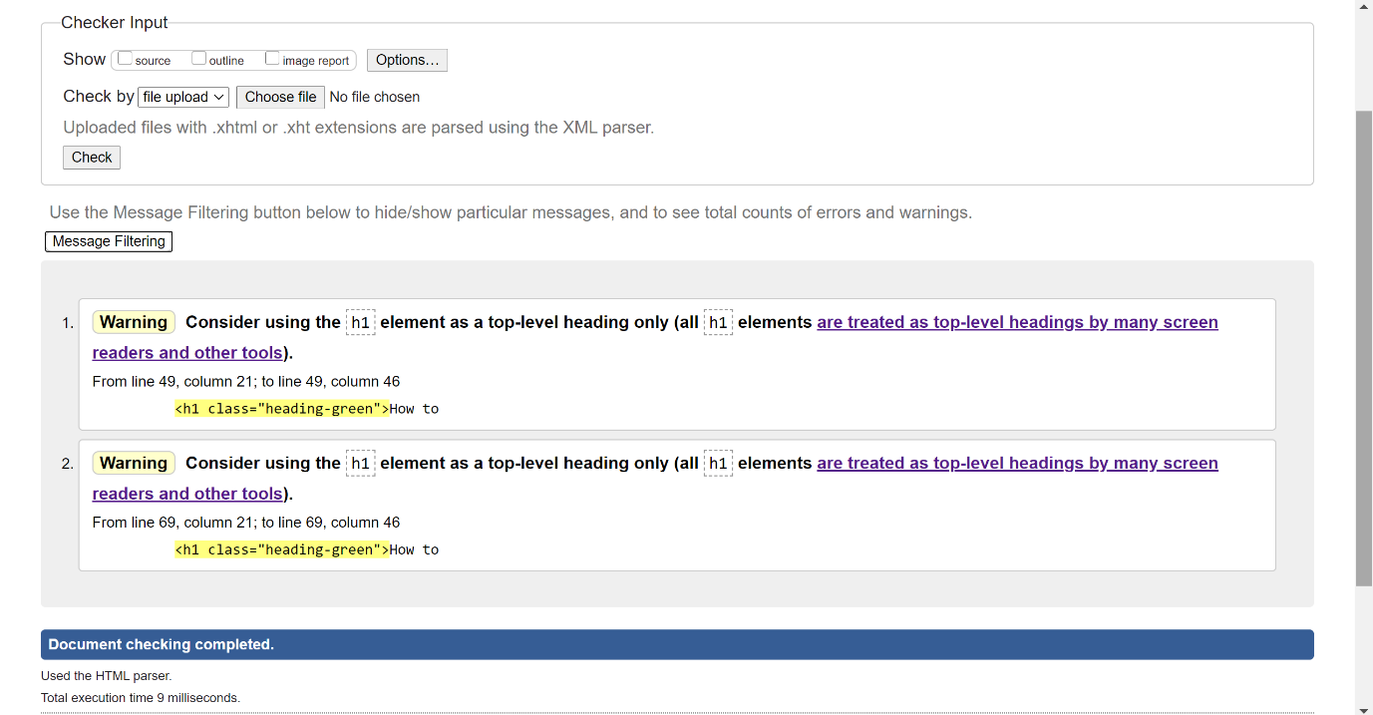
I originally used two H1 tags on the same page, I have rectified this by changing the lower level heading to level 2.

6
CSS
I validated my CSS file using https://jigsaw.w3.org/css-validator/
No errors where found.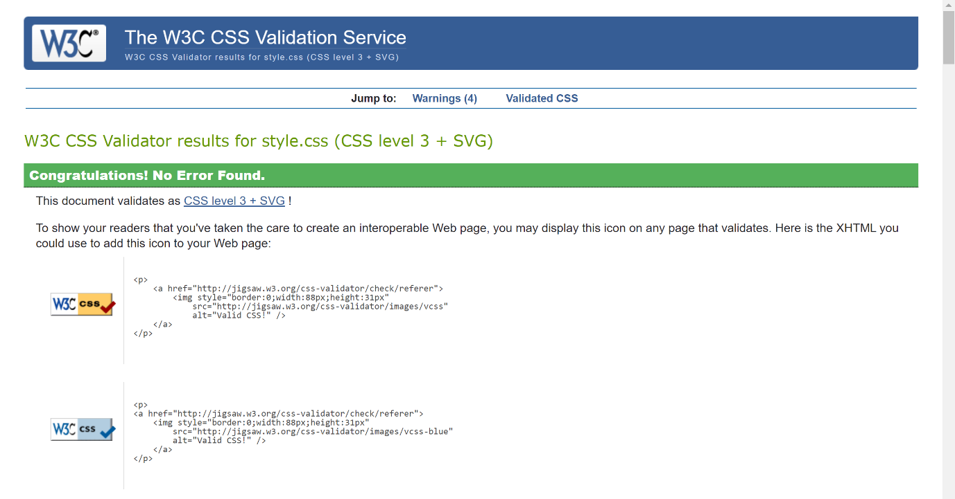

The warnings that are stated are from the use of the ROOT variables that I added to store the colours for the website, it shows as a warning as it is proprietary code, it is not needed but it does add consistency and ease of use to the website, allowing develops to easily change the colours as needed.

7
Evaluation
Website Usability
The usability of a Website is defined by the ISO (International organisation for standardisation) as: “… Usability is to enable users to achieve their goals effectively, efficiently and with satisfaction … enabling new users to be become effective, efficient and satisfied when starting a system regardless of the capabilities of the user… and allow for effective maintenance [of the system] … usability is an outcome of use” [1]
To create a user-friendly website, we must design our site with this in mind. Careful consideration is needed when deciding on a layout, functionality, carefully placed graphics and how a user will traverse the site are all important in creating a website that passes the usability test.
Usability tests are often used throughout the industry to get relevant feedback from users before the site is published.
Web users tend to be impatient when it comes to the web, most do not stay on a page for longer than 20 seconds. [2] within this time scale, load times must be less than 1 second and your intended message should be easy to see, and the user should know where they need to go, if a site looks to complicated or loads to slow the user will click off and find somewhere else to go.
Therefore, usability Is important to ensure users can find the information quickly and effortlessly. Usability should be incorporated within the design face and then tested on the general public before full completion and release is started.

Accessibility
Website accessibility refers to the ability to be able access the information that is been presented to the user, regardless of impaired vision / hearing or other illnesses and syndromes that can affect a person. Taking into consideration accessibility needs of the population is important to ensure every visitor has a good experience and leaves your site feeling satisfied.
Accessibility functionality can be added to any website without changing the look and feel of a site.
2.2 billion people worldwide have a level of vision impairment [3]
430 million people worldwide have hearing impairment. [4]
Around 50 million people worldwide have epilepsy.
Without accessibility on a website, these people that suffer due to their diagnosis are isolated from viewing your site. Although there are many accessibility utilities provided by Microsoft and 3rd party vendors in the form of brail pads, read-aloud technology, and the ability to disable flashing ads (mostly) these technologies can only work if the developers put in the work and effort to ensure that the code supports these features. [5]
To code for accessibility:
Ensure alt tags have a valid description of the image
Use correct heading element to allow for the read-aloud technologies to form a precise DOM tree to read the items in order. 8
Ensure no flashing elements are present on the website, are all easy things to add when developing a website that does not disclude and isolate any person.

SEO
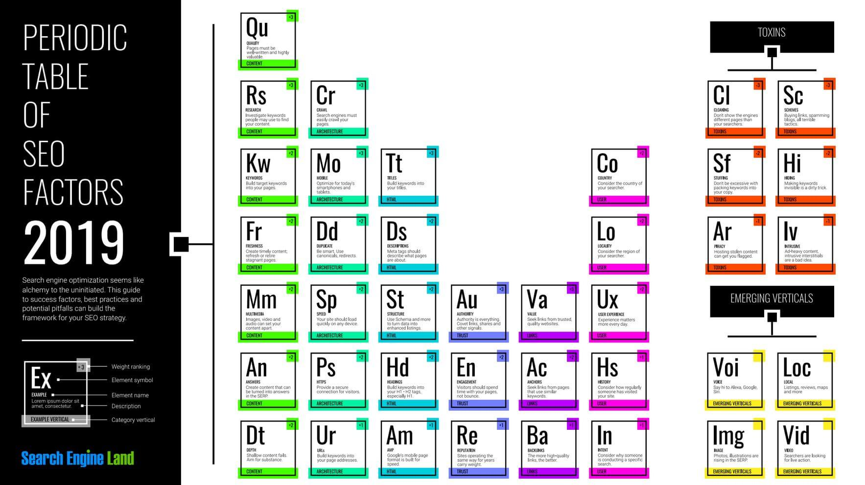
Search engine optimisation is the process of improving visibility and web flow traffic through the site. To do this, browsers like google and fox use bots that visit each and every page that is uploaded on to the web and ranks them in the order that they should appear in the search engine. The more optimized your website is, the higher the ranking and the more clicks your site will obtain. There are many factors that go into SEO ranking, you can either gain or lose points if the criteria is not met. [7]
[Figure 1: searchengineland.com]

Adding links to well trusted vendors will increase your SEO ranking, using meta-tags like the description attribute and the title tag will also increase rank.
Search engine optimization is important to ensure top ranking within browser search engines to drive more traffic through the website.

9
Website evaluation
Usability
- ensured images are the correct size to reduce load times and ensure image quality does not deteriorate.
- Website is responsive for users on mobile or tablet devices.
- easy to navigate with drop down navigation and highlighted links.
- Site is plane and simple
- text is well laid out and easy to read

SEO
- Added links to trusted vendors and sites for search engine optimisation
-Added meta tag description to the index page and relevant title tags to all other pages. Keywords are deprecated and not used as a source for ranking for all of the major web browsers [6]

Accessibility
-Added descriptive alt tags to all images for accessibility and Search engine optimisation
- only added links to fonts that are used to speed up loading time.
- used a small variation of colours that are gender neutral.

10
REFERENCES
[1] Technical Committee ISO/TC 159 Ergonomics, Subcommittee SC 4, Ergonomics of human-system interaction. “Ergonomics of human-system interaction -Part 11: Usability: Definitions and concepts”, Published: ISO 9241-11:2018(en), available online: https://www.iso.org/obp/ui/#iso:std:iso:9241:-11:ed-2:v1:en
[2] https://www.nngroup.com/articles/how-long-do-users-stay-on-web-pages/#:~:text=Summary%3A%20Users%20often%20leave%20Web,value%20proposition%20within%2010%20seconds.
[3] https://www.who.int/news-room/fact-sheets/detail/blindness-and-visual-impairment#:~:text=Globally%2C%20at%20least%202.2%20billion,near%20or%20distance%20vision%20impairment.
[4] https://www.who.int/news-room/fact-sheets/detail/deafness-and-hearing-loss#:~:text=Over%205%25%20of%20the%20world's,will%20have%20disabling%20hearing%20loss.
[5] Tim Thatcher el: “Web Accessibility: Web standards and regulatory” Published: Friends of ED, Published on: 30-03-2007”, ISBN: 9781430201885. Available online: https://r1.vlereader.com/Reader?ean=9781430201885
[6] Wordstream “Meta tags – How google Meta tags impact SEO”, Published online: https://www.wordstream.com/meta-tags
https://snipcart.com/blog/images-optimization-page-load-time
https://www.gardendesign.com/plants/lavender.html

11

Appendices
Style.css
/* UTILITY CLASSES -------------------- */
:root{
--dark-green: #83958A;
--font-green: #95A29C;
--box-green:#38CA91;
--pale-green:#F0FAEF;
}
body *{
box-sizing: border-box;
font-size: 100%;
margin:0;
padding:0;
font-family: 'Raleway', sans-serif;
}
a{
text-decoration: none;
}
.flex-row{
display: flex;
flex-direction: row;
justify-content: space-between;
}
.flex-col{
display: flex;
flex-direction: column;
}
.reverse{
flex-direction: row-reverse;
}
/* END OF UTILITY CLASSES ------------- */
.navigation{
padding: 20px;
position: relative;

}
.navigation > ul{
display: flex;
flex-direction: row;
justify-content: space-evenly;
list-style-type: none;
}
.navigation > ul > li > a{
font-size: 1.3em;
color:black;
font-family: 'Raleway', sans-serif;
border-bottom: transparent;
}

.navigation > ul > li > a:hover{
border-bottom: 2px solid var(--dark-green);
}
.dropdown-content {
display: none;
position: absolute;
margin-left: -14px;
min-width: 160px;
padding: 12px 16px;
z-index: 1;
background-color: white;
}
.dropdown-content > a{
font-size: 1em;
color:black;
border-bottom: transparent;
padding: 10px;
border: 2px solid transparent;
width:100%;
}
.dropdown-content > a:hover{
background-color: var(--dark-green);
color:white;
}
.nav-list:hover .dropdown-content {
display: flex;
flex-direction: column;
}
/* end of navigation */
.flower-banner{
width:100%;
height:90px;
background-image: url(flower-banner.png);

}
.heading-banner{
font-family: 'Montserrat', sans-serif;
font-weight: 400;
font-size: 3em;
width:100%;
text-align: center;
padding: 20px;
}
/* home page styles */
.heading-landing{
font-size: 2.5rem;
text-align: center;
color: var(--font-green);
font-weight: 400;
padding:10px;
}
.plant-menu > p{
width:70%;
padding:3px;
}
/*main pages stles */
.plant-box > div{
width:25%;
position: relative;
}
.plant-box > div > img{
width:100%;
height:100%;
}
.hover-boxpop{
position: absolute;
bottom: 0px;
width:100%;
background-color: #38ca92a6;
padding:20px;
color:white;
}
.off{
display: none;
}
.plant-menu:hover .off{
display: block;
}
/* Individual item pages */
/* banners */
#bromeliad-banner{
background-image: url(image/bromeliad.png);
height:100px;
}
#rubber-banner{
background-image: url(image/rubber-tree-0.png);
height:100px;
}
#aglaonema-banner{
background-image: url(image/aglaonema.png);
height:100px;
}
#peace-banner{
background-image: url(image/peace-lily.png);
height:100px;
}

#rose-banner{
background-image: url(image/rose-banner.png);
height:100px;
}
#lavender-banner{
background-image: url(image/lavender.png);
height:100px;
}
#jasmine-banner{
background-image: url(image/jasmine.png);
height:100px;
}
#hibiscus-banner{
background-image: url(image/hibiscus.png);
height:100px;
}
#basil-banner{
background-image: url(image/basil.png);
height:100px;
}
#coriander-banner{
background-image: url(image/coriander.png);
height:100px;
}
#mint-banner{
background-image: url(image/mint.png);
height:100px;
}
#parsley-banner{
background-image: url(image/parsley.png);
}

/* end of banners */
.heading-indi{
padding:20px;
color:white;
text-align: center;
font-size: 2.5em;
}
.heading-green{
color:var(--font-green);
font-size: 2.5em;
}
.top-sec{
margin-top: 20px;
padding:20px;
}
.bot-sec{
padding:20px;
}
.text{
width:50%;
margin-left: 10px;
}
.text > ol{
margin-left: 20px;
padding:10px;
}
.text > ol > li{
margin: 20px;
}
.text > ol > li > a{
color: var(--dark-green);
border-bottom: 1px solid var(--dark-green);
}

.divider{
width: 100%;
height:50px;
background-color: var(--font-green);
margin:0;
padding:0;
}
.text-right{
width:50%;
}
/*Login / create account styles */
.create-account{
width:30%;
position: absolute;
top:50%;
left:50%;
transform: translate(-50%, -50%);
margin-top: 60px;
}
.create-account > input{
padding:10px;
margin:20px;
border:0;
border-bottom:1px solid var(--dark-green);
}
.create-account > h1{
text-align: center;
font-weight: 300;
font-size: 1.4rem;
}
/*Footer*/
.footer{
background-color: var(--dark-green);
width:100%;
height:20px;
color:white;
float:bottom;
}
/* MEDIA QUERY */
@media only screen and (max-width: 700px){
.hover-boxpop{
display: block;
padding:50px;
}
.plant-box{
display: flex;
flex-direction: column;
padding:50px;
}
.plant-box > div{
width:100%;
}
.navigation > ul{
font-size: .6rem;
}
.top-sec{
display: flex;
flex-direction: column;
}
.bot-sec{
display: flex;
flex-direction: column;
}
.text{
width:100%;
}
.text-right{
width:100%;
}
}

Index.html
<!DOCTYPE html>
<html lang="en">
<head>
<meta charset="UTF-8">
<title>The plants co</title>
<meta name=”description” content="Learn how to grow and care for a variety of indoor and outdoor plants, herbs and flowers. Use our community diagnostic forum to diagnosis sick plants.">
<link rel="stylesheet" href="style.css">
<link rel="preconnect" href="https://fonts.gstatic.com">
<link href="https://fonts.googleapis.com/css2?family=Raleway:wght@300&display=swap" rel="stylesheet">
<link href="https://fonts.googleapis.com/css2?family=Rajdhani&family=Train+One&display=swap" rel="stylesheet">
</head>
<body>
<nav class="navigation">
<ul>
<li class="nav-list"><a href="#">Home</a></li>
<li class="nav-list">
<a href="pages/flowers/flower.html">Flowers</a>
<div class="dropdown-content">
<a href="pages/flowers/rose.html">Rose</a>
<a href="pages/flowers/lavender.html">Lavender</a>
<a href="pages/flowers/jasmine.html">Jasmine</a>
<a href="pages/flowers/Hibiscus.html">Hibiscus</a>
</div>
</li>
<li class="nav-list">
<a href="pages/plants/plant.html">Plants</a>
<div class="dropdown-content">
<a href="pages/plants/bromeliad.html">Bromeliad</a>
<a href="pages/plants/rubbertree.html">Rubber Tree</a>
<a href="pages/plants/aglaonema.html">Aglaonema</a>
<a href="pages/plants/peacelily.html">Peace Lily</a>
</div>
</li>
<li class="nav-list">
<a href="pages/herbs/herbs.html">Herbs</a>
<div class="dropdown-content">
<a href="pages/herbs/basil.html">Basil</a>
<a href="pages/herbs/coriander.html">Coriander</a>
<a href="pages/herbs/mint.html">Mint</a>
<a href="pages/herbs/parsley.html">Parsley</a>
</div>
</li>
<li class="nav-list"><a href="pages/com-hub.html">Community Hub</a></li>
<li class="nav-list"><a href="pages/login.html">Login</a></li>
</ul>
</nav>
<div class="wrapper">
<div class="flower-banner">&nbsp;</div>
<h1 class="heading-landing">Plant.co</h1>
<div class="plant-box flex-row">
<div class="plant-menu">
<img src="image/bromeliad.png" alt="Learn to grown plants"/>
<div class="hover-boxpop">
<a href="pages/plants/plant.html"><h3>Plants</h3></a>
</div>
<p>Learn to grow a variety of plants, indoor and outdoors</p>
</div>
<div class="plant-menu">
<img src="image/lavender.png" alt="Learn to grown flowers"/>
<div class="hover-boxpop">
<a href="pages/flowers/flower.html"><h3>Flowers</h3></a>
</div>
<p>Learn to grow a variety of flowers, indoor and outdoors</p>
</div>
<div class="plant-menu">
<img src="image/basil.png" alt="Learn to grown Herbs"/>
<div class="hover-boxpop">
<a href="pages/herbs/herbs.html"><h3>Herbs</h3></a>
</div>
<p>Learn to grow a variety of herbs, indoor and outdoors</p>
</div>
<div class="plant-menu">
<img src="image/bromeliad.png" alt="Learn to grown plants"/>
<div class="hover-boxpop">
<a href="pages/plants/plant.html"><h3>Community Hub</h3></a>
</div>
<p>Your place to share photos, get diagnostics on sick plants and help others</p>
</div>
</div>
</div>
</body>
</html>

Plant.html
<!DOCTYPE html>
<html lang="en">
<head>
<meta charset="UTF-8">
<title>Plants</title>
<link rel="stylesheet" href="../../style.css">
<link rel="preconnect" href="https://fonts.gstatic.com">
<link href="https://fonts.googleapis.com/css2?family=Montserrat:wght@300&family=Raleway:wght@200&display=swap" rel="stylesheet">
</head>
<body>
<nav class="navigation">
<ul>
<li class="nav-list"><a href="../../index.html">Home</a></li>
<li class="nav-list">
<a href="flower.html">Flowers</a>
<div class="dropdown-content">
<a href="../flowers/rose.html">Rose</a>
<a href="../flowers/lavender.html">Lavender</a>
<a href="../flowers/jasmine.html">Jasmine</a>
<a href="../flowers/hibiscus.html">Hibiscus</a>
</div>
</li>
<li class="nav-list">
<a href="../plants/plant.html">Plants</a>
<div class="dropdown-content">
<a href="bromeliad.html">Bromeliad</a>
<a href="rubbertree.html">Rubber Tree</a>
<a href="aglaonema.html">Aglaonema</a>
<a href="peacelily.html">Peace Lily</a>
</div>
</li>
<li class="nav-list">
<a href="../herbs/herbs.html">Herbs</a>
<div class="dropdown-content">
<a href="../herbs/basil.html">Basil</a>
<a href="../herbs/coriander.html">Coriander</a>
<a href="../herbs/mint.html">Mint</a>
<a href="../herbs/parsley.html">Parsley</a>
</div>
</li>
<li class="nav-list"><a href="../com-hub.html">Community Hub</a></li>
<li class="nav-list"><a href="../login.html">Login</a></li>
</ul>
</nav>
<div class="wrapper">
<div class="flower-banner">&nbsp;</div>
</div>
<h1 class="heading-banner">Plants</h1>
<div class="plant-box flex-row">
<div class="plant-menu" id="plant-1">
<img src="../../image/bromeliad.png" alt="Bromeliad plant, red variety"/>
<div class="hover-boxpop">
<a href="bromeliad.html"><h3>Bromeliad</h3></a>
</div>
</div>
<div class="plant-menu" id="plant-2">
<img src="../../image/rubber-tree-0.png" alt="Rubber tree, Fiscus Robusta"/>
<div class="hover-boxpop">
<a href="rubbertree.html"><h3>Rubber Tree</h3></a>
</div>
</div>
<div class="plant-menu" id="plant-3">
<img src="../../image/aglaonema.png" alt="Aglaonema, chinese evergreen"/>
<div class="hover-boxpop">
<a href="aglaonema.html"><h3>Aglaonema</h3></a>
</div>
</div>
<div class="plant-menu" id="plant-4">
<div class="hover-boxpop">
<a href="peacelily.html"><h3>Peace Lily</h3></a>
</div>
<img src="../../image/peace-lily.png" alt="Peace-lily in bloom"/>

</div>
</div>
<footer class="footer">
<div>&copy;</div>
</footer>
</body>
</html>

Login.html

<!DOCTYPE html>
<html lang="en">
<head>
<meta charset="UTF-8">
<title>Login</title>
<link rel="stylesheet" href="../style.css">
<link rel="preconnect" href="https://fonts.gstatic.com">
<link href="https://fonts.googleapis.com/css2?family=Raleway:wght@300&display=swap" rel="stylesheet">
<link href="https://fonts.googleapis.com/css2?family=Rajdhani&family=Train+One&display=swap" rel="stylesheet">
</head>
<body>
<nav class="navigation">
<ul>
<li class="nav-list"><a href="../index.html">Home</a></li>
<li class="nav-list">
<a href="pages/flowers/flower.html">Flowers</a>
<div class="dropdown-content">
<a href="flowers/rose.html">Rose</a>
<a href="flowers/lavender.html">Lavender</a>
<a href="flowers/jasmine.html">Jasmine</a>
<a href="flowers/Hibiscus.html">Hibiscus</a>
</div>
</li>
<li class="nav-list">
<a href="plants/plant.html">Plants</a>
<div class="dropdown-content">
<a href="plants/bromeliad.html">Bromeliad</a>
<a href="plants/rubbertree.html">Rubber Tree</a>
<a href="plants/aglaonema.html">Aglaonema</a>
<a href="plants/peacelily.html">Peace Lily</a>
</div>
</li>
<li class="nav-list">
<a href="pages/herbs/herbs.html">Herbs</a>
<div class="dropdown-content">
<a href="herbs/basil.html">Basil</a>
<a href="herbs/coriander.html">Coriander</a>
<a href="herbs/mint.html">Mint</a>
<a href="herbs/parsley.html">Parsley</a>
</div>
</li>
<li class="nav-list"><a href="#">Community Hub</a></li>
<li class="nav-list"><a href="login.html">Login</a></li>
</ul>
</nav>
<div class="wrapper">
<div class="flower-banner">&nbsp;</div>
<section class="form">
<form class="create-account flex-col">
<h1>Create Account</h1>
<input type="text" class="form-name" id="user-name" placeholder="Enter name">
<input type="email" class="form-name" id="user-email" placeholder="Enter email">
<input type="password" class="form-name" id="user-password" placeholder="Enter password">
<input type="password" class="form-name" id="user-Cpassword" placeholder="Confirm password">
<input type="submit">
</form>
</section>
</div>
</body>
</html>

Lavender.html
<!DOCTYPE html>
<html lang="en">
<head>
<meta charset="UTF-8">
<title>Lavender</title>
<link rel="stylesheet" href="../../style.css">
<link rel="preconnect" href="https://fonts.gstatic.com">
<link href="https://fonts.googleapis.com/css2?family=Montserrat:wght@300&family=Raleway:wght@200&display=swap" rel="stylesheet">
</head>
<body>
<nav class="navigation">
<ul>
<li class="nav-list"><a href="../../index.html">Home</a></li>
<li class="nav-list">
<a href="../flowers/flower.html">Flowers</a>
<div class="dropdown-content">
<a href="rose.html">Rose</a>
<a href="lavender.html">Lavender</a>
<a href="jasmine.html">Jasmine</a>
<a href="hibiscus.html">Hibiscus</a>
</div>
</li>
<li class="nav-list">
<a href="plant.html">Plants</a>
<div class="dropdown-content">
<a href="../plants/bromeliad.html">Bromeliad</a>
<a href="../plants/rubbertree.html">Rubber tree</a>
<a href="../plants/aglaonema.html">Aglaonema</a>
<a href="../plants/peacelily.html">Peace Lily</a>
</div>
</li>
<li class="nav-list">
<a href="../herbs/herbs.html">Herbs</a>
<div class="dropdown-content">
<a href="../herbs/basil.html">Basil</a>
<a href="../herbs/coriander.html">Coriander</a>
<a href="../herbs/mint.html">Mint</a>
<a href="../herbs/parsley.html">Parsley</a>
</div>
</li>
<li class="nav-list"><a href="../com-hub.html">Community Hub</a></li>
<li class="nav-list"><a href="../login.html">Login</a></li>
</ul>
</nav>
<div class="wrapper">
<div id="lavender-banner"><h1 class="heading-indi">Lavender</h1></div>
<section class="top-sec flex-row">
<div class="text text-left">
<h2 class="heading-green">How to Grow</h2>
<p>
Lavender originates from the Mediterranean. English lavender however achieved its name as it grows well in the English climate. Lavender is a flower and a herb, it is used In many Asian cuisines, beauty products and tea. The vibrant purple colour and the beautifully aromatic aroma is also very popular with bees and can be a great pollinators plant for your garden.
</p>
<ol>
<li>Choose a spot in the garden that gets direct sun all day, if you plant on keeping your lavender alive during the winter months (English lavender only) plant the lavender under a tree canopy for protection against the harsh winter elements. </li>
<li>Unpot and plant the seedlings so that the root ball and base of the flower is submerged.</li>
<li>Water lightly every day until the lavender is well established. </li>
</ol>
</div>
<div class="images">
<img src="../../image/lavender-1.png" alt="Lavender bloom"/>
</div>
</section>
<div class="divider">&nbsp;</div>
<section class="bot-sec flex-row">
<div class="images">
<img src="../../image/lavender-2.png" alt="Lavender sprig"/>
</div>
<div class="text text-right">
<h1 class="heading-green">How to care for</h1>
<ol>
<li>Prune the lavender plant at the beginning of every spring for healthy new growth</li>
<li>Feed with <a href="https://www.thewarehouse.co.nz/p/yates-thrive-liquid-concentrate-all-purpose-500ml/R1874655.html">All purpose plant food</a> every 2 weeks during the bloom season (spring – autumn) </li>
<li>Cut back in the winter. </li>
</ol>
</div>
</section>
</div>
</body>
</html>

