University of Wales Trinity Saint David
Wales Institute of Science &Art

Engine Characteristics
Motorsport Engineering (ACHA4004)

Owain Wilcox (2003601)
March 2022
Contents

1 Introduction 1
1.1 Objectives 1
2 Literature & Analysis 2
2.1 Water Dynos 2
2.2 Electric Dynos 2
3 Methodology 3
4 Analysis & Discussion 4
5 Conclusion 8
6 References 9

Figure 1: Torque and Power vs RPM at full load 4
Figure 2: BMEP and Thermal efficiency vs RPM at full load 5
Figure 3: Specific Guel Consumption graph with best and worst SFC points 6
Figure 4: 3D graph of pressure and crank angle vs RPM 7
Figure 5: Side views of crank angle and pressure vs rpm 7

Introduction

This report highlights the different methods of measuring engine power via the use of an engine dynamometer (Dyno). It will cover the various types of dynos, what their advantages and disadvantages are and why this testing procedure is used in the motorsport industry.

Objectives

The objectives for this report will be to outline the dyno testing procedure on an early 2000’s Honda Jazz Vtec engine. Data will be collected and run in a MATLAB live script to produce various engine data values and their respective graph forms. This will then be analysed to assess the efficiency against power of the engine.

Literature & Analysis

Dynos come in 2 forms: engine and chassis. Chassis dynos are more commonly used as this calculates the overall performance of a vehicle’s drivetrain and engine combined. Engine dynos are more commonly used by manufacturers or specific engine performance businesses to assess the performance characteristics during an engine’s development stage. This section will look at the differences between the water and electric dynos as friction dynos are no longer used due to their inaccuracies and maintenance requirements.

Water Dynos

Water dynos are more common than friction dynos, especially in the performance automotive section due to its good accuracy and lower costs to purchase, and therefore use. It works much the same way as a torque converter does as the engine is connected to a rotor in a water filled housing. When this rotor spins, a stator wheel will try to spin with it. This wheel is attached to a strain gauge and counterbalance weights which provide resistance to the spinning unit whilst subsequently reading the torque values the flywheel is producing. From these values, the engine horsepower can be calculated (S.Kim, 2007). The dynos are very versatile as their operating range is between 350hp up to 10000hp (Power Test Dynamometer. n.d).

Electric Dynos

Electric dynos are the most expensive of the three and work via magnetic fields and electric currents. There are a couple of types: Eddy current and AC Regenerative. Eddy current dynos are either air or water cooled and work via a spinning rotor creating a disturbance in the magnetic field between 2 coil plates. The power can be controlled by altering the current the coils receive (UWTSD, 2022). Eddy current dynos are suitable for low HP engines up to around 250hp. AC Regenerative, however, have a higher operating range from 10hp to 5000hp (Power Test Dynamometer. n.d). Electric dynos are more accurate than the other dynos however they are more expensive.

Methodology

As previously stated, the engine used in this procedure is an early 2000’s Honda engine connected to a Schenck W230 Eddy current dyno at UWTSD. This rig allows for total control over the engine operational parameters except for the air temperature and pressure due to the dyno cell being open without an atmospheric control system. However, these values were measured prior to testing to provide reference values. The data was collected by inputting various combinations of dyno load vs engine rpm into the dyno and recording data sets such as cylinder pressures and fuel consumptions.

Analysis & Discussion

This section analyses the gathered data. Graphs were generated in MATLAB to assist in visualisation of the data.

Figure 1 shows the engine torque and power vs RPM. This graph was plotted under full load conditions.
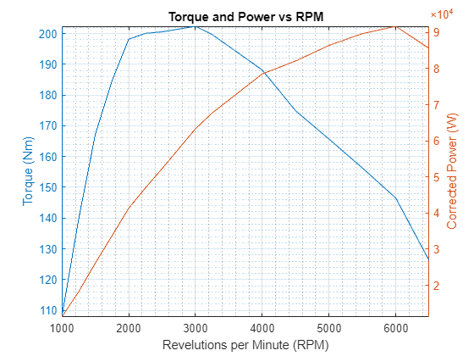
Figure 1: Torque and Power vs RPM at full load
This graph shows that the highest torque value is at 3000rpm and the highest power output at 6000 rpm. The torque increases steeply to its highest value of 202Nm at 3000rpm because the engine is most volumetrically efficient at this point and is sucking in the most air that it can to fill the cylinders. After this point, the curve decreases steadily as the engine is rotating too quickly for the air to fully fill the cylinders before it is compressed. To improve this curve, a turbo can be fitted to the vehicle to force the air into the cylinder. The power increases steadily to its highest value of 92000W at 6000rpm due to the increase in speed. Power is effectively rpm multiplied by torque so the value will continue to increase with higher rpms up until a certain point where it will begin to suddenly decrease.

Figure 2 displays the relations between Brake mean effective pressure and thermal efficiency against rpm.
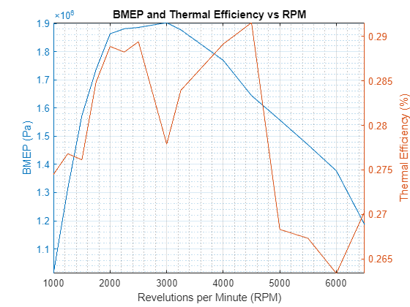
Figure 2: BMEP and Thermal efficiency vs RPM at full load

The BMEP mirrors the torque curve with a steep increase in gradient up to 2000rpm and a slow increase from 2000-3000rpm. This is the highest value of 1,900,000 Pa of pressure within the cylinder. Beyond this point, the graph decreases steadily in gradient, again, mirroring the torque curve as the engine can’t pull in enough air to completely fill the cylinder. Regarding the thermal efficiency, it reaches a peak around 0.287% efficient at 2500rpm before dropping to 0.278% at 3000rpm. This engine has Vtec which alters the characteristics of the engine by altering the valve timings, therefore the thermal efficiency increases to a new peak at 4500rpm. At this point the engine is considered most thermal efficient where the least amount of energy is being wasted in heat generation. The worst thermal efficiency is at 6000rpm.

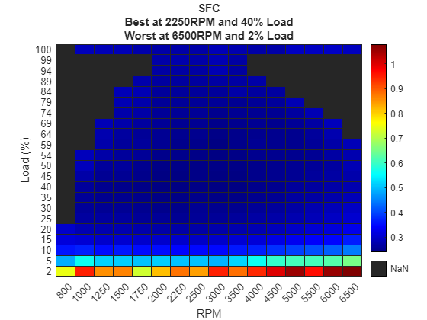
Figure 3: Specific Guel Consumption graph with best and worst SFC points

Figure 3 highlights the fuel consumption of the engine throughout the rev range and loads. It depicts that the best fuel consumption is at 2250rpm at 40% load such as under cruising conditions. The worst fuel consumption is at 2% load at 6500rpm when the engine is being revved high while stationary. A point to note is that below the 10% load mark the fuel consumption is significantly higher than above 10%.
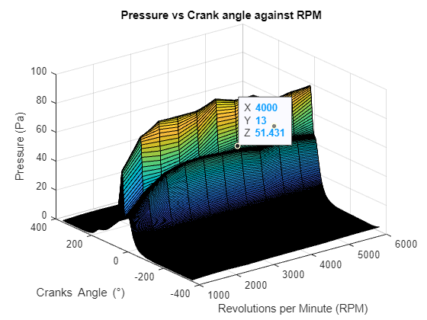
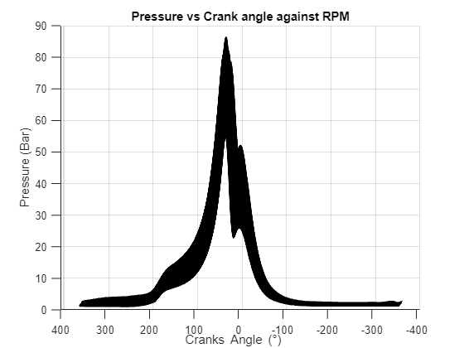
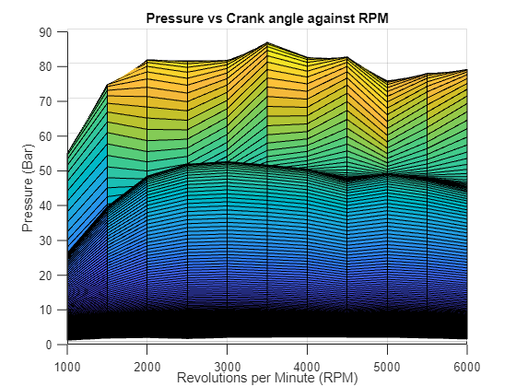
Figure 4: 3D graph of pressure and crank angle vs RPM

Figure 5: Side views of crank angle and pressure vs rpm

Figure 4 displays a 3D graph of the pressure in the engine in relation to crank angles and rpm. Figure 5 shows side views of the graphs. The left view of figure 5 shows that the peak cylinder pressures occur at around 30 degrees before TDC at 0 degrees with a peak pressure of 88 bar. The right of figure 5 shows that the 88 bar was experienced at 3500rpm. The pressures average around 80 bar between 2000rpm and 6000rpm. Below 2000rpm they are significantly less with around 60 bar of pressure at 1000rpm.

Conclusion

To conclude, this report has outlined the testing procedure of the Honda Jazz engine as well as the different available dyno options. Evaluation of the test data in MATLAB has led to the creation of multiple graphs from which the engines peak power, torque, heat, and efficiency values can be read. These graphs were analysed, and conclusions were drawn for the best fuel consumption, best power, and best torque were in relation to the engines load and revs.

This report has highlighted why dynos are used in the automotive and motorsport sectors. It’s useful to car manufacturers as monitoring the engines fuel consumption and efficiency will aid in meeting Euro emission standards. To the motorsport industry it is useful to assess the performance of the engine, where the peak power and torque levels are as well as spotting any optimisable points that can be tuned out to further improve vehicle performance.

References

Kim, S., 2007. Learn About Dyno Testing - How Dynos Work - Chevy High Performance Magazine. [online] MotorTrend. Available at: <https://www.motortrend.com/how-to/0710ch-how-dynos-work/> [Accessed 24 March 2022].

Power Test Dynamometer. n.d. What is a Dynamometer? [online] Available at: <https://powertestdyno.com/what-is-a-dyno/> [Accessed 24 March 2022].

