

Design and implementation of object detection and verification algorithm based on YOLO
by
Shengqing Pei
Supervisor: Terry Walcott

Project submitted as part of the requirements for the award of
MSc Software Engineering

November 2021

DECLARATION

I, Shengqing Pei FULL NAME Shengqing Pei declare that I am the sole author of this Project; that all references cited have been consulted; that I have conducted all work of which this is a record, and that the finished work lies within the prescribed word limits.

This work has not previously been accepted as part of any other degree submission.

Signed : Shengqing Pei

Date : 2021/11/10

FORM OF CONSENT

I Shengqing Pei FULL NAME Shengqing Pei hereby consent that my Project, submitted in candidature for the M.Sc. Applied Computing degree, if successful, may be made available for inter-library loan or photocopying (subject to the law of copyright), and that the title and abstract may be made available to outside organisations.

Signed : Shengqing Pei

Date : 2021/11/10

ABSTRACT
Computer vision is a long-standing development direction in the computer branch, but limited by hardware equipment and technology, the development of computer vision is slow. With the improvement of computing power and the birth of deep learning, computer vision has become a popular development direction, and target detection is an important development direction in computer vision. Target detection uses computers to automatically locate and identify targets, which is of great significance in the development of UAV tracking and automatic driving. At present, convolutional neural network in deep learning is the mainstream method in the field of solar standard detection. Because of its inherent characteristics, convolutional neural network has incomparable advantages in image feature extraction compared with traditional target detection. From r-cnn, the ancestor of neural network target detection, to the recent m2det, target detection has made remarkable progress, but the accuracy and speed of the existing target detection methods can not be considered. How to carry out target detection well and quickly is still an urgent problem to be solved in target detection. There is still room for improvement in target detection. This paper proposes an improved sliding window algorithm based on Yolo algorithm, By sliding windows at different scales on the input image, the target in the high-resolution image is detected and the small target detection accuracy is improved. In addition, the image significance and RESNET recognition network are used to correct the target position and target category respectively. Finally, the two algorithms are connected to further improve the detection effect of Yolo algorithm.
The target of the target detection task is to obtain the position and category of the target in the image from the input image. In order to improve the detection performance of target detection task, an improved Yolov3 algorithm is proposed based on yolo-v3 algorithm in one-stage algorithm. The improved Yolov3 algorithm still applies the darknet-53 network of YoloV3 algorithm in the image feature extraction module; In the target prediction module, five DBL modules in the medium-scale output network and large-scale output network are replaced by "three in one" network. The "three in one" network includes up sampling and two convolution operations, and can fuse the feature information after up sampling and two convolution operations. The "three in one" network not only has a simple network structure, but also the features fused by the network contain rich semantic information and image detail information to help the network identify small targets in the image and improve the network performance. The improved Yolov3 algorithm is tested with Pascal VOC and MS coco database. The experiments show that the improved Yolov3 algorithm also has high target detection performance on the premise of simplifying the network structure

Table of Contents
ABSTRACT ii
1 Introduction 2
1.1 Aim 3
1.2 Objectives 5
1.3 Structure of the report 5
2 Research and review of literature 6
2.1 One stage algorithm 6
2.1.1 Y0l0 and its extended algorithm 8
2.1.2 SDD algorithm 9
2.2 Two stage algorithm 9
2.2.1 R-CNN algorithm 10
2.2.2 SPPNet algorithm 11
2.2.3 Fast R-CNN algorithm 14
2.2.4 Faster R-CNN algorithm 15
2.3 Typical feature fusion network structure 16
2.3.1 Introduction 17
2.3.2 Feature pyramid network (FPN) 17
2.3.3 Path aggregation network (panet) 18
2.3.4 Bidirectional feature pyramid network (bifpn) 18
2.4 Target detection and tracking based on deep learning 20
2.4.1 Artificial neural network and back propagation algorithm 21
2.4.2 Convolutional neural network 24
2.5 Target tracking based on deep learning 28
2.5.1 Two classification target tracking method 28
2.5.2 Target tracking method based on twin network 29
2.5.3 Target tracking method based on probability graph 29

2.6 Theoretical basis of deep learning 30
2.6.1 Concept of deep learning 30
2.6.2 Feedforward operation 35
2.6.3 Feedback operation 36
2.6.4 Layer 37
2.6.5 Objective function 37
2.7 Regularization 38
2.7.1 Classification task 40
2.7.2 Regression task 40
2.7.3 Regularization 41
2.8 Attention mechanism 42
2.8.1 Introduction to attention mechanism 42
2.8.2 Action principle of attention 42
2.8.3 Attention mechanism in deep learning 43

3 RESEARCH METHODOLOGY 44
3.1 Research Overview 44
3.1.1 Research Process 45
3.1.2 Research Methodologies 46
3.1.4 Data Collection 47
3.1.5 Research Design 48
3.2 Experiment Preparation 48
3.2.1 Hardware 49
3.2.2 Software 50
3.3 Development Methodology 51
4 DESIGN AND IMPLEMENTATION 52
4.1 Selection of deep learning framework and introduction of libraries 52
4.1.1 Selection of Deep Learning Framework 52
4.2 Design and implementation 53
4.3.1 Pre training model 54
4.3.2 Detection process 54
4.3.3 Batch renormalization 55
4.3.4 Yolo batch renormalization 56
4.3.5 Multiscale training 56
5 experiment 57
5.1 Experimental setup 57
5.2 Feature extraction of pre-trained network 58
5.3 Experimental simulation and result analysis 58
6 Conclusion and follow-up research direction 60
6.1 Display of experimental operation results 61
6.2 Conclusion and follow-up development 62
7 summary 65
References 67
Appendices 72

Table of Figures
Figure 1 Yolov1 network structure 7
Figure 2 Yolov1 algorithm flow 8
Figure 3 Several commonly used feature utilization forms 8
Figure 4 SFPN network structure diagram 9
Figure 5 Panet network structure diagram 9
Figure 6 Bifpn network structure diagram 12
Figure 7 Schematic diagram of neuron 12
Figure 8 Neural network structure diagram 13
Figure 9 Sigmoid activation function image 18
Figure 10 2 * 2 convolution kernel diagram 19
Figure 11 Schematic diagram of convolution operation 19
Figure 12 Schematic diagram of convolution operation 20
Figure 13 Maximum pooling diagram 21
Figure 14 Schematic diagram of dropout 22
Figure 15 Sanet target tracking algorithm framework 23
Figure 16 Twin network frame diagram 28
Figure 17 SiamFC target tracking algorithm structure 29
Figure 18 Principle of c-cot target tracking algorithm 33
Figure 19 Comparison of processing process between machine learning and deep learning 34
Figure 20 Feedforward operation diagram 41
Figure 21 Two dimensional convolution operation 41
Figure 22 Sigmoid function image 41
Figure 23 Tanh function image 42
Figure 24 Relu function image 43
Figure 25 Leaky relu and prel function images 43
Figure 26 ELU function image 44
Figure 27 Human attention distribution 44
Figure 28 Frame prediction chart 45
Figure 29 Yolo-v3 structure diagram 46
Figure 30 Structure diagram of darknet-53 46
Figure 31 Improved yolo-v3 structure diagram 47
Figure 32 "Three in one" network 48
Figure 33 Cspnet structure diagram 49
Figure 34 Yolo detection flow chart 51
Figure 35 Comparison of yolov5 series algorithms with efficientdet series algorithms 60
Figure 36 Comparison of yolo5ours, yolo5 series and other similar algorithms 62
Figure 37 Detection comparison of targets with different scales by Yolo \ 5ours, yolo5 series and other similar algorithms 64
Figure 38 Taking yolo5 ours as the benchmark, the results of binary cross entropy loss and focal loss are compared 65
Figure 39 Simulation demonstration results 1 69
Figure 40 Simulation demonstration results 2 70
Figure 41 Simulation demonstration results 3 70

1 Introduction
The term "deep learning" was first proposed in the 1980s. It is an important branch of machine learning. The predecessor of deep learning is artificial neural network, which is the earliest network model of deep learning. The reason for the downturn of artificial neural network is that single-layer perceptron only has the ability to classify linear problems, but can not complete the classification of nonlinear problems. Later, the back-propagation algorithm was applied to the training of neural network, which made the neural network have the ability of nonlinear representation, and solved the problem that multi-layer perceptron can not be trained. However, the limitation of back propagation algorithm is that the training speed will be greatly reduced with the increase of neuron nodes. In addition, due to the disadvantages of nonconvex optimization, training with gradient descent method can easily lead to the convergence of the network to the local optimal solution. The most serious problem is that the increase of layers often leads to the disappearance of gradients, resulting in the inability to improve the learning ability of the network. These problems restrict the development of neural network.
In 2006, Geoffrey Hinton first proposed the concept of deep belief network , which is composed of a series of restricted Boltzmann machines. Hinton etal. Applied this method to the experiment of handwritten font recognition and achieved good results. Pretraining is an important step in the deep belief network. This operation can make the network parameters find an initial value close to the optimal solution, and then use the fine-tuning technology to train the whole network, so as to achieve the effect of optimizing the network. Since then, the speed of neural network training has been greatly improved. At the same time, the gradient disappearance problem caused by back propagation has been effectively solved. Since then, deep neural networks have developed rapidly, and various neural networks with different structures (such as AlexNet VGG, Google net and RESNET) have been proposed successively. Convolutional neural network is the most representative model of deep learning. In the 2012 Imagenet competition, Professor Hinton and his students classified more than 1 million pictures containing 1000 categories, and achieved an excellent result with an error rate of only 15% by using the advantages of convolutional neural network. In addition, Professor Hinton and his team applied the weight attenuation operation to the network training, which effectively reduced the network over fitting phenomenon. Later, with the development of GPU acceleration technology and the improvement of computer computing power, the deep learning model not only improves the accuracy of image recognition, but also greatly reduces the time cost of manual feature extraction. Now, the extensive research of deep learning has greatly promoted the development of artificial intelligence and machine learning, Deep learning has achieved good research results in many fields such as natural language processing and computer vision, which has made a breakthrough in many technical tasks. The object detection task studied in this paper belongs to the research field of computer vision.

1.1 Aim
According to different detection methods, the target detection algorithm based on deep learning can be divided into two-stage algorithm and one-stage algorithm. Based on the proposed candidate region, the two-stage algorithm first extracts the candidate box of the target, and then modifies the candidate box twice to obtain the results of classification and regression; Based on the regression of bounding box, the one-stage algorithm classifies and regresses while generating the bounding box. Firstly, we introduce the two-stage algorithm. In chronological order, we introduce RCNN, sppnet, fast r-cnn and fasterr CNN algorithms, and summarize the main problems solved by each algorithm and the areas to be improved by subsequent methods; Secondly, we introduce the one-stage algorithm, SSD and Yolo series algorithms in turn, focusing on the basic principle and network structure of Yolo algorithm. We find that the target detection algorithm at this stage has relatively poor detection effect on small-scale targets. Considering that multi-scale feature fusion is an effective measure to improve small target detection.

1.2 Objectives
- Carefully read the literature related to the subject in recent years, master some main algorithms of target detection and the latest research status, and have a deeper understanding of deepfacelab, yolov5, deepfake, Darknet, retinaface and convolutional neural network in practical operation.
- Collect a large number of photos, images and videos of different target objects on Baidu, Google and other platforms, and divide them into training data and test data;
- The depth network model based on Yolo is established, and the output layer, excitation layer, hidden layer and output layer are set;
- By setting positive labels and negative labels, the deep network can carry out independent learning and training, and get the trained network;
- Through the trained deep learning network, and then further improve a series of parameters to adjust the recognition rate of target detection.

1.3 Structure of the report
The project consists of three parts. The first part is literature review, that is, the basis and process steps of deep neural network, the basis of target detection algorithm based on deep learning, and the application of target detection and recognition in deep learning, which provides a solid theoretical basis for the project. The second part introduces in detail how to design and improve the neural network model based on Yolo algorithm, and introduces in detail to solve the problems of slow recognition speed and low efficiency. The third part is to train the improved neural network model through self-made data sets, and verify the recognition rate through a large number of positive labels. Then compare the accuracy, speed and rate of multiple neural network models. The final target detection neural network is selected as the final depth neural network model of this experiment.

Chapter one This paper makes a basic overview and summary of this topic, and briefly describes the basic research purpose, goal and basic framework of this topic.
Chapter two After reading a large number of references, this paper summarizes the research ideas of target detection based on deep learning at home and abroad, and summarizes the research ideas and views of different scholars and researchers on this topic
Chapter three This paper expounds the research theoretical basis, process and method of this subject in detail
Chapter four This paper describes the network structure design process of this subject in detail, and explains the basic steps of establishing our own target detection neural network model.
Chapter five After establishing the neural network model of target detection, the model is trained through a large amount of data, and the recognition speed and accuracy are adjusted by adjusting the loss function and network framework.
Chapter six Then select the best network model and determine the network parameters according to the experimental results to achieve the best recognition effect.
Chapter Seven Based on the comparison of experimental data and results, the scheme is finally determined and summarized.
Chapter eight When referring to other similar projects, reflect on the shortcomings of the project and explain the improvement scheme.
Chapter nine Reflect on the difficulties and solutions encountered in the process of this research and the innovation of this research content.

2 Research and review of literature

The rapid development of deep learning makes target detection technology benefit a lot. In recent years, deep learning has been widely used in the field of target detection. However, small-scale targets account for less pixels in the image and have less semantic information. Compared with the mature large and medium-scale target detection technology, the effect of small target detection is relatively poor. Therefore, how to improve the detection accuracy of small target is a difficult problem in the field of computer vision. If the accuracy of target detection can be provided, it is a very important development prospect for the whole computer vision. It can be applied in all aspects of life, such as safety face recognition, vehicle and road sign detection and recognition in traffic.
The field of computer vision includes image classification, image segmentation, target detection, image annotation, image generation and so on. In recent years, the rapid development of target detection has added a heavy color to the arrival of the information age. The purpose of target detection is to obtain the position and category of all targets in the image from the input image. It is widely used in many fields, such as navigation robot, aerospace, video surveillance and so on. The development of target detection has greatly reduced human, material and financial resources, and has a far-reaching impact on the development of society. As a basic algorithm, target detection has a far-reaching and important impact on face recognition and other tasks. Therefore, in recent years, with the rapid development of target detection task, it has become a research hotspot of researchers.

2.1 One stage algorithm

2.1.1 YOlO and its extended algorithm
(一)YOlOv1 algorithm
Yolov1 (you only look once) can be said to be the pioneering work of one-stage target detection algorithm, which also led to the emergence of a series of improved Yolo algorithms. The most significant advantage of Yolo algorithm is that it is very fast. On Pascal voc2007 dataset, the fast version of yolov1 can achieve accuracy map = 52.7% and running speed of 155fps; The enhanced version can achieve an accuracy of map = 63.4% and a running speed of 45fps. The core idea of yolov1 is to unify the target detection problem into a regression algorithm, and directly predict the position and category probability of the frame from the input image with a convolutional neural network structure.
Network structure: The backbone network structure of the algorithm is shown in Figure 2.1. Similar to Google net, the network of yoov1 is composed of 24 volume layers, 4 pooling layers and 2 full connection layers. First, we need to unify the size of the input image to 448 × 448, and then 7 is obtained through multiple convolution layers and pooling layers × seven × 1024 dimensional tensor, and finally output 7 through two full connection layers × seven × 30 dimensional tensor. The convolution layer is used to extract features, and the full connection layer is used to obtain the predicted category probability and location information.
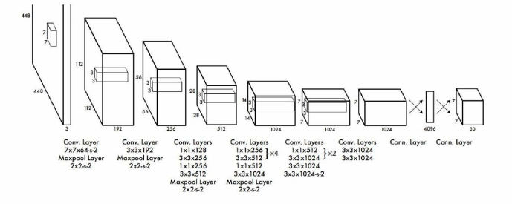
Figure 1 Yolov1 network structure

Basic principles:We explain the basic principle of yolov I by explaining the meaning of output tensor value. The network passes through the last full connection layer and gets 7 × seven × 30 output tensor. seven × seven × The meaning of 7x7 in 30 is: as shown in the left figure of Figure 22, divide the input image into SXS grid cells (the parameter s can be selected by itself, and the value of yoov1 is s = 7). If the center point of some kind of object falls at 7 × When one of the seven grid cells, the grid will be responsible for predicting such objects. Taking the left figure of Figure 2.2 as an example, assuming that the coordinates of the grid in the lower left corner are (1,1) and the center point of the smallest bounding box where the dog is located is (2,3), then in these 7 × In the grid cell of 7, grid (2,3) is responsible for prediction.
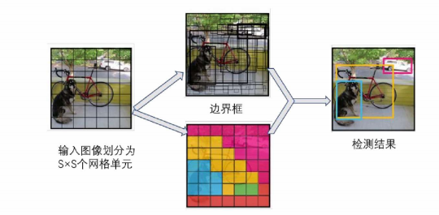
Figure 2 Yolov1 algorithm flow

Output tensor 7 × seven × 30 means that each grid finally has a 30 dimension output, where 30 is composed of (4 + 1) × 2 + 20. Each grid cell generates B rectangular boxes (yolo1 takes B = 2), and each rectangular box predicts 4 position information values (coordinates x and y of the object center point and the length and width W and h of the box) and 1 confidence value C. The calculation formula of confidence C is shown in formula (21)
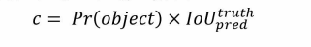
The value of PR (object) is 0 or 1, that is, when the center of the object falls in the grid cell, the confidence value is the Lou value between the real frame and the prediction frame; When the object center is not in the grid, the confidence is 0. In addition, each grid cell also predicts the probability score of C categories (for example, Pascal V oc2007 has a total of 20 categories of objects, so C = 20), that is, PR (class object). To sum up, the output is 7 × seven × The category probability and bounding box regression information are extracted from the 30 dimensional tensor. Note that the confidence is for the bounding box and the category probability is for the grid cell. Finally, according to the previous steps, predict 7 × seven × 2 = 98 target windows, then remove the target windows with low possibility according to the threshold (usually 0.2), and then remove the redundant windows through non maximum suppression (NMS). In the test stage, the confidence of each box is multiplied by the probability of each category to obtain the confidence score of which category each box belongs to, as shown in formula (2.2)
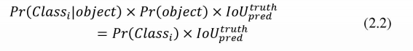

Loss function yolov1 loss function is defined as (2.3)
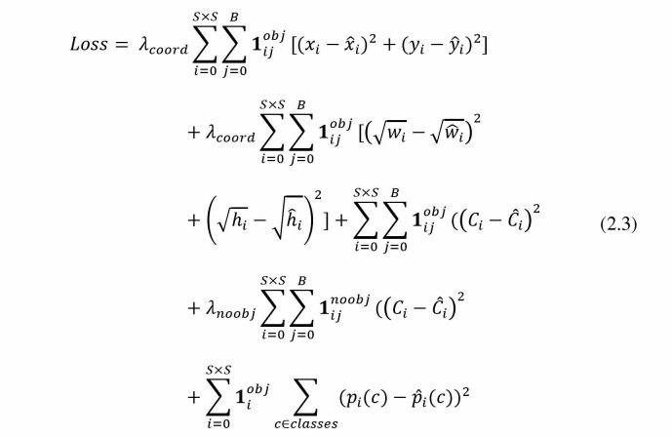
The first two terms of the loss function formula represent the position prediction of the boundary box, where 1I represents the indicative function, that is, when the j-th border of the i-th grid is responsible for a target, the result is 1, and the rest is 0. Items 3 and 4 of the formula represent the confidence prediction of the box, and the last item represents the prediction of the category. The indicative function 1I is used to judge whether the center of the target falls on the grid center I.
(二)YOlOv2 algorithm
Yolov2 improves the original yolov1 detection framework. On the basis of maintaining the original speed, yoov2 achieves better prediction effect, faster speed and more types of recognition objects. Yolov2 adopts the joint training algorithm, that is, it uses the data of classified data sets (such as Imagenet) to learn more categories of classification, and uses the data of detection data sets (such as Ms coco) to learn the location information of targets, so as to improve the ability of the model. In addition, yolov2 adopts many techniques, each of which improves the performance of the model to some extent. The improvement results are shown in the table. The main techniques of yolov2 algorithm are: ① batch normalization: normalize the features of the middle layer respectively, so that the data distribution of the features is transformed into a mean value of 0 and a variance of 1, and then add linear transformation to restore its original data expression ability. This method can effectively solve the problems of gradient disappearance and gradient explosion in the process of back propagation. ② High resolution classifier: the input resolution of yolovi pre trained on Imagenet is 224 × The input resolution of 224 detection is 448 × 48. Such switching will have a certain impact on the performance of the model. Therefore, yolov2 uses 448 after inputting the pre training with the size of 224x24 × 448 high-resolution samples fine tune the model, so that the network can gradually adapt to high-resolution input and alleviate the impact of sudden resolution switching. ③ Use a priori boxes: each cell grid is preset with 9 a priori boxes of different sizes and aspect ratios. Although the map is slightly reduced by 0.2, the recall rate is greatly improved. ④ Select a priori frame by clustering: K-means clustering method is adopted for the frame marked in the training set, and a priori frame more matching the sample size is selected ⑤ restrict the position prediction of the frame: yoov2 adjusts the formula for predicting the position of the frame, and restricts the prediction of the center point coordinates in a specific grid unit, making the value more parametric, the network more stable and easy to learn. ⑥ Multi scale training: in the process of network training, the input size will be randomly selected from the multiple of 32 {320352.. 608}, so that the same network can still achieve good results under the input of different resolutions
(三)YOlOv3 algorithm
The improved Yolo V3 can achieve the same accuracy as SSD algorithm, and the speed is nearly three times faster. The improvement of yolov3 algorithm is in three aspects: the application of multi-scale prediction, the use of a new network structure darknet-53 and the use of binary cross entropy loss network structure for classification loss: yolo3 draws lessons from the idea of RESNET, adopts a large number of residual jump connection layers, and designs and trains a new network darknet-53. At the same time, in order to reduce the negative impact of gradient caused by pooling, the network adopts full convolution layer and realizes down sampling by adjusting the step size of convolution. In order to strengthen the detection accuracy of the algorithm for small targets, yolo3 uses feature pyramid network (FPN) for multi-scale feature fusion. If the input image size is 416 × four hundred and sixteen × 3, three prediction branches are output. The feature map scales of the three prediction branches are 13 respectively × thirteen × 255、26 × twenty-six × 255 and 52 × fifty-two × 255, multi-scale method is used to detect targets of different sizes, where 255 means: 255 = 3 × (4 + 1 + 80), 3 grid cells predict 3 bounding boxes, 4 information of bounding box coordinates, 1 confidence of bounding box, and 80 categories of MS coco dataset
- YOlOv4 algorithm
Yolo-v4 algorithm has made more innovative improvements on the basis of previous algorithms, including data processing, backbone network, loss function and so on. Compared with other algorithms, this algorithm has higher performance. Yolo-v4 algorithm mainly includes four important parts: first, the input part is the image to be detected; Second, the feature extraction network part applies the feature extraction network when extracting the features of the input image; Third, the feature processing part processes the extracted features, such as weighting the feature layer; Fourth, in the target detection part, the target location and label are obtained by using the target detection method. Yolo - ⅵ 4 algorithm achieves the balance of speed and accuracy.

2.1.2 SDD algorithm
SSD (single shot multi frame detector) algorithm predicts on feature maps of different scales, and the training process is also end-to-end. Compared with fast r-cnn, SSD algorithm eliminates the step of generating the proposed area and can directly predict the category and location of the target, which greatly improves the operation speed. Therefore, SSD algorithm is also classified as one-stage detection algorithm. The reasons for the good effect of SSD algorithm can be attributed to the following three points: the use of multi-scale feature map prediction, the setting of default boxes with various aspect ratios, and the use of data enhancement technology. Firstly, in the network structure of SSD, six feature maps with different scales are used respectively (38) × 38、19 × 19、10 × 10、5 × 5、3 × 3、1 × 1) To predict targets of different sizes; Secondly, SSD introduces the default box. The default box means that each small cell on the feature map matches a series of fixed size boxes. Experiments show that the more the shape and number of default boxes, the better the detection effect. The default frame has different scales in different feature layers and different aspect ratios in the same feature layer, so it can basically cover targets of various shapes and sizes in the input image; Finally, SSD adopts data enhancement methods such as reduction operation. Reduction operation and random clipping can produce more targets with smaller scales and improve the generalization ability of the model to targets with different scales. SSD algorithm has certain advantages in speed and accuracy, but the main disadvantage is that the effect of small target detection is still general, mainly because there are not enough features of small targets at the high level.

2.2 Two stage algorithm

2.2.1 R-CNN algorithm
RCNN (regional convolutional neural network) is the foundation work of target detection algorithm based on convolutional neural network. The main steps of RCNN algorithm are as follows: firstly, the "selective search" algorithm is used to generate several regions that may contain objects; Secondly, convolutional neural network (such as Alex netl2) is used to extract features from the selected region; Then, support vector machine (svm) classifier is used for classification; Finally, the boundary box regression method is used for accurate positioning. Although RCNN algorithm has made great progress, it still has some problems to be improved. For example, model training is not end-to-end, but is carried out in multiple steps on different platforms. The training process and reasoning process consume a lot of space and time.The traditional algorithm of target detection usually has two methods when extracting candidate regions: sliding window and selective search. Sliding window is a direct method. For the extraction of candidate regions, the sliding window is used to slide from left to right and from top to bottom on the image; For selective search, it first groups the pixels of the image, then combines the similar pixel regions according to a certain measure, and finally selects the region of interest. In comparison, the implementation of selective search is more efficient. R-cnn algorithm applies selective search method when extracting candidate regions, convolutional neural network when extracting regional features, SVM classifier to predict category labels, and linear regression to predict location. Because RCNN applies the selective search method in extracting candidate regions, the prediction accuracy and speed of the algorithm have good performance.
2.2.2 SPPNet algorithm
The main problem solved by spatial pyramid pooling network (sppnet) is that in RCNN algorithm, for each candidate region, the image needs to be scaled to a fixed size (for example, the fixed size in alexnet is 224) × 224) as an input to the network, this practice may cause image distortion. Therefore, the sppnet proposed by he Kaiming's team adds a spatial pyramid pooling (SPP) layer before the full connection layer of the network structure, which pools feature maps of different scales and generates feature representations of fixed length, so as to avoid geometric deformation caused by scaling images, which will affect the performance of the target detection network. Compared with RCNN, sppnet effectively improves the accuracy, but there are still some shortcomings: spp structure only acts before the last full connection layer, ignoring the improvement of the network before spp layer; Like RCNN, the training process is divided into multiple steps and runs separately, which still needs huge storage space.
2.2.3 Fast R-CNN algorithm
Fast r-cnn is a further improvement of r-cnn algorithm and sppnet algorithm. It is a faster version of r-cnn algorithm. Fast r-cnn algorithm takes the whole image as the input to extract features, and introduces a new concept: region of interest pooling layer (ROI). ROI layer extracts fixed size features from proposed regions of different sizes, and these features are used as the input of full connectivity layer for subsequent classification and regression. In essence, fast r-cnn no longer convolutes each proposed region separately like r-cnn, but directly convolutes the whole image, and uses ROI pooling and mapping relationship to obtain uniform size features, so as to reduce a large number of repeated calculations. The experimental results on Pascal voc2007 dataset show that compared with RCNN, the average accuracy (map) of fast CNN is improved from 58.5% to 70.0%, and the speed is also improved by nearly 200 times. Although fast r-cnn realizes multi task end-to-end training, the drawback is that the selective search algorithm used to generate candidate regions is still very time-consuming in the actual process, and a more efficient candidate box proposal method is needed to replace the selective search.
2.2.4 Faster R-CNN algorithm
The faster CNN algorithm proposed by Ren et al. Adds a regional proposal network (RPN) behind the convolution layer to replace the selective search method of fastr CNN. RPN is a full convolution network, which maps the output results into probability values and four coordinate values, and unifies the binary classification loss and boundary box regression loss as the target loss function of the training process. The experimental results on Pascal Ⅴ oc2007 data set show that under the same VGg backbone network, the accuracy (map) of fast r-cnn is similar to that of fast r-cnn, but the training time and testing time are greatly shortened. Fast r-cnn has obvious speed improvement effect, but there is still computational redundancy, which needs further improvement and strengthening in the future.

2.3 Typical feature fusion network structure
2.3.1 Introduction
Although the target detection task has made great progress in recent years, the scale problem of target detection is always a difficult problem for the deep learning algorithm, that is, when the model faces the target with too large or too small scale, the detection performance will decline relatively. For the problem of multi-scale target detection, several methods of using features have been proposed in previous papers, as shown in the figure below. This paper gives four examples for brief introduction.
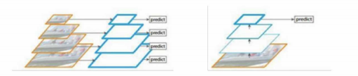
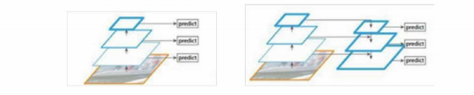
Figure 3 Several commonly used feature utilization forms

- Image pyramid structure: as shown in the figure, the image pyramid is used to construct feature pyramids of different scales. This method performs independent feature extraction for images of different scales, so as to generate multi-scale feature representation, and the feature maps of all levels retain strong semantic information.However, the defect of image pyramid method is that the reasoning time is greatly increased and the memory is too large, which makes it more difficult to train the neural network end-to-end.(2) Prediction of single high-level feature: for example, sppnet and faster CNN algorithm use single high-level feature to classify and regress targets. (3) Hierarchical pyramid feature:, a typical application of this method is SSD target detection algorithm. Because the convolution neural network calculation itself will produce multi-level feature maps, and the scales of different layer feature maps are not necessarily the same, this method proposes a pyramid hierarchical structure that can reuse convolution network calculation, which is similar to the characteristic image pyramid. However, in order to avoid using low-level features, SSD method directly abandons shallow features. For small target detection, discarding high-resolution features will lead to poor detection effect (4) feature pyramid network (FPN): in order to solve the shortcomings of the above three methods, FPN naturally uses the pyramid form of CNN hierarchical features, and feature maps with different scales at different levels have strong semantic information. The FPN structure is designed from the top-down network structure and horizontal connection, which integrates the low-level features with high resolution with the high-level features with rich semantic information. The specific form of FPN structure will be introduced in detail in the next section.
2.3.2 Feature pyramid network (FPN)
Feature pyramid network (FPN) is proposed to solve the problem of dealing with multi-scale change in target detection task. As mentioned above, in the previous target detection (such as fast r-cnn), both the regional proposal network (RPN) and the region of interest (ROI) basically act on the last layer of the network. For small targets, the number of pixels is small, and it is easy to lose information in the process of repeated down sampling. Therefore, when the volume layer and pool layer reach the final level, there is relatively little meaningful semantic information, so the role of this kind of network is very limited. FPN structure uses top-down paths and horizontal connections to fuse high-resolution low-level features with high-level features of multi semantic information. Using the feedforward calculation of CNN and taking RESNET as an example, FPN takes the characteristic activation of the last residual structure of each stage as the output, which is recorded as [C1, C2, C3, c4c5] respectively. The size of feature C is 12 times the size of the input image. For example, if the resolution of the input image is 640 × 640, then C3 represents the feature of level 3, and the size is 80 × 80。 The specific steps of multi-scale feature generation are as follows: as shown in Fig. 24, taking the generation of P4 layer features as an example, first pass C5 layer through 1 × The convolution layer of 1 changes the number of channels of the characteristic graph to obtain F5. F5 first passes through up sampling (usually the nearest neighbor interpolation method), and then passes through 1 with C4 × 1 the feature map obtained by convolution is added according to each element at the same position on the feature map to obtain F4, and then the final P4 layer feature is obtained through 3x3 convolution. According to the same principle, other levels can obtain the final pyramid feature {P2, P3, P, P5} FPN structure and the feature acquisition process of each layer, as shown in the figure.

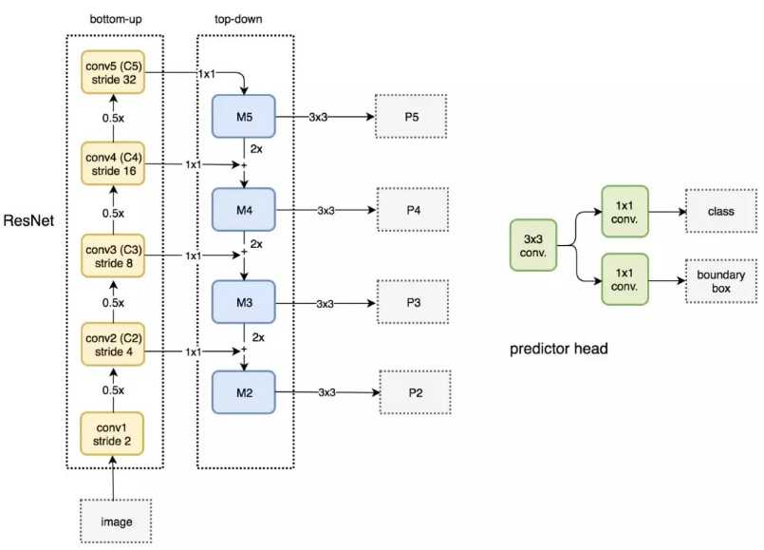
Figure 4 SFPN network structure diagram

2.3.3 Path aggregation network (panet)
The traditional top-down FPN structure is essentially limited by the one-way transmission of information. In order to solve this problem, path aggregation network (panet) 3 adds an additional bottom-up aggregation network. The top-down structure of FPN transmits the rich semantic information at the high level and enhances the pyramid features. However, the enhanced feature is only semantic information, ignoring the transmission of location information. Therefore, panet structure complements FPN structure and adds bottom-up pyramid structure behind FN. As shown in Figure 2.5, similar to the calculation of FPN, the N feature of each layer first passes through 3 with a step size of 2 × 3 convolution for down sampling, and then through horizontal connection, add each element in the P + 1 characteristic map to the characteristic map obtained after m down sampling, and the obtained result passes through 3 × 3 convolution generates N + 1 layer features.
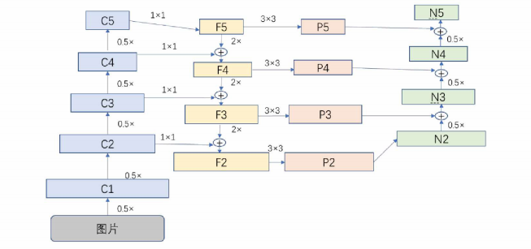
Figure 5 Panet network structure diagram

2.3.4 Bidirectional feature pyramid network (bifpn)
Bi directional feature pyramid network (bifpn) was first proposed by Google brain team in efficient DET4 target detection algorithm. The network structure is intended to solve the problem of network multi-scale feature fusion. The main idea of bifpn can be summarized as: effective two-way cross-scale connection and weighted feature fusion. When fusing features with different resolutions, the previous feature fusion methods in target detection algorithms are to adjust them to the same resolution and then add them. Most of the previous methods treat the features of different scales equally, that is, feature fusion with the same weight. However, we find that the contribution of input features with different resolutions to output features is usually unequal.
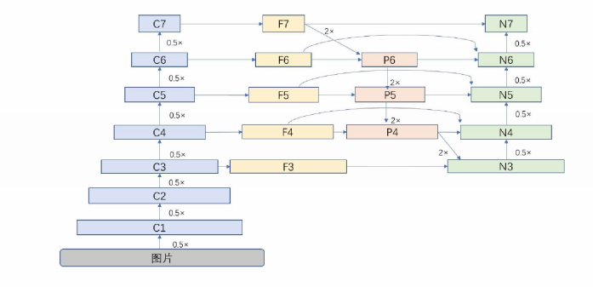
Figure 6 Bifpn network structure diagram

2.4 Target detection and tracking based on deep learning
In recent years, with the continuous improvement of GPU computing power, deep learning has also developed vigorously. Deep learning breaks through the limitation of classical neural network on the number of network layers, which is also the biggest advantage of deep learning over traditional neural network. Deep learning no longer needs to select and transform image features separately, but directly input the original image data into the deep learning network model, and learn effective feature expression through the deep learning network model to realize specific tasks. At present, the method of deep learning has been widely used in many research fields such as computer vision, and shows the incomparable advantages of traditional methods. This section will elaborate the relevant theories of deep learning and convolutional neural network.
2.4.1 Artificial neural network and back propagation algorithm
(1) Artificial neural network (ANN) is the basis of deep learning. It aims to simulate the information processing and transmission between human brain neurons through mathematical models. Neurons are the most basic unit of neural network, and the structure of neurons is shown in the following figure:
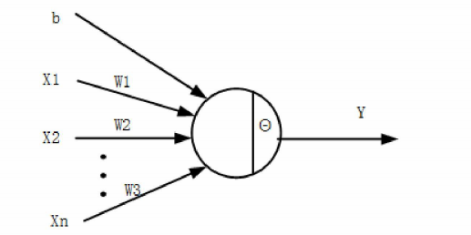
Figure 7 Schematic diagram of neuron

Each neuron receives a set of n-dimensional signal data input x = (x1, X2, X3,..., xn,) and a bias B. after processing by the neuron, an output value y is obtained. The processing process of neurons corresponds to a function f, which is expressed as:
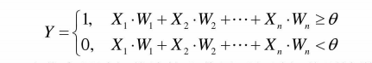
When the information exceeds the threshold after weight connection and bias, it is activated, and the information is selectively transmitted in this way. Multiple neurons in the graph are connected together by layers to form an artificial neural network. Generally, when the number of layers of the neural network is greater than 2, it is called deep neural network.
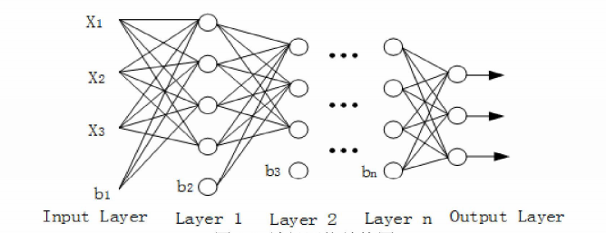
Figure 8 Neural network structure diagram

The figure above is a typical fully connected neural network. Each neuron is connected through a weight parameter W. each input is transmitted to the next layer through the weight. At the same time, the whole network parameters include bias B. finally, the input is mapped through the neural network through the output layer. In essence, artificial neural network is essentially a matrix linear operation from input to output. With the deepening of neural network layer, only such linear operations are superimposed, and the whole depth neural network is still linear. Because the depth neural network is such a linear operation, the deepening of the network depth does not play a role in extracting structured and hierarchical features. In order to enhance the rich nonlinear expression of the depth neural network, the nonlinear activation function is introduced. The nonlinear activation function is essentially an improvement of the formula. The sigmoid activation function is a classical activation function, The expression of sigmoid activation function is as follows:
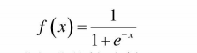
For input x, the neuron performs nonlinear mapping through the equation. Sigmoid activation function not only has good nonlinear mapping function, but also has good mathematical properties, easy derivation and is conducive to the realization of back propagation. The function image of sigmoid activation function is shown in the figure. In addition, there are other excellent activation functions such as relu, leaky relu, ELU, etc. They are suitable for different application scenarios. The purpose is to increase the nonlinear expression of the model and make the training of network model faster.
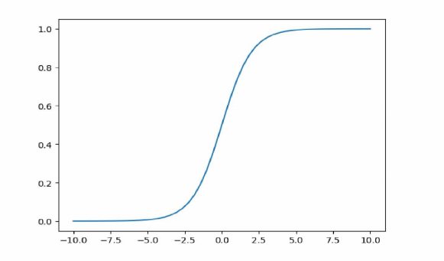
Figure 9 Sigmoid activation function image

- Back propagation algorithm back propagation algorithm (BP) was first proposed by werbos in 1974 and developed by Rumelhart et al in 1985. BP algorithm consists of two processes: signal forward propagation and error back propagation. In the forward propagation process, the input is transmitted through the forward neural network according to the layer backward operation until the output of the neural network; In back propagation, the weight of the network is modified by minimizing the error between the output of the forward propagation calculation and the real value. Through continuous forward and backward calculation, the weight parameters learned by the neural network can map the input through the neural network to the output within the allowable error range, so the weight parameters of the neural network are the network model parameters we want. From a mathematical point of view, BP algorithm calculates the weight update gradient through the chain derivation rule, and updates the weight according to the gradient. Assuming that the weight parameter of the neural network is offset parameter B, the sample data set is (x1, Y1), (X2, Y2),..., (xn, yn), and the mapping function of the neural network is equation, the loss function is defined as equation.
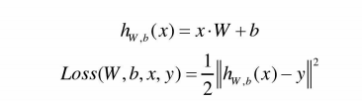
- In order to avoid over fitting of neural network, L2 regularization is introduced, and the optimized objective function is as follows:
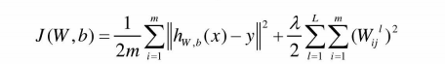
Where f is the regularization coefficient and 1 is the layer 1 neural network. Where the weight parameter is w and the bias parameter B is derived to obtain its gradient, then the weight and bias are as follows:
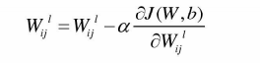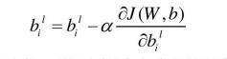
2.4.2 Convolutional neural network
Convolutional neural network is a deep feedforward neural network which can effectively extract and express the features of the input image by integrating three technologies: local sensing region, weight sharing and pooling. Convolution neural network extracts image features through convolution operation, and extracts deeper feature expression of image information by increasing the depth of neural network. Usually, a complete convolution neural network model consists of input layer, convolution layer, pooling layer, full connection layer and classifier.
1) Convolution layer digital image is essentially a two-dimensional digital matrix. Convolution operation is the convolution operation between convolution kernel and image matrix to obtain a series of characteristic images, and convolution layer is a network structure composed of a series of convolution cores. Convolution kernel is a square lattice with a certain scale composed of discrete numbers, as shown in Figure 24, which is a convolution kernel with a scale of 2 * 2.
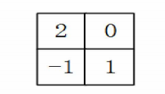
Figure 10 2 * 2 convolution kernel diagram

The training process of convolution neural network is essentially a process of minimizing the loss function by selecting the parameters of convolution kernel. The convolution operation of convolution kernel on the input image is shown in the figure below. The convolution operation is to add and sum the products of the convolution kernel and the corresponding parts in the input characteristic graph. At the same time, the convolution kernel slides along the length of the input characteristic graph until it slides through the whole characteristic graph.
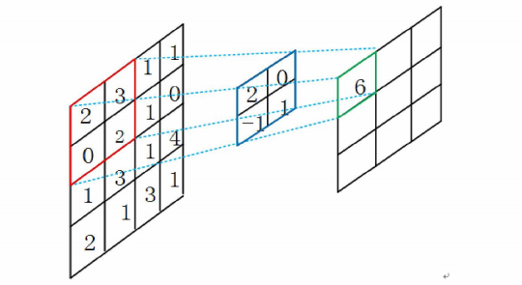
Figure 11 Schematic diagram of convolution operation

- Pooling layer the pooling layer directly acts on the feature map, and the output feature map is obtained by the operation of pooling function. The main function of the pool layer is to reduce the sampling. By reducing the size of the feature map, the amount of training parameters is reduced, which can make the depth features more compact and the training model more convenient to store. When the scale and attitude of objects change in image information, pooling operation can reduce the impact of these changes on object feature extraction to a certain extent. Generally, pooling operations are mainly divided into mean pooling and maximum pooling. Figure 12 and figure 13 show the principles of mean pooling and maximum pooling respectively.
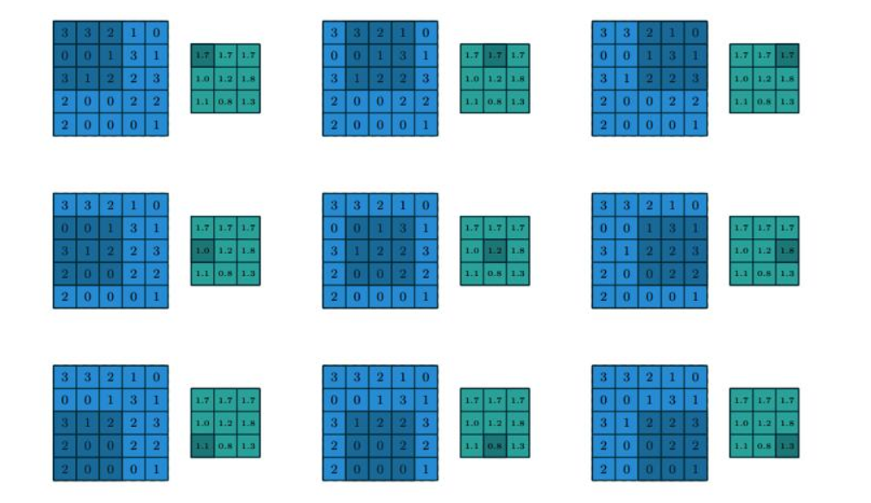
Figure 12 Schematic diagram of convolution operation

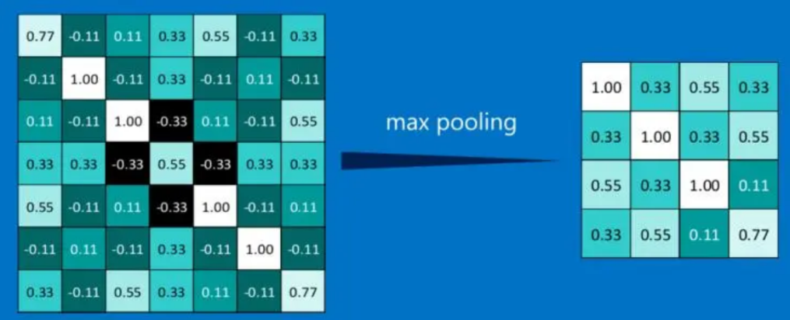
Figure 13 Maximum pooling diagram

As can be seen from Fig. 12 and FIG. 13, the pooling layer has no learning parameters and only needs to specify the pooling function. Assuming that the input characteristic diagram size is hw, the sliding step size is s and the pooling window size is k * k, the output characteristic diagram size is calculated by the following formula:
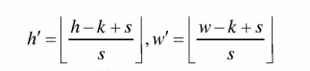
- BN (batch normalization) a each batch of training data has different data distribution. In the process of neural network training, the model parameters need to be continuously adjusted to adapt to different data distribution, which makes the model training difficult to converge. In order to improve the convergence speed of the model and reduce the influence of the difference of parameter update caused by the distribution of each batch of training data, researchers proposed BN. Assuming that each layer of training data X has m dimensions, i.e. x = (x (1), X (2),..., X (m), BN first normalizes each batch of data according to the following formula.
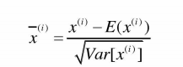
- Dropout layer depth neural network has strong representation ability. After many iterations on limited training data sets, it will fit the data sets well, and even there will be serious over fitting phenomenon. The training weight of the back layer of the neural network may be more dependent on the features of the previous training, and the training weight of the front layer may be an effective extraction of the local features of the limited data set, so the generalization ability of the trained neural network model is not strong. In order to avoid excessive dependence on the local features of the front and back layers of the neural network and improve the generalization ability of the network model, Some neurons will be randomly inhibited during the test. As shown in Figure 14 below, some neurons are inactivated randomly to enhance the generalization ability of neural network and avoid over fitting.
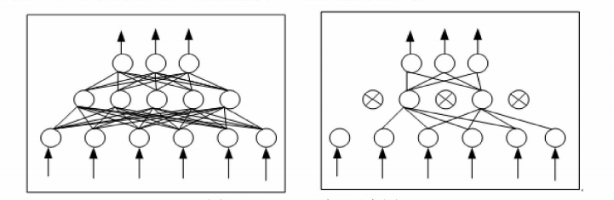
Figure 14 Schematic diagram of dropout

2.5 Target tracking based on deep learning
Target tracking is a process of determining the target position and size to be tracked in subsequent video frames only according to the target position and size given by the first frame of the video sequence without prior knowledge. In recent years, deep learning has made gratifying achievements. Deep convolution neural network has better ability of feature extraction and representation than traditional methods. Deep learning target tracking method is a target tracking algorithm that uses deep convolution network to extract and classify targets. This algorithm has better performance in tracking accuracy and robustness to complex background. There are three main ideas of target tracking algorithm based on deep learning: transforming target tracking into binary classification of target and background; Tracking through twin network; Target tracking is transformed into probability graph problem 5. This section will focus on the key technologies of target tracking algorithm based on deep learning, so as to pave the way for the improvement of tracking algorithm later.
2.5.1 Two classification target tracking method
The classification method based on deep learning divides each frame image into target and background, so as to realize target tracking. Because the target tracking task can only provide the information of the first frame image, the advantages of feature extraction and classification based on deep convolution neural network can not be highlighted. Aiming at the problem of converting deep learning target tracking into binary classification, so as to realize the lack of training data in target tracking, it can be alleviated by online training and offline fine-tuning training, and the feature attribute domain of the actual tracked target can be fine tuned by using the similar attributes of the tracked target. Sanet algorithm is one of the representative target tracking algorithms based on binary classification. Based on mdnet algorithm, the algorithm learns the feature expression that can effectively distinguish the tracked target from the background in the target tracking task through a large amount of image information, Then, according to the long-term dependence of the front and back frames of the captured target in the sequence data, the modeling is carried out to capture the subtle differences between the target object and the similar object. The framework of sanet target tracking algorithm is shown in Figure 15.
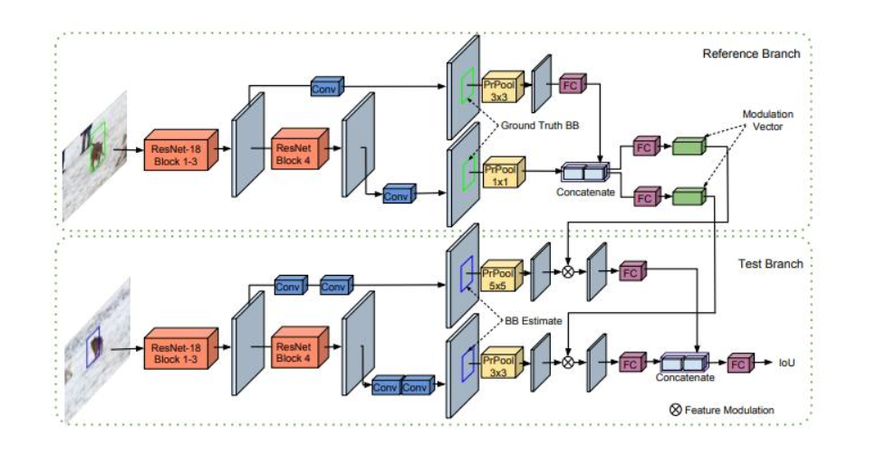
Figure 15 Sanet target tracking algorithm framework
Sanet target tracking algorithm combines convolutional neural network terminal and cyclic neural network terminal. Convolutional neural network terminal mainly discriminates between target object and background, and cyclic neural network provides discrimination between target object and similar object. It can be seen from FIG. 15 that the convolution features of different layers of convolution neural network are introduced into sanet, and the target features are extracted from different semantic levels to express the features of the target to enhance the discrimination of the algorithm. The cyclic neural network is used to model the self structure of the target object, and the subtle differences between the target object and similar objects are captured by this method. In addition, the sanet target tracking algorithm adopts the jump connection strategy between different layers to obtain the multi-layer convolution features and fuse the features of the cyclic neural network. The experiments show that the improved strategy on the network structure of fusing the semantic features of different levels is helpful to improve the discrimination performance of the algorithm.
Target tracking method based on binary classification is a common method in deep learning target tracking algorithm. The representative sanet target tracking algorithm has good performance in tracking speed and accuracy. Sanet target tracking algorithm provides two aspects for the deep learning target tracking method based on binary classification: one is to add different levels of language features for target discrimination, which is conducive to enhance the discrimination performance and robustness of the algorithm; Second, the circular neural network can be used to model the tracking object to enhance the subtle differences between the tracking target and similar objects, and the video sequence modeling can enhance the dependency between contexts.
2.5.2 Target tracking method based on twin network
Twin network is a special neural network framework containing two or more identical weights. The twin network framework is shown in Figure 16 below。
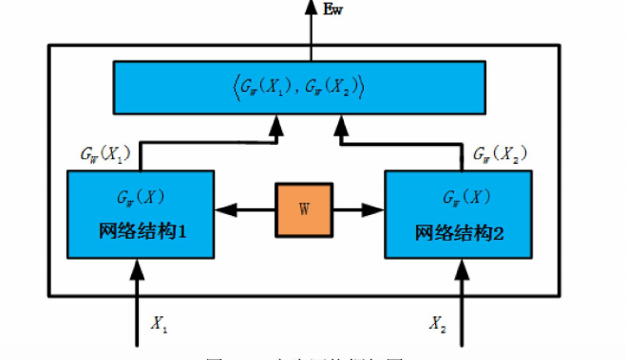
Figure 16 Twin network frame diagram
As shown in FIG. 16, X1 and 2 represent two pictures to be learned. X1 and X2 are mapped to the low-dimensional feature space through G (x1) and G (2) respectively, and then the similarity is measured according to the following formula. What needs to be learned is the shared parameter W.
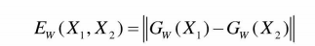
The target tracking algorithm based on twin network is to the feature extraction network through the deep convolution neural network after off-line training of a large amount of data. In the tracking process, a large number of off-line trained networks are used directly without on-line update, so as to accelerate the tracking speed. Siamfo algorithm s is a representative target tracking algorithm based on twin network. The network framework of the algorithm is shown in Figure 17:
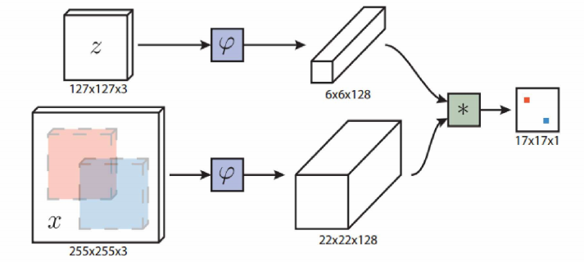
Figure 17 SiamFC target tracking algorithm structure
As shown in FIG. 17, the twin network is used for similarity measurement, where Z is the template picture and X is the picture to be detected. The lower dimensional feature map is obtained through the same feature extraction function, and finally the final similarity matrix is obtained through convolution with the template. The Lisheng network performs the same transformation on the two inputs, and measures the transformed image similarity through the similarity function g. the similarity measurement function is as follows:
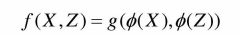
The full convolution structure can directly match the template image with the large candidate region, and the final output of the full convolution network is the response graph. Find the point with the highest response value in the response graph, and the corresponding part of the point in the candidate region is the predicted target position. In addition, scholars further improve the target tracking algorithm based on twin neural network, and introduce the attention mechanism to improve the real-time performance of tracking while ensuring the accuracy.

2.5.3 Target tracking method based on probability graph
Convolution features with different depths can express different levels of features. Generally, the top-level convolution features contain higher-level and more abstract semantic information, while the bottom-level convolution features have more in class recognition information. Therefore, the probability map of each target to be tracked is output by using different depth convolution features, and the problem of target tracking interference caused by complex background and similar distractors is solved by the fusion of different depth convolution information. The example of CCOT algorithm is a representative deep learning target tracking algorithm based on probability graph, and its algorithm principle is shown in Figure 18 below:
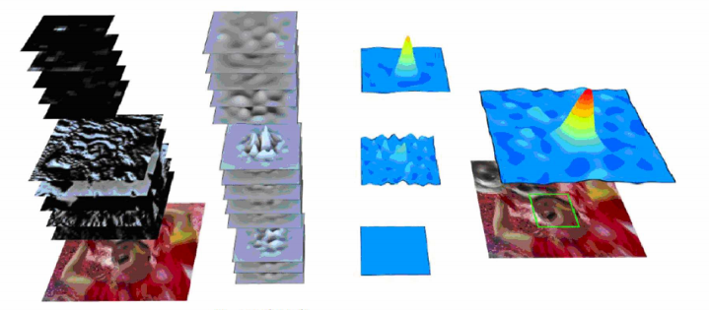
Figure 18 Principle of c-cot target tracking algorithm
CCOT target tracking algorithm proposes a general framework to learn the distinguishing convolution operator in continuous space domain to realize object tracking and feature point tracking, which can realize sub-pixel location. In view of the progress and improvement of c-cot algorithm, subsequent scholars reduced the redundant filter and simplified the algorithm training set, which solved the problems of high computational complexity of CCOT algorithm and over fitting of similar samples. By using the convolution characteristics of different layers, excellent pre training filters and the introduction of high-performance discriminators, the target tracking problem is transformed into an algorithm for solving the probability map, which effectively overcomes the interference of similar background and complex background, but the tracking accuracy and tracking speed of the algorithm still can not meet the actual needs.

2.6 Theoretical basis of deep learning
2.6.1 Concept of deep learning
Machine learning is committed to improving the performance of computer system by means of computing and using a priori knowledge. It is a branch of artificial intelligence, which obtains knowledge from experience. Machine learning algorithm abandons the operation of inputting knowledge to the machine, and instead relies on the algorithm itself to learn all the required knowledge. For traditional machine learning algorithms, experience often corresponds to the data stored in the form of features. What traditional machine learning algorithms do is to rely on these data to generate models.
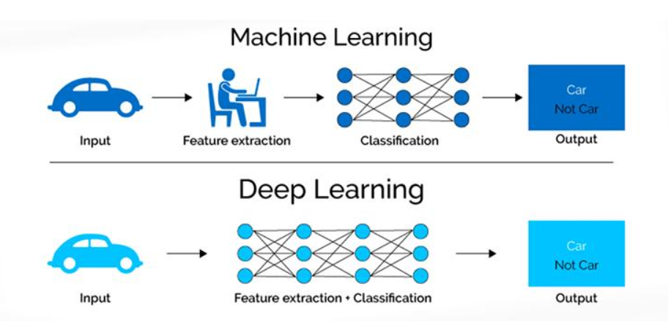
Figure 19 Comparison of processing process between machine learning and deep learning
Deep learning is a subdivision of machine learning. Figure 2.1 illustrates the difference between traditional machine learning and deep learning. Compared with the single task module of traditional machine learning algorithm, in addition to model learning, deep learning also involves task modules such as feature learning and feature abstraction. After layer by layer abstraction, the algorithm abstracts the original data (image, sound, etc.) layer by layer into the feature representation required by its own service, and finally completes the mapping from feature to target service. The shaded module in Figure 19 indicates that the module can be taught directly from the data by the algorithm.

2.6.2 Feedforward operation
Convolutional neural network is a hierarchical model, whose input is original data, such as RBG image, original audio data and so on. Convolution neural network extracts high-level semantic information from the original data input layer layer by layer through a series of operations such as convolution operation, pooling operation and nonlinear activation function mapping. This process is called feed forward operation. Among them, different types of operations are called layers in convolution neural network: convolution operation corresponds to convolution layer, pooling operation corresponds to pooling layer, etc. FIG. 20 briefly illustrates the process of feedforward operation.
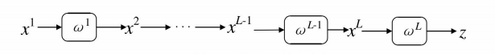
Figure 20 Feedforward operation diagram
In computer vision applications, each layer of data is a three-dimensional tensor. Specifically, the data layer of convolutional neural network is usually the image of RGB color space: H row, w column and 3 color channels. It is written here as X. X through the first layer operation, X2 can be obtained, and the corresponding parameter in the first layer operation is O; X2 is used as the input of the operation layer o of the second layer, and X3,... Can be obtained until the L-1 layer. At this time, the network output is X. In the above process, theoretically, each operation layer can be a separate convolution operation, pooling operation, nonlinear mapping or other transformation, or a combination of different forms of operation or transformation. Finally, the whole network ends with the calculation of loss function. If y is the round truth corresponding to input x, the loss Z is expressed as
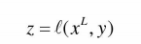

2.6.3 Feedback operation
Assuming that the loss of n samples obtained after a batch feedforward operation is Z, each layer of operation corresponds to two derivatives: one is the derivative Z \ wi of the error with respect to the parameters of layer I, and the other is the derivative Z \ Xi of the error with respect to the input of this layer.
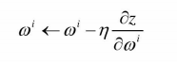
2.6.4 Layer
This section details the common layers of convolutional neural network: input layer, convolution layer, pooling layer and full connection layer, as well as their functions. Generally, there are more than these types of convolutional neural network layers, but some of the other layers are for a specific network structure, and some have specific functions and are not representative. The following layers are generally needed for neural network structure.
1.Input layer
The input layer is a sample image after simple preprocessing (such as clipping, scale unification, graying or normalization, etc.). In convolution neural network, some geometric features obtained from sample data after one-time processing are called feature map. The initial input layer can be understood as a layer with only one characteristic graph. In this paper, it is agreed that the three-dimensional tensor x ∈ 9 "WD is used to represent the input of the first layer of the convolutional neural network, and the triplet (, J, d) is used to represent the elements of the color channel of row, column and D, where 0 ≤ < h, 0 ≤ / < W, 0 ≤ d < D. due to the batch training strategy, the input of the first layer of the network is usually a four-dimensional tensor, i.e. x ∈ 9" WDN, where n is the number of samples per batch (minibatch).

- Convolution layer
Fig. 21 is a convolution operation of a two-dimensional scene when d = 1. Assume 5 to the right of the input image (input data) × 5, whose corresponding convolution kernel is a 3 × At the same time, it is assumed that the convolution kernel moves one pixel position every time convolution is performed during convolution operation, that is, the convolution step (stripe) is 1
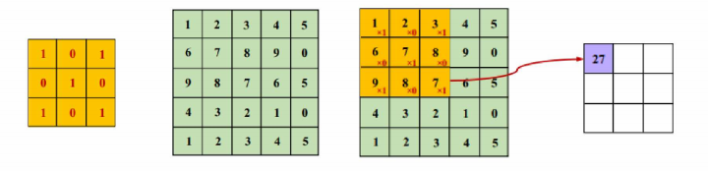
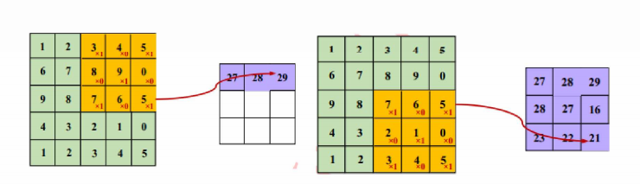
Figure 21 Two dimensional convolution operation
The first convolution operation starts from the image pixel (0,0), and the convolution kernel parameters are multiplied bit by bit with the image pixel at the corresponding position and accumulated as the result of one convolution operation, i.e. 1 + 2 × 0+3 × 1+6 × 0+7 × 1+8 × 0+9 × 1+8 × 0 + 7x1 = 27. Similarly, when the step size is 1, the convolution kernel continues the convolution operation on the input image from left to right from top to bottom according to the step size, and finally outputs 3 × 3 large and small convolution features, i.e. feature map, and the result will be used as the input dimension of the next operation. In the case of convolution layer L, the input tensor is x ∈ 9 "WM, and the convolution kernel of this layer is ∫. During three-dimensional input, only the two-dimensional convolution is extended to all channels (i.e. d) at the corresponding position, and finally the sum of all HWD elements of one convolution process is taken as the convolution result of this position.
If there are d convolution kernels like ∫ we can get 1 at the same position × one × Convolution output of 1XD dimension. And D is the number of channels D + 1 of layer L + 1 feature X. The formal convolution operation can be expressed as:
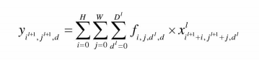
Where, (IL + 1, JL + 1) is the position coordinate of the convolution result, which meets the following requirements:
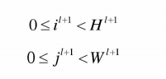
It can be regarded as the learned weight, which is the same for all inputs at different positions, that is, the weight is shared.

3.Pool layer
The most common pooling operations are average pooling and Max pooling. Assuming that the pool core of layer 1 is expressed as P ∈ 9, the average pooling takes the average of all values in the coverage area of the pool core as the pooling result, then
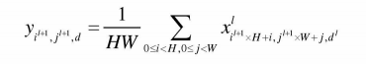
Maximum pooling takes the maximum value of all values in the pool core coverage area as the pooling result. Namely
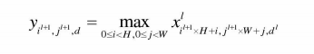
Among:
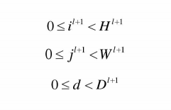
4.Full connection layer and output
The full connection layer acts as a classifier in the whole convolutional neural network. Convolution layer, pooling layer and activation function map the original data to the hidden layer feature space, while the full connection layer maps the learned feature representation to the sample label space. In practical application, the full connection layer can be realized by convolution operation: the full connection layer with full connection to the previous layer can be transformed into convolution kernel of 1 × Convolution of 1; The former layer is the convolution layer, and the fully connected layer can be transformed into the global convolution with the convolution kernel as hxw. Here, h and W are the height and width of the convolution output characteristic graph of the previous layer, respectively.
2.6.5 Activation function
Activation function, also known as nonlinear mapping function. It is an indispensable key module of deep convolution neural network. The powerful representation ability of deep network model is mostly brought by activation function. The following concepts are often encountered in the application of activation functions.
1 Sigmoid function
The sigmoid function is defined as:
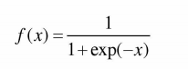
Figure 22 shows the sigmoid function image. It can be seen that the sigmoid function is monotonic and continuous, and the value range is (0,1). The derivation of this function is very easy. It can be used as the output layer of neural network in neural network training or prediction, and the optimization is very stable. However, due to the soft saturation of sigmoid activation function, the gradient is easy to disappear during model training. In addition, the calculation output of sigmoid activation function is not centered on 0, which often leads to problems in network training.
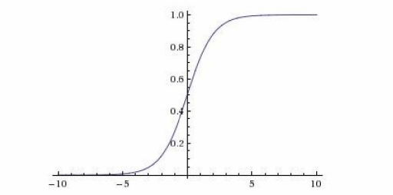
Figure 22 Sigmoid function image

2.Tanh function
The tanh function is defined as:
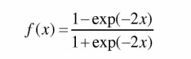
Figure 23 shows the tanh function image. It can be seen from the function image that the output of the function is centered on 0 and the output interval is [- 1,1].
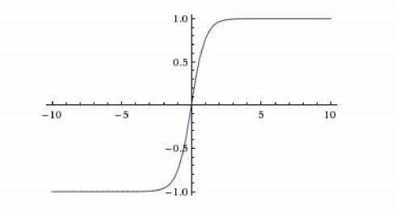
Figure 23 Tanh function image
Tanh function converges faster than sigmoid function. Generally, in practical applications, tanh function is preferred to sigmoid function. However, tanh function does not improve the problem that sigmoid function will make the model training gradient disappear.
3 Relu function
The Relu function is defined as:
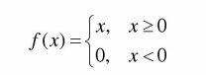
Figure 24 shows the relu function image. Relu function provides the sparse expression ability of neural network to a certain extent. Compared with sigmoid function and tanh function, relu converges faster during training. Sigmoid function and tanh function involve many expensive operations, such as exponential calculation. Relatively speaking, relu is cheaper and can be implemented more simply. Moreover, relu effectively alleviates the problem of gradient disappearance. However, relu function also has obvious disadvantages: with the training of network model, neurons may die. This makes the weight of dead neurons unable to be updated. This will cause the gradient flowing through the neuron to flow to the following neurons in a state of 0 from this point. Thus, relu neurons die irreversibly during training.
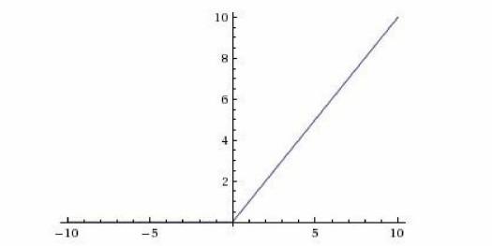
Figure 24 Relu function image
4 Leaky relu and PREL functions
These two functions can be defined as:
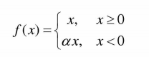
Figure 25 shows the function image. When α When it is small and fixed, it is called leaky relu function. Leaky relu was originally designed to avoid the disappearance of gradients. However, in some experiments, it was found that leaky relu had little effect on the accuracy. In many cases, if you want to apply leaky relu, you must repeat the training very carefully and select the appropriate A. only when leaky relu shows better results than relu. Therefore, a prelu that adaptively learns parameters from data is proposed. It can adaptively learn from the data α Parameters. Prelu has the characteristics of fast convergence and low error rate. In addition, prelu can be used for back propagation training and can be optimized simultaneously with other layers.
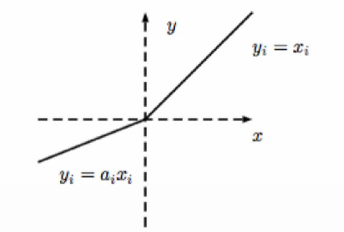
Figure 25 Leaky relu and prel function images
5. ELU function
The ELU function is defined as:
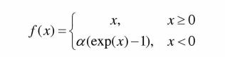
Where a > 0.
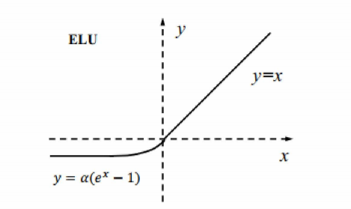
Figure 26 ELU function image
Figure 26 shows the image of the ELU function. The ELU activation function controls the mean value of the activation value of the input unit to 0. In the activation function before the ELU, the negative part of the activation function has almost no information, and the ELU function makes the negative part of the activation function can also be used to enhance the robustness of training. But the ELU function also increases the computational complexity of the back propagation algorithm.
6.SeLU function
The Selu function is defined as:
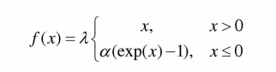
In the above formula, λ And a are fixed values. Selu function image is the same as ELU function image in form. Compared with ELU function, Selu function adds self normalization attributes, which make the excitation value of neurons automatically converge to zero mean and unit variance. Compared with batch normalization, the accuracy of normalization is required, but the neuron excitation value of Selu function only needs to be close to zero mean and unit variance. Moreover, in the presence of strong disturbance and a large amount of noise, the Selu function will still make the neuron excitation value converge to zero mean and unit variance after propagating forward through many layers. The convergence property of Selu function can make the neural network training adopt strong regularization and make the training more robust. If the neuron excitation values do not approximate the unit variance, then the variance of these excitation values is bounded. Therefore, in the process of neural network training, the problems of gradient disappearance and gradient explosion cannot appear.

2.7 Objective function
Objective function is the baton of the whole deep network model. It guides the network parameter learning and representation learning through the back propagation of the error generated by the sample prediction results and the real markers. Generally speaking, the design of objective function is determined according to the actual task and environment, but there are also some specific patterns in the design process. This section summarizes the classical objective functions commonly used in classification and regression tasks. In practical problems, these classical objective functions can be transformed and selected as models. In addition, regular terms are often added to the objective function to constrain parameters, which can prevent over fitting.
2.7.1 Classification task
Suppose that there are N training samples for a classification task, the input characteristic of the ith sample in the last classification layer of the network is x, and its corresponding real mark is y ∈ {1,2,, C}, so that h = (, H2..., H) is the final output of the network model, that is, the prediction result of sample I, where C is the number of classification task categories.
1.Cross entropy loss function cross entropy 4 loss function maps the network output h into probability form through exponential transformation. This function is the most commonly used objective function of neural network model, which is defined as:
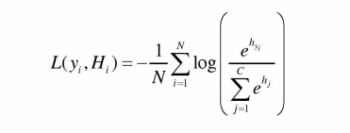
2.Hinge loss function hinge loss 4 function is widely used in support vector machine and can also be selected in neural network model. The hinge loss function imposes more severe penalties on samples with greater contribution to classification errors. This function has poor resistance to noise. The function is defined as:
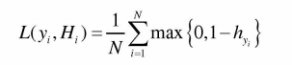
3.Ramp loss function ramp loss + function is the representative of non convex loss function in classification task. It has good noise resistance to noisy data or discrete points. The function is defined as:
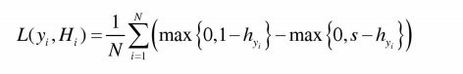
4.Center loss function center loss 4 function mainly considers the distance between classes and reduces the difference within classes. It is defined as:
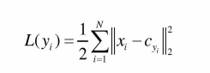
Where, C is the mean value of all depth features of Class Y, i.e. center. In practical application, the central loss function is often used in combination with other loss functions considering the distance between classes. If the cross entropy loss function is combined with the central loss function, the objective function is:
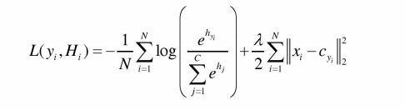
2.7.2 Regression task
In the classification task, for sample I, the vector is 1 at y, which represents the real category of the sample. Accordingly, the other C-1 dimensions are 0. In the regression task, the real mark of the sample also corresponds to a vector, but each dimension of the real mark of the regression task corresponds to a real number instead of two values of 0 and 1. Let the true marker y = (y, Y2, y) of the ith input feature X in the regression problem, M is the total dimension of the marker vector, j is the regression prediction value, and N is the number of samples.
1.L1 Loss function:
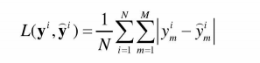
2.L2 Loss function:
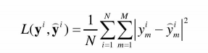
In practical application, there is little difference in the regression accuracy between L1 loss function and L2 loss function, but the convergence speed of L2 loss function will be faster than L1 loss function in training.
3. Biweight loss function
Biweight loss function is a kind of non convex loss function, which can overcome the interference of outliers or sample noise on the overall regression model in the regression task. The loss function is defined as:
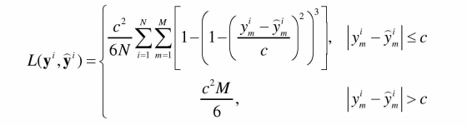
2.7.3 Regularization
1. There is no free lunch theorem: in all possible data generation distributions, the performance of the optimization algorithm is equivalent due to the mutual compensation of all possible learning algorithms. No free lunch theorem points out that to a certain extent, no machine learning algorithm is better than other learning algorithms. On all possible tasks, the most advanced learning algorithms have the same average performance as the simple learning algorithms that simply classify all points into the same class. Therefore, the goal of machine learning research is to understand what kind of data distribution is related to the real world for artificial intelligence to obtain experience, and what kind of learning algorithm can perform best in specific data generation distribution, rather than studying a general learning algorithm or the absolutely best learning algorithm to apply to all learning tasks. In the function hypothesis space, compared with one learning algorithm, the actual choice may prefer another learning algorithm. This means that both functions are qualified, but prefer one of them. Only when the non preference function is much better than the preference function on the training data set, it will be considered that choosing the non preference function to express the preference for the function is a processing strategy to control the model capacity. Regularization expresses this preference for functions in hypothesis space by controlling the magnitude of training parameters.
2.Maximum norm constraint
The maximum norm constraint is regularized by setting the maximum upper bound of the order of network parameters. Namely:
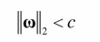
- Dropout
For each neuron in a certain layer, the neuron weight is randomly reset to 0 with probability P in the training stage. The weight in the test stage needs to ensure that the weights in the training and test stages have the same expectations with probability of (1-p). Dropout alleviates the complex same adaptation between neurons to a certain extent, reduces the dependency between neurons, and prevents over fitting to a certain extent.

2.8 Attention mechanism
2.8.1 Introduction to attention mechanism
The convolution network trained by process has a strong ability to fit data, but due to the limitations of optimization algorithm and computing power, it is difficult for the convolution network to achieve the ability of general approximation in practice. Especially when dealing with large-scale input data and realizing complex tasks, computing power may still become the bottleneck of the model. The design of locally connected convolution structure and pooling layer in convolution network can be used to simplify the network structure and alleviate the contradiction between model complexity and expression ability. For the task of network model, we need to carry out further operations, which can not only increase the complexity of the model, but also improve the expression ability of the model. In neural networks, the amount of information that can be stored is called network capacity. Obviously, the network capacity is directly proportional to the complexity of the network. The need to store more information will increase the complexity of the network and significantly increase the parameters of the network. The same problem exists in the neural network of the human brain. The human brain receives a lot of data every time. For visual tasks including image classification, the eye will send tens of millions of bits of information to the visual nervous system every second. Under the limited computing resources, the human brain can not process the visual image of each position at the same time for the overloaded visual information, but through the visual attention mechanism (attention mechanism (chikkerur, 2010; borji et al, 2013) , the fovea corresponds to the strongest acuity. In order to make rational use of limited visual information processing resources, the human brain will intentionally or unintentionally select specific parts of the visual area and focus on these parts. In Figure 27, for the image on the left, the instrument is used to observe and record the distribution of people's attention when observing the image, which is displayed on the right. It can be found that people's attention is focused On the main object in the image, especially in the area containing more visual information, this is consistent with people's life experience.
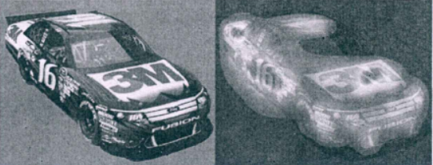
Figure 27 Human attention distribution
According to the way of attention generation, attention can be divided into two types: one is top-down attention, or focus attention, which refers to the active and conscious attention focused on a certain object with a predetermined purpose and task. The other is bottom-up attention, which is called salience based attention. Saliency based attention is driven by the external information obtained, which is independent of the task. When applying attention mechanism to neural network model, these two kinds of attention are often combined, especially in the case of complex attention generation mechanism. According to the form of the characteristics of attention function, attention mechanism can be divided into two kinds: item wise attention and location wise attention. The input of item based attention is sequential data containing explicit items; The input of location-based attention is a feature graph with spatial dimension. In the field of computer vision, location-based attention is a more task-related and direct attention mechanism, which is more widely used, but item based attention has also been applied in many special models. In the form of attention itself, attention mechanisms can be divided into two types: soft attention, or flexible attention, and hard attention, or rigid attention. Soft attention is represented by the weight information of each position or dimension on the corresponding characteristics, that is, attention itself is a combination of soft attention values of different sizes. Hard attention is represented by discrete position information, which only focuses on one position of the input feature, such as cutting a region in the input as the result of attention. A major disadvantage of hard attention is that it uses discrete locations to select information, resulting in the role of attention can not become a differentiable function, which makes it difficult for hard attention itself to carry out end-to-end training in neural networks. In general, soft attention is a better choice when the network model itself needs to provide attention information.
2.8.2 Action principle of attention
The input characteristic information of attention is expressed as x1n = {x1,..., xn], I = 1,, N. when using the network to process it, the network will act on these inputs differently, but select some information related to the task for processing. Given the query information Q related to the current task or scenario of the model, the attention variable Z ∈ can be used (1, n represents the position of the selected information, that is, z = represents that the input feature information with serial number I is selected. In the case of using soft attention, the possibility of selecting each input information is expressed in the form of probability, expressed by attention weight a; and the generation process can be expressed as:

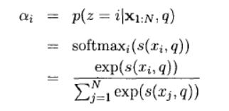
Among them, 8 (x, q) is the attention scoring function, which needs to be selected according to the task and model of the current attention mechanism. S (x, q) can be provided by relevant external supervision information or generated by the model according to the input characteristics. When using feature generation, s (x1q) can be the following additive model.
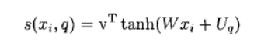
2.8.3 Attention mechanism in deep learning
In the field of computer vision, the modeling of visual attention mechanism has a history of more than 25 years. The initial work mainly comes from biology related research. In the 1980s, Treisman and Gelade's "feature integration theory" selected the most important visual features (Treisman et al., 1980). After that, Koch and Ullman proposed a "winner take all" neural network, which is used to select the most significant region in the image (Koch et al, 1987). The first mock exam has been implemented by Iti et al. This model has been widely applied (TTI et al, 1998). The main focus of classical visual attention research is the selection location and method of image related areas related to the target. With the development of deep neural network, research on the combination of attention mechanism and deep learning has gradually emerged. An important research is the method of using recursive neural network to guide hard attention made by mnih and others in 2014 (mnih et al, 2014). In this model, the regions of concern in the image are cut at the first mock exam in each stage, and then the hard attention position in the next stage is obtained by using the region. After a number of stages, the final image classification results are obtained.
In fine-grained image classification, image category differences often focus on some areas in the graph, which can be selected by attention mechanism. Therefore, fine-grained image classification is one of the most widely used directions in the sub research directions of image classification. Especially after the deep convolution neural network has been widely used, how to combine the attention mechanism with the rich features provided by the convolution network has become a widely explored problem, Many depth image classification methods based on attention mechanism have been born. Zhang et al. Proposed a part-based RCNN (pbr-cnn) for fine-grained image classification, which utilizes the hard attention mechanism (Zhang et al, 2014). Pb r-cnn is based on the classic object detection framework, regions with CNN features algorithm (girshick et al, 2014). In the model, the RCNN part detector is trained by using the image part labeling of cub200-201 dataset, so as to obtain the regional positions corresponding to each part as hard attention. The features corresponding to these positions are extracted, trained SVM classifier for classification, and the final result is obtained. Similar to this method, there are a series of fine-grained image classification methods, which can be divided into the following main parts:
Train the position detection framework to get the corresponding position of each part as hard attention. 2. Crop low-level features according to the position provided by hard attention. 3. Classify the features extracted after attention.
The two-level attention method (Xiao et al, 2015) proposed by Xiao et al. Is the first fine-grained image classification method that does not use additional location information and relies on the model to generate attention weight. As the name suggests, two different levels of attention mechanisms are used in this method, namely object level and part level. The candidate regions obtained by selective search (uijlings et al., 2013) are screened by convolution network to obtain object level hard attention, and then the regions are distinguished and classified by clustering method to obtain different position level hard attention. Finally, these regions are used to select features and fuse to obtain the final classification result output of the model. The first work to apply location-based soft attention to deep learning is the spatial transformer networks (STN) proposed by Jader Berg et al. (aderberg et al., 2015) , the starting point of this method is that the convolution cores in the convolution network are rectangular, and the objects in the image may have irregular shapes. Therefore, the sampling coordinates can be generated in the network, the features can be sampled, and the object image aligned according to a certain specification can be obtained. The core part of the network is the generation and action part of soft attention, which can be divided into three parts: positioning network and grid generator The first two are used to generate sampling coordinates as attention, and the latter acts on features. This method has achieved good results in multiple image classification tasks. Among them, the results obtained in the cub-200-2011 dataset of fine-grained image classification are better than this front method.
In the fine-grained image classification framework (Fu et al., 2017) of recursive attention convolution neural network (ra-cnn) proposed by Fu et al., according to the process from coarse to fine, the recursive network is used to extract important regions according to attention and enlarge them as the next level input image. The applied attention mechanism combines hard attention and soft attention. The generated hard attention position is fitted with a ladder function such as k-order logic function with index K, so as to obtain the differentiable attention weight, and then a network model for end-to-end training is proposed. Most of the above methods use location-based attention. The squeeze and excitation network (senet) (Hu et al, 2017) proposed by Hu et al. Performs feature compression, generates weights and reweights in the feature channel dimension of the network. This operation can be regarded as item based attention acting on the feature channel. This network won the champion of image classification project in ilsvrc competition in 2017. Besides image classification, attention mechanism has also been widely used and achieved good results. For example, Ⅻ u et al. Used a soft attention machine to make images and input them into the long-term memory netwok (LSTM), which can effectively generate the description text of images (Xu et al., 2015).
In recent years, attention mechanism has been widely used in natural language processing, and a large number of methods have been born. Among them, Vaswani et al. Proposed multi head attention in translation tasks (Vaswani et al., 2017) On the basis of not using the complex network structure, the mechanism has achieved the effect beyond the previous methods. Multi terminal attention is to generate multiple attention in the network and act on the features in parallel. In the natural language processing framework of this method, the task related query is expressed as Q, and the input features and other information are expressed as K and V in the form of key value pairs, then the effect of attention is excessive The process can be expressed as:
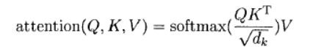
Where D is the dimension corresponding to K. Multiple ends of attention generate multiple attention in parallel, and combine the results of these attention effects to obtain the final output, which is expressed as:
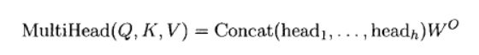
Where head, corresponding to each single attention effect result, is expressed as:
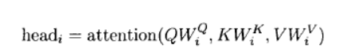
The multi terminal attention model proves that in many tasks, the dimension and size of attention are often a bottleneck restricting the performance of the model. Especially in many models using soft attention, attention is often a feature map with only one channel, which can not provide enough location information. Therefore, it is an important direction to improve the effect of attention mechanism model to build higher dimensional and multi-channel attention information, reasonably act on features and explore rich location information.

3 RESEARCH METHODOLOGY

3.1 Research Overview
Since convolutional neural network was applied to target detection in 2012, convolutional neural network has made excellent achievements in the field of computer vision. Through the training of a large number of labeled training data sets, convolutional neural networks can learn a large number of rich features better than traditional manual design. In addition, convolutional neural networks with different structures are designed to fuse the bottom image features and high-level abstract features, so that the network model has stronger generalization ability and robustness. The target detection algorithm based on convolutional neural network is mainly divided into two stage target detection algorithm represented by fast r-cnn and one stage target detection algorithm represented by Yolo and SSD. Among them, Yolo absorbs many practices that are conducive to improving network detection speed and detection accuracy, makes a trade-off between detection speed and detection accuracy, and realizes the speed of real-time detection while ensuring high detection accuracy. Firstly, this chapter analyzes the principle of Yolo detection model, improves the network structure of the model based on Yolo, introduces the method of multi granularity feature fusion to improve the performance of the algorithm in small object detection under complex background, and prepares for target tracking in the next chapter.
3.1.1 Research Process
As a stage algorithm in target detection task, Yolo algorithm has the characteristics of simple training and testing process and fast detection speed compared with traditional algorithms. Yolo algorithm is an end-to-end training method, which can directly output the positions and categories of all targets in the image from the input image. With the continuous innovation of target detection research, Yolo algorithm is also developing. Yolo series algorithms have made great progress in order to improve the prediction accuracy while ensuring the detection speed. In 2018, in the paper published by CVPR, Yolo - V3 added more innovations on the basis of the previous network, and the effect is to steadily improve the detection accuracy while ensuring the speed. Experiments show that the gate has a resolution of 320 in the input image × In case 320, the speed of yolo-v3 algorithm when the map (mean average precision) reaches 282 is only 22ms. Under the same average prediction accuracy of target detection, the prediction speed of yolo-v3 algorithm is three times faster than SSD algorithm. In order to improve the detection performance of target detection task, yolo-v3 algorithm has been innovated and improved in many details such as network depth and loss function. Our paper further improves the network structure based on Yolo - V3 algorithm, so as to improve the detection performance of target detection algorithm.
1.Frame prediction
Frame prediction refers to predicting the frame of the target in the image for the divided grid area. The predicted frame information includes the position, size and confidence of the target. The frame information can be expressed as (BX, by, BW, BH, c), in which the variables respectively represent the position, width, height and confidence of the target in the image, as shown in Fig. 28. In fact, in order to obtain the predicted frame information, yolo-3 algorithm first applies logistic regression to obtain the objective score through the 9 a priori frames (obtained by clustering the frame information in the database with k-means method), that is, it can obtain the possibility that this position is the target in the image, and then obtain the position coordinates (TX, ty, TW, th, t0) of the frame center point, where, Tx.ty is the position coordinate of the center point of the prediction frame relative to the center point of the grid; Tw and th are the width and height of the prediction frame relative to the a priori frame. Finally, the frame information (BX, by, BW, BH, c) is obtained through the following formula. The last formula in the formula is to calculate the confidence C, that is, P (object) and ou (B, object) represent the probability of containing the target in the frame and the probability of accurate position of the frame respectively, where IOU means the similarity between the real frame B and the predicted frame containing the target object. Where σ Refers to the SIGMOD I activation function; PW, pH refers to the width and height of a priori frame, and CX, cy refers to the length and width of meshing. The application of logistic regression for objective scoring before prediction greatly reduces the workload, which is a major innovation of yolo-v3 algorithm.
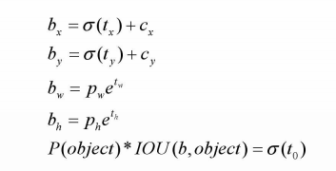
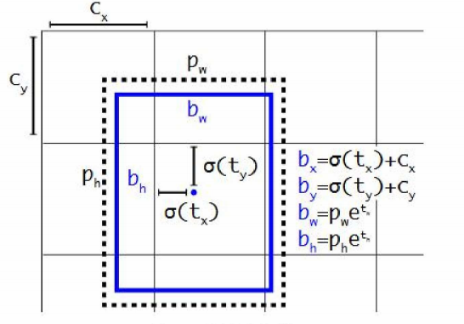
Figure 28 Frame prediction chart
2.Category forecast
Category prediction is to predict the category of targets in the image. When Yolo - V3 algorithm predicts, each border may contain more than one category label. For example, a target in a border contains "person" and "Women has two labels. If softmax operation is applied like the previous Yolo series algorithm, each border can only have one label. Yolo-3 algorithm replaces softmax operation with logistic classifier, and uses logistic regression for all categories to obtain the scores of all categories. Finally, the categories with high scores are obtained through the set threshold. This operation can support the targets in the border There are multiple tags. This is the second innovation of yolo-v3 algorithm.
3.Multiscale prediction
In order to improve the performance of target detection and enable target detection to detect both large targets and small targets in the image, yolo-3 algorithm uses three different scales to predict the frame. The whole feature extraction process is similar to the feature pyramid network structure. In the convolution network layer 79, the small-size feature map is obtained by down sampling. Due to the large receptive field, the large target in the image can be detected; Then, the feature map of layer 79 is spliced with the feature map of layer 61 through up sampling to obtain the feature map of layer 91, and the feature map of layer 9 also obtains the feature map of medium size through down sampling, which can detect the target of medium size in the image; Finally, the feature map of layer 91 is spliced with the feature map of layer 36 through up sampling, and then the large-size feature map is obtained through down sampling, so that small targets in the image can be detected. The multi-scale prediction method enables Yolo - V3 algorithm to predict targets of different sizes in the image, which is the third innovation of the algorithm. As shown in Figure 3 and 2, the frame diagram is the schematic diagram of Yolo √ 3 algorithm, which intuitively shows that the input resolution is 416 × 416 images, and then get the output of three different scales. The side lengths of the output n, Y2 and Y3 are 13, 26 and 52 respectively, and the depth 255 here is relative to the coco data set. The coco data set contains 80 image categories. Therefore, 255 = 3 * (4 + 1 + 80). 3 here means that each grid will output three border information; 4 means 4 indicators of frame information; 1 means the number of confidence levels of the prediction frame; 80 means the number of forecast categories.
The specific network architecture of yolov3 algorithm is shown in Figure 29. The DBL in the network refers to the convolution layer, batchnormalization and leaky relu activation functions; Resn represents residual block, referring to RESNET network; Con represents convolution operation. Since the function of the first half of the algorithm is mainly to extract image features, and the second half has three different scale outputs for target detection, we divide the whole yolo-v3 structure into the image feature extraction part of the first half and the target detection part of the second half. The image feature extraction part applies darknet-53 when extracting the input image features. Darknet-53 is composed of DBL network and several residual blocks, including 53 convolution layers, without pool layer and full connection layer, which can extract image features well; The target detection part is divided into three different scale outputs to detect targets of different sizes, that is, the multi-scale prediction mentioned above. As shown in Fig. 29, first, the extracted image features are subjected to multiple DBL networks and convolution operations to obtain a small-scale output, so that large targets can be detected; Then the first γ After the up sampling operation, the 9-layer convolution features are fused with the 61 layer features, and the resulting features are obtained through 5 DBL networks to obtain the 91 layer features, and then through 1 DBL network and convolution operation to obtain a medium-scale output for detecting medium-sized targets; Finally, the 91st layer features are fused with the 36th layer features after up sampling operation, and then through multiple DBL networks and convolution operation, a large-scale output is obtained to detect small targets.
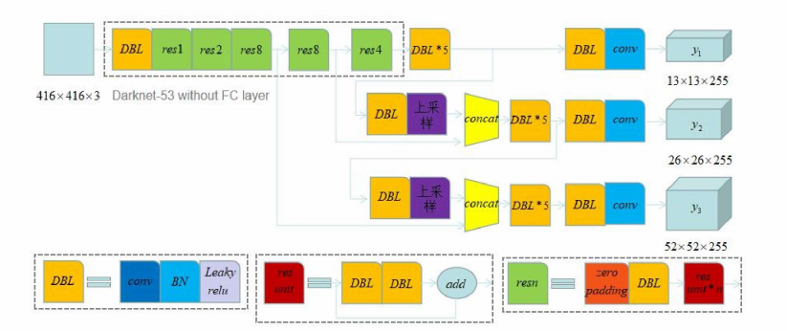
Figure 29 Yolo-v3 structure diagram
4.loss function
Yolo-v3 algorithm improves the speed, accuracy and stability of target detection to a certain extent by virtue of deeper network structure and improved loss function. The yolo-v3 algorithm is the same as the Yolo series algorithm, which inputs the image to be detected, and outputs the border position and category of the target. The improved loss function can be divided into four parts: frame center point loss; Loss of frame width and height; Frame confidence loss; Category loss, of which the first two losses can be summarized as location loss. In general, the purpose of the loss function is to ensure that the network predicts the correct target location and category. (1) Frame center point loss the purpose of frame center point loss is to make the frame center point predicted by the network consistent with the frame center point of the target in the real image.
Among them, λ。 Represents the coordination coefficient to ensure that frames of different sizes have the same contribution to the loss function; SXS represents the number of meshed areas for the image; B represents the number of frame information output from each grid area; Im means whether the j-th border of the ith grid is responsible for predicting a target object; x. Y represents the abscissa and ordinate of the center of the real frame respectively; x. Y represents the abscissa and ordinate of the center of the prediction frame respectively.
(2) Frame width and height loss the purpose of frame width and height loss is to make the predicted frame of the network consistent with the width and height of the real frame.
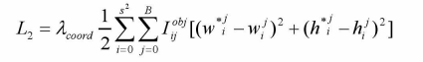
(3) Frame confidence loss frame confidence loss is to predict that the greater the probability that the frame contains the target, the better.
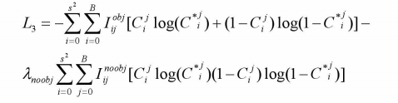
(4) Category loss category loss is to ensure the authenticity of the prediction target category. The purpose of the loss function is to predict the probability of the target category as large as possible.
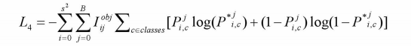

3.1.2 Research Methodologies
Improved yolo-v3 algorithm,The improved Yolo - V3 algorithm is the basic network architecture using Yolo - V3 algorithm. The image feature extraction part remains unchanged. The darknet-53 draws on the architecture of the residual network and includes 53 convolution layers to extract the features of the input image. As shown in Fig. 30, the size of the input image is 416 × four hundred and sixteen × 3. Then, via the DBL network, the output feature size is 416 × four hundred and sixteen × 32, and then through the residual blocks with the number of residual units of 1, 2, 8 and 4 respectively, the output feature size is 13 × thirteen × 1024; The remaining part of the network, that is, the target detection part, has three outputs of different scales. Such a setting enables the network to detect not only large targets in the image, but also small targets in the image, which effectively solves the problem that small targets cannot be detected. In order to enrich the semantic information of features and enhance the performance of the network to detect targets of different sizes, we modified the DBL network in the medium-scale and large-scale output networks among the three different scale outputs of the yolo-v3 network. As shown in Figure 30, the red dashed box is that we replace the two groups of DBL networks of the original algorithm with two "three in one" networks, and the rest of the algorithm flow is consistent with the yolo-v3 algorithm. The "three in one" network includes up sampling and two convolution operations.
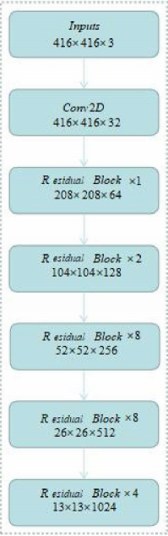
Figure 30 Structure diagram of darknet-53
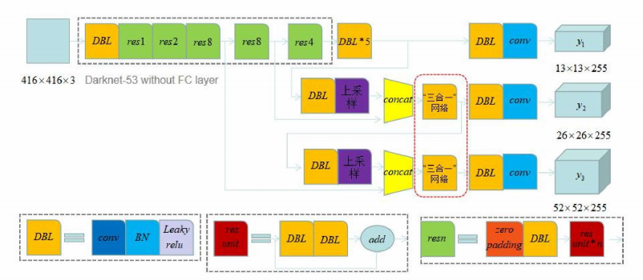
Figure 31 Improved yolo-v3 structure diagram

1.Convolution operation
Convolution operation is an operation for obtaining image information. Convolution layer 2 is a component of convolution neural network, which is generally used to extract image features, and is composed of multiple convolution cores and offsets. Convolution kernel is essentially a weight matrix. The number of convolution kernels in convolution operation is not limited to one, that is, there can be multiple. In the convolution operation, the input image and the selected convolution kernel are multiplied and then added to obtain the convoluted characteristic image. In this process, it should be noted that the number and size of convolution kernel and the moving step of convolution kernel should select appropriate data according to the specific situation. In reality, the input image will become smaller and smaller through continuous convolution. In order to maintain the same scale between the convoluted feature map and the input image, a filling operation is introduced, that is, the number 0 is added around the convoluted feature map. Convolution layer can obtain image feature information well and ensure the basic performance of the network.
2."Three in one" network
The improved yolo-v3 algorithm changes the DBL network in the medium-scale output network and large-scale output network of the target detection part of yolo-v3 algorithm into a "three in one" network. The "three in one" network structure shown in Figure 3.5 consists of up sampling and two convolution operations. The purpose of up sampling is to enlarge image features, and the convolution operation is to better extract information. Taking the large-scale feature output network as an example, when the feature map of layer 91 is fused with the feature map of layer 36 through up sampling, the final output is obtained through the "three in one" network instead of the five DBL networks of the original yolo-v3 algorithm. In the "three in one" network, after the fusion features are obtained, the features obtained by up sampling are fused with the features obtained by two subsequent convolution operations, and then the subsequent operations are carried out. Therefore, the "three in one" network is named.
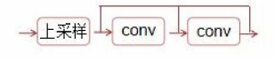
Figure 32 "Three in one" network
Feature fusion is to better improve the performance of target detection. Because of less convolution, the underlying features have less semantic information, but more detailed information; Because of more convolution of high-level features, there is more semantic information. On the contrary, there is less image detail information. Therefore, in order to better extract semantic information without losing detail information, the "three in one" network proposed in this paper effectively integrates the up sampled features and the features after two convolutions. The fused features enrich the semantic information and have more image details. Compared with the previous network, the "three in one" network has a relatively simple structure and includes the operation of feature fusion, which can better enrich semantic information and contain more image details. It is not only helpful for the network to detect large-scale targets, but also small-scale targets, which enhances the performance of the target detection network.
3.CSP structure
Aspnet (cross stage partial network) mainly reduces the amount of calculation in reasoning from the design of network structure. The main improvements of cspnet are as follows: enhance the learning ability of CNN and maintain the accuracy while lightweight; Reduce computing bottlenecks and memory costs. Cspnet divides the bottom feature map into two parts according to the channel, one part passes through dense blocks (composed of multiple fully connected layers) and transition layers (usually convolution kernel size is 1) × 1), and the other part is combined with the transmitted characteristic graph, which not only reduces the amount of calculation, but also improves the speed and accuracy of reasoning. CSNET is not only a network structure, but also a processing idea. It can be combined with RESNET, resnext, densenet and other networks. Taking densinet as an example, the comparison diagram between densinet and cspdensenet is shown in Figure 33.
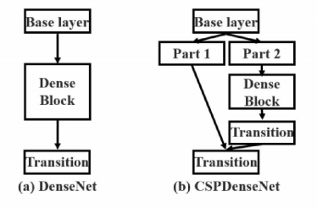
Figure 33 Cspnet structure diagram
As shown in Figure 33 (a), taking dense net as an example, the forward propagation process is as follows, and the update process of back propagation weight is as follows. Where "*" represents the convolution operator, [XO, x1,..., XK] represents the splicing of x0, x1,..., XK, f is the function of updating the weight, GI represents the gradient passed to the ith fully connected layer, and WI and Xi are the weight and output of the ith fully connected layer respectively.
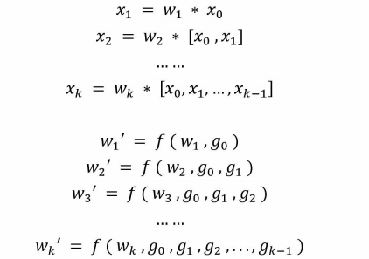
We find that a large amount of gradient information is reused in the calculation process of updating the weight between full connection layers by back propagation, resulting in different full connection layers repeatedly learning the same gradient information. In order to solve this problem, cspdensenet divides the underlying features into two parts according to channels, which are recorded as XO = [x0, X00]. X0 'is directly connected to the end of the stage, and X. "It needs to pass through dense blocks and transition layers. As shown in Figure 34, the output [XO, x,..., XK] of dense blocks passes through the transition layer to obtain the output XR. XR and X are spliced through the transition layer to obtain the output Xu. The forward propagation process of cspdensenet is as follows, and the update process of back propagation weight is as follows
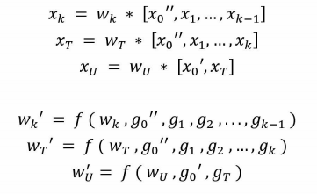
It can be seen that the gradients of the paths on both sides are integrated separately. When updating the gradient information of the weight, neither side contains the repeated gradient information belonging to the other side. Cspnet prevents too much repeated calculation of gradient information by truncating gradient flow. The idea of cspnet continues to be used in yoov4 and yolo5 target detection algorithms. Yoov4 combines cspnet with dark net53, the backbone network of yoov3, which not only enhances the learning ability of convolutional neural network, but also reduces the computational bottleneck and memory cost. The difference between yolo5 and yolo4 is that yolo4 only uses cspnet structure in the backbone network, while yolo5 designs two CSNET structures, csp1x and csp2x respectively. As shown in figures 34 and 35, the csp1x structure is applied to the backbone network, another csp2_ X structure is applied to neck part. In conclusion, in the target detection task, using cspnet to improve the backbone network can improve the detection performance, enhance the learning ability of CNN, reduce the amount of calculation and improve the speed of reasoning.
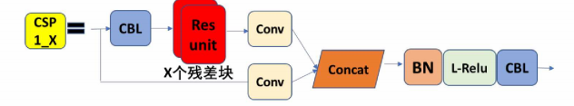
Figure 34 CSPI_X structure
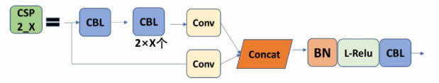
Figure 35 CSP2_X structure
3.1.4 Data Collection
Databases commonly used for target detection tasks include Pascal V OC, Ms coco, Google open Imagenet, DOTA, etc. Ⅴ OC, fully known as visual object classes challenge, is often applied to the training and testing of target detection tasks; MS coco is a large database, which is obtained by Microsoft through Amazon Mechanical Turk platform. It contains 80 categories and is often applied to tasks such as image generation and target detection; Google open image is also a large database, which is produced by Google team. The latest open imagev4 contains 190000 images, 600 categories and 1500000 border annotation information, which contains rich data information, ensures the accuracy of data, and is conducive to the development and innovation in the field of computer vision; As a large image database, Imagenet is widely used in computer vision fields such as image generation, target detection and so on. The database contains 14197122 images and 21841 categories; Dota database is different from other common databases. It belongs to aerial images, including 2806 images, a total of 15 categories, and can also be applied to target detection tasks. In this paper, Pascal VOC and MS coco, which are commonly used in target detection, are selected in order to apply different databases to train, verify and test the improved yolo-v3 algorithm.
1.Pascal VOC
Pascal VOC database is commonly used in target classification, image segmentation, target detection and other tasks for model training and testing. At present, Pascal VOC database is divided into Pascal voc2007 and Pascal Ⅴ oc2012. The data contained can be divided into 4 categories and 20 sub categories. The four categories are: person "animal", "vehicle" and "indoor". Among them, the category of "animal" includes "bird", "cat", etc.; the category of "vehicle" includes "aeroplane", "bicycle", etc.; and the category of "indoor" includes "bolt" and "chair" Pascal VOC database contains image information label information, including training set, verification set, combination of training set and verification set, and test set. Because the two types of data are independent of each other, different combinations of the two types of data are often used for training, verification and testing in this paper to achieve satisfactory experimental results. The following table shows the basic characteristics of the two types of data Information, including training set, verification set, the sum of training set and verification set, as well as the number of images and targets in the test set. In this paper, Pascal voc2012 database is used for experiments.
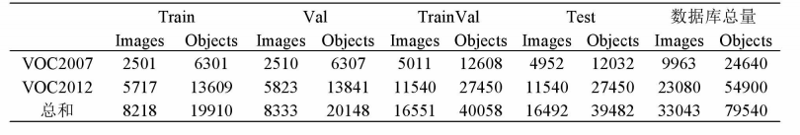
2.MS COCO
MS coco is a large database built by Microsoft. The database includes training images, verification images, test images, various annotation information (bounding box, etc.) and category label information. MS coco database contains more than 330000 images and 80 categories in daily life, such as people, bicycles, birds, umbrellas and other complex daily scenes. MS coco database is often used to train and test models in target classification and target detection tasks. Compared with Pascal VOC database, it contains more image data and image types, which is more conducive to researchers' research and use. In this paper, the coco2017 database is used for experiments. The following table briefly introduces the number of images used to train, verify and test the network in coco data.
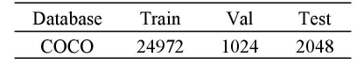

3.1.5 Research Design
A new feature fusion network structure is proposed. Considering the actual engineering requirements of target detection task, we focus on improving on the basis of lightweight yolo5s and yolo5m. We find that the detection ability of multi-scale targets is an important standard to measure the performance of target detection algorithms, and the detection of small and medium-sized targets is becoming more and more meaningful. Therefore, we have improved the structure of yolo5s and yolo5m models, which not only basically maintains the reasoning speed, but also improves the detection accuracy, especially for the detection effect of medium and small targets. In the original program of yolo5, the neck part, like yolo4, adopts the panet structure. The specific form of the structure is to add the bottom-up panet structure behind the top-down FPN structure. As mentioned in section 23.4 above, considering the structural advantages of bidirectional feature pyramid network (bifpn), we propose to apply the idea of bifpn to multi-scale feature fusion. At the same time, in order to improve the detection effect of small and medium-sized targets, we improve the network structure of feature fusion, make full use of high-resolution low-level features, and expand the receptive field of the model. In order to verify the performance of the improved algorithm proposed in this paper, we conduct data experiments on the challenging MS coco data set. The experimental results show that our model improves the detection accuracy based on yoov5s and yolo5m, especially for the detection of small and medium-sized targets. The speed measurement experiment shows that our model yolo5 s ours not only improves the accuracy, but also basically maintains the reasoning speed. In addition, we also compare the accuracy and speed of the improved algorithm proposed in this paper with other classical target detection algorithms. The comparison results show that the improved algorithm proposed in this paper has a certain improvement in detection performance.

3.2 Experiment Preparation
3.2.1 Hardware
The hardware environment of the experiment is shown in Table 1
Table 1 Experimental environment parameters.
Hardwareconfiguration | Parameter
CPU | Intel(R) Core(TM)i7-4710MQ CPU @2.50GHz
RAM | 10G
GPU*3 | RTX2080
GPU Memory | 15G
Development Framework | Pytorch 1.7.6, tensflow
Table 1 Experimental environment parameters.
3.2.2 Software
1. Install anaconda and pycharm development tools
2. Use Python to train and test the network model and program the related files in the framework of Python and tnsfolw.
3. Install opencv, numpy, and other common API libraries

- DESIGN AND IMPLEMENTATION
Theoretically, the deeper the network structure of neural network, the stronger its characterization ability. However, the deeper the neural network structure, the more difficult it is to train the network model. So far, there is no complete solution to these problems, such as over fitting, gradient dispersion, gradient explosion and so on. In order to prevent these problems, model trainers are often required to have more parameter adjustment experience. The optimization of neural network structure is often to avoid or reduce over fitting in network training. Such as regularization term, design of nonconvex objective function, etc. Batch normalization algorithm is also such an optimization algorithm for neural network training. In addition to preventing the phenomenon of over fitting, the batch normalization algorithm can also speed up the training speed of the model and improve the classification accuracy of the network model to a certain extent. However, in two cases, the effectiveness of batch normalization algorithm in network model training may be reduced: one is that the batch sample is small in network model training; the other is that in practice, the batch sample is composed of non independent identically distributed samples. In order to solve these two problems of batch normalization algorithm, literature [23] proposed a batch re normalization algorithm. Compared with the batch normalization algorithm, which generates the same output based on the whole batch of samples, batch renormalization can make the training model and prediction model generate the same output in the case of a single sample. Therefore, when training the model in two cases, we can consider using the batch renormalization algorithm instead of the batch normalization algorithm: (1) the sample size of the training batch is small; (2) the sample data is not independent and identically distributed. In addition, the batch renormalization algorithm is insensitive to the initialization of parameters during model training, and has good training efficiency. By setting small batch training samples, the training of network model can be carried out under the condition of hardware equipment with low computing power.

4.1 Selection of deep learning frameworks
Yolo detection algorithm is different from fast r-cnn detection algorithm series. Fast r-cnn series has obvious advantages in detection accuracy. If there is no real-time requirement for the detection speed of the target object, the fast r-cnn series will be a very good choice. Yolo algorithm solves the problem of slow target detection. Compared with the fast r-cnn series algorithm, which uses RPN and anchor mapping mechanism to calculate the coordinate position, Yolo algorithm framework uses regression method to directly regress the frame coordinates and confidence score of daily standard objects in the full connection layer. The disadvantage is that Yolo's regression method makes the positioning deviation of the target object large, so the final detection accuracy is relatively low. This chapter discusses the framework of Yolo detection algorithm in detail, and makes improvement efforts in the network training of Yolo algorithm, so as to further improve the detection accuracy and detection speed of Yolo algorithm. The main contributions of this chapter are: (1) adding batch re normalization processing to the network structure of Yolo algorithm and removing its dropout processing; (2) appropriately setting a relatively small batch training sample size to enable Yolo algorithm to perform detection tasks under the condition of low hardware equipment; (3) At the same time, this chapter also adds batch renormalization in the yolov2 algorithm framework for comparison; (4) The experimental results show that the improved algorithm in this chapter improves the detection accuracy and speed of Yolo algorithm.
Yolo detection algorithm directly treats the detection problem of the target object as a regression problem of position coordinates and confidence score. Therefore, Yolo detection algorithm can predict the category and border position of multiple target objects in real time at one time. Different from the traditional target detection algorithms that select sliding window and fast r-cnn series algorithms to extract candidate regions, Yolo detection algorithm directly selects the whole picture to input the network model for training or detection, which greatly improves the training and detection speed of the network model.
The Yolo network structure consists of five parts: input layer, convolution layer, pooling layer, full connection layer and output layer. Figure 34 shows the specific organization form of the Yolo network structure.
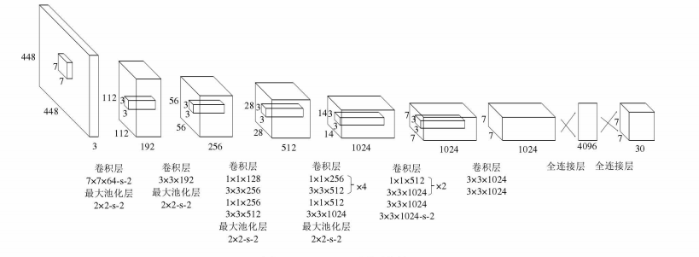
Figure 34 Yolo network structure

(1) Convolution layer. The Yolo network structure uses 24 convolution layers successively, and the convolution cores corresponding to these convolution layers are 3 × 3 and 1 × 1 two sizes. Where, the size is 1 × The convolution kernel of 1 can control the number of channels during convolution. In this paper, 1 × The convolution kernel of 1 reduces the dimension of the eigenvector of its corresponding layer, and finally reduces the parameters in the network. (2) Pool layer. The maximum pooling layer is adopted in the Yolo network structure. During down sampling, the maximum value of each element in each small block is selected as the characteristic value of this element. It can be seen from the figure that the block size of the pool layer is 2 × 2。 (3) Full connection layer. The full connection layer maps the input feature map to the output feature map by means of full connection. Generally, the full connection layer classifies the output feature map. In the Yolo network architecture, the first full connection layer will be 7 × seven × The 1024 dimensional feature matrix is directly arranged as a one-dimensional vector of 4096 dimensional features, and the second fully connected layer reduces the dimension again. In practical application, the full connection layer of convolutional neural network is an unnecessary layer, which consumes a lot of time. Therefore, the output layer of this design mode (4) is omitted in yoov2. It can be seen from Figure 3.1 that Yolo finally needs to regress the coordinates, width, height and confidence score of the frame center point of the output target object, and the final output is 7 × seven × 30 dimensional vector. See section 3.2.3 for the analysis of detection process.

4.2 Design and implementation
4.3.1 Pre training model
The training depth neural network model can be carried out by unsupervised pre training combined with supervised fine-tuning. Therefore, training the Yolo network model needs two steps: (1) take out the first 20 convolution layers from the Yolo network structure in Figure 33, and then add an average pooling layer and a full connection layer. Then, 224 is used for pre training on image net2012124 × 224 dimensional image input (2) based on the previous step, take 20 pre trained convolution layers, and then add 4 new convolution layers and 2 full connection layers. When fine tuning these newly added new layers, use 448 × 448 and randomly initialize the parameters of the newly added layer. When designing the loss function, the Yolo algorithm framework considers two problems: (1) if the positioning error and classification error are equally important, it will appear to be unrealistic to meet the detection requirements; (2) if there is no target object in a grid, the target frame confidence score of these grids will be set to 0. However, the contribution of these meshes that do not contain the target object to the gradient update will be much greater than that of the meshes that contain the target object, which will make the network training very unstable. The way to solve these two problems is to weight in front of the relevant loss items. That is: (1) in coordinate prediction, make the loss weight λ Is 5; (2) If the target object does not appear in the target frame, the loss weight predicted by the confidence score λ 0.5. At the same time, the confidence score loss weight of the target object frame and the loss weight of category prediction are 1. Finally, the loss function of Yolo algorithm framework is:
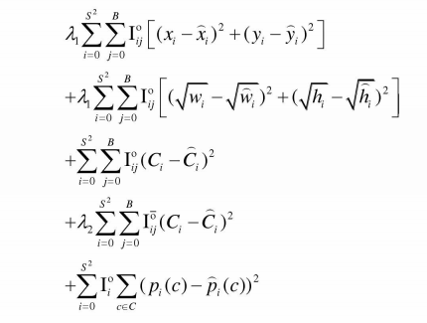
Where, I is the target object appearing in the 讠 th grid, and I grid is responsible for predicting the frame of the j-th target object, (x, YW, IX) represents the coordinate position of the target object appearing in the i-th grid during coordinate prediction, (x, W,) represents the coordinate position of the object pre labeled with the image target, and C represents the category of a target object predicted by the i-th grid, C represents the category of the target object in the pre labeled image, B is the number of target frames predicted by each grid, S2 is the number of grids divided into the input picture, formula (3.1) has five parts, the first and second parts are coordinate prediction, the third part is the confidence score prediction of the target frame containing the detection target, and the fourth part is the confidence score prediction of the target frame without the detection target, The fifth part is category prediction.

4.3.2 Detection process
To get the Yolo detection model, first pre train the classification model Darknet on Imagenet, and then fine tune Darknet into the detection model. Figure 3.2 illustrates the target detection process of Yolo algorithm framework. (1) Yolo algorithm framework takes the whole image as the input, and divides the input image into S × S networks 2) each target frame needs to make two predictions. First, predict the target object. If the center of a target object falls within a grid, the grid is responsible for detecting the target object. Second, the prediction target frame. Each network needs to predict B target frames, and each target frame has 5 parameters to be predicted, namely, the width and height of the target frame, the coordinates of the center point (x, y) and the confidence score, where o represents the target object existing in the target frame and P (o represents the probability of the target object existing in the current target frame. If a target object exists in a target frame, pr (o is 1. If there is no target object in a target frame, PR (o) is 0. IOU (intersection over union) is usually used as a threshold to control the number of predicted target frames. This value needs to be calculated by the predicted target frame P and the pre labeled target frame T
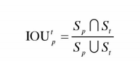
Where, s is the area of the pre labeled target frame, and accordingly, s is the area of the predicted target frame (3). Calculate the posterior probability pr (CO). That is, when there is a target object in the target frame, the probability that the target object belongs to a certain class. Assuming there are k-class target objects, each grid predicts the conditional probability of class I target object C, that is, pr (c|o, I = 1,2,..., K; at the same time, each grid also predicts B target frames. This means that a certain type of target object predicted by each grid shares the conditional probability pr (c|o) with the target frame predicted by each grid. (4) according to the above analysis, when pr (CO) is calculated, the class related confidence of a certain target frame can be obtained in combination with the following formula, that is:
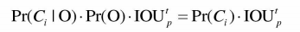
In particular, in the Yolo algorithm framework, s = 7, B = 2, k = 20. That is, each input image is divided into 7 × There are 7 grids, and each grid predicts 2 daily standard frames. Meanwhile, Pascal VOC has 20 types of target objects to be detected. Therefore, the Yolo algorithm framework finally predicts that a vector with a length of s will be obtained × S × (B × 5+K)=7 × seven × 30。 At this point, the detection process of Yolo algorithm ends.
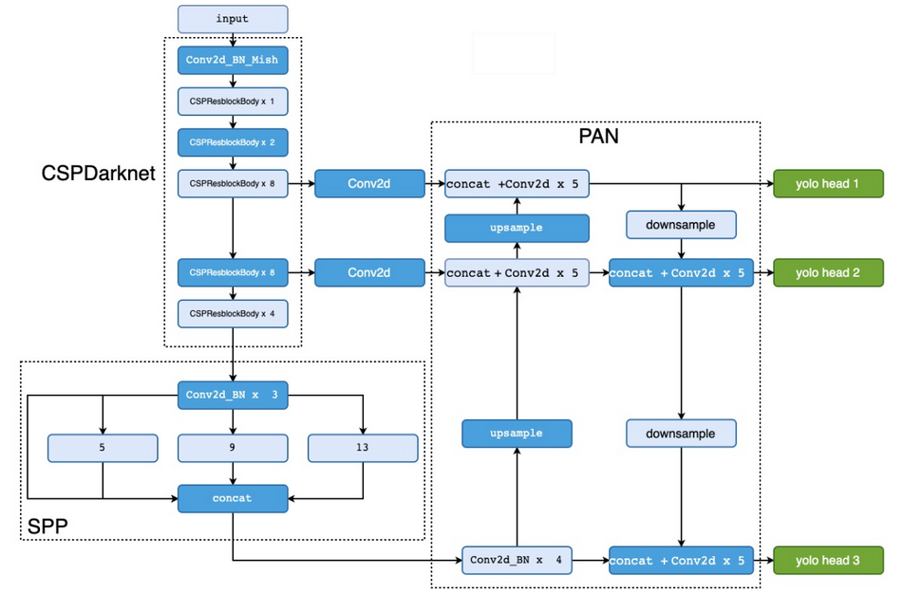
Figure 34 Yolo detection flow chart

4.3.3 Batch renormalization
Batch renormalization algorithm is an improved algorithm of batch normalization algorithm. Firstly, the batch normalization algorithm is introduced, and then the batch renormalization algorithm is analyzed in detail. Finally, the batch renormalization algorithm is applied to the Yolo algorithm framework.
In the training of deep neural network model, the random gradient descent method is generally used to update the network weight parameters. Among them, momentum and gadra are the most commonly used random gradient descent algorithms. In general, order ω Is the model weight parameter, {X2, X2,..., X} is the whole training data set. When the loss function value of the neural network reaches the minimum, the weight parameters of the network model are reduced .
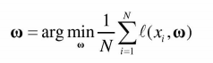
The training data set is divided into several subsets. Generally, if a subset is {x, x,..., XM}, where m < n neural network model is trained in this batch of sample data, the gradient should be approximated as with parameters ω The gradient of the loss function, i.e.:
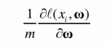
If the input sample of a layer of the network model has d dimension, i.e. {x, X2..., X}, the normalization of the input sample is:
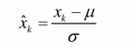
Where, represents the expectation of the input sample, σ Represents the standard deviation of the input sample, k = 1,2... D. However, different activation functions have their specific function properties. In neural network training, if we simply normalize the mean value of neuron excitation value to 0 and the variance to 1, the ability of activation function to describe data distribution will be greatly reduced. For example, the sigmoid activation function simply normalizes the excitation value of neurons, and only the approximate linear part of the function is used. The characteristics learned by the layer of activation function are also imperfect. The expression ability of neural network model will eventually be greatly reduced. To solve this problem, you can make
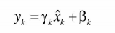
Among them, γ, B is the additional learning parameter. These two parameters are used to maintain the expressiveness of the model. In equation (3.8), X shall be obtained from equation (3.7). In general, μ and σ For the entire dataset. However, here, the expectation of the whole data set is estimated by the expectation of the input data of a certain layer, and accordingly, the variance of the whole data set is estimated by the variance of the input data of a certain layer. Therefore, when
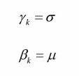
When, the features learned at a certain layer will better reflect the characteristics of the original data, and the feature distribution to be trained and learned by the network will also be corrected. Finally, take the batch sample B = {x, x,..., XM} with the data volume of M, and carry out linear transformation on this batch sample, that is:
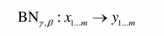
In the algorithm, if R and D are updated as parameters, it is equivalent to using and a in the training stage, which will lead to the conflict between gradient optimization and normalization. The purpose of gradient optimization is to adapt to a small batch of samples by calculating the scale and shift of weight. Normalization will counteract this effect. The moving averages eliminates the dependence of the normalized activation value on the current small batch samples, so that the small batch samples lose the adjustment of the direction of each weight update, so that the scale of the weight increases due to the normalization offset, but the loss will not be reduced. In the prequel, the affine transformation of R and D corrects the difference between a small batch of samples and the whole sample, so that the activation of this layer can be more generalized corrected in the prediction stage. Such correction can still play a role when the small batch sample is very small or even 1, and even when the data in the small batch sample is non independent and identically distributed, it will eliminate the over fitting of the training set because of this correction.

4.3.4 Yolo batch renormalization
The analysis shows that the batch renormalization algorithm not only inherits various excellent characteristics of the batch normalization algorithm, but also can deal with the failure of the batch normalization algorithm when the number of small batch samples is very small and the data is not independent and identically distributed. Batch renormalization is introduced into the network structure of Yolo algorithm framework. At the same time, in order to better compare the results, this chapter also improves the network structure of yolo2 algorithm framework: that is, on the yoov2 network structure, batch renormalization is used to replace batch normalization. (1) The batch renormalization algorithm is used on the characteristic graph of each layer of Yolo network structure. Batch renormalization algorithm can normalize each neuron, and can only normalize a neuron in a certain layer of the network model. In addition, the weight sharing strategy is used in convolution operation of convolution neural network. In this paper, the feature maps obtained by convolution operation of convolution layer are treated as neurons. Based on these observations, this chapter re normalizes the characteristic graphs obtained by product operation in batch. That is, the input data of a certain layer of the network is represented as (m, F, W, H) quadruple. Where m is the sample size of a small batch, ∫ represents the number of characteristic graphs of a certain layer, w represents the width of the characteristic graph, and H represents the height of the characteristic graph. When batch re normalizing the characteristic graph of each layer, the input data is MX ν XH. Therefore, according to the description of the algorithm, each feature graph has only four learnable parameters, namely y, B μ as well as σ (the batch normalization algorithm has only two learnable parameters y and b). Then, transform, train and predict according to the algorithm.
- Remove dropout processing of Yolo network structure. Batch renormalization algorithm has strong characteristics of improving network generalization ability, which can replace dropout to a great extent. Before the batch normalization algorithm, dropout was widely used as an effective skill in neural network training. Yolo algorithm also uses dropout, and the probability of dropout is initially set to 0.5. Here, the improved algorithm comprehensively considers the calculation amount of dropout and the batch renormalization algorithm to prevent over fitting, and removes dropout
- from the network structure to increase the learning rate. Learning rate is an important super parameter in neural network training. Generally, after initializing the learning rate, the learning rate needs to be adjusted according to a certain proportion during neural network training. The batch renormalization algorithm can initialize a relatively large learning rate, and the attenuation ratio can be set relatively large. This feature makes the convergence speed of network training faster. Based on this observation, this chapter initializes the learning rate of Yolo network training to 0.001, which can greatly improve the training speed of network model compared with the original initial learning rate of 0.0005.
(4) The training of deep neural network and the operation of pre training model need expensive hardware support. Without these conditions, we have to make some compromises. Due to the use of batch renormalization, a relatively small batch size can be appropriately set in the improved algorithm, so that the algorithm can still run well on low-cost hardware equipment and maintain good detection accuracy.
4.3.5 Multiscale training
The original Yolo model first pre trains the first 20 layers of convolutional neural network on the image net dataset. During training, the resolution of the input image is 224 * 224, and then uses Pascal VOC dataset to train the target object recognition and positioning. The resolution of the input image on Pascal VOC dataset is 448 * 448, which increases the number of training samples and changes the scale of training samples. Although the detection accuracy of the target detection algorithm is improved to a certain extent, it may be difficult for the target detection algorithm to quickly adapt to high resolution by directly switching the resolution, As a result, the detection accuracy is reduced. The target detection algorithm based on the improved multi granularity feature fusion of Yolo proposed in this paper removes the full connection layer in the original Yolo, and the neural network structure is changed to the form of full convolution, so that the algorithm model is not sensitive to the scale of the input image. As shown in the structure in 3.3.1, the size of the output characteristic graph of the improved model is 13 * 13, and the convolution kernel with size of 3 * 3 is used to replace the convolution kernel with size of 7 * 7 in the original Yolo model. With the deepening of neural network hierarchy, the size of feature map is reduced by pooling operation, and the original information in the image will be lost to varying degrees. In order to ensure that the target features after pooling can be fully extracted, the number of channels of the feature map after pooling is increased on the original basis. In the training stage, this paper adopts multi-scale training to ensure the detection accuracy of the model when images of different sizes are used as input, and improve the robustness of the target detection algorithm based on Yolo improved multi granularity feature fusion. The size of the selected input image has four scales: 224 * 224288 * 228352 * 352480 * 480. The size of the input image is changed every 16 batches of training, so that the algorithm model can be suitable for the detection of images of various sizes. At the same time, the training process will be accompanied by data enhancement to reduce the risk of over fitting and improve the robustness of the model. During training, the pre trained network weight of Yolo corresponding layer on Pascal Ⅴ OC data set is used as initialization, and the random gradient descent algorithm is used for optimization during network training.

5. experiment

5.1 Experimental setup
In the experiment, the optimization method we choose is the random gradient descent method with momentum. The initial learning rate is set to 1e-2, the descent mode of learning rate is cosine descent, and finally to 1e-4. The weight attenuation parameter is set to 5e-4. In the initial stage of training, we used three epochs for warm-up training. When using focal loss training, the gamma parameter was set to 1.5. In order to facilitate the comparative experiment, we use the basic training strategy of yolov5 in other settings. Our training graphics card is Tesla V100. The training time of yoov5s is about 4 days and yoov5m is about one week.

5.2 Feature extraction of pre-trained network
In terms of data preprocessing of the experiment, data enhancement methods such as random scale transformation, random shift, random left-right flip mosaic and color enhancement algorithm (HS V space) are adopted. Among the mosaic data enhancement methods, in addition to the above data preprocessing methods, we also adopt the method of adaptive image scaling in the reasoning stage. In the traditional target detection algorithm, the length and width of the image in the data set are different, and the image input to the detection network needs the same scale. For example, the size of the image input to the detection network by Yolo algorithm is generally 608 × 608 or 416 × 416, so the original image needs to be scaled to a certain extent and unified before being input into the detection network. However, in the practical application of the project, due to the different aspect ratios of the images in the dataset, the sizes of the black edges filled after scaling are different. If the filled black edge area is too large, it will cause information redundancy and affect the speed of reasoning. Therefore, we adaptively add as few black edges as possible to the original image, reduce the amount of calculation, and then improve the speed of algorithm reasoning. The specific process of adaptively scaling pictures is as follows:
(1) Calculate the scaling factor: set the size of the original image to W × H. The size of the input image of the scaled network is s × S. The scaling factors for the calculated width and height are s / W and S / h, respectively. Select the smaller min {s / W, S / h} as the scaling factor.
(2) Calculate the size of the scaled image: multiply the scaling coefficient obtained in step (1) with the original image to obtain the length and width of the scaled image as w * min {s / W, S / h} and h * min {s / W, S / h} respectively.
(3) Calculate the amount of black edges to be filled: first, calculate the amount of black edges to be filled X. The calculation method of X is as follows:

Then divide the result obtained after taking the remainder of X and 32 by 2 to obtain the amount of black edges filled on both sides of the adaptive scaling method. Among them, the value 32 means that the network of yolo5 algorithm has experienced 5 down sampling in the process of forward propagation, that is, 32 = 2 * 2 * 2 * 2 * 2.
In conclusion, the adaptive image scaling operation in the reasoning stage of the experiment can effectively improve the reasoning speed of the detection algorithm.

5.3 Experimental simulation and result analysis
The yolo5 series network has four structures: yolov5s, yolov5m, yolo51 and yolo5x. Yoov5s is the network with the smallest feature map width and the least parameters. The other three networks are continuously widened on the basis of yoov5s. In the experimental part of this paper, the challenging MS coco data set is selected. The main contents of this section can be divided into the following parts: (1) referring to the experimental results of the original yolo5 algorithm, we compare yolo5 with the current efficient det algorithm with better performance, as shown in Figure 4.3. It can be found that yolo5 algorithm has more advantages. Therefore, our algorithm is improved on the basis of yolo5 S5 and has better practical application value. (2) We refer to the experimental data of efficient det, list the data table, and compare the improved algorithm yoov5ours with yoov5 series algorithms and other similar daily standard detection algorithms with efficient det. Observing the experimental data, we found that the accuracy (AP value) of the improved algorithm has been improved to a certain extent. (3) we focused on the improvement results of lightweight yoov5s and yoov5m on small and mesoscale targets, and compared them with similar methods with similar operation speed. It can be found that our improved models yolo5 s ours and yoov5 m ours can improve the detection of small targets. (4) We changed the loss function and carried out comparative experiments, and changed the original binary cross entropy loss to focal loss for balancing positive and negative samples. The experimental data show that the accuracy of the model using focal loss decreases. Therefore, for the yolo5 series models, the binary cross entropy loss is a more appropriate loss function.(5) We compare the recall rate and reasoning speed between the improved model yoov5s ours and the original yoov5s model. We find that compared with the yoov5s algorithm, the recall rate of the improved algorithm yoov5s ours is improved to a certain extent. In addition, yolo5_ Our detection accuracy is improved, while the reasoning speed is basically maintained. Next, we will elaborate on the specific content of each part.
(一)Yolo5 series algorithms are compared with efficient det series algorithms. Because efficient det is the current algorithm with fast reasoning speed and high detection accuracy, the original program code of yolo5 compares the performance of yolo5 series and efficient det algorithms. As shown in Figure 43, the horizontal axis represents the reasoning speed of the model on the GPU, and the value of the horizontal axis refers to the time taken to calculate each image (in milliseconds); The vertical axis represents the accuracy of the model, and the value of the vertical coordinate represents the accuracy (AP value) measured by the model on the MS coco validation set. It can be seen that the closer the point coordinates representing the model are to the upper left corner, the better the performance of the model. From Fig. 35, we can find that compared with efficientdet-d0, yolo5s has faster reasoning speed and higher accuracy in the verification set; Similarly, compared with efficientdet-d1 and efficientdet-d2, the yolov5iyolo51 and yoo5x series algorithms are faster and more accurate. In conclusion, the performance of each model of yolo5 series is relatively better than that of effective det. Therefore, our algorithm yolo5ours is improved on the basis of yoov5 series algorithms and has good practicability
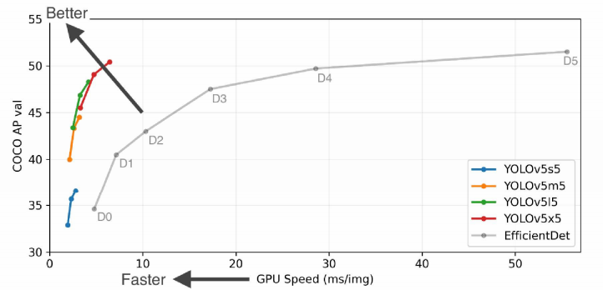
Figure 35 Comparison of yolov5 series algorithms with efficientdet series algorithms
（2） Comparison of yolov5ours, yolo5 series and other similar algorithms we list the data table to compare the improved model yolo5ours, yolo5 series and other target detection algorithms similar to efficientdet. According to the comparison diagram between yoov5 series and efficientdet series (Figure 4.3), we can make the following groups for comparison: yoo5s and efficientdet d0, yoo5m and efficientdet DL, D2, yoo51 and efficientdet-d3, and yoov5x and efficientdet-d4. We then divide the algorithms with similar accuracy (AP) into a group, as shown in Figure 36. We bold the data with the least parameters and the highest accuracy. By comparing the average accuracy of each model on the test set and verification set of MS coco data set, we find that yoov5 algorithm has the highest accuracy in each group, and our improved algorithms yoov5 s ours and yoov5 s ours have higher accuracy than yoov5s and yoov5m algorithms respectively. From the comparison of parameters, the parameters of Yolo V5 algorithm are slightly higher than that of efficient det algorithm, but far less than other similar algorithms. Although the efficientdet algorithm has fewer parameters, the algorithm occupies a high amount of memory in the calculation process, and the calculation time used in reasoning is more than that of yolo5 algorithm. In conclusion, compared with other similar detection algorithms, the accuracy of yolo5 improved algorithm has been improved to a certain extent.
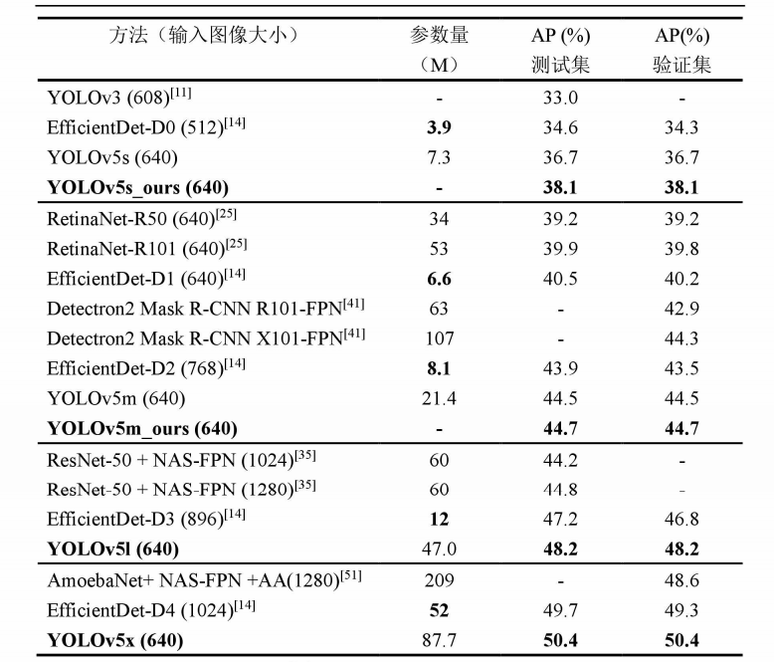
Figure 36 Comparison of yolo5ours, yolo5 series and other similar algorithms
（3） For the improvement of yoov5 s ours and yoov5 m ours on small and mesoscale targets, we focus on the improvement on the basis of lightweight yoov5s and yoov5m, and apply the new two-way feature fusion structure and make full use of low-level features to the original detection network, so as to improve the detection effect of small and mesoscale targets. In addition, for the detection accuracy of small and mesoscale targets, we also compare the improved algorithm with other similar methods. We divide the algorithms similar to yolo4 and with similar reasoning time tested on Tesla V100 into a group and compare the average accuracy of the algorithms in the same group. The experimental data are shown in Figure 37. APS, APM and APL respectively refer to the average accuracy of detection on small, medium and large-scale targets. We can see that compared with other algorithms in the same group, when the reasoning time is similar or even less, based on Yolo ν The average accuracy of the improved algorithm and the average accuracy on small and mesoscale targets are relatively high.
In addition, we also observed that the average accuracy of the improved algorithm yoov5 ours based on yoov5s on the mscoco test set was improved from 36.7% to 38.1%. On small-scale targets, the average accuracy of yolov5s is 21.0%, while the average accuracy of our improved algorithm is 22.7%, which is improved by 1.7%; On the mesoscale target, the average accuracy of yolov5s is 42.1%, while the average accuracy of our improved algorithm is 43.0%, an increase of 0.9%. The average accuracy of the improved algorithm yoov5m ours on the MS coco test set is increased by 44.7 ‰ from the original 44.5%. For small-scale targets, the average accuracy of Yolo V 5m is 27.4%, while the average accuracy of our improved algorithm is 28.4%, an increase of 1.0%. It can be seen that compared with yoov5m, our improved algorithm yoov5m ours can improve the average accuracy, and the improvement in target detection is more obvious. However, for large and mesoscale targets, the detection effect of the improved algorithm is relatively small. By analyzing the reasons, we can find that with the increase of model capacity, the gain brought by our changes is relatively weak on large-scale targets. Therefore, compared with the original yolov5 algorithm, the improved algorithm proposed in this paper can improve the average accuracy, and the improvement effect in small target detection is relatively obvious.
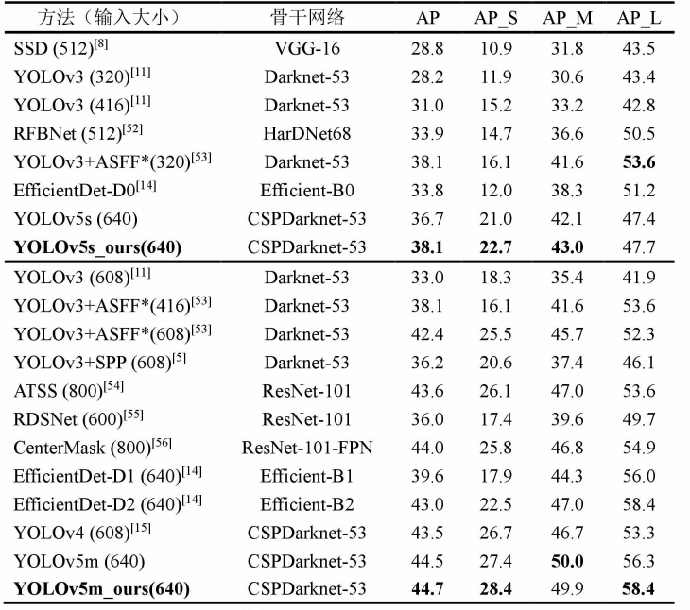
Figure 37 Detection comparison of targets with different scales by Yolo \ 5ours, yolo5 series and other similar algorithms

（4） Comparison between binary classification cross entropy loss (BCE loss) and focal loss based on the improved model yolo5 s ours, we changed the classification loss function from binary classification cross entropy loss to focal loss, and carried out a comparative experiment. Focal loss is a loss function for target detection proposed by he Kaiming's team, which is mainly to solve the problem of serious imbalance in the proportion of positive and negative samples in the one-stage target detection algorithm. Focal loss gives small loss weight to simple samples, mainly mining difficult samples. Therefore, focal loss is widely used in the field of target detection. Focal loss is expressed by the following formula. The experimental results are shown in Figure 38. We note that the accuracy of the model using focal loss is lower than that using binary cross entropy loss (BCE). Therefore, if focal loss is used in the loss function, better results cannot be obtained. Therefore, focal loss can accelerate the convergence of the model, but it may not improve the detection accuracy.
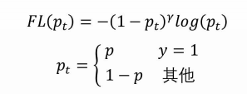
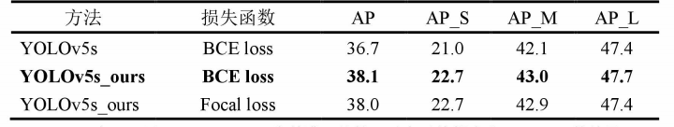
Figure 38 Taking yolo5 ours as the benchmark, the results of binary cross entropy loss and focal loss are compared
（5） Yolo5s_ Comparison of recall rate and reasoning time between ours and yoov5s in addition to comparing the accuracy (AP) of the model, our experiment also compared another important index of target detection task: recall rate. Similar to the calculation accuracy, when we calculate the recall rate, we also calculate the average of 10 recalls with IOU increasing from 0.5 to 0.95 and step size of 0.05. In addition, we set the confidence to 0001., It can be seen that the recall rate of our newly improved model has also been improved compared with the original model, and the recall rate of targets with different scales has been improved to a certain extent.

Finally, we carried out the velocity measurement experiment based on yoov5s. In the experimental stage, we selected the fp16 version of the model, and the test equipment was Tesla V100. In velocity measurement, we remove the time consumption of non maximum suppression (NMS) and only record the reasoning time. As shown in table 4.6, it can be seen that our improved model yoov5 s ours not only improves the accuracy of small target detection, but also maintains the speed of reasoning. In addition, we found that with the increase of the number of model channels, if our improved algorithm takes yolo5l or yolo5x as the benchmark, the following situations will occur: Although the detection accuracy will be improved to a certain extent, the reasoning time will increase. Therefore, our improved algorithm based on the lightweight yolo5s is of more practical significance. The algorithm can basically maintain the reasoning speed and improve the accuracy of target detection, and the improvement effect on small and medium-scale targets is better.
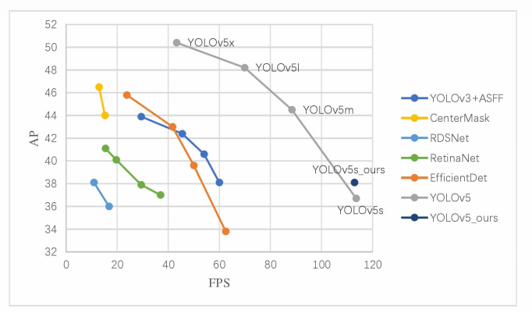
Figure 39 Comparison of detection performance of yolo5 s ours, yolo5 series and similar algorithms

6 Conclusion and follow-up research direction

6.1 Display of experimental operation results
This paper focuses on the target detection task, and introduces the research background of deep learning and the development status of target detection task. At present, target detection algorithms based on deep learning can be divided into one-stage algorithms and two-stage algorithms. Firstly, we introduce the typical two-stage algorithms based on regional proposal, such as RCNN, sppnet, fast ran, fast RCNN, etc; Secondly, we introduce one-stage algorithms based on bounding box regression: SSD and Yolo series algorithms. As for the methods of feature fusion, this paper mainly introduces feature pyramid network (FPN), path aggregation network (panet) and bidirectional feature fusion network (bifpn). In addition, because yolo5 algorithm is a better detection algorithm at present, we describe yolo5 algorithm in detail from the aspects of data enhancement, network structure, loss function and so on.
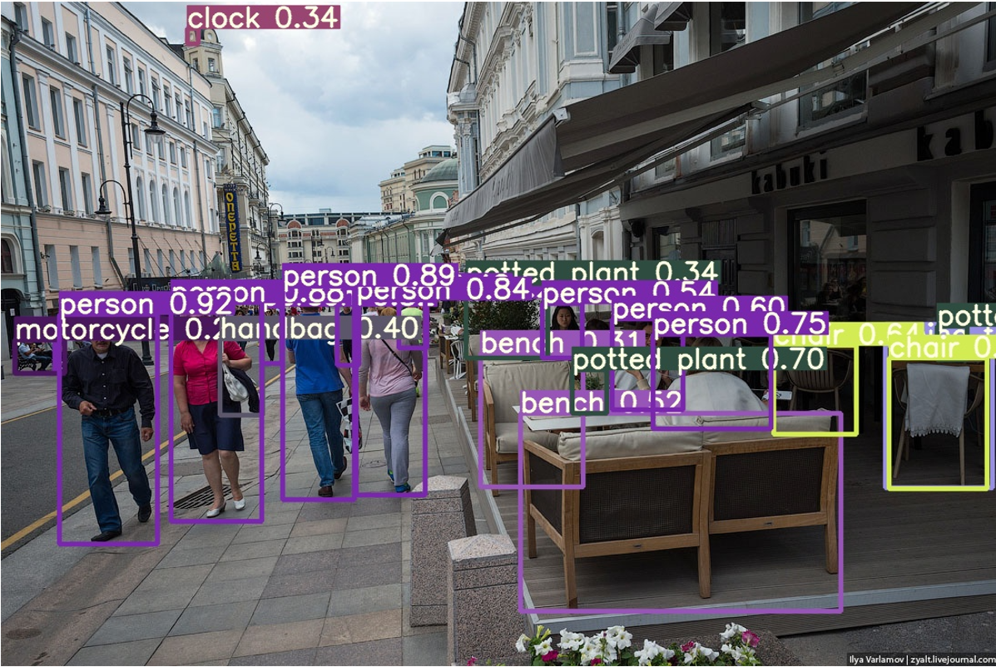
Figure 39 Simulation demonstration results 1

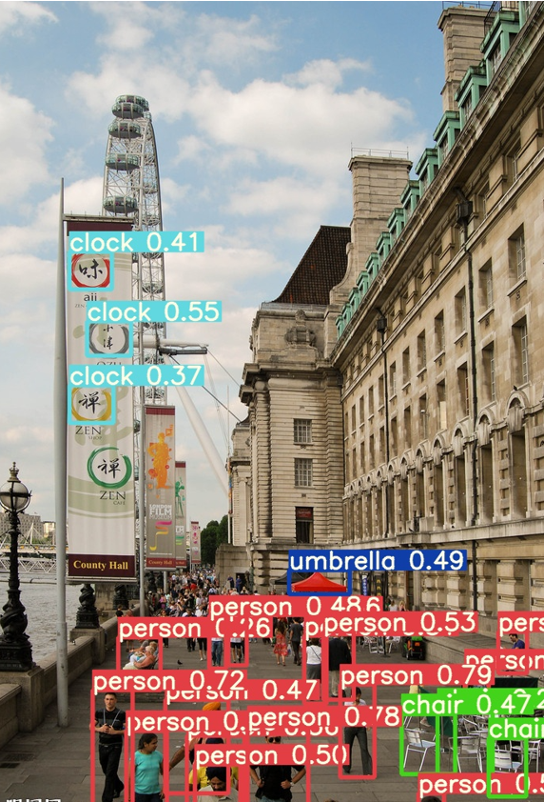
Figure 40 Simulation demonstration results 2

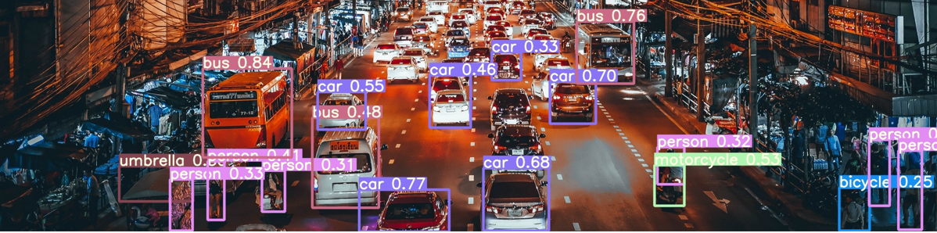
Figure 41 Simulation demonstration results 3

6.2 Conclusion and follow-up development
Firstly, this paper introduces the research background and research status of target detection in computer vision, introduces the common methods of image target detection in recent years, and introduces the target detection based on traditional scheme and the target detection based on deep learning in detail. Aiming at the problems of poor small target detection effect of Yolo algorithm and undetectable high-resolution pictures in deep learning target detection, this paper proposes an improved deep learning target detection algorithm based on sliding window mechanism, which enlarges the local details of the image through windows of different scales, so as to improve the detection accuracy of the model. Then, aiming at the problems of heavy frame and false detection caused by sliding window, This paper further proposes an improved non maximum suppression algorithm and the idea of identification network correction. Finally, this paper compares the two data sets with some classical target detection algorithms to verify the effectiveness of the proposed algorithm. The main algorithms proposed in this paper are as follows: (1) a classification algorithm for automatically distinguishing foggy and non foggy images is proposed; (2) a sliding window interface is added to the target detection process in the original algorithm to solve the problem of difficulty in daily target detection and small target detection in high-resolution images; (3) the position of the target obtained by the detection network is corrected by using image saliency (4) The training recognition network modifies the results obtained by the detection network
Inspired by bi-directional feature fusion (bifpn) and yolo5 algorithm, an improved target detection algorithm is proposed in this paper. Firstly, considering the advantages of bifpn structure, we apply the bidirectional feature fusion structure to the neck part of the network, and change the original fusion strategy of summing by pixels to splicing by channel dimensions; Secondly, in order to improve the detection ability of the network on small-scale targets, we make full use of the high-resolution low-level features. In the experimental part, we selected the challenging MS coco data set and compared it with several other similar detection algorithms. The experimental data results show that, based on the lightweight Yolo V 5S, our improved algorithm can improve the detection accuracy while basically maintaining the reasoning speed, especially for small and medium-sized targets. The follow-up research direction of this paper can be divided into the following two aspects: on the one hand, although the existing small target detection algorithms have achieved some results, the detection accuracy is still not high enough. Small target detection and rotating target detection are still difficult problems in the field of target detection, which will be an important direction of follow-up research; On the other hand, with the application of example engineering, whether the model can better adapt to the hardware will become particularly critical. We also need to further consider how to make the model have good detection performance, reduce the complexity of the algorithm and improve the efficiency of detection. Therefore, getting a new network more suitable for practical application is our future goal.

- Summary
In order to improve the detection performance of target detection, this paper proposes an improved yolo-v3 algorithm based on the proposed yoov3 algorithm. The improved yolo-v3 algorithm still applies the original network structure in image feature extraction network; In the aspect of target detection network, the DBL network in the original network is replaced by a "three in one" network. The "oneness" network consists of an up sampling structure and two convolution networks. The improved yolo-v3 algorithm with "three in one" network not only simplifies the network structure, but also can obtain deeper semantic information and image detail information, so as to help detect small targets in the image. The built model is tested with V OC database and MS coco database. The experimental results show that, relatively speaking, the improved yolo-v3 algorithm with "three in one" network can not only simplify the network structure, but also achieve high target detection performance. Although the yolo-v3 algorithm with "three in one" network has high target detection performance, the experiment of the improved Yolo √ 3 algorithm will be affected to some extent due to uncontrollable factors such as experimental equipment. In the future, it will better adjust parameters, improve the network and improve the performance of target detection.

References

- Alexey Bochkovskiy, Chien-Yao Wang, and HongYuan Mark Liao. Yolov4: Optimal speed and accuracy of object detection. arXiv preprint arXiv:2004.10934, 2020. 2, 7, 10
- Daniel Bolya, Sean Foley, James Hays, and Judy Hoffman. Tide: A general toolbox for identifying object detection errors. In ECCV, 2020. 9
- Zhaowei Cai and Nuno Vasconcelos. Cascade r-cnn: Delving into high quality object detection. In Proceedings of the IEEE conference on computer vision and pattern recognition, pages 6154–6162, 2018. 1
- Nicolas Carion, Francisco Massa, Gabriel Synnaeve, Nicolas Usunier, Alexander Kirillov, and Sergey Zagoruyko. End to-end object detection with transformers. arXiv preprint arXiv:2005.12872, 2020. 2, 5, 6, 7, 8, 9, 10, 11
- Kai Chen, Jiangmiao Pang, Jiaqi Wang, Yu Xiong, Xiaoxiao Li, Shuyang Sun, Wansen Feng, Ziwei Liu, Jianping Shi, Wanli Ouyang, et al.Hybrid task cascade for instance segmentation. In Proceedings of the IEEE conference on computer vision and pattern recognition, pages 4974–4983, 2019. 6, 10
- Jifeng Dai,Yi Li,Kaiming He,and JianSun. R-fcn: Object detection viaregion-based fully convolutional networks. In Advances in neural information processing systems, pages 379–387, 2016. 2
- Kaiwen Duan, Song Bai, Lingxi Xie, Honggang Qi, Qingming Huang, and Qi Tian. Centernet: Keypoint triplets for object detection. In Proceedings of the IEEE International Conference on Computer Vision, pages 6569–6578, 2019. 2
- VIOLA P, JONES.Rapid object detection using aboosted cascadeofsimple features [C]//Proceedings of Proceedings of the 2001 IEEE Computer Society Conference on Computer Vision and Pattern Recognition. CVPR 2001. Piscataway: IEEE Press, 2001: I.
- Dalal N, Triggs B. Histograms of oriented gradients for human detection[C]//2005 IEEE computer society conference on computer vision and pattern recognition (CVPR'05). IEEE, 2005, 1: 886-893.
- Priya Goyal, Piotr Dollar, Ross Girshick, Pieter Noord huis, Lukasz Wesolowski, Aapo Kyrola, Andrew Tulloch, Yangqing Jia, and Kaiming He. Accurate, large mini batch sgd: Training imagenet in 1 hour. arXiv preprint arXiv:1706.02677, 2017. 10
- Kaiming He, Georgia Gkioxari, Piotr Dollar, and Ross Gir shick. Mask r-cnn. In Proceedings of the IEEE international conference on computer vision, pages 2961–2969, 2017. 1
- Kaiming He, Xiangyu Zhang, Shaoqing Ren, and Jian Sun. Deep residual learning for image recognition. In Proceedings of the IEEE conference on computer vision and pattern recognition, pages 770–778, 2016. 1, 3, 4, 5, 6
- Sergey Ioffe and Christian Szegedy. Batch normalization:Accelerating deep network training by reducing internalcovariate shift. arXiv preprint arXiv:1502.03167,2015.4, 6
- Kang Kim and Hee Seok Lee. Probabilistic anchor assignment with iou prediction for object detection. In ECCV, 2020. 5
- Tao Kong, Fuchun Sun, Chuanqi Tan, Huaping Liu, and Wenbing Huang. Deep feature pyramid reconfifiguration for object detection. In Proceedings of the European Conference on Computer Vision (ECCV), pages 169–185, 2018. 1, 2
- Harold W Kuhn. The hungarian method for the assignment problem. Naval research logistics quarterly, 2(1-2):83–97, 1955. 5
- Hei Law and Jia Deng. Cornernet: Detecting objects as paired keypoints. In Proceedings of the European Conference on Computer Vision (ECCV), pages 734–750, 2018. 2
- Yanghao Li, Yuntao Chen, Naiyan Wang, and Zhaoxiang Zhang. Scale-aware trident networks for object detection. In Proceedings of the IEEE international conference on computer vision, pages 6054–6063, 2019. 2, 4
- Zeming Li, Chao Peng, Gang Yu, Xiangyu Zhang, Yangdong Deng, and Jian Sun. Detnet: Design backbone for object detection. In Proceedings of the European conference on computer vision (ECCV), pages 334–350, 2018. 4
- Tsung-Yi Lin,PiotrDollar,Ross Girshick, Kaiming He,Bharath Hariharan, and Serge Belongie.Feature pyramid networks for object detection.In Proceedings of the IEEE conference on computer vision and pattern recognition, pages 2117–2125, 2017. 1, 2, 4
- Mengnan Du, Shiva Pentyala, Yuening Li, and Xia Hu. Towards generalizable forgery detection with locality-aware autoencoder. arXiv preprint arXiv:1909.05999, 2019. 3
- Ricard Durall, Margret Keuper, and Janis Keuper. Watch your up-convolution: Cnn based generative deep neural networks are failing to reproduce spectral distributions. In CVPR, 2020. 3, 4
- Ricard Durall, Margret Keuper, Franz-Josef Pfreundt, and Janis Keuper. Unmasking deepfakes with simple features. arXiv preprint arXiv:1911.00686, 2019. 3
- Steven Fernandes, Sunny Raj, Eddy Ortiz, Iustina Vintila, Margaret Salter, Gordana Urosevic, and Sumit Jha. Predicting heart rate variations of deepfake videos using neural ode. In ICCV Workshop, 2019. 3
- Gereon Fox, Wentao Liu, Hyeongwoo Kim, Hans-Peter Seidel, Mohamed Elgharib, and Christian Theobalt. Videoforensicshq: Detecting high-quality manipulated face videos. arXiv preprint arXiv:2005.10360, 2020. 2
- Joel Frank, Thorsten Eisenhofer, Lea Sch onherr, Asja Fischer, Dorothea Kolossa, and Thorsten Holz. Leveraging frequency analysis for deep fake image recognition. arXiv preprint arXiv:2003.08685, 2020. 3
- Yaroslav Ganin, Evgeniya Ustinova, Hana Ajakan, Pascal Germain, Hugo Larochelle, Franc¸ois Laviolette, Mario Marchand, and Victor Lempitsky. Domain-adversarial training of neural networks. JMLR, 17(1):2096–2030, 2016. 4
- Shuyang Gu, Jianmin Bao, Dong Chen, and Fang Wen. Giqa: Generated image quality assessment. In ECCV, 2020. 4
- David Guera and Edward J Delp. Deepfake video detection using recurrent neural networks. In AVSS, 2018. 3, 5
- Kaiming He, Xiangyu Zhang, Shaoqing Ren, and Jian Sun. Deep residual learning for image recognition. In CVPR, 2016. 7
- Javier Hernandez-Ortega, Ruben Tolosana, Julian Fierrez, and Aythami Morales. Deepfakeson-phys: Deepfakes detection based on heart rate estimation. arXiv preprintarXiv:2010.00400, 2020. 3
- [Gao Huang, Zhuang Liu, Laurens Van Der Maaten, and Kilian Q Weinberger. Densely connected convolutional networks. In CVPR, 2017. 5
- Yihao Huang, Felix Juefei-Xu, Run Wang, Xiaofei Xie, Lei Ma, Jianwen Li, Weikai Miao, Yang Liu, and Geguang Pu. Fakelocator: Robust localization of gan-based face manipulations via semantic segmentation networks with bells and whistles. arXiv preprint arXiv:2001.09598, 2020. 3
- Tero Karras, Samuli Laine, and Timo Aila. A style-based generator architecture for generative adversarial networks. In CVPR, 2019. 4
- ero Karras, Samuli Laine, Miika Aittala, Janne Hellsten, Jaakko Lehtinen, and Timo Aila. Analyzing and improving the image quality of stylegan. In CVPR, 2020. 4
- Hyeongwoo Kim, Pablo Garrido, Ayush Tewari, Weipeng Xu, Justus Thies, Matthias Niessner, Patrick P´erez, Christian Richardt, Michael Zollh ofer, and Christian Theobalt. Deep video portraits. ACM TOG, 37(4):1–14, 2018. 2
- Pavel Korshunov and S´ebastien Marcel. Deepfakes: a new threat to face recognition? assessment and detection. arXiv preprint arXiv:1812.08685, 2018. 1, 2, 3
- Jia Li, Tong Shen, Wei Zhang, Hui Ren, Dan Zeng, and Tao Mei. Zooming into face forensics: A pixel-level analysis. arXiv preprint arXiv:1912.05790, 2019. 3
[39] Computer subconscious. A Brief Talk on Neural Networks: From Neurons to Deep Learning[Online]. Available: https://www.cnblogs.com/subconscious/p/5058741.html
[40] yi_cloud. Forward and back propagation[Online]. Available: https://www.jianshu.com/p/f69ba3bebd27
[41] Wang Tianxiang. Research on the application of gradient descent algorithm in deep learning[D].
[42] wepon. How to select hyperparameters in machine learning algorithms: learning rate, regular term coefficients, minibatch size[Online]. Available: https://blog.csdn.net/u012162613/article/details/44265967/
[43] Mr.k. Introduction to several commonly used activation functions[Online]. Available: https://blog.csdn.net/kangyi411/article/details/78969642
[44] Softdiamonds. Activation function of Softmax[Online]. Available: https://blog.csdn.net/softdiamonds/article/details/80101440
[45] Yian Li. Deep learning framework comparison, what is the difference between Caffe/Tensorflow/Keras? [Online]. Available: https://blog.csdn.net/melancholyming/article/details/83501946
[46] genie, Caffe/pytorch series framework and tensorflow framework implementation comparison[Online]. Available: https://zhuanlan.zhihu.com/p/62056297
[47] bonelee. VGG16 2, VGG19 3, ResNet50 4, Inception V3 5, Xception introduction-migration learning[Online]. Available: https://www.cnblogs.com/bonelee/p/8972139.html
[48] Danker. Overfitting and underfitting [Online]. Available: https://blog.csdn.net/weixin_42575020/article/details/82949285
[49] penguin. Overfitting and solutions[Online]. Available: https://blog.csdn.net/lqz790192593/article/details/83045114
[50] qauzy. Convolutional neural network-convolutional layer, pooling layer, fully connected layer [Online]. Available: https://blog.csdn.net/idwtwt/article/details/87567432
[51] Image classification rethinking DNN seems to follow a confusing simple strategy to classify images[Online]. Available: https://blog.csdn.net/weixin_42137700/article/details/90600628

Appendices
import argparse
import time
from pathlib import Path
import cv2
import torch
import torch.backends.cudnn as cudnn
from numpy import random
from models.experimental import attempt_load
from utils.datasets import LoadStreams, LoadImages
from utils.general import check_img_size, check_requirements, check_imshow, non_max_suppression, apply_classifier, \
scale_coords, xyxy2xywh, strip_optimizer, set_logging, increment_path
from utils.plots import plot_one_box
from utils.torch_utils import select_device, load_classifier, time_synchronized
def detect(save_img=False):
source, weights, view_img, save_txt, imgsz = opt.source, opt.weights, opt.view_img, opt.save_txt, opt.img_size
save_img = not opt.nosave and not source.endswith('.txt') # save inference images
webcam = source.isnumeric() or source.endswith('.txt') or source.lower().startswith(
('rtsp://', 'rtmp://', 'http://', 'https://'))
# Directories
save_dir = Path(increment_path(Path(opt.project) / opt.name, exist_ok=opt.exist_ok)) # increment run
(save_dir / 'labels' if save_txt else save_dir).mkdir(parents=True, exist_ok=True) # make dir

# Initialize
set_logging()
device = select_device(opt.device)
half = device.type != 'cpu' # half precision only supported on CUDA
# Load model
model = attempt_load(weights, map_location=device) # load FP32 model
stride = int(model.stride.max()) # model stride
imgsz = check_img_size(imgsz, s=stride) # check img_size
if half:
model.half() # to FP16
# Second-stage classifier
classify = False
if classify:
modelc = load_classifier(name='resnet101', n=2) # initialize
modelc.load_state_dict(torch.load('weights/resnet101.pt', map_location=device)['model']).to(device).eval()
# Set Dataloader
vid_path, vid_writer = None, None
if webcam:
view_img = check_imshow()
cudnn.benchmark = True # set True to speed up constant image size inference
dataset = LoadStreams(source, img_size=imgsz, stride=stride)
else:
dataset = LoadImages(source, img_size=imgsz, stride=stride)
# Get names and colors
names = model.module.names if hasattr(model, 'module') else model.names
colors = [[random.randint(0, 255) for _ in range(3)] for _ in names]
# Run inference
if device.type != 'cpu':
model(torch.zeros(1, 3, imgsz, imgsz).to(device).type_as(next(model.parameters()))) # run once
t0 = time.time()
for path, img, im0s, vid_cap in dataset:
img = torch.from_numpy(img).to(device)
img = img.half() if half else img.float() # uint8 to fp16/32
img /= 255.0 # 0 - 255 to 0.0 - 1.0
if img.ndimension() == 3:
img = img.unsqueeze(0)
# Inference
t1 = time_synchronized()
pred = model(img, augment=opt.augment)[0]
# Apply NMS
pred = non_max_suppression(pred, opt.conf_thres, opt.iou_thres, classes=opt.classes, agnostic=opt.agnostic_nms)
t2 = time_synchronized()
# Apply Classifier
if classify:
pred = apply_classifier(pred, modelc, img, im0s)
# Process detections
for i, det in enumerate(pred): # detections per image
if webcam: # batch_size >= 1
p, s, im0, frame = path[i], '%g: ' % i, im0s[i].copy(), dataset.count
else:
p, s, im0, frame = path, '', im0s, getattr(dataset, 'frame', 0)

p = Path(p) # to Path
save_path = str(save_dir / p.name) # img.jpg
txt_path = str(save_dir / 'labels' / p.stem) + ('' if dataset.mode == 'image' else f'_{frame}') # img.txt
s += '%gx%g ' % img.shape[2:] # print string
gn = torch.tensor(im0.shape)[[1, 0, 1, 0]] # normalization gain whwh
if len(det):
# Rescale boxes from img_size to im0 size
det[:, :4] = scale_coords(img.shape[2:], det[:, :4], im0.shape).round()

# Print results
for c in det[:, -1].unique():
n = (det[:, -1] == c).sum() # detections per class
s += f"{n} {names[int(c)]}{'s' * (n > 1)}, " # add to string

# Write results
for *xyxy, conf, cls in reversed(det):
if save_txt: # Write to file
xywh = (xyxy2xywh(torch.tensor(xyxy).view(1, 4)) / gn).view(-1).tolist() # normalized xywh
line = (cls, *xywh, conf) if opt.save_conf else (cls, *xywh) # label format
with open(txt_path + '.txt', 'a') as f:
f.write(('%g ' * len(line)).rstrip() % line + '\n')

if save_img or view_img: # Add bbox to image
label = f'{names[int(cls)]} {conf:.2f}'
plot_one_box(xyxy, im0, label=label, color=colors[int(cls)], line_thickness=3)
# Print time (inference + NMS)
print(f'{s}Done. ({t2 - t1:.3f}s)')
# Stream results
if view_img:
cv2.imshow(str(p), im0)
cv2.waitKey(1) # 1 millisecond
# Save results (image with detections)
if save_img:
if dataset.mode == 'image':
cv2.imwrite(save_path, im0)
else: # 'video' or 'stream'
if vid_path != save_path: # new video
vid_path = save_path
if isinstance(vid_writer, cv2.VideoWriter):
vid_writer.release() # release previous video writer
if vid_cap: # video
fps = vid_cap.get(cv2.CAP_PROP_FPS)
w = int(vid_cap.get(cv2.CAP_PROP_FRAME_WIDTH))
h = int(vid_cap.get(cv2.CAP_PROP_FRAME_HEIGHT))
else: # stream
fps, w, h = 30, im0.shape[1], im0.shape[0]
save_path += '.mp4'
vid_writer = cv2.VideoWriter(save_path, cv2.VideoWriter_fourcc(*'mp4v'), fps, (w, h))
vid_writer.write(im0)

if save_txt or save_img:
s = f"\n{len(list(save_dir.glob('labels/*.txt')))} labels saved to {save_dir / 'labels'}" if save_txt else ''
print(f"Results saved to {save_dir}{s}")

print(f'Done. ({time.time() - t0:.3f}s)')

if __name__ == '__main__':
parser = argparse.ArgumentParser()
parser.add_argument('--weights', nargs='+', type=str, default='yolov5s.pt', help='model.pt path(s)')
parser.add_argument('--source', type=str, default='data/video/03.jpg', help='source') # file/folder, 0 for webcam
parser.add_argument('--img-size', type=int, default=640, help='inference size (pixels)')
parser.add_argument('--conf-thres', type=float, default=0.25, help='object confidence threshold')
parser.add_argument('--iou-thres', type=float, default=0.45, help='IOU threshold for NMS')
parser.add_argument('--device', default='', help='cuda device, i.e. 0 or 0,1,2,3 or cpu')
parser.add_argument('--view-img', action='store_true', help='display results')
parser.add_argument('--save-txt', action='store_true', help='save results to *.txt')
parser.add_argument('--save-conf', action='store_true', help='save confidences in --save-txt labels')
parser.add_argument('--nosave', action='store_true', help='do not save images/videos')
#-classes 0
parser.add_argument('--classes', nargs='+', type=int, help='filter by class: --class 0, or --class 0 2 3')
parser.add_argument('--agnostic-nms', action='store_true', help='class-agnostic NMS')
parser.add_argument('--augment', action='store_true', help='augmented inference')
parser.add_argument('--update', action='store_true', help='update all models')
parser.add_argument('--project', default='runs/detect', help='save results to project/name')
parser.add_argument('--name', default='exp', help='save results to project/name')
parser.add_argument('--exist-ok', action='store_true', help='existing project/name ok, do not increment')
opt = parser.parse_args()
print(opt)
check_requirements(exclude=('pycocotools', 'thop'))

with torch.no_grad():
if opt.update: # update all models (to fix SourceChangeWarning)
for opt.weights in ['yolov5s.pt', 'yolov5m.pt', 'yolov5l.pt', 'yolov5x.pt']:
detect()
strip_optimizer(opt.weights)
else:
detect()

