Research proposal

Topic: The effectiveness of servant leadership in enhancing job satisfaction within cross-cultural IT teams: a case study of Google UK

Student Name: Akashkumar Prajapati
Student ID: 2438331

Words: 2670

Table of Contents
1. Introduction 4
1.1 Background 4
1.2 Problem Statement 5
1.3 Significance 5
2. Research aim, objectives and questions 6
3. Preliminary literature search 6
3.1 Introduction 6
3.2 Role of the servant leadership approach 7
3.3 Barriers in cross-cultural team management 7
3.4 Theoretical Foundation 8
3.5 Conceptual Framework 8
3.6 Literature gap 9
3.7 Summary 9
4. Research methodology 10
4.1 Research Design 10
4.2 Data collection 10
4.3 Data analysis 13
4.4 Ethics 14
5. Risks 15
6. Timeline 15
References List 17

1. Introduction

1.1 Background
The servant leadership approach is considered as the highly effective approach to foster collaboration within multicultural IT teams. It emphasises on empowerment, innovation, empathy and inclusivity directly addresses the cross-cultural communication issue. Servant leadership enhances team coordination, reduces team conflict, and improves team learning and innovation in diverse environments (Irfan et al., 2022). Servant leaders prioritise the well-being and growth of team members over hierarchical authority, in cross-cultural IT teams like Google.
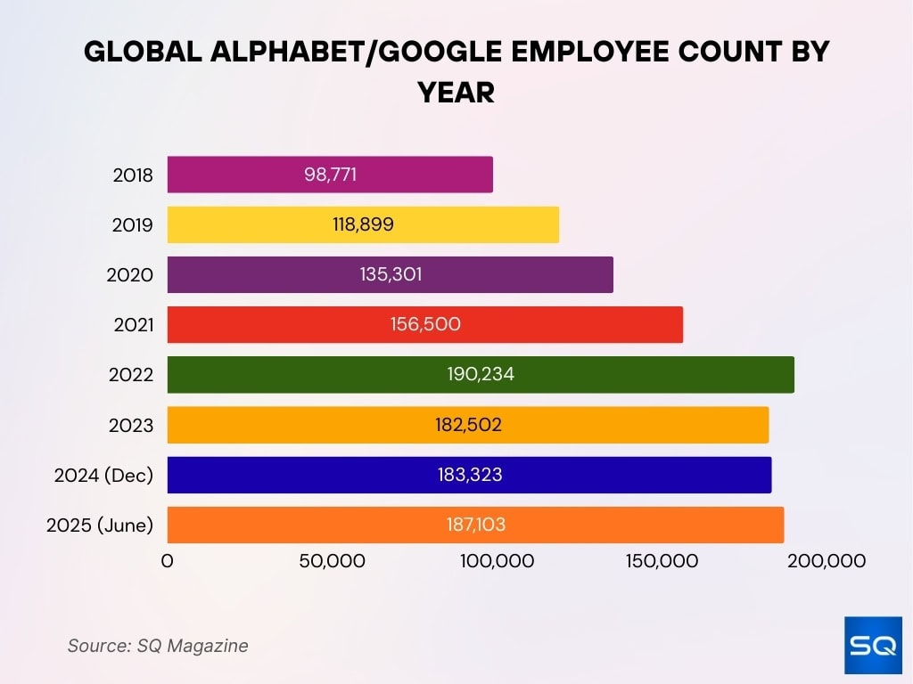
Figure 1: Employee engagement
(Source: Lee, 2025)
Figure 1 shows that servant leadership approach is particularly effective because it promotes psychological safety among employees across diverse cultural backgrounds that maintain engagement rate over the period in Google (Lee, 2025). Servant leaders encourage open communication among the team members. Google revealed that it uses a digital dashboard to communicate with employees. It reduces misunderstandings caused by cultural differences (Zada et al., 2024). The servant leadership approach builds mutual respect across the team by valuing each other's efforts and contributions for organisational growth and resilience. The IT team recruits employees from a global scale, like Google, in the United Kingdom, including members from diverse locations – Asia, Africa, Europe and the Americas (Tennakoonge, 2023). Along with this, experiencing communication issues, internal conflict is a very common phenomenon in cross-cultural teams. Servant leaders tackle the issue with empathy by meeting the expectations of all employees that balance the organisational system.

1.2 Problem Statement
In today's globalised business working environment, the cross-cultural IT team concept becomes the backbone of digital transformation and innovation. Organisations like Google are heavily dependent on a cross-cultural team to drive creativity, adaptability and problem-solving (Ellahi et al., 2022). However, cultural diversity in the workplace leads to several socio-cultural issues, in the workplace which can hinder collaboration. Traditional leadership approaches fail to address communication and conflict in cross-cultural teams. Authoritative attitudes create gaps to fulfil the needs of cross-cultural teams (Bou Reslan, Garanti and Emeagwali, 2021). The servant leadership approach focusses on serving diverse team members to ensure growth. The theoretical strength of the servant leadership approach is widely available which creates an information regarding its applicability in Google, UK that will be filled by using practical data from Google to supports the investigation.

1.3 Significance
This study will offer a clear understanding of the application of servant leadership in cross-cultural IT teams at Google, UK. By examining the operational activity of servant leadership in Google company to enrich the knowledge regarding the process to add value in the organisational system (Hassan and Raheemah, 2021). It will bridge the gap in understanding how servant leadership approaches influence collaboration of cross-cultural IT teams and HRM approaches (Ruiz‐Palomino, Linuesa‐Langreo and Elche, 2023). Along with this, it provides actionable insights to manage the multicultural teams in the UK by sharing relevant evidence-based practice.

2. Research aim, objectives and questions
Research aim
The main aim of the study is to critically analyse the effectiveness of the servant leadership style and its role in enhancing job satisfaction in the cross-cultural IT team of Google in the UK.
Research objective
To evaluate the current role of the servant leadership approach in cross-cultural IT team to analyse the job satisfaction
Research questions
- What is the role of servant leaders in managing cross-cultural IT teams in Google, UK?
- What is the cross-cultural collaboration strategy followed by the leader of Google in the UK?
- How does job satisfaction of cross-cultural IT team under a servant leadership approach is measured by using KPIs? using KPI like engagement rate, innovation and productivity rate

3. Preliminary literature search

3.1 Introduction
This section offers an idea regarding the current leadership role and strategy followed by the servant leader to manage cross cultural team in an IT organisation. Employee composition in the IT team is different from other team that create a difficulty to maintain the stability in the work process (Canavesi and Minelli, 2022). Servant leaders generally emphasise empathy to tackle the scenario, which is critically examined in this section.

3.2 Role of the servant leadership approach
According to, Latif et al. (2021), servant leaders play an important role in tackling the internal conflicts among the employees. The leader shows empathy to understand the issues of employees. The leader bridges cultural gaps and reduces misunderstanding in a diverse team. By using secondary data, this data reveals that the inclusive decision-making strategies of servant leaders encourage diverse team members to participate and share ideas. This data support that when individual employees get the scope share their ideas in cross cultural team and heard by other it motivates them and increase satisfaction level to continue their work (Latif et al., 2021). It promotes trust among the employees that the leader values the opinion of the employees. To support this argument, Ren and Shen (2024), mention that, generally minority groups in any MNC do not get the opportunity to share their ideas and opinions. Under the servant leadership approach, a minor group of people exchange ideas that leave a positive message in the UK market. There is another unique insight revealed by Irfan et al. (2022), prioritising a well-being program: servant leaders foster trust across the IT team. Strengthening the trust among the employees is essential for innovation, creativity and collaboration. As per the data, the IT team in the UK is continuously engaged in different experimental programs, which is the result of the strong integrated team bond. This discussion develops the idea that a servant leader is uniquely effective in cross-cultural team management because it aligns the universal values in the organisation while managing cultural diversity.

3.3 Barriers in cross-cultural team management
The common barrier in cross-cultural team management is the language barrier. As per, Tennakoonge (2023), Difference in language proficiency leads to misinterpretation of data and information. Unclear instructions among the team members impact productivity and engagement. It reduces confidence to participate in group projects. Individual culture has a strong influence on communication styles. Jaiwant, Gowda and Kureethara (2023), stated, collecting constructive feedback from the employees allows them to inform the leader regarding the issue experienced by the employees. With respect to Google in the UK, it can be said that the leader is experiencing a severe issue in managing cross-cultural communication. Misunderstanding rates are significantly high in this region, that reflect on team performance.

3.4 Theoretical Foundation
Servant leadership theory is a management approach that was developed by Robert K in 1970. The main purpose of the formation of this leadership approach is to guide the organisational performance to meet the objectives (Friedman and Mizrachi, 2022). This theory emphasises the priorities served by the leader to maintain the integration in the workplace. As per, Jaiwant, Gowda and Kureethara (2023), It provides central support to successfully complete IT projects by a multinational IT team. Servant leadership generally follows a team building model, a job satisfaction strategy to develop an integrated organisational structure and a strong team. Servant leaders act as a coach of the organisation. It provides the necessary resources to avoid the cross-cultural obstacles to complete the task properly.

3.5 Conceptual Framework
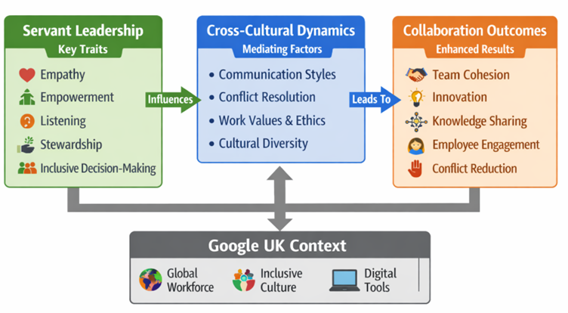
Figure 2: Conceptual framework diagram
(Source: self -developed)
The above conceptual framework identified that the servant leadership approach has a significant impact on managing cross-cultural teams. As per the above diagram, the interactive communication style and strong conflict resolution capability of the leader ensure that the Google IT team is successfully delivering the project on time (Tennakoonge, 2023). The leader pays attention to the concerns experienced by the employee in the IT team, which solves the issue on time and ensures productivity and engagement (Irfan et al., 2022). As per the diagram, selecting the right organisational culture, communication style and technological system plays a vital role in maintaining team cohesion.

3.6 Literature gap
The majority of discussions are based on the descriptive research strategy. Friedman and Mizrachi (2022), does not evaluate the effectiveness of servant leadership approach to enhance job satisfaction of cross-cultural IT teams. To evaluate the current scope, application and effectiveness of servant leadership style use of primary data is highly essential, which is missing in this section, creating a knowledge gap to critically examine the research context. Only theoretical evidence of Jaiwant, Gowda and Kureethara (2023), is not enough to identify the practical implications of this study in the current business process of Google. A generic overview of the servant leadership approach offers limited understanding in organisational practice which will be address by using company specific evidence and contributions.

3.7 Summary
The overall discussion develops a clear insight that now the demand for servant leadership in IT team is increasing at a high rate to promote job satisfaction. It identified the key strategies that followed by servant leaders to enhance employed job satisfaction in cross cultural team. The data shows IT team prefers to work under servant leadership to get the proper support and assistance that boost satisfaction level. As per the theoretical application, this leadership approach empowers the employees on time to adopt the new system in the business process to continue the services which reveals employees get professional growth and opportunities that increase satisfaction.

4. Research methodology

4.1 Research Design
Research methodology is a systematic plan that is used to conduct the investigation to get the possible answer to research questions (Verma, Verma and Abhishek, 2024). It outlines the overall approach for data collection and analysis to ensure the validity of findings. A systematic literature review will be used to examine the research concept under interpretivism philosophy. A systematic literature review is a transparent process to identify the use of servant leadership from existing research and data through inductive research approach.

4.2 Data collection
Data collection is the process of collecting data from various sources to answer the selected research question and evaluate the outcomes. This research will collect the data from the secondary sources by using systematic literature review techniques. A systematic literature review is a highly structured process that offers a rigorous scope to critically examine the research concept. The main reason for considering a systematic literature review for this research is that it minimises the bias regarding current leadership attitudes. It offers evidence-based knowledge to fill the identified gap (Gupta and Gupta, 2022). This research strategy ensures that the high-quality relevant data will be provided to evaluate the current approach followed by the servant leader in Google, UK. There is a wide source of evidence available on the online sites, which will be used to examine the research concept. From the credible and authentic sources, the evidence will be collected which will meet the research objectives. Purpose driven approach will be followed to identify the credible and authentic sources. To avoid any kind of bias, it will use a sampling strategy and inclusion exclusion criteria to maintain relevance. By following this strategy, it will collect the information from company reports, annual publications, newspapers, articles, journals published in last five years. Emerald, Sage Publications, MDPI, ResearchGate, Google Scholar are secure databases to collect high-quality articles.

The key texts, articles and journals:
- Ellahi, A., Rehman, M., Javed, Y., Sultan, F. and Rehman, H.M., (2022). Impact of servant leadership on project success through mediating role of team motivation and effectiveness: a case of software industry. Sage Open, 12(3), p.21582440221122747.
- Medtia. G., (2026). Servant Leadership: An Ideal Approach to Enhance Job Satisfaction in Employees. Available at: https://www.etechgs.com/blog/servant-leadership-enhance-job-satisfaction-in-employees/ [Accessed on: 9.6.2026]
- Sudiarti, N. and Saepudin, T.H., (2024). The role of servant leadership in improving employee satisfaction and performance. Siber International Journal of Digital Business (SIJDB), 1(4), pp.23-32.
- Vrcelj, N., Bevanda, V. and Bevanda, N., (2024). Servant leadership: Influence of job satisfaction and organizational commitment. Management: Journal of Sustainable Business and Management Solutions in Emerging Economies, 29(3), pp.1-11.
Sampling strategy: Sampling strategy allows to select a representative group to examine the research context (Ocaña-Fernández and Fuster-Guillén, 2021). Based on the trend of the selected research topic, it will use a purposive sampling strategy. Purposive sampling strategy support to collect the leadership-specific information from Google.
Search strings - "cross-cultural management" AND/OR "team collaboration", "job satisfaction" AND/OR "multicultural teams", "servant leadership" and "information technology teams" AND/OR "collaboration", "barriers to collaboration" AND "cross-cultural IT teams", "employee perceptions" AND/OR "servant leadership", "organizational behaviour" AND "global it teams" OR "leadership effectiveness".
Inclusion and exclusion criteria
Factor | Inclusion | Exclusion
Cross-cultural IT team | Data and information on the cross-cultural IT team will be considered to evaluate the scenario. | Google is a large-scale firm that has a different type of organisational group. Collecting data from a specific segment meets the research aim.
Company focused | Servant leadership is applied in many MNCs and tech companies (Irfan et al., 2022). This research will collect the evidence from the Google company to meet the purpose. | In case study research, selecting a particular company's specific information is important because other data is irrelevant.
Country | Google operates in multiple locations. Collecting the evidence from the UK met the research objectives. | Strategic decisions of every company get changed in terms of country, location and regulatory policies (Irfan et al., 2022). For this reason, any other country-specific information is not relevant in this context.
Year and language | Recent published data from 2021 will be considered for the research that available in English language only. | Outdated data does not provide clear insights about the current leadership strategy and employee behaviour.
Table 1: Selection criteria

PRISMA for SLR
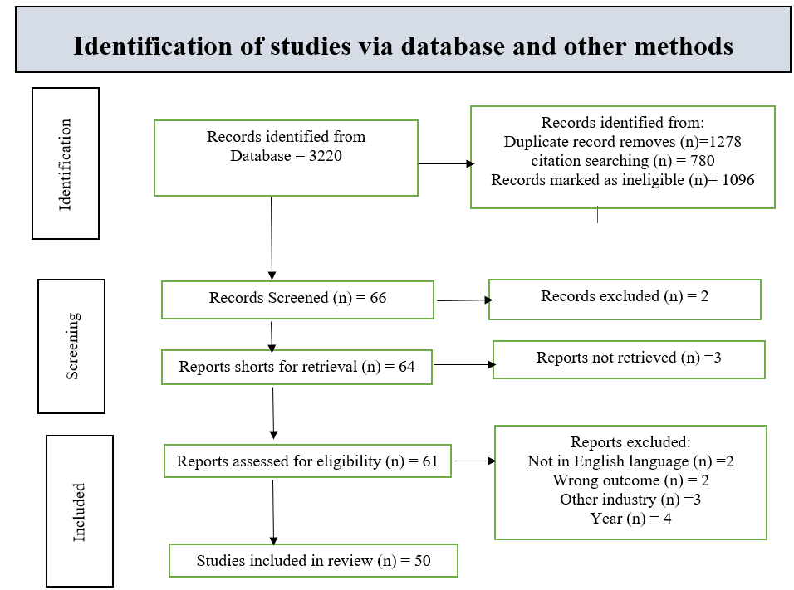
Figure 3: PRISMA diagram
(Source: self-developed)
PRISMA flowchart offers a clear understanding of the process that will be followed to collect the data. Considering the search strategy and inclusion, exclusion criteria the research will focus on collecting 50 key articles on the topic area to conduct the systematic literature review (SLR).

4.3 Data analysis
Thematic data analysis techniques will be followed to represent the collected information (Ahmed et al., 2025). Braun and Clarke's thematic analysis technique will be used to identify the current trend of using the servant leadership approach in Google, UK. Braun and Clarke's thematic analysis techniques follow 6 steps to offer the core understanding from the collected data and evidence (Jowsey, Deng and Weller, 2021). Thematic analysis offers objective, specific information to critically analyse the context.
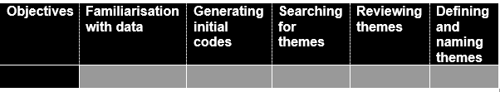Table 2: 6 Steps of Braun and Clarke
(Source: Braun and Clarke, 2023)
This table shows the process which will be followed to decide the information from the key findings for the final report writing. This technique is used to identify the analytical approach that is followed by the leader to manage the cross-cultural team in the UK.

4.4 Ethics
Following ethical principles in a research study is highly essential. It ensures that the research safeguards the data collection and data analysis process from any ethical and legal threats (Jowsey, Deng and Weller, 2021). This research collects the information from secondary sources that removes the participant-related issue. Still, there is a chance to experience an ethical issue regarding accessibility. Due to this reason, it will collect the evidence from all open accessible sources. Any private information or selected data will not be used in this research. Use of publicly available or licensed data avoids any use of unauthorised data in this research. Copyright claims create several issues in secondary research, which will be strictly avoided by using open, accessible sources, as the research plans to use the secondary evidence for evaluation (Ocaña-Fernández and Fuster-Guillén, 2021). There will be a high chance to experience plagiarism issues. Direct quotation will not be used to avoid a similarity issue. All the paper will be cited properly to acknowledge the contribution of others. Accurate information from the secondary sources ensures that there is no bias or manipulation involved while critically examining the concept. The collected data and information will be stored in Google device as per GDPR guideline. Cloud storage will be used to gather the information. Password and encryption mode will ensure that no third party is involved in collecting the data.

5. Risks
Understanding the behaviour of multicultural groups through a systematic literature review will be challenging. There will be a high chance of misinterpretation of communication styles, behaviour and values due to cultural bias. Findings from secondary sources on Google UK do not fully apply to the other organisation or IT team, which causes a conceptual risk (Gupta and Gupta, 2022). Because similar theory and practice are not acceptable in other cases, general discussion on a topic creates a knowledge gap regarding the scenario. Within a very limited period, the entire process must be done, which causes time pressure. Within a fixed time, it is difficult to identify the actual trend of leadership practices, effectiveness and KPI measurement in Google, UK. Time limitations can cause issues for interpretation during thematic analysis (Verma, Verma and Abhishek, 2024). For qualitative coding, this is a common issue involved in cross-sectional research.

6. Timeline
Action | Week 1 | Week 2 | Week 3 | Week 4 | Week 5 | Week 6 | Week 7 | Week 8 | Week 9 | Week 10 | Week 11 | Week 12 | Week 13 | Week 14
Setting aims and objectives
Literature review
Data collection
Data analysis
Discussion
Conclusion
Table 3: Gantt chart

References List
Ahmed, S.K., Mohammed, R.A., Nashwan, A.J., Ibrahim, R.H., Abdalla, A.Q., Ameen, B.M.M. and Khdhir, R.M., (2025). Using thematic analysis in qualitative research. Journal of Medicine, Surgery, and Public Health, 6, p.100198. https://www.sciencedirect.com/science/article/pii/S2949916X25000222
Bou Reslan, F.Y., Garanti, Z. and Emeagwali, O.L., (2021). The effect of servant leadership on innovative work behavior and employee knowledge sharing in the Latvian ICT sector. Baltic Journal of Management, 16(5), pp.729-744. https://www.emerald.com/bjm/article-pdf/16/5/729/398544/bjm-09-2020-0321.pdf
Braun, V. and Clarke, V., (2023). Toward good practice in thematic analysis: Avoiding common problems and be (com) ing a knowing researcher. International journal of transgender health, 24(1), pp.1-6. https://www.tandfonline.com/doi/pdf/10.1080/26895269.2022.2129597
Canavesi, A. and Minelli, E., (2022). Servant leadership: A systematic literature review and network analysis. Employee responsibilities and rights journal, 34(3), pp.267-289. https://pmc.ncbi.nlm.nih.gov/articles/PMC8476984/pdf/10672_2021_Article_9381.pdf
Ellahi, A., Rehman, M., Javed, Y., Sultan, F. and Rehman, H.M., (2022). Impact of servant leadership on project success through mediating role of team motivation and effectiveness: a case of software industry. Sage Open, 12(3), p.21582440221122747. https://journals.sagepub.com/doi/pdf/10.1177/21582440221122747
Friedman, H.H. and Mizrachi, M., (2022). Humanity-centered leadership: Servant leadership with a worldview. Analysis and Metaphysics, 21, pp.25-41. https://www.researchgate.net/profile/Hershey-Friedman/publication/366518065_Humanity-Centered_Leadership_Servant_Leadership_with_a_Worldview/links/63a4e947a03100368a1feb1d/Humanity-Centered-Leadership-Servant-Leadership-with-a-Worldview.pdf?_sg%5B0%5D=started_experiment_milestone&origin=journalDetail&_rtd=e30%3D
Gupta, A. and Gupta, N., (2022). Research methodology. SBPD publications. https://www.sipnaascc.ac.in/pdf/One%20Day%20Workshop%20On%20Research%20Methodology%20%284.2.2025%29.pdf
Hassan, Z.A. and Raheemah, S.H., (2021). Servant Leadership and its Impact on the Effectiveness of Teamwork. Journal of Economics and Administrative Sciences, 27(129), pp.69-84. https://jeas.researchcommons.org/cgi/viewcontent.cgi?article=3958&context=home
Irfan, M., Salameh, A.A., Saleem, H., Tahir Naveed, R., Dalain, A.F. and Shahid, R.M., (2022). Impact of servant leadership on organization excellence through employees’ competence: Exploring a cross-cultural perspective. Frontiers in Environmental Science, 10, p.985436. https://www.frontiersin.org/journals/environmental-science/articles/10.3389/fenvs.2022.985436/pdf
Jaiwant, S.V., Gowda, K.R. and Kureethara, J.V., (2023). Servant leadership and diversity: a focus on ethnic and cultural diversity. In Cases on servant leadership and equity (pp. 177-191). IGI Global Scientific Publishing. https://www.researchgate.net/profile/Kavitha-Gowda-3/publication/366247927_EXECUTIVE_SUMMARY_Servant_Leadership_and_Diversity_A_Focus_on_Ethnic_and_Cultural_Diversity/links/63994d4be42faa7e75bed092/EXECUTIVE-SUMMARY-Servant-Leadership-and-Diversity-A-Focus-on-Ethnic-and-Cultural-Diversity.pdf
Jowsey, T., Deng, C. and Weller, J., (2021). General-purpose thematic analysis: a useful qualitative method for anaesthesia research. BJA education, 21(12), pp.472-478. https://www.sciencedirect.com/science/article/pii/S2058534921000949
Latif, K.F., Machuca, M.M., Marimon, F. and Sahibzada, U.F., (2021). Servant leadership, career, and life satisfaction in higher education: A cross-country study of Spain, China, and Pakistan. Applied Research in Quality of Life, 16(3), pp.1221-1247. https://www.academia.edu/download/97070602/s11482-019-09809-x20230110-1-1ymqxr5.pdf
Lee., (2025). How Many People Work At Google 2026: Employee Count, Compensation & Growth. Available at: https://sqmagazine.co.uk/how-many-people-work-at-google/ [Accessed on:25.5.2026]
Ocaña-Fernández, Y. and Fuster-Guillén, D., (2021). The bibliographical review as a research methodology. Revista Tempos e Espaços em Educação, 14(33), pp.e15614-e15614. https://ufs.emnuvens.com.br/revtee/article/download/15614/11680
Ren, L. and Shen, H., (2024). The relationship between servant leadership and team innovation performance: Mediating effect of self-efficacy. Heliyon, 10(6). https://scholar.google.com/scholar?output=instlink&q=info:svhAJUtQaZgJ:scholar.google.com/&hl=en&as_sdt=0,5&as_ylo=2021&scillfp=5855464865001738982&oi=lle
Ruiz‐Palomino, P., Linuesa‐Langreo, J. and Elche, D., (2023). Team‐level servant leadership and team performance: The mediating roles of organizational citizenship behavior and internal social capital. Business Ethics, the Environment & Responsibility, 32, pp.127-144. https://onlinelibrary.wiley.com/doi/pdfdirect/10.1111/beer.12390
Tennakoonge, W.S.T., (2023). Influence of Servant Leadership for Cultural Intelligence in Multicultural IT Companies. https://www.theseus.fi/bitstream/handle/10024/812703/Tennakoon_Wasana.pdf?sequence=2
Verma, R., Verma, S. and Abhishek, K., (2024). Research methodology. Booksclinic Publishing. https://hpuniv.ac.in/hpuniv/upload/uploadfiles/files/3_5.pdf
Zada, M., Khan, J., Saeed, I. and Zada, S., (2024). How servant leadership influences the effectiveness of project management: antecedents and consequences. Journal of Organizational Effectiveness: People and Performance, 11(2), pp.307-324. https://www.emerald.com/joepp/article-pdf/11/2/307/9478890/joepp-08-2022-0233.pdf

